Inclusive Teaching Practice
Facilitator’s Guide
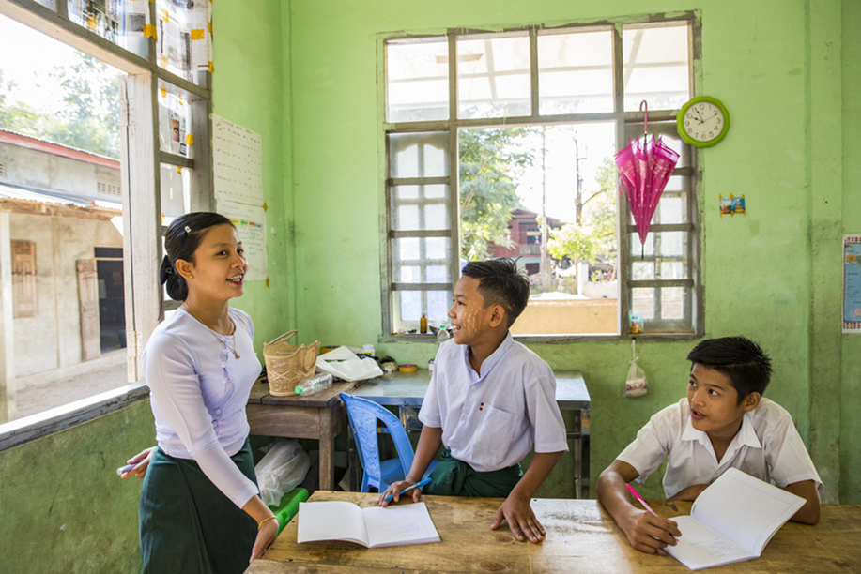
Source: VSO Image library

Module 8:
Peer, co-operative and collaborative learning

Module 8: Peer, co-operative and collaborative learning

Overview
This is the eighth of fifteen modules that look at how we create a positive Inclusive Learning Environment for all. You will see how inclusive teaching practices encourage, develop and use the 21st century skills of critical thinking, communication, collaboration and creativity. These modules are for any educators or those studying in education in Myanmar. The terms student and learner are used interchangeably throughout the module.

Module number | Module title
1 | What is an Inclusive School, Classroom and Teacher?
2 | Knowing your learners
3 | Planning learning outcomes for all
4 | Participating through learner centred approaches
5 | Creating a positive learning environment
6 | Effective questioning and feedback
7 | Active participation
8 | Peer, cooperative and collaborative learning
9 | Supporting students’ emotional and social wellbeing
10 | Legal framework and policies around Inclusion in Myanmar
11 | Supporting all students through differentiation
12 | Identifying specific learning difficulties
13 | Supporting all learners with differences or disabilities
14 | Positive behaviour management
15 | Assessment for student achievement

Learning Journal
Please ensure all participants are aware of the learning journal and its purpose for the module. Point them to the advice given in their participants’ copy of the best way to complete. All answers to activities need to be written in their journal. Remember, reflection is an important part of the learning process and a worthy activity alone. Encourage participants to make a note of new and interesting words/phrases/terms as they make their way through the module.

Study tips
It is important to explain how to approach completing the module. Participants need to take their time, develop a suitable timetable and where possible check their answers with colleagues. The use of think / pair / share is a good way for them to collaborate, share ideas, ask questions, check their work, and give feedback.

Background to the Inclusive Practice CPD modules.
There are 3 key themes explored in the modules that reflect the educational reform taking place in all education settings: Inclusion, Gender Equity and 21st century skills. These themes are key in all areas of curriculum, and vital not only for Myanmar’s educational ambitions and sustainable development but equally vital for the global future.
This course has been designed to help participants engage in this discussion by challenging their beliefs and attitudes about their own teaching, their students’ learning and the impact their educational institution has on inclusion. It is expected that as a facilitator, you will challenge their beliefs and attitudes throughout the modules.
It is also important for you as a facilitator to embed many of the teaching and learning techniques associated with inclusion in education into this course. Encourage participants to work at their own pace and consider their own abilities, interests and skills.
The modules look at how we create a positive Inclusive Learning Environment for all. You will see how inclusive teaching practices support gender equity and encourage, develop and use the 21st century skills of critical thinking, communication, collaboration and creativity.
Each module is made up of a series of activities participants can work through at their own pace. Once they have completed the module, they will have a multiple-choice quiz to complete.

Learning outcomes for Module 8
By working through this module, you will be able to:
- discuss the concept and advantages of peer, cooperative and collaborative learning.
- recognise examples of these types of learning in the classroom.
- demonstrate strategies to promote cooperative and collaborative learning in your own classroom.
- reflect on your own classroom practice and adapt lesson plans to include opportunities for collaborative, cooperative and peer learning.

In this eighth module, continue to encourage the participants to think about what inclusion means to them, why we need inclusion and what the features are of an inclusive educational institution and teacher. The activities in the module will take them approximately 7 hours to complete. This module will help participants think about how students can support each other’s learning and how they can facilitate peer, co-operative and collaborative learning. The key learning in this module is ensuring that participant’s understand the change in their role as educators when student’s are engaging in more collaborative ways of learning. Their role as an educator will be considerably different to a more traditional style of teaching.

Extra instructions for the activities in module 8
Activity | Additional points to consider
Prior knowledge assessment | The first task is a recap assessment of module 7. This reminds the learner of the previous module contents and helps them to recall important information in preparation for this module. After the first attempt, suggest the learners refer to the previous module to check their answers.  Discuss any ways that the learning from Module 7 has been used to enable students to be more active in their learning. What impact has this had on teaching and learning?
Introduction | Ask participants what they understand by ‘Peer, cooperative and collaborative learning.’ What would they like to find out? Write up questions to address over the duration of the module. Perhaps there are definitions that they wish to discuss or challenges that they have faced if they have used some of these teaching and learning styles before.
1st Self- assessment | Some participants may need encouragement to be honest in their self-assessment. The results from this self-assessment will be compared to another self-assessment at the end of the module, allowing participants to make comparisons and reflect on their learning.
Section 2 – Learning outcomes (where are participants now?) | After participants have thought about how often they provide opportunities to enable students to learn ‘by themselves’ through peer, cooperation and collaboration, invite them to think about why learning with others is an important life skill.
Activity 8.1 - What does peer, co-operative and collaborative learning mean to you? | Ask participants what peer learning, co-operation and collaboration means to them. Encourage participants to think about the differences between them and record their ideas in their learning journal.  Ask participants to discuss in groups examples of peer co-operation & collaboration in a wider context, outside of the educational setting. How can we start to develop the skills they will need from an early age?
Activity 8.2 – Match the description to the learning style | This activity asks participants to match the learning style to the description. If participants are still confusing the learning styles, encourage them to revisit the reading task in the previous section and discuss the differences with them.
Activity 8.3 – Examples of Peer learning | Suggest participants watch the video about peer learning before they attend your facilitated session. This will allow them time to reflect on their prior learning from the module and think about peer learning techniques a bit more. Ask participants if they have used the techniques before and about their experiences. What did they think the impact was on learning?  https://www.youtube.com/watch?v=SaLgg8QrBCY  Model activities using the 3 peer learning techniques Think, pair, share,  3before me and Jigsaw groups. Ask participants about how they felt using the techniques and how confident they feel to use them with students.  In groups, ask participants to think about the advantages and disadvantages of using the different techniques with different types of learners in their class. A few ideas are provided in the participant book to get them started.
Activity 8.4 – Advantages and disadvantages of co-operative learning | Having read through the examples of cooperative learning talk about the techniques and ask participants about any potential challenges or disadvantages. Discuss how to overcome these and then discuss the advantages. When discussing Expert groups, The fish bowl and Q & A match up, ask participants to think about specific learners that they teach and consider how they might benefit from these styles of learning. Will participants need to make any adaptations to ensure that all learners can participate and achieve?
Activity 8.5 – Examples of Collaborative learning | Watch the video about collaborative learning and ask participants if they have used it before. What was the impact on learning?  https://www.youtube.com/watch?v=ncyXxMcmWhE  Introduce participants to Dylan William’s work and his use of the term ‘reporter’. Carry out an activity with participants, assigning one team member as a reporter, asking them to report back to the rest of the group on the work carried out in their group.  https://www.youtube.com/watch?v=TqBNWEQmBRM  Write up the quote ‘work as a group rather than just work in a group.’  Use the Think, pair, share technique from the previous section to discuss what participants think this means. What might this mean to the work participants do with students.  Start to explore the role of the teacher and what this looks like when students are working collaboratively. What do participants think teachers will be doing?
Activity 8.6 – Learning retention when using peer, co-operative and collaborative learning | Look at the learning pyramid and encourage participants to reflect on a lesson that they think was particularly memorable for students. In their learning journals, ask participants to note what they think made it a success? Ask them how they engaged learners? E.g. Were students given time to discuss their learning?  Share an image of a class in motion and ask participants to discuss where they think the lesson would fit on the learning pyramid. Ask participants to share their own experiences or examples of lessons and where they feel these lessons would fit on the pyramid for retention.
Activity 8.7 – Writing a definition | Ask participants to think about what they have read so far about co-operative and collaborative learning. Can they explain the difference between the two? In pairs ask participants to describe a style for their partner to guess.  If this is a challenge for them, they may wish to look back at the notes they have made so far or revisit previous sections of the module.
Activity 8.8 – What it looks like in the classroom | There are 3 videos in this section, showing classroom activities in Indian schools (with English commentary). The videos demonstrate many of the techniques that have been discussed in this module for participants to see what they look like in practice.  https://www.youtube.com/watch?v=tR2hIYOpBcI&feature=youtu.be  https://www.youtube.com/watch?v=Qm2hp-hNEI4  https://www.youtube.com/watch?v=UHQwZlU2o80&feature=youtu.be  If possible, watch the videos with participants and discuss them using the following prompts.  • What features can they see in each video?  • How were ALL learners’ contributions valued in class?  • Could your participants use these ideas in the classroom?  • How confident do they feel to trial ideas now they have seen them?
Activity 8.9 – Different roles of the teacher | Allow time for this activity as it focusses on the role of the teacher and how this might look different when participants use peer, cooperative and collaborative learning techniques. Encourage participants to copy the table from the participant book into their learning journal and tick the descriptions that they think would be most effective. In pairs, ask participants to provide an explanation for their choices. When they have completed it, invite them to share their answers. Suggested explanations are provided in the participant book. Discuss each one and allow participants time to edit their answers if they wish to following the discussion.
Activity 8.10 – Scenarios – which technique might work best? | In this activity participants are provided with scenarios, and they are asked to suggest an appropriate learning technique. This activity could be used as an end of module assessment.
Wrap up | A consolidation of the module and key points. There is no activity here.
End of module 8 quiz | This is a multiple-choice questionnaire that tests participants’ understanding of the module. Encourage participants to self-assess and revisit their answers as many times as needed to achieve 100%.
Answers to the end of module 8 quiz | Participants should revisit the questions until they achieve 100%. Remind them that some questions require more than one answer. Encourage participants to read the explanations given for answers and discuss them if they are unclear.
Activity 8.10 - Improving your own teaching practice | This activity provides a scenario for participants to consider. It asks them to complete two statements provided by their head of department. Invite participants to role play and share their experiences with the group. Ask participants how confident they felt when giving their responses. Encourage them to make notes in their learning journal.
Self-assessment | The self-assessment duplicates the first self-assessment. Ask participants to reflect on their confidence and discuss comparisons between scores.
The 8th promise | Ask participants to think of one thing they will take away from module 8 and make a promise to their learners about what they will improve. Ask them to evaluate that promise and recognise changes (after x weeks). Encourage participants to reflect on any impact that change has had on teaching and learning and how to improve it further. This reflects the beginning of the action research cycle and can be built on in future modules to create an ongoing action plan for development. Participants are encouraged to make a section in their learning journal entitled ‘Promises’. There will be a total of 15 promises.

End of module 8 quiz - Answers
Participants can attempt the questions as many times as they like to reach 100% pass. This allows them the opportunity to become confident. (Answers in bold)

Q1 - What is peer learning?
c- The situation where students teach, learn and support each other through a task or concept.
Explanation - Peer to peer learning works with guidance from teachers to enable students to work through new concepts and content with other students and gives them opportunities to teach and be taught by each other. It helps expand their perspectives and foster meaningful connections between new and previously known knowledge as well as making social connections.

Q2 - Which statements show the main characteristics of collaborative learning? (Choose 3)
      - It often works well after introducing the class to a new concept, through teacher explanation or some reading material. It enables individual students to combine their own expertise, experience, and ability to accomplish a common learning goal and gain new information.
- Success depends on individual’s strengths and students are responsible for each other’s learning as well as their own. It promotes self-management, social awareness and helps students develop relationships and communication skills.
- Students organise themselves and find resources to help them complete the task. It is not monitored by the teacher (although they can help when requested by the group) and students assess their own individual and group performance.
Explanation - Collaborative learning involves groups of students working together to explore ideas to solve a problem, complete a task, or create a project. Each student has a separate role in the work and is responsible for the team’s learning and success. For example, each student produces a part of a larger assignment and the team assembles the final work together. The student group is self-directed and do not have direction or instruction from the teacher. They decide their group roles, resources and organisation as a group. The teacher can act as advisor when needed.

Q3 - What is cooperative learning? (Choose 1)
b - Each individual student is responsible for their own learning and the learner needs to use their knowledge and resources to ensure that all group members understand what they are learning. It has structure, roles and responsibilities are defined but open for negotiation, and there is a director overseeing the project closely.
Explanation - Each individual student is responsible for their own learning and success during cooperative learning, and that of the group as a whole. They need to use their knowledge and resources to ensure that all group members understand what they are learning.
In collaborative learning, students make individual progress alongside each other, but cooperative learning involves more interdependence, and greater accountability. In a well-planned cooperative learning activity, the structure, roles and responsibilities are defined but open for negotiation, and there is a director overseeing the project closely. The success of the project depends on all the interconnected roles supporting each other

Q4 - Which of the following show the differences between collaborative and cooperative learning? (Choose 2)
a - In collaborative learning, students make individual progress alongside each other, but cooperative learning involves more interdependence, and greater accountability.
c - In cooperative learning, the teacher directs and provides resources or direct students to resources while collaborative teacher acts as advisor when needed.
Explanation - In collaborative learning, students make individual progress alongside each other, but cooperative learning involves more interdependence, and greater accountability.

Q5 - Which of the following show the benefits of ‘peer learning’, collaborative learning and cooperative learning? (Choose 4)
a - Improve student’s social and communication skills and sense of responsibility.
c - Increase student’s self confidence
d - Students have deeper learning experiences through explaining and teaching each other.
f - Learners are actively involved and participate.
Explanation - Peer learning, collaborative and cooperative learning have a lot of benefits for the teaching and learning process. They can improve student’s social and communication skills and sense of responsibility, self-confidence. Students understand each other through working in groups together and are actively involved in their own learning.

Q6 - What is the key to plan a cooperative learning activity? (Choose 1)
b - Teacher defines the structures, roles and responsibilities of each student.
Explanation - In a well-planned cooperative learning activity, the structure, roles and responsibilities are defined but open for negotiation, and there is a director overseeing the project closely. The success of the project depends on all the interconnected roles supporting each other. Students know that they can reach their learning goals only if the other students in the learning group also reach their goals. Like the cast and crew of a theatre production, co-operation requires interdependence, and accountability to each other.

Q7 – During a group work activity, what does the teacher’s role look like?
b - It allows the teacher time to listen to the groups and assess their current understanding, making a more informed decision on where to take the learning next.
c - It can provide a gap in the lesson for a teacher to check in with a student to ensure they are following and understanding.
Explanation – If a teacher establishes routines for effective group work by teaching students how to work together, they will independently work together allowing the teacher time to question a group or individual students further either to consolidate learning or extend their thinking. The time setting students off to a task, provides a moment to check in with key students and check to see if they require any additional support.

