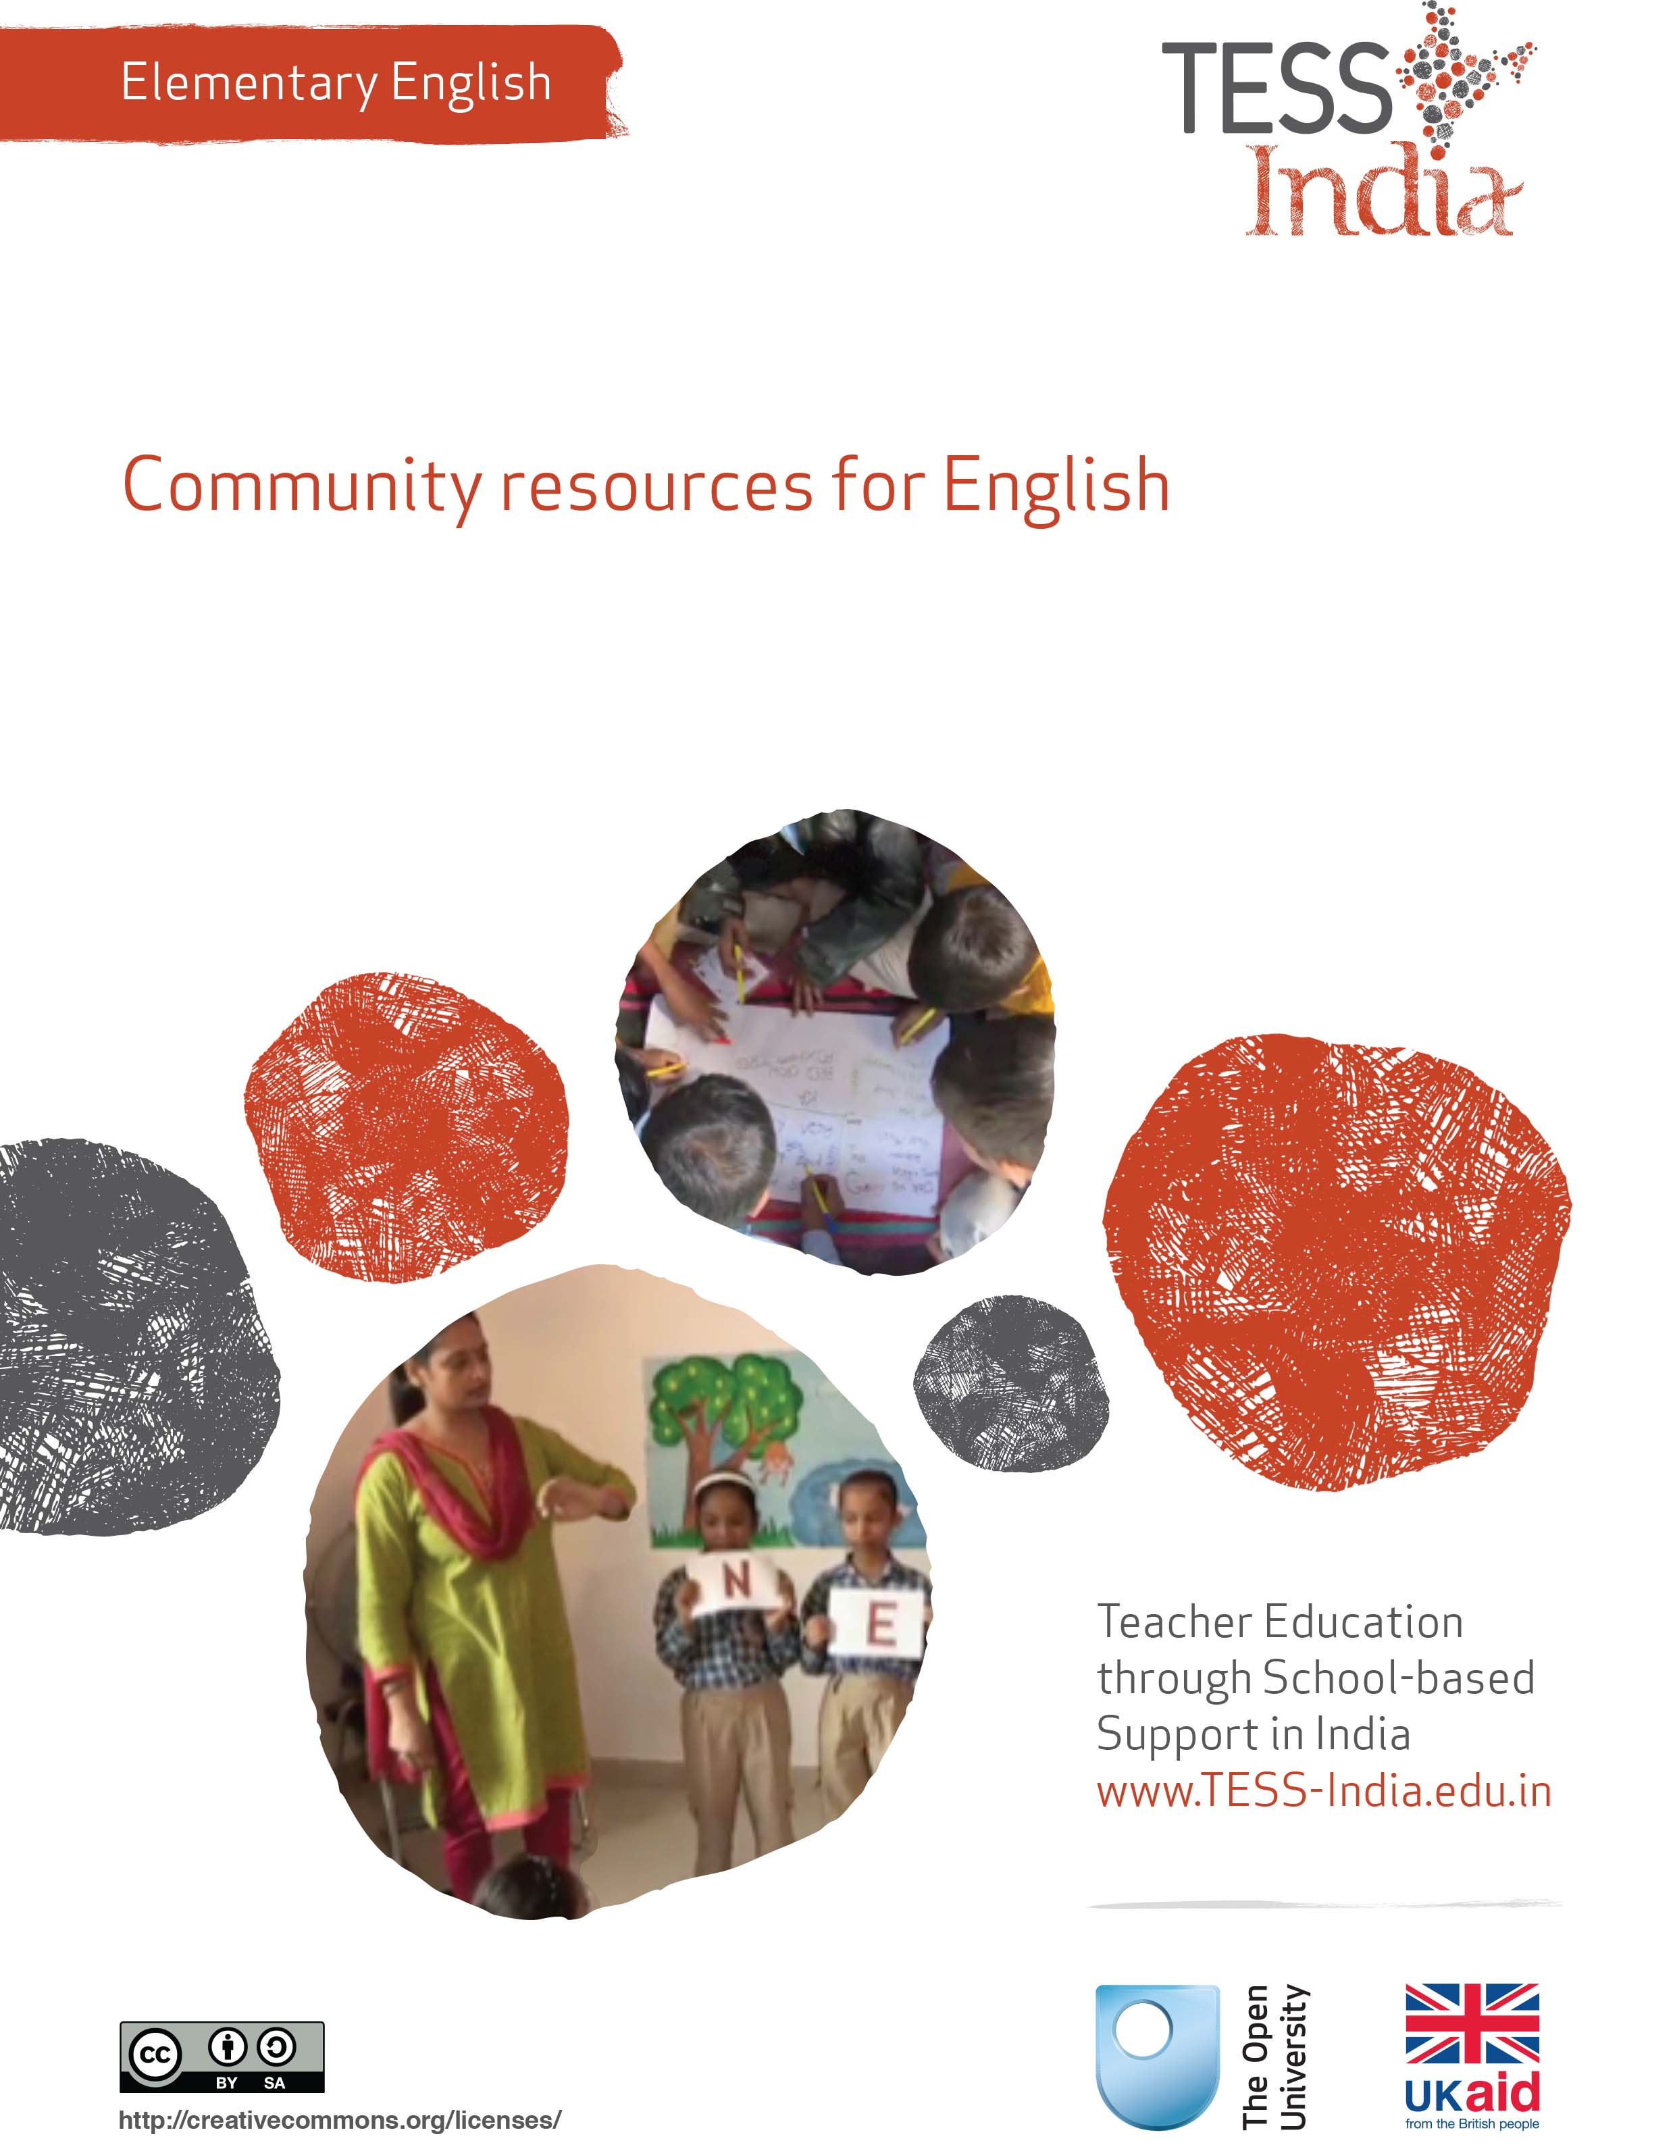
TESS-India (Teacher Education through School-based Support) aims to improve the classroom practices of elementary and secondary teachers in India through the provision of Open Educational Resources (OERs) to support teachers in developing student-centred, participatory approaches. The TESS-India OERs provide teachers with a companion to the school textbook. They offer activities for teachers to try out in their classrooms with their students, together with case studies showing how other teachers have taught the topic and linked resources to support teachers in developing their lesson plans and subject knowledge.
TESS-India OERs have been collaboratively written by Indian and international authors to address Indian curriculum and contexts and are available for online and print use (http://www.tess-india.edu.in/). The OERs are available in several versions, appropriate for each participating Indian state and users are invited to adapt and localise the OERs further to meet local needs and contexts.
TESS-India is led by The Open University UK and funded by UK aid from the UK government.
Video resources
Some of the activities in this unit are accompanied by the following icon: . This indicates that you will find it helpful to view the TESS-India video resources for the specified pedagogic theme.
The TESS-India video resources illustrate key pedagogic techniques in a range of classroom contexts in India. We hope they will inspire you to experiment with similar practices. They are intended to complement and enhance your experience of working through the text-based units, but are not integral to them should you be unable to access them.
TESS-India video resources may be viewed online or downloaded from the TESS-India website, http://www.tess-india.edu.in/). Alternatively, you may have access to these videos on a CD or memory card.

Version 2.0 EE15v2
All India - English
Except for third party materials and otherwise stated, this content is made available under a Creative Commons Attribution-ShareAlike licence: http://creativecommons.org/licenses/by-sa/3.0/

What this unit is about
In this unit you will explore ways to teach English using the spoken and written English that you and your students come into contact with every day. This ‘everyday’ English can provide you with interesting teaching resources that can be motivating to students.
English is used in India for different purposes and in different ways in each part of the country. In the big cities, many people use English every day. English is seen on street signs, in advertisements, newspapers and magazines, and is heard on FM radio, in popular music and at the cinema.
In remote villages, English in the community is less common but is often present. English words like ‘bus’, ‘car’, ‘phone’, ‘TV’, ‘radio’, ‘fridge’ or even ‘school’ are now a part of the everyday vocabulary in most parts of the country. When you look for it, you may find more written English than you expect – on food packets, tickets and clothing labels, and in music. Every village has a bus or train link where people come and go to nearby towns or cities. Such people can be resources for English. They can share their experiences about communicating with people from outside their own village, and how they use English and other languages to do so.
As a teacher, you can bring English from your immediate community and from the wider community into your classroom. This unit is designed to help you get started.

What you can learn in this unit
- To locate English resources in your community.
- To learn what students already know about English.
- To connect English inside and outside the classroom.

1 What is everyday English?
You will start by thinking about what ‘everyday English’ is and how you can access this as a resource in your community.

Activity 1: What is everyday English?
In India, most communities use several languages. This means that many students come to school speaking more than one language. Because of the presence of English in our societies, students may also regularly use some English words in their day-to-day talk, even though they may not be aware that these words are English.
In our everyday language we often use English words for common objects and activities. For example, those of us who live in cities have holidays, we work in factories or offices, and we go to school with a bag full of books, pens, pencils and water bottles, travelling in buses on roads. Even those who do not live in cities may know many English words. For example, the words ‘post office’ and ‘bus stop’ are understood all over India. Some of our new highways now collect a road toll, or ‘tax’. Many people have learned what these words mean without being explicitly taught to say them in English.
What everyday English words do you know? Make a list of them and mark the words that you use in the classroom. Do your students also know these words? Highlight the words on the list that your students will know.
When students try to understand the English they see and hear in the community, they are focused on understanding the meaning. They can forget that they are also learning the language. When you build on your own and your students’ knowledge of everyday English, you are helping them to learn authentic English – that is, English they can use in the real world outside the classroom.
Activity 2: Everyday English – a planning activity
Think about your own community and about which of the following resources in English you think that you and your students could have access to:
- magazines
- newspaper articles
- advertisements
- sports reports
- popular songs
- restaurant menus
- street signs
- shop signs
- tourist information brochures
- maps
- tickets
- comic books
- greeting cards
- bus schedules
- T-shirts
- calendars
- wrapping from food or medical products
- cinema
- radio
- television
- the Internet.
Over the next few weeks carry around a small notebook. Make notes of the English that you see and hear in your community. Add these to the list you made in Activity 1. If there are words that you don’t recognise, use a dictionary to find out their meaning. Write the definitions in your notebook to help you learn the words.
Are there certain places where you are more likely to see or hear English? What are these places? Why do you think that you see or hear more English being used there? Some examples of everyday English that may give you some ideas are shown in Figure 1.
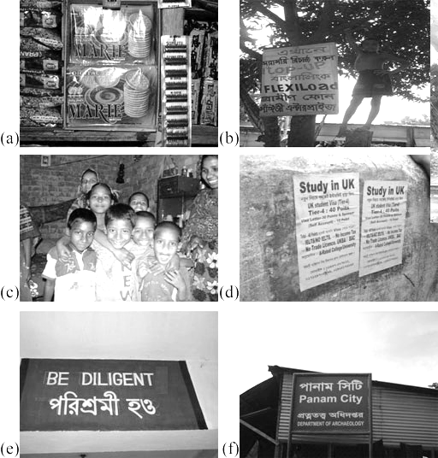
Figure 1 Examples of English in the community: (a) on packaging; (b) in an
advert for mobile phone services; (c) on children’s T-shirts; (d) in an advertisement
on a village wall; (e) on a bilingual sign in a school; (f) on a street sign.
Once you have made your list, review it and think about whether your students will also be likely to encounter English in these places. Will they be familiar with the language? Are some of the words and phrases that you teach in your language lessons also present in the local environment? Can you draw on some of the examples that you have collected and use them in your classes?
See Resource 1, ‘Using local resources’, to learn more about how to draw on the community resources around your school.

2 Find out how much English your students know
Your students might already know more English than you think they do. In Case Study 1 a teacher finds out what his students know.
Case Study 1: Mr Nagaraju learns what his students know about English
Mr Nagaraju is a teacher of English in Class I–III in a tribal school in Orissa. He speaks Oriya and Hindi, but only has a little knowledge of the local language, Savara.
The students I teach are from a very poor background and many come from environments that are not ‘print-rich’. If I taught in the city, I would expect that students might hear English spoken at home or that their parents might read English newspapers. I didn’t think that the students I taught in the village would be exposed to much English in their local environment. I was wrong!
One day I asked the students about the games that they like to play. Not surprisingly, all of them responded with ‘Cricket!’ What surprised me was that the students knew a number of cricket-related English words. So I started writing these words on the board. After some time, the list got so long that I started to use a notebook to keep track of all the words they knew. Within a few days, this list grew from words and phrases about cricket to other sports as well.
By the end of that week, I had made a list of more than 100 English words and phrases that the students already knew: words used in the market, words for professions and words relating to transport and vehicles – the latter because their parents or other family members were often truck drivers, guards and transport workers. They knew words like ‘Jeep’, ‘tyre’, ‘brake’ and ‘lights’, and words relating to the maintenance of vehicles and any associated tools: ‘wash’, ‘polish’, ‘water’, ‘air’, ‘petrol’, ‘nut’, ‘bolt’ and ‘pana’. I didn’t know the last word. Then from the students’ gestures and description, I realised that this was their word for ‘spanner’. I then introduced them to the equivalent English word.
Soon I had many lists. I started to think of ways that I could use them with students to help their learning. First I went through the lists, looking for words that also appeared in their lessons. I started to think more and more about how I could remind the students of what they already knew when teaching the lessons from the textbook.

Pause for thought
Mr Nagaraju started to compile a list on the board of words that students knew. But this list grew and grew. Can you think of ways in which you could compile a list of English vocabulary that students are familiar with from their communities? How could you draw on this list to consolidate students’ learning?
- Could you make a display of words and pictures on a classroom wall?
- Could you make and keep a class ‘English reference book’ that you regularly review with students?
- What are the barriers that stop you from activities like this?

Activity 3: Find out what English words and phrases your students are familiar with
Have you noticed that your students are already familiar with some English words and phrases? Look at Table 1 and think about what words or phrases you use to speak about one or more of the topics in the left-hand column.
Table 1 Do your students know any English words related to these topics?
Topic | Examples of English words or phrases
Cricket or other games | Bat, ball, game, out, team, point, score, stadium, field
Jobs that people have | Police, teacher, guard, driver, doctor, nurse, engineer
Vehicles we use, and related words | Bus, car, scooter, train, cycle, petrol
Houses and the things in them | Gate, door, bed, TV, computer, kitchen, phone, bulb, light, current
Tools we use | Hammer, tape, pencil, rubber
What we eat and drink | Cool drink, juice, bread, biscuit
Forms of entertainment | Film, actor, dance, music, singer
Computers, technology and mobile phones | Computers, text message, mobile phones
Medicine | Prescriptions, cough syrup, vitamin, tonic
Ask your students to list the words and phrases that they know, in any language, that are related to these topics. Are some of these words and phrases from English?
Compare your students’ contributions with the examples in the right-hand column of Table 1. Using a copy of Table 1, tick a word that the students say – even if they say it in a different way, as in ‘pana’/‘spanner’ in Case Study 1. Did they mention any other English words?
To support this kind of activity, you might find it interesting to talk to teachers of particular subjects within your school. Sports teachers often use English words and phrases such as ‘Run!’ or ‘Stand in a line!’ Similarly, science teachers often refer to equipment using their English name (e.g. ‘microscope’), and a teacher who talks about health and hygiene may mention words like ‘antiseptic’ and ‘bandage’. In this way, students learn English and another subject at the same time.
Based on the English word list you and your students create, you can make a word wall. Write out six to eight words in big letters and display them in the classroom. Looking at the words frequently will help all students become familiar with them. You can change or update the list once a week.

3 Discovering English words
Now try the following activity.

Activity 4: English in the community
Since there is so much English being used within our local languages, some students may be using English without being aware that they are doing so. There are several ways that you could make your students more aware of the English language in their community. Here are some examples of activities that elementary teachers have tried:
- Take students to the railway station. Look for all the signs in English and discuss what they mean.
- Bring in a toothpaste advertisement that says ‘Brush your teeth every day’. Discuss irregular plural forms of words such as ‘tooth’ and ‘teeth’.
- Give a homework task to look out for the English words in the community over one weekend. Examples: newspapers, magazines, advertising; tickets to the cinema or other entertainment, and signs saying things like ‘Entry’, ‘Exit’, ‘Tickets’ and ‘Toilet’; or signs on the roads that say things like ‘No parking’, ‘One way’ and ‘No entry’. In the classroom, discuss the words that are familiar and those that aren’t.
- Look for T-shirts that have some writing in English. Check your clothes to find labels in English. Talk about the meaning of the words and phrases you find.
- Ask students to note down any English words and expressions they hear or see in the school building.
- Ask students to listen to the radio broadcasts in English. Even if they do not understand very much, they will benefit from hearing English being used authentically and enjoy being able to recognise some of the words and phrases.
Choose one of these examples to try out with your students. What do you need to organise to make the activity successful? What criteria will you use to assess students in the activity?
Carry out the activity with your students. How did they respond? Did they hear or read more English words? How did you evaluate this?
In the next case study, a teacher brings an English newspaper into her classroom. Many English newspapers in India contain supplements for younger readers, which may be of interest to your students.
Case Study 2: Mrs Chadha uses an article from an English newspaper
Mrs Chadha teaches Class VII.
I found a short article called ‘They have long legs’ in a newspaper supplement for young readers called ‘Young World’, part of The Hindu. I thought my students would enjoy learning about all these creatures with long legs. I realised that the text was a little difficult for Class VII students, as I had to look up some of the vocabulary myself. I didn’t know what a cranefly was, for example, and I had to remind myself what ‘vulnerable’ meant. But the text was predictable in that it moved from talking about insects to birds and then animals. So I thought that my students could follow it as long as I helped them.
In the first lesson, I read the first two paragraphs aloud, translating some of the key unfamiliar words into the students’ home language. These first two paragraphs were the most difficult, but the text became easier as it went on. In the next lesson, I read out the first part of the text again, and then continued with the rest of it.

Craneflies are insects with slender bodies and extremely long legs, which is why they are sometimes called daddy long legs.
They are slow flyers and vulnerable to predators. When they perch on plants or on the ground, they bob up and down, due to their habit of alternately bending and straightening their legs.
The black-winged stilt has the longest legs among birds – not the longest in absolute terms but longest relative to its body length, the legs making up 60 per cent of its height.
The giraffe’s great height – it is the tallest animal – is due to its long legs and neck …
The students were amused by the name ‘daddy long legs’ for the insect. My drawing of the cranefly on the board made it clear what it was. The ideas and words in the phrases ‘up and down’, ‘bending and straightening their legs’, and ‘habit’ were familiar to the students. The difficult parts were about ‘vulnerability to predators’, and the concept of ‘perching’ (sitting). I quickly explained these words in the students’ home language.
The students now added the word ‘insect’ to their vocabulary, along with the words ‘bird’ and ‘animal’, which are in our textbook. In the part about birds, to explain the relative height of the leg compared to the body, I used my hands and fingers to show 50 per cent (half), 60 per cent and 40 per cent.
Something interesting happened when, before I read out the third paragraph, I asked: ‘Now you know a long-legged insect and a long-legged bird – can you think of a long-legged animal?’ Many students immediately mentioned the word ‘giraffe’. Some said they had seen one on television. So when I said that the giraffe was indeed the animal that the newspaper mentioned next, the children crowded round me to look at the newspaper. The pleasure of correctly guessing what an authority like the newspaper had said was very great indeed!
(Adapted from Amritavalli, 2007)

Pause for thought
- Mrs Chadha used a newspaper article for Class VII students. How would you adapt this activity to younger classes?
- Do you think it was effective for Mrs Chadha to switch between English and the home language? When and why did she decide to do this?
- Based on Mrs Chadha’s observation in her final paragraph, how do you think she assessed students’ knowledge of the new vocabulary?

4 Real-life English
Now try these two activities.
Activity 5: People who use English – a planning activity
Your students may know people who use English regularly for personal or professional reasons. Heightening their awareness of these uses of the language can reinforce the value of learning English.
Plan a language lesson where you ask your students some questions based on the following prompts. It might be helpful to write some of these prompts on the board before the lesson:
- Have you seen a member of your family fill out a form in English? Why was this – to get a driver’s licence or a birth certificate? Discuss the English words and meanings.
- Have you seen someone in your family receive or send letters and/or emails in English? Have you received or sent letters and/or emails in English?
- Have you seen someone in your family write their address in English? Can you write your address in English?
- Have you seen a doctor write a prescription? Was it in English or the local language?
- Have you seen a policeman write a ‘challan’ to fine someone? What language was this in?
Tell students to write a table with two columns. In the first column, they list people they know (for example, their doctor, a policeman, their grandmother, etc.) or they can draw pictures of these people. In the second column, they list what they have seen these people reading and writing in English. They should use the prompts from the board to help them make their lists.
- Does your textbook refer to any of this English? Are there connections you can make between the textbook and the students’ tables?
Use the students’ tables to plan language lessons on ‘everyday’ English. See where you can make a link to what is in the textbook.

Pause for thought
Would it be possible for you, or someone at your school, to invite someone who speaks English to come to the class to talk about how they use English? Could you contact a doctor, postman or policeman? The students could prepare for such a visit by looking around for examples of English used in these professions. The class can prepare simple questions to ask the visitor. After the visit, the students could write the person a short letter in English, thanking them for the visit.

Activity 6: English and technology
Both the English language and its alphabet are gaining increasing popularity in Indian communities, in part because of their role in technology. These days, almost everybody has a mobile phone. Now people commonly send each other text messages, often employing English phrases to do so. The roman script is increasingly used to write texts in local languages as well.
Ask your students to work in groups and brainstorm answers to the following question:
How do you communicate with each other and your families – both those family members you live with and those who live elsewhere?
At the end, each group reports back on the ideas in their brainstorm. When you use a brainstorm activity one student in each group should take responsibility for writing down the ideas. They can do this in their notebook or on a large sheet of paper.
Walk around the room as the students do the brainstorm. Listen to their ideas. If some students are finding it difficult to think of ideas, you might want to use one or two of these questions to help them.
- ‘Do you use the telephone or a mobile phone?’
- ‘Do you send text messages?’
- ‘Have you ever seen a typewriter?’
- ‘Have you used a word processor (computer)?’
- ‘Do you or your parents write letters or emails?’
When they have written down their ideas about how people communicate, ask them to think about what language(s) people use for these activities – is it English, Hindi or their local languages? Or a mix of these? They should show this information on their brainstorm chart.
Then gather the students together and hold a class discussion about what determines which language they use for each activity. Is it easier to use English because of the computer keyboard? Do they use the roman script for transliterated Hindi words? Write the class ideas on the board so that students see and hear more English.

Pause for thought
Are there ways in which you could use technology in your lessons? Could the students send an email or text message to someone, inviting them to their class, or thanking them for their visit? You could compose the text together on the board, or students could draft the message in groups if your class is large. Then someone could type the message into a computer or a mobile phone. You can help draw out students who are too shy to participate in activities that require them to speak by giving them more time to type into the computer (if you have access to one) or mobile phone.

Video: Using local resources
http://tinyurl.com/video-usinglocalresources

5 Presenting English to the community
In the previous activities you have thought about the English that is available in your school community and how it can be brought into your classroom. There are also ways that you and your class can reach out to the community.
Activity 7: Presenting English to the community
An English assembly is one way to engage with your local community. You could hold an event once or twice a year that brings students’ parents to the school, or brings students from one school to another. This event could be an exhibition of the kind of language work suggested in some of these units – poems that students write, accompanied by drawings, for example. It could be a song, dance and play evening where students recite these poems, sing a song in English or perform a short play in English. (The play could be a poem that they act out, or a part of a story. It need not last more than five to ten minutes.) The whole event need not be all in English, but an opportunity to ‘showcase’ it.
When you plan for the event, students can write invitations in English and in home languages. In order to spread awareness about the event, they can make bilingual posters to display around the school and the community.
In delegating the roles for the event, make sure to involve every student in the class:
- Some can greet and welcome the visitors in English and in home languages. (‘Good afternoon! Please come in. Please sit down.’)
- Some can make bilingual announcements during the programme. (‘Now we will have a poem by Class II students.’)
- Some can use bilingual flash cards to make up words such as ‘Welcome’ and ‘Thank you’.
As the students prepare and put effort and attention into what they are doing, you will find that they reinforce their use of language. As well as learning their own parts in the performance, they will also benefit from listening to other students’ parts as well.
Make sure you involve every child in the class in an activity, including those with learning or physical disabilities.
Afterwards, students can write thank you letters to all those who attended.
Parents are often eager to see what their children are learning in school. They might be unsure of what their children can learn outside what is in the textbook. When they see their children speaking in English, performing rhymes, songs and plays, they will be proud of them. They may then also understand that there is more to learning English than writing in their school notebooks.

6 Summary
In this unit you have explored ways of building on your students’ pre-existing knowledge of English and how you can bring the English that is used in the community into your classroom. You have thought about the presence of English in your school community and some classroom activities that draw on these uses of English. You have also thought about ways in which you can involve members of the community in your English language classroom, either by inviting them to speak about how they use English in their lives and professions or by inviting them to attend an English assembly.
Other Elementary English teacher development units on this topic are:
- Classroom routines
- Using the textbook creatively
- English and subject content integration
- Learning English in the creative arts.

Resources
Resource 1: Using local resources
Many learning resources can be used in teaching – not just textbooks. If you offer ways to learn that use different senses (visual, auditory, touch, smell, taste), you will appeal to the different ways that students learn. There are resources all around you that you might use in your classroom, and that could support your students’ learning. Any school can generate its own learning resources at little or no cost. By sourcing these materials locally, connections are made between the curriculum and your students’ lives.
You will find people in your immediate environment who have expertise in a wide range of topics; you will also find a range of natural resources. This can help you to create links with the local community, demonstrate its value, stimulate students to see the richness and diversity of their environment, and perhaps most importantly work towards a holistic approach to student learning – that is, learning inside and outside the school.
Making the most of your classroom
People work hard at making their homes as attractive as possible. It is worth thinking about the environment that you expect your students to learn in. Anything you can do to make your classroom and school an attractive place to learn will have a positive impact on your students. There is plenty that you can do to make your classroom interesting and attractive for students – for example, you can:
- make posters from old magazines and brochures
- bring in objects and artefacts related to the current topic
- display your students’ work
- change the classroom displays to keep students curious and prompt new learning.
Using local experts in your classroom
If you are doing work on money or quantities in mathematics, you could invite market traders or dressmakers into the classroom to come to explain how they use maths in their work. Alternatively, if you are exploring patterns and shapes in art, you could invite maindi [wedding henna] designers to the school to explain the different shapes, designs, traditions and techniques. Inviting guests works best when the link with educational aims is clear to everyone and there are shared expectations of timing.
You may also have experts within the school community (such as the cook or the caretaker) who can be shadowed or interviewed by students related to their learning; for example, to find out about quantities used in cooking, or how weather conditions impact on the school grounds and buildings.
Using the outside environment
Outside your classroom there is a whole range of resources that you can use in your lessons. You could collect (or ask your class to collect) objects such as leaves, spiders, plants, insects, rocks or wood. Bringing these resources in can lead to interesting classroom displays that can be referred to in lessons. They can provide objects for discussion or experimentation such as an activity in classification, or living or not-living objects. There are also resources such as bus timetables or advertisements that might be readily available and relevant to your local community – these can be turned into learning resources by setting tasks to identify words, compare qualities or calculate journey times.
Objects from outside can be brought into the classroom – but the outside can also be an extension of your classroom. There is usually more room to move outside and for all students to see more easily. When you take your class outside to learn, they can do activities such as:
- estimating and measuring distances
- demonstrating that every point on a circle is the same distance from the central point
- recording the length of shadows at different times of the day
- reading signs and instructions
- conducting interviews and surveys
- locating solar panels
- monitoring crop growth and rainfall.
Outside, their learning is based on realities and their own experiences, and may be more transferable to other contexts.
If your work outside involves leaving the school premises, before you go you need to obtain the school leader’s permission, plan timings, check for safety and make rules clear to the students. You and your students should be clear about what is to be learnt before you depart.
Adapting resources
You may want to adapt existing resources to make them more appropriate to your students. These changes may be small but could make a big difference, especially if you are trying to make the learning relevant to all the students in the class. You might, for example, change place and people names if they relate to another state, or change the gender of a person in a song, or introduce a child with a disability into a story. In this way you can make the resources more inclusive and appropriate to your class and their learning.
Work with your colleagues to be resourceful: you will have a range of skills between you to generate and adapt resources. One colleague might have skills in music, another in puppet making or organising outdoor science. You can share the resources you use in your classroom with your colleagues to help you all generate a rich learning environment in all areas of your school.

Additional resources
- Teachers of India classroom resources: http://www.teachersofindia.org/en
- ‘Children talk their way into literacy’ by Gordon Wells: http://people.ucsc.edu/~gwells/Files/Papers_Folder/Talk-Literacy.pdf

References/bibliography
Amritavalli, R. (2007) English in Deprived Circumstances: Maximising Learner Autonomy. Department of Linguistics, The English and Foreign Languages University, University Publishing Online, Foundation Books.
Cummins, J. (undated) ‘BICS and CALP’ (online), Jim Cummins’ Second Language Learning and Literacy Development Web. Available from: http://iteachilearn.org/cummins/bicscalp.html (accessed 2 July 2014).
Cummins, J. (2000) Language, Power, and Pedagogy: Bilingual Children in the Crossfire. Bristol: Multilingual Matters.
Gibbons, P. (2002) Scaffolding Language, Scaffolding Learning: Teaching Second Language Learners in the Mainstream Classroom. Portsmouth: Heinemann.
Krashen, S. (1981) Second Language Acquisition and Second Language Learning. Oxford: Pergamon Press.
Krashen, S. (1982) Principles and Practice in Second Language Acquisition. Oxford: Pergamon Press.
Mohan, B. (1986) Language and Content. Reading, MA: Addison-Wesley.
Mohan, B., Leung, C. and Davison, C. (eds) (2001) English as a Second Language in the Mainstream: Teaching, Learning and Identity. New York, NY: Longman.
Wells, G. (2003) ‘Children talk their way into literacy’, published as ‘Los niños se alfabetizan hablando’ in García, J.R. (ed.) Enseñar a escribir sin prisas … pero con sentido. Sevilla, Spain: Publicaciones MCEP. Available from: http://people.ucsc.edu/~gwells/Files/Papers_Folder/Talk-Literacy.pdf (accessed 8 July 2014).
Wells, G. (2009) The Meaning Makers: Learning to Talk and Talking to Learn, 2nd edn. Bristol: Multilingual Matters.

Acknowledgements
This content is made available under a Creative Commons Attribution-ShareAlike licence (http://creativecommons.org/licenses/by-sa/3.0/), unless identified otherwise. The licence excludes the use of the TESS-India, OU and UKAID logos, which may only be used unadapted within the TESS-India project.
Every effort has been made to contact copyright owners. If any have been inadvertently overlooked the publishers will be pleased to make the necessary arrangements at the first opportunity.
Video (including video stills): thanks are extended to the teacher educators, headteachers, teachers and students across India who worked with The Open University in the productions.

