Inclusive Teaching Practice
Participant’s Book
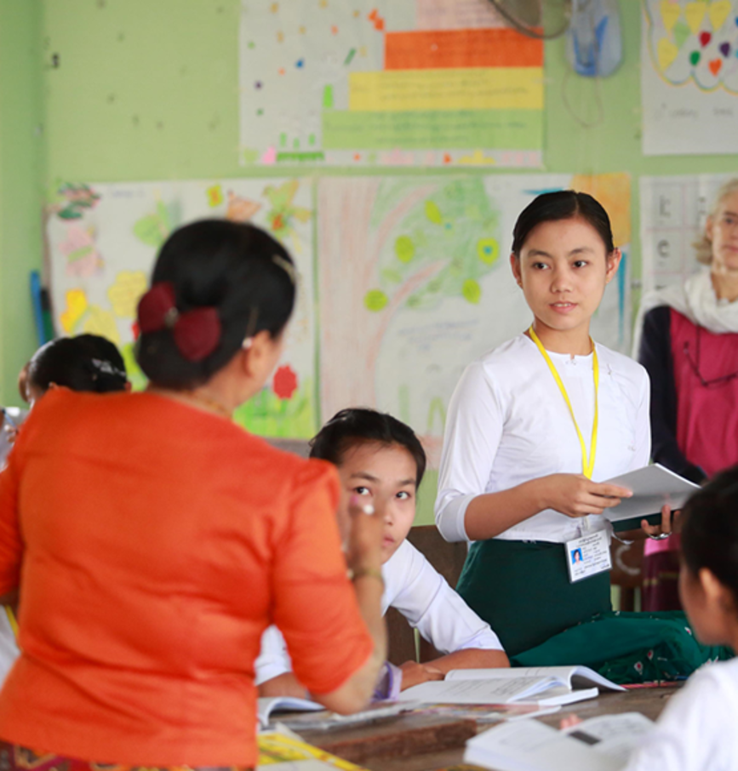

Source: VSO Image library

Module 1:
What is an Inclusive School, Classroom and Teacher?
Module 1: What is an Inclusive School, Classroom and Teacher?

Overview
This is the first of fifteen modules that look at how we create a positive Inclusive Learning Environment for all. You will see how inclusive teaching practices encourage, develop and use the 21st century skills of critical thinking, communication, collaboration and creativity. These modules are for any educators or those studying in education in Myanmar. The terms student and learner are used interchangeably throughout the module.

Module number | Module title
1 | What is an Inclusive School, Classroom and Teacher?
2 | Knowing your learners
3 | Planning learning outcomes for all
4 | Participating through learner centred approaches
5 | Creating a positive learning environment
6 | Effective questioning and feedback
7 | Active participation
8 | Peer, co-operative and collaborative learning
9 | Supporting students’ emotional and social wellbeing
10 | Legal framework and policies around Inclusion in Myanmar
11 | Supporting all students through differentiation
12 | Identifying specific learning difficulties
13 | Supporting all learners with differences or disabilities
14 | Positive behaviour management
15 | Assessment for student achievement

This module helps you to think about the basic principles of Inclusion and the features of an Inclusive School, Classroom and Teacher. A checklist is provided for you as an educator to reflect on your own inclusive practice throughout the course. You will also be asked to record your reflections in a learning journal, so it is important to make good notes and think carefully and deeply about your current and future practice.

This CPD module also encourages you to develop communities of practice between yourself and your colleagues. This will support and extend your own use of inclusive practices in your teaching and will help your student teachers build on inclusion in their learning and future professional practice.

Learning Journal
It will be useful to record your reflections in a learning journal throughout the module.
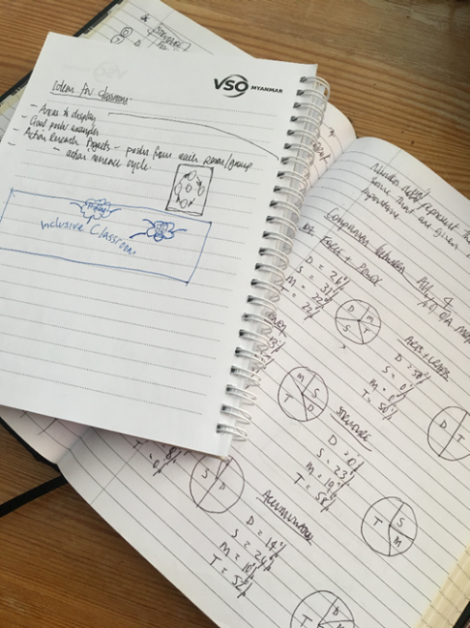
A learning journal can be digital (e.g. using Word or Google Docs) or on paper. You can also take photos of your learning journal pages if you want to share your thoughts with others. It is important that you record your thoughts and ideas so that you can remember and use them later in activities and in your own teaching.

Here are some useful tips for a good learning journal:
- Use headings and dates for all your journal entries.
- Use the activity number for reflections linked to that activity, e.g. Activity 1.1
- Add references to any other resources you find that help you.
- Record answers to activities.
- Write reflections about your learning.
- Make notes of new vocabulary.
- Identify topics you want to learn more about.

Source: Rose, N. (2018) Personal Learning Journals

The important thing is that it is easy for you to use. You can take notes which answer simple questions like these:

These questions follow the LEARN- APPLY- REFLECT model which is used in education globally. You can return to this journal as you progress through your CPD journey and reflect on your progress.

Study tips
Take your time to work through the activities, rather than trying to complete the whole unit at once. Set yourself a timetable and choose a time to work through the tasks, then check and compare ideas with colleagues. Finally, remember to make notes in your learning journal as you go. This will help you remember more about the skills and knowledge you develop as you complete these units.

Working alone or with colleagues
This unit is designed for self-study or can be led by a facilitator. The answers can be found after each activity. However, if possible, we recommend working in a pair or group so you can share ideas, ask questions, check your work, and give feedback.
If you work in a pair or group, we recommend using Think / Pair / Share for each activity.
Discuss your ideas in a group, and then check the answers on the next page(s) together.
Check your answers with your partner.
Work alone and make brief notes of your own ideas.

Welcome to the Inclusive Practice CPD modules There are 3 key themes explored in the modules that reflect the educational reform taking place in all education settings: Inclusion, Gender Equity and 21st century skills. These themes are key in all areas of curriculum, and vital not only for Myanmar’s educational ambitions and sustainable development but equally vital for the global future.
Inclusion is a global event, pursued by most countries in the world. It is recognised as a method to disrupt the inequalities that stop people, communities and countries growing and succeeding. Getting it right is therefore a critical goal for both you and Myanmar.
This course has been designed to help you engage in this discussion by challenging your beliefs and attitudes about your own teaching, your student teachers’ learning and the impact your EDC or school has on inclusion. It will help you reflect on how you can improve your practice so that all participants and pupils can be present, participate and achieve in lessons. Importantly you have the responsibility to share your knowledge of inclusion and its practice with all your colleagues and students in the wider community.
The work will progress at your own pace and will consider your own abilities, interests and skills. Most of all, enjoy the work you participate in and feel happy you are contributing to Myanmar’s prosperity.
You can watch the video below to begin to reflect on what education means to you.
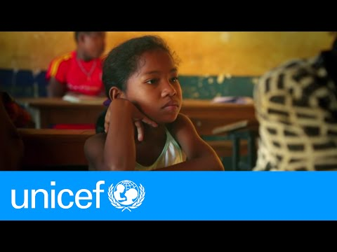
https://youtu.be/Un5msddQl6U

The modules look at how we create a positive Inclusive Learning Environment for all. You will see how inclusive teaching practices support gender equity and encourage, develop and use the 21st century skills of critical thinking, communication, collaboration and creativity.
Each module below is made up of a series of activities which you can work through at your own pace. Once you have worked through the book you will have a quiz to complete.

Learning outcomes for module 1
By working through this module, you will be able to:
- explain the basic principles of inclusion.
- discuss reasons why inclusion is important.
- explain what makes an Inclusive school.
- explain what makes an Inclusive classroom.
- explain what makes an Inclusive teacher.

Introduction
In this first module, think about what inclusion means to you, why we need inclusion and what are the features of an inclusive school, classroom and teacher.
You will be asked to:
- Read about inclusive practice (link above).
- Watch videos and provide some analysis.
- Complete activities either alone, in pairs or in small groups.
- Think about key questions.
- Answer an end of module quiz.
- Reflect on your experience and knowledge.

The module will take approximately 7 hours to complete. We hope you have an enjoyable learning experience.

Key to symbols
Activity – this is work you need to complete.

Question/s – please answer the questions.
Reflection – think carefully about how you feel about this.
Learning Journal – please write your answers and reflections in your learning journal.
Read – please read the text provided. Make any notes you like.

Activity 1.1 - Self-assessment
REFLECTION: How confident are you about your understanding of inclusion at this point in your career? Look at the scale below and identify the number that best describes YOU.
NOT confident
VERY confident
You will be prompted to do this again at the end of the module.

2. What does inclusion mean to you?
In this first activity think about what you understand by inclusion.

Activity 1.2 - What does Inclusion mean to you? (15 minutes)

Think about your work as a teacher and your life in the community outside teaching. Answer the questions below to start to reflect on what inclusion means to you.

Record your ideas in your learning journal.
- How do you understand inclusion?
- What does Inclusive Practice mean to you?
- Is it something that is only about education or can inclusive practice relevant to/important in other workplaces and social areas?

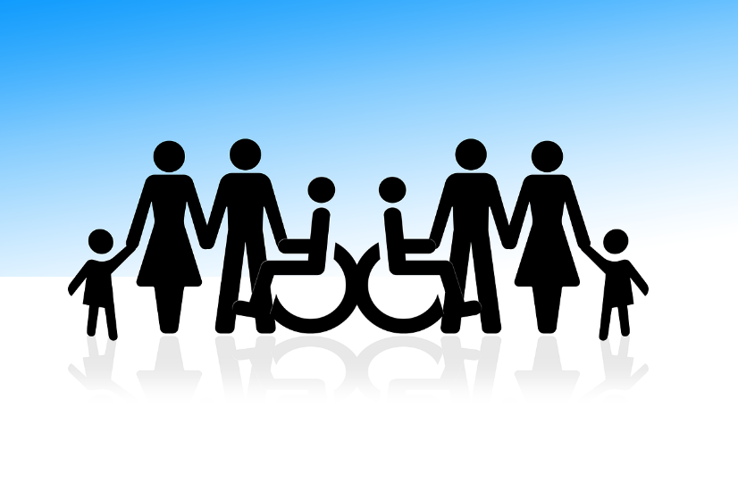

Source: https://pixabay.com (Free use).

Reading task
Please read the brief extract about inclusion. Make a note of any interesting/new words.
The extract has been adapted from International Bureau of Education/UNESCO – 'Reaching out to all learners'. (IBE, 2018) https://unesdoc.unesco.org/ark:/48223/pf0000137522_bur

'Inclusion is a process. It is a never-ending search to find better ways of responding to student differences. It is about:
- learning how to live with differences.
- learning how to learn from differences.

- Inclusion is about finding and removing barriers that make it difficult for children to learn. Barriers may come from:
- the way a school is organised,
- the way people teach,
- the way we look at how well children are learning.
It is important that schools look for these barriers and study how they are making it difficult for children to learn. Schools can then use creativity and problem solving to find ways to improve their inclusion.

- Inclusion is about valuing the presence, participation and achievement of ALL students.
- Presence – are children attending school?
- Participation – are children involved in good, enjoyable learning experiences in school?
- Achievement – are children’s achievements in learning across the whole curriculum important, not just test or examination results?

- Inclusion involves giving special attention to groups of learners who are at risk of marginalization, exclusion or underachievement. We have a responsibility to check these groups of learners, and make sure that there are actions in place that support their presence, participation and achievement in the education system. All over the world it is important that everyone is involved in making schools inclusive – teachers, families, communities, political and religious leaders and education offices.

- In 2009 UNESCO noted that inclusive schools are:
- academically efficient,
- healthy environments,
- protective of all children
- gender-responsiv.

5& 6. Inclusive schools encourage:
- The participation of the learners, their families and their communities. They make sure that no child is excluded from friendship and participation in the school.
- Inclusive schools are rights-based, child-friendly schools where all learners are welcome.

Relationships are important – how learners work and play together, how teachers and learners work together, how teachers work together – and how every learner is valued and encouraged to participate in the learning and teaching process.

Activity 1.3 - Definition of inclusion (30 minutes)

In the previous reading task you learnt a little about inclusion. Use the information you’ve learnt to match the answers to the questions to develop your thinking further. Either draw a line or copy the table at the bottom into your learning journal. One example is given.

Every teacher and learner needs to feel valued so they can work well together.

Why is it important that schools look at possible barriers to inclusion?

A1
Q1

They provide physical security around the school & safeguarding, healthy snacks, fresh air, water, washing facilities.

Who should be involved in making schools inclusive?
A2
Q2

Some groups are more at risk of not participating. Girls for example are less likely to attend school.
What are the 3 key areas that ensure inclusion?

A3
Q3

Barriers need to be identified and removed so all can participate.

How do you think inclusive schools protect children and keep them healthy?

A4
Q4

Presence, participation and achievement.
Why are effective relationships important in inclusive schools?

A5
Q5

How do you think inclusive schools are gender-responsive?

Teachers, families, communities, political and religious leaders and education offices – everyone.

A6
Q6

Answers
Q1 | Q2 | Q3 | Q4 | Q5 | Q6
 |  |  |  | A1
Using the information and answers above, answer the question below in your learning journal. Discuss your answers with a colleague if you can.

What is inclusion? Write in your learning journal.

Answers to Activity 1.3 - Definition of inclusion

Q1 | Q2 | Q3 | Q4 | Q5 | Q6
A4 | A6 | A5 | A2 | A1 | A3

What is inclusion?
Inclusion is a process. It is a never-ending search to find better ways of responding to student differences. It is about removing barriers so that all learners can actively be present, participate and achieve in school.

Activity 1.4 - Feeling valued (20 minutes)

The extract you read in activity 1.2 focused on inclusion valuing the Presence, Participation and Achievement of every child or young person.

Using these three principles think about times in your teaching career, your education, and your life outside teaching when you felt valued. Please copy and complete the table below, in your learning journal after you have reflected. One example is given.

Principles | When did you feel valued? | What did people do to make you feel valued?
- My presence was valued when…

- My participation was valued when…

- My achievement was valued when.... | At home with my family | Being asked by my father to show my elder sister how to apply to university. He valued my experience and trusted me.

3. Why is inclusion important
Inclusion is a key aspect of the Sustainable Development Goal 4 (UN, 2021)‘Ensure inclusive and equitable quality education and promote lifelong learning opportunities for all’. It is also an important part of SDG 10 (UN, 2021)‘Reduce inequality within and among countries.’

Activity 1.5 - The importance of inclusion (45 minutes)

In the previous activities you have thought about and defined inclusion.

Please watch the 3 videos below and draw links from the comments on the right to the videos on the left. Which comment matches which video? One example is given.

After you have made the links between the statements and the videos, answer the following questions:
- What do the videos say about the importance of inclusion?
- Is this similar to your reasons why inclusion is important or different?
- Do you agree or disagree with the ideas in the videos? Can you explain why?

Record your answers in your learning journal and share them with a colleague if you can.

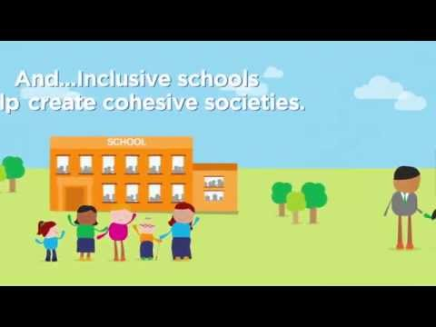
- Schools include every child.
- She didn’t need special instructions.
- Inclusion helps higher economic growth.
- All children have equal rights.
- All the class are involved learning experiences
- Barriers don’t need to stop learning.
- Inclusion is a good investment for the country.
- Inclusion means less unemployment.
- Inclusive schools celebrate difference.
- Europe and Asia agreed to include all in learning.
- Anyone can achieve high grades.
- Inclusive schools respond to individual needs.
- All children have equal opportunities.
- Inclusion increases numbers in schools.
- Inclusion – is the right of every child.
- Inclusion means more productive societies.

https://youtu.be/8HPh4RoV63s
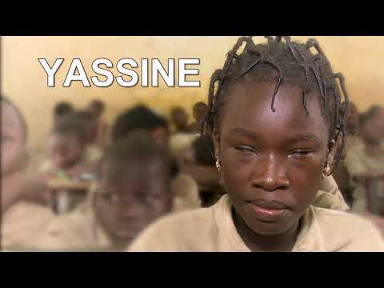
https://youtu.be/GrdcE6iKV-k
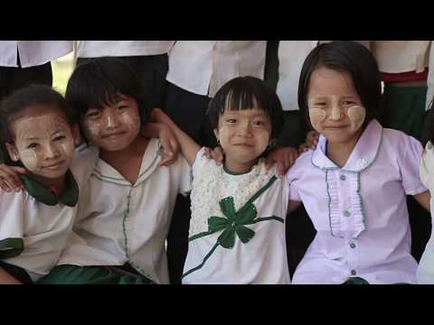
https://youtu.be/j0aiuxq_Uh0

Answers to Activity 1.5 – The importance of inclusion.

By now you will have understood that inclusion is an important issue across most of the world. It is a good way to help countries and their citizens improve and develop to be prosperous and lead enjoyable, productive lives. It helps to ensure everyone is valued in society.

You may also have noticed that many of the comments link to all three videos.

4. What makes an inclusive school/Educational institution?
So far in this module you have begun to reflect on what inclusion means. In the following three sections think about what this looks, feels and sounds like in an educational institution and importantly how you can be an inclusive teacher.
Take time to read the first section (1.1) of Embracing Diversity (Booklet 1). https://unesdoc.unesco.org/ark:/48223/pf0000137522_bur This is available in Myanmar as well as in English and can be found in the resource file. You do not need to do the activities in the booklet, but you will use what you learn from the booklet to complete the following activities.
One inclusive school may look, feel and sound very different to another inclusive school. It may be big, small, be in a town or in a village. It may have lots of resources or only a few resources. It is inclusive because of what happens in the school and because of the attitude of the managers, teachers and children. The school will have created an inclusive learner friendly environment that replaces barriers to learning with support for learning. Everybody will feel that their presence, participation and achievements are valued.
An inclusive school will include all of the senses, even smell. We will focus on the following three.
Look | Feel | Hear
 | 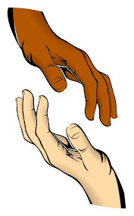
Source: https://pixabay.com | Source: commons.wikimedia.org/ | Source: https://pixabay.com

Activity 1.6 - What makes an inclusive educational institution? (45 minutes)

THINK: Read the examples below of what one EDC does on a daily basis. Decide whether it is INCLUSIVE practice or NOT INCLUSIVE practice. Two examples have been given.

All students and parents feel welcome in school.

Some students’ work is displayed around EDC.

Every class has a celebration of achievement.

Every class has a 150mm step at the door. No ramp.

Different cultures are celebrated at festivals.

Most teachers speak with parents regularly.

Very few resources but they are used well.
Inclusive
Not Inclusive
Senior staff never observe classes.

One CPD event focused on new curriculum.

Some teachers use information about each student to plan lessons.

30% of parents know what their child is studying.

Plans are in place for all teachers to observe each other teach.

Students’ feedback about the educational institution is used to improve learning.

Answers to Activity 1.6 - What makes an inclusive educational institution?

For a school/EDC to be inclusive, it needs to consider all the needs of all the students and parents. Look at each of the examples below and think about why they are separated the way they are. How would you recognise it as an inclusive school? Discuss your thoughts with a friend or small group (think, pair, share) and make a note in your Learning Journal.

All students and parents feel welcome in school.

Some students’ work is displayed around EDC.

Every class has a celebration of achievement.

Every class has a 150mm step at the door. No ramp.

Different cultures are celebrated at festivals.

Most teachers speak with parents regularly.

Very few resources but they are used well.
Inclusive
Senior staff never observe classes.
Not Inclusive

One CPD event focused on new curriculum.

Some teachers use information about each student to plan lessons.

30% of parents know their child’s progress.

Plans are in place for all teachers to observe each other teach.

Students’ feedback about educational institutions is used to improve learning.

4. What makes an inclusive school/EDC?

Review

UNESCO and the International Bureau of education in ‘Reaching out to all learners’ give 8 features of an inclusive school.
Check the answers you have developed in section 1.5 and consider how they link to the 8 features of an inclusive school in the description below.
Each feature has a set of questions schools and teachers can use to think about inclusion in their school, these are in the box below.

8 features of an inclusive school/educational institution
1. Everyone is made to feel welcome.
  - Are students, parents and visitors made to feel welcome on arrival at the school?
  - Is accessible information about the school made available?
2. Students are equally valued.
  - Is the work of all students displayed around the schools and classrooms?
  - Are all students encouraged to take part in all school activities?
3. There are high expectations for all students.
  - Do all students feel that they expected to achieve?
  - Are the achievements of all students celebrated?
4. Staff and students treat one another with respect.
  - Are there warm and friendly relationships between staff and students?
  - Is respect shown for different cultural traditions and religious beliefs?
5. There is a partnership between staff and families.
  - Is there effective communication between homes and school?
  - Do parents feel they are involved in supporting their children’s learning?
6. The school is accessible to all students.
  - Are efforts made to overcome potential barriers to participation and learning?
  - Can disabled students and adults gain access to all parts of the building?
  - Are students who speak a different language helped to participate?
7. Senior staff support teachers in making sure that all students participate and learn.
  - Are there regular staff development activities focused on the improvement of teaching?
  - Do senior staff observe lessons and offer suggestions for improvement?
  - Do teachers have opportunities to observe one another’s practices?
8. The school monitors the presence, participation and achievement of all students.
  - Are there systems for checking on student attendance in school and lessons?
  - Are students offered opportunities to comment on how it feels to be a member of the school?
  - Is the progress and achievements of every student tracked?

IBE, 2018. International Bureau of Education 'Training Tools for Curriculum Development – Reaching Out to All Learners: a Resource Pack for Supporting Inclusive Education'

Activity 1.7 - How inclusive is your educational institution? (10 minutes)

Using the work you have completed for activity 1.5, How inclusive do you think your educational institution is? Please identify the number that is closest to your thoughts.
VERY inclusive
NOT inclusive

What is the most important thing to improve so that you move towards VERY INCLUSIVE? Write in your learning journal.

5. What makes an inclusive Classroom?
Just like an inclusive school, one inclusive classroom can look, feel and sound very different to another inclusive classroom. There may be many pupils or just a few. There may be many resources or only ones the teacher and school pupils make. It is what happens in the classroom that makes it inclusive. Everybody in the classroom helps to create an inclusive learner friendly environment.
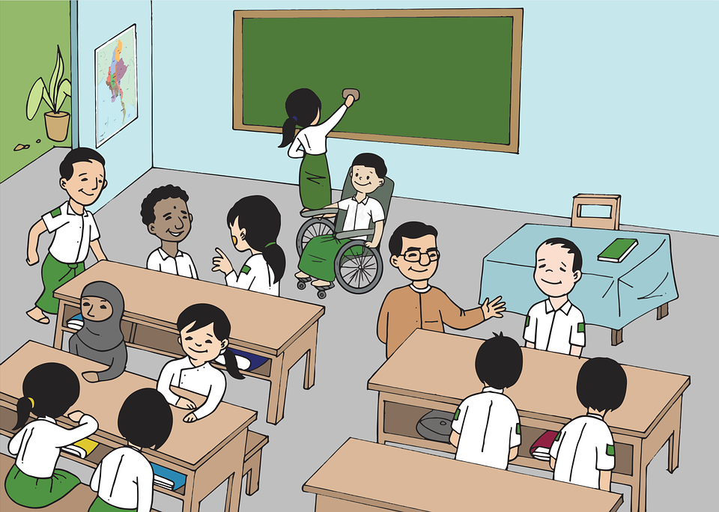
Source: https://pixabay.com//illustrations/burma-myanmar-classroom-boy-girl-5204371/

Activity 1.8 - What makes an inclusive classroom? (45 minutes)

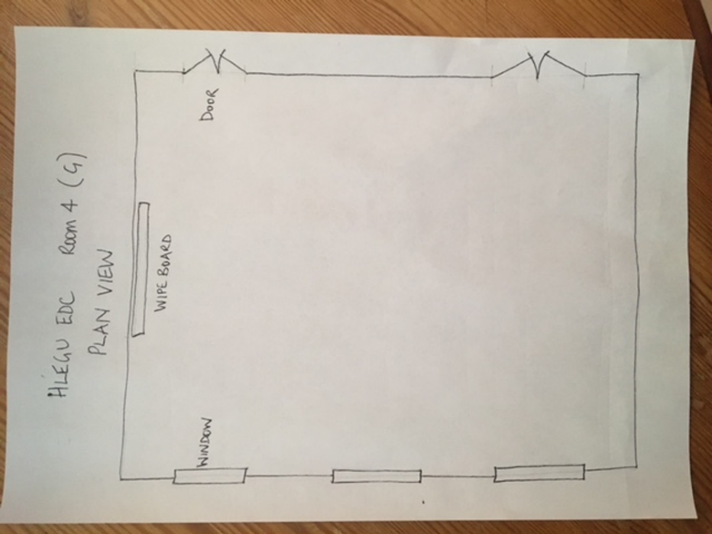
First - Sketch a plan view (view from above) of a classroom you use most in your EDC on a sheet of A4 paper and save it for later. Include basic features, i.e., doors, windows, boards (things that are fixed). Example provided below.

Activity 1.9 - How inclusive are our current classrooms?

During this next activity please close your eyes and imagine you are in one of your favourite classes.

  - Imagine what this looks like – in your mind, slowly look at everything: the windows, entrance doors, desks, books, the wipe board and all students.
  - Imagine and focus now on the students. How many? What are they doing? What do they sound like? What other sounds can you hear?
  - Now imagine how you and your students feel in class. Happy? Bored? Excited? Engaged? Ignored? Not encouraged to do better?

In your learning journal draw three circles (see below). This will help you to visualise. Make notes under each heading.

My favourite class…

- Looks like
3. Feels like

Too sunny through windows
Door – no ramps
Groups too large

2. Sounds like

5.What makes an inclusive Classroom? Review

UNESCO and the International Bureau of education in ‘Reaching out to all learners’ outlines features of an inclusive classroom. Did you include these features in your list?
Each feature has a set of questions teachers can use to think about inclusion in their classroom. Read about the 8 features of an inclusive classroom, whilst thinking about your favourite class. As you read and make a note of any interesting words or comments.

8 features of an inclusive school/educational institution
1. Teaching is planned with all students in mind.
  - Do lesson activities take account of student interests and experiences?
  - Are varied teaching methods used?
  - Do the students understand the purposes of lesson activities?
2. Lessons encourage the participation of all students.
  - Are all students addressed by their name?
  - Are there materials that engage the interest of the students?
  - Do students feel they are able to speak during lessons?
3. Students are actively involved in their own learning.
  - Are students encouraged to take responsibility for their own learning?
  - Does the classroom environment encourage independent learning?
4. Students are encouraged to support one another’s learning.
  - Do seating arrangements encourage students to interact?
  - Are students sometimes expected to work in pairs or groups?
  - Do students help one another to achieve the goals of lessons?
5. Support is provided when students experience difficulties.
  - Does the teacher watch out for students experiencing difficulties?
  - Do students feel able to ask for help?
6. Classroom discipline is based on mutual respect.
  - Are there established rules for taking turns to speak and listen?
  - Do students feel that classroom rules are fair?
  - Is bullying discouraged?
7. Students feel that they have somebody to speak to when they are worried or upset.
  - Are the concerns of students listened to?
  - Do teachers make themselves available for students to talk to them privately?
8. Assessment contributes to the achievement of all students.
  - Do teachers use assessment to encourage learning?
  - Are students given constructive feedback on their work?
  - Are students helped to revise for tests or examinations?
  - Do teachers ensure that diversity is respected, even within one unified formal assessment system?

Activity 1.10 - Making improvements to your classroom (45 minutes)

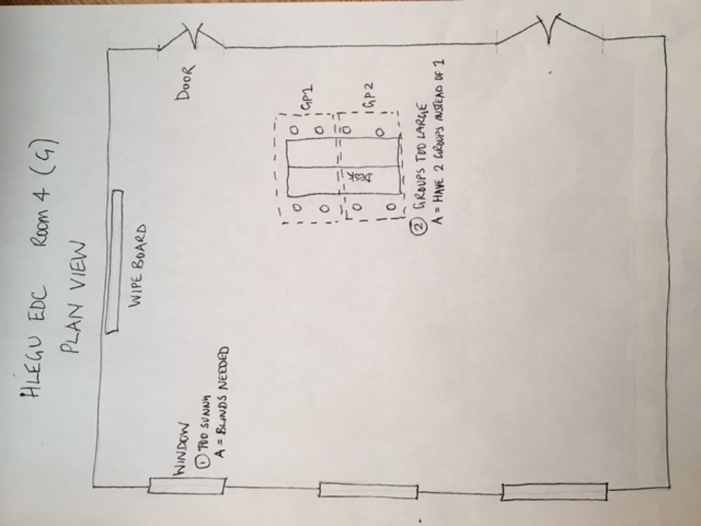
Return to the sketch you made of your favourite classroom. Using your notes on what it ‘looked like, sounded like and felt like’ make notes on the sketch of how you can improve the classroom and activities to improve inclusive practice. Two examples are given below.

6.What makes an inclusive teacher?
So far you have thought about the features of an inclusive school and classroom; what they look, feel and sound like and what happens that makes them inclusive.

Most important in the inclusive school and classroom is what the teacher is doing. What are they doing to demonstrate that they value the presence, participation and achievement of each pupil? What is their attitude towards the differences or difficulties pupils may have?

Activity 1.11 What makes an inclusive teacher? (30 minutes)
THINK: What about makes an inclusive teacher? You may want to look back at the features of an inclusive school and inclusive classroom. Use those features and your own ideas to make a mindmap (in your learning journal) of criteria for an inclusive teacher. One example has been given.
2. What are their expectations of all learners?

3. How do they respond to learners’ mistakes?

- What do they believe in?
- Positive attitude
- Respect everyone
- All deserve a chance
- Removing barriers for all
- Everyone can achieve

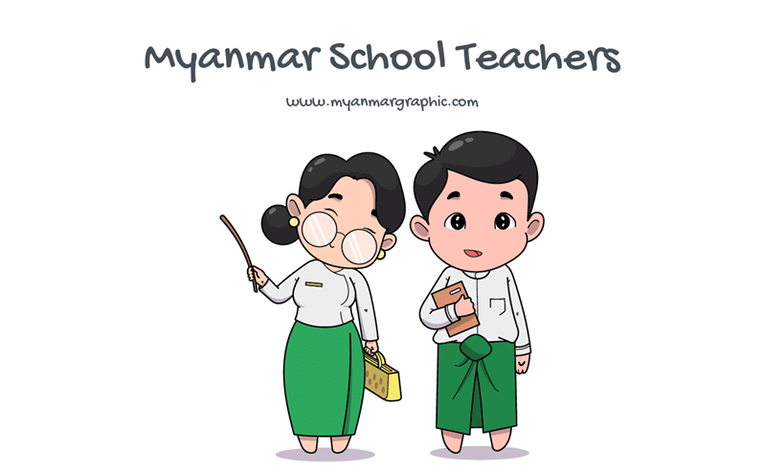
- How to they value every learners’ presence, participation and achievement?

6. How do they behave with their pupils?

Myanmar School Teachers Vector | Free Download Myanmar Graphic
- How do they respond to difficulties or barriers to learning?

6. What makes an inclusive teacher?

Review

Using UNESCO/International Bureau of Education’s features of an inclusive school and inclusive classroom as a guide for inclusion, we need to think carefully about how we teach.
Most importantly we need to think about our attitude to the differences and difficulties our students may have with learning. Differences and difficulties with cognitive, social, emotional, physical, medical and environment (family and community) aspects of the learner’s life can all become barriers to learning, but only if our attitude lets that happen.
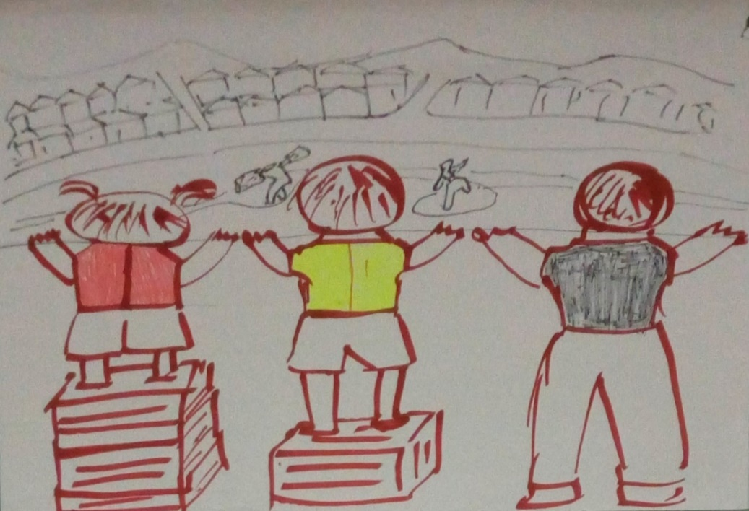
Our attitude can be the biggest barrier.

Source: Mawlamyine EDC, Myanmar (2020) sketch produced about equity by one group of TEs

Equity recognises that each person has different circumstances and allocates the exact resources and opportunities needed to reach an equal outcome.
Equality means each individual or group of people is given the same resources or opportunities.
(Source: https://onlinepublichealth.gwu.edu/resources/equity-vs-equality)3

Activity 1.12 - Self-assessment – are you an inclusive teacher? (20 minutes)
Use this checklist to think about yourself as an inclusive teacher. Score each statement carefully and be honest. You can use the results to inform and develop your CPD plan. Write in your learning journal. I am an Inclusive Teacher using inclusive teaching practices, I aim to effectively teach everyone in my class.

- I believe in equity and human rights.
Never |  | All of the time
- I see difference as normal and an opportunity to learn from and about each other.

Never |  | All of the time
- I have high expectations, aiming for all students to learn the best they can.

Never |  | All of the time
- I support my students to learn academically, socially and emotionally.

Never |  | All of the time
- I create a positive encouraging learning environment where it is safe to make a mistake.

Never |  | All of the time
- I plan teaching with all students in mind.

Never |  | All of the time
- I use learning activities so all students can participate and be actively involved in their learning.

Never |  | All of the time
- I work as a team with my students, families, communities and other professionals where we can support each other’s learning.

Never |  | All of the time
- I help students learn to manage their behaviour with respect and care for their well-being.

Never |  | All of the time
- I am always keen to find ways to solve problems, overcome difficulties or remove barriers to learning.

Never |  | All of the time
- I am always learning and reflecting, looking for more effective ways to support learning for all.

Never |  | All of the time
- I assess informally (formative assessment) so that any formal assessment (summative assessment) enables all students to achieve
Never |  | All of the time
- I listen to students and make sure I am available to help?
Never |  | All of the time
- I am a role model for thinking skills, learning and behaviour.

Never |  | All of the time

Activity 1.13 - How inclusive are you? (10 minutes)

How inclusive are you?
Think, pair and share with a colleague.
Write a brief answer in your learning journal.

7. Wrap up
In this module you have:
- Explained the basic principles of inclusion.
- Discussed reasons why inclusion is important.
- Explained what makes an Inclusive school.
- Explained what makes an Inclusive classroom.
- Explained what makes an Inclusive teacher.

Key points from this module:
Inclusion is one of the 3 key themes in the new curriculum and important all over the world.
Inclusion is a process that enables every child to learn and grow to be the best they can be.
Inclusion is important because:
- it is a human right to education which enables equity in opportunities,
- it removes social exclusion and discrimination,
- we can celebrate and learn from differences so we can benefit from a society of different people,
- more young people with more skills and knowledge means the country can progress,
- all children have the opportunity to contribute to benefit the community.
Inclusion happens when we value the presence, participation and achievement of every student.
There are lots of different barriers or difficulties to inclusion, but the biggest barriers are our thoughts and beliefs about the learner and their difficulties, and the learning environment we make in our school and classroom. If we make our schools and classroom inclusive learner friendly environments and teach through inclusive practice then we will have inclusion for our learners.

End of module 1 quiz
Please answer the following questions in your learning journal. You can attempt as many times as you like to reach 100% pass. Some questions require more than one answer.

Q1- Inclusion is…
- just about thinking how to teach children with disabilities.
- a process that enables all children regardless of any difference to learn and grow together.

Q2 - Inclusion happens when we value every learners'…
- presence, performance and ability.
- progress, participation and ability.
- presence, participation and achievement.
- personality, progress and achievement.

Q3 - The biggest barriers to inclusion are… (choose 2)
- if we think a learner's difficulties stops them from learning.
- if a learner has a physical difference such as being blind.
- if a learner comes from a poor family and must work.
- if we create a learning environment that makes it difficult for a learner to participate.

Q4 - Which of these are features of an inclusive school? (Choose 2)
- Specialist teachers for disabilities.
- Everyone feels welcome.
- Students are equally valued.
- Computers available for learning.

Q5 - Which of these are features of an inclusive classroom? (Choose 2)
- Lessons encourage the participation of all students.
- Every learner has a textbook.
- Teaching is planned with all students in mind.
- Class size less than 30 learners.

End of module 1 quiz - Answers
Answers in bold
Q1- Inclusion is…
- just about thinking how to teach children with disabilities
- a process that enables all children regardless of any difference to learn and grow together

Q2 - Inclusion happens when we value every learners'…
- presence, performance and ability.
- progress, participation and ability.
- presence, participation and achievement.
- personality, progress and achievement.

Q3 - The biggest barriers to inclusion are… (choose 2)
- if we think a learner's difficulties stops them from learning.
- if a learner has a physical difference such as being blind.
- if a learner comes from a poor family and has to work.
- if we create a learning environment that makes it difficult for a learner to participate.

Q4 - Which of these are features of an inclusive school? (Choose 2)
- Specialist teachers for disabilities.
- Everyone feels welcome.
- Students are equally valued.
- Computers available for learning.

Q5 - Which of these are features of an inclusive classroom? (Choose 2)
- Lessons encourage the participation of all students.
- Every learner has a textbook.
- Teaching is planned with all students in mind.
- Class size less than 30 learners.

Activity 1.14 Improving your own teaching practice. (30 minutes)

It is important to reflect on your answers to the activities you completed earlier.
Scenario – Your Head of Department asks to meet you to ask about inclusive practice in your classroom. They ask you to think carefully about the following questions. Make notes in your learning journal:

Do all the students in your class feel their presence, participation and achievements are valued?
- How could you find out?
- What could you do to help them feel valued?

Are girls equally encouraged to participate and achieve in your classroom/college?
- What could you do to encourage girls to participate?

Are you an inclusive teacher?
- How can you help your students understand what inclusion is?

Activity 1.15 - Self-assessment (10 minutes)
REFLECT: Think again about how confident about inclusion you are right NOW in your career? Look at the scale below and choose the number that best describes YOU.
NOT confident
VERY confident
Compare your first self-assessment score at the beginning of this module to this one. In your learning journal provide a short analysis of your thoughts about any differences.

Your PROMISE to your STUDENTS

1
3
2

Review

Do

Plan

Please make a section in your learning journal entitled ‘Promises.’
Each module contains one promise you will make to your learners: you will make 15 promises in total.

References

IBE (2018) International Bureau of Education 'Training Tools for Curriculum Development – Reaching Out to All Learners: a Resource Pack for Supporting Inclusive Education' Available online at: http://www.ibe.unesco.org/sites/default/files/resources/ibe-crp-inclusiveeducation-2016_eng.pdf
Light for the World (2018) What is Inclusive Education?
https://www.youtube.com/watch?v=GrdcE6iKV-k

Pact Myanmar (2019) The Bravest Girl: Fostering Inclusive Education in Kayah State, Myanmar.
https://www.youtube.com/watch?v=j0aiuxq_Uh0

The George Washington University - Milken Institute School of Public Health (2020) Equity vs. Equality: What’s the Difference?
https://onlinepublichealth.gwu.edu/resources/equity-vs-equality/

UN Sustainable Development Goals - 4
Ensure inclusive and equitable quality education and promote lifelong learning opportunities for all
Available online at:
https://sdgs.un.org/goals/goal4

UN Sustainable Development Goals - 10
Reduce inequality within and among countries
Available online at:
https://sdgs.un.org/goals/goal10

UNESCO (2015) Embracing Diversity: toolkit for creating inclusive, learning-friendly environments – Booklet 4.
Available online at:
https://unesdoc.unesco.org/ark:/48223/pf0000137522

UNICEF (2015) Inclusive Education - Education Equity Now
https://www.youtube.com/watch?v=8HPh4RoV63s

UNICEF (2015) What does education mean to you?
https://www.youtube.com/watch?v=Un5msddQl6U

