Notes for the session Designing for online learners (2): Learning Outcomes

Learning outcomes:
After working through this material you should be able to:
- Explain what a learning outcome is to a colleague in your university
- Write or adapt learning outcomes for an OER course

How to use these notes
These notes are designed for use with the slides ‘Designing for online learners (2) to help you to use it when a tutor is not present.

What is a learning outcome? (see slide 4)
- A statement for the learner of what they will be able to do on completion of a course or piece of learning
- For example:
- ‘Having completed this course you should be able to use English language skills in everyday conversations’
- ‘Having completed this course you should be able to describe the benefits of using Open Educational Resources (OERs) in distance education’

Why are learning outcomes important? (slide 5)
They ensure that the focus is on the learner and their needs, and what they will be able to do as a result of studying the course or piece of learning. Good learning outcomes encourage teachers to design active learning and to stay focused on the key aims of the course. For the learner, it means they understand clearly what they should be able to do as a result of studying the course.

Features of effective learning outcomes (see slides 6-7)
- They speak directly to the learner
- They tell the learner what to expect to learn
- They are clearly linked to learning activities and assessment. The term used for this in English is ‘Constructive Alignment’ (see diagram below). The words used are the basis for learner activities and assessment tasks. This means thinking about what students should be able to do after studying the course or piece of learning, and how you will know they can do it. You can then think about activities students are going to do in order to be able to demonstrate their learning and pass the assessment.
- They are written in simple language that is clear to the learner
- The learner knows what they have to do to succeed
- The learning outcomes are set at the right level – not too general and not too specific. Think about how you would get the learner to demonstrate their learning.

Image showing how learning outcomes, assessment and learning activities relate to each other

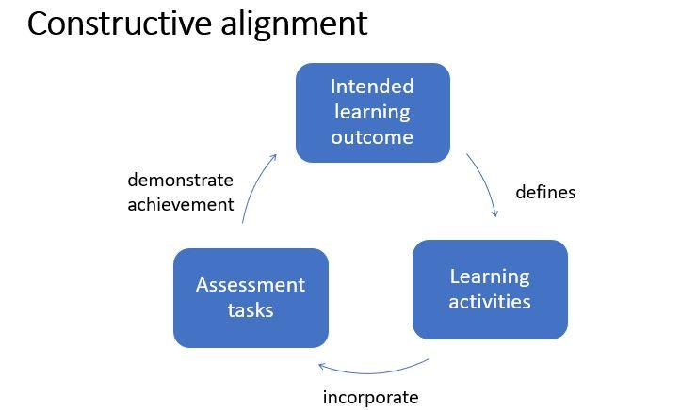
This diagram shows the relationship between the intended learning outcomes, the learning activities and the assessment tasks. It is saying that learning outcomes should define what learning activities are used, and that the learning activities should incorporate (bring in) elements of the assessment tasks, so that learners are prepared for the assessment tasks and can demonstrate their achievement of the learning outcomes.

How a learning outcome is put together (see slide 8 for examples)
A learning outcome has a verb or ‘doing’ word, for example, ‘use’. It has an object, for example (see Example 1 above), ‘English language skills’. It has a qualifying phrase which describes the way in which learners should be able to do the action, the purpose for which they should be able to do the action, or the level to which they should be able to do it. In this case the qualifying phrase is ‘in everyday conversations’. So it is clear what level of English language skills is being referred to, and it is about being able to use skills in real life.
In example 2 above, the verb is ‘describe’, the object is ‘the benefits of using OERs’ and the qualifying phrase is ‘in distance education’. This makes it clear that the learning is about use of OERs in distance education, and the learners just have to recall and state information they have learned.

Active learning (see Slide 9, Engaging your learners)
Ask yourself, ‘What will I get the learners to do’? This could include reading text, watching a video, listening to a piece of audio or a podcast.
There are other activities that learners can do, which helps them to apply and use what they are learning. This is particularly important if you are trying to teach skills as well as factual knowledge.
Examples include:
- finding information on the internet
- practising what they have learned in their own real-life situation
- discussing with other learners or with their teacher what they have read or watched
- creating something, for example, a presentation, report or video
- taking a quiz
- working through a scenario or case study.
If you are involved in creating learning materials, or supporting academic colleagues to create learning materials, look at what kind of activities are appropriate. Try to get a balance of different types of activities so that learners are not just reading, watching or listening. You probably know from your own experience that people learn better when they can see the point of what they are learning and apply it to real life.

Key ideas (slide 10)
- Learning is an active process
- Assessment is part of learning
- Learners focus on what they need to do to pass the course (so this means making sure that learning activities are directly relevant to the assessment)

Activity 1: Active learning (slide 11)
- Think about a time when you had a good experience of learning something - what was it that helped you to learn?

- Watch the short video made by participants at the November 2019 residential school on ‘Different purposes of wearing thanakha’.

- Review the section on ‘Active learning’ above

- Several learning outcomes are stated in the text that accompanies the video. Look at the self-assessment questions and see if you can answer them after watching the video. What more support do you think learners might need to be able to do the actions stated in the list of learning outcomes?

- Note down one or two examples of activities that would help your learners to master the skills of creating thanakha

- If you are working in a group with others, feed back and compare examples.

Thanakha activity
Here are the instructions if you want to work through this activity either by yourself or in a group:
- Identify a learning activity related to use of thanakha – this could be skill or knowledge related. At the residential school, participants were given materials they could use! You could try this yourself at home or at work, if you have access to a thanakha-making kit.
- How will you present and deliver this learning activity?
- How will you test/assess the knowledge gained?
- What is the learning outcome your assessment is testing?
- If doing this in a group, after 20 minutes each group should share what they have produced, the other groups can score their ideas. The group with the highest score could be awarded a prize.

Activity 2: Write a learning outcome (slide 12)
Now that you have looked at an example of learning outcomes for a familiar activity (‘Different purposes of wearing thanakha’), you are going to have a go at writing some learning outcomes for an OER course. The OER you choose may already have learning outcomes, but it is important to keep in mind the needs of your learners, which may require you to change or adapt the existing learning outcomes. If you have created student profiles, these will help you focus on the needs of your learners and what they should be able to do after studying your OER course.
- Study the tutor / participant notes on learning outcomes

- In your small group, or individually, choose an OER that you would like to adapt to make a course (use the skills you have learned in the Finding and evaluating OER session to select an OER)

- Look at the OER you are going to focus on and identify something you would like your learners to be able to do after studying your OER course. (Note that your OER may already have some learning outcomes, but you should consider the needs of the learners you have in mind – if you have created student profiles these will help you).

- How will you know if your learners can do it? Note your ideas

- Are there any learning activities you would like to add to the OER to help your learners be able to achieve the learning outcomes and do the assessment?

- Share with your group or (if you are working alone) with others from the TIDE community if you can, to get feedback on your ideas.

Next time (slide 13)
In this session you have been introduced to learning outcomes and thought about how learning outcomes relate to assessment and learning activities. You have had a go at writing a learning outcome for an OER course. You have also thought about what learning activities you will need to include in order for your learners to achieve the learning outcomes and do the assessment.
This will help you to plan the structure of your OER course. Once you have planned the structure, you will be ready to start putting it online.

