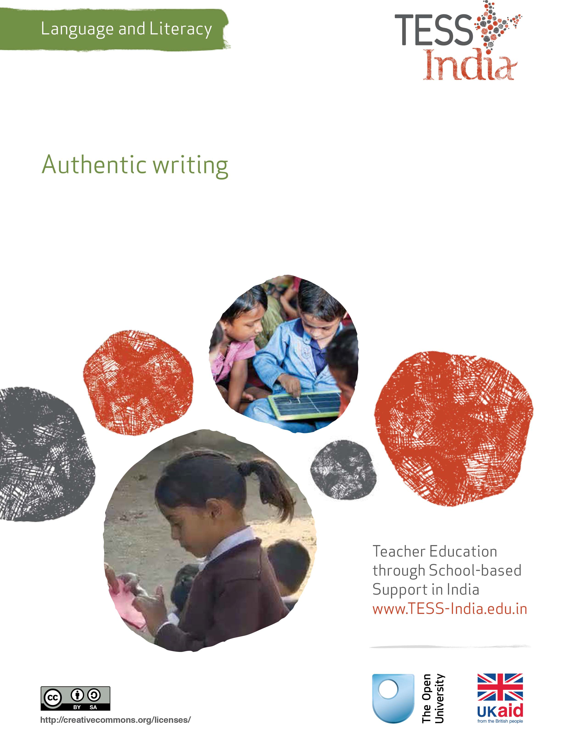
TESS-India (Teacher Education through School-based Support) aims to improve the classroom practices of elementary and secondary teachers in India through the provision of Open Educational Resources (OERs) to support teachers in developing student-centred, participatory approaches. The TESS-India OERs provide teachers with a companion to the school textbook. They offer activities for teachers to try out in their classrooms with their students, together with case studies showing how other teachers have taught the topic and linked resources to support teachers in developing their lesson plans and subject knowledge.
TESS-India OERs have been collaboratively written by Indian and international authors to address Indian curriculum and contexts and are available for online and print use (http://www.tess-india.edu.in/). The OERs are available in several versions, appropriate for each participating Indian state and users are invited to adapt and localise the OERs further to meet local needs and contexts.
TESS-India is led by The Open University UK and funded by UK aid from the UK government.
Video resources
Some of the activities in this unit are accompanied by the following icon: . This indicates that you will find it helpful to view the TESS-India video resources for the specified pedagogic theme.
The TESS-India video resources illustrate key pedagogic techniques in a range of classroom contexts in India. We hope they will inspire you to experiment with similar practices. They are intended to complement and enhance your experience of working through the text-based units, but are not integral to them should you be unable to access them.
TESS-India video resources may be viewed online or downloaded from the TESS-India website, http://www.tess-india.edu.in/). Alternatively, you may have access to these videos on a CD or memory card.

Version 2.0 LL09v1
All India - English
Except for third party materials and otherwise stated, this content is made available under a Creative Commons Attribution-ShareAlike licence: http://creativecommons.org/licenses/by-sa/3.0/

What this unit is about
In this unit you will focus on incorporating purposeful, enjoyable, authentic writing activities into your classroom, thereby motivating your students to develop the important skill of writing. You will consider the differences between composition and transcription, draw up a detailed writing-focused lesson plan, and try out shared and collaborative writing with your students.

What you can learn in this unit
- How to identify authentic audiences and purposes for your students’ writing.
- How to balance composition and transcription in your students’ writing lessons.
- How to plan shared writing activities that encourage interactive and sociable learning.

Why this approach is important
Writing always has an audience, even if that person is oneself. Similarly, every piece of writing has a purpose, even if it is simply a reminder to buy rice in the market. In schools, writing tasks sometimes lack this authentic audience and purpose, particularly if they take the form of mechanical exercises. If writing tasks aren’t authentic, students may not fully appreciate why being able to write matters so much in the real world, and how enjoyable and creative the mastery of this skill can be.
There are two elements of writing development: composition and transcription.
- Composition may be considered ‘the author’s role’, as it involves knowing who will read the writing (its audience) and what it is intended to achieve (its purpose), generating and organising ideas, and making choices about what style of language to use.
- Transcription may be considered ‘the secretary’s role’, as it involves making sure that the writing is legible, the spelling is correct, the punctuation is accurate and the layout of the text is appropriate.
Teachers usually tend to focus primarily on the transcription element of their students’ work and spend time explaining and correcting this. However, of the two, the more important skill for students to master is composition.
When your students are composing writing that interests and inspires them – that is to say, when they are developing their authoring skills – they will also be practising the secretarial skills of handwriting, spelling, punctuation and paragraphing. The opposite nevertheless does not follow. It is therefore important to introduce more authentic composition tasks so that students can become independent writers of meaningful texts.

1 Writing in the real world

Activity 1: Writing in the real world
What kinds of writing can you find around your school and your community? Together with a colleague, take a few moments to make a list. Examples might include:
- traffic signs
- advertisements
- timetables
- health posters
- political slogans
- calendars
- religious texts
- magazines
- newspapers
- books
- cinema posters
- school notices
- subject charts
- attendance charts.
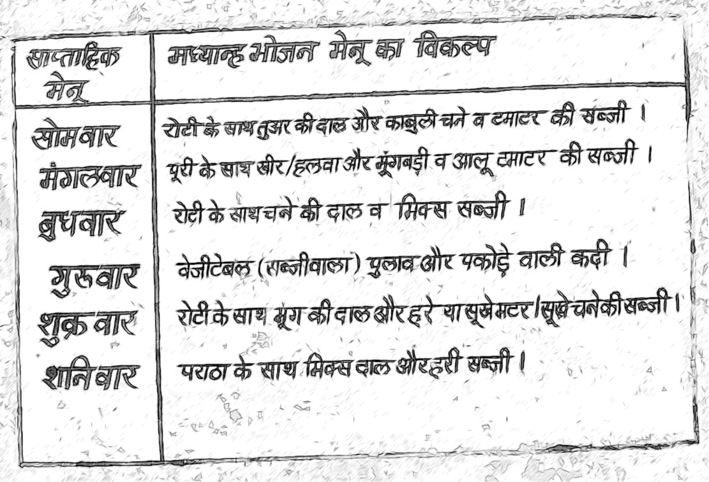
Figure 1 A school menu.
Now answer these two sets of questions:
- Set 1:
- What writing do you think your students see in their homes or community?
- Who is the intended audience of this writing?
- What is the purpose of this writing?
- Set 2:
- What writing do your students do in school?
- Who is the intended audience of this writing?
- What is the purpose of this writing?
Are there any similarities between the writing your students see outside school and the writing they do in school? Why, or why not?
In Case Study 1 you will read about a teacher who brought real-world writing into her classroom.
Case Study 1: Writing postcards
Mrs Shamila is a Class II teacher in a school in Kanpur. Here she describes a simple writing activity that she undertook with her young students.
Before the summer, I received a postcard from a friend who had travelled to Delhi. I brought it into the classroom to show my students. They were excited by the picture of the Red Fort on the front and the message from my friend on the back.
I decided to plan a lesson to develop my students’ interest in the postcard. I cut out rectangles of thick white card and handed out one to each of them. I then asked them to draw a picture on one side of whatever they wished – be it something familiar or imaginary.
When they had finished, I asked them to turn over the picture and divide the other side in two. On the right, they wrote their home address. Some of my students weren’t sure of this, so I explained to them how to say and write it.
On the left of the address, they wrote a short message to their parents. I modelled some sentences on the blackboard such as ‘Dear Maaji and Pitaaji’, ‘I hope you are well’, ‘I send you greetings’ and so on. In this way, I supported the less able students. The more able students wrote a message of their choice. They then signed their name at the end of their message.
My headteacher had kindly agreed to give me funds to purchase stamps for the postcards. Having pasted a stamp in the top right-hand corner of the postcard, my students and I walked to the nearest postbox and they put the cards inside.
My students were thrilled when the postcards were delivered to their homes the following week. Their parents were also happy to receive them.

Pause for thought
- How does Mrs Shamila’s postcard activity balance composition and transcription-related tasks?
- How would you adapt this activity for older students?
In this activity, students are invited to compose a text using their own ideas, but the teacher gives them some of the phrases that they may need to do this. Sending messages to parents in an activity like this promotes home–school communication in a positive way. Older students have more options for what they write, They could also write postcards to each other, or to students at another school that you are familiar with.

2 Shared writing
At times it can be difficult for students to know how to start and what to include in a writing task. By drawing together the ideas of a number of contributors, shared writing is a collaborative way of overcoming this difficulty in the classroom.
Shared writing is particularly effective with young students who are learning to read, as it helps them to understand how thoughts can translate into speech and how spoken language can in turn be captured in writing. However, it is valuable with all levels of students.
Now read the two examples in Case Study 2.
Case Study 2: Turning students’ words into writing
Ms Usha is a Class II teacher in a rural school near Varanasi.
I regularly cut out pictures from magazines and promotional material. They include images of places, people and animals. I try to find colourful, funny and unusual pictures wherever possible. I have quite a collection now.
I do this writing activity with a small group of students in turn, giving the rest of the class another task to do at the same time. I begin by distributing a picture to the group of students and give them a short while to discuss it together. I then invite different students to say something about the picture. I write what they say on the blackboard.
When everyone has contributed, I read out what they have said, pointing to the words as I do so. We then look at the sentences and re-arrange them to make a coherent story. We read the story aloud together, inserting further words and phrases to make it flow and to add to its interest. When everyone is happy with the story, we agree a suitable title.
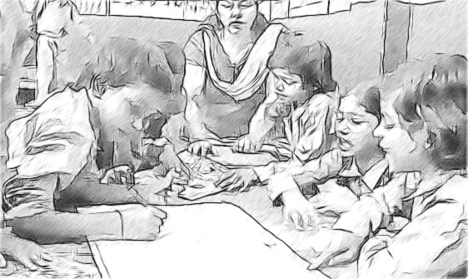
Figure 2 A group working on a story together.
I then write out the story on chart paper and hang it on the classroom wall, followed by the names of the students who contributed.
I ask my students to copy out the story neatly in their exercise books, and illustrate it with suitable pictures.
Mr Gulab is a Class VIII teacher in a large school in Bhagalpur.
My students were very upset about a government plan to move the local market to a more distant location. This would inconvenience many families in the community who bought and sold goods there.
My students wanted to write a protest letter to the local governor. I agreed to help them to do this. I gave each group of six a piece of paper and told them to write down the main points they wanted to make about the plan to move the market.
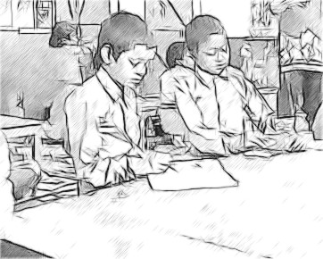
Figure 3 Writing a letter.
When they had finished, I asked each group report back to the whole class. As they did so, I wrote their ideas on the blackboard. Sometimes their language was very angry, so I explained the importance of making their points respectfully, and the need to support these points with good reasons, if they wished to persuade the governor to pay attention. Together, we made several drafts of the letter on the blackboard, re writing the points and making the language more formal.
I then asked my students to write out the final version of the letter so that they had their own copy. They then selected one of these, added their signatures and posted it to the governor.
My students also had the idea of starting a petition to show the governor the weight of local feeling against moving the market. We therefore used the same shared writing process to write a short text protesting against the move, as an introduction to the petition. My students then arranged a rota to take the petition into the community over several days to ask people to sign it.

Pause for thought
Consider the following questions for each of the above case studies:
- What is the audience and the purpose of the students’ writing?
- How are the composition and transcription-related tasks balanced?
- What opportunities do the teachers have to assess their students during the activities?
- Notice how, in each case, students wrote both collaboratively and individually. What do you think are the social benefits of shared writing?
The key resource ‘Using groupwork’ (http://tinyurl.com/kr-usinggroupwork) may be helpful at this stage.
Video: Using groupwork
http://tinyurl.com/video-usinggroupwork

Activity 2: Planning a writing-focused lesson
Choose either of the accounts of classroom practice in Case Study 2 and write out a lesson plan for the shared writing activity that they describe.
Try to include as much detail as you can. Start by identifying the resources you will require and be sure to estimate the time needed for each stage of the activity. You can spread the stages over several lessons if you prefer.
Refer to Resource 1 for further guidance on planning lessons.
Here is the start of an example plan based on Ms Usha’s account. You may wish to use a table format, however.
Lesson plan: Ms Usha’s shared writing activity.
Objectives:
- To encourage students to make the connection between thoughts, speech and writing.
- To encourage pair discussions using pictures as prompts.
- To encourage students to contribute to whole class story creation .
Resources:
- Magazine photos or pictures cut out or photocopied, large enough for students to see clearly.
Timing:
- Ten minutes to introduce the pictures.
- Five minutes for students to talk in pairs about the pictures.
- Twenty minutes for a whole-class talk about what the pictures show.
Keep your completed plan, as it will provide you with a model to use in Activities 3 and 4 that follow.

Video: Planning lessons
http://tinyurl.com/video-planninglessons

Activity 3: Writing for real audiences and purposes
With your colleagues, think of as many opportunities as you can for your students to write for real audiences and purposes.
Here are some possibilities. You will be able to add others that are suited to your particular context, as well as your students’ age and experience.
Your students could:
- write and illustrate birthday or festival cards for their families
- make simple books for babies in the village
- write stories or poems for younger children in the school
- become ‘pen pals’ with a class in another district or city, using connections from the DIET
- write a letter to an author, performer or politician, asking questions about their work
- make posters about a health-related issue, such as the importance of hand-washing, to place around and outside the school
- write out recipes used at home and compile a class cookbook to photocopy and distribute
- write to the local paper, giving their views about a topical local concern
- create a ‘Welcome Guide’ to the school, containing advice for new students
- produce a guide to their village or district.
For all the suggestions you list, makes notes on:
- who the intended audience of the writing is (parents, other students, local people, visitors, etc.)
- what the purpose of the writing is (to inform, entertain, persuade, teach, etc.)
- how you might model the type of writing to be done (you may show your students a real example, provide them with a general outline, list the key words and phrases to include, etc.)
- how you would balance composition and transcription-related tasks within the writing activity.

Activity 4: Implementing a shared writing lesson with your students
Select one of the ideas in your list and prepare to try it out with your class. Using the lesson plan that you devised earlier as a guide, write a new plan for this lesson, ensuring that you take account of:
- the audience and purpose of the task
- the nature of the shared writing element
- the balance of time to be spent on composition and transcription.
You might find it helpful to try out the activity with your colleagues first. Invite their feedback and adapt your lesson plan accordingly. When you are ready, implement the lesson in your class.
In order to draw your students’ attention to the different aspects of the writing process, provide them with a running commentary of the changes you are making to the shared text, in response to their suggested improvements. These might relate to aspects of its style – for example, whether it is formal or informal, its vocabulary, or its sequencing and flow. Read out what you have written as you go along to check how it sounds as it is progressively modified. In so doing, you are showing your class that good composition needs thought and attention.
At the same time you should demonstrate transcriptional skills by using neat writing and even spacing, and by pointing out appropriate punctuation, spelling and grammar. Explain how such details can contribute to the overall effect of the text on the intended audience.

Pause for thought
- How successful was the lesson? How could you tell?
- How did you monitor that all your students were learning?
Shared writing is sociable and collaborative. It is supportive of students who are unsure of what to write and who are nervous of making transcriptional errors when they do so. It demonstrates the processes of drafting and rewriting to students.

3 Summary
In this unit you have considered ways of incorporating writing for authentic audiences and purposes into your classroom. Students need practice to become confident writers. You can help them to develop their writing skills by showing them that writing can be purposeful and rewarding. You can do this by focusing on composition with transcription only acting as a means to enhance communication. Your students can also come to understand authentic purposes for writing by working together on a shared piece of writing.
This unit gives you an opportunity to plan a writing-focused lesson. Plans like this help focus your teaching on achieving a learning point, and these plans can be used and expanded across several lessons.

Resources
Resource 1: Planning lessons

Why planning and preparing are important
Good lessons have to be planned. Planning helps to make your lessons clear and well-timed, meaning that students can be active and interested. Effective planning also includes some in-built flexibility so that teachers can respond to what they find out about their students’ learning as they teach. Working on a plan for a series of lessons involves knowing the students and their prior learning, what it means to progress through the curriculum, and finding the best resources and activities to help students learn.
Planning is a continual process to help you prepare both individual lessons as well as series of lessons, each one building on the last. The stages of lesson planning are:
- being clear about what your students need in order to make progress
- deciding how you are going to teach in a way that students will understand and how to maintain flexibility to respond to what you find
- looking back on how well the lesson went and what your students have learnt in order to plan for the future.

Planning a series of lessons
When you are following a curriculum, the first part of planning is working out how best to break up subjects and topics in the curriculum into sections or chunks. You need to consider the time available as well as ways for students to make progress and build up skills and knowledge gradually. Your experience or discussions with colleagues may tell you that one topic will take up four lessons, but another topic will only take two. You may be aware that you will want to return to that learning in different ways and at different times in future lessons, when other topics are covered or the subject is extended.
In all lesson plans you will need to be clear about:
- what you want the students to learn
- how you will introduce that learning
- what students will have to do and why.
You will want to make learning active and interesting so that students feel comfortable and curious. Consider what the students will be asked to do across the series of lessons so that you build in variety and interest, but also flexibility. Plan how you can check your students’ understanding as they progress through the series of lessons. Be prepared to be flexible if some areas take longer or are grasped quickly.

Preparing individual lessons
After you have planned the series of lessons, each individual lesson will have to be planned based on the progress that students have made up to that point. You know what the students should have learnt or should be able to do at the end of the series of lessons, but you may have needed to re-cap something unexpected or move on more quickly. Therefore each individual lesson must be planned so that all your students make progress and feel successful and included.
Within the lesson plan you should make sure that there is enough time for each of the activities and that any resources are ready, such as those for practical work or active groupwork. As part of planning materials for large classes you may need to plan different questions and activities for different groups.
When you are teaching new topics, you may need to make time to practise and talk through the ideas with other teachers so that you are confident.
Think of preparing your lessons in three parts. These parts are discussed below.
1 The introduction
At the start of a lesson, explain to the students what they will learn and do, so that everyone knows what is expected of them. Get the students interested in what they are about to learn by allowing them to share what they know already.
2 The main part of the lesson
Outline the content based on what students already know. You may decide to use local resources, new information or active methods including groupwork or problem solving. Identify the resources to use and the way that you will make use of your classroom space. Using a variety of activities, resources, and timings is an important part of lesson planning. If you use various methods and activities, you will reach more students, because they will learn in different ways.
3 The end of the lesson to check on learning
Always allow time (either during or at the end of the lesson) to find out how much progress has been made. Checking does not always mean a test. Usually it will be quick and on the spot – such as planned questions or observing students presenting what they have learnt – but you must plan to be flexible and to make changes according to what you find out from the students’ responses.
A good way to end the lesson can be to return to the goals at the start and allowing time for the students to tell each other and you about their progress with that learning. Listening to the students will make sure you know what to plan for the next lesson.

Reviewing lessons
Look back over each lesson and keep a record of what you did, what your students learnt, what resources were used and how well it went so that you can make improvements or adjustments to your plans for subsequent lessons. For example, you may decide to:
- change or vary the activities
- prepare a range of open and closed questions
- have a follow-up session with students who need extra support.
Think about what you could have planned or done even better to help students learn.
Your lesson plans will inevitably change as you go through each lesson, because you cannot predict everything that will happen. Good planning will mean that you know what learning you want to happen and therefore you will be ready to respond flexibly to what you find out about your students’ actual learning.

Additional resources
- A language activity using newspapers: http://www.teachersofindia.org/en/article/classroom-sparkler-newspaper
- Some writing resources can be found on the Azim Premji Foundation website: http://www.azimpremjifoundation.org/E-learning_Resources
- You may be able to find some resources on the NUEPA website: http://www.nuepa.org/
- Support for teachers can be found on the Teacher Education website of MHRD: http://www.teindia.nic.in

References/bibliography
Black Country Children’s Services Improvement Partnership (undated) Black Country Challenge KS1 & 2 Writing Project 2009/2010 (online). Wolverhampton: Black Country Children’s Services Improvement Partnership. Available from: http://www.gillmatthews.co.uk/images/downloads/bcc%20writing%20project_FINAL.PDF (accessed 29 October 2014).
Katahira, J. (undated) ‘Note writing in the primary classroom’ (online), ReadWriteThink. Available from: http://www.readwritethink.org/classroom-resources/lesson-plans/note-writing-primary-classroom-285.html?tab=4#tabs (accessed 29 October 2014).
Kopp, K. (2008a) Learning through Writing, Grade 3: Authentic Writing Activities for the Content Areas. Gainsville, FL: Maupin House Publishing.
Kopp, K. (2008b) Learning through Writing, Grade 5: Authentic Writing Activities for the Content Areas. Gainsville, FL: Maupin House Publishing.
Lidvall, C.D. (2008) Get Real: Instructional Implications for Authentic Writing Activities (online), DiscoverArchive, Vanderbilt University. Available from: http://discoverarchive.vanderbilt.edu/bitstream/handle/1803/789/CarlyLidvallCapstone.pdf?sequence=1 (accessed 29 October 2014).
O’Sullivan. O. (2007) Understanding Spelling, London: Centre for Literacy in Primary Education.
Pavlock, K. (undated) ‘Writing for the real world’ (online), ReadWriteThink. Available from: http://www.readwritethink.org/parent-afterschool-resources/tips-howtos/writing-real-world-30115.html (accessed 29 October 2014).
Wilcox, A. (undated) ‘Literary resource: writing for purpose’ (online), Teach Primary. Available from: http://www.teachprimary.com/learning_resources/view/literacy-resource-writing-for-purpose (accessed 29 October 2014).

Acknowledgements
This content is made available under a Creative Commons Attribution-ShareAlike licence (http://creativecommons.org/licenses/by-sa/3.0/), unless identified otherwise. The licence excludes the use of the TESS-India, OU and UKAID logos, which may only be used unadapted within the TESS-India project.
Every effort has been made to contact copyright owners. If any have been inadvertently overlooked the publishers will be pleased to make the necessary arrangements at the first opportunity.
Video (including video stills): thanks are extended to the teacher educators, headteachers, teachers and students across India who worked with The Open University in the productions.

