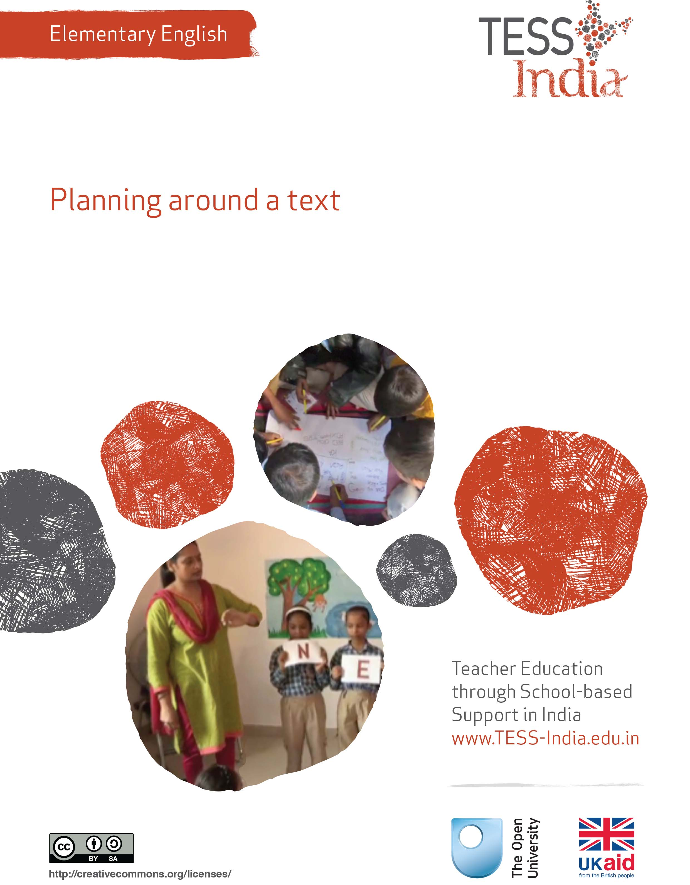
TESS-India (Teacher Education through School-based Support) aims to improve the classroom practices of elementary and secondary teachers in India through the provision of Open Educational Resources (OERs) to support teachers in developing student-centred, participatory approaches. The TESS-India OERs provide teachers with a companion to the school textbook. They offer activities for teachers to try out in their classrooms with their students, together with case studies showing how other teachers have taught the topic and linked resources to support teachers in developing their lesson plans and subject knowledge.
TESS-India OERs have been collaboratively written by Indian and international authors to address Indian curriculum and contexts and are available for online and print use (http://www.tess-india.edu.in/). The OERs are available in several versions, appropriate for each participating Indian state and users are invited to adapt and localise the OERs further to meet local needs and contexts.
TESS-India is led by The Open University UK and funded by UK aid from the UK government.
Video resources
Some of the activities in this unit are accompanied by the following icon: . This indicates that you will find it helpful to view the TESS-India video resources for the specified pedagogic theme.
The TESS-India video resources illustrate key pedagogic techniques in a range of classroom contexts in India. We hope they will inspire you to experiment with similar practices. They are intended to complement and enhance your experience of working through the text-based units, but are not integral to them should you be unable to access them.
TESS-India video resources may be viewed online or downloaded from the TESS-India website, http://www.tess-india.edu.in/). Alternatively, you may have access to these videos on a CD or memory card.

Version 2.0 EE07v1
All India - English
Except for third party materials and otherwise stated, this content is made available under a Creative Commons Attribution-ShareAlike licence: http://creativecommons.org/licenses/by-sa/3.0/

What this unit is about
This unit is about how to plan a variety of language and literacy activities linked to a story, a text or to a textbook lesson. The unit also focuses on managing group work for these activities.
There is so much you can do with a story, a poem or even a newspaper article. Any text that you choose for English lessons can be the starting point for helping students to develop English language skills through activities linked to this text.
Students like new experiences, but they also like routines where they can have repeated opportunities to practise new skills and ideas. These factors mean that you should be ready to plan a range of activities around any text that you choose for your English class. You can also adapt your activities to cater to a diverse group of students and classes.
The activities in this unit will take you, step by step, through planning, preparing, managing and evaluating multiple activity lessons based on a text of your choice.

What you can learn in this unit
- To extend English textbook lessons.
- To plan linked activities for English lessons.
- To develop classroom management skills for English.

1 One story, many activities
When you plan a variety of activities around a story or a poem, you can address the different language learning needs of students. In Case Study 1, a teacher plans multiple activities linked to a familiar story.
Case Study 1: Mythili plans multiple activities for mixed ages
Mythili teaches a large mixed age group of students in Classes I, II and III.
In my class there are students of different ages and abilities. Instead of giving different language books to different groups, I plan learning activities based on one story that each group can achieve at their level.
For example, all my students love the story of ‘The Puri Boy’ [see Resource 1]. For this story, I planned four activities for different age groups. I put students into groups and display a wall chart of these groups. Then I set up the classroom so that on each day of the week a group has an area to work on a ‘Puri Boy’ activity. The younger students work with me, and the older students work independently – this is a good skill for them to learn.
Over a two-week period, I rotate the groups through all the activities. I make another wall chart that says what each group will do every day. The group name chart and the activity chart encourage students to read in English.
Sometimes I mix the groups, so that the older ones help the younger ones. Also, I expect the older students to do more writing than the younger ones.
Here are my activities for the ‘Puri Boy’ story. Can you guess which groups worked with me, and which groups worked independently?
- Extend the story orally with pictures, introducing other animals such as a dog, goat, ox, bullock, elephant or monkey, and the sounds they make. Students will tell me the names of these animals in their mother tongues.
- Read from the board and practise other action words:
- Run, run, as fast as you can
- Jump, jump, as high as you can
- Skip, skip, as far as you can
- Walk, walk, as far as you can
To ensure that students with physical disabilities do not feel excluded, these can be used:
- Eat, eat as much as you can
- Clap, clap as loud as you can
- Sleep, sleep as long as you can
- Word search: students identify word(s) hidden in these words: ‘catch’, ‘woman’, ‘late’, ‘fast’ and ‘dough’. Less able students and younger students match pictures and words.
- Practise and write English dialogue in pairs: one student is the talking puri and the other student talks to the puri. Start by using the words and phrases of the story, and try out other English phrases such as ‘Oh no! Don’t eat me! I will run away!’
I always plan some extension activities for able students to do, such as:
- Story extension and different endings: say or write what would happen if the fox didn’t eat the Puri Boy.
- Create new characters such as a talking car, a talking doll, or a talking chapati, and tell or write new stories with these new characters.
Finally, I plan activities for the whole class to do. This brings the learning together for everyone:
- Mask making: draw on a sheet of paper any character from the story. Cut out the eyes. Punch a hole on either side of the mask. Thread the holes and knot up the ends. Learn additional vocabulary reinforced through craft instructions, e.g. ‘draw’, ‘cut’, ‘string’, ‘eyes’, etc. Label craft resources in English.
- Playscript writing: dialogue between characters, acting out the story using the new characters, the new action words and the masks.
Students do not get bored returning to the same story. Planning different activities around one story gives them – and me – repeated opportunities to practise English using a familiar and playful theme. With multiple activities around a text, students have time to develop confidence in using English and I have assessment opportunities when I work with groups.

Pause for thought
- Do you think your students would enjoy these kinds of story-based lesson? Why, or why not?
- What are the difficulties for you, as a teacher, in organising such sessions?
- Do you think you could achieve some of these types of session, if not all of them?
The activities that follow will help you to plan, manage and evaluate multiple activity sessions.

Activity 1: Plan multiple activities with a story
Do this activity with colleagues, if possible. Use the short story below or choose one from your own English textbook.
‘Raja’
Raja called Shyama to come and play with him. Shyama said that he had to work and could not play. Raja went to a field with a ball. Raja saw honey bees and called them to play. The honey bees said they could not play as they had to work. He then saw ants. Raja called out, ‘Ants! Ants! Come let us
play!’ ‘No, we cannot play. We have to work,’ said the ants. Raja went home. He helped his father at work. Father said, ‘You are a good boy.’ Raja felt happy.
Brainstorm and list possible activities based on the story of Raja’s search for playmates. Think about activities that might involve the following elements:
- art and craft
- games
- drama, dialogue or role plays
- reading
- writing
- links to other subjects, using English.
As you do this, think about the different abilities of your students. How could the activities support their learning?
Here is what a group of Class III teachers thought of, for the story of Raja. In each activity, there is an emphasis on reading, writing or speaking English.
- Craft activity: Make insect and animal masks. For a sight-impaired or blind student in the class, other students outline the masks for them. Label tools and materials (mask, paper, scissors, paint, string) in English.
- Drama/role play: Act out the dialogue, adding other animals and friends of Raja using the masks made in the craft activity. Practise English pronunciation and speaking.
- Reading and vocabulary development: Read the story aloud together from the chalkboard or the textbook, looking at the sentences ‘Come let us play’ and ‘No, we cannot play’. Substitute and read together different words in the sentences, such as ‘Come let us dance’, ‘Come let us cook’ or ‘Come let us sing’, and ‘No, we cannot dance/cook/sing’. Focus on new vocabulary.
- Writing: Draw a series of scenes from the story with speech bubbles and write in the dialogues. Students with writing difficulties are encouraged to label the scenes. Encourage attempts to write in English.
- Links to other subjects: Using English to describe insect and animal habitats, and differences between insects and mammals. Use English beyond the language lesson.
Now choose no more than three activities that you feel you could implement using a short story or a poem. Choose a text that you and your students will enjoy. Choose activities that you feel confident doing with students. You might feel more confident about craft or a game, or you might feel more secure with a reading activity. When you have chosen a story and thought of some activities, discuss your ideas with your colleagues. Take their feedback and revise your ideas.

Pause for thought
- Would you put students in age groups or ability groups?
- Would you have two or three groups doing different activities, or all students doing the same activity?
- How would you organise your classroom space?
- What resources would you need?
- How would you inform students of your plans?
- What additional plans do you need to make for students with learning needs?
See Resource 2, Using groupwork’, to learn more about organising students in multiple activities.
Now continue the activity, adding more detail.

Activity 2: Detailed plans for multiple activities
Multiple activities work well when planning is detailed and flexible. Here are some points to consider.

Timing
How much time will you need for each activity, including time needed for giving instructions, grouping students, moving equipment and distributing resources?
For example, for the ‘Puri Boy’ activities in Case Study 1:
- narrating or reading the story: 20 minutes
- teaching and practising the new action words: 15 minutes (including instructing students to stand in a circle and listen, repeat, etc.)
- mask-making: 30 minutes (including distributing resources and repeating instructions).
As you can see, one class period is not enough time to do everything well. Activities should be planned over two or more periods, or on different days of the week. Look at the school calendar to find a suitable time to do the activities without interruption.

English language
Make the activities into opportunities for English language learning. What words or phrases do you want students to practise? How will you make sure these are used? Make a list of these words and phrases. You could display them in your classroom either on the board or on a poster.

Classroom space and organisation
You might need to change the way your classroom is set up. Do you need to move chairs or desks? Students can help you to do this. How will you organise the students to start, stop or change from one activity to another? Practise English words and phrases to organise students and get their attention. Here are a few examples:
- ‘Turn around and face each other.’
- ‘Turn your chairs around.’
- ‘Form a circle.’
- ‘Move around quietly.’
- ‘Listen to me.’
- ‘Is everyone ready?’
- ‘Please stop and look at me.’
- ‘It’s time to stop now.’
Now come up with some phrases of your own related to your activity, your classroom and your students. Practise these at home or with a colleague.

Resources and classroom management
Make a list of the resources you will need. How will you organise the distribution of the resources? For example, you could:
- lay out the resources on tables beforehand and instruct how many students should stand at each table
- tell students to group themselves and assign one member of each group to pick up the resources
- call out names of students and ask them to collect the resources.
You should now have a very detailed plan for multiple activities based on a story or other text, covering timing in the lessons, the English language you will use and encourage your students to use, and the resources needed.
Review and discuss your plan with a colleague, reworking it if necessary.

2 Multiple activities in the classroom
Multiple activities can be an effective way to manage large classes, and classes of mixed ages and mixed abilities. It is also an opportunity for you to separate specific groups for a more focused talking, reading or writing session with you, while the other groups are doing other tasks. In this way, every student will have focused reading with you at some time during the week. When you read with a small group, you have an opportunity to assess individual reading development.
It is important to think about what you will be doing while students are busy with their work. You might go around to each group and monitor its progress during the lesson. When you begin group work, it is often useful to ensure that students are doing the task, but you should also encourage students to try to work independently – even if only for ten minutes. This will build their independent learning skills.
Remember to plan for contingencies. What might go wrong or get in the way of your plan? Students may not be used to working in this way, or they may not understand your instructions. You should be ready to reorganise your activity or rephrase your instructions.
Give students clear instructions so they understand what is required in terms of their behaviour and their outputs. Repeat instructions and encourage students to repeat them to confirm their understanding. Recognise that you have opportunities to practise and speak English for yourself in this role.
Initially you may have to plan this in detail, including strategies for managing the class and groups. Over time, you will find that activities become easier to organise as students get used to the routines.
When you implement the plan you developed in Activities 1 and 2, try to answer these questions so you can learn from the outcome and apply your learning to future lessons:
- What did you enjoy most? Why?
- What did the students enjoy?
- What could have been planned better?
- To what extent did the activities give students opportunities to practise English?
- How did you plan variety in the activities to cater to the needs of different students?
- What opportunities were there for you to practise English yourself?
- What would you do differently next time?
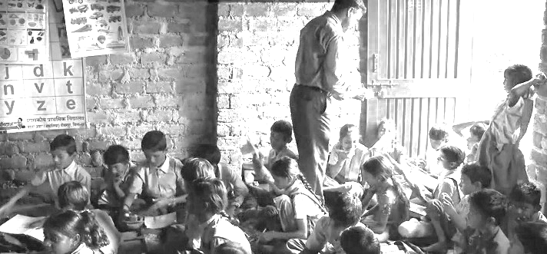
Video: Planning lessons
http://tinyurl.com/video-planninglessons

3 Summary
This unit has focused on how you can organise activities to extend the potential of textbook lessons, so that students can learn and practise English. To learn English well, students need a variety of language experiences organised by you.
Fluency in English cannot be developed by using just the textbook. Fortunately, India’s national curriculum and most state curricula give teachers the freedom to choose and plan additional activities based on the needs of the students. So think of your English textbook as the starting point for a range of interesting and meaningful language learning activities where you can use your creativity and teaching skills.
Other Elementary English teacher development units on this topic are:
- Learning English in the creative arts
- English and subject content integration
- Shared reading
- Developing and monitoring reading.

Resources
Resource 1: ‘The Puri Boy’
Once upon a time, an old woman and her husband lived alone in a little old house. They had no children. One day the woman made a puri shaped like a boy. She carefully rolled out the dough, and cut out a very nice-looking boy. What a fine looking boy he was!
The old woman put him in the pan full of hot oil, to fry. After he was fully fried and fluffy, she carefully lifted him from the pan. Up jumped the puri boy, and he ran out the door saying, ‘Run, run, as fast as you can! You can’t catch me! I’m the puri boy!’
The old woman and the old man ran after him, but they could not catch him.
And so the puri boy ran and ran. While he was running, he met a cow.
‘Moo,’ said the cow. ‘You look very fine! Fine enough to eat!’ and the cow started to chase the little boy.
But the puri boy ran faster, saying, ‘I ran away from an old woman, I ran away from an old man, and I can run away from you!’
And he laughed, ‘Run, run, as fast as you can! You can’t catch me! I’m the puri boy!’
The cow ran after the puri boy, but it could not catch him.
While he ran, he met a cat.
‘Meow,’ said the cat. ‘You look good enough to eat. I’m going to eat you, puri boy.’
But the puri boy just laughed, ‘I ran away from an old woman, I ran away from an old man, I ran away from a cow, and I can run away from you!’
And so he ran singing, ‘Run, run, as fast as you can! You can’t catch me! I’m the puri boy!’
The cat ran after the puri boy, but it could not catch him. The puri boy was proud that he could run so fast.
‘Nobody can catch me,’ he thought. So he kept on running until he met a fox. He wanted to tell the fox how he ran faster than all the others.
‘Mr Fox,’ he said, ‘I ran away from an old woman, I ran away from an old man, I ran away from a cow, I ran away from a cat, and I can run away from you.’
‘Why would I want to eat you?’ asked Mr Fox. ‘I do not like puris.’
The puri boy was happy to hear this. He stopped running. Immediately, the fox ate him up. The fox said, ‘Sorry, puri boy – I do like puris.’
Resource 2: Using groupwork
Groupwork is a systematic, active, pedagogical strategy that encourages small groups of students to work together for the achievement of a common goal. These small groups promote more active and more effective learning through structured activities.
The benefits of groupwork
Groupwork can be a very effective way of motivating your students to learn by encouraging them to think, communicate, exchange ideas and thoughts, and make decisions. Your students can both teach and learn from others: a powerful and active form of learning.
Groupwork is more than students sitting in groups; it involves working on and contributing to a shared learning task with a clear objective. You need to be clear about why you are using groupwork for learning and know why this is preferable to lecturing, pair work or to students working on their own. Thus groupwork has to be well-planned and purposeful.
Planning groupwork
When and how you use groupwork will depend on what learning you want to achieve by the end of the lesson. You can include groupwork at the start, the end or midway through the lesson, but you will need to allow enough time. You will need to think about the task that you want your students to complete and the best way to organise the groups.
As a teacher, you can ensure that groupwork is successful if you plan in advance:
- the goals and expected outcomes of the group activity
- the time allocated to the activity, including any feedback or summary task
- how to split the groups (how many groups, how many students in each group, criteria for groups)
- how to organise the groups (role of different group members, time required, materials, recording and reporting)
- how any assessment will be undertaken and recorded (take care to distinguish individual assessments from group assessments)
- how you will monitor the groups’ activities.
Groupwork tasks
The task that you ask your students to complete depends on what you what them to learn. By taking part in groupwork, they will learn skills such as listening to each other, explaining their ideas and working cooperatively. However, the main aim is for them to learn something about the subject that you are teaching. Some examples of tasks could include the following:
- Presentations: Students work in groups to prepare a presentation for the rest of the class. This works best if each group has a different aspect of the topic, so they are motivated to listen to each other rather than listening to the same topic several times. Be very strict about the time that each group has to present and decide on a set of criteria for a good presentation. Write these on the board before the lesson. Students can the use the criteria to plan their presentation and assess each other’s work. The criteria could include:
  - Was the presentation clear?
  - Was the presentation well-structured?
  - Did I learn something from the presentation?
  - Did the presentation make me think?
- Problem solving: Students work in groups to solve a problem or a series of problems. This could include conducting an experiment in science, solving problems in mathematics, analysing a story or poem in English, or analysing evidence in history.
- Creating an artefact or product: Students work in groups to develop a story, a piece of drama, a piece of music, a model to explain a concept, a news report on an issue or a poster to summarise information or explain a concept. Giving groups five minutes at the start of a new topic to create a brainstorm or mind map will tell you a great deal about what they already know, and will help you pitch the lesson at an appropriate level.
- Differentiated tasks: Groupwork is an opportunity to allow students of different ages or attainment levels to work together on an appropriate task. Higher attainers can benefit from the opportunity to explain the work, whereas lower attainers may find it easier to ask questions in a group than in a class, and will learn from their classmates.
- Discussion: Students consider an issue and come to a conclusion. This may require quite a bit of preparation on your part in order to make sure that the students have enough knowledge to consider different options, but organising a discussion or debate can be very rewarding for both you and them.
Organising groups
Groups of four to eight are ideal but this will depend on the size of your class, the physical environment and furniture, and the attainment and age range of your class. Ideally everyone in a group needs to see each other, talk without shouting and contribute to the group’s outcome.
- Decide how and why you will divide students into groups; for example, you may divide groups by friendship, interest or by similar or mixed attainment. Experiment with different ways and review what works best with each class.
- Plan any roles you will give to group members (for example, note taker, spokesperson, time keeper or collector of equipment), and how you will make this clear.
Managing groupwork
You can set up routines and rules to manage good groupwork. When you use groupwork regularly, students will know what you expect and find it enjoyable. Initially it is a good idea to work with your class to identify the benefits of working together in teams and groups. You should discuss what makes good groupwork behaviour and possibly generate a list of ‘rules’ that might be displayed; for example, ‘Respect for each other’, ‘Listening’, ‘Helping each other’, ‘Trying more than one idea’, etc.
It is important to give clear verbal instructions about the groupwork that can also be written on the blackboard for reference. You need to:
- direct your students to the groups they will work in according to your plan, perhaps designating areas in the classroom where they will work or giving instructions about moving any furniture or school bags
- be very clear about the task and write it on the board in short instructions or pictures. Allow your students to ask questions before you start.
During the lesson, move around to observe and check how the groups are doing. Offer advice where needed if they are deviating from the task or getting stuck.
You might want to change the groups during the task. Here are two techniques to try when you are feeling confident about groupwork – they are particularly helpful when managing a large class:
- ‘Expert groups’: Give each group a different task, such as researching one way of generating electricity or developing a character for a drama. After a suitable time, re-organise the groups so that each new group is made up of one ‘expert’ from all the original groups. Then give them a task that involves collating knowledge from all the experts, such as deciding on what sort of power station to build or preparing a piece of drama.
- ‘Envoys’: If the task involves creating something or solving a problem, after a while, ask each group to send an envoy to another group. They could compare ideas or solutions to the problem and then report back to their own group. In this way, groups can learn from each other.
At the end of the task, summarise what has been learnt and correct any misunderstandings that you have seen. You may want to hear feedback from each group, or ask just one or two groups who you think have some good ideas. Keep students’ reporting brief and encourage them to offer feedback on work from other groups by identifying what has been done well, what was interesting and what might be developed further.
Even if you want to adopt groupwork in your classroom, you may at times find it difficult to organise because some students:
- are resistant to active learning and do not engage
- are dominant
- do not participate due to poor interpersonal skills or lack of confidence.
To become effective at managing groupwork it is important to reflect on all the above points, in addition to considering how far the learning outcomes were met and how well your students responded (did they all benefit?). Consider and carefully plan any adjustments you might make to the group task, resources, timings or composition of the groups.
Research suggests that learning in groups need not be used all the time to have positive effects on student achievement, so you should not feel obliged to use it in every lesson. You might want to consider using groupwork as a supplemental technique, for example as a break between a topic change or a jump-start for class discussion. It can also be used as an ice-breaker or to introduce experiential learning activities and problem solving exercises into the classroom, or to review topics.

Additional resources
- Karadi Tales: http://www.karaditales.com/
- National Book Trust India: http://www.nbtindia.gov.in/
- NCERT textbooks: http://www.ncert.nic.in/NCERTS/textbook/textbook.htm
- Teachers of India classroom resources: http://www.teachersofindia.org/en

References/bibliography
Bromley, H. (2000) Book-based Reading Games. London: Centre for Literacy in Primary Education.
Bryant, P. and Nunes, T. (eds) (2004) Handbook of Children’s Literacy. Dordrecht: Kluwer Academic Publishers.
Dombey, H. and Moustafa, M. (1998) Whole to Part Phonics: How Children Learn to Read and Spell. London: Centre for Literacy in Primary Education.
Goswami, U. (2010a) ‘Phonology, reading and reading difficulties’ in Hall, K., Goswami, U., Harrison, C., Ellis, S. and Soler, J. (eds) Interdisciplinary Perspectives on Learning to Read. London: Routledge.
Goswami, U. (2010b) ‘A psycholinguistic grain size view of reading acquisition across languages’ in Brunswick, N., McDougall, S. and Mornay-Davies, P. (eds) The Role of Orthographies in Reading and Spelling. Hove: Psychology Press.
Graham, J. and Kelly, A. (2012) Reading under Control: Teaching Reading in the Primary School. London: Routledge.
Hall, K., Goswami, U., Harrison, C., Ellis, S. and Soler, J. (2010) Interdisciplinary Perspectives on Learning to Read: Culture, Cognition and Pedagogy. London: Routledge.

Acknowledgements
Except for third party materials and otherwise stated below, this content is made available under a Creative Commons Attribution-ShareAlike licence (http://creativecommons.org/licenses/by-sa/3.0/). The material acknowledged below is Proprietary and used under licence for this project, and not subject to the Creative Commons Licence. This means that this material may only be used unadapted within the TESS-India project and not in any subsequent OER versions. This includes the use of the TESS-India, OU and UKAID logos.
Grateful acknowledgement is made to the following sources for permission to reproduce the material in this unit:
‘The Puri Boy’: a traditional tale adapted and developed by the RVEC (http://www.rvec.in/).
Every effort has been made to contact copyright owners. If any have been inadvertently overlooked the publishers will be pleased to make the necessary arrangements at the first opportunity.
Video (including video stills): thanks are extended to the teacher educators, headteachers, teachers and students across India who worked with The Open University in the productions.

