Inclusive Teaching Practice
Participant’s Book
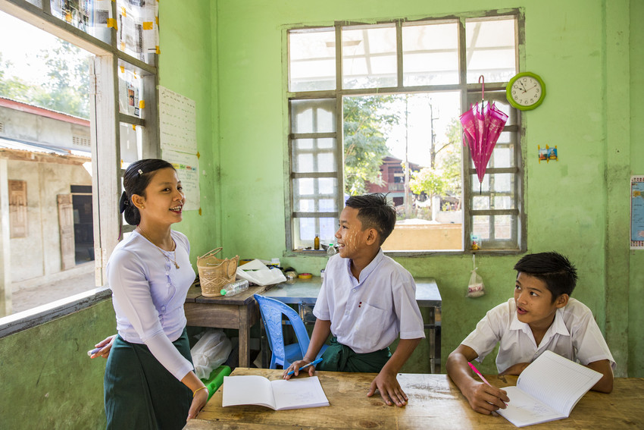

Source: TREE Image library

Module 8:
Peer, co-operative and collaborative learning

Module 8: Peer, co-operative and collaborative learning

Overview
This is the eighth of fifteen modules that look at how we create a positive Inclusive Learning Environment for all. You will see how inclusive teaching practices encourage, develop and use the 21st century skills of critical thinking, communication, collaboration and creativity. These modules are for any educators or those studying in education in Myanmar. The terms student and learner are used interchangeably throughout the module.

Module number | Module title
1 | What is an Inclusive School, Classroom and Teacher?
2 | Knowing your learners
3 | Planning learning outcomes for all
4 | Participating through learner centred approaches
5 | Creating a positive learning environment
6 | Effective questioning and feedback
7 | Active participation
8 | Peer, cooperative and collaborative learning
9 | Supporting students’ emotional and social wellbeing
10 | Legal framework and policies around Inclusion in Myanmar
11 | Supporting all students through differentiation
12 | Identifying specific learning difficulties
13 | Supporting all learners with differences or disabilities
14 | Positive behaviour management
15 | Assessment for student achievement

This module helps you to think about how students can support each other and explores the benefits of providing opportunities for students to work cooperatively and collaboratively. As in previous modules, you will be asked to self-assess your current understanding or practice and then reflect again at the end of the module. You will also be asked to record your reflections in a learning journal, so it is important to make good notes and think carefully and deeply about your current and future practice.

This CPD module also encourages you to develop communities of practice between yourself and your colleagues. This will support and extend your own use of inclusive practices in your teaching and will help your student teachers build on inclusion in their learning and future professional practice.

Learning Journal
It will be useful to record your reflections in a learning journal throughout the module.
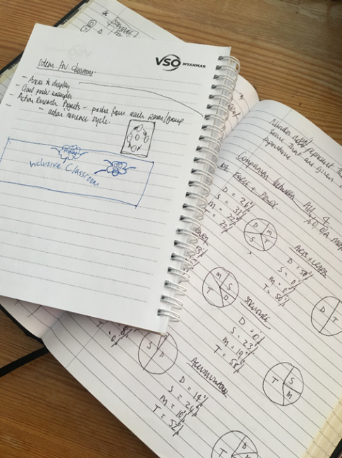
A learning journal can be digital (e.g. using Word or Google Docs) or on paper. You can also take photos of your learning journal pages if you want to share your thoughts with others. It is important that you record your thoughts and ideas so that you can remember and use them later in activities and in your own teaching.

Here are some useful tips for a good learning journal:
- Use headings and dates for all your journal entries.
- Use the activity number for reflections linked to that activity, e.g. Activity 1.1
- Add references to any other resources you find that help you.
- Record answers to activities.
- Write reflections about your learning.
- Make notes of new vocabulary.
- Identify topics you want to learn more about.

Source: Rose, N. (2018) Personal Learning Journals

The important thing is that it is easy for you to use. You can take notes which answer simple questions like these:

These questions follow the LEARN- APPLY- REFLECT model which is used in education globally. You can return to this journal as you progress through your CPD journey and reflect on your progress.

Study tips
Take your time to work through the activities, rather than trying to complete the whole unit at once. Set yourself a timetable and choose a time to work through the tasks, then check and compare ideas with colleagues. Finally, remember to make notes in your learning journal as you go. This will help you remember more about the skills and knowledge you develop as you complete these units.

Working alone or with colleagues
This unit is designed for self-study or can be led by a facilitator. The answers can be found after each activity. However, if possible, we recommend working in a pair or group so you can share ideas, ask questions, check your work, and give feedback.
If you work in a pair or group, we recommend using Think / Pair / Share for each activity.
Discuss your ideas in a group, and then check the answers on the next page(s) together.
Check your answers with your partner.
Work alone and make brief notes of your own ideas.

Learning outcomes for module 8
By working through this module, you will be able to:
- discuss the concept and advantages of peer, cooperative and collaborative learning.
- recognise examples of these types of learning in the classroom.
- demonstrate strategies to promote cooperative and collaborative learning in your own classroom.
- reflect on your own classroom practice and adapt lesson plans to include opportunities for collaborative, cooperative and peer learning.

Introduction
The previous module introduced the concept of using flipped classroom and explored ways of using inquiry and problem-based learning methods. It built on the learning from Module 4 about learner centered approaches, where the learner takes responsibility for their own learning - this is very different to traditional teacher centred approaches.
This module will develop the learning you started in Module 4 around grouping learners and the video that you watched on co-operative learning, exploring further the impact of students learning with their peers.
You will be asked to:
- Read about ‘Peer, Cooperative and Collaborative learning.’
- Watch videos and provide some analysis.
- Complete activities either alone, in pairs or in small groups.
- Answer an end of module quiz.
- Reflect on your experience and knowledge.
- Make a promise to your learners.

The module will take approximately 6 hours to complete. We hope you have an enjoyable learning experience.

Key to symbols
Activity – this is work you need to complete.

Question/s – please answer the questions.
Reflection – think carefully about how you feel about this.
Learning Journal – please write your answers and reflections in your learning journal.
Read – please read the text provided. Make any notes you like.

1.1 - Self-assessment
REFLECTION: How often do you provide opportunities to enable students to learn ‘by themselves’ through peer, cooperation and collaboration? Look at the scale below and identify the number that best describes YOU.
NOT confident
VERY confident
You will be prompted to do this again at the end of the module.

    - Link to previous learning – module 7 (Active participation).
Think back to module 7. Fill in the missing words to the following statements about the Flipped Classroom learning approach. One example has been given.
Missing words
After | during | prior | blended learning | discuss
outside | ALL | inside |  | ‘lecture style’

- A flipped classroom is a type of 1) blended learning, which aims to increase student engagement and learning during class time.
- Students are asked to carry out a task 2)____________ to the lesson. This could be reading a text, watching a short video or study the content.
- Time is given 3)______________the lesson for live problem-solving and opportunities to investigate.
- During the class, learners 4)______________ the content with their peers and the teachers.
- 5)______________ class, learners are encouraged to check and confirm their understanding by doing further learning activities.
- It differs from a traditional model of teaching where teachers deliver a 6)_______________ lesson and then set homework.
- The delivery of instructional content can often take place 7)___________of the classroom so that time spent the 8)_______classroom is focused on collaboration and engaging in concepts.
- Flipped learning can be beneficial for 9)_____________ learners as it allows students time to process information before a lesson.

- Answers
- blended learning | - prior | - during | - discuss | - After
- ‘lecture style’ | - outside | - inside | - ALL

Learning with others
Think: why is it important to allow students to work together?
There are many benefits for you as a teacher and for your students, which will be explored in this module. It is more than 2 or more learners watching each other to learn how to do a task.
Meaningful opportunities to learn with others, involves engagement in different discussions and to understand different perspectives. Learners see and experience the impact of giving and receiving feedback. Before we discuss this further, the next activity asks you to reflect.

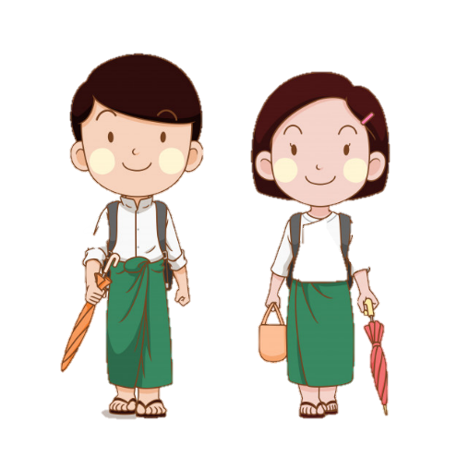
Activity 8.1 - What does peer, co-operative and collaborative learning mean to you?
Think about your work as a teacher and your life in the community outside of teaching. Answer the questions below to start to reflect on what peer learning, co-operation and collaboration means to you. Record your ideas in your learning journal.

- What does it mean
  - to work with peers?
  - to cooperate?
  - to collaborate?
Image Source: https://www.freepik.com (free)
- What are the differences between them?

- Does peer learning, co-operation & collaboration only happen in educational settings? Or are these practices relevant and important in other workplaces and social contexts?

- Can you think of any examples of peer co-operation & collaboration in a wider context?

Reading task
Read the extract below. Make a note of any interesting or new words in your learning journal. Think about the role of the student and the role of the teacher in each of these modes of learning. What do you notice about the roles ?

Peer, Collaborative and Cooperative Learning.
Peer Learning (or Peer-to-Peer Learning) involves one student leading another student through a task or concept. Peer learning works with guidance from teachers to enable students to work through new concepts and content with other students. It gives them opportunities to teach and be taught by each other. Their teacher supervises and can give more individual attention where required.
Cooperative Learning involves each individual student taking responsibility for their own learning and success. As well as that of the group as a whole. They need to use their knowledge and resources to ensure that all group members understand what they are learning. The teacher directs and provides or guides them to use specific resources.
Collaborative learning involves groups of students working together to explore ideas and solve a problem, complete a task, or create a project. Each student has a separate role in the task, and all are responsible for the team’s learning and success. For example, each student produces part of a larger assignment, and the team assembles the final work together. Their teacher acts only as advisor.

Activity 8.1 example answers
What does it mean to work with peers?
Peer learning is when one student guides or teaches another, or others.

What does it mean to co-operate?
Co-operative learning is when students work together, with guidance from their teacher. It is the responsibility of the team to ensure everyone understands.

What does it mean to collaborate?
Students decide on their different roles within the team and how they will work together to achieve a goal. The teacher plays a minimal part.

What are the differences between them?
Collaboration is more student centred & autonomous than peer or co-operative learning styles.

Does peer, co-operation & collaboration only happen in schools and colleges? Or are these practices relevant to/important in other workplaces and social areas?
They all happen in normal interaction within a workplace or community.

Activity 8.2 – Match the description to the learning style (15 minutes)
Which learning type do these characteristics best describe?
These activities create the atmosphere for students to increase their academic achievement, especially their reasoning and critical thinking. They are more active participants in learning as they care about the class and they are more personally engaged.

Peer learning

Co-operative learning
Collaborative learning
Students organise themselves and find resources to help them complete the task. It is not monitored by the teacher (although they can help when requested by the group) and students assess their own individual and group performance.

It works best when students of different ability levels work together. Same-age peer is as effective as cross-age peer.

Answers to Activity 8.2
These activities create the atmosphere for students to increase their academic achievement, especially their reasoning and critical thinking. They are more active participants in learning as they care about the class and they are more personally engaged.

Peer learning

Co-operative learning
Collaborative learning
Students organise themselves and find resources to help them complete the task. It is not monitored by the teacher (although they can help when requested by the group) and students assess their own individual and group performance.

It works best when students of different ability levels work together. Same-age peer is as effective as cross-age peer.

  - Peer Learning
- It works best when students of different ability levels work together. Same-age peer is said to be as effective as cross-age peer partnerships.
- It provides students with opportunities to practice their social skills in a structured environment, and helps them to develop into active, self-regulated learners.
- Students can achieve higher academic gains.
- Students can improve relationships with peers, and their personal and social development.
- Students’ motivation can be increased.
- Teachers can directly monitor social interaction. They have more opportunity for individualized instruction by interacting closely with students and giving specific individual goals to measure and examine progress.
- Peer learning facilitates inclusion and provides opportunities to reduce anti-social behaviors.

Activity 8.3 – Examples of Peer learning (20 minutes)

Watch the video below about peer learning.

Write down the 3 suggested peer learning techniques in your learning journal.

Have you used them before? What was the impact on learning?
https://www.youtube.com/watch?v=SaLgg8QrBCY

Think about the 3 peer learning techniques

Think, pair, share

3before me

Jigsaw groups

Think about the advantages and disadvantages of using the different techniques with different types of learners in your class. There are a few ideas to get you started.

Peer learning techniques | Possible advantages | Possible disadvantages
Think, pair, share | -Opportunity for all students to discuss their ideas & learning. | -One student may be shy or not confident to speak.
3 before me | -Developing independence.
Jigsaw groups | -Opportunity to explore and discuss.

Activity 8.3 example answers
See some possible suggestions of advantages and disadvantages below.

You may have thought of others or not see the answers suggested as a disadvantage, e.g. all children speaking at the same time. Whilst this could be noisy or distracting, if the noise levels are managed well, ALL children are engaged and on task (which is a huge advantage of this technique).

Peer learning techniques | Possible advantages | Possible disadvantages
Think, pair, share | -Opportunity for students to discuss their ideas & learning.  -Suitable for all aged learners.  -Students can check their understanding.  -Engaging and motivating (especially when used with a set time, e.g. 2 minutes)  -Helpful for less confident student or students who need longer to process learning. | -One student may be shy or not confident to speak.  -It could be noisy/distracting with all students speaking at the same time.  -One student could dominate the conversation.
3 before me | -Developing independence.  -Develop speaking & listening skills.  -Opportunity for students to teach & learn from each other. | -Students rely on others for instructions.  -Another student could give an incorrect response for others to follow.
Jigsaw groups | -Opportunity to explore and discuss.  -Opportunities to work in a group and learn from others.  -Taking on responsibility within a team. | -Learners in the same group might not work well together.  -Someone takes the lead and others don’t get a chance to contribute.

  - Cooperative Learning
- Activities are structured. Each student is assigned a specific role by the teacher and the teacher supplies information and/or resources for students to read, analyse and/or research. To be effective, a cooperative activity requires the teacher to pre-plan, introduce the activity to students, monitor and intervene when needed, and assess.
- Cooperative learning activities create the atmosphere for students to increase their academic achievement, especially their reasoning and critical thinking. They are more active participants in learning as they care about the class and they are more personally engaged.
- Cooperative learning nurtures students, building their sense of responsibility, organizational skills, decision-making and motivation. It builds the self-confidence to experiment, explore, express feelings, and empathize.

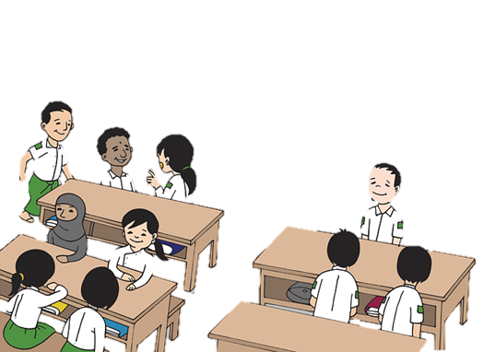
Read through some examples of cooperative learning and think about how you might use them in your class and how the learners might respond to this style of learning.

Expert groups
C
B
A
Group 1
The teacher puts learners into groups (Group 1, 2, 3, 3, etc.) to research or read about a topic. Learners are given a letter A, B, C, etc. They are then asked to re-group according to their letter (all the As, Bs, Cs, etc. together). They then explain to the new group what their original group researched or read about. Note: There will often be an odd number of students in a group. The teacher might add an extra pupil to a group that needs more input or add an extra learner to a group where they need to develop confidence in group work. In the picture shown, the teacher has allocated the letter C to two children in Group 3.
Group 3
C
C
B
A
C
B
A
Group 2
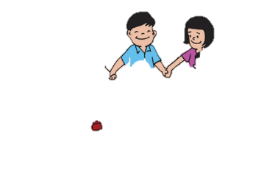
The fish bowl
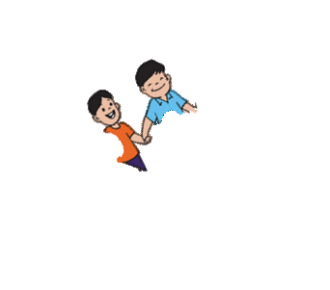
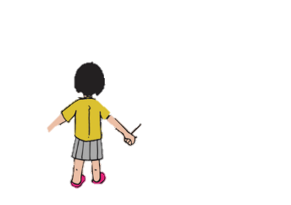
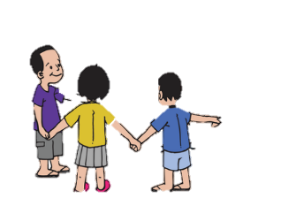
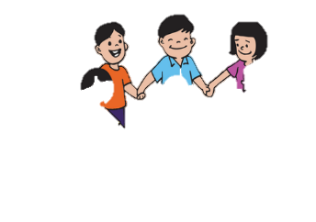
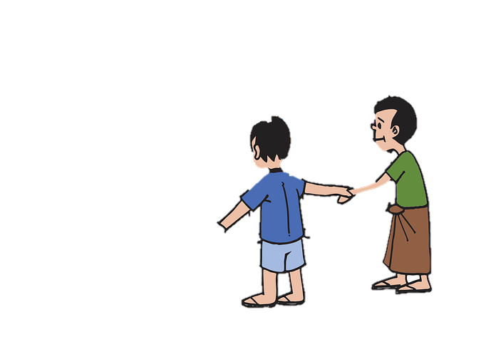
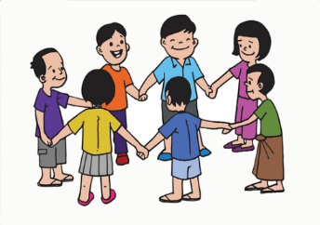
The teacher divides the class in half. One half will form the centre circle, facing inwards and the other half will form the outer circle, also facing inwards. The learners in the inner circle will discuss a selected a topic and the outer circle must listen. They cannot contribute to the discussion. When the teacher indicates, the circles switch so the inner circle moves to the outer side and become the listeners. The learners that were on the outside initially move to the inside of the circle and can continue the discussion.

Q & A match up
The teacher creates a set of questions and answers based on a theme the class is studying. Each question and each answer is placed on a separate piece of paper. Question papers could be on a different colour paper to the answer cards for learners who might need support with matching.
The teacher randomly distributes all the pieces of paper and gives learners time to read them. They will need to think about what the corresponding answer or question could be. Students then work together to try and match up their correct answer or question. When everyone has found a match, learners can read out their questions and answers for the class to agree or suggest a better response/match.
Adapted images - Source: https://pixabay.com/images/search/burma/?pagi=2& (free)

Activity 8.4 – Advantages and disadvantages of co-operative learning (20 minutes)
Cooperative learning technique | Possible advantages | Possible disadvantages
Expert groups | -Learners must focus and take personal responsibility. | -Learners might feel pressured to represent their group.
The fish bowl |  | -Could be difficult with large class size.
Q & A match up | -Could easily be adapted to a simple matching game.
Think about the three examples of cooperative learning.
What do you think the advantages and disadvantages would be of using these methods in class? It might be helpful to think about specific learners that you teach and consider how they might benefit from them and what some of the risks might be. There are a few ideas in the table below to get you started.

Activity 8.4 example answers
See some possible suggestions of advantages and disadvantages below.

You may have thought of others or not see the answers suggested as a disadvantage, e.g. where some activities may be a challenge with a large class size, you may decide to use the technique using 2 groups/circles, etc. which would engage/include all learners.
Cooperative learning technique | Possible advantages | Possible disadvantages
Expert groups | -Learners must focus and take personal responsibility.  -Learners work with other learners increasing engagement.  -Opportunity for discussion and critical thinking.  -Opportunity to teach others. | -Learners might feel pressured to represent their group.  -Would need adapting for younger learners.
The fish bowl | -Learners must listen carefully.  -Active learning.  -Opportunity for thinking time and planning best possible responses. | -Some learners might not get a chance to speak.  -Could be a challenge with younger learners.  -Could be difficult with large class size.
Q & A match up | -Could easily be adapted to a simple matching game.  -Develop speaking and listening skills.  -Opportunity for critical thinking, analysing different responses.  -Active learning and opportunity to move around. | -Learners may need support in finding their partner if using with large class.  -It could take a long time.  -Learners who pair up quickly could go off task whilst waiting for others to finish.

  - Collaborative Learning
- A cooperative arrangement where two or more students work together towards a common goal.
- Works well after introducing the class to a new concept, through teacher explanation, a video or some reading material. It enables individual students to combine their own expertise, experience and ability to accomplish a common learning goal and so gain new information and experiences.
- Students organise themselves and find resources to help them complete the task. It is not monitored by the teacher (although they can help when requested by the group) and students assess their own individual and group performance
- Success depends on individual strength and students are responsible for each other’s learning as well as their own. It promotes self-management, social awareness and responsible decision-making, and helps students develop relationship and communication skills.

Activity 8.5 – Examples of Collaborative learning (20 minutes)

Watch the video below about collaborative learning.

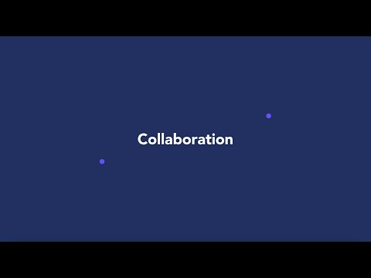
Write down a suggested collaborative learning techniques in your learning journal.

Have you used it before? What was the impact on learning?
Think about how the activities you set in class link to this style of learning. Discuss your ideas with a colleague.

https://www.youtube.com/watch?v=ncyXxMcmWhE
Watch the following video.
In this video Dylan William uses the term ‘reporter’. This refers to a group member reporting back to the rest of the class on the work carried out in their group.

https://www.youtube.com/watch?v=TqBNWEQmBRM

He also says that we should encourage learners to ‘work as a group rather than just work in a group.’
What do you think he means by this? Have a discussion with a colleague if you can. Discuss with another teacher about what this means to you and the work you do with your students.

Reflect: If you have asked learners to work in a group, do they have the skills to work effectively as a group? How can we ensure that all learners are actively involved in a team task (collaborative learning)?

What does Dylan say about roles of the teacher and learner? Have a discussion with a colleague if you can about how the information here can relate to the work you do with students.

  - The difference between co-operative and collaborative learning
In collaborative learning, students make individual progress alongside each other. Cooperative learning involves more interdependence, and greater accountability.
Look at the Venn diagram below to understand the difference between the two methods of learning. The intersection displays the benefits of both.

Collaborative learning
Co-operative learning
Student’s work is dependent on others in the group.

Students are given specific roles.

Teacher directs and provides resources.

Tasks are only completed if all students work together.
Students work on the same project but alongside each other.

Students organize themselves and their resources.

Tasks are completed by combining all the individual work.

Teachers act as advisors when needed.
Peer learning
Social skills
Sense of responsibility
Self-confidence
Communication skills
Deeper learning through explaining

  - The benefits of peer, cooperative and collaborative learning
If we look at different learning styles and link that to learning retention, we can start to recognise where we are having the most impact on student learning.

Edgar Dale’s (1946) Learning Pyramid is a model that incorporates several theories related to teaching and learning processes. His theory suggests that learners retain more information by what they “do” as opposed to what is “heard”, “read” or “observed”.

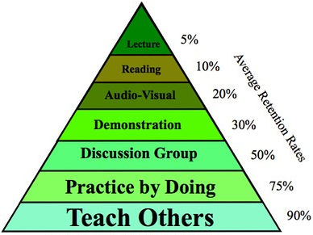

Each of the learning styles that we are focussing on in this module requires learners to work together and discuss as part of a group. If we look at the model above, learners will retain 50-90% of learning compared to a traditional ‘lecture’ method of teaching where learners are required to listen and read. In this model, the learner will retain only 5-10%.

If we think about ALL learners (linking back to module 2 – Knowing your learners) we will recognise that they all have a prefered learning style. This might be due to their learning needs or that they simply respond better when information is presented visually rather than auditory. When we teach using a multi layered approach, using visuals to support verbal instruction and include a practical demonstration, it is likely that more children can access the learning and will retain the information.

If learners have sight or hearing difficulties, they will not receive the same sensory input as other learners. Ask yourself, “What activities will be relevant to them?” and “How can I as a teacher adapt an activity to make it more relevant so ALL students can learn?”

Image Source: https://www.flickr.com/photos/dkuropatwa/with/2097911609/ (Creative Commons)

Activity 8.6 – Learning retention when using peer, co-operative and collaborative learning (15 minutes)
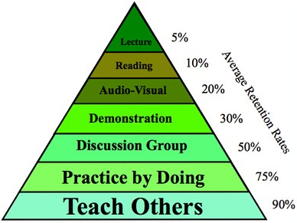
- Look at the learning pyramid and reflect on a lesson that you think was particularly memorable for students.
Q
- What made it a success?
- How did you engage learners? E.g. Did you give them time to discuss their learning?
- Where do you think your lesson would fit on the learning pyramid?

Share your example with a colleague and discuss what you did to engage learners.

- In your learning journal list the benefits of allowing students to work together.
Look back over the previous sections in the module if you need to or watch the videos again in Activities 8.3 and 8.5.

Activity 8.7 – Writing a definition (15 minutes)

Think about what you have read so far about co-operative and collaborative learning. Can you explain the difference between the two?

If this is a challenge for you, you may wish to look back at the notes you have made so far or revisit previous sections of the module. Try to explain the difference to a colleague as it will help with your own understanding.

Has your view on these styles of learning changed from your opinion at the start of the module?
In your learning journal write a definition for both.

Discussion -

Peer learning helps expand students’ perspectives and fosters meaningful connections between new and previously known knowledge as well as making social connections. It is an effective way of managing the different rates at which students learn. Faster learners can take the role of the explainer, developing their own deeper understanding and helping other members of the class. These roles can then be rotated to ensure everyone benefits from a similar experience.

Collaborative learning can be a single question during class or a long project with several outcomes over a semester. Activities could be: a case study, student-moderated informal discussions or formal debates, collaborative writing, presentations, games, and demonstrations.
The student group is self-directed and does not receive direction or instruction from the teacher. They decide their group roles, resources and organisation as a group. The teacher can act as advisor when needed.

In cooperative learning, the activity structure, roles and responsibilities are defined but open for negotiation, and there is a director overseeing the project. The success of the project depends on all the interconnected roles supporting each other. Students know that they can reach their learning goals only if the other students in the learning group also reach their goals. In school and in life, co-operation requires interdependence, and accountability to each other.

Activity 8.8 – What it looks like in the classroom (20 minutes)
Here are 3 videos showing classroom activities in Indian schools (with English commentary). The videos demonstrate many of the techniques that have been discussed in this module for you to see what they look like in practice.
Video 1: A secondary science class https://www.youtube.com/watch?v=tR2hIYOpBcI&feature=youtu.be

Video 2: A secondary English class (3’23’’)
https://www.youtube.com/watch?v=Qm2hp-hNEI4

Video 3: A lower primary maths class
https://www.youtube.com/watch?v=UHQwZlU2o80&feature=youtu.be

Watch and discuss with a colleague if possible.
- What features can you see in each video?
- How were ALL learners’ contributions valued in class?
- Could your students use these ideas in the classroom?
- How confident do you feel to trial these ideas now you have seen them?
- How can you include peer, collaborative and cooperative learning activities so your students are involved in their own learning?

2.6 Selecting the right technique
When you start to think about how your students might learn best, you are thinking about the process of learning rather than the content and what you want students to understand by the end of a lesson. Most teachers find it helpful to write this down using an Inclusive Lesson plan. You may already use a template for planning lessons but do you think about INCLUSION?. You will find an example/template in the appendices of this module but most teachers adapt lesson plans to suit themselves and their students’ needs. For example, most include timings for parts of the lesson to keep them on track. Some find it useful to write a list of resources they will need and others focus solely on the content of the parts of the lesson, e.g. notes about what the starter will involve or what questions to ask in a plenary activity.

If you are trying to make your lesson plans more inclusive and to think of a different technique to facilitate learning rather than using a traditional lecture method, you might find it helpful to answer the following questions which focus on your learners:
- How old are the learners? Are they all the same age or are there mixed grades? Younger learners may need more guidance or require an activity to be broken down or adapted in some way.
- Academic readiness. What is the current level of understanding? Are they similar? This can help you start to think about how to group students. You could do this randomly or put students in a group who might support or learn from each other.
- How many students? This will affect the success of group work. When you are planning the size of a group, think about how much the individual members can contribute. If students do not have lots of experience of working in a group, you might start with smaller sizes and build up.
- Can ALL students participate and achieve? There may be students that need further support. Think about how they can contribute to the team performance or if other students can offer support.
- Social skills. Are students able to organise and manage themselves in a group without an adult? How much guidance do they need from you? You may need to spend time problem solving before the task about what they might do if members of the team disagree, or they face a problem.
- Learning styles. Can you integrate multisensory learning to make the activities more engaging and varied?
Too much structure and guidance can be overwhelming for students and too much freedom can be equally overwhelming! You might want to use a combination of collaborative and cooperative approaches. If your class are new to group work, you might keep the content of the task quite light to start with, spending time to teach students how to work effectively as a team. You may wish to give a detailed set of steps and questions to complete and allow the group to choose their roles.
Image source: https://www.myanmargraphic.com/category/people/ (free)

2.7 How to facilitate peer, cooperative and collaborative learning?
A good routine is to plan the lessons you teach and think through the details of what tasks you are setting for students and how to engage them in the learning process as much as possible.
You might find it useful to read back over module 3 again to ensure that you are planning learning outcomes for ALL learners. There is guidance in the module around what to consider when setting a learning outcome (SMART – Specific, measurable, achievable, relevant and timely).
- Plan your inclusive lesson – write down your instructions so they are clear.
- Have examples ready to show or demonstrate what to do and how to do it.
- Be prepared to answer questions and explain the activity in a different way if students aren’t clear.
- Prepare the learning space, equipment and materials needed before the lesson. If you are asking students to work in teams, will they all fit around the tables? Do they need paper to record their ideas? Will they all write or will it be one person’s role?

Depending on the age of the students you teach, they may need a reminder of the expectations of working together and taking turns, if they are all contributing to the discussion or activity.

Activity 8.9 – Different roles of the teacher (15 minutes)

Look at the table below and think about the role of the teacher during group work. Copy the table into your learning journal and tick the descriptions that you think would be most effective. Provide an explanation for your choice.

Description of teacher’s role during group work activity | Tick effective strategies | Explanation
Sit at the front of the class and watch to see which groups are working.
Walk around the classroom, listening to conversations within the groups.
Offer support when you think a group might need it or they ask.
Interrupt students and stop them discussing if you feel they are not on the right track.
Before you engage with a group, hold back and listen to their conversations.
If you notice that some students aren’t speaking, check they understand or encourage others to ask if they would like a turn to speak.
Use prompt questions to get a group conversation back on the right track or extend their thinking.
Listen for a change in noise level and think about what it could mean – have they finished the task? Is it too hard/easy?
Listen for a change in noise level and stop the group work if it gets too loud.
If you notice members of a group not talking, ask others to be quiet and make them speak.

Activity 8.9 – example answers
Suggestions are given below for possible explanations but you may have interpreted the scenario in a different way. Discuss your answers with a colleague to see if they had a similar idea.
Description of teacher’s role during group work activity | Tick effective strategies | Explanation
Sit at the front of the class and watch to see which groups are working. |  | You may decide to sit back/at the front initially whilst groups get started with their activity. This will give them time to settle into the activity and agree what they need to do. When the groups get going it may seem as though you are not interested if you remain at the front and don’t engage with them.
Walk around the classroom, listening to conversations within the groups. |  | This will show the students you are interested and engaged with their task. Be careful not to ‘hover’ and make students feel nervous or uncomfortable.
Offer support when you think a group might need it or they ask. |  | Another alternative might be to ask the group if they need any help rather than assume or encourage them to ask each other before seeking support from a teacher.
Interrupt students and stop them discussing if you feel they are not on the right track. |  | It is important to give groups time to solve their own problems. Give enough support (feedback, suggestions, questions) to help learners reflect and progress but try not to solve their problems for them.
Before you engage with a group, hold back and listen to their conversations. |  | By listening to the conversations, you can make an assessment on what to do next, e.g. do you need to stop and give more direction? Do you need to add another element to the task to deepen their learning experience?
If you notice that some students aren’t speaking, check they understand or encourage others to ask if they would like a turn to speak. |  | You could stop the class and say you have noticed that some students haven’t had a chance to contribute yet. Ask students how they will ensure everyone has a chance to speak.
Use prompt questions to get a group conversation back on the right track or extend their thinking. |  | If you feel a group do need some input, you might ask a question to get them back on track rather than tell them. If this doesn’t work you may need to tell them to ensure they stay on task.
Listen for a change in noise level and think about what it could mean. |  | If the noise level increases or decreases it could mean that the group have finished a task. It could also mean they are finding it too easy or too difficult.
Listen for a change in noise level and stop the group work if it gets too loud. |  | The change in noise level could mean the students are off task but it could also be excitement and engagement. Listen to what the students are discussing and remind them that they need to be able to hear each others contributions.
If you notice members of a group not talking, ask others to be quiet and make them speak. |  | You could have a quiet word with a student to check they understand. Try not to call them out in front of their peers and embarrass them.

Activity 8.10 – Scenarios – which technique might work best? (20 minutes)
Read the scenarios below and suggest an appropriate learning technique.
You could choose from a peer learning, cooperative or collaborative learning technique based on the information you have been given.

I am teaching a Grade 2 class in a basic school. There are 70 students in my class.​
Subject: Art​
The students will design and create individual paintings for a township event in the school.​
Which approach would you choose? Why?

Scenario 1

Peer learning?
Cooperative learning?​
Collaborative learning?

I am teaching Grade 3 in a basic school. There are 50 students​ in my class.
Subject: Myanmar/History​
The students have read and discussed folk tales of their region. In this lesson, they will act out short episodes (role-play). ​
Which approach would you choose? Why?

Scenario 2
Peer learning?
Cooperative learning?​
Collaborative learning?

I am teaching Grade 6 in a basic school. There are 50 students​ in my class.
Subject: Science​
The students will experiment with bean plants to understand how the amount of water and light affects the growth of a plant.​
Which approach would you choose? Why?

Scenario 3
Adapted image source: https://www.myanmargraphic.com/category/people/ (free)

Peer learning?
Cooperative learning?​
Collaborative learning?

Scenario | Suggested learning technique
1
2
3

Activity 8.10 suggested answers
See some possible suggestions of an appropriate learning technique to suit the teacher’s lesson plans and context. You may feel that a different technique is better suited with a different task in mind.
Scenario | Suggested learning technique | Explanation
1 | Peer learning  Collaborative learning | The think, pair, share technique might be useful in this activity to give students a chance to talk about their designs for their individual paintings.  The teacher could use a more collaborative process in the design part of the lesson, to support students in generating ideas. Th students could then work independently and perhaps carry out another think, pair, share task at the end or part way through their painting to review their work and receive feedback.
2 | Cooperative learning | To carry out role play and act out a scene, students will need to have a role. Their role will be dependent on the roles of others in the group. As the class will have already read and discussed the tales, they will have a good understanding of their role.
3 | Collaborative learning | As the students are in Grade 6, it is unlikely that they will need a huge amount of direction from their teacher for this task. With the information we have from the teacher, it sounds as though students could design their own experiments working collaboratively.

NOTE: As previously mentioned, these are just suggestions. Every teacher will have a preferred way of teaching the same lesson and may choose different techniques or a combination throughout a lesson.
Depending on the Grade you teach, where you are in the school year (first few weeks, middle, end, etc.) the number of students, their needs and the experience of previous learning, the most appropriate technique will vary. The technique a teacher uses could depend also on their confidence or they may wish to use a technique that has worked well in the past, changing the content.

- Possible ideas for action research projects
In module 6, you were introduced to the idea of carrying out small-scale action research projects.
The diagram below shows the action research cycle.
1) decide on the question,
2) plan how to answer it,
3) carry out the research – observe, question, etc.
4) review the data
5) plan if/how to improve.
The cycle then continues until you are confident with the changes you have made.
Action ResearchCycle
- Question
5. New plan

4. Review
2. Plan

3. Do

Suggestions:
- Investigate how much time you spend interacting with students when using the collaborative and cooperative methods – are you able to spend more time with individuals or small groups of students, what are you doing when interacting?

- Investigate students’ responses to a lesson using different learning techniques. You could use a questionnaire for students to reflect after the lesson. Are they involved and participating? Has the lesson taken collaborative/cooperative and peer learning into consideration? What skills are they developing?

Wrap up
In this module you have:
1. Discussed the concept and advantages of peer, co-operative and collaborative learning.
2.Recognised examples of these types of learning in the classroom.
3.Suggested appropriate strategies to promote co-operative and collaborative learning.
4.Reflected on your own classroom practice and adapted lesson plans to include opportunities for collaborative, cooperative and peer learning.

Key points from this module:
- Students should be given meaningful opportunities to learn with others. The research suggests that they will be more engaged, retain more knowledge and develop better social, speaking and listening skills.
- Learners should learn how to work as a group rather than just in a group.
- Peer Learning involves one student leads another student through a task or concept. Peers may be given time to discuss their ideas before they are asked to speak in front of the whole class.
- Cooperative learning involves individual students taking responsibility for their own learning and success, as well as their role within a group. The teacher provides guidance and resources.
- Collaborative learning involves groups of students working together to explore ideas or solving a problem together. The process maybe freer for students to explore and discuss.
- Different learning techniques can be used within lessons. Whilst this module has given an overview and looked the different methods in detail, the important factor is that teachers allow students to talk and learn together, rather than worry about whether it is peer, cooperative or collaborative.
- When using peer, cooperative and collaborative learning styles, the role of the teacher changes considerably, from a traditional style. Teachers take on more facilitation providing prompts and providing students with more ownership and responsibility for their learning.
- During these more active learning styles, teachers can tune in and listen to their students to begin to assess their learning more informally. This will be part of Module 15 around assessment.

End of module 8 quiz
Please answer the following questions in your learning journal. You can attempt as many times as you like to reach 100% pass. Some questions require more than one answer.
Q1 - What is peer learning? (Choose 1 answer)
  - The situation where the teacher gives direction and organisation with well-structured activities for student to work together.
  - The situation where a student has a separate role in the work and is responsible for the team’s learning and success.
  - The situation where students teach, learn and support each other through a task or concept.

Q2 - Which statements show the main characteristics of collaborative learning? (Choose 3)
- It often works well after introducing the class to a new concept, through teacher explanation or some reading material. It enables individual students to combine their own expertise, experience, and ability to accomplish a common learning goal and gain new information.
- Activities are structured. Each student is assigned a specific role by the teacher and the teacher supplies information and/or resources for students to read, analyse and/or research.
- Success depends on individual’s strengths and students are responsible for each other’s learning as well as their own. It promotes self-management, social awareness and helps students develop relationships and communication skills.
- Students organise themselves and find resources to help them complete the task. It is not monitored by the teacher (although they can help when requested by the group) and students assess their own individual and group performance.
- learning involves more interdependence, and greater accountability.
- It provides students with opportunities to practice their social skills in a structured environment, and helps them develop into active, self-regulated learners.

Q3 - What is cooperative learning? (choose 1)
- It enables individual students to combine their own expertise, experience and ability to accomplish a common learning goal and so gain new information and experiences.
- Each individual student is responsible for their own learning and the learner needs to use their knowledge and resources to ensure that all group members understand what they are learning. It has structure, roles and responsibilities are defined but open for negotiation, and there is a director overseeing the project closely.
- Students organise themselves and find resources to help them complete the task. It is not monitored by the teacher.

Q4 - Which of the following show the differences between collaborative and cooperative learning? (Choose 2)
- In collaborative learning, students make individual progress alongside each other, but cooperative learning involves more interdependence, and greater accountability.
- Collaborative learning is more teacher centered.
- In cooperative learning, the teacher directs and provides resources or direct students to resources while collaborative learning, the teacher acts as an advisor when needed.

Q5 - Which of the following show the benefits of ‘peer learning’, collaborative learning and cooperative learning? (Choose 4)
- Improve student’s social and communication skills and sense of responsibility.
- The activity of working either in pairs or small groups promotes autonomous learning.
- Increase student’s self confidence
- Students have deeper learning experiences through explaining and teaching each other.
- Reduces the amount of higher level thinking required by the students.
- Learners are actively involved and participate.

Q6 - What is the key to plan a cooperative learning activity? (Choose 1)
- Teacher gives guidance of a new concept for students to learn together.
- Teacher defines the structures, roles and responsibilities of each student.
- Students organise and arrange themselves, find resources to complete the task

Q7 – During a group work activity, what does the teacher’s role look like? (Choose 2)
  - It provides a good opportunity for the teacher to get organized for the next part of the lesson whilst students are busy.
  - It allows the teacher time to listen to the groups and assess their current understanding, making a more informed decision on where to take the learning next.
  - It can provide a gap in the lesson for a teacher to check in with a student to ensure they are following and understanding.

Answers - end of module 8 quiz
Answers in bold

Q1 - What is peer learning?
c - The situation where students teach, learn and support each other through a task or concept.
Explanation - Peer to peer learning works with guidance from teachers to enable students to work through new concepts and content with other students and gives them opportunities to teach and be taught by each other. It helps expand their perspectives and foster meaningful connections between new and previously known knowledge as well as making social connections.

Q2 - Which statements show the main characteristics of collaborative learning? (Choose 3)
      - It often works well after introducing the class to a new concept, through teacher explanation or some reading material. It enables individual students to combine their own expertise, experience, and ability to accomplish a common learning goal and gain new information.
- Success depends on individual’s strengths and students are responsible for each other’s learning as well as their own. It promotes self-management, social awareness and helps students develop relationships and communication skills.
- Students organise themselves and find resources to help them complete the task. It is not monitored by the teacher (although they can help when requested by the group) and students assess their own individual and group performance.
Explanation - Collaborative learning involves groups of students working together to explore ideas to solve a problem, complete a task, or create a project. Each student has a separate role in the work and is responsible for the team’s learning and success. For example, each student produces a part of a larger assignment and the team assembles the final work together. The student group is self-directed and do not have direction or instruction from the teacher. They decide their group roles, resources and organisation as a group. The teacher can act as advisor when needed.

Q3 - What is cooperative learning? (Choose 1)
b - Each individual student is responsible for their own learning and the learner needs to use their knowledge and resources to ensure that all group members understand what they are learning. It has structure, roles and responsibilities are defined but open for negotiation, and there is a director overseeing the project closely.
Explanation - Each individual student is responsible for their own learning and success during cooperative learning, and that of the group as a whole. They need to use their knowledge and resources to ensure that all group members understand what they are learning.
In collaborative learning, students make individual progress alongside each other, but cooperative learning involves more interdependence, and greater accountability. In a well-planned cooperative learning activity, the structure, roles and responsibilities are defined but open for negotiation, and there is a director overseeing the project closely. The success of the project depends on all the interconnected roles supporting each other

Q4 - Which of the following show the differences between collaborative and cooperative learning? (Choose 2)
a -In collaborative learning, students make individual progress alongside each other, but cooperative learning involves more interdependence, and greater accountability.
c - In cooperative learning, the teacher directs and provides resources or direct students to resources while collaborative teacher acts as advisor when needed.
Explanation - In collaborative learning, students make individual progress alongside each other, but cooperative learning involves more interdependence, and greater accountability.

Q5 - Which of the following show the benefits of ‘peer learning’, collaborative learning and cooperative learning? (choose 4)
a - Improve student’s social and communication skills and sense of responsibility.
c - Increase student’s self confidence
d - Students have deeper learning experiences through explaining and teaching each other.
f - Learners are actively involved and participate.
Explanation - Peer learning, collaborative and cooperative learning have a lot of benefits for the teaching and learning process. They can improve student’s social and communication skills and sense of responsibility, self-confidence. Students understand each other through working in groups together and are actively involved in their own learning.

Q6 - What is the key to plan a cooperative learning activity? (Choose 1)
b - Teacher defines the structures, roles and responsibilities of each student.
Explanation - In a well-planned cooperative learning activity, the structure, roles and responsibilities are defined but open for negotiation, and there is a director overseeing the project closely. The success of the project depends on all the interconnected roles supporting each other. Students know that they can reach their learning goals only if the other students in the learning group also reach their goals. Like the cast and crew of a theatre production, co-operation requires interdependence, and accountability to each other.

Q7 – During a group work activity, what does the teacher’s role look like? (Choose 2)
b - It allows the teacher time to listen to the groups and assess their current understanding, making a more informed decision on where to take the learning next.
c - It can provide a gap in the lesson for a teacher to check in with a student to ensure they are following and understanding.
Explanation – If a teacher establishes routines for effective group work by teaching students how to work together, they will independently work together allowing the teacher time to question a group or individual students further either to consolidate learning or extend their thinking. The time setting students off to a task, provides a moment to check in with key students and check to see if they require any additional support.

- Improving teaching and learning

Activity 8.11 Improving your own teaching practice. (30 minutes)
It is important to reflect on your answers to the activities you completed earlier.

Scenario – Your Head of Department asks to meet you to ask about what you do to create a positive learning environment. They ask you to think carefully about the following questions. Make notes in your learning journal:

What do you do to create a positive learning environment for the learners in your class?
- How to you organise the physical space?
- What routines do you have in place that enable learners to feel safe and comfortable?

Are all learners asked questions during lessons?
- What could you do to encourage some learners to participate or become more actively involved?

Adapting your own curriculum/ textbook.
In groups if possible, look at your Myanmar teachers’ book or the primary school curriculum and try to adapt lesson plans to integrate collaborative/cooperative/peer learning strategies. Discuss and give feedback on your colleagues’ ideas.

Activity 8.12 - Self-assessment (10 minutes)
REFLECT: How confident are you about your understanding of ways to enable students to learn ‘by themselves’ through Peer, Co-operation and Collaboration? Look at the scale below and choose the number that best describes YOU.
VERY well
NOT well

Compare your first self-assessment score at the beginning of this module to this one. In your learning journal provide a short analysis of your thoughts about the opportunities you said you provided at the start of the module compared to what you might try now.

Your 8th PROMISE to your STUDENTS

1
3
2

Review

Do

Plan

Please add your 8th promise to the section in your learning journal entitled ‘Promises.’
Each module contains one promise you will make to your learners: you will make 15 promises in total.

References

Edutopia (2018) The Protégé Effect: 3 Ways to Maximize Peer-to-Peer Learning
https://www.edutopia.org/video/3-ways-maximize-peer-peer-learning

Cambridge University Press ELT (2020) Cambridge Life Competencies: Explaining Collaboration
https://www.youtube.com/watch?v=ncyXxMcmWhE

Education Scotland (2016) Dylan Wiliam: Collaborative learning

https://www.youtube.com/watch?v=TqBNWEQmBRM

Edgar Dale (1964) Audio-Visual Methods in Teaching: Cone of Experience (Learning Pyramid)

TESS India (2015) Talk for learning: Secondary Science (English commentary)
YouTube: https://www.youtube.com/watch?v=tR2hIYOpBcI&feature=youtu.be

TESS India (2015) Involving all: A secondary English class
YouTube:https://www.youtube.com/watch?v=Qm2hp-hNEI4

TESS India (2015) Talk for learning: A lower primary maths class YouTube: https://www.youtube.com/watch?v=UHQwZlU2o80&feature=youtu.be
Appendix 1
Lesson Plan template

Class/Grade: | Topic: | Duration of lesson:
Prior learning:

Learning objective:

Materials/resources needed:

Outline of activity: (What will the students do & How will I enable them to be able to achieve?)

Assessment: (How will I know/the students know if they have been successful?)

