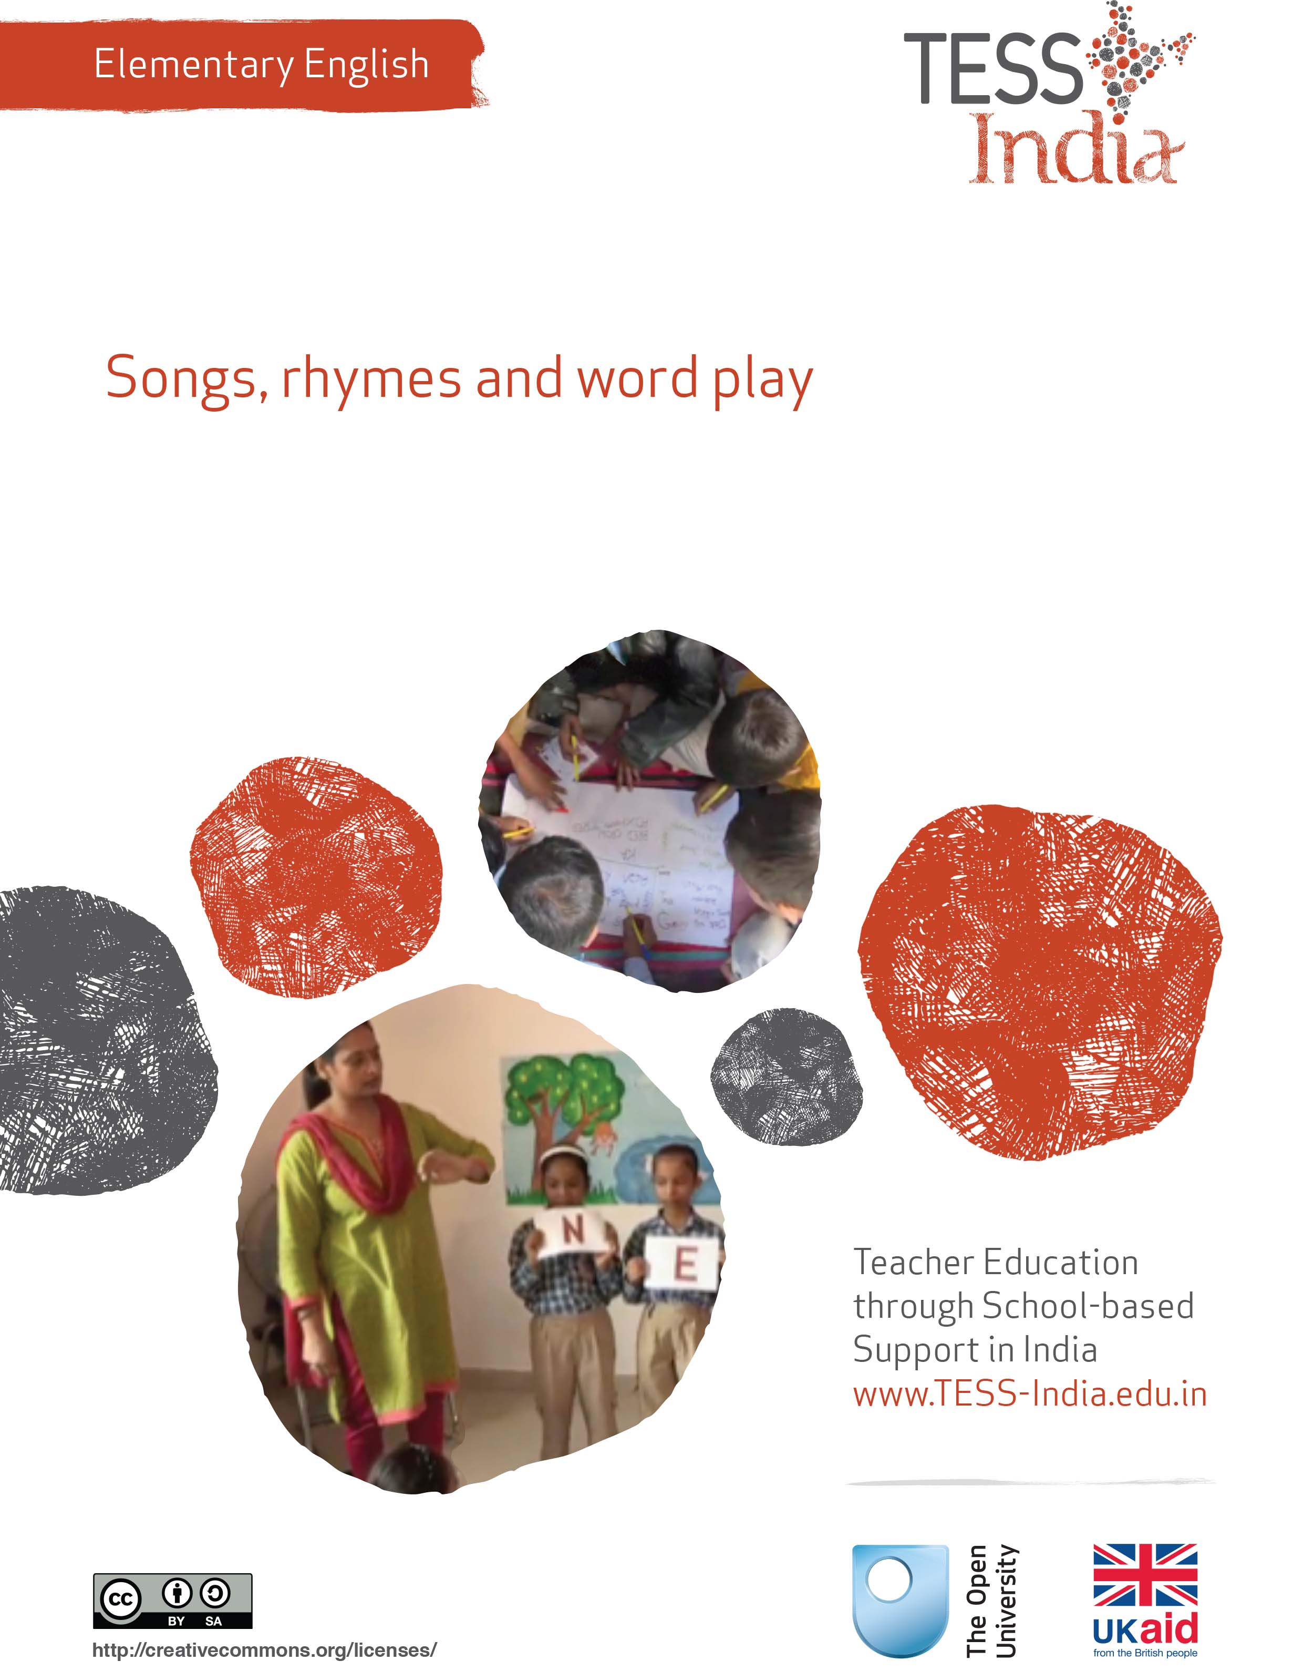
TESS-India (Teacher Education through School-based Support) aims to improve the classroom practices of elementary and secondary teachers in India through the provision of Open Educational Resources (OERs) to support teachers in developing student-centred, participatory approaches. The TESS-India OERs provide teachers with a companion to the school textbook. They offer activities for teachers to try out in their classrooms with their students, together with case studies showing how other teachers have taught the topic and linked resources to support teachers in developing their lesson plans and subject knowledge.
TESS-India OERs have been collaboratively written by Indian and international authors to address Indian curriculum and contexts and are available for online and print use (http://www.tess-india.edu.in/). The OERs are available in several versions, appropriate for each participating Indian state and users are invited to adapt and localise the OERs further to meet local needs and contexts.
TESS-India is led by The Open University UK and funded by UK aid from the UK government.
Video resources
Some of the activities in this unit are accompanied by the following icon: . This indicates that you will find it helpful to view the TESS-India video resources for the specified pedagogic theme.
The TESS-India video resources illustrate key pedagogic techniques in a range of classroom contexts in India. We hope they will inspire you to experiment with similar practices. They are intended to complement and enhance your experience of working through the text-based units, but are not integral to them should you be unable to access them.
TESS-India video resources may be viewed online or downloaded from the TESS-India website, http://www.tess-india.edu.in/). Alternatively, you may have access to these videos on a CD or memory card.

Version 2.0 EE02v1
All India - English
Except for third party materials and otherwise stated, this content is made available under a Creative Commons Attribution-ShareAlike licence: http://creativecommons.org/licenses/by-sa/3.0/

What this unit is about

This unit is about how you can make English language learning an enjoyable experience for your students. Language learning does not need to be stressful, and should not be stressful, especially in the early years of school.

Students love to sing, chant, recite rhymes, make sounds and make up nonsense words that have no meaning. This is more than just having fun – this is language learning in action. Songs, rhymes and word play are ‘pre-reading’ activities. Hearing and practising the sounds of English prepares students to recognise and read these sounds on the written page.

What you can learn in this unit
- To recognise indicators of English pre-reading skills.
- To use songs and rhymes to develop your students’ English.
- To use poetry to develop your students’ English.

1 What do pre-readers know?
You start by thinking about what pre-readers know about language and how it works, in an activity for you.

Activity 1: What do pre-readers know?
First read the short description of Sanjay, below. Then answer the questions that follow.
Sanjay is four years old. He loves rhyming games and rhyming jokes, even when he doesn’t completely understand the meanings. For instance, he likes to play this word game with his older brothers:
Q: What is Bruce Lee’s finger called? A: Ungli (finger)
Q: What is his sister-in-law called? A: Saali (sister-in-law/derogatory word)
Q: Who is his gardener? A: Maali (gardener)
Q: What is Bruce Lee’s favourite vegetable? A: Muulee (radish)
Q: What is Bruce Lee’s favourite breakfast? A: Idli (south Indian rice cakes)
Q: … festival? A: Diwali
Q: … music? A: Qawwali
Q: … film? A: Coolie
Q: … animal? A: Billee (cat)
Q: … brain? A: Yours! Because it is khaalii (empty)!
Now answer these questions:
- Why do you think Sanjay and his brothers like to play this game?
- What do they know in order to play it?
- Can you identify the rule behind this game?
- Do you know any other similar games? Could you create one yourself?
Sanjay’s game is imaginative and creative, and also silly and fun. The game develops vocabulary. These elements combined make language learning memorable for children. The rule behind this game is that the ending sound of each word must rhyme. Each word must also make sense and be familiar. Children who can hear and predict rhyming words are learning important pre-reading skills. They are hearing the sounds of language and will match these sounds to written words later on.

Pause for thought
Think about the students in your class. Do they know rhymes and short poems in their own language, or in English? Do they play any games with language? Can they recognise rhyming words?

2 Singing poetry
Now try this activity.

Activity 2: Singing poetry
There are many poems that are short and easy to memorise. Poems are a good way to introduce students to the sounds of language, even if the words are initially unfamiliar. This will encourage language learning in an enjoyable way. In this activity, you will choose a short poem to teach your class.
Here is a rhyme in Hindi. Can you identify the rhyming words?
Akkad bakkad bambe bo,
Assi nabbe poore sau,
Sau mein laga dhaga,
Chor nikal ke bhaga.
Now read the poems in Resource 1. You may be familiar with some of them. Read the short commentary that follows the poems.
Choose one of the poems and read it aloud to yourself. Identify the rhyming words in the poem.
Try to memorise the poem and recite it to another person. Are there actions you can put to the poem? Can you associate the poem with any movements, such as dancing in a circle?
Now choose a rhyme or a song – either one from Resource 1 or one that you are familiar with – to use with your class. Recite it or sing it with your students. You can do this outside the classroom, and put students in a large circle or in two lines (Figure 1).
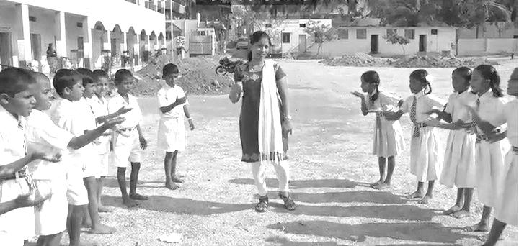
Figure 1 You can do this activity outside the classroom,
with the students in a large circle or in two lines.
Do you notice any students who have difficulty distinguishing rhyming patterns and rhyming words? Make a note of this – it may indicate a hearing impairment.
All languages have rhymes for young students. Some are funny, some are serious – and some can be a bit rude! These rhymes provide students with language experience. Because rhymes are easy to remember and recite, they build fluency and confidence in young language learners. They also build knowledge of the sounds in words – an important pre-reading skill. A student who knows rhymes in any language develops confidence, creativity and skills for language and reading.
In Case Study 1, the teacher notices that her students enjoy rhymes. She builds on this interest to develop their English.
Case Study 1: Miss Pratima uses a rhyming game for English
Miss Pratima developed a rhyming game from her textbook lesson for Class II.
I taught a textbook poem about animals. One afternoon, I saw the students playing a clapping game outside. I could hear them saying some of the words from the textbook poem. They were also saying words in English that were not in the lesson. Sometimes they were making up words that made no sense but rhymed with the English words. They were jumping up and down, clapping in a rhythm, and chanting:
‘Frog!’
‘Log!’
‘Dog!’
‘Pog!’
Their game was not part of my lesson. I thought about how I could build on their interest in playing a game with rhyming words.
The next textbook lesson was ‘What can you carry in your school bag?’ I told my class that they would play a game called ‘The Bowl that Rhymes’ based on this lesson.
I put several small objects into a bowl: a piece of chalk, a spoon, a ball, a pen, a pin and a hat. Some of the objects were in the textbook lesson. Then I explained to the students that I would say a word in English that would rhyme with one of the objects in the bowl. I said ‘moon’, and then I asked a student to take out of the bowl the object that rhymes with ‘moon’ (spoon). I continued until all the objects were selected.
The students enjoyed this game very much and wanted to play it again. Sometimes they used words in Hindi, and sometimes they used completely made-up words. I accepted this, as long as the words they came up with rhymed with the English word.
Later that week, I divided the class into small groups of four students. Each small group played ‘The Bowl that Rhymes’ using objects or picture cards.
I now try to make a short rhyming game or activity for every chapter of the English textbook to reinforce vocabulary. I have students recite rhymes in pairs and make up gestures to go with the rhymes.
See Resource 2, ‘Using pair work’, to learn more about ways to organise students to work as a small team.
Pause for thought
Pratima tried out an activity based on what the students seemed to enjoy doing with language. How did she find out what they enjoy?
Do you think it was a good idea for her to accept Hindi words and nonsense words from the students, as long as they rhymed with the English words?
What are the benefits and possible difficulties of having students do ‘The Bowl that Rhymes’ activity in small groups?
Can you identify opportunities for Pratima to evaluate students in the group activity?

Video: Storytelling, songs, role play, drama
http://tinyurl.com/video-ssrpd

3 What rhymes teach
Rhymes help to build confidence in using English independently. They are a fun way to expand students’ early vocabulary, and they introduce simple sound and sentence patterns. Here is an example of a rhyme:
One, two, three-four-five
Once I caught a fish alive
Six, seven, eight-nine-ten
Then I let it go again.
What vocabulary, sentences patterns and sound patterns does this rhyme teach? Check your ideas with ours:
- Rhyming words and sound patterns: The rhymes are ‘five’ and ‘alive’, and ‘ten’ and ‘again’. You can help students to learn more words that rhyme with these pairs, e.g. ‘dive’, ‘hive’ and ‘arrive’ (they may notice also that ‘give’ does not rhyme with ‘five’), and ‘men’, ‘hen’, ‘pen’, ‘when’ and ‘then’.
- Vocabulary: The number names for one to ten; ‘alive’ (opposite of dead); ‘again’ (once more, to repeat).
- Sentence patterns: These include ‘let …’ (allow, permit) and ‘once …’ (to speak about an incident in the past). You can demonstrate to students and teach them how to use words like these in different ways. Encourage and help students speak about what they want to do and what has happened, using ‘let …’ and ‘once …’. For instance: ‘Let it go!’; ‘Let us out!’; ‘Let me play!’; ‘Let him read’; ‘Let her speak’; ‘Let me come in!’; ‘Let the baby sleep!’; ‘Once upon a time …’; ‘Once I got lost’; ‘Once I ate ten rotis!’; ‘Once I saw a crocodile’; ‘Once I fell down and got hurt’; ‘Once I found a baby bird’.

Activity 3: Using rhymes in English
This is a planning activity for you to undertake in preparation for a lesson.
Go to Resource 3 and choose a short poem, rhyme or song in English to do with your students. You can also find a good rhyme or poem from your English textbook.
Practise saying or singing it in English, and practise doing the related actions. In the poem you chose, make sure you can identify:
- the rhyming words and sound patterns
- the sentence patterns
- key vocabulary.
Make a plan to use the rhyme with your students. Review your plan with a colleague or your headteacher.
Will you incorporate the poem into the English lesson, or do it at some other time?
Where will you teach it – inside the classroom or outside?
Is there a tune you can put to the words? Are there movements or gestures you can use?
What resources will you need? For example, will you use pictures or word cards to help students understand?

4 Using rhymes to teach English in the classroom
Rhymes are a fun way for your students to improve their English and for you to develop your confidence in using spoken English.

Activity 4: Using rhymes to teach English
Over the next few lessons, introduce a short rhyme or a poem in English – you can use the rhyme you prepared in Activity 3 or choose another rhyme or poem. Choose a rhyme that has simple action words. Recite the rhyme several times during the week. Students will need more than one hearing to learn it for themselves.
You could start or end the school day with a short rhyme. Try to introduce a short rhyme each week. You can use short rhymes and songs for classroom management, for example, when moving students from one activity to another, or to focus their attention on you.
Help students remember and use rhyming words. When it is appropriate in a language lesson, help students to identify words in the lesson that rhyme. You can reinforce the learning by writing and reading the rhyming words together on the board.
You can also put rhyming words on the bulletin board for students to read every day. Write the rhyming words in bold letters and in the same colour, to encourage students’ recognition of the same sounds and word endings.
When you evaluate students and build up their records of achievement, note those who can recognise words that sound alike and have similar sound patterns. This is an important pre-reading skill. There is a link between the ability to hear and recognise sounds and the ability to read later on. Students who recognise the sounds of letter patterns and words will begin to apply this knowledge to the printed page. Record your observations about which students can easily identify the rhyming words, and which students can make their own sentences using the words and patterns in the rhyme. Note when they attempt to link their oral knowledge to printed words.
Older students also enjoy rhymes and play with words, and this can help them build their English knowledge and skills. In the next case study the teacher encourages his students to create poems in English.
Case Study 2: Mr Dinesh’s class creates poems
Mr Dinesh’s Class III students are at many different levels of ability in English. He asked them to write poems on the theme of water.
I started by writing some new words on the board, which I called ‘help words’. As the class talked about the theme of ‘water’, more words were added to the list. These words were either noted down in students’ notebooks, kept in the class ‘word box’ or displayed on the bulletin board.
I asked the students to talk in their home language about the games that they play with water: jumping in water that collects on the roadside after rain; throwing water on each other; trying to hold water in their hands; slapping at spilled water with their palm; creating bubbles in water. I asked the students to make drawings of these activities. Then I asked them to describe their drawings in English.
The students came up with bits of sentences, mixing their home language and English, and using nonsense words for sounds, for instance:
‘Chup chup water’
‘Water jump’
‘Water hands’
‘Ravi pipe water’
‘Sapna, water bulbule soap.’
The sentences were not complete and accurate in English, and sometimes the students used nonsense words, but I accepted this because the words and sounds were meaningful and fun for them. I acknowledged the students’ efforts and helped them where necessary, rephrasing their sentences into complete English. Sometimes the students used nonsense words to convey sounds or environments, and they had to create spellings for these words. Together, the class created this poem on water:
Water says chup chup,
Let’s go jump jump.
Let’s play with water,
Come my friend, come come,
Without water, I am not happy.
I continued to do poems linked to other topics. On the theme of ‘transport’, the class created this poem using the sounds of the train:
Train at the station,
Koo chuk chuk chuk chuk,
Sapna takes a ride,
Ha ha ha, wah wah wah wah.
Sometimes I would start the class off with a short phrase or a word, such as ‘little red apple’. I asked students to continue this line, first by talking with each other and making drawings, and then presenting suggestions to create a whole poem:
Little red apple,
Hmm! So juicy,
See! See! See!
Little drop falling,
Drip drip drip.
My students created a number of poems in English. I compiled the poems and drawings in a folder, and bound them together to make a class book of poetry.
The students invited parents to come to school and read their poems. They also performed their poems to a school assembly.
(The poems were created by Class II and Class III of the CIE Experimental Basic School in Delhi, session 2011–12.)

Activity 5: Create a poem
Using the example of Mr Dinesh in Case Study 2, plan a poem exercise with your class.
What topic or theme would interest the students? Remember to begin with some ‘help words’.
When you implement your plan, remember to use what the students contribute. Ask students to talk about their ideas and draw them. You can incorporate local names and places into the poem.
Let them ‘have a go’, using nonsense words if they choose. Remember that it is not always necessary to have rhyming words at the end of each line. Accept errors in students’ spoken English so that they can gain confidence. Students can create spellings for words that represent sounds or noises.
Compile a folder of their poems so that they can re-read their work.
Is there an opportunity for students to perform the poems, at the end of the lesson, or to an assembly for the school or for parents? Providing an audience for your students’ poems will encourage them to practise their spoken English and to gain confidence in their English skills. Make sure that all the students in your class take part in the assembly or performance.

5 Summary
This unit has introduced you to rhyming games, songs and word play. There is a serious purpose to rhymes and play with words. The ability to hear and distinguish similar and different sound patterns and word patterns is an important pre reading skill. Children who have a lot of experience with rhyming poems and stories are often able to read with expression.
We hope you have gained ideas about how to use rhymes in English and in students’ home languages to encourage pre-reading skills and the enjoyment of language.
Other Elementary English teacher development units on this topic are:
- Classroom routines
- Using the textbook creatively
- Learning English in the creative arts
- Letters and sounds of English.

Resources
Resource 1: Singing poetry
By listening to poetry regularly, young students get accustomed to the basic patterns of a language. What is especially useful about poetry in this matter is that it is so easy to store it in one's memory. Small children have to put in no special effort to memorise poetry; just by enjoying it several times and reciting it they make it a part of their permanent collection.
The important question for the teacher is: 'How do I select good poems and where can I find them?' The poems that most primers and textbooks carry are often of a low quality and have little value for the development of language. Similarly, much of the poetry published in Hindi monthly magazines has little worth. Most poems we see in textbooks and magazines are moralistic and dull. They have an artificial sentence structure and vocabulary. They lack the feel of real day-to-day language. This is why they have hardly any value as resources for learning language.
Quite a different kind of poems, are needed for building the foundation of children's reading skills. A selection of such poems in Hindi is given below.
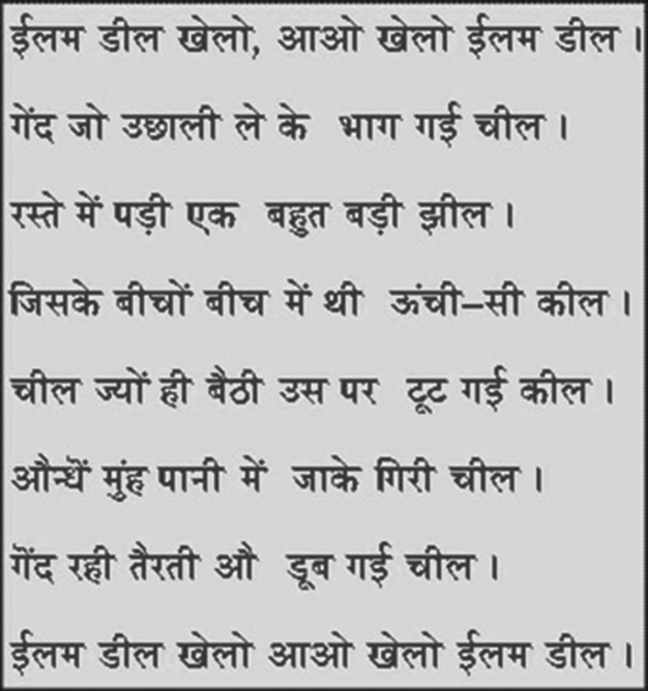
Nirankar Dev Sewak

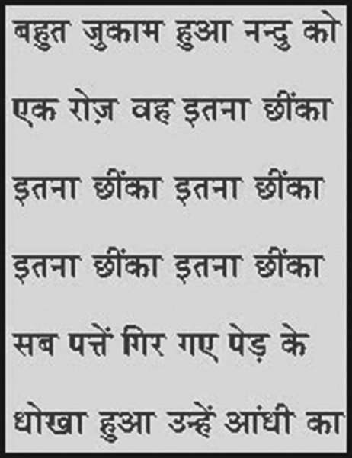
Ram Naresh Tripathi
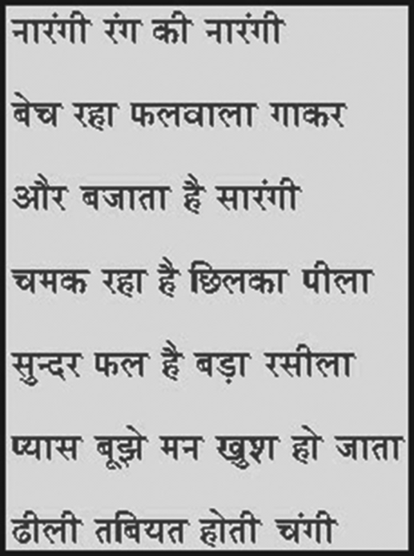
Sudha Chauhan

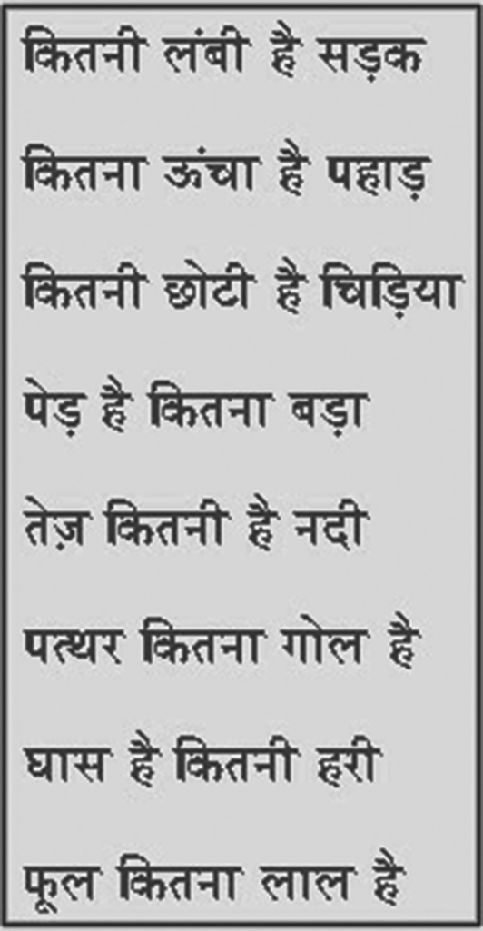
Krishna Kumar
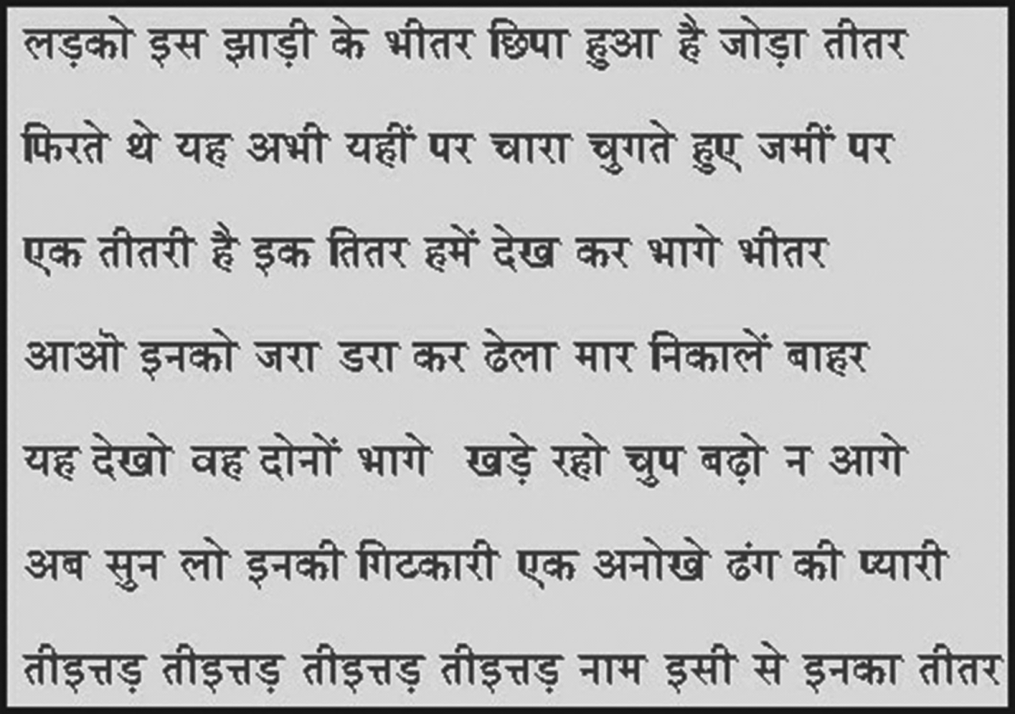
Sridhar Pathak

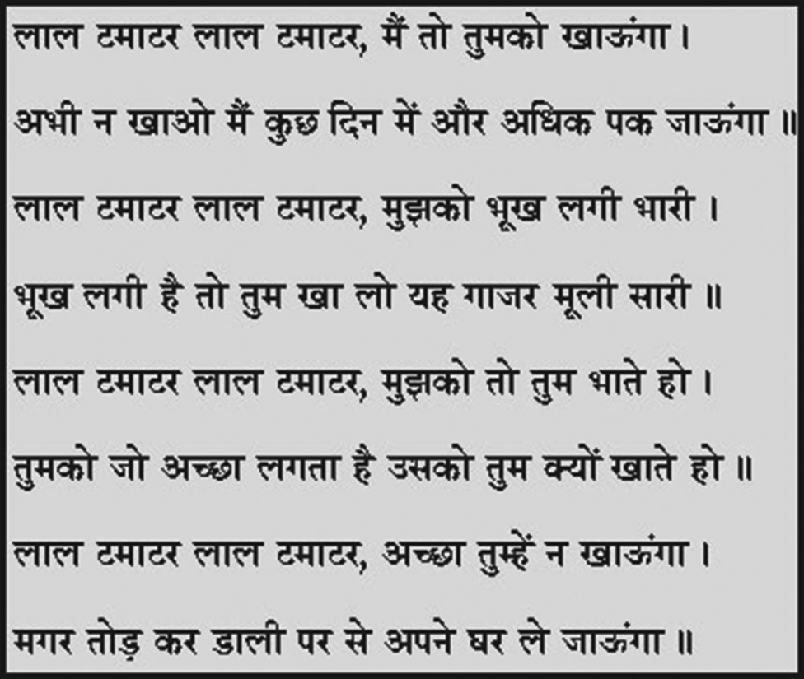
Nirankar Dev Sewak
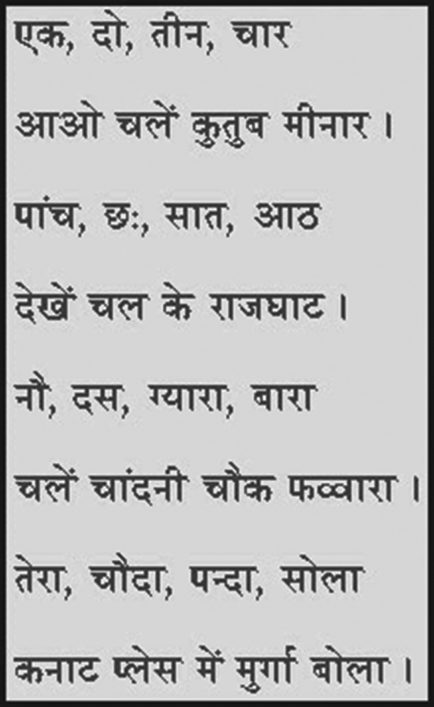
Sarveshwar Dayal Saxena

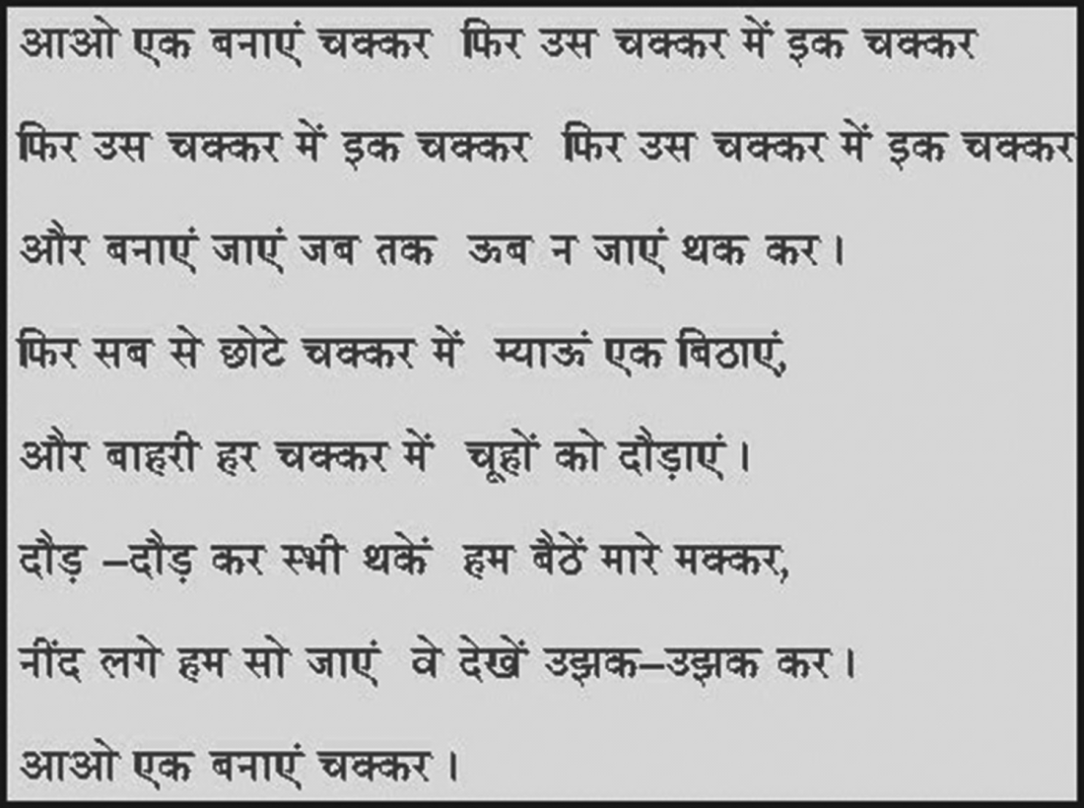
Sarveshwar Dayal Saxena
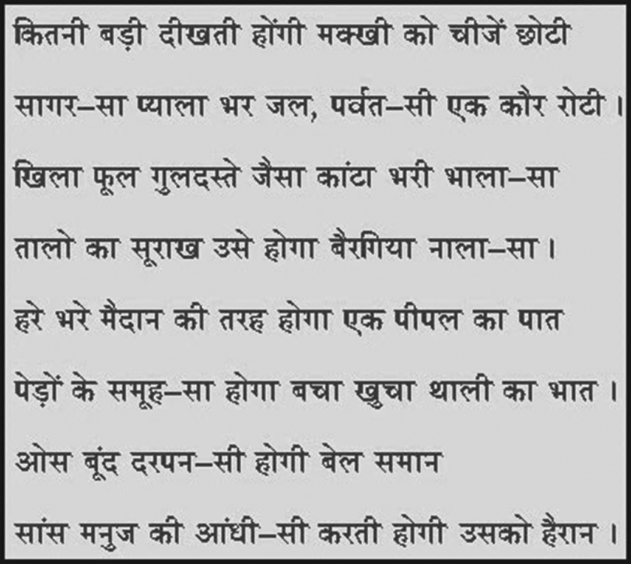
Thakur Srinath Singh

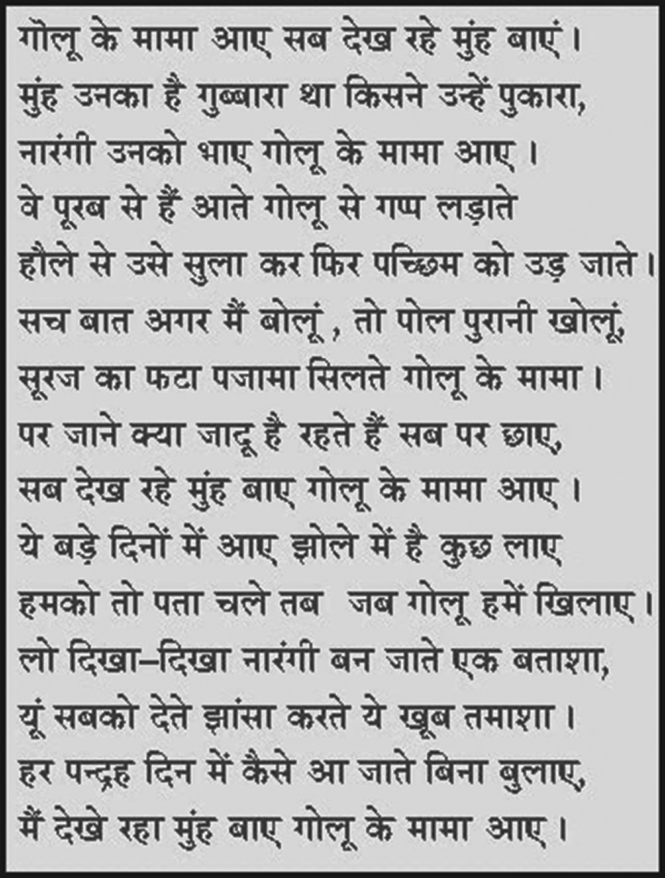
Ramesh Chandra Shah
Such poems can surely be found in all Indian languages, but the teachers who want to find them will have to search very carefully. They will need to keep their eyes open for playful and natural use of language. Also, purely didactic poems will have to be left out.
One thing that any teacher can easily do is to write out the songs that students sing while playing certain games, such as while skipping, jumping and playing ball. These are traditional rhymes, and it may be difficult to collect them in cities. However, with some effort, we can make our own collections of such songs. The collection can take the form of one or more little books with a song written neatly on each page, along with a suitable picture which can either be made or cut out from a magazine or some other source. It is not always necessary that the picture should accurately portray what the poem says. If the picture simply evokes a mood or scene that is vaguely associated with the poem, this is fine. You can prepare several books by yourself in this manner, each one of about 16 pages, using ordinary white paper if you cannot afford the slightly more expensive drawing paper. If you use drawing paper, the book will last longer and you won't have to prepare the same book each year.
The way to read poetry books is the same as for other books, that is, sitting with a group of students with the book in the middle. After two or three occasions, you can sing the poem aloud without the book and ask students to sing with you. They will be able to sing the poem from memory quite soon if the poem is of good quality. Later, when you read it again from the book, they will anticipate the words given on the pages. Students of six can happily copy out a whole poem on a separate piece of paper or slate, and if they know it by heart by that time, they will have little difficulty recognising individual words after a few days.
(Adapted from Kumar, 1986.)
Resource 2: Using pair work
In everyday situations people work alongside, speak and listen to others, and see what they do and how they do it. This is how people learn. As we talk to others, we discover new ideas and information. In classrooms, if everything is centred on the teacher, then most students do not get enough time to try out or demonstrate their learning or to ask questions. Some students may only give short answers and some may say nothing at all. In large classes, the situation is even worse, with only a small proportion of students saying anything at all.
Why use pair work?
Pair work is a natural way for students to talk and learn more. It gives them the chance to think and try out ideas and new language. It can provide a comfortable way for students to work through new skills and concepts, and works well in large classes.
Pair work is suitable for all ages and subjects. It is especially useful in multilingual, multi-grade classes, because pairs can be arranged to help each other. It works best when you plan specific tasks and establish routines to manage pairs to make sure that all of your students are included, learning and progressing. Once these routines are established, you will find that students quickly get used to working in pairs and enjoy learning this way.
Tasks for pair work
You can use a variety of pair work tasks depending on the intended outcome of the learning. The pair work task must be clear and appropriate so that working together helps learning more than working alone. By talking about their ideas, your students will automatically be thinking about and developing them further.
Pair work tasks could include:
- ‘Think–pair–share’: Students think about a problem or issue themselves and then work in pairs to work out possible answers before sharing their answers with other students. This could be used for spelling, working through calculations, putting things in categories or in order, giving different viewpoints, pretending to be characters from a story, and so on.
- Sharing information: Half the class are given information on one aspect of a topic; the other half are given information on a different aspect of the topic. They then work in pairs to share their information in order to solve a problem or come to a decision.
- Practising skills such as listening: One student could read a story and the other ask questions; one student could read a passage in English, while the other tries to write it down; one student could describe a picture or diagram while the other student tries to draw it based on the description.
- Following instructions: One student could read instructions for the other student to complete a task.
- Storytelling or role play: Students could work in pairs to create a story or a piece of dialogue in a language that they are learning.
Managing pairs to include all
Pair work is about involving all. Since students are different, pairs must be managed so that everyone knows what they have to do, what they are learning and what your expectations are. To establish pair work routines in your classroom, you should do the following:
- Manage the pairs that the students work in. Sometimes students will work in friendship pairs; sometimes they will not. Make sure they understand that you will decide the pairs to help them maximise their learning.
- To create more of a challenge, sometimes you could pair students of mixed ability and different languages together so that they can help each other; at other times you could pair students working at the same level.
- Keep records so that you know your students’ abilities and can pair them together accordingly.
- At the start, explain the benefits of pair work to the students, using examples from family and community contexts where people collaborate.
- Keep initial tasks brief and clear.
- Monitor the student pairs to make sure that they are working as you want.
- Give students roles or responsibilities in their pair, such as two characters from a story, or simple labels such as ‘1’ and ‘2’, or ‘As’ and ‘Bs’). Do this before they move to face each other so that they listen.
- Make sure that students can turn or move easily to sit to face each other.
During pair work, tell students how much time they have for each task and give regular time checks. Praise pairs who help each other and stay on task. Give pairs time to settle and find their own solutions – it can be tempting to get involved too quickly before students have had time to think and show what they can do. Most students enjoy the atmosphere of everyone talking and working. As you move around the class observing and listening, make notes of who is comfortable together, be alert to anyone who is not included, and note any common errors, good ideas or summary points.
At the end of the task you have a role in making connections between what the students have developed. You may select some pairs to show their work, or you may summarise this for them. Students like to feel a sense of achievement when working together. You don’t need to get every pair to report back – that would take too much time – but select students who you know from your observations will be able to make a positive contribution that will help others to learn. This might be an opportunity for students who are usually timid about contributing to build their confidence.
If you have given students a problem to solve, you could give a model answer and then ask them to discuss in pairs how to improve their answer. This will help them to think about their own learning and to learn from their mistakes.
If you are new to pair work, it is important to make notes on any changes you want to make to the task, timing or combinations of pairs. This is important because this is how you will learn and how you will improve your teaching. Organising successful pair work is linked to clear instructions and good time management, as well as succinct summarising – this all takes practice.
Resource 3: Classroom songs
‘Butterfly, Butterfly’
This was contributed from a rural school in Karnataka. The teacher has children chant each line after her, at first. Then she puts the children into groups and they take turns to say each line.
What gestures would you use for each line? Can you think of other ‘action’ words to use in this poem?
Butterfly, butterfly,
Where are you going?
Out in the garden,
Singing, singing,
Dancing, dancing!
Butterfly, butterfly,
What are you doing?
Sucking the nectar,
Flying, flying,
Jumping, jumping!
‘Our Zoo’
This is a song from a village school near Lucknow, but you can put in the name of your own town or village. The teacher and students sing it to the tune of ‘Old MacDonald Had a Farm’, but you can make up your own tune.
Lucknow City has a zoo
Ee-ai-ee-ai-oh!
And in this zoo are some tigers
Ee-ai-ee-ai-oh!
A tiger here! (make a tiger noise, roar and show claws!)
A tiger there! (roar!)
Here a tiger, there a tiger, Everywhere a tiger!
Lucknow City has a zoo
Ee-ai-ee-ai-oh!
Repeat with different animals, using sounds and gestures, for example: some monkeys (scratch and jump), some elephants (wave trunk), some lions, some snakes, etc.
‘The Wheels on the Bus’
The wheels on the bus go
Round and round,
Round and round,
Round and round.
The wheels on the bus go
Round and round,
All through the town.
The wipers on the bus go
Swish, swish, swish,
Swish, swish, swish,
Swish, swish, swish.
The wipers on the bus go
Swish, swish, swish,
All through the town.
The horn on the bus goes
Beep, beep, beep,
Beep, beep, beep,
Beep, beep, beep.
The horn on the bus goes
Beep, beep, beep,
All through the town.
The lights on the bus go
On and off,
On and off,
On and off.
The lights on the bus go
On and off,
All through the town.
The driver on the bus says,
‘Sit, sit, sit,
Sit, sit, sit,
Sit, sit, sit.’
The driver on the bus says,
‘Sit, sit, sit,’
All through the town.
The people on the bus …
(Make up your own words.)
The conductor on the bus …
(Make up your own words.)
The wheels on the bus go
Round and round,
All through the town,
All through the town,
All through the town.
‘Action Song’
Hop a little, jump a little,
One, two, three;
Run a little, skip a little,
Tap one knee;
Bend a little, stretch a little
Nod your head
Yawn a little, sleep a little
In your bed!
‘Wiggles’
I wiggle my fingers,
I wiggle my toes,
I wiggle my shoulders,
I wiggle my nose.
Now no more wiggles
Are left in me
And I will be
As still as can be.
‘Dance Your Fingers’
(Have students mimic your actions – dancing fingers in the air and on the body.)
Dance your fingers up,
Dance your fingers down,
Dance your fingers to the side,
Dance them all around.
Dance them on your shoulders,
Dance them on your head,
Dance them on your tummy,
And put them all to bed.
(Rest head on hands together at side of face.)

Additional resources
- Teachers of India classroom resources: http://www.teachersofindia.org/en

References/bibliography
Amritavalli, R. (2007) English in Deprived Circumstances: Maximising Learner Autonomy. Department of Linguistics, The English and Foreign Languages University, University Publishing Online: Foundation Books.
Cummins, J. (undated) ‘BICS and CALP’ (online), Jim Cummins’ Second Language Learning and Literacy Development Web. Available from: http://iteachilearn.org/cummins/bicscalp.html (accessed 2 July 2014).
Cummins, J. (2000) Language, Power, and Pedagogy: Bilingual Children in the Crossfire. Bristol: Multilingual Matters.
Gibbons, P. (2002) Scaffolding Language, Scaffolding Learning: Teaching Second Language Learners in the Mainstream Classroom. Portsmouth: Heinemann.
Krashen, S. (1981) Second Language Acquisition and Second Language Learning. Oxford: Pergamon Press.
Krashen, S. (1982) Principles and Practice in Second Language Acquisition. Oxford: Pergamon Press.
Kumar, K. (1986) The Child’s Language and the Teacher: A Handbook. United Nations Children’s Fund.
Mohan, B. (1986) Language and Content. Reading, MA: Addison-Wesley.
Mohan, B., Leung, C. and Davison, C. (eds) (2001) English as a Second Language in the Mainstream: Teaching, Learning and Identity. New York, NY: Longman.
Wells, G. (2003) ‘Children talk their way into literacy’, published as ‘Los niños se alfabetizan hablando’ in García, J.R. (ed.) Enseñar a escribir sin prisas… pero con sentido. Sevilla, Spain: Publicaciones MCEP. Available from: http://people.ucsc.edu/~gwells/Files/Papers_Folder/Talk-Literacy.pdf (accessed 8 July 2014).
Wells, G. (2009) The Meaning Makers: Learning to Talk and Talking to Learn, 2nd edn. Bristol: Multilingual Matters.

Acknowledgements
Except for third party materials and otherwise stated below, this content is made available under a Creative Commons Attribution-ShareAlike licence (http://creativecommons.org/licenses/by-sa/3.0/). The material acknowledged below is Proprietary and used under licence for this project, and not subject to the Creative Commons Licence. This means that this material may only be used unadapted within the TESS-India project and not in any subsequent OER versions. This includes the use of the TESS-India, OU and UKAID logos.
Grateful acknowledgement is made to the following sources for permission to reproduce the material in this unit:
Resource 1: extract from Kumar, K. (1986) The Child’s Language and the Teacher: A Handbook. United Nations Children’s Fund.
Every effort has been made to contact copyright owners. If any have been inadvertently overlooked the publishers will be pleased to make the necessary arrangements at the first opportunity.
Video (including video stills): thanks are extended to the teacher educators, headteachers, teachers and students across India who worked with The Open University in the productions.

