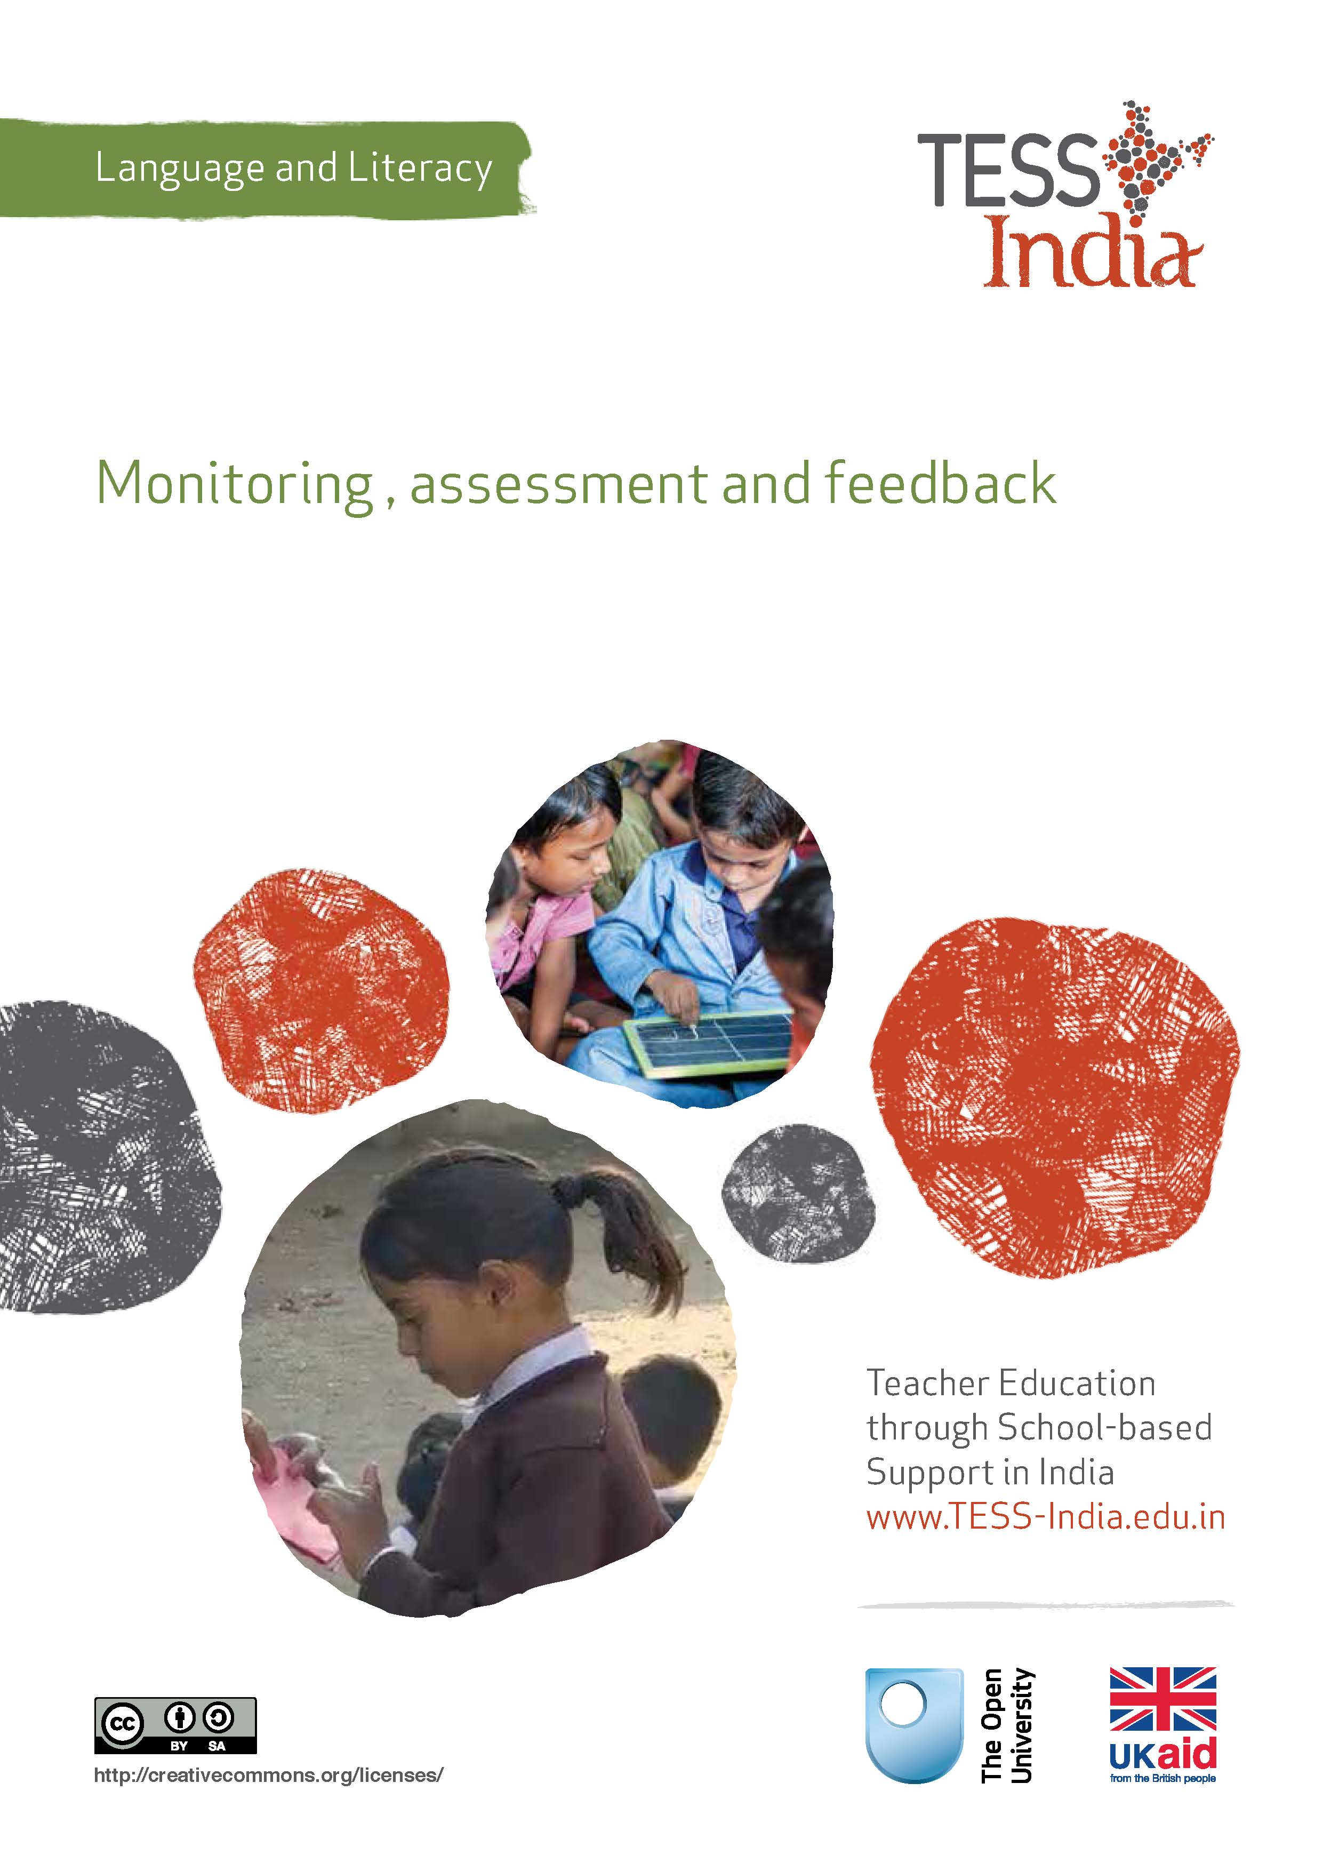
TESS-India (Teacher Education through School-based Support) aims to improve the classroom practices of elementary and secondary teachers in India through the provision of Open Educational Resources (OERs) to support teachers in developing student-centred, participatory approaches. The TESS-India OERs provide teachers with a companion to the school textbook. They offer activities for teachers to try out in their classrooms with their students, together with case studies showing how other teachers have taught the topic and linked resources to support teachers in developing their lesson plans and subject knowledge.
TESS-India OERs have been collaboratively written by Indian and international authors to address Indian curriculum and contexts and are available for online and print use (http://www.tess-india.edu.in/). The OERs are available in several versions, appropriate for each participating Indian state and users are invited to adapt and localise the OERs further to meet local needs and contexts.
TESS-India is led by The Open University UK and funded by UK aid from the UK government.
Video resources
Some of the activities in this unit are accompanied by the following icon: . This indicates that you will find it helpful to view the TESS-India video resources for the specified pedagogic theme.
The TESS-India video resources illustrate key pedagogic techniques in a range of classroom contexts in India. We hope they will inspire you to experiment with similar practices. They are intended to complement and enhance your experience of working through the text-based units, but are not integral to them should you be unable to access them.
TESS-India video resources may be viewed online or downloaded from the TESS-India website, http://www.tess-india.edu.in/). Alternatively, you may have access to these videos on a CD or memory card.

Version 2.0 LL15v1
All India - English
Except for third party materials and otherwise stated, this content is made available under a Creative Commons Attribution-ShareAlike licence: http://creativecommons.org/licenses/by-sa/3.0/

What this unit is about
In this unit you will reflect on ways of monitoring, assessing and giving feedback on your students’ language and literacy development. You will learn how continuous monitoring, assessment and feedback can give you insights into your students’ progress, and how these insights can inform your subsequent lesson planning and teaching.

What you can learn in this unit
- How to incorporate regular informal monitoring, assessment and feedback opportunities into your language lessons.
- How to consider the implications of student assessment on your subsequent teaching plans.
- How to involve your students in self- and peer assessment.

Why this approach is important
Examinations provide information about students’ achievements once or twice a year and generally focus on their reading and writing skills. However, there are opportunities to monitor, assess and provide feedback on your students’ progress in every lesson. ‘Feedback’ in this context means constructively informing students of their performance in respect of a particular learning objective and guiding them as to how to improve or build on this.
Monitoring, assessment and feedback can relate to many aspects of students’ listening, speaking, reading and writing development. By gathering information on your students in a continuous way, and identifying those students who are experiencing difficulty or those who are ready for further challenges, you can adjust your teaching to better meet the needs of everyone in the class. This unit shows you how teaching, monitoring, assessment and giving feedback can be integrated into your regular classroom practice.

1 Attitudes and practices regarding monitoring, assessment and feedback
What are your attitudes and practices regarding monitoring, assessment and feedback? Try Activity 1 to find out.

Activity 1: Attitudes and practices
Together with a colleague, read the statements that follow. Decide if you agree or disagree with them either completely or in part. Give reasons for your views.
- Children find examinations worrying and stressful. This can cause them to underperform.
- Tests and examinations are often carried out at the end of a period of learning and are not usually accompanied by feedback. This means that their outcomes cannot be acted upon in a timely and continuous manner.
- Tests and examinations assess aspects of language learning such as comprehension, grammar and vocabulary, but not the skills of listening or speaking.
- Teachers are usually too busy during their lessons to monitor their students at the same time.
- Students tend to ignore the feedback provided on their work. They are only interested in their overall grade.
- Keeping assessment records can be time-consuming. Moreover, the records do not always provide a real picture of a student’s capabilities.

Pause for thought
- What are the implications of your responses to the above statements for your own classroom practice? What changes can you make to address these points?
- What information do you consider most useful when you assess your students?

2 Monitoring your class

Activity 2: Monitoring and giving feedback
Read Resource 1, ‘Monitoring and giving feedback’. Annotate the document as you read it, noting the ideas that you already implement, the ones that appeal to you and that you could easily implement, and any questions that you have. Do this with a colleague and compare your notes, if possible.

Video: Monitoring and giving feedback
http://tinyurl.com/video-monitoringandfeedback
The next two activities – which should be undertaken on different days – invite you to purposefully monitor your students as they work.

Activity 3: Monitoring the whole class
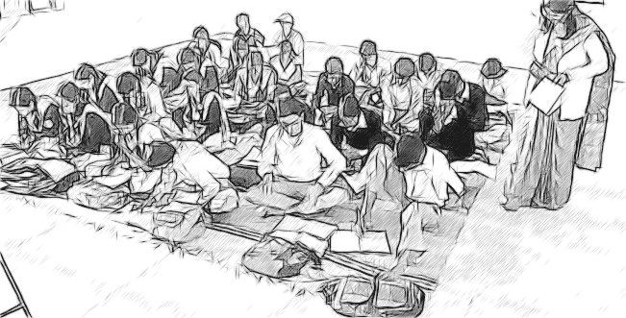
Figure 1 Monitoring the whole class.
Give your students some classwork to do independently and silently for approximately 15 minutes. A short textbook-based reading or writing activity would be ideal for this. While your students are working, stand back and observe them. Consider the following questions:
- What kinds of things are your students doing?
- Do any of them appear unsure of what to do? How do you know?
- Are your students working at different speeds? How can you tell?
- What can the quicker ones do when they finish?
- Do you anticipate that some of the students will not finish within the time set? How can they be supported?
- How will you evaluate your students’ learning from the task you have set them?

Activity 4: Monitoring groups
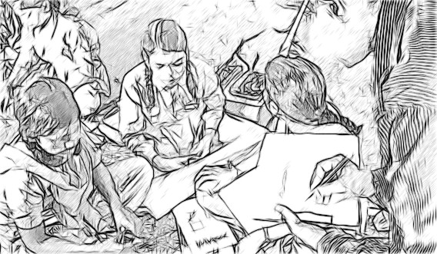
Figure 2 Monitoring groups.
Divide your class into groups of five or six and ask them to do a short talk-based task. This could involve making up a story to accompany a picture or responding to a problem or a controversial question. The group discussion should last no more than 15 minutes. Remind your students how to work politely together, taking turns and listening to one another’s contributions.
Walk around the class, observing and listening to your students as they talk.
Consider the following questions:
- What kinds of things are your students doing?
- Did they understand your instructions? How can you tell?
- How have they organised themselves for the task?
- Do they need additional support? If so, what kind?
- Are any students silent?
- Are any students especially confident?
- How will you evaluate your students’ participation in and learning from the task?

Pause for thought
Activities 3 and 4 invited you to observe and monitor your students as they undertook language- and literacy-related tasks individually and in a group.
- How did the two observation tasks compare?
- How easy was it to observe your students both individually and in a group?
- What did you learn from doing so?
- How could you record this information?
Watchful monitoring is one of the core skills of an effective teacher because it helps them gauge the extent to which their students make learning gains from the tasks they are set.
Whether such monitoring involves the whole class, small groups or individual students, the following question should be at the forefront of the teacher’s mind: how is this lesson being experienced and understood by my students?

3 Different approaches to student assessment and feedback
In Case Study 1 you will read about two teachers’ approaches to student assessment and feedback.
Case Study 1: Two teachers’ approaches to student assessment and feedback
Ms Asan teaches Class IV in a rural school near Indore.
Recently I finished teaching ‘’ (‘Bus ke niche bagh’, or ‘A tiger under the bus’).
I decided to follow this by testing my students’ spelling skills. I wrote ten difficult words from the lesson on the blackboard and asked my students to copy them out in their notebooks and prepare to be tested on them the next day.
The following morning, I read out the words in turn and asked my students to write them down. I took in their notebooks, marked their work and returned it to them.
Many students got full marks. Some made spelling mistakes and scored less well. I asked the students with the highest scores to raise their hands, then those with the lowest to raise theirs. I told those who did less well to practise writing the words again at home.
Mr Dubashi teaches Class V in a large school in Kanpur.
I wanted to assess my students’ spelling of the words they had encountered over the last few lessons. I began by announcing: ‘Today we will have a dictation activity.’
I asked my students to work in groups of four. I explained that I would read out five short sentences and that they had to listen to each sentence carefully before they started writing it out. I checked that everyone had understood my instructions. I then dictated the sentences, giving my students time to write them in turn.
When they had finished, I asked my students to discuss their sentences with the other members of their group, comparing their work and making any corrections if necessary. Finally, I told them to compare their sentences with those I had written out on the blackboard.
During the activity, I walked around the classroom and observed who was participating in the discussion, who wrote their sentence correctly the first time and who needed to correct their work subsequently. I noted these observations in my assessment book.
The next day, I described to the whole class the typical spelling problems I noticed in the activity the day before. I did this to ensure that those students who had had difficulties with the task were not made to feel exposed.
I now do an activity of this kind at the end of every topic. My students seem to look forward to it. I have found that it is most effective if I include a student with a higher level of attainment in each group, as they can support the others.

Pause for thought
- What are your reactions to Ms Asan and Mr Dubashi’s distinct approaches to assessing their students’ spelling ability?
- What do you think are the advantages and disadvantages of each approach?
- Which of the approaches most closely reflects your current classroom practice?
Ms Asan’s approach to assessment has the advantage of taking very little class time. However, it separates testing from other learning and draws attention to those students who do not perform well. Mr Dubashi’s approach to assessment takes longer, but actively involves his students in this process, incorporates talk for learning, is supportive of those who experience difficulties with spelling and provides helpful feedback afterwards. The spelling test is also more meaningful in that the words are embedded in sentences rather than being assessed out of context. This approach is more likely to result in long term learning gains.

4 Encouraging students to evaluate their own writing
Traditionally, assessment of learning has been considered solely the teacher’s responsibility. Increasingly, however, teachers in many countries have started to realise that students can and should be involved in assessing their own progress. Self-monitoring or self-assessment draws on the ability that students have to judge their own work and identify ways of improving it.
Now read Case Study 2.
Case Study 2: Using a marking ladder
Ms Mayuri is a teacher in Patna. Here she describes a self-assessment tool that she has used successfully with her Class V students.
When reading a teaching publication, I learned about something called a ‘marking ladder’. I decided to try it out with my students. In a marking ladder, the student collaborates with me to evaluate a piece of their writing. I set the learning objectives, and we both decide if they are met. [An example is shown in Table 1.]
Table 1 An example of a marking ladder that assesses imaginative story writing. (Adapted from Symons and Currans, 2008)
Student’s name | Shashi Sure
Class | V
Writing task | Imaginative story writing

Student | Writing objectives | Teacher
 | My story is set in an imaginary place or time.
 | It describes what can be seen or heard or touched.
 | There are make-believe characters. | There could have been more of these in your story. A made-up bird, perhaps?
 | I used special effects such as magic.
I’m not sure how to do this. I did try. | I used some made-up words. | You had a good try. Don’t worry, we can talk about this.
 | I used adjectives to create atmosphere. | A few more would have been good.
What I could do to improve my story | I need to read through my story several times. I need to be more careful with my spellings. I need to learn about made-up words. I need to think about my story before I start writing it.
With a marking ladder, the student first evaluates themselves (left-hand column) against the learning objectives that I have set. I then assess their work and give them brief written feedback (right-hand column). They then write out what they plan to do next (final row). This process not only engages students in monitoring their progress but gives them additional reading and writing practice.
I can use the assessment ladder with different areas of writing development, whether creative or information-based, and with students of all abilities, adapting their learning objectives accordingly.
Sometimes I pair an older or more able student with a younger or less confident one, to evaluate a piece of work together. My students keep their marking ladders in their exercise books so that I can review their progress over time.
Being involved in their own assessment is very motivating to my students. I have noticed improvements in their work as a result of our two-way written exchanges.

Pause for thought
- How do you feel about this kind of joint assessment between students and teachers? What are the benefits? What are the possible challenges?
- How can the information from marking ladders contribute to your lesson planning?

Activity 5: Constructing a marking ladder
Using the example in Table 1 as a guide, construct your own marking ladder for the area of writing development that your students are involved in.
Table 2 shows the beginnings of a marking ladder that assesses descriptive writing. You can adapt the ladder to whatever best suits your lesson.
Table 2 The start of a marking ladder that assesses descriptive writing.
Student’s name
Class
Writing task | Descriptive writing
Student | Writing objectives | Teacher
 | I make it clear what is being described.
 | I include a variety of adjectives.
 | I use clear, precise language.
What I could do to improve my story
Once you have devised your marking ladder, photocopy it and distribute it among your students. Explain to them how it works, using an example of a completed version if possible.
Try using the ladder over a period of a month or term, ensuring that all your students are given feedback over that period.

Pause for thought
- How did you find the experience of using a marking ladder with your students?
- How did they respond?
- Did you notice any benefits in their language and literacy development as a result of using the marking ladder?
- In what ways did you use this assessment technique to inform your lesson planning?
Resource 2, ‘Assessing progress and performance’, provides more information and suggestions on effective assessment practice.
Video: Assessing progress and performance
http://tinyurl.com/video-assessingprogress

5 Summary
This unit has focused on ways of integrating monitoring, assessment and feedback activities into your students’ language classes on an ongoing basis. Such practices can provide valuable information on your students’ evolving speaking and writing skills, enabling you to adapt your teaching to match the needs of individuals and the class as a whole. With practice, combining teaching, monitoring, assessment and giving feedback will become a natural part of your role in the classroom.

Resources
Resource 1: Monitoring and giving feedback
Improving students’ performance involves constantly monitoring and responding to them, so that they know what is expected of them and they get feedback after completing tasks. They can improve their performance through your constructive feedback.

Monitoring
Effective teachers monitor their students most of the time. Generally, most teachers monitor their students’ work by listening and observing what they do in class. Monitoring students’ progress is critical because it helps them to:
- achieve higher grades
- be more aware of their performance and more responsible for their learning
- improve their learning
- predict achievement on state and local standardised tests.
It will also help you as a teacher to decide:
- when to ask a question or give a prompt
- when to praise
- whether to challenge
- how to include different groups of students in a task
- what to do about mistakes.
Students improve most when they are given clear and prompt feedback on their progress. Using monitoring will enable you to give regular feedback, letting your students know how they are doing and what else they need to do to advance their learning.
One of the challenges you will face is helping students to set their own learning targets, also known as self-monitoring. Students, especially struggling ones, are not used to having ownership of their own learning. But you can help any student to set their own targets or goals for a project, plan out their work and set deadlines, and self- monitor their progress. Practising the process and mastering the skill of self-monitoring will serve them well in school and throughout their lives.

Listening to and observing students
Most of the time, listening to and observing students is done naturally by teachers; it is a simple monitoring tool. For example, you may:
- listen to your students reading aloud
- listen to discussions in pair or groupwork
- observe students using resources outdoors or in the classroom
- observe the body language of groups as they work.
Make sure that the observations you collect are true evidence of student learning or progress. Only document what you can see, hear, justify or count.
As students work, move around the classroom in order to make brief observation notes. You can use a class list to record which students need more help, and also to note any emerging misunderstandings. You can use these observations and notes to give feedback to the whole class or prompt and encourage groups or individuals.

Giving feedback
Feedback is information that you give to a student about how they have performed in relation to a stated goal or expected outcome. Effective feedback provides the student with:
- information about what happened
- an evaluation of how well the action or task was performed
- guidance as to how their performance can be improved.
When you give feedback to each student, it should help them to know:
- what they can actually do
- what they cannot do yet
- how their work compares with that of others
- how they can improve.
It is important to remember that effective feedback helps students. You do not want to inhibit learning because your feedback is unclear or unfair. Effective feedback is:
- focused on the task being undertaken and the learning that the student needs to do
- clear and honest, telling the student what is good about their learning as well as what requires improvement
- actionable, telling the student to do something that they are able to do
- given in appropriate language that the student can understand
- given at the right time – if it’s given too soon, the student will think ‘I was just going to do that!’; too late, and the student’s focus will have moved elsewhere and they will not want to go back and do what is asked.
Whether feedback is spoken or written in the students’ workbooks, it becomes more effective if it follows the guidelines given below.
Using praise and positive language
When we are praised and encouraged, we generally feel a great deal better than when we are criticised or corrected. Reinforcement and positive language is motivating for the whole class and for individuals of all ages. Remember that praise must be specific and targeted on the work done rather than about the student themselves, otherwise it will not help the student progress. ‘Well done’ is non-specific, so it is better to say one of the following:
I was impressed by how you helped your group by reminding them to read aloud.
That’s a good question!
What would make this even better is …
I really liked the way you …

Using prompting as well as correction
The dialogue that you have with your students helps their learning. If you tell them that an answer is incorrect and finish the dialogue there, you miss the opportunity to help them to keep thinking and trying for themselves. If you give students a hint or ask them a further question, you prompt them to think more deeply and encourage them to find answers and take responsibility for their own learning. For example, you can encourage a better answer or prompt a different angle on a problem by saying such things as:
Explain how you came up with that.
That’s a good start, now do some more thinking about …

Think again …

It may be appropriate to encourage other students to help each other. You can do this by opening your questions to the rest of the class with such comments as:
So we have two factors. What other factors might we consider?
Can anyone add to that answer?
I want to see groups helping each other.

Correcting students with a ‘yes’ or ‘no’ might be appropriate to tasks such as spelling or number practice, but even here you can prompt students to look for emerging patterns in their answers, make connections with similar answers or open a discussion about why a certain answer is incorrect.
Self-correction and peer correction is effective and you can encourage this by asking students to check their own and each other’s work while doing tasks or assignments in pairs. It is best to focus on one aspect to correct at a time so that there is not too much confusing information.
Resource 2: Assessing progress and performance
Assessing students’ learning has two purposes:
- Summative assessment looks back and makes a judgement on what has already been learnt. It is often conducted in the form of tests that are graded, telling students their attainment on the questions in that test. This also helps in reporting outcomes.
- Formative assessment (or assessment for learning) is quite different, being more informal and diagnostic in nature. Teachers use it as part of the learning process, for example questioning to check whether students have understood something. The outcomes of this assessment are then used to change the next learning experience. Monitoring and feedback are part of formative assessment.
Formative assessment enhances learning because in order to learn, most students must:
- understand what they are expected to learn
- know where they are now with that learning
- understand how they can make progress (that is, what to study and how to study)
- know when they have reached the goals and expected outcomes.
As a teacher, you will get the best out of your students if you attend to the four points above in every lesson. Thus assessment can be undertaken before, during and after instruction:
- Before: Assessing before the teaching begins can help you identify what the students know and can do prior to instruction. It determines the baseline and gives you a starting point for planning your teaching. Enhancing your understanding of what your students know reduces the chance of re-teaching the students something they have already mastered or omitting something they possibly should (but do not yet) know or understand.
- During: Assessing during classroom teaching involves checking if students are learning and improving. This will help you make adjustments in your teaching methodology, resources and activities. It will help you understand how the student is progressing towards the desired objective and how successful your teaching is.
- After: Assessment that occurs after teaching confirms what students have learnt and shows you who has learnt and who still needs support. This will allow you to assess the effectiveness of your teaching goal.

Before: being clear about what your students will learn
When you decide what the students must learn in a lesson or series of lessons, you need to share this with them. Carefully distinguish what the students are expected to learn from what you are asking them to do. Ask an open question that gives you the chance to assess whether they have really understood. For example:
How can you convince me that you have understood what I have just said?
Who can explain in their own words what we are going to learn and what we have to do today?
Shavi, what do you think you will learn today?

Give the students a few seconds to think before they answer, or perhaps ask the students to first discuss their answers in pairs or small groups. When they tell you their answer, you will know whether they understand what it is they have to learn.

Before: knowing where students are in their learning
In order to help your students improve, both you and they need to know the current state of their knowledge and understanding. Once you have shared the intended learning outcomes or goals, you could do the following:
- Ask the students to work in pairs to make a mind map or list of what they already know about that topic, giving them enough time to complete it but not too long for those with few ideas. You should then review the mind maps or lists.
- Write the important vocabulary on the board and ask for volunteers to say what they know about each word. Then ask the rest of the class to put their thumbs up if they understand the word, thumbs down if they know very little or nothing, and thumbs horizontal if they know something.
Knowing where to start will mean that you can plan lessons that are relevant and constructive for your students. It is also important that your students are able to assess how well they are learning so that both you and they know what they need to learn next. Providing opportunities for your students to take charge of their own learning will help to make them life-long learners.

During: ensuring students’ progress in learning
When you talk to students about their current progress, make sure that they find your feedback both useful and constructive. Do this by:
- helping students know their strengths and how they might further improve
- being clear about what needs further development
- being positive about how they might develop their learning, checking that they understand and feel able to use the advice.
You will also need to provide opportunities for students to improve their learning. This means that you may have to modify your lesson plans to close the gap between where your students are now in their learning and where you wish them to be. In order to do this you might have to:
- go back over some work that you thought they knew already
- group students according to needs, giving them differentiated tasks
- encourage students to decide for themselves which of several resources they need to study so that they can ‘fill their own gap’
- use ‘low entry, high ceiling’ tasks so that all students can make progress – these are designed so that all students can start the task but the more able ones are not restricted and can progress to extend their learning.
By slowing the pace of lessons down, very often you can actually speed up learning because you give students the time and confidence to think and understand what they need to do to improve. By letting students talk about their work among themselves, and reflect on where the gaps are and how they might close them, you are providing them with ways to assess themselves.

After: collecting and interpreting evidence, and planning ahead
While teaching–learning is taking place and after setting a classwork or homework task, it is important to:
- find out how well your students are doing
- use this to inform your planning for the next lesson
- feed it back to students.
The four key states of assessment are discussed below.
Collecting information or evidence
Every student learns differently, at their own pace and style, both inside and outside the school. Therefore, you need to do two things while assessing students:
- Collect information from a variety of sources – from your own experience, the student, other students, other teachers, parents and community members.
- Assess students individually, in pairs and in groups, and promote self-assessment. Using different methods is important, as no single method can provide all the information you need. Different ways of collecting information about the students’ learning and progress include observing, listening, discussing topics and themes, and reviewing written class and homework.
Recording
In all schools across India the most common form of recording is through the use of report card, but this may not allow you to record all aspects of a student’s learning or behaviours. There are some simple ways of doing this that you may like to consider, such as:
- noting down what you observe while teaching–learning is going on in a diary/notebook/register
- keeping samples of students’ work (written, art, craft, projects, poems, etc.) in a portfolio
- preparing every student’s profile
- noting down any unusual incidents, changes, problems, strengths and learning evidences of students.
Interpreting the evidence
Once information and evidence have been collected and recorded, it is important to interpret it in order to form an understanding of how each student is learning and progressing. This requires careful reflection and analysis. You then need to act on your findings to improve learning, maybe through feedback to students or finding new resources, rearranging the groups, or repeating a learning point.
Planning for improvement
Assessment can help you to provide meaningful learning opportunities to every student by establishing specific and differentiated learning activities, giving attention to the students who need more help and challenging the students who are more advanced.

Additional resources
- ‘Using marking ladders to support children’s self-assessment in writing’ by Victoria Symons and Deborah Currans: http://www.campaign-for-learning.org.uk/cfl/assets/documents/CaseStudies/Wooler(%20final%20pdf).pdf
- ‘Using marking ladders to support children’s self-assessment of writing’, a poster by Victoria Symons and Deborah Currans: http://www.campaign-for-learning.org.uk/cfl/assets/documents/CaseStudies/Yr1Wooler.pdf
- Documentation and reports on continuous assessment in elementary education: http://www.ncert.nic.in/departments/nie/dee/publication/report.html#

References/bibliography
Graham, J. and Kelly, A. (2010) ‘Monitoring and assessing writing’, Chapter 6 in Writing under Control: Teaching Writing in the Primary School. London: Routledge.
Graham, J. and Kelly, A. (2012) ‘Monitoring and assessing reading’, Chapter 4 in Reading under Control: Teaching Reading in the Primary School. London: Routledge.
Graves, D. (2003) Writing: Teachers and Children at Work. Portsmouth: Heinemann.
Symons, V. and Currans, D. (2008) ‘Using marking ladders to support children’s self-assessment in writing’ (online), Campaign for Learning. Available from: http://www.campaign-for-learning.org.uk/cfl/assets/documents/CaseStudies/Wooler(%20final%20pdf).pdf (accessed 31 October 2014). Additionally, a poster by the same authors is available from: http://www.campaign-for-learning.org.uk/cfl/assets/documents/CaseStudies/Yr1Wooler.pdf (accessed 31 October 2014).
Tibetan Teachers Professional Development Website (undated) ‘Source Book on Assessment for Classes I–V (Environmental Studies’ (online). Available from: http://www.tibetanteachers.com/book-list-assessment/386-source-book-on-assessment-for-classes-i-v-environmental-studies (accessed 19 November 2014).
Walker, M. (2014) ‘National assessment in India’ (online), Research Developments, Australian Council for Educational Research, 11 March. Available from: http://rd.acer.edu.au/article/national-assessment-in-india (accessed 19 November 2014).

Acknowledgements
Except for third party materials and otherwise stated below, this content is made available under a Creative Commons Attribution-ShareAlike licence (http://creativecommons.org/licenses/by-sa/3.0/). The material acknowledged below is Proprietary and used under licence for this project, and not subject to the Creative Commons Licence. This means that this material may only be used unadapted within the TESS-India project and not in any subsequent OER versions. This includes the use of the TESS-India, OU and UKAID logos.
Grateful acknowledgement is made to the following sources for permission to reproduce the material in this unit:
Table 1: adapted from Symons, V. and Currans, D. (2008) ‘Using marking ladders to support children’s self-assessment in writing’, Campaign for Learning, http://www.campaignforlearning.org.uk.
Every effort has been made to contact copyright owners. If any have been inadvertently overlooked the publishers will be pleased to make the necessary arrangements at the first opportunity.
Video (including video stills): thanks are extended to the teacher educators, headteachers, teachers and students across India who worked with The Open University in the productions.

