Contents

Study Session 3 Introduction to Sanitation and Waste Management 2
Learning outcomes Study Session 3 2
3.1 What are sanitation and waste management 3
3.2 Types of liquid and solid waste 5
3.2.1 Types of liquid waste 5
3.2.2 Types of solid waste 6
3.3 The sanitation ladder and waste hierarchy 7
3.3.1 The sanitation ladder 7
7
3.3.2 The waste hierarchy 9
3.4 Sanitation and waste management in urban areas 10
3.4.1 The trend of urbanisation 10
3.4.2 Environmental challenges 12
3.5 The present state of sanitation and waste management in Myanmar 14
3.5.1 Liquid waste 15
3.5.1 Solid waste 15
Summary of Study Session 3 18
Answers to in-text questions 19
References 21

Study Session 3
Introduction to Sanitation and Waste Management
All humans produce wastes of various types; for example, urine and faeces, wastes from washing and cooking, and solid wastes produced at home and in workplaces, schools, hospitals and other public buildings. All these wastes need to be controlled and managed for the benefit of people and the environment that they live in. Sanitation aims to protect people from contact with waste (particularly faeces) and waste management protects the environment so people can live healthy lives. In urban areas where people live close together and space can be limited, managing these wastes is a particularly difficult problem.
Learning outcomes Study Session 3
When you have studied this session, you should be able to:
- describe the similarities and differences between sanitation and waste management
- describe the sanitation ladder and the waste hierarchy
- describe the particular features of urban areas that influence sanitation and waste management
- understand the current level of sanitation and waste management in Myanmar.

3.1 What are sanitation and waste management
We can think of sanitation as the prevention of human contact with wastes, or as the provision of facilities and services for the safe disposal of human faeces and urine as shown in Figure 3.1. Inadequate sanitation is a major cause of disease world-wide.
Figure 3.1 Sanitation as facilities and services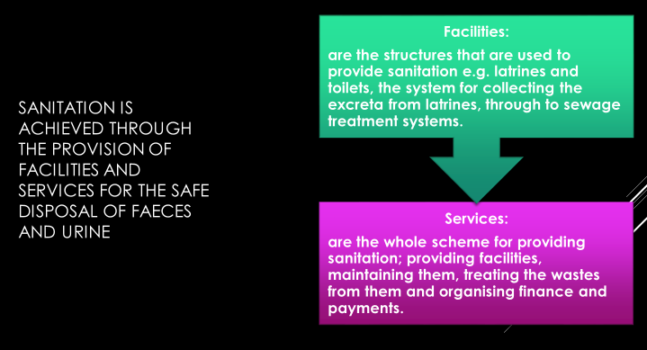
Waste management is the collection, transport, recovery and disposal of waste. The two terms – sanitation and waste management – both refer to waste, but sanitation is primarily concerned with liquid waste and waste management is primarily concerned with solid waste.
Liquid wastes are any wastes in a liquid form such as wastewater and sewage. Faeces and the contents of pit latrines and septic tanks are also classed as liquid wastes. Solid wastes are anything in solid form that is discarded as unwanted.
Throughout this course we will be using the following definitions:
- Sanitation means preventing people from coming into contact with wastes by providing facilities and services for the treatment and disposal of human excreta and other liquid wastes produced in homes, workplaces and public buildings.
- Waste management is the collection, treatment and disposal of solid wastes produced in the home, workplace, and public buildings.
Some of the consequences of a lack of waste management and sanitation can be seen in Figures 3.2.

Figure 3.2 Wastes including paper, plastics and other solid waste, litter the environment and are discharged into a river that may be used as a water source. (Photo: Susan Fawssett)

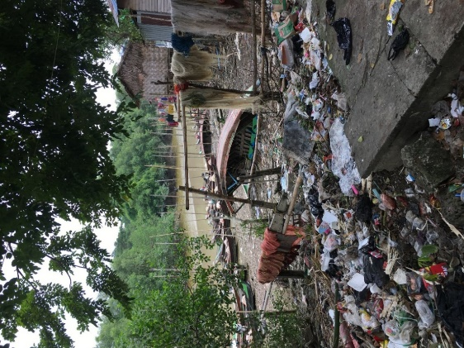

Although sanitation and waste management address different issues using different techniques, they have a number of features in common. For example, they both:
- deal with wastes
- are concerned with safeguarding human health and preventing disease
- cause major problems if not done correctly
- help to reduce environmental pollution (introduction into the environment of substances liable to cause harm)
- need to be paid for by the users, the city authorities, or the government.

3.2 Types of liquid and solid waste
Solid and liquid wastes are usually transported and treated in different ways, so we will consider the two wastes separately. Note that all human excreta (urine and faeces) are considered to be liquid wastes.

3.2.1 Types of liquid waste
A useful general classification of domestic liquid waste is shown in Figure 3.3.
Figure 3.3 Types of domestic liquid waste
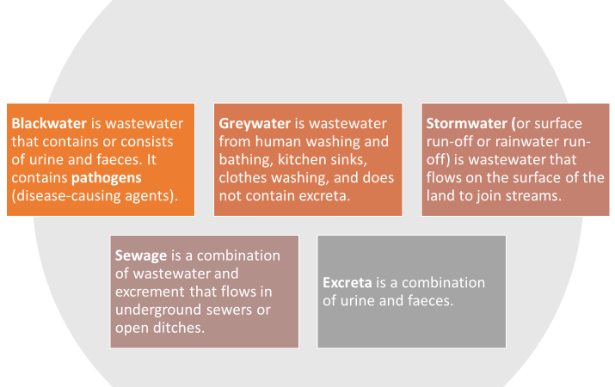

3.2.2 Types of solid waste
There are different ways of classifying solid wastes according to the source of generation or the nature of the waste. Solid waste can be categorised as follows:
- residential waste: from households and residential areas, sometimes called household waste
- commercial waste: from businesses such as food and drink establishments, shops, et cetera
- industrial waste: from various types of industrial processes, e.g. food processing, paper manufacture, manufacture of chemicals and metal processing
- institutional waste: from public and government institutions, e.g. offices, religious institutions, schools, universities, etc. This is similar to residential and commercial waste in composition
- municipal waste (or municipal solid waste) covers all the above wastes produced in an urban area. It is similar in composition to residential waste but excludes some industrial wastes
- healthcare waste: any solid waste produced in hospitals, clinics, health posts and other health facilities
- agricultural waste: waste that comes from farming
- waste from open areas: street sweepings, contents of roadside dustbins, ditches and other public places
- construction and demolition waste: from various types of building and demolition activities in urban areas
- electronic and electrical waste (e-waste): wastes generated from used electronic devices such as computers and TVs and household appliances such as fridges and washing machines.

3.3 The sanitation ladder and waste hierarchy
Generally speaking, all countries are aiming to improve their standards of sanitation and waste management and have many policies and regulations to try and achieve these improvements. The sanitation ladder and the waste hierarchy provide an excellent summary of these aims.

3.3.1 The sanitation ladder
The sanitation ladder provides a measure of progress towards the provision of adequate sanitation facilities for every household as shown in Figure 3.4
Figure 3.4 The WHO/UNICEF Joint Monitoring Programme (JMP) sanitation ladder

SERVICE LEVEL
DEFINITION
OPEN DEFECATION
Disposal of human faeces in fields, forests, bushes, open bodies of water, beaches or other open spaces, or with solid waste.
SAFELY MANAGED
Use of improved facilities which are not shared with other households and where excreta are safely disposed of in situ or transported and treated off-site
LIMITED
Use of improved facilities shared between two or more households
BASIC
Use of improved facilities which are not shared with other households
UNIMPROVED
Use of pit latrines without a slab or platform, hanging latrines of bucket latrines
SANITATION LADDER

The lowest rung of the ladder is open defecation (no service), where people without access to latrines or toilets deposit their faeces in open spaces such as fields, bushes, bodies of water and beaches.
Unimproved facilities are one step up and include latrines that do not ensure the separation of faeces from humans. Examples are pit latrines without a platform, hanging latrines or bucket latrines.
Then comes limited facilities where people use improved facilities, but they are shared with other households, for example a pit latrine with a slab or a composting toilet.
Then there is basic sanitation which is using improved sanitation facilities which are not shared with other households.
Finally, at the top of the sanitation ladder is safely managed facilities where human contact with faeces is avoided and disposed of in one of the following ways:
- treated and disposed in situ
- stored temporarily and then emptied and transported to treatment off-site, or
- transported through a sewer with wastewater and then treated off-site.
Improved sanitation facilities are the three categories at the top of the sanitation ladder, and unimproved sanitation facilities are the bottom two categories. Improved sanitation facilities are those designed to hygienically separate excreta from human contact and include flush/pour to piped sewer system, septic tanks and pit latrines; ventilated improved pit latrines, composting toilets or pit latrines with slabs.

3.3.2 The waste hierarchy
The waste hierarchy is shown in Figure 3.5. The hierarchy ranks the different ways of dealing with waste in order of priority. At the top is waste reduction, which means not generating waste in the first place or minimising the amount of waste produced. Below that is waste reuse (for example, refilling a drinks bottle), followed by recycling (processing of wastes into new raw materials). Then comes the recovery of energy by burning or biological treatment.
Waste disposal, ideally in a landfill site, is the final option for any wastes that cannot be dealt with in any other way. A landfill site is an area of land set aside for the final disposal of solid waste.
Figure 3.5 The waste hierarchy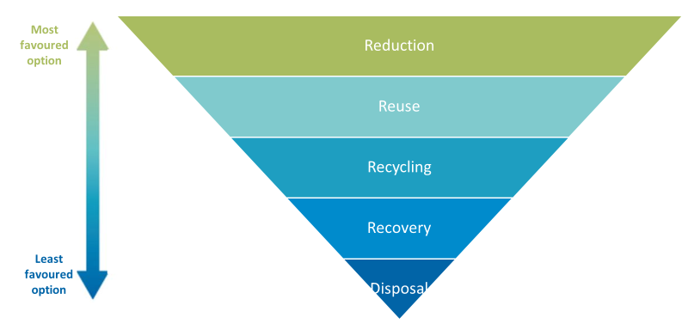

The top three stages of the hierarchy (reduction, reuse and recycling) are often referred to as the ‘3 Rs’.

In-text question 1.1
What are some of the ways that you could reuse wastes at home?

3.4 Sanitation and waste management in urban areas
Sanitation and waste management can cause problems in any community, regardless of its size. In urban areas, where people live close together these problems can have a much greater effect on people’s health and on their surroundings. The following sections explore some of these issues.

3.4.1 The trend of urbanisation
Over half of the world’s population live in urban areas. The United Nations Department of Economic and Social Affairs (2014) predicts that between 2014 and 2050 the global urban population will rise from 3.9 billion to 6.4 billion people, and that about 90% of this increase will be in Asia and Africa. Figure 3.7 looks at the percentage urban population in each of the ASEAN countries in 2019.
Figure 3.6 Urbanisation in the ASEAN countries 2019 (Plecher, 2020)

In-text question 1.2
Explain what Figure 3.6 shows about Myanmar’s urban population relative to other ASEAN nations?

Figure 3.7 Urban population growth rate of Myanmar from 2009 to 2019 (World Bank, 2020)

Figure 3.8 Flooding in an informal settlement of Yangon
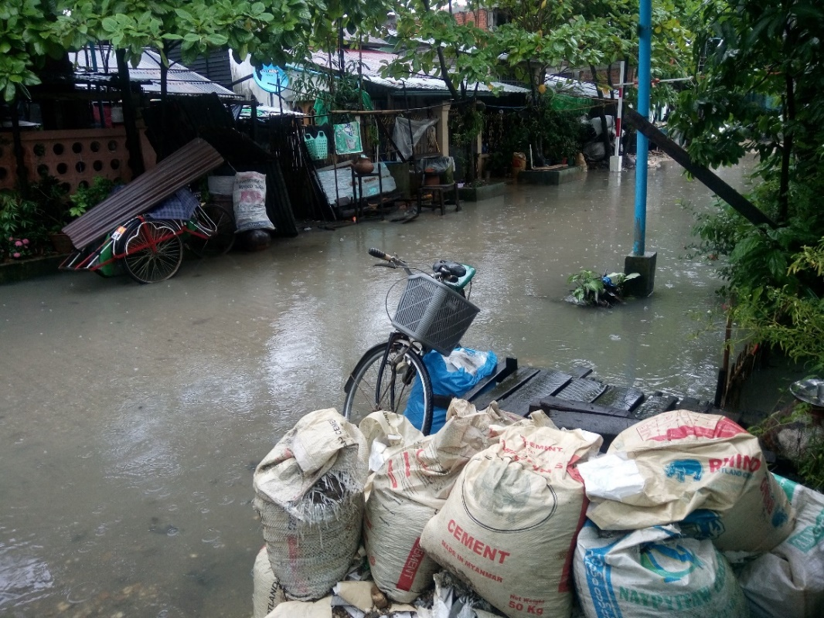
Rapid urbanisation creates a number of additional health risks to the population (Bai et al., 2012) to add to those caused by inadequate sanitation and waste management. These include:
- infectious diseases among crowded communities with substandard living conditions
- acute and chronic respiratory and other illnesses caused by air pollution
- chronic and non-communicable diseases that are on the rise with unhealthy urban lifestyles (physical inactivity, unhealthy diets, tobacco smoking, and the harmful use of alcohol)
- injuries resulting from motor vehicle collisions, violence and crime
- health risks related to climate change, such as heat stress and changed patterns of infectious disease, which are considered to be one of the biggest health risks in the twenty-first century.
In the next section we will look at some of these challenges in more detail.

3.4.2 Environmental challenges
Even without the influxes from rural areas, urban centres are congested and crowded. They have often grown without any planning, so the problems arising from the lack of sanitation, waste management and other infrastructure are present. Urban growth also means that there is an increase in the area of land covered with concrete and other hard surfaces.

In-text question 1.3
Why would an increase in the area of land covered with concrete or other hard surface be a problem?

Challenges from industrial discharges
Most industries in developing countries discharge untreated or partially treated liquid wastes to sewers, where these are available, or to rivers, streams or ditches. Industries also release waste gases that may contain harmful substances and produce solid wastes that may contain hazardous materials (such as poisons, strong acids, infectious material, et cetera that can cause harm to humans because of their properties). As a result, unregulated industries can harm human health and the environment in many ways.

Challenges from transport
We have already mentioned problems from traffic congestion, but the use of a large number of often badly maintained petrol- and diesel-fuelled cars, lorries and buses cause additional health problems. The exhaust gases from these vehicles contain fine particles, partly burned fuel and acidic substances that make breathing difficult and cause irritation of the lungs. While this is a problem for all people, it is much worse for the old, the very young and the ill, especially those with heart problems or who suffer from asthma.

3.5 The present state of sanitation and waste management in Myanmar
The WHO/UNICEF Joint Monitoring Programme (JMP) data for sanitation coverage in Myanmar in 2019 is shown in Figure 3.9.
Figure 3.9 Sanitation services accessed by people living in urban areas, rural areas and by the total population of Myanmar (JMP, 2020)

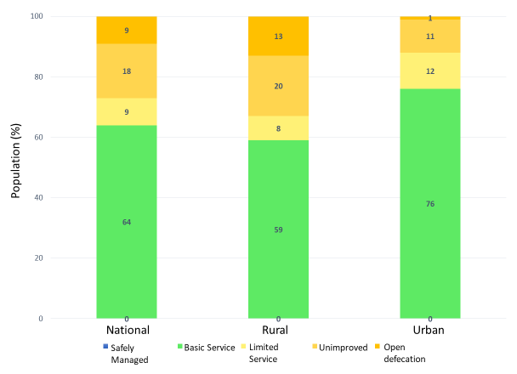

In-text question 1.4
What is the percentage of open defecation nationally in Myanmar?

3.5.1 Liquid waste
Though there have been improvements in recent years, Myanmar struggles to provide basic sanitation services as shown in Figure 3.9 which shows that 0% is safely managed. This is especially the case in areas affected by extreme poverty, conflict and natural disasters.
Only three cities (Yangon, Mandalay and Nay Pyi Taw) have piped sewerage systems or centralised wastewater treatment systems. Most households outside of these three cities in formal residential areas, have septic tanks but these are not routinely emptied and there is no systematic collection and treatment of domestic wastewater.
Households in informal settlements rely on improvised latrines and stormwater drains that carry untreated sewage in open channels. Furthermore, small-scale enterprises and industries often allow chemical waste (such as dyes for silk and weaving cloth) to run into the roadside drains causing pollution of water courses and groundwater (ADB, 2017).
Watch this video that looks at how a poor community in Yangon built their own latrines and improved hygiene in their neighbourhood thanks to a small-scale sanitation project supported by the Asian Development Bank.
Then answer the question. Whilst the video is narrated in English, we hear from the community members in Myanmar language.
https://www.adb.org/news/videos/four-cleans-myanmars-sanitation-challenge

In-text question 1.5
What was the situation before the sanitation project?
What is the situation after the sanitation project?

3.5.1 Solid waste
At present, solid waste collected by the respective townships and city development committees is transported to the final disposal sites, mostly open dumping sites located within city boundaries (Figure 3.10).
Waste separation at source and 3 R activities (reduce, reuse and recycle) are not widely prevalent in Myanmar, although some cities conduct public awareness-raising campaigns and environmental education programmes in order to promote 3 R activities.

Figure 3.10 Waste disposal site in Mandalay
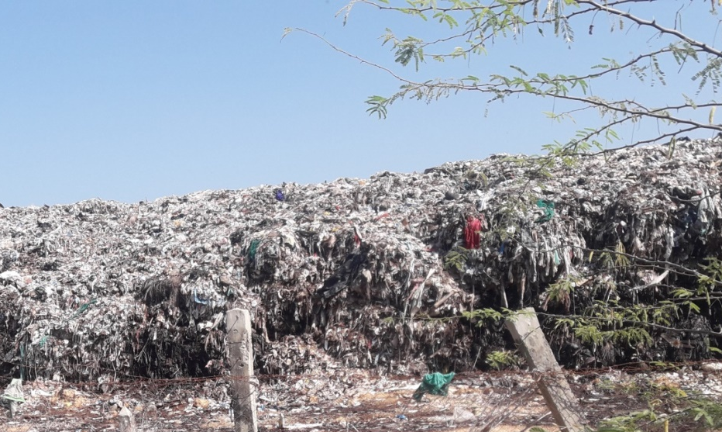

The recycling of solid waste that does happen is carried out mostly by the informal sector, which includes waste pickers, waste collectors, and waste dealers.
These waste pickers and waste collectors gather recyclable materials such as newspapers, metal, plastic bottles, tin and glass from households, communal depots, streets, commercial areas, and final disposal sites.
In turn they sell these items to waste dealers who subsequently clean, sort, store and sell them in bulk to the recycling industry both locally and for export (Premakumara et al., 2017)
The problems associated with waste management in Myanmar can be categorised as shown in Figure 3.11.
The sanitation landscape is extremely fragmented in Myanmar, with responsibility for rural sanitation and hygiene falling under the Ministry of Health and Sports, and responsibility for urban sanitation resting with individual municipalities with no central government oversight.
But the profile of sanitation needs in Myanmar is growing, and the Minister of Health has assumed a leadership role for the overall sector which should strengthen co-ordination.

Figure 3.11 Problems associated with solid waste management in Myanmar (Source: Adapted from Premakumara et.al. (2017))

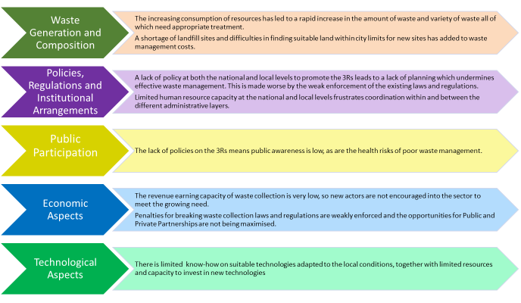

An important step was the development of the Myanmar National WASH strategy for 2016–
2030 to which you were introduced in Study Sessions 1 and 2 and which outlines key WASH actions in rural areas, schools, healthcare facilities and in emergencies, and sets targets for a major rise in the quality and quantity of sanitation facilities country-wide. However, it says nothing about solid waste management.

Summary of Study Session 3
In Study Session 3 you have learned that:
- Sanitation and waste management both refer to the appropriate management of waste to protect people and the environment. Sanitation generally focuses on liquid waste and waste management on solid waste.
- Liquid waste includes all types of wastewater and includes human excreta. Solid waste is any solid material discarded by people and is often classified according to its source.
- The sanitation ladder illustrates the different types of sanitation provision in order of desirability.
- The waste hierarchy is a guide to the different ways of treating wastes from waste reduction (the best option) through to disposal (the worst option).
- The challenges and unplanned population growth and urbanisation in Myanmar make it difficult to achieve acceptable levels of sanitation and waste management quickly.
- Sanitation in Myanmar has experienced increased attention in recent years.

Answers to in-text questions
1.1 Some suggestions are to:
- use empty food containers to store food that was bought loose
- refill plastic drinks bottles with water
- use clothes from your oldest child to dress younger children
- use worn-out clothes as cleaning cloths
- give books to friends when you have finished with them.

1.2 With approximately 31% of Myanmar population living in cities in 2019, Myanmar is still considered to be at an early stage of urbanisation with a level below that of Laos PDR (35.65%) and Vietnam (36.63%), but higher than Cambodia (23.81%).
The annual urban population growth rate of Myanmar has risen from 1.3% in 2009, to 1.51% in 2019 (Figure 3.7).
This is also lower than that of other countries in the region. However, Myanmar is expected to continue to urbanise, with a projected increase to 35% of the total population urbanised by 2050 (World Bank, 2020).
Despite the positive benefits to economic growth that urbanisation brings, the increase in urban population has begun to put a strain on cities and the need for affordable housing, infrastructure and services.
In Yangon, only a third of the city’s population have access to piped water, traffic congestion is on the rise, as is solid waste, flooding and pollution as shown in Figure 3.8. There is also a rise in the number of informal settlements as new residents cannot afford the existing supply of housing (World Bank, 2019).

1.3 Urban development reduces the ability of the ground to absorb rainwater. In urban areas a high proportion of the ground is paved, which prevents the absorption of rainwater. Also, unplanned developments usually lack the drainage ditches or channels necessary to carry away surface waters.
These two factors combine to create an increased risk of flooding and the outbreak of waterborne disease that can follow floods.
1.4 A total of 9% of the national population use open defecation.
1.5 Before the project people used to defecate out in the open and rubbish was scattered everywhere because people could not afford to do otherwise.
After the project, the neighbourhood is clean, and people have more knowledge about health and understand the importance of environmental sanitation. New latrines keep human excreta inside the pit and there is no contamination of the tidal water and so no more human excreta getting into the houses when there is flooding.

References
ADB Asian Development Bank (2017) Urban Development and Water Sector Assessment, Strategy and Road Map: Myanmar [Online]. Available at:
https://www.adb.org/publications/myanmar-urban-development-water-strategy-roadmap (Accessed 13 November 2020).

Bai, X., Nath, I., Capon, A., Hasan, N. and Jaron, D. (2012) ‘Health and wellbeing in the changing urban environment: complex challenges, scientific responses, and way forward’, Current Opinion in Environmental Sustainability, vol. 4, no. 4, pp. 465–72.

Plecher, H. (2020) Urbanization in the ASEAN countries 2019 [Online]. Available at:
www.statista.com/statistics/804503/urbanization-in-the-asean-countries/
(Accessed 24 March 2021).

Premakumara, D.G.J., Hengesbaugh, M., Onogawa, K. and Ohnmar May Tin Hlaing (2017) Waste Management in Myanmar: Current Status, Key Challenges and Recommendations for National and City Waste Management Strategies. POLICY REPORT UN Environment International Environmental Technology Centre and IGES. 45pp [Online]. Available at:
https://www.researchgate.net/publication/331332872_Waste_Management_in_Myanmar_Current_Status_Key_Challenges_and_Recommendations_for_National_and_City_Waste_Management_Strategies (Accessed 24 March 2021)

WASH data (2020) JMP Household data. [Online]. Available at: https://washdata.org/data/household#!/dashboard/new (Accessed 24 March 2021)

WHO (2020) Sanitation. WHO/UNICEF Joint Monitoring Programme (JMP). [Online]. Available at: https://washdata.org/monitoring/sanitation (Accessed 10 November 2020)

World Bank (2019). Myanmar’s urbanization creating opportunities for all, full report. World Bank, Washington, DC. [Online]. Available at:
https://openknowledge.worldbank.org/handle/10986/31824
(Accessed 12 November 2020)

World Bank (2020) World Development Indicators. World Bank, Washington, DC. [Online]. Available at:
https://databank.worldbank.org/source/world-development-indicators
(Accessed 24 March 2021).

