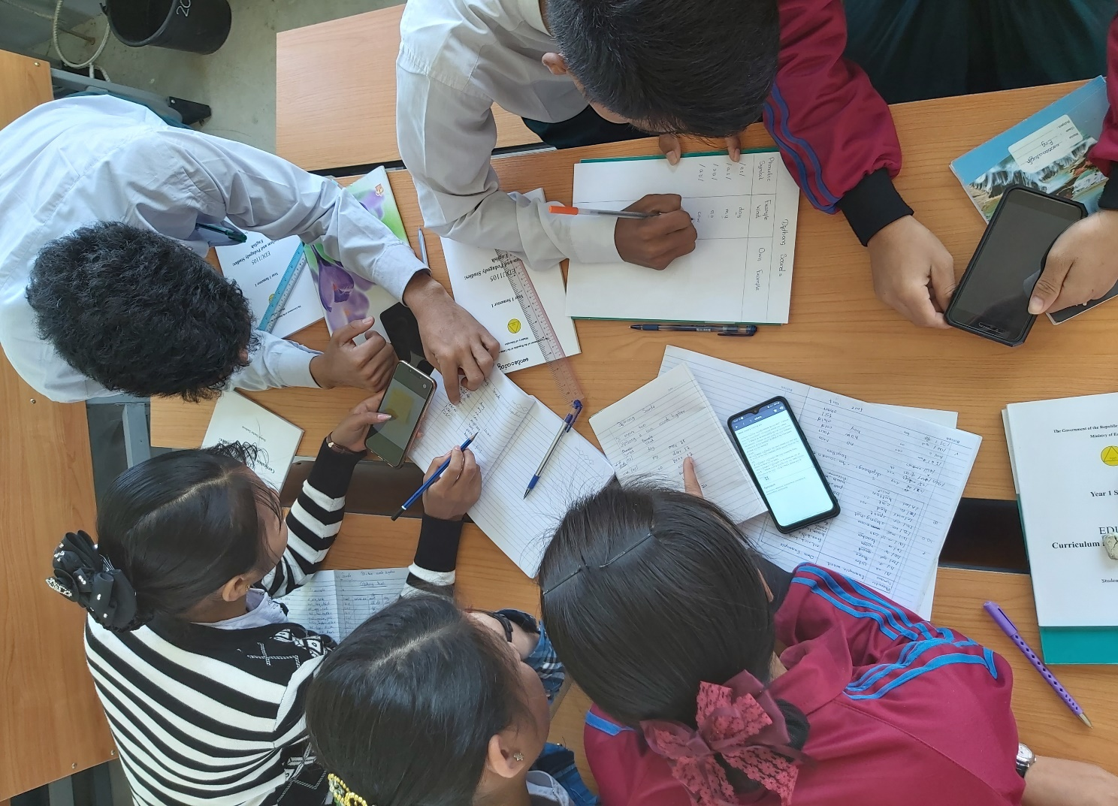

Formative Assessment Toolkit

Contents
1. Introduction 3
1.1. Who is this Formative Assessment Toolkit for? 3
1.2. Why is Formative Assessment Important? 3
1.3. Purpose and Structure of this Formative Assessment Toolkit 4
STAGE ONE: Before Learning - Where are you trying to go? 5
Instrument 1: Learning Outcomes 6
Instrument 2: Success Criteria 7
STAGE TWO: During Learning - Where are you now? 8
STAGE THREE: After Learning - Did I reach my destination? What else do I need to do? 10
Formative Assessment Techniques 14
3,2,1 15
5,3,1 17
Basketball Questioning (or Bouncing) 19
Entrance Tickets 20
Exit Tickets 21
Know Want Learn (KWL) 23
One-Minute Paper 25
One-Minute Problem 27
Student Response Cards 29
Study Cards 31
Thumbs Up, Thumbs Down, Thumbs Middle 33
Traffic Lights 34
Triangle – Square – Circle 35
Two Stars and a Wish 36
Whip Around 37
References 39

- Introduction

  - Who is this Formative Assessment Toolkit for?
Although this Formative Assessment Toolkit was originally designed for Teacher Educators and Student Teachers at Myanmar Education Degree Colleges, the Formative Assessment Toolkit can be used by all educators and student teachers. It will be relevant and useful to:
- educators training student teachers
- educators training in-service teachers
- student teachers
- in-service teachers
- students (pupils/ children in Basic Education)
- principals of schools and higher education institutes (colleges and universities)
- parents and the wider community

  - Why is Formative Assessment Important?
Formative assessment plays a key role in pedagogy, that is, in teaching and learning. It helps guide and support both teacher and student in understanding how learning is progressing, where the strengths of a learner might be and where there might be ‘gaps’ in the learning and need for additional teaching and learning.

It is advocated as part of the new four-year degree curriculum for pre-service teachers in Myanmar.
The new Teacher Educator Guides stress the importance of reviewing content at the end of each lesson and provide some suggestions on how to do this:
(Curriculum & Pedagogy Studies: Educational Studies, Teacher Educator Guide: Year 1 Semester 2, How to use this guide, p3)
(Curriculum & Pedagogy Studies: Educational Studies, Teacher Educator Guide: Year 1 Semester 2, How to use this guide, p18)

  - Purpose and Structure of this Formative Assessment Toolkit
The purpose of this Formative Assessment Toolkit is to build on the ideas contained in the Teacher Educator Guides and Student Teacher Textbooks. This toolkit provides Teacher Educators of all subjects with practical suggestions for implementing formative assessment in their classrooms.

The Formative Assessment Toolkit guides Teacher Educators in how to integrate formative assessment into a lesson - before, during and after learning. These three stages correspond to the three sections in this toolkit.

Each section starts with a question that a Teacher Educator should ask themselves before starting a particular stage of the lesson. This is followed by an overview of instruments and teaching techniques a Teacher Educator can use to gain a clear idea before starting a lesson of the prior knowledge of learners as well as during and after a lesson to gauge the amount of learning that took place. These techniques are practical, easy to use and require minimal or no resources. There are also clear and easy to follow instructions for each technique at the end of the toolkit. Many of the techniques come from the Teacher Toolkit which is mentioned on page 11 of the English Teacher Educator Guide for year 1, semester 2.

STAGE ONE: Before Learning - Where are you trying to go?
Teacher Educators should ask themselves this question when planning a lesson. The stages and activities you plan should build on students’ knowledge and a final practice task or activity should allow you to assess students’ learning in the lesson against the desired learning outcomes. As such, in order for assessment to play a formative role in teaching and learning, it must be integral to a Teacher Educator’s planning.

This section starts with an outline of learning outcomes, why they are important for teaching and learning and when and how they should be incorporated into a lesson. It then moves on to show how success criteria can be developed from learning outcomes. It outlines the benefit for both Teacher Educators and students of creating success criteria, as well as providing tips on how to use them.

A number of formative assessment techniques to assess the prior knowledge and understanding of students are also suggested.

Assessment phase | Question | Instruments and Techniques | Pages
Before  Learning | Where are you trying to go? | Instrument 1: Learning Outcomes  Instrument 2: Success criteria  Formative Assessment Techniques:  5,3,1  Entrance ticket  KWL  One-minute paper  Student response cards  Study cards  Whip around | 6  7  17  20  23  25  29  31  37

Instrument 1: Learning Outcomes
- Setting clear and relevant learning outcomes can support both Teacher Educators and students in a number of ways, as illustrated in figure 1 below.
Learning outcomes are brief statements that describe, for the student, what they should know and be able to do by the end of a lesson.
Sharing learning outcomes with students at the beginning of a lesson is important. Students take more responsibility for their own learning when they know what they are expected to learn and how they will know they have been successful.

In the Teacher Educator guides and Student Teacher textbooks, expected learning outcomes are displayed in the content map, at the beginning of each unit and at the beginning of each lesson.
Here is an example from the Science textbook.
(Curriculum & Pedagogy Studies: Science, Teacher Educator Guide: Year 1 Semester 2, Unit 5.1.3. Atmosphere p90)

- Research shows that students are more highly motivated and task-orientated if they know and understand the learning outcomes in a lesson.
- Learning outcomes describe what students are going to learn, rather than what they are going to do. They focus on the learning, not the task.

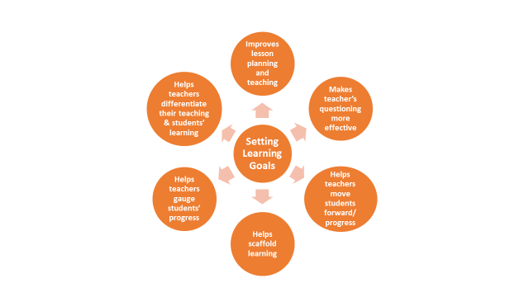
(Drinan, F. H. (2016) ‘Formative Assessment Toolkit,’ for USAID project ‘Formative Assessment for Georgian Teacher Educators’)

Implications for teaching
At the beginning of the lesson:
- share learning outcomes with students
- check that students understand the learning outcomes
- display the learning outcomes
- ask students to record the learning outcomes in their notebooks
- use one of the formative assessment techniques to assess students’ prior knowledge of the topic before teaching the lesson.

Instrument 2: Success Criteria
Success criteria describe what a student will be able to do if the learning outcomes are achieved.

Here is an example of success criteria for a science lesson on the atmosphere, based on the learning outcomes listed on page 6.
I can describe five features of the atmosphere.
I can outline the composition of specific gases in air and their properties.
I can do an experiment to demonstrate that air has weight.

Success criteria enable both a Teacher Educator and a student to recognise if learning outcomes have been achieved. Here are some ideas to consider when using success criteria:
- Develop success criteria at the planning stage of a lesson.
- When writing success criteria, use clear language and descriptions.
- Share and clarify success criteria with students.
- Provide students with examples of success criteria.
- Involve students in the creation of success criteria.
- Ask students to apply success criteria to samples of work.
- Use success criteria as the basis for feedback as well as self and peer assessment.

STAGE TWO: During Learning - Where are you now?
In this section, instruments and formative assessment techniques for assessing where students are now are outlined. These include the need for learning outcomes to be reviewed throughout a lesson as a way for Teacher Educators and students to check learning, and the importance of questioning as an instrument for assessing learning.

Tips are provided about effective questioning techniques as well as interaction patterns and recommendations on how to monitor and observe students. The final instrument to encourage collaboration provides a number of suggestions regarding interaction patterns when checking learning.

Assessment phase | Question | Instruments and Techniques | Pages
During  Learning | Where are you now? | Instrument 1: Learning Outcomes  Instrument 2: Questioning  Instrument 3: Monitoring and Observation  Instrument 4: Encouragement for collaboration  Formative Assessment Techniques:  3,2,1  5,3,1  Basketball Questioning  One-minute paper  One-minute problem  Student response cards  Study cards  Thumbs Up, Thumbs Down, Thumbs Middle  Traffic Lights  Two stars and a wish | 9  9  10  10  15  17  19  25  27  29  31  33  34  36

Instrument 1: Learning Outcomes
- Review the learning outcomes at various points in the lesson.
- Use some of the techniques suggested in the toolkit to ask students to assess their progress in relation to each learning outcome at various points in the lesson.
Instrument 2: Questioning
- Ask an appropriate balance of open and closed questions.
- Ask an appropriate balance of higher and lower order questions.
- Ask questions which encourage critical thinking including asking ‘why?’ and other questions which require students to justify their answers.
- Nominate a wide range of students to answer questions. Select appropriate questions for individual students. Use ‘random sampling’ when appropriate.
- Give appropriate waiting/thinking time.
- Use Think-Pair-Share. Think-Pair-Share - The Teacher Toolkit
- Ask questions and encourage students to discuss and respond in groups.
- Ask individual students if they agree or disagree with other students’ answers.

(The Teacher Toolkit http://www.theteachertoolkit.com/index.php/tool/all-tools)

Instrument 3: Monitoring and observation
- Monitor students’ learning: their responses and difficulties.
- Make notes of students’ responses and difficulties.
- Provide consistent, equitable and constructive monitoring of individuals and groups by ensuring that you monitor / observe a range of different students.
- Use these notes during feedback to give examples of correct responses and provide additional support with difficulties.
- If, during monitoring, you observe a number of learners are struggling with a particular task, it may be necessary to provide further input before moving onto the next stage of the lesson.
- Focus attention on two or three different learners in a lesson in order to build up a comprehensive picture of student abilities over time.
- Record (formally or informally) results of observations during monitoring.

Instrument 4: Encouragement for collaboration
- Make use of effective classroom management techniques to maximise student collaboration.
- Group students in appropriate ways (and in appropriate sizes). Organise and monitor group work effectively.
- Use a variety of interaction patterns which maximise opportunities for student to student learning.
- Allocate specific roles to students when appropriate to maximise collaboration and interaction.
- Involve as many students as possible in group feedback stages. For example, after students have worked in small groups, ask one member of each group to come to the board and write down their group’s answers. Alternatively, use one of the formative assessment techniques, e.g. Basketball Questioning or Student response cards to get responses from a larger number of students.

STAGE THREE: After Learning - Did I reach my destination? What else do I need to do?
In this section, instruments and formative assessment techniques are outlined to help a teacher assess to what extent learning outcomes have been achieved at the end of a lesson. A number of formative assessment techniques to check what students have and haven’t understood in a lesson are suggested as well as student-centred ways in which these techniques can be used, including, self-assessment, peer assessment and student generated questions.

Assessment phase | Question | Instruments and Techniques | Pages
After  Learning | Did I reach my destination?  What else do I need to do? | Instrument 1: Feedback  Instrument 2: Self-assessment  Instrument 3: Peer assessment  Instrument 4: Student generated questions  Instrument 5: Evaluation of teaching  Formative Assessment Techniques:  3,2,1  Exit ticket question  One-minute paper  One-minute problem  Student response cards  Study cards  Traffic Lights  Triangle-Square-Circle  Two stars and a wish  Whip around | 11  12  12  12  12  15  21  25  27  29  31  34  35  36  37

Instrument 1: Feedback
- Review learning outcomes and the extent to which they have been met.
- Give constructive feedback which recognises that all students have potential rather than feedback which discriminates between successful and unsuccessful students.
- Acknowledge strengths of individual student performance as well as student areas for development.
- Systematically select key/common areas for development rather than a) aiming to deal with all errors and/or b) dealing with errors unsystematically.
- Summarise and provide feedback on how student performance can be improved.
- Use sandwich feedback and encourage students to use sandwich feedback in assessing peers’ performance.
- Provide comments for each individual student rather than grades or rewards.
- Use error correction codes to assess written work. Encourage redrafting.

Instrument 2: Self-assessment
- Use one of the formative assessment techniques to help students self-assess their own learning.
- Provide success criteria for students to self-assess what they have learnt.
- Ask students to keep learning/reflective journals to reflect on what they have learned and what they need further input/practice with.
- Ask students to keep portfolios and select examples of work demonstrating effective learning and/or reflection on learning.

Instrument 3: Peer assessment
- Provide opportunities for peer assessment/feedback using one of the formative assessment techniques appropriate for peer assessment, e.g. ‘Two stars and a wish’, ‘Exit ticket question’ etc.
- Provide opportunities for group assessment, e.g. students work together in groups to complete ‘Study Cards’.
- Provide success criteria for students to assess their peers’ learning in a lesson.
- Ask students to use error correction codes to provide feedback on each other’s written work.
- Ask students to design their own success criteria for assessing performance and use these criteria to assess performance.

Instrument 4: Student generated questions
- Students ask the teacher questions to clarify understanding and aspects of lesson content which are not clear.
- Students ask peers questions to check the extent of learning.
- Students write questions and post in a question box or stick on a question poster.
- Students design quizzes for peers to complete.

Instrument 5: Evaluation of teaching
- Students provide feedback for the teacher by answering questions or a questionnaire to evaluate the effectiveness of classroom delivery and the extent to which it supports learning and how it can be developed to support learning further.
- Collect feedback periodically, e.g. weekly or monthly.
- Ask students to work in small groups.
- Ask students to complete the questionnaire by writing responses.

Here are some examples:
Example 2
What is one thing you would like to change about the way we learn in class?
What is one thing you would like me to start doing in class?
What is one thing you would like me to stop doing in class?
What is one thing you would like to continue doing in class?

Example 1
Name one classroom activity that helps you learn the most.
Name one classroom activity that does not help you learn.

(Adapted from Lynch Myles, (2021) 11 exit ticket questions you can use with your students)

Formative Assessment Techniques

3,2,1
When to use
- at the end of an activity or at the end of the day as reflection
- during a lesson to check for understanding
Why use
- to provide a structure for students to record their own comprehension and summarise their learning
- to encourage students to reflect in an organized way
- to identify common problematic areas that need re-teaching
- to identify what students are interested in learning about
Estimated timing
5-7 minutes
Procedure
1. At the end of the lesson, write the following prompts on the board:
3 things you learned today.
2 things you found interesting.
1 question you have about the lesson.
2. Ask students to work individually, in pairs or in small groups. Note, the first time you do this you could model it with the whole class activity.
3. Ask students to respond to the 3-2-1 prompt in their notebooks or on post-it notes.
4. Informally review some of the responses to determine how much of the lesson the students have understood and processed.
5. Make a note of some of the most common questions so that you can address these in the next lesson.

Variations
Ask students to list 3 new facts, 2 questions and one idea they would like to know more about.
Reading 3,2,1
When reading a text from the coursebook, students record:
- 3 most important ideas from the text
- 2 supporting ideas and reasons
- 1 question they have about the text

Pyramid 3,2,1
Students draw a triangle and divide it into 3 sections.

- In the bottom section, students write 3 things they learned today.
- In the middle section, they write 2 questions.
- In the top section, they describe how the information is useful and applicable to their lives.

You can be as open ended as you like for reflection, but for review and summary of a lesson you may like to choose re-call type prompts like the example below:

Geometry

Ask students to name:

3 – Types of triangles
2 – Names of quadrilaterals
1 – Shape with only one set of parallel sides

Templates
The prompts you choose to use within the 3-2-1 format depend on your lesson objectives and the needs of your students. This flexibility allows for easy differentiation. Here are some examples:
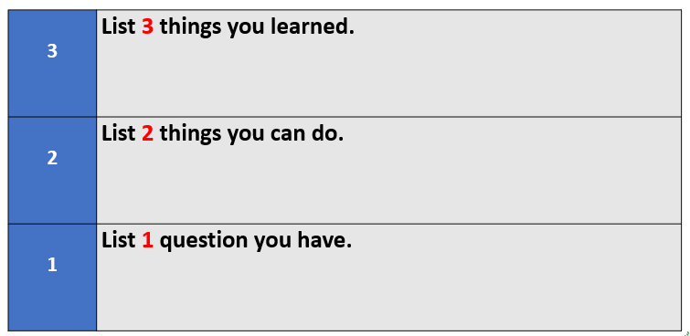

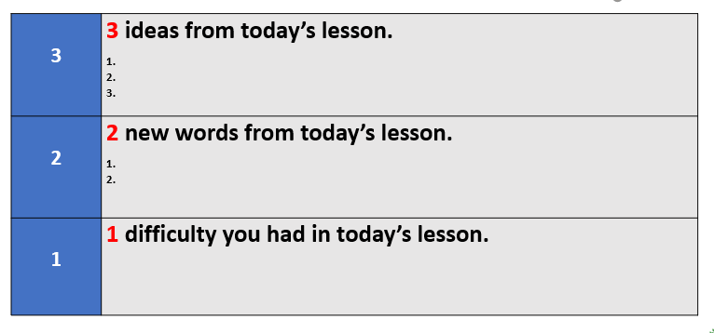

Link: https://www.theteachertoolkit.com/index.php/tool/3-2-1

5,3,1
When to use
- at any time during the lesson to structure meaningful conversation
- before introducing new material to activate prior knowledge
- after reading a short text or watching a clip to determine main ideas, check understanding and initiate discussion
Why use
- to assess background knowledge of the topic
- to assess students’ level of understanding
- to determine the most important concepts or content is a valuable skill and supports students’ notetaking skills

Estimated timing
10-15 minutes
Procedure
1. Ask students a question connected to the topic of the lesson. The question should have many possible responses.

Example question:
What are the differences between learning to read in English and learning to read in Myanmar?
Curriculum & Pedagogy Studies: English, Year 1 Semester 2, Unit 5.1.1 Learning to read

2. Ask students work individually to brainstorm 5 possible answers / ideas related to the topic.

3. Put students in pairs to compare their lists. Each pair then decides on the 3 best answers / ideas.

4. Combine two pairs of students to make a group of 4. Each group compares their answers / ideas and chooses the 1 response they think is the best or most significant.
5. Monitor throughout.
6. Elicit responses, in plenary or by asking groups to record their best response on the board.

7. Ask groups to justify their choices.

Templates

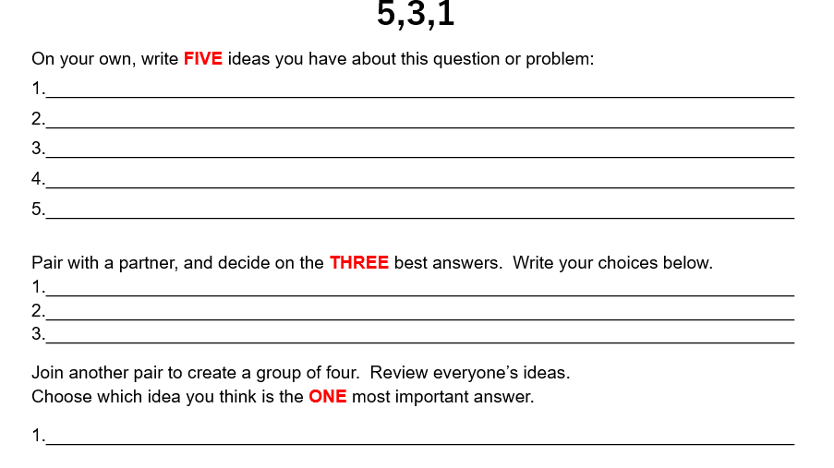

Link: https://www.theteachertoolkit.com/index.php/tool/5-3-1

Basketball Questioning (or Bouncing)
When to use
- during an activity to stop the teacher being the focus of all questioning
- to make the lesson more learner-centred
- to engage and refresh the class during the day
Why use
- to move the conversation from teacher to student over to student to student
- to develop connected thinking and development of ideas
- to bounce answers to build on understanding and encourage students to develop stronger reasoning skills
Estimated timing
10 minutes
Procedure
1. Start the discussion by asking a question.

Example:
How does storytelling help children learn English?
Curriculum & Pedagogy Studies: English, Year 1 Semester 2, Unit 7.1.3 Storytelling

2. Throw the ball to one student and invite them to respond.
3. Once an answer is given, ask the nominated student to throw the ball to another student. The new student must either elaborate on a previous answer, give an additional answer or answer a follow up question.
3. Repeat this procedure until all of the main points have been covered.
Note: Half-formed ideas should be accepted, but students should be encouraged to provide more detail. Try asking questions such as What do you think of Thida’s answer? Can you add more detail to Nay Lin’s answer?

Variations
- Ping Pong questioning is a more controlled variation and is managed by the teacher. Once one student answers the question, the ball goes back to the teacher each time. The teacher then selects a new student to answer.

- Student names can be chosen out of a bag using ‘pick a name’ questioning technique. This process of random selection is often seen as a lot fairer and equal and stops any student concerns about who to choose. https://www.theteachertoolkit.com/index.php/tool/popsicle
Link: https://www.nwea.org/blog/2013/classroom-techniques-formative-assessment-idea-number-ten/

Entrance Tickets
When to use
- at the start of the day as students walk in the door
- as a lead-in to a topic
Why use
- to assess initial understanding of a new topic or a discussion point
- to link a new unit to students’ own lives and check for prior knowledge and experience
- to monitor student learning and check understanding of previous learning
- to review learning from the previous day to check what students remember, what they can apply or what questions they have

Estimated timing
5-7 minutes

Procedure
1. Hand each student an entrance ticket as they enter the classroom. Each ticket should include the same question or statement, connected to the topic/ outcomes of the lesson.
Example question:
Write down as many threats and risks involved in using the internet that you can think of in 2 minutes.
ICT Curriculum, Year 1 Semester 2, Unit 6.12 Protecting Yourself Online
2. Ask students to follow the instructions and complete the task immediately.
3. Optional: students share their answers with each other in pairs or small groups.
4. The teacher collects the entrance tickets to evaluate how much the students already know about the topic.
Variations
- To save paper, write the entrance question or problem on the board and ask students to complete the task in their notebooks or journals.
- The students complete the entrance ticket (as above), but they do not submit it to the teacher. At the end of the lesson the teacher asks the students to add to their entrance ticket and write what they have learnt in the lesson. Students can only exit the class with their completed entrance ticket and their completed exit ticket. These can be used to reflect on the learning that has taken place in the lesson.
Link: https://www.theteachertoolkit.com/index.php/tool/entry-ticket

Exit Tickets
When to use
- as a closing activity
Why use
- to check students’ understanding of the key information presented in a lesson
- to check students can answer a key question related to the lesson
- to check what has / hasn’t been understood in the lesson
- to check if anything needs to be taught again
Estimated timing
3 – 5 minutes
Procedure
1. Prepare a question or set of questions before the lesson to check students’ understanding of the main points of the lesson.
2. At the end of the lesson, write the question(s) on the board.
3. Ask students to write their answer(s) on a piece of paper and hand it in as they are leaving the classroom.
4. Use the students’ responses to evaluate how much of the lesson the students have understood. Do you need to review any of the content before moving onto the next stage?

Example exit ticket questions
- What was the most important thing you learned in today’s class? Why is it important?
- What is something you weren't sure about at the start of the lesson but understand now?
- Imagine a classmate is absent from class today. How would you explain the lesson to him/her in 25 words or less?
- Imagine you’re the teacher. If you were creating a quiz about today’s lesson, what are 2 questions you’d include?
- What areas did you find most difficult to understand / complete?
- What is one question that you still have about the lesson?
Adapted from Loop – exit ticket questions

Variations

Verbal Exit ticket
Students answer the teacher’s exit ticket question by speaking instead of writing.

Link: http://www.theteachertoolkit.com/index.php/tool/exit-ticket

Know Want Learn (KWL)
When to use
- to activate background knowledge, develop a purpose for learning at the start of the lesson and summarize what has been learnt at the end of the lesson

Why use
- to activate student interest and help activate background knowledge about a new topic
- to monitor and track progress during a lesson
- to develop students critical thinking skills

Estimated timing
5 minutes at the beginning + 5 minutes at the end.
Procedure
1. Give each student a KWL chart or ask them to draw a table with three columns in their notebooks.
2. Tell students the topic and the learning objective for today’s lesson.
3. Before the lesson, ask students to write what they already know about the topic in the first column, and what they want to know about the topic in the second column. Remember to give students some time to think before they completing the table.
4. At the end of the lesson, ask students to discuss the topic in pairs, before asking them to complete the third column about what they learnt during the lesson.
5. If time, ask students compare charts in small groups and add extra information to their chart where necessary.
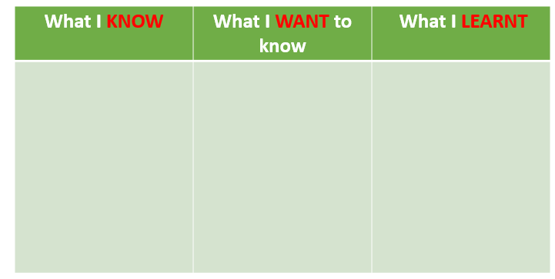

Variations
Reading KWL

- Ask students to look at the title of the reading text and complete the first column (K) of the chart. Students write what they already know about the topic before reading.
- Ask students to complete the second column (W) and write what they want to know about what will happen in the reading text. Students formulate questions and add to this section.
- Give students time to read the text. While reading if they find the answer to any of their questions, they complete the chart.
- After reading, tell students to go back to any unanswered questions and search for answers.
- Finally, ask students to complete the third column of the chart (L) with what they learnt from the reading text.

KWL + +
- Students organize their new knowledge and the results from the learnt section into a new concept map or graphic organizer that reflects the key information.
- Then, each student writes a summary paragraph about what they have learnt.

Link: http://www.theteachertoolkit.com/index.php/tool/kwl

One-Minute Paper
When to use
- at the beginning of a lesson
- during a lesson
- as a closing activity

Why to use
- to check students’ understanding of content from a previous lesson or homework
- for students to identify and summarise the main ideas from a lesson
- to develop students’ skills in writing concise summaries of lesson content
Estimated timing
3 - 5 minutes
Procedure
1. Ask students a prompt question.
Example question
What are the differences between learning to read in English and learning to read in Myanmar?
Curriculum & Pedagogy Studies: English, Year 1 Semester 2, Unit 5.1.1 Learning to read
2. Ask students to work individually to write a response in one or two sentences. Set a time limit of one minute.
3. At the end of one minute, ask students to share their sentences with a partner.
4. Elicit some examples and / or collect the sentences to evaluate how much learning has taken place.
Examples of one-minute prompts
A prompt can be specific to the content of a particular lesson or
a prompt can be more general, e.g.
- Most important learning from the day and why
- Most surprising concept and why
- Most confusing topic and why
- Something I think might appear on an assessment or a test.
https://www.nwea.org/blog/2019/27-easy-formative-assessment-strategies-for-gathering-evidence-of-student-learning/

Variations

- Students can summarise in one sentence not only the content of a lesson, but also, an event, an article, an issue, etc.
- To make the technique more collaborative, after students have written and shared their sentences, they can write a new sentence using the best ideas of each student.
- One-minute sentence competition - stick the sentences on the wall. Ask students to work in small groups to vote on the best sentence.

Link: http://www.theteachertoolkit.com/index.php/tool/one-minute-sentence

One-Minute Problem
When to use
- at the beginning of a lesson
- during a lesson
- as a closing activity

Why to use
- to discuss previous lesson or homework content
- to evaluate prior knowledge about a difficult concept
- to summarise ideas
- to check students’ understanding
- to allow students to discuss responses in a group before sharing with the whole class, building students’ confidence in their answers and to correct any misunderstandings through peer correction

Estimated timing
3 - 5 minutes

Procedure
1. Give students a question, a problem or a prompt related to the content of a lesson.
Example:
Do you agree or disagree with the following statements? Why or why not?

- Learning to read in Myanmar is like learning to read in English.
- Our students need to be able to understand very word they read.
- It is important to ask our students to sound out and blend the letters in unknown words.
- We should teach the names of the 26 letters of the English alphabet to our students in their first lesson

Curriculum & Pedagogy studies: English, Year 1 Semester 2, Unit 5.1.1 Learning to read, Learning activity 5, p13

2. Ask students to work alone to answer the question, then to discuss in a small group. Set a short time limit, e.g. 2 minutes.

3. Ask the groups to record their answer(s) on a piece of paper and stick it on the board.

4. Discuss the responses and correct any misunderstandings.

Variations

- Truly one-minute problems - give students shorter problems or questions and set a time limit of 30 seconds or one minute. This works well with quick answers, e.g. maths problems or multiple-choice questions.

- Independent Work - some one-minute problems can be solved individually by students without collaboration with classmates.

- Agree or Disagree - give students a statement related to the current topic. Ask students to work in a group to decide if they agree or disagree with the statement and why. Ask students to write their answer and explanation. Divide the board into two parts, one for agree and one for disagree. Review the explanations and ask follow-up questions if clarification is needed.

Link: http://www.theteachertoolkit.com/index.php/tool/one-minute-problem

Student Response Cards
When to use
- at the beginning of a lesson
- during a lesson
- as a closing activity

Why use
- to activate prior knowledge
- to check students’ understanding after an activity
- to check students’ understanding of key points in a lesson
- as a stirrer activity, to keep students engaged
- to check any gaps in understanding so teacher can plan to address this

Estimated timing
3 - 5 minutes
Procedure
1. Create a set of student response cards one set per student. The cards can be different coloured cards or different lettered cards such as A, B, C, D.
.
2. In a student response activity, students use as many cards as there are answers.
For example, with yes/no questions, students use two cards, e.g. a green card for yes and a red card for no. For questions with 4 multiple choice answers, students use 4 cards.
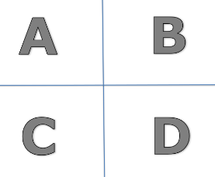

3. Ask students a question or write a question on the board.
Example:
Summative assessment is used….

- at the beginning of a course.
- at the end of a course or period of learning.
- at the beginning and end of a course.
d. during the course while the learning is still taking place.
Curriculum and Pedagogy Studies: English, Year 1 Semester 2, Unit 8.1 Assessments

4. Ask students to hold up the card corresponding to their answer. All students should hold up their card immediately and at the same time as other students so that they do not have time to look at how their classmates are answering.
5. Assess the responses to get an idea of how well students have understood the lesson content and correct any misunderstandings.

Link: http://www.theteachertoolkit.com/index.php/tool/student-response-cards

Study Cards
When to use
- at the beginning of a lesson
- during a practice stage of a lesson
- as a closing activity as an exit ticket

Why use
- to help students identify and summarise the main ideas in a lesson
- as an entry ticket to check students’ prior knowledge
- as an entry ticket to review learning from a previous lesson
- as an exit ticket to check students’ understanding of key points in a lesson
- to check any gaps in understanding so teacher can plan to address this in a subsequent lesson

Estimated timing
3 - 5 minutes
Procedure
1. Ask students to create their own study cards. The number of cards depends on what they are reviewing, but approximately 4-6 index cards. These should include important ideas, vocabulary, facts and concepts from the lesson or unit.
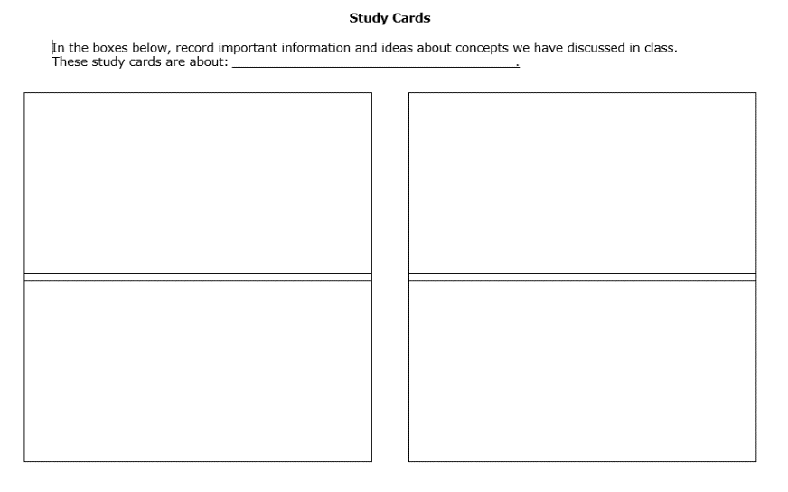
2. Collect the student study cards to assess the students’ understanding and, if needed, plan to re-teach any parts of the lesson or unit which have not been clearly understood.
3. Return the study cards so the students can use them to review the topic and study for a quiz or test. Students can also use them for peer practice quizzes and games.

Variations

2-sided cards - students write on both sides of the index card and use them to revise and study key concepts and terminology.
- Side 1 students write a concept or topic.
- Side 2 students write a summary of everything they know about that topic.
- Students look at side 1 and try to remember everything written on side 2. They then look and check against side 2 and review what they have missed.

Link: http://www.theteachertoolkit.com/index.php/tool/study-cards

Thumbs Up, Thumbs Down, Thumbs Middle
When to use
- after presenting part of a lesson, the teacher asks students to use their hand to signal their depth of understanding
- at the end of an activity

Why use
- as a quick visual to gauge understanding
- to help plan subsequent lessons according to gaps in students’ knowledge
- to hold students more accountable for their “truthfulness” and to call on someone who signalled a thumbs up to explain the concept to the class

Estimated timing
5 minutes
Procedure
1. Ask students to use a hand signal to indicate their level of confidence at the end of a task or the end of a lesson.
- A thumbs up means “I have a good understanding.”
- A thumb to the side means “I still have some questions.”
- A thumb down means “I don’t get it.”
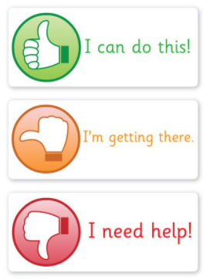
3. Ask questions to discover the reasons behind any thumbs down or in the middle.
4. Call on someone who signalled a thumbs up to explain the concept to the class. This encourages peer support.

Traffic Lights
When to use
- at the end of an activity
- at the end of the lesson

Why use
- to self-assess and develop critical thinking skills
- to see how confident the students feel about a new concept or skill
- to encourage students to reflect on whether they have achieved the learning objective, if they are happy with their work or if they think they could have done better

Estimated timing
5 minutes
Procedure
1. Teacher gives each student three small circles – one green, one red, one yellow.
2. At the end of an activity or at the end of a lesson, ask students to hold up the coloured circle which best represents how confident they feel.
- Green light = I understand this very well and could explain it to a friend.
- Yellow light = I understand the basics but could not explain it.
- Red light = Help! I don't understand this yet.
Students could also draw and colour the face in their notebooks as a visual written record.
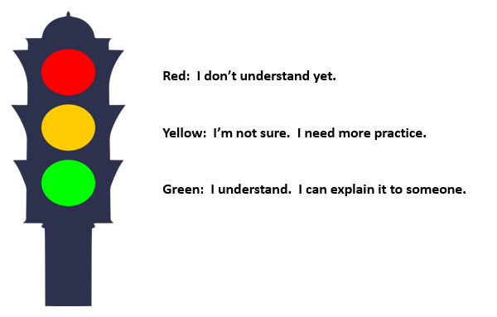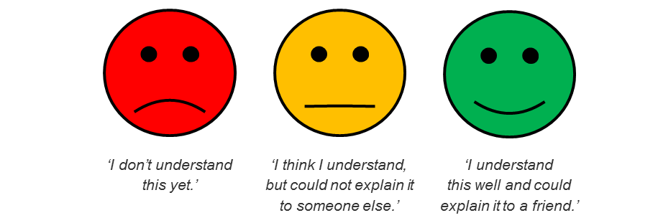
Variations
- Traffic lights can also be used for test preparation. When students complete a test or an assignment, they put a red, yellow, or green circle next to their name to indicate how well they understood the content.
- Students could also use the traffic light system to peer assess each other’s presentations and group work.

Triangle – Square – Circle
When to use
- as a closing activity or exit ticket
Why use
- to check students’ understanding of the key information presented in a lesson
- to check what students have understood in the lesson and what they haven’t
- to check if anything needs to be taught again
- before reviewing for a test, to know which areas to focus test preparation on
Estimated timing
3 – 5 minutes

Procedure
1. Draw a triangle, a square and a circle on the board.
2. Ask students to copy the drawing on a piece of paper.
3. Give the following instructions:
- On the triangle, write three key points from the lesson.
- In the square, write one point from the lesson that you agree with or knew already.
- In the circle, write one thing from the lesson that you are not clear about.
3. Collect the piece of paper from each student at the end of the lesson. Use this information to help you understand what additional support students need.

Link: http://www.theteachertoolkit.com/index.php/tool/triangle-square-circle

Two Stars and a Wish
When to use
- at the end of an activity
- at the end of the day

Why use
- to provide student feedback via peer- and self-assessment in a constructive and timely manner
- to help students set personal goals and to raise the standards of student performance
- to develop students’ self and peer reflection skills

Estimated timing
10-12 minutes
Procedure
1. Ask students look at each other’s work and give feedback. They should identify two features of the work that are positive (the “stars”) and one suggestion for how the work could be improved (the “wish”).

2. Ask students to write the feedback on a slip of paper or in their notebook.

3. Allow students to share their feedback and supporting evidence with each other and give the receiver of the feedback a chance to ask questions.

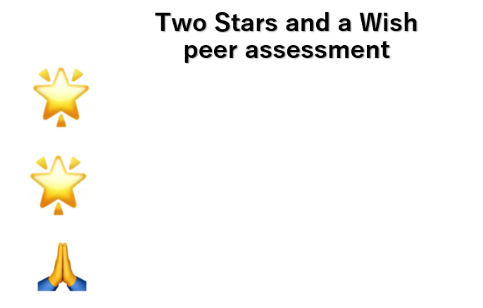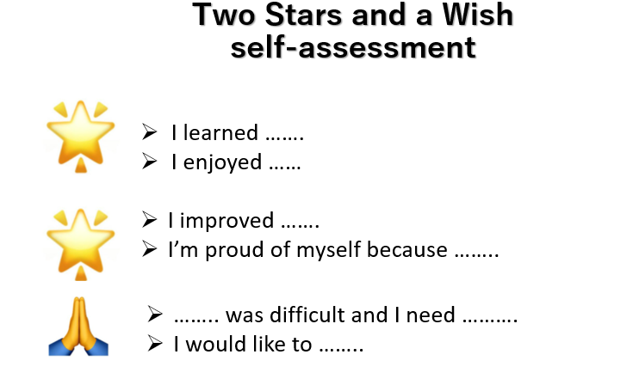

Variations
- Students use 2 stars and a wish to self-assess and give themselves regular feedback.
- Students review an anonymous piece of work with the entire class and have all students provide feedback. Change it to 2 comments and a question.

Whip Around
When to use
- at the beginning of a lesson
- during a practice stage of a lesson
- as a closing activity

Why to use
- as an entry ticket to review key points from a previous lesson
- to check prior knowledge
- to check students’ understanding of a reading text
- as an exit ticket to check students’ understanding of key points in a lesson
- to encourage students to identify and summarise the main ideas in a lesson
- to encourage participation by all students in a class
- to encourage active listening by students in a class

Estimated timing
5 - 7 minutes
Procedure
1. Ask students a question that has multiple answers.
Example question:
What is matter?
Curriculum & Pedagogy Studies: Science, Year 1 Semester 2 - Unit 4.1.1 What is matter?

2. Ask students to write down as many answers as they can within a short time limit of 1 – 2 minutes.
3. Nominate a number of individual students to give one answer.
Remind students not to repeat an answer that has already been given.
Encourage students to pay attention and listen actively to their classmates’ answers.
4. At the end of the activity, give students time to record any information they had not included in their original answer.

Variations

Whip Around, Sit Down
- After students have written down their answers, ask all students to stand up.
- As students respond, they are allowed to sit down.

One Word Whip Around
- In this variation, students do not write their answers in advance.
- Ask students a question that has multiple answers.
- Ask individual students to give a response.
- Don’t stop and correct students if they are wrong. Feedback on answers after the students have finished giving responses.

Whip Around Ice Breaker
As the name suggests, this variation is done at the beginning of a lesson to check for prior knowledge before teaching a new topic or as a warmer with questions that require students to share personal information, e.g. ‘If you could live in a foreign country, which country would you live in and why?’

Link: http://www.theteachertoolkit.com/index.php/tool/whip-around

References

Drinan, F. H. (2016) ‘Formative Assessment Toolkit,’ for USAID project ‘Formative Assessment for Georgian Teacher Educators’.
The Government of the Republic of the Union of Myanmar, Ministry of Education, (2020) Curriculum & Pedagogy Studies: Educational Studies, Teacher Educator Guide: Year 1 Semester 2
The Government of the Republic of the Union of Myanmar, Ministry of Education, (2020) Curriculum and Pedagogy Studies: English Teacher Educator Guide Year 1 Semester 2

The Government of the Republic of the Union of Myanmar, Ministry of Education, (2020) Curriculum & Pedagogy Studies: Science, Teacher Educator Guide: Year 1 Semester 2
The Government of the Republic of the Union of Myanmar, Ministry of Education, (2020) Curriculum & Pedagogy Studies: ICT Curriculum Teacher Educator Guide: Year 1 Semester 2
The Government of the Republic of the Union of Myanmar, Ministry of Education, (2020) Curriculum & Pedagogy Studies:

Websites

Dyer Kathy (2019) 27 easy formative assessment strategies for gathering evidence of student learning
https://www.nwea.org/blog/2019/27-easy-formative-assessment-strategies-for-gathering-evidence-of-student-learning/

Dyer, Kathy (2013) Classroom techniques: Formative assessment idea number 10
https://www.nwea.org/blog/2013/classroom-techniques-formative-assessment-idea-number-ten/

Education Service Center Region 13, The Teacher Toolkit http://www.theteachertoolkit.com/index.php/tool/all-tools

