Climate Change and Agriculture

Tutor notes and handouts for activity 1 and 2
Professor Amanda Bamford, University of Manchester, UK

Activity title | Agriculture: vulnerable to climate change or climate smart?
Total time needed for activity | 2.5- 3hrs
Number of sessions | 2
Learning outcome(s) | - Understand the vulnerability of agriculture to climate change and its impacts on crop production particularly rice.  - Understand how climate-smart agriculture can help maintain yields under stressful environmental conditions
Brief description of activity (knowledge to be covered and how it will be run) | The activity will be split into 2 sessions.  Session 1: Impacts of climate change on agriculture (~1.5hrs)  Combined lecture and discussion activity session  - Lecture 1: ~35 min lecture video on ‘’Vulnerability of agriculture to climate change’’. The impact of increasing temperature and changing rainfall patterns on crop growth & productivity with a focus on rice.  - Activity 1: ~30-40 min activity: ’’Climate change and Rice- data analysis’’ = consists of a lecture video and 2 handouts (copies of handouts later in these tutor notes.  The group will be split into small groups of 3-4 people. The groups will be given a set of figures/graphs to analyse from published research paper. Tutor can choose their own figures from recent papers as this session is all about extracting information from figures.  Coffee break- 30 mins  Session 2: Climate-smart agriculture (~1 hr)  Combined lecture and activity session  - Lecture 2: ~35min lecture on ‘’climate-smart agriculture and adaptations to climate change’’.  - Activity 2: ~30 min activity: ‘’Pictogram poster of climate-smart agriculture solutions’’ - handouts at end of tutor notes.  In small groups discuss Climate-smart agriculture news articles to create a summary pictogram of solutions to present to rest of group at end of session. Tutors can choose their own to use from the news. It is best to choose ones with a photo for impact to distribute to class. Or ask participants to bring their owns so there is some preparation involved before the session. Each group can have one article or a selection to include on their pictogram.  At the send of the session, participants display their pictograms and summarise them to the rest of the class.
Equipment needed | - Laptop and projector  - Coloured marker pens or white board markers  - large sheets of plain paper-A0 or flipchart paper  - A4 blank paper  - Handouts of graphs from research paper;  - Handouts of Climate-smart case studies info sheet from news articles

Suggested seating plan
table
SCREEN
table
table

Activity 1:’’Climate change and Rice- data analysis’’ – Handout Fig. 1
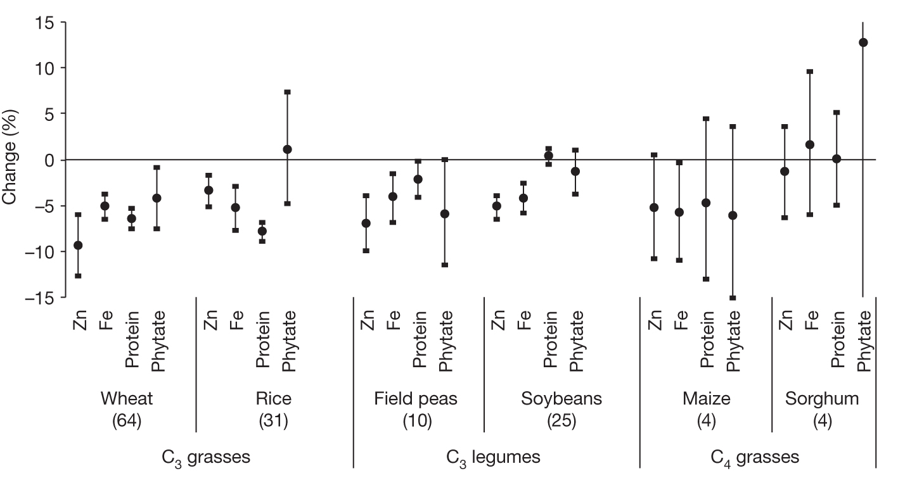
Fig. 1 Percentage change in nutrients at elevated [CO₂] relative to ambient [CO₂].
Myers, S. et al. Increasing CO₂ threatens human nutrition. Nature 510, 139–142 (2014). https://doi.org/10.1038/nature13179

Activity 1: Handout Fig. 2

Figure 2: Percentage change (with 95% confidence intervals) in nutrients at elevated [CO₂] relative to ambient [CO₂], by cultivar.
Myers, S. et al. Increasing CO₂ threatens human nutrition. Nature 510, 139–142 (2014). https://doi.org/10.1038/nature13179
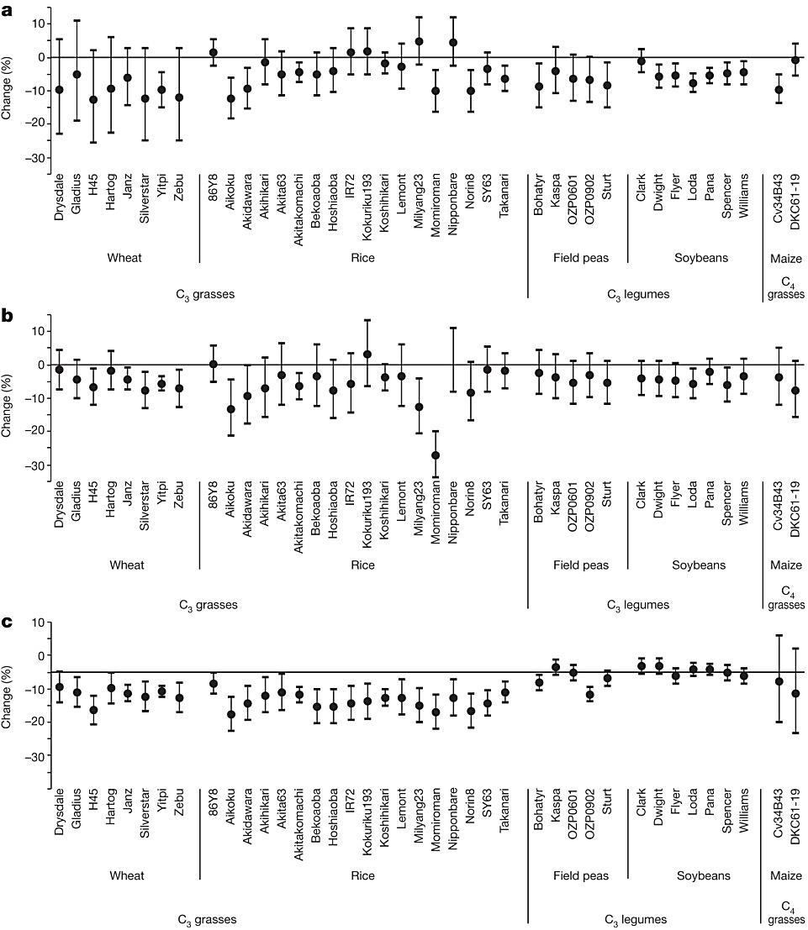
c, protein.
b, iron
a, Zinc;
Activity 2: ‘’Pictograms of climate-smart agriculture solutions’’
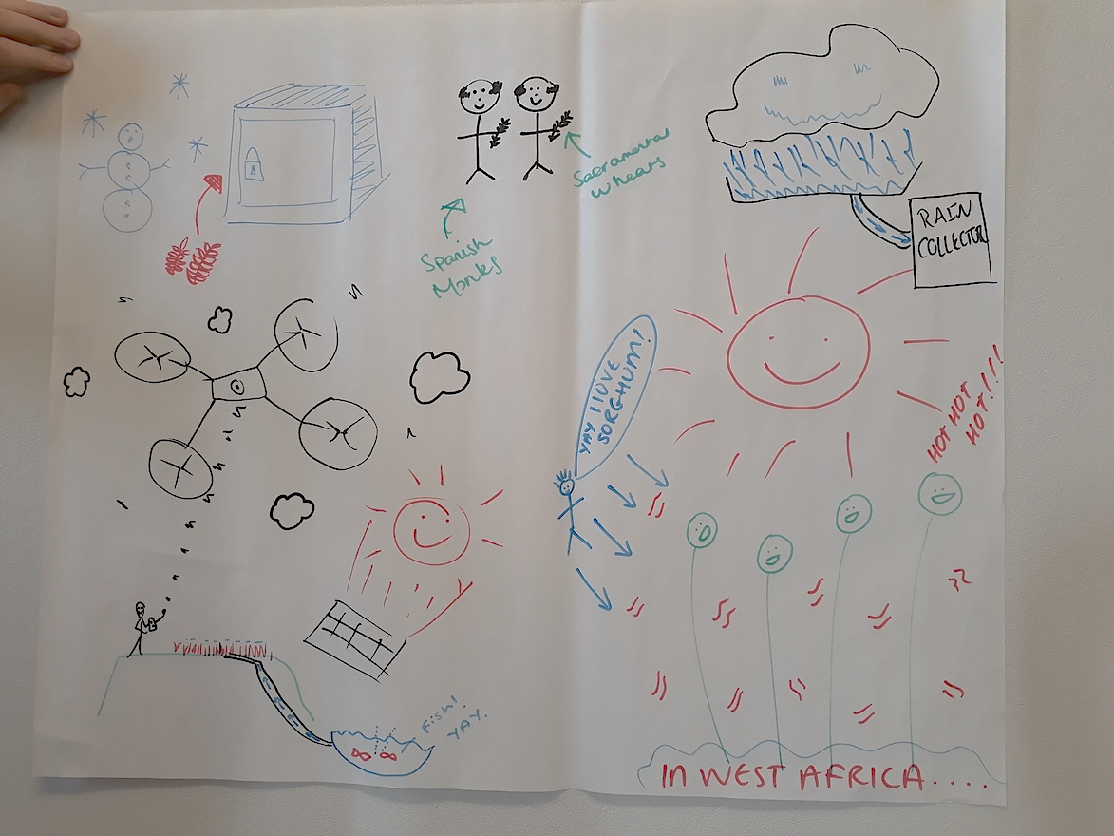
Example CSA news articles handouts
1. Create a pictogram poster of CSA solution(s) from your chosen news article(s).
2. Groups will show and explain to class their pictogram poster
Example pictogram
https://www.thepatriot.co.zw/old_posts/drip-irrigation-way-to-go-mitigating-erratic-rainfall-effects/ accessed April 2021
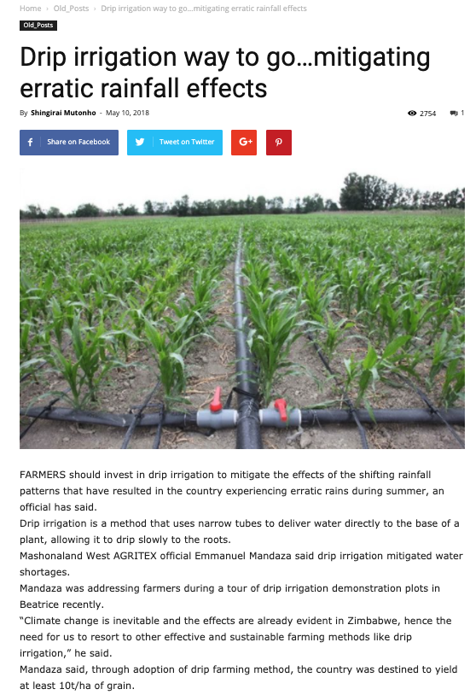
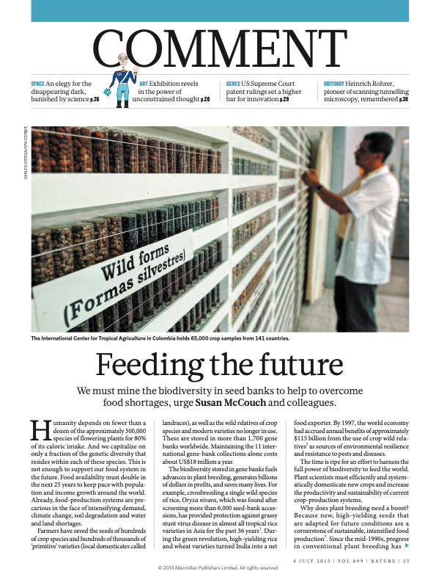
McCouch, S., Baute, G., Bradeen, J. et al. Feeding the future. Nature 499, 23–24 (2013). https://doi.org/10.1038/499023a
https://www.irri.org/climate-change-ready-rice
accessed April 2021

