EBS & MAED
Hands-on 1: Energy Balance Studio Installation

Learning outcomes
By the end of this exercise, you will be able to:
1) Accessing the EBS installation file and preparing your computer for installation of Energy Balance Studio
2) Install Energy Balance Studio on Windows
3) Install Energy Balance Studio on Mac
4) Create a New Case Study in Energy Balance Studio

Accessing the EBS installation file and preparing your computer for installation of Energy Balance Studio
In order to access the EBS installation files, fill the following anonymous Google Form:

Google Form:
https://docs.google.com/forms/d/e/1FAIpQLSe2mXztFFI_wt_TSMB2xgFfZetjxtNCzMW9zrQ5YMngsHqYSg/viewform

Once you click on that link, you will land on the Google Form page shown in the picture below. As stated in the consent form, anonymous data on your country and affiliation are collected for statistical purposes. If you agree to these terms, complete the survey, and click the button “Submit”.
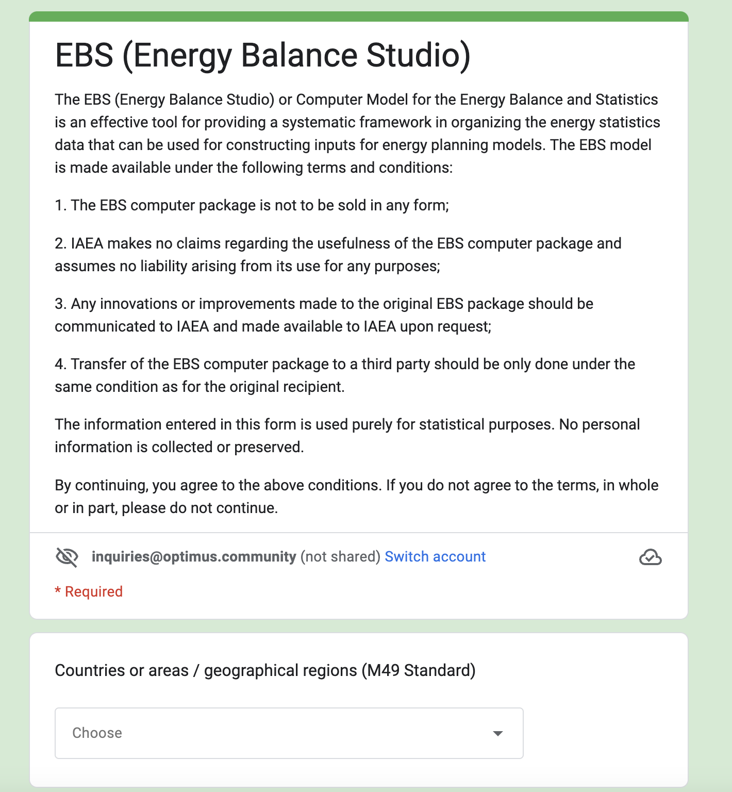

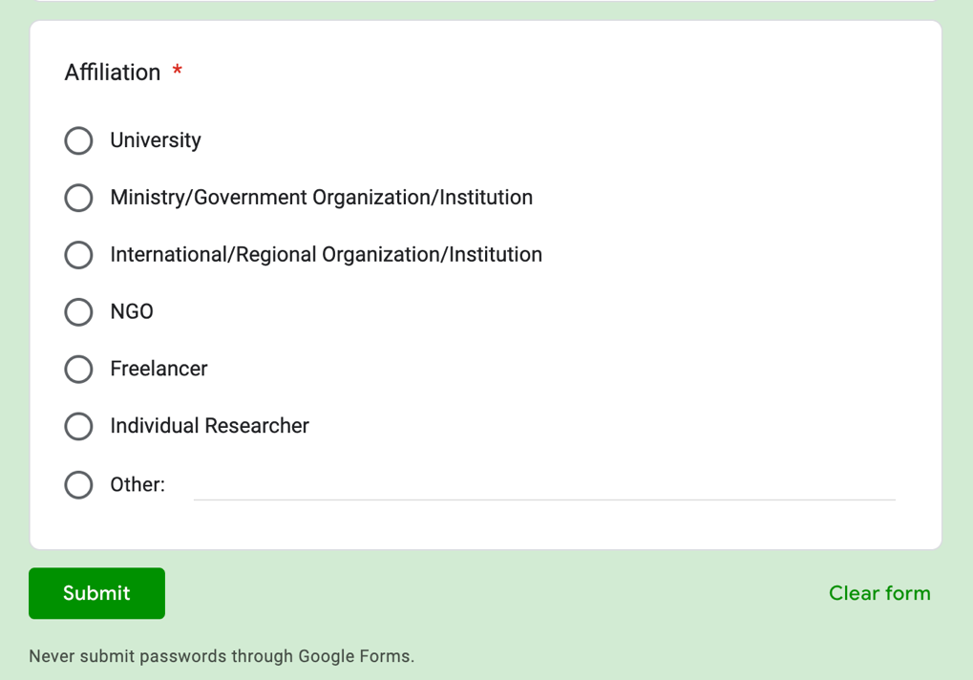

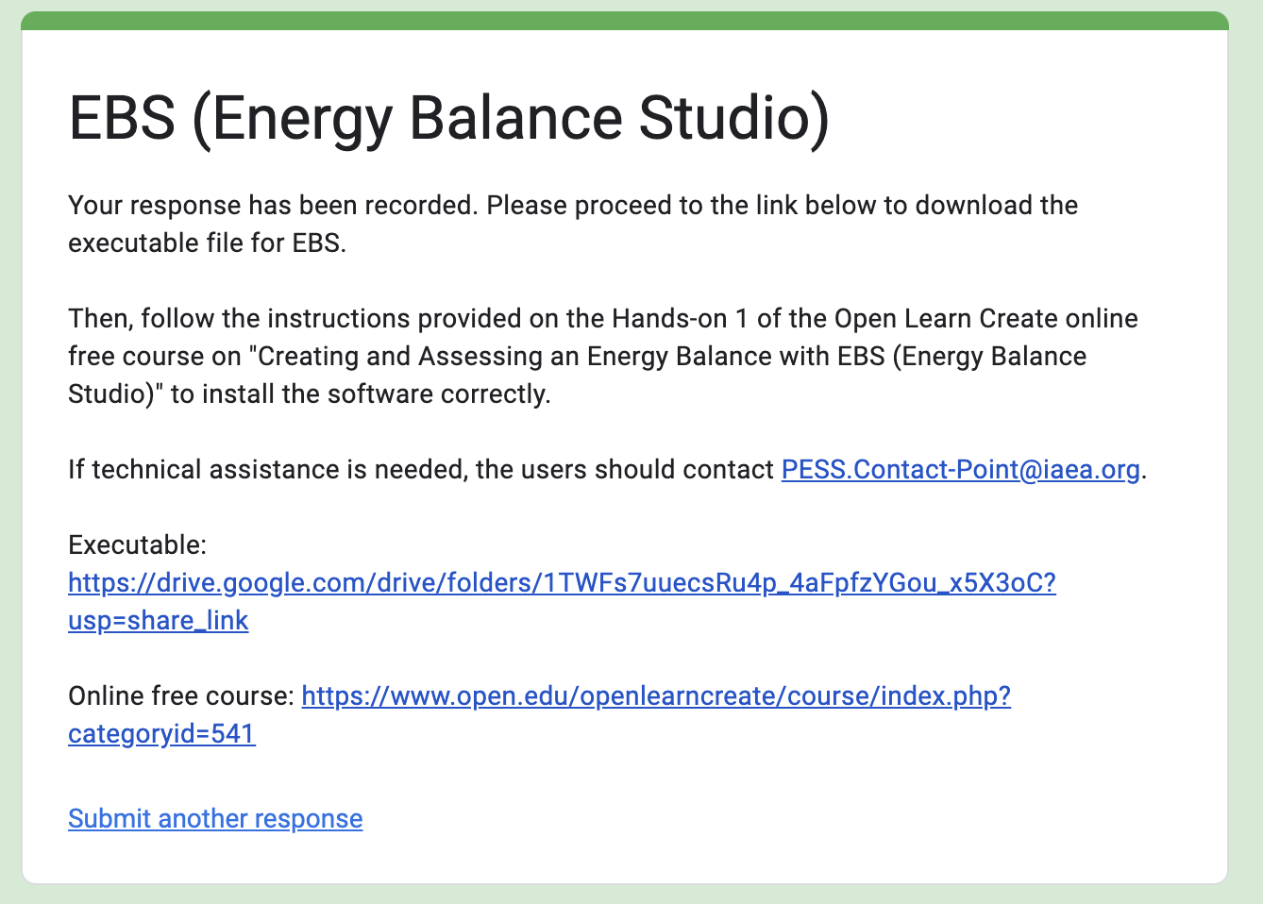
Once you Submit the Google Form, you will be redirected to this confirmation message which include the full link to the Drive folder where you can find the EBS executable:

Then, click on the link as pointed out by the red arrow and you will be redirected to a Drive Folder (as shown below).

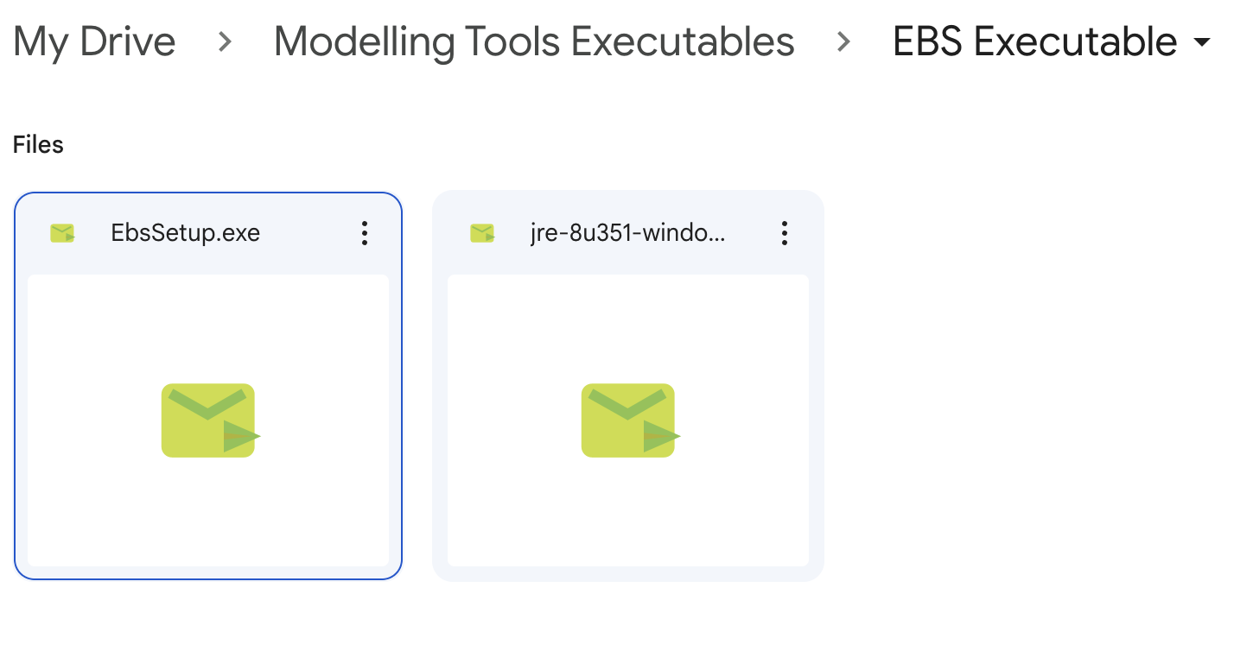
You will see two files here. The EBS executable is the first file on the left, named ‘EbsSetup.exe’, pointed out by the orange arrow. This is the file that concerns the actual software.
Right click on the file, and click download in order to download the file. If a pop-up message appears, click download anyway.
Before installing EBS, it is necessary that you have Java installed on your computer.
If you are using a Mac computer, please install the latest version of Java via the following link: https://www.java.com/en/download/
If you are using a Windows computer, please install java by downloading the other file in the google drive, the one called ‘jre-8u351-windows-x64.exe’ (pointed out by the purple arrow) and run it on your computer.
Once you have installed Java successfully, you can move on to install EBS.

Installing Energy Balance Studio on Windows
The installation of the EBS software is straightforward. The user has to start the installation file EbsSetup.exe and follow the steps listed below. It is recommended to install it as the standard installation.
Please note that the user must have administrative rights to install EBS. EBS can be installed in any folder according to the user preferences. However, it is recommended NOT TO install it into the “Programme Files” folder to avoid some operational issues. The user may create a new folder, e.g., “C:\Programs\EBS” and install the software there.
Select the folder to install EBS.
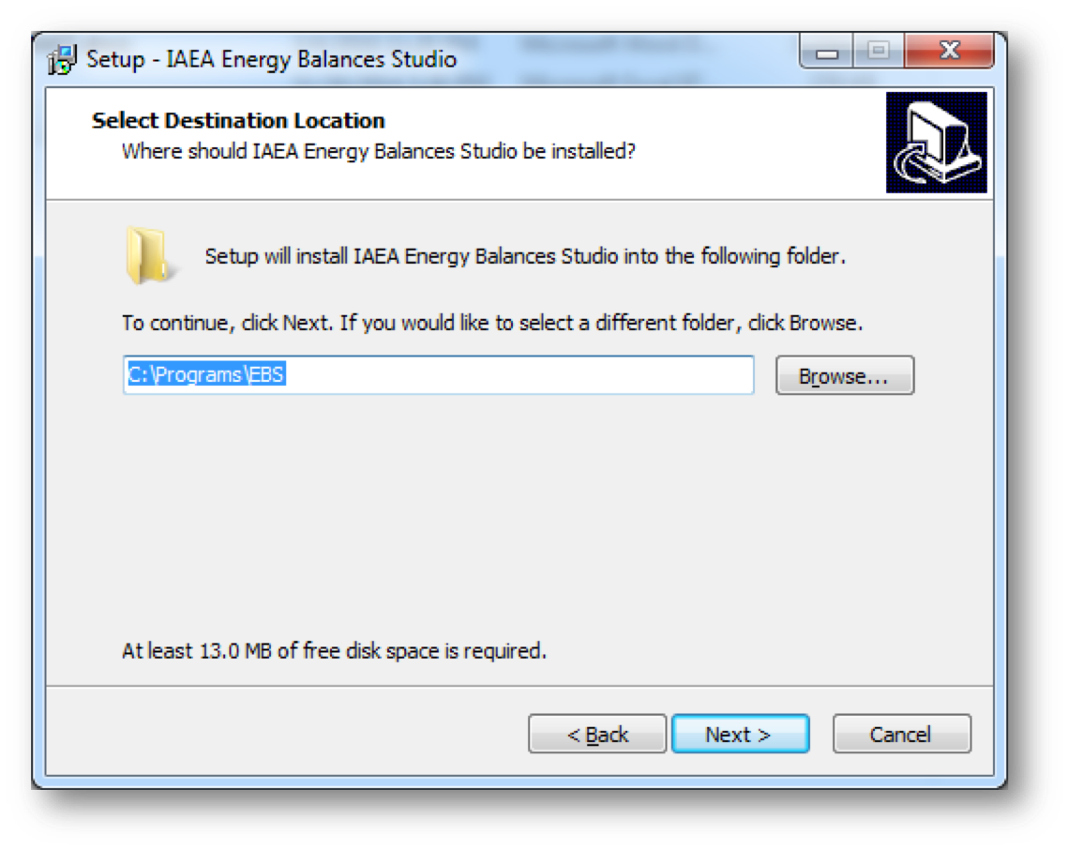
Choose where to create the programme's shortcut (default is IAEA group)
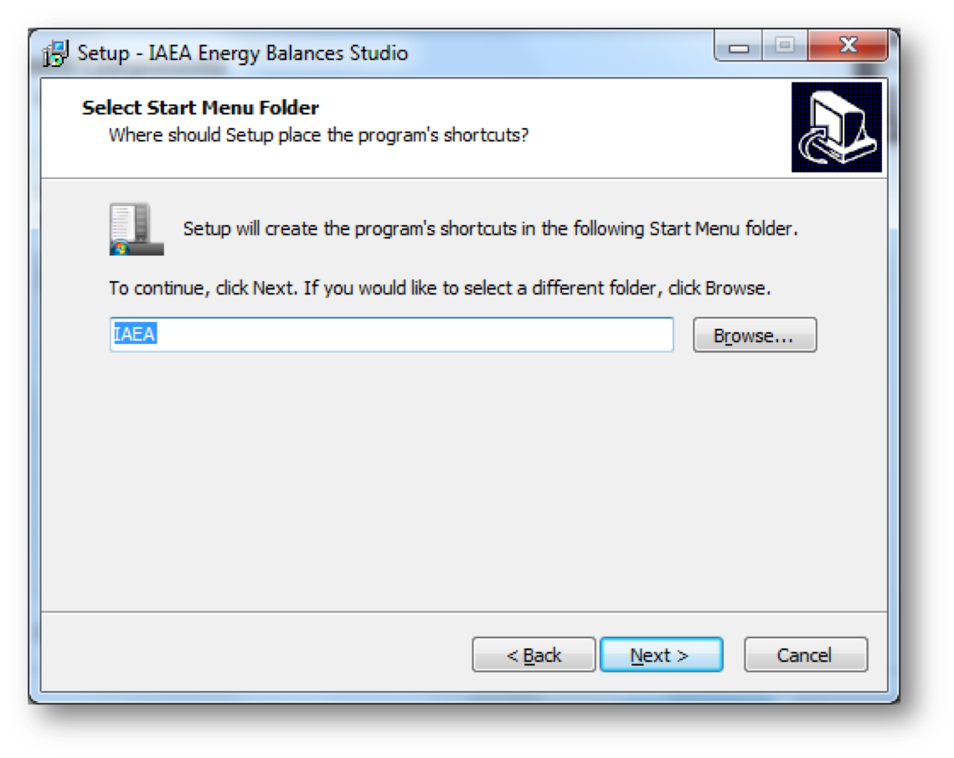
Confirm installation.
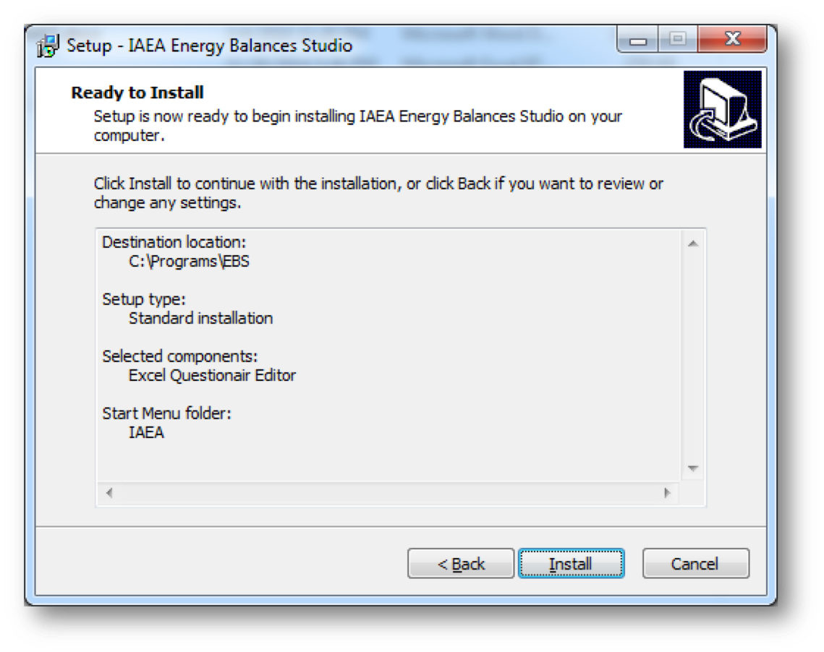
EBS is Successfully Installed.
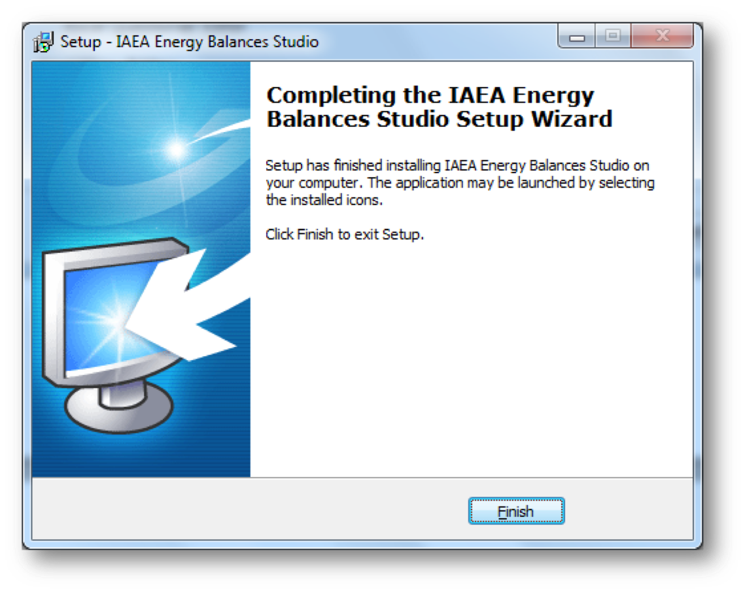
After the installation is complete there will be a link to the programme visible under the Start-up menu. No desktop shortcut is created during the installation; however, the user can create this themselves.

Installing Energy Balance Studio on Mac
For Mac, grab all subfolders in “ESB Tool 2019” and copy it to machine.
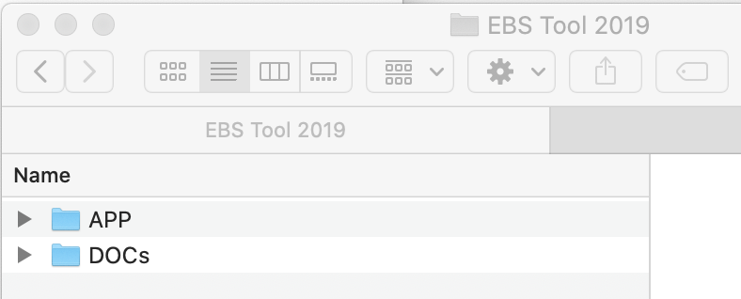
Go to folder “APP”, subfolder “lib”, locate file “ebs.jar” and run it.
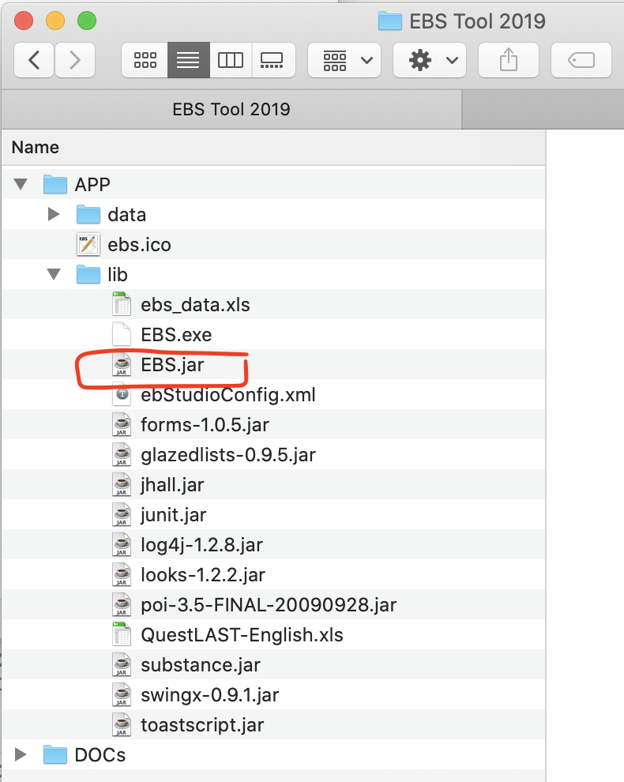
EBS should open.

Creating a new case study in Energy Balance Studio
Open EBS. You should see a window like this:
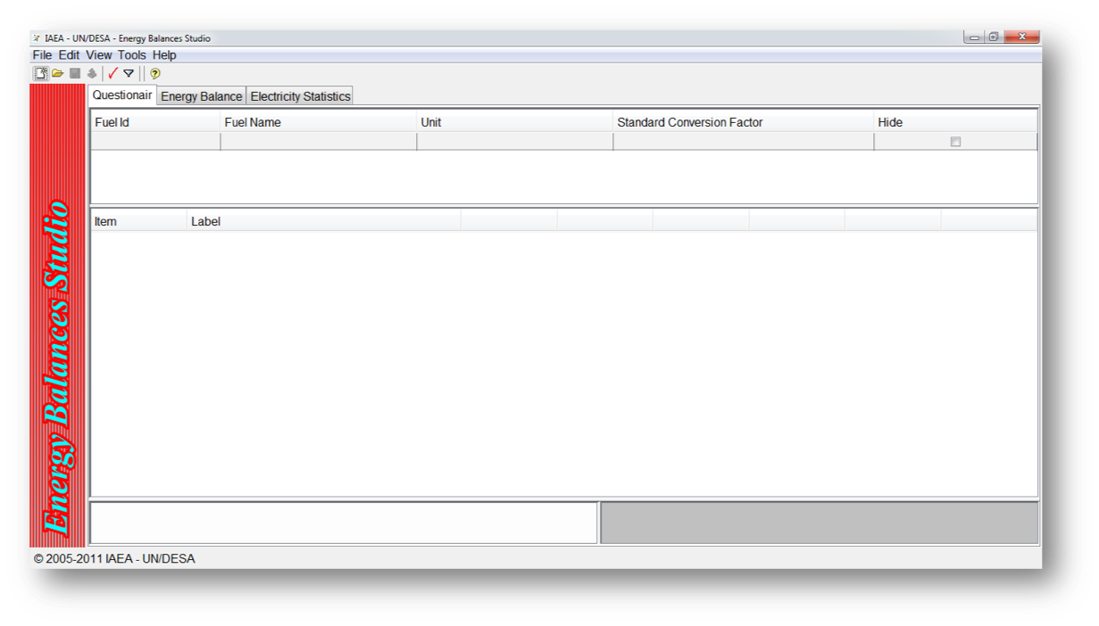
To create a new case, click File > New.
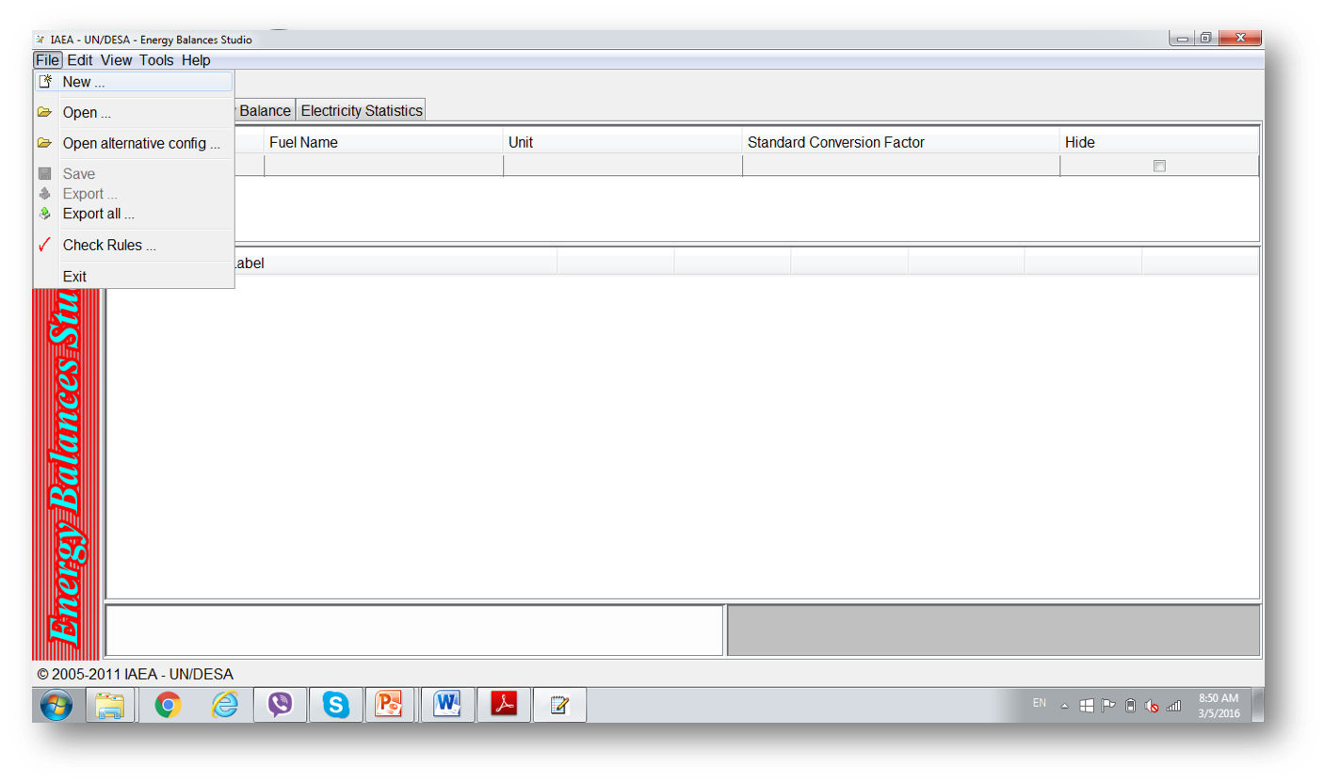
For this example, the case study will be in Mauritius. Please select Mauritius from the drop-down menu and click apply.
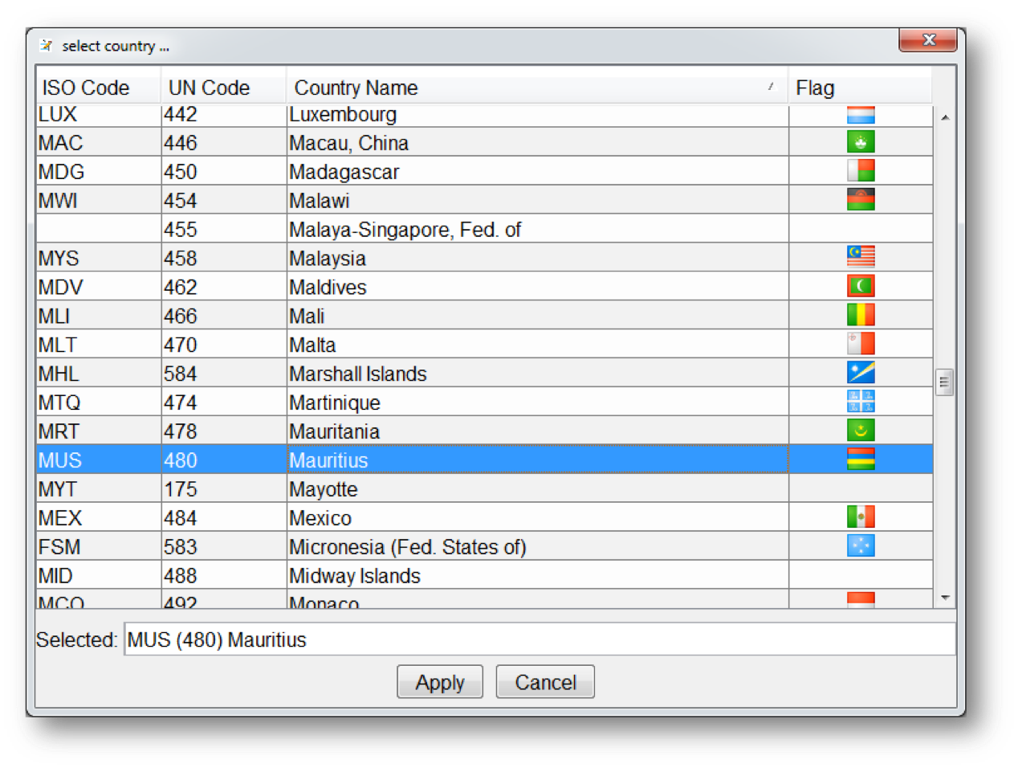
An alert will pop-up.
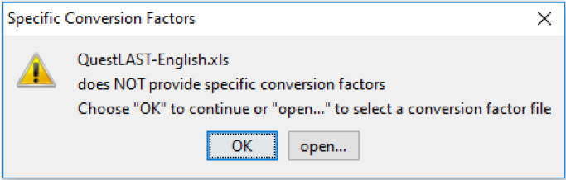

This is to inform you that the UNSD Questionnaire file "QuestLAST-English.xls" does not contain information on specific conversion factors. If it is the case that the user has a separate file containing specific conversion factors, those can be read from the file by choosing "Open". In this exercise, we will select "OK" and will add/edit specific conversion factors later.
Click “OK”.
Your case has been created:
