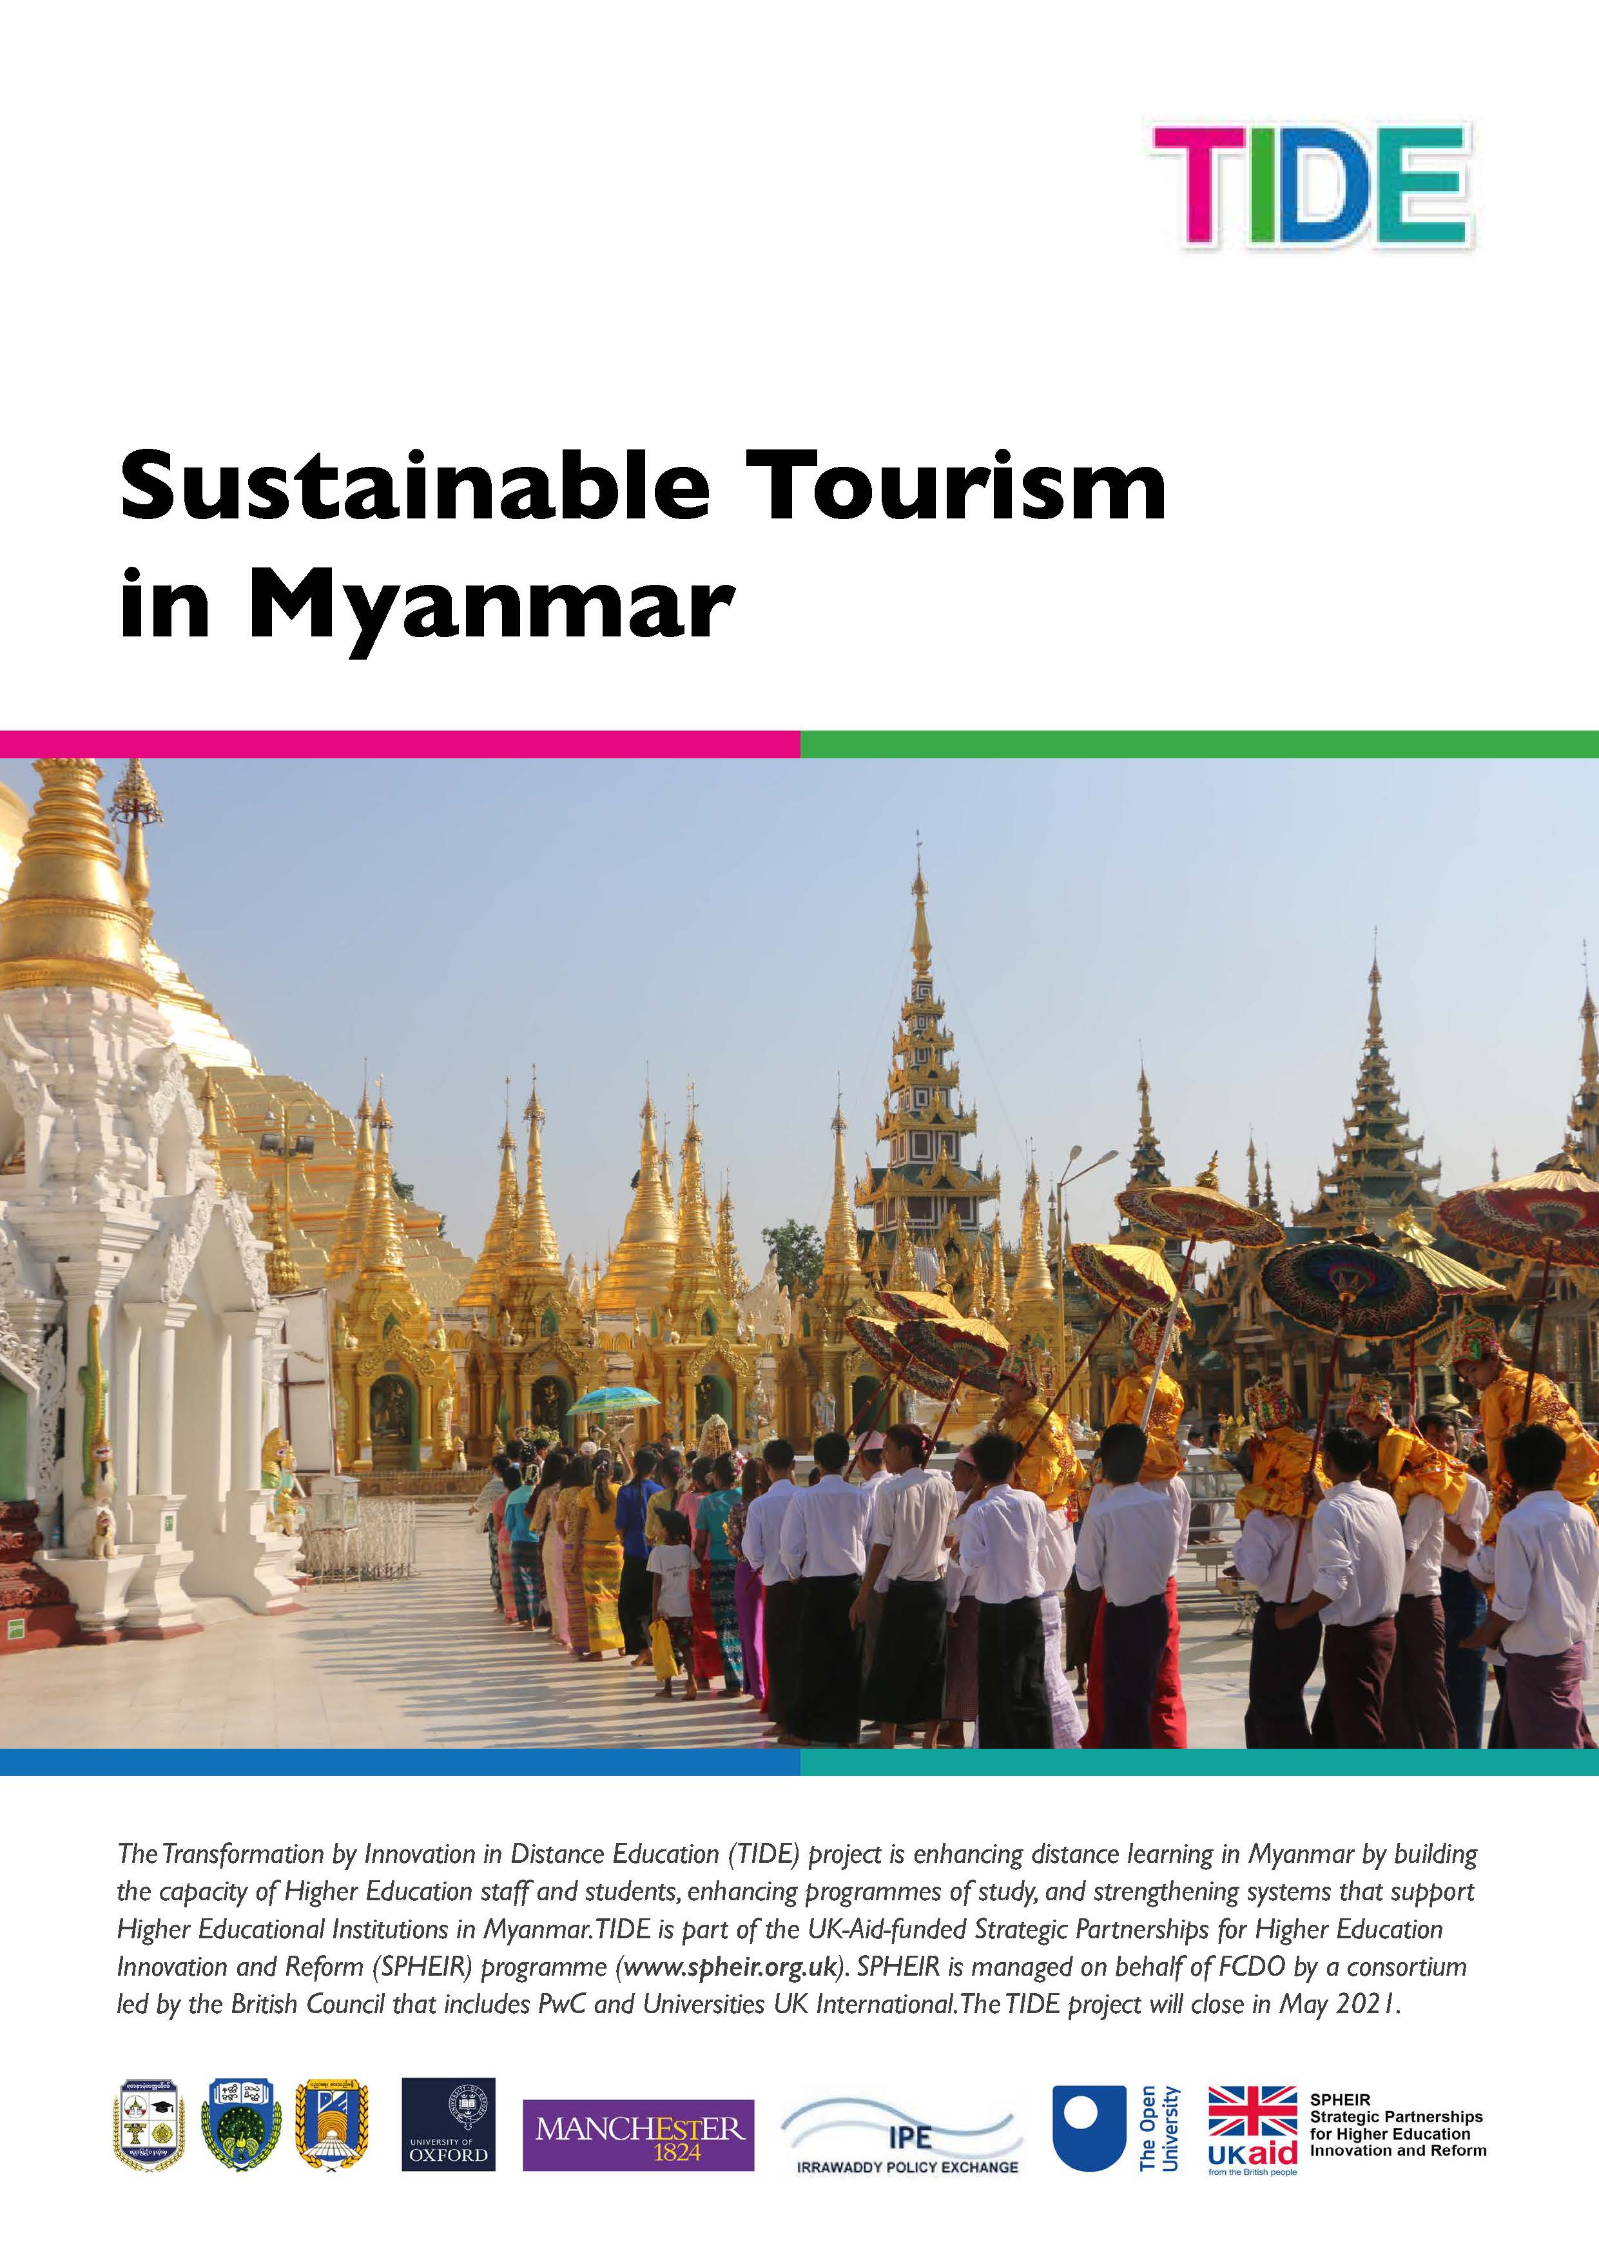

Contents

Introduction
Learning outcomes 5
Course content 5
Assessment strategy 6
Getting started 7
Acknowledgements 7
References 7

Topic 1: Introduction to tourism
1.1 The history of travel and tourism 9
1.2 Tourism concepts and types of tour 13
1.3 Types of tourism 18
1.4 Sustainable tourism 22
1.5 Components of the tourism destination 24
1.6 The customer journey 27
Answers to activities 30
References 32

Topic 2: Travel and tour operations 1
2.1 Travel agents and tour operators 34
2.2 Functions and operations of a travel agency and tour operator 37
2.3 Tour packaging 41
2.4 Ticketing 44
2.5 Transportation services 47
2.6 Digital tourism 50
Answers to activities 53
References 55

Topic 3: Travel and tour operations 2
3.1 Destination management 57
3.2 The tourism destination life cycle 60
3.3 Sustainable tourism planning 63
3.4 Tour guide profession 67
3.5 Fundamental tasks of a tour guide 70
3.6 Specific tasks of a tour guide 73
Answers to activities 75

Topic 4: Introduction to hospitality
4.1 History of hospitality 78
4.2 Serviced accommodation 82
4.3 Non-serviced accommodation 84
4.4 Dawei case study 86
4.5 What is a hotel? 89
4.6 Trends in hotel development 92
Answers to activities 95
References 97

Topic 5: Hotel operations
5.1 Departments in a hotel 99
5.2 Front office operations 102
5.3 Housekeeping operations 106
5.4 Food and beverage operations 110
5.5 Tourism and hospitality job opportunities 114
5.6 Hotel careers 116
Answers to activities 122
References 124

Topic 6: Future of tourism and hospitality in Myanmar
6.1 Myanmar as a tourist destination 126
6.2 Tourist attractions of Myanmar 129
6.3 Myanmar’s tourism performance 133
6.4 Tourism investment opportunities in Myanmar 135
6.5 Challenges to sustainable tourism 138
6.6 The future of tourism in Myanmar 141
Answers to activities 144
References 146

Conclusion

Glossary

Acknowledgements
Sustainable tourism in Myanmar
Introduction
In this free course you will learn the key concepts needed to understand the tourism and hospitality sector and how it works. The learning is presented through the lens of a country that is relatively new to tourism: Myanmar. This enables you to understand the opportunities and constraints inherent in developing the sector.
The course is authored by Myanmar academics for two audiences. Firstly, Myanmar school leavers progressing to higher education who want to brush up their study skills. Secondly, others who are considering careers in the tourism sector and want to understand the opportunities better.
The course is entirely self-study. It has six topics, with each topic requiring three hours of study – a total of 18 hours of study. Each topic is broken down into six sessions, enabling short bursts of learning that can be studied on a mobile phone. The course is assessed by an end-of-course quiz, and a Statement of Participation is available.

Learning outcomes
Learning outcomes are what you will know and be able to do after studying the course. They are divided into knowledge-learning outcomes and skill-learning outcomes.
The knowledge-learning outcomes of the course are:
- Use tourism concepts confidently
- Explain the functions of a travel agent and tour operator
- Understand the relationship between tourism and hospitality
- Explain hotel management operations
- Appreciate the opportunities for tourism growth in Myanmar.
The skill learning outcomes of the course are:
- Work independently
- Analyse data
- Manage your time effectively.

Course content
The six topics that make up the course are introduced below.

Topic 1: Introduction to tourism
This topic begins with the history of tourism and the types of tours tourists take. It will introduce you to some key tourism concepts and you will learn many more as you study the course. It considers different types of tourism, including what is meant by sustainable tourism, and what makes up a tourism destination. Finally, the stages in a tourist journey are considered and how the internet has transformed the experience.

Topic 2: Travel and tour operations 1
This topic looks at what travel agents and tour operators do, their scope and range. It looks at the elements that make up an all-inclusive tour package and how they are costed, before looking at ticketing for air, rail and sea transportation. These transportation services are explored and finally, the concept of digital tourism is examined.

Topic 3: Travel and tour operations 2
This topic looks at destination management, which is a form of tourism planning. It is best achieved through a destination management organisation. Every tourism destination follows a life cycle which is explored. Tour guiding is also considered: the characteristics, responsibilities and qualities a tour guide needs. You are invited to consider whether you have the skills to work in this profession and further detail is provided on the fundamental and specific tasks performed by guides.

Topic 4: Introduction to hospitality
This topic covers types of accommodation that tourists use and the business of hospitality. It begins by tracing the history of hospitality, before looking at serviced and non-serviced accommodation. It considers how a tourist destination is born by telling the story of Dawei, in the south of Myanmar. It goes on to look at the major form of tourist accommodation, hotels, and the latest trends in their development.

Topic 5: Hotel operations
This topic begins by considering the different departments needed to operate a hotel successfully, focusing on the four main departments: the front office, housekeeping, food and beverage service, and food and beverage production. Travel and tourism’s contribution to employment is then considered, together with career opportunities in the hotel industry and how to extract information from job advertisements.

Topic 6: Future of tourism and hospitality in Myanmar
This topic begins by introducing the country from the foreign tourist’s perspective and what they like to see and do on their visits to the country. The most frequently visited attractions are then explored, before considering the growth in international visitors to the country. Tourism and hospitality have the potential to make a huge contribution to economic growth and create diversified employment opportunities, but investment is necessary. Tourism investment is considered relative to other Association of South East Asian Nations (ASEAN) countries. The challenges of sustainable tourism in Myanmar are explored. Finally, the impact of Covid-19 in 2020–21 for the future of tourism in Myanmar is reflected upon.

Assessment strategy
There are activities throughout each session to consolidate your learning and help you self-assess your progress. Most of these activities contain questions that have specific answers, but some have reflective questions where you will be asked to draw on your own experience. There are no right or wrong answers to these questions. These reflective questions are included because your experience is valued and they give you an opportunity to reflect upon it. Your reflections will deepen and customise your personal learning journey.
To gain your Statement of Participation, you must complete the end-of-course quiz and gain a pass grade of at least 60%. There is no limit to the number of times you can attempt the quiz, although only your last attempt will be counted.
The skill-learning outcomes will be achieved by completing the course, as this will demonstrate that you can work independently, analyse data and manage your time effectively.

Getting started
The hyperlinks in this document are functional throughout.
Once you have clicked through a hyperlink, you can right-click your mouse and use ‘previous view’ to return to the page from which you hyperlinked.
Please go to Topic 1: Introduction to tourism, to begin your study of the course.

Acknowledgements
Grateful acknowledgement is made to the following:
Authors at Mandalar University and Dawei University, Myanmar.
Picture editor, Rachel Rogers.

References
United Nations. (2019) Sustainable Development Goals. Available at: https://www.un.org/sustainabledevelopment/water-and-sanitation/ (Accessed: 27 December 2020).

Topic 1:
Introduction to tourism
This topic begins with the history of tourism and the types of tours tourists take. It will introduce you to some key tourism concepts and you will learn many more as you study the course. It considers different types of tourism, including what is meant by sustainable tourism, and what makes up a tourism destination. Finally, the stages in a tourist journey are considered and how the internet has transformed the experience.

1.1 The history of travel and tourism
Travel and tourism have become a major part of many countries’ economies and are an important force in globalising our world. But they began a very long time ago.

The Empire Era (900 BCE–300 CE)
While people have always travelled, tourism began to develop during the era of empire with the Greek and Roman Empires. People began travelling in large numbers for commercial, educational and religious purposes. The Greek Empire (900–200 BCE) advanced tourism through its use of a common language improving communications. The Greeks also introduced a common currency, which made purchasing goods and services when travelling easier. The ease of travel made it possible for the first ancient Olympic Games to be held in Greece in 776 BCE and for athletes, sculptors and poets to attend.
The growth of the Roman Empire (500 BCE–300 CE) expanded tourism further. The middle classes and the wealthy travelled for leisure, visiting cultural and historical sites of importance and spa resorts, as shown in Figure 1.1.1. Visiting spa towns was a popular leisure activity in Roman times. They continue to attract tourists today, who come both to learn about their heritage and to enjoy their health and well-being benefits. The Romans built roads and rest houses throughout Europe, which made tourism more accessible. They also developed guidebooks and travel writing.
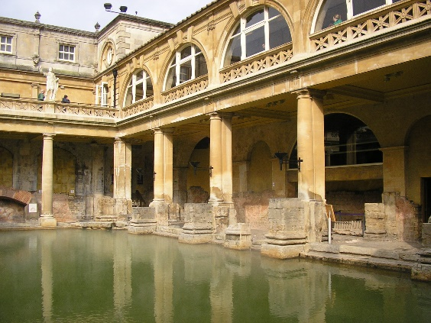
Figure 1.1.1 Roman baths, in the English city of Bath

Outside Europe, pilgrimage became a major reason for travel along defined routes. Pilgrimage to the earliest Buddhist sites by monks and small groups of people began more than 2,000 years ago. This period also saw the beginning of the Silk Road, which was a trade route connecting Asia with the Middle East and Africa. Started by the Chinese, it connected merchants along its route.

The Middle Ages (5th–14th centuries CE)
Travel became much more dangerous and uncomfortable as the Roman Empire crumbled. There were many risks for travellers, from diseases like the plague, to war, famine, violence and extreme weather. Moreover, the provision of hospitality was difficult to find. Only the most adventurous people travelled during this time.

The Renaissance Era (15th–16th centuries CE)
The Renaissance, meaning ‘rebirth’, was a period in European history marking the transition out of the Middle Ages. It was associated with great social change, a thirst for learning and it saw the popularity of travel grow again as people travelled to experience art, culture and science.

The Grand Tour Era (1613–1785)
The Grand Tour marked the height of luxurious travel and tourism activities in Europe. It originated with wealthy, young Englishmen and soon became fashionable among wealthy, young men from other countries, who had time and money. Grand Tour participants travelled throughout Europe experiencing the best of Western civilisation through its arts and sciences (Figure 1.1.2). There was a standard itinerary that served as an educational rite of passage. However, the tradition declined with the advent of accessible rail and steamship travel.
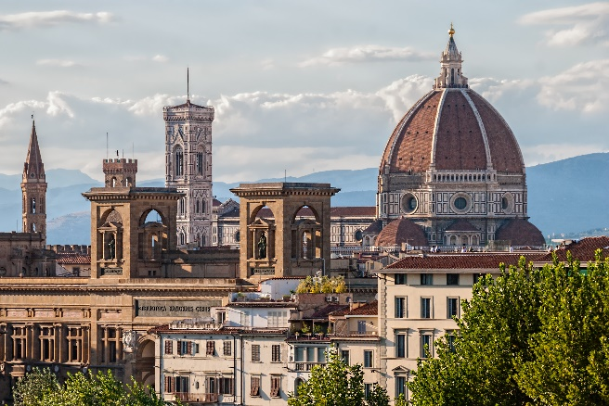
Figure 1.1.2 Florence was frequently visited by young men on the Grand Tour

The Mobility Era (1800–1944)
Growing economic prosperity and the advent of leisure time, as well as the availability of affordable travel, ushered in a new era in the history of tourism. People who were no longer tied to the daily chores of farm life began to search for new ways to spend their precious leisure time away from their jobs in offices, stores and factories. The Mobility Era was characterised by increased travel to new and familiar locations, near and far. Tourism activities began to increase as new roads, stagecoaches, passenger trains and sailing ships became common sights.
An Englishman called Thomas Cook (1800–1892) can be credited with finally bringing travel to the general public by introducing the package tour. Cook organised the first inclusive tour from England to the Paris Exhibition in 1855, with the travel arrangements, accommodation, and transport all part of the package. A further boost to mass tourism was the invention of the motor car – the Model T in 1908 by the American Henry Ford – although it would be many decades before it was affordable by the masses. The car expanded opportunities to travel independently far and wide.

The Modern Era (1945–present day)
Mass tourism received an additional boost after World War II as more hotels were built and jet travel was introduced in the 1950s. Its growing popularity in the 1960s further accelerated growth in domestic and international travel. The first ever credit card was introduced in 1950: the Diners Club card. This meant individuals could buy goods and services with a card, rather than cash, which further facilitated international travel. The growth of mass tourism accelerated over the last quarter of the twentieth and into the twenty-first century, with the growth in commercial airlines (Figure 1.1.3).
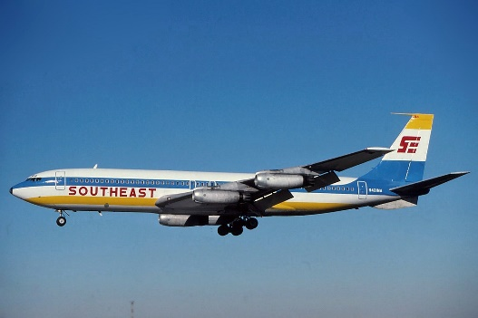
Figure 1.1.3 The Boeing 707 was the first commercial jet airline

Activity 1.1
1. What two things did the Greeks develop that helped increase travel and tourism:
- common culture
- common language
- common currency
- common land
- common uniform?

2. What two things did the Romans develop that helped increase travel and tourism:
- roads
- rest houses
- underfloor heating
- mosaics?

3. Select the correct word(s) to complete the sentence.
The Grand Tour was a journey undertaken by wealthy young men to understand _____ civilisation through its art and sciences.
- Eastern
- Chinese
- African
- Western

4. Select the correct word(s) to complete the sentence.
Thomas Cook organised the first inclusive tour in 1855 to the _____.
- Expo
- Olympic Games
- Paris Exhibition
- World Cup
Answers to Activity 1.1

1.2 Tourism concepts and types of tour
Tourism is defined as the movement of people from their normal place of residence to another place (with the intention to return) for a minimum period of 24 hours to a maximum of one consecutive year for different purposes (Figure 1.2.1). Tourism takes people out of their familiar environment to experience new environments. It involves travel and a stay and can be for business, leisure or bleisure (travel for a blend of business and leisure).
Figure 1.2.1 Tourism involves travel and a stay away from home

Tourists travel to visit friends and relatives, for entertainment, to attend conventions, for business meetings and for outdoor recreation. Tourism involves travel and hospitality. Hospitality is the friendly and generous reception and entertainment of guests, visitors or strangers. You will learn more about hospitality in Topics 4 and 5.

Key concepts for understanding tourism
Concepts are chunks of knowledge and understanding that make communication easier. For example, when the concept ‘tourism’ is used, you now know what is meant, so it isn’t necessary to give the meaning every time. Reading would become very dull and time-consuming if it was. Read the following two sentences to experience this for yourself.
- Tourism is a global phenomenon today.
- The movement of people from their normal place of residence to another place with the intention to return for a minimum period of 24 hours to a maximum of one consecutive year for different purposes is a global phenomenon today.
Do you see?
All subjects have their key concepts that make studying that subject easier and allow students to dive deeper with their learning. Concepts are the building blocks of all thinking and learning. Some of the key concepts for travel and tourism are now explained, although you will be introduced to many more throughout the course.
Tourism can be divided into domestic tourism and international tourism. Domestic tourism is where the residents of one country travel within that country for the purposes of tourism. International tourism is travel to another country, which can be broken down into inbound and outbound tourism (Figure 1.2.2).
Figure 1.2.2 International tourism can be divided into inbound and outbound tourism

Travel can be divided into leisure travel and business travel (Figure 1.2.3).
Figure 1.2.3 The definitions of leisure and business travel

Tourists travel to a tourism destination to enjoy tourist attractions (Figure 1.2.4).
Figure 1.2.4 The definitions of tourism destination and tourist attraction

For convenience, tourists often use a tour operator or travel agent to create and book their holiday (Figure 1.2.5).
Figure 1.2.5 The definitions of tour operator and travel agent

A tour package can consist of transport, accommodation, food, attraction entrance tickets and other services. Other distinguishing characteristics of the tour package are shown in Figure 1.2.6.
Figure 1.2.6 Characteristics of a tour package

The five main types of tours are independent, escorted, hosted, incentive and freedom. The details of each are shown in Figure 1.2.7.
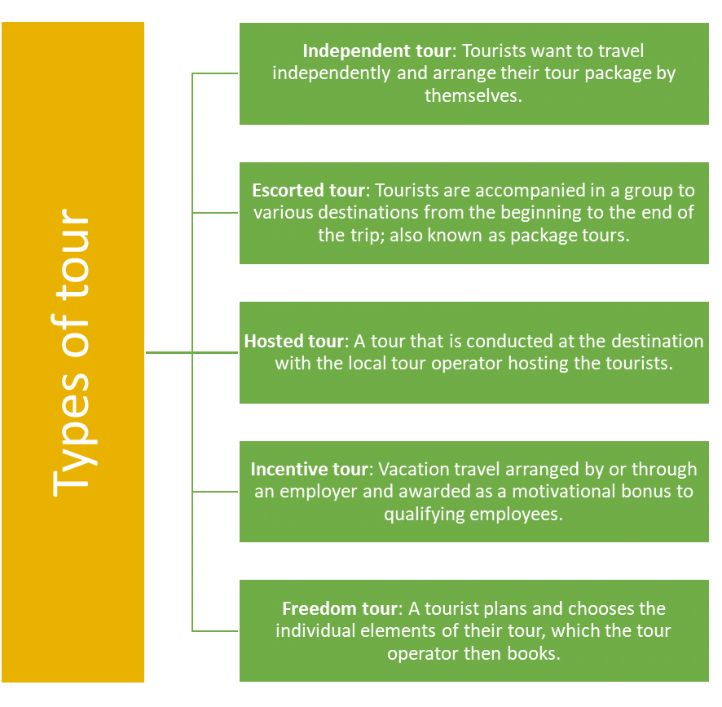
Figure 1.2.7 Main types of tours
Activity 1.2
1. Select the correct concepts to complete the diagram.
Hospitality, Escorted tour, International tourism, Hosted tour, Inbound tourism, Excursion
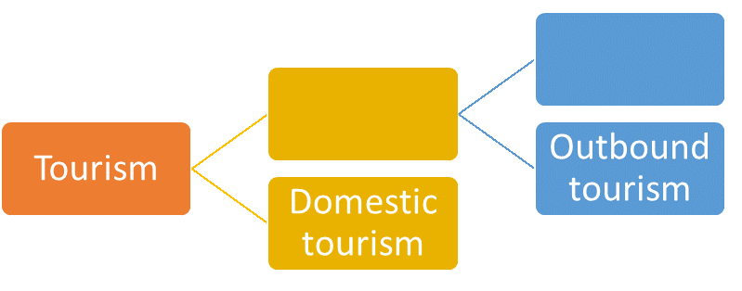
2. Read the profiles of some different travellers and match them with the type of tour package that would best suit them.
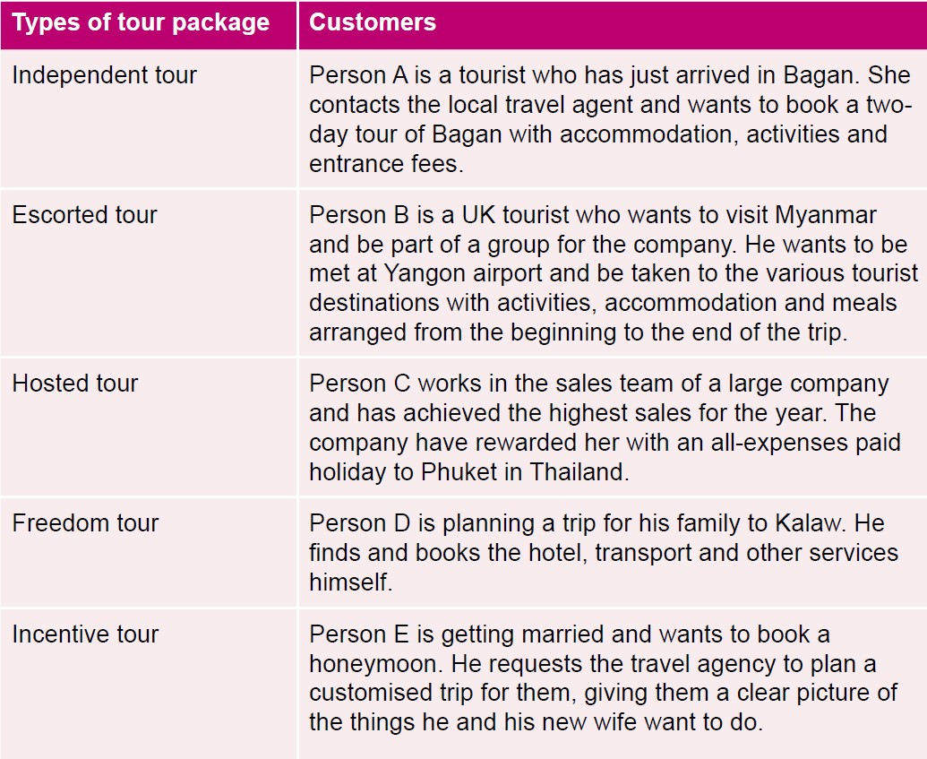
Answers to Activity 1.2

1.3 Types of tourism
There are many different types of tourism. Here is a selection based on recent trends, but it is not a comprehensive list. There is currently a lot of interest in sustainable tourism, community-based tourism (CBT), responsible tourism and ecotourism (Figure 1.3.1). What is common about these four types of tourism is that they have a strong ethical underpinning and are increasingly highly desirable, becoming the gold standard for tour companies.

Sustainable tourism |  | Community-based tourism |  | Responsible tourism |  | Ecotourism
Tourism that protects natural environments, provides an authentic tourist experience that celebrates and conserves heritage and culture, and creates socio-economic benefits for communities |  | Travel in which visitors are given the chance to meet local people and experience authentic cultural exchange, as well as providing employment and income-earning opportunities for the local community |  | Both visitors and hosts are mindful of developing tourism in a way that makes better places for people to live in and visit |  | Travel to natural areas that conserves the environment, wildlife and natural resources; sustains the well-being of the local people; involves interpretation and education

Figure 1.3.1 Types of ethical tourism

Another form of tourism focuses on health and wellness. This is travel for the purpose of medical treatment, to enhance personal well-being or which is accessible for anyone, regardless of physical impairments. This can be divided into medical tourism, wellness tourism and accessible tourism (Figure 1.3.2).
Figure 1.3.2 Types of health and wellness tourism

Some forms of tourism are more niche or specialised. Specialised tourism is travel for a special purpose, which appeals to a small sector of the market, such as disaster tourism, which is visiting locations that have experienced a natural or man-made disaster (Figure 1.3.3).
Figure 1.3.3 Some specialised forms of tourism

There are also forms of action tourism, which is travel for the purpose of sport, extreme sport or adventure (Figure 1.3.4).
Figure 1.3.4 Some forms of action tourism

Activity 1.3
1. Match the types of tourism with the images:
- wildlife tourism
- sport tourism
- dark tourism
- religious tourism
- adventure tourism
- accessible tourism.

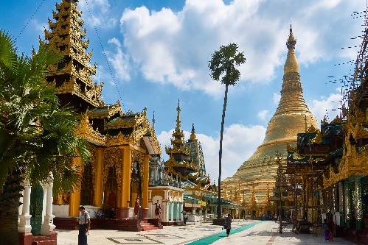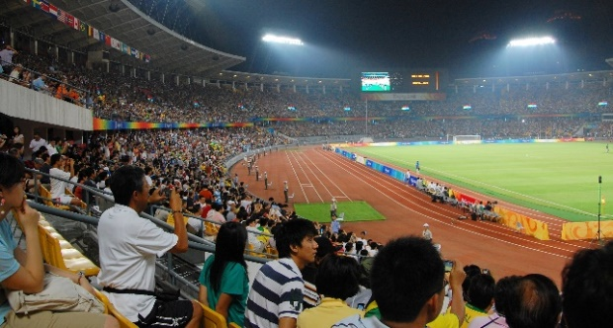
(i) (ii)
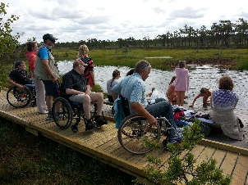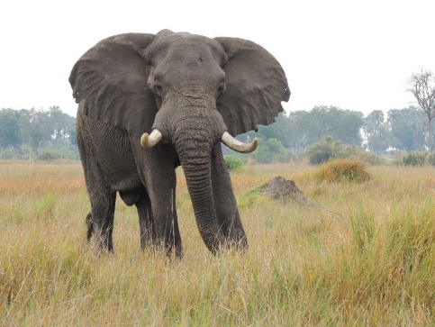
(iii) (iv)
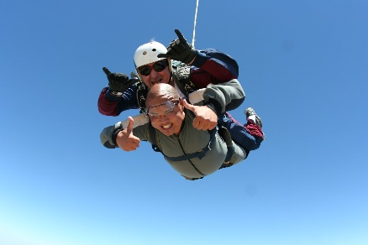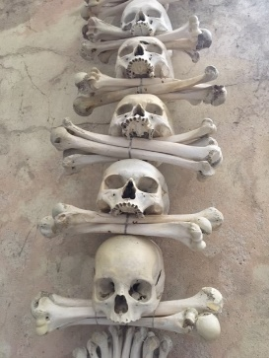
(v) (vi)
Answers to Activity 1.3

1.4 Sustainable tourism
Tourism brings together tourists, tourism suppliers, host governments, host communities and the surrounding environment. According to the World Tourism Organization (UNWTO), sustainable tourism is ‘Tourism that takes full account of its current and future economic, social and environmental impacts, addressing the needs of visitors, the industry, the environment, and host communities,’ (UNWTO, 2021). The concept of sustainable tourism has been advancing for over 20 years, becoming increasingly relevant in national and international agendas. The United Nations (UN) General Assembly has adopted several resolutions acknowledging its importance as a tool for development, poverty eradication and environmental protection. This culminated in the UN declaration of 2017 as the International Year of Sustainable Tourism for Development.
Sustainable tourism principles and practices are applicable to all forms of tourism in all types of destinations, including mass tourism and the various niche tourism segments discussed in Session 1.3. They place the environment, economy and sociocultural dimensions at the centre of tourism development, and strive for a harmonious balance between these three dimensions that guarantees sustainability over the long term.
Figure 1.4.1 The three dimensions of sustainability

Environmental resources – such as nature and stunning vistas – are a key element in tourism development, as they are what many tourists come to enjoy. For sustainability, the essential ecological processes that created and conserve the rich natural heritage and biodiversity need to be maintained.
Respecting sociocultural heritage is important, as it is the authenticity of host communities that many tourists wish to see. Tourists wish to understand the lived experience of traditional ways of life and the values that underpin it. In the process of exchange, better understanding and tolerance grows, which is beneficial for all.
Ensuring sustainable economic growth contributes to poverty alleviation. Socio-economic benefits can result for all stakeholders, in the form of stable employment, income-earning opportunities, and health and education services to host communities.
For sustainable tourism to develop, all relevant stakeholders need to be consulted and involved. Strong political leadership is needed to ensure that all stakeholders are meaningfully involved and that a consensus about the future direction of development is reached. This is not a one-off process, but a continuous process that requires constant monitoring of impacts, so that preventive and/or corrective measures can be taken when necessary. When sustainable tourism is done well, it delivers a high level of tourist satisfaction and a meaningful experience for the tourist. It also raises tourist awareness of sustainability issues, which in turn further promotes sustainable tourism practices and principles (UNWTO, 2021).

Activity 1.4
Watch the video ‘Sustainable Tourism in Myanmar’ and answer the following questions.
https://www.youtube.com/watch?v=OgRO-sOxoxI
1. What are the problems of becoming a mass tourism destination for Inle Lake?
2. Who benefits from sustainable tourism?
3. What Shan traditional crafts have been revived by a sustainable tourism approach?
4. What benefits does the Pa-O community hotel bring to the community:
- education
- employment
- health
- collective identity
- preserves cultural heritage?
Answers to Activity 1.4

1.5 Components of the tourism destination
This session analyses what makes up a tourism destination in order to better understand how to meet tourists’ needs.
The basic components of a tourism destination are access, accommodations, attractions, activities and amenities (Figure 1.5.1).

Figure 1.5.1 Basic components of a tourism destination

Access refers to the ease of reaching the destination, which requires good transport and communications links, such as an airport, highway and railway station. It also includes the ability of the destination to cater for visitors with disabilities such as mobility, vision, hearing and cognitive impairments.
Accommodations means having sufficient quantity and quality of accommodation options in the destination to meet tourist numbers, tourist budgets and tourist needs.
Attractions are often the focus of visitor attention and provide the initial motivation for the tourist to visit the destination. They vary widely among destinations and can be people, places, things or experiences that attract visitors (Figure 1.5.2).

Figure 1.5.2 Types of attractions

Activities are becoming more popular as tourists look for experiences in the destination. Packaging attractions as activities means that they can command a higher price. For example, if the cuisine of the local area is an attraction, offering food tours and cooking classes is a way of leveraging the attraction to reach a specific market.
Amenities means the basic facilities provided in a tourist destination, which are sometimes referred to as the ‘pleasantness’ of a place. They include basic signage, public toilets, paths, internet access, restaurants, money-changing facilities and safe drinking water. They play an important role in shaping the visitor experience.
Thinking about all five of these dimensions and how they integrate is important for ensuring a good tourist experience. Developing the infrastructure, facilities, events, activities and accommodation together will distinguish the destination and make it uniquely attractive to the tourist.
Tourism is a unique product because the tourists (buyers) go to the destination communities (sellers). What the tourists come to see is not used up either. For example, a scenic view remains after the tourists visit. It is also labour intensive, offering continuous employment, and is people oriented, enabling the tourist and local communities to connect and benefit from the interaction.

Activity 1.5
1. Select the five basic components of a tourism destination from the list below:
- aeroplanes
- cruises
- access
- railways
- accommodations
- roads
- attractions
- weather
- activities
- amenities.

2. Tourism is a unique product because of four characteristics shown in the diagram. Match the description to each characteristic.
(i) Tourism is about connecting with different people.
(ii) The tourist has to purchase and travel to the tourist site (the product they have bought).
(iii) Tourism continuously employs lots of people.
(iv) Tourism does not exhaust the country’s natural resources.
Answers to Activity 1.5

1.6 The customer journey
The customer journey is a helpful framework for understanding the experience of the tourist customer. It encompasses the time between them first beginning to think about a trip to recalling the experience after they have returned home, as shown in Figure 1.6.1.
Figure 1.6.1 The customer journey

Dreaming
The customer journey begins when the customer is considering a vacation and looking for ideas and recommendations. Decision-making will probably begin at the national level, as different countries are considered and a choice made.

Planning
The customer decides on the country to be visited and will then look for specific information. The decision-making may be narrowed down to regions and/or destinations in the country of choice.

Booking
The customer makes comparisons of different tourism products. They will search for the best value for their budget and preferences. The booking may be made through an intermediary, such as a travel agent or tour operator, or directly with individual providers.

Experiencing
This stage will include everything from the welcome the customer receives on arrival, the standard of the facilities, the quality of the attractions, accommodation and other amenities, and the information that visitors receive.

Remembering
On their return home, the customer will recall their journey and will assess whether it was good or bad.

Changes in the customer journey
All stages of the customer journey have been transformed over the past 20 years by the internet and social media. For example, when dreaming, customers are likely to undertake internet searches of countries in order to determine where to go. When planning they look at social media and review destination websites. Research suggests people increasingly choose destinations based on a photo or video seen online, such as Facebook, YouTube and Instagram (White, 2018).
Word of mouth is also a significant influencer. As people travel more today, it is likely that the customer will know someone who has visited the place and from whom they can ask for advice. At the booking stage, customers compare the price competitiveness of different tour operators online and may delay booking some tourism products until they are in the country. This is because ease of access to mobile internet makes it possible to book later.
When it comes to experience, the research done before travelling is highly significant in influencing the customer’s overall experience. Indeed, it is estimated that half the evaluation is based on the physical value of what the customer experiences. The other half is the emotional experience they have which is informed by their initial research (Rowett, 2020).
Finally, remembering is enhanced by social media. Customers share their memories through sites such as Facebook and review sites, such as TripAdvisor, providing feedback to a broader audience.
Figure 1.6.2 People carry out independent online research on their holidays today

Tour operators, destinations and tourism-related businesses are realising that today’s tourist is more astute and discerning than in the past. They purchase tourism products differently, making many more critical decisions on their tourism journey. Thus, tourism brands need to be smarter in marketing to new tourists.

Activity 1.6
The internet has transformed the way customers experience the different stages of the tourist journey. Match the changes brought by the internet to each stage of the customer journey.
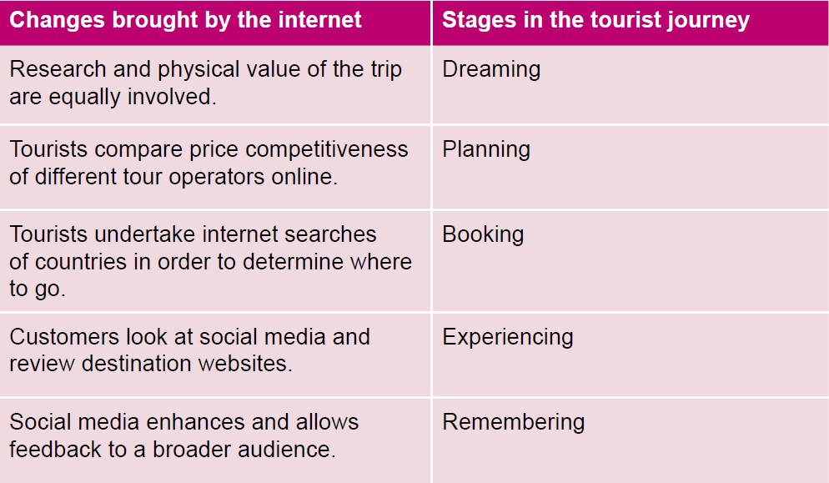
Answers to Activity 1.6

Answers to activities

Activity 1.1
- b) common language, c) common currency
- a) roads, b) rest houses
- d) Western
- c) Paris Exhibition.

Activity 1.2

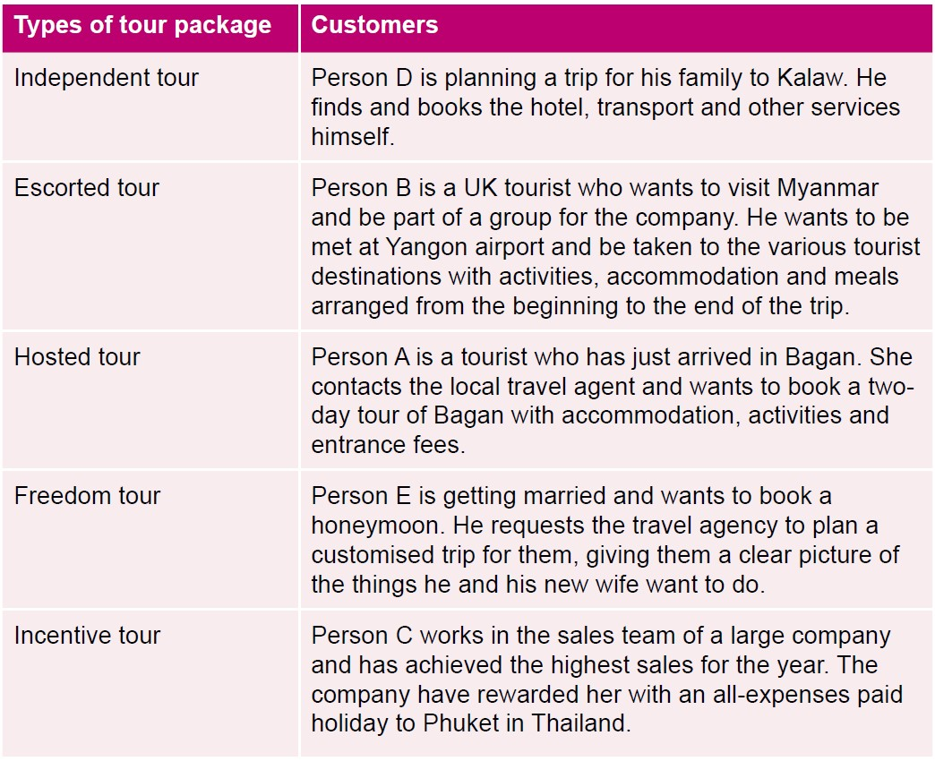

Activity 1.3
- a) iv, b) ii, c) vi, d) i, e) v, f) iii.

Activity 1.4
- Deforestation, sewage run-off, overuse of chemical pesticides and fertilisers on farms, and land grab and loss of traditional ways of life.
- It benefits local people, nature and animals.
- Paper making, ceramics, fabric weaving and woodworking.
- All answers a)–e).

Activity 1.5
- c) access, e) accommodations, g) attractions, i) activities, j) amenities.

Activity 1.6
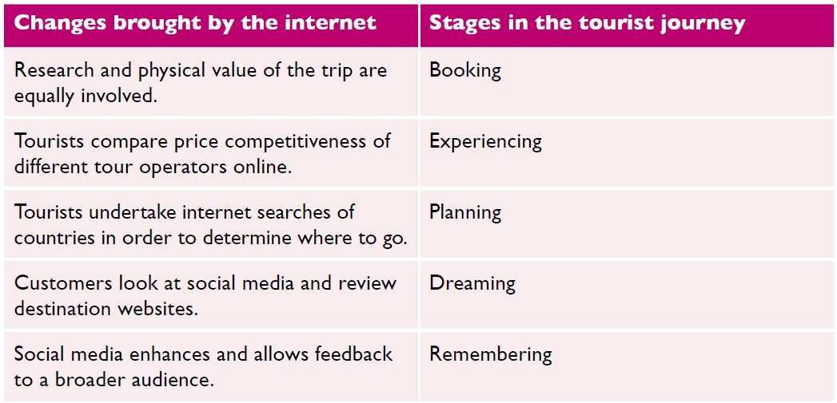

References
Rowett, P. (2020) Customer Journey Mapping for Tourism Brands.
Available at: https://tourismeschool.com/blog/customer-journey-mapping-tourism-brands/ (Accessed: 19 February 2021).

UNEP and UNWTO. (2005) Making Tourism More Sustainable: A Guide for Policy Makers.
Available at: https://www.sustainablesids.org/wp-content/uploads/2016/11/UNEP-WTO-2005-Making-tourism-more-Sustainable-A-guide-for-policy-makers.pdf (Accessed: 21 February 2021).

White, R. (2018) Story Ideas that Attract and Convert Your Ideal Customers.
Available at: https://tourismeschool.com/blog/tourism-content-marketing-themes/ (Accessed: 19 February 2021).

Topic 2:
Travel and tour operations 1
This topic looks at what travel agents and tour operators do, their scope and range. It looks at the elements that make up an all-inclusive tour package and how they are costed, before looking at ticketing for air, rail and sea transportation. These transportation services are explored and finally, the concept of digital tourism is examined.

2.1 Travel agents and tour operators
A travel agent facilitates people travelling to distant places. Planning a trip can be time-consuming and complicated. Travel agents simplify this process for their customers. They can book flights, accommodation and rental cars, as well as entry to attractions and events.
Travel agents serve both individuals and corporations. Some concentrate on a special segment of the industry, for example, a cruise specialist or ski specialist. Others are location-specific, such as for Europe, Africa or Latin America. Travel agents are travel intermediaries between the customer, the tour operator and tourist service providers.
The development of organised travel has its roots in the mid-nineteenth century, with a man called Thomas Cook (Figure 2.1.1) who you were first introduced to in Session 1.1. Thomas Cook helped his community members travel safely to a temperance (teetotal) meeting by railway between the cities of Leicester, Nottingham, Derby and Birmingham in 1841. Cook is considered the first organised travel agent in the world and is credited with being the inventor of the value-for-money travel and tour package. Cook quickly expanded his tour packages, taking 150,000 people from across Britain to visit the Great Exhibition in London in 1851 and offering the first continental tour in 1855.
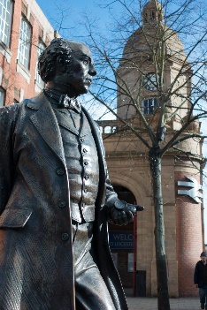
Figure 2.1.1 Statue of Thomas Cook in Leicester, UK

Cook introduced hotel coupons, circular notes (an early form of travellers’ cheques) and advance reservation as part of his travel innovations. This led to the all-inclusive package tour for leisure tourists, showing the way for other travel agents. Gradually, the business has grown in scale with many multinational travel agency chains operating today.
The main responsibility of a travel agent is to make the process of travel planning easier for their clients and ensure they have the best trip possible. Travel agents need to understand what the customer is looking for in their trip, as well as their budget, preferences and expectations. This is normally done through a conversation in person, on the telephone or online. The information provided enables the agent to determine the best possible travel destinations, transportation arrangements and accommodations for the client. Travel agents can also make suggestions to the client based on their own experience or offer complete travel packages from various tour operators. Agents work with computers or call airlines, cruise lines, tour operators, resorts and rental companies to secure travel reservations for their customers.
Travel agents also relay important information such as travel advisories, health requirements (vaccinations needed) and required documents (such as visas) for their destination. Travel agents keep up to date with the latest news, ensuring that each planned destination is safe for their customers to visit. They provide cultural guidance on what is acceptable and unacceptable behaviour at the destinations. Travel agents work all year round, but there are particularly busy periods when customers plan their vacations for the summer.

What is a tour operator?
A tour operator is an organisation or company that buys individual travel components separately from their suppliers and combines them into a package tour. Tour operators sell only the product they created. The package tour is sold with its own price tag directly to the public or through intermediaries like travel agents.
Tour operators are primarily responsible for delivering and performing the services specified in a given package tour. They can provide these services themselves or can buy them from other suppliers. Tour operators are sometimes seen as acting like wholesalers because they buy tourism goods and services in bulk, which they package and then sell through travel agencies or directly to clients.
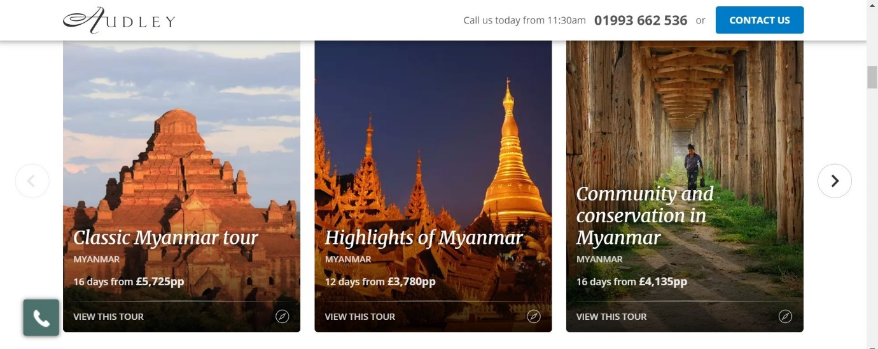
Figure 2.1.2 A range of tour packages to Myanmar by the British tour operator Audley
Activity 2.1
1. Identify the services offered by a travel agent from the following list:
- book flights, rail transport and ferries
- reserve accommodation
- hire rental cars
- purchase attraction entry tickets
- holiday planning
- provide travel advice
- issue passports and visas
- book tour packages.

2. Identify whether the following statements are true or false.
- The package tour is sold with its own price tag to the public directly or through intermediaries like travel agents.
- Tour operators are not responsible for delivering and performing the services specified in a given package tour.
- Tour operators can provide travel services themselves or can buy them from other suppliers.
Answers to Activity 2.1

2.2 Functions and operations of a travel agency and tour operator
The scope and range of travel agency operations depends on the size of an agency, with large agencies offering a more comprehensive choice and range of services. A large agency will have specialised departments, each performing different functions, such as provision of travel information, preparation of itineraries, provision of foreign currencies, airline ticketing, accounts and more.
A travel agency sells package tours from tour operators and other separate services, such as transport, accommodation, attraction tickets, activities, etc. They act as a representative of airlines, hotels, tour companies and cruise lines, and give advice to tourists to follow at the destinations.
The range of activities a travel agency provides depends upon the extent of the economic development in the country, the travel patterns of its citizens and the availability of disposable incomes for holidays (Figure 2.2.1).
Figure 2.2.1 Factors affecting travel agency services

Types of travel agency

Retail travel agency
The retail travel agency (Figure 2.2.2) sells directly to customers and gets commission from the gross sale of hotel rooms; airline, train and bus tickets; insurance; foreign exchange, etc. Commission is the primary source of its revenues.

Wholesale travel agency
The wholesale travel agency initiates the process of forming organised tours or sells the individual components directly or indirectly through franchise or retail agents. The wholesale travel agency doesn’t get its revenue from commissions directly, but earns revenue through discounts on bulk reservations from principal suppliers.

Full service agency or commercial agency
The full service or commercial agency is a complete travel agency, as it deals with all kinds of services and owns the transport fleets, charter flights and cruises. A sub-category deals with business travel booking, convention centres and stalls in exhibition centres, and arranges venues for conducting small and large meetings or conferences.

Online travel agency (OTA)
The OTA operates on the internet through a website connected to a global distribution system. They sell package tours where they customise tours and take enquiries. Transaction of payment is also done online using online payment methods. Some of the major OTAs are Expedia, Priceline, Lastminute.com, Orbitz, Booking.com and Travelocity.
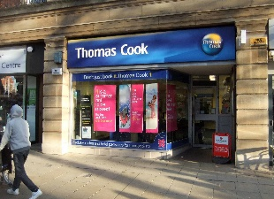
Figure 2.2.2 A high street retail travel agency

Types of tour operator

Inbound tour operator
Inbound tour operators handle inbound foreign tourists in the host country and provide them with various services on their arrival and departure. They make tour packages individually or in collaboration with foreign tour operators. They are paid in foreign currency, which increases the foreign exchange reserves of the host country.

Outbound tour operators
Outbound tour operators sell package tours highlighting the destinations in foreign countries and specialise in designing and promoting multinational tours. Generally, they appoint inbound tour operators/ground operators to make arrangements for services in the foreign countries visited.

Domestic tour operator
Domestic tour operators provide tours within the boundary of the home country and cater to the diverse needs of individuals and group travellers. They promote tour packages through their own outlets or other retail travel agents.

Ground handlers/operators
Ground handlers provide ground arrangements in country, such as transfers on arrival and departure and between destinations, and deliver the services required by large tour companies.

Special interest tour operator
Special interest tour operators mostly rely on direct marketing to sell their special interest packages to customers or sell them through retail travel agents. These special interest packages are niche products, such as wildlife tourism or dark tourism, which you learned about in Session 1.3. They do not plan for the mass market, as buyers are limited in number.

Differences between travel agencies and tour operators
The major difference between travel agencies and tour operators is in the system of providing service to customers. A tour operator is a company that buys certain services from different companies and forms them into a single tourist product using its own pricing system. A travel agency acts like an independent reseller. Its profit is the commission for the sale of the operator’s tours to customers.
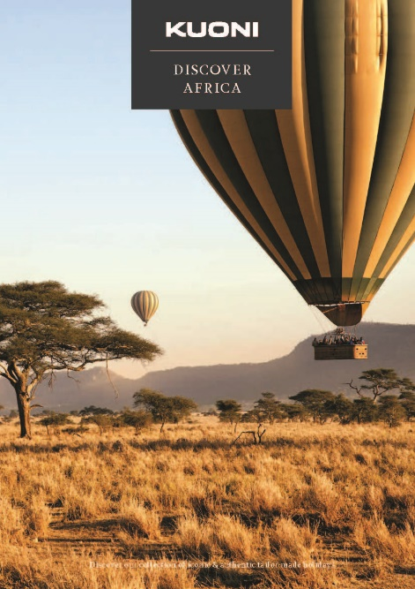
Figure 2.2.3 Tour operator brochure for Africa

Activity 2.2
1. Imagine you are a tour operator offering package tours to Myanmar for guests from Thailand. Identify the components of the tour that need to be included for an eight-day tour from the following list:
- transfers within Thailand to and from the airport
- return flight from Bangkok to Yangon
- ground travel services in Myanmar (transfer to hotels, to attractions, and from and to airport)
- accommodation for seven nights
- bar bills at the accommodation
- meals for eight days
- entrance fees for attractions
- services of tour guides
- guest’s personal travel insurance.
Answers to Activity 2.2

2.3 Tour packaging
A tour package includes several components of travel that are sold as one product, such as transportation, accommodation, entrance fees or tickets for events or attractions, meals and may also include a tour guide. Types of tour packages vary according to the desires and needs of consumers. Tourists buy package tours for different reasons, such as convenience, competitive pricing, recommendation from peers, and a desire for a smooth flow of specialised activities and experiences offered in the tour.

Examples of package tours
In Session 1.2 you were introduced to five different types of tour:
- independent
- escorted
- hosted
- incentive
- freedom.
Here you are introduced to some more types of tour.
- All-inclusive group tour – fixed itinerary and schedule, includes all elements that might be required in a trip.
- Event package tour – simple transportation and entry fee or registration fee for an event and on-site lodging and meals.
- Fly-drive package tour – includes the airfare, car rental and sometimes land accommodation.
- Fly-cruise package tour – includes the air and ground transportation to and from the cruise ship’s home and destination ports.
- Convention/meeting package tour – includes meeting and convention centre hire, with coffee break(s), lunch, screen, IT equipment and accommodation.

Elements of a tour package
A tour operator generally purchases the following elements to create an all-inclusive tour:
- transport – flights, rail, ferry
- accommodation
- services – sightseeing, meals, ground handling, car rental, etc.
A well-planned itinerary holds the key to success of a package tour. Planning an itinerary normally involves choosing points of interest (POIs), deciding in which order to visit them, and accounting for the time it takes to visit each POI and transit between them. Resources like information brochures pertaining to places of interest, hotel and ground transport tariff, rail and airfare, guide charges, toll taxes, entry fees and so on are collected before the preparation of a tour itinerary. Planning for preparing an itinerary is done one to two years before a tour package is launched and advertised. Pricing of a package is settled after estimating the operational costs and profit margin.

Factors influencing package pricing
The pricing of a package is dependent on the costs of all the services offered in a package, of which there are two types:
- fixed costs – costs that stay the same regardless of the number of tours sold by the operator
- variable costs – costs that change as the number of customers that book the package tour changes.
Fixed costs include interest on business loans taken to fund the business, building rents, salaries, insurance, advertising. The variable costs include meals, accommodation, entrance fees and other costs charged at a rate per person. It includes the actual expenses of rooms, tickets and other package components incurred with the sale of each package.
After taking all these costs into consideration, tour operators usually add a 10–15% mark-up for an individual tour package to make their profit. However, the pricing tourists pay can vary depending on other factors (Figure 2.3.1).
Figure 2.3.1 Factors affecting tour pricing

Activity 2.3
1. From the following list, identify which are advantages and which are disadvantages of all-inclusive tours for the customer.
- often cheaper than buying each element separately
- no package has every destination that meets the personal choice of a customer
- multiple destinations increase the attractiveness to customers
- saves time
- saves lots of individual enquiries to suppliers
- some places in the tour may not be of interest to the customer
- confidence that all will go to plan
- customer cannot change the itinerary.

2. Identify the two correct statements.
- when there is low demand for all-inclusive tours, prices are low
- when there is high demand for all-inclusive tours, prices are low
- when there is low demand for all-inclusive tours, prices are high
- when there is high demand for all-inclusive tours, prices are high.

3. Which season do you think would be the most attractive to foreign tourists to visit Myanmar:
- wet season
- summer
- winter?
Answers to Activity 2.3

2.4 Ticketing
An important function of a travel agency is selling tickets to clients using different modes of transport. Ticketing is not an easy job as the range and diversity of international airfares, train journeys and sea crossings is very complex and varied. A constant challenge for a travel agent is changing air schedules, train and sea timetables, and the addition/reduction of flights, train and boat services from time to time. Access to current data about various timetables of airlines, railways and steamship companies is essential. The computerised reservation system has revolutionised the reservation system for air, rail and sea travel, and also booking rooms in hotels with confirmation of reservations available in seconds (Figure 2.4.1).
Figure 2.4.1 Computerised reservation systems have transformed bookings, enabling services such as air, rail and sea – and more – to be booked online

An expensive element of many package tours is the cost of flying to the country and to different destinations within it. Airline ticketing is especially complex and varied with thousands of different types of fare combinations available across the world. The routing, pricing and ticketing for flights is largely done electronically through the computerised network of a global distribution system (GDS). There are a number of these, such as Amadeus, Galileo and Sabre. This means that there is no issuing of physical tickets, just e-ticket numbers and an airline reference, which is called a passenger name record (PNR).
The PNR is a digital file that contains information about the passenger which is shared by different airlines that are carrying the passenger. It allows passengers to check in either through the airline websites or at the airport and print airline boarding passes. If a passenger books an itinerary containing flights with multiple airlines, the PNR in the GDS system would hold information on their entire itinerary, while each airline they fly with would only have the portion of the itinerary that is relevant to them. The staff of airlines and travel agents have to double-check ticketing to ensure there are no incorrect entries in a passenger ticket, as this could result in serious problems for the client and substantial financial loss for the agent.
Price-comparison websites are increasingly used by individuals to book flights. They offer a huge range of flight combinations, with several airlines, departure times, routing with direct and indirect flights, and layover lengths (time spent waiting between parts of a journey on an itinerary). They allow maximum flexibility on price and convenience.

Airline e-ticketing
E-tickets contain all the information relating to a passenger’s itinerary, such as fare, class, taxes, endorsements, baggage, etc. They are stored as an electronic record in the database of the airline issuing the ticket. The passengers can access their booking details at any time on an airline’s website or at an airport check-in desk, using their booking reference/PNR and their last name.

Activity 2.4
Look at the example e-ticket and identify the following information from the ticket.
1. What is the passenger’s name?
2. What is the passenger’s booking reference/PNR?
3. How many flights are in the itinerary?
4. How much did the passenger pay for the ticket?
5. The ticket pricing is broken down into different elements. How much was the base fare, and how much was added to the base fare in duties, taxes and other fees?
6. How did the passenger pay for the ticket?
7. Can the passenger get a refund if they cancel?
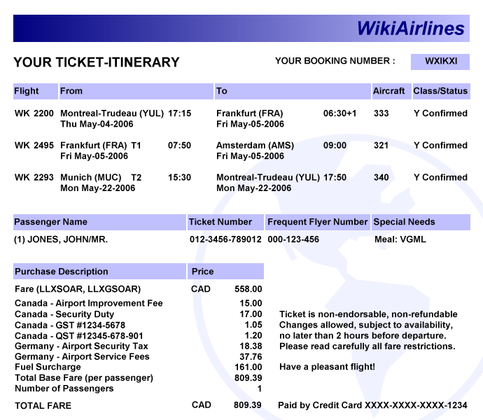
Answers to Activity 2.4

2.5 Transportation services
Transportation lies at the heart of the tourism industry and is the link between home, destination, accommodation, attraction and all other sites on the tourist trip. Its efficiency, comfort and safety make a considerable contribution to the quality of the tourism experience. In many cases, its cost comprises the largest portion of a tourist’s total expenses. This session discusses the important aspects of air, ground/land and water transportation.

Air travel
The earliest passenger service in airborne vehicles began in 1910 with airships in Germany. Aircraft engines which were originally powered by propellers are now powered by jet engines, thanks to substantial technological advances. Boeing, the plane manufacturer, introduced its first commercial passenger flight with the Boeing 707 plane in the late 1950s, as you learned in Session 1.1. In 1970, the wide-bodied or jumbo jet – the Boeing 747 – was introduced, followed by the Airbus A300 in 1972. The Boeing 747 carried many more passengers on long-haul journeys.
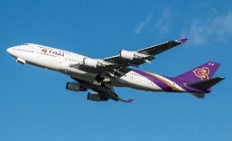
Figure 2.5.1 A jumbo jet, the Boeing 747

Passenger air transportation is differentiated into two categories: scheduled and charter flights.
A scheduled flight is one in which the airline sells single seats to individuals until the aircraft is full. Flights are offered on a regular, timetabled basis, with the departure times and routing fixed. Thus, scheduled flights offer reliability.
A charter flight is when a person or company rents an entire aircraft for a flight, with the departure time and final destination set out in the agreement between the hirer and the aircraft company. Therefore, charter flights do not follow an airline schedule. Tour operators often charter whole planes for their customers when building packages.
Although charter services can be an important component of tourism, most air travel statistics refer primarily to scheduled air services. The regulatory environment of international air travel is shaped by agreements between countries. The UN, through the International Civil Aviation Organization (ICAO), provides general rules and mediates international concerns regarding aviation law.

Land travel
The term ground transportation generally refers to travel by bus, limousine, caravan, train and other modes for sightseeing and for travel between hotels, attractions and airports. The railroads, which utilised steam engine technology to power trains, transformed land travel, making it much more accessible and affordable. Improvements in roads and coach design also made land travel more comfortable for passengers.
Buses, also referred to as coaches, are a major mode of passenger travel within countries for tourists, providing service between air and rail terminals, accommodations and attractions. Modern buses have many amenities such as larger, more comfortable seats that can recline, air conditioning, Wi-Fi and toilets. One of the most popular types of bus service is the bus tour.

Water travel
Improvements in steamship technology in the early 1900s led to the age of the great ocean liners. These included the Queen Mary and the Queen Elizabeth, which could make the transatlantic voyage in less than four days. They operated a twice weekly service across the Atlantic Ocean from the 1930s to 1960s, when the jet engine meant they became less profitable. However, they still sail today.
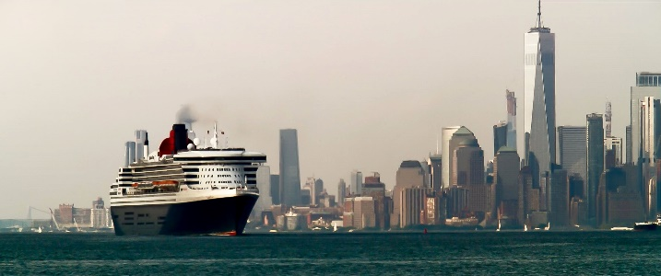
Figure 2.5.2 The Queen Mary 2 outbound from New York Harbour for Southampton, England

Today the primary form of water travel for tourists is the cruise ship. A ship might include various amenities, such as a gym, swimming pool, health spa, movie theatre, restaurant and bar, casino, discotheque and retail shops. The larger cruise ships are like floating hotels (Figure 2.5.3).
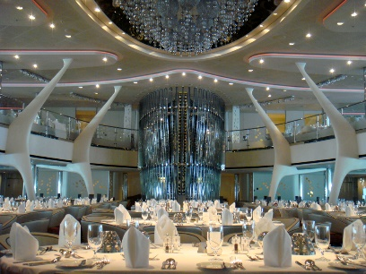
Figure 2.5.3 The dining area of a cruise ship can be very luxurious

Ferry boats offer tourists a leisurely and often scenic route between inland points. Ferry boats may also feature snack bars, restaurants and lounges.
Chartering a yacht has traditionally been associated with the very rich. Today, it is available for other income groups and offers a trip from place to place as well.

Activity 2.5
Create two escorted package tours for two different tourist markets. The first package should be targeted at tourists who want to see as much of Myanmar as possible, but have a limited budget and limited time available.
The second escorted package should be targeted at tourists who want a leisurely, luxury and educational experience, seeing the highlights of Myanmar.
Select one component from each category.
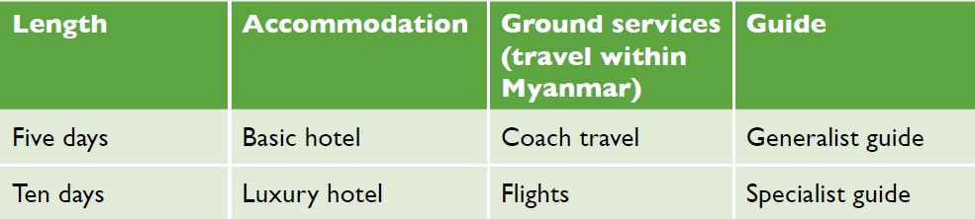
Answers to Activity 2.5

2.6 Digital tourism
Digital tourism refers to how digital tools are used to select, book, manage and deliver tourism products and experiences. In Session 1.6 you saw how the tourist journey has been transformed by digital tools from the perspective of the customer. Here the impact of digital technologies for travel agents, tour operators and tourism service providers is explored, in particular how they market and supply their services using the new opportunities provided by the internet and social media.

Dreaming
The customer journey begins when they are considering a vacation and looking for ideas and recommendations. Sites such as Instagram have become an online brochure of trips to choose from. Research from the travel site Expedia found that one-in-four millennials (those aged 18 to 34) were influenced by Instagram posts when booking trips abroad. This led the airline easyJet to add a new feature in its app that lets customers upload screenshots of celebrities, friends and family on holiday to find out where they went and how to get there (Microsoft, 2019). The Look&Book feature uses artificial intelligence and image recognition technology to identify where the photo was taken. Then easyJet identifies the nearest airport to that location and searches for available flights to market its services (Microsoft, 2019).

Planning
Once the customer has decided on which country to visit they will be looking for specific information. Customers increasingly plan their holidays with a view to the photo opportunities a destination may give. Trolltunga is a rock formation in Norway that was not well known ten years ago. However, photos posted on Instagram awakened interest in the place and, in the month of January 2019, there were over 100,000 photos on Instagram with the Trolltunga hashtag (Righini, 2020).
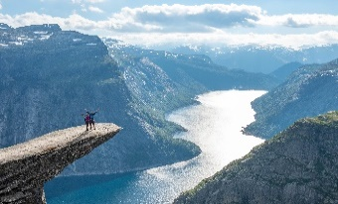
Figure 2.6.1 Trolltunga, Norway

Booking
Increasingly, travellers are booking their own itineraries directly with individual tourism service providers. Alternatively, sites such as Google Flights, Priceline, Booking.com and Hotels.com allow travellers to compare prices before booking flights and hotels. Different business models mean tourists also have access to a much broader range of accommodations. Airbnb, for example, enables tourists to book stays in other people’s homes, and Couchsurfing, a hospitality exchange service, allows people to provide their sofa or rooms in their home for short periods to tourists.
TripIt and KAYAK can be used to organise and archive different bookings. They are travel management sites that automatically process and import original vendor confirmations into a master itinerary, which is available to the customer on the web and their mobile device.
Digital technologies have not only changed the way many tourism providers market and sell their products and services, and brought new companies into the market, but have also enabled small hotels and guest houses to reach millions of customers through online booking portals such as Lastminute.com, Expedia and eDreams.

Experiencing
The tourist’s research and engagement in the earlier stages of their journey mean they have a well curated expectation of the experience and one that they are personally invested in. There is emerging evidence that this in itself can improve the experience, regardless of the quality of the physical offering, as was discussed in Session 1.6. Thus, tourism product suppliers need to be mindful of the expectations of tourists as curated by social media, providing sufficient opportunities for tourists to visit iconic places and capture them in photos.

Remembering
On their return home, the customer will recall their journey and will reflect on whether it was good or bad. Some travellers are adept at using Flickr, Instagram and Facebook to manage and curate the photo record of their journey. Moreover, they can also write and publish reviews on sites such as TripAdvisor. Tour operators ask guests to evaluate their experience at the end of their trip to capture their insights for tour improvements and encourage guests to place reviews on such sites.

2.6 Activity
Visit one of the websites mentioned in this session and explore the offering. Then answer the following questions.
1. Did you find the website attractive and engaging?
2. Were you able to navigate around the site to follow your interests?
3. Can you see an opportunity to use this website in your next tourism journey?
Answers to Activity 2.6

Answers to activities

Activity 2.1
- a) book flights, rail transport and ferries, b) reserve accommodation, c) hire rental cars, d) purchase attraction entry tickets, e) holiday planning, f) provide travel advice, h) book tour packages.
- a) true, b) false, c) true.

Activity 2.2
- b) return flight from Bangkok to Yangon, c) ground travel services in Myanmar (transfer to hotels, to attractions, and from and to airport), d) accommodation for seven nights, f) meals for eight days, g) entrance fees for attractions, h) services of tour guides.

Activity 2.3
- Advantages: a) Often cheaper than buying each element separately, c) Multiple destinations increases the attractiveness to customers, d) Saves time, e) Saves lots of individual enquiries to suppliers, g) Confidence that all will go to plan.
Disadvantages: b) No package has every destination that meets the personal choice of a customer, f) Some places in the tour may not be of interest to the customer, h) Customer cannot change the itinerary.
- a) When there is low demand for all-inclusive tours, prices are low, b) When there is high demand for all-inclusive tours, prices are high.
- c) Winter, because the weather is dry and cool.

Activity 2.4
- John Jones
- WXIKXI
- Three
- CAD 809.39
- Base fare: CAD 558. Duties, taxes and other fees: CAD 251.39
- Card
- No, the ticket is non-refundable.

Activity 2.5
First package: five days, basic hotel, coach and generalist guide.
Second package: ten days, luxury hotel, flights and specialist guide.

Activity 2.6
Students’ own answers.

References
Microsoft. (2019) You can now book your dream holiday by uploading a picture of someone else’s break.
Available at: https://news.microsoft.com/en-gb/2019/01/14/you-can-now-book-your-dream-holiday-by-uploading-a-picture-of-someone-elses-break/ (Accessed: 8 March 2021).

Righini, E. (2020) What is digital tourism? Much more than a definition.
Available at: https://www.doxee.com/blog/customer-experience/what-is-digital-tourism/ (Accessed: 8 March 2021).

Topic 3:
Travel and tour operations 2
This topic looks at destination management, which is a form of tourism planning. It is best achieved through a destination management organisation. Every tourism destination follows a life cycle, which is explored in this topic. Tour guiding is also considered; the characteristics, responsibilities and qualities a tour guide needs. You are invited to consider whether you have the skills to work in this profession and further detail is provided on the fundamental and specific tasks performed by guides.

3.1 Destination management
A tourism destination is a place or area that relies heavily on the economic benefits of tourism. Destinations contain a number of elements which you learned about in Session 1.5, such as access, accommodations, attractions, activities and amenities. Other elements that contribute to creating a tourism destination are price, human resources (its workforce) and image (Figure 3.1.1).
Figure 3.1.1 Elements that contribute to making a tourism destination

Price is an important aspect of the destination’s competitiveness over other destinations, as well as ensuring the tourist gets excellent value. A pricing strategy helps to market a destination to potential visitors and repeat visitors. For example, a resort might offer lots of free activities which the guest might be expected to pay for at other resorts. Or it might offer special family rates for visiting attractions, accommodation and meals, making it more affordable and attractive to families.
A well-trained tourism workforce ensures tourists’ needs are effectively met. It is important to set high standards and keep staff trained in using new technologies, such as for bookings. This, together with ongoing coaching and mentoring, builds staff efficiency, staff morale and improves the guest experience.
The brand image of a destination can be a critical factor in a tourist deciding to visit. It also has an impact on the satisfaction level of the visitor if what they expected is delivered, as you read in Sessions 1.6 and 2.6. If satisfaction is high, visitors are loyal and are likely to recommend the destination to family and friends. They may also return. A destination’s brand identity is the external perception of a brand that is purposefully created by the business stakeholders to promote the product. It is formed through many stakeholders (who have an interest in the destination’s success) working together to create it. How this is interpreted by the public and media creates the brand image for the destination. This is something that is best managed through a destination management organisation.

Destination management organisations
Destination management calls for a group of many organisations and interests (stakeholders) working towards a common goal. The destination management organisation’s (DMO) role is to lead and coordinate activities under a coherent strategy to promote the destination and its sustainability. DMOs include the national tourism authority; regional, provincial and state tourism organisations; and local tourism organisations.
The DMO ensures the quality of every aspect of the visitor’s experience by creating a suitable environment to attract visitors, through marketing and developing the right social, economic and physical environment. This involves planning, infrastructure and human resources development, product development, technology and systems development and development of related industries and procurement. The DMO promotes the brand, organises campaigns to drive business, provides unbiased information services to visitors, facilitates bookings and generally provides good customer relationship management.
Well-managed and sustainable destinations are more likely to attract and maintain investment, see businesses grow and employment increase without having a detrimental effect on the environment or local population. Small- and medium-sized businesses are encouraged, such as community-based arts and crafts enterprises. Tourism allows small- and medium-sized businesses, many of whom are local, access to foreign consumers. Because the tourists come to them, they do not face export barriers or have to invest in an export distribution channel. For tourism goods and services that are supplied locally, tourist expenditures can be retained in the destination, building sustainability.
Planning and good marketing can lengthen the average visitor stay, which increases visitor expenditure. The community can also benefit from the facilities and services developed for tourism, such as road and rail development, an airport, sanitation and solid waste management, entertainment and well-maintained public spaces.
The DMO’s role in maintaining the environmental integrity, resources, and social and cultural character of the destination makes them great places to live, work and visit.
Figure 3.1.2 The advantages of managing a destination through a DMO

Activity 3.1
1. What are three elements that contribute to creating a tourism destination? Select from the following list:
- price
- ground transportation
- beaches
- human resources
- mountains
- image.

2. Are the following statements true or false?
- To deliver excellent value to visitors, it is vital that the various components of the visitor’s stay are managed and coordinated throughout the visit, while ensuring local benefits, through a DMO.
- A DMO builds sustainable tourism.
- A DMO limits the spread of tourism benefits.
- A DMO causes tourism yield to fall.
- A DMO builds strong brand identity, which increases brand loyalty.
Answers to Activity 3.1

3.2 The tourism destination life cycle
This session looks at the tourism destination life cycle. Tourism destinations are constantly changing. This model shows how tourism destinations move through five distinct stages of growth.

Figure 3.2.1 Tourism destination life cycle

- Exploration: A small numbers of visitors are attracted by natural or cultural attractions to visit, although few tourist facilities exist.
- Involvement: There is some involvement by local residents, who provide some facilities for visitors and begin to market their services. Visitors are likely to come from within the state or region, rather than internationally.
- Development: A large numbers of tourists arrive, increasingly from overseas, and external organisations take more of a key role in meeting the needs of the growing number of visitors.
- Consolidation: Tourism becomes a major part of the local economy and of increasing political importance. Rates of visitor growth may level off and some facilities may be in need of upgrading.
- Stagnation: The number of visitors has peaked and the destination may no longer be considered fashionable.
Depending on the response of the DMO to the onset of stagnation, various scenarios – such as decline, stabilisation, rejuvenation or reinvention – are possible. The DMO needs to intervene and take action to avoid decline at the stage of stagnation. To do this, the following model needs to be followed (Figure 3.2.2).
Figure 3.2.2 The DMO model for success

Making the partnership work
Whilst the DMO is critical for ensuring the effective management of a destination, many other groups are involved in supporting the destination. The tourism experience is delivered by a range of partners, including private sector businesses, the public sector and the community at large. For tourism to succeed in the destination, these stakeholders have to work together in accordance with a collective vision. But this is challenging, as all stakeholders need to join forces and work together closely.

Strong leadership is needed
Strong and effective leadership from the DMO is essential for retaining a collective focus, ensuring all stakeholders work to the same end. If there is a lack of coordination and cooperation among the different stakeholders, conflict can arise leading to fragmentation, poor quality control and loss of value for the guest.

Planning to achieve competitive advantage
Successful tourism destinations require a clear, competitive strategy to achieve a competitive advantage. This means following a targeted tourism approach that builds a distinctive identity and brand, and delivers excellent customer value.

Limiting economic leakage
Not all the income generated by tourism stays within the destination. For example, in many all-inclusive package tours, a large percentage of visitor expenditure goes to the airlines, hotels and other international companies who often have their headquarters in the visitor’s home countries. Food and drink may also be sourced from the visitor’s home country. This lost revenue is called economic leakage, and the DMO should seek to minimise this.

Delivering quality
Because the tourism industry is made up of many different companies, quality control is difficult. Value can be substantially reduced by the actions of weak or unscrupulous service providers in the tourism value chain, which can destroy the destination’s reputation. The DMO should agree a framework and standards of quality control for consistent quality to be delivered.

Activity 3.2
You have learned that destinations can stagnate after some time and that their future can follow one of four pathways: decline, stabilisation, rejuvenation and reinvention. Match the stages with the explanations of what each of these futures could look like for a DMO.
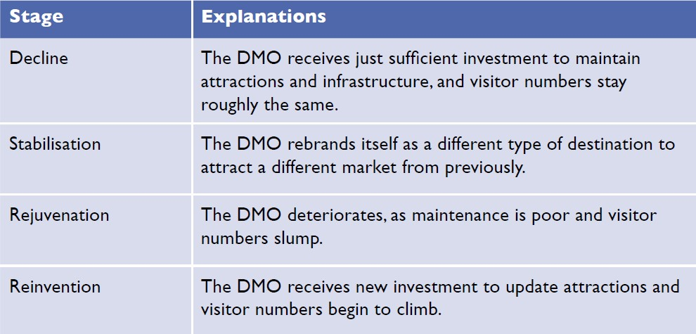
Answers to Activity 3.2

3.3 Sustainable tourism planning
Sustainable tourism planning has evolved over the past 70 years and has a considerable impact on the social, economic and environmental conditions in host destinations. To ensure that tourism brings positive benefits, and to minimise the harm it can cause and be sustainable, a tourism plan is needed. Figure 3.3.1 details the aims sustainable tourism planning seeks to achieve.
Figure 3.3.1 Sustainable tourism planning objectives

Sustainable tourism seeks to promote economic growth by increasing visitor numbers, but to protect the environment and minimise the negative sociocultural impacts of tourism. This is achieved by strategic, long-term planning and stakeholder participation.
Tourism planning today is much more comprehensive and integrated than when it was first introduced in the 1950s. Today it is more inclusive of all stakeholders, who get the opportunity to have their say on how tourism should look in the future.

Benefits of tourism planning
Every destination needs tourism planning and the DMO is at the centre of this. The DMO must be able to clearly articulate the future direction of tourism in their area. Destination tourism planning produces clear overall directions for all stakeholders on how tourism will be developed and progressed in future years.
Initiating and conducting planning tends to draw greater attention and focus to tourism within the destination, as it provides a vision and goals for tourism. Targets are set for the destination to achieve within specific time frame. Opportunities are identified that will enhance and improve tourism in the destination. All stakeholders are involved in the planning process, giving rise to a feeling of shared ownership of the plan. The planning process produces steps for implementation and measures for assessing the effectiveness of the plan. The benefits of the tourism planning process are shown in Figure 3.3.2.
Figure 3.3.2 Benefits of the tourism planning process

Types of tourism plans
There are three types of tourism plan.
- Tourism master plan: a long-term plan for ten or more years
- Tourism strategy: a medium-term plan for five to nine years
- Tourism action plan: a short-term plan for two to four years.
You will learn about Myanmar’s tourism planning in Session 6.5.

Outcomes of tourism planning
The DMO and its stakeholders must define the key goals for completing a tourism plan and state the desired outcomes of planning. Tourism planning should have at least five outcomes (Figure 3.3.3).
Figure 3.3.3 Outcomes of tourism planning

Activity 3.3
Consider the outcomes of tourism planning and identify where the following issues would be addressed in the tourism planning process:
- global pandemic, e.g. Covid-19
- high level of cooperation among tourism organisations and businesses
- overcrowding, congestion and traffic problems
- historical monuments and landmarks are regularly cleaned
- attracting different types of visitors through varied marketing approaches
- high level of community awareness of the benefits of tourism
- hostile and unfriendly attitudes of local residents towards visitors
- improving transportation and infrastructure
- global economic slump
- local festivals, events and activities are supported.
Sort the outcomes into the correct rows of the table.
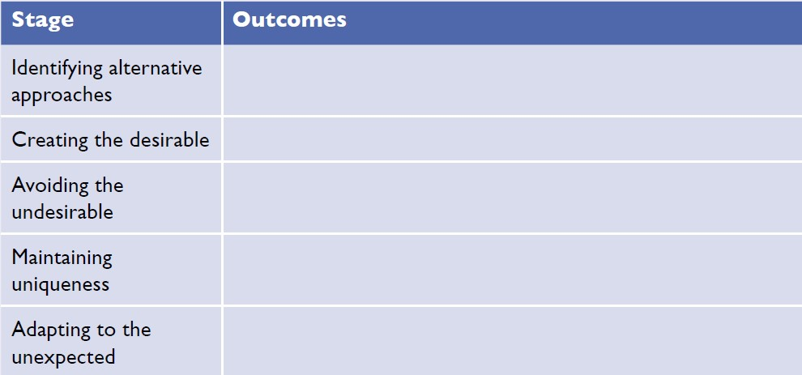
Answers to Activity 3.3

3.4 Tour guide profession
This session looks at the profession of tour guiding. It analyses the characteristics, responsibilities and qualities of a tour guide, and invites you to consider whether you have the skills to work in this profession.
A tour guide is someone who is employed either directly by the traveller, or a tour operator or travel agent to inform, direct and advise the tourist before and during their journey. The role of a tour guide is to accompany visitors to tourist attractions and provide information and insights that enhance the visitors’ experience. Attractions include historic monuments, cultural centres and natural beauty spots. Guides might work with a group of visitors over a number of days, accompanying them to lots of different attractions, organising their meals and overnight accommodation, or they may provide a specialist tour of a particular attraction for day trippers. They may give walking tours, bus tours or even lead tours of rivers and lakes on a boat.

Main characteristics
For many visitors, the tour guide is the only person from whom they learn about the city or attraction and the only local person with whom they have an extended conversation. Throughout the world, the role and responsibility of the tour guide varies, but guides wherever they are share many common traits. They are often generalists, well-read and interested in many branches of knowledge, particularly history, art, architecture and geography. The success of a guided tour depends largely upon how well the tour guide performs his or her job. A visitor’s impression of a foreign country is heavily related to the knowledge of the tour guide.

The role of tour guide
The tour guide serves as interpreter, introducer, educator, companion, host and even ambassador. Tour guides are representatives of their community, country and society, and are entrusted to tell its story. The tour guide plays a very important role – they are the front line of the tourism industry. It is the tour guide whom a visitor first meets on arrival in the country and the last they see on departure (Figure 3.4.1).
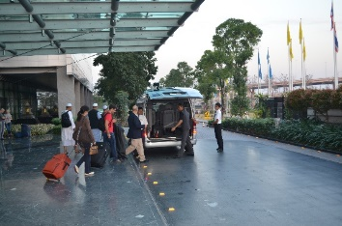
Figure 3.4.1 A tour guide meets the visitors he will be guiding at the airport

The qualities of a tour guide
- Personal characteristics: Smart appearance, pleasant manner, pleasant voice, talent for human relations, enthusiasm, willingness to learn, a positive outlook.
- Knowledge: educated and intelligent, good general knowledge, adequate knowledge of the destination regions (geography, history, cultural heritage of the religions to which he/ she escorts the tourist), fluency in at least one foreign language.
- Social skills: behaves in a friendly and professional manner towards others in different social situations.
- Communication skills: ability to communicate effectively.
- Presentation skills: ability to present information concisely, fluently and in an interesting way.
- Leadership skills: ability and techniques needed to organise and control groups of people tactfully.
- Organisational skills: flexibility and agility to manage itinerary changes and to perform clerical duties.
- First aid skills: knowledge of emergency first aid to tend to sick or injured guests.

Practicalities of guiding
Guiding is strenuous and demanding, requiring a great deal of energy, enthusiasm and patience. A tour guide must have the ability to handle groups of people with courtesy and diplomacy. When delays or problems develop, it is the tour guide who bears the brunt of complaints, so they must know how to deal with difficult tour members.
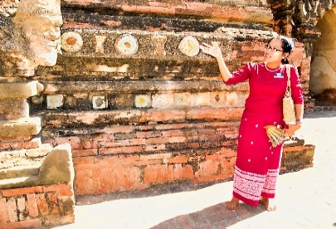
Figure 3.4.2 A tour guide provides a commentary to visitors at a historical site

Tour guides, like all educators, are teachers and students, as they are constantly learning. A good guide reads widely and also seeks every opportunity to attend relevant lectures, classes and programmes to broaden their understanding.

Activity 3.4
Watch part of this video, in which young people from Myanmar discuss the skills and knowledge needed by tour guides. The video is made by the education charity, Mote Oo. Watch from 2 minutes 46 seconds to 5 minutes.
https://www.youtube.com/watch?v=suxh6e07LoI&list=PLjRPoXCoejwYtRXIk9ibQuuRB943Ed7hy&index=1
Now read the following questions and watch the video again to help you answer them.
1. List the skills and knowledge needed by tour guides.
2. From what you have watched and read and drawing on your own knowledge also, what other skills and attributes do you think a tour guide needs?
3. Are you suited to be a tour guide?
Answers to Activity 3.4

3.5 Fundamental tasks of a tour guide
Regardless of the type of tour, there are some tasks that all tour guides have to perform. They are called the fundamental tasks.

Preparing for the tour
Tour guides need to be very organised and have good time managements skills. Checklists are essential for ensuring they remember everything, as is an itinerary of the tour. The guide needs to have organised the commentary materials for all attractions and have liaised with their employer regarding what to expect from the group.

Meeting service on arrival
Before meeting the tour participants, the tour guide needs to check a number of arrangements. They should check that the clients are arriving on time, or if there are any delays in their schedule involving outgoing or incoming transport. The guide needs to make arrangements with porters to support luggage transfer, as well as reconfirming reservations for tour accommodations, attractions and activities.
When meeting the tour participants, the guide needs to greet them with a smile, introduce themselves and help participants with health, immigration and customs formalities. The guide should check the luggage before leaving, making sure to count the participants and bags.
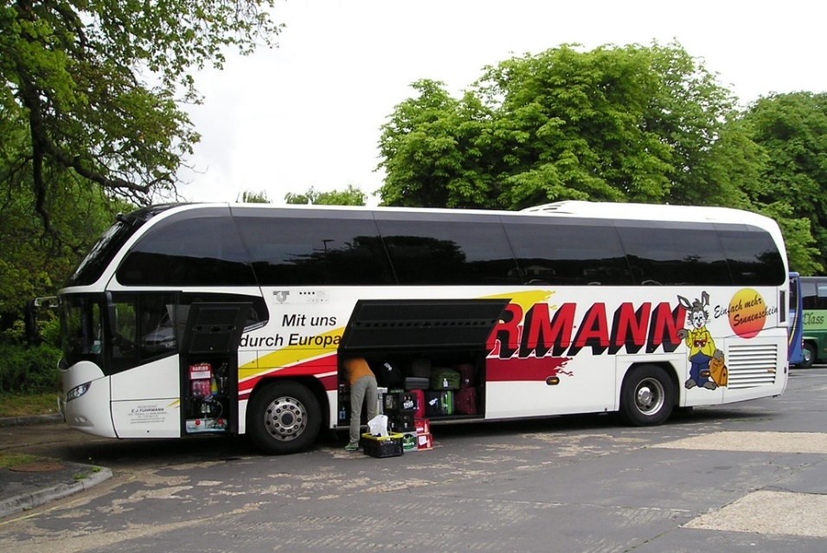
Figure 3.5.1 A tour guide is responsible for making sure all luggage is loaded onto the coach

Check-in at the hotel
On arrival at the hotel, the tour guide should inform hotel staff of the number of bags and notify the hotel reception of any special requirements of tour participants. They should assist the hotel reception staff in handling registration and informing participants of the location of their rooms. They should ask the tour participants to check their baggage, inform them of meal times, describe facilities available in and outside the hotel, and arrange the next meeting with the tour participants. The guide should only leave the hotel lobby after the baggage for the tour members is in order and any unexpected problems have been dealt with.
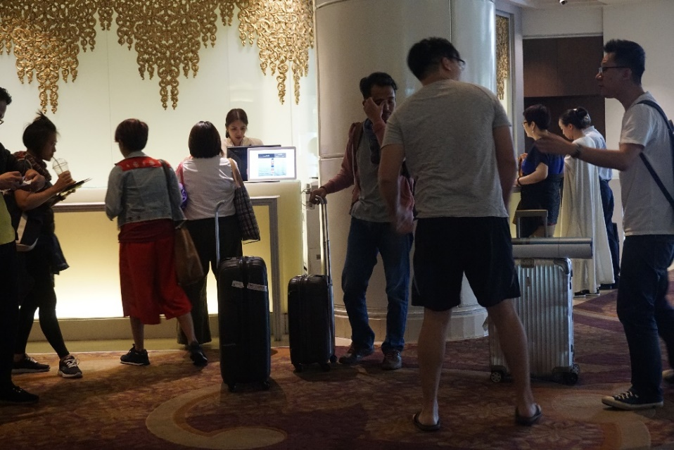
Figure 3.5.2 A tour guide assists guests at hotel check-in

Check-out from the hotel
Checking out from the hotel requires the guide to check the hotel bills and amend any hotel vouchers. They must notify the tour members of the time and place of departure. They should deal with any last-minute problems and check the number of tour participants and their baggage before leaving.

Special problems and situations
Some tour problems are beyond the control of even the most organised and experienced tour guide. However, most problems can be anticipated and avoided. Besides experience and careful planning, tact and common sense are valuable assets, especially when the unexpected occurs. Some of the common problems a tour guide might face are lost possessions, complaints about bad service, delays, accidents/breakdown of vehicles, participant illness, crime and death.

Transfer for departure
On the way to the departure point, the tour guide should wish farewell to the tour participants and ask them to complete an evaluation form, so the guide’s employer can have feedback and comments on the tour. The guide should also inform participants about customs and currency regulations, before thanking the tour participants.

Arriving at the departure point
At the departure point, the tour guide must make sure that participants have not left anything in the vehicle. They should arrange with the porters to send the baggage to the appropriate means of transport, inform the tour participants to check out with the immigration and customs counter in the external lounge, and wish them farewell.

Activity 3.5
Imagine you are the tour guide in the two scenarios and say how you would respond to the problem from the possible responses.
1. Due to a travel delay, visiting one of the most popular destinations on the tour has to be cancelled because there is insufficient time. In this situation, what would be the best solution for the participants?
- Don’t say anything to tour participants.
- Blame the participants for being late.
- Drive to the site and look at it from the outside.
- Apologise to participants, but explain that it is out of your control.
- Apologise to participants and downplay the importance of the site missed.
- Revise the itinerary and visit the site the following day.

2. One of your tour participants has lost their mobile phone while at an attraction and no one has handed it in. What will you do? Choose all the options that apply.
- Tell the participant to take better care of their things.
- Tell the participant that you can’t help.
- Let the participant borrow your phone.
- Empathise with the participant and leave your contact number with the attraction management in case the lost phone is found.
- Support the participant in disabling the phone remotely.
Answers to Activity 3.5

3.6 Specific tasks of a tour guide
In the last session we looked at the fundamental or basic tasks of the tour guide. In this session we will look at the specific tasks that relate to the presentation of points of interest and the art of commentary.
The tour guide utilises a vast amount of technical and cultural knowledge, information and imagination. Before passing information to others, the tour guide must be fully informed. They should know what to emphasise during a tour, selecting the most significant places to visit and giving a methodical presentation about them.
Tour guides are often hired by the visitor’s tour operators and are likely to be residents of the region where they guide. Let’s look at three popular tour types for guiding today.

Historical tour guides
Historical tour guides lead visitors to national monuments, historical sites, historical districts, religious or archaeological sites, and museums. They know the history of the site or monument very well and can talk about the significance the site or monument has today. They may also have some personal stories to tell that can add interest for the visitor. The guide answers visitor questions and keeps the tour organised by ensuring rest breaks. They make sure that is it efficient and running to schedule, as well as conducting a risk assessment to ensure that it is safe.
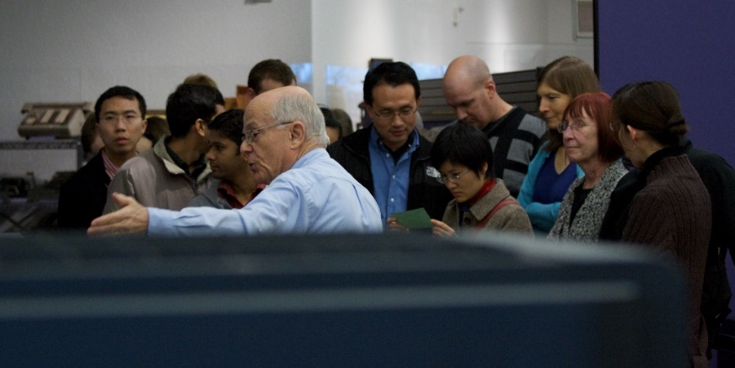
Figure 3.6.1 A historical guide leads a group around a museum

Nature tour guides
Nature tour guides lead visitors to natural attractions and national parks to look at wildlife and scenic locations. These guides are experts in biology, geology, botany or zoology and can talk about the attraction in a way that can be understood by a non-specialist, but still interest the specialist. Nature tours will draw attention to the natural aspects of the area, including a study of its changes from the past to the present, both in terms of the land and human activity. The tour guide helps the visitors to comprehend the beauty and intrinsic value of the area visited.

Eco tour guides
A new type of nature touring is eco tour guiding. This is where a guide leads a small group of visitors to remote or protected sites of natural interest. The guide ensures that the group’s impact on the surrounding environment is minimal. This encourages a sustainable model of tourism that appreciates the natural environment and supports local communities. Guides need to ensure that visitors follow the rules for visiting particular sites.

Activity 3.6
Below is a list of tasks carried out in order by a tour guide who meets their tour group at a museum:
- welcoming participants
- introducing yourself
- checking the number of participants
- introducing the museum
- informing participants of the time allocated for the visit
- informing participants of how to reidentify their vehicle after the visit
- helping participants disembark the vehicle
- arranging any details concerning cameras, tickets and cloakroom facilities
- keeping one’s own tour group separate from other tour groups
- holding the interest of participants by orientating the visit by theme
- selecting the most significant exhibits and commenting on them
- allowing time for participants to contemplate and appreciate what they are viewing
- answering questions about the museum objects
- showing the souvenirs of the museum
- assisting participants into the vehicle
- thanking participants.

Drawing on your learning from this session, as well as Session 3.5, sort each task into the columns in the table as either fundamental or specific tasks.
Answers to Activity 3.6

Answers to activities

Activity 3.1
- a) price, d) human resources and f) image.
- a) true, b) true, c) false, d) false, e) true.

Activity 3.2
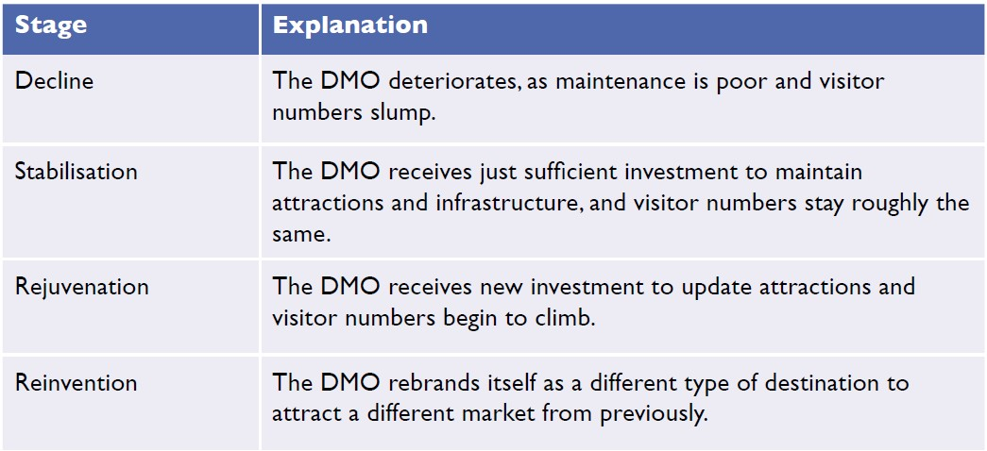

Activity 3.3
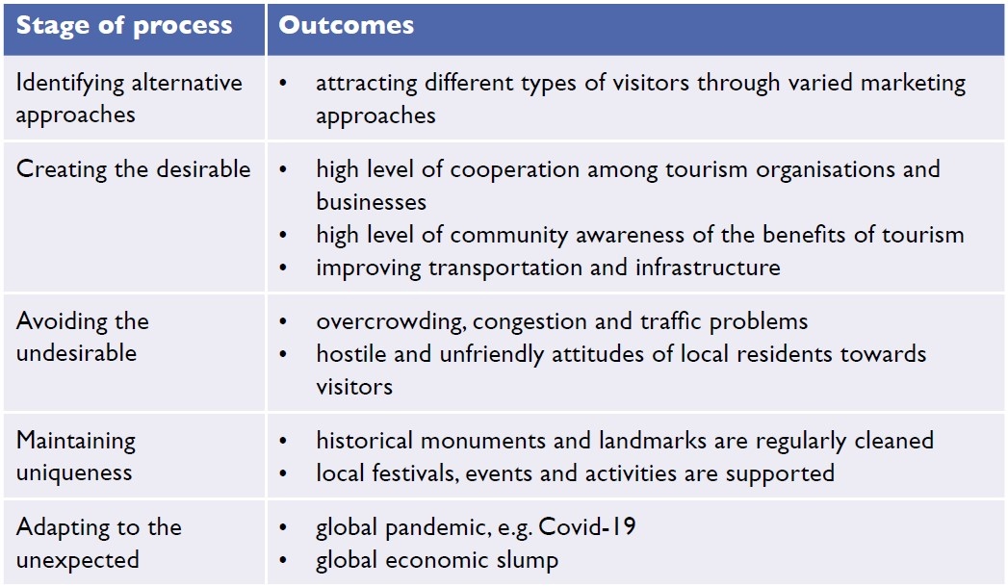

Activity 3.4
- Language skills, communication skills, problem solving skills, presentation skills, motivation skills, sense of humour, first aid skills, camera knowledge and creativity.
- Suggested answers: Friendly, patient, helpful, caring, calm, kind, organised.
- Students’ own answers. With all jobs, you need to start by asking yourself whether you have the necessary skills and, if you don’t, whether you want the job enough to develop those skills.

Activity 3.5
- f) Revise the itinerary and visit the site the following day.
This option may mean not visiting a less popular sight or having less time at the scheduled attractions, but it is likely to be the best outcome for the majority of participants.
- d) Empathise with the participant and leave your contact number with the attraction management in case it is found; e) Support the participant in disabling the phone remotely.
If you also ticked letting the participant borrow your phone, whilst it might seem a generous thing to do, you need your phone at all times to communicate with the head office and to manage changes in the itinerary and emergencies. You should also note that a tour guide can’t solve every problem. But guides can show the participants that they understand their loss and do what they can to try to recover the lost item. By disabling the phone, the guide is preventing further loss for the participant through illegal use and data charges.

Activity 3.6
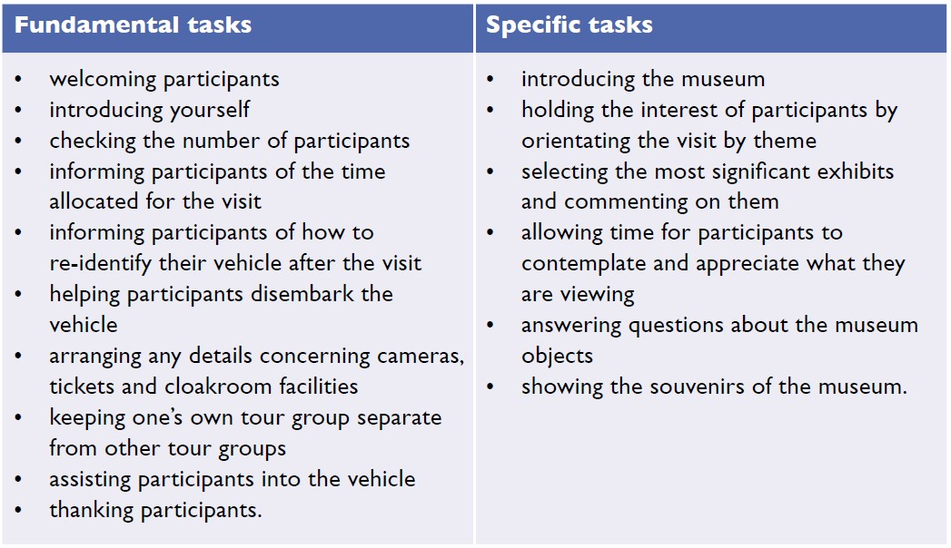

Topic 4:
Introduction to hospitality
This topic looks at types of accommodation that tourists use and the business of hospitality. It begins by tracing the history of hospitality, before looking at serviced and non-serviced accommodation. It considers how a tourist destination is born by telling the story of Dawei, in the south of Myanmar, before looking at the major form of tourist accommodation, hotels, and the latest trends in their development.

4.1 History of hospitality
Hospitality is the friendly and generous reception and entertainment of guests, visitors or strangers. Hospitality also refers to how guests are received in hotels, restaurants, entertainment venues, sporting events and other tourism-related services. In this session, we look at the history of hospitality. It complements and builds on the discussion in Session 1.1, which looked at the history of travel and tourism.

The Empire Era (900 BCE–300 CE)
In ancient Greece and Rome, spas and bathhouses not only provided recuperation for weary travellers, but some provided sleeping facilities as well. The Romans also built large houses to accommodate travellers on government business.

The Middle Ages (5th–14th centuries CE)
On Middle Eastern routes, caravanserais, which were roadside inns that existed in the Middle Ages, provided travellers with rest from the day’s journey, as well as caring for their camels and horses. Caravanserais were important for supporting the flow of commerce, information and people along Asian, Middle Eastern and African trade routes, most notably the Silk Road. Refuges or inns also served pilgrims and crusaders on their way to the Holy Land, while in China and Mongolia staging posts provided shelter for couriers and allowed horses to be changed more easily. In Japan, a type of inn called a ryokan began to be built in the early 700s. It typically features tatami-matted rooms and communal baths (Figure 4.1.1). They continue to exist today.
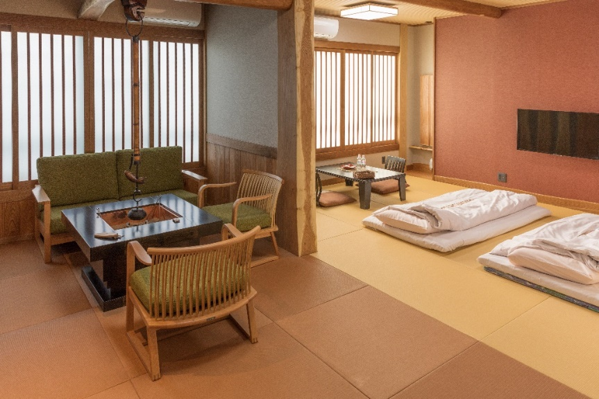
Figure 4.1.1 A contemporary Japanese ryokan following the traditional style

In Europe, cloisters and abbeys provided free accommodation to travellers. Gradually, inns and guest houses began to open on popular trade routes to provide lodging for travelling merchants and their horses.

16th–17th centuries
During this time, the law in France required that inns keep a register. English law introduced rules for inns at a similar time and more than 600 inns were registered in England (Figure 4.1.2). Guide books for travellers began to be published in France and signs were displayed outside establishments advertising their hospitality.
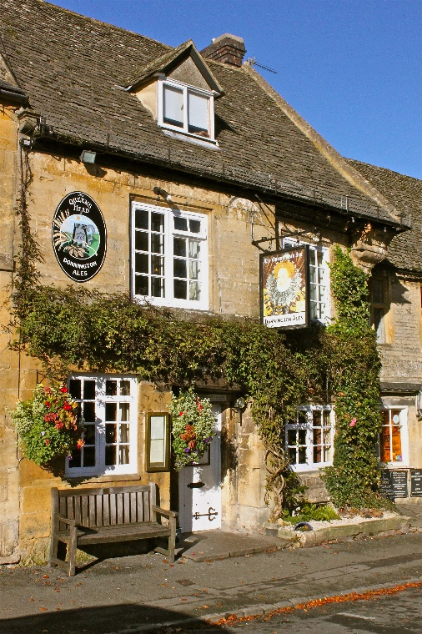
Figure 4.1.2 A seventeenth-century inn in England

18th–19th centuries
In the 1750s the Industrial Revolution began and hotels began to be built. They were bigger than guest houses and inns, and provided more services as the newly wealthy began to travel to explore. Travel became more of a leisure activity than it had ever been before. Hotels became grand and offered their guests something extra that they couldn’t get at home. Hotel construction increased across England, mainland Europe and America.
In the early 1800s, the first modern hotel built in England was the Royal Hotel in Plymouth. Holiday resorts began to flourish along the Mediterranean Riviera. In Boston, in the US, the first deluxe hotel, the Tremont House, was opened in a city centre (Figure 4.1.3). The hotel was the first to provide its guests with indoor toilets and baths, and bell boys to help guests with their luggage. It also offered free soap (which tourists continue to enjoy even today) and had a proper reception desk area servicing guests beyond simply checking in and taking payment. Charles Dickens, the English author, was a guest. In 1890, a training school for hoteliers was founded in Lausanne, Switzerland, as the importance of good service was recognised.
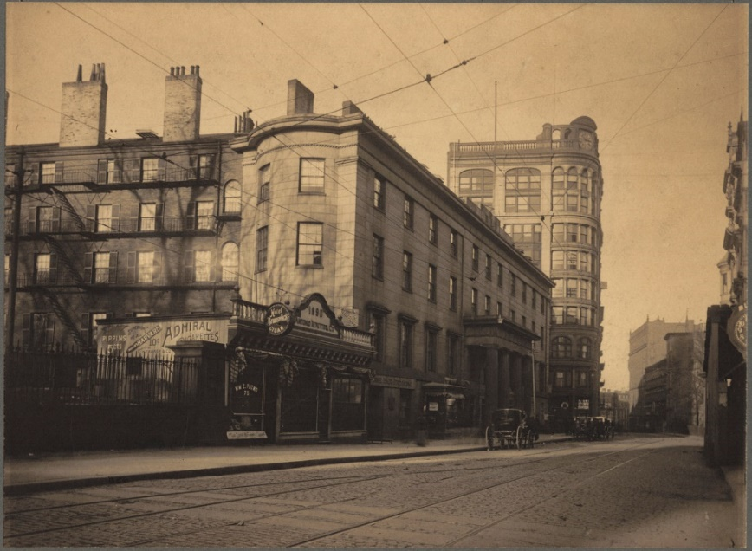
Figure 4.1.3 The Tremont House hotel, Boston, USA

The 20th century
As travelling got physically easier, enabling more people to travel and to travel further, the hotel industry boomed. The first business hotel, the Hotel Statler (later called the Hotel Buffalo), was established in 1907 in the US. The economic boom after World War II meant people had more disposable income and leisure time, which many decided they wanted to spend abroad, particularly in Europe. In the 1960s, new tourist resorts grew up around the Mediterranean and countries such as Spain, Greece and Yugoslavia thrived with the development of beach hotels (Figure 4.1.4). Today the hospitality industry is a major contributor to many countries’ foreign exchange earnings and a large source of employment.
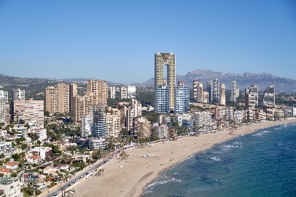
Figure 4.1.4 Hotels line the beach in Benidorm, Spain

The differences between hospitality and tourism
The hospitality industry and the travel industry are closely connected, but there are also some subtle differences. At a basic level, the travel and tourism industry is concerned with services for people who have travelled away from their usual place of residence, for a relatively short period of time. By contrast, the hospitality industry is concerned with services related to leisure and customer satisfaction. This may well mean offering services to tourists, but it can also include the provision of services to people who are not tourists, such as locals enjoying their free time or people coming to an area for reasons other than tourism. The hospitality sector forms part of the wider service industry.

Activity 4.1
Look at the timeline for the development of hospitality. Match each picture to each point on the timeline.
1. 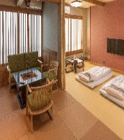 2. 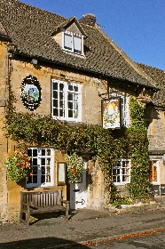
3. 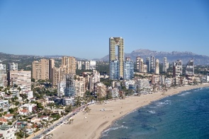 4. 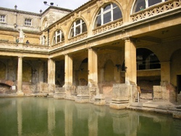
5. 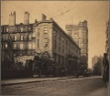
Answers to Activity 4.1

4.2 Serviced accommodation
Accommodation plays a prominent part within hospitality and the tourism industry. Accommodation refers to a temporary lodging, where travellers may rest and sleep. In the previous study session, you saw how hospitality developed across the centuries and around the world. The choice of accommodation is a big consideration for travellers today and is influenced by the amount they want to pay, the level of service they require and the degree of privacy they expect.
Hotels are the most traditional and most common types of accommodation and offer a full range of services. You will learn more about hotels in Session 4.5, but here other forms of serviced accommodation are considered.
Motels are a form of hotel that are mostly situated along highways and roads, and designed primarily for motorists. They typically have the rooms arranged in low blocks with parking directly outside. Some motels have restaurants, dining rooms and swimming pools (Figure 4.2.1).
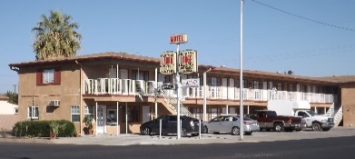
Figure 4.2.1 A motel along a US highway

A guest house is a private house converted into a lodging facility for tourists. Breakfast may or may not be offered at the guest house. The owner and family often live in another building nearby.
Bed and breakfast (B&B) is accommodation provided in a private house by the owner for up to six paying guests. The owners typically live in the accommodation and separate their personal living space away from the guest space. The breakfast served is traditionally a cooked breakfast.
An inn is an establishment that offers travellers food, drink and lodging. They are typically located in the country or along a highway and are usually used for a short stay as travellers pass through.

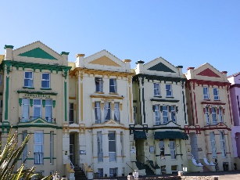
Figure 4.2.2 A British B&B in a seaside resort

A home stay is intended to facilitate a deep cultural tourism experience. The guest stays with a family and immerses themselves in the family’s life.

Activity 4.2
Match the type of serviced accommodation with its explanation.
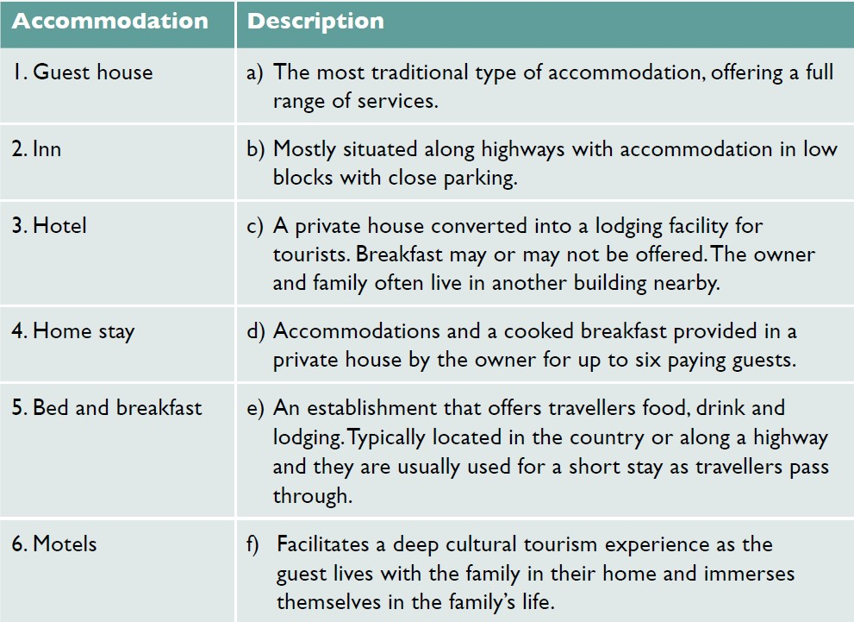
Answers to Activity 4.2

4.3 Non-serviced accommodation
Non-serviced accommodation is accommodation that does not offer food or cleaning. Non-serviced accommodations include apartments, villas, cottages, campus accommodation, youth hostels and campsites. The guest has to do most things for themselves, like cooking, cleaning and changing the bed linen.
Apartments and villas are privately owned by individuals or companies. They can be large or small and can be offered on a short-term or long-term let. Guests must provide their own food and do their own cooking during their stay.
Cottages are typically a small, cosy house that is classed as being old or traditional. They are found in semi-rural locations. Because of their unique character, culture and heritage, cottages make popular holiday homes. Cottages provide tourists with the opportunity for a ‘home from home’ experience.
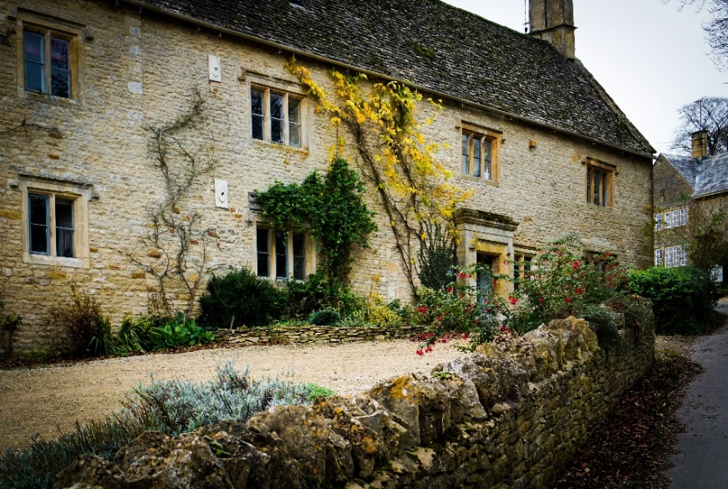
Figure 4.3.1 An English holiday cottage in the Cotswolds

Youth hostels are a form of cheap accommodation for travellers. Guests can rent a bed, often in a dormitory or a smaller shared room. They share a bathroom, lounge and possibly a kitchen with other guests. Hostels are popular with young people and others travelling on a small budget. They are less formal than hotels and offer a lot of opportunity to socialise, but also less privacy.
Campsites are a place used for an overnight stay outdoors. They offer ground pitches for the erection of tents, with facilities for washing and sanitation, campfires and sometimes electricity. Campsites charge a nightly user fee for the services they provide. Caravans can also be driven on to campsites and stay there overnight.
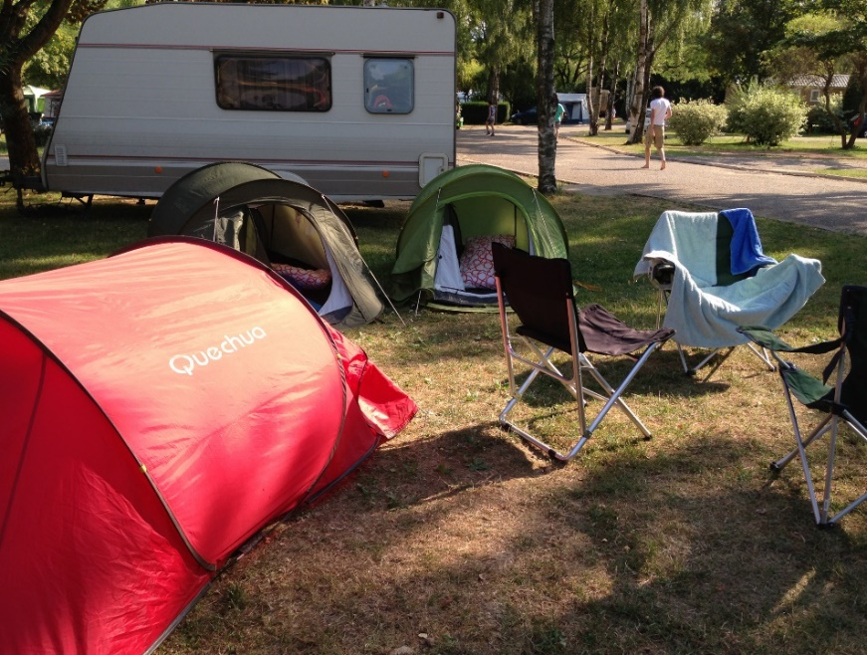
Figure 4.3.2 A campsite in France

Activity 4.3
What type of accommodation would best suit each of these four different travellers?
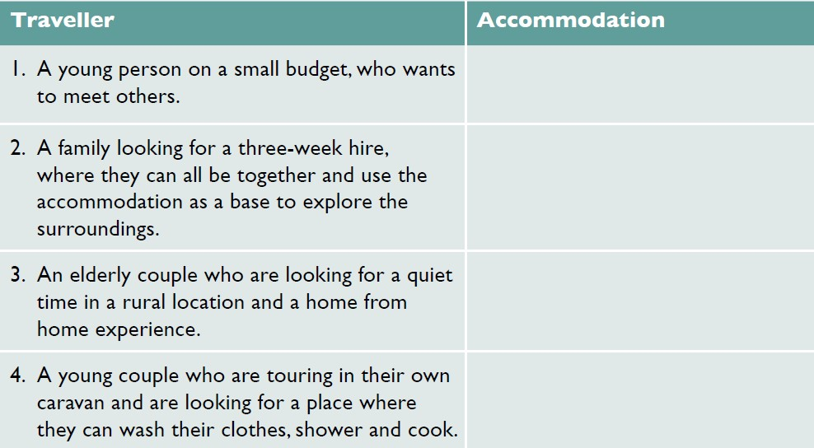
Answers to Activity 4.3

4.4 Dawei case study
We now consider how a tourist destination is built, by looking at one area: Dawei, in Tanintharyi Region, in the south of Myanmar (Figure 4.4.1). This region was closed to international tourists until 2013 and encouraging tourism is a recent initiative. Because of the lack of tourist development, the city and area retains an authentic charm, with many surviving colonial buildings.
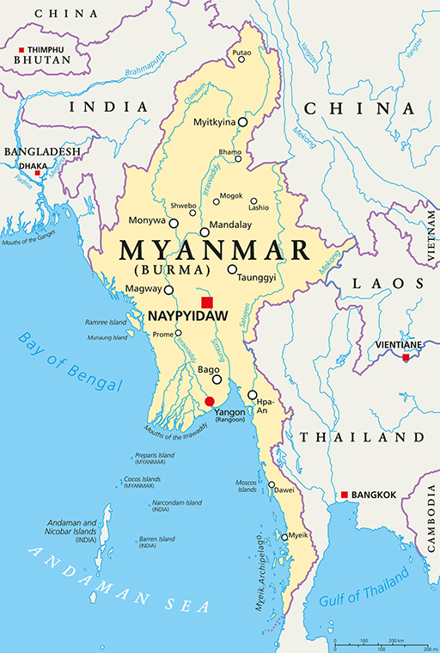
Figure 4.4.1 Map of Myanmar showing Dawei in the south

Tourists first started to go to Dawei for pilgrimage. The pilgrims stayed at numerous monastery compounds and rest houses (Zayat). Today, Dawei is being supported to build its tourism presence by investment from the Dutch government, through the International Trade Centre (ITC). They are supporting the development of tourism products and services, which include cultural community-based tours and creative tourism activities. They are also providing training to tourism service providers, such as local communities, local guides, ground handlers, hotels and restaurants (ITC, 2019).
Certain villages have been identified as offering the best potential for inclusive tourism activities, as well as showcasing the local style of housing (Figure 4.4.2). Dawei city centre is also seen as ideal for cultural and heritage walks. Working with the Ministry of Hotels and Tourism, the ITC are supporting the local communities to develop tourism products and increasing their quality through training. To build Dawei’s presence as a tourism destination, Yangon tour operators were consulted and invited to visit. The purpose of the visit, called a familiarisation trip, was to market the new community-based tourism experiences to Yangon tour operators. This is seen as a first step to reach international tourism markets.
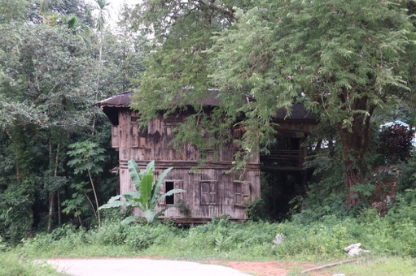
Figure 4.4.2 Traditional village home in Dawei

The familiarisation visit has built trust and understanding between the communities, local tourism businesses and domestic tour operators. Dawei ground handlers, hoteliers, restaurants and tour guides presented their products and services, which were well received.

Activity 4.4
Read the following account of the day experienced by 30 Yangon tour operators on their familiarisation visit to Dawei and answer the following question.
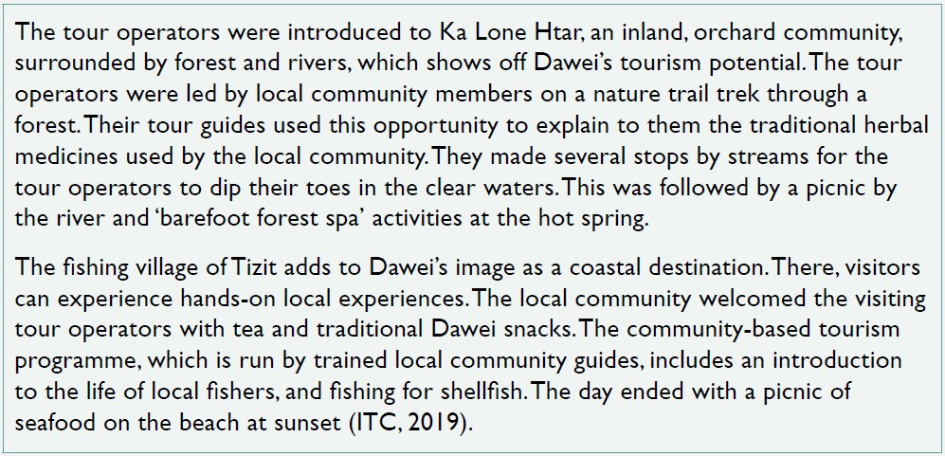
What types of tourism experiences are on offer here:
- religious tourism
- community-based tourism
- wellness tourism
- nature tourism
- disaster tourism
- eco tourism
- dark tourism
- rural tourism
- sport tourism?
Answers to Activity 4.4

4.5 What is a hotel?
This session looks at what a hotel is, the types of hotel and the types of meal plans that are available to hotel guests.
A hotel is an establishment that provides accommodation, meals and other services, such as a pool, gym, conference facilities and banqueting rooms to its guests. There are a number of ways of classifying hotels. They can be classified according to their size. A small hotel has up to 150 bedrooms, a medium hotel has 150 to 250 bedrooms and a large hotel has over 250 bedrooms (Figure 4.5.1).
Figure 4.5.1 Classification of hotels based on number of rooms

They can also be classified by the location of the hotel, such as a resort hotel, airport hotel and ski hotel, or by the clientele of the hotel, such as a business hotel, spa hotel and casino hotel. Hotels are also characterised according to the ambience and vibe they create, such as a boutique hotel (a small hotel with individualised unique selling points) or a heritage hotel (a hotel that has historical or cultural significance).
The most common classification is to rank hotels according to a star system, which tells the guest the level of service to expect. Hotels are awarded a grade between one and five stars, with one being the lowest and five the highest (Figure 4.5.2).
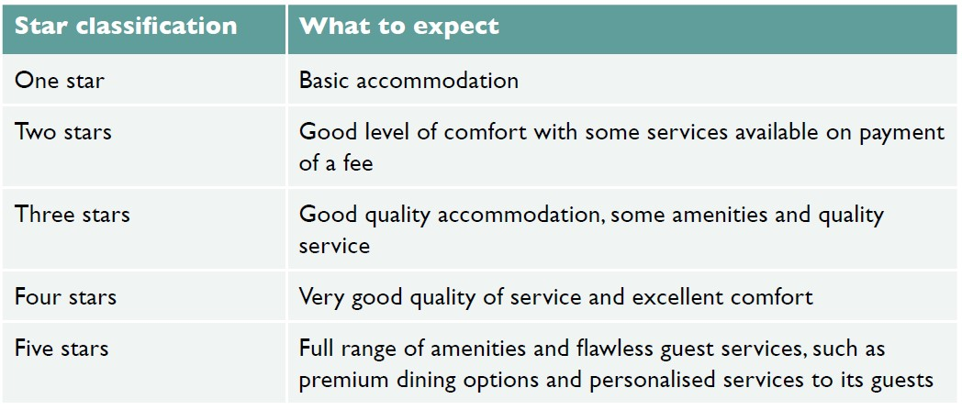
Figure 4.5.2 Hotel star classification

Hotel tariff
A hotel tariff is the charge for services offered by the hotel. Most commonly it refers to the room charge. The main types of room in a hotel are:
- single room – a single bed for single occupancy
- double room – a double bed for two-person occupancy
- double and double room – two double beds for up to four people
- triple room – one double bed and one single bed, or three single beds for three people
- twin room – two single beds, each for single occupancy
- interconnecting rooms – a door connects two adjacent rooms, allowing the guests to access either room without passing through the public area
- suite – more than one room, normally a bedroom and lounge
- deluxe room – a larger room and larger bed for two people, often with view
- king room – a king-sized bed for two people
- queen room – a queen-sized bed for two people.
Guests can also choose different meal combinations or a meal plan. There are many different types of plan that guests can choose from, even at the same hotel, although not all would be available at every hotel. Some types of meal plans include:
- full board (FB) or American plan – accommodation, breakfast, lunch and dinner
- modified American plan – accommodation, lunch or dinner
- half board (HB) – accommodation, breakfast and dinner
- bed and breakfast (B&B) or continental plan – accommodation and breakfast
- Bermuda plan – accommodation with morning tea and coffee
- room only (RO) – accommodation only.
Hotels operate 24 hours a day with staff working eight hours each day. Their duty time is called a shift. Thus, staff might work the morning shift, afternoon shift or night shift. Sometimes this is called A shift, B shift and C shift. Most hotels have some handover time of 30 minutes or one hour, so that the staff starting the new shift can be briefed about the guests by the staff just finishing. In this way, hotels operate a smooth 24-hour service.

Activity 4.5
Look at the photos and match them to the type of room shown.
1) 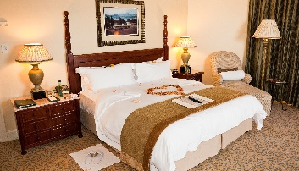 2) 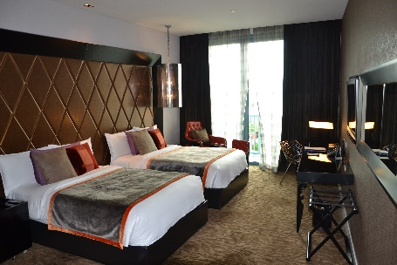
3) 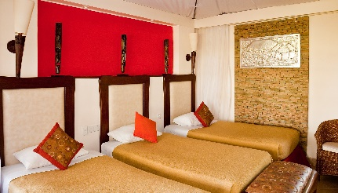 4) 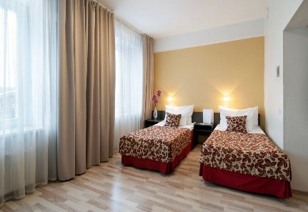
5)
- Triple room – one double bed and one single bed, or three single beds for three people.
- Double room – a double bed for two-person occupancy.
- Suite – more than one room, normally a bedroom and lounge.
- Double and double room – two double beds for up to four people.
- Twin room – two single beds, each for single-person occupancy.
Answers to Activity 4.5

4.6 Trends in hotel development
This session looks at three current trends in the development of hotels: environmental impact, digitalisation and different hotel ownership models.

Environmental impact
Hundreds of millions of people travel around the world every year staying in hotels, which makes hotels a multimillion-dollar industry. But hotels’ environmental impact is becoming an increasing concern for hoteliers, governments, local communities and guests. The three key areas of concern are energy, water and waste (Figure 4.6.1).
Figure 4.6.1 Three areas of environmental concern for hotels

Addressing these issues is called ‘greening’ and hotels are increasingly greening their management approach, becoming more environmentally responsible and sustainable by adopting good environmental practices. Technology has supported and driven these environmentally aware changes. Customers are also becoming increasingly aware of the environmental credentials of hotels, which influences their hotel choice.

Energy
Hotel guests use more energy than local residents, because there are more energy-intensive services available to guests, such as air conditioning, restaurants and gyms. Hotels are installing energy-efficient technologies and fittings, for example energy-efficient lighting. These small adjustments can lead to major cost savings, as well as cutting greenhouse gas emissions. Today, most hotels are changing their practices from energy consumption to energy conservation.

Water
Water is central to many of the extra services provided to guests, such as gardens, spas, golf courses and pools. Water-efficient devices can cut water usage and leakage. Guests are also encouraged to reuse towels and bed linen, rather than having them changed daily. This reduction in laundry cuts water and energy usage.

Waste
Hotels produce a lot of waste, because they are major consumers. They are increasingly looking at reducing, reusing and recycling their waste. For example, rather than providing water in plastic bottles in every guest room, hotels are providing water fountains on each floor and glass jugs for filling (Figure 4.6.2). They are providing shampoo and conditioner in refillable bottles rather than single-use plastic bottles, as well as purchasing organic products and using fewer chemicals as cleaning agents.
Figure 4.6.2 Hotels increasingly provide glass jugs of water in hotel rooms, rather than single-use plastic bottles of water

A hotel impacts its environment not only at the operational stage of its life cycle, but also at the planning and construction stages. Consequently, developers are seeking the support of local communities when making choices about where to locate a new hotel. Consideration is given to the construction materials used and their source, and the building techniques used. All of these elements add to the environmental footprint of the hotel, as does its closure and decommissioning.

Digitalisation of hotels
Many hotels are becoming paperless and moving to greater digitalisation. The central reservation system is increasingly computerised, cutting out the need to print documents. Digital copies are held and emailed to guests, saving time and resources. In many hotels, guests no longer have physical keys, but plastic key cards that offer greater security and convenience. Staff increasingly check in for their shifts using face scans or a fingerprint for secure recognition.
Guests are increasingly likely to make their reservation online, having searched the internet to view the hotel’s website and reading online reviews. They can also book dinner at a hotel restaurant or view their bill any time through their room TV screens. Some hotels even use robots for front office operations, housekeeping and service in restaurants and bars.

Hotel ownership models
Vacation ownership is the fastest growing segment in the travel and tourism industry. These properties are where multiple parties hold rights to use the property, and each owner of the same accommodation is allotted their period of time when they can use it. Many leading hoteliers are entering this market, building resort properties, urban condos, townhouses or single-family homes.
Another developing trend is franchise hotels. Most hotels are independent hotels or chain hotels. An independent hotel is a small-scale hotel, for example a family-run hotel. Chain hotels are normally local hotels in a country, or international chains, owned by a parent or partner company. Chain hotels each occupy an identical position in the market, with the same concept, design, service and name. In contrast, a franchise hotel is a way of growing the business in multiple locations, with the same or similar products or services, through a contractual agreement. The franchisor grants the franchisee the rights to use the company name.

Activity 4.6
Covid-19 has had a devastating impact on tourism. Hotels are likely to start exploring strategies that target local customers to grow their income until overseas guests return. Imagine you are a hotel general manager. Which of the following reopening strategies might you use:
- encourage domestic guests to stay with special local rates
- market conference facilities
- market banqueting facilities
- promote the hotel as a wedding venue
- promote hotel restaurants with special dining offers, such as children under 12 eat free
- promote the bars with special entertainment evenings, such as a jazz evening?
Answers to Activity 4.6

Answers to activities

Activity 4.1
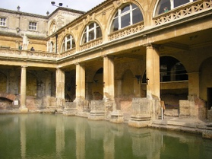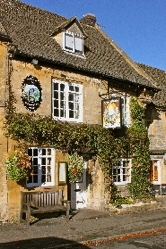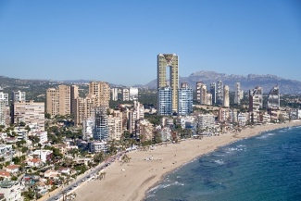

Activity 4.2
1. c), 2. e), 3. a), 4. f), 5. d), 6. b)

Activity 4.3
1. Youth hostel
2. Apartment or villa
3. Cottage
4. Campsite

Activity 4.4
- b) community-based tourism, c) wellness tourism, d) nature tourism, f) eco tourism, h) rural tourism.

Activity 4.5
- b) Double room
- d) Double and double room
- a) Triple room
- e) Twin room
- c) Suite

Activity 4.6
All answers a) to f) are likely to grow hotel earnings.

References
International Trade Centre. (2019) Experiencing local life and culture in Dawei, Myanmar. Available at: https://www.intracen.org/news/Experiencing-local-life-and-culture-in-Dawei-Myanmar/ (Accessed: 1 March 2021).

Topic 5:
Hotel operations
This topic looks at the operations of a hotel. It begins by considering the different departments needed to operate a hotel successfully, focusing on the four main departments: the front office, housekeeping, food and beverage service, and food and beverage production. Travel and tourism’s contribution to employment is then considered, together with career opportunities in the hotel industry and how to extract information from job advertisements.

5.1 Departments in a hotel
This session looks at the organisational structure of a hotel and its many departments to understand how a hotel operates.
Organisational structures can differ from hotel to hotel, but most hotels are usually headed by a general manager. In a small hotel, the hotel owner is usually the general manager, while in a large hotel there may be a president instead of a general manager.
Under the general manager, there are department heads who report to the general manager. Beneath the department heads, there are supervisors who supervise other staff within the department. The number of staff they supervise depends on the size and importance of the department.
Departments in a hotel can be divided into two categories: main departments and support departments. The main departments are shown in Figure 5.1.1.
Figure 5.1.1 The main departments of a hotel

The support departments are shown in Figure 5.1.2.
Figure 5.1.2 The support departments of a hotel

A further distinction is made between those departments that have some direct contact or service to the guests (called front of house) and those departments that have no direct contact with guests (called back of house). Front of house includes the front office department, and food and beverage service (restaurant and bar staff). All of the support departments and two of the main departments – housekeeping, and food and beverage production (kitchen and pastry staff) – are back of house. A consideration of the main departments follows.

Responsibilities of departments

Main departments
The front office is responsible for reservations, guest registration, room arrangements, handling guest complaints and other services. The staff includes the front office manager, receptionists, cashier, night audit, bell attendant, concierge and reservation staff. You will learn more about the front office in Session 5.2.
The housekeeping department is responsible for the daily cleaning and maintenance of the hotel. Bedroom cleaning, public area cleaning, laundry service, linen keeping and flower arrangements are the responsibility of housekeeping. The staff includes the executive housekeeper, floor or public supervisors, room attendants, public attendants, the florist and gardener. You will learn more about housekeeping in Session 5.3.
The food and beverage responsibilities are shared between two departments: food and beverage service, and food and beverage production. Food and beverage service, which is front of house, includes restaurants, bars, banqueting and catering staff. Food and beverage production includes the kitchens, pastry and larder staff, who are back of house. You will learn more about the food and beverage departments in Session 5.4.

Support departments
The supportive departments are not so important for a small hotel, as their roles are often undertaken by the main departments. But for medium and large hotels they operate as separate departments.
- The human resources department is responsible for staff recruitment and training.
- Finance and cost control is responsible for hotel cash flow and cost control for the food and beverage departments. The staff includes an accountant and cashier.
- The maintenance and engineering department is responsible for the upkeep of the building and hotel equipment. The staff includes a carpenter, painter, plumber, electrician and mechanic.
- The security department looks after the security of guests and staff, and the timekeeping of the hotel staff.
- The sales and marketing department is responsible for promoting the hotel and includes sales and marketing staff, event experts and IT technical support.
- The public relations department is responsible for building the brand identity of the hotel and includes guest relations.
- The purchasing department is responsible for buying the goods and services needed to run the hotel. The staff includes a purchaser and storekeeper.

Activity 5.1
1. Which of the following staff work in the front office department:
- florist
- receptionist
- waiter?

2. The bar is an outlet of which department:
- front office
- housekeeping
- food and beverage service?

3. Which of the following staff work in the maintenance department:
- plumber
- room attendant
- purchaser?

4. Which of the following is a support department in a medium or large hotel:
- front office
- food and beverage service
- human resources?

5. Is this statement true or false?
Food and beverage service staff are back of house.

6. Is this statement true or false?
Food and beverage production staff are front of house.
Answers to Activity 5.1

5.2 Front office operations
In this session you will learn about what the front office does, in particular, the basic procedures of check-in and check-out, the duty of a night audit, and how to handle guest complaints.

Check-in
The check-in procedure starts before the guest arrives, when the guest makes the reservation, which is processed by the sales executive. Reservations can be made through the hotel’s website, by telephone call or email.
When a guest arrives at a hotel, the first person they are likely to see is the doorman or bell attendant. The doorman opens the door for them and the bell attendant assists them with their luggage, then leads them to reception for check-in. These people are part of the front office department. The organisational structure of the front office varies according to the size of the hotel, standard of service and the type of hotel.
The guest is greeted by the receptionist and politely asked for their name, in order to search for the reservation. The receptionist prints out the guest registration card and fills in the guest information. The guest is asked to show their ID card or passport and photocopies are made. The guest is asked to sign their guest registration card and the photocopied documents are attached to it and filed.
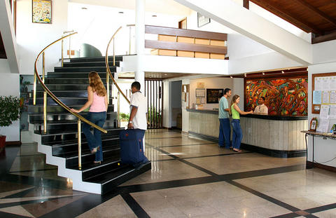
Figure 5.2.1 Reception is part of front office operations

Guests can pay in advance or at the time of check-out. Those who want to pay on check-out are asked during check-in to provide a credit card number against which charges can be applied. Providing a credit card means the guest can also charge extras consumed during their stay directly to their room, rather than having to pay each time. The guest is then given their room key and the bell attendant shows them to their room and brings their luggage. The bell attendant also explains the facilities of the room.

Check-out
When the guest requests to check out, they are asked for their room number and to confirm their name. Reception staff print out the bill for the guest to review. The guest will choose the payment method, complete payment and be offered a paper receipt or to have a digital copy emailed to them. They will be asked if they need assistance with their luggage. The guest is thanked for giving an opportunity to serve and for choosing their hotel for their stay. The guest cycle captures the stages of the guest stay, as shown in Figure 5.2.2.
Figure 5.2.2 The guest cycle

Night audit
Hotels operate 24 hours a day. During the night, the night audit takes control of the front desk. The night audit performs not only as an accountant, but also as a receptionist during the night shift. The responsibilities of night audit are:
- posting room rates and tax charges
- verifying room status reports
- handling guest check-in and check-out during the night
- settling the financial activities of each department
- closing the financial activity for the day
- preparing the list of expected arrivals for the next day
- preparing the night audit report, which balances the regular financial transactions.
Figure 5.2.3 The organisational structure of front office operations

Guest complaints
Another responsibility for the front desk is to handle guest complaints. When a guest makes a complaint, the member of the front desk staff needs to listen with concern and empathy. They should stay calm and not argue with the guest, being mindful of the guest’s self-esteem. They should concentrate on the problem, writing down the key facts. They should apologise to the guest for the inconvenience caused and offer resolution options, but they should not exceed their authority. A report should be made to the supervisor or manager, so they are aware of the problem and how it was resolved. The guest should be contacted later to ensure that they are satisfied with the way their complaint was dealt with.

Activity 5.2
Read the transcript of a guest making a complaint to the front desk and select the most appropriate response from the front desk staff member.
1. Guest: Hello, the air-conditioning unit in my room isn’t working.
Receptionist:
- Oh, that’s a shame. What do you want me to do about it?
- I’m very sorry to hear that. Let me see what I can do. Can I take your room number please?
- I’m sorry but maintenance have finished for today. You will have to wait until tomorrow before I can get someone to have a look at it. Can I take your room number?

2. Guest: Room 208
Receptionist:
- Thank you, Mr Aung San. I’m really sorry for the inconvenience. A maintenance person can be with you in the next 20 minutes. Or if you like, you can have another room right now.
- OK. I’ve got that. I’ll see what I can do.
- Thank you, Mr Aung San. I will make enquiries and get back to you later today.

3. Guest: I really don’t want to change rooms. And if it is only going to be 20 minutes as you said, that will be all right.
Receptionist:
- I’m glad you are satisfied, Mr Aung San. Goodbye!
- I apologise, Mr Aung San, and I’ll call you after the maintenance engineer has been to check that everything is working as you want it to.
- Let’s hope the engineer can fix it.
Guest: Thank you for your help.
Answers to Activity 5.2

5.3 Housekeeping operations
In this session you will learn about the housekeeping department and its operations. Housekeeping are responsible for maintaining a standard of cleanliness throughout a hotel.

Housekeeping staff
Figure 5.3.1 The organisational structure of the housekeeping department in a large hotel

The executive housekeeper is responsible to the hotel general manager for the efficient and effective leadership and operation of all the housekeeping areas. They need a strong level of commitment to maintaining high standards and they are responsible for a substantial amount of record-keeping. They are assisted by a deputy and an assistant housekeeper. Reporting to them are different supervisors, such as the linen room supervisor and the public area supervisor. The supervisors have a number of attendants working under them depending on the size of the hotel (Figure 5.3.1). Housekeeping staff are the largest group of employees in a hotel.

Housekeeping departments
The housekeeping department has two service outlets:
- cleaning
- laundry and linen.
Cleaning consists of preparing and cleaning guest rooms and the public areas. These tasks are undertaken by the room attendants and public area attendants. Laundry and linen involves washing, starching and ironing all the hotel staff uniforms, the food and beverage linen (table covers, dinner napkins, chef aprons), the towels and bed linen for guests, as well as guest laundry when requested. These tasks are undertaken by the uniform room and linen room attendants. To support the smooth running of these services, there are also store attendants and night attendants. Some hotels also have florists (Figure 5.3.2), gardeners, pest control and security in their housekeeping department.
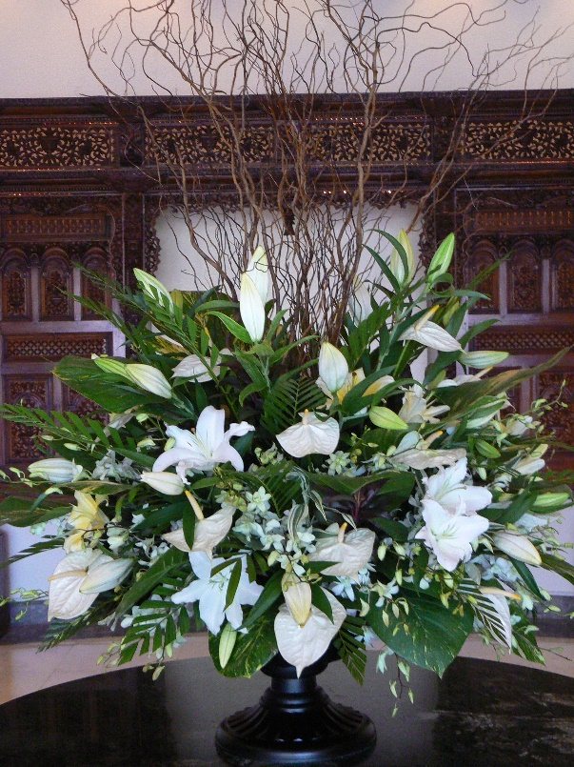
Figure 5.3.2 A floral display to welcome guests to the hotel

Housekeeping coordinates closely with the maintenance and engineering department. For example, they alert maintenance of air-conditioning problems, televisions not working, and toilet and shower problems. As you learned in Session 5.1, housekeeping is considered to be a back of house department, even though housekeeping staff can have some direct contact with the guests. For example, they might interact with guests while cleaning rooms, picking up laundry or providing turndown services.

Housekeeping tasks
Before check-in, a guest’s room is cleaned and checked. It is dusted, swept, scrubbed, mopped and polished starting with the upper parts of the room, including the ceiling and lighting; then the sides of the room, walls and curtains; and finally the bed, furniture and floor by guest room attendants. Housekeeping staff are also responsible for refreshing room amenities, such as shampoo, toothpaste and toothbrushes, for guests. They must check that electrical items, such as an iron and hair dryer, are available.
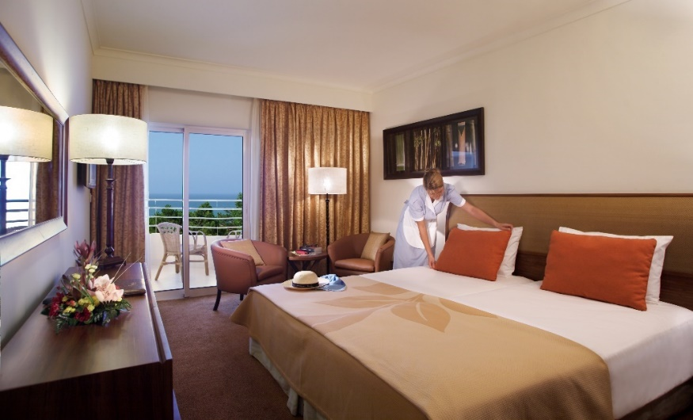
Figure 5.3.3 Room attendant preparing the room for a guest

Before check-out, the guest’s room is checked by a room attendant. They check for linen stains, items consumed from the minibar, broken or damaged furniture and fittings, and missing items. The room attendant also checks that the guest hasn’t left any of their possessions. They make a report to the front office about anything they find. In some instances, the guest may be charged for damages.

Activity 5.3
1. Which members of staff wash and iron the hotel linen:
- room attendants
- laundry attendants
- florists?

2. Who is the head of the housekeeping department:
- executive housekeeper
- store keeper
- gardener?

3. Choose the correct word to fill in the blank in the statement below.
When the guests check out, housekeeping staff check on the room status and report this to the front office ....... the guests check out.
- before
- after

4. Which of the following do housekeeping staff check at guest check-out:
- minibar use
- left guest possessions
- water consumed
- linen stains
- broken items
- damaged furniture
- bed slept in?
Answers to Activity 5.3

5.4 Food and beverage operations
This session looks at the food and beverage operations in a hotel. There are two departments responsible for food and beverage in a hotel: food and beverage production, which prepares the food and beverages; and food and beverage service, which serves food and beverages to the guests. The organisation of the food and beverage department of a small hotel is shown in Figure 5.4.1.
Figure 5.4.1 The organisation of the food and beverage department of a small hotel

The restaurant manager heads up the food and beverage department in a small hotel. It is the food and beverage manager for a medium hotel and the food and beverage director for a large hotel. The organisation of the department is normally divided into two areas:
- restaurant and food outlets
- bar and entertainment outlets.
The range and number of food and beverage outlets depends on the service and type of hotel. Examples of different restaurants and food outlets include:
- fine dining or a signature restaurant (Figure 5.4.2)
- family restaurant
- seafood restaurant
- BBQ or steak restaurant
- quick service/fast-food restaurant
- cake and pastry shop.
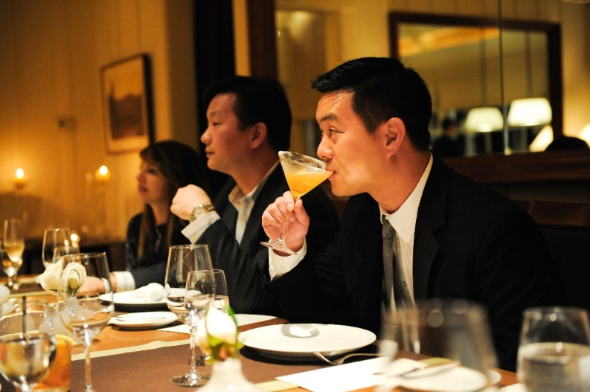
Figure 5.4.2 A fine dining restaurant in a five-star hotel

The bar and entertainment outlets can include a pub, a cocktail bar, a pool bar, a karaoke bar and a nightclub. Room service, banqueting and catering are also included under the food and beverage department in a hotel.

Food service to guests and diners
Depending on the type of establishment and the menus offered, there are a range of service types available to serve guests and other diners, as shown below.
  - Gueridon, trolley or French service – food is cooked and presented to the diner at the table from a movable trolley (Figure 5.4.3).
  - Plated or American service – food is prepared and plated in the kitchen and delivered to the diner at the table.
  - Silver or English service – food service is at the table, with the waiter transferring food from a serving dish to the guest’s plate using service forks and spoons.
  - Buffet or Russian service – courses are brought to the table sequentially. The food is portioned on the plate by the waiter, usually at a sideboard in the dining room, before being given to the diner.
  - Cafeteria or self-service – customers select various dishes from an open-counter display. The food is usually placed on a tray, paid for at a cashier’s station and carried to a dining table by the customer.
  - Family service or Asian service – a casual style of dining, with dishes moderately priced. It usually involves table service rather than counter service.
  - Breakfast service – there are many different types of breakfast service, for example continental, which is pastries, bread, juice and a hot beverage; and English, which is a cooked breakfast.
  - Room service – in-room dining enables guests to choose items of food and drink for delivery to their hotel room. Room service may be provided on a 24-hour basis or limited to late night hours only. Due to the cost of customised orders and delivery of room service, prices charged to the guest are much higher than in the hotel’s restaurant and a gratuity (money paid to service staff for good service) is expected.
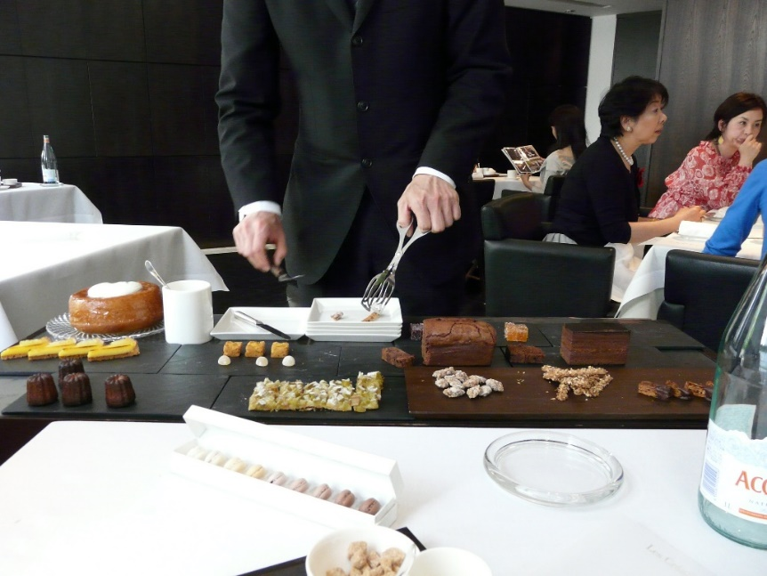
Figure 5.4.3 Gueridon, trolley or French service

Bar service to guests and visitors
A range of beverages are usually available to guests and visitors, including alcoholic and non-alcoholic, mixed beverages, as well as hot and cold drinks.
Alcoholic beverages include:
- aperitifs
- spirits – whiskey, rum, brandy, gin, vodka, tequila
- wines – table, fortified, aromatised, sparkling
- beer – lager, pilsner, ale, stout
- liqueur.
Non-alcoholic beverages include:
- water – natural, manufactured, aerated/carbonated
- juices – fresh, cordials or syrups
- soft drink – colas, lemonade
- hot beverages – tea, coffee, hot chocolate
- milk and milk-based – yoghurt, milkshake.
Mixed beverages include:
- cocktails – one or more alcoholic beverages mixed with other ingredients, such as juice or cream
- mocktails – a non-alcoholic beverage made of a mixture of fruit juices and/or soft drinks.

Activity 5.4
1. A young family want to have lunch at a hotel. They want a casual dining experience and do not want to pay too much. What styles of dining would you recommend for them:
- trolley or French service
- plated or American service
- silver or English service
- buffet or Russian service
- cafeteria or self-service
- family service or Asian service?

2. The young family begin by ordering drinks. They have asked for carbonated water to be provided for the table. The father wants a light alcoholic drink, while the mother would like a mixed beverage with alcohol. The children each want a non-alcoholic, cold drink and both children are intolerant of milk. What drinks would you suggest they order?
Answers to Activity 5.4

5.5 Tourism and hospitality job opportunities
This session looks at the employment opportunities in tourism and hospitality.
Tourism and hospitality are two of the main economic engines for growth in many countries. But the industry can only flourish if it can attract qualified staff and employ a committed workforce. Both are at the heart of excellent service delivery. Employment opportunities in travel and tourism can be created either directly or indirectly (Figure 5.5.1).
Figure 5.5.1 Employment opportunities in travel and tourism

Direct employment opportunities are the total number of job opportunities supported directly by travel and tourism. Direct employment includes jobs in hotels, travel agencies, airlines and other passenger transport services, and the jobs in the restaurant and leisure industries.
Tourism also involves indirect employment, which includes those employed in supporting the tourism sector, such as restaurant and hotel suppliers, construction companies that build hotels, and necessary infrastructure manufacturers and accounting services.
The tourism industry is often characterised by the large number and variety of jobs that must be performed for it to function efficiently. For example, the accommodation sector requires bell staff, front desk staff and room maintenance staff. The food services sector requires chefs, waiting staff, bartenders and kitchen maintenance staff. The attractions sector requires facilitation and equipment operators, as do the entertainment, event and transportation sectors, while the adventure and outdoor recreation sectors need guides and group leaders.
Tourism is one of the most labour-intensive industries among non-agricultural sectors. It offers access to employment in the formal, service economy, and creates significant employment in the informal sector.

Tourism opportunities in Myanmar
Travel and tourism directly generated 804,000 jobs in 2016 in Myanmar, making up 2.7% of the total employment across the country. The total number of jobs indirectly supported by tourism was 1,662,000, which represented 5.7% of the total employment (World Travel and Tourism Council, 2017). Travel and tourism provides a high level of employment and diversified job opportunities in Myanmar, and makes a valuable contribution to gross domestic product (GDP) (Figure 5.5.2).
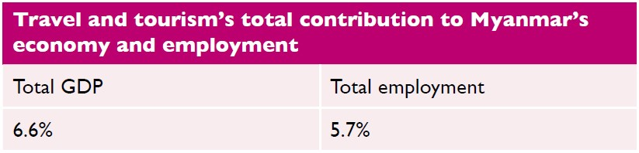
Figure 5.5.2 Travel and tourism’s contribution to Myanmar’s economy

Activity 5.5
The following table shows travel and tourism’s total contribution to GDP and employment in the ten Association of Southeast Asian Nations (ASEAN) countries for 2016. What is Myanmar’s ranking for the total contribution to GDP and employment among its ASEAN neighbours?
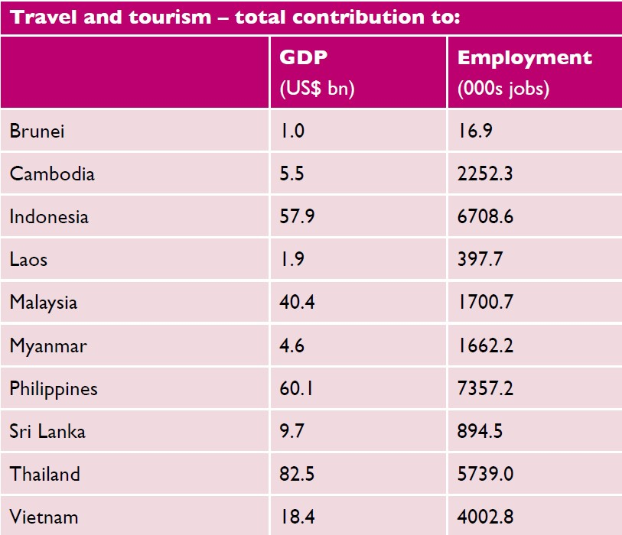
Answers to Activity 5.5

5.6 Hotel careers
Hotel careers can be ideal for people with a wide range of different skills, qualifications and experience. There is often excellent scope to progress to senior positions, for example from working in a busy hotel kitchen as a junior (commis) chef to becoming a hotel general manager (Figure 5.6.1). Here are some brief insights into a selection of hotel careers.
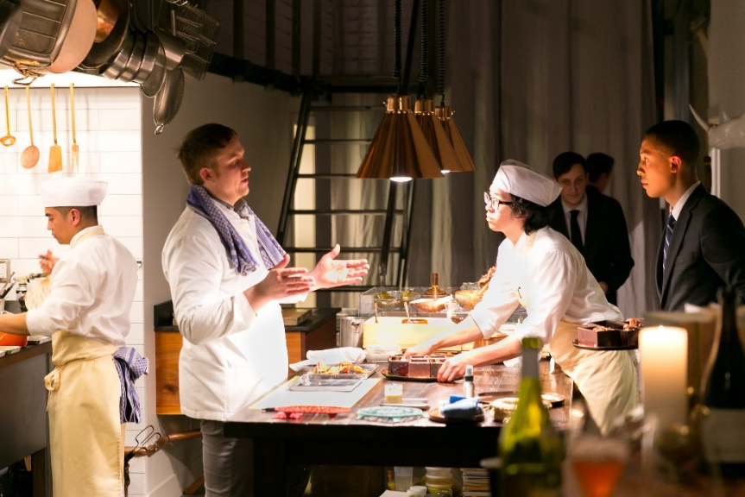
Figure 5.6.1 A junior (commis) chef in a busy hotel restaurant kitchen

Hotel general manager
The general manager is often the most senior executive of a hotel. They set room rates, develop the budget for each department, approve expenses and establish the standards for service to guests.

Experience required
Hotel managers have a degree or certificate in hotel management and a few years of experience. They need to have strong business, management and interpersonal skills.

Duties
Hotel general managers plan and direct the operations of hotels. They have responsibility for front office operations, overseeing restaurant and banquet operations, guest services, housekeeping and decor. They prepare budgets, monitor expenses, and schedule and supervise staff.

Sales manager
A hotel sales manager is responsible for ensuring high occupancy rates and bringing in conference, banqueting and other business.

Experience required
A sales manager must have good communication skills, a confident, optimistic personality and must enjoy working with people. Previous experience of sales, customer service, marketing, business and finance may be requested.

Duties
The sales manager:
- promotes the hotel’s services
- identifies and wins new clients
- prepares sales reports and tracks sales performance
- provides quotes for services
- prepares sales contracts
- processes orders.

Housekeeping room attendant
A housekeeping room attendant ensures guest bedrooms within the hotel are cleaned to a high standard on a daily basis. They should have an eye for detail and notice what isn’t quite right. Being a housekeeping attendant requires some physical stamina, because they have to lift heavy loads.

Experience required
A housekeeping attendant can quickly learn on the job what is required but they need to be willing to learn from and accept criticism in order to maintain high standards.

Duties
The housekeeping room attendant cleans the guest room and bathroom, changes the bed linen, shapes and corrects the curtains and blinds, adjusts the air conditioning and/or heating, and replenishes toiletries for the guest’s comfort. They also provide decoration, such as room flowers, and check the working of electricals. They must report any maintenance issues to the appropriate department.

Front desk agent (receptionist)
Front desk agents provide many guest services. They provide guests with verbal or written information about the hotel facilities, services, room choices and rates, as well as information about area attractions.

Experience required
A front desk agent must have good communication and organisational skills, along with a professional and friendly approach. They also benefit from good computer skills.

Duties
They make room reservations and handle guest arrivals and departures. They also prepare bills and process payments. They deliver hotel information and manage guest complaints.

Executive chef
An executive chef is a managerial role that involves a lot of work in the back office. It can be highly stressful because of the fast-paced working environment (Figure 5.6.2).

Experience required
Many executive chefs have some training at a culinary school, technical school or college programme. They need a track record of meeting deadlines and reaching targets, and experience with stock control. They must have an understanding of health and safety requirements for food hygiene compliance.

Duties
An executive chef oversees the food operations in restaurants, hotels or other venues that serve food. People in this role supervise other chefs and kitchen employees, and manage their performance. They typically order all the food ingredients, plan the menu and supervise the preparation of the food in the kitchen.
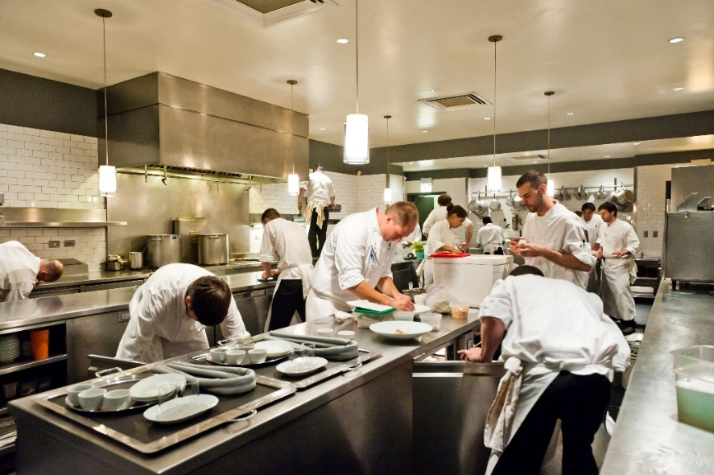
Figure 5.6.2 A busy hotel kitchen

Waiting staff
Waiting staff work in restaurants, bars, hotels, casinos and other food-serving establishments. They have to be detail-oriented, because they need to remember customers’ orders, especially complicated drinks orders.

Experience required
Waiting staff must have strong interpersonal and communication skills. This job is ideal for people in the hospitality industry who want to engage with customers face-to-face.

Duties
They interact directly with customers when taking orders, serving food and beverages, and taking payments from guests.

Finding opportunities
Getting a job in the hospitality industry is likely to start with reviewing job advertisements in newspapers or online recruitment sites. Close reading of job advertisements can tell you a lot about what the job requires and what an employer is looking for.

Activity 5.6
Below is an advertisement for an assistant housekeeping manager in the hospitality industry. The recruiter is looking for a graduate to fill the role. The advert is based on those for similar roles, which appear each week on recruitment websites and in newspapers in Myanmar. It contains the kind of information that is useful for demonstrating an employer’s needs.
Read the job advertisement and extract the relevant information to answer the questions.
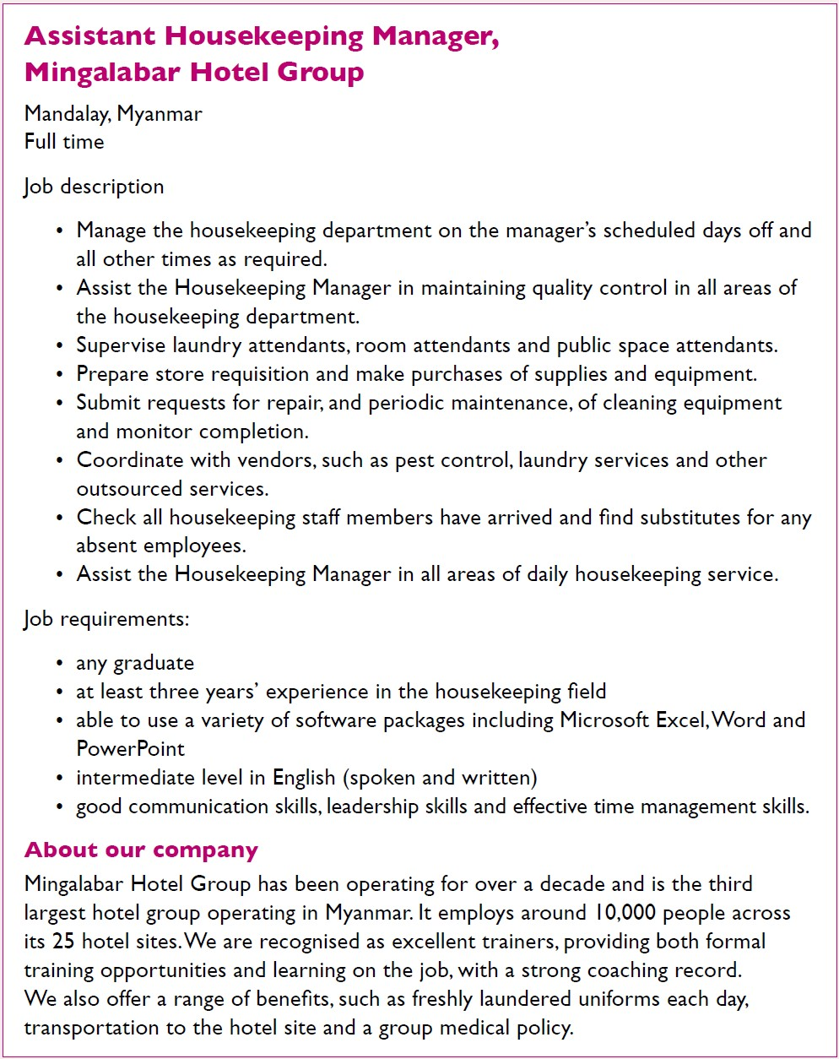
1. What hotel group is the job with?

2. Which of the following will be needed to do the job:
- checking
- dancing
- coordinating
- singing
- cooking
- running
- managing
- ironing
- supervising
- monitoring
- assisting?

3. Identify the requirements for the job:
- degree
- time management skills
- five years’ experience
- basic English
- knowledge of Microsoft packages
- three years’ experience
- leadership skill
- high school certificate
- intermediate English
- no experience needed
- communication skills
- advanced English.

4. What tells you that the company has a good training record?
Answers to Activity 5.6

Answers to activities

Activity 5.1
- b) receptionist
- c) food and beverage service
- a) plumber
- c) human resources
- false
- false

Activity 5.2
- b) I’m very sorry to hear that. Let me see what I can do. Can I take your room number please?
- a) Thank you, Mr Aung San. I’m really sorry for the inconvenience. A maintenance person can be with you in the next 20 minutes. Or if you like, you can have another room right now.
- b) I apologise, Mr Aung San and I’ll call you after the maintenance engineer has been to check that everything is working as you want it to.

Activity 5.3
- b) laundry attendants
- a) executive housekeeper
- a) before
- a) minibar use, b) left guest possessions, d) linen stains, e) broken items, f) damaged furniture

Activity 5.4
- Either e) cafeteria service or f) family service would suit this young family.
- Father – beer or a glass of wine. These are lighter alcoholic drinks.
Mother – a cocktail.
Children – a soft drink or a juice.

Activity 5.5
In 2016, Myanmar was eighth in the ranking for tourism’s total contribution to GDP among ASEAN members. It was seventh for tourism’s total contribution to employment.

Activity 5.6
- Mingalabar Hotel Group
- a) checking, c) coordinating, g) managing, i) supervising, j) monitoring, k) assisting
- a) degree, b) time management skills, e) knowledge of Microsoft packages, f) three years’ experience, g) leadership skills, i) intermediate English, k) communications skills
- The advertisement states, ‘We are recognised as excellent trainers, providing both formal training opportunities and learning on the job, with a strong coaching record.’

References
World Travel and Tourism Council. (2017) Travel and Tourism: Economic impact 2017, Myanmar. Available at: https://bandapost.org/wp-content/uploads/pdf/Economic%20Impact%202017%20Myanmar%20by%20World%20Travel%20&%20Tourism%20Council.pdf (Accessed: 5 March 2021).

Topic 6:
Future of tourism and hospitality in Myanmar
This topic looks at the future of tourism and hospitality in Myanmar. It begins by introducing the country from the foreign tourist’s perspective and what they like to see and do on their visits. The most frequently visited attractions are then explored, before considering the growth in international visitors to the country. Tourism and hospitality have the potential to make a huge contribution to economic growth and create diversified employment opportunities, but investment is necessary. Tourism investment is considered relative to other Association of Southeast Asian Nations (ASEAN) countries. The challenges of sustainable tourism in Myanmar are explored and, finally, the impact of Covid-19 in 2020–21 and political unrest for the future of tourism in Myanmar are reflected upon.

6.1 Myanmar as a tourist destination

Natural and cultural attractions
Myanmar has an abundance of natural and cultural tourism assets, a distinct cuisine, and diverse architecture. Tourists are attracted to visit the country for this rich natural and cultural heritage. Of particular interest are the different ways of life of Myanmar’s people. Myanmar is an extremely ethnically diverse country with 135 distinct ethnic groups and eight major national ethnic races:
- Barmar
- Chin
- Kachin
- Kayin
- Kayah
- Mon
- Rakhine
- Shan.
There are plans to expand the range of tourist attractions in the country. The government of Myanmar’s Tourism Masterplan, 2013–2020, sees tourism making a positive contribution to the country’s development. Tourism can improve people’s living standards by providing employment and business opportunities. It can contribute to the conservation of the country’s natural and cultural heritage and, by sharing the rich cultural diversity of its people, bring resources into remote areas.
The cultural and ethnic diversity of Myanmar means there are a range of festivals and ceremonies celebrated throughout the year by different ethnic groups in the various states and regions. They include the Manaw Festival in Kachin State, which is an annual dance festival, and the Naga New Year Festival. National festivals, such as the Water Festival of Thingyan (where water is thrown over people in a party atmosphere) and the Lighting Festival of Thadingyut (buildings are festooned with bulbs and candles, and lanterns are released into the sky) are popular with tourists. Festivals are attractive to tourists as they are joyful and they showcase diverse cultures and traditions. Some tourists time their visits to enjoy such celebrations.

Climate
Tourists also want good weather when they travel. Myanmar’s climate varies depending on location and elevation, being much cooler in the highlands in the north. It has a subtropical/tropical climate with three seasons:
- a cool winter from November to February
- a hot summer season in March and April
- a rainy season from May to October, dominated by the south-west monsoon (Figure 6.1.1).
The higher elevations of the highlands are predisposed to heavy snowfall.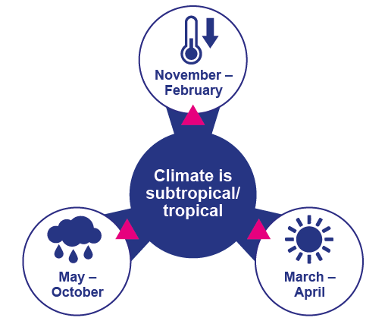
Figure 6.1.1 Climate conditions in Myanmar

The climate of Myanmar has a significant impact on tourist arrivals. Tourists tend to avoid the rainy season and travel in the dry season, which runs between November and April. Peak arrivals occur between December and February.
The impact of global climate change could be quite severe for the country. Myanmar is already one of the most negatively affected countries by natural disasters. Its long coastline makes it subject to tropical storms and cyclones, which are growing in frequency and severity, as shown by the devastation of Cyclone Nargis in 2008. Rising sea levels also threaten parts of the coast with salination as soils and ground water have increasing salt content. The monsoon is starting later and ending earlier, which results in large quantities of rain falling over short periods. This leads to flooding, contamination of water resources and erosion. Climate and temperature are important determinants for tourists in destination selection.
The Covid-19 pandemic has caused tourist numbers to crash, as Myanmar’s borders closed and international flights ceased. The country’s troubled history and ongoing regional conflicts are further deterrents to greater tourist numbers.

Activity 6.1
Watch this video of the Naga New Year Festival and answer the questions that follow.
https://www.youtube.com/watch?v=amNmX67dBXE
1. How did watching this video make you feel? Did you feel proud of the cultural diversity of Myanmar and would you like to attend this festival?
2. Does your area of Myanmar have a colourful festival that you think tourists would enjoy seeing and sharing?
3. Have you ever seen tourists visiting your area of Myanmar? What time of year did they come and what did they see?
Answers to Activity 6.1

6.2 Tourist attractions of Myanmar
This session looks at the most frequently visited attractions in Myanmar. There are five of them: Yangon, Bagan, Inle Lake, Golden Rock Pagoda and Mandalay (Figure 6.2.1). They receive the majority of international visitors and benefit the most from tourism revenues. Most tourists travel around Myanmar on classic sightseeing tours viewing these attractions (Ministry of Hotels and Tourism, The Republic of the Union of Myanmar, 2020, p.25).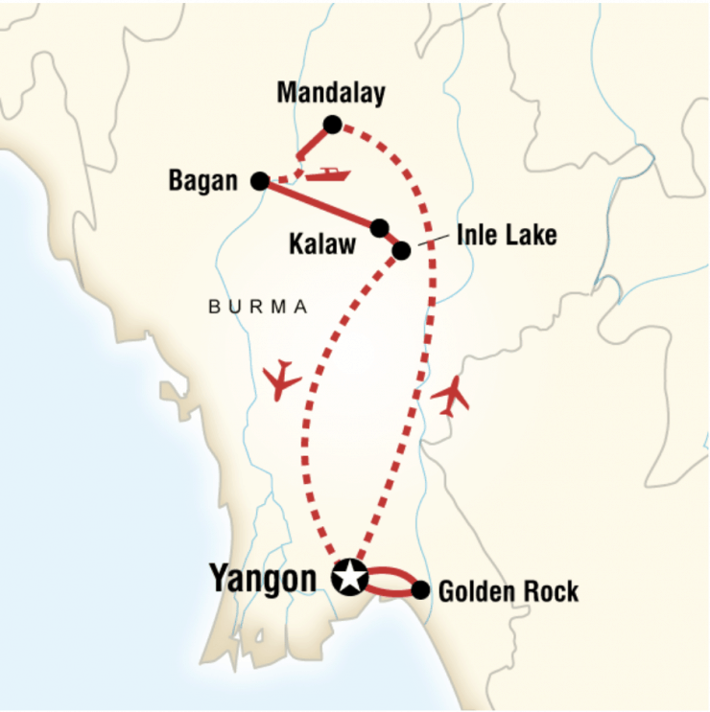
Figure 6.2.1 Map showing the location of the major tourist sites in Myanmar

Yangon
The city of Yangon is the commercial hub of the country and was once the capital of Myanmar. In 1989, the government requested that other countries change their spelling of Rangoon to Yangon to more closely reflect its Burmese pronunciation. In 2005, it lost its position as the capital, which was moved to Nay Pyi Taw in the centre of the country. However, Nay Pyi Taw is mostly an administrative capital and most tourists still fly into Yangon.
Yangon is a vibrant and diverse city, with the most famous pagoda in the country: Shwedagon Pagoda. Of particular interest to tourists are the colonial buildings dating from the British colonial era, a period of rich architectural styles: art deco, Edwardian, Victorian and British-Burmese (Figure 6.2.2). Yangon has the highest density of colonial buildings in South East Asia. The Bogyoke Aung San Market is the best place to explore Myanmar’s traditional arts and crafts, gems and clothing. The Chauk Htat Kyi Reclining Buddha is the third largest in Myanmar. A walk around Kandawgyi Park brings locals and tourists together, as they enjoy the amenities offered by the lake.
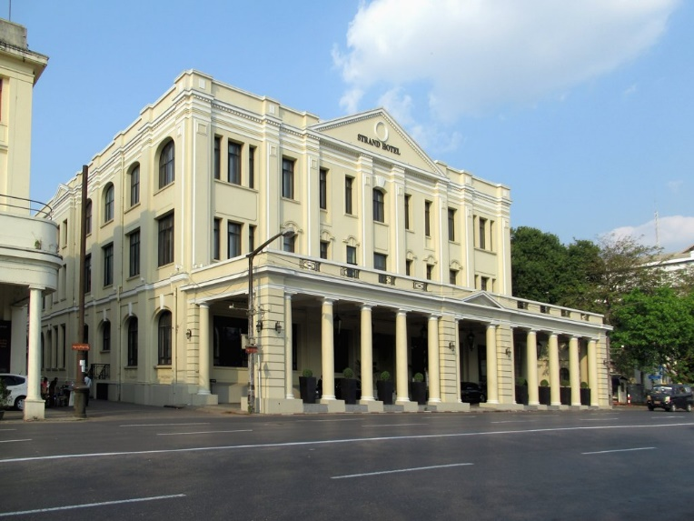
Figure 6.2.2 The Strand Hotel, Yangon is one of the colonial buildings that line Yangon’s waterfront – a heritage feature for tourists

Bagan
Bagan is a sacred landscape, lying on the central plain of Myanmar and features numerous temples, stupas, monasteries and places of pilgrimage. It also has important archaeological remains, frescoes and sculptures showcasing a range of Buddhist art and architecture. The peak of Bagan civilisation was between the eleventh and thirteenth centuries CE, when the site was the capital of a regional empire. It continues to be a place of pilgrimage for Myanmar people today. An activity favoured by tourists is to fly in a hot-air balloon over the temple site at sunrise.

Inle Lake
Inle Lake is best known for its fishermen, with their unique fishing style of rowing their boats with one leg (Figure 6.2.3). Its scenic beauty lies in it being a natural wetland. It has a rich ecosystem, where tourists can observe rare aquatic species, birds and the unique floating farms of local farmers. Along with fishing and farming, traditional handicrafts are a significant part of the local economy, with silk weavers and silversmiths working on the lake.
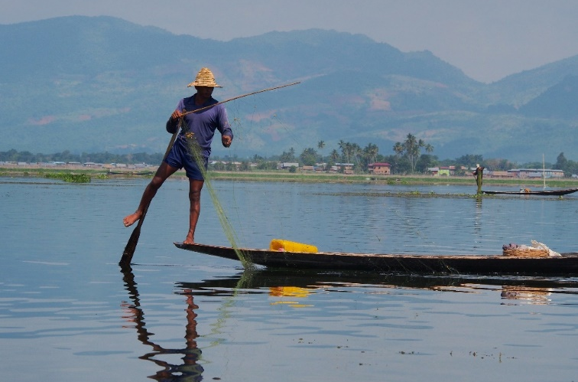
Figure 6.2.3 A fisherman on Inle Lake

Golden Rock Pagoda
Also known as Kyaikhtiyo Pagoda, the Golden Rock Pagoda is said to cover a hair of the Buddha. For Myanmar travellers, the religious significance of the site’s connection with the Buddha is the major attraction. But for tourists, the attraction is the beauty of the golden dome, high up on the mountain and the panoramic views of the surrounding Mon State mountains offered from the summit.

Mandalay
Mandalay is the former royal capital in northern Myanmar and sits on the Irrawaddy River. In the centre of the city is the restored Mandalay Palace from the Konbaung Dynasty, surrounded by a moat. Mandalay Hill provides views of the city from its summit, which is reached by a covered stairway. At its foot, the Kuthodaw Pagoda houses marble slabs inscribed with Buddhist teachings, which are referred to as the world’s largest book. The Zegyo Bazaar is the largest of many markets that attract artisans and farmers from throughout the country. Just outside Mandalay is the U Bein Bridge, which is the longest teak bridge in the world.
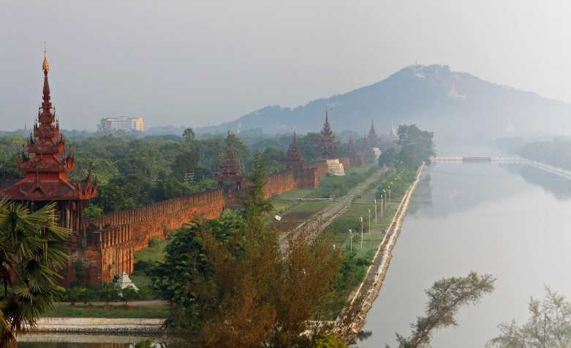
Figure 6.2.4 Mandalay Palace is surrounded by a moat

Problems at attractions
The popularity of these five tourist sites is becoming a problem, because they are being over-visited. For example, the water and sanitation facilities at Inle Lake are under severe strain. To alleviate the pressure on these sites, the government is focusing on developing new destinations within the country, to attract new and repeat travellers. Their vision for the future of tourism is explored in the next session.

Activity 6.2
Select the picture to match the Myanmar attraction based on the descriptions you have read in this session.
1. 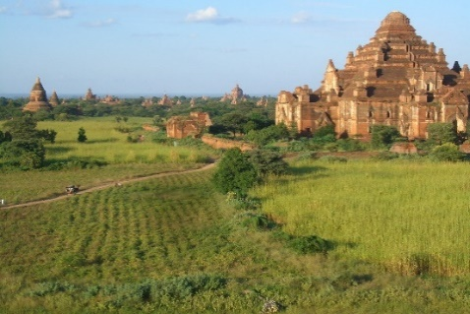 2. 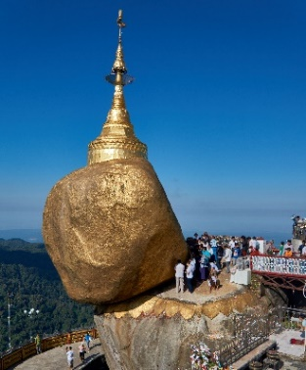
3. 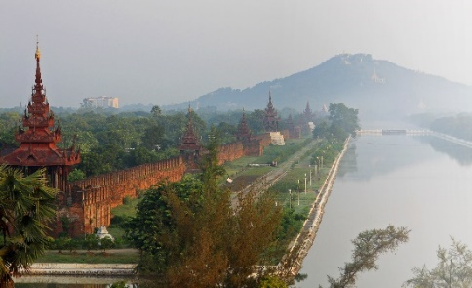 4. 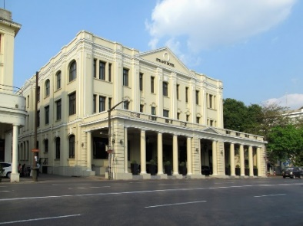
5. 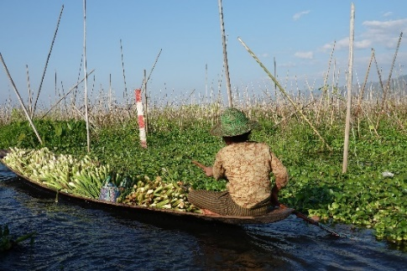
- Inle Lake
- Bagan
- Yangon
- Golden Rock Pagoda
- Mandalay
Answers to Activity 6.2

6.3 Myanmar’s tourism performance
This session considers Myanmar’s recent experience with tourists, focusing on the number of visitors. Tourism numbers have grown steadily since the country opened up to foreign tourists in 2013. The introduction of the e-visa system in 2014 has allowed foreign tourists to apply for a visa online, and improved accessibility to the country. A Tourism Master Plan 2013–2020 was created, targeting 7.5 million arrivals each year by 2020. However, it has been estimated that the annual performance for 2019 was about 4 million arrivals – a long way short of the 2020 target (Thitha, 2020).
Although Myanmar possesses great tourist potential, much of the industry remains underdeveloped. The number of visitors to Myanmar is small compared with her neighbours, even outpaced by Laos. The Tourism Master Plan seeks to maximise the contribution of tourism to national employment and income generation. It aims to ensure equal distribution of tourism’s social and economic benefits (Figure 6.3.1). The government wants to balance its objectives for economic growth with the well-being of host communities. The plan is to minimise any negative impacts on the country’s social, cultural and environmental heritage.
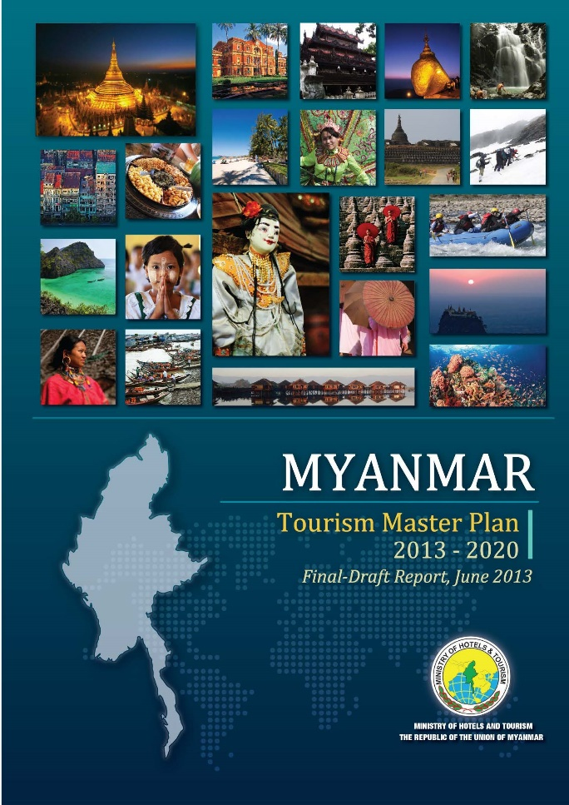
Figure 6.3.1 Myanmar’s Tourism Master Plan, 2013–2020

Encouraging tourists to visit sites other than the popular attractions discussed in Session 6.2 is challenging. However, it is necessary, if the economic benefits of tourism are to be spread more equally. One way to create new attractions is to establish tourism routes, which tie up several attractions that would not have the potential to attract visitors to the area by themselves. The bundling of attractions along a tourist route has greater pulling power, as well as dispersing tourist money across a larger area and more recipients.
Community participation and a pro-poor focus should be at the heart of new route development. Any new routes should provide direct employment opportunities, enterprise opportunities, communal income and livelihood benefits. Establishing links between private sector businesses and neighbouring communities can help produce a unique tourism product, which benefits both stakeholders. Such an alliance will greatly improve the sustainability of tourism (Meyer, 2004).

Activity 6.3
Look at the table of tourist arrivals in Myanmar and answer the following questions.
Source: Ministry of Hotels and Tourism

Where has the information in the table come from?
Why would the creator of the table choose to compare January 2018 with January 2019?
What form of arrival has seen the biggest percentage increase?
What form of arrival has seen the smallest percentage increase?
Answers to Activity 6.3

6.4 Tourism investment opportunities in Myanmar
Tourism and hospitality have the potential to make a huge contribution to economic growth and create diversified employment opportunities in different sectors. This is because tourism includes the industries of transportation, building and construction, accommodation, food and beverage establishments, and many more.
However, Myanmar’s tourism sector is underdeveloped, as shown in Session 6.3. There is insufficient domestic investment to grow the sector quickly, with foreign investment needed for major expansion (World Travel and Tourism Council, 2017). Foreign direct investment refers to the investment in domestic companies and assets of another country by a foreign investor. The government in Myanmar has invited responsible investors to seek business opportunities in Myanmar to accelerate tourism growth. The Foreign Investment Law introduced in 2012 included incentives to encourage foreign investment, such as corporate ownership, tax relief and employment of foreign nationals. Despite this, Myanmar’s travel and tourism sector receives the least investment of all ASEAN members (Figure 6.4.1).
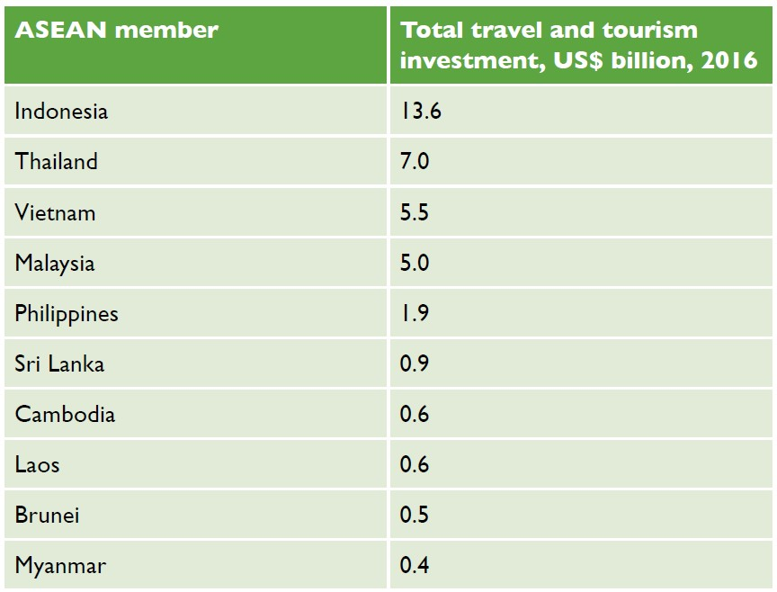
Figure 6.4.1 Investment in Myanmar’s tourism sector is low compared with other ASEAN members

Myanmar’s accommodation facilities are currently concentrated in the cities of Yangon and Mandalay. There is a considerable lack of available accommodation in numerous other locations outside those centres. There is a need for affordable, as well as high-end, accommodation. Under the Foreign Investment Law, foreign investors can own 100% of hotel developments with rankings above three stars. Local investors are encouraged to consider opportunities in budget accommodation, such as guest houses.
Investors are exploring new investment locations in Myanmar, and developing different types of tourism. Investors are considering the opportunities offered by ecotourism, including the development of ecotourism-oriented hotels and lodges, and activities such as trekking routes. Another key area of expansion is cultural and community-based tourism. Investors are developing cultural experiences, exhibitions and workshops to inform visitors, and local shops in which to sell locally produced cultural artefacts (Embassy of the Republic of the Union of Myanmar London, 2021).
However, the sustainability of tourism is being undermined by the lack of investment, which is putting further strain on the most visited sites. There are plans to create destination management organisations (DMOs) to tackle these problems. You were introduced to DMOs in Session 3.1. As you will learn in the next session, the plans to create DMOs seem to be at a relatively early stage.
In addition to investing in tourism and related areas of tourism (such as accommodation and the catering sector), there is also a need to train staff. This would ensure a more coordinated and effective tourist offering, involving both the public and private sectors.

Activity 6.4
Study the graph, which shows the number of tourist arrivals at Myanmar’s three international airports (left) and the total number of hotel rooms (right) in Myanmar from 2008 to 2019. The graph excludes tourists who arrived in Myanmar by crossing a border by land or sea.
Answer the following questions.
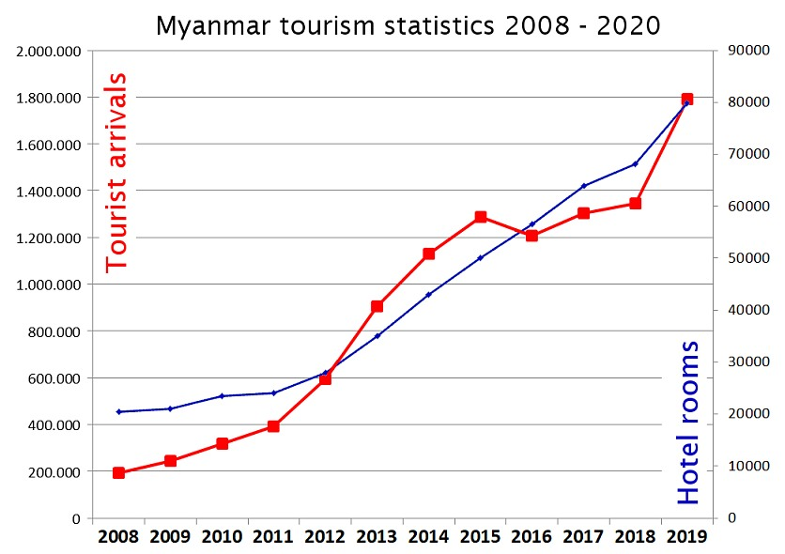
Source: The Tourism Industry of Myanmar

1. When did the number of rooms available first meet the number of tourist arrivals?
2. In what years were there not enough rooms to meet tourist demand?
3. Between 2013 and 2016 was there an oversupply or undersupply of rooms to meet tourist demand?
4. Why do you think the rate of increase of tourist arrivals slowed between 2016 and 2018?
Answers to Activity 6.4

6.5 Challenges to sustainable tourism
As you learned in Session 1.4, sustainable tourism is tourism that protects natural environments, provides an authentic tourist experience that celebrates and conserves heritage and culture, and creates socio-economic benefits for communities. Increasingly it is becoming clear that key destinations within Myanmar, such as Inle Lake, need to be managed sustainably. Inle Lake is experiencing the effects of the overuse of chemical pesticides and fertilisers on its famous floating gardens, which is polluting the lake. As the surrounding forest is cut down for agricultural use, soil is no longer held in place by the trees and it washes into the lake. This is making the lake shallower and threatening livelihoods (Figure 6.5.1).
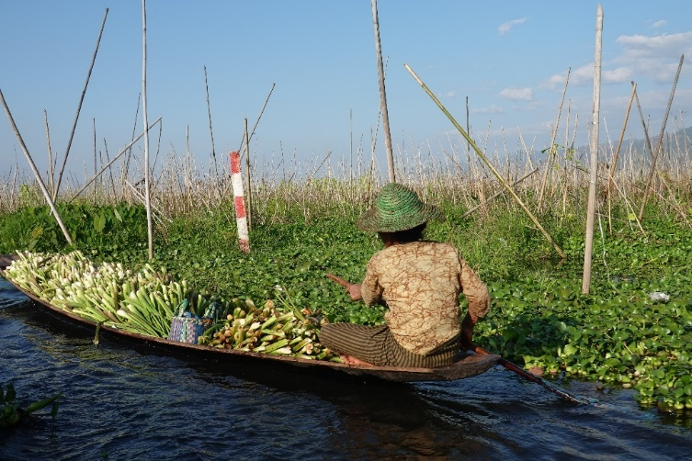
Figure 6.5.1 The floating gardens of Inle Lake, which are used to grow a wide variety of produce, including tomatoes, papayas, onions and chillies

Destination management is a concept that you were introduced to in Session 3.1. It focuses on managing all the elements of a destination, including its environment, tourism assets, skill development and infrastructure. While the Ministry of Hotels and Tourism needs to provide a coordinating role across the country, the state and regional governments should be empowered to manage destinations more sustainably through well-resourced DMOs. In this way, Myanmar can move forward to build a sustainable tourism sector.

The impact of Covid-19
The greatest threat to the sustainability of tourism in Myanmar is the Covid-19 pandemic. The Ministry of Hotels and Tourism has reported that revenue from tourism dropped by more than 80%, or around US$2.3 billion, in response to the pandemic (Hein, 2020). International airlines were suspended from landing in the country from April 2020, leading to an overnight collapse in the number of tourists entering the country. Land and sea borders were also closed. The impacts on hotels, restaurants, shops and transport have been severe. The Ministry of Hotels and Tourism is looking to domestic travellers and expatriate travellers to rebuild the sector as soon as restrictions are lifted. A recovery plan is in place to aid the industry, under which tourism businesses will be permitted to resume operations with Covid-19 prevention measures in place (Figure 6.5.2).
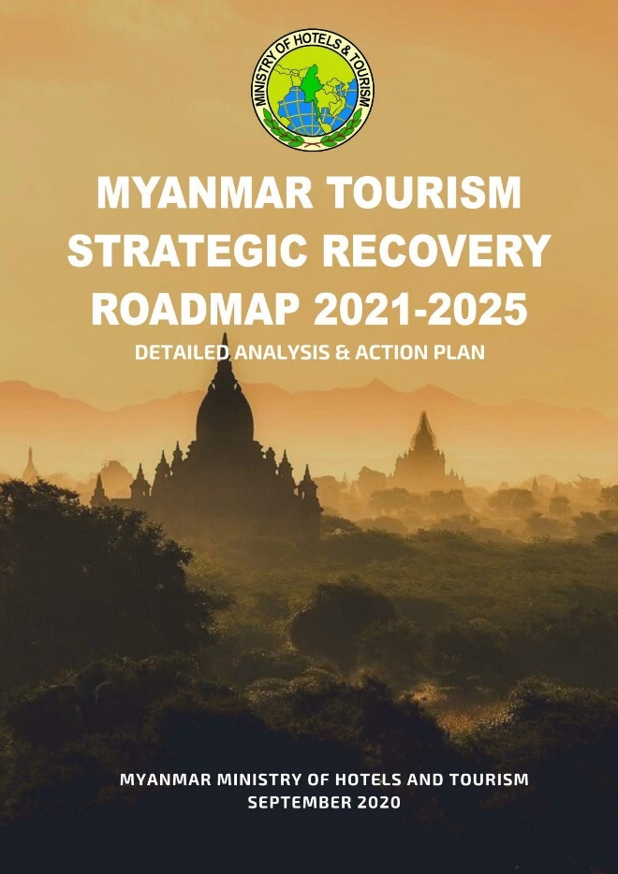
Figure 6.5.2 Myanmar’s tourism recovery plan in response to the Covid-19 pandemic

The Myanmar Tourism Strategic Recovery Roadmap (MTSRR) 2020 is the bridging document between the first Tourism Master Plan 2013–20 and the second Tourism Master Plan 2021–25, which is in the process of being written. The aim of the MTSRR is to recover, reset and restart the tourism industry, but to do this in a sustainable way. Myanmar’s tourism industry was heavily focused on international travellers and there are efforts to broaden the tourism base. To this end, all state and regional tourism committees will develop their own state and regional master plans. Myanmar also plans to create district and township-level destination management organisation committees to create their own destination-specific action plans. These will be incorporated into the state’s and region’s master plans. The challenges may be significant, but sustainability can create jobs, connect tourists with local and diversified supply chains, benefit other sectors, and strengthen the country’s future economy.

Activity 6.5
The MTSRR 2020 sets out three goals for tourism recovery over three time frames. Select one action to support each goal.
1. Realign tourism destinations to the ‘new normal’.
2. Invest in developing and expanding the scope of community-based tourism.
3. Establish Myanmar as a trusted and safe destination.
Answers to Activity 6.5

6.6 The future of tourism in Myanmar
Tourism in Myanmar has suffered a severe setback during the Covid-19 pandemic of 2020–2021. Therefore, this final session focuses on why stability is so necessary for tourism growth.
Figure 6.6.1 shows all international arrivals from 2002 to 2014 globally. During this period there were two health crises: the SARS outbreak in 2002 and the H1N1 outbreak in 2009, which was made worse by the 2008–2009 global economic crisis. While the following year saw a slight downturn in international arrivals, within two years international arrivals had increased past pre-crisis levels. Thus, tourism is an industry that can recover quickly from negative global events.
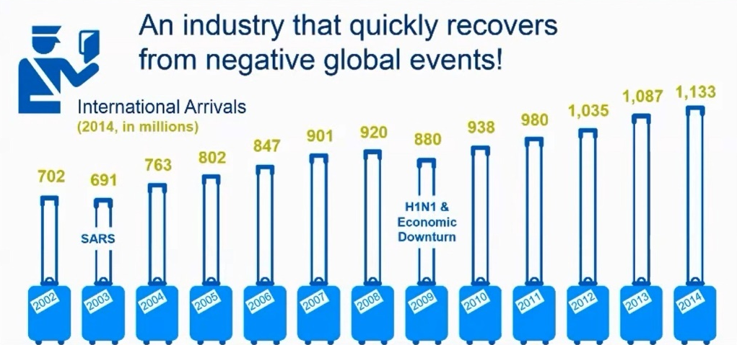
Figure 6.6.1 International arrivals 2002 to 2014 globally

On the evidence presented here, it might be expected that tourist numbers would rebound quickly after the Covid-19 pandemic is over. However, global health events are not the only shocks to negatively impact on tourist visitors, as the following case study from South Africa shows.

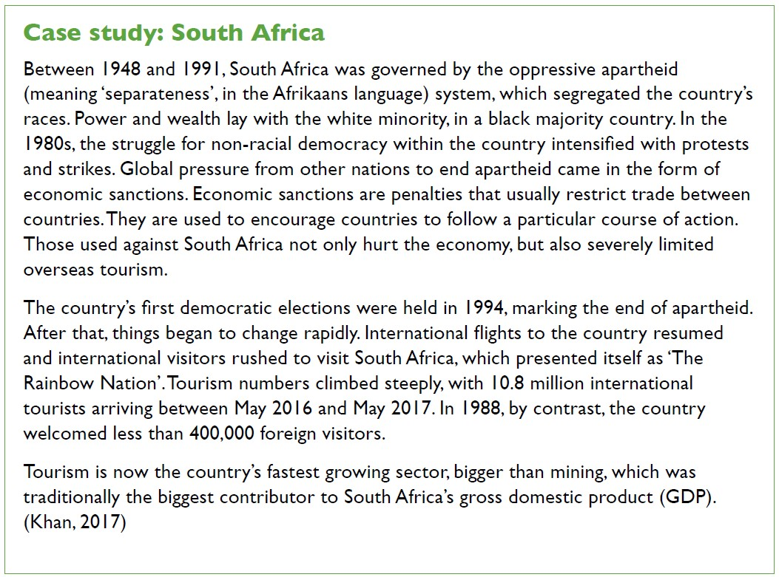
Tourism is prone to many shocks, both global and domestic, but also health, political and economic events.

Activity 6.6
1. Answer the following questions relating to the South Africa case study.
- How long did the apartheid regime rule in South Africa?
- How did citizens struggle for non-racial democratic elections within South Africa?
- How did the international community exert pressure for change in South Africa?
- How did South Africa present itself to the world after apartheid?

2. Study the graph below, which shows international tourist arrivals by air to Myanmar between 2010 and 2018. Why do you think tourist numbers declined sharply in 2018? What might the bar chart look like between 2018 and 2023 and why?
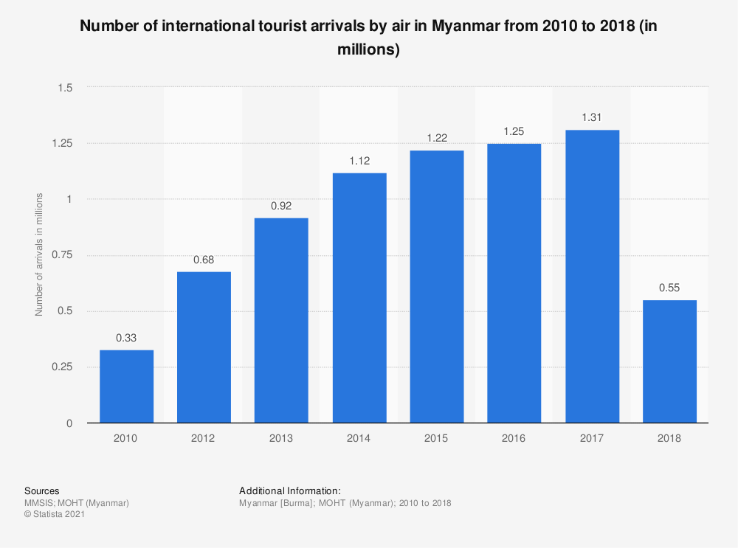
Answers to Activity 6.6

Answers to activities

Activity 6.1
- Students’ own answers.
- Students’ own answers.
- Students’ own answers. However, it is likely that you saw the tourists in winter, as tourists tend to avoid the rainy season and travel in the dry season.

Activity 6.2
- b)
- d)
- e)
- c)
- a)

Activity 6.3
- Ministry of Hotels and Tourism
- By comparing January 2018 and January 2019 it is possible to have a clear understanding of the change year on year. If January 2018 were compared with July 2019, the comparison would not be as useful. As discussed in Session 6.1, tourists like to visit Myanmar in the winter months, when it is cool and dry, which is between November and April. July is not a popular month with tourists because it is hot and wet.
- Arrival by cruise
- Arrival by air

Activity 6.4
- 2012
- 2013 to 2016
- Oversupply
- Due to unrest in Rakhine State

Activity 6.5

Activity 6.6
- a) 43 years, b) protests and strikes, c) economic sanctions, d) as The Rainbow Nation
- Tourist arrivals to Myanmar are likely to have dropped in 2018 in response to political unrest in border areas.

References
Embassy of the Republic of the Union of Myanmar London. (2021) Trade and Investment Opportunities. Available at: https://www.londonmyanmarembassy.com/index.php?id=143 (Accessed: 14 April 2021).

Hein, Zeyar. (2020) ‘Tourism revenue in Myanmar dips 80% during COVID-19’, Myanmar Times, 3 December. Available at: https://www.mmtimes.com/news/tourism-revenue-myanmar-dips-80-during-covid-19.html (Accessed: 5 March 2021).

Khan, S. (2017) ‘How South Africa Is Telling Its Story Through Tourism’, Conde Nast Traveller, 9 November. Available at: https://www.cntraveler.com/story/how-south-africa-is-telling-its-story-through-tourism (Accessed: 4 March 2021).

Meyer. (2004) TOURISM ROUTES and GATEWAYS: Key issues for the development of tourism routes and gateways and their potential for Pro-Poor Tourism. Available at: https://www.odi.org/sites/odi.org.uk/files/odi-assets/publications-opinion-files/4040.pdf (Accessed: 14 March 2021).

Ministry of Hotels and Tourism, The Republic of the Union of Myanmar. (2020) Myanmar Tourism Strategic Recovery Roadmap. Available at: https://www.myanmore.com/wp-content/uploads/2021/01/MYANMAR-TOURISM-STRATEGIC-RECOVERY-ROADMAP-23.10.20.pdf (Accessed: 15 April 2021).

Thitha. (2020) ‘Myanmar reports tourist arrivals’, Consult Myanmar, 20 January. Available at: https://consult-myanmar.com/2020/01/20/myanmar-reports-tourist-arrivals/ (Accessed: 5 March 2021).

World Travel and Tourism Council. (2017) Travel and Tourism: Economic impact 2017, Myanmar. Available at: https://bandapost.org/wp-content/uploads/pdf/Economic%20Impact%202017%20Myanmar%20by%20World%20Travel%20&%20Tourism%20Council.pdf (Accessed: 5 March 2021).

Conclusion
Well done for completing the course!
In this course you have explored tourism and hospitality through the lens of a country relatively new to tourism: Myanmar. You have learned key concepts needed to understand the tourism and hospitality sector, which you should now be able to use confidently, and how the sector works. You have also practised the skills of working independently, analysing tourism data and managing your time to successfully complete this self-study course.
To gain your Statement of Participation, you must complete the end-of-course quiz and gain a pass grade of at least 60%. There is no limit to the number of times you can attempt the quiz, although only your last attempt will be counted.
Thank you for participating in the course!

Glossary

Accommodation – A temporary lodging, where travellers may rest and sleep
Action tourism – Travel for the purpose of sport, extreme sport or adventure
Back of house – Those departments in a hotel that have no direct contact with guests
Bed and breakfast (B&B) – Accommodations provided in a private house by the owner for up to six paying guests
Bleisure – Travel for a blend of business and leisure
Brand identity – The external perception of a brand that is purposefully created by the business stakeholders to promote the product
Brand image – The external perception of a brand identity mixed with other influences, such as media reporting and personal experience, which varies between people
Brand reputation – A blend of the brand image and identity. It takes a long time to build and is easily damaged, especially in an age of social media. It is built on trust, which is hard to rebuild when broken
Business travel – Travel carried out on behalf of a business, or for the purpose of doing business with someone else
Caravanserais – Roadside inns that existed in the Middle Ages to provide travellers with rest from the day’s journey, as well as caring for their camels and horses

Charter flight – A person or company rents an entire aircraft for a flight, with the departure time and final destination set out in the agreement between the hirer and the aircraft company
Commission – Money earned by a salesperson on the sale of another party’s product or service; it is usually a percentage of the value of the sale
Community-based tourism (CBT) – Travel in which visitors are given the chance to meet local people and experience authentic cultural exchange, and provide employment and income-earning opportunities for the local community
Destination management organisation (DMO) – A group that leads and coordinates activities under a coherent strategy to promote a destination
Direct employment – The total number of job opportunities supported directly by travel and tourism
Domestic tourism – Where the residents of one country travel within that country for the purposes of tourism
Economic leakage – Visitor revenue that does not stay in the tourism destination, instead going to companies with headquarters in other countries
Ecotourism – Travel to natural areas that conserves the environment, wildlife and natural resources; sustains the well-being of the local people; and involves interpretation and education

Escorted tour – Tourists are accompanied in a group to various destinations from the beginning to the end of the trip; also known as package tours
Fixed costs – Costs that stay the same regardless of the number of tours sold by the operator
Food and beverage production – The department in a hotel that is responsible for producing the food and drinks, which includes the kitchens, pastry and larder staff
Food and beverage service – The department in a hotel that is responsible for serving the food and drinks, which includes restaurants, bars, banqueting and catering staff
Foreign direct investment – The investment in domestic companies and assets of another country by a foreign investor
Franchise – A form of business in which a franchisor sells the rights to use the business name and products to a franchisee who runs the new franchise
Freedom tour – A tourist plans and chooses the individual elements of their tour, which the tour operator then books
Front office – The department in a hotel that is responsible for reservations, guest registration, room arrangements, handling guest complaints and other services
Front of house – Those departments in a hotel where there is some direct contact with or service to the guests
Gratuity – A sum of money paid to service staff for good service
Greening – A hotel management approach that involves becoming more environmentally responsible and sustainable by adopting good environmental practices
Gross domestic product (GDP) – The value of all goods and services produced in a country during a specific period
Ground transportation – Refers to travel by bus, limousine, caravan, train and other modes for sightseeing and for travel between hotels, attractions and airports
Guest house – A private house converted into a lodging facility for tourists; breakfast may or may not be offered at the guest house
Health and wellness tourism – Travel for the purpose of medical treatment, to enhance personal well-being or which is accessible for anyone, regardless of physical impairments
Home stay – A guest stays with a family and immerses themselves in the family’s life to facilitate a deep cultural tourism experience
Hospitality – The friendly and generous reception and entertainment of guests, visitors or strangers
Hosted tour – A tour that is conducted at the destination with the local tour operator hosting the tourists
Hotel – The most traditional type of serviced accommodation, offering a full range of services
Housekeeping – The daily cleaning of guest rooms, public areas, laundry service, linen keeping and flower arrangements in a hotel
Inbound tourism – A passenger arriving in a country that is not where they live for the purpose of tourism
Incentive tour – Vacation travel arranged by or through an employer and awarded as a motivational bonus to qualifying employees
Independent tour – Tourists want to travel independently and arrange their tour package by themselves
Indirect employment – Those employed in supporting the tourism sector, such as restaurant and hotel suppliers, construction companies that build hotels, as well as necessary infrastructure manufacturers and accounting services
Inn – An establishment that offers travellers food, drink and lodging
International tourism – Travel to another country, which can be broken down into inbound and outbound tourism
Layover – Time spent waiting between parts of a journey on an itinerary
Leisure travel – Where the primary motivation for travel is to take a vacation from everyday life
Mark-up – The difference between the cost of a product or service and its price
Motel – A form of hotel that is mostly situated along highways and roads, and designed primarily for motorists
Non-serviced accommodation – accommodation that does not offer food or cleaning
Operational costs – The costs associated with the day-to-day running of a business
Outbound tourism – A passenger travelling out of their home country for the purpose of tourism
Passenger name record (PNR) – A digital file that contains information about a passenger which is shared by different airlines that are carrying the passenger
Profit – The amount of money a business makes on a sale once all the costs of the sale have been paid
Responsible tourism – Both visitors and hosts are mindful of developing tourism in a way that makes better places for people to live in and visit
Risk assessment – The process of identifying risks and hazards in a particular setting, such as a tour
Ryokan – A Japanese inn which typically features tatami-matted rooms and communal baths
Scheduled flight – The airline sells single seats to individuals until the aircraft is full. Flights are offered on a regular, timetabled basis, with the departure times and routing fixed
Serviced accommodation – Accommodation that offers food and cleaning
Shift – A hotel staff member’s duty time, usually lasting eight hours
Specialised tourism – Travel for a special purpose which appeals to a small sector of the market, such as disaster tourism, which is visiting locations that have experienced a natural or man-made disaster
Stakeholder – A party that has an interest in an issue, and can either affect or be affected by the issue
Sustainable tourism – Tourism that protects natural environments, provides an authentic tourist experience that celebrates and conserves heritage and culture, and creates socio-economic benefits for communities

Tour guide – Someone who is employed either directly by the traveller, or a tour operator or travel agent to inform, direct and advise the tourist before and during their journey
Tourism – The movement of the people from their normal place of residence to another place (with the intention to return) for a minimum period of 24 hours to a maximum of one consecutive year for different purposes
Tourism destination – A place or area that relies heavily on the economic benefits of tourism
Tourist attraction – A place that people visit for pleasure and interest, usually while they are on holiday
Tour operator – An organisation or company that buys individual travel components separately from their suppliers and combines them into a package tour. Tour operators sell only the product they created
Travel agent – Sells tour packages from tour operators and other separate services, such as transport, accommodation, attraction tickets, activities, etc.
Variable costs – Costs that change as the number of customers that book the package tour changes
Wholesale – Refers to goods bought directly from the manufacturer, usually in large quantities

Acknowledgements
Grateful acknowledgement is made to participants from Mandalar University and Dawei University in the creation of this course. Without their generous contribution of time, commitment and energy the course would not have been possible.

Grateful acknowledgement is made to the following sources:
Course Image: Courtesy of Jon Gregson

Topic 1
Figure 1.1.1: Nigel Swales, https://www.flickr.com/photos/nigel321/3460363224/in/photolist-6gMgqU-GRHhjq-cphaYS-cpgXVd-cpgBWj-6gMpBN-cphfYU-cphe8J-cpheYU-mbovXz-PtiGQH-cpguDh-cpgt8U-cph389-cpgGw3-cpgyLA-cpgUVQ-cphqWW-VvGnfD-8S3VtU-cpha55-cpgRAd-cpgPdL-cphpaA-cpgSG5-cpgTsm-cph1hh-cphqaU-cphktW-cphcbu-cpgscm-cph51y-cphrN9-cpgK5h-cphsDA-cpgWf5-cpgzew-cpgFGb-ziW7bz-cpgg73-q2TF5p-2hYvM7p-cphikm-6gMfR3-cpgJvw-cpgCT3-cpgZRh-cphjhf-cpgTTj-cphhtE. This file is licensed under the Creative Commons Attribution Licence https://creativecommons.org/licenses/by-sa/2.0/
Figure 1.1.2: Gary Campbell-Hall, https://www.flickr.com/photos/garyullah/21403124671/in/photolist-28B4TG1-H1JqW-F6GQ1-dgjpjK-yzC8Dy-a187dt-bNpVzt-67MNFV-bwSzMJ-3Be1c-a2cHnt-ZdKzAP-f472NV-GyC6x8-AFaPcS-bKNQ68-4wV7xS-HQHLe-f7unZD-77cqoY-778oS8-HQHeu-7cfyx1-eE2XwJ-a2cFAF-deuXBN-bQuXDr-AK7y5Q-Q2CSXf-HDKY1-b1yaz2-dbTkik-dFKcuQ-apM57x-hTvf3-eDTCY2-yBjBhT-77ckPy-g6j46i-hTvwZ-a2ftC9-7yhiaf-dFKknf-g6j3Nz-7ydtkF-bwRsLJ-a2fCjU-338d6-bwSpSm-V3tB. This file is licensed under the Creative Commons Attribution Licence https://creativecommons.org/licenses/by/2.0/
Figure 1.1.3 GeorgeM757, https://www.flickr.com/photos/73886013@N06/30385076765/. This file is licensed under the Creative Commons Attribution Licence https://creativecommons.org/licenses/by-sa/2.0/
Figure 1.2.1, 1.2.2., 1.2.3, 1.2.4, 1.2.5, 1.2.6, 1.2.7, Activity 1.2, Figure 1.3.1, 1.3.2, 1.3.3., 1.3.4: Created by Dr Susan Fawssett on behalf of The Open University
Activity 1.3(i): Radek Kucharski, https://www.flickr.com/photos/137294100@N08/50221384382/. This file is licensed under the Creative Commons Attribution Licence https://creativecommons.org/licenses/by/2.0/
Activity 1.3(ii): Andre Kiwitz, https://www.flickr.com/photos/akiwitz/2786202276/in/photolist-5fd1Sh-5etTLo-6r3jEu-4QSaMr-4hCEbH-4KW9bk-5hDM4p-5bpB7Y-4QWoSW-5erSXs-5hFcaX-5ckihu-5ckiwQ-tJUFv-5entS2-4QS9Sp-5enw5c-4QSaap-5f8CF2-4QSaqz-5hF4eR-4s29ri-eeSNnq-u8S5N-4QWpCw-5epqXR-5gF62V-5apSyu-5erTYb-5epqXK-5epqY4-5hDHmg-g3aFah-3y5erQ-5hDWXz-5f9dwX-5gF3Mr-5cyff7-5f8ESa-5cyfGy-3CHnnA-5gF62R-xGQ6Vf-5epqXT-jt15S-xraGaH-5apSTW-g3aJ19-5a2gbL-5hF3Ge. This file is licensed under the Creative Commons Attribution Licence https://creativecommons.org/licenses/by-sa/2.0/
Activity 1.3(iii): Aivar Ruukel, https://www.flickr.com/photos/soomaa/10778415403/. This file is licensed under the Creative Commons Attribution Licence https://creativecommons.org/licenses/by/2.0/
Activity 1.3(iv): Created by Richard Fawssett on behalf of The Open University
Activity 1.3(v): respiritu, https://www.flickr.com/photos/respiritu/196510788/. This file is licensed under the Creative Commons Attribution Licence https://creativecommons.org/licenses/by-sa/2.0/
Activity 1.3(vi): Created by Richard Fawssett on behalf of The Open University
Figure 1.4.1, 1.5.1, 1.5.2, Activity 1.5, Figure 1.6.1: Created by Dr Susan Fawssett on behalf of The Open University
Figure 1.6.2: Nenad Stojkovic, https://www.flickr.com/photos/nenadstojkovic/49750886296/. This file is licensed under the Creative Commons Attribution Licence https://creativecommons.org/licenses/by/2.0/
Activity Answer 1.2 and 1.5: Created by Dr Susan Fawssett on behalf of The Open University

Topic 2
Figure 2.1.1: Paul Hudson, https://www.flickr.com/photos/pahudson/16458163987/in/photolist-hjC8G1-qBXuvh-9ksh6D-gFWkQ5-iMKcVX-7ZwaF6-92MjC6-ptvNXN-2jzZm8S-gqFQhT-qPezch-gFWxKX-5GHiyb-2h2oD7f-4CFAwH-qPezr5-8kRzuE-2h2oBiA-WMupe3-fk3xFJ-qRwwft-ChCTPd-qPezg5-5VEfDj-5GHjaW-9cwsgF-7Zwan8-P39oYT-gFWvDy-uWxX5K-b17xBn-xivoJV-uVgyLz-J9aN7B-8mQsnz-7oNtL2-5GD58D-2iXZv8n-6fGtvm-6djF7c-r5moL4-9Jya5i-qmFf1d-2gPcy7e-sNf6PY-5GD6M2-RN4K5k-uSWsWE-pZqek1-r1V1HE. This file is licensed under the Creative Commons Attribution Licence https://creativecommons.org/licenses/by/2.0/
Figure 2.1.2: Taken from https://www.audleytravel.com/myanmar
Figure 2.2.1: Created by Dr Susan Fawssett on behalf of The Open University
Figure 2.2.2: Gwydion M Williams, https://www.flickr.com/photos/45909111@N00/6564844687/in/photolist-3P5xwh-2d3avRN-2d3awH7-fPxGqz-26kTymp-5HwZ1W-e2ydrv-af1QVy-7egVCZ-abNm6Y-b17xBn-6aFDp6-2d3auTW-QnSCcX-79Fkzk-9ksh6D-2d3axof-2d3axUq-79FkmP-aXbnT4-aXbmui-nvdbEo-eihko6-7easct-nvtVhR-ncZMgv-e5tx7u-e5txzA-7kd1yE-7kd27j-2hwhSX9-ndZaQe-aeUNqe-nqQ9th-akEgL1-2hYwG26. This file is licensed under the Creative Commons Attribution Licence https://creativecommons.org/licenses/by/2.0/
Figure 2.2.3: Kuoni (2020) Discover Africa, Kuoni.
Figure 2.3.1 and 2.4.1: Created by Dr Susan Fawssett on behalf of The Open University
Activity 2.4: Airodyssey, https://en.wikipedia.org/wiki/Electronic_ticket#/media/File:ETicketAirline.png. This file is licensed under the Creative Commons Attribution-Share Alike Licence http://creativecommons.org/licenses/by-sa/3.0/
Figure 2.5.1: Steve Lynes, https://www.flickr.com/photos/lynothehammer/49714055742/in/photolist-2iK4wL7-2jcGnk2-2jYNPhL-2kH54sJ-2jHLqYG-hsyxLw-2eqrAwt-FYU3dF-2hU1Yf3-2jW1fS4-7CQD4W-2kHyFeS-26vMc8s-Jybu4d-2huKBDH-2TD5Ax-29CQnzf-qSKBug-24fxpsT-2THxfJ-2jZ9LPv-SYCxCj-27BZoDT-2jgedKC-VfZLvs-24mjijv-zChLks-mdvTt4-CRcNtG-2jJdiX1-KaMVar-DBDNms-2hRr8M-2jfTYmk-2hRr76-M8QYAy-2hVLNj-2gTFFUU-xivGwx-2hVLNC-2hVLN5-27SzWF-2iSxqh8-ULG8Rr-ayChVp-XXMWAq-2jqEGC6-4gru8Z-2inWMy8-24uXz4n. This file is licensed under the Creative Commons Attribution Licence https://creativecommons.org/licenses/by/2.0/
Figure 2.5.2: Ron Cogswell, https://www.flickr.com/photos/22711505@N05/50916396991/in/photolist-2kziQVD-2kzfcQe-bD8EJU-6D8yND-6YvdDL-2kEUcwF-Qkkuz5-P7hW1W-QaESYS-P7gq2E-bXT5ud-2kziGB9-u2Us6m-PbStop-Qf8ytr-QqqtAk-PHxaWd-Mx3Vc-Mx2Yn-MwSMN-MwZAv-MwY5z-MwTLj-MwTYm-MwPQY-MwRPJ-MwMh9-Mx3cg-Mx24g-MwZP8-MwXma-MwMMN-MwUaw-MwRaL-MwXtc-MwX9X-MwLBN-Mx2BK-MwXLZ-MwMFN-MwTns-Mx1f4-MwYdk-MwVY4-MwW5z-MwUJy-MwNPb-MwRjG-MwNaS-MwUdN. This file is licensed under the Creative Commons Attribution Licence https://creativecommons.org/licenses/by/2.0/
Figure 2.5.3: Tom Mascardo, https://www.flickr.com/photos/mascardo3/4423749341/. This file is licensed under the Creative Commons Attribution Licence https://creativecommons.org/licenses/by-nd/2.0/
Figure 2.6.1: Martyn Smith, https://www.flickr.com/photos/tinz/40666170243/in/photolist-24XwKCg-ZdkGF3-KSXDVg-22Kd2B7-2et8jVL-2ebdKDg-2ebdHAt-RNHsLH-RNHqEt-TqQyK9-24XwGqz-24XwGKH-TqQwj7-2et8tzu-RNHoyp-2ebdQmc-2fz8hug-RNHoSR-2fusF3L-24XwHaF-2ebdKP6-RNHqSn-2et8syb-24XwH1c-2fz85Ee-2et8kay-dE1nm4-2fusP4q-2ebdHMF-24XwLFZ-2ebdTGk-RNHt3z-24XwHyg-2et8rHy-2fusQiQ-dnY9Bs-26E6gKW-2fusPJy-2et8rCU-2fusERd-24XwwJa-RNHgJc-2fz86yZ-24XwMwg-28jrhDs-TqQG8A-puCVt4-ZBagfB-pumDXc-pR3Xxo. This file is licensed under the Creative Commons Attribution Licence https://creativecommons.org/licenses/by/2.0/

Topic 3
Figure 3.1.1, 3.1.2, 3.2.1, 3.2.2, 3.3.1, 3.3.2, 3.3.3: Created by Dr Susan Fawssett on behalf of The Open University
Figure 3.4.1: eGuide Travel, https://www.flickr.com/photos/eguidetravel/6692351721/in/photolist-bco41v-bkPagg-Fpn435-775WsU-775XqG-2kbpEH6-2kwQCEY-2komKhS-2ksdHeD-VX793E-2kwRf5r-2kxoCY1-2kwLYCP-2kyp1cG-2kyGMmL-2kxniRW-2ksdHwn-2ky7HgP-2kwADgM-2kbpc7P-2kxnjsR-2kaJE9o-2kJLW6F-2kb9erj-2kbE8Jr-2jj6e1W-2kwwpHt-pWiqbj-2hFnfdi-2hJ25fj-2hjV1AE-2k7yWeD-2ksbBww-2kxH2dq-2korbR8-2kKi6hd-2kzUXf2-2kdoEDV-2kzWf5i-2kxnjiC-2kaEo22-2kc9puf-2kKi6hU-HYxguy-2ky4AUb-2kzS5EW-2kbQw3u-2kdoEES-2kzUX88-2kakHir/. This file is licensed under the Creative Commons Attribution Licence https://creativecommons.org/licenses/by/2.0/
Figure 3.4.2: Dan Lundberg, https://www.flickr.com/photos/9508280@N07/12848960234/in/photolist-kzqhe9-TrUz24-QVmKzG-SarWs7-TcZn9h-TfsNax-Tfy7J6-TfvUh6-TcY6BC-TcWPsq-TftC1c-ToinQA-TftDHF-Td2TmY-Td3UPA-TcWxxE-Td2NMN-Sd2EXZ-SRP7kC-TrSxTg-Tohnzh-Sapbzb-Sd3jiv-SaponQ-Togqaj-kzoyVk-TohJjJ-SRPFZb-SaoMmC-Sd3iki-TrSMRX-SaoJe5-Sd2w46-SRQ9qN-SapQsf-Sd3u4H-Td3Ros-TrUpST-SahEKy-TrVFXg-Td9WeY-TrZbtD-SanEjd-SRSX5L-SRNjMJ-Tohpm3-Tdad4o-TrWQAX-Sd62hR-SRWse1/.This file is licensed under the Creative Commons Attribution Licence https://creativecommons.org/licenses/by-sa/2.0/
Figure 3.5.1: KK70088, https://www.flickr.com/photos/kk70088/36440380082/in/photolist-dyWdxY-8gTbkp-Xw7trd-haujVm-hjJERa-zvLiVh-b5nQJ8-69Dk7x-52wsb8-8Je912-AbbAH5-j2FSfL-JQ66Sw-j2HFWC-eXnUWk-J3gxx7-Hoe5yM-ULBsCb-2fVCwBr-dbGLJE-HqjaJR-7A2tvG-b5nRck-22n2H7F-b5nQUx-Ja958A-ngnCa1-4QQfwX-22n2F6M-HzhiLh-JcDz1z-BvoVeS-2fYaJoD-HhWnoo-J59cSU-JaYFYm-J59bh9-yixrQ7-xDhfBB-J7rPrc-J5992N-Je3hF2-EefNaU-tZxV6-HEYPSi-hTxYW-V1YgpB-V1YksX-QP791i-GQXLbV/. This file is licensed under the Creative Commons Attribution Licence https://creativecommons.org/licenses/by-sa/2.0/
Figure 3.5.2: Insights Unspoken, https://www.flickr.com/photos/insightsunspoken/34678016610/. This file is licensed under the Creative Commons Attribution Licence https://creativecommons.org/licenses/by-sa/2.0/
Figure 3.6.1: Marcin Wichary, https://www.flickr.com/photos/mwichary/3229979465/. This file is licensed under the Creative Commons Attribution Licence https://creativecommons.org/licenses/by/2.0/

Topic 4
Figure 4.1.1: Espen Faugstad, https://www.flickr.com/photos/noxstar/40418781185/in/photolist-24zEPtF-5p6h2L-aaXJ8E-59DE35-AJjFo-exnUab-4WxLbi-4WC3VG-baxkLg-28EHCJ-baxkrT-baxkAx-92msAb-G7Qcs-5p6h3E-8UfaWC-6vznF5-28EURA-7pruD-5z9zKS-5kq4BS-SdYNLo-Sp7uwL-SsNHpa-RT1oQb-Sp7wud-dY2fB-QUySse-Sp7Eqo-SdYNbL-Rb8s8Q-YUps5W-Sp7UEf-32Lema-28EF5f-exnUfW-9vQBBp-28ESzj-db6dBZ-72bjQm-oqceZx-4WC3yb-71WBJw-6hoxou-G7QaL-oorE3S-dY23g-6G7g8q-5p6gWY-9gJUrE. This file is licensed under the Creative Commons Attribution Licence https://creativecommons.org/licenses/by/2.0/
Figure 4.1.2: Mike Cattell, https://www.flickr.com/photos/mikecattell/5254816282/. This file is licensed under the Creative Commons Attribution Licence https://creativecommons.org/licenses/by/2.0/
Figure 4.1.3: Boston Public Library, https://www.flickr.com/photos/boston_public_library/2885428658/in/photolist-6wC97x-4zNwgW-4zNwfb-jAR3ip-4zJgyM-5oYzpY-aawttA-aawuWq-qzFNaT-8weiKE-4WQkED-7nJ77c-2jiZeaX-2kueWDx.This file is licensed under the Creative Commons Attribution Licence https://creativecommons.org/licenses/by/2.0/
Figure 4.1.4: steffen l, https://www.flickr.com/photos/82381210@N00/49516840776/in/photolist-2irCKC5-BpxZz-EjryNh-BZN9TY-UL6BtC-E43oTa-jDFbiW-e9cgm5-LtamXV-E43rw6-GWKpt8-VWC7NR-5mJtPe-2b4VKet-VTnpEA-uPxz37-VXCHRR-5hmdie-W9aeEc-LiLNxQ-W5EHxU-LmfFp2-tSZQts-cy3ae-UUBZu4-5gsrdi-gDyYv-8eCiXj-2jWqetQ-LiLMmw-2i6iaZm-BpxZT-6mhU9A-pbhBfD-URN8XW-L2J8b1-cBa7GJ-4qxBdB-QbGzPH-2ha8e2E-askPeN-2iz4YnT-h697fW-2jYAsyH-2jYF2Hz-2hxhPXg-S3br7Q-2hxhQ3M-h68W1u-h6a8SR. This file is licensed under the Creative Commons Attribution Licence https://creativecommons.org/licenses/by/2.0/
Figure 4.2.1: young shanahan, https://www.flickr.com/photos/youngshanahan/21264566394/in/photolist-yp5sK5-NEn7NS-d3EuyJ-JKZw3-9N9kXW-pXC3-vJujsQ-W7PrgS-4XpTTv-9HUSBh-b6qz4t-9KqTXf-62MJLs-B9RyTq-bkqbuT-d3EypA-W7Pt9E-d26t1E-NZecgc-ccQpH-dkSnAC-WbcuET-d9W6YN-NWH43S-g3xhyT-b6qBit-dvfrCy-F5B2Ye-4x88PC-WnJ1r4-EFK8rG-W7Pjkh-oMbWTH-W7Poc5-Wbcx38-WbcxPZ-23B7q9e-4Yfmia-W7PwWu-aaXTkS-W7Pphw-2knqjif-8YaUda-PSV1Hd-W7Nu19-W7Pvn7-WbcyR8-68gmva-WnHYmn-WbcAeD. This file is licensed under the Creative Commons Attribution Licence https://creativecommons.org/licenses/by/2.0/
Figure 4.2.2: Alex Liivet, https://www.flickr.com/photos/alexmartin81/17189346311/in/photostream/. This file is licensed under the Creative Commons Attribution Licence https://creativecommons.org/licenses/by/2.0/
Figure 4.3.1: judy dean, https://flic.kr/p/B5Av4t. This file is licensed under the Creative Commons Attribution Licence https://creativecommons.org/licenses/by/2.0/
Figure 4.3.2: Andy Hay, https://flic.kr/p/gXK3XS. This file is licensed under the Creative Commons Attribution Licence https://creativecommons.org/licenses/by/2.0/
Figure 4.4.1: © Peter Hermes Furian / 123 Royalty Free
Figure 4.4.2: Jon Gregson
Figure 4.5.1: Created by Dr Susan Fawssett on behalf of The Open University
Activity 4.5 (1): John Hickey-Fry, https://flic.kr/p/oukoAH. This file is licensed under the Creative Commons Attribution Licence https://creativecommons.org/licenses/by/2.0/
Activity 4.5 (2): Simon Clancy, https://flic.kr/p/hAWc1b. This file is licensed under the Creative Commons Attribution Licence https://creativecommons.org/licenses/by/2.0/
Activity 4.5 (3): John Hickey-Fry, https://flic.kr/p/bWPoGa. This file is licensed under the Creative Commons Attribution Licence https://creativecommons.org/licenses/by/2.0/
Activity 4.5 (4): Unique Hotels, https://flic.kr/p/9ETuzH. This file is licensed under the Creative Commons Attribution Licence https://creativecommons.org/licenses/by-sa/2.0/
Activity 4.5 (5): AA Ireland, https://flic.kr/p/arcDkQ. This file is licensed under the Creative Commons Attribution Licence https://creativecommons.org/licenses/by/2.0/
Figure 4.6.1: Created by Dr Susan Fawssett on behalf of The Open University
Figure 4.6.2: jenny downing, https://flic.kr/p/8oDgkG. This file is licensed under the Creative Commons Attribution Licence https://creativecommons.org/licenses/by/2.0/

Topic 5
Figure 5.1.1, 5.1.2: Created by Dr Susan Fawssett on behalf of The Open University
Figure 5.2.1: Rosanetur, https://www.flickr.com/photos/rosanetur/. This file is licensed under the Creative Commons Attribution Licence http://creativecommons.org/licenses/by/2.0/
Figure 5.2.2, 5.2.3: Created by Dr Susan Fawssett on behalf of The Open University
Figure 5.3.1: Clipart.me
Figure 5.3.2: Constantine Agustin, https://www.flickr.com/photos/biagkensiak/4623075627/in/photolist-83wtjt-bwMNfD-6cv5A-eFgT8E-dVHMMv-bwFE2a-67szv8-q4B3UW-g1vHbK-dpVqdW-G4TZF-ucFHeh-dzthoK-MseQMv-tVrDGE-uddA1B-zPqN9n-48n1SL-5cGE3L-aTZren-29gz2Yh-qkZgJB-67wC13-dpVfPk-bwFysa-qF8Lnc-fyi2J6-ZN248y-2gnho6U-2g8tEBR-W2tgeZ-4tCACN-fj3nKn-sb3ug6-dpVeFV-aTZpor-5xXT5A-44HKT7-KxTmzw-29o1giR-28ft5yA-28ft66Y-9a8orG-22E8L7-6cVcaT-uiFY1G-oXcSj9-3JWYbi-5eZeq-joRcBu. This file is licensed under the Creative Commons Attribution Licence https://creativecommons.org/licenses/by-sa/2.0/
Figure 5.3.3: PortoBay Hotels & Resorts, https://flic.kr/p/4tJ9L8. This file is licensed under the Creative Commons Attribution Licence https://creativecommons.org/licenses/by/2.0/
Figure 5.4.1: Created by Dr Susan Fawssett on behalf of The Open University
Figure 5.4.2: Johnn, https://flic.kr/p/9eDqqH. This file is licensed under the Creative Commons Attribution Licence https://creativecommons.org/licenses/by-sa/2.0/
Figure 5.4.3: Tristan Ferne, https://flic.kr/p/6onJQb. This file is licensed under the Creative Commons Attribution Licence https://creativecommons.org/licenses/by/2.0/
Figure 5.5.1: Created by Dr Susan Fawssett on behalf of The Open University
Activity 5.5: World Travel and Tourism Council: Travel & Tourism Economic Impact 2017 - March 2017. All rights reserved.
Figure 5.6.1: City Foodsters, https://flic.kr/p/riXdMm. This file is licensed under the Creative Commons Attribution Licence https://creativecommons.org/licenses/by/2.0/
Figure 5.6.2: Johnn, https://flic.kr/p/8pMkn9. This file is licensed under the Creative Commons Attribution Licence https://creativecommons.org/licenses/by-sa/2.0/
Activity Answer 5.5 Graph 1: World Travel and Tourism Council: Travel & Tourism Economic Impact 2017 - March 2017. All rights reserved.
Activity Answer 5.5 Graph 2: World Travel and Tourism Council: Travel & Tourism Economic Impact 2017 - March 2017. All rights reserved.

Topic 6
Figure 6.2.1: Publisher unknown: Found https://www.bordersofadventure.com/myanmar-travel-guide/
Figure 6.2.2: David Stanley, https://flic.kr/p/26DsnLb. This file is licensed under the Creative Commons Attribution Licence https://creativecommons.org/licenses/by/2.0/
Figure 6.2.3: Clay Gilliland, https://flic.kr/p/oBhLxG. This file is licensed under the Creative Commons Attribution Licence https://creativecommons.org/licenses/by-sa/2.0/
Figure 6.2.4: Allan Grey, https://flic.kr/p/8W6aFz. This file is licensed under the Creative Commons Attribution Licence https://creativecommons.org/licenses/by-sa/2.0/
Activity 6.2 (1): Marc Veraart, https://flic.kr/p/485Xwr. This file is licensed under the Creative Commons Attribution Licence https://creativecommons.org/licenses/by/2.0/
Activity 6.2 (2): Radek Kucharski, https://flic.kr/p/2jwp7No. This file is licensed under the Creative Commons Attribution Licence: https://creativecommons.org/licenses/by/2.0/
Activity 6.2 (3): Allan Grey, https://flic.kr/p/8W6aFz. This file is licensed under the Creative Commons Attribution Licence https://creativecommons.org/licenses/by-sa/2.0/
Activity 6.2 (4): David Stanley, https://flic.kr/p/26DsnLb. This file is licensed under the Creative Commons Attribution Licence https://creativecommons.org/licenses/by/2.0/
Activity 6.2 (5): Richard Mortel, https://flic.kr/p/Qw53Gt. This file is licensed under the Creative Commons Attribution Licence: https://creativecommons.org/licenses/by/2.0/
Figure 6.3.1: Ministry of Hotels and Tourism, The Republic of the Union of Myanmar. (2013) Myanmar Tourism Master Plan, 2013-2020.
Activity 6.3: Tourist Arrivals in 2019, taken from https://tourism.gov.mm/statistics/arrivals-2019-january/
Figure 6.4.1: World Travel and Tourism Council: Travel & Tourism Economic Impact 2017 - March 2017. All rights reserved.
Activity 6.4: Myanmar tourism chart (2020), taken from The Tourism Industry of Myanmar, http://bytelife.altervista.org/pophotels.htm
Figure 6.5.1: Richard Mortel, https://flic.kr/p/Qw53Gt. This file is licensed under the Creative Commons Attribution Licence https://creativecommons.org/licenses/by/2.0/
Figure 6.5.2: Ministry of Hotels and Tourism, The Republic of the Union of Myanmar. (2020) Myanmar Tourism Strategic Recovery Roadmap 2021-2025.
Activity 6.5: Created by Dr Susan Fawssett on behalf of The Open University
Figure 6.6.1: Taken from The World of Travel (2015) IATA Travel and Tourism Program
Activity 6.6: Number of international tourist arrivals by air in Myanmar from 2010 to 2018. © Statista 2021
Activity Answer 6.5: Created by Dr Susan Fawssett on behalf of The Open University

Every effort has been made to contact copyright holders. If any have been inadvertently overlooked the publishers will be pleased to make the necessary arrangements at the first opportunity.

