Inclusive Teaching Practice
Facilitator’s Guide
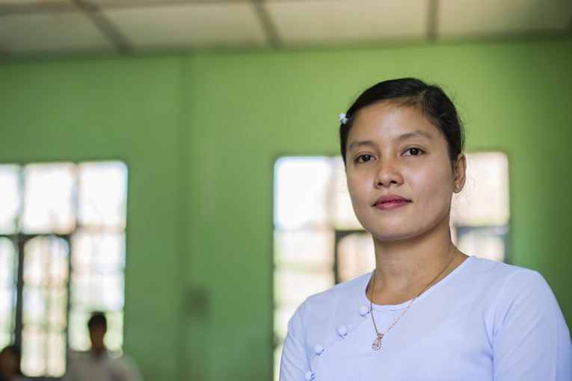
Source: VSO Image library

Module 10:
Legal framework and policies around Inclusion in Myanmar

Module 10:
Legal framework and policies around Inclusion in Myanmar.

Overview
This is the tenth of fifteen modules that look at how we create a positive Inclusive Learning Environment for all. You will see how inclusive teaching practices encourage, develop and use the 21st century skills of critical thinking, communication, collaboration and creativity. These modules are for any educators or those studying in education in Myanmar. The terms student and learner are used interchangeably throughout the module.

Module number | Module title
1 | What is an Inclusive School, Classroom and Teacher?
2 | Knowing your learners
3 | Planning learning outcomes for all
4 | Participating through learner centred approaches
5 | Creating a positive learning environment
6 | Effective questioning and feedback
7 | Active participation
8 | Peer, co-operative and collaborative learning
9 | Supporting students’ emotional and social wellbeing
10 | Legal framework and policies around Inclusion in Myanmar
11 | Supporting all students through differentiation
12 | Identifying specific learning difficulties
13 | Supporting all learners with differences or disabilities
14 | Positive behaviour management
15 | Assessment for student achievement

Learning Journal
Please ensure all participants are aware of the learning journal and its purpose for the module. Point them to the advice given in their participants’ copy of the best way to complete. All answers to activities need to be written in their journal. Remember, reflection is an important part of the learning process and a worthy activity alone. Encourage participants to make a note of new and interesting words/phrases/terms as they make their way through the module.

Study tips
It is important to explain how to approach completing the module. Participants need to take their time, develop a suitable timetable and where possible check their answers with colleagues. The use of think / pair / share is a good way for them to collaborate, share ideas, ask questions, check their work, and give feedback.

Background to the Inclusive Practice CPD modules.
There are 3 key themes explored in the modules that reflect the educational reform taking place in all education settings: Inclusion, Gender Equity and 21st century skills. These themes are key in all areas of curriculum, and vital not only for Myanmar’s educational ambitions and sustainable development but equally vital for the global future.
This course has been designed to help participants engage in this discussion by challenging their beliefs and attitudes about their own teaching, their students’ learning and the impact their educational institution has on inclusion. It is expected that as a facilitator, you will challenge their beliefs and attitudes throughout the modules.
It is also important for you as a facilitator to embed many of the teaching and learning techniques associated with inclusion in education into this course. Encourage participants to work at their own pace and consider their own abilities, interests and skills.
The modules look at how we create a positive Inclusive Learning Environment for all. You will see how inclusive teaching practices support gender equity and encourage, develop and use the 21st century skills of critical thinking, communication, collaboration and creativity.
Each module is made up of a series of activities participants can work through at their own pace. Once they have completed the module, they will have a multiple-choice quiz to complete.

Learning outcomes for Module 10
By working through this module, participants will be able to:
- Identify the policies and laws which support the realization of Inclusive education in Myanmar
- Outline the relevant sections of international and national policies and laws in relation to Inclusive Education in Myanmar
- Summarise how aspects of the policies or laws relate to the work of the educator

This module will help your students understand the legal framework and policies around Inclusive Education in Myanmar and how they affect you as an educator. It describes the differences between laws and policies and how they link to your practice. The origins of international and national laws, and policies are explored and how they impact on your practice in the classroom. The activities in the module will take them approximately 5 hours to complete.

Extra instructions for the activities in module 10

Activity | Additional points to consider
Prior knowledge assessment of module 9 | The first task is a recap assessment of module 9. This reminds the learner of the previous module contents and helps them to recall important information in preparation for this module. After the first attempt, suggest that the learners refer back to the 9th module to check their answers.
Activity 10.1 -  Self- assessment | Some participants may need encouragement to be honest in their self-assessment. Ensure that they know that their understanding and confidence will develop over time. The results from this self-assessment will be compared to another self-assessment at the end of the module, allowing participants to make comparisons and reflect on their learning.
Activity 10.2 - Difference between a policy, a law and a practice | Participants are asked to match the three key words: policy, law and practice with three jumbled definitions. They can either draw a line between the two that match or simply write the number and letter as a pair. Facilitators might decide to not provide the definitions and ask participants to create their own definitions and then compare. Ask participants to write the agreed definitions into their learning journal.
Activity 10.3-  Policy, law, and practice | This activity encourages the participants to consider the differences in policy, law and practice by asking them who they think are responsible for each. They need to identify who they think are responsible by putting a tick in the corresponding column. Participants record their answers in their learning journals. Encourage them, if possible, to discuss with colleagues to check each other’s’ understanding. The extension activity is optional but encourages participants to think about the different levels of the organisations involved. They need to place them in order of highest to lowest level.
Activity 10.4- Inclusive Education policy (international) | This is activity introduces where the policies about Inclusive Education originate internationally. They are signposted to SDG4 (quality education) and are asked to scan read the document online (either in English or Myanmar). Participants are asked to record in their learning journal, the titles of each target from 4.1 – 4.7. Target 4.5 is highlighted as this is the most important for IE. If possible, link pairs of students in relation to access to the internet.  Participants who find this difficult can be signposted to the next reading task which contains an extract from the online SDG 4.5 so they can read it in full.
Reading task | This task contains an extract from the online SDG 4.5 for those who find it difficult to access the online version. It focusses specifically on the international goal of 193 countries to eliminate discrimination in education.
Activity 10.5- Inclusive Education policy (international) | This activity continues from 10.4 and asks participants to look at the Convention on the Rights of Persons with Disabilities (2011 and 2016) and the Convention on the Rights of the Child (1990). Again, participants are asked to visit the online documents. If possible, link pairs of students to read these together and discuss them. Important extracts of the online documents are also given for those who find it difficult to access the online version. Participants are asked to highlight any key phrases or points from the documents. They could also write in their learning journal.
Activity 10.6 & 10.7 Myanmar national laws and policy for Inclusive Education | This activity highlights the laws and policy documents for Myanmar. Participants are encouraged to view the documents online and begin to think about how these laws and the policy link to their work as an educator. The answer/discussion for 10.6 provides extracts from each document with key words/phrases highlighted for those who find it difficult to access them online. If possible, link pairs of students in relation to access to the internet.
Activity 10.8  A recap - Importance of Inclusive Education | A video link is provided for participants to watch and revisit a video from a previous module. It provides them time to consider how the laws, policies and practices influences their work in the classroom. They are encouraged to reflect again on at least three reasons why Inclusive Education is important for Myanmar.
Activity 10.9 Practice - introducing policies and laws about Inclusion to student teachers. | This activity links theory (laws and policies) to practice (teachers’ classroom practice) about Inclusion. They have a choice, in groups, to either.  - Create a poster that introduces the laws and policies (discussed in this module) to student teachers.  OR  - Draw a mind map showing why policies are often not enacted at school or classroom level due to challenges with the implementation process, teachers’ interpretation of policies, etc. An example of this could be the language of instruction policies.  OR  - Relate policies and laws to the Teacher Competency Standards Framework (TCSF). How you do this is your choice.  Emphasis the difficulty of teaching about policies and laws to students because of the difficulty in subject matter. They need to make it simple, clear and engaging for different types of learners (multisensory). They need to think about the different needs of students they find in a class (inclusion). Encourage them to plan how they might do this (they could produce a mind map or list etc. of their ideas). The third activity (if they choose) is designed to stretch the participants.
Activity 10.10 Reflection | Participants are encouraged to reflect on a few questions related to policies and law and how these can be shared with their learners
Activity 10.11  Self-assessment | The self-assessment duplicates the first self-assessment. Ask participants to reflect on their confidence and discuss comparisons between scores.
Wrap up | A consolidation of the module and key points. There is no activity here.
End of module 10 quiz | This is a multiple-choice questionnaire that tests participants’ understanding of the module. Encourage participants to self-assess and revisit their answers as many times as needed to achieve 100%.
Answers to the end of module 10 quiz | Participants should revisit the questions until they achieve 100%. Remind them that some questions require more than one answer.

Answers - End of module 10 quiz
Answers in bold

Q1 – A law;
- is something that schools write for their staff to follow
- can be ignored
- makes the legal framework to make sure that policies are put into action
- is linked to tradition and culture
Explanation - the system of rules which a particular country or community recognises as regulating the actions of its members and which it may enforce by the imposition of penalties.

Q2 – A policy;
- provides different views of a law.
- states the intention of an individual or an organisation (for example a government). It says what the person or organisation plans to do.
- is a law.
- provides examples of how a teacher needs to teach.
Explanation – This is what an organisation/government plans to do and how they will do it.

Q3 – The Acronym SDGs means:
- Substantial Development Goals
- Sustainable Development Gains
- Sustainable Development Goals
- Specific Development Goals
Explanation – The 17 Sustainable Development Goals, specifically SDG 4, followed by 193 countries, forms the basis of worldwide targets for improving the quality of education.

Q4 – A practice (linked to laws and policies)
- means to repeat an activity until you get it right
- the actual application (in the school/classroom) or use of an idea, policy and/or law
- is a term used for a law firm (law practice)
Explanation – Policies plan what an organisation/government wants to do; practices are ‘how’ they are going to do it. Myanmar’s NESP (2011-2016) linked to the TCSF provides examples.

Q5 – Which SDG is linked specifically to ‘quality education’
- SDG 1
- SDG 5
- SDG 10
- SDG 4
Explanation – Sustainable Development Goal 4 is linked specifically in improving the quality of education internationally.

Q6 – Which international policies and laws effect inclusive practice worldwide (choose three)
- Geneva Convention 1949
- United Nations Convention on the Rights of Persons with Disabilities (2016).
- Myanmar National Education Law 2014
- Sustainable Development Goals
- United Nations Convention on the Rights of Persons with Disabilities (signed 2011)
Explanation – The Geneva convention 1949 relates to the treatment of captured and wounded military personnel. The Myanmar National Education Law 2014 is a national, not an international policy.

Q7 – Which three national laws and one policy effect inclusive practice in Myanmar? (choose 4)
- Myanmar International Education Law 2014
- Geneva Convention 1949
- National Disability Law 2015
- Myanmar National Education Law 2014
- Child Rights law 2019
- Myanmar Teacher Competency Standards Framework 2020
Explanation – The Myanmar International Education Law 2014 is not correct as it is not a law and it states ‘international’ in its title. The Geneva convention 1949 relates to the treatment of captured and wounded military personnel. The other four are linked to Myanmar and stem from international policy.
.

