Open Learning Champions
Everything you need to know to get started
March 2023
§
Contents
Hyperlinked Section Titles | Page
What do Open Learning Champions do? | 3
Video Introduction to OpenLearn | 4
Accessibility | 6
Course Levels | 8
Courses | 9
Future Pathways (incl further study with OU and links to employability) | 11

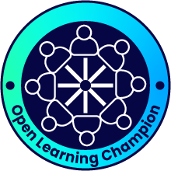

What do Open Learning Champions do

Bringing free online education resources to communities across Scotland
The Open Learning Champions project equips a wide network of people with the knowledge and skills to use the Open University's free online resources to help learners in a way that meets individual goals and is adapted to suit learning styles, digital literacy, IT access, time available and other real-life factors that we all need to consider when taking on a new course or piece of learning,
How you work with learners in your community or organisation will be your decision, but this online module will lay the foundations for you to be able to:
- Become familiar with OpenLearn - how to navigate the site to find relevant courses, become familiar with formats, course levels, duration, and accessibility in order to then support your learners.
- Support your learners to choose the right first, next, and next again course
- Decide on the right level of facilitation. This will range from very light touch where learners work independently and you may check in from time to time, to where learning takes place in a supported session or series of sessions. This will depend on multiple factors to be explored later in this module
- Recognising achievement and celebrating success
- Understand potential pathways beyond OpenLearn and where to signpost learners for more information
Beyond this module you will be able to connect with other Champions and Open University staff through the module’s online forum, monthly newsletters and bimonthly Champion coffee mornings where we can discuss new courses, share practice and celebrate success

Back to contents

OpenLearn & OpenLearn Create
It is worth noting that while much of the information in this booklet focusses on OpenLearn, where the majority of materials are written by OU academics for the platform. You will also find many useful courses on OpenLearn Create. The functionality is very similar to OpenLearn. The key differences are:
- OpenLearn Create courses have been developed by a range of organisations making use of the functionality that allows you to create your own Open Educational Resources (for more information see the 'Create A Course' should this be of interest to your organisation)
- Some courses start at level '0', very much designed for absolute beginners to online learners.
Video Introduction to OpenLearn
The video linked to the image below is a short introduction of what is available on OpenLearn.
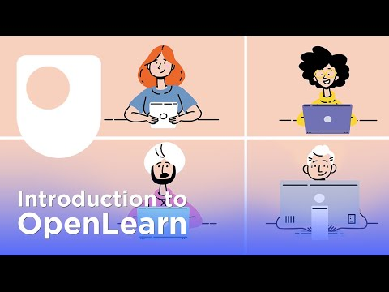

Creating Your Openlearn Account
While it is possible to access a wide range of OpenLearn & OpenLearn Create content without creating an account, doing so will allow you to enrol on courses, participate in activities, record progress, and create a record of learning including Digital Badges and Statements of Participation.
You can create an account via this link which will work for both OpenLearn and OpenLearn Create courses. If you already have an OU account you can use this. The only details required are:
- Name
- Date of Birth
- Email Address
- Create a Password
- Contact Preferences
A full set of FAQs about all aspects of OpenLearn can be found via this link

Back to contents
Accessibility
Alternative Formats on OpenLearn
While all modules are online, most OpenLearn courses will also be available in a number of formats that can be downloaded. As well as increased accessibility, for example Word Documents for use with screen readers, once downloaded these can be used offline for learners with limited access to IT, broadband or who prefer learning offline. Learners with screen magnifier or who use specific operating system or browser settings should not have any difficulties with the site
It is worth noting that there may be some interactive elements on some courses that will not be included in a printed version of an online course and for completion certificates and/or digital badges there is normally a minimum number of activities that need to be completed online.
Examples of Alternative formats
Below are links to the alternative versions of the short level 1 course IT in Everyday Life
- Word Version
- PDF Version
- Kindle Version
- Epub2 Version
Videos within courses will usually also have captions and transcripts that can be downloaded for offline use, showing as below:
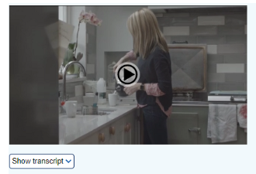
The image is a snapshot from a Health and Social Care online module which shows the transcript and download option below the main video still image

Google Translate
As you may work with learners who do not have English as a first language it is also worth being aware that you can use Google Translate to translate OpenLearn web content into around 50 languages. Most content will be translated with the exception of videos. You may also be able to translate documents embedded within web pages as well.
Instructions on how to use Google Translate from your computer and mobile devices can be found on this google support help page

Back to contents

What Do the Different Levels Mean?
It can be useful to know how the different levels map against both Open University study and the SCQF framework. The table below gives a brief overview:
OpenLearn / OpenLearn Create | Open University | SCQF Level
0 – beginner level. Accessible inclusive language and focus on functional skills | Access module – equivalent to a Scottish Higher or NC in terms of academic level | 6
1 – Introductory. Can be a good starting point for many with a mix of content created for OpenLearn and extracts of taught OU courses | Roughly equivalent to stage 1 OU study and HNC level | 7
2 - Intermediate. Content is similar to degree level | Roughly equivalent to Stage 2 (HND) and 3 (final year) of Open University study | 8-10 depending on course
3 - Postgraduate. Usually extracts from postgraduate modules | Postgraduate study such as PG Cert, PG Dip and master’s programmes | 11
Level 0 and Level 1 are usually the best starting points. You can use the search functions on both OpenLearn and OpenLearn Create to search for courses by a number of factors including level.
Back to contents

Courses
Course Type & URL | Info
Badged Courses  Badged courses - OpenLearn - Open University | Some OpenLearn courses carry a free digital badge this is awarded in addition to a Statement of Participation. These courses are 24 hours in length and require learners to read every page of a course and pass compulsory online quizzes.
Latest on OpenLearn  Latest from OpenLearn - OpenLearn - Open University | All the most recent courses uploaded to the site
Skills for study  For Study - OpenLearn - Open University | From skills for study, to induction material – we've got all your student needs covered with our range of learning resources and guides.
Skills for life  For Life - OpenLearn - Open University | From skills for work, to resources for health and wellbeing, we've got all your needs covered with our range of resources to support your life skills outside of study.
Core Subjects  Subjects - OpenLearn - Open University | We have nine subject categories with thousands of free resources  - Money & Business  - Education & Development  - Health, Sports & Psychology  - History & The Arts  - Languages  - Nature & Environment  - Science, Maths & Technology  - Society, Politics & Law  - Digital & Computing
Wellbeing & mental health resources (focus on FE and HE students)  Wellbeing and mental health collection - OpenLearn - Open University | The collection provides resources on a range of wellbeing subjects for students studying at Higher or Further Education level. Staff in the Higher and Further Education sector can also use the resources to improve their knowledge of positive health behaviours, building their capacity to support students and supporting Continuing Professional Development.

You can search on Openlearn by subject, course type, course level and length to find the courses that are right for you and your learners.

Some Useful OpenLearn Create Courses
Course & URL | Info
Everyday computer skills  OLCreate: Everyday computer skills_2.0 Everyday computer skills: a beginner’s guide to computers, tablets, mobile phones and accessibility (open.edu) | This course is designed to equip you with the knowledge and skills you need to get started in this digital world. It explores accessible ways to use computers and the internet.
Everyday skills for online learning - OLCreate: Essential skills for online learning Essential skills for online learning (open.edu) | This resource, developed by The University of Manchester Library, will help you to develop skills to get the most out of being an online learner.
Caring for adults  OLCreate: NNCO_Carers Caring for adults (open.edu) | Caring for adults is an introductory course for both paid and unpaid carers who are supporting people at home or in a residential, community or day care setting.
Caring Counts  OLCreate: Reflections_3 Caring Counts: a self-reflection and planning course for carers (open.edu) | This free reflection course was developed with and for carers. It will help you reflect on your experiences, gain a clearer understanding of who you are, and recognise the range of skills and abilities you’ve developed from your caring role. It will also help you to look forward, to think about what you’d like to do now or in the future, and to make plans that will help you get where you hope to be.
Back to contents

Future Pathways
The Future Is Open
For some learners, completing OpenLearn courses will empower them to learn new life skills, develop employability attributes and support them to take a variety of next steps. This could include:
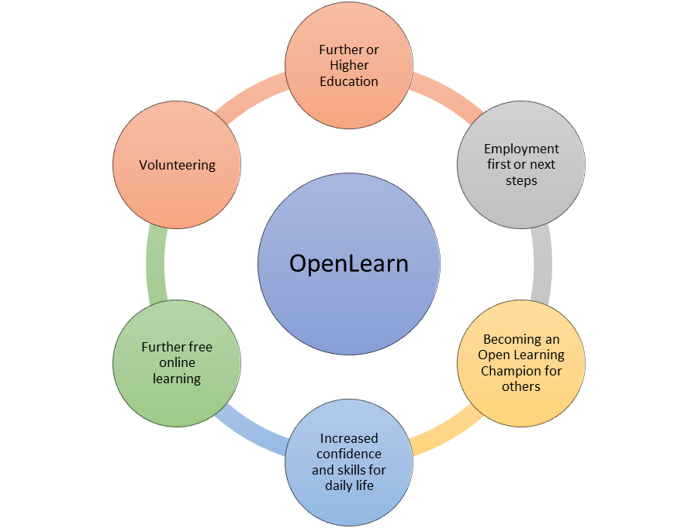
Studying With the Open University
For some, that next step can include moving onto study with the Open University. Options to study at the OU can include Open University Access modules, and a course called Making Your Learning Count. These are not the only first steps people can take with the OU but can support effective transition into Higher Education.
This page will take you to a link on OpenLearn that will provide some key information about these options
Resources To Support Further Learning
Other OpenLearn resources that can help with transition to Open University study include the courses linked below:
Resource & Link | Info
Am I Ready to be a Distance learner | 3-hour course exploring how distance learning
Being an OU Student | An induction resource for OU students – note not all activities available unless enrolled for study
What is Distance Learning | An overview of our approach to teaching & learning
Open University Course Search | Search for all undergraduate and postgraduate courses
Contact Information | Links to contact information depending on needs

Support for Open University Students
Most of our courses at undergraduate level require no previous knowledge and the Access and core Stage 1 courses are developed with new learners in mind with a focus on key study skills development to build a firm foundation for further learning. Taught courses are supported by a Tutor who will provide academic support, feedback on work and be key in supporting learners to develop their knowledge, skills and move to ever more independent learning.
Holistic Support
There is a huge amount of support for Open University students should any of your learners decide this is a step they want to take. Whether they are starting with Access, a single module or embarking on a qualification, The Open University can support them from choosing the right course to graduation and beyond!!
Support Type & Link to webpage
Fees & Funding | Tutors and Tutorials | Mental Health & Wellbeing | Support for care Experienced students
Disability Support | The OU Community | Careers & Employability | Support for Carers

And who knows, maybe one day it will be you or one of your learners in a picture celebrating like the one below!
Picture of graduates celebrating

Employability in Context
Employability can mean different things to different audiences - what it means to one of your learners may differ greatly from an employer or careers adviser. Words like 'career' and 'employability' may be alienating for some and no doubt you already adapt how you position employability and career planning, if it is even part of the ongoing dialogue you have with your learners.
For many people employability is about much more than getting a job:
- For some, employability will be related to changing job or progressing in their existing area of employment - others might view it as undertaking voluntary activities and community engagement, e.g. being a children’s football coach or a on a parent teacher council
- Some may see it as achieving academic success.

Some useful sources of information
- Skills Development Scotland (SDS) national Career Management Skills framework
- Skills for the Future - SDS have also produced a report on skills for the future , also referred to as meta skills classified under 3 headings as below. Page 8 onwards in the report has more detail on each of these:
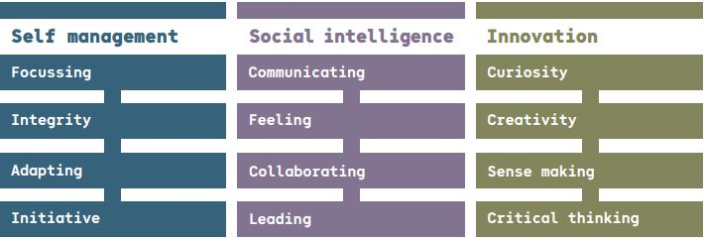
- National careers website - My World of Work - with resources that can be used to establish goals, understand options, and take next steps.
- Planit Plus careers website
Employability Focussed Courses
In the following table you’ll find short descriptions of core employability skills, competencies, personal attributes, and external awareness along with a link to an OpenLearn course that may be useful for development of the skill. These are just examples, and lots of courses will develop multiple skills.

Core Skill or Competency | Description | Example Module Link
Problem Solving | Analysing facts and circumstances and applying creative thinking to develop appropriate solutions | Understanding Management: I’m Managing Thank you!
Communication | Application of literacy, ability to produce clear, structured written work and oral literacy including listening & questioning. | Talk the talk
Collaboration | Respecting others, co-operating, negotiating/persuading, and contributing to discussions | Early Years Team Work & leadership
Numeracy | Manipulation of numbers, general mathematical awareness and its application in practical contexts | You and Your Money
Digital and Information Literacy | Ability to find information, communicate & collaborate online. Have social awareness in digital environment along with understanding of online safety. | Presenting Information
Initiative | Having ideas of your own which can be made into a reality | Innovation in Health & Social Care
Self-Management & Reliance | Readiness to accept responsibility, be flexible, manage own time and seek to improve performance | Developing Career Resilience
Self-Awareness | Insight into personal goals, aptitudes and values and ability to articulate these. | Improving Your Own Learning & Performance
Commercial Awareness | Understanding of the marketplace in which a business operates and / or understanding of a specific sector. | Understanding Your Sector
Back to contents

