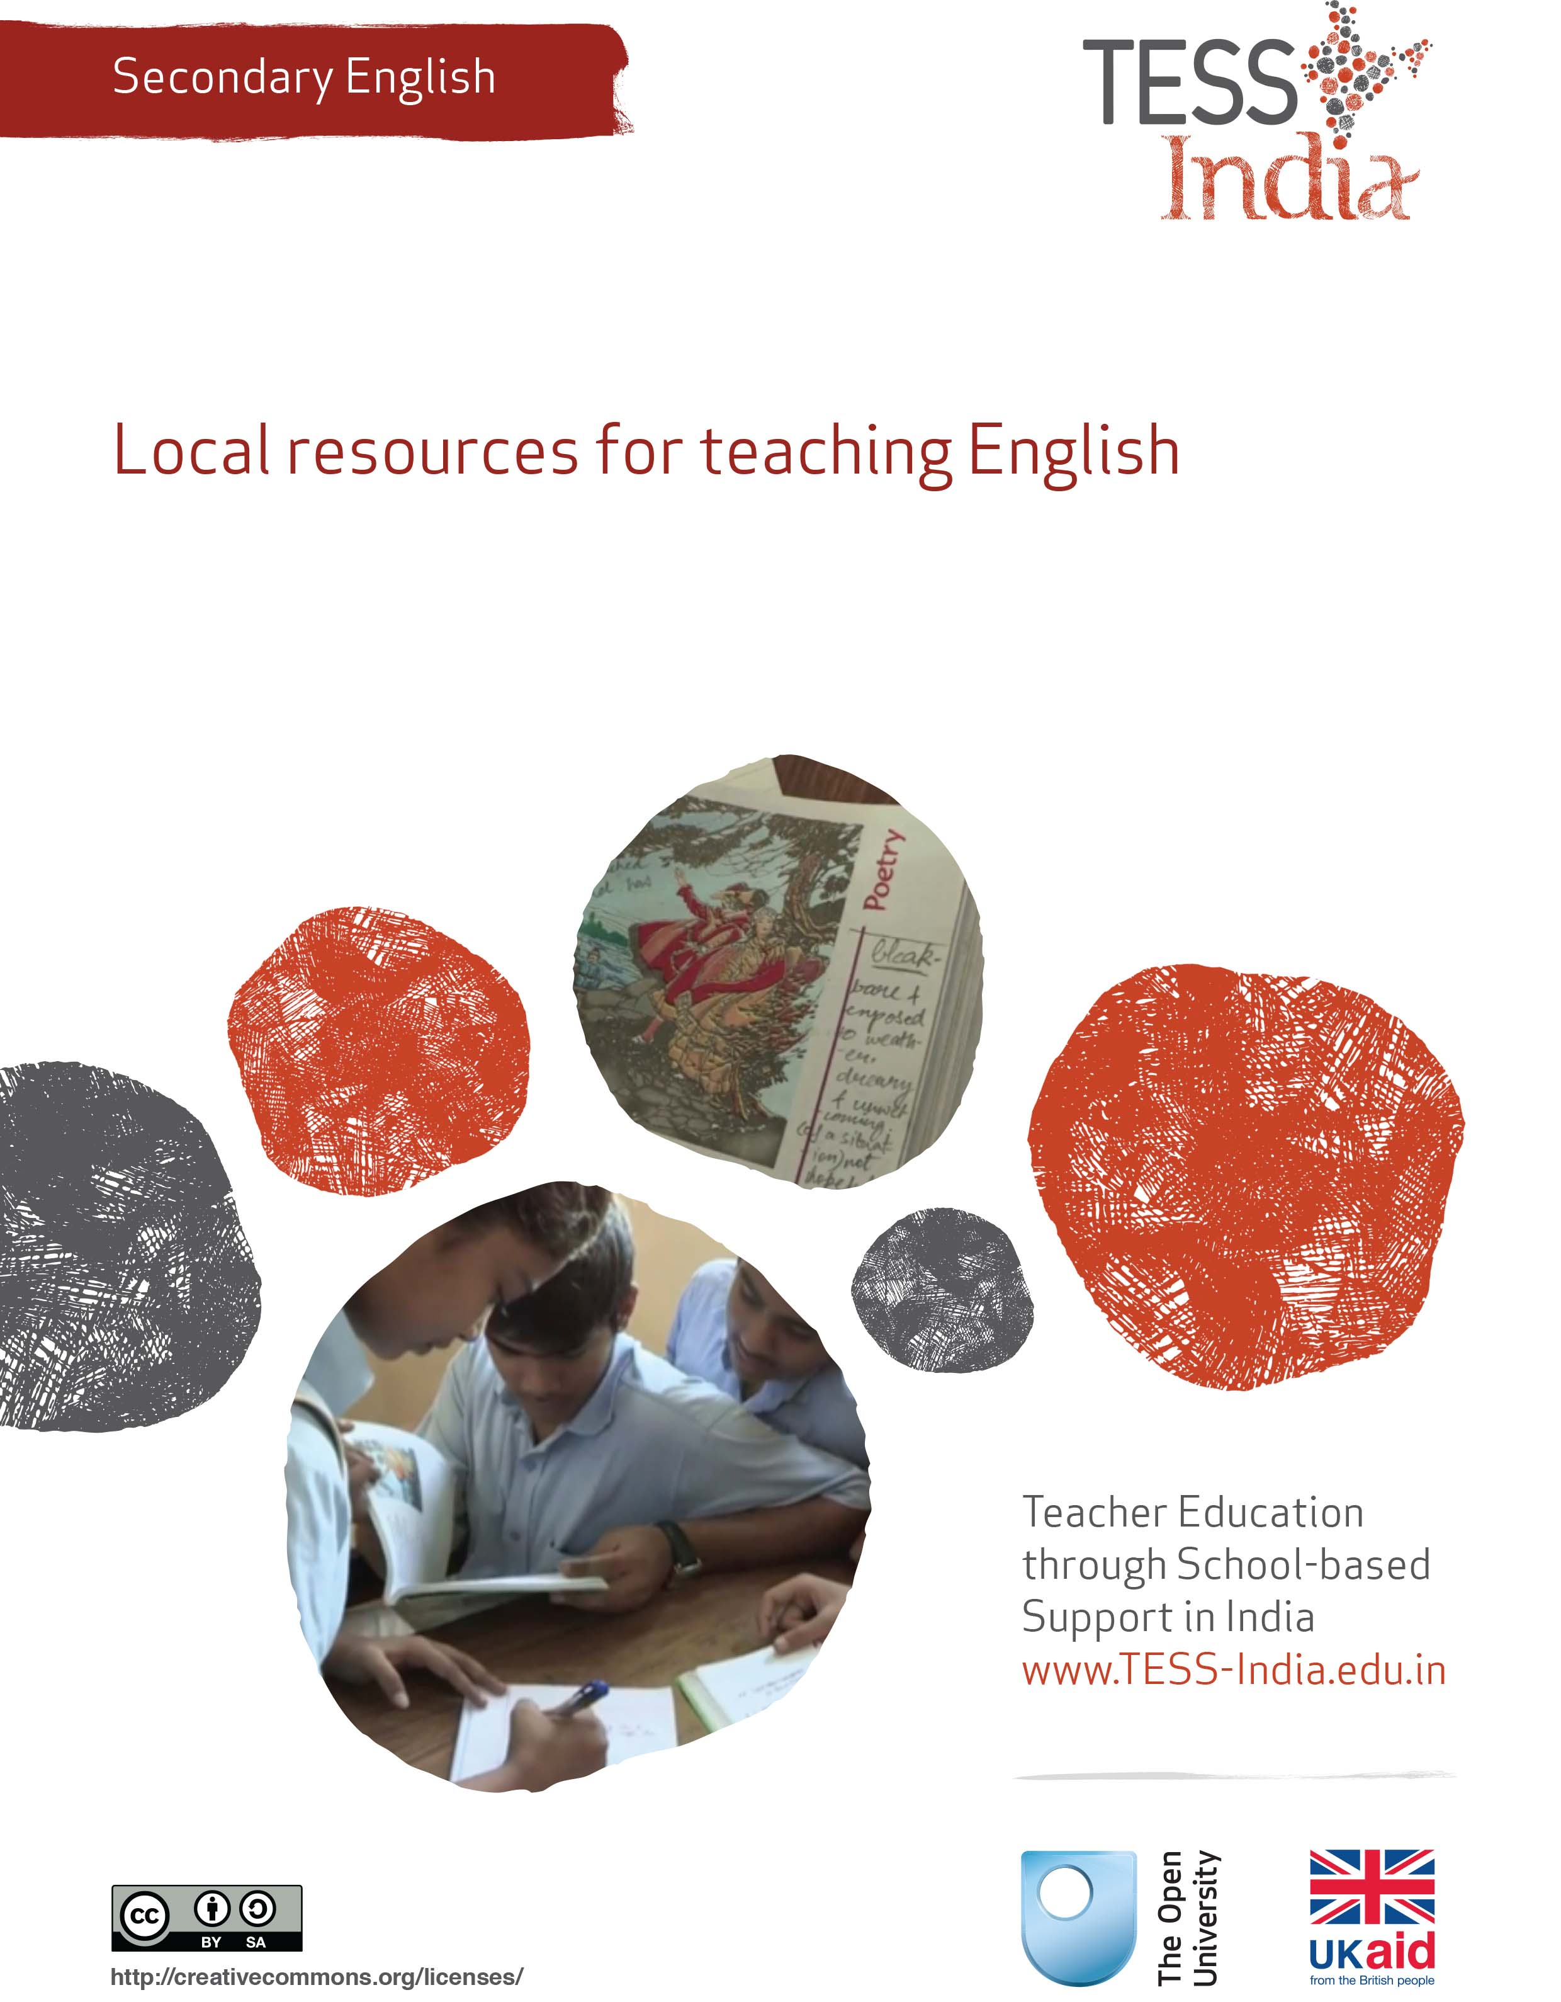
TESS-India (Teacher Education through School-based Support) aims to improve the classroom practices of elementary and secondary teachers in India through the provision of Open Educational Resources (OERs) to support teachers in developing student-centred, participatory approaches. The TESS-India OERs provide teachers with a companion to the school textbook. They offer activities for teachers to try out in their classrooms with their students, together with case studies showing how other teachers have taught the topic and linked resources to support teachers in developing their lesson plans and subject knowledge.
TESS-India OERs have been collaboratively written by Indian and international authors to address Indian curriculum and contexts and are available for online and print use (http://www.tess-india.edu.in/). The OERs are available in several versions, appropriate for each participating Indian state and users are invited to adapt and localise the OERs further to meet local needs and contexts.
TESS-India is led by The Open University UK and funded by UK aid from the UK government.
Video resources
Some of the activities in this unit are accompanied by the following icon: . This indicates that you will find it helpful to view the TESS-India video resources for the specified pedagogic theme.
The TESS-India video resources illustrate key pedagogic techniques in a range of classroom contexts in India. We hope they will inspire you to experiment with similar practices. They are intended to complement and enhance your experience of working through the text-based units, but are not integral to them should you be unable to access them.
TESS-India video resources may be viewed online or downloaded from the TESS-India website, http://www.tess-india.edu.in/). Alternatively, you may have access to these videos on a CD or memory card.

Version 2.0 SE01v1
All India - English
Except for third party materials and otherwise stated, this content is made available under a Creative Commons Attribution-ShareAlike licence: http://creativecommons.org/licenses/by-sa/3.0/

What this unit is about
I have noticed that there is a lot of English used in our local area. There is English used in advertisements and in songs. While my students may sometimes struggle with their English lessons, they seem to be really interested in the way it is used outside the classroom. How can I use the English in our area to increase students’ motivation for learning the language?
In this unit you will explore ways to teach English using the spoken and written English that you see and hear around you in your local area as a resource.
English is used in India for different purposes and in different ways in each part of the country. In the big cities many people use English every day. English is seen on street signs, in advertisements, newspapers and magazines, and English is heard in popular music and cinema. These examples can provide you with interesting teaching resources that can be motivating to students.
In remote villages, English may not be found everywhere, but it is often present. When you look for it, you may find more than you expect; for example, on food packets, tickets and labels on the clothes you buy, and in Hindi film music. In most rural areas there are people who go to or come from nearby towns and cities. Such people can be resources for English. They can share their experiences about how they use English and other languages for different purposes.
This unit is designed to help you use resources from your local area in your English lessons. This will help you to motivate students and highlight the usefulness of knowing English.

What you can learn in this unit
- How to locate English resources in your local area.
- Ways to use English language resources such as advertisements and songs in your classroom.
- How to connect English inside and outside the classroom.

1 English in your local area
Because of the presence of English in India, you and your students may come into contact with English every day, even though you may not be aware of it. When students see and hear English outside the classroom, they have to try and understand the meaning by themselves. By bringing students’ attention to English as it is used in the local area, you can help them to learn authentic English. This will increase their motivation to learn the language, as they will see the advantages of being able to use and understand English for their own purposes.

Activity 1: English in your local area
Over the next few weeks, carry around a small notebook. Make notes of the English that you see and hear in your community. Think about the words and phrases that you recognise and those that you don’t.
- Are there certain words or phrases that you see or hear frequently? What are they?
- Are there certain places where you are more likely to see or hear English? Where are these?
- Why do you think that you see or hear more English being used in these places?
Figure 1 has some examples of everyday English that may give you some ideas.
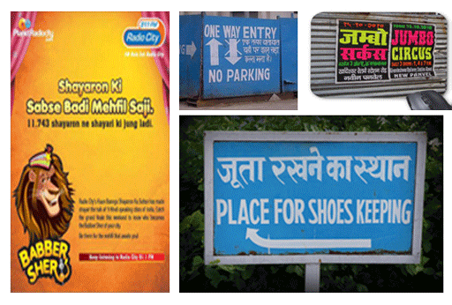
Figure 1 A series of signs with English text.
You can ask your students to carry out this activity so that they become more aware of the role of English in their locality. Often English is used to make sure information is accessible to speakers of many languages, or to give something an international ‘feel’. You can also use the resources you find in your teaching. In the next case study, you will read about a teacher who uses an advertisement in his English lesson.

2 Using advertisements
You have probably noticed that English is often used for advertisements, either on its own or together with other Indian languages (see Figure 1). Advertisers may use English because they think it makes a product look more modern, international or marketable. Using English – and mixing it with other languages – can also make an advertisement seem more interesting, creative or humorous.
Advertisements using English can be used in the classroom as a prompt for English speaking and writing activities. You can discuss the language used in the advertisement, how it is used, why it is used, and so on. By analysing the language used in advertisements you can also help to develop the students’ critical thinking skills.
Note in Case Study 1 how Mr Chourdhury chooses an advert that the students are familiar with and find interesting, which results in them being motivated to express their ideas. This allows Mr Choudhury to find out about their ideas and helps to improve their communication skills.
Case Study 1: Mr Choudhury uses an advertisement in English in a classroom activity
Mr Choudhury teaches English to Class IX. Here, he tries an activity with an advertisement in English to raise his students’ awareness of the use of English in their local area.
I recently saw a new advertisement for Amul butter [Figure 2] and realised that it was mostly in English. I know that my students are familiar with such adverts, and I thought they would probably enjoy talking about them in class. So I began to think about how I could use an advert like this in my teaching.
Figure 2 Amul butter advertisement.
I cut the advertisement out and stuck it on a piece of chart paper. I then prepared a few questions about the advert. I decided that instead of going straight to a textbook activity, we would spend the first 15 minutes of class talking about at the advert. That would still give us enough time to do textbook work in the lesson.
At the beginning of the class, I passed the advertisement around the students, making sure that each one had a chance to look at it. Many of them seemed to recognise it. While the students were looking at the advert, I wrote the following questions on the board:
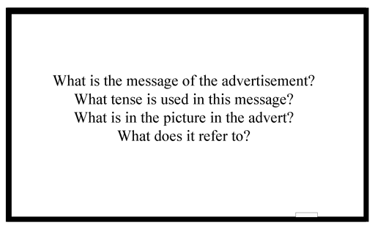
I asked the students to discuss these questions in pairs. Then I called on individual students to answer the questions. Some noticed that the main message of the advert (‘Speak less, eat more!’) was in the imperative. Most knew that the advert referred to the Bollywood film Barfi, in which a very lovable deaf and dumb boy (which explains ‘speak less, eat more’) named Barfi ferries the heroine around town on his bicycle and has many delightful mishaps.
I then asked the students:
Why do you think that English is used in the advertisement?
Do you think that this is an effective advertisement? What makes a good advertisement?

At first, the students didn’t have many ideas about why English was used. So I asked them if they thought that using English made people want to buy things more. Some of the students thought that it might. Then one student said that maybe they use English because butter is a product that English people use more than Indian people. I thought that was an interesting idea.
They thought it was a good advertisement because they liked the picture. They thought that the slogans were creative because they made creative use of both English and Hindi. They also made references to current events in film, sports and politics.
We did most of this discussion in Hindi because I wanted them to feel free to express their ideas about the advertisement. But the next time that I do an activity like this, I will ask the students to use more English. They really enjoyed talking about the advertisement, and they were much more lively and talkative than they usually are.

Activity 2: Try in the classroom – using an advertisement
Follow this guidance to try using a local advertisement in your class:
- Before class, find a local advertisement that uses English. It could be from a newspaper or magazine, or even a photo of one taken with your mobile phone. If you have access to the internet you could download and print an advertisement like the Amul advert.
- Decide what the purpose of the activity is. Are you teaching particular vocabulary or grammar? Or is the primary purpose for you students to speak in English?
- Decide how long you want the activity to be. You may just want to use the advertisement to prompt a brief discussion at the beginning or end of a class.
- Prepare the questions that you will ask students about the advertisement. These will relate to the purpose of the activity.
- In class, show the advertisement so that all students can see it.
- Write your questions on the blackboard. These are some examples but you will have your own questions depending on the level of your class, the purpose of the activity and the particular advertisement you are using:
- What is the message of the advertisement?
- Can you guess the meaning of all the English words?
- What tense is used in the message?
- Is there any word play in the message?
- Describe what is in the picture in the advert. Why do you think that picture was chosen?
- Use English to ask questions, and encourage your students to reply in English by giving them some of the vocabulary and grammar that they will need to answer the questions.
- Finish the activity by discussing whether or not the advertisement is effective, and what makes it effective. For example, you could ask:
- Why do you think that English is used in the advertisement?
- Do you think that this is an effective advertisement? What makes a good advertisement?
This discussion might be done in students’ home language, as the main focus is to get them thinking critically about the use of language in advertising. If, however, you would like to challenge your students to hold this discussion in English, there are some ideas to help you plan this in the unit Supporting speaking in English: pair and group work.

Pause for thought
Here are some questions for you to think about after trying this activity. If possible, discuss these questions with a colleague.
- Was it difficult to find and choose an advertisement to use in your classroom? How easy was it to connect to the curriculum?
- Did your students enjoy the activity? How could you tell? Did all the students take part or were some students not familiar with the advertisement?
- Mr Choudhury used this as a warm-up activity at the beginning of his lesson. Can you think of ways that you could extend this activity into longer speaking and writing activities?
There are plenty of examples of advertisements that you could use in your classroom. Look for examples that you think would be interesting and familiar for students and would motivate them to talk and write. Advertisements that are funny and make use of multiple languages or word play can be particularly useful. When choosing an advertisement, you should try to connect it to the curriculum and textbook lessons that you are teaching. For example, you could focus on the use of tense, how the passive voice is used, or how prepositions or adverbs are used in the advert.
You could also ask students to find advertisements themselves. This will be motivating for students and will help you to find out about their interests and the English words or phrases that they are familiar with. You could ask students to design their own advertisement using English – see Resource 1 for some ideas about a project on creating advertisements.

3 Using songs
Many English songs are played on the radio. If you listen to popular songs in Hindi, Tamil, Telugu or any other Indian language, you will probably also hear lots of English words and phrases. Using songs that contain English words can be a good way to motivate your students to learn English and to help them practise English in an informal manner.
Songs in English can be used in listening activities, for learning new vocabulary, and for singing along and practising pronunciation. They can also be used as a prompt for a speaking or writing activity. Case Study 2 is about a teacher who uses a popular song in her English lessons. (See Resource 2 for the lyrics to the song she uses.)
Case Study 2: Mrs Rawool uses a local language song with English words in the classroom
Mrs Rawool is a teacher of secondary English. She uses a song with her students to increase their motivation and confidence to learn by bringing their attention to the English that they already use and hear around them.
Recently I noticed that a new song from the film English Vinglish is very popular among my students. I often hear them singing it when they finish their school day and are on the way home. I heard them singing:

I'm learning-vearning seekhun-veekhun nayi zubaan
I'm learning-vearning seekhun-veekhun nayi zubaan
Aflatoon (English Vinglish)
Hain junoon (English Vinglish)
Morning noon (English Vinglish ...) [×2]
It’s all about English Vinglish
Oh oh oh!
Morning noon English Vinglish
Oh oh oh!

I noticed that there were a lot of English words in the song, and that it was about learning English. I wanted to find out more about what the song was about, and whether I could use it in my teaching.
First I had to listen to the song properly. My colleague recently got a new smartphone. I asked if she could download the song. She told me that I could probably find the lyrics to the song too and I did (see Resource 2). I wrote them down during a teaching break. I asked my colleague if she would be kind enough to let me borrow her phone for my secondary English class the next day and she was happy to lend it to me.
That evening I was thinking about the song. Why did it make use of both Hindi and English? What do those ‘Hinglish’ words mean? What kind of activities could I do with the song in the classroom?
The next day, I told my students:
Today we will listen to a song from a film. I have it here on this smartphone. I hope that you all can hear it. I think that most of you will recognise it. Sing along if you want to!

First I played part of the song. Once I started, I noticed big smiles across my students’ faces. I asked them if they could tell me what the song was. Nearly all of them recognised it and could tell me about the film English Vinglish, and how the housewife in it wants to learn English.
Then I told my students that I was going to play the song again and I asked them to write down the English words that they could hear. When they had finished, I asked them to compare their list with another student.
This was difficult because some of the words are in English, some are in Hindi and some are in ‘Hinglish’ or some made-up language. I played the song again and they checked again with a different student to see whether they had all the same words.
I asked them if they knew the meaning of all of the words in the song. The only one that they weren’t sure about was ‘bonding’. One student wanted to know if ‘Aflatoon’ was a real English word.
That was all I had planned to do with the song in that class, but my students were very motivated and interested to discuss it. The next day I decided to have a discussion about the use of English in India, based on ideas from the English Vinglish song and film.
Earlier I thought that using songs in my classes was just something fun. Now I realise that students can learn a lot from songs, and they have fun doing it.

Activity 3: Try in the classroom – using songs in the classroom
Like Mrs Rawool in Case Study 2, you can try using a song in your classroom. Use these steps to guide you:
- Choose a song with English that you can use with your classes. Choose something that will be familiar and interesting for students, and where the level of English isn’t too difficult.
- If possible, get an audio recording of the song (on a smartphone, MP3/4 player, or on a CD). You could download it from the internet or record it on a mobile phone. You could bring some inexpensive portable speakers or a CD player to class. (See the unit Helping your students to listen in English for further advice on using audio in your classroom.) A copy of the song lyrics can also be useful – these can usually be found on CD jackets or on a website.
- Introduce the song to your students. Tell them to listen and write down the English words that they hear. After playing the song, have students compare their list of words with another student.
- Play the song again, and have the students compare their list of words with a different student.
- Ask your students if they have any questions about the words they have heard. Ask them to tell you what the song is about.
- Play the song one final time and tell students to sing along if they want to.

Pause for thought
Here are some questions for you to think about after trying this activity. If possible, discuss these questions with a colleague.
- How did the students respond when you played the song? Did they seem to enjoy the activity?
- How easy did they find it to write down the English words? What did this tell you about their level of English?
- Did you need to intervene or prompt at any point in the activity? What might you change the next time you do this activity?
Most students like music and will enjoy listening and singing along to songs in English or songs that have English words in them. You could ask your students to choose the next song that you discuss. They may have a particular song that they would like to understand better in English. You could try to translate the English words in songs into local languages, or to translate local songs into English. Other ideas for using songs in your classes are in Resource 3.

4 Connecting English inside and outside the classroom
In the previous activities you have thought about the English that is available in your local area and how it can be brought into your classroom. There are also ways that you and your class can reach out to the local community. For example, your students may know people who use English regularly for personal or professional reasons. You can heighten your students’ awareness to these uses of the language, and this can reinforce the value of learning English. It will also help both you and them think about what kind of English skills you should be practising in your class.

Activity 4: People who use English
Write the following questions on the board before the lesson.
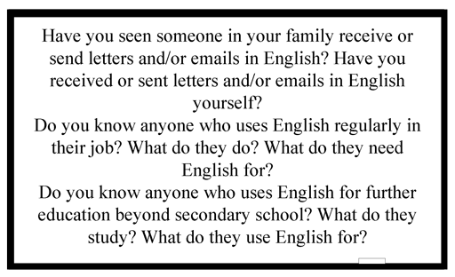
- Tell your students to draw a table with two columns.
- Ask them to fill in the table. In the first column, they list people they know, e.g. their doctor, a policeman, their grandmother, etc. In the second column, they list what they have seen these people reading and writing in English. They should use the prompts from the board to help them make their lists.
- Ask them to look at the table of the student next to them to compare. They may then want to add other things to their lists.
- Finally, ask them to work in pairs to present their information to the class. Are they surprised at how much English is used?

Pause for thought
Here are some questions for you to think about after trying this activity. If possible, discuss these questions with a colleague.
- After the lesson, think about how you can use your students’ responses in future lessons. Are there people you could ask to come into class to talk about how they use English?
- Are there connections you can make between the lessons in the textbook and the ways in which these people use English?
- Are there other local resources you could use in your classroom?
See Resource 3, ‘Using local resources’, for more ideas on this topic.

5 English and technology
Both the English language and the alphabet are gaining increasing popularity in Indian communities, in part because of the role they play in technology. These days, almost everybody has a mobile phone, and people commonly send each other text messages (SMS), often using English words to do so. The English alphabet is increasingly used to write SMS in local languages as well.
Video: Using local resources
http://tinyurl.com/video-usinglocalresources

Activity 5: Your students use of technology
Have your students work in groups to brainstorm ideas in response to the following question: how do you communicate with your friends and your family? Think about both the people you live with and those who live further away.
You can ask this question orally or write it on the blackboard. When you use a brainstorming activity like this, one student in each group should take responsibility for writing down the ideas in their notebooks or on a large sheet of paper. (See the unit Whole-class writing routines for further guidance on brainstorming.)
Walk around the room as the students brainstorm. Listen to their ideas. If some groups are struggling, you might want to ask some prompting questions such as:
- Do you use the telephone or a mobile phone?
- Do you send messages using your mobile phone?
- Have you ever used a typewriter?
- Have you used a computer?
- Do you or your parents write letters or emails?
When your students have written down their ideas about how they communicate, ask them to think about what language(s) they use for these activities – is it English, Hindi or their local languages, or a mix of these? Ask them to write the language on their brainstorm chart.
Then gather the students together and ask for ideas on what determines which language is used for each activity. Is it easier to use English because of the computer keyboard? Do they use the English alphabet for words in Hindi or other local languages (e.g. ‘Hain junoon’)?
Write the class ideas on the blackboard so that the students see and hear more English. If you are unsure about holding the discussion in English you can find ideas in the unit Supporting speaking in English: pair and groupwork.

Pause for thought
Here are some questions for you to think about after trying this activity. If possible, discuss these questions with a colleague.
- Was there anything unexpected in your students’ responses?
- Are there ways in which you could use technology in your lessons? How would you enable all students to participate with technology?
- Could the students send a joint email or text message to someone, inviting them to their class, or telling them of a recent event? You could compose the text together on the blackboard, or students could draft the message in groups if your class is large. Then someone could type it into a computer or a mobile phone if you have access to either.

6 Summary
By paying attention to the role of English in your local area, you may see that English can be found in advertisements, messages, songs and on the TV. You can make use of these local resources in English in your classroom. By bringing students’ attention to English as used in the local area, you can help them to learn authentic English the way it is used in the real world outside the classroom. You will also find that this increases their motivation to learn English, as they will see the advantages of being able to use and understand English for their own purposes.
See the additional resources section for links to further reading about topics discussed in this unit.
Another Secondary English teacher development unit on this topic is:
- Using resources beyond the textbook: Find more about using media from the local environment in the classroom for language learning purposes (including pictures, adverts, newspapers and news articles, and television programmes).

Resources
Resource 1: A project idea for designing an advertisement
After doing an activity in class in which you analyse an advertisement, ask your students to start a project to design their own. You could start the activity in class and ask students to continue it at home.
Tell the students that they are going to design their own advertisement in English. It should will contain a picture, a slogan and some text.
Give the students 15 minutes to discuss their ideas with a partner. Write the questions below on the blackboard. Have each student ask their partner these questions:
The final comment allows students to give their partner some feedback and suggests further ideas for their project.
As they discuss this, walk around the room and help students who are struggling to find language and ideas.
Students can then develop these ideas for a project. Projects are an important way of assessing students, and can form part of their overall grades (see the unit Supporting language learning through formative assessment). You could use the advertisement that students make in this activity for assessment purposes, focusing on the oral and written contributions made by each student, and also on how they have collaborated with each other.
When students have finished, hang some of their advertisements on the wall to display. Students could vote on which advertisement is the most effective.
You could extend the project by asking students to collect advertisements from various sources (such as billboards (i.e. advertisements on walls, buildings and roads), wall notices, pamphlets and newspapers), and analyse the use of language in them. Advertisements in other languages can also be used.
Resource 2: Lyrics of the song ‘English Vinglish’
Coffee-voffee, sugar-vugar, paper-vaper,
News-vews, clock-vock, time-vime, run-vun
Train-vain, pass-vass, late-vate, class-vass
Friendship-vendship, bonding-vonding, fun-vun
Badla nazara yun yun yun
Saara ka saara new new new
Main happy-vappy kyun kyun kyun
Main busy-vusy hoon hoon hoon
Dheeme dheeme, slowly slowly
I'm learning-vearning seekhun-veekhun nayi zubaan
I'm learning-vearning seekhun-veekhun nayi zubaan
Aflatoon (English Vinglish)
Hain junoon (English Vinglish)
Morning noon (English Vinglish ...) [×2]
It’s all about English Vinglish
Oh oh oh!
Morning noon English Vinglish
Oh oh oh!
Teda lagta hain sab kuch yun
Acchha lagta hain phir bhi kyun
I'm trying vying dekho toh
I'm liking viking this that woh
Dheeme dheeme, slowly slowly I'm learning vearning
Seekhun veekhun nai zubaan
Dheeme dheeme, slowly slowly I'm learning vearning
Seekhun veekhun nai zubaan
Aflatoon (English Vinglish)
Hain junoon (English Vinglish)
Morning noon (English Vinglish ...) [×2]
It's all about English Vinglish!
Oh oh oh!
Morning noon English Vinglish!
Oh oh oh!
Kaisaa asar
Chadhaa hai sar
Ke chalte chale hum bekhabar
Rukne ko naa kaho
Chalte hi jaane do
Oh oh
Qatraa hain darr
Qatraa fikar
Kahin raahon mein hum kho naa jaaye
Raahon ko mod do
Rukne ko naa kaho, oh oh
Badlaa nazaraa
Yun yun yun
Saaraa ka saara new new new
Main happy vappy kyun kyun kyun
Mein busy vusy hun hun hun
Ha!
Aflatoon (English Vinglish)
Hain junoon (English Vinglish)
Morning noon (English Vinglish ...) [×2]
It's all about English Vinglish!
Oh oh oh!
Morning noon English Vinglish!
Oh oh oh!
Hurry vurry
Walk shalk
Train vain
Clock vlock
Late vate
Home vome
Run vun run vun
Hello vello
Food vood
Call vall
Talk valk
TV SHIVI
Sleep veep
Num num num num ...
(Source: lyricsmint.com, 2012. For a video of the song, see http://www.youtube.com/watch?v=2rZibqh-2HI)
Resource 3: Using local resources
Many learning resources can be used in teaching – not just textbooks. If you offer ways to learn that use different senses (visual, auditory, touch, smell, taste), you will appeal to the different ways that students learn. There are resources all around you that you might use in your classroom, and that could support your students’ learning. Any school can generate its own learning resources at little or no cost. By sourcing these materials locally, connections are made between the curriculum and your students’ lives.
You will find people in your immediate environment who have expertise in a wide range of topics; you will also find a range of natural resources. This can help you to create links with the local community, demonstrate its value, stimulate students to see the richness and diversity of their environment, and perhaps most importantly work towards a holistic approach to student learning – that is, learning inside and outside the school.

Making the most of your classroom
People work hard at making their homes as attractive as possible. It is worth thinking about the environment that you expect your students to learn in. Anything you can do to make your classroom and school an attractive place to learn will have a positive impact on your students. There is plenty that you can do to make your classroom interesting and attractive for students – for example, you can:
- make posters from old magazines and brochures
- bring in objects and artefacts related to the current topic
- display your students’ work
- change the classroom displays to keep students curious and prompt new learning.

Using local experts in your classroom
If you are doing work on money or quantities in mathematics, you could invite market traders or dressmakers into the classroom to come to explain how they use maths in their work. Alternatively, if you are exploring patterns and shapes in art, you could invite maindi [wedding henna] designers to the school to explain the different shapes, designs, traditions and techniques. Inviting guests works best when the link with educational aims is clear to everyone and there are shared expectations of timing.
You may also have experts within the school community (such as the cook or the caretaker) who can be shadowed or interviewed by students related to their learning; for example, to find out about quantities used in cooking, or how weather conditions impact on the school grounds and buildings.

Using the outside environment
Outside your classroom there is a whole range of resources that you can use in your lessons. You could collect (or ask your class to collect) objects such as leaves, spiders, plants, insects, rocks or wood. Bringing these resources in can lead to interesting classroom displays that can be referred to in lessons. They can provide objects for discussion or experimentation such as an activity in classification, or living or not-living objects. There are also resources such as bus timetables or advertisements that might be readily available and relevant to your local community – these can be turned into learning resources by setting tasks to identify words, compare qualities or calculate journey times.
Objects from outside can be brought into the classroom – but the outside can also be an extension of your classroom. There is usually more room to move outside and for all students to see more easily. When you take your class outside to learn, they can do activities such as:
- estimating and measuring distances
- demonstrating that every point on a circle is the same distance from the central point
- recording the length of shadows at different times of the day
- reading signs and instructions
- conducting interviews and surveys
- locating solar panels
- monitoring crop growth and rainfall.
Outside, their learning is based on realities and their own experiences, and may be more transferable to other contexts.
If your work outside involves leaving the school premises, before you go you need to obtain the school leader’s permission, plan timings, check for safety and make rules clear to the students. You and your students should be clear about what is to be learnt before you depart.

Adapting resources
You may want to adapt existing resources to make them more appropriate to your students. These changes may be small but could make a big difference, especially if you are trying to make the learning relevant to all the students in the class. You might, for example, change place and people names if they relate to another state, or change the gender of a person in a song, or introduce a child with a disability into a story. In this way you can make the resources more inclusive and appropriate to your class and their learning.
Work with your colleagues to be resourceful: you will have a range of skills between you to generate and adapt resources. One colleague might have skills in music, another in puppet making or organising outdoor science. You can share the resources you use in your classroom with your colleagues to help you all generate a rich learning environment in all areas of your school.

Additional resources

Using songs in the English classroom
- ‘Using songs in the English classroom’: http://www.hltmag.co.uk/apr09/less01.htm
- ‘Using songs in the classroom’: http://www.teachingenglish.org.uk/article/using-songs-classroom and https://www.teachingenglish.org.uk/article/using-songs-classroom-0

Links to songs (with activities for learners for English)
- ‘Using authentic songs in the ELT classroom’: http://www.tuneintoenglish.com/?p=833

References/bibliography
Eros Now [YouTube user] (2013) ‘English Vinglish (female version) – full song with lyrics’ (online), YouTube, 21 January. Available from: http://www.youtube.com/watch?v=2rZibqh-2HI (accessed 15 September 2014).
Kavanagh, F. (2007) ‘Using authentic songs in the ELT classroom’ (online), Tune into English. Available from: http://www.tuneintoenglish.com/?p=833 (accessed 19 February 2014).
lyricsmint.com (2012) ‘English Vinglish title song lyrics – Amit Trivedi, Shilpa Rao’ (online), August. Available from: http://www.lyricsmint.com/2012/08/english-vinglish-title-song-lyrics.html#ixzz2sY7AQrQn (accessed 6 February 2014).
Moll, H. (2009) ‘Using songs in the English classroom’ (online), Humanising Language Teaching, vol. 11, no. 2, April. Available from: http://www.hltmag.co.uk/apr09/less01.htm (accessed 6 February 2014).
TeachingEnglish (2011) ‘Using songs in the classroom’ (online), British Council/BBC. Available from: http://www.teachingenglish.org.uk/article/using-songs-classroom (accessed 6 February 2014).
TeachingEnglish (2012) ‘Using songs in the classroom’ (online), British Council/BBC. Available from: https://www.teachingenglish.org.uk/article/using-songs-classroom-0 (accessed 6 February 2014).
Tucker, H. (2009) ‘Using advertisements to teach English’ (online), suite.io, 26 November. Available from: https://suite.io/heather-tucker/2njz2xb (accessed 15 September 2014).

Acknowledgements
Except for third party materials and otherwise stated below, this content is made available under a Creative Commons Attribution-ShareAlike licence (http://creativecommons.org/licenses/by-sa/3.0/). The material acknowledged below is Proprietary and used under licence for this project, and not subject to the Creative Commons Licence. This means that this material may only be used unadapted within the TESS-India project and not in any subsequent OER versions. This includes the use of the TESS-India, OU and UKAID logos.
Grateful acknowledgement is made to the following sources for permission to reproduce the material in this unit:
Figure 1: photographs by Snehlata Gupta (author).
Figure 2: Amul butter advertisement, http://www.amul.com.
Resource 2: Song title ‘It’s All About English Vinglish’, lyrics courtesy of Swanand Kirkire.
Every effort has been made to contact copyright owners. If any have been inadvertently overlooked the publishers will be pleased to make the necessary arrangements at the first opportunity.
Video (including video stills): thanks are extended to the teacher educators, headteachers, teachers and students across India who worked with The Open University in the productions.

