Contents

Study Session 6 Institutional Hygiene and Sanitation 2
Learning outcomes for Study Session 6 2
6.1 Scope of institutional hygiene 3
6.2 Public health importance of institutional hygiene 3
6.3 School hygiene and sanitation 4
6.3.1 Public health importance of school hygiene and sanitation 4
6.3.2 Components of school hygiene and sanitation 4
6.4 Health facilities 10
6.5 Public offices 10
6.6 Religious institutions 11
6.7 Identifying the problems related to hygiene and sanitation in an institution of your choosing 11
6.7.1 Carrying out WASH inspection 12
6.7.2 Making recommendations 14
Getting your messaging right 15
Summary of Study Session 6 16
Answers to in-text questions 17
References 17

Study Session 6
Institutional Hygiene and Sanitation
In this session you will be introduced to the public health importance of various local institutions, such as schools, offices, health clinics and hospitals, and religious institutions.
The essential hygiene requirements of these institutions will be considered, and suggestions made as to how these could be better planned for and managed.
You will also have an opportunity to apply what you have learned in the course to benefit your local community by taking action as a WASH champion.
Learning outcomes for Study Session 6
When you have studied this session, you should be able to:
- identify the local institutions that require attention for hygiene
- describe the public health importance of public institutions
- explain the basic hygiene requirements of different institutions
- develop an action plan for the promotion of hygiene and sanitation in an institution of your choice.

6.1 Scope of institutional hygiene
Public institutions are those that provide social, educational and religious public services to the general population. They include schools, nurseries, health clinics, hospitals and religious institutions. These are the focus of institutional hygiene which is the promotion of basic hygiene in local institutions. Children attending school, patients attending health clinics and people seeking services are vulnerable to various diseases, accidents and stresses. Protecting the health of all these people is essential from a public health point of view.

6.2 Public health importance of institutional hygiene
Protection against infections in these institutions depends on how hygiene is promoted. It is possible for places like schools to be the focal points for epidemic diseases such as diarrhoea and measles that are due to poor hygiene. Measures must be in place to address this risk.

6.3 School hygiene and sanitation
When we say schools, we include kindergartens, primary schools, and high schools, all of which could be present in your locality (Figure 6.1).
Figure 6.1 A rural high school in Myanmar
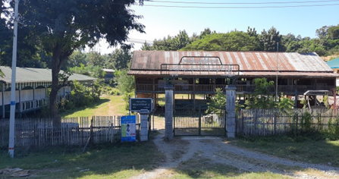

6.3.1 Public health importance of school hygiene and sanitation
Schoolchildren spend about one third of their time in school, so schools provide an ideal opportunity to detect poor hygiene practice by children. Safe water, basic toilets and good hygiene are essential to child survival and development.
The provision of school hygiene and sanitation ensures the rights of students to acceptable hygiene practices, safe water supply, latrines and a healthy school environment in general. The impact could also have further beneficial effects, for example:
- healthy environments promote more effective learning
- opportunities for students to gain life-long positive hygiene routines
- opportunities for increased school enrolment, retention and attendance for girls who may miss school because of inadequate facilities for menstrual hygiene.

6.3.2 Components of school hygiene and sanitation
The components of good school health services are shown in Figure 6.2. We discuss these and other aspects of the school environment in turn.
All schools should be aware of the importance of school hygiene and sanitation for their students. There is a national standard for WASH in Myanmar Schools. For example, the government standard is 50 pupils to one latrine, but only half of schools meet this standard.
Two thirds of schools have access to sanitation facilities, and four-fifths of schools have access to an improved water source on site throughout the year. A quarter of schools provide soap for handwashing on a daily basis (UNICEF, 2020). Therefore, the provision of WASH services in Myanmar schools is mixed.
Promotion of hygiene, organising hygiene/health clubs, having a clean school compound and supervising classrooms for their cleanliness are some of the items for the attention of school authorities.
Figure 6.2 Health-related policies in schools

Promoting hygiene
Teaching students about health focuses mainly on delivering hygiene information. Health information is usually incorporated within various school subjects such as science, biology and physical education.
However, teaching aimed at changing the behaviour of students is not part of the traditional education system. There are ways to fill this gap. Setting up and supporting health or hygiene clubs in schools is one way.
The effective involvement of the local health clinic can also help in the promotion of school hygiene and sanitation.

Provision of drinking water
The provision of safe water for drinking and personal hygiene is important and there needs to be adequate facilities in proportion to the number of students.
Low-cost water fountains and water taps arranged in a water trough design are acceptable for schools. They should be mounted at the appropriate height from the ground surface to match the height of the students (Figure 6.3).
Figure 6.3 Drinking taps and handwashing basin arrangements in a school

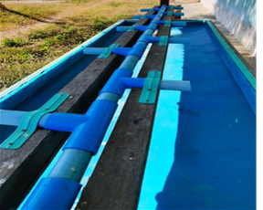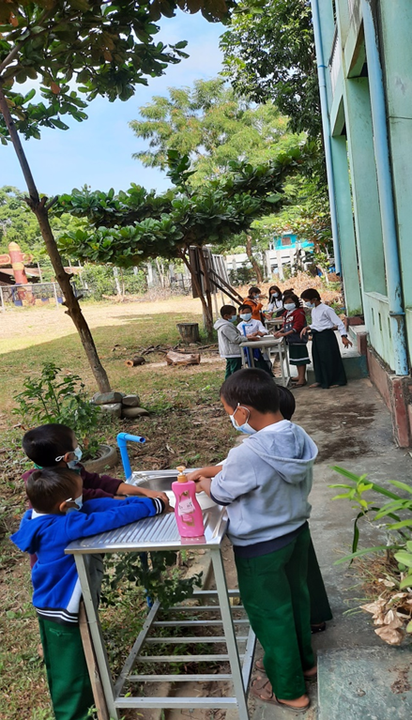

Water must be available throughout the school day. A water storage tank may be necessary to provide water reserves and satisfy the demand at peak hours. The wastewater (greywater) that results because of handwashing must be drained to a seepage or soak pit, or a ditch.

Provision of latrines
The provision of latrines (toilets) is also extremely important. In addition, separate latrines for girls and boys should be provided to encourage girls to continue their education when menstruating.
The usual type of latrine at schools is a communal dry pit latrine equipped with a vent.
School latrines should meet the following requirements:
- The latrines must be located away from the classroom in order to avoid interfering with the students’ learning process. They must be accessible for students with disabilities.
- The latrines must be well-maintained and agreeable to use. They should provide privacy and security.
- The dimensions of the latrine must be adequate to accommodate the storage needs for three to five years.
- There must be handwashing facilities near the latrine (Figure 6.3). Handwashing with soap after using the latrine and before lunch must be encouraged.
- There should be separate latrines for male and female students. Latrines for teachers must be separated as well.
- There must be a bucket with water and a jug inside female latrines. This is essential for cleaning for female students during menstruation.
- Latrines should be hygienic to use and easy to clean. Students themselves should participate in daily cleaning of the latrine.
Figure 6.4 School latrines and handwashing facilities

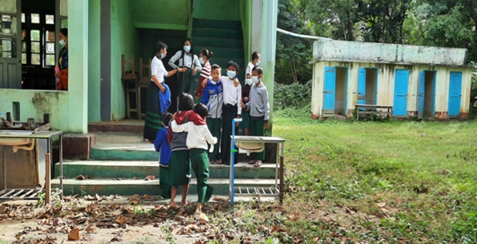

Provision of solid waste management facilities
Discarded paper and cartons are the usual type of waste at schools. Teaching around reducing, reusing and recycling solid waste (3 Rs) could be usefully taught in the classroom. There could also be chemical wastes from school laboratories. Schools should have the following facilities:
- waste bins/buckets in each classroom and teacher’s office; waste bins may be placed in the school compound when deemed necessary (around corridors, playgrounds)
- waste disposal pit at an appropriate location; a local incinerator can be used if the amount of school solid waste is significant.

Classroom sanitation
The cleanliness of the classroom like the one shown in Figure 6.5 is vital to create a good place to learn. Students should be involved on a daily basis in the maintenance of classroom cleanliness. Dust and cracks in the floor must be avoided because these are good hiding sites for biting animals such as the chigger (also known as the chigger red bug or harvest mite).
Figure 6.5 Classroom sanitation: smooth floor, physical suitability of seats and desks, and adequate light and ventilation
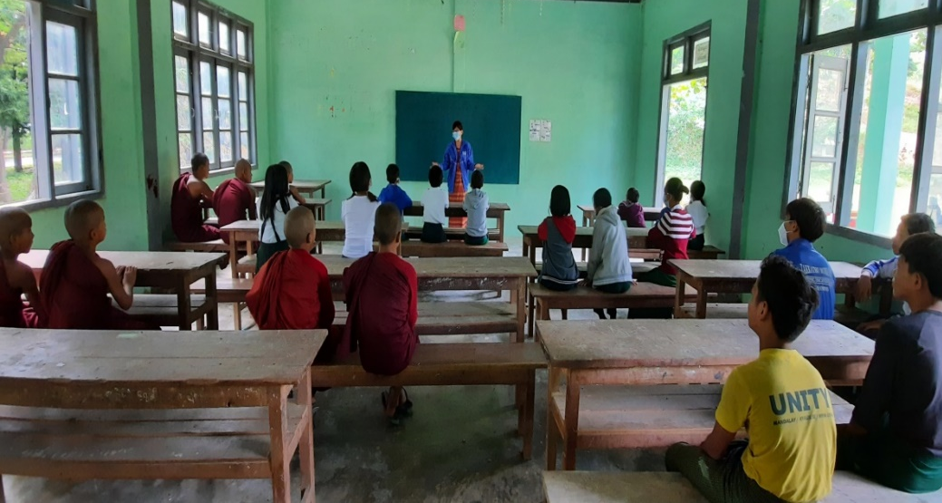

Watch this short film looking at a project to provide clean water and sanitation to several rural schools in Myanmar and answer the question.
https://www.pactworld.org/video/world-toilet-day-promoting-wash-and-waste-management-myanmar

In-text question 1.1
What WASH improvements did this project make?

6.4 Health facilities
Over half of health facilities in Myanmar significantly lack WASH services and the systems to monitor them effectively (UNICEF, 2020). But there are added health risks associated with health facilities that are not always well understood by patients and the general population.
Health facilities generate infectious wastes, needles and other sharps that are potentially harmful and need careful disposal as shown in Figure 6.5.
Figure 6.5 Health facility waste disposal

6.5 Public offices
For the benefit of the health of the civil servants working in offices to serve the population, it is important to maintain a healthy office environment such as well-lit and ventilated rooms, latrines, and proper solid waste management. The supply of safe water and handwashing facilities are also important for the provision of personal hygiene.

6.6 Religious institutions
In monasteries, temples and mosques, the provision of a safe water supply and the development of latrines should have priority. Proper liquid and solid waste management are also important areas for action.

6.7 Identifying the problems related to hygiene and sanitation in an institution of your choosing
How can you help to promote institutional hygiene and sanitation in your community? You can do so by becoming a WASH champion. A champion is someone who works to improve the lives of others by changing community attitudes and practices.
As a WASH champion you can seek to bring about good WASH practices in the community or in a school or religious institution or working with others in a WASH club to make a difference (Figure 6.6).
Figure 6.6 WASH champions bring change.

So far, this session has focused on helping you gain an understanding of hygiene and sanitation requirements in different institutions.
Using this knowledge, we hope you will now consider how you can contribute to the improvement of institutional hygiene and sanitation in your community by focusing on an institution that is important to you. This could be your school, the office you work in, or the religious institution where you worship.
Whichever institution you chose, it should be one that you have a personal connection with. This will make it easier to build a relationship with the management or leadership. If you cannot carry out an inspection of an institution, you could inspect your own home.
Some simple steps to plan for the improvement of hygiene and sanitation in your chosen institution are briefly described here.

6.7.1 Carrying out WASH inspection
Once you have identified your institution, approach the management or leadership of your chosen institution. Tell them of your association with their institution, that you have studied this new WASH course and would like to use the new knowledge you have to improve hygiene and sanitation for all at the institution.
Be open, honest and sincere when you approach them to show that you want to help the institution to attain proper sanitation and hygiene practices and not to criticise them. Remember what you learned about BCC in Study Session 5:
- Tell them that you would like to carry out an inspection of their existing WASH services and how effectively they are used.
- Make it clear that any recommendations you make will not need financial outlay. You are looking at ways that the existing services can be better delivered, used and enhanced.
- Try to build a good relationship with the management or leadership so that they see your interest as helpful rather than critical, as this will make them more likely to listen to the recommendations you make.
- If you have opportunities to interview people (staff, pupils, worshippers, visitors, community members) on your visit they can help you gain a more detailed understanding of the hygiene and sanitation provision at the institution and any problems.
Below is a checklist to help you carry out a sanitary inspection of your chosen institution which you can download HERE. Please add comments on things you notice.

Table 6.1 Sanitary inspection checklist
Service | Availability | Comments
Water supply
Is water available in the school compound? | Yes/No
Supply of drinking water and handwashing facilities | Yes/No
Number of water taps | ?
Are the wash basins accessible for all ages and for those with disabilities? | Yes/No
Cleanliness around wash basins | Yes/No
Is soap provided? | Yes/No
Latrine/toilet provision
Is a latrine/toilet available in the compound? | Yes/No
Type of latrine/toilet? | Pit latrine,  ventilated improved pit latrine,  Flush
Floor of latrine | Concrete slab/earth
Latrine available for: | Staff/students  Staff/visitors
Separate latrines for male and female students (if yes, is there a bucket for sanitary products) | Yes/No
Excreta seen around the latrine | Yes/No
Excreta inside the latrine | Yes/No
Can the latrine be used in its current condition? | Yes/No
Number of latrine holes/toilets | ??
Is there a toilet that is accessible by wheelchair? | Yes/No
Solid waste management
Is there a refuse container in the compound? | Yes/No
Is there waste lying around the compound? | Yes/No
Is there a burial pit for refuse? | Yes/No
Is there an incinerator? | Yes/No
Summary of findings

6.7.2 Making recommendations
Now you have an idea of weaknesses in the WASH services of your chosen institution, you need to identify some actions to strengthen WASH. You want to be positive and helpful when you share the findings from your inspection with the management or leadership of the institution. This will make them more likely to listen to you, and they could share more about the difficulties they face.
Any actions you recommend are likely to be quite modest and focus mostly on changing attitudes and practices of people or minor changes to the physical environment. You cannot pay for the construction of new latrines or an incinerator or even provide soap for handwashing. But if your inspection revealed that there was excreta around the latrines, you could develop a cleaning schedule and encourage individual users to leave the latrine clean.
If there were no separate latrines for males and females, you might think about how to designate latrines for different genders. If the latrines were not accessible by wheelchair, you might designate one latrine for disabled use and make it accessible.
If the handwashing basins were too high for the smallest children to reach, you might think of ways of adjusting the height difference. And if there was waste lying around the compound, you might suggest ways that the compound could be tidied.
Here are some suggestions for action:
- Establish a hygiene/health club to take the leading role in the maintenance of latrine cleanliness.
- Paint latrine doors to indicate whether they are for male of female use, providing buckets for sanitary products in the female latrines.
- Build an access ramp to a dedicated latrine for wheelchair access.
- Provide a low bench for the smaller children to reach the handwashing basins.
- Recycle old boxes as waste containers, painted the same colour for ease of recognition, and with the wording ‘I am a bin, please use me!’ and position these around the complex to keep the compound tidy.
- Longer-term initiatives that require collaborative working within the institution could be to encourage the setting up of a WASH Action group inviting staff /students/visitors /parents/worshippers to participate and discuss how to improve WASH practices.
- An education campaign via a school-produced drama with clear messaging about clean water, sanitation and hygiene which the students could perform for parents.

Getting your messaging right
What type of messages will prompt others to take action for change? You will need to develop strong stories that inspire others to do what they might otherwise not do e.g. washing hands after using the toilet or not discarding litter around the school compound. Figure 6.7 shows three types of messaging to persuade someone to do something or not to do something:
- Appeal to their emotions and values – with stories based on feelings such as love, fear, anger, shame or disgust. Here you are appealing to their heart.
- Appeal to their reason – with facts, figures and examples based on evidence. Here you are appealing to their head and intelligence.
- Appeal to their desire for change – show what difference they can make. Here you are appealing to their wanting to be involved in change, so we say you are appealing to their hands.

Figure 6.7 Messaging for action

Really powerful messaging would include elements of all three approaches to reach different types of people. A simple structure to help with your messaging is to lay it out as a story as follows:
- (PURPOSE) The problem we want to change is… (need)
- (MOTIVATIONS) It matters that we fix it because… (shared values, beliefs, concerns)
- (SOLUTION and BENEFITS) If we can achieve… the difference it will make to people’s lives is…
- (POWER and ACTION) You have the power to make or influence this change, by doing …

Summary of Study Session 6
In Study Session 6, you have learned that:
- Institutional hygiene is important for a range of institutions including schools, health facilities and local religious institutions.
- It is important for public and environmental health that public institutions meet basic sanitation requirements, including water supply, provision of latrines and proper waste management.
- School hygiene and sanitation are especially important because children spend a great deal of time at school and they need a healthy environment to learn and grow, physically, mentally, and socially.
- You can become a WASH champion by inspecting a local institution for WASH services and taking action to address weaknesses.

Answers to in-text questions
  - A water tank and water purification system to provide safe drinking water, separate latrines for girls and boys and handwashing facilities were provided.

References
UNICEF (2020) ‘Water, sanitation and hygiene (WASH)’. [Online]. Available at: https://www.unicef.org/myanmar/water-sanitation-and-hygiene-wash
(Accessed 24 March 2021)

