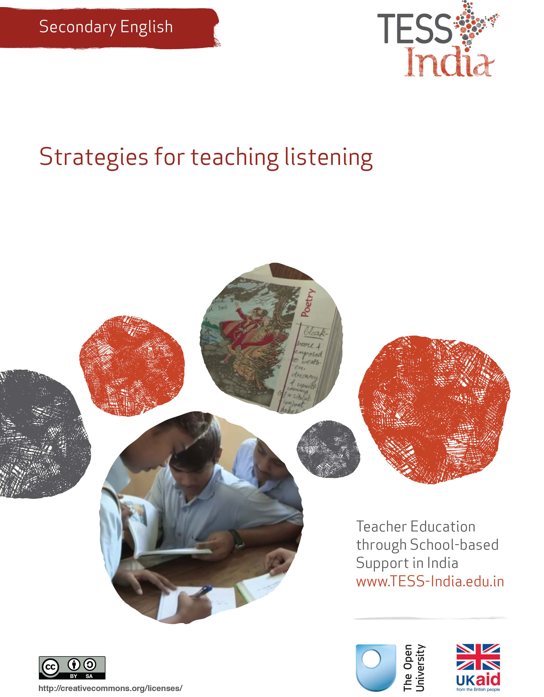
TESS-India (Teacher Education through School-based Support) aims to improve the classroom practices of elementary and secondary teachers in India through the provision of Open Educational Resources (OERs) to support teachers in developing student-centred, participatory approaches. The TESS-India OERs provide teachers with a companion to the school textbook. They offer activities for teachers to try out in their classrooms with their students, together with case studies showing how other teachers have taught the topic and linked resources to support teachers in developing their lesson plans and subject knowledge.
TESS-India OERs have been collaboratively written by Indian and international authors to address Indian curriculum and contexts and are available for online and print use (http://www.tess-india.edu.in/). The OERs are available in several versions, appropriate for each participating Indian state and users are invited to adapt and localise the OERs further to meet local needs and contexts.
TESS-India is led by The Open University UK and funded by UK aid from the UK government.
Video resources
Some of the activities in this unit are accompanied by the following icon: . This indicates that you will find it helpful to view the TESS-India video resources for the specified pedagogic theme.
The TESS-India video resources illustrate key pedagogic techniques in a range of classroom contexts in India. We hope they will inspire you to experiment with similar practices. They are intended to complement and enhance your experience of working through the text-based units, but are not integral to them should you be unable to access them.
TESS-India video resources may be viewed online or downloaded from the TESS-India website, http://www.tess-india.edu.in/). Alternatively, you may have access to these videos on a CD or memory card.

Version 2.0 SE08v1
All India - English
Except for third party materials and otherwise stated, this content is made available under a Creative Commons Attribution-ShareAlike licence: http://creativecommons.org/licenses/by-sa/3.0/

What this unit is about
In our English classes, we tend to practise reading and writing, but don’t often practise speaking and listening. Our textbooks don’t have listening exercises, and there is no listening exam. I know that it is important that my students understand spoken English, but whenever I try to speak English with them they have trouble understanding me. How can I help my students to improve their listening skills?
In the past, the school curriculum for English language teaching in India privileged the teaching of reading and writing. However, policy documents like the National Curriculum Framework (2005, p. 40) now also recognise the importance of teaching listening and speaking:
Speech and listening, reading and writing, are all generalised skills, and children’s mastery over them becomes the key factor affecting success at school. In many situations, all of these skills need to be used together.
Listening and speaking are now taught because they are very important parts of being able to use English to communicate. Listening skills are also crucial to the development of speaking skills. Listening to other speakers helps students to develop their pronunciation and fluency in English.
Successful listening skills are acquired over time and with lots of practice. Your students need exposure to spoken English to be able to develop their listening skills. However, students in some parts of India may not have many opportunities to listen to English outside the classroom.
This unit offers ideas about how you can use resources creatively to develop meaningful listening activities in your English classes that involve all pupils.

What you can learn in this unit
- How to design meaningful listening activities for your English class.
- Asking questions to help students actively listen.
- Ideas for using audio recordings for listening activities.

1 Involving students in listening
You listen to many different things in your home language (or other languages) every day. Think back to your day so far – what have you listened to already? Maybe you have noted some of the following:
- a weather report on the radio
- a colleague at work talking about a new school policy
- a friend phoned you to tell you why he is going to be late.
You probably have many other things on your list.
In each of these situations you were not a passive listener. You actively listened to what the person said in order to find out information. When you have a reason to listen, you listen actively.
When students are doing a listening activity in the classroom, there should be a reason for them to be listening. In Case Study 1 the teacher tries one approach to his class.
Case Study 1: Mr Khan tries the ‘listen and draw’ activity
Mr Khan is a secondary English teacher. He recently went to an English language teacher training workshop on how to help students improve their listening skills in English. Read his account of how he tried to apply what he experienced there.
The trainer showed us an activity that we can do with our students. The activity was called ‘listen and draw’. The trainer told us to follow her instructions and draw what she said. She told us to draw:
- a tree
- three birds in the tree
- two flowers under the tree
- a sun on the left side.
Each of us had a paper and pen and we had to draw what the trainer said. At first I thought it was strange to do some drawing, as I’m not a very good artist. But the trainer told us just to play along and be quick. It was fun and it also made a nice change from listening to the lectures. At the end, we compared our drawings to those of the person sitting next to us. We all laughed to see how the drawings differed.
While this was a fun activity, I realised that it could help my students to practise listening. It could also help them to practise language structures like prepositions (such as ‘in’, ‘under’ or ‘on’). I decided to try the activity with my class as soon as I could.
I saw a good opportunity when my students were reading the story ‘The Bond of Love’ by Kenneth Anderson from the Class IX textbook Beehive. The story has a few illustrations in it. I decided to use the picture on page 117 for a ‘listen and draw’ activity (see Resource 1).
To start the activity, I told my students:
I’m going to read out a few instructions and as I talk, you have to draw. You don’t have to worry about your drawing – it’s not an art exam. It’s just that I am checking to see whether you follow the instructions given in English. Is this clear? Is there a question, or is the activity clear to everybody?

After I was sure that they had understood I started by saying:
Right, so close your textbooks please. You all have pens with you. Can I see your pens? Right, draw a bear on the left side of the page. Now, draw a cage around the bear. After you have drawn the cage, draw a woman sitting on the ground to the right of the bear. Draw a picnic basket to the right of that woman. Then draw some apples in the picnic basket. Draw a cake next to the basket …

Some of my students looked surprised or worried at first. Some complained that they were not very good at drawing. I explained that this was not a test of their drawing skills, but that it was a chance to practise listening to English. I told them: ‘Don’t worry about how good your drawing is. This is not art class, it’s English class! Just draw quickly.’ As they drew, I walked around the room to encourage them, saying things like ‘Nice bear!’ or ‘Good, the woman is on the right side of the page.’
After giving the instructions, I told my students to compare their pictures with each other [Figure 1]. They laughed as they looked at each other’s drawings because they were very different. One student noticed that she had drawn her bear on the right side of the page instead of the left. Then I then told them to look at the illustration on page 117 of the Beehive textbook.
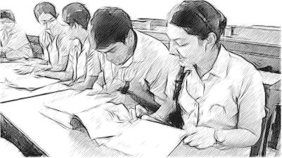
Figure 1 Students comparing pictures.
This was a great activity for helping my students to practise listening. It also helped the students to prepare for reading the story. By talking about the illustration, they now had some ideas about the text before reading it.
My students liked this ‘listen and draw’ activity, so I decided that I would repeat it from time to time in the future, using simple illustrations from the textbook. I also thought that once my students were used to it, they could perhaps do the activity in groups or pairs – one student could look at a picture and describe it to their classmates, who would listen and draw it. This way, they would practise listening and speaking.

Activity 1: Try in the classroom: listen and draw
The ‘listen and draw’ activity in the case study is a simple activity that you can do with any age group, and with many different pictures. This activity:
- helps students to practise listening
- helps students to practise language in context (for example, prepositions)
- involves all the students
- can prepare the students for a reading from the textbook. They will be introduced to some vocabulary and ideas from the text before reading it.
Follow the steps below and try using the activity in your classroom:
- Before class, choose a simple picture with a few objects that are simple to draw. You will need to make sure that both you and your students know most of the words for the objects in the picture. It is probably best to choose a picture that does not have too many objects in it so that it is relatively easy to describe and draw. If the picture is too complex, it might take students a long time to draw it. To speed the activity up, encourage students to do a very quick drawing. You could demonstrate how quickly they could draw by drawing an example of the picture on the board.
- Think about (or write down) the instructions that you will give to students to draw the picture. (Resource 2 includes some of the classroom language you might need to do this activity.)
- When you introduce the activity to your students, tell them not to worry about how good their drawing is.
- Read the first instruction and give students some time to draw – but not too much time! Encourage your students to draw quickly.
- Repeat each instruction as many times as you feel your students need. If they still don’t understand, use a different word. You can also use their home language to help them understand. But remember you are helping them to listen in English, so try not to use the home language very often.
- After you have read the instructions, tell your students to compare their drawings. Have them note any differences and then tell them to compare their pictures with the one in the textbook.
If your students enjoy this activity, you could get them to do it in pairs or groups. One student can choose a picture from the textbook and describe it to their classmates. The classmates draw the picture from the description (and should not look at the textbooks). You could also tell your students to choose a picture and ask you to draw it on the board.

Pause for thought
After trying this activity with your students, think about the following questions:
- Was the picture you chose easy for your students to draw? If not, what kind of picture will you choose next time?
- Did your students enjoy the activity? Did all your students do a drawing?
- When did you need to actively intervene? Why was this? How would you modify the activity for next time?

2 Asking questions to help students listen
When students do listening activities in English, they should not be expected to understand every word of what they hear. They may just understand a few words. It can be frustrating for students if they don’t understand what they are listening to, so tell them to be patient. The listening activities you do in class should help them develop their listening skills over time. One way to do this is to give your students questions to think about before they listen.
Pause for thought
Why do you think that asking questions will help students prepare for listening?
Just as it is important to ask students questions before they read a text (see the unit Supporting reading for understanding), asking questions before students listen to something can also help them. It can:
- orient them for what they are going to listen to
- help them learn to pick out key – or important – words, and to use these words to try to understand what is being said
- make them more interested in what they are listening to – when they are trying to find out the answers to the questions while listening, they are listening actively.
In this part of the unit, you look at how you can ask questions to help your students develop listening skills.
Case Study 2: Mr Khan tries an activity to help students listening to a story from the textbook
In Case Study 1, you read about Mr Khan, a secondary English teacher who went to an English language teacher training workshop on how to help students improve their listening skills in English. Here he describes how he tried to use questions to help students understand a story he read to them.
During the workshop, I had to discuss the following question with other participants: ‘How can you get your students to develop their listening skills in the classroom?’ One participant described an activity that she regularly does in the classroom:
I read parts of the texts aloud to the class … just one or two paragraphs.

Oh, don’t you read the whole text aloud?

No, the whole text is too long. For example, I read the first paragraph and tell my students to close their books and listen.

Can your students understand?
Well, no they can’t understand every word. But they get the general meaning. After I’ve read the first paragraph, I ask my students to guess what happens next … then they read the rest of the text to see if they were right.

I liked this idea and tried it the following week in my English class. The students were doing Chapter 9 of the NCERT Class X textbook. The lesson is called ‘Madam Rides the Bus’ and begins with the following paragraph:
There was a girl named Valliammai who was called Valli for short. She was eight years old and very curious about things. Her favourite pastime was standing in the front doorway of her house, watching what was happening in the street outside. There were no playmates of her own age on her street, and this was about all she had to do.
At the start of the lesson, I asked all of my students to close their books, and then I told them that I was going to read a paragraph about a girl called Valli. I wrote the following questions on the board, and asked my students to write them down in their notebooks:
What was the girl’s name?
How old was she?
What was her favourite pastime?
Why did she do this?
When the students had finished writing, I asked: ‘Do you understand the questions? Do you know the word “pastime”? A pastime is like “hobby” or “शौक”.’
When I felt certain that they understood the questions, I then asked them to listen carefully to the paragraph, and to listen out for the answers to the questions on the board. I read the paragraph aloud, slowly and clearly. I then told them to see if they could answer the questions in pairs. Many of them couldn’t answer the questions at first, so I read the paragraph aloud again. After that, most were able to answer the questions.
I then asked my students to guess what things Valli would see when she was watching the street outside. Once again, I told them to discuss their ideas in pairs, and to note them down. I gave them a short time limit for this, after which I asked my students to suggest some ideas. They suggested that she might see people travelling in rickshaws, selling goods and so on.
After this, I asked my students to open their books and continue reading the story, and to find out what Valli liked to see the most on the street. The students quickly found that she enjoyed watching the bus.
In this case study, the teacher used a story from the textbook for a listening activity. This activity encourages students to listen for key words, which helps them to understand the main message from words and phrases that they know. If you do it often, students will get used to listening to English without texts in front of them – this will help them to listen to English outside the classroom.

Activity 2: Try in the classroom: helping students to listen for information
You can do this activity to help your students develop listening skills with lessons from your own English textbook. You can also do this with many different texts and for students at any level. This activity can also be done with stories or songs.
Follow the steps below and try using it in your classroom:
- Choose a text from your textbook. Look at the first paragraph. Is it quite short? Could you ask some interesting questions about it?
- Practise reading the paragraph aloud before the class, and prepare two or three questions to ask about the text. (See Resource 2 for some of the classroom language you might need to do this activity.)
- In class, write the questions on the board. Tell your students that you are going to read a text aloud and they should listen to it to find the answers to the questions.
- Read the paragraph aloud. Make sure your students have their books closed.
- Tell your students to discuss the answers to the questions in pairs. If necessary, read the paragraph again to help them answer. For more on the value of discussion, see Resource 3 and the video below.
- Ask them to discuss in pairs what might happen next. Give a short time limit for this. Ask students for some suggestions. This can also be a useful speaking activity, so encourage students to use English. But it is also important that you allow them to respond in their home language too, as this will help you monitor whether they have understood the text.

Video: Talk for learning
http://tinyurl.com/video-talkforlearning

Pause for thought
Here are some questions for you to think about after trying this activity. If possible, discuss these questions with a colleague.
- Was it easy for you to read the text aloud? If not, what could you do to make it easier?
- How did your students respond to the questions? Would you change the questions you asked if you did this activity again?
- How did you assess the learning in this activity? Were all students learning?
If you found it difficult to read the text aloud, you could try practising before class. The more often you read it, the more natural it will become. The questions that you ask students should help them to find the main ideas and the important words in the text. If your students have problems answering the questions, you may need to help them with some of the vocabulary used in the text (see Helping students to learn, use and remember vocabulary for more ideas).

3 Using audio recordings
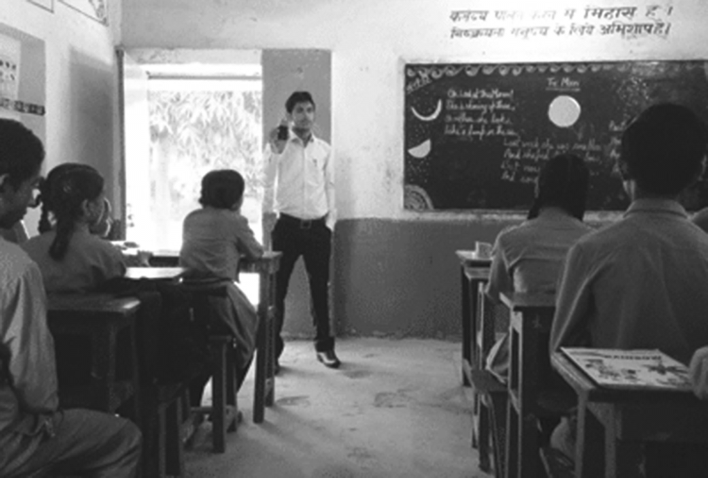
Figure 2 Using audio recordings in class.
There are several listening activities that you can do with students in your classes. However, it can also be good for students to listen to other voices. You can do this by bringing audio recordings into the classroom. Some examples are:
- recordings taped from the radio and played on a tape recorder
- songs played on a tape recorder or CD player
- songs played on an MP3/4 player or a mobile phone
- audio recordings made by teachers, students or other people by a mobile phone (for example, teachers can record a dialogue)
- audio books played on a CD player or downloaded to a laptop or MP3 player
- audio recordings downloaded onto a mobile phone or laptop (see Resource 3) or links to audio recordings that have been developed for learners of English.
Pause for thought
What are the benefits of using audio recordings in your classroom? Discuss this with a colleague if you can.
While it is good for you to speak as much English as possible with your students, it is also important that they hear a variety of voices and accents. Audio recordings can provide different models of spoken English. This can help students with pronunciation. Using audio recordings also adds variety to lessons, and some students will enjoy being in a class that uses technology.
Now read a case study about a teacher who uses audio recordings in the classroom.
Case Study 3: Listening to the news with Ms Sengupta
Ms Sengupta loves English and always tries to improve her own language abilities. Whenever she can, she reads English books and magazines, and she watches TV programmes and movies in English. She knows that she has learned a lot by listening to programmes and movies: she’s learned words and phrases, her pronunciation has improved, and she can understand people from other countries better. She believes that it is important for learners of a language to listen to as much of that language as possible, and she tries to give her students the opportunity to listen to as much English as possible, from as many different people as possible. Read her account of how she used audio recordings in her class to improve listening skills.
I teach Class IX. I regularly record the news of the day from All India Radio [http://allindiaradio.gov.in/default.aspx] on my mobile phone and take the recording into my class. I have bought some inexpensive portable speakers that I can use for audio recordings, so that all of the students can hear. Before I play the recording, I plug the speaker wires into my mobile phone. That way the volume is loud enough for the whole class to hear.
Before I play the recording of the news, I ask my students what the latest news is. I ask them this in English but allow them to reply in any language they feel comfortable talking in. Not many of them listen to the news in English. But this activity gets them thinking about the topic of the news. I can then introduce them to some new words that appear in the news items. This prepares them for the recording they are going to listen to. For example, I might say something like:
Now you are going to listen to some news items. For the moment, just listen and write down how many news items you hear. Don’t worry if you can’t understand every word! That’s completely normal. I’m going to play the recording more than once.

I then play the audio recording. I know that it is difficult to listen to a lot of English at one time, so I keep it short. I play just three or four news items and play them twice.
Once they have noted down some news items, I say:
Now work in pairs. Compare how many news items you heard. Was it two? Three? Four? Five? Then write down the topic of each news item you heard.

I ask the students to work in pairs, because that way all students get a chance to think and talk about what they heard. If I ask students one by one, only a few members of the class will participate. I give my students a few minutes to discuss and write down what they heard. Then I ask them to say how many news items they heard, and to say in English what each one was about. I try to get them to speak English, but I really want to know if they have understood the general meaning of the recordings. So if they don’t reply in English, I ask them in their home language what they have understood [Figure 3].

The last story was about President Pranab Mukherjee. He went to Agartala.

One was about the rupee. I’m not sure what they said.

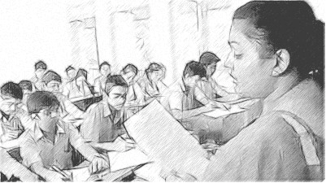
There were three news items. One was about floods.

Figure 3 Students explaining what they understood.
Once I knew that the students understood what the news items were about, I wanted them to listen out for more information about each news item. So I played the recording again. Before I played it, I asked my students some questions about each news item.
I played the recording, and this time my students tried to listen out for the answers to my questions. After playing the recording, I gave the students two or three minutes to discuss the answers to the questions I asked in pairs. Then I asked them to answer the questions. Sometimes I ask more questions and play the recording again. At the end of the lesson, I played the recording again. By this time, the students understood much more of the recordings.
I now do this activity regularly in my classes, about once a week. It is quite simple to do as I can follow the same procedure with all news items, so I don’t have to prepare much before the classes. My students are getting better at listening to English, and they are learning many new words and phrases. They are also feeling much more confident about listening to and using English, and they are preparing for work or study in the future.

Activity 3: Try in the classroom: listening to the news
Now it’s your turn. If you have access to a device where you can make a recording (such as a mobile phone, MP3/4 player or a computer), try using an audio recording in your classroom. You will find links to audio recordings that have been developed for learners of English in Resource 3.
- Select an audio recording that is suitable for your students and that they will find interesting. Choose a recording that is short.
- Listen to the audio recording before the class. Write down some questions to ask your students about the piece. You don’t need many; five to eight questions is fine. (See Resource 2 for some of the classroom language you might need to do this activity.)
- In class, write questions on the blackboard before you play the audio recording. This will get your students thinking about the topic. It will also help them to focus on key points. It gives them a reason for listening, and it helps them to listen for specific information.
- Play the recording and then give your students some time to discuss the questions in pairs or groups.
- If your students need it, play the recording again. Then ask for answers to the questions. Remember that you can pause the recording whenever you like. This can be very useful if the recording is long, or if your students are having problems finding the answers to questions.

Pause for thought
After trying this activity with your students, think about the following questions:
- Did your students find listening to the audio difficult or easy? When did you need to intervene to guide listening and learning?
- What would you modify next time you do this activity? Would you use a different type of recording?
Students will probably find an activity like this quite challenging the first time they do it. Preparing the students before they listen will make it easier for them to follow. Follow the steps from Case Study 3: introduce students to the topic of the text before they listen, and some of the vocabulary they will hear. Provide questions to give students a reason for listening.
Tell your students that the language might be difficult to understand. Tell them that this is normal, and that they should not worry. Encourage your students as much as possible. With more practice, they will get used to listening to English.
If you found it difficult to find suitable audio recordings to use with your students, some tips are provided below.
- If you are nervous about using technology in the classroom (mobile phones, tape recorders, laptops, CD players), practise using the equipment outside the classroom first so that you feel confident using it.
- You could also ask for the help of another teacher who is good with technology if you are not very confident yourself. You might even have one or two students who can help. Young people are often very good with technology!
- Always make sure that you listen to audio recordings before you play them in the classroom. This ensures that the material is suitable.
- Make sure that all of the students in your classroom can hear. Speakers will be necessary for classroom use, especially with large groups. A set of small portable speakers would be suitable. If speakers are not available, you can ask students to listen to the recording in small groups, one group at a time.
- Play audio recordings more than once. The first time that the students listen, they can try to understand the general meaning; the second time, they can listen out for specific information.
Don’t play long audio recordings. Keep them short and pause often, especially if your students are having problems. You want to give your students confidence.

4 Summary
In this unit you have learned about how you can devise activities that use resources creatively in order to support your students in developing their listening skills. See Resource 2 for some of the language you might need for carrying out these activities. In all these activities it is important to think about how the activity can be made accessible and meaningful to students. These listening activities should link to other activities in the textbook or to events and experiences in your students’ lives. In all the activities you will need to carefully listen to and observe how your students respond so that you can intervene to direct and facilitate learning for all students in your class.
If you would like to improve your own listening skills, you can find links and tips in Resource 4 and in the unit Developing your English. Find links for further reading in the additional resources section.
You can learn more about creating opportunities for students to listen to English in the unit Using more English in your classroom.

Resources
Resource 1: The picture in Mr Khan’s ‘listen and draw’ activity
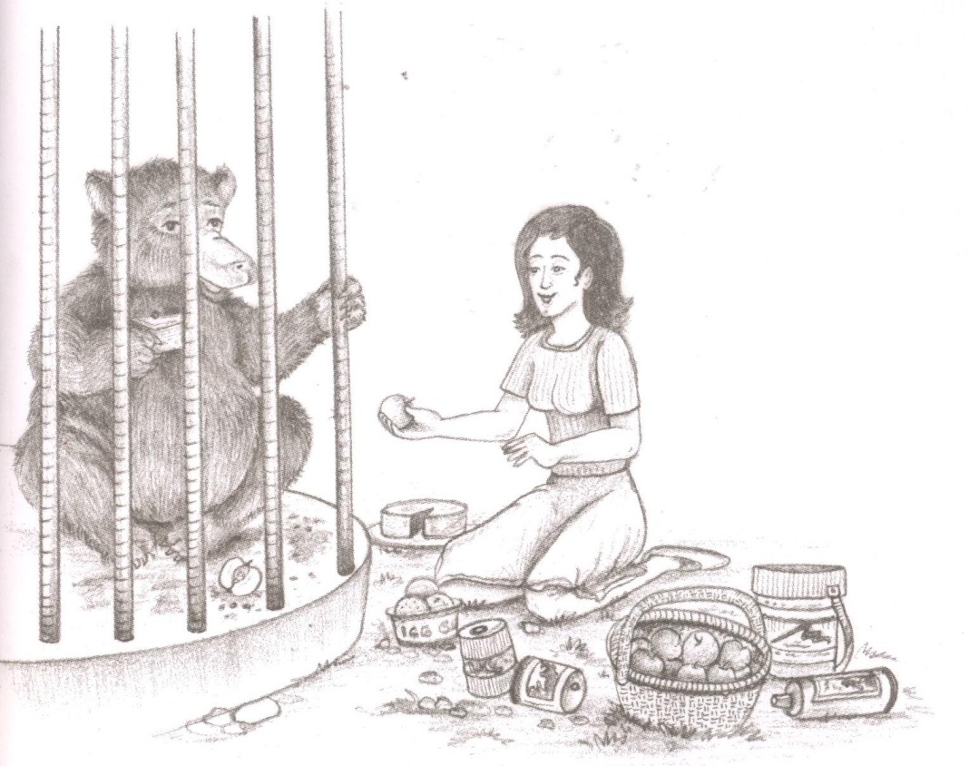
Figure R1.1 Illustration of a sloth bear in a cage (NCERT, 2006a, p. 117).

Resource 2: Developing your English
Here is a list of phrases that could be useful for carrying out the activities in this unit.
- ‘Have you got a pen and some paper?’
- ‘I’m going to give you some instructions. Listen, and draw what I say.’
- ‘Don’t worry about your drawing. This is not an art class. Just draw quickly!’
- ‘Now compare your drawing with your friend’s/the book. Are there any differences?’
- ‘That’s a great/funny picture!’
- ‘I’m going to read a paragraph about …’
- ‘Look at the questions on the board and write them in your notebooks.’
- ‘Now listen carefully, and find the answers to the questions.’
- ‘Shall I read that again?’
- ‘Now discuss the answers in pairs.’
- ‘Has anybody listened to the news today?’
- ‘What has happened?’
- ‘Can you tell me about the news?’
- ‘I’m going to play the news in English.’
- ‘Can everybody hear?’
- ‘Can you hear at the back of the room?’
- ‘How many news items were there?’
- ‘Did you understand anything? What did you understand?’
- ‘Did you understand the first news item? What was it about?’
- ‘Would you like to listen again?’
If you want to develop your own listening skills, you could:
- if possible, listen to English TV programmes or films
- listen to the news in English – you could listen to it in your home language first
- try some of the activities in Resource 3.
Resource 3: Talk for learning

Why talk for learning is important
Talk is a part of human development that helps us to think, learn and make sense of the world. People use language as a tool for developing reasoning, knowledge and understanding. Therefore, encouraging students to talk as part of their learning experiences will mean that their educational progress is enhanced. Talking about the ideas being learnt means that:
- those ideas are explored
- reasoning is developed and organised
- as such, students learn more.
In a classroom there are different ways to use student talk, ranging from rote repetition to higher-order discussions.
Traditionally, teacher talk was dominant and was more valued than students’ talk or knowledge. However, using talk for learning involves planning lessons so that students can talk more and learn more in a way that makes connections with their prior experience. It is much more than a question and answer session between the teacher and their students, in that the students’ own language, ideas, reasoning and interests are given more time. Most of us want to talk to someone about a difficult issue or in order to find out something, and teachers can build on this instinct with well-planned activities.

Planning talk for learning activities in the classroom
Planning talking activities is not just for literacy and vocabulary lessons; it is also part of planning mathematics and science work and other topics. It can be planned into whole class, pair or groupwork, outdoor activities, role play-based activities, writing, reading, practical investigations, and creative work.
Even young students with limited literacy and numeracy skills can demonstrate higher-order thinking skills if the task is designed to build on their prior experience and is enjoyable. For example, students can make predictions about a story, an animal or a shape from photos, drawings or real objects. Students can list suggestions and possible solutions about problems to a puppet or character in a role play.
Plan the lesson around what you want the students to learn and think about, as well as what type of talk you want students to develop. Some types of talk are exploratory, for example: ‘What could happen next?’, ‘Have we seen this before?’, ‘What could this be?’ or ‘Why do you think that is?’ Other types of talk are more analytical, for example weighing up ideas, evidence or suggestions.
Try to make it interesting, enjoyable and possible for all students to participate in dialogue. Students need to be comfortable and feel safe in expressing views and exploring ideas without fear of ridicule or being made to feel they are getting it wrong.

Building on students’ talk
Talk for learning gives teachers opportunities to:
- listen to what students say
- appreciate and build on students’ ideas
- encourage the students to take it further.
Not all responses have to be written or formally assessed, because developing ideas through talk is a valuable part of learning. You should use their experiences and ideas as much as possible to make their learning feel relevant. The best student talk is exploratory, which means that the students explore and challenge one another’s ideas so that they can become confident about their responses. Groups talking together should be encouraged not to just accept an answer, whoever gives it. You can model challenging thinking in a whole class setting through your use of probing questions like ‘Why?’, ‘How did you decide that?’ or ‘Can you see any problems with that solution?’ You can walk around the classroom listening to groups of students and extending their thinking by asking such questions.
Your students will be encouraged if their talk, ideas and experiences are valued and appreciated. Praise your students for their behaviour when talking, listening carefully, questioning one another, and learning not to interrupt. Be aware of members of the class who are marginalised and think about how you can ensure that they are included. It may take some time to establish ways of working that allow all students to participate fully.

Encourage students to ask questions themselves
Develop a climate in your classroom where good challenging questions are asked and where students’ ideas are respected and praised. Students will not ask questions if they are afraid of how they will be received or if they think their ideas are not valued. Inviting students to ask the questions encourages them to show curiosity, asks them to think in a different way about their learning and helps you to understand their point of view.
You could plan some regular group or pair work, or perhaps a ‘student question time’ so that students can raise queries or ask for clarification. You could:
- entitle a section of your lesson ‘Hands up if you have a question’
- put a student in the hot-seat and encourage the other students to question that student as if they were a character, e.g. Pythagoras or Mirabai
- play a ‘Tell Me More’ game in pairs or small groups
- give students a question grid with who/what/where/when/why questions to practise basic enquiry
- give the students some data (such as the data available from the World Data Bank, e.g. the percentage of children in full-time education or exclusive breastfeeding rates for different countries), and ask them to think of questions you could ask about this data
- design a question wall listing the students’ questions of the week.
You may be pleasantly surprised at the level of interest and thinking that you see when students are freer to ask and answer questions that come from them. As students learn how to communicate more clearly and accurately, they not only increase their oral and written vocabulary, but they also develop new knowledge and skills.
Resource 4: Links to audio recordings
Here are some links to free audio recordings that have been developed for older learners of English:
- Randall’s ESL Cyber Listening Lab: http://www.esl-lab.com/
- elllo: http://elllo.org/
- Listen a Minute: http://listenaminute.com/
- ‘Listen and watch’: http://learnenglish.britishcouncil.org/en/listen-and-watch
- ‘English listening exercises’: http://www.esolcourses.com/content/topicsmenu/listening.html
This link has free audio recordings that have been developed for teenage students of English:
- ‘Readers for teens’: http://www.cambridge.org/gb/elt/catalogue/subject/project/custom/item5633106/Readers-for-Teens-Audio/?site_locale=en_GB
And some links to songs (with activities for learners for English):
- ‘Using authentic songs in the ELC classroom’: http://www.tuneintoenglish.com/?p=833
Here are some simple listening activities from the TeachingEnglish website that you can do in the classroom:
- Active listening activities: http://www.teachingenglish.org.uk/activities/active-listening-activities
- Listening activities for songs: http://www.teachingenglish.org.uk/activities/listening-activities-songs
- Total physical response – TPR: http://www.teachingenglish.org.uk/article/total-physical-response-tpr

Additional resources
Here are some links to articles and tips for teachers of English:
- Articles on listening: http://www.teachingenglish.org.uk/articles/listening
- Listening skills: http://www.onestopenglish.com/skills/listening/
- ‘Better listening’: http://orelt.col.org/module/1-better-listening

References/bibliography
All India Radio, http://allindiaradio.gov.in/ default.aspx (accessed 30 July 2013).
British Council (undated) ‘Listen and watch’ (online). Available from: http://learnenglish.britishcouncil.org/en/listen-and-watch (accessed 31 July 2013).
Cambridge English (undated) ‘Readers for teens’ (online). Available from: http://www.cambridge.org/gb/elt/catalogue/subject/project/custom/item5633106/Readers-for-Teens-Audio/?site_locale=en_GB (accessed 31 July 2013).
elllo, http://elllo.org/ (accessed 31 July 2013).
ESOL Courses (undated) ‘English listening exercises – online lessons for ESL students’ (undated). Available from: http://www.esolcourses.com/content/topicsmenu/listening.html (accessed 31 July 2013).
Kavanagh, F. (2007) ‘Using authentic songs in the ELC classroom’ (online), Tune into English. Available from: http://www.tuneintoenglish.com/?p=833 (accessed 31 July 2013).
Listen a Minute, http://listenaminute.com/ (accessed 31 July 2013).
National Council of Educational Research and Training (2005) National Curriculum Framework, National Council of Educational Research and Training. Available from: http://www.ncert.nic.in/rightside/links/pdf/framework/english/nf2005.pdf (accessed 25 September 2014).
National Council of Educational Research and Training (2006a) Beehive: Textbook in English for Class IX, National Council of Educational Research and Training. Available from: http://www.ncert.nic.in/NCERTS/textbook/textbook.htm (accessed 26 September 2014).
National Council of Educational Research and Training (2006b) Honeydew: Textbook in English for Class VIII, National Council of Educational Research and Training. Available from: http://www.ncert.nic.in/NCERTS/textbook/textbook.htm (accessed 31 July 2013).
National Council of Educational Research and Training (2006c) Position Paper 1.4: National Focus Group on Teaching of English, National Council of Educational Research and Training. Available from: http://www.ncert.nic.in/new_ncert/ncert/rightside/links/pdf/focus_group/english.pdf (accessed 31 July 2013).
Onestopenglish (undated) ‘Listening skills’ (online). Available from: http://www.onestopenglish.com/skills/listening/ (accessed 31 July 2013).
Randall’s ESL Cyber Listening Lab, http://www.esl-lab.com/ (accessed 31 July 2013).
TeachingEnglish, http://www.teachingenglish.org.uk/ (accessed 31 July 2013).

Acknowledgements
Except for third party materials and otherwise stated below, this content is made available under a Creative Commons Attribution-ShareAlike licence (http://creativecommons.org/licenses/by-sa/3.0/). The material acknowledged below is Proprietary and used under licence for this project, and not subject to the Creative Commons Licence. This means that this material may only be used unadapted within the TESS-India project and not in any subsequent OER versions. This includes the use of the TESS-India, OU and UKAID logos.
Grateful acknowledgement is made to the following sources for permission to reproduce the material in this unit:
Figure 2: photo by Kim Ashmore.
Figure R1.1: illustration from the textbook Beehive (2006) published by NCERT, page 117.
Every effort has been made to contact copyright owners. If any have been inadvertently overlooked the publishers will be pleased to make the necessary arrangements at the first opportunity.
Video (including video stills): thanks are extended to the teacher educators, headteachers, teachers and students across India who worked with The Open University in the productions.

