Inclusive Teaching Practice
Participant’s Book
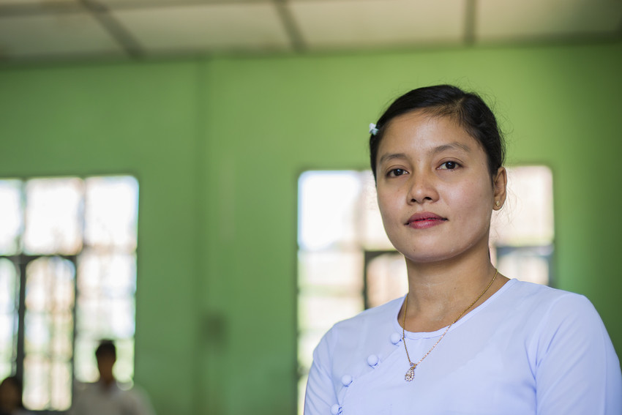
Source: VSO Image library

Module 10:
Legal framework and policies around Inclusion in Myanmar

Module 10: Legal framework and policies around Inclusion in Myanmar

Overview
This is the tenth of fifteen modules that look at how we create a positive Inclusive Learning Environment for all. You will see how inclusive teaching practices encourage, develop and use the 21st century skills of critical thinking, communication, collaboration and creativity. These modules are for any educators or those studying in education in Myanmar. The terms student and learner are used interchangeably throughout the module.

Module number | Module title
1 | What is an Inclusive School, Classroom and Teacher?
2 | Knowing your learners
3 | Planning learning outcomes for all
4 | Participating through learner centred approaches
5 | Creating a positive learning environment
6 | Effective questioning and feedback
7 | Active participation
8 | Peer, cooperative and collaborative learning
9 | Supporting students’ emotional and social wellbeing
10 | Legal framework and policies around Inclusion in Myanmar
11 | Supporting all students through differentiation
12 | Identifying specific learning difficulties
13 | Supporting all learners with differences or disabilities
14 | Positive behaviour management
15 | Assessment for student achievement

This module helps you to understand the legal framework and policies around inclusion in Myanmar and how they affect you as an educator. It describes the differences between laws and policies and how they link to your practice. The origins of international and national laws, and policies are explored and how they impact on your practice in the classroom.

You will also be asked to record your reflections in a learning journal, so it is important to make detailed notes and think carefully and deeply about your current and future practice. This CPD module also encourages you to develop communities of practice between yourself and your colleagues. This will support and extend your own use of inclusive practices in your teaching and will help your student teachers build on inclusion in their learning and future professional practice.

Learning Journal
It will be useful to record your reflections in a learning journal throughout the module.
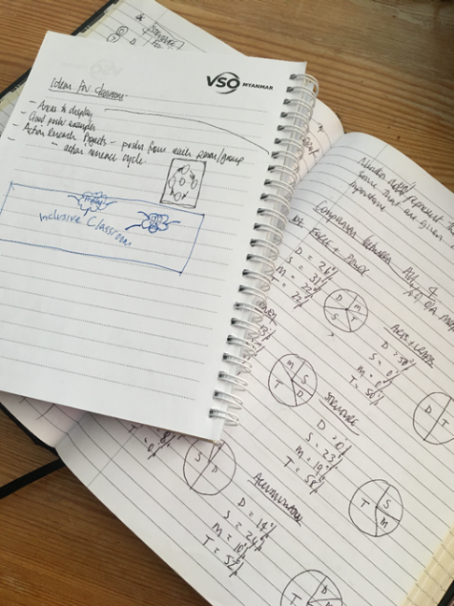
A learning journal can be digital (e.g. using Word or Google Docs) or on paper. You can also take photos of your learning journal pages if you want to share your thoughts with others. It is important that you record your thoughts and ideas so that you can remember and use them later in activities and in your own teaching.

Here are some useful tips for a good learning journal:
- Use headings and dates for all your journal entries.
- Use the activity number for reflections linked to that activity, e.g. Activity 1.1
- Add references to any other resources you find that help you.
- Record answers to activities.
- Write reflections about your learning.
- Make notes of new vocabulary.
- Identify topics you want to learn more about.

Source: Rose, N. (2018) Personal Learning Journals

The important thing is that it is easy for you to use. You can take notes which answer simple questions like these:

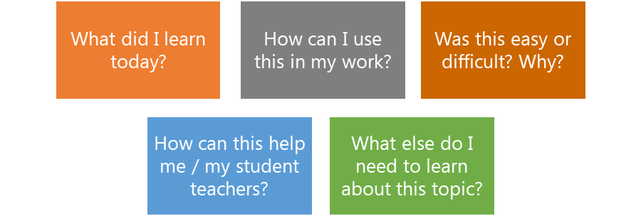

These questions follow the LEARN- APPLY- REFLECT model which is used in education globally. You can return to this journal as you progress through your CPD journey and reflect on your progress.

Study tips
Take your time to work through the activities, rather than trying to complete the whole unit at once. Set yourself a timetable and choose a time to work through the tasks, then check and compare ideas with colleagues. Finally, remember to make notes in your learning journal as you go. This will help you remember more about the skills and knowledge you develop as you complete these units.

Working alone or with colleagues
This unit is designed for self-study. The answers can be found after each activity. However, if possible, we recommend working in a pair or group so you can share ideas, ask questions, check your work, and give feedback.

If you work in a pair or group, we recommend using Think / Pair / Share for each activity.
Discuss your ideas in a group, and then check the answers on the next page(s) together.
Check your answers with your partner.
Work alone and make brief notes of your own ideas.

Learning outcomes for module 10
By working through this module, you will be able to:

- Identify the policies and laws which support the realization of Inclusive education in Myanmar
- Outline the relevant sections of international and national policies and laws in relation to Inclusive Education in Myanmar
- Summarise how aspects of the policies or laws relate to the work of the educator

Introduction
In the previous module, you were introduced to the concept of supporting students’ emotional and social wellbeing. You thought about how you, as an educator, could signpost and/or provide support to those students who are finding their situations difficult to deal with. By coping with anxiety and stress, even in difficult situations, students can develop healthier, better balanced, more motivated and happier lives and, by doing so, help others. Maslow’s hierarchy of needs suggests how dealing with social and emotional wellbeing is fundamental to your students being present, being able to participate and finally achieving in your school and classroom.
This module explores the international starting points of the policies and laws associated with Inclusive Education and how they impact you as an educator and your students in the classroom.
You will be asked to:
- Read about international and national laws, and policies about Inclusive Education.
- Make links between policy, law and your practice.
- Watch videos and provide some analysis.
- Complete activities either alone, in pairs or in small groups.
- Think about key questions.
- Reflect on your experience and knowledge.
- Make a promise to your learners.

The module will take approximately 5 hours to complete. We hope you have an enjoyable learning experience.

Key to symbols
Activity – this is work you need to complete.

Question/s – please answer the questions.
Reflection – think carefully about how you feel about this.
Learning Journal – please write your answers in your learning journal.
Read – please read the text provided. Make any notes you like.

Activity 10.1 Self-assessment
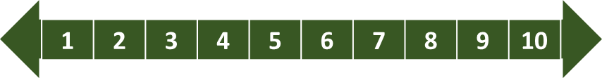
REFLECTION: How well do you think you know and understand the international and national laws and policies that effect the inclusive practice in your school/classroom? Look at the scale below and choose the number that best describes you now. Answer in your learning journal.
VERY well
NOT well
You will be asked to do this again at the end of the module.

  - Link to previous learning – Module 9 (Supporting students’ emotional and social wellbeing)

Think back to Module 9.

Complete a mind map showing as many of the factors that can affect social and emotional wellbeing of either yourself or your learners.

Note: Try to answer without looking at your previous notes. However, if you can’t, use your Module 9 book to help.

One example is given and some clues are given below.

Exploitation

Factors

I miss my father
They don’t like me
I’m always late
I must care for my 6 younger siblings
No rice!
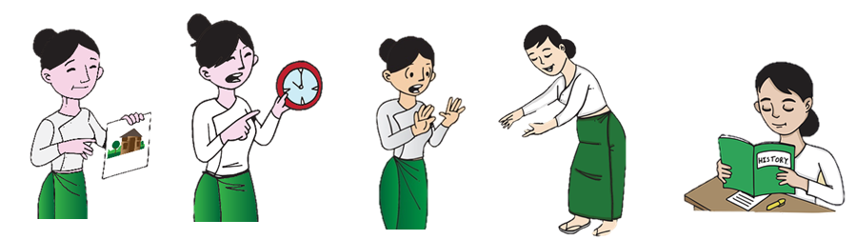
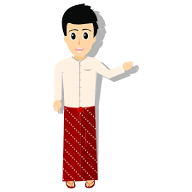
Adapted image sources: https://pixabay.com/images/search/burma/?pagi=2& (free)

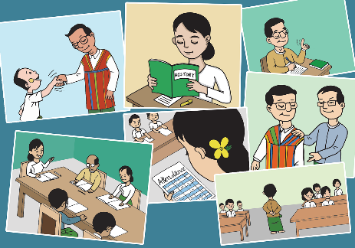
These are my colleagues and I have concerns about each of them.

https://freesvg.org/native-myanmar-man (free) https://pixabay.com/vectors/myanmar-burma-teachers-education (free)

1.2 Answers - factors that can affect social and emotional wellbeing
Check how many you managed to answer correctly. Did you give any different answers?
- exposure to violence
- exploitation
- poor health
- conflict in their community
- self-esteem
- family structure
- family history
- recent change or loss in the family
- attitude or personality
- limited access to food or poverty

Policy, laws and practice
Inclusive education requires a whole system approach to create an enabling environment where laws and policies are in place that establishes the rights of all children to receive a quality education in inclusive settings (including children with disabilities). It is important for educators to understand the relevant international and national laws which contribute to the realization of Inclusive Education in Myanmar, including best practice.

2.1 The differences between a policy, a law and practice.

Activity 10.2 – What is the difference between a policy, a law, and a practice? (5 minutes)

Match the words; policy, law and practice with their correct definitions. Draw a line between the two or match the numbers to the correct letters, e.g. 1-A.
Definitions
A policy
1
creates the legal framework to make sure that policies are put into action.
A
A Policy

A law
2
is the application of the policy and follows the law.

B

states the intention of an individual or an organisation (for example a government). It says what the person or organisation plans to do.
C
Practice
3

Examples of how policy, law and practice link to the Myanmar context for Inclusive Education
- The government’s policy on basic education is to develop a new curriculum.
- The government passed a law to make basic education free for all children.
- The practice is to train the teachers in the new curriculum.

Activity 10.2 Answers - What is the difference between a policy, a law and a practice?

A policy states the intention of an individual or an organisation (for example a government). It says what the person or organisation plans to do.
C
1
A
2
Laws make the legal framework to make sure that policies are put into action
B
3
Practice is the application of the policy and follows the law.

Activity 10.3 – Policy, law, and practice (15 minutes)

Decide who you think makes policy, who makes law and who is involved in practice. Put a tick () in the most appropriate column. Hint: Some organisations can do more than one.

Institutions | - Policy | - Law | - Practice
a) Teacher Education Institutions

b) Schools

c) National level authorities

d) Regional level authorities

e) United Nations Conventions

f) National level education authorities

g) Local Education offices

h) National level health authorities

Optional extension task:
Put these organisations into a diagram (graphic organiser) that links top (international) to bottom (local)

Activity 10.3 Answers: Policy, law, practice

Institutions  a) Teacher Education Institutions  b) Schools  c) National level authorities  d) Regional level authorities  e) United Nations Conventions  f) National level education authorities  g) Local Education offices  h) National level health authorities | - Policy | - Law | - Practice

International  Local | United Nations Conventions  National level authorities  National level education authorities  National level health authorities  Regional level authorities  Local Education offices  Teacher Education Institutions  Schools
Optional extension task answer – international to local level

Note: Some ethnic providers who are linked with ethnic armed organisations, may make their own policies.

3.Inclusive Education policy (international)

The Myanmar government has signed up to and is formally in agreement with three United Nations (UN) Conventions that refer to Inclusive Education. Myanmar is one of 193 countries who are signed up and who are members of the United Nations. Inclusive Education is a worldwide goal.
- Sustainable Development Goal (SDG) 4 – Quality Education
- Convention on the Right of People with Disabilities. This has two parts.
Image Source: https://www.google.com/search?q=world&tbm (free)
  - part 1 is from 2011
  - part 2 is from 2016.
- Convention on the Rights of the Child (CRC)

Activity 10.4 Inclusive Education policy (international). (40 minutes)

Sustainable Development Goal (SDG) 4

Please scan read this document (either the English or Myanmar version below) and consider how these policies link to your work as a teacher educator.

Make a note of the headings (4.1-4.7) for each target, eg. SDG 4.1 = Free Primary and Secondary Education

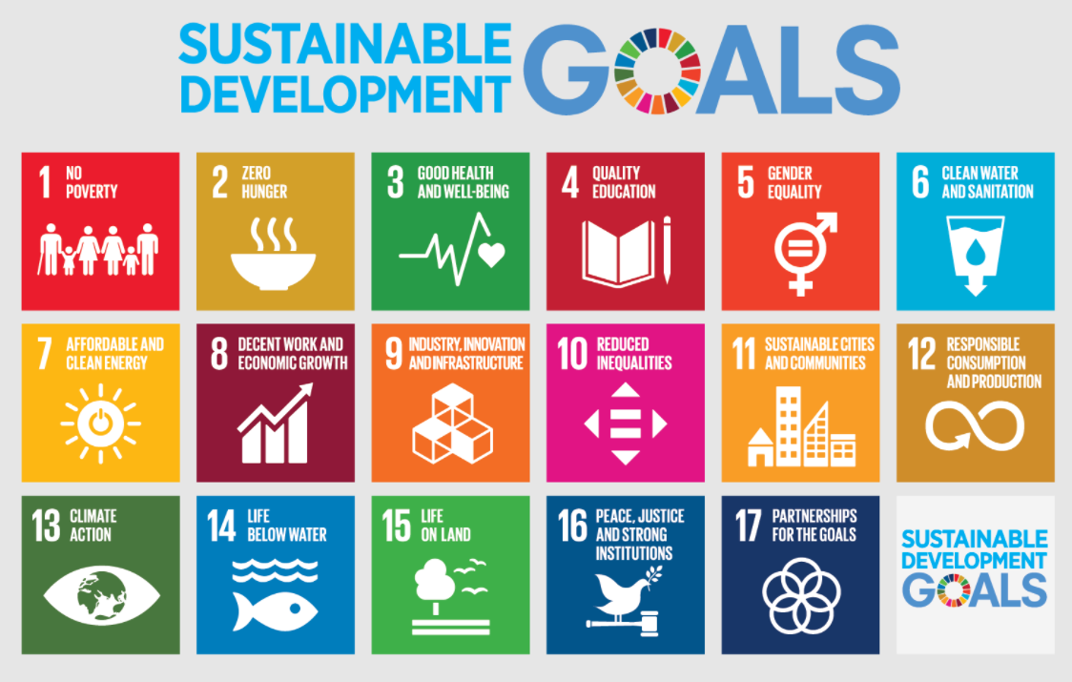
‘UN Sustainable Development Goal (SDG) 4 NB 4.5
English version: https://sdg4education2030.org/the-goal
Myanmar version: https://www.mm.undp.org/content/myanmar/my/home/sustainable-development-goals/goal-4-quality-education.html

Source: https://www.google.com/search?q=SDGs&tbm (free)

Activity 10.4 Answers - Discussion
Target headings for Sustainable Development Goal (SDG) 4

4.1 - Free Primary and Secondary Education
4.2 - Equal Access to Quality Pre-primary
4.3 – Equal Access to Affordable Technical, Vocational and Higher Education
4.4 – Increase the Number of People with Relevant Skills for Financial Success
4.5 – Eliminate all Discrimination in Education
4.6 – Universal Literacy and Numeracy
4.7 – Education for Sustainable Development and Global Citizenship

The next reading task focusses your attention onto Target 4.5 – the Elimination of all Discrimination in Education

Reading task
Please read the brief extract below taken from Sustainable Development Goal 4 (which you will have scanned previously in activity 10.3), Target 4.5

Sustainable Development Goal 4, Target 4.5 - the Elimination of all Discrimination in Education
The aim of SDG 4 is to | “Ensure inclusive and equitable quality education and promote lifelong learning opportunities for all.”
Target 4.5 aims to | “Eliminate all discrimination in Education.”

By 2030, eliminate gender disparities in education and ensure equal access to all levels of education and vocational training for the vulnerable, including persons with disabilities, indigenous peoples and children in vulnerable situations
- Inclusion and equity: All people, irrespective of sex, age, race, colour, ethnicity, language, religion, political or other opinion, national or social origin, property or birth, as well as persons with disabilities, migrants, indigenous peoples, and children and youth, especially those in vulnerable situations or other status, should have access to inclusive, equitable quality education and lifelong learning opportunities. Vulnerable groups that require particular attention and targeted strategies include persons with disabilities, indigenous peoples, ethnic minorities and the poor.

- Gender equality: All girls and boys, women and men, should have equal opportunity to enjoy education of high quality, achieve at equal levels and enjoy equal benefits from education. Adolescent girls and young women, who may be subject to gender-based violence, child marriage, early pregnancy and a heavy load of household chores, as well as those living in poor and remote rural areas, require special attention. In contexts in which boys are disadvantaged, targeted action should be taken for them. Policies aimed at overcoming gender inequality are more effective when they are part of an overall package that also promotes health, justice, good governance and freedom from child labour.

Activity 10.5 Inclusive Education policy (international) – UN Conventions (40 minutes)

Read the short extracts (below) from two documents (conventions) and consider how these link to your work as a teacher educator. Please follow the hyperlinks provided in the white boxes IF you feel confident to read the full documents.

When reading part 1 and part 2 below, choose one key point (or phrase) to highlight. An example is given below.
- Convention on the Rights of the Child

Part 1, article 2

United Nations Convention on the Rights of the Child (Adopted and opened for signature, ratification and accession by General Assembly resolution 44/25 of 20 November 1989 entry into force 2 September 1990, in accordance with article 4)

English version: https://www.ohchr.org/en/professionalinterest/pages/crc.aspx

Myanmar version: not available

a) States Parties shall respect and ensure the rights set forth in the present Convention to each child within their jurisdiction without discrimination of any kind, irrespective of the child's or his or her parent's or legal guardian's race, colour, sex, language, religion, political or other opinion, national, ethnic or social origin, property, disability, birth or other status.

b) States Parties shall take all appropriate measures to ensure that the child is protected against all forms of discrimination or punishment on the basis of the status, activities, expressed opinions, or beliefs of the child's parents, legal guardians, or family members.

2. Convention on the Rights of Persons with Disabilities. This has two parts.
Part 1 is from 2011.

United Nations Convention on the Rights of Persons with Disabilities (signed 2011) Article 24 (full version).

English version: https://www.un.org/development/desa/disabilities/convention-on-the-rights-of-persons-with-disabilities/article-24-education.html

Mynamar version: not available

Part 1 – short extract from the full document above
Section 2. In realising this right, States Parties shall ensure that:

a) Persons with disabilities are not excluded from the general education system on the basis of disability, and that children with disabilities are not excluded from free and compulsory primary education, or from secondary education, on the basis of disability;

b) Persons with disabilities can access an inclusive, quality and free primary education and secondary education on an equal basis with others in the communities in which they live;

c) Reasonable accommodation of the individual’s requirements is provided;

d) Persons with disabilities receive the support required, within the general education system, to facilitate their effective education;

e) Effective individualised support measures are provided in environments that maximize academic and social development, consistent with the goal of full inclusion.

Part 2 is from 2016.
United Nations Convention on the Rights of Persons with Disabilities
General comment No. 4 (2016). Article 24: Right to inclusive education (full version).

English version: https://www.right-to-education.org/sites/right-to-education.org/files/resourceattachments/CRPD_General_Comment_4_Inclusive_Education_2016_En.pdf
Mynamar version: not available

Part 2 – short extract from the full document (2016)
Barriers that impede access to inclusive education for persons with disabilities can be attributed to multiple factors, including:

    - the failure to understand or implement the human rights model of disability, in which barriers within the community and society, rather than personal impairments, exclude persons with disabilities;

    - persistent discrimination against persons with disabilities, compounded by the isolation of those still living in long-term residential institutions, and low expectations about those in mainstream settings, allowing prejudices and fear to escalate and remain unchallenged;

    - lack of knowledge about the nature and advantages of inclusive and quality education, and diversity, including regarding competitiveness, in learning for all; lack of outreach to all parents and lack of appropriate responses to support requirements, leading to misplaced fears, and stereotypes, that inclusion will cause a deterioration in the quality of education, or otherwise impact negatively on others;

    - lack of disaggregated data and research, necessary for accountability and program development, impeding the development of effective policies and interventions to promote inclusive and quality education;

    - lack of political will, technical knowledge, and capacity in implementing the right to inclusive education including insufficient education of all teaching staff;

    - inappropriate and inadequate funding mechanisms to provide incentives and reasonable accommodations for inclusion of students with disabilities, inter-ministerial coordination, support and sustainability;

    - lack of legal remedies and mechanisms to claim redress for violations.

Activity 10.5 Discussion about the UN Conventions 2011 and 2016

Both parts of the United Nations Convention on the Rights of Persons with Disabilities (2011 and 2016) focus on the rights of disabled people to access education.

Part 1 identifies the rights of people with disabilities and the requirements placed on governments to ensure presence, participation and achievement.

Part 2 specifically focusses on the barriers that prevent those with disabilities from accessing, participating and achieving in education. The highlighted paragraph draws attention to the problems, a lack of knowledge about inclusive quality education and diversity, can cause.

4.Myanmar national laws and policy for Inclusive Education.

Activity 10. 6 - Myanmar national laws and policy for Inclusive Education. (40 minutes)

Myanmar has national laws and key policy documents that refer to Inclusive Education.

- Please visit the links provided below and scan read the websites/documents about Myanmar law and policy linked to Inclusion.

- Think about how these laws and policy link to your work as an educator. For each law or policy, choose one or two key points (or phrases) to highlight.

Inclusive Education in Myanmar

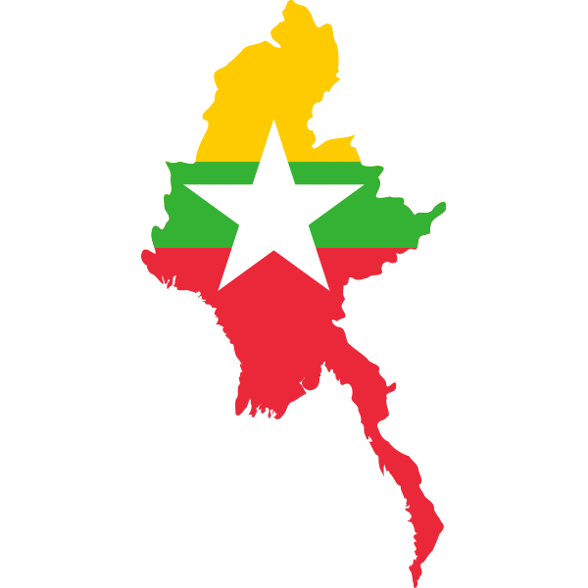
National Disability Law 2015

http://www.ilo.org/dyn/natlex/natlex4.detail?p_lang=en&p_isn=100494&p_count=8&p_classification=08

Myanmar National Education Law 2014
http://www.ilo.org/dyn/natlex/natlex4.detail?p_lang=en&p_isn=100492&p_country=MMR&p_count=100

Child Rights Law 2019
http://www.myanmar-law-library.org/law-library/laws-and-regulations/laws/myanmar-laws-1988-until-now/national-league-for-democracy-2016/myanmar-laws-2019/pyidaungsu-hluttaw-law-no-22-2019-child-law-burmese.html

Microsoft Word - ကလေးသူငယ် အခွင့်အရေးများဆိုင်ရာဥပဒေ.docx (myanmar-law-library.org)
Key Policy

Teacher Competency Standards Framework (TCSF) 2020
Teacher Competency Standards Framework (TCSF) - Resource - EDC (moe.edu.mm)

Image Source: https://freesvg.org/burmaoutline2 (free)

NOTE: extracts from two of the laws and the policy above have been copied into a discussion below. One or two key points (or phrases) from each have been highlighted.

Activity 10.7 Discussion - Myanmar national laws and policy for Inclusive Education

The following text has been extracted from two of the laws and the policy from Myanmar (in Activity 10.6 above). The main aims and key points are highlighted in yellow.

Please note: These are not official translations

Law - Myanmar National Education Law 2014 (Chapter 8, paragraphs 45, 48 & 49)

Chapter 8: Educational Rights and Responsibilities

45. Parents and guardians have the responsibility to enrol their school-aged children in a relevant school to study and to complete all grades of education designated as free and compulsory by the government.

48. All members of a neighborhood or village shall participate to ensure that the children in their community complete the free and compulsory education levels.

49. Regional governments: (a) shall help and guide educational matters in accordance with current law. (b) shall aim and work to have every child complete the free and compulsory 2 education. (c) shall have programs to reward exceptional students. (d) shall implement programs for the continuing education of both exceptional students and those with learning difficulties. They shall also assess and approve programs of outside help.

Law - National Disability Law 2015 (Chapter 2)
The aims of the Law are as follows: a) to take better care of persons with disabilities in accordance with the national Constitution b) to implement more effectively the provisions for the rights of persons with disabilities as recognized by the UN Convention c) to enable person with disabilities to enjoy the human rights and fundamental freedoms of citizens on an equal basis with others d) to integrate in the society of different fields such as politics, social, education, health, economic, culture, and public affairs on an equal basis with others e) to acknowledge the dignity, ability and capacity of the persons with disabilities by the nation and its citizens f) to develop the living standards and assure the life security 3 g) to reduce and eliminate the discrimination in all fields in different manners, and to present the discrimination under this law h) to protect the persons with disabilities, especially women and children from being abused and exploited including domestic violence and bullying i) to give special care to the persons with disabilities without parents, guardians, and who suffer from more than one type of disabilities depending on its type.

Policy – Myanmar Teacher Competency Standards Framework (TCSF) 2020
As Myanmar raises the quality of the education system, through reforms to the basic education
curriculum and structure of schooling (Kindergarten to Grade 12), it needs teachers with the right values, skills and knowledge to be effective practitioners. To achieve this objective, Myanmar needs a strong system of teacher education (pre-service and in service continuing), with programmes that provide the theoretical foundations to produce graduates and a quality teacher workforce with the kinds of professional knowledge, understanding and skills associated with the role and duties expected of Myanmar’s teachers and the process of teaching.

A teacher competency standards framework provides the guidance to meet this need. It documents clear and concise profiles of what teachers are expected to know and be able to do and how well they do at the different stages of their career. It establishes benchmarks against which progress in professional development can be assessed over time, ensuring that appraisal and feedback are used in a supportive way to recognise and reward effective practice.

5.The importance of Inclusive Education

Activity 10.8 - The importance of Inclusive Education (a reminder from previous modules) (15 minutes)

Watch the video - Inclusive Education: Equity Now (1 minute 53 seconds).
This video was shared in module 1 when we explored inclusive teachers, classrooms and schools.

- State at least 3 reasons why Inclusive Education is important for Myanmar.
- What is your role in ensuring that inclusive education exists in your setting?

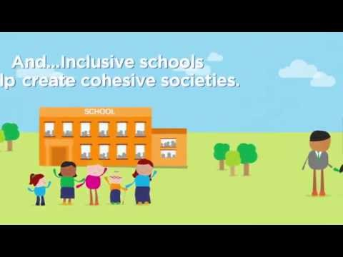

https://www.youtube.com/watch?v=8HPh4RoV63s

Activity 10.8 Answers - the importance of Inclusive Education

- Fundamental right of every child
- Everyone receives quality education
- All children can be present, participate and achieve
- Differences are celebrated rather than seen as a barrier
- Individual needs are met
- Smart investment
- Productive society
- Less unemployment
- Higher economic growth
- Cohesive society

Linking policies, laws and teaching practice

As an educator, you will be responsible for teaching your students about the specific policies and laws that effect their Inclusive Educational practice in their classrooms. To help you think carefully about the different information you will need to share, please complete the following activity.

Activity 10.9 - Introducing policies and laws about Inclusion to student teachers in your context (90 minutes)

This activity links theory (laws and policies) to practice (teachers’ classroom practice) about Inclusion.
You have a choice, in groups to.

Either.

- Create a poster that introduces the laws and policies (either discussed in this module or which relate to your context) to student teachers. It must be simple, clear and engaging to different types of learners (multisensory). Think about the different needs of students you find in a class (inclusion).

OR

- Draw a mind map showing why policies are often not enacted at school or classroom level due to challenges with the implementation process, teachers’ interpretation of policies, etc. An example of this could be the language of instruction policies.

OR

- Relate policies and laws to Teacher Competency Standards Framework (TCSF). How you do this is your choice. It needs to be simple, clear, and engaging to different types of learners (multisensory). Think about the different needs of students you find in a class (inclusion).

Before you start, plan how you might do this (you could produce a mind map or list etc. of your ideas). Consider the following.
  - What will it include?
  - What images/graphic organisers will you use?

- Possible ideas for action research project
In module 6, you were introduced to the idea of carrying out small-scale action research projects to develop your inclusive teaching practice.

The diagram below shows the action research cycle.
1) decide on the question,
2) plan how to answer it,
3) carry out the research – observe, question, etc.
4) review the data
5) plan if/how to improve.

The cycle then continues until you are confident with the changes you have made.

Action ResearchCycle
- Question
5. New plan

4. Review
2. Plan

3. Do

Suggestions:
The following two questions give examples/suggestions of what you might ask when trying to improve your teaching about introducing policies, laws and practice to your students. There are many other questions that could be asked.

- What is the best way of teaching about laws, policies and practices linked to Inclusion to your students?
- When is it appropriate, in the scheme of work, to introduce learners to the subject of policies, laws, and teaching practices linked to Inclusion?

Wrap up
In this module you have:

- Identified the policies and laws which support the realization of Inclusive education in Myanmar
- Outlined the relevant sections of international and national policies and laws in relation to Inclusive Education in Myanmar
- Summarised how aspects of the policies or laws relate to the work of the teacher educator

Key points from this module:

- The United Nations has taken the lead role internationally in driving the improvement of education with 193 countries globally.
- The Sustainable Development Goal (SDG 4) and the Convention on the Right of People with Disabilities (2011 and 2016) are the main international drivers.
- Inclusive Education is fundamental in supporting the rights of ALL learners
- Myanmar has three laws and a policy that addresses the international requirements for Inclusive Education but on a national scale.
- The Teacher Competency Standards Framework (2020) adapts policies and laws into a meaningful ‘practical’ plan of action for educators.

Reflection

- Were you aware that so many countries are all trying to improve the quality of their education systems linked to international policies and laws?
- It is important to realise that millions of teachers around the world are trying to do what you are doing – improving your inclusive practice.
- Think about all the policies and laws from the United Nations to your practice (TCSF) as an educator in school or college.
- Why is it important to be aware of what drives your teaching practice in the classroom?
- How might your improved inclusion practice effect your learners’ and their families’ lives?

- Improving teaching and learning

Activity 10.10 – Reflection (15 minutes)

Using your learning journal, spend some time reflecting on the following questions.
You might find it useful to discuss the questions in pairs or prefer a more private reflection.

- How will I teach children or young people about international/national policies and laws about Inclusive Education?
- When would I introduce this subject into the curriculum?
- You might want to revisit these questions when carrying out your self-assessment at the end of the module and use some ideas from the module.

End of module 10 quiz
Please answer the following questions in your learning journal. You can attempt as many times as you like to reach 100% pass. Some questions require more than one answer.
Q1 – A law;
- is something that schools write for their staff to follow
- can be ignored
- makes the legal framework to make sure that policies are put into action.
- is linked to tradition and culture

Q2 – A policy;
- provides different views of a law.
- states the intention of an individual or an organisation (for example a government). It says what the person or organisation plans to do.
- is a law.
- provides examples of how a teacher needs to teach.

Q3 – The Acronym SDGs means:
- Substantial Development Goals
- Sustainable Development Gains
- Sustainable Development Goals
- Specific Development Goals

Q4 – A practice (linked to laws and policies)
- means to repeat an activity until you get it right
- the actual application (in the school/classroom) or use of an idea, policy and/or law
- is a term used for a law firm (law practice)

Q5 – Which SDG is linked specifically to education
- SDG 1
- SDG 5
- SDG 10
- SDG 4

Q6 – Which international policies and law effect inclusive practice worldwide (choose three)
- Geneva Convention 1949
- United Nations Convention on the Rights of Persons with Disabilities (2016).
- Myanmar National Education Law 2014
- Sustainable Development Goals
- United Nations Convention on the Rights of Persons with Disabilities (signed 2011)

Q7 – Which three national laws and one policy effect inclusive practice in Myanmar? (choose 4)
- Myanmar International Education Law 2014
- Geneva Convention 1949
- National Disability Law 2015
- Myanmar National Education Law 2014
- Child Rights law 2019
- Myanmar Teacher Competency Standards Framework 2020

Answers – end of module 10 quiz
Answers in bold

Q1 – A law;
- is something that schools write for their staff to follow
- can be ignored
- makes the legal framework to make sure that policies are put into action
- is linked to tradition and culture
Explanation - the system of rules which a particular country or community recognises as regulating the actions of its members and which it may enforce by the imposition of penalties.

Q2 – A policy;
- provides different views of a law.
- states the intention of an individual or an organisation (for example a government). It says what the person or organisation plans to do.
- is a law.
- provides examples of how a teacher needs to teach.
Explanation – This is what an organisation/government plans to do and how they will do it.

Q3 – The Acronym SDGs means:
- Substantial Development Goals
- Sustainable Development Gains
- Sustainable Development Goals
- Specific Development Goals
Explanation – The 17 Sustainable Development Goals, specifically SDG 4, followed by 193 countries, forms the basis of worldwide targets for improving the quality of education.

Q4 – A practice (linked to laws and policies)
- means to repeat an activity until you get it right
- the actual application (in the school/classroom) or use of an idea, policy and/or law
- is a term used for a law firm (law practice)
Explanation – Policies plan what an organisation/government wants to do; practices are ‘how’ they are going to do it. Myanmar’s NESP (2011-2016) linked to the TCSF provides examples.

Q5 – Which SDG is linked specifically to ‘quality education’
- SDG 1
- SDG 5
- SDG 10
- SDG 4
Explanation – Sustainable Development Goal 4 is linked specifically in improving the quality of education internationally.

Q6 – Which international policies and laws effect inclusive practice worldwide (choose three)
- Geneva Convention 1949
- United Nations Convention on the Rights of Persons with Disabilities (2016).
- Myanmar National Education Law 2014
- Sustainable Development Goals
- United Nations Convention on the Rights of Persons with Disabilities (signed 2011)
Explanation – The Geneva convention 1949 relates to the treatment of captured and wounded military personnel. The Myanmar National Education Law 2014 is a national, not an international policy.

Q7 – Which three national laws and one policy effect inclusive practice in Myanmar? (choose 4)
- Myanmar International Education Law 2014
- Geneva Convention 1949
- National Disability Law 2015
- Myanmar National Education Law 2014
- Child Rights law 2019
- Myanmar Teacher Competency Standards Framework 2020
Explanation – The Myanmar International Education Law 2014 is not correct as it is not a law and it states ‘international’ in its title. The Geneva convention 1949 relates to the treatment of captured and wounded military personnel. The other four are linked to Myanmar and stem from international policy.

Activity 10.11 Self-assessment
REFLECTION: How well do you think you know and understand the international and national laws and policies that effect the inclusive practice in your school/classroom? Look at the scale below and choose the number that best describes you now. Answer in your learning journal.
VERY well
NOT well
Compare your first self-assessment score at the beginning of this module to this one. In your learning journal provide a short analysis of your thoughts about any differences.

Your 10th PROMISE to your STUDENTS

1
3
2

Review

Do

Plan

Please add your 10th promise to the section in your learning journal entitled ‘Promises.’
Each module contains one promise you will make to your learners: you will make 15 promises in total.

References

UN Convention on the Rights of Person with Disabilities (2011) Article 24 https://www.un.org/development/desa/disabilities/convention-on-the-rights-of-persons-with-disabilities/article-24-education.html
UN Convention on the Rights of Person with Disabilities : General comment (2016) Number 4
https://www.right-to-education.org/sites/right-to-education.org/files/resource-attachments/CRPD_General_Comment_4_Inclusive_Education_2016_En.pdf
UN Convention on the Rights of the Child (1990) Article 49
https://ohchr.org/Documents/ProfessionalInterest/crc.pdf
National Education Law (2014) http://www.ilo.org/dyn/natlex/natlex4.detail?p_lang=en&p_isn=100492&p_country=MMR&p_count=100
National Disability Law (2015) http://www.ilo.org/dyn/natlex/natlex4.detail?p_lang=en&p_isn=100494&p_count=8&p_classification=08
National Education Strategic Plan (2016-2021) https://www.britishcouncil.org/sites/default/files/myanmar_national_education_strategic_plan_2016-21.pdf
UN Sustainable Development Goal 4 NB 4.5
English: https://sdg4education2030.org/the-goal
Mynamar: https://www.mm.undp.org/content/myanmar/my/home/sustainable-development-goals/goal-4-quality-education.html

