Plant, Grow, Harvest

What to grow
- Look at your growing area – is it susceptible to frosts, high up, low lying?
- Where are you in your growing journey – plants like radishes, potatoes and tomatoes are easy starting points.
- What type of soil have you got?
- When will produce be ready to harvest and can you make use of it when it is ready?
- Have you got the time to look after more demanding vegetables?
- What will the children like to eat?

When to grow
- Consult your growing calendar.
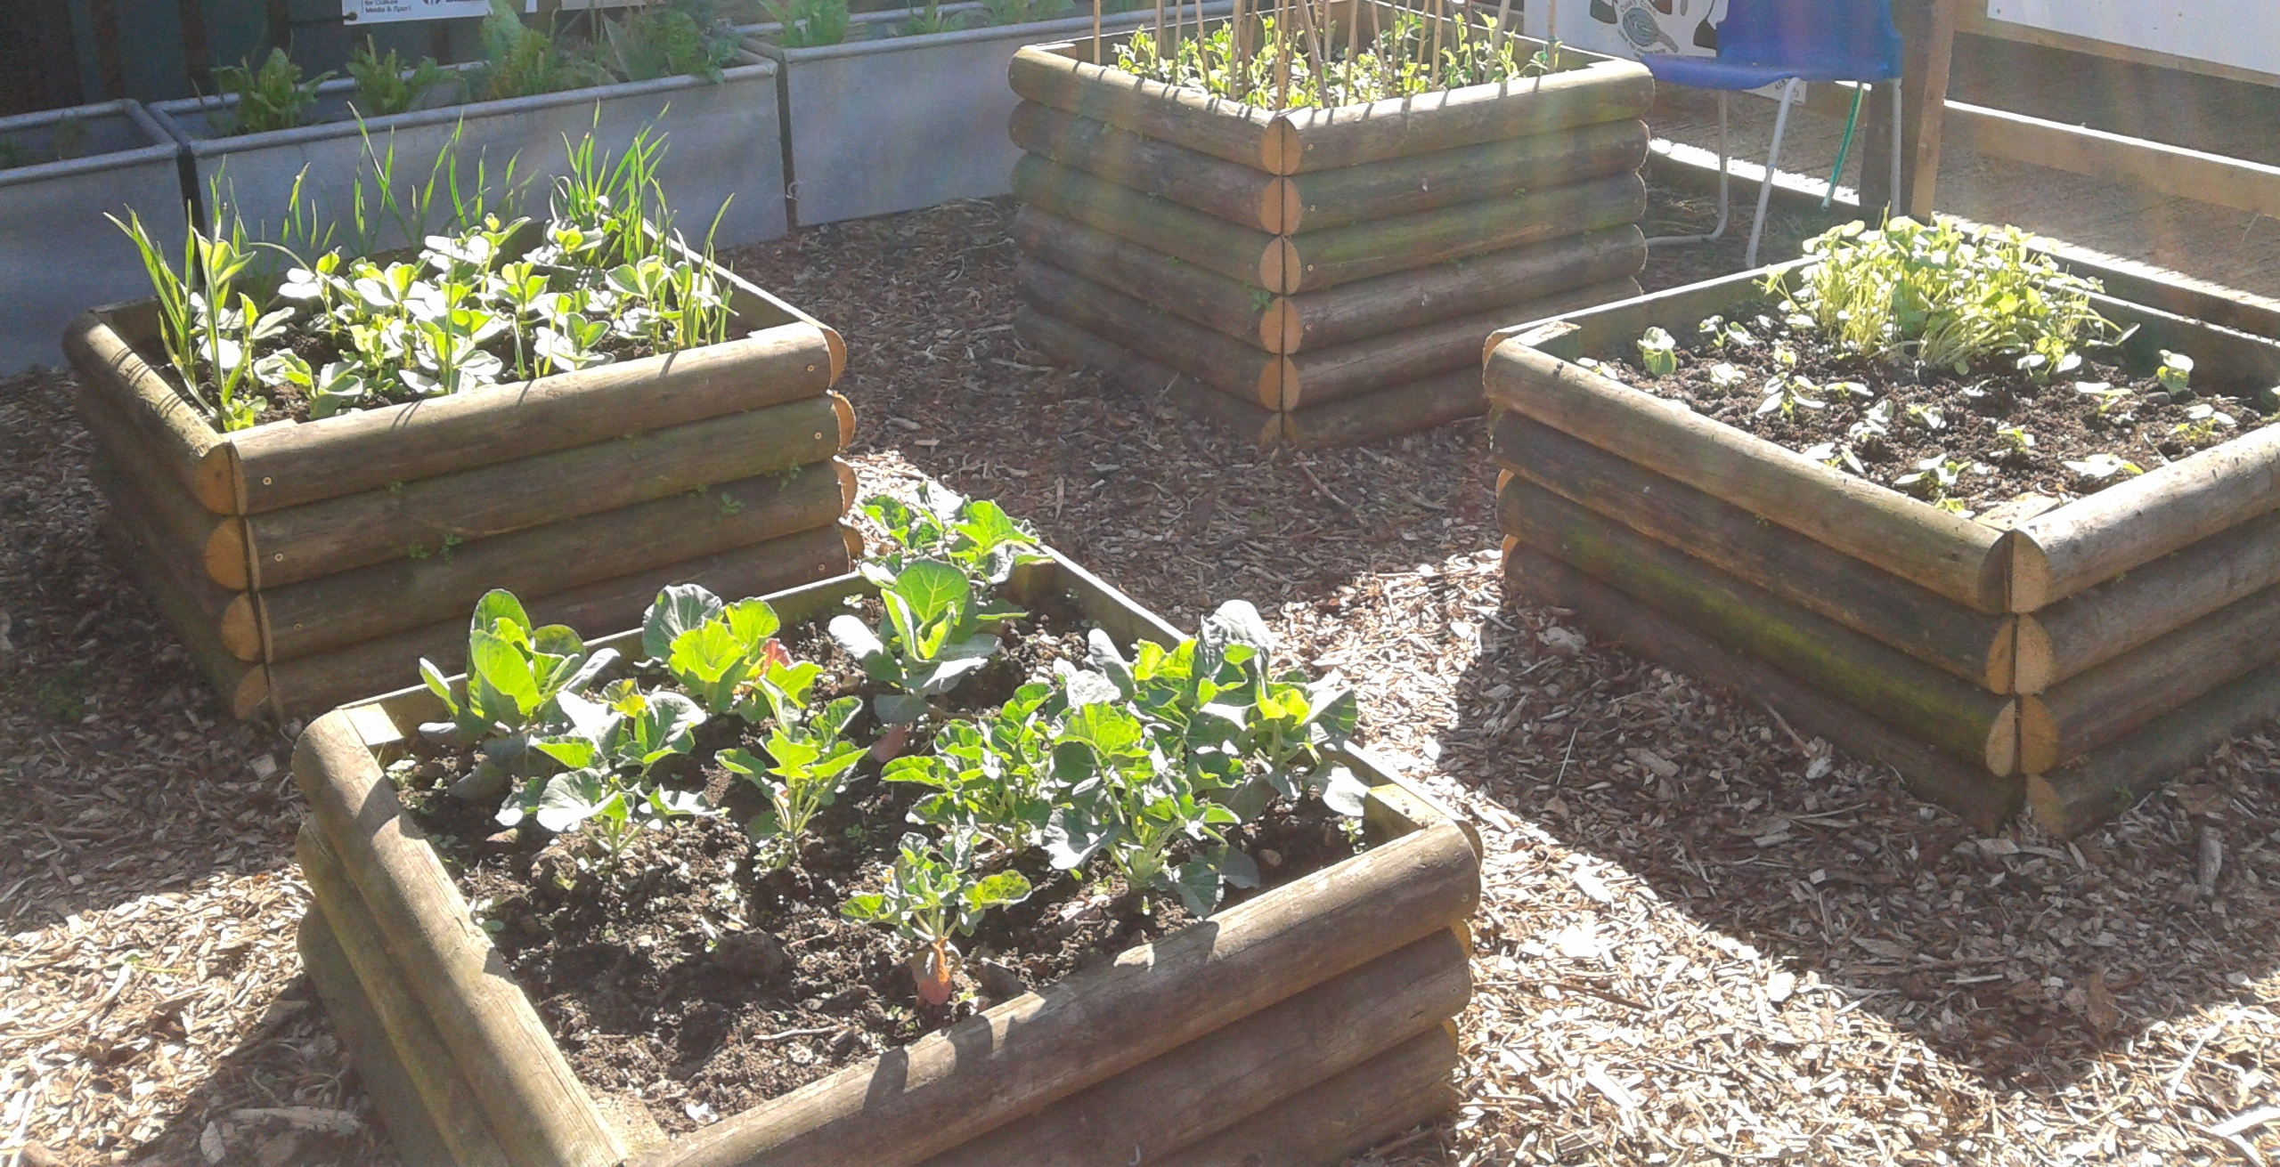
- Use the following guide hardy seeds – onions, broad beans, garlic can be sown outside when soil is 5⁰ C. More tender seeds (tomatoes) need a temperature of 12⁰ C.
- Germination times – pairing up slow and fast growing plants can make the most of the available space (parsnip and radish).
- Successional growing – rather than planting all at once, sow sets of the same plant over a period of several weeks then you have then maturing at different times.

Growing together - Companion planting
3 reasons for companion planting
- Introduce nutrients – beans with sweetcorn, carrots and lettuce as they fix nitrogen.
- Repel pests and diseases – chives and carrots, nasturtium and cabbage, beans (cabbage white butterfly and aphids) Mint can be used with a variety of plants but does grow fast and can overshade/take over so care needs to be taken, marigolds and tomatoes.
- Attract beneficial insects – borage with any plant that needs pollination - peas, beans, strawberries.

Perennial plants
When you are ready you might want to think about plants that are more permanent – rhubarb, fruit trees, artichokes. You need to take more care when planting these as if you get it wrong they won’t flourish

Crop rotation
Putting a plan in place for the long term can help in a number of ways
- Moving crops disrupts diseases like blight and clubroot
- Rotation can help maintain nitrogen levels if legumes are involved
Legumes like beans and peas fix nitrogen. If crops with high nitrogen requirements (brassicas) are grown after legumes they make good use of the nitrogen. Other crops like onions, garlics and roots do not require as much nitrogen
- Can help with maintaining soil ph levels – potatoes don’t like lime and brassicas peas and beans do.
- Maintaining soil structure – roots break up the soil and rotating deep rooted plants with those that don’t mind some compaction is useful

Area 1  potatoes ( for 4 year rotation) | Area 2  beetroot, carrot, chicory, parsnips salsify, potatoes (for 3 year rotation)
Area 3 x  broccoli sprouts, cabbage, cauliflower, kale, radish | Area 4  aubergine, beans, cucumber, leek, lettuce, onion, peas, tomatoes

Focus on leeks
Information from www.growfruitandveg.co.uk
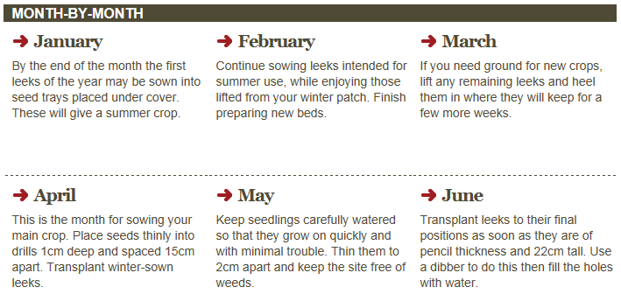

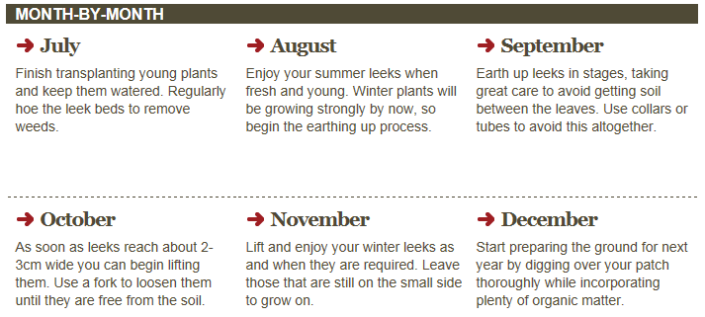

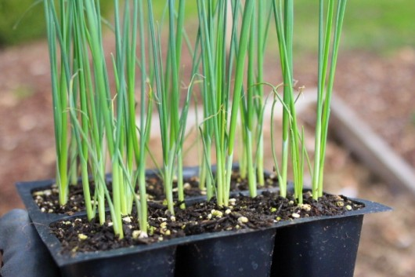

Focus on strawberries
Information from www.growfruitandveg.co.uk
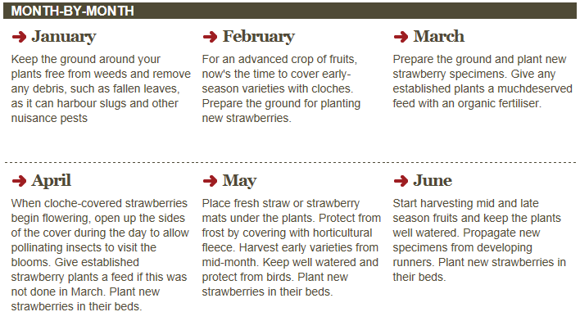
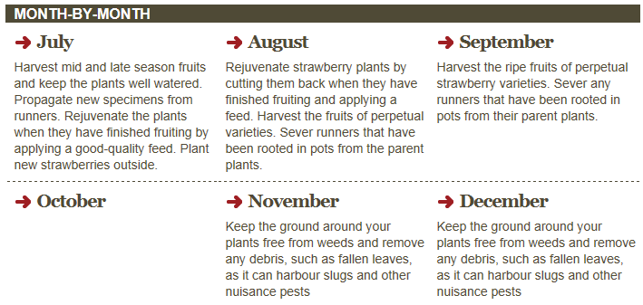
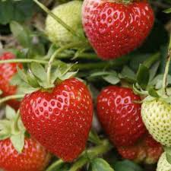

Focus on parsnips
Information from www.growfruitandveg.co.uk
