Course Choice Questionnaire
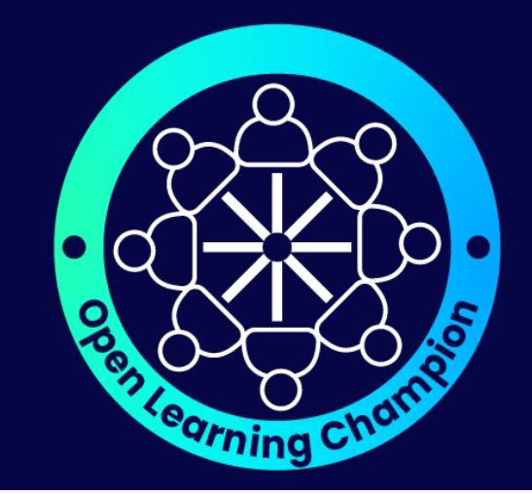
Choosing the right OpenLearn Course for You
This questionnaire is just a basic framework to start from. Depending on your role it is very likely you will have had / will have more holistic conversations about lots of things including:

- Life goals and motivations
- Barriers and enablers
- Current priorities and where learning would fit in – and is it the right time

It may be that it will be several conversations before a discussion about learning comes up naturally, and even then you may feel the best approach is a light tough, informal approach and say away from this questionnaire approach. All approaches, as long as they are learner centred, are valid. This is just a tool to use/adapt/refer to if and when appropriate

- How confident are you working on a computer?
1 2 3 4 5
Not  Confident | Very  Confident
- How would you feel about doing an online course with help?
1 2 3 4 5
Not  Confident | Very  confident

- How much time so you think you could spend roughly each week (best guess ok )
In answering this, don’t forget to account for things like sleeping, cooking, putting kids to bed, having time for fun or anything else that’s important to you!!
Time | Please Tick
< 1 hour
1-2 hours
3-4 hours
More than 4 hours

- What topics to you want to learn about?

- What would you want to get out of learning about these topics?

- What kind of support might you need to help you get the best out of your learning?

- What are the next steps and when will you take them?

Next Step | By when

