**Inclusive Teaching Practice**

**Participant’s Book**

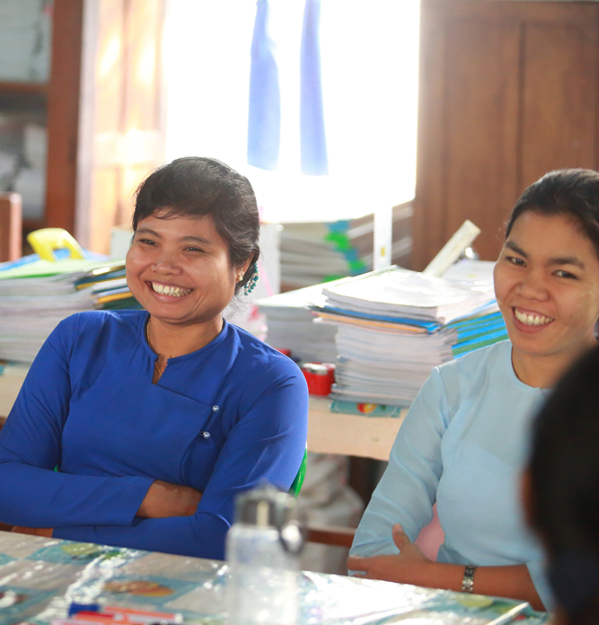

Source: VSO Image library

**Module 9:**

**Supporting students’ emotional and social wellbeing**

Module 9: Supporting students’ emotional and social wellbeing

# **Overview**

This is theninth **of fifteen modules** that look at how we create a positive Inclusive Learning Environment for all. You will see how inclusive teaching practices encourage, develop and use the 21st century skills of critical thinking, communication, collaboration and creativity. These modules are for any educators or those studying in education in Myanmar. The terms student and learner are used interchangeably throughout the module.

|  |  |
| --- | --- |
| Module number | Module title |
| 1 | What is an Inclusive School, Classroom and Teacher? |
| 2 | Knowing your learners |
| 3 | Planning learning outcomes for all |
| 4 | Participating through learner centred approaches |
| 5 | Creating a positive learning environment |
| 6 | Effective questioning and feedback |
| 7 | Active participation |
| 8 | Peer, cooperative and collaborative learning |
| **9** | **Supporting students’ emotional and social wellbeing** |
| 10 | Legal framework and policies around Inclusion in Myanmar |
| 11 | Supporting all students through differentiation |
| 12 | Identifying specific learning difficulties |
| 13 | Supporting all learners with differences or disabilities |
| 14 | Positive behaviour management |
| 15 | Assessment for student achievement |

This module helps you to think about how you can support and motivate students to develop healthy, well balanced, and positive habits and attitudes towards themselves and others. The module will explore how to support students when they are struggling socially and emotionally and also offer suggestions on how to create safe spaces for dialogue about social and emotional wellbeing in the educational settings you might work in.

You will also be asked to record your reflections in a learning journal, so it is important to make detailed notes and think carefully and deeply about your current and future practice. This module also encourages you to develop communities of practice between yourself and your colleagues. This will support and extend your own use of inclusive practices in your teaching and will help your student teachers build on inclusion in their learning and future professional practice.

**Learning Journal**

It will be useful to record your reflections in a learning journal throughout the module.

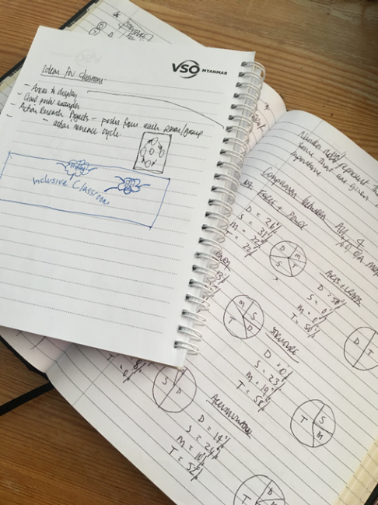A learning journal can be digital (e.g. using Word or Google Docs) or on paper. You can also take photos of your learning journal pages if you want to share your thoughts with others. It is important that you record your thoughts and ideas so that you can remember and use them later in activities and in your own teaching.

Here are some useful tips for a good learning journal:

* Use headings and dates for all your journal entries.
* Use the activity number for reflections linked to that activity, e.g. Activity 1.1
* Add references to any other resources you find that help you.
* Record answers to activities.
* Write reflections about your learning.
* Make notes of new vocabulary.
* Identify topics you want to learn more about.

Source: Rose, N. (2018) Personal Learning Journals

The important thing is that it is easy for you to use. You can take notes which answer simple questions like these:

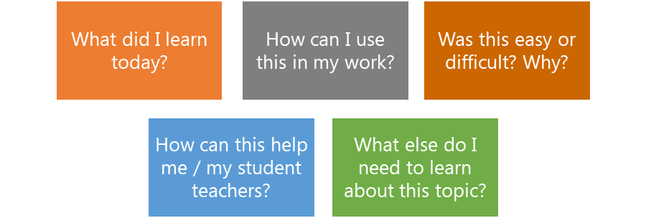

These questions follow the LEARN- APPLY- REFLECT model which is used in education globally. You can return to this journal as you progress through your CPD journey and reflect on your progress.

**Study tips**

Take your time to work through the activities, rather than trying to complete the whole unit at once. Set yourself a timetable and choose a time to work through the tasks, then check and compare ideas with colleagues. Finally, remember to make notes in your learning journal as you go. This will help you remember more about the skills and knowledge you develop as you complete these units.

**Working alone or with colleagues**

This unit is designed for self-study. The answers can be found after each activity. However, if possible, **we recommend working in a pair or group** so you can share ideas, ask questions, check your work, and give feedback.

If you work in a pair or group, we recommend using **Think / Pair / Share** for each activity.

Discuss your ideas in a group, and then check the answers on the next page(s) together.

Check your answers with your partner.

Work alone and make brief notes of your own ideas.

# **Learning outcomes for module 9**

|  |
| --- |
| **By working through this module, you will be able to:**   1. **Explain the effect emotional and social stress has on learning** 2. **Outline a range of emotional and social situations that can cause stress.** 3. **Explain the effect adverse childhood experiences (ACEs), and trauma have on learning and healthy development** 4. **Explain the key areas of social and emotional support** 5. **Identify your own need for social and emotional support and recognise strategies to support themselves** 6. **Select appropriate social and/or emotional support tools to help students socially and emotionally** |

# **Introduction**

In the previous module, you were introduced to the concept of peer, co-operative and collaborative learning styles and the benefits gained by students working together in these ways. You thought about how you, as a teacher, could use techniques to promote student centred learning styles in your educational institution and classroom.

This module introduces why coping well with anxiety and stress, even in difficult situations, can enable students to develop healthier, better balanced, more motivated and happier lives and, by doing so, help others. Inclusive resources can inform you to help support their individual needs.

You will be asked to:

* Read about social and emotional support and why we need it; also about adverse childhood experiences and how they can affect people.
* Watch videos and provide some analysis.
* Complete activities either alone, in pairs or in small groups.
* Think about key questions.
* Reflect on your experience and knowledge.
* Make a promise to your learners.

The module will take **approximately 8 hours to complete.** We hope you have an enjoyable learning experience.

# **Key to symbols**

|  |  |
| --- | --- |
|  | **Activity** – this is **work you need to complete.** |
|  | **Question/s** – please answer the questions. |
|  | **Reflection** – think carefully about how you feel about this. |
|  | **Learning Journal –** please write your answers in your learning journal. |
|  | **Read –** please read the text provided. Make any notes you like. |

# **9.1 Self-assessment**

REFLECTION: How well do you think you **are equipped to support students suffering from stress or well-being difficulties?** Look at the scale above and choose the number that best describes you now. Answer in your learning journal.

VERY well

NOT well

You will be asked to do this again at the end of the module.

* + 1. **Shape, arrow

       Description automatically generatedLink to previous learning – module 8 (Students support each other through peer, cooperative and collaborative learning)**

## Think back to module 8. Match the type of learning to the description provided.

Which learning type do these characteristics best describe?

**Peer learning**

These activities create the atmosphere for students to increase their academic achievement, especially their reasoning and critical thinking. They are more active participants in learning as they care about the class and they are more personally engaged.

**Co-operative learning**

**Collaborative learning**

Students organise themselves and find resources to help them complete the task. It is not monitored by the teacher (although they can help when requested by the group) and students assess their own individual and group performance.

It works best when students of different ability levels work together. Same-age peer is as effective as cross-age peer.

# **1.1.2 Answers**

These activities create the atmosphere for students to increase their academic achievement, especially their reasoning and critical thinking. They are more active participants in learning as they care about the class and they are more personally engaged.

**Peer learning**

**Co-operative learning**

**Collaborative learning**

Students organise themselves and find resources to help them complete the task. It is not monitored by the teacher (although they can help when requested by the group) and students assess their own individual and group performance.

It works best when students of different ability levels work together. Same-age peer is as effective as cross-age peer.

1. **What is social and emotional wellbeing?**

When we think about someone with good emotional and social wellbeing, we tend to think of people who appear positive and happy. Research and experience tell us that this is not the case, someone’s behaviour is not always an indicator of how they feel inside.

In education, sometimes social and emotional wellbeing can be called life skills, personal development or character development. Sometimes, it can refer to mental health or psychosocial support. In this module we will use the term **social and emotional wellbeing** to refer to student’s development socially and emotionally, and their ability to cope with ‘normal’ and ‘abnormal’ situations that happen in their life, addressing relationships, values and practices.

Social and emotional wellbeing are the skills that children and young people develop in how resilient they are and how they manage their thoughts, feelings and behaviour towards themselves and others. It is an understanding of how they manage and act, how they relate to others and make responsible choices.

Social and emotional learning help children and young people to:

Build and maintain healthy relationships

Identify, understand and manage their feelings and behaviour

Be self-aware

Have a sense of self-control in how they behave.



Engage in peer support and self-care strategies

Reach out for help when they need it

Build resilience, self-esteem and confidence

Feel and show empathy for others

Recognise poor mental health and know how to prevent it

Resolve, handle and overcome difficulties

Make appropriate decisions

Think positively about themselves and how they see the world around them

Behave responsibly with good intentions

Image source: <https://www.myanmargraphic.com/category/people/> (free)

Social and emotional wellbeing is essential for overall health and wellbeing. Being socially and emotionally well, means being able to realise your abilities, cope with the ‘normal’ stresses of life, and contribute to community and grow into well-rounded and healthy adults.

Often in education institutions, the focus is on academic subjects and there is pressure on outcomes. This can leave little time for educators to intentionally teach children and young people about skills such as resilience and how to build successful relationships. Is it therefore assumed that children and young people will simply learn the skills along the way or that it is the responsibility of parents to teach them?

In module 2 we explored the need for teachers to ‘know your learners’ and understand the factors in their lives that impact how they are able to learn at school. Schools can play a pivotal role in building the strong emotional foundations that children and young people need to thrive and be mentally healthy and balanced.

|  |
| --- |
| **Shape, arrow  Description automatically generatedActivity 9.1 – Reflection (15 minutes)** **A picture containing logo  Description automatically generatedPersonal** reflection  Which social and emotional skills did you use in the last week?  • Were you able to recognise others’ emotions?  • Were you able to manage the way you expressed your emotions?  • Did you use any coping strategies to deal with any stress or challenges?  • Have you provided or have you received support from others?  If you can, discuss the questions above with a colleague or peer. Think about how you developed these skills and how important they are in your life and in different situations.  **Professional** reflection  Think about the students you teach. You might find it useful to discuss the questions in pairs or you may prefer a more private reflection in your learning journal.   * How do I **teach** students about their **social and emotional wellbeing**? * Do I **support** students’ ability to cope with difficult situations? * What **opportunities** do I provide for students to **build positive relationships** with their peers and adults?   You might wish to revisit these questions when carrying out your self-assessment at the end of the module and use some ideas from module 2 (Knowing your learners) as this will be crucial in the support you are able to give once you know students’ background, etc. |

If social and emotional skills can improve academic attainment and enhance pupils’ motivation, as well as promote wellbeing and help prevent mental health difficulties from developing, teachers should allow time to teach and develop these skills with as much importance as learning to read and write. A range of studies carried out over the past few years suggest that a range of approaches that enhance learners’ wellbeing improve:

|  |  |  |
| --- | --- | --- |
| Participation in learning | Improves mental wellbeing | Improves employability |
| Reduces mental health problems following  exposure to conflict  and disasters | Improves social and classroom behaviour | Improves connectedness to school, teachers and learning |
| Academic achievement and performance | Reduces bullying and gender-based harassment | Reduces school drop-out numbers |

1. **Factors that can affect social and emotional wellbeing**

In module 2 we identified key factors that would help a teacher to understand their learners. Emotional and Social Influences were discussed and with the information that we knew about the learners, we could then understand if there were considerations that needed to be made to teaching and learning in the classroom. Those influences are listed below with a few additional ones;

* family structure
* exposure to violence
* exploitation
* poor health
* conflict in their community
* self-esteem
* family history
* recent change or loss in the family
* attitude or personality
* limited access to food or poverty

|  |  |  |  |  |  |  |  |  |  |  |  |  |  |  |  |  |  |  |
| --- | --- | --- | --- | --- | --- | --- | --- | --- | --- | --- | --- | --- | --- | --- | --- | --- | --- | --- |
| **Activity 9.2 – Factors that can affect social and emotional wellbeing (45 minutes)** **Think** about **students** you teach. Icon  Description automatically generatedDo you suspect any of them are **struggling socially or emotionally**?   * Perhaps they seem **stressed** (we will move on to this later in the module). * What factors might be **causing or influencing this change in behaviour**? * What **impact** is this having on their learning in class?   A group of people in a classroom  Description automatically generated with medium confidenceRead the examples below and then think about the students you teach. You may find it easier to start with the bottom box (**Impact**) listing behaviours you see and then think about their unique situation.   |  |  | | --- | --- | | Child | Aung Aung | | Situation | Father died recently which has put pressure on the whole family. Aung Aung feels sad for the loss and that he should be at home supporting family. | | Impact | He is not engaging as he previously did. Aung Aung’s behaviour has changed, he is starting to call out and seems angry a lot of the time. |  |  |  | | --- | --- | | Child | Thet SuKyi | | Situation | Lives in large family unit with babies Does not get regular sleep | | Impact | Thet Sukyi looks tired in class and isn’t joining in with group work and discussions. She never completes her homework. |   Draw the table below in your learning journal to make notes about the students you teach. You could label your students as Child A, B, etc to ensure personal details remain confidential.  Use the list in the previous section to help you identify any issues that are affecting a student’s social and emotional wellbeing.   |  |  | | --- | --- | | Child |  | | Situation |  | | Impact |  |   Image source: <https://pixabay.com/images/search/burma/?pagi=2&> (free) |

Many of the factors that have been discussed will be particularly challenging for children and young people to deal with. It is important to acknowledge that they may affect boys and girls and men and women differently. Not all people will have them same reaction to the same situation. It is likely that everyone will experience a stressful, upsetting, or traumatic experience in their lives and their individual social and emotional skills and wellbeing will affect the way they respond to it.

|  |
| --- |
| **Further reading - Adverse Childhood Experiences**  Children can experience adverse experiences in their childhood which can affect their development. The more aware that teachers are of any background or adverse experiences in a child’s life, the more effectively they can understand the student and offer support or guidance.  **Adverse Childhood Experiences** are **unhappy, frightening, hurtful events** that a child experiences. They often happen over a period of time. The child is under a lot of stress during the experience which can affect the way their brain and body develops.  Adverse Childhood Experiences can be:   * **Physical abuse** – being hit, kicked, pushed. * **Emotional abuse** – being made to feel unvalued, stupid, scared. * **Sexual abuse** – unwanted sexual activity. * **Physical neglect** – not having enough shelter, food and physical care. * **Emotional neglect** – not having enough positive attention and loving care. * **Mental illness in the family** – difficulties with positive interactions. * **Violence in the family** – either parent being hit, constant shouting and arguments. * **Separation from a parent** – through divorce or being abandoned. * **Death of a parent** * **Member of the family in jail** – separation and loss. * **Drug or alcohol abuse in the family** – someone using drugs or drinking too much too often. * **Bullying** – threatened or hurt physically or emotionally * **Discrimination** – treated unfairly and harshly especially because of ethnic or religious background or racism. * **Violence in the community** – gangs, crime, conflict and war. * **Migration** – moving from one country or area to another especially when because of conflict, disasters and discrimination.   Each of these events can cause a child to experience stress. If there is no support, the stress can become harmful. We will explore this in more detail later in the module. |

1. **How social and emotional wellbeing affects teaching and learning**

It is likely that if students are struggling with their emotional and social wellbeing, there may be changes in their behaviour. If you know your students well, you will be more likely to recognize any changes. This can be a huge challenge where class sizes are large. Whilst it will be unique to each child, you may recognize some of these behaviours in the students you teach;

* Students may appear tired or depressed
* They may be quieter than usual or withdrawn
* They may be easily distracted or are more likely to distract others
* Students might find it difficult to focus or give up easily.
* Students may act out and display behaviour that is unlike their character
* Experience more breakdowns in relationships, unable to resolve conflicts

|  |
| --- |
| **Shape, arrow  Description automatically generatedActivity 9.3 – video: Learning Brain vs Survival Brain (15 minutes)** This video explains how stressed or traumatized students and children feel (and compares with a baby elephant!).  [Understanding Trauma: Learning Brain vs Survival Brain](https://www.youtube.com/embed/KoqaUANGvpA?feature=oembed)  Video –  Understanding trauma: Learning Brain vs Survival Brain  [www.youtube.com/watch?v=KoqaUANGvpA](http://www.youtube.com/watch?v=KoqaUANGvpA)  **A picture containing logo  Description automatically generated**  **Watch, listen and make notes in your journal.** You can pause or rewind at any time. After you have made some notes read through the key points taken from the video on the next page.    Please find the reminder below if you would like to watch with subtitles or look at a transcript. **Subtitles on YouTube videos -** Turn **subtitles** on in a YouTube video Graphical user interface, text, application  Description automatically generated **Transcripts on YouTube videos**   Read the **transcript** for a YouTube video. Click 3 dots.  Graphical user interface, text, application  Description automatically generatedGraphical user interface, application  Description automatically generated  Click ‘open transcript’ |

**Surviving Brain**

**Learning Brain**

Fearful of making mistakes

Feels panicked, unable to focus on more than one thing

Feels threatened by new learning experiences

Able to see the bigger picture

Not afraid to make mistakes

Feels calm, peaceful, and curious

Comfortable with ambiguity (information which is unclear)

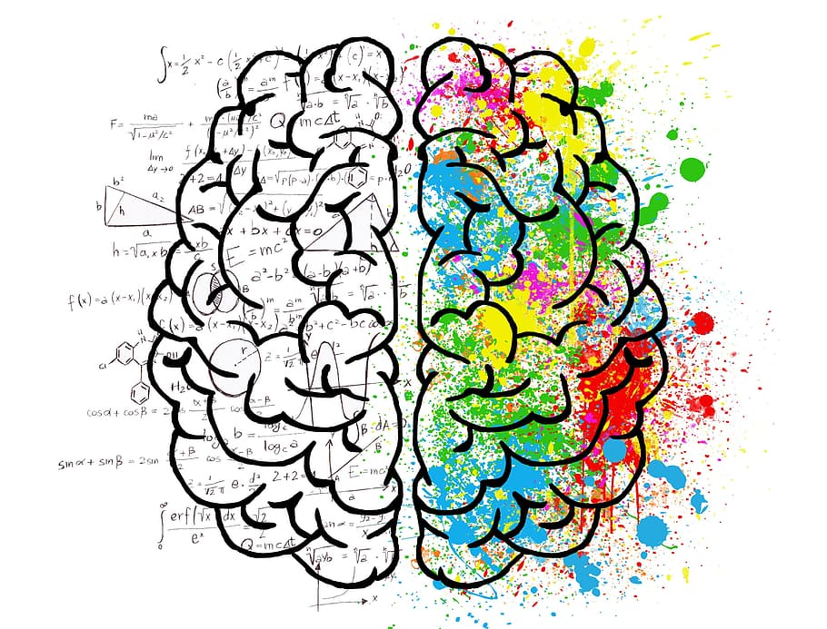

Open to new learning experiences

Image source: <https://www.piqsels.com/en/public-domain-photo-fhzno> (free)

Less likely to engage, lacking confidence

Does not like ambiguity

(Information which is unclear)

In this theory, the survival brain will always override the learning brain as it is designed to seek safety. Highly stressed students find it difficult to learn because the focus in the brain is on any perceived threats or dangers. When stress is controlled, the learning brain is easier to use, as a feeling of control and balance in emotional wellbeing resumes. Students learn best when they feel safe and supported by the adults around them. It is important for schools to create an environment where students feel they are surrounded by protected adults, so they feel safe (like the baby elephant in the video).

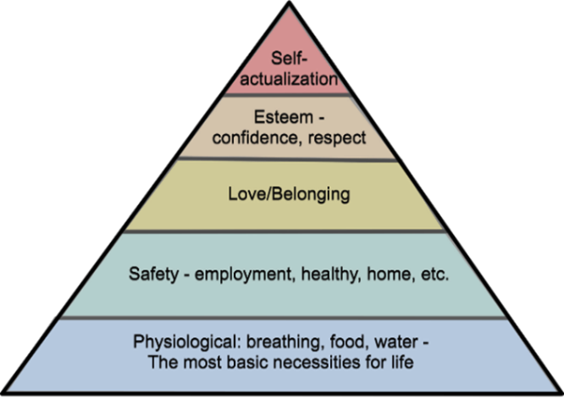In module 5, you were introduced to Maslow’s Hierarchy of Needs (1943). He argued that human motivation is based on the pursuit of different levels of needs. This order begins with the most basic needs (physiological) being met before your are ready to move on. At the lowest level, you must have enough food and water, moving on to the need to feel safe, warm and healthy. The ultimate goal, is to reach the top of the hierarchy: self-actualization, where students are creative and can reach their full potential. Before this can happen, they must feel safe, loved and a sense of belonging.

If there has been a long period of time where students have not been at school or they have experienced a sense of trauma, educators might find that students are not ready to go back to the way they learnt before they were absent. Often children with social and emotional difficulties are not considered when we think about inclusion and inclusive practice but it is important that their needs are met along with other students.

Image Source: <https://pixabay.com/illustrations/needs-hierarchy-maslow-triangle-5193151/> (free)

|  |  |  |  |  |  |  |  |  |  |  |  |  |  |  |  |  |  |  |
| --- | --- | --- | --- | --- | --- | --- | --- | --- | --- | --- | --- | --- | --- | --- | --- | --- | --- | --- |
| **Shape, arrow  Description automatically generatedActivity 9.4 – Emotional needs or academic needs. What is the priority?**  **(30 minutes)** A picture containing text  Description automatically generated  Use the Maslow model to **reflect** on the needs of your learners and link it back to Module 5 - how you create a positive learning environment, particularly the emphasis on building meaningful relationships.    **A picture containing logo  Description automatically generated**If students are having emotional and social problems, either due to a personal situation or something that may have happened on a larger scale, how can we as educators provide a sense of security and ensure their basic needs are met?  Copy the following table in your learning journal and discuss it with a colleague if you can. Write some practical ideas of what you can do to start to meet the needs of the students you teach. A few examples have been added to discuss and help you get started.   |  |  |  | | --- | --- | --- | | **Physiological needs**  Food, water, warmth, rest | **Safety needs**  Security, safety, healthy | **Belongingness/love needs**  Relationships, friends, sense of belonging | | Ask students if they have eaten. If they haven’t it will be unlikely that they will be able to focus for a long period of time. Is there a way that you can provide food or talk to their family to find out if they need any support? | Ensure that the environment you are using to teach is safe. | Welcome the students in your class by greeting them (by name if you can). | |  |  |  | |  |  |  | |  |  |  | |  |  |  | |

|  |  |  |  |  |  |  |  |  |  |  |  |  |  |  |  |  |  |  |  |
| --- | --- | --- | --- | --- | --- | --- | --- | --- | --- | --- | --- | --- | --- | --- | --- | --- | --- | --- | --- |
| **Activity 9.4 answers**  Suggested answers have been provided below, but you may have thought of other practical examples that will meet the needs of the students you teach.   |  |  |  | | --- | --- | --- | | **Physiological needs**  Food, water, warmth, rest | **Safety needs**  Security, safety, healthy | **Belongingness/love needs**  Relationships, friends, sense of belonging | | Ensure that students have access to fresh drinking water. | Ensure that the environment you are using to teach is safe. Do the windows need to open or closed? | Welcome the students in your class by greeting them (by name if you can). | | Are they warm enough? Do they have the clothing they need? | Ensure the route that students take to the educational institution is safe. | Give students time to talk to you or each other about how they are feeling. | | Ask students if they have eaten. If they haven’t it will be unlikely that they will be able to focus for a long period of time. Is there a way that you can provide food or talk to their family to find out if they need any support? | Can all students access the setting? If you are asking students to study in a different sort of setting, have you made sure any students with physical needs can access the way you are facilitating learning? | Put students work on the walls to show to ensure they feel that the environment is theirs. | | Show you care by using supportive language and recognising the effort that students put in rather than completed work. | | Is there enough light, heat and ventilation in the place where you asking students to study? | Set up routines and establish them quickly to make students feel safe. You could set up a visual timetable (revisit module 5 for a reminder). | Plan opportunities for students to develop friendships and model effective relationship skills. | |  |  | Acknowledge student’s emotions and validate how they are feeling. | |

1. **Understanding anxiety and stress**

People who experience stress and anxiety may display a range of physical, behaviourial, and psychological effects. It is helpful for educators to understand what this might look like in the students they teach or work with and the difference between the two.

**Definitions**

|  |  |
| --- | --- |
| **Stress** | People may experience mental and physical symptoms, such as irritability, anger, fatigue, muscle pain, digestive troubles, and difficulty sleeping. |
| **Anxiety** | People may experience persistent, excessive worries that don't go away, even in the absence of a stressor. |

**Stress Anxiety**

Unavoidable Excessive worry

Can be managed and controlled Difficult to control

Relatively harmless Difficulty concentrating

Is usually due to a recognisable threat The trigger may not always be obvious

Usually short term It can linger

|  |
| --- |
| **Shape, arrow  Description automatically generatedActivity 9.5 – Stress and Anxiety sort (15 minutes)** Using the definition and list above, look at the symptoms below and think about whether they fit better with the description of stress or anxiety.  You might decide to draw a Venn diagram in your **learning journal** as there are a few symptoms that are typical of both stress and anxiety.   * Feeling of general unhappiness * A sense of unease and dread * Change in mood–nervous and restless * Change in mood–irritable and angry * Irregular and faster breathing and heartbeat * Nausea * A sense of loneliness * Sweating or sweaty palms * Diarrhea * A feeling of being overwhelmed * Feeling lightheaded   **Symptoms to look out for**  **Stress Anxiety**  **Both** |

|  |
| --- |
| **Activity 9.5 answers**  **Symptoms to look out for**  **Stress Anxiety**  Feeling of general unhappiness A sense of unease and dread  Irregular  Change in mood–irritable and angry and faster Change in mood–nervous  Nausea breathing Restless  A sense of loneliness and Sweating or sweaty palms  heartbeat Diarrhea  A feeling of being overwhelmed Feeling lightheaded |

* 1. 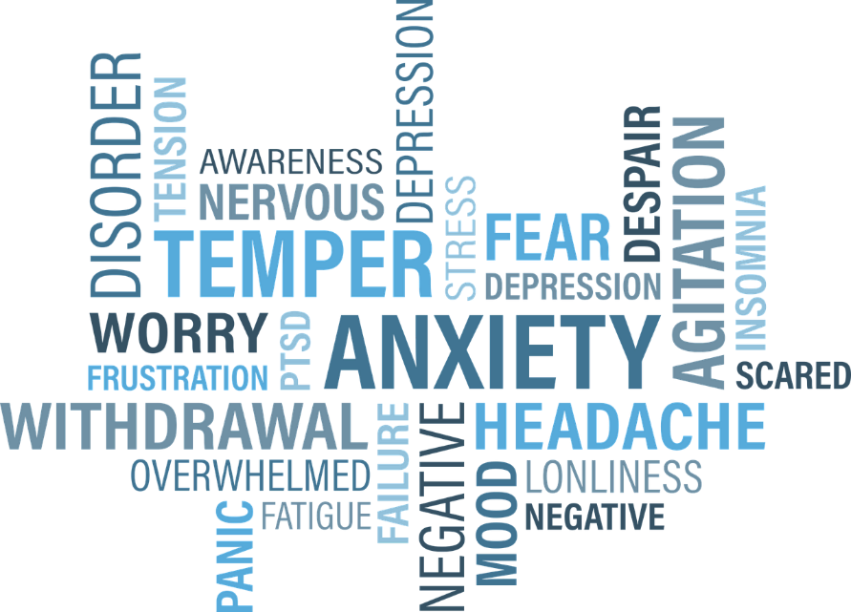**Anxiety**

Students who suffer with anxiety are not always aware of the trigger for their feelings and it can be difficult for them to talk about or explain their feelings. There may be a general sense of unease, such as worry or fear, which could be mild or severe. It could be seen through panic attacks, obsessive behaviours, and/or depression.

If you suspect a student if suffering with anxiety, you could speak to their parents or explore if there is any professional support available. If it is not, you might find that emotional support from the student’s family and friends will be most useful. You could share your understanding of anxiety and provide advice and/or practical tips on how the family can support the student with their emotions.

Image source:

https://pixabay.com/vectors/anxiety-word-cloud-word-chronic-1337383/ (free)

See the image below to begin to understand the potential relationship between a student’s thoughts to a trigger which could be a real or imagined danger and what you might see.

Educators should also keep in mind that it is common for people who feel high level of anxiety to try and hide how they feel and therefore could appear to be well or act in a way that seems overly positive to mask their feelings and counteract their potential appearance to others.

-Avoidance

-lack of eye contact

-opting out of tasks

-lack of engagement

-behaviours that help them

feel in control or safe

Something terrible is going to happen

I can’t cope

If I feel this bad, then the situation must be bad

Anxious

Fearful

Behaviours

Feelings

Thoughts

Image sources: <https://www.myanmargraphic.com/category/people/> (free)

* 1. **Stress**

Stress is a feeling of emotional pressure. It can be felt on a scale from mild to severe. It isn’t always negative and can be a lot easier to manage than anxiety. Stress can be healthy and necessary for us to accomplish goals and tasks. When it becomes too much to handle, it can make you feel overwhelmed. This is often referred to as Toxic stress.

**Positive stress**

A healthy response to a potentially stressful event such as a first day at school.

**Tolerable stress**

Stress response to a long lasting or severe stress event when there is support from others, such as the loss of a loved one.

**Toxic stress**

Constant stress response to frequent, long lasting, severe events when there is little or no support from others.

Toxic stress can change how the brain works and can cause a change in behaviour and health.

* changes in the way the brain usually deals with stress causing **anxiety, depression** and **impaired learning and memory.**
* a decrease in the upper thinking part of the brain and an increase in the lower survival part causing **hypervigilance** and **reducing the ability to control attention.**
* decreases in reward response causing **difficulty in experiencing joy.**
* 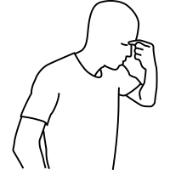disruption in the ways different parts of the brain makes connections with other parts causing **difficulty understanding situations and how to respond.**

Many studies have found that **toxic stress in childhood** can lead to problems as adults:

* Alcohol or drug abuse
* Physical inactivity &/or obesity
* Frequently missing work
* Mental health problems including suicide attempts.
* Depression
* Diabetes
* Lung &/or heart disease
* Cancer

Image source: <https://thenounproject.com/term/stress/4230462/> (free)

* Other health problems

Stress can be from one event, or it can happen over a period of time. People experience different levels of stress from different things and at different times. Something that did not give you stress to begin with can start to give you stress at a different time.

|  |  |  |  |  |  |  |  |  |  |  |  |  |
| --- | --- | --- | --- | --- | --- | --- | --- | --- | --- | --- | --- | --- |
| **Activity 9.6 – Where does stress come from? (15 minutes)** To support the students we teach it is helpful to understand where potential stress comes from. This will strengthen the relationships we have with students if we are able to empathise with them and understand how factors can affect how they are able to learn.  **Stress can come from many sources.** These sources can be grouped into:   * Things that **threaten your sense of safety** – How safe am I? Do I have shelter and food? * Things that **threaten your sense of who we are** – How am I doing? Am I competent? Do people like me?   Look at the subheading below and match up the statements that you think may threaten students’ sense of safety or sense of who they are.  I really miss my friend. She has moved to another school now. Will I make friends like her?  **Disruption**  If I put my hand up and I am wrong will all my peers laugh at me?  **Change**  **Loss**  Now I have a new teacher, I wonder if the routines will be the same as they were before.  I heard that there is a pupil in my new class who is violent. I am a bit scared.  **Threat**  I used to be so confident when speaking to my peers in a group but now I sit quietly on my own.    When the school had to close, I was unsure when we would be able to come back.  **Isolation**  Copy the table below into your learning journal and write the numbers of the answers. One example is given.   |  |  |  |  |  |  | | --- | --- | --- | --- | --- | --- | | Disruption | Change | Loss | Threat | Fear | Isolation | |  |  |  |  |  |  |   **Discuss** the feeling of uncertainty with a colleague and how it can make you feel.  Link your conversation back to what you can do to support students if they feel uncertain.  For example, establishing routines quickly and having some familiarity in a setting can help students. |

|  |  |  |  |  |  |  |  |  |  |  |  |  |
| --- | --- | --- | --- | --- | --- | --- | --- | --- | --- | --- | --- | --- |
| **Activity 9.6 answers**   |  |  |  |  |  |  | | --- | --- | --- | --- | --- | --- | | Disruption | Change | Loss | Threat | Fear | Isolation | |  |  |  |  |  |  |   It is possible that you may have linked numbers to similar answers. For example, the example given about a student feeling scared of another maybe linked to threat or fear. |

It is important that we are aware of our own stress levels and recognize when things are too stressful. We explore some strategies that will help ourselves and students when we recognize stress in the next section.

|  |
| --- |
| **Shape, arrow  Description automatically generatedActivity 9.7 – The effects of stress (15 minutes)** **Think** of a time when you have been under stress (you may possibly be so now).  Using your learning journal, spend some time **reflecting** on the following questions.  **A picture containing logo  Description automatically generated**You might find it useful to discuss the questions in pairs or prefer a more private reflection.  **Q**   1. How did/do you **feel**? (emotions) 2. How did/do you **react** to others? (behaviour) 3. What do you think happens in your body when you’re **stressed**? (physiological) 4. Do you think these reactions are the **same for everyone**? |

|  |  |  |  |  |  |  |  |  |  |  |  |  |  |  |  |  |  |  |
| --- | --- | --- | --- | --- | --- | --- | --- | --- | --- | --- | --- | --- | --- | --- | --- | --- | --- | --- |
|    |  |  |  | | --- | --- | --- | | **Question** | **True** | **False** | | 1. Stress can happen over a long period of time. |  |  | | 1. Stress can ‘catch up with us’ after the cause is already over. |  |  | | 1. Toxic stress is a response to a long lasting or severe stress event when there is support from others. |  |  | | 1. Excessive stress helps us to think clearly. |  |  | | 1. Positive stress is a healthy response to a potentially stressful situation. |  |  |     Image Source: [https://www.freepik.com](https://www.freepik.com/premium-vector/cute-couple-myanmar-students-going-school_7714066.htm#page=1&query=myanmar%20cartoon%20students&position=0) (free)    Image Source: [https://www.freepik.com](https://www.freepik.com/premium-vector/cute-couple-myanmar-students-going-school_7714066.htm#page=1&query=myanmar%20cartoon%20students&position=0) (free) |

|  |  |  |  |  |  |  |  |  |  |  |  |  |  |  |  |  |  |  |
| --- | --- | --- | --- | --- | --- | --- | --- | --- | --- | --- | --- | --- | --- | --- | --- | --- | --- | --- |
| **Activity 9.8 answers**   |  |  |  | | --- | --- | --- | | **Question** | **True** | **False** | | 1. Chronic stress happens over a long period of time. | ✓ |  | | 1. Stress can ‘catch up with us’ after the cause is already over. | ✓ |  | | 1. Toxic stress is a response to a long lasting or severe stress event when there is support from others. |  | ✓ | | 1. Excessive stress helps us to think clearly. |  | ✓ | | 1. Positive stress is a healthy response to a potentially stressful situation. | ✓ |  | |

1. **Recognising stress – linking to knowing your learners**

It is not always easy to recognise when stress is the reason you or someone else is feeling or acting differently. Look at the images below and think about which teacher you think looks stressed. Are you drawn to an image over another? It is important to remember that it could be anyone. The importance of educators knowing their learners (outlined in module 2) is critical here to ensure that you recognise changes in behaviour amongst learners.

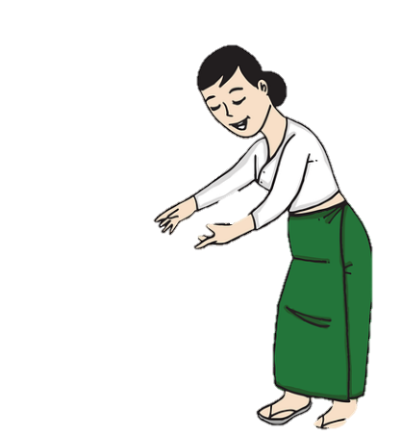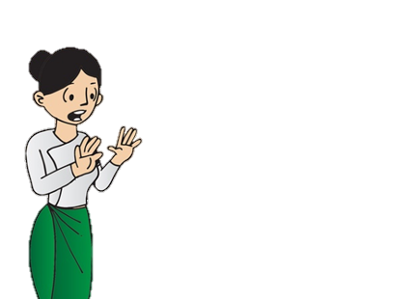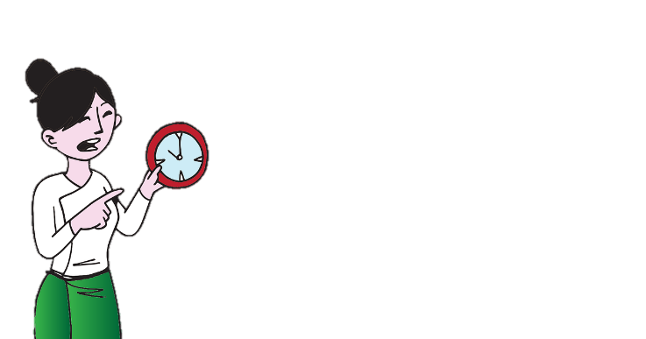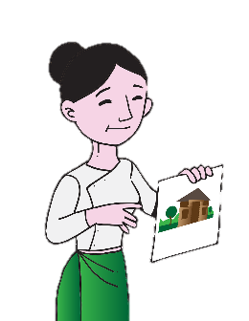

Adapted image sources: <https://pixabay.com/images/search/burma/?pagi=2&> (free)

|  |
| --- |
| **Summary and discussion**  **Some stress can be good for us**. It helps us gets things done. Our brain and body’s stress reaction gives us energy and focus. **Too much stress can be harmful**. It can stop us being able to think and can make us ill. Adverse Childhood Experiences (ACEs), where a child experiences a lot of stress and does not have someone caring and supporting them, can be harmful for all their future life. |

1. **Areas of social and emotional support**

The next section focusses on **areas of social and emotional support**you can use to support students. They are not separate from each other. When you support one area and develop skills in that area, you help develop skills in the other areas.

**Activity 9.9 Areas of social and emotional support (15 minutes)**

**READ:** Look at the summary of the areas of social and emotional development and add the correct label at the bottom of the page.

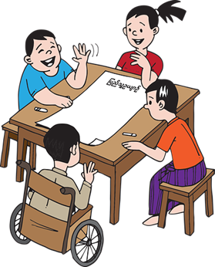

The ability to recognise and understand our own emotions, thoughts and values, and understand how they affect our behaviour. It is about understanding our personal strengths and understanding that we can develop and improve our abilities. The main skills are:

* identifying emotions,
* self-perception – (the kind of person we think we are),
* understanding strengths,
* self-confidence – (believing in our abilities, ideas and decisions),
* self-efficacy – (our belief in our ability to succeed).

The ability to manage our feelings, thoughts, and behaviors in different situations. This is includes managing stress, controlling impulses and keeping motivated. The main skills include:

* impulse control,
* stress management,
* self-discipline,
* self-motivation,
* goal-setting,
* organisational skills.

|  |  |  |  |  |
| --- | --- | --- | --- | --- |
| **Self-awareness** | **Self-management** | **Social awareness** | **Relationship skills** | **Responsible decision making** |

The ability to develop and maintain healthy and positive relationships with other people. It includes the ability to communicate clearly, listen, cooperate, resist peer pressure and negotiate conflict. The main skills include:

* communication,
* social engagement – (interacting and connecting with other people),
* relationship building,
* teamwork.

The ability to make positive responsible choices about how we behave and how we interact with others. The main skills include:

* identifying and solving problems,
* analysing situations,
* self-evaluation,
* self-reflection,

ethical responsibility – (behaving according to what is right).

Image source (free): <https://pixabay.com/images/search/burma/?pagi=2&>

The ability to understand and empathize with other people’s points of view, feelings and needs, and to understand expected behaviour. The main skills include:

* perspective-taking – (seeing a situation from another person’s point of view),
* empathy – (able to imagine what someone may be thinking or feeling),
* appreciating diversity,
* respect for others.

**Activity 9.9 answers**

|  |  |  |  |  |
| --- | --- | --- | --- | --- |
| **Self-awareness** | **Self-management** | **Social awareness** | **Relationship skills** | **Responsible decision making** |
| **1** | **2** | **3** | **4** | **5** |

1. **Strategies and activities**

The next section outlines some activities and strategies you can use to support students. But first it may be useful to think about what you or those around you do to help you de-stress. Do you listen to music? Do you take deep breaths or go for a walk?

In your learning journal, list some of the strategies that work for you and those around you.

Everyone has their own way of coping with challenges they might face in their life, but some of the more common strategies fall into the following categories;

**1. Energetic activities such as exercise, running, walking, sports**

**2. Self-calming activities such as drawing, meditation, reading, listening to music**

**3. Social strategies such as meeting up with friends, talking things over, help-seeking**

**4. Shifting attention such reading, watching TV, playing games, doing a practical task**

**5. Getting organized such as cleaning, making plans, tidying up**

If you develop your own skills as an educator, you will be more equipped in your ability to help students to develop their own social and emotional skills. Coping strategies can be learnt through observation so we must always think about our own behaviour when working with students.

The examples of learning activities in the next section will support you in creating short tasks or longer lessons/experiences which teach social and emotional skills.

They will help students to:

• Feel and show empathy for others – encourage the feeling of coming together

• Understand emotions – recognizing challenges in the past and how they were overcome.

• Manage how they express their emotions

• Establish and maintain positive relationships

• Set and carry out strategies to achieve positive goals

• Think critically and ethically and make responsible decisions

• Engage in peer support and self-care strategies

**Note:** *The context that you work in may affect the strategies that you use with students. For example, often international resources found online to support social and emotional wellbeing suggest strategies such as mindfulness and resilience. Many people in Myanmar know and are familiar with the term mindfulness but it is not a big part of their everyday life. The activities listed in this module are not from any specific religious perspective. We acknowledge the Buddhist origin of mindfulness and how it has been spread widely and adapted in various ways in different parts of the world. Even if mindfulness is understood and used in non-Buddhist contexts differently in some aspects from the original Buddhist concept/practice, it can still be useful in education, which is why we felt it appropriate to include.*

**Self-awareness:** the ability to identify our own feelings, as well as how our feelings and thoughts influence what we do.

|  |  |  |  |  |  |  |  |  |
| --- | --- | --- | --- | --- | --- | --- | --- | --- |
| **Zones of regulation** |  | **Blue zone**  **Low energy**  **Must re-energise** |  | **Green zone**  **Calm and**  **good to go** |  | **Yellow Zone**  **High energy**  **Take care** |  | **Red Zone**  **Out of control**  **Need to stop** |
| **What does this look like?** | *Sleepy*  *Head down* | *Alert* | *Over-alert*  *Hyperactive*  *Talk faster* | *Fast heart*  *Loud voice* |
| **How do I feel?** | *Tired, Sad*  *bored* | *Happy*  *Relaxed* | *Excited*  *Nervous* | *Angry*  *Hysterical* |
| **What strategies can I use to move into the green zone**? | *eat some fruit* | *Smile*  *Be kind* | *Go for a walk*  *Focus on a challenge* | *Listen to calm music*  *meditate* |

**Strategy 1 - Zones of regulation** is a tool we can use to recognise and talk about emotions, how they make us feel and how we can control those feelings.

**Self-awareness – what does this zone look like?**

Talk or think about changes in the body caused by the emotion. For example, heart beating faster, voice getting louder, feeling hot are signs of feeling angry and out of control. Discuss how different people will have different physical signs of their emotions. For example, some people may walk around, unable to keep still when they feel nervous, other people may sit quietly biting their nails or playing with something like a pen. Thinking about how our body reacts to emotions helps us to understand how we are feeling and find strategies to control them. Young children might find it helpful to draw a body and talk about positive and negative emotions. Ask students to think about the emotions or feelings in each zone. Different people will have different emotions and feelings in each zone. Some people might put themselves in the Blue zone if they feel hungry because they have low energy and feel tired. Others maybe in the Yellow zone because they are easily annoyed, can’t focus and feel agitated. Teach students about empathy and how to recognize differences in other’s emotions and what some of the triggers might be. Encourage them to talk about this openly amongst themselves.

Negative emotions

Positive emotions

Jealous

excited

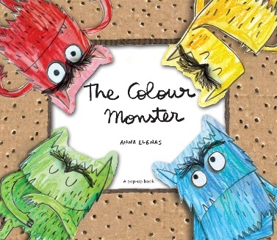Thinking about which emotions and feelings put us in each zone increases our understanding of our emotions and how they make us feel. The more we understand them, the more we can control them. This activity also helps us identify emotions and put a name to how we are feeling, which makes it easier to talk about when we need to. For young children particularly it is helpful to hear ‘I am feeling tired and hungry’ rather than an educator having to deal with an incident with students because one if them is angry. It is an activity that can be used with students in early childhood to adult. Young children might enjoy exploring a range of emotions and talking about what makes them feel that way. Educators could use handmade coloured puppets or create a story around the zones. If you have access to the internet, here is a link to the story The Colour Monster, that helps children to understand the emotions and the colours through pictures and characters. <https://www.youtube.com/watch?v=Ih0iu80u04Y>

Image source: <https://freesvg.org/one-eyed-monster> (free)

**Self-management – what strategies can I use?**

This is the key part of Zones of Regulation – “I’ve recognized that I am in the Red Zone, what can I do to move back towards the Green Zone?” It is important to focus on positive strategies and to have plenty of positive alternatives if your usual strategy isn’t healthy. For example, an adult might smoke when in the Yellow Zone to help them feel calmer. Encourage them to write a list of alternative strategies they can do that will help them feel calmer.

Recognising our own emotions and what they look like supports our **social awareness**, developing our ability to understand and empathise with how others feel. Use the blank version of the Zones chart to complete for yourself or ask your learners to.



**Strategy 2 - Mindfulness and grounding**

Mindfulness can be used for self-management as it can calm you down. It is the practice of *‘paying attention in a particular way, on purpose, in the present moment, and non-judgmentally.*’ Kabat Zinn, J (2017).

Our mind often jumps around paying attention to different things, thinking of things from the past, imagining things in the future. Each of those thoughts affect how your body reacts and how we feel. If we are busy, life can seem overwhelming, giving us no time or mind space to think before we react. Mindfulness helps to focus our awareness on the present moment and encourages us to acknowledge and accept our thoughts and feelings about that moment in a calm way. In a similar way the idea of grounding is to also be present and feel grounded or connected to earth, focusing on what is around you, what you can see rather than any feelings of what might be.

Mindfulness and grounding can reduce feelings of stress, anxiety, anger, depression, and tiredness. They can increase your energy to do other things. By slowing our mind down, we gain time and mind space to see things clearly, to solve problems, to concentrate, to consider others and to enjoy our experiences of the world more. It can help us see things more rationally which improves the relationships we have with others, making us less likely to react negatively. The activities below could be used as a few minutes of calm before you begin a lesson, during or after or you might spend time focusing on teaching some of these strategies so that students can use them independently to support their social and emotional wellbeing.

Being able to regulate their feelings, will enable students to know what steps they can take to feel a sense of balance and control and can help them to not become overwhelmed.

**1. Mindful breathing** – stand or sit still, focus on your breathing for 1 minute.

1. Breathe in and out slowly. A breath in and out should last for about 6 seconds.
2. Breathe easily. Try to breathe in through your nose and out through your mouth.
3. Try to let go of your thoughts and try to focus on your breathing.
4. Put your hand on your chest, watch and feel your breath as it enters your body.

You might like to talk with students about when this might be a helpful strategy to use. Is it something they feel they can do discretely if they start to feel anxious or overwhelmed?

You could encourage students to take three deep breaths at regular intervals during their day, such as before class or whenever strong feelings of anxiety or tension arise. As an educator, try to model putting your hand on your chest and taking 3 deep breaths, modelling and demonstrating your our own emotional regulation.

**2. Mindful observation** – Choose a natural object from your environment. Focus on watching it for a minute or two. This could be an animal, an insect, the clouds, or a plant.

1. Look carefully at the object, as if you are seeing it for the first time.
2. Watch it for as long as your concentration allows.
3. Look closely at every aspect of the object, its shape, colour, texture and purpose.
4. **Mindful listening** – Choose some music that you enjoy or that you haven’t heard before.
5. Close your eyes and listen.
6. Try to focus on the music without thinking about the type of music, its title, or the artist.
7. Let yourself explore the music. Even if you don’t like it at first, try and explore each sound.
8. Can you identify instruments within the music?
9. **Mindful appreciation** – You might start the class by having students reflect for a minute about something that has gone well or something that they are grateful for. They could discuss this with a peer, write it down or shared in a larger group discussions. Encourage students to list 5 things that usually go unnoticed. These could be objects or people. For example, the electricity that powers a lamp, the person who says hello when you walk, clothes that provide warmth, etc.
10. How did these things/processes come to exist, or how they really work?
11. How do these things benefit your life and the lives of others?
12. **Grounding countdown** – Start with a deep breath in, and out.
    1. Look around you and notice 5 things you can see.
    2. Identify 4 things that you can feel.

embarrassment

* 1. Listen out for 3 sounds you can hear.
  2. Find 2 things you can smell.
  3. Think of 1 thing you can taste.

1. **An iceberg of emotions –** Ask students to draw an iceberg (see image) to help them explain emotions. The top includes words or emotions that might be showing on the surface (above the water line) and below will show any emotions that may be hidden (below the waterline), or be felt at a deeper level. This will help students build empathy and understand emotions in others.

anger

fear

1. **Allowing time to be still** – You could start class, asking students to sit quietly for a minute. Often to the point of getting somewhere, the journey may have been rushed. Allowing students time to sit and breathe will help them to focus and be present in class.
2. **Classroom conversations –** Earlier in the module, you were asked to think about opportunities you provide for students to build positive relationships with their peers and adults. This activity encourages educators to start the day/class with a conversation. It could be a quote, or an image shared with students to stimulate short conversations to help them interact with each other.



1. **Positive role-models –** Share stories about role-models students can learn from. Discuss character strengths and virtues. Students could describe the positive qualities in a person they admire and talk about how they respond to challenging situations.

Listens

kind

1. **Collaborative learning –** By providing opportunities for students to work together enables them to have a voice and connect with their peers. Think back to the previous module for ideas to allow students work collaboratively, interacting with their peers and encouraging problem-solving. Encourage students to use role-play to practice communication skills, developing crucial social skills.



1. **Tools for problem-solving and thinking –** Provide students with different images of emotions, or a scale for them to rate their feelings. A tree and its branches might provide an effective tool to think of solutions to a problem or the fish bone diagram (see image).

problem

solutions

1. **Role play -** Provide students with scenarios which contain challenges or problems they may encounter in their lives. Allow students to discuss strategies and use role-play to develop confidence and communication skills needed to carry out strategies.

Image sources: <https://www.freepik.com/free-icon/iceberg_14713063.htm>, <https://freesvg.org/dead-fish>, <https://www.maxpixel.net/Stickman-Character-Matchstick-Man-Man-Stick-Figure-25571> (free)

1. **Active reflection –** Encourage students to think about their day or a class. Younger students may benefit from some verbal or visual prompts. Equally older students may need a model or a structure of some form to start off with.

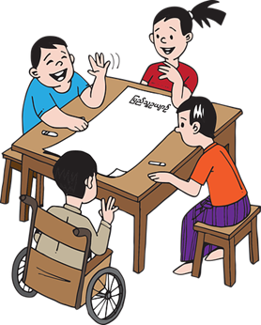

I

I feel like I challenged myself

today by … I feel really proud of

myself for taking a risk.

I really enjoyed … today …

because it made me feel…

I feel really curious about …. When we talked about it in Science.

Something new I learned today is …

1. **Shape, arrow

   Description automatically generatedDaily positives’ journal -** Older students may benefit from keeping a diary, taking some time at the end of each day to focus on the good things. This can help become more self-aware and when we focus on looking for the positives in life, we are learning how to manage stress.

|  |  |  |  |  |  |  |  |  |  |  |  |  |  |  |  |  |  |  |  |  |  |  |  |  |  |  |  |  |  |  |  |  |  |  |  |  |  |  |  |
| --- | --- | --- | --- | --- | --- | --- | --- | --- | --- | --- | --- | --- | --- | --- | --- | --- | --- | --- | --- | --- | --- | --- | --- | --- | --- | --- | --- | --- | --- | --- | --- | --- | --- | --- | --- | --- | --- | --- | --- |
| **Activity 9.10 – Using the tools to improve teaching and learning (45 minutes)** **Think** about the students you teach and when you might any of the activities. You might feel that an activity will work best with a student you are concerned about or decide to use one with a whole class of students to help them to focus or settle down if an activity has been active.  **A picture containing logo  Description automatically generated**Perhaps students come back into class after a break time with a lot of energy and a little bit noisy. These strategies can shift their attention away and help them regain a feeling of calm and focus on learning.  Look at the list below and discuss with a colleague which activity you will try out straight away. Copy the table into your learning journal and tick or add comments next to each one to remind yourself of the ideas behind them. If you are working with others, you may decide to try different activities and report back on their effectiveness and if you can see an impact on teaching and learning.   |  |  |  | | --- | --- | --- | | **Strategy** | **I will try straight away** | **I will plan to use this one another time** | | Zones of regulation – colours & developing vocabulary around emotions & feelings |  |  | | Body drawing – listing positive & negative emotions |  |  | | Mindful breathing, observing, listening, appreciation |  |  | | Grounding countdown |  |  | | Iceberg of emotions |  |  | | Time to be still |  |  | | Classroom conversations |  |  | | Collaborative learning opportunities |  |  | | Positive role model drawings and discussions |  |  | | Tools for problem solving & role play scenarios |  |  | | Active reflection |  |  | | Daily journal |  |  | |

1. **Systems, programmes, and interventions**

Social and emotional skills should be developed from an early age and taught throughout a student’s education. e.g. giving time for learners to think, listen and talk to each other.

|  |  |  |  |  |  |  |  |  |
| --- | --- | --- | --- | --- | --- | --- | --- | --- |
| Fill in the missing words to the following statements about social and emotional wellbeing. One example has been given.  Missing words   |  |  |  |  | | --- | --- | --- | --- | | mentors | talk partners | ~~social & emotional~~ | belonging | | approachable | physically active | uncomfortable | routine |  1. All students should have access to **high-quality lessons** designed to build and strengthen their social and emotional skills. 2. It is ideal if lessons on social and emotional wellbeing are **built into the curriculum** and that educators get to **know their students** so they are aware of themes that could trigger some students, or make them feel ____________. 3. **Learning __________** could be a member of staff or another student who checks in with a student. The student knows that someone wants to hear about their day, the successes, and the challenges. 4. **Regular opportunities to come together as a community** could be a regular assembly or a daily class meeting. Coming together as a community will support students to feel a sense of _____________. 5. Where there are large class sizes, _____________ allow time for **all students to speak** rather than a few. 6. Giving students a sense of normality and _________ will help them **feel safe in the learning environment.** 7. Plan time for students to be ____________ in school. Teachers might include a song in a lesson with actions to **get children moving within lessons**. Exercise reduces levels of the body's stress hormones, such as adrenaline and stimulates the production of chemicals in the brain that are the body's natural painkillers and mood elevators. 8. If students feel that a teacher cares and that they are __________, they are more likely to talk about any worries or issues around their social and emotional wellbeing. Teachers will also be more likely to recognise changes in their students’ behaviour. Learn about students interests and **build relationships** with them. |

|  |  |  |  |  |  |  |  |  |
| --- | --- | --- | --- | --- | --- | --- | --- | --- |
| **Activity 9.11 answers**   |  |  |  |  | | --- | --- | --- | --- | | 3.mentors | 5.talk partners | ~~1.social & emotional~~ | 4.belonging | | 8.approachable | 7.physically active | 2.uncomfortable | 6.routine | |

|  |  |  |  |  |  |  |  |  |  |  |  |  |
| --- | --- | --- | --- | --- | --- | --- | --- | --- | --- | --- | --- | --- |
| **Linking learning from earlier activities**.  Think about previous modules and how you can relate the information to what has been covered in this one.  If you can, you might like to discuss this with a colleague and share your ideas on possible solutions.  **Scenario** – May Zin arrives in her classroom to teach the students. It is a large class, and she is struggling to build meaningful relationships with every student. May Zin heard from another teacher that Naing Win (a child in her class) has had a recent bereavement in the family. She thinks it may be an aunt but she’s not sure. She has noticed that Naing Win hasn’t been contributing as much in class discussions and is withdrawn. May Zin has been meaning to chat with him, but the lessons are so busy and there are so many children to support. Another child, Aye Su has been displaying challenging behaviour recently, by calling out and distracting other students on her table. This has taken a lot of May Zin’s attention.   1. List some thoughts or questions in the boxes below. What would you want to ask May Zin if she was your colleague?   This has been started for you below.   |  |  |  | | --- | --- | --- | | May Zin | Naing Win | Aye Su | | It sounds like she feels pressured to teach academic subjects. Can she ask her senior manager if she can spend some time doing some more informal, getting to know you activities to find out about her students? |  |  | |  |  |  | |  |  |  |   **Think about;**   * What could May Zin do to ensure that all children have the opportunity to speak about any social and emotional wellbeing issues they may have? * How can May Zin support her students if they are experiencing social and emtional issues? |

|  |  |  |  |  |  |  |  |  |  |  |  |  |
| --- | --- | --- | --- | --- | --- | --- | --- | --- | --- | --- | --- | --- |
| **Possible answers Activity 9.12**  There are lots of possible questions or ideas you may have about the given scenario. Please find a few suggestions of possible questions or ideas for support to put in place for May Zin’s students.   |  |  |  | | --- | --- | --- | | May Zin | Naing Win | Aye Su | | It sounds like she feels pressured to teach academic subjects. Can she ask her senior manager if she can spend some time doing some more informal, getting to know you activities to find out about her students? | How close was he to the family member who died?  How has this impacted the family and their home situation? | Why is there a sudden change in Aye Su’s behaviour? | | Can May Zin speak to Naing Win to find out how he is feeling? This will help her understand his situation and it how it may be affecting his learning. | If there is no time in lessons, May Zin could find Naing Win during a lunch break and have a chat with him then. | Have any other teachers noticed the change? | |  | What does he think might help him at school to be able to engage with learning again? | How are they managing the behaviour? |  1. **What could May Zin do to ensure that all children have the opportunity to speak about any social and emotional wellbeing issues they may have?**  * May Zin could set up a routine where students check in and talk about how they are feeling at the start of the day. * Establish a system for quiet reading at the start of the afternoon for May Zin to walk around the room and check in with any students she is worried about. * Greet the students at the door, say hello and ask them how they are as they arrive. * May Zin can ensure she is available during a few break times a week to support any students who need it with any social and emotional problems.  1. **How can May Zin support her students if they are experinecing social and emotional issues?**  * May Zin could have a feelings display in the classroom for students to move their name on a zone (like zones of regulation) * Plan explicit teaching time to discuss feelings and emotions and coping strategies or lessons that are pitched to meet the needs of any concerns about students. * May Zin could speak to the parents of any students she is concerned about and ask if they have any similar concerns. * Find out what professional support is available for her students and how they can access it. |

1. **Looking after our own social and emotional wellbeing**

Educators juggle a multitude of different tasks and demands, it is important that everyone looks after their own emotional and social wellbeing so that they can, in turn, support their pupils.

Teacher well-being and job satisfaction strongly influence teacher behaviour and are positively related to school and classroom climate and student achievement. Wellbeing is all about our holistic health, including the physical and emotional. When we have good levels of wellbeing we feel that life is in balance and that we can generally cope well. We feel motivated and engaged, we are resilient and able to deal effectively with daily troubles, and ’bounce back’ from challenges we face in life.

|  |
| --- |
| **Activity 9.13 – Chatting to a colleague or friend about wellbeing (1 hour)**  Arrange a meeting with a colleague or friend to discuss social and emotional wellbeing and strategies that you use to support your own wellbeing. Share the question prompts below for you both to think about before you meet. Use your learning journal to write down some ideas. Try and think of some examples to share with each other.  **Professional self-care –** What motivates you? Do you maintain a balance between professional and personal life? Do you find ways to develop your practice and have healthy relationships with your colleagues?  **Physical self-care** - Do you feel like you get enough sleep and rest and eat healthy meals?  **Social self- care –** Do you have stimulating conversations and spend time with people whose company you enjoy? How do you support others with their social and emotional wellbeing?  **Emotional self-care** – Do you have hobbies, learn new things and talk about how you are feeling? How do you keep yourself calm if you start to feel stressed?  **Spiritual self-care** – Do you recognize things that give meaning to your life? Do you spend time in nature or find peace in rituals such as mindfulness or prayer?  You might want to think your role as an educator more specifically – reflecting on how you are able to stay calm in a classroom scenario and how any potential stress impacts your teaching or your students.  Share your coping strategies with your peers or colleagues. |

1. **Sense of control**

**A sense of control is a basic human need.** No sense of control in our life can make us feel helpless and lead to depression and anxiety. If children grow up in an unstable environment where they have a constant sense of anxiety, they can grow up trying to control the people around them to hide the no sense of control inside.

A sense of control is not about power or controlling other people or even controlling what happens. It is about feeling a **sense of certainty, understanding how things are working, being able to predict what is going to happen, being able to complete things, and seeing that people around us and ourselves are constant**.

Sometimes when people have no sense of control, they find it through behaviour and actions that are harmful. For example, some people get a sense of control by controlling what they eat or don’t eat, which can lead to serious eating disorders.

There are times, when for many different reasons in the world around us, we lose our sense of control. There are some **positive actions** we can do to give us back that important sense of control.

**Positive people** –surround yourself with support and positive emotions.

**Challenge yourself** work towards achieving or completing something.

**Routine and ritual** create or maintain positive regular behaviours.

**Trust** someone to control part of your life.

**Move**

5-minute walk or longer exercise.

**Recognise emotions** give yourself quiet time to question why you feel that way.

**Help someone or something** – make a good difference.

**Learn** something new, nurture your curiosity.

**Quiet time** reduce stimulus, turn off phone, move away from noise.

# **Wrap up**

In this module you have:

* + 1. Explained the effect emotional and social stress has on learning.
    2. Explored a range of emotional and social situations that can cause stress and anxiety.
    3. Read about the effect adverse childhood experiences and trauma have on learning and healthy development.
    4. Explained the key areas of social and emotional support.
    5. Reflected on your own need for social and emotional balance and recognised strategies to support yourself.
    6. Considered appropriate social and/or emotional support tools to help colleagues and students.

**Key points from this module:**

* Social and emotional wellbeing are the skills that children and young people develop in how resilient they are and how they manage their thoughts, feelings and behaviour towards themselves and others.
* People who experience stress and anxiety may display a range of physical, behaviour, and psychological effects. It is helpful for educators to understand what this might look like in the students they teach or work with.
* When young people develop language around coping, they are more likely to be able to understand and deliberately use a range of different strategies.
* Students can use roleplay to practice skills for peer support, such as helpful listening, and acts of kindness.
* Educators should give children and young people opportunities for positive experiences, talking to them about what makes them happy.
* Educators should provide a safe and respectful learning environment

**Reflection**

Think about your students.

* What stress and trauma might they have experienced?
* How might this effect their learning and behaviour?
* What could your students/teachers do to support these children and help them learn?

Think about yourself and your colleagues.

* What stress and trauma might your colleagues have experienced? What stress and trauma have you experienced?
* How might this effect your colleagues and yourself?
* What can you and the educational institution do to support yourself and your colleagues?

# **Shape, arrow Description automatically generatedEnd of module 9 quiz**

Please answer the following questions in your learning journal. You can attempt as many times as you like to reach 100% pass. Some questions require more than one answer.

Q1 – If students have a well-balanced social and emotional wellbeing, they are more likely to; (Choose 2 answers)

1. participate in learning
2. achieve well academically
3. find themselves in conflicts
4. need support to control their emotions

Q2 – Which statements are signs of a ‘Learning Brain’? (Choose 2 answers)

1. Feels calm, peaceful and curious
2. Feels threatened by new learning experiences
3. Fearful of making mistakes
4. Not frightened of making mistakes

Q3 – Which of the following defines anxiety (Choose 1 answer)

1. To experience mental and physical symptoms, such as irritability, anger, fatigue, muscle pain, digestive troubles, and difficulty sleeping.
2. To have feelings that are easily excited and openly displayed.
3. To experience persistent, excessive worries that don't go away, even in the absence of a stressor.

Q4 – Choose the correct definition of mild stress (Choose 1 answer)

1. Can be helpful. It can focus our attention. It can teach us how to cope with things and how to be resilient.
2. Can change the way our brain works and can stop us from being able to use higher thinking skills.
3. Stress from one event or happening. It comes from just one time
4. Stress from something that is happening over a long period of time – it is ongoing.

Q5 – What can educational institutions do to support students’ emotional and social wellbeing? (Choose 2)

1. Tell the parents that it is their responsibility to develop these skills at home.
2. Provide regular opportunities to come together as a community
3. Establish routines to help students feel safe in the learning environment.

**Answers – end of module 9 quiz**

Answers in **bold**

Q1 – If students have a well-balanced social and emotional wellbeing, they are more likely to; (Choose 2 answers)

**a)participate in learning**

**b)achieve well academically**

c)find themselves in conflicts

d)need support to control their emotions

Q2 – Which statements are signs of a ‘Learning Brain’? (Choose 2 answers)

1. **Feels calm, peaceful and curious**
2. Feels threatened by new learning experiences
3. Fearful of making mistakes
4. **Not frightened of making mistakes**

Q3 – Which of the following defines anxiety (Choose 1 answer)

1. To experience mental and physical symptoms, such as irritability, anger, fatigue, muscle pain, digestive troubles, and difficulty sleeping.
2. To have feelings that are easily excited and openly displayed.
3. **To experience persistent, excessive worries that don't go away, even in the absence of a stressor.**

Q4 - Choose the correct definition of mild stress (Choose 1 answer)

1. **Can be helpful. It can focus our attention. It can teach us how to cope with things and how to be resilient.**
2. Can change the way our brain works and can stop us from being able to use higher thinking skills.
3. Stress from one event or happening. It comes from just one time
4. Stress from something that is happening over a long period of time – it is ongoing.

Q5 – What can educational institutions do to support students’ emotional and social wellbeing? (Choose 2)

1. Tell the parents that it is their responsibility to develop these skills at home.
2. **Provide regular opportunities to come together as a community**
3. **Establish routines to help students feel safe in the learning environment.**
4. **Improving teaching and learning**

|  |
| --- |
| **A picture containing logo  Description automatically generatedShape, arrow  Description automatically generatedActivity 9.14 – Reflection (15 minutes)**   Using your learning journal, spend some time reflecting on the following questions.  They are similar to the questions that you were asked at the start of the module.  You might find it useful to discuss the questions in pairs or prefer a more private reflection.  A picture containing text  Description automatically generated   * How will I **teach** children or young people about their **social and emotional wellbeing**? * Do will I **support** pupils’ ability to cope with and negotiate their way through difficult situations? * What **opportunities** will I provide for students to **build positive relationships** with their peers and adults?   You might want to revisit these questions when carrying out your self-assessment at the end of the module and use some ideas from the module. |

**Activity 9.15 Self-assessment**

REFLECTION: How well do you think you **are equipped to support students suffering from stress or well-being difficulties?** Look at the scale above and choose the number that best describes you now. Answer in your learning journal.

VERY well

NOT well

**Compare** your first self-assessment score at the beginning of this module to this one. In your learning journal provide a short analysis of your thoughts about any differences.

# **Shape, arrow Description automatically generatedYour 9th PROMISE to your STUDENTS**

**Review**

**Do**

**Plan**

**Please add your 9th promise to the section in your learning journal entitled ‘Promises.’**

**Each module contains one promise you will make to your learners: you will make 15 promises in total.**

**References**

Cahill, H (2021) Building resilience through social and emotional learning webinar

Emeritus Professor Helen Cahill, Graduate school of Education

The University of Melbourne, Australia

[h.cahill@unimelb.edu.au](mailto:h.cahill@unimelb.edu.au)

Ham, J (2017) Understanding trauma: Learning Brain vs Survival Brain

[www.youtube.com/watch?v=KoqaUANGvpA](http://www.youtube.com/watch?v=KoqaUANGvpA)

Kabat-Zinn, J (2017) Defining Mindfulness

What is mindfulness? The founder of Mindfulness-Based Stress Reduction explains.

<https://www.mindful.org/jon-kabat-zinn-defining-mindfulness/>

McLeod, S (2020)

Simply Psychology – Maslow’s Hierarchy of Needs

<https://www.simplypsychology.org/maslow.html> (Creative Commons)

What Children Really Want – FUN (2018) The Colour Monster - by Anna Llenas. Read aloud by Sherry.

<https://www.youtube.com/watch?v=Ih0iu80u04Y>

Zau Myet Awng & Emily Fishbein (2021) ‘It’s OK not to be OK’: Finding support amid trauma & grief

<https://www.myanmar-now.org/en/news/its-ok-not-to-be-ok-finding-support-amid-trauma-and-grief>