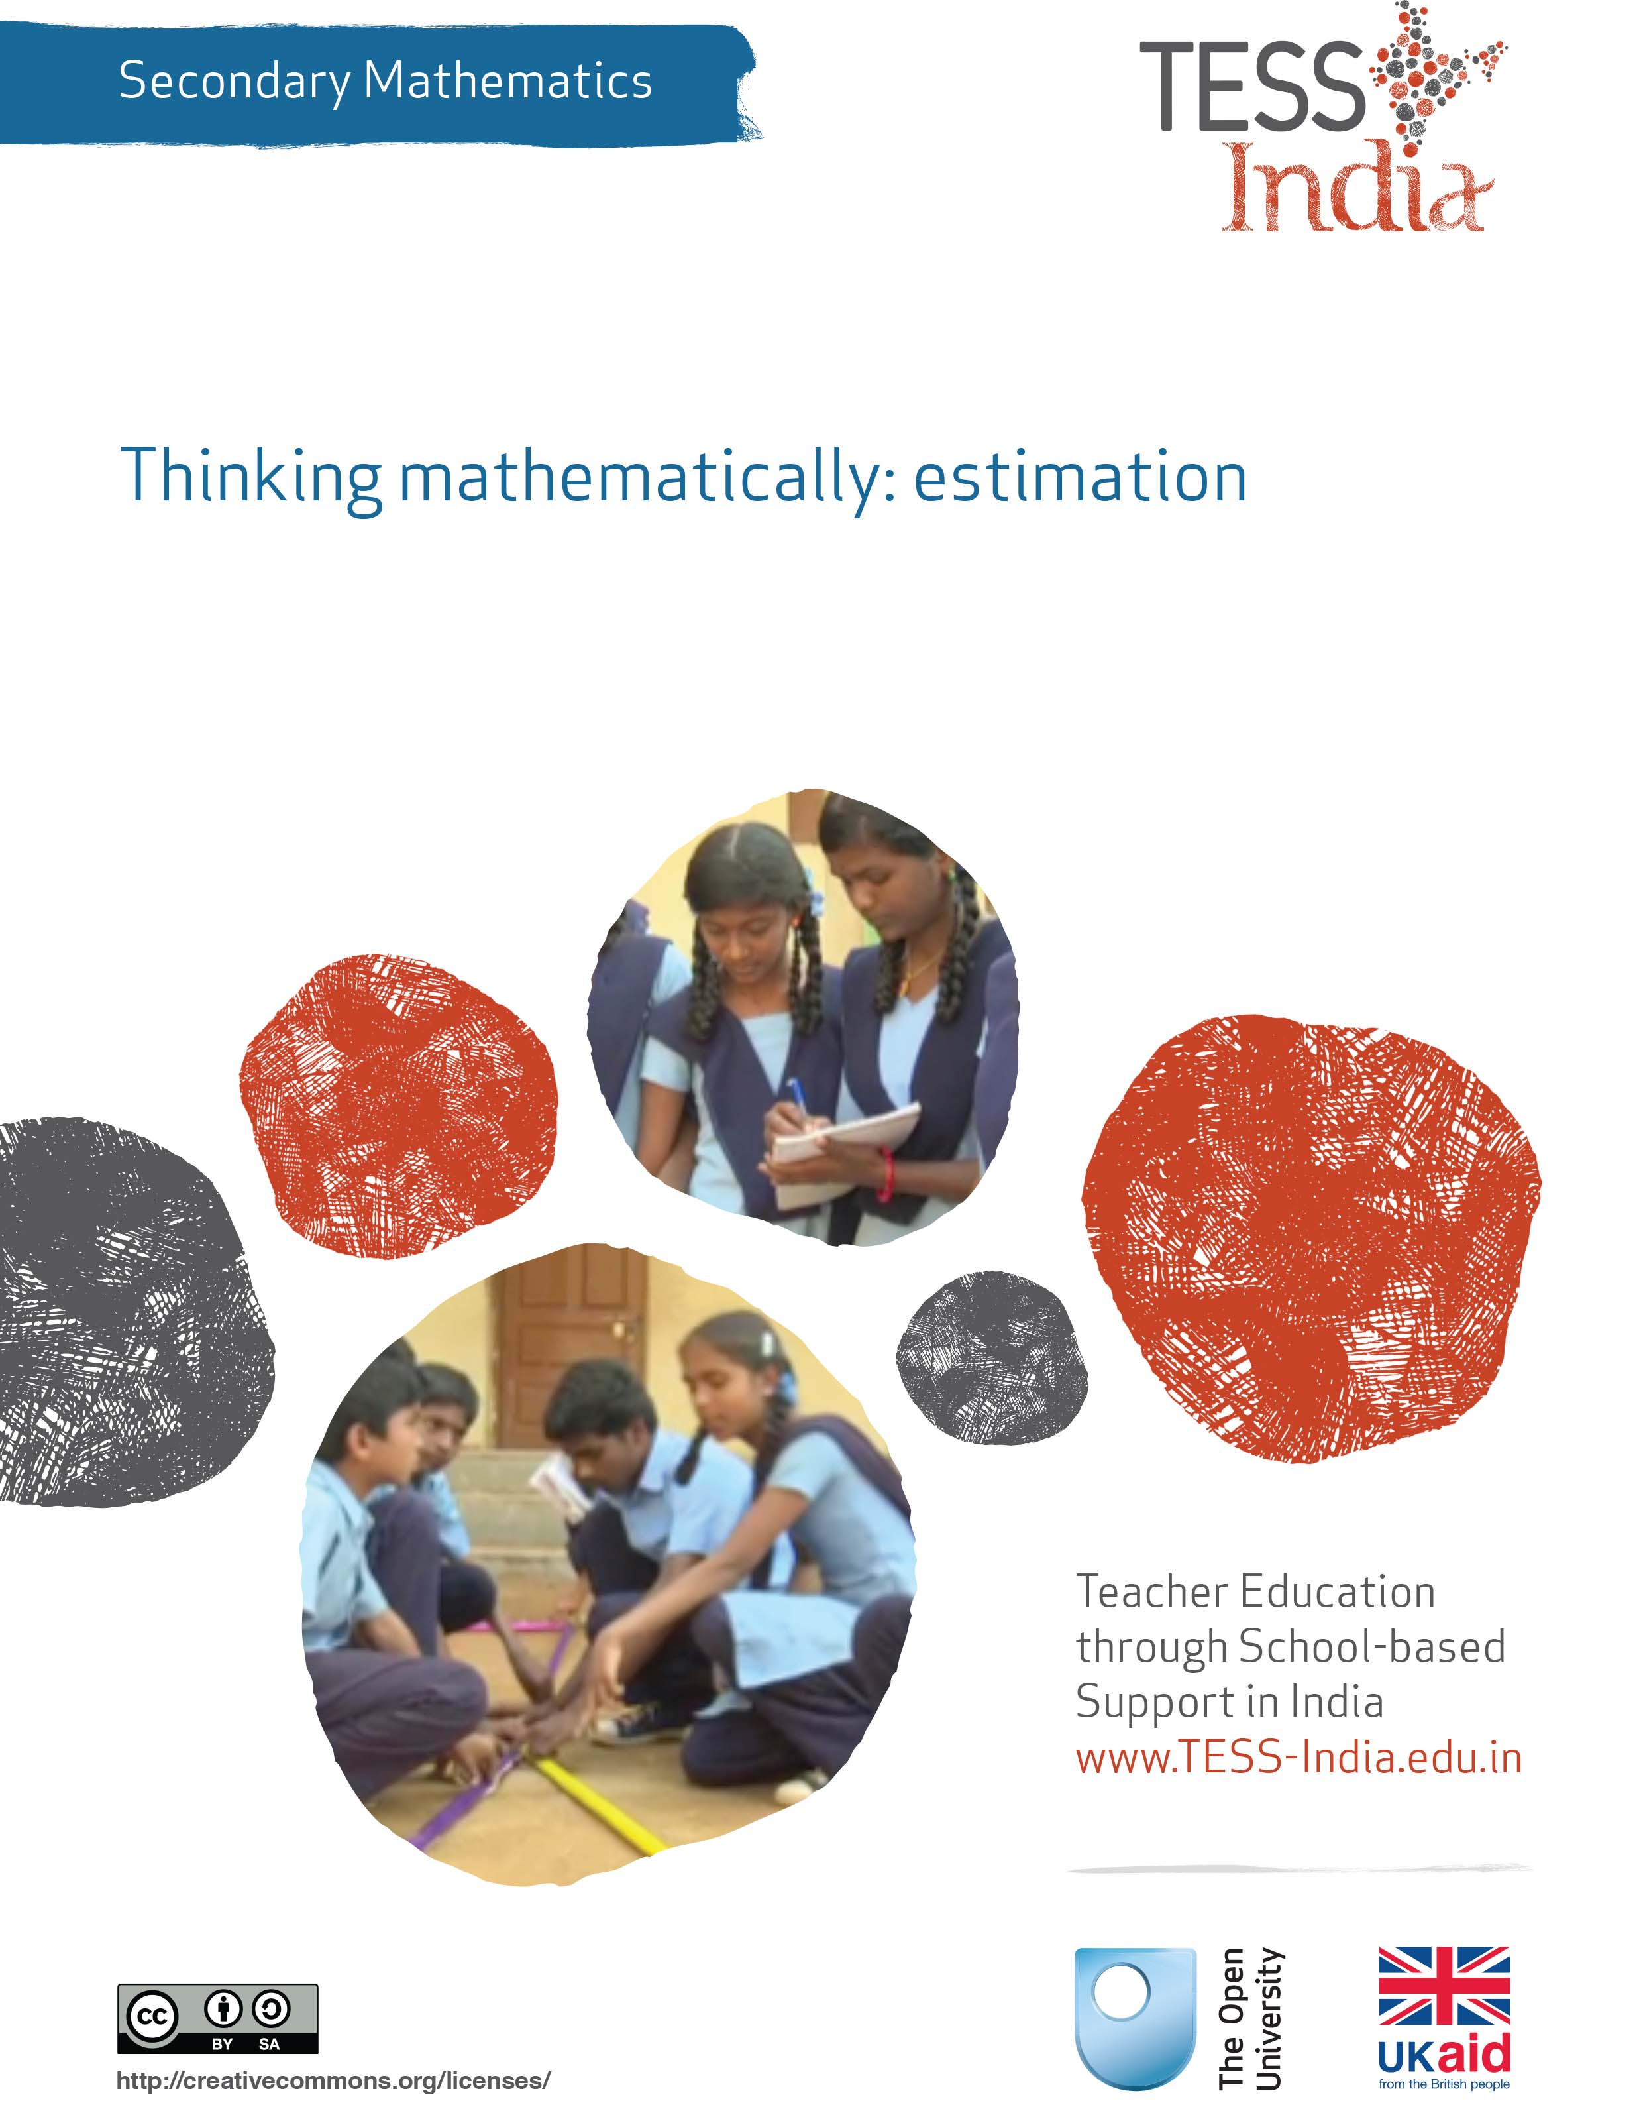
TESS-India (Teacher Education through School-based Support) aims to improve the classroom practices of elementary and secondary teachers in India through the provision of Open Educational Resources (OERs) to support teachers in developing student-centred, participatory approaches. The TESS-India OERs provide teachers with a companion to the school textbook. They offer activities for teachers to try out in their classrooms with their students, together with case studies showing how other teachers have taught the topic and linked resources to support teachers in developing their lesson plans and subject knowledge.
TESS-India OERs have been collaboratively written by Indian and international authors to address Indian curriculum and contexts and are available for online and print use (http://www.tess-india.edu.in/). The OERs are available in several versions, appropriate for each participating Indian state and users are invited to adapt and localise the OERs further to meet local needs and contexts.
TESS-India is led by The Open University UK and funded by UK aid from the UK government.
Video resources
Some of the activities in this unit are accompanied by the following icon: . This indicates that you will find it helpful to view the TESS-India video resources for the specified pedagogic theme.
The TESS-India video resources illustrate key pedagogic techniques in a range of classroom contexts in India. We hope they will inspire you to experiment with similar practices. They are intended to complement and enhance your experience of working through the text-based units, but are not integral to them should you be unable to access them.
TESS-India video resources may be viewed online or downloaded from the TESS-India website, http://www.tess-india.edu.in/). Alternatively, you may have access to these videos on a CD or memory card.

Version 2.0 SM14v1
All India - English
Except for third party materials and otherwise stated, this content is made available under a Creative Commons Attribution-ShareAlike licence: http://creativecommons.org/licenses/by-sa/3.0/

What this unit is about
Estimation is an integral part of our daily lives because, in most contexts, we are more concerned with an estimate rather than the exact value of any measure. For example, if we are to go from destination A to destination B, we are interested in estimating the duration of the journey rather than the exact time of completion.
Repeated attempts to estimate the same quantity make our estimates better. For example, a fruit juice vendor (Figure 1), through experience, can estimate very accurately the number of oranges from which they can extract five glasses of juice.
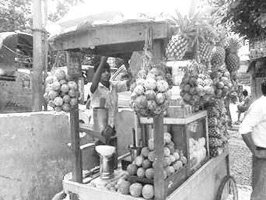
Figure 1 A fruit juice vendor.
Even so, students often ignore the process of estimation and work out the exact answer instead – even when specifically asked not to. Because they are not confident estimators, they do not have the tools to help them realise when their calculated answers are not plausible.
In this unit you will focus on how to teach estimation as a tool for working on mathematical thinking and for making fewer errors in mathematical calculations. The activities will ask your students work on their mathematical thinking processes and on clarifying these through discussion.

What you can learn in this unit
- How to enhance students’ ability to estimate values of numerical expressions, lengths, times and areas, and use upper and lower bounds.
- How to enable your students to see mathematics as ‘many right answers’, rather than one correct answer.
- Some methods to engage students’ thinking processes.
The learning in this unit links to the NCFTE (2005, 2009) teaching requirements specified in Resource 1.

1 Estimation is thinking about the mathematical process
As with most things in life, and like the fruit juice vendor in particular, the more you practise estimation, the better you get at doing it. The interesting question is, why is it a good idea to be a good estimator? Why do you want to encourage your students to be good estimators? What learning does estimation afford that is different from working out the exact answer?
When estimating, students can actually start to consider in detail the thinking process required to solve the problem posed, without the pressure of finding the exact answer, and without being drawn into the details of precise calculations. Applying algorithms will give an exact answer, not an estimate. Hence, estimating is making an outline of the thinking that will happen, together with a sense of the range of where a solution can lie. It can make students think about why an algorithm works. When they then later work out the exact answer to a question, they can verify whether or not their thinking was clarified in the estimation process, and thus become aware of any errors in thinking made in the calculations.
So in this way, estimating is a tool for thinking mathematically. This is especially relevant in India, because the use of calculators is not allowed in school mathematics – becoming caught up in lengthy calculations is therefore a reality.
In Activity 1 you will ask your students to first practise estimation in questions they might be more used to, but this activity also forces them to start thinking about a range of possible answers. In Question 3 of the activity you will ask them to think about estimation as a way to describe the mathematical thinking process involved in calculations using a real-life object.
Before attempting to use the activities in this unit with your students, it would be a good idea to complete all (or at least part) of the activities yourself. It would be even better if you could try them out with a colleague, as that will help you when you reflect on the experience. Trying the activities yourself will mean that you get insights into learners’ experiences that can in turn influence your teaching and your experiences as a teacher. When you are ready, use the activities with your students. After the lesson, think about the way that the activity went and the learning that happened. This will help you to develop a more learner-focused teaching environment.

Activity 1: Estimation and errors
Ask your students the following:
- Find the integer closest to the given numeric expressions without calculating the exact answer.
- 106 × 107
- $\frac{639}{225}$
- 7√5
- Estimate the values of these expressions at the given values of the variables. Again, do not calculate the exact answer.
- Estimate the value of $\frac{7}{8}$x + 5 if x = 210
- Estimate the value of $\frac{7}{8}$ x + 5 if x = $\frac{14}{3}$
- Estimate the value of the expression 5x³ – 3x² + 7 if x = 1.05
- Estimate the length of the rope that is used to make a traditional cot like the one in Figure 2.
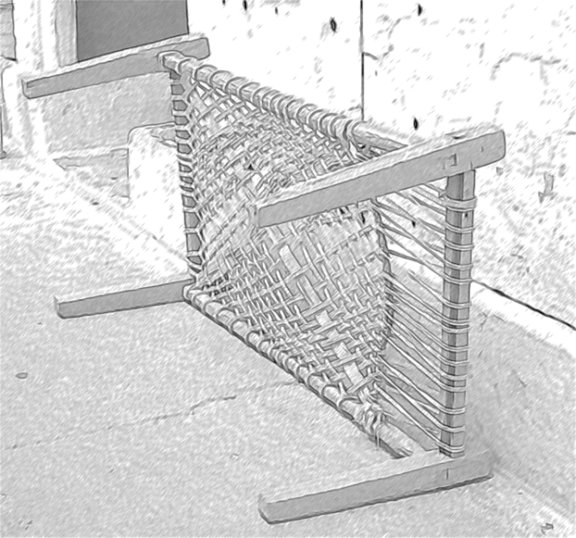
Figure 2 A traditional cot.
When most of your students have made an attempt at the questions, ask them:
- Can you describe what you did to answer these questions? What does estimating make you do or think? It might help to first look at what you did in Question 3.
Students may have used different approaches to the estimation. It is important to accept all their suggestions and then ask them to evaluate the different ways of doing the estimation.

Case Study 1: Mrs Aparajeeta reflects on using Activity 1
This is the account of a teacher who tried Activity 1 with her secondary students.
Questions 1 and 2 we did as a whole class activity. I wrote the questions on the blackboard, one at a time, and then took answers and ideas from the students. For questions 3 and 4 we started off as a whole class, and then they worked on it further in pairs.
When I wrote the first question on the blackboard, the students were giving each other very doubtful looks as they had never been encouraged to do anything like this before – they wanted to simply calculate the exact answer.
Suddenly, Rachit said it would be 420,000. I asked him why he thought so and he said that 6 times 7 was 42 and we add the four zeros for the hundred times hundred. Sakshi at once said that 6 and 7 were in the units place so that would not be so, but she said that she thought it would be more than 10,000 because both 106 and 107 are bigger than 100 and 100 × 100 equals 10,000. Taruna and Rahul agreed.
Part (b) of Question 1 slowed them a bit but Taruna decided it would be more than 2 and less than 3. When asked for reasoning, she said 3 times 225 would be 675, which was more than the numerator, and twice 225 would be 450, which is less than the numerator. For part (c), Aditya decided it would be more than 14 as root 4 was 2, and so root 5 would be more than that and thus the result of the product would be more than 14.
What struck me was that in their rationale they automatically started using the language of ‘more than’ or ‘less than’. It seemed that thinking about upper and lower boundaries is actually a natural thing to do. It made me think that perhaps I should not spend so much teaching time on it, but use questions like this to make them develop these concepts naturally.
They were very doubtful about the expressions to start off with. I assumed this was because it involved a fraction – perhaps I should have asked. I waited for a little while so they would really be aware that they were stuck and they would value the hint I was going to give: to start with estimating $\frac{7}{8}$. Shivam decided that $\frac{7}{8}$ would be around 0.8, which is almost 1, and hence that expression would be x + 5. I asked them whether that would be the maximum or minimum value, and they all agreed that it would be the maximum. For the expression involving $\frac{14}{3}$ I did not need to give any hints. They all went straight away to estimating what $\frac{14}{3}$ would be – it seemed my hint had worked. They said the value would be around 4 and this meant the minimum value would be 9.
With the third expression their faces looked worried. I asked them what worried them and they said it was the cubing and squaring. So I helped them by giving them a support question: I asked them to cube 3 and 0.1, and see the results. Taruna said that 3 cubed would be a bigger number than 3, but the cube of 0.1 would be smaller than 1. I then simply said ‘now look at this expression’ and they at once came up with answers. Again, without prompting, they identified a range in their estimations.
With the cot there was a real sense of excitement in the classroom. They asked me what the length and breadth of the cot was. I told them that their estimation started from there – it was up to them. They all decided they should take it as 2 metres by 1 metre. But there was a lot of discussion about how they would have to double, as the rope had to be wrapped around the frame. At this point I asked them to work on this in pairs, and be ready to share their thinking later on with the whole class.
Question 4 caused a lot of discussion. They found it difficult to describe this – they did not seem to have the language at first. I thought it would help them if they all could practise their talking aloud and sounding out their thoughts, so I asked them to describe their thinking to each other in pairs and when they were happy with their descriptions to write these in their exercise books. We then shared some of the descriptions with the whole class. I noticed some students made changes to what they had written as a result of that whole-class discussion. The descriptions were perhaps not very polished, but I was impressed with their attempt and commitment to start thinking about their thinking – it is not an easy thing to do! I told them that and also said that I still found it very hard to do.
Reflecting on your teaching practice
When you do such an activity with your class, reflect afterwards on what went well and what went less well. Consider the questions that led to the students being interested and those that you needed to clarify. Such reflection always helps with finding a ‘script’, which helps you engage the students to find mathematics interesting and enjoyable. If they do not understand and cannot do something, they are less likely to become involved.
Pause for thought
Good questions to trigger such reflection are:
- How did it go with your class?
- What responses from students were unexpected? Why?
- Were all the students interested in the activities? Were there any students who did not participate? If so, why do you think they didn’t join in?
- What questions did you use to probe your students’ understanding?
- Did you modify the task in any way? If so, what was your reasoning for this?

2 Comparing estimations with exact calculations
In Activity 1 you asked students to practise estimation and to start thinking about the mathematical thinking processes involved in the calculations. The next activity pushes this further and offers more opportunities for you and your students to focus on mathematical processes by comparing estimates with exact answers and for students to become more aware of the purpose of estimating. It uses problems where students would normally not consider estimating the answer first but move straight into working out the exact answer. This activity asks them to stop and think first.

Activity 2: Estimating as a guide
Ask your students the following:
In each of these problems, first estimate the answer (without working it out) and then work out the exact answer. Find the difference between the estimate (E) and the exact answer (A).
- How many kilograms of sugar can Mohan purchase for Rs. 500 if a kilogram of sugar costs Rs. 75?
- Temperatures in some countries are measured in Fahrenheit (°F); in India, temperatures are measured in Celsius (°C). The two measures of temperatures are related by the equation
F = ($\frac{9}{5}$) C + 32 . If the temperature in New Orleans, USA is 95 °F, what is the corresponding temperature in Celsius?
- The area of a triangle with sides a, b and c is given by
A = $\sqrt{s(s – a)(s – b)(s – c)}$, where 2s = a + b + c. Find the area of an equilateral triangle whose side is 4 cm in length.
When the students have given an estimate and an exact answer, ask them:
Do you think your estimation was good? What could you have done to improve it? Did estimating the answer first help you at any stage in finding the exact answer?
Did your students find estimating the answer helpful? Are they confident at estimating? If not, how can you and other students help them?

Case Study 2: Mrs Kapur reflects on using Activity 2
I asked the students to work on this individually and to be ready to explain later on to the whole class how they did their estimation. We then compared answers – quite a few gave in to the temptation and found actual values. In those cases I asked them to explain what their methods of estimating would have been. This was actually really interesting, because when they were tempted to explain the estimating process as exactly the same as working out the correct answer, the other students who had done the estimation as well would comment and critique (in a friendly and constructive way, of course!).
For Question 1, Rahul said that 1 kg cost Rs. 75, so 2 kg would be Rs. 150. Rs. 300 would mean 4 kg and Rs. 450 would mean 6 kg, and because there was more money than that available, the quantity would be more than 6 and less than 7 kg.
The second question was not one they had ever tried talking about, so at first they simply would not try it – no one volunteered! So I acknowledged this might be uncomfortable for them and asked who would attempt an explanation. Sakshi and Usha, who were sitting next to each other, both put their hands up after nudging each other. I applauded their ‘bravery’ and invited them to both help each other with explaining. They explained they would take 95 to be 90 and would subtract 30 to give 60. They said that $\frac{9}{5}$ is almost 2, so dividing by two they could estimate that the Celsius would be more than 30. No one could come up with a better way to estimate. We then discussed what the effect was of first estimating on the understanding of the problem. The students felt that by hearing the description of the process of the estimation, they could suddenly see connections of how degrees in Celsius might be related to degrees in Fahrenheit.
Question 3 was interesting in that nobody, including myself, could think of a way to estimate that would be different from working out the exact answer. We then had a good discussion about why this was, and concluded that actually we did not have a picture, or a clear understanding, of what the formula of the area as was given meant, apart from that it was an algorithm.

3 Estimation in real life
Estimation is used in real life all the time. The NCF (2005) also recommends that mathematics be applied to other curriculum areas to improve understanding and increase the relevance of the subject, and estimation is a useful idea in many other areas.
The next activity involves engaging your students in estimating real-life quantities such as distance, areas and volumes, connecting mathematics with geography, history and local customs. The objects and scenarios used for estimation may be adapted to suit your local environment. You could also ask students to come up with examples as part of their homework. If you or your students have access to the internet, you can find lots of local information quite easily.

Activity 3: Estimation in real life
If you are doing all three activities with your class, you might want to divide students into groups and ask different groups to work on different problems. Decide if you want your groups to be students who are all confident maths learners or if you will create mixed groups.
Tell your students to get into their groups and tell them which problem to solve. You could write the problems on large pieces of paper to stick up on the walls of the classroom:
- Estimating distances: Figure 3 provides us with details of the Duronto rail services in India. For each journey between two cities you are provided with the travel time as well as the average speed of the train in km/h. Can you estimate the total distance that a person will travel if they have to visit all the cities in the network using the Duronto network?
Figure 3 Duronto rail services in India.
- Estimating area: Find a method to estimate the area of each district in your state (Figure 4).
Figure 4 Districts of Rajasthan.
- Estimating volumes: Pick any three objects that can hold different volumes of liquid. (Some examples are shown in Figure 5.) How would you estimate the volumes of water they can hold?
Figure 5 Four examples of objects that can hold liquid.

Video: Using local resources
http://tinyurl.com/video-usinglocalresources
Video: Using groupwork
http://tinyurl.com/video-usinggroupwork
Read Resources 2 and 3, ‘Using local resources’ and ‘Using groupwork’, to find out more.
Case Study 3: Mrs Agawal reflects on using Activity 3
The first question the students came up with was ‘Are we to go to all the cities connected with Duronto network?’ So I said yes, try to go to all of them and yet travel the minimum distance possible, and that it might be really handy to keep a tab where you have been and where not. They really liked the task – they had to work out their own method of approaching it. I suggested that they make groups of four, because this might lead to finding better solutions. There was a lot of discussion about which should be the centre from where the movements could take place.
During sharing time we had a very interesting debate about what was the best way to travel and the purpose of estimation in this case. They all agreed that estimation was the only sensible way to work on this problem, as an exact answer would actually be irrelevant.
They were a bit confused at first about the area estimation in Question 2. They said they needed some more information to work on this. We discussed why this was, and what they would need. They agreed that they would be allowed to find one small bit of information that they could find from atlases or from the internet. One group went and found the area of the smallest district as they said that would help them to estimate the others. Another group decided to find the area of their own district and then estimate the areas of the others. A third group tried to find the scale of the map given and then decided to use some geometrical formulae to get to the answer. There were a variety of answers. We then added up their estimates to see which of them were closest to the actual area of their state. We discussed the purpose of estimating in this problem and the mathematical learning they gained from doing this. They all agreed that estimating was the only sensible approach, and that having to estimate the areas again and again for different shapes of states made them think about what needs to be paid attention to when calculating area.
Then came the volume question. They all picked the glass as one of the items. The reason they gave was that they knew that a litre bottle of Pepsi filled five such glasses (although some said six glasses). So they could then decide how many glasses would be needed to fill the other shapes. The answers were of course varied, as they all estimated the size of the vessels differently. But they gave good justifications for their answers, which was satisfying to me as a teacher.

Pause for thought
- What questions did you use to probe your students’ understanding?
- Did you feel you had to intervene at any point? What points did you feel you had to reinforce?
- Did you modify the task in any way? If so, what was your reasoning for this?

4 Summary
This unit has focused on estimation and how students can use this approach to concentrate on the mathematical ideas rather than on the detail and difficulty of working out an exact numerical answer. Estimation can help students understand what they are doing and why, as well as help them gain more marks in examinations because they notice if they have made a calculation error.
The activities include many ideas for giving a point to estimation so that it does not seem another chore to do when ‘doing mathematics’. They also show that working together can not support students’ thinking but also a reason to articulate their thinking, making it real and much easier to recall later.

Resources
Resource 1: NCF/NCFTE teaching requirements
This unit links to the following teaching requirements of the NCF (2005) and NCFTE (2009), and will help you to meet those requirements:
- View students as active participants in their own learning and not as mere recipients of knowledge; to encourage their capacity to construct knowledge; to ensure that learning shifts away from ‘rote’ methods.
- View learning as a search for meaning from personal experience and knowledge generation as a continuously evolving process of reflective learning.
- Support students to learn to enjoy mathematics rather than fear it.
- Help students to see mathematics as something to talk about, to communicate through, to discuss among themselves, and to work together on.
- Connect school knowledge with community knowledge and life outside school.
Resource 2: Using local resources
Many learning resources can be used in teaching – not just textbooks. If you offer ways to learn that use different senses (visual, auditory, touch, smell, taste), you will appeal to the different ways that students learn. There are resources all around you that you might use in your classroom, and that could support your students’ learning. Any school can generate its own learning resources at little or no cost. By sourcing these materials locally, connections are made between the curriculum and your students’ lives.
You will find people in your immediate environment who have expertise in a wide range of topics; you will also find a range of natural resources. This can help you to create links with the local community, demonstrate its value, stimulate students to see the richness and diversity of their environment, and perhaps most importantly work towards a holistic approach to student learning – that is, learning inside and outside the school.

Making the most of your classroom
People work hard at making their homes as attractive as possible. It is worth thinking about the environment that you expect your students to learn in. Anything you can do to make your classroom and school an attractive place to learn will have a positive impact on your students. There is plenty that you can do to make your classroom interesting and attractive for students – for example, you can:
- make posters from old magazines and brochures
- bring in objects and artefacts related to the current topic
- display your students’ work
- change the classroom displays to keep students curious and prompt new learning.

Using local experts in your classroom
If you are doing work on money or quantities in mathematics, you could invite market traders or dressmakers into the classroom to come to explain how they use maths in their work. Alternatively, if you are exploring patterns and shapes in art, you could invite maindi [wedding henna] designers to the school to explain the different shapes, designs, traditions and techniques. Inviting guests works best when the link with educational aims is clear to everyone and there are shared expectations of timing.
You may also have experts within the school community (such as the cook or the caretaker) who can be shadowed or interviewed by students related to their learning; for example, to find out about quantities used in cooking, or how weather conditions impact on the school grounds and buildings.

Using the outside environment
Outside your classroom there is a whole range of resources that you can use in your lessons. You could collect (or ask your class to collect) objects such as leaves, spiders, plants, insects, rocks or wood. Bringing these resources in can lead to interesting classroom displays that can be referred to in lessons. They can provide objects for discussion or experimentation such as an activity in classification, or living or not-living objects. There are also resources such as bus timetables or advertisements that might be readily available and relevant to your local community – these can be turned into learning resources by setting tasks to identify words, compare qualities or calculate journey times.
Objects from outside can be brought into the classroom – but the outside can also be an extension of your classroom. There is usually more room to move outside and for all students to see more easily. When you take your class outside to learn, they can do activities such as:
- estimating and measuring distances
- demonstrating that every point on a circle is the same distance from the central point
- recording the length of shadows at different times of the day
- reading signs and instructions
- conducting interviews and surveys
- locating solar panels
- monitoring crop growth and rainfall.
Outside, their learning is based on realities and their own experiences, and may be more transferable to other contexts.
If your work outside involves leaving the school premises, before you go you need to obtain the school leader’s permission, plan timings, check for safety and make rules clear to the students. You and your students should be clear about what is to be learnt before you depart.

Adapting resources
You may want to adapt existing resources to make them more appropriate to your students. These changes may be small but could make a big difference, especially if you are trying to make the learning relevant to all the students in the class. You might, for example, change place and people names if they relate to another state, or change the gender of a person in a song, or introduce a child with a disability into a story. In this way you can make the resources more inclusive and appropriate to your class and their learning.
Work with your colleagues to be resourceful: you will have a range of skills between you to generate and adapt resources. One colleague might have skills in music, another in puppet making or organising outdoor science. You can share the resources you use in your classroom with your colleagues to help you all generate a rich learning environment in all areas of your school.
Resource 3: Using groupwork
Groupwork is a systematic, active, pedagogical strategy that encourages small groups of students to work together for the achievement of a common goal. These small groups promote more active and more effective learning through structured activities.
The benefits of groupwork
Groupwork can be a very effective way of motivating your students to learn by encouraging them to think, communicate, exchange ideas and thoughts, and make decisions. Your students can both teach and learn from others: a powerful and active form of learning.
Groupwork is more than students sitting in groups; it involves working on and contributing to a shared learning task with a clear objective. You need to be clear about why you are using groupwork for learning and know why this is preferable to lecturing, pair work or to students working on their own. Thus groupwork has to be well-planned and purposeful.

Planning groupwork
When and how you use groupwork will depend on what learning you want to achieve by the end of the lesson. You can include groupwork at the start, the end or midway through the lesson, but you will need to allow enough time. You will need to think about the task that you want your students to complete and the best way to organise the groups.
As a teacher, you can ensure that groupwork is successful if you plan in advance:
- the goals and expected outcomes of the group activity
- the time allocated to the activity, including any feedback or summary task
- how to split the groups (how many groups, how many students in each group, criteria for groups)
- how to organise the groups (role of different group members, time required, materials, recording and reporting)
- how any assessment will be undertaken and recorded (take care to distinguish individual assessments from group assessments)
- how you will monitor the groups’ activities.

Groupwork tasks
The task that you ask your students to complete depends on what you what them to learn. By taking part in groupwork, they will learn skills such as listening to each other, explaining their ideas and working cooperatively. However, the main aim is for them to learn something about the subject that you are teaching. Some examples of tasks could include the following:
- Presentations: Students work in groups to prepare a presentation for the rest of the class. This works best if each group has a different aspect of the topic, so they are motivated to listen to each other rather than listening to the same topic several times. Be very strict about the time that each group has to present and decide on a set of criteria for a good presentation. Write these on the board before the lesson. Students can the use the criteria to plan their presentation and assess each other’s work. The criteria could include:
  - Was the presentation clear?
  - Was the presentation well-structured?
  - Did I learn something from the presentation?
  - Did the presentation make me think?
- Problem solving: Students work in groups to solve a problem or a series of problems. This could include conducting an experiment in science, solving problems in mathematics, analysing a story or poem in English, or analysing evidence in history.
- Creating an artefact or product: Students work in groups to develop a story, a piece of drama, a piece of music, a model to explain a concept, a news report on an issue or a poster to summarise information or explain a concept. Giving groups five minutes at the start of a new topic to create a brainstorm or mind map will tell you a great deal about what they already know, and will help you pitch the lesson at an appropriate level.
- Differentiated tasks: Groupwork is an opportunity to allow students of different ages or attainment levels to work together on an appropriate task. Higher attainers can benefit from the opportunity to explain the work, whereas lower attainers may find it easier to ask questions in a group than in a class, and will learn from their classmates.
- Discussion: Students consider an issue and come to a conclusion. This may require quite a bit of preparation on your part in order to make sure that the students have enough knowledge to consider different options, but organising a discussion or debate can be very rewarding for both you and them.

Organising groups
Groups of four to eight are ideal but this will depend on the size of your class, the physical environment and furniture, and the attainment and age range of your class. Ideally everyone in a group needs to see each other, talk without shouting and contribute to the group’s outcome.
- Decide how and why you will divide students into groups; for example, you may divide groups by friendship, interest or by similar or mixed attainment. Experiment with different ways and review what works best with each class.
- Plan any roles you will give to group members (for example, note taker, spokesperson, time keeper or collector of equipment), and how you will make this clear.

Managing groupwork
You can set up routines and rules to manage good groupwork. When you use groupwork regularly, students will know what you expect and find it enjoyable. Initially it is a good idea to work with your class to identify the benefits of working together in teams and groups. You should discuss what makes good groupwork behaviour and possibly generate a list of ‘rules’ that might be displayed; for example, ‘Respect for each other’, ‘Listening’, ‘Helping each other’, ‘Trying more than one idea’, etc.
It is important to give clear verbal instructions about the groupwork that can also be written on the blackboard for reference. You need to:
- direct your students to the groups they will work in according to your plan, perhaps designating areas in the classroom where they will work or giving instructions about moving any furniture or school bags
- be very clear about the task and write it on the board in short instructions or pictures. Allow your students to ask questions before you start.
During the lesson, move around to observe and check how the groups are doing. Offer advice where needed if they are deviating from the task or getting stuck.
You might want to change the groups during the task. Here are two techniques to try when you are feeling confident about groupwork – they are particularly helpful when managing a large class:
- ‘Expert groups’: Give each group a different task, such as researching one way of generating electricity or developing a character for a drama. After a suitable time, re-organise the groups so that each new group is made up of one ‘expert’ from all the original groups. Then give them a task that involves collating knowledge from all the experts, such as deciding on what sort of power station to build or preparing a piece of drama.
- ‘Envoys’: If the task involves creating something or solving a problem, after a while, ask each group to send an envoy to another group. They could compare ideas or solutions to the problem and then report back to their own group. In this way, groups can learn from each other.
At the end of the task, summarise what has been learnt and correct any misunderstandings that you have seen. You may want to hear feedback from each group, or ask just one or two groups who you think have some good ideas. Keep students’ reporting brief and encourage them to offer feedback on work from other groups by identifying what has been done well, what was interesting and what might be developed further.
Even if you want to adopt groupwork in your classroom, you may at times find it difficult to organise because some students:
- are resistant to active learning and do not engage
- are dominant
- do not participate due to poor interpersonal skills or lack of confidence.
To become effective at managing groupwork it is important to reflect on all the above points, in addition to considering how far the learning outcomes were met and how well your students responded (did they all benefit?). Consider and carefully plan any adjustments you might make to the group task, resources, timings or composition of the groups.
Research suggests that learning in groups need not be used all the time to have positive effects on student achievement, so you should not feel obliged to use it in every lesson. You might want to consider using groupwork as a supplemental technique, for example as a break between a topic change or a jump-start for class discussion. It can also be used as an ice-breaker or to introduce experiential learning activities and problem solving exercises into the classroom, or to review topics.

Additional resources
- A newly developed maths portal by the Karnataka government: http://karnatakaeducation.org.in/KOER/en/index.php/Portal:Mathematics
- Class X maths study material: http://www.zietmysore.org/stud_mats/X/maths.pdf
- National Centre for Excellence in the Teaching of Mathematics: https://www.ncetm.org.uk/
- National STEM Centre: http://www.nationalstemcentre.org.uk/
- OpenLearn: http://www.open.edu/openlearn/
- BBC Bitesize: http://www.bbc.co.uk/bitesize/
- Khan Academy’s math section: https://www.khanacademy.org/math
- NRICH: http://nrich.maths.org/frontpage
- Mathcelebration: http://www.mathcelebration.com/
- Art of Problem Solving’s resources page: http://www.artofproblemsolving.com/Resources/index.php
- Teachnology: http://www.teach-nology.com/worksheets/math/
- Maths is Fun: http://www.mathsisfun.com/
- National Council of Educational Research and Training’s textbooks for teaching mathematics and for teacher training of mathematics: http://www.ncert.nic.in/ncerts/textbook/textbook.htm
- LMT-01 Learning Mathematics, Block 1 (‘Approaches to Learning’) Block 2 (‘Encouraging Learning in the Classroom’), Block 5 (‘Exploring Numbers’), Block 6 (‘Thinking Mathematically’): http://www.ignou4ublog.com/2013/06/ignou-lmt-01-study-materialbooks.html
- Learning Curve and At Right Angles, periodicals about mathematics and its teaching: http://azimpremjifoundation.org/Foundation_Publications
- Central Board of Secondary Education’s books and support material (also including the Teachers Manual for Formative Assessment – Mathematics (Class IX)) – select ‘CBSE publications’, then ‘Books and support material’: http://cbse.nic.in/welcome.htm

References/bibliography
Freudenthal, H. (1991) Revisiting Mathematics Education: China Lectures. Dordrecht: Kluwer.
Mason, J., Burton, L. and Stacey, K. (2010) Thinking Mathematically, 2nd edn. Harlow: Pearson Education.
National Council of Educational Research and Training (2005) National Curriculum Framework (NCF). New Delhi: NCERT.
National Council of Educational Research and Training (2009) National Curriculum Framework for Teacher Education (NCFTE). New Delhi: NCERT.
Van Hiele, P. (1986) Structure and Insight: A Theory of Mathematics Education. Orlando, FL: Academic Press.
Watson, A., Jones, K. and Pratt, D. (2013) Key Ideas in Teaching Mathematics. Oxford: Oxford University Press.

Acknowledgements
Except for third party materials and otherwise stated below, this content is made available under a Creative Commons Attribution-ShareAlike licence (http://creativecommons.org/licenses/by-sa/3.0/). The material acknowledged below is Proprietary and used under licence for this project, and not subject to the Creative Commons Licence. This means that this material may only be used unadapted within the TESS-India project and not in any subsequent OER versions. This includes the use of the TESS-India, OU and UKAID logos.
Grateful acknowledgement is made to the following sources for permission to reproduce the material in this unit:
Figure 1: © Thamizhpparithi Maari http://commons.wikimedia.org/wiki/File:A_road_side_fruit_juice_stall.jpg – this file is licensed under the Creative Commons Attribution-Share Alike 3.0 Unported licence.
Figure 2: © author: http://upload.wikimedia.org/wikipedia/commons/2/24/Cot-rope,traditional_-Tamil_Nadu52.JPG
Figure 3: © Harvardton, http://commons.wikimedia.org/wiki/File:Indian_Railways_Duronto_map.gif – this file is licensed under the Creative Commons Attribution-Share Alike 3.0 Unported licence.
Figure 4: © Sudhir Kumar Garhwal, http://en.wikipedia.org/wiki/File:Rajasthan_locator_map.svg. This file is licensed under the Creative Commons Attribution-Share Alike 3.0 Unported licence.
Figure 5: drinking glass: © Derek Jenson (Tysto), http://upload.wikimedia.org/wikipedia/commons – this file is licensed under the Creative Commons Attribution-Share Alike 3.0 Unported licence; bucket: © MarlonBSB: http://commons.wikimedia.org/wiki/File:Balde.PNG – this file is licensed under the Creative Commons Attribution-Share Alike 3.0 Unported licence; water tank: http://www.hrp.co; ghatam: © Sven Petersen, http://commons.wikimedia.org/wiki/File:Ghatam.jpg?uselang=en-gb – this file is licensed under the Creative Commons Attribution-Share Alike 3.0 Unported licence.
Every effort has been made to contact copyright owners. If any have been inadvertently overlooked the publishers will be pleased to make the necessary arrangements at the first opportunity.
Video (including video stills): thanks are extended to the teacher educators, headteachers, teachers and students across India who worked with The Open University in the productions.

