WASH: Context and Environment

About OpenWASH

OpenWASH learning resources provide an innovative curriculum of study designed to be used in education and training programmes in the water, sanitation and hygiene (WASH) sector in Ethiopia. They have been written by Ethiopian WASH experts with the support of teaching specialists from The Open University UK (OU). The name ‘OpenWASH’ is derived from this link with the OU and also indicates that the resources are free to use as open educational resources.
The OpenWASH resources are the output from a partnership agreement between the OU, World Vision Ethiopia (WVE) and UNICEF. They are part of the capacity-building component of WVE’s Urban WASH programme. This is part of UNICEF’s One WASH plus programme, which is funded by UK aid from the UK Government as a contribution to the Ethiopian Government’s One WASH National Programme (OWNP).
The modules are designed for people engaged across a range of positions and levels in the WASH sector. The main audience is intended to be students who are training to work in the sector, but the modules may also be used for in-service training of new employees and by more experienced practitioners seeking to improve knowledge and skills in specific areas. The material could also contribute to training of community groups, in schools, etc.
There are five OpenWASH modules covering a range of WASH subjects, with an emphasis on WASH in urban settings. The module titles are:
- Ethiopia’s One WASH National Programme
- WASH: Context and Environment
- Urban Water Supply
- Urban Sanitation and Solid Waste Management
- Urban WASH: Working with People.
They have been written in such a way that they can be used separately or together. As a set of five, the modules provide a comprehensive set of resources that introduce students to a wide range of essential skills and knowledge about urban WASH. They can also be used individually or as a group of two or more modules to support particular training needs. Each module consists of 15 separate ‘study sessions’ that follow a consistent structure and length thus facilitating effective learning.
The modules are accompanied by the OpenWASH Trainers’ Handbook, which provides guidance on how the modules can be used in a variety of teaching contexts.

This Module, WASH: Context and Environment, was prepared by a team of Ethiopian authors with support from experts in blended learning pedagogy at The Open University UK. It was first published in February 2016. The contributors of original material are:
Dr Abera Kumie, School of Public Health, Addis Ababa University
Dr Kassahun Alemu, Institute of Public Health, Gondar University
Samson Wakuma, School of Public Health, Addis Ababa University
The Academic Editors of WASH: Context and Environment are Dr Sarah Davies, Senior Lecturer in Environmental Sciences in the Faculty of Science, and Pam Furniss, Senior Lecturer in Environmental Systems in the Faculty of Mathematics, Computing and Technology, The Open University UK.
Additional thanks to:
Michele Paba, Urban WASH Specialist, UNICEF Ethiopia
Rahel Kaba, Urban WASH Specialist, UNICEF Ethiopia
Tamene Gossa, Urban WASH Specialist, UNICEF Ethiopia
Dr Sam Godfrey, Chief of WASH, UNICEF Ethiopia
Dereje Alemu, WASH Operations Director, World Vision Ethiopia
Felipe Chaparro, Team Leader Urban WASH Project, World Vision Ethiopia
Nicholas Owuor, Team Leader Urban WASH Project, World Vision Ethiopia
Ellen Scott, OpenWASH Project Manager
Gail Vardy, OpenWASH Project Coordinator
Julie Herbert, Project Coordinator
Hannah Juma, OpenWASH Curriculum Manager
This Module should be cited as follows:
OpenWASH (2016) WASH: Context and Environment, The Open University UK/World Vision Ethiopia/UNICEF.

Contents

Study session | Title | Page
 | Introduction to WASH: Context and Environment | 7
1 | Human Interactions with the Environment | 9
2 | Population Growth | 21
3 | Development and Sustainability | 33
4 | The Water Cycle and Sources of Water | 43
5 | Urbanisation: Trends, Causes and Effects | 55
6 | Land Use and Urban Planning | 67
7 | Pollution: Types, Sources and Characteristics | 77
8 | Pollution: Effects, Prevention and Control | 87
9 | Introduction to Climate Change | 99
10 | Extreme Weather Events | 111
11 | Impacts of Climate Change in Ethiopia | 121
12 | Resilience and Coping Strategies | 129
13 | Human Values and Behaviour | 139
14 | Global Environment Policies and International Agreements | 149
15 | National Policy Context in Ethiopia | 159
 | Notes on the Self-Assessment Questions (SAQs) for WASH: Context and Environment | 169
 | Key terms | 183
 | References | 185
 | Acknowledgements | 195

Introduction to WASH: Context and Environment

Appreciation of the context for water, sanitation and hygiene (WASH) services is necessary if those services are to be effective and long-lasting. This Module provides essential background to WASH in Ethiopia by explaining broader topical issues such as sustainability, resilience, population growth, urbanisation, climate change, and global policy. It will also look at the interconnections between people and their environment, and the science that underpins that relationship.

Learning Outcomes for this Module
After you have studied this Module you should be able to:
- Describe the impacts of our actions and behaviour on the environment in which we live, and identify ways in which we can all contribute to creating a better environment.
- Understand the patterns of change and underlying trends in population, climate and urbanisation, and how these may affect progress in WASH.
- Describe the water cycle, the importance of a safe water supply and the relationship between water resources and human activities.
- Explain the effects of pollution on the natural environment and in human health, and how this influences waste disposal options.
- Describe the national and international policy context for the WASH sector in Ethiopia.

How to use this Module
This Module is designed for independent study, although you may in fact be studying in a group with others. Either way, we recommend that you use a Study Notebook that you keep with you as you work through the Module to note down answers to questions and keep a note of any important points.
The Module is divided into 15 separate study sessions, each expected to take about two hours to study if you are learning on your own. You will see that the study sessions all have a similar structure. Following a brief introduction, each study session has a set of learning outcomes that are linked to self-assessment questions (SAQs) at the end of the session. Within the text, there are in-text questions (ITQs) with answers immediately following. When you come across one of these questions, try to answer it in your head or by noting down your answer in your notebook before you read the response that is given. This will help you to learn.
Each session ends with a summary, which lists the key points that have been made, and the SAQs. Each SAQ tests one or more of the learning outcomes that were stated at the beginning of the session. When you have finished reading, you should work through the SAQs, writing answers in your notebook. Writing your answers, rather than just thinking about them, will reinforce your learning and enable you and anyone else to check how well you have achieved the learning outcome. You can check your answer with the notes on the SAQs from all sessions, which you will find collected together at the back of this book.
Important terms are highlighted in bold and defined in the text. You will find that the first learning outcome for all study sessions is to be able to understand and use these key terms. All the key terms from this Module are listed alphabetically at the back of this book with a reference to the study session where they are defined.
You will see that the sources of information used in the text are indicated by the name of the author or organisation followed by the date of publication in brackets, for example ‘(Haddis and Genet, 2012)’. Full details of these sources are listed alphabetically by author in the list of references at the back of the book. If an article has more than two authors, we have used the notation ‘Faris et al., 2012’, where ‘et al.’ is a shortened form of the Latin words for ‘and others’.
Please note that we have used UK English spellings rather than US spellings. Please also note that all years are according to the Gregorian rather than Ethiopian calendar, unless otherwise stated.

Study Session 1 Human Interactions with the Environment

Introduction
This Module is about the context and background to water, sanitation and hygiene (WASH) in Ethiopia. The WASH sector is concerned with provision of safe water, the separation and management of wastes, and promotion of hygienic practices to improve people’s health and well-being. To understand the context of the WASH sector you need to understand the nature of the interactions between us as human beings and our environment.
Humans need to interact with the environment to obtain our food, water, fuel, medicines, building materials and many other things. Advances in science and technology have helped us to exploit the environment for our benefit, but we have also introduced pollution and caused environmental damage. The impact of environmental problems on humans is significant, affecting all human activities, including health and socio-economic development. In this study session you will learn about the relationships between humans and the environment, and the ways in which we use environmental resources. This study session introduces you to many of the topics that are further developed later in the Module.

Learning Outcomes for Study Session 1
When you have studied this session, you should be able to:
1.1 Define and use correctly all of the key words printed in bold. (SAQs 1.1 and 1.3)
1.2 Describe the relationships between human activities and the environment and explain the importance of creating a better environment. (SAQ 1.2)
1.3 Describe the ways in which humans use natural resources and give examples of problems caused by over-exploitation. (SAQ 1.3)
1.4 Give examples of positive and negative ways in which technology affects the environment. (SAQ 1.4)

1.1 Relationships between human activity and the environment
Our environment means our physical surroundings and the characteristics of the place in which we live. It also refers to the wider natural world of land, sea and atmosphere. Humans have been interacting with their environment since people first walked the Earth. For example, humans have been cutting down forests to clear land to grow crops for centuries and by doing so we have altered the environment. Conversely, the environment affects us in many different ways as well. A simple example is the way we change our clothes in response to cold or hot weather. In this section we will introduce some of the ways in which humans influence their environment and how the environment influences us, both positively and negatively.
A good climate, accessible clean water, fertile soil, etc. are aspects of the physical environment that enable people to live and thrive. However, harsh environments, such as a very hot climate, limited water and infertile land, make it more difficult for people to survive. We are also affected by major environmental events such as earthquakes, floods and drought that damage homes, property and agriculture. These can lead to the displacement of people and can cause injury, loss of life and destruction of livelihoods. They can also damage water sources and pipelines, causing water contamination and spreading waterborne diseases. In Study Session 10 you will learn more about the effects of floods and droughts.
Our relationship with the environment changed with industrialisation, which began in the 18th century in the UK, shortly followed by elsewhere in Europe and North America, and then spreading across the world. Prior to industrialisation, the impacts of human activity were not very significant because the technologies used were not capable of modifying the environment on a large scale. People at that time lived in agricultural societies using hand tools and simple technologies with limited environmental impact (Figure 1.1). Industrialisation has allowed for a greater exploitation of resources. For example, we now use powerful chainsaws to cut down trees and industrially produced chemical fertilisers and pesticides for crop production. These changes have rapidly increased the human impact on the environment.
The links between human activity and the environment are complex and varied, but can be grouped into two main types of activity:
- use of natural resources such as land, food, water, soils, minerals, plants and animals
- production of wastes from a range of activities including agriculture, industry and mining, as well as wastes from our own bodies.
These are described in the following sections.
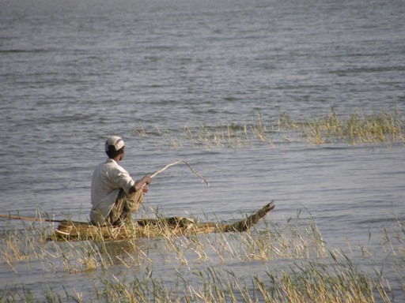
Figure 1.1 Fishing on Lake Awassa using simple technologies.

1.2 Use of natural resources
We use many different types of natural resources in our daily lives. We depend on food and water for survival and we need energy for many different purposes, from domestic cooking through to major industrial processes. Our clothes, transport, buildings, tools and all other items we use require many different resources for their production. Let’s take a simple example. Think about the resources that have been used to produce a notebook of the type you may be using right now as you study this Module. Manufacturing the paper needed raw materials of wood and water as well as energy for the production process. The trees that supplied the wood required soil, water and land to grow on. There may be ink or metal staples or other components in your notebook that were made from other types of resources. Our need for resources is vast and it is growing as the population increases and consumption per person increases with socio-economic progress. Depletion of natural resources by extraction and exploitation is especially of concern for non-renewable resources (see Box 1.1).

Box 1.1 Renewable and non-renewable resources
The resources we use can be classified as renewable or non-renewable. The basic difference between the two is the rate at which they are regenerated back into a usable form, relative to the rate at which they are used by humans. Non-renewable resources cannot be replenished by natural means as quickly as the rate at which they are consumed. They include minerals and fossil fuels such as oil, coal and gas, which are formed over millions of years by natural processes from decayed plants and animals.
Renewable resources are constantly available or regenerated over short timescales by natural processes. Some renewable resources, such as solar energy, are not modified or used up by humans. Others, such as water, are altered when we use them and can be over-exploited or damaged such that the resource is no longer available for use.
- Can you suggest some other renewable resources that are replenished naturally but need to be managed properly and not over-exploited?
- You may have suggested examples such as wood, animals and plants. For example, trees are cut down to provide wood and they will regrow but they need time to regenerate.
Globally, both population and resource extraction increased by almost 50% in the 25 years from 1980 to 2005 (SERI et al., 2009). Over that time, the world population increased from 4.44 billion in 1980 to 6.49 billion. Figure 1.2 shows how the extraction of natural resources increased between 1980 and 2005 from 40 billion tonnes to 58 billion tonnes. The graph shows the extraction of four types of natural resource: fossil fuels, biomass, metals and minerals. Biomass means biological material derived from living organisms such as crops, livestock, fish, wood, etc. Metals are used in the manufacture of a wide range of goods – from cars to computers. Minerals are used in industrial processes and in construction to build our houses and roads. Both metals and minerals are obtained from rocks that have been mined and are then processed in various ways to extract the valuable resource.
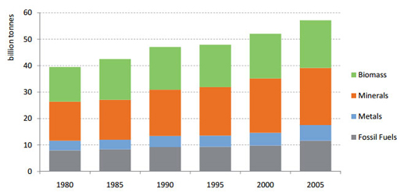
Figure 1.2 Global extraction of natural resources, 1980 to 2005. (SERI et al., 2009)
- Look at Figure 1.2. What is the pattern of natural resource extraction from 1980 to 2005 and what do you think could be the reason?
- Natural resource extraction shows a steady increase from 1980 to 2005, with the greatest amount extracted in the most recent year (2005). The most likely reason is the increase in the global population in this period; more people need more resources. It could also be the case that the amount used by individuals and by wider society is increasing due to changes in behaviour and levels of consumption.
Advances in technology have increased natural resource exploitation by enabling people to reach new resources and to exploit more resources per capita (per person). For example, fishermen who use traditional technologies such as small boats are limited in the number of fish they can catch. Modern industrial fishing fleets use very large ships that cover huge areas of ocean at greater depths to catch many more fish. This can lead to overfishing, which means catching fish at a faster rate than they can reproduce.
- Are fish a renewable or non-renewable resource?
- Fish are a renewable resource. However, if fishing is not managed properly and more fish are taken from the water than can be replaced naturally, the fishery will fail.
Overfishing and other examples of over-exploitation of natural resources can result in damage to or the loss of entire ecosystems. An ecosystem includes all the living organisms (humans, plants, animals, micro-organisms) and their physical environment (soil, water, air, land) and the interactions between them. If one component of the system is removed, this can have knock-on effects on the other parts of the system.

1.2.1 Deforestation
One particular problem caused by over-exploitation of natural resources is deforestation, which occurs when forest areas are cleared and the trees are not replanted or allowed to regrow. In Ethiopia, clearing land for agriculture to meet the food needs of the growing population and the demand for fuel and construction materials has resulted in a steady loss of forest area, which is still continuing as you can see from Figure 1.3.
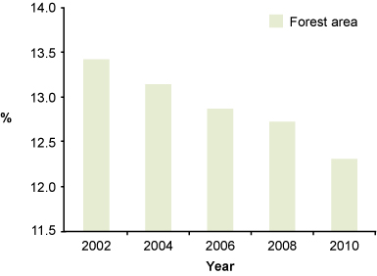
Figure 1.3 Proportion of land area in Ethiopia covered by forest (%) from 2002 to 2010. (MoFED, 2012a)
The loss of forest has several undesirable consequences. Forests are home to many different types of trees, as well as other plants, and a wide range of animals from insects to birds and mammals. The conversion of forests to agriculture greatly reduces biodiversity, which is a measure of the variety of living organisms (all life forms). Biodiversity is important for humans because we use other living organisms to provide several essentials:
- Food: we use plants and animals such as fish, goats, wheat, rice and maize as sources of food.
- Medicines: many traditional medicines are made from plants and animals and new medicines are developed from them.
- Ecological services: living organisms, especially plants and micro-organisms, play an important role in processes that maintain our lives and environment such as providing oxygen, cleaning the air, purifying water, breaking down wastes and controlling erosion.
Deforestation is a significant contributory cause of soil erosion. Once the trees and undergrowth are removed, the underlying ground is exposed. Without the intercepting effect of the vegetation and the tree roots binding the soil together, the soil is more likely to be washed away when it rains. Loss of forests also has a significant impact on water supply. Tree roots reach deep into the soil and create spaces between the particles which increases soil permeability, allowing rainwater to soak in and replenish groundwater. (Permeability means the ease with which water moves through soil or rock.)

1.2.2 Energy resources
The use of renewable or non-renewable resources is a critical factor when considering energy resources. Fossil fuels have been the main energy source for global industrialisation, but because they are non-renewable, the quantity is ultimately limited and their use is not sustainable over the long term. Furthermore, burning of fossil fuels is the main cause of climate change. (Climate change is discussed fully in later study sessions.) There are several renewable alternatives to fossil fuels. Wood used as a fuel is renewable in the sense that trees will regrow but there are other disadvantages such as deforestation, as you have read. In Ethiopia, windfarms are harnessing wind power to generate electricity (Figure 1.4) but the most important source of renewable energy in Ethiopia is water. Ethiopia already has several hydropower stations and more are planned, including the Grand Ethiopian Renaissance Dam, currently under construction. Hydroelectric power is renewable because it makes use of the energy of flowing water but does not use up the water in the process. Another renewable energy source is solar power, using photovoltaic cells that convert the sun’s energy into electricity.
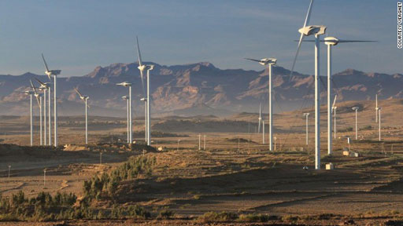
Figure 1.4 Windfarm at Ashegoda, Tigray Region.

1.2.3 Water resources
You may have noticed that the four categories of resources shown in Figure 1.2 do not include water, and yet this is one of our most vital resources and is obviously central to the WASH sector. The direct use of water by people falls into three main categories:
- domestic uses, including drinking, washing and cooking
- agricultural uses, principally irrigation
- industrial uses, in manufacturing processes and for energy generation.
The relative proportions of these three categories vary in different parts of the world, but globally the sector using the most water is agriculture (FAO, 2012) (Figure 1.5).
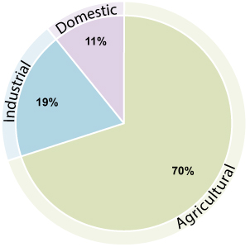
Figure 1.5 Global water withdrawal by sector. (Adapted from FAO, 2012)
As well as direct use of water for human activities, water is also essential for the environment and to maintain biodiversity. Rivers, lakes and wetlands are important habitats for wildlife and need a minimum amount of water at all times. This becomes a problem when the demand for water for human activities exceeds the supply.
Water is not an endlessly renewable resource. In many parts of the world water demand is significantly above sustainable water supply. Sustainable water supply means there are adequate supplies, in both quality and quantity, to meet the current and future needs of people and of the environment.
Many countries are already experiencing water stress or scarcity. These terms refer to the volume of water available relative to the use and demand for it, which is linked to the population served. Figure 1.6 shows the availability of freshwater across the world. Countries which have less than 1700 m³ of water per person per year for all purposes are defined as water stressed (United Nations, 2014). Water scarce countries have been defined as those with less than 1000 m³ of water per person per year. These precise figures should be used with caution, however, because they do not recognise variations between countries and they hide the underlying causes of water scarcity.
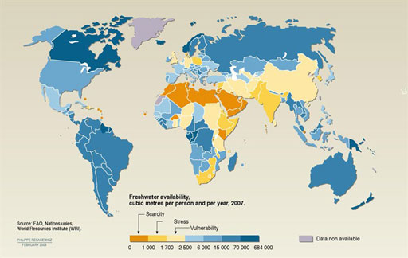
Figure 1.6 Global freshwater availability in cubic metres (m³) per person per year (2007). (Note that although calculated ‘per person’, these figures apply to all uses of water not just personal use.) (WWAP, 2012)
Increasing water demand leads to unsustainable use of water resources. By the actions of the water cycle (which you will learn about in Study Session 4) water supply is replenished, but taking excessive amounts of water from rivers and groundwater for domestic, industrial and agricultural use decreases the amount of water available for current and future generations. Globally, water withdrawals have tripled over the last 50 years due to population growth and to increased consumption per person. Many areas with plentiful supplies can sustain this use, but in some countries the future may bring water shortages unless demand is managed.
- If the trend for increased consumption continues, what could be the result for Ethiopia?
- As you can see from Figure 1.6, Ethiopia is already classed as being under water stress. If consumption increases due to population growth and/or increased use per person, this could put Ethiopia into the water scarcity category.
In practice, for Ethiopia, the problem of water supply is not so much about the volume of water that is available. The problem is the infrastructure and investment required in delivering adequate quantities of safe water to all the people wherever they live. The availability of water and access to a safe supply varies considerably throughout the country and between rural and urban populations.
Case Study 1.1 illustrates the problems that can arise from excessive water use.

Case Study 1.1 Effects of water use on Lake Alemaya
Lake Alemaya in the Ethiopian Highlands has always provided local people with water for drinking and domestic use, for irrigating crops, watering livestock and fishing. In the mid-1980s it was around 8 m deep and covered 4.72 km². However, by 2005 the amount of water in the lake had dropped dramatically (Figure 1.7) and the size of the lake had fallen (UNEP, n.d. 2).
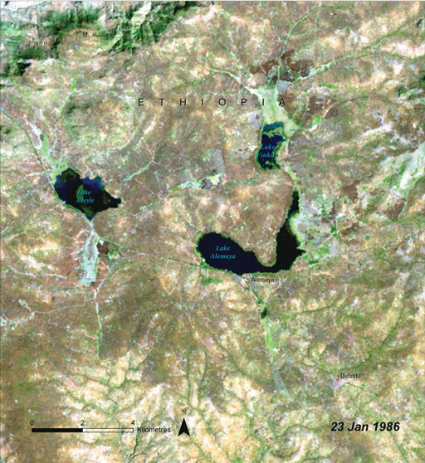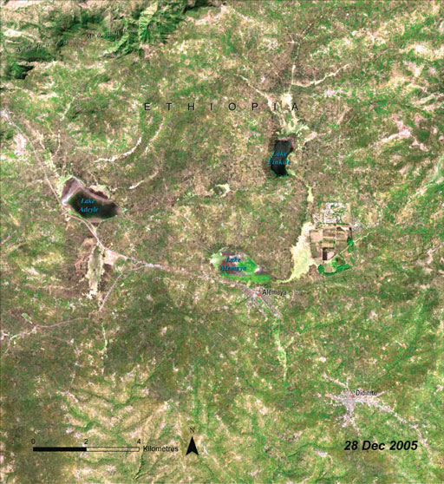
Figure 1.7 Loss of water from Lake Alemaya, between 1986 and 2005. (UNEP, n.d. 2)
It is believed that changes in water use by local people and changes in the local climate are responsible. The use of domestic water and also water for irrigation (especially for growing khat) has increased significantly. Deforestation of the surrounding area, as land is cleared for farming and to meet an increasing need for wood, means that tree roots no longer hold the soil together and it is washed off the hillsides into the lake. This causes it to silt up and reduces the capacity of the lake. Warming of the local climate may also have had an effect, increasing the rate of evaporation from the lake. Recently, lack of water in the lake has interrupted water supply to Harar, a nearby town of over 100,000 people.

- What are the possible causes of the loss of water from Lake Alemaya?
- Increased use of water for domestic uses and for irrigation, deforestation leading to soil erosion and silt deposition in the lake, and possibly climate change.

1.3 Production of waste and pollutants
Following on from our use of natural resources, it is inevitable that wastes are produced. For the WASH sector, the most important of these is our own bodily wastes. The impacts of open defecation and inadequate sanitation on human health and on the wider environment are profound. Waterborne diseases are caused by pathogens (disease-causing agents) in water and food that have been contaminated by the wastes from infected people. Preventing this connection between human wastes and the intake of contaminated water is the primary goal of WASH services.
Industry, agriculture and energy production all generate wastes that can pollute air, water and soil. Pollution means the introduction into the environment of substances liable to cause harm to humans and other living organisms. For example, the leather industry produces large amounts of liquid wastes from the tanning process. These wastes contain organic materials such as fat from the hides and toxic (poisonous) chemicals including some human carcinogens (cancer-causing agents). Another example is the release of so-called greenhouse gases such as carbon dioxide, methane and nitrous oxide, which contribute to human-induced climate change. (Pollutants and pollution are the topics of Study Sessions 7 and 8 and climate change is described in more detail in Study Session 9.)
Figure 1.8 summarises the interactions between ‘human activities’ and ‘the environment’. The green arrow indicates the waste generated as a product of this interaction. The red arrows indicate the negative effect on both the environment and humans if the waste is not properly managed.
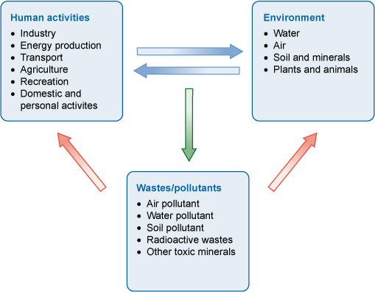
Figure 1.8 Human–environment interaction and the generation of waste and pollutants.

1.4 Technology and the environment
Technologies have transformed transport, industry, communications and our lives at home and work. For instance, gadgets such as mobile phones, computers, televisions, microwave ovens and refrigerators have improved living standards for those people who can afford them. Technology can also improve the quality of our environment. For example, energy can be generated from renewable sources such as wind and solar power, which reduces our reliance on non-renewable energy sources such as fossil fuels, and also helps to reduce the release of polluting gases to the atmosphere.
Another example of the benefits from technology is the highly advanced eco-friendly wastewater treatment plant at the St. George Brewery in Addis Ababa. This plant recovers nutrients and waste water from the brewery that would otherwise be released into the environment. This type of technology can help to alleviate the problem of water shortage, prevent surface water pollution and protect the environment.
Although technology has many positive impacts on people and the environment, it also has negative impacts, including the production of toxic waste from technological processes and electronic gadgets that are thrown away when they reach the end of their useful lives, as illustrated in Case Study 1.2.

Case Study 1.2 E-waste in Ethiopia
When electronic equipment or gadgets get old or stop working they are often thrown away. This type of electronic waste is referred to as e-waste. E-wastes pose a huge challenge to the environment because they contain toxic substances such as cadmium and lead from batteries, which leach out and pollute rivers and groundwater. (Leaching means the substances seep out or are washed out by rain into the soil below.) Toxic substances may get into the soil, making it unfit for agriculture. Copper from wiring is valuable for recycling, but if wiring is burned, it produces very hazardous air pollution.
E-waste is becoming a major problem in many African countries, including Ethiopia, where the use of electrical equipment has increased sharply with the rising number of people on higher incomes. According to a United Nations University report, there are about 4300 tonnes of non-functioning computers, televisions, mobile phones and refrigerators in Ethiopia, mostly in the ten largest cities (Manhart et al., 2013).
As there is no proper e-waste management system in Ethiopia, some e-wastes are disposed of together with other household wastes or dumped in an uncontrolled way that may cause huge environmental problems. Figure 1.9 shows open solid waste disposal sites in Addis Ababa and Bahir Dar close to residential areas. All types of waste, including hazardous waste like heavy metals, are discarded here without any treatment, so toxins can seep into the soil and groundwater. (Hazardous waste is any waste that contains material that is potentially harmful, for example, toxic, infectious, corrosive, explosive or flammable materials.)
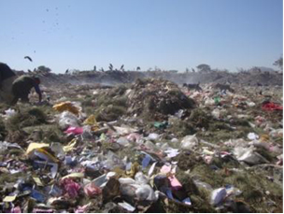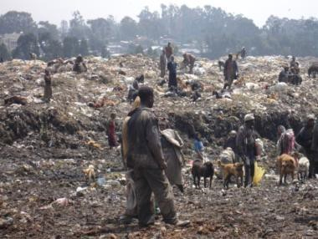
Figure 1.9 Uncontrolled waste disposal in Bahir Dar (left) and Addis Ababa (right).
There is one e-waste demanufacturing facility (DMF) in Addis Ababa managed by the government. The DMF collects e-waste from governmental offices, dismantles them manually and sorts the different components to recover valuable metals (Figure 1.10), which is an example of good practice in e-waste disposal.
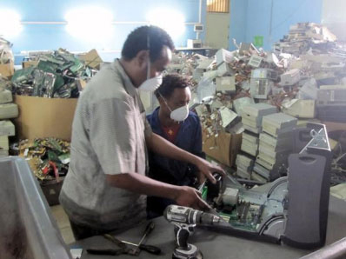
Figure 1.10 Computer dismantling in the Demanufacturing Facility in Akaki, Ethiopia.

1.5 Agriculture and environment
Agriculture is very important in Ethiopia to provide essential food crops and as a source of income, contributing about 46% of our country’s Gross Domestic Product (GDP). About 80% of the labour force in Ethiopia is in the agricultural sector, so it is vital to the livelihoods of the majority of people. However, agriculture also has significant negative impacts on our environment, including loss of biodiversity, pollution, climate change, soil erosion and the use of large amounts of water for irrigation.
- What problems do you think are caused by using large amounts of water for agriculture?
- This reduces the amount of water available for other human purposes such as drinking and washing, and for sustaining wildlife and maintaining the levels of rivers and lakes.
Agricultural activities are also major sources of water pollution. Pesticides and fertilisers applied to crops may wash into rivers and leach into soil and groundwater. (These effects are discussed in Study Session 8.)
Poor farming practices, especially on steeply sloping land, are a significant cause of soil erosion in Ethiopia because rainfall washes away the soil particles downhill. Each year more than 1.5 billion tons of soil are lost from the Ethiopian highlands (Tamene and Vlek, 2008). This lost soil is not only a problem for agriculture, it silts up rivers and lakes. Soil erosion and loss of soil biodiversity causes a decline in soil fertility and this in turn reduces agricultural productivity. Good agricultural practices, such as the use of terraces and diversion ditches, can help stop soil being lost from hillsides (Figure 1.11).
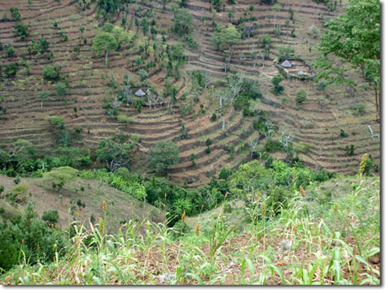
Figure 1.11 Good agricultural practices such as building terraces on sloping land helps to conserve soil.
Agriculture also plays a role in causing climate change through the release of greenhouse gases into the atmosphere. For example, fertilisers added to the soil release nitrous oxide and livestock production releases methane from the digestion process in cattle and the decomposition of manure. The use of fossil fuels to power agricultural machines and burning trees to clear agricultural land both release carbon dioxide. In Study Session 9 you will learn more about climate change and the role of greenhouse gases in changing our climate.

1.6 How we can protect and restore our environment
We end this study session with a positive message. Humans not only affect the environment negatively – we can also contribute positively to sustaining it. When we install wastewater treatment plants, protect endangered species and replant forests, we have a positive impact on our environment. Since 2000, huge efforts have been made in Ethiopia to increase the forest coverage through government and NGO reforestation programmes. More than 700 million trees were planted in 2007 alone (AFP, 2010). Figure 1.12 shows people in Konso, Ethiopia, planting trees to celebrate World Environment Day 2012. In some parts of the country where the reforestation programme has been implemented effectively, the community has already started to benefit from environmental improvements, through effects such as creating more spring water, a higher water table, and less soil erosion and flooding (Rinaudo, 2010).
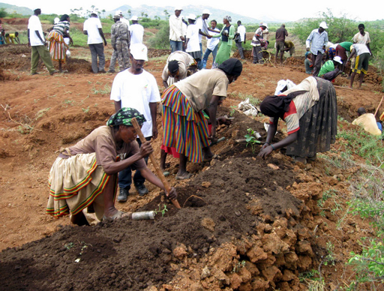
Figure 1.12 World Environment Day 2012 celebration in Konso.

Summary of Study Session 1
In Study Session 1, you have learned that:
- Humans and the environment have been interacting since humans first walked the Earth. Humans change their environment both positively and negatively and the environment affects how humans live in many different ways.
- The main interactions between humans and our environment can be grouped into the use of resources and the production of wastes.
- Resources can be classified as renewable (e.g. water) or non-renewable (e.g. fossil fuels).
- Humans are extracting increasing quantities of natural resources from the Earth which is causing problems of over-exploitation, for example through overfishing and deforestation.
- Water is used for domestic, industrial and agricultural purposes. Some countries are classed as ‘water stressed’ or ‘water scarce’ because available supply does not meet demand.
- Human activities produce many different types of waste which can pollute the environment. One example is e-waste from discarded electronic gadgets such as mobile phones contain many toxic substances that can pollute groundwater, soil and air unless their disposal is well-managed.
- Agriculture is the dominant economic activity in Ethiopia and has a significant impact on the use of resources, especially water and soil. It also contributes to climate change through the release of greenhouse gases (e.g. methane from cattle) into the atmosphere.

Self-Assessment Questions (SAQs) for Study Session 1
Now that you have completed this study session, you can assess how well you have achieved its Learning Outcomes by answering these questions. You can check your answers with the Notes on the Self-Assessment Questions at the end of this Module.

SAQ 1.1 (tests Learning Outcome 1.1)
The Glossary Game: Write down each of the key words printed in bold in this study session. Cut the paper into strips with one word on each strip; fold them and put them into a bowl. Take a strip, read the word and write a definition in your notebook. Then check your definitions with those in the study session.

SAQ 1.2 (tests Learning Outcome 1.2)
Which of the following statements are false? In each case explain why it is incorrect.
- As a population increases, the amount of natural resource extraction and consumption increases.
- Agriculture doesn’t have any negative impacts on the environment.
- As a population increases, more waste is produced as a result of increased activity.
- The environment influences human beings, both positively and negatively.
- The impact of human activity on the environment is always damaging.

SAQ 1.3 (tests Learning Outcomes 1.1 and 1.3)
Explain why biomass resources are classified as renewable. Give two examples of biomass resources that can be over-used despite being renewable. What are the consequences of their over-exploitation?

SAQ 1.4 (tests Learning Outcome 1.4)
Imagine you have a colleague who always blames technology for environmental problems. What would you say to your colleague to demonstrate that technology affects the environment in both a positive and a negative manner?

Study Session 2 Population Growth

Introduction
In Study Session 1 you learned about the major impacts of human activity on the environment. These impacts are inevitably linked to the number of people living on the Earth. Human population growth affects all people around the world through its impact on the economy, the environment, and the systems that support life. The population has grown rapidly over the past hundred years as a result of high birth rates and low death rates across the globe. Understanding population growth patterns and dynamics is important in helping to understand current and future trends in the use of the Earth’s resources and the impacts resulting from that use. For the water, sanitation and hygiene (WASH) sector, an increasing population means more demand for water to be used for domestic purposes as well as in agriculture and industry. It also means the production of more waste materials. Population growth is therefore a critical aspect of the context for improving WASH services.
In this study session you will learn about the causes of rapid population growth and demographic transitions; the changes in population size, its composition and characteristics; and the consequences of those changes on the environment, food security and health. We also briefly consider the link between poverty, population and the environment.

Learning Outcomes for Study Session 2
When you have studied this session, you should be able to:
2.1 Define and use correctly all of the key words printed in bold. (SAQ 2.1)
2.2 Describe the dynamics of population growth and demographic transition. (SAQ 2.2)
2.3 Describe population composition and characteristics. (SAQ 2.3)
2.4 Describe the impacts of population growth on food security and health. (SAQ 2.4)
2.5 Explain the interactions between poverty and the environment. (SAQ 2.5).

2.1 Trends and causes of population growth
Throughout human history the world’s population has been gradually growing. Figure 2.1 shows the trend from the year 1700. Growth is slow until the middle of the 20th century, when the gradient (slope) of the graph increases, indicating a change to more rapid population growth. The graph continues into the future to a predicted global population in 2050 in excess of 9 billion.
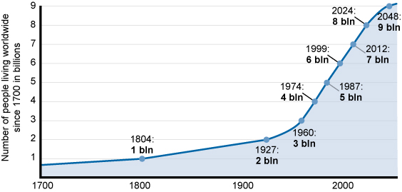
Figure 2.1 Population growth globally.
There are many factors that influence this trend. High rates of infant and childhood deaths and short lifespans put a limit on population growth in the past. However, improvements in nutrition, water, medical care and other technological advances have contributed to a sharp decline in deaths while births continue to increase, resulting in population growth.
Population change is governed by the balance between birth rates and death rates.
- If the birth rate stays the same and the death rate decreases, then population numbers will grow.
- If the birth rate increases and the death rate stays the same, then population will also grow.
- Look at Figure 2.1. How would you describe the predicted trend in world population for the middle of the 21st century?
- For most of the 21st century, from 2000 to about 2040, the trend shows a steady increase. By the middle of the century, at the far-right side of the graph, the gradient of the line on the graph is less steep – it flattens out slightly – indicating the rate of increase is expected to slow down by that date.
The main causes of death are disease, famines, accidents and war. Underlying these direct causes are interrelated contributory factors such as poverty, availability of health care, education and other social and economic factors. Since the start of the 20th century, there has been a sharp decline in death rates and an increase in length of life due to changes in these factors, which has resulted in an ageing global population. In 1950, about 8% of the world’s population was above 60 years of age. In 2013, this proportion had increased to 12% and it is expected to reach 21% in 2050 (UNDESA, 2013).
The rates of change in population vary in different regions of the world and can be categorised into groups based on the socio-economic development status of different countries, as shown in Figure 2.2.
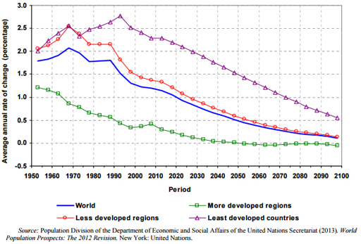
Figure 2.2 Average annual rate of population change for the world and development groups, 1950–2100. (Note that more developed regions comprise Europe, Northern America, Australasia and Japan; less developed regions include Africa, Asia (except Japan), and Latin America; 49 countries, including Ethiopia, are defined by the United Nations as ‘least developed’.) (UNDESA, 2013)
- Does the trend in population change shown in Figure 2.2 correspond to the answer to the previous question about Figure 2.1 and the predicted trend for the middle of the 21st century?
- Yes. Figure 2.2 shows a downward trend in the annual rate of change in all regions of the world for the remainder of this century. This corresponds to the slowing down of population increase shown in Figure 2.1.
- (a) From Figure 2.2, which group is expected to have zero population growth by 2050?
(b) Which development group has the highest annual rate of population change?
- (a) More developed regions are expected to have zero growth or, in other words, a static population level.
(b) Least developed countries contribute the highest annual population change for the world in the years between 1950 and 2100.
The least developed countries continue to have a higher rate of population increase for several reasons. Significant among these is the fact that the benefits from advances in health and agriculture are not spread evenly across the world. Medical technologies, for example vaccines and antibiotics, reduce the death rate by protecting people against diseases like influenza, measles, polio and rubella. However, vaccines are still not available for many diseases like malaria that are common in less developed countries, particularly in sub-Saharan Africa. Other public health measures, like water and sanitation, waste management and nutritional education are very important in preventing disease and in reducing the death rate. These measures are well developed in industrialised countries but less so in developing countries. Similarly, in agricultural science and technology, advances such as new kinds of seed, fertilisers, pesticides and mechanisation in farming have transformed food production. These have increased the quantity of food produced, which has helped to improve nutrition and decrease death rates. However, advanced food production and distribution are still developing in many countries.

2.2 Demographic transition
The changes in the population of countries over time have been found to follow a pattern described as ‘demographic transition’. Demographic transition is a process of fundamental change by which a country moves gradually from high birth and death rates to low birth and death rates. During the transition, death rates decline first and this is followed by a decline in birth rates. Figure 2.3 shows the five stages of demographic transition, described below.
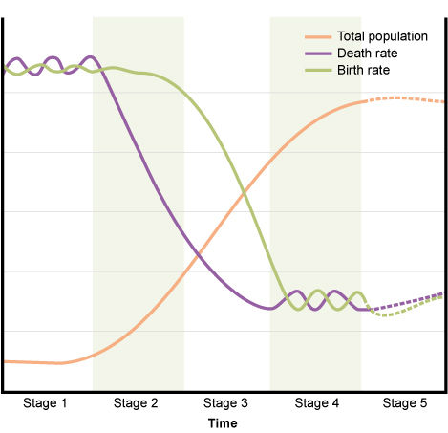
Figure 2.3 The demographic transition model depicts demographic changes from high- to low-level births and deaths in five stages.
The stages are:
- Stage 1: High birth rates and death rates: This stage is characterised by high birth rates, high death rates and little population growth. Total population numbers are low and the high birth rate is balanced by the high death rate.
- Stage 2: Continued high birth rates, declining death rates: In this stage, there is a decline in the death rate. As the birth rate is still high, the result is population growth as there are more births than deaths.
- Stage 3: Falling birth rates and death rates, finally stabilising: Both birth rates and death rates are declining, but birth rates remain higher. Population growth continues due to the large numbers of people in the reproductive age group. Reproductive age group refers to all women aged 15-49 years. Death rates gradually level off and birth rates decline until eventually the population growth slows down.
- Stage 4: Death rates and population growth slows: The fourth stage is characterised by a fall in birth rate and a decline in the proportion of the population in the reproductive age group. These changes cause population growth to end and population size stabilises. The total population number is high, but the low birth rate and low death rate balance each other so that the population is no longer increasing. In this phase the birth rate falls to below replacement level. The replacement level is the number of births to each generation required to replace the generation before. You might think the replacement level would be two children per woman to replace the two parents, but in practice the level is slightly higher than this. The figure depends on several factors including fertility and mortality, and varies in different regions and countries. In developed regions it is usually taken to be about 2.1 children per woman but this figure is generally higher in less developed regions.
- Stage 5: Negative population growth: This stage occurs when slow population growth turns into a population decline after birth rates fall below the replacement level and, on average, women have fewer than two children in their lifetime. At this stage, the total population is high but it is going into decline due to an ageing population.
Countries throughout the world are currently at different stages of demographic transition. Some countries in Asia and Europe have low death rates, low birth rates and low population growth and are in stage 4. Most of the ‘least developed countries’ are still in stages 2 and 3. There are many causes that contribute to the changes of the demographic transition model and account for the variations seen between different countries. The main factors include:
- improved health and living conditions over time
- increase in age at time of marriage
- decrease in need or wish to have more children
- move from rural to urban living (urbanisation)
- increase in level of education, especially of girls and women
- increase in paid employment opportunities for women
- increase in awareness and availability of contraception and family planning services (Figure 2.4).
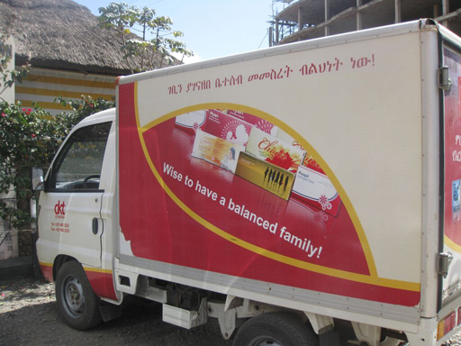
Figure 2.4 Family planning is now widely advertised in Ethiopia.
- How does an increase in marriage age and better awareness of family planning services affect population growth?
- These would both lead to a decrease in the birth rate, which leads to a decrease in population growth.
- Ethiopia is currently at stage 2 or 3 of the demographic transition. Looking at Figure 2.3 and the description of these stages in the text, what do you think this means for Ethiopia’s birth and death rates and for population growth in Ethiopia?
- Both the birth rates and death rates are declining, but the birth rate remains much higher than the death rate, therefore the population continues to increase.
Figure 2.5 shows how Ethiopia’s total population has changed since 1980 and is heading towards 100 million.
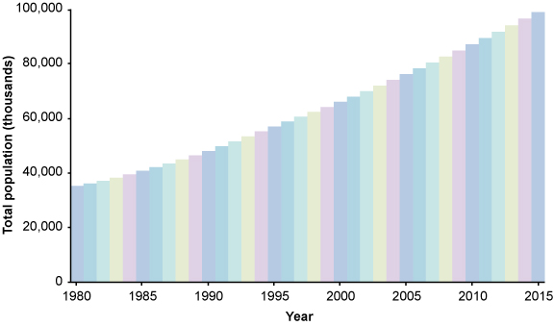
Figure 2.5 Graph of Ethiopian population from 1980 to 2015. (Adapted from JMP, 2014)

2.3 Population composition and characteristics
Population composition is the description of the characteristics of a group of people in terms of factors such as their age, sex, marital status, education, occupation, and relationship to the head of household. Of these, the age and sex composition of any population are most widely used. The number and proportion of males and females in each age group have considerable impact on the population’s current and future social and economic situation.

2.3.1 Age
The age structure of a population is one of the basic demographic characteristics and is helpful for demographic analysis and for socio-economic development planning. Generally, less developed countries have young populations, while more developed countries have old or ageing populations (Population Reference Bureau, 2011). The relative numbers of different age groups have a significant impact on social and economic policies and on the way people live their lives.
The age dependency ratio is the ratio of the number of people in dependent age groups compared to the economically productive age groups. Dependent age groups are the young (aged under 15) and the old (over 65). People aged from 15 to 64 are classed as economically productive. The age dependency ratio is often used as an indicator of the economic burden of the countries. In countries with high age dependency ratios there is a large number of elderly and young people who are dependent on the economic productivity of the people in the middle age group. The large proportion of children in the population means countries with very high birth rates have the highest age dependency ratios.

2.3.2 Sex ratio
The sex ratio is the ratio of males to females in a given population, usually expressed as the number of males for every 100 females. Sex ratios may vary due to different patterns of death and migration for males and females within the population. For example, males are more vulnerable to wars and more likely to be mobile and migrate to other regions or countries, which would affect the sex ratio within the population, especially for young adult males.

2.3.3 Population pyramid
Both key variables of age and sex are combined in the population pyramid. A population pyramid is a graph which displays a population’s age and sex composition. The numbers or proportions of males and females in each five-year age group are represented using horizontal bars. Population pyramids of countries can differ markedly as a result of past and current patterns of birth rates, death rates and migration.
Figure 2.6(a) shows the population pyramid for Ethiopia and, for comparison, Figure 2.6(b) gives the data for Japan. The shape of the Ethiopian pyramid shows that there is a high birth rate and many more young people than old. The pyramid for Japan shows an ageing population with the majority of the people aged between about 30 and 70. There are also significant numbers of people, especially women, over 90 in Japan, indicating longer life expectancy.
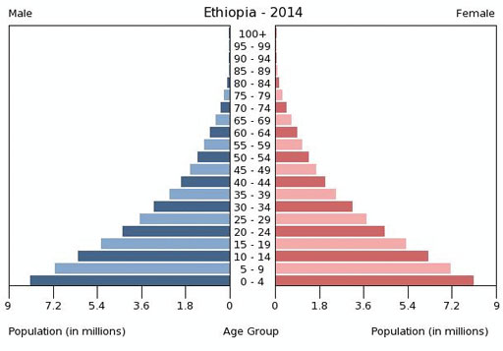
Figure 2.6(a) Population pyramid of Ethiopia, 2014.
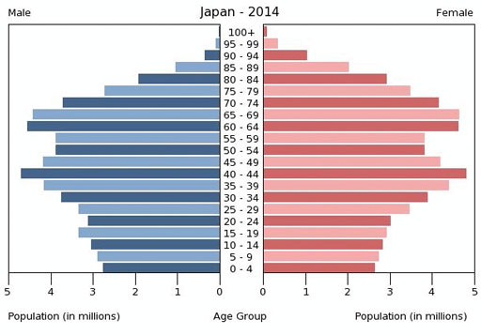
Figure 2.6(b) Population pyramid of Japan, 2014.
- Look at Figure 2.6(a) and (b) and consider the three age groups used to calculate the age dependency ratio. How would the differences in the two pyramids affect the age dependency ratios for Ethiopia and Japan? (Hint: You do not have to calculate the ratio, just describe the differences.)
- In Ethiopia there are many more people aged under 15 compared to the economically productive group, but few aged over 65. In Japan, there are more in the middle, productive, age group and a smaller proportion of children but also many more dependent older people. If this trend continues, in a few decades’ time there will be an even greater proportion of dependent elderly people in Japan compared to the economically productive middle group.

2.4 Impacts of population growth
As noted in Study Session 1, an increase in the number of people on Earth will mean that the impacts of their activities will increase too. However, it is important to note that this is not a simple cause and effect relationship. High population growth may deplete resources and trigger social or economic problems, but these same problems may also contribute to the causes of high population growth.
The impacts of population numbers on water resources and sanitation are covered in other study sessions. In this section we will look at the links between rapid population growth and problems with food, health and poverty.

2.4.1 Population growth and food security
As the population grows, the amount of food required to adequately feed people is increasing. Food security exists when all people at all times have physical and economic access to adequate, safe and nutritious food that meets their dietary needs for an active and healthy life (WHO, n.d.). In many developing countries, the numbers of hungry, malnourished people who don’t have food security are growing.
In Africa, agricultural production is increasing, but it is still lagging behind population growth. This means that even though the proportion of the population with inadequate food is decreasing, the total number of people is increasing. Graff and Bremner (2014) reported that between 1992 and 2010, the proportion of underweight children in sub-Saharan Africa decreased from 27% to 22% of all children, but the number increased from 24.8 million to 30.3 million.
One of the long-term consequences of malnutrition in children is stunting, which means children are not the height expected for their age. Stunting also affects child development and health, with the result that stunted children are less successful at school and are more vulnerable to anaemia, diarrhoea and some other diseases. In Ethiopia, more than two out of five children are stunted and 67% of the adult population suffered from stunting as children (World Food Programme, 2013). However, recent reports indicate the trend is positive and stunting has reduced in the past decade (Mideksa, 2015).
Food security can be improved by increasing the quantity and quality of food produced. This could be by bringing more land into cultivation or by improving crop yields by irrigation or the use of fertilisers. However, these ‘solutions’ to the problem will all have environmental impacts that need to be weighed up against the potential benefits.

2.4.2 Population growth and health
Population growth has a number of effects on health. Rapid population growth increases demand for health services, infrastructure, and financial resources. For a rapidly growing population, a shortage of health workers and resources causes difficulties in accessing health care services.
The number and spacing of children per family both have significant effects on health. Women who have many children are more likely to become ill than those with small families. Furthermore, the gap between children has a significant effect on the survival rate of the child. Figure 2.7 shows the difference in child survival for children born less than two years apart compared to a three-year interval.
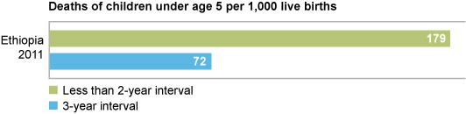
Figure 2.7 Birth spacing. The time interval between births in a family has a very significant impact on the survival rate of the children. (Adapted from Graff and Bremner, 2014)
The health implications of population growth are closely linked to poverty, which is the subject of the next section.

2.5 Poverty, population and the environment
Families with many children are more likely to live in poverty with an inadequate diet and poor living conditions. This leads to ill health, which diminishes people’s ability to work and puts them deeper into poverty in a negative downward spiral.
The environment is very important for the well-being of everyone, but particularly poor people because they tend to have a closer relationship with their immediate surroundings than people who are better off. Poor people are more directly dependent on the environment for food, water, fuel and traditional medicines, as well as deriving their income from it through agriculture, forestry or fishery.
Poor people are also more vulnerable to natural disasters such as flood and drought, and to climate change. They may live in undesirable areas such as marshy lands without flood protection, or on unstable hillsides. Poverty means they don’t have the resources to build shelters that can withstand floods and landslides (Figure 2.8). In urban areas they are likely to live in slums with less access to affordable clean water, good sanitation or health facilities.
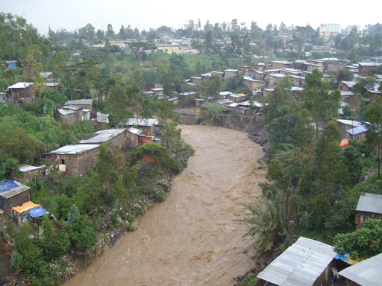
Figure 2.8 Informal dwellings built close to the Akaki River in Addis Ababa are vulnerable to flooding.
Poor people cannot afford to buy electricity to meet their energy needs, so they cut down trees for cooking, heating and other purposes. This adds to the problems of deforestation discussed in Study Session 1. Deforestation reduces the resources available from the forest and increases soil erosion and flooding, which in turn reduces productivity and damages crops, making poor people poorer.
For farmers, the lack of capital to invest in environmentally friendly technologies, coupled with constraints of land tenure, make it difficult for them to change their farming practices to safeguard the environment. A degraded environment significantly affects the health of poor communities, which impacts on their livelihoods, as they earn less and have to spend more money on health care.
All of this adds up to the recognition that poverty leads to environmental degradation, which in turn increases poverty in a ‘vicious circle’ (Figure 2.9).
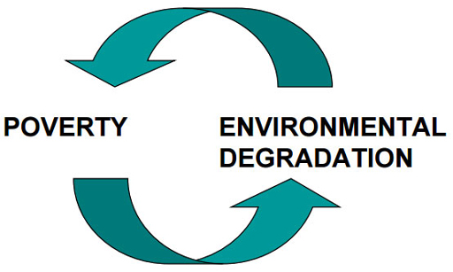
Figure 2.9 The ‘vicious circle’ between poverty and environmental problems.
How can the vicious circle be broken? Three things have to be addressed. First, there should be investment to create job opportunities for poor people and increase their income. The government of Ethiopia’s Plan for Accelerated and Sustained Development to End Poverty (PASDEP) of 2006 was designed to lay out the programme for poverty eradication (MoFED, 2006). This has been carried forward with the Growth and Transformation Plans I and II.
Second, education can increase awareness and knowledge of environmental protection. Educated people are more likely to implement good farming practices, such as digging diversion ditches and terraces to prevent soil erosion, and follow proper waste management practices. Understanding the value of good hygiene practices can reduce waterborne diseases. This has an economic gain because better health means improved fitness, more income from work, and less expenditure on medicines.
Third, gender equality is another important way to break the vicious circle between poverty and environmental problems. Women, if they are empowered, will make informed decisions about the environment because they are in close contact with it when they collect wood, manage wastes and fetch water.
These three approaches have combined effects as well, and connect back to population growth. Educated women are more likely to be knowledgeable about contraception, and therefore to choose the size of their families. They will also be better placed to take advantage of new employment opportunities, as well as playing an important role in protecting the environment.

Summary of Study Session 2
In Study Session 2, you have learned that:
- The world’s population has grown rapidly since the mid-20th century and continues to increase. Improvements in health care, education and technology have all contributed to a sharp decline in the death rate.
- Births, deaths and migration are the main direct factors accountable for population change. Rates of change vary in different regions of the world. Population numbers are growing, but the rate of increase is declining throughout the world.
- Countries move gradually from high birth and high death rates to low birth and low death rates. This trend is called ‘demographic transition’.
- Age and sex are the important characteristics of a population. Developing countries have young populations, while developed countries have old populations. Because of the large proportion of children in the population, countries with very high birth rates usually have the highest age dependency ratios.
- Sex ratios may vary due to different patterns of death and migration for males and females within the population.
- Rapid population growth can put pressure on food supplies. It also increases the demand for health services.
- The consequences of population growth in terms of increasing demand for limited resources will have the greatest impact on poor people because poverty makes them more vulnerable and they do not have the money to change their situation.
- Environmental degradation increases poverty, which increases degradation in a vicious circle. Ways to break out of this circle include appropriate planning, education on ways to protect and restore the environment while improving incomes, and gender equality measures.

Self-Assessment Questions (SAQs) for Study Session 2
Now that you have completed this study session, you can assess how well you have achieved its Learning Outcomes by answering these questions. You can check your answers with the Notes on the Self-Assessment Questions at the end of this Module.

SAQ 2.1 (tests Learning Outcome 2.1)
Rewrite the paragraph below using terms from the list provided to fill the gaps.
age dependency ratio, demographic transition, population composition, population pyramid, sex ratio.
Populations change over time as birth and death rates vary in a process called ……………… At any one time, the characteristics of the population of a country are described by its ……………… One of the factors typically included is the ………………, which compares the numbers of men and women. The other important ratio is the ……………… These two main population characteristics can be presented as a ………………

SAQ 2.2 (tests Learning Outcome 2.2)
Which of the following statements are false? In each case explain why it is incorrect.
- Advances in agricultural science and technology lead to changes in death rates.
- Falling birth and death rates are characteristic of stage 1 of demographic transition.
- Advances in public health measures are reducing the death rate.
- Processes for food production and distribution are the same throughout the world.
- The total population of a country increases to a maximum in stages 4 and 5 of demographic transition.

SAQ 2.3 (tests Learning Outcome 2.3)
Which of the following statements are false? In each case explain why it is incorrect.
- Developing countries have old populations, while developed countries have young populations.
- Sex ratios may vary due to different patterns of death and migration for males and females within the population. For example, males are more likely to migrate or to be killed in wars; both these factors would decrease the sex ratio within a population.
- The age dependency ratio can be used as an indicator of the economic burden of a country.
- The shape of the population pyramid of a country with a high age dependency ratio is always broader at the bottom than the top.

SAQ 2.4 (tests Learning Outcome 2.4)
Briefly explain the relationship between population growth, food security and health.

SAQ 2.5 (tests Learning Outcome 2.5)
You are putting together a presentation on interactions between poverty and the environment for a class of high school students. List five points you plan to address in your presentation.

Study Session 3 Development and Sustainability

Introduction
The world’s population and economy are growing rapidly, resulting in an increasing demand for natural resources and increasing risk of environmental damage. Excessive use of natural resources such as water, land and forests affects the livelihoods of many people and national economies. Similarly, environmental damage can affect current and future economic and social development. In other words, the economy, society and the environment are interlinked issues. So, if you want to solve one of these problems you need to consider all three together, because addressing only one aspect either will not solve the problem in the long term, or it will create another problem. This is the concept of sustainability, which you are going to look at in this study session. We will also discuss different interpretations of development including economic, human and sustainable development and discuss the sustainability of WASH services.

Learning Outcomes for Study Session 3
When you have studied this session, you should be able to:
3.1 Deﬁne and use correctly each of the key words printed in bold. (SAQs 3.1 and 3.2)
3.2 Explain the difference between economic development and sustainable development. (SAQ 3.2)
3.3 Summarise the three pillars of sustainability. (SAQ 3.3)
3.4 Identify important factors for the sustainability of WASH services. (SAQ 3.4)

3.1 Economic growth, economic development and human development
You may have noticed that a lot of building work for new roads, schools and hospitals is taking place in Ethiopia (Figure 3.1). All these are the result of economic growth in the country, especially since the year 2000. You may think economic growth and economic development are the same thing and use the terms interchangeably, but they are not exactly the same.
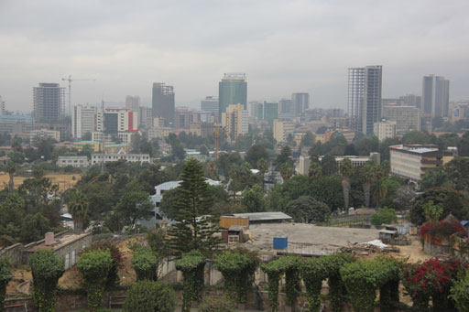
Figure 3.1 New buildings in Addis Ababa and other Ethiopian cities are signs of economic growth.
The economic growth of a country is an increase in worth of the national economy and is measured by its Gross Domestic Product (GDP). GDP is a measure of the total value of goods and services produced by a country in a year. It is usually measured in US dollars.
Economic development is a broader concept than economic growth that also includes aspects of human welfare. It is linked to technological and social progress, and general improvements in living standards. Economic development means improvements to infrastructure such as roads, schools, water and wastewater treatment plants, hydropower, etc. One of the indicators of economic development is GDP per capita. GDP per capita is the total GDP value divided by the population of the country, giving an indication of the economic output per head of population. This reflects an increase in the economic productivity and average material well-being of a country’s population but does not take account of uneven distribution of wealth among the population.
- The GDP of India (US$2.05 trillion) is greater than the GDP of Norway (US$0.5 trillion) (IMF, 2015). So, can we say that India is more economically developed than Norway?
- No. India has a higher total GDP than Norway, but it also has a much larger population. So, if you divide the GDP by the population to give GDP per capita, you would see that Norway has a much higher per capita GDP (US$97,013) than India (US$1,626). In reality, therefore, Norway is more economically developed than India.
GDP is a purely economic measure. Economic growth does not necessarily lead to human development. This is because a country can have an increase in GDP without improving the quality of life of the majority of people. Human development is the continuous improvement of human well-being and the quality of life. Some of the characteristics associated with countries that are not highly developed are a low literacy rate, high poverty level, high unemployment rate, high malnutrition, low water supply coverage, low health service coverage, poor roads, poor public transport and poor environmental conditions.
The most widely used indicator for human development is the Human Development Index (HDI), which measures the relative development status of different countries on a scale from 0 to 1. It looks beyond economic assessment and brings in other ways of measuring well-being. HDI is a composite index that focuses on three criteria:
- life expectancy
- education
- standard of living.
The first criterion, life expectancy, is the average number of years that a person may expect to live. If people live long and healthy lives, this will increase the HDI of a country. Ethiopia is one of the top six countries where life expectancy has increased the most in recent times, from 45 years in 1990 to 64 years in 2012 (WHO, 2014). This can be attributed to many factors such as better health services, increased safe water supplies and improved access to sanitation.
The second criterion in the HDI, education, comprises two components: years of schooling for the adult population, which is the average number of years of education received in a lifetime by people aged 25 years and older; and the expected years of schooling for children of school-entrance age. Developed countries are expected to have people in education for longer. Average years of education of adults in Ethiopia increased from 1.5 in 2000 to 2.2 in 2012, and expected years of schooling for children increased from 4.4 to 8.7 years over the same period (UNDP, 2013). This is because, since 1994, many schools have been built, teachers have been trained and emphasis has been placed on creating a child-friendly teaching and learning environment in schools (Figure 3.2). Alternative ways of providing basic education for children in remote areas have also been established, such as making the time of learning flexible (e.g. by letting the community decide the time of learning) and establishing mobile schools to reach disadvantaged groups and remote rural areas.
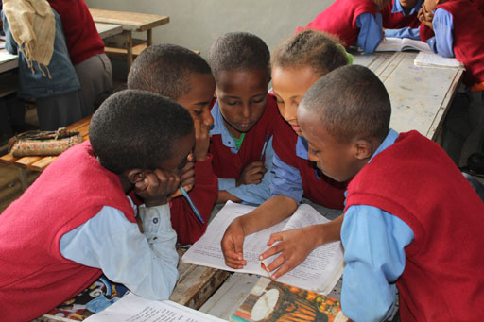
Figure 3.2 Classrooms should provide an environment that encourages learning.
The final criterion in the HDI is standard of living, which means the level of wealth, comfort and material goods available to people. Ethiopia’s standard of living increased by more than 100% between 1985 and 2012 (UNDP, 2013). Despite this achievement, Ethiopia’s standard of living remains one of the lowest in the world.
The Human Development Index for Ethiopia is low. The value for 2012 was 0.396 which puts it in the category of ‘low human development’. The country is ranked 173rd out of 187 countries (UNDP, 2013). However, the situation has been improving as Ethiopia’s HDI increased by 32% in the 10 years to 2012 (UNDP, 2012) and an annual rate of increase of 3.1% places Ethiopia as the country with the third-fastest improving HDI in the world (MoFED, 2012a).
Ethiopia’s development progress can be seen by improvements in a range of areas:
- The poverty level in Ethiopia (defined as the percentage of the population below the national poverty line) declined from 38.7% in 2005 to 29.6% in 2012 (MoFED, 2006, 2012b).
- The adult literacy rate (defined as the percentage of the population age 15 and above who can, with understanding, read and write a short, simple statement on their everyday life) increased from 27% in 1994 to 36% in 2010/2011.
- Access to health facilities increased from 38% in 1991 to 89.6% in 2010 (Banteyerga et al., 2011).
- The total federal road network expanded more than threefold between 1997 and 2013, by which time it included 11,301 km of asphalt and 14,455 km of gravel road (Ethiopian Roads Authority, 2013).
Ethiopia is on track to achieve most of the Millennium Development Goals (MDGs). The MDGs are international development goals that were established following the Millennium Summit of the United Nations in 2000. UN Member States committed to achieve the MDGs by 2015. The goals were grouped into eight areas:
- Eradicate extreme poverty and hunger.
- Achieve universal primary education.
- Promote gender equality and empower women.
- Reduce child mortality.
- Improve maternal health.
- Combat HIV/AIDS, malaria and other diseases.
- Ensure environmental sustainability.
- Develop a global partnership for development.
Each of these goals had more specific targets associated with them. For example, Goal 7 had four targets, including one for improvements to water and sanitation. Target 7C was to ‘halve, by 2015, the proportion of the population without sustainable access to safe drinking water and basic sanitation’.
The 2014 report on MDG progress stated that Ethiopia was on track to achieve six out of the eight goals, i.e. all those except Goals 3 and 5 (NPC, 2015). For Goal 7, the picture is a little more complicated. Ethiopia successfully achieved the target for water supply but not for improvements to sanitation. Water supply coverage has increased and in March 2015 Ethiopia celebrated achieving the target of halving the number of people who were without access to safe water (Figure 3.3). Sanitation coverage has greatly improved, but with 37% of the population still using open defecation in 2012 (JMP, 2014) it has fallen short of the MDG target.
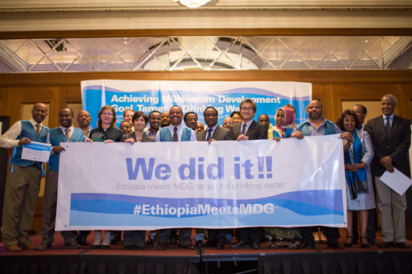
Figure 3.3 Celebration in March 2015 of achieving the MDG target for water supply in Ethiopia.

3.2 The Ethiopian economy
The Ethiopian economy has undergone rapid transformation since 2003/2004. GDP has grown at an average annual rate of 11% over the decade to 2012, making the country one of the fastest-growing in the world (UNDP, 2012). The poverty level in the country declined from 38.7% in 2005 to 29.6% in 2012 (WHO, 2014). The country has an ambitious plan to be a middle-income country by 2025.
In Ethiopia, agriculture has traditionally provided the biggest share of GDP, as the country is in the early stages of economic development. However, Figure 3.4 shows that agriculture’s share of GDP declined slightly from 2003/4 to 2008/9. This does not mean that the overall agricultural production decreased, but its contribution to the country’s overall GDP went down relative to other areas, particularly the service sector. The share of GDP earned by the service sector, such as retail, banks, hotels and real estate, grew rapidly over this time. The industrial sector makes up a smaller percentage of GDP and has remained relatively static at between 13% and 14%.
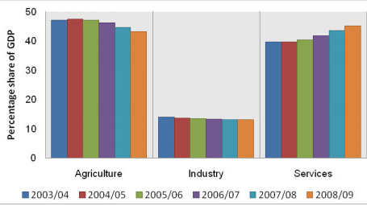
Figure 3.4 Structural composition of the Ethiopian economy. (Ncube et al., 2010)
There are many factors that have driven Ethiopia’s rapid economic development, including:
- favourable weather conditions for agriculture in the past decade and an increase in land area under cultivation
- investment to improve schools, health facilities, roads, telecommunications and the energy sector
- diversification of exports from only a few commodities, such as coffee, to other commodities including oilseeds, flowers, animals and animal products
- increased remittances from Ethiopians living abroad
- increased tax revenue collection and more development aid from external donors
- government policies that focus on infrastructure development, commercialisation of agriculture and private sector development (Ncube et al., 2010).
Among the most relevant government policies is the Growth and Transformation Plan (GTP). This was introduced in 2010 to run for the five years up to 2015, coinciding with the timeframe of the Millennium Development Goals. It is followed with a second phase, GTP II. The GTP aims to improve the national economy and bring an end to poverty by increasing opportunities for commercial agriculture, large-scale industry and infrastructure development.
- Do you think that Ethiopian economic growth (GDP increase) has translated to human development? What figures can you use to back up your answer?
- Yes. To mention some figures, the HDI has increased by 32%; the poverty level declined from 38.7% in 2005 to 29.6% in 2012, and the country is on track to achieve six of the eight MDGs.
Despite the positive trends, Ethiopia’s economy is still vulnerable to climate-induced shocks (UNDP, 2012). Although the dominance of the agriculture sector is slowly declining (as shown in Figure 3.4), the country’s economy still depends on rain-fed agriculture. This means that if the rains fail the loss of crops can have disastrous results. To overcome these problems requires a more resilient economy; this will be discussed in Study Session 12.

3.3 Sustainable development
The idea that development can be measured purely in economic terms can be criticised because it does not take account of the impacts of economic growth on the environment and on society. Increasing awareness in the 20th century of the environmental degradation caused by human activities led to the idea of sustainable development. There are many different definitions of sustainable development, but the most commonly used is from the 1987 World Commission on Environment and Development Report. This report defined sustainable development as ‘development that meets the needs of the present without compromising the ability of future generations to meet their own needs’ (Brundtland, 1987).
- What are the needs of the present and future generations? List at least three things that you think are basic needs for present and future generations.
- There are many things that both the present and future generations need for their survival. You may have listed the following: clean air to breathe, clean water to drink, a clean environment, food, shelter and other natural resources that can be used to improve the quality of life.
If development improves only the lives of the present generation without taking future generations into consideration, it is not sustainable. For example, if a development extracted groundwater faster than it is replenished over the long term, it would cause groundwater depletion and thus affect the ability of future generations to meet their own water needs; it would not be sustainable.
The concept of sustainable development therefore incorporates human and economic development but adds another dimension by considering long-term consequences and environmental impacts as well. It means a system of development that allows current generations to develop economically and socially without passing on insoluble problems to future generations. To understand what this means in practice, we need to take a closer look at sustainability.

3.4 What is sustainability?
In general, sustainability can be defined as the ability of something to sustain itself or be sustained over time, but a more complete definition for our discussion is that sustainability is an approach that combines environmental, economic and social aspects to produce long-lasting development or prosperity. These three aspects – environmental, economic and social – are the pillars of sustainability (Figure 3.5).
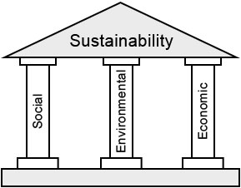
Figure 3.5 The three pillars of sustainability.
The economic pillar of sustainability is the efficient and responsible use of resources such as land, labour, capital and technology to create affordable goods and services with good value for money. The environmental pillar consists of implementing best practices that minimise the environmental impacts, such as using renewable energy to reduce the emission of greenhouse gases or minimising production of waste. The social pillar is about meeting the needs of all people or improving the quality of life for all members of society by better access to health care and education, and reducing poverty.
The central idea of sustainability is that all three pillars must be taken into consideration because without all three, the ‘building’ will collapse. For example, focusing only on economic growth without considering environmental impacts would not bring long-lasting profits if that growth depends on consumption of finite, non-renewable resources.
- Name the non-renewable resources that humans use to provide energy.
- You may have mentioned oil, coal, or gas.
Focusing on economic growth without addressing social problems such as poverty and unemployment will also be unsustainable. For example, when unemployment and poverty are very high, it means people do not have adequate money to meet their basic needs for food, shelter and clothing. This may lead to crime and unrest. If there are high crime levels and instability in a country, investors will be reluctant to invest and educated people may leave the country in search of a better life. The result is a negative impact on economic growth.
Similarly, just focusing on the environment may not ultimately protect it. Environmental sustainability needs both economic growth and social development, which may include changes in the structure of the economy and the way in which its benefits are distributed. For example, without opportunities for advancement, poor people will not have the options to use alternative energy sources and environmentally-friendly technologies so they are more likely to degrade the environment, for example, by cutting down trees for fuel.

3.5 Sustainability and WASH
If we want WASH projects to be sustainable, we need to consider the environmental and social aspects as well as the economic aspects. For example, WASH activities should not cause negative impacts to the environment; they should be economically feasible and financially sustainable, and they should be socially acceptable (i.e. consider the culture and value of the community).
Sustainability of WASH services such as hand pumps or communal latrines also relates to the very simple definition of sustainability that we started with, the ability of something to sustain itself or be sustained over time. WaterAid (2011) uses this definition:
Sustainability is about whether or not WASH services and good hygiene practices continue to work and deliver benefits over time. No time limit is set on those continued services, behaviour changes and outcomes. In other words, sustainability is about lasting benefits achieved through the continued enjoyment of water supply and sanitation services and hygiene practices.
The emphasis is clearly that the service must last a long time. There are a number of factors that contribute to the sustainability of WASH services. A WASH service is sustainable when (adapted from ACF International, 2007):
- it functions and is being used
- it is able to deliver an appropriate level of benefits (quality, quantity, convenience, comfort, continuity, affordability, efficiency, equity, reliability, health)
- it continues over a prolonged period of time and can be maintained and repaired to continue its life
- its management is institutionalised (community management, gender perspective, partnership with local authorities, involvement of formal/informal private sector)
- its operation and maintenance, administrative and replacement costs are covered at local level (through user fees, or alternative financial mechanisms)
- it can be operated and maintained at local level with limited but feasible, external support (technical assistance, training, monitoring)
- it does not affect the environment negatively.
Among the most important of these factors is the need for the service users to be fully involved in its planning, development and continuing maintenance, as the following case study demonstrates.

3.5.1 WASH case study
The sustainability of a WASH service is considered in Case Study 3.1. As you read it, think about the different pillars of sustainability and whether they are addressed here, and then answer the questions below.

Case Study 3.1 Jallele and the communal latrine
Jallele is a WASH practitioner at Kembebit Woreda Health Office, Oromia region. The woreda’s biggest market place is found in kebele 01 and the people who live in rural as well as urban areas of the woreda and nearby places gather twice a week on Wednesday and Saturday to buy and sell goods.
Jallele observed that open defecation was a common practice in kebele 01. In an effort to tackle the problem, she called for a meeting and held a discussion with the people/community living in the kebele. From this discussion, she found out that the people live in very congested conditions and they did not have land that they could spare for building individual household latrines.
During the discussion, the community suggested the construction of a communal latrine as a solution. Jallele discussed the situation with an NGO that is engaged in WASH and was able to convince them to allocate money for the construction of a communal latrine with eight seats. She told the community about the funding she had obtained and discussed the location of the latrine with the kebele administration. They identified an open access area near the market place and allocated this land for the construction. The justification they gave her was that this area was located at the centre of the community who did not have household latrines.
The latrine was built at the location the kebele administration identified. When the community started to use it Jallele was happy in her accomplishment. However, after some time, the latrine started to smell badly. The community stopped using it and went back to their old practice of open defecation. After a while, the latrine was totally abandoned as a result of the poor management. Besides, the bad smell started to affect the people who came to the market to buy and sell goods and they complained strongly about the construction of the latrine at this location.
Finally, Jallele introduced a follow-up system to address these problems. She encouraged the community to make a contribution to renovation of the existing latrine and to construct a new facility further away from the centre. She involved the community in the decision-making process and facilitated the setting up of an appropriate management system.

- From Case Study 3.1, what do you think is the possible cause of the failure of the first project that Jallele implemented?
- She didn't consider the financial sustainability or need for management. There was no money for maintaining, cleaning and managing the latrine. And she didn’t consider all social aspects. She hadn’t involved all members of the community in deciding where the latrine should be.
- Which of the pillars of sustainability would you say that Jallele did consider when setting up the project?
- She considered the environmental pillar and, to some extent, the social pillar. The latrine was set up to stop open defecation in order to improve the environment and people’s health. When she introduced the second plan she consulted the community and made sure they were involved in the process.

Summary of Study Session 3
In Study Session 3, you have learned that:
- Economic growth is concerned with Gross Domestic Product (GDP), while economic development refers to the distribution of the economy between different sectors and social groups and is linked with technological and social progress.
- Human development is concerned with reducing poverty and improving the quality of life. The most widely used indicator for human development is the Human Development Index (HDI) which is composed of three parts: life expectancy, education and standard of living.
- The Ethiopian economy has undergone rapid transformation since 2003/2004; because of this the poverty level in the country declined from 38.7% in 2005 to 29.6% in 2012.
- The Millennium Development Goals (MDGs) set international targets for development that included poverty reduction and improvements in health, education and environmental sustainability.
- Sustainable development considers the needs of the present without compromising the ability of future generations to meet their own needs.
- There are three pillars of sustainability: environmental, economic and social pillars. All three must be considered if sustainability is to be achieved.
- Sustainable WASH activities should not cause negative impacts on the environment; they should be economically feasible and financially sustainable and should also be socially acceptable.

Self-Assessment Questions (SAQs) for Study Session 3
Now that you have completed this study session, you can assess how well you have achieved its Learning Outcomes by answering these questions. You can check your answers with the Notes on the Self-Assessment Questions at the end of this Module.

SAQ 3.1 (tests Learning Outcome 3.1)
Write the following words next to their correct definitions in the table below:
economic development; economic growth; Gross Domestic Product; human development; sustainable development; sustainability.
measured by Gross Domestic Product (GDP)
the total volume of goods and services produced by a country
an approach that considers environmental, economic and social aspects to produce long-lasting development or prosperity
meeting the needs of the present without compromising the ability of future generations to meet their own needs
more than just measuring GDP; it also includes some aspects of technological and social progress
continuous improvement in human well-being and quality of life

SAQ 3.2 (tests Learning Outcomes 3.1 and 3.2)
You have a colleague who has difficulty in understanding the difference between economic development and sustainable development. How might you explain the difference between these two concepts?

SAQ 3.3 (tests Learning Outcome 3.3)
A friend has read in a newspaper article that in order for a society to thrive in the long term it must first address the three pillars of sustainability. Your friend asks you what these pillars represent and why they are considered important. Before answering, make a note of the three pillars and against each, list one or two key points you think your friend should know.

SAQ 3.4 (tests Learning Outcome 3.4)
Imagine a project to install a new water or sanitation service for a community. What is wrong with each of the following statements?
- Developing a process for paying for future maintenance of the service is not important as long as the users were fully involved in the planning of the project and participated in decision making.
- WASH projects should be designed to meet the current needs of users so that financial costs can be minimised.
- When identifying the best location for the new installation, the only factor to consider is the wishes of the users.

Study Session 4 The Water Cycle and Sources of Water

Introduction
Water is a valuable natural resource that is found in different forms in the environment. It is important to understand how water moves through the environment so that we can understand how to manage it successfully. Fresh water is finite and vulnerable. Supplying sufficient clean, fresh water is one of the most vital natural resource issues facing humanity. Water shortages are becoming a global issue, due to an increasing population, economic growth and climate change. A lack of clean, fresh water can hinder the efforts to reduce poverty and progress national development, resulting in poor health, low productivity, food insecurity and restricted economic development.
In this study session you will learn about the hydrological cycle. You will learn about where fresh water is found, the types of water sources that people use and how important it is to select suitable water sources. Finally, you will look at the increasing demands on supplies of fresh water.

Learning Outcomes for Study Session 4
When you have studied this session, you should be able to:
4.1 Define and use correctly all of the key words printed in bold. (SAQ 4.1)
4.2 Describe the hydrological cycle. (SAQ 4.1)
4.3 Describe the main types of water source. (SAQ 4.2)
4.4 Outline the main factors to be considered when selecting a water source. (SAQ 4.3)
4.5 Describe the factors affecting the distribution and availability of water resources. (SAQs 4.2 and 4.4)

4.1 The hydrological or water cycle
Water is continually moving around the Earth and continuously changing its physical form.
- In which three forms can water be found on Earth?
- Water can be found in liquid form in oceans, rivers, lakes and rain; in solid form in ice and snow; and as a gas (water vapour) in the atmosphere.
The hydrological cycle, or water cycle, is the continuous circulation of water between oceans, atmosphere and land (Figure 4.1). The sun and wind cause water to evaporate (change its physical state from liquid to gas) from land and water bodies (oceans, lakes and rivers). Also, plants take up liquid water and give off water vapour through pores in their leaves in a process called transpiration. The water vapour moves high above the Earth’s surface on rising currents of air through the atmosphere. Eventually as the water vapour reaches the cooler air higher up in the atmosphere, it condenses (changing from gas to liquid) to form clouds and falls back to Earth in the form of rain and snow (together these are called precipitation). Precipitation that falls on land can flow over the surface as run-off into rivers and streams, and can also percolate (trickle down) through the soil into underground rocks to become groundwater.
Water is held in reservoirs (indicated in Figure 4.1) and moves between them in transfer processes. (‘Reservoirs’ here refers to all stores or reserves of water, not just water held behind a dam.) The water transfer processes continue in an ongoing cycle through evaporation and transpiration, transportation of water vapour in the atmosphere, precipitation, and water flowing off and through the land back to the sea.
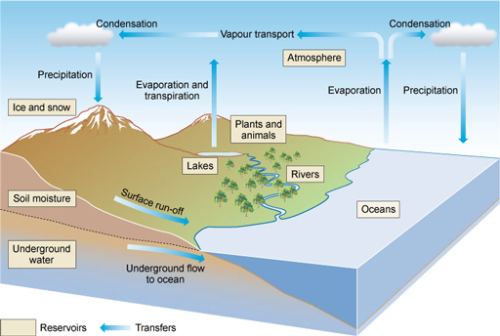
Figure 4.1 The hydrological cycle or water cycle. Hydrology is the study of water, hence the alternative name for the water cycle.
- Why is water described as a renewable resource?
- Because the processes of the water cycle are constantly renewing the surface water and groundwater. Precipitation (rainfall) feeds the rivers and streams and infiltrates into the ground to replace the water that we use.

4.2 Distribution of water resources
About two-thirds of the Earth’s surface is covered with water. The total amount of water on the Earth is about 1400 million km³ (UNEP, 2002). Of this, around 97.5% by volume is held in the oceans and is salt water. Only 2.5% (or about 35 million km³) is fresh water. Figure 4.2 shows the proportions of Earth’s water found in different parts of the environment.
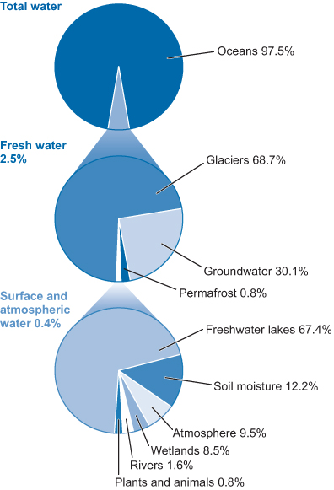
Figure 4.2 Distribution of water resources on Earth. (Note that the size of the smaller segments has been exaggerated for clarity.)
- From Figure 4.2, which percentages of fresh water are estimated to be stored in the forms of: ice and permanent snow (glaciers), groundwater, and as surface and atmospheric water?
- Around 69% is stored in the form of ice and permanent snow, about 30% as groundwater, and only about 0.4% of fresh water is stored as surface and atmospheric water.
Fresh water is water with a dissolved salt concentration of less than 1%. Globally, fresh water is distributed unevenly. About three-quarters of global annual rainfall occurs in countries containing less than one-third of the world’s population. About 80% of the world’s water run-off is concentrated in countries in northern and equatorial regions, which have relatively small populations. For example, the Amazon River in South America accounts for 20% of global run-off each year. The area drained by the Amazon is huge, but it is sparsely populated. In Africa, the Congo River and its tributaries account for 30% of the entire continent’s annual run-off, but the Congo’s area contains only 10% of Africa’s population.
- Why is it a problem that the huge areas of the Amazon and Congo rivers have large amounts of fresh water but only a relatively small number of people?
- The problem is that the fresh water is unequally distributed. A large proportion is found in places that are remote from the majority of the population so the water is not available to them.
An additional problem is that rainfall throughout much of the developing world is highly seasonal. The seasonal rains may last for only between one and three months, which can leave people short of fresh water during the dry season.

4.2.1 Distribution of fresh water in Ethiopia
In Ethiopia, there are 12 major river basins/valleys, 11 lakes, 9 saline lakes, 4 crater lakes and more than 12 major swamps (Mekiso, n.d.). The average annual flow of water from all the 12 river basins is estimated to be 123.25 billion m³ (Figure 4.3). Several of the major rivers cross to neighbouring countries. For example, the Abbay River flows to Sudan and Egypt, and the Omo to Kenya. It has been estimated that 95% of Ethiopia’s annual run-off flows out of the country in these cross-boundary rivers (Waterwiki, n.d.).
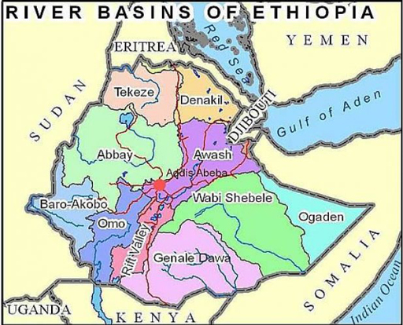
Figure 4.3 Map of Ethiopia showing main river basins.
In Ethiopia, it is estimated that 54.4 billion m³ of surface run-off and 2.6 billion m³ of groundwater could be developed for use by people. However, the amount of rainfall, river flow and groundwater is highly variable across the country and depends on location and altitude. Some areas have sufficient water, while others don’t have enough. Figure 4.4 shows maps of rainfall and groundwater availability during drought in Ethiopia. Most permanent springs and streams exist only in the highlands in the west of the country. In areas below 1500 m above sea level, which is more than 55% of the country, there is hardly any surface run-off and very few permanent springs and streams.
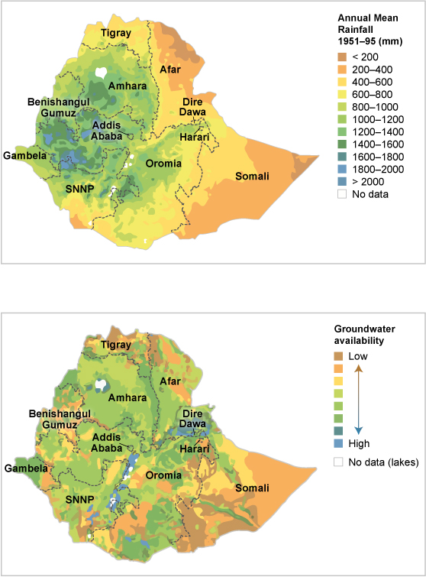
Figure 4.4 Rainfall (above) and groundwater (below) availability during drought in Ethiopia. (MacDonald et al., 2001)
- Based on the two maps in Figure 4.4, which regions of Ethiopia have the least available water?
- Somali and Afar regions have the lowest mean annual rainfall in the country. Somali also has very little available groundwater. Afar has relatively high groundwater availability.
The availability of water resources is also uneven over the year. At some times of the year you might have too much water, leading to flooding. At other times there may not be enough water, leading to drought.

4.3 Sources of water
Our main sources of water for drinking, washing, agriculture and industry are surface water, groundwater and collected rainwater, all of which are dependent on rain and snow falling on the Earth’s surface.

4.3.1 Surface water
Rivers, streams, lakes, and ponds are widely used as water sources in Ethiopia, especially in rural areas (Figure 4.5). The amount of available surface water depends largely on rainfall. When rainfall is limited, the supply of surface water will vary considerably between wet and dry seasons and also between years. One way to overcome this problem is to construct a dam across a river to create a reservoir that provides water storage. Large surface water reservoirs may be used for hydroelectric power generation, regulating water releases to control river flows, for recreational purposes and to provide water for agricultural, municipal and industrial uses. Smaller dams are also used to enable irrigation (Figure 4.6). The water collects behind the dam and flows under gravity into irrigation channels leading to the fields.
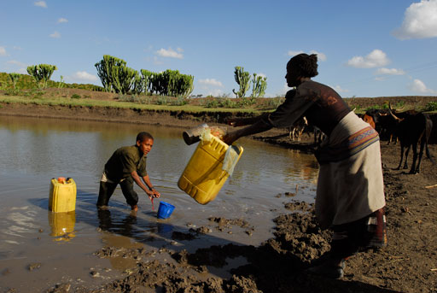 | 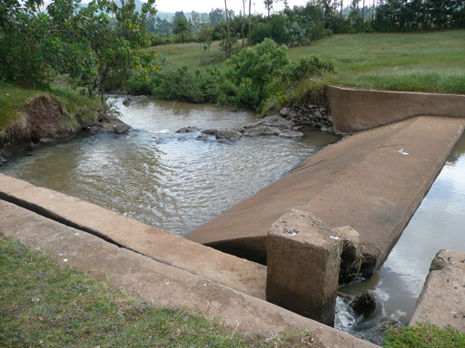
Figure 4.5 Many people rely on lakes and rivers for their water supply. | Figure 4.6 Small dams hold back river water so it flows into irrigation channels.

4.3.2 Groundwater
An aquifer is an underground layer of water-bearing rock. Water-bearing rocks are permeable, meaning that liquids and gases can pass through them. Groundwater is the water contained in aquifers (Figure 4.7). This is replenished or recharged by precipitation that percolates through the soil to the water table, and by water seeping from streams, as well as other bodies of surface water, such as lakes and wetlands.
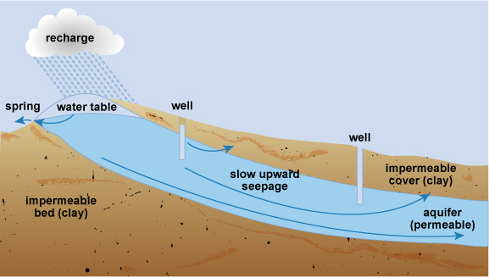
Figure 4.7 Groundwater formation.
The water table is the top of the groundwater below the land surface. Its level fluctuates seasonally and from year to year as the inputs from precipitation and the outputs vary. The depth of the water table also varies with location, from being near to the land surface in areas close to surface water bodies and in humid climates, to being hundreds of metres below the land surface in drier regions.
Groundwater reaches the surface naturally through springs or artificially through wells. Springs typically rise up where the water table meets the land surface. Springs are important sources of water to feed streams and are attractive cultural and landscape features in themselves. Wells and boreholes are dug by hand or drilled by machine. These have to be deep enough to extend below the water table so that water can be drawn up by bucket or by pumping.

4.3.3 Rainwater
Rainwater is also an important source of water, although on a relatively small scale. Collecting rain from roofs or other hard-surfaced areas and storing it until it is needed can provide a valuable source of water for many purposes.

4.4 Water source selection
The quantity, quality, and reliability of available water are three main factors that need to be considered when evaluating water sources. Socio-cultural and technical issues may also be important. This section provides an overview of some of these different factors.

4.4.1 Water quantity
If you were selecting a new source of water for a community you would need to be sure that the volume of water that could be supplied would be sufficient to meet the community’s needs, both now and in the future. It would also be important to consider the reliability of the source over time.

4.4.2 Water quality
The quality of water required depends on what it will be used for. Drinking water must be clean and safe to drink and protected from any contamination by pathogens or other pollutants. The primary concern must be to prevent the transmission of waterborne diseases. For other water uses such as for domestic washing or for agricultural or industrial uses, the quality is less critical.
In general, surface water sources are likely to contain many different materials and potential pollutants. These include micro-organisms, some of which may be pathogens, and small solid particles referred to as suspended particulates or suspended solids. These make the water turbid (Figure 4.8). Turbidity (the cloudiness of water) is a measure of water clarity. Turbidity is considered a useful approximate measure of water quality because pollutants and micro-organisms can be carried on the surface of suspended solids. The more turbid or cloudy the water is, the more suspended particles there are in it, and the more polluted the water is likely to be. It is important to realise, however, that clear water is not necessarily clean, because some contaminants may not be visible.
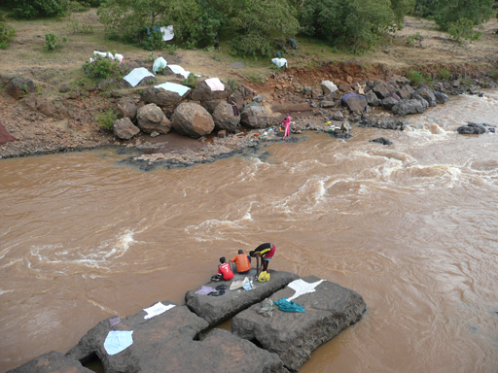
Figure 4.8 The brown colour of river water is caused by the suspended solids carried in the flow.
- Why is surface water likely to be turbid?
- Surface water is highly vulnerable to turbidity because solid particles of soil are washed off the land in run-off that flows to river and lakes, especially by heavy rains.
Surface water is easily polluted and can be affected by wide seasonal variations in turbidity. As a water source, surface water is often the easiest to access, but large quantities of suspended solids make it difficult to treat effectively. In general, groundwater is less likely than surface water to be polluted by pathogens or solid particles because the water is cleaned to some extent as it percolates down into the rock. However, it may have higher concentrations of dissolved substances. This means that groundwater has less microbial contamination but the dissolved substances and minerals, such as fluoride, may have significant effects on its quality.

Fluoride
Fluoride in drinking water is a well-known health concern. In some parts of Ethiopia concentrations in groundwater exceed the World Health Organization guideline of 1.5 mg/l (milligrams per litre). The highest concentrations, which can be greater than 10 mg/l, are found in waters from the Rift Valley zone. For people living in this area, dental and skeletal fluorosis are significant public health problems causing brown patches on the teeth, joint pain, limited movement of joints and, ultimately, crippling.
The National Fluorosis Mitigation Project has responsibility for planning a national strategy to deal with this problem. Several methods of defluoridation (removing fluoride from water) using chemicals or bone char have been successfully trialled at community and household levels (Osterwalder et al., 2015; Abaire et al., 2009; Esayas et al., 2009). However, selecting an affordable and sustainable standard technology for widespread use is challenging. Yang et al. (2015) found there is no single, preferable method for fluoride removal in Ethiopia because selection depends on the specific conditions of each location and on the preferences of the people involved.

4.4.3 Socio-cultural considerations
Socio-cultural considerations may be important for water source development. Before a new water source is developed, a thorough assessment of the needs and wishes of the community should be undertaken, involving all groups of people including women, men, and children, members of any distinct social groups, disabled persons, and other vulnerable groups. It is particularly important that women participate in the process because they are likely to have the most knowledge about existing sources and are most likely to benefit if new supplies are developed. If the community’s opinions are not taken into account, the water supply system is likely to be under-used and may easily fall into disrepair, causing people to revert to their old water sources which may be more polluted.

Case Study 4.1 Hadera and the community who would not drink the blood of their forefathers
Hadera is a senior WASH expert working as a water and sanitation coordinator in small rural town. The town’s inhabitants had been suffering from a critical lack of sufficient safe water supplies and from waterborne diseases. Hadera had a good connection with the manager of an international non-governmental organisation (INGO), and convinced him to develop a water supply scheme for the needy community. The INGO finally managed to dig a well and get a good yield of water, and was able to handover the new facility to the kebele leadership for community use. Unfortunately, the community refused to use the water supply as their drinking water source. The INGO was surprised and asked them why not, mentioning the huge investment put into developing the water point in order to support the community. The community replied ‘we will not drink the blood of our forefathers’. The water source was developed in an area that served as a burial place many years ago and the villagers believed that the water contained the blood of their ancestors and so would not drink it.
- What should Hadera and the INGO have done differently?
- The problem could have been avoided if the villagers had been involved and consulted in the process of the water source development.

4.4.4 Technical requirements
The development of the source must be technically feasible and the operation and maintenance requirements for the source abstraction and supply system must be appropriate to the resources available. Supply systems are likely to be misused if they cannot be operated and maintained either by community members or by organisations and institutions within the area. People who have responsibility for the maintenance of water sources or distribution points should be properly trained and rewarded for their contribution, to ensure sustainability.

4.5 Depletion and contamination of water sources
As you read in Study Session 1, humans interact with water both by using it and by producing the wastes that may contaminate it. Both of these activities can damage water sources.

4.5.1 Water source depletion
Although water is a renewable resource, excessive extraction of water will result in its depletion. If groundwater is extracted from aquifers more quickly than the water is replenished by recharging, this will lower the water table. Excessive groundwater pumping changes the flow patterns around wells and creates a localised depletion of groundwater stores in the area around the well. If several wells are located close together these zones can overlap. The result is that existing wells and boreholes may dry up and new ones have to be dug deeper and deeper before they reach water. The lowering of the water table also affects rivers and streams, which are normally fed partially by underground water. Over-exploitation of groundwater can also affect springs, which may change from permanent to temporary or even dry up completely.
Water source depletion is also directly linked to reduction in forest cover. With the loss of trees and other vegetation, rainwater runs straight off the surface and does not penetrate into the ground to recharge the groundwater. Added to this are the uncertainty of climate change and the effects of periods of drought which have a serious impact on the availability of surface and groundwater sources.

4.5.2 Water source contamination
Surface water can become contaminated in many ways. This may by direct discharge into the river from a sewer or pipe. Rivers and streams are considered to be convenient ways of disposing of wastewaters of all types, including domestic and industrial wastes. Industrial sources may discharge hazardous substances, as well as organic matter and suspended solids without adequate treatment. Surface water pollution can also come from stormwater run-off, which may carry contaminated materials into the water. Open defecation and the uncontrolled disposal of solid wastes are two likely sources of contamination by run-off.
Groundwater is generally cleaner than surface water for reasons explained earlier but pollution of groundwater resources has become a major problem in Ethiopia and around the world. Groundwater is polluted by the leaching of human and industrial waste, pesticides and fertilisers, which infiltrate into the aquifers from the surface and pollute groundwater supplies. Pit latrines that are located too close to a water source or are poorly constructed and maintained can also be sources of groundwater contamination. The polluted water reaches people and animals through contaminated spring and well water.

4.6 Water demand and supply
You will recall from Study Session 1 that many countries in the world, including Ethiopia, are suffering from water stress or water scarcity. The world is heading towards a fresh water crisis, partly due to mismanagement and partly due to the unequal distribution and small amount of fresh water available in the first place. This crisis is already evident in many parts of the world, varying in scale and intensity depending on the time of the year, climate and location.
The imbalance between the demand for and the supply of water is increasing globally. On the one hand, the volume available for supply remains much the same but has additional problems of contamination of surface and groundwater sources, inefficient utilisation of available supplies and the uncertainties of climate change. On the other hand, the demand for fresh water per capita is rising as countries develop economically. Industrial development leads to additional demands for water and, at the same time, agriculture is becoming increasingly dependent on irrigation to produce food for the growing population.
The global challenge is to find ways to manage the increasing demand for water but this is not to say that everyone should use less water. Developing countries still use far less water per capita than developed regions. Household use in developing countries is especially low, reflecting the difficulty many people have in obtaining clean water for personal use. Improving access to water is important so that people can use more water for household and personal hygiene, which will improve living standards and bring significant benefits to health and well-being.
Population growth, urbanisation and migration all affect the availability and quality of water resources. With the rapid increase in urbanisation, meeting the demand for fresh water will be difficult for cities. Rapid urban growth in developing countries puts tremendous pressure on inadequate water supply systems and can lead to water shortages. The next two study sessions look more closely at urbanisation and its causes and effects.

Summary of Study Session 4
In Study Session 4, you have learned that:
- Water is continually moving around the Earth and continuously changing its form. The hydrological cycle maintains a balance between evaporation, precipitation, the transport of water vapour in the atmosphere from the sea to the land and run-off from land to sea.
- About two-thirds of the Earth's surface is covered with water. Of this, around 97.5% by volume is held in the oceans as salt water; only 2.5% is fresh water and only a very small fraction of this is accessible as a water source.
- Surface water, groundwater and rainwater are our main sources of water. The quantity, quality, and reliability of available water are the important factors considered when sourcing water.
- Fluorosis caused by fluoride in water is a well-known health problem in Ethiopia. The highest concentrations of fluoride are found in waters from the Rift Valley zone.
- Selecting a water source for a community supply system requires careful consideration of a range of factors, such as water quantity and quality, technical requirements and socio-cultural considerations.
- Water sources can be depleted by over-extraction and can be contaminated by pollutants.
- Globally, the consumption of water is increasing due to the rising population and increased consumption per capita. Water use per capita in developing countries is far less than in industrialised countries.

Self-Assessment Questions (SAQs) for Study Session 4
Now that you have completed this study session, you can assess how well you have achieved its Learning Outcomes by answering these questions. You can check your answers with the Notes on the Self-Assessment Questions at the end of this Module.

SAQ 4.1 (tests Learning Outcomes 4.1 and 4.2)
Rewrite the paragraph below using terms from the list provided to fill the gaps.
aquifers, condenses, evaporation, groundwater, hydrological, percolates, precipitation, run-off, transpiration.
Water on the Earth’s surface moves in an unceasing cycle through rivers, oceans, clouds and rain called the water or ……………… cycle. The heat from the sun causes ……………… of water from oceans and from lakes and wetlands on land. Plants lose water through their leaves by ……………… Water vapour in the atmosphere ……………… to form clouds which are moved around by wind. Rain and snow, collectively known as ………………, fall from the clouds. Some water that falls on the ground forms ……………… which collects into streams and rivers and some ……………… through the soil to become ………………, which is held in layers of rock called ………………

SAQ 4.2 (tests Learning Outcomes 4.3 and 4.5)
Name the three main types of water source that people use and explain how each would be affected by an extended period of drought.

SAQ 4.3 (tests Learning Outcome 4.4)
Town A has does not have a convenient water source for its residents. You are part of a team that has been tasked to select a water source for development to meet the water needs of Town A. List four points that you need to consider as part of the selection process.

SAQ 4.4 (tests Learning Outcome 4.5)
Which of the following statements are false? In each case explain why it is incorrect.
- More fresh water is held in lakes on the Earth’s surface than is held in aquifers as groundwater.
- Demand for water tends to increase as countries develop economically.
- In rainy seasons, surface water sources are topped up with fresh water therefore they are less likely to be contaminated with pathogenic micro-organisms than groundwater sources.
- Ethiopia has plentiful supplies of fresh water but it is not evenly distributed across the country.
- Globally, the demand for water is increasing but the volume available to meet that demand is not.

Study Session 5 Urbanisation: Trends, Causes and Effects

Introduction
More than half of the world’s population lives in urban areas. Due to the ongoing urbanisation and growth of the world’s population, there will be about 2.5 billion more people added to the urban population by 2050, mainly in Africa and Asia. The world’s urban areas are highly varied, but many cities and towns are facing problems such as a lack of jobs, homelessness and expanding squatter settlements, inadequate services and infrastructure, poor health and educational services and high levels of pollution.
In this study session, you will learn about the trends in urbanisation and the causes of urban growth. You will also learn about the demographic, health, environmental and social consequences of urbanisation.

Learning Outcomes for Study Session 5
When you have studied this session, you should be able to:
5.1 Define and use correctly all of the key words printed in bold. (SAQs 5.1 and 5.2)
5.2 Describe the global and local trends in urbanisation. (SAQ 5.3)
5.3 Explain the main causes of urban growth. (SAQs 5.1 and 5.2)
5.4 Describe the main positive and negative impacts of urbanisation. (SAQ 5.4)

5.1 Urbanisation trends
In Study Session 2 you learned about the overall trend in global population growth. Most of this increase is taking place in urban areas. Urbanisation is an increase in the number of people living in towns and cities. Urbanisation occurs mainly because people move from rural areas to urban areas and it results in growth in the size of the urban population and the extent of urban areas. These changes in population lead to other changes in land use, economic activity and culture. Historically, urbanisation has been associated with significant economic and social transformations. For example, urban living is linked with higher levels of literacy and education, better health, lower fertility and a longer life expectancy, greater access to social services and enhanced opportunities for cultural and political participation (UNDESA, 2014). However, urbanisation also has disadvantages caused by rapid and unplanned urban growth resulting in poor infrastructures such as inadequate housing, water and sanitation, transport and health care services.

5.1.1 Global trends in urbanisation
In 1960, the global urban population was 34% of the total; however, by 2014 the urban population accounted for 54% of the total and continues to grow. By 2050 the proportion living in urban areas is expected to reach 66% (UNDESA, 2014). Figure 5.1 shows the change in the rural and urban populations of the world from 1950 through to projected figures up to the year 2050.
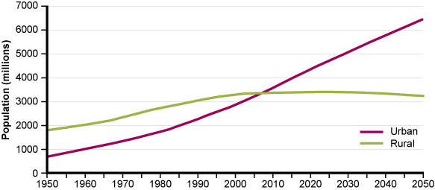
Figure 5.1 Urban and rural population of the world, 1950–2050. (UNDESA, 2014)
- From Figure 5.1, in which year did the number of people living in urban areas first exceed the number living in rural areas?
- The two lines cross at about 2007 or 2008. This is when urban first exceeded rural population.
The process of urbanisation affects all sizes of settlements, so villages gradually grow to become small towns, smaller towns become larger towns, and large towns become cities. This trend has led to the growth of mega-cities. A mega-city is an urban area of greater than ten million people. Rapid expansion of city borders, driven by increases in population and infrastructure development, leads to the expansion of city borders that spread out and swallow up neighbouring urban areas to form mega-cities. In 1970, there were only three mega-cities across the globe, but by the year 2000, the number had risen to 17 and by 2030, 24 more mega-cities will be added (see Figure 5.2).
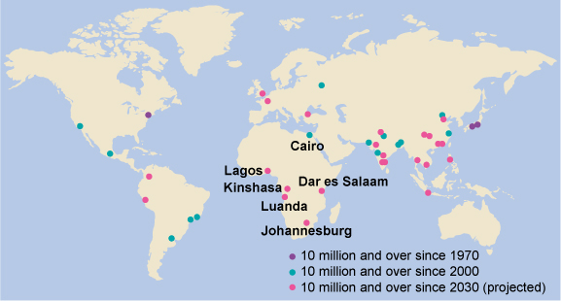
Figure 5.2 The top mega-cities in the world in 1970, 2000 and 2030. (UNDESA, 2014)
- From Figure 5.2, in Africa how many mega-cities are predicted to exist by 2030 and how many have already existed since the year 2000?
- Six mega-cities are predicted to exist in Africa by the year 2030 – Luanda (Angola), Lagos (Nigeria), Johannesburg (South Africa), Kinshasa (Democratic Republic of Congo), Dar es Salaam (Tanzania) and Cairo (Egypt). There is one mega-city, Cairo, which has had a population of more than 10 million since 2000.
The global trend in urbanisation is not the same in all parts of the world. Asia and Africa currently have the highest rates of urbanisation. Figure 5.3 shows a comparison of trends in more or less developed regions of the world.
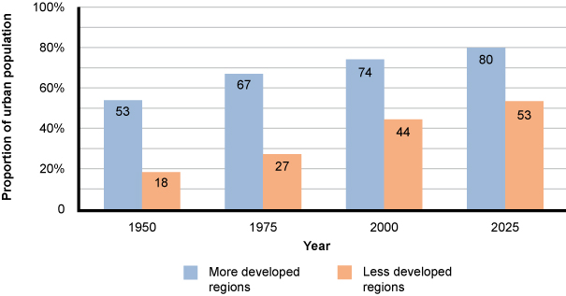
Figure 5.3 Trends in urban population growth, comparing more and less developed regions. The graph shows the proportion of the total population living in urban areas.
- In Figure 5.3, how would you describe the trends in urban growth in more and less developed regions during this century?
- The growth of urban populations in less developed regions is increasing at a faster rate than developed regions. In 2000, in more developed parts of the world 76% of the population lived in urban areas and a small increase to 83% is forecast by 2030. In less developed regions, there was a much smaller proportion living in urban areas in 2000 (only 40%) but this is expected to increase significantly to 56% by 2030.

5.1.2 Urbanisation in Ethiopia
Ethiopia is one of the least urbanised countries in the world today, and only 18% of its population lives in urban areas (JMP, 2014). In common with many other developing countries, however, this pattern is changing (Figure 5.4). Ethiopia’s urban growth rate is more than 4.0% per year, which places it among the highest in Africa and the world (MWUD, 2007).
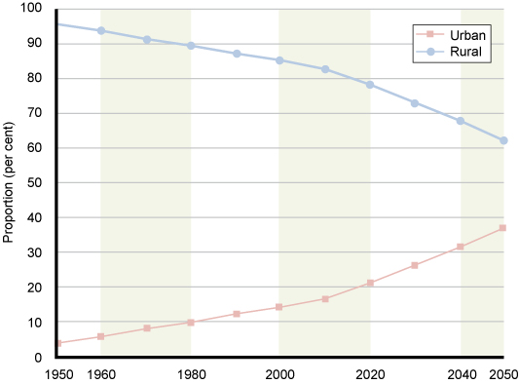
Figure 5.4 Changing proportion of urban and rural population in Ethiopia from 1950 to 2050 (estimated from 2014 onwards). (UNDESA, 2014)
The rapid increase in urban populations has meant that peri-urban areas are growing much more quickly than formal urban centres. Peri-urban areas are those areas immediately around a town or city. They are areas in transition from countryside to city (rural to urban), often with undeveloped infrastructure, where health and sanitation services are under pressure and where the natural environment is at risk of degradation.
Defining the boundaries of urban, peri-urban and rural areas is not straightforward. They do not neatly separate themselves by lines on a map. On the contrary, the sprawling nature of urban development means that the areas merge into each other. The lack of a clear boundary can make it difficult to assess the size of towns by their population or geographical area. However, judgements have to be made and, for planning and administrative purposes, data on population size are collected. Table 5.1 shows the number of towns and cities in Ethiopia by population in 2007, the most recently published data.
Table 5.1 Numbers and sizes of urban settlements in Ethiopia. (Adapted from MWUD, 2007)
Population of urban settlement | Number
Up to 2,000 | 171
2,000 to 4,999 | 339
5,000 to 19,999 | 310
20,000 to 49,999 | 79
50,000 to 99,999 | 14
100,000 to 200,000 | 8
Above 200,000 | 4
Total | 925
Of the four cities with a population of more than 200,000, by far the largest is Addis Ababa. In 2007, the population of Addis Ababa was more than 3 million, which amounted to about 25% of Ethiopia’s urban population (MWUD, 2007). The next-largest city, Dire Dawa, had only 293,000 occupants at that time. The impacts of urbanisation are generally much more evident in the capital than in other towns and cities.

5.2 Causes of urbanisation
Urbanisation in the developing world occurs for two main reasons: the natural increase of population and rural to urban migration.

5.2.1 Natural increase of population
From Study Session 2 you will know that the population is increasing in developing countries. This natural increase is a significant cause of the growing urban population.
- Explain what is meant by natural increase of population.
- Natural increase of population occurs when the number of births exceeds the number of deaths.
As birth rates decline over time, according to the demographic transition model, the role of natural increase in determining the pace of urban population growth becomes less important in comparison to migration.

5.2.2 Rural to urban migration
In developing countries, urbanisation usually occurs when people move from villages to settle in cities in hope of gaining a better standard of living. The movement of people from one place to another is called migration. Migration is influenced by economic growth and development and by technological change (Marshall et al., 2009) and possibly also by conflict and social disruption. It is driven by pull factors that attract people to urban areas and push factors that drive people away from the countryside.
Employment opportunities in cities are one of the main pull factors. Many industries are located in cities and offer opportunities of high urban wages. There are also more educational institutions providing courses and training in a wide range of subjects and skills. People are attracted to an urban lifestyle and the ‘bright lights’ of city life. All of these factors result in both temporary and permanent migration to urban areas.
Poor living conditions and the lack of opportunities for paid employment in rural areas are push factors. People are moving away from rural areas because of poor health care and limited educational and economic opportunities as well as environmental changes, droughts, floods, lack of availability of sufficiently productive land, and other pressures on rural livelihoods.
Rural to urban migration can be a selective process, as some types of people are more likely to move than others. One of the factors involved is gender, because employment opportunities vary greatly with different jobs for men and women. Another factor is age. Young people are more likely to move to towns, with more elderly people and children left in rural areas. Selectivity in migration affects the population in both the rural and the urban areas. If more men move to towns and cities than women, this leaves a predominantly female society in rural areas.

5.3 Impacts of urbanisation
Although people are pulled towards the advantages of cities, the impacts of urbanisation are mixed. First we will look at the many positive impacts of urbanisation before going on to describe some of the challenges created by rapid unplanned urban growth.
Thriving towns and cities are an essential element of a prosperous national economy. The gathering of economic and human resources in one place stimulates innovation and development in business, science, technology and industry. Access to education, health, social services and cultural activities is more readily available to people in cities than in villages. In cities, child survival rates are better than in rural areas because of better access to health care (Mulholland et al., 2008). The density of urban populations makes it easier and less costly for the government and utilities to provide essential goods and services (Brockerhoff, 2000). For example, the supply of basic facilities such as fresh water and electricity can be achieved with less effort and less cost per person.
Schools, colleges and universities are established in cities to develop human resources. A variety of educational courses are available, offering students a wide choice for their future careers. People of many classes and religions live and work together in cities, which creates better understanding and harmony and helps break down social and cultural barriers. Cities also have advanced communication and transport networks.
However, these many benefits of urban life do not apply to all. Rapid population increases and unplanned growth create an urban sprawl with negative economic, social, and environmental consequences. In Ethiopia, the rate of urban growth often strains the capacity of local and national government to provide urban residents with even the most basic services of housing, water supply, sewerage and solid waste disposal (MWUD, 2008).

5.3.1 Housing
In developing countries, about a third of urban inhabitants live in impoverished slums and squatter settlements (UN-Habitat, 2012). Slums are urban areas that are heavily populated and have sub-standard housing with very poor living conditions, creating several problems.
In Addis Ababa, a report in 2008 found that 80% of the houses in the city were classed as slums due to the physical deterioration of its housing, overcrowding, high density, poor access and lack of infrastructure services (Tolon, 2008) (Figure 5.5).
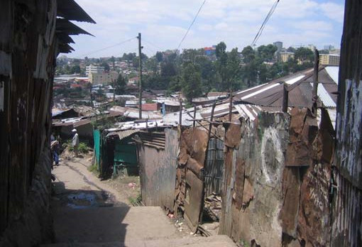
Figure 5.5 Urban slum in Addis Ababa .
Slum areas typically suffer from:
- poor housing with small, overcrowded houses built very close together using inadequate materials and with uncertain electricity supply
- restricted access to water supplies
- little or no sanitation/latrine facilities and no solid waste disposal, which leads to a polluted and degraded local environment
- inadequate health care facilities which, coupled with the poor living conditions, increases sickness and death rates
- insecure living conditions – slum dwellers may be forcibly removed by landowners or other authorities.
Many low-income families gravitate to these informal settlements that proliferate in and around towns. Poverty is one of the most critical issues facing urban areas. Urban poverty degrades both the physical and social environment. This then makes it more difficult for people to escape from poverty and they fall victim to the ‘vicious cycle’ that you read about in Study Session 2.

5.3.2 Water supply and sanitation
The provision of water and sanitation services to growing urban settlements, peri-urban and slum areas presents critical challenges. The increased demand for water from the growing population can place added stress on already stretched resources. In and around cities, water is commonly in short supply and subject to increasing competition by different users. Urban growth leads to increasing demand for water for industrial and domestic use, which conflicts with agricultural demands.
It is especially difficult to provide water and sanitation services to deprived areas and the poorest people. Many people in these areas live without access to safe drinking water and proper sanitation. Even where adequate water supplies are available, sanitation and wastewater disposal are often inadequate or missing. Pit latrines and septic tanks are the usual methods for human waste disposal but they have limited capacity and are not always adequate to cope with the quantity of waste produced by many people living close together. Overflowing latrines and septic tanks contaminate surface water and create a serious health risk.
The lack of these essential services threatens not only the health and the environment of people in slum areas, but also that of people living in formal urban areas. In Africa and Asia most of the urban centres have no sewers at all, which affects rich and poor alike. This is true of many cities with a million or more inhabitants, as well as smaller cities and towns.

5.3.3 Wastes and pollution
Urbanisation affects land, water, air and wildlife because of the number of people, the amount of buildings and construction, and the increased demands on resources. It has impacts on the physical environment in several ways.

Water quality
In developing countries, including Ethiopia, many rivers in urban areas are more like open sewers (Figure 5.6). The lack of sanitation and sewerage systems has a dramatic impact on urban watercourses. People use the rivers to dispose of all their wastes from homes, industries and commercial businesses. Wastewater from human settlements contains organic material and nutrients; industrial wastewater contains many different types of toxic pollutant. These make the water unsafe for humans to use for many purposes including drinking and irrigation, as well as harming the fish and other animals and plants living in the water. Any changes to the quality of surface water also affects groundwater because they are linked by the processes of the water cycle so pollutants from the surface will infiltrate down and contaminate soil and groundwater as well.
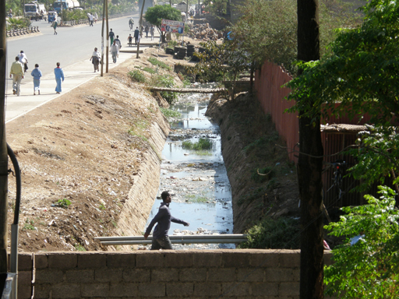
Figure 5.6 Urban rivers contain wastes from many sources.

Solid waste
In many towns and cities solid waste management is inefficient or non-existent. Solid waste management means the proper collection, transfer, recycling and disposal of all the solid material we throw away, including plastics, paper and cardboard, food wastes, electrical waste, etc. It also includes industrial, hospital and institutional wastes which often contain pathogens as well as hazardous and toxic chemicals, which need special care.
Urban waste often ends up in illegal dumps on streets, open spaces, wastelands, drains or rivers. This is frequently a problem in peri-urban areas, which are convenient for dumping wastes because of the availability of open space and ease of access from central urban areas. This can lead to the pollution of groundwater and surface waters which may be used as a source for drinking water. Sometimes the wastes are collected and taken to legalised waste disposal sites but these are not always properly managed to protect water bodies and groundwater.
The combustion of solid waste creates yet another environmental problem. People want to get rid of the wastes and they will burn them in their backyards if there is no collection system (Figure 5.7).
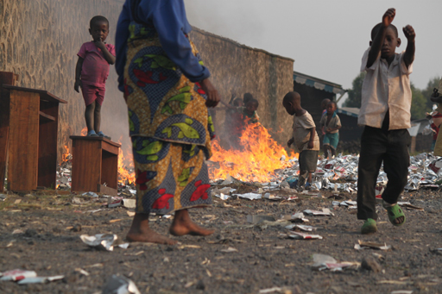
Figure 5.7 Burning waste in an urban area.

Air quality
Air quality in towns and cities is frequently very poor as a result of air pollution from many different sources (Figure 5.8). These include:
- vehicle exhausts
- smoke from domestic fires
- outputs from factory chimneys
- diesel-powered generators
- dust from construction works and city streets.
Poor air quality has a significant impact on the health of many urban residents as well as leaving a damaging and unsightly layer of dust on plants, buildings and other surfaces.
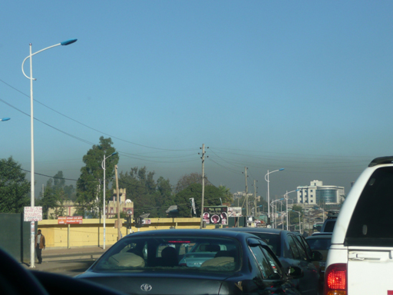
Figure 5.8 The brown colour of the air near the ground shows how polluted the air in Addis Ababa can be.

5.3.4 Health
Urbanisation can have both positive and negative effects on health. The main benefits are associated with easier access to hospitals, clinics and health services in general. If you live close to these services you can reach a doctor in minutes rather than hours or days, so this improves emergency care and general health. There are also benefits from easier access to sources of information such as radio and television which may be used to communicate information about health to the general public. For example, women living in towns and cities are more likely to be informed about family planning, which results in reduction in family size and less frequent childbirth, with consequent benefits to general health.
However, urban life can also damage your health. Poor environment, housing and living conditions are the main reasons for poor health in urban areas. Contamination of water sources can cause epidemics of waterborne disease. Close proximity to other people can make the spread of many types of infectious disease more likely. The polluted air can also cause respiratory disease and contribute to premature deaths among more vulnerable sections of the population such as older people and children.

5.3.5 Food
Population movements also put pressure on food supplies and on food distribution. As people migrate to the cities, they tend to use purchased food instead of their own crops and this makes them more vulnerable to changes in food prices. As the population grows and the demand for water and land increases, it becomes difficult to increase food production in a sustainable way. The increase in urban demand, combined with a loss of agricultural land, means more pressure on rural people to produce food for the growing number of urban people.
Furthermore, pollution from urban areas can disrupt food supply. For example, fisheries are often damaged by urban domestic wastes and liquid effluents from city-based industries. (Effluent is another word for wastewater that flows out from a source.) In several Ethiopian cities, such as Bahir Dar, Hawassa, Bishoftu and others, untreated wastes are dumped into nearby lakes, which can damage the fish stocks (Figure 5.9).
Figure 5.9 Many people living in towns and cities near lakes rely on local fish for food, but this may be contaminated by urban waste.

5.3.6 Economic and social systems
The process of urbanisation has positive as well as negative economic and social changes. The positive effects include economic development, and education. However, urbanisation places stresses on existing social services and infrastructure. Crime, prostitution, drug abuse and street children are all negative effects of urbanisation. Also there tends to be a lack of social support for children in school and home by their hard-working, usually poor, parents. Inadequate income, overcrowded housing and poor living conditions create a fertile ground for the development of violence. Violent crime is more visible in the cities than in rural areas and it affects people’s everyday life, their movements and the use of public transport. Crime in the city can create a sense of insecurity in its inhabitants. This unsafe feeling in city streets separates residential areas into higher-income and lower-income groups, which reduces the sense of community and forms areas with dissimilar incomes, costs and security levels.
In the next study session we will look at some of the ways in which these problems and challenges can be addressed by considering the future demands for urban living and by taking a planned approach to the development of new urban areas.

Summary of Study Session 5
In Study Session 5, you have learned that:
- Urbanisation is a global trend reflecting the growing population of the world. The urban populations of less-developed countries are currently increasing at a faster rate than those of more-developed countries.
- Urbanisation results from a natural increase in the population and rural to urban migration.
- People migrate to towns and cities in hope of gaining a better standard of living. They are influenced by pull factors that attract them to urban life, and push factors that make them dissatisfied with rural living.
- Urban living is associated with better employment and education opportunities, better health, greater access to social services and opportunities for social and cultural activities.
- Uncontrolled migration and rapid urban growth are associated with increasing urban poverty and inequality and rises in slum and squatter populations. These people usually have inadequate water supply and sanitation services.
- Urbanisation affects the physical environment through the impacts of the number of people, their activities and the increased demands on resources.
- Urbanisation has negative consequences on health due mainly to pollution and overcrowded living conditions. It can also put added pressure on food supply systems.
- The pressures of urban living may lead to crime and other consequences of social deprivation.

Self-Assessment Questions (SAQs) for Study Session 5
Now that you have completed this study session, you can assess how well you have achieved its Learning Outcomes by answering these questions. You can check your answers with the Notes on the Self-Assessment Questions at the end of this Module.

SAQ 5.1 (tests Learning Outcomes 5.1 and 5.3)
Rewrite the paragraph below using terms from the list provided to fill the gaps.
increase, mega-cities, peri-urban, rural to urban migration, slums.
Urbanisation is an ……………… in the number of people living in towns and cities. The two causes of urbanisation are natural population increase and ……………… Urbanisation affects all sizes of settlements from small villages to towns to cities, leading up to the growth of ……………… which have more than ten million people. Rapid urbanisation often means that ……………… areas immediately around a city grow more rapidly than urban centres and this can lead to development of ………………

SAQ 5.2 (tests Learning Outcomes 5.1 and 5.3)
Both push and pull factors drive the migration that leads to urbanisation. What is meant by the terms ‘push and pull factors’? In your answer you should state one push factor and one pull factor.

SAQ 5.3 (tests Learning Outcome 5.2)
Is urbanisation increasing faster in developed or developing countries? How does the rate of urbanisation in Ethiopia compare with other countries?

SAQ 5.4 (tests Learning Outcome 5.4)
Do you think that urbanisation is a bad thing or a good thing? Justify your answer by giving two examples of the impacts of urbanisation.

Study Session 6 Land Use and Urban Planning

Introduction
This is the second study session that looks at the growing trend for people to live in urban rather than rural areas. Study Session 5 described the main causes and effects of urbanisation. In this study session we will review how urbanisation changes the nature of the land surface and the consequences of that change. We will then consider the role of urban planning in reducing some of the negative effects of urbanisation and look at current urban development in Ethiopia.

Learning Outcomes for Study Session 6
When you have studied this session, you should be able to:
6.1 Define and use correctly all of the key words printed in bold. (SAQs 6.1, 6.2 and 6.3)
6.2 Explain the connections between land use and the physical environment. (SAQ 6.1)
6.3 Summarise the problems created by uncontrolled urban developments. (SAQ 6.2)
6.4 Describe how urban planning can contribute to sustainable urban living. (SAQ 6.4)
6.5 Summarise the achievements and challenges of the Integrated Housing Development Programme. (SAQ 6.5)

6.1 Change of land use
We depend on land to provide many essential life-supporting systems.
- Think back through the previous study sessions and consider the different ways that we all use land. What different types of land use can you think of?
- We use the land to provide food from agricultural activities; to supply wood from trees for construction and fuel; for water which is extracted from rivers and lakes on the land’s surface or from underground, and to provide rocks and building materials.
You may also have thought of the land that is used when we build houses, shops, factories, roads and other components that make up the urban environment. This is the aspect of land use that we will be focusing on in this study session.
Land use can be defined as arrangements, activities and inputs by people to produce, change or maintain a certain land cover type (FAO/UNEP, 1999). This definition makes it clear that there is a link between land use and land cover. Land cover is the observed biophysical cover on the Earth's surface. In non-urban areas land cover is usually described by the dominant vegetation type, such as forest, grassland or cropland. Changing the way the land is used (for example by building towns and cities on it) changes the land cover and has many direct and indirect effects.
Most consequences of changing land use through urbanisation can be grouped into two main categories: the decrease in natural and agricultural land, and the increase in hard surfaces of built-up areas.

6.1.1 Decrease in natural and agricultural land
Change from non-urban to urban land use causes the loss of many different types of vegetated land cover. This may be grassland used for grazing animals, cultivated fields that produce food and other crops, uncultivated areas of river banks and hillsides, and wooded areas covered with trees. Deforestation was discussed in Study Session 1 as one of the negative impacts of human use of resources.
- What are the main negative effects of deforestation?
- Deforestation can reduce the infiltration of water into the soil and groundwater, which can lower the water table and increase the volume and speed of surface run-off; if this happens it can increase soil erosion because the land surface is exposed. Deforestation also results in a loss of wildlife habitat and a reduction in biodiversity; and the loss of ecological services provided by trees (such as converting atmospheric carbon dioxide to oxygen by photosynthesis). You may also have mentioned the loss of the aesthetic value of trees, which are attractive elements in our biophysical environment.
The reduction in agricultural land also shifts the balance in the land area available for food production. The most productive land for agriculture tends to be near to towns. When towns expand this land gets covered with buildings and so it is no longer available for food production. This means there is less productive land available to meet the increasing demands for food from a growing urban population. The additional demands for food production in the areas around towns and cities can encourage the increased use of pesticides and fertilisers to improve productivity, which can have negative environmental impacts. It also encourages the cultivation of previously unused land such as sloping hillsides which, when ploughed, are extremely vulnerable to soil erosion when it rains.

6.1.2 Increased area of hard surfaces
The construction of urban areas increases the area of hard surfaces such as roofs, roads, and pavements. Unlike the natural land cover they replace, these hard surfaces are impermeable, meaning water cannot pass through them. When rain falls it does not infiltrate into soil and groundwater but instead pours off the surface very quickly. Water collects in gutters and drains and flows directly into rivers and ditches, which rapidly fill up and can overflow. The volume and speed of the flow of run-off leads to frequent flooding in many city areas (Figure 6.1). These problems are made even worse if there is no drainage system or if drainage is inadequate or becomes blocked with rubbish.
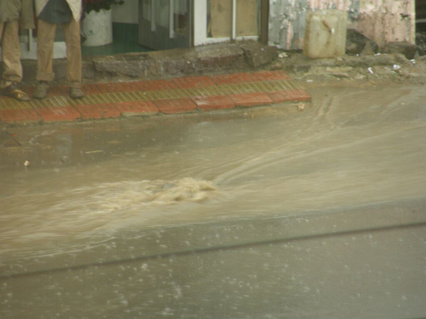
Figure 6.1 Flooding in an urban area.
In addition to the effect on the water cycle, the increase in hard surface area also influences the exchange of energy with the atmosphere, which can lead to localised changes to the weather and climate. In large cities the temperature can be a few degrees warmer than in surrounding rural areas, an effect known as an urban heat island. This is caused by the hard surfaces of roads and buildings, which absorb energy from the sun and radiate heat into the surrounding air to a much greater extent than natural vegetated surfaces, especially at night. The raised temperature can increase the impact of poor air quality on people’s health.

6.1.3 Extraction of building materials
A third category of changed land use is the extraction of rocks and minerals for the construction industry (Figure 6.2). This process results in the loss of vegetated land cover where the rocks are extracted. Most of this resource extraction takes place in peri-urban areas because they are located conveniently close to the construction sites to minimise transport costs and time. Many small-scale, unregulated and low-technology extraction activities can be seen on sites around towns in Ethiopia.
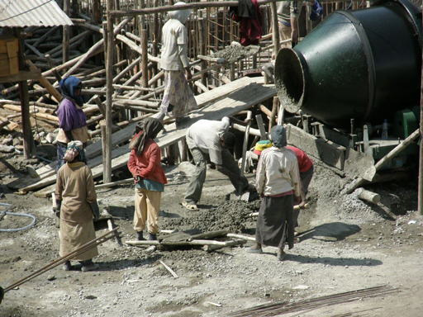
Figure 6.2 Construction of new buildings uses many different resources.
These impacts of change in land use from rural to urban, combined with the effects that you read about in Study Session 5, add up to a lengthy list of negative consequences from urbanisation. Managing and minimising these effects is one of the main purposes of urban planning.

6.2 What is urban planning?
Urban planning is about designing towns and cities to function effectively and meet the needs of people living in them. This is a technical process, concerned with bringing benefits to people, controlling the use of land and enriching the natural environment. It requires careful assessment and planning so that community needs such as housing, environmental protection, health care and other infrastructure can be incorporated.
Urban planning means managing urban development so that uncontrolled and haphazard building is prevented. Unplanned development in peri-urban areas can lead to towns and cities spreading out and extending the impacts of change of land use over an ever-increasing area. In central urban areas, unplanned development gives rise to densely-packed, single-storey housing with narrow alleys making it very difficult to provide necessary services for the inhabitants (Figure 6.3). The negative effects of impoverished, informal settlements were described in Study Session 5.
- What are the main negative impacts of slum areas on the people who live there?
- The main problems are the poor quality of housing construction materials, overcrowding, and limited access to water and sanitation, which combine to create unhealthy living conditions.
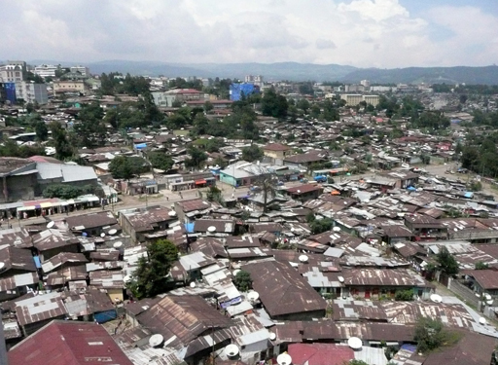
Figure 6.3 Close-packed houses in Addis Ababa.
Unplanned urban development is characterised by poor housing quality and by the lack of supporting infrastructure and services. These inadequate services can include any or all of: electricity, water supply, sanitation, drainage, solid waste management, roads and transport facilities, shops and schools and health care. The lack of available space in central urban areas also results in people building insecure homes in unsafe places, as shown in Figure 6.4. Urban planning aims to address these problems.
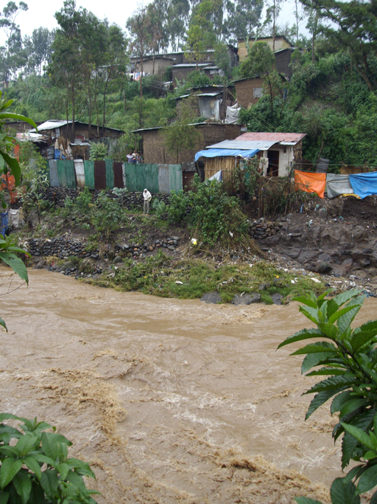
Figure 6.4 Houses perched precariously close to the flooding Akaki River in central Addis Ababa.
Historically, the concept of urban planning arose in Europe in the 19th century (Corburn, 2005). It emerged from the awareness that public health and infectious disease outbreaks were closely related to inadequate housing and poor sanitation, particularly affecting the urban poor. By the 20th century, the idea of land-use zoning was the dominant approach to urban planning. Zoning meant the creation of defined areas within a town that were designated for different activities such as residential, commerce, industry, etc. The aim was to improve urban living conditions by separating people from ‘noxious land uses’ (Corburn, 2005). However, zoning also had the effect of creating a social divide by separating areas where well-off people lived from those occupied by people with little or no income, with increasing inequality between the services and facilities available in different zones. Excluding people from living in central zones that were allocated for commerce and business resulted in increasing urban sprawl, where the effects of urbanisation and land-use change were spread over larger areas (UN-Habitat, n.d. 1). Recommended urban planning practice has since moved away from the zoning approach and currently adopts principles of integrated use designed to ensure the sustainability of future towns and cities.

6.3 Planning for sustainability
You could say that the purpose of urban planning is to manage land use so that it is sustainable. This means it should bring economic benefits, with social equity and without causing environmental harm. The promotion of ‘socially and environmentally sustainable human settlements development’ is part of the mission of UN-Habitat, the United Nations programme that is ‘working towards a better urban future’ (UN-Habitat, n.d. 2). They set out five principles for urban planning, shown in Box 6.1 (UN-Habitat, n.d. 1).

Box 6.1 UN-Habitat’s five principles for sustainable neighbourhood planning
The UN-Habitat approach to urban planning is based on three key features of sustainable neighbourhoods and cities, which are that they should be compact, integrated and connected. Five principles support these three features:
- Adequate space for streets and an efficient street network.
- High density of people: at least 15,000 people per km².
- Mixed land use: housing mixed with business and other economic uses.
- Social mix: houses in different price ranges and tenures (rented, owned etc.) in any given area.
- Limited land-use specialisation: large areas should not be allocated for a single function.

In contrast with the zoning approach, these five principles emphasise the need for mixed land use developments that integrate different functions of residential, commercial and business together. Ideally, urban plans should mix housing with employment opportunities and include schools, shops and health care facilities. An adequate street network will allow access for cars, public transport and service vehicles. Plans should also consider the need for space for places of worship and for entertainment and leisure. Incorporating this diverse range of requirements for the urban environment is challenging. To be successful and sustainable, urban plans should ideally be developed with the participation of the people who will be living and working in the area. Meeting these expectations also requires significant economic resources, an effective decision-making and regulatory framework, and good governance.
We will now consider in a little more detail some aspects of sustainable urban planning that are particularly relevant to WASH, the environment and health, but are typically absent from unplanned developments. These are: housing quality; the infrastructure related to water, sanitation and solid wastes management; drainage systems; and green spaces.

6.3.1 Housing quality
One of the key elements to address health problems in poor urban areas is the quality of housing construction. Houses must be built with materials that are waterproof and durable, using appropriate construction techniques and following correct procedures. Regulatory systems need to be in place to ensure that buildings are constructed to a specified standard and monitoring procedures should be established to ensure compliance. However, the affordability of housing also needs to be considered. A research study found that the majority of households in Addis Ababa were unable to afford to build dwellings that met the standards set in 1994 and 2003 (Bihon, n.d.).

6.3.2 Infrastructure for water, sanitation and solid wastes management
If you were planning a new water supply system for a town the first thing you would need to consider would be the source of water. (Some aspects of water source selection were discussed in Study Session 4.) Key questions include: Will there be enough water to meet the needs of the people living in the town? Will there be enough to meet future demand, say for the next 10 or 20 years? Is the quality of water acceptable? What water treatment will be needed to ensure the water is safe to drink? How far is the source from the town? And how will the water be moved from the source to users? Answering these questions is a complex technical process requiring models and calculations based on the number of people using the supply, expected use for non-domestic purposes, future expansion and growth, and geographical and hydrological survey data. In addition, for a piped water supply system, the infrastructure plan would include details of the network of water mains that deliver water to the users, with the layout of pipes and pumps required to distribute water to the new buildings.
Planning for sanitation is frequently neglected in urban plans. Sanitation services often focus on providing latrines and toilets but they do not give adequate attention to what happens next and how the waste is disposed of. Where houses are provided with piped water supplies and have water-flushed toilets, the most appropriate solution is a network of sewers to collect and transport the wastewater to a sewage treatment works. This is obviously a major undertaking at significant financial cost. In the absence of sewers, septic tanks are commonly used. Septic tanks are underground tanks into which sewage is piped. The wastewater remains in the tank for long enough for the solids to settle out as sludge and the liquid part is discharged from the tank, usually into the surrounding soil. The size of septic tank required is determined by the number of people using it. In heavily-populated urban areas, septic tanks are not ideal because there is limited space to accommodate the size and number of tanks required.
Where septic tanks and pit latrines are used, they need to be accessible for emptying (Figure 6.5). Sludge builds up in the tanks and pits and has to be removed on a regular basis. Faecal sludge management is a neglected area of urban planning. It requires systems to be in place for emptying the pits and tanks and transporting the sludge to an appropriate treatment plant or disposal site, away from the inhabited areas.
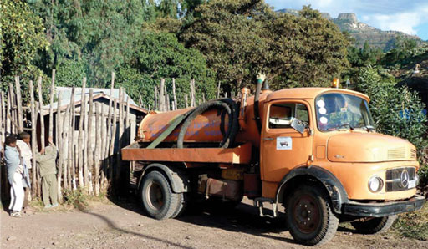
Figure 6.5 Streets in urban areas need to be wide enough to allow access for sludge tankers.
Urban plans also need to consider solid waste management. All sorts of wastes are indiscriminately discarded in towns and cities from homes, businesses and industry. Establishing systems to collect and manage the waste is a significant challenge, but urban planners can contribute by ensuring that the streets they design are wide enough to accommodate collection vehicles and that sites are identified for waste handling and disposal.

6.3.3 Drainage systems
Minimising the risk of flooding by designing effective drainage systems is another important aspect of urban plans. This is partly a matter of designing and building drains that are large enough to cope with high volumes of water. Rainwater from roofs can be collected and put to good use rather than just allowed to run into the drains. There are also ways of reducing the area of impermeable hard-surfacing so that more water can infiltrate into the ground and the speed and volume of surface run-off is reduced. These sustainable drainage systems (SuDS) include a range of techniques such as using gravel or cobblestones, which are permeable, rather than solid concrete, leaving grass or bare earth areas where possible so that water can infiltrate into the ground, and building ponds or water-holding areas into the drainage system so that rainwater is temporarily contained and the speed of flow is reduced.

6.3.4 Green spaces
Parks and other green spaces are important components of the urban environment for several reasons. Firstly, they are pleasant and enjoyable places to visit, offering a peaceful respite from busy city life (Figure 6.6). They provide areas of natural ground which absorb run-off and assist in the problems of surface water drainage. They also have a measurable cooling effect and can reduce the impact of the urban heat island. Feyisa et al. (2014) studied parks in Addis Ababa and found that the temperature inside the parks was as much as 6.7 ºC cooler than in the surrounding city.
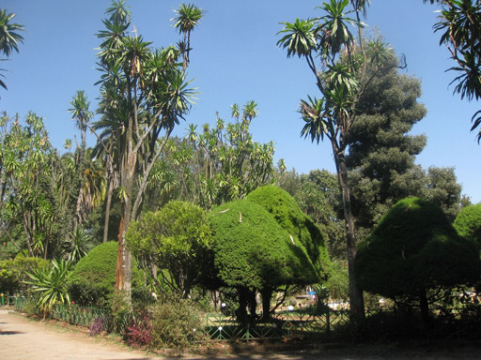
Figure 6.6 Parks are an important part of the urban environment.

6.4 Urban planning in Ethiopia
In the past the development of urban areas has received less attention than the rural and agricultural sector in Ethiopia (Ayenew, 2008). In combination with the significant challenges of urban poverty, this has allowed unplanned urban development and the growth of slum areas with undeveloped services and the associated social, health and environmental problems. In response to these challenges the government devised a National Urban Development Policy.

6.4.1 National Urban Development Policy
The National Urban Development Policy was approved in 2005 (Ayenew, 2008). It has two main packages: the Urban Development Package and the Urban Good Governance Package. The Urban Development Package set out the answer to the question ‘what’ was the government going to do to deliver urban-based public services of ‘jobs, houses, roads, schools, clinics, water supply etc.’? (MWUD, 2007). The Urban Good Governance Package set out how they would deliver these and other services with ‘efficiency, effectiveness, accountability, transparency, participation, sustainability, the rule of law, equity, democratic government and security’ (ibid).
The Urban Development Package includes five programmes, one of which is the Integrated Housing Development Programme.

6.4.2 Integrated Housing Development Programme
The Integrated Housing Development Programme (IHDP) is a government-led programme to provide new, affordable housing for low- and middle-income people. The programme began in 2005 and has been implemented in 56 towns across the country to date, but the greatest impact has been seen in Addis Ababa, where new condominium blocks are springing up all over the city (Cities Alliance, 2012) (Figure 6.7). Outside the capital the programme has since been suspended, partly because the multi-storey condominiums were unpopular and considered ‘an eyesore’ in smaller, low-rise towns (UN-Habitat, 2011).
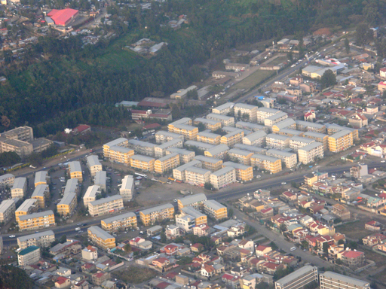
Figure 6.7 Condominium blocks in Addis Ababa.
The IHDP aimed to construct 360,000 new housing units in condominium blocks, to be built at low cost, plus 9000 commercial units, with the creation of 200,000 jobs and promotion of 10,000 small enterprises in the construction industry (UN-Habitat, 2011).
The standard design of IHDP condominium has five storeys, with a mixture of studios and 1-, 2- and 3-bedroom apartments. Each unit has a bathroom with shower, flush toilet, and basin, and a separate kitchen. The units are sold, not rented, and are transferred to owners by a computer-based lottery system. Owners have to pay a down payment. For studios and 1-bedroom units this is 10% of the price, for 2-bedroom units it is 20%, and for 3-bedroom units 40%. The remainder is paid by monthly mortgage payments with interest. Thirty per cent of units are allocated to women.
By 2011, 171,000 units had been built (UN-Habitat, 2011). The programme has been very popular and demand has exceeded supply from the outset. Its main achievements are a dramatic increase in the number of homeowners and an improvement in the living conditions of many thousands of people. In addition, the programme has created 176,000 jobs, mainly for mineral extraction and construction workers (Cities Alliance, 2012).
Despite these successes, a number of problems have arisen. Electricity and water companies have been slow to provide essential services because they lack the resources to meet the new demands. Approximately 50% of condominium sites are behind schedule because of delays with the infrastructure. The absence of a sewerage network is an obvious problem (only 3% of Addis Ababa is sewered) (UN-Habitat, 2011). Solid waste management is a more positive story, however, with opportunities for small enterprises to set up and organise door-to-door collection services.
The initial designs for the condominium sites included green spaces, but this idea was dropped when the housing density had to be increased. The sites had allocated spaces for commercial use, such as shops, food and drink outlets. There were also plans for communal buildings for social activities, but where these were built, the continuing management has been problematic. On other sites the communal buildings were not built, in order to reduce costs.
Affordability is a major issue. The costs put the units beyond the reach of many people on low incomes. Many people who have managed to make the initial down payment find that the monthly payments are too much, so they rent out all or part of the unit to other people. This has the unforeseen benefit of increasing the supply of rental housing in the city, but if people decide to share their unit this can result in overcrowded conditions. The higher down payment for the larger units can also cause overcrowding because families opt for a smaller unit than they need to reduce the initial cost.
Most building so far has been on the edges of Addis Ababa in areas with little or no employment opportunities. This forces people to travel into the city for work, which is costly for them and adds to the pressures on the transport system. There has also been criticism of the construction quality and the design of some of the blocks. The ongoing management of the sites, especially the shared areas, is also essential for the long-term sustainability of the programme (UN-Habitat, 2011).
- What aspects of the IHDP’s condominium sites do and do not correspond to UN-Habitat’s principles for sustainable neighbourhood planning (Box 6.1)?
- The condominium sites have wide streets and some space between the blocks but they are also compact and have a high density of people. There is some mixed land use, with units allocated for commercial purposes, but the location on the edges of the city means there are limited sources of employment. The sites are predominantly for the single function of housing. The condominiums are designed for low- and middle-income families, so there is little social mixing.

Summary of Study Session 6
In Study Session 6, you have learned that:
- Urban development causes a change in land cover with decrease in permeable surfaces and increase in hard, impermeable surfaces. The loss of agricultural land adds pressure on the food production system.
- This change in land cover reduces infiltration of rainwater into the ground, increases the rate and volume of surface run-off and may lead to flooding and soil erosion. It may also lead to raised temperatures in cities.
- Urban planning aims to avoid the problems of unplanned development, to design towns and cities that meet the needs of the people who live in them, and to provide a healthy environment.
- Urban planning has complex requirements which include consideration of housing quality and affordability; infrastructure for water, sanitation and waste management; effective drainage systems; and green spaces.
- In Ethiopia, many new condominiums have recently been built according to the Integrated Housing Development Programme’s plans for new housing for low- and middle-income households.

Self-Assessment Questions (SAQs) for Study Session 6
Now that you have completed this study session, you can assess how well you have achieved its Learning Outcomes by answering these questions. You can check your answers with the Notes on the Self-Assessment Questions at the end of this Module.

SAQ 6.1(tests Learning Outcomes 6.1 and 6.2)
You have come across the following terms in this study session when you have been reading about land use and the physical environment. Beside each term write a definition and then list the parts of the physical environment involved: atmosphere, water, or land.
Term | Definition | Part(s) of physical environment
Urban heat island
Land use
Deforestation
Impermeable surfaces
Land cover

SAQ 6.2 (tests Learning Outcomes 6.1 and 6.3)
What is the aim of urban planning? List three problems of unplanned urban development that can be solved by urban planning.

SAQ 6.3 (tests Learning Outcome 6.1)
What is zoning and why is it no longer considered a good idea in urban planning?

SAQ 6.4 (tests Learning Outcome 6.4)
The three pillars of sustainability are economics, society and environment. For each pillar, give an example to show how urban planning can contribute to sustainable urban living.

SAQ 6.5 (tests Learning Outcome 6.5)
Imagine that you are an urban WASH worker and have been asked to summarise in a short written report the achievements and challenges of the Integrated Housing Development Programme (IHDP) for people who have never heard of it before. In your report you should include a description of the IHDP, a list of its achievements and a warning about the challenges faced in its implementation.

Study Session 7 Pollution: Types, Sources and Characteristics

Introduction
You were introduced to wastes and pollutants in Study Session 1, where we discussed the interactions between humans and our environment. Pollution was defined as the introduction into the environment of substances liable to cause harm to humans and other living organisms. Many human activities pollute our environment, adversely affecting the water we drink, the air we breathe, and the soil in which we grow food.
In this and the next study session we will look more closely at pollution. In this session you will learn about the different types and sources of pollution and the various human activities that can cause pollution. We will also describe the ways pollution can affect different sectors of the environment: water, air and soil. Study Session 8 describes some of the significant effects of pollution on the environment and on human health. It also discusses options for preventing and controlling pollution.

Learning Outcomes for Study Session 7
When you have studied this session, you should be able to:
7.1 Define and use correctly all of the key words printed in bold. (SAQs 7.1, 7.2, 7.3 and 7.4)
7.2 Describe the main types of pollution. (SAQ 7.3)
7.3 Describe the sources of pollution and the way pollutants reach the environment. (SAQ 7.4)
7.4 Describe the main characteristics of water, air and soil pollution. (SAQ 7.5)

7.1 What is pollution?
If you hold up a glass of water in front of you, how can you tell if it’s polluted? You would expect drinking water to be colourless, odourless and transparent (not turbid with suspended particulates). If it was not all of these things, then it could be polluted. If you were looking at water in a river, it is unlikely to be as clear as drinking water in a glass, but you could deduce it was probably not polluted if you observed that the water did not look dirty or smell bad. You might also observe that animals were drinking the water without ill effects and fish were swimming in it. However, if the water was discoloured or had an unpleasant odour, or you could see dead fish floating on the surface you could conclude that pollution was the problem.
Let us consider the human activity that could have caused the pollution. Imagine a river that flows through an area of land on the edges of a town. The water is used by the community for drinking and other domestic uses and also for vegetable farming. Several residents use this water to irrigate small areas of land where they cultivate vegetables and many of the farmers use fertiliser and pesticide to improve productivity (Figure 7.1). Fertilisers are made of chemicals such as nitrogen, potassium and phosphorus, which are essential plant nutrients. Pesticides are chemicals that destroy pests but can be harmful to other forms of life – including humans.
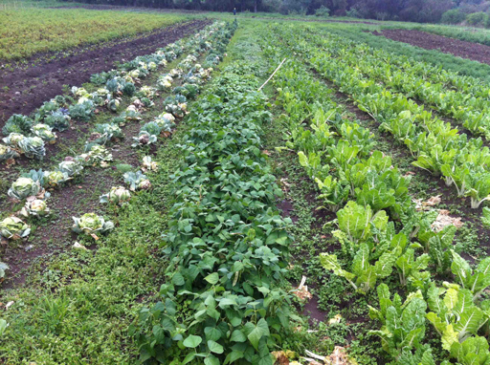
Figure 7.1 Farmers use fertilisers and pesticides on their vegetable crops to improve productivity.
Imagine that one farmer has finished spreading the chemicals on his crop and decides to wash the empty pesticide sack he has been using in the river. Later that day, it rains heavily and rainwater is seen running off the field into the river. What do you think happens? The river is receiving run-off containing fertiliser and pesticide chemicals that had been applied to the crops, which is made worse by the farmer washing his sack that had contained the pesticide. This could harm fish and other organisms living in the water – possibly killing them. The river is also used by the community so the chemicals could get into drinking water that is consumed by humans. The river has been polluted by the careless action of the farmer washing his sack and by the action of rainwater washing the chemicals into the river.
Pollution always has a source and a recipient. The source is where the pollution comes from, that is, where the pollution is released into the environment. The recipient is where the pollution ends up, which may be a part of the environment or people or animals that become contaminated or damaged.
- In the above example about the farmer washing the pesticide sack in the river, what is the source and what is the recipient of the pollution?
- The pollution source is the activity of urban farming with pesticides and fertilisers and washing sacks so that pollutants get into the river. In this example, the primary recipient is the water body that receives the pollutants. Other recipients are the people who drink the contaminated water and animals such as fish that also are affected.
There are a number of ways of identifying pollution. These include finding symptoms of damage to aquatic plants and animals (such as dead fish), finding chemicals in the water, comparing the previous history of the quality of water with the present quality, and getting complaints from water users. Even when a problem has been found, investigations to identify the source may take time. For example, water samples from several different points upstream and downstream will need to be analysed to locate precisely where the problem originated.
There are several different ways of classifying pollutants. They can be categorised by their physical nature, by their source, by the recipient or by the sector of the environment affected. In the following sections we will look at each of these classification groups.

7.2 Physical nature of the pollutant
Pollutants may be in the form of gas, liquid, solid or energy.
- What polluting gases can you think of?
- Greenhouse gases are pollutants that contribute to human-induced climate change (mentioned in Study Session 1). The main greenhouse gases are carbon dioxide, methane and nitrogen oxides.
Liquid pollutants usually come from liquid waste. Liquid waste includes human excreta (both faeces and urine), industrial wastewaters and other forms of waste from water-using activities (Figure 7.2). Factories generate liquid waste from activities related to washing in the manufacturing process, cleaning objects and chemical mixing. Sewage is a mixture of human excreta from water-flushed toilets and other wastewater from houses and businesses. Sewage and human waste from overflowing septic tanks and latrines are frequent sources of pollution.
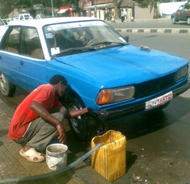
Figure 7.2 Car washing produces contaminated water containing engine oil and fuel, which may flow into rivers and lakes.
Urban run-off is another type of liquid waste that can cause pollution. Rainwater washes many different types of waste from the land surface into lakes and rivers. Urban run-off can contain a lot of organic matter. This may come from open defecation or inappropriate handling of organic wastes produced from households and businesses. Organic matter includes anything that is derived from living organisms, such as human and animal wastes, decaying plants and food wastes.
Pollutants also come in solid form. Plastic bags are one of the most common solid wastes. Solid waste is any solid material that is assumed not to be useful and is therefore thrown away. Factories, businesses and households produce different kinds of solid waste such as paper, plastics, metals, chemicals in solid form, pieces of cloth or food and animal remains (Figure 7.3). Sometimes you may have observed faecal matter discarded with solid waste, which adds to the problems.
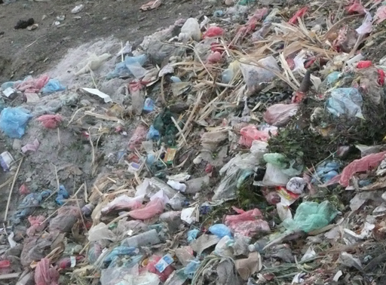
Figure 7.3 Solid waste is an unsightly problem in many towns.
There is a fourth type of pollution that is common in urban communities. This is energy in the form of noise pollution. Noise pollution means unacceptable levels of noise in work, residential and recreational places. Noise makes it difficult to have a conversation and also irritates and disturbs us and in the long term can damage our hearing. Loud music from music shops and clubs in an urban community is a known source of noise disturbance. Such noise may please some, but it disturbs many other people because it interferes with communication in the daytime and sleeping at night.

7.3 Sources of pollution
Another way of classifying pollution is by the sector of human activity that produces it. Before we look at the various sectors, there is an important distinction to be made about pollution sources. Sources of pollution can be categorised as point or non-point sources. Point sources are identifiable points or places that you can easily locate. An example is a diesel truck that produces visible black exhaust fumes from its tailpipe. Liquid waste released from a pipe into a river is another example (Figure 7.4). A non-point source (also known as ‘diffuse pollution’) is one where it is difficult to identify the exact origin of the pollution. A good example is floodwater that washes all types of waste from the land (possibly including faecal matter) into a river. In this situation you cannot identify the individual or household or establishment that has caused the water pollution (Figure 7.5).
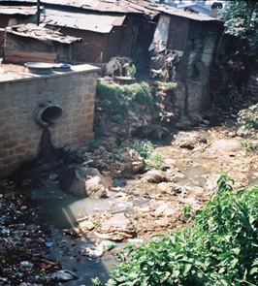 | 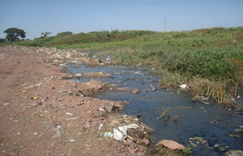
Figure 7.4 Point source: liquid waste entering a small stream. | Figure 7.5 Non-point source: solid waste and faecal matter are distributed all along the banks of the river so no single source can be identified.
- Can you think of examples of point and non-point source pollution from earlier in this study session?
- The farmer washing his sack is an example of a point source because you could identify where he washed his sack. However, the pesticide washing from the field is an example of a non-point source. The pollutant would wash into the river at several places, and could possibly also have come from other fields. This is an example of how difficult it can sometimes be to accurately identify the source.

7.3.1 Domestic sources
Domestic sources of pollution include toilets, latrines and wastewater from kitchens and bathrooms. If these wastes are properly contained and prevented from getting into the environment, they will not cause pollution. However, frequently this is not the case. Open defecation obviously releases human waste into the environment, which can then be washed into rivers and other surface waters.
- What types of organic waste are produced by a typical household?
- The organic wastes from domestic sources include human excreta and also food waste and other kitchen waste such as cooking oil residues.
Solid wastes from households and also from shops, markets and businesses include food waste, packaging materials and other forms of rubbish. Domestic sources are also responsible for gaseous pollutants in the form of smoke and carbon dioxide from domestic fires.

7.3.2 Industry
Pollution from the industrial sector in Ethiopia has been on the rise, posing a serious problem to the environment. Many industrial processes produce polluting waste substances that are discharged to the environment, frequently through chimneys (to the air) or through pipes (to surface water) (Figure 7.6). Among the most polluting industries are food processing, tanneries and textiles with processing plants and factories that produce liquid effluents which are discharged into rivers, often without treatment (Ademe and Alemayehu, 2014; Wosnie and Wondie, 2014). In practice, rivers frequently receive polluting discharges from many different sources all at the same time. The Little Akaki River in Addis Ababa, for example, is polluted by several different industrial sources as well as by domestic wastes (Tegegn, 2012).
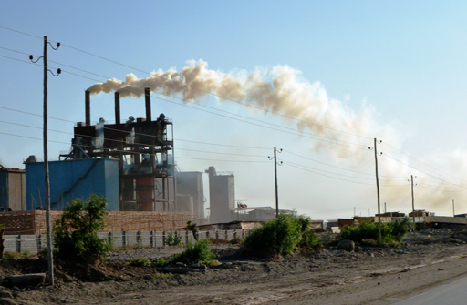
Figure 7.6 Air pollution from an industrial source.

7.3.3 Agriculture
Like industry, agricultural activities are also increasing in Ethiopia, and changing too. Nowadays, agricultural activities in Ethiopia use more pesticides and fertilisers. Ethiopia imports over 3000 tons of various types of pesticides annually (Federal Environment Protection Authority, 2004). Fertiliser use in Ethiopia has increased from 140,000 metric tons in the early 1990s to around 650,000 metric tons in 2012 (Rashid et al., 2013). Fertiliser contains phosphate and nitrate and if these reach water bodies they can cause excessive plant growth (Figure 7.7).
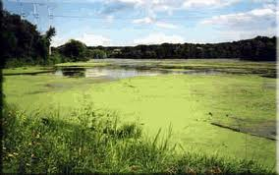
Figure 7.7 Plant fertilisers can encourage excessive growth of vegetation if they are washed into lakes and other water bodies.
Agriculture is also responsible for gaseous pollutants in the form of methane produced by livestock and solid pollutants from crop residues, packaging materials and other wastes similar to those produced domestically. Animals also contribute to waste products and potential pollutants with their excrement.

7.3.4 Transport
Do you live in a city or have you visited a city close to where you live? If so you will no doubt be familiar with the variety of vehicles on our roads (Figure 7.8). Some are small cars, others are heavy motor trucks. These vehicles differ not only in their size, but also by using different types of fuel such as petrol, diesel, and blended fuel (10% ethanol and petrol). If you observe the tailpipe of diesel engine vehicles, you will have seen the black exhaust gas produced. The intensity of the black colour is greater for poorly maintained vehicles, to the extent sometimes that it makes the air hazy or smoky and causes coughs and eye irritation. The lack of a policy to remove old vehicles from the roads adds to the problem. Tiwari (2012) found that nearly a third of vehicles in Addis Ababa were over 30 years old, resulting in high levels of tailpipe emissions. Traffic jams, common in all big cities, make the problems worse.
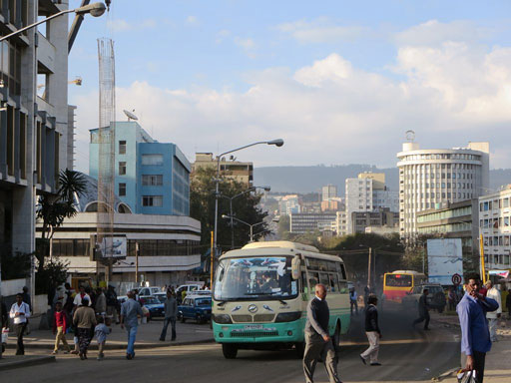
Figure 7.8 Pollution from exhaust is worse if vehicles are poorly maintained.

7.4 Pathways of pollution
We said earlier that pollution always has a source and a recipient. The pathway of pollution is the way the pollutant moves from the source, enters into the environment, and finally how it reaches the human body or other recipient. The pathway between source and recipient can take several different forms depending on the type of pollutant. Primary recipients for pollution are water, air, and soil. Pollutants usually reach humans through the consumption of contaminated and polluted water and food, and breathing polluted air.
Once released into the environment, the worst effects of many pollutants are reduced by one or more of the following processes:
- Dispersion – smoke disperses into the air and is no longer noticeable away from the source.
- Dilution – soluble pollutants are diluted in the water of a river or lake.
- Deposition – some suspended solids carried in a river settle (are deposited) on the river bed.
- Degradation – some substances break down (degrade) by natural processes into different, simpler substances that are not polluting.
In each case the effect is to reduce the concentration of the pollutant. Concentration is a measure of the amount of the substance in a known volume of water or air. The units used for water pollutants are usually milligrams per litre (mg/l, also written as mg l⁻¹), although sometimes you may see ppm which stands for ‘parts per million’.
These processes do not apply to all pollutants. There are some persistent pollutants which remain intact when released into the environment because they do not break down by natural processes. These are described in Study Session 8.

7.5 Sector of the environment affected by pollution
Classifying pollution by the sector of the environment affected – water, air, soil and land – is probably the most commonly used method.

7.5.1 Water pollution
Water pollution can affect surface water such as rivers and lakes, soil moisture and groundwater in aquifers, and the oceans. As you know from Study Session 4, the actions of the water cycle connect all these different reservoirs of water. For example, a polluted river will discharge into the ocean and could damage the marine environment. However, the volume of water in the ocean can disperse and dilute the pollutant so that its worst effects are only felt near the mouth of the river.
Water pollution is characterised by the presence of excess physical, chemical or biological substances that change the qualities of the water and are capable of causing harm to living organisms. We mentioned earlier that natural or unpolluted water is colourless, odourless and transparent. Water that tastes or smells bad or is cloudy can be said to have the symptoms of water pollution. However, some water pollutants cannot be seen or tasted, for example some chemicals, such as pesticides, and most of the micro-organisms that cause waterborne diseases. So, water pollution involves more than just the appearance of the water. Polluted water should not be used for drinking, washing, bathing or agriculture. If polluted water is used by humans, then it can adversely affect the body in different ways, depending on the type and concentration of pollutant.
You also read in Study Session 4 that most rivers and streams in Ethiopia contain significant quantities of suspended solids that are carried along in the flow and make the water look brown in colour, especially in the rainy season (Figure 7.9). Most of the solids are fine particles of soil that have been washed into the river from surrounding land by rain, often following cultivation or construction work. Large quantities of solids in the water can reduce light penetration into the water which can affect the growth of plants.
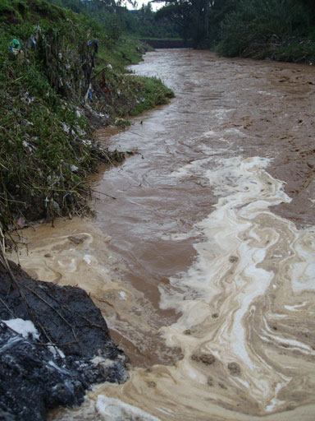
Figure 7.9 Akaki River: suspended solids carried in the flow make the water look brown.
Biological water pollutants are micro-organisms that are harmful to humans and other forms of life. They are responsible for many different waterborne diseases. The original source of these pollutants is people or animals already infected with the micro-organisms concerned. If faeces from infected people are not correctly contained and treated, the pollutants can get into surface and groundwater. The main groups of biological pollutants are bacteria, viruses, protozoa and helminths (worms).
Chemical water pollutants take many different forms depending on their source. They include plant nutrients (compounds of phosphorus and nitrogen) used as fertilisers which, as you read earlier, can be washed from fields into rivers. These nutrients are also produced by the breakdown of human and animal wastes and are common pollutants of surface waters.
Chemical pollutants also include heavy metals, pesticides and other persistent pollutants. Heavy metals are a group of toxic chemical pollutants that contain compounds of persistent metals such as mercury, cadmium, lead and chromium. The presence of heavy metals in water in excess of acceptable levels can cause illness and death among animals and humans if consumed through drinking and food (Zinabu and Pearce, 2003).
Persistent organic pollutants (POPs) are also toxic to humans and wildlife. They include many different synthetic organic chemicals manufactured for use as pesticides and in industrial processes, e.g. DDT, aldrin and PCBs (polychlorinated biphenyls). Many of these persistent chemicals have been banned in some countries. Their persistence in the environment creates specific problems that are described in Study Session 8.

7.5.2 Air pollution
Air pollution can exist at all scales, from local to global, and can include gases and solid particles. It can affect you in your own home, or in your town or city, and can contribute to global atmospheric changes. The most common sources of air pollution in the urban centres of Ethiopia include the burning of wood, charcoal and other biomass fuel by households, small businesses such as bakeries, manufacturing industries, and vehicles.
Air pollution is defined as the presence in the air of abnormal amounts of chemical constituents capable of causing harm to living organisms. Clean air consists of nitrogen (78% by volume), oxygen (21%) and trace gases (< 1%). Polluted air may contain particulate matter (such as black soot) and many different gaseous chemicals such as carbon monoxide, carbon dioxide, nitrogen oxides, sulphur oxides, ozone, nitrates, sulphates, organic hydrocarbons and many others. Many of these are also found in clean air as trace gases but they become pollutants if present in abnormal quantities.
The emission of black smoke is an indication of intense pollution. However, not all air pollution is visible or can be smelled. Gases such as carbon monoxide and carbon dioxide are invisible and odourless. Carbon monoxide is very dangerous to humans. It can be produced by inefficient burning of fuel (for example a charcoal stove in a home with inadequate air supply) and if breathed in large quantities it can be deadly. Carbon dioxide is an important pollutant that is involved in climate change. (You will learn about in climate change in Study Sessions 9, 10 and 11.)

7.5.3 Soil and land pollution
Soil pollution, also called land pollution, is linked to water pollution. Liquid wastes containing toxic chemicals or pathogenic micro-organisms on the surface of the land can seep slowly into the soil and may percolate down to contaminate groundwater, which can affect people using springs or wells in the area. Possible sources include open defecation, pit latrines or leaking storage containers for industrial chemicals and wastes.
Solid waste can cause soil pollution. A collection of solid wastes in one place or scattered around is unsightly and might smell bad to you as you pass by (Figure 7.10). Household waste typically consists mostly of food waste that will gradually decompose. This produces a bad odour and attracts insects and rats, both of which contribute to the transmission of disease. As the waste decomposes it produces a liquid called leachate which trickles down into the soil. Leachate is a highly concentrated liquid pollutant that may contain toxic chemicals and pathogenic micro-organisms as well as high levels of organic compounds. Rainwater falling on, and washing through, solid waste adds to the problem.
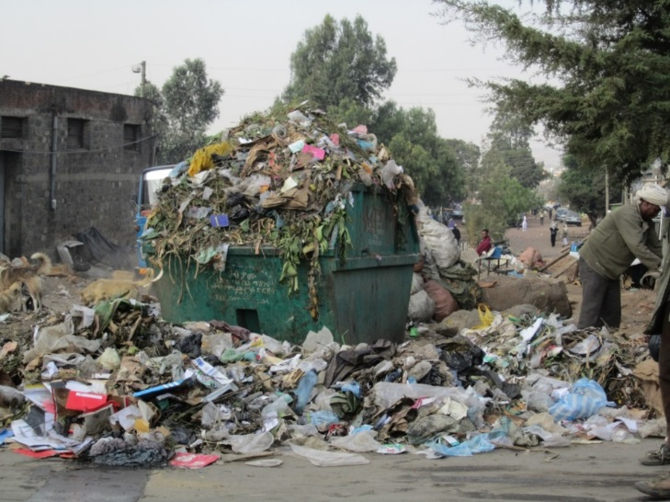
Figure 7.10 Urban solid waste contains a mixture of many different types of waste and can pollute soil and water if it is not contained and managed correctly.

Summary of Session 7
In Study Session 7, you have learned that:
- Environmental pollution is the result of human activity and development that occurs when physical, biological and chemical agents are released to the environment in such quantities that the pollution adversely affects human health and damages the environment.
- Pollution can be classified by its physical nature, by its source, by its recipient, by the sector affected or by its effects.
- Pollution may be in the form of a gas, liquid, solid or energy.
- Sources of pollution may be point sources, which are easily identified, or non-point sources, where the pollution comes from diffuse sources that are not easy to pinpoint.
- There are different types of pollution: water pollution, air pollution, solid waste pollution and noise pollution. All of these can be found in urban areas.
- The main sources of pollution are household activities, factories, agriculture and transport.
- Once they have been released into the environment, the concentration of some pollutants is reduced by dispersion, dilution, deposition or degradation.
- Water can be contaminated by physical pollutants (solid material), biological pollutants (such as bacteria that cause waterborne diseases), and many different chemical pollutants.
- Air pollution can be caused by gases or solid particulates.
- Soil pollution is linked to groundwater pollution. Solid waste can produce highly polluting leachate which contaminates soil groundwater.

Self-Assessment Questions (SAQs) for Study Session 7
Now that you have completed this study session, you can assess how well you have achieved its Learning Outcomes by answering these questions. You can check your answers with the Notes on the Self-Assessment Questions at the end of this Module.

SAQ 7.1 (tests Learning Outcome 7.1)
Why is a point source of pollution easier to identify than a non-point source of pollution?

SAQ 7.2 (tests Learning Outcome 7.1)
Rewrite the sentences below using terms from the list provided to fill the gaps:
concentration, heavy metals, organic matter, persistent pollutant, sewage.
……………… consists of human excreta and wastewater. It has a high ……………… of ………………
Some pollutants, called ………………, do not break down naturally in the environment. Examples are mercury, cadmium and other ………………

SAQ 7.3 (tests Learning Outcomes 7.1 and 7.2)
Describe what is meant by the terms liquid waste and solid waste, using examples from your own experience to illustrate your answer.

SAQ 7.4 (tests Learning Outcomes 7.1 and 7.3)
For the scenarios (a) to (d), fill in the table below to show the pollutant, the source of pollution, the possible pathways and the recipients:
- A farmer washes an empty pesticide sack in a river; the river flows into a lake which is used for drinking water by people from a local town.
- Rain falls on a waste dump used to collect household waste; the waste dump isn’t properly sealed and liquid percolates down into the soil and into groundwater that is extracted from a nearby well for domestic use.
- A tannery based in a town produces liquid waste that contains organic matter and chemicals used in the tanning process; this effluent is discharged into the local river which flows out of the town and through a nature park.
- A bus driving through a busy town emits black smoke from its tailpipe.
 | Pollutant | Source | Pathway | Recipient
(a)

(b)

(c)

(d)

SAQ 7.5 (tests Learning Outcome 7.4)
Describe how water pollution can change the characteristics of water.

Study Session 8 Pollution: Effects, Prevention and Control

Introduction
Study Session 7 introduced you to some of the main sources and types of pollution. In this study session you will learn about the effects of pollution on the environment and on human health. You will find out how some pollutants can lead to unexpected problems because of the way they behave and their persistence in the environment. You will also learn about the different ways that people are exposed to pollution. Finally we consider some important principles that underpin the prevention and control of pollution.

Learning Outcomes for Study Session 8
When you have studied this session, you should be able to:
8.1 Define and use correctly all of the key words printed in bold. (SAQs 8.1, 8.2, 8.4 and 8.5)
8.2 Describe the effects of water pollution on aquatic ecosystems. (SAQ 8.2)
8.3 Describe the effects of air pollution on the environment and on human health. (SAQ 8.3)
8.4 Describe the effects of water pollution on human health. (SAQ 8.4)
8.5 Describe some key principles that support pollution prevention and control. (SAQ 8.5)

8.1 Effects of water pollution on the environment
This study session begins by describing the effect of water pollution on surface water ecosystems, such as lakes, rivers and streams. Pollution from human activities enters surface waters, either directly when wastes are dumped into lakes and rivers, or indirectly when wastes released on land or into the air are washed into surface waters.
An ecosystem was defined in Study Session 1 as ‘all living organisms and their physical environment and the interactions between them’. Pollution can disturb and unbalance those interactions in a number of ways.

8.1.1 Effects of organic pollution
You will remember from Study Session 7 that organic matter is any material derived from living organisms. Organic pollution is any contamination of water by organic matter. Examples include human and animal wastes and urban run-off.
Many aquatic (water-living) organisms depend on oxygen dissolved in the water to survive. Aquatic animals include fish, amphibians (e.g. frogs, toads) and many invertebrate species such as insect larvae, snails and worms. Their supply of oxygen in the water is maintained from atmospheric oxygen in the air above the water and from oxygen produced by green aquatic plants in the process of photosynthesis. Fast-flowing, turbulent water will be aerated (gain oxygen) more than still water because the boundary between air and water is more active.
If organic pollutants such as human and animal wastes are released into a water body, bacteria will use the waste as food. Bacteria break down the complex organic chemicals (proteins, fats, carbohydrates) into simpler chemicals that are further oxidised into nitrates, sulphates and carbonates. This process, known as biodegradation, provides energy to the bacteria and uses dissolved oxygen from the water.
If the quantity of organic matter is small and there is plenty of dissolved oxygen, then this natural breakdown process will remove the pollution quite quickly. However, if there are high levels of organic pollution, the population of bacteria increases and may use up all the oxygen from the water. This is called deoxygenation. Complete deoxygenation is unlikely in a river where the water is moving, but it can happen in lakes or slow-flowing channels. Anaerobic (without oxygen) conditions are unsightly and cause unpleasant odours. Fish and other aquatic organisms that need oxygen to survive will eventually die if they cannot migrate elsewhere (Figure 8.1). The reduction in fish populations and other aquatic animals not only disrupts the ecosystem but also results in a loss of food for local people and loss of jobs for local fishermen.
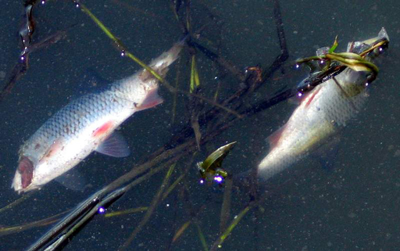
Figure 8.1 Dying fish due to oxygen starvation.

8.1.2 Effects of excess nutrients on the environment
Phosphorus and nitrogen are common pollutants generated from residential areas and agricultural run-off. They are usually associated with human and animal wastes and/or fertiliser. Nitrogen and phosphorus are plant nutrients that plants need in order to grow. If there are large quantities of nutrients, they can encourage excess plant growth in the water. This can cause the phenomenon known as an algal bloom, which means a sudden increase in the population of microscopic algae. If a water body has high nutrient levels it is said to be eutrophic; the process is called eutrophication. Eutrophication is a common phenomenon in Ethiopia and has been observed in Lake Alemaya, Lake Boye, Lake Aba Samuel and Lake Koka (Figure 8.2).
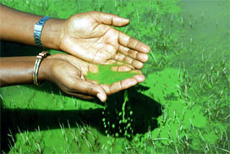
Figure 8.2 Eutrophication in Lake Koka, Oromia Region.
The density of microscopic green algae, as shown in Figure 8.2, blocks sunlight from penetrating the water causing larger plants under the surface to die and decompose. The main problem of eutrophication is that the sudden algal bloom can die off equally quickly. The decay of the algae by bacteria can cause deoxygenation of the water.
Water that contains large amounts of nitrates is unpleasant to drink and can be toxic to humans and animals. Also, some species of cyanobacteria (also known as blue-green algae) that flourish under these conditions produce toxins that cause liver, nerve and skin problems in humans and animals. Toxic levels of cyanobacteria have been found in several Ethiopian lakes (Mankiewicz-Boczek et al., 2015; Willén et al., 2011).
Eutrophication also encourages the growth of larger plants, such as the floating and invasive water hyacinth (Eichhornia crassipes) which can cover large areas of lakes (Figure 8.3). When these plants die, they add to the problems of deoxygenation caused by decaying organic material.
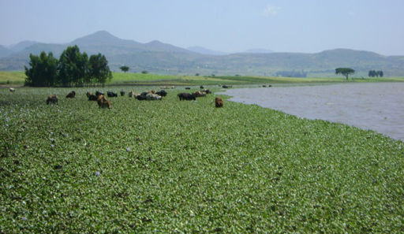
Figure 8.3 Water hyacinth: an aquatic weed growing on the surface of Lake Tana.

8.1.3 Effects of persistent pollutants
Persistent pollutants, such as heavy metals and persistent organic pollutants (POPs), were mentioned in Study Session 7.
- Why are persistent pollutants a major environmental problem?
- Persistent pollutants are a major problem because they do not break down by natural degradation processes and therefore remain in the environment for a very long time.
These pollutants may be present at very low concentrations in water but, over time, they build up in the tissues of organisms by a process called bioaccumulation. These chemicals have no known biological function in animals and there is no process to expel them from the body. If the chemicals are ingested or otherwise absorbed from the environment, they remain in the body and gradually accumulate. This is a particular problem for fish and shellfish that feed by filtering plankton from very large volumes of water. If the plankton are contaminated, this will pass into the fish. The pollutants become more and more concentrated and can reach toxic levels.
Figure 8.4 shows how levels of heavy metals, in this case mercury, increase through a food chain. A food chain is the sequence of who eats whom, or what. In Figure 8.4 you can see that the concentration of mercury in water is very low, but increases in the bodies of phytoplankton (small aquatic plants), then in zooplankton (small aquatic animals) as they eat the phytoplankton, and then in the bodies of fish that eat the zooplankton and finally in fish-eating birds. The chemicals can also be passed on to eggs and damage reproduction of the birds. This gradual increase in concentrations through the levels of a food chain is a form of bioaccumulation called biomagnification.
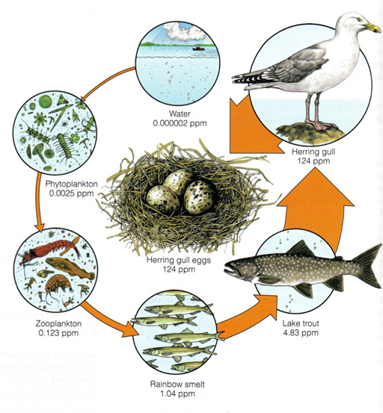
Figure 8.4 Biomagnification of a heavy metal (mercury) in a food chain. The concentration of the heavy metal is expressed as parts per million (ppm) in the environment.
The aquatic food chain extends to terrestrial (land-living) animals and humans. The amount of a pollutant such as mercury can reach a level dangerous enough to cause harm if consumed. Mekuyie (2014) analysed the levels of heavy metals in milk from cows that had drunk water from lagoons that contained wastewater from a textiles factory in Hawassa. The milk contained unsafe levels of heavy metals. The study concluded that this could have toxic effects on people who drank the milk, as well as decreasing livestock productivity and causing damage to the aquatic ecosystem.
Pollutants will continue to bioaccumulate in plants and animals as long as the pollution continues. The Hawassa example demonstrates that some pollutants do not go anywhere, but instead become a part of our life system in the environment.

8.2 Effects of air pollution on the environment
Air pollution is the presence of pollutants in air in quantities that can cause health damage to humans, animals, and plants. When gases such as nitrogen oxides, hydrogen sulphides and sulphur oxides are released into the atmosphere they can dissolve in the water vapour of clouds and fall as rain. The presence of these pollutants acidifies the water and causes acid rain (Figure 8.5).
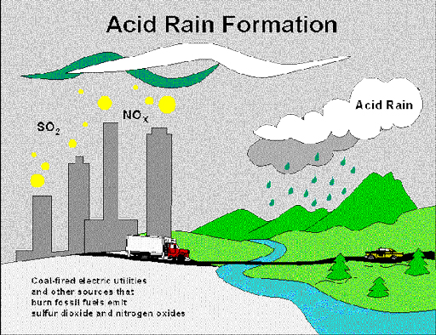
Figure 8.5 Acid rain formation.
Acid rain usually has a pH of less than 5 and is highly corrosive and damaging, especially to buildings and forests (Figure 8.6). (pH is a measure of acidity and alkalinity on a scale from 0 to 14. pH 7 is neutral; less than 7 is acid; more than 7 is alkaline.)
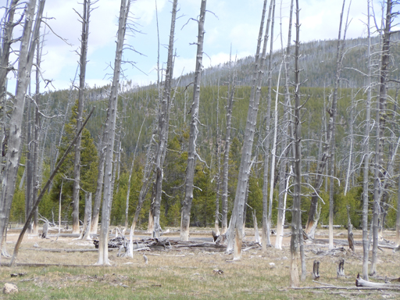
Figure 8.6 Acid rain due to air pollution kills trees and destroys forests.

8.3 Effects of pollution on human health
Most of this section will focus on the effects of water pollution, but we should not forget air pollution. Air pollutants in the form of dust and soot (particulate matter) and gases such as carbon monoxide, sulphur dioxides and nitrogen oxides have serious impacts on health. Intense air pollution causes reduced lung function and diseases of the respiratory system such as asthma and bronchitis. Acute respiratory infections are among the leading causes of attendance at outpatient clinics in health centres and hospitals in Addis Ababa (Tiwari, 2012). The direct causal link is difficult to prove, but air pollution from domestic fires and vehicle emissions is a likely contributory factor. We now turn to the significant impacts on health from water pollution.

8.3.1 Waterborne diseases
- On average, every child in Ethiopia has diarrhoea five times before the age of five. What could be the cause of these illnesses in children? What other factors might have been involved in transmitting these illnesses?
- Ingesting contaminated water and food is the cause of diarrhoea. Poor hand hygiene is also a significant factor in its transmission.
Diarrhoea (frequent loose stools) is a symptom of many waterborne diseases. They are caused by biological pollution from human bodily wastes from infected people. Faecal matter contains pathogenic organisms that cause waterborne diseases, mainly diarrhoeal diseases and parasitic worm infections. Some examples of diarrhoeal and other waterborne diseases and their causes are shown in Table 8.1.
Table 8.1 Examples of waterborne disease.
Group | Disease | Causative agent
Bacteria | typhoid fever | Salmonella
 | cholera | Vibrio cholerae
Viruses | viral gastroenteritis | rotavirus and others
 | poliomyelitis | polio virus
 | viral hepatitis | hepatitis A and E virus
Protozoa | cryptosporidiosis | Cryptosporidium
 | giardiasis | Giardia
Parasitic worms | ascariasis | Ascaris lumbricoides
 | schistosomiasis or bilharzia | Schistosoma

With one exception, all the diseases in Table 8.1 are caused by people ingesting pathogens by drinking or eating contaminated water or food, or they result from poor hand hygiene. This is faecal–oral transmission which means people are infected with disease when pathogens from faeces enter their body through the mouth. The exception is schistosomiasis, which is caused by worms penetrating the skin when people are swimming or washing in water that has been contaminated with excreta from an infected person.

8.3.2 Chronic health effects of water pollution
Humans are susceptible to the chronic health effects of chemical pollutants if they regularly consume contaminated water or food, especially by eating fish that have lived in polluted water. The process of bioaccumulation can lead to toxic levels of pollutants in fish which, when eaten, lead to damaging levels of toxins in humans. We will illustrate this effect using a historical event that took place in Japan.

Case Study 8.1 Minamata Bay, Japan, 1951
Japan was recovering from an economic crisis in the 1940s after being defeated in the Second World War and was expanding its chemical industries. The Chisso Chemical Corporation had been operating in Minamata since 1932, but had introduced a new manufacturing process using inorganic mercury in 1951. The mercury was released into the sea with wastewater at nearby Minamata Bay. The inorganic mercury was biodegraded and changed into organic mercury, a form that was readily absorbed by fish. Biomagnification of the organic mercury took place in the food chain and led to very high concentrations in the bodies of fish and shellfish.
These fish and shellfish were eaten by the local Japanese people as part of their normal diet. Public complaints started in 1956 as serious damage to people’s health started to be seen. People had symptoms indicating damage to the nervous system (Figure 8.7). There was also damage to the sea environment and other animals such as pigs, cats, dogs and birds that ate contaminated fish. Early studies in 1956 made the link to consumption of fish by victims and suggested the cause was heavy metal contamination (Hachiya, 2006). Factory waste from the Chisso Corporation was suspected but it was difficult to prove. The government and the factory denied the pollution was due to mercury discharges for many years and mercury continued to be released into the environment. It was not until 1968 that the government officially recognised that the cause of ‘Minamata disease’ was mercury poisoning. It took 12 years and many protests and lawsuits before the pollution was stopped. By 2001, of the 2955 victims who had been officially certified and paid compensation, many had died (Ministry of Environment, 2002), although many thousands more had been affected (Hachiya, 2006).
Figure 8.7 The crippled hand of a Minamata disease victim (W. Eugene Smith).
(Adapted from Cunningham and Cunningham, 2011)

What can we learn from the Minamata story? Although the source was suspected, it still took 12 years before it was recognised. The government and the company denied responsibility and we may suspect a political and economic motive for their refusal to recognise the problem for more than ten years, despite the evidence. We can also see that pollutants can enter the human body through complex routes. The mercury changed its form after it was released into the bay, making it harder to trace. It was not put straight into human food but entered it by bioaccumulation through the food chain from micro-organisms, through small fish to bigger fish.
Another important point from this example is whether the generator of waste is responsible for the waste that they produce, the pollution that they cause in the environment and for the harm caused by that pollution. In this example, the pollution was traced back to the polluter and compensatory payment was made. However, it took a long time and some think that payment was not adequate for the damage caused.

8.4 Human exposure to pollution
Exposure is the state of being unprotected. It is a set of conditions that allows a pollutant or contaminant to enter the human body. The presence of pollution, the medium that the pollutant is in and the human subject or host that will be affected by the pollutant are the set of conditions used to describe the exposure. In the Minamata example, the source was the Chisso factory, the medium was the water and the subjects were the people who consumed contaminated fish.
There are three main routes by which people are exposed to pollution. These are:
- Ingestion: in the Minamata example people ingested contaminated fish.
- Inhalation: repeatedly breathing in air pollutants can cause respiratory diseases.
- Skin contact (also called dermal exposure): direct contact, usually with the hand, in which chemicals penetrate the skin and enter the circulatory system.
Figure 8.8 indicates the possible exposure routes for pollutants and links from source to recipient.
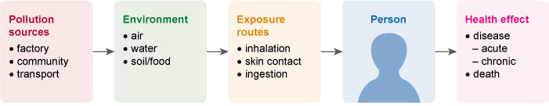
Figure 8.8 Exposure routes of pollutants.

8.5 Preventing and controlling pollution
In this final section we look at some important principles that should be applied when attempting to prevent or control pollution. Pollution prevention means avoiding or minimising the generation of wastes that produce pollutants, thereby restricting their release into the environment. Pollution control focuses on measures taken after wastes have been produced to limit the damage they may cause. It is often more difficult and expensive to control pollution after it has been released into the environment.
- Which do you think is better - pollution prevention or pollution control?
- Pollution prevention is better. It is better to try and prevent pollution from being created in the first place and it is more difficult and expensive to control pollution after it has been created. However, if pollution has been created, it should be controlled.

8.5.1 Prevention
There are many methods for prevention of pollution. For water pollution the main priority is to improve water, sanitation and hygiene (WASH) provision. If everyone has access to effective sanitation (latrines) and there is no open defecation, this will prevent contamination of the environment with human faeces. Combined with this is the need for safe drinking water to be available for all. In addition, improving hygiene behaviour and ensuring that everyone washes their hands will radically reduce the impacts on human health from biological pollutants. In practice there needs to be a coordinated approach to improving all three – water, sanitation and hygiene – which is reflected in current WASH programmes.
Air pollution can be improved by reducing the reliance on biomass fuels for domestic cooking, especially for indoor fires. Legislation to remove very old vehicles from the road or a requirement for regular maintenance and certification would also help.
For pollutants derived from solid wastes, waste optimisation should be adopted. This principle is based on the notion that, ideally, waste should not be produced in the first place. However, this primary target is not always possible and so, if waste is produced, there is a range of options for waste management that form a waste hierarchy from most desirable to least desirable (Figure 8.9).
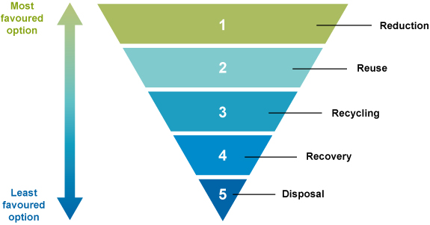
Figure 8.9 The waste hierarchy. Waste management options are listed in order of desirability, from most desirable at the top to least desirable at the bottom.
The waste optimisation principle includes the application of what is known as the ‘3 Rs’ – reduce, reuse and recycle. Reduction refers to the minimisation of waste at source by efficient use of raw materials and changing the technology for producing items. Reuse means using an item more than once, for example, the use of plastic bottles for collecting water. Recycling refers to the use of discarded materials as raw materials that are taken back into the factory process. The use of discarded and broken bottles in a glass factory to make new glass bottles is an example of recycling. The waste hierarchy also includes recovery of materials or energy, for example through composting or incineration. Composting is a good example of recovering materials from waste organic matter that can be then used to improve soil in a constructive way rather than allowing the decomposition process to cause pollution by careless disposal.
The concept of waste optimisation is applied in industries through the process of cleaner production. Cleaner production aims to reduce the impact of industry on the environment through waste minimisation and the application of the 3 Rs, and other processes such as replacement of toxic chemicals with less toxic alternatives, and process and product modification to use less energy.

8.5.2 Principles for pollution control
The following principles are used to help control pollution.

Polluter pays principle
The polluter pays principle says that whoever is responsible for pollution should pay for the damage caused. It is about economic accountability. Any organisation or individual is responsible for handling and taking care of the waste they produce and should be accountable for any damage that it causes. Imagine a factory that produces many types of wastes that potentially damage the air, water and soil. The polluter pays principle encourages the factory to treat the waste before it is released. If any damage to the environment is caused by the factory waste, then the factory is liable to compensate for the loss of life, damage to health and damage to property and the environment.

Precautionary principle
For any activity, there should be an obligation not to cause harm, even if you are not sure of the outcome. For example, if a factory owner wants to discharge wastewater into a river, they should not be allowed to do so if the possible effects of the wastes are not known. The precautionary principle means you do not release any waste into the environment even if you are not certain that damage will result. It means to be cautious rather than take risks about unknown consequences.

Principle of duty of care
Article 44 of The Constitution of Ethiopia provides a guarantee that citizens have the right to live in a clean and healthy environment. But how can this be achieved? All citizens should be actively involved in safeguarding their environment, either by not producing any waste or by properly handling and taking care of their own waste. In other words, each citizen has an obligation or duty to make their environment clean and safe.

8.5.3 Policies and proclamations
In Ethiopia there are several policies, strategies, proclamations and regulations that apply to different aspects of pollution prevention and control. These include the Environmental Policy of Ethiopia (1997) which promotes the use of renewable resources and recycling, and includes specific policies for industrial waste among other environmental sectors. The Prevention of Industrial Pollution Regulation (2008) requires any establishment, institution or factory to obtain a permit to discharge its waste into the nearby environment. The Solid Waste Management Proclamation (2007) sets out the responsibilities of urban administrations to provide solid waste management services. These and other national policies are described in Study Session 15.

Summary of Study Session 8
In Study Session 8, you have learned that:
- Biodegradation of organic matter removes oxygen from the water and can lead to deoxygenation with consequent harm to fish and other aquatic life.
- High nutrient levels in water is called eutrophication. This process causes increasing density of algae and other plants which can reduce penetration of light into the water and cause deoxygenation when the plants die and decay.
- Bioaccumulation is the gradual build-up of chemicals in the bodies of living organisms. Increasing accumulation through the levels of a food chain is called biomagnification. Eating food such as fish containing bioaccumulated chemicals will damage human health.
- Humans are exposed to pollutants by ingestion with water and food, inhalation through breathing and absorption through the skin.
- Pollution prevention means avoiding or minimising the production of wastes before they are released into the environment. Pollution control involves measures to limit the damage caused by pollutants.
- Pollution control is supported by principles such as the polluter pays principle, the precautionary principle and the principle of duty of care, and by relevant legislation and policies.

Self-Assessment Questions (SAQs) for Study Session 8
Now that you have completed this study session, you can assess how well you have achieved its Learning Outcomes by answering the following questions. You can check your answers with the Notes on the Self-Assessment Questions at the end of this Module.

SAQ 8.1 (tests Learning Outcome 8.1)
Define the words biodegradation, bioaccumulation and biomagnification, and explain the difference between them.

SAQ 8.2 (tests Learning Outcomes 8.1 and 8.2)
Nutrients such as nitrogen and phosphorus are useful to farmers who apply them to fields to help increase growth of their crops. Write a paragraph that explains how these same nutrients cause pollution when they are washed off into rivers and lakes. Your answer must include the following words: algal bloom; deoxygenation; eutrophic; fish; organic matter.

SAQ 8.3 (tests Learning Outcome 8.3)
Give three examples of air pollutants, three examples of sources of air pollution and three possible effects of air pollution on human health.

SAQ 8.4 (tests Learning Outcomes 8.1 and 8.4)
- Complete all the gaps in the table below.
Water pollutant | Exposure route | Human health effect
Vibrio cholerae bacteria
 |  | schistosomiasis/bilharzia
organic mercury | ingestion
 |  | ascariasis
- Which of the diseases in your completed table are transmitted by faecal-oral transmission?

SAQ 8.5 (tests Learning Outcomes 8.1 and 8.5)
A junior manager in a manufacturing company is asked to write a report to the Chief Executive with recommendations for reducing the environmental impact of their factory. Rewrite this extract from the report using terms from the list provided to fill the gaps:
cleaner production; pollution prevention; precautionary principle; polluter pays principle; recycling; reduce; reuse; waste hierarchy; waste minimisation.
Our company has a duty to reduce pollution from the wastes produced in our factory. We should adopt policies of ………………, which avoid pollution in the first place. I recommend that we follow the ……………… and do not assume that our wastes will not cause any environmental damage. We should adopt ……………… processes to ensure we reduce our impact on the environment.
For management of the solid wastes produced in our factory we should follow the ……………… This means we should first ……………… the amount of waste produced and identify opportunities for ……………… and ……………… If we successfully adopt these ……………… procedures we will reduce potential pollution from our company. Although some costs may be incurred, this could save money in the long run because under the ……………… we may be liable for costs of any environmental damage that we cause.

Study Session 9 Introduction to Climate Change

Introduction
This is the first of three study sessions on the rapid changes in the world’s climate since the start of the 20th century, which scientists have detected. Climate change is a global problem that is having widespread effects on the weather on every continent and in every nation. It is altering environments and impacting on biodiversity, human health and sustainable economic and social development. We begin this study session by introducing some key terms and concepts in climate science, and describing the main features of current and future projections of how the global climate is changing. You will then learn about the causes of climate change, both naturally occurring and resulting from human activity. Finally we discuss Ethiopia’s climate and some reasons for concern about Ethiopia’s vulnerability to climate change. In Study Sessions 10 and 11 you will focus on Ethiopia in greater detail as we review the frequency and severity of extreme weather events that are due to climate change, and describe the impacts on health, agriculture and the Ethiopian economy.

Learning Outcomes for Study Session 9
When you have studied this session, you should be able to:
9.1 Deﬁne and use correctly each of the key words printed in bold. (SAQs 9.1, 9.2 and 9.3)
9.2 Summarise how the global surface temperature of the land and oceans has changed since the start of the 20th century and describe the effect on sea levels. (SAQ 9.2)
9.3 Describe the naturally occurring and human-generated causes of climate change. (SAQ 9.3)
9.4 Explain how the emission of greenhouse gases into the atmosphere leads to global warming. (SAQ 9.4)
9.5 Identify the observed and predicted changes in climate in Ethiopia. (SAQ 9.5)

9.1 Weather, climate variability and climate change
Everyone is familiar with what is meant by the weather – the temperature, rainfall, wind strength, sunshine, cloud cover, etc. that we experience from hour to hour and from day to day in our local environment. For example, the weather in Addis Ababa on Wednesday 11 March 2015 was light winds (wind speed 10 km/hour), humidity 28%, pleasantly warm (a maximum temperature of 22 °C) and sunny with some clouds.
By contrast, the climate refers to a general description of longer-term features of the weather in a particular location, such as the average temperature or rainfall for each month of the year, calculated over a period of 30 years or more (Pollution Probe, 2004). You can think of the weather as being a daily expression of the fluctuations of climate around the long-term average pattern.
Climates vary widely around the world – from the hot, rainy climates of tropical regions near the equator, to the cold, icy climates near the poles, both of which experience much the same temperature all year round. There are hot, dry deserts and milder ‘temperate’ regions where there is a large difference in temperature between summer and winter. Some regions can have rain in any month, others have a well-defined wet or dry season, and some receive little rain or snow throughout the year.
Although climate is the average weather over a period of a few decades, the climate in a particular country or region isn’t exactly the same every year – it varies around the average climate for that location. You probably remember a year that was hotter or cooler than this year, but the difference was probably not outside the normal range you would expect in your region of Ethiopia. These fluctuations around the average climate are termed climate variability. They are mainly due to fluctuations in natural conditions in the environment such as changes in the patterns of ocean currents or atmospheric pressure (Pollution Probe, 2004).
The global climate has undergone many long-term cyclical variations during millions of years of Earth’s history, owing to shifts in natural environmental factors (described in Section 9.3). But from about the beginning of the 20th century, climate scientists began to detect changes in the global climate over time that were happening at a much faster rate than could be explained by normal climate variability. As the evidence for widespread, rapid changes in the world’s climate increased, scientists began using the term climate change to distinguish these trends from normal climate variation.
A frequently mentioned feature of climate change is global warming – a sustained increase in the Earth’s average surface temperature, which is predicted to continue rising during the 21st century. However, climate change has other important features, including changes in ocean currents, sea surface temperature, wind strength and direction, and the distribution and extent of rainfall. Many scientists from all over the world agree that climate change is a reality (IPCC, 2013). In the next section, we describe what climate scientists have observed; then in Section 9.3 we examine what is causing the climate to change.

9.2 Observed and projected patterns of global climate change
We begin by considering the long-term rising trend referred to as global warming, and then consider the effect of rising surface temperatures on sea levels and patterns of rainfall.

9.2.1 Global land and sea surface temperatures are rising
In the 100 years between 1905 and 2005, the average global surface temperature has increased by 0.74 °C. Most of this increase has occurred since 1950 and the upward trend is continuing (Bates et al., 2008). The first decade of the 21st century was the warmest since humans began recording surface temperature (IPCC, 2013). If present trends continue, the average global surface temperature is projected to increase by between 0.3 °C and 4.8 °C by the end of the 21st century (IPCC, 2013).
The surface temperature of the oceans has also been rising and the increase is expected to accelerate during the 21st century. Figure 9.1 shows global averages for the annual combined land and ocean surface temperature and the average in each decade from 1850 to 2012.
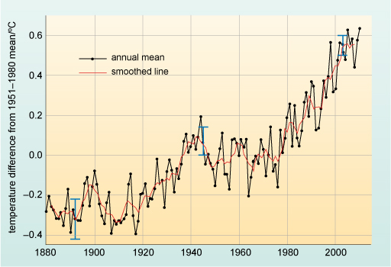
Figure 9.1 The global annual mean atmospheric surface temperature change from 1880 to 2010. 0 ºC on the vertical axis is the mean global atmospheric surface temperature minus the mean global temperature from 1951 to 1980. The black line is the annual mean and the solid red line is a smoothed line through the annual mean. The blue bars show uncertainty estimates.
- Look at the general pattern of surface temperatures shown in Figure 9.1. How would you describe the trend during this period?
- The global surface temperature fluctuated around a relatively stable average from 1880 to about 1920, but after that date it began to rise. Around 1950, the temperature increase seems to have levelled for about 30 years, but it has been increasing rapidly in the decades since 1970.

9.2.2 Effects of rising global temperature on sea levels
Increased global temperature affects the amounts of snow, ice and glaciers that remain frozen. Several reports indicate that the frozen water in the northern hemisphere is melting faster than expected, particularly in the last two decades (IPCC, 2013). As you can see from Figure 9.2, there has been a sharp decrease since about 1960 in the extent of Arctic sea ice during the summer months and in the spring snow cover in the northern hemisphere. About 60–70% of Africa’s glaciers have also been lost since the early 1900s (UNEP, 2012).
(a) | (b)
Figure 9.2 (a) Decrease in Arctic summer sea ice and (b) Northern hemisphere spring snow cover from 1900 to 2010. The coloured lines indicate different original sources of data that have been combined in one graph. (IPCC, 2013)
When there is increased melting of polar ice sheets and snow cover, the melted water flows into the oceans and contributes to the long-term rising trend in global sea levels, shown in Figure 9.3. The global sea level has risen by an estimated 190 millimetres (mm) since the start of the 19th century.
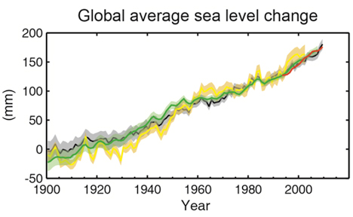
Figure 9.3 Global average change in sea level from 1900 to 2010. The coloured lines indicate different original sources of data that have been combined in one graph. (IPCC, 2013)
Rising sea levels erode coastlines and allow seawater to flood inland, damaging coastal towns and cities.
- What other effects will seawater flooding have on coastal communities and environments?
- Sea water contaminates fresh water and soils with salt, which reduces the productivity of agricultural land, kills trees and destroys habitats for animals and plants. Salt damage to the environment causes shortages of food and fresh drinking water, leading to malnutrition, displacement of human populations and loss of biodiversity.
Global warming also increases the evaporation of surface water into the atmosphere, which in turn leads to changes in the patterns and intensity of rainfall in different parts of the world. Changes in rainfall cause an increase in floods in some regions and more frequent droughts in others. You will learn more about these changes and their effects on humans and the environment in Study Sessions 10 and 11. Next we discuss the causes of the global climate changes we have just described.

9.3 What are the causes of climate change?
We mentioned earlier that cyclical variations in the global climate have been occurring for millions of years because of shifts in natural environmental factors. We briefly describe two of the main natural causes of climate change before turning to those that can be attributed to human activity.

9.3.1 Natural causes of climate change
The amount of energy reaching the Earth as heat from the sun has varied over millennia due to changes in the intensity of activity in the sun’s magnetic core. The average temperature of the Earth’s surface increases when solar activity is high and decreases when solar activity is reduced. These changes in the intensity of solar activity take place in cycles lasting hundreds of years, with profound effects on the Earth’s climate. For example, between the 17th and 19th centuries, winters in the northern hemisphere were unusually long and cold, leading to reduced growing seasons, widespread crop failure and famine. This period has become known as the ‘Little Ice Age’ and is thought to have been caused partly by low solar activity.
The global climate can also be influenced by volcanic eruptions. The explosion of dust particles, ash, water vapour and gases such as sulphur dioxide into the atmosphere is dispersed around the globe and reflects sunlight back into space.
- What effect do you think volcanic eruptions could have on the Earth’s surface temperature?
- If some of the energy from sunlight is reflected back into space by the dust in the atmosphere, the average surface temperature of the Earth is likely to be reduced.
Even though the volcanic eruption may last only a few days, the effect on the global climate may last for several years. For example, the average surface temperature in the northern hemisphere was reduced by about 0.5 °C for a few years after the eruption of Mount Pinatubo in the Philippines in June 1991 (Figure 9.4).
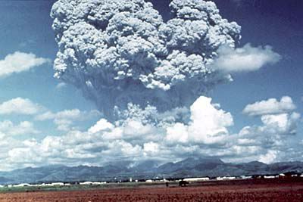
Figure 9.4 The eruption of Mount Pinatubo, Philippines, released huge amounts of dust particles and gas into the atmosphere.
Solar activity and volcanic eruptions cannot be modified by human interventions. However, human activity is increasingly seen as a direct cause of climate change from the 20th century onwards.

9.3.2 How do greenhouse gases contribute to climate change?
Climate change has been accelerating in recent decades in part due to increasing emissions into the atmosphere of so-called greenhouse gases generated by a range of human activities. We will explain why they have been given this name in a moment, but first note from Figure 9.5 how the atmospheric concentration of the major greenhouse gases – carbon dioxide, methane and nitrous oxide – has changed over the past 2000 years. It remained constant until about 1750, but then began rising, with dramatic increases since about 1900. These recent increases are attributed to human industrial and domestic activity.
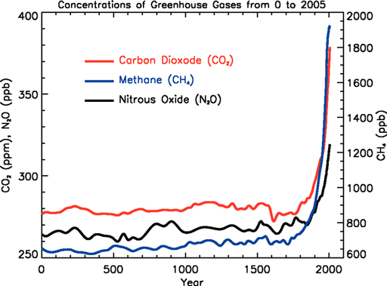
Figure 9.5 Changes in the atmospheric concentration of carbon dioxide, methane and nitrous oxide over the last 2000 years, measured in parts per million (ppm) or parts per billion (ppb). (IPCC, 2007a)
These gases have been called ‘greenhouse’ gases because they act like the glass or plastic sheeting in a greenhouse (see Figure 9.6). Sunlight has a short wavelength and high energy, which enables it to pass through the glass into the greenhouse. Sunlight energy heats the air, plants, soil and structures in the greenhouse, and some of this heat energy is radiated back towards the glass in the form of infra-red radiation. However, infra-red radiation has a long wavelength and low energy, which means it is not able to pass back out through the glass, so the radiated heat remains in the greenhouse causing it to heat up very quickly. This phenomenon increases the productivity of greenhouse crops because plants grow faster in the higher temperature.
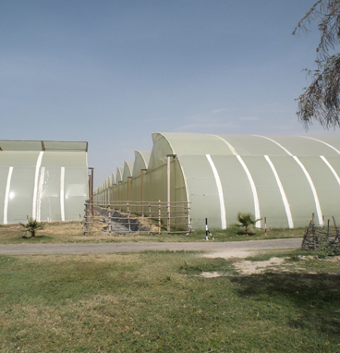  (a) | 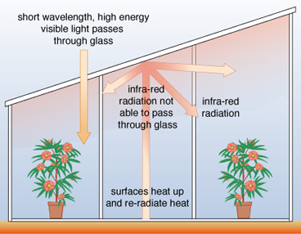  (b)
Figure 9.6 (a) Plastic greenhouses used for flower growing in Ethiopia and (b) the greenhouse effect.
A similar process happens at a global scale. Global warming is partly due to the effect of greenhouse gases in the atmosphere. Sunlight has enough energy to pass through these gases in the Earth’s atmosphere, so it reaches the Earth’s surface and transmits heat energy. Some of this heat energy is radiated back from the Earth’s surface into the atmosphere as lower-energy infra-red radiation. The greenhouse gases in the atmosphere absorb some of this infra-red radiation and reflect it back towards the Earth, causing the Earth’s temperature to heat up a bit more (Cunningham and Cunningham, 2006).
This greenhouse effect is a natural phenomenon. It is crucial for the survival of life on Earth because it maintains a global average temperature of about 15 °C. Without the greenhouse effect our global average temperature would be much colder: about –18 °C. However, human industrial and domestic activity since the start of the 20th century has released rapidly increasing amounts of greenhouse gases into the atmosphere. As a consequence, more sunlight energy is trapped close to the Earth because even less of the radiated heat can escape through the thicker shield of greenhouse gases surrounding the Earth.

9.3.3 How are greenhouse gases generated?
Human civilisation is highly dependent for its sources of energy on burning fossil fuels such as coal, oil and natural gas. Fossil fuels are formed over millions of years from the decayed remains of living organisms buried underground. The burning of fossil fuels, wood and compressed animal dung generates large amounts of carbon dioxide (CO₂), one of the major greenhouse gases. Carbon dioxide remains in the atmosphere for many years and causes the Earth’s surface temperature to rise as a result of the greenhouse effect. Figure 9.7 shows that the concentration of atmospheric CO₂ increased from 280 ppm in 1958, to more than 380 ppm in 2010 (IPCC, 2013).
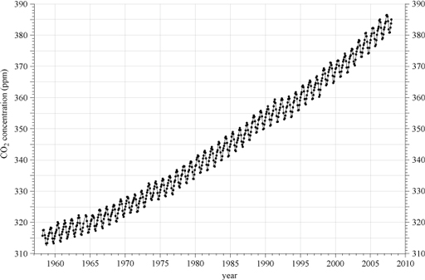
Figure 9.7 The concentration of carbon dioxide in the atmosphere from 1958 to 2010 measured in ppm at Mauna Loa, Hawaii. (Scripps, 2007)
There are natural processes on Earth that, to some extent, balance the generation of carbon dioxide. For example, all green plants remove CO₂ from the atmosphere in the process of photosynthesis. Plants, especially forests, oceans and wetlands are all important carbon sinks. Carbon sink is the term used to describe natural systems that absorb and store carbon dioxide from the atmosphere. However, as Figure 9.7 shows these balancing processes are not able to keep up with the rate of CO₂ generation.
Another important greenhouse gas is methane (CH₄), which is increasing in the atmosphere as a result of two main aspects of human activity: the decomposition of organic solid waste, and livestock farming. The digestive processes of ruminant animals such as cows (Figure 9.8), sheep and goats produce and release large amounts of methane gas (USEPA, n.d.; NASA, n.d.).
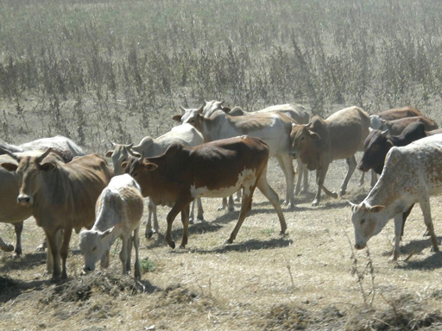
Figure 9.8 Cattle produce methane gas when they digest plant material.
Nitrous oxide (N₂O) is another major greenhouse gas. It is generated from human activities such as burning organic materials, vehicle exhaust emissions and the production and use of organic fertilisers (USEPA, n.d.; NASA, n.d.). The concentration of N₂O in the atmosphere has increased from the pre-industrial level of 270 parts per billion (ppb) to about 324 ppb in 2011 (IPCC, 2013).
Now that you know about the pattern of climate change at a global level and how it is affected by human activities, we can turn our attention to the effects in Ethiopia in the final section of this study session.

9.4 Observed and projected climate change in Ethiopia
The wide variation in elevation (the height of land above sea level) in Ethiopia produces three types of climate, illustrated in Figure 9.9:
- The hot Kolla climate occurs in regions below 1500 m and has an average annual temperature of about 30–33 °C with an average annual rainfall of 300–1000 mm.
- The temperate Woina dega climate occurs in regions between 1500 and 2500 m and has an average annual temperature of 16–29 °C with an average annual rainfall of 400–2400 mm.
- The cool Dega climate occurs in regions above 2500 m and has an average annual temperature of 10–16 °C with an average annual rainfall of 1000–1600 mm.
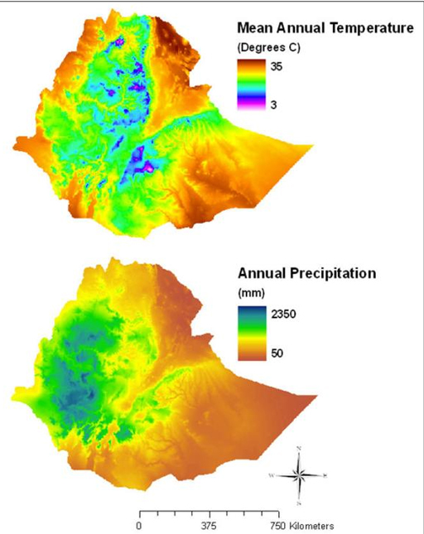
Figure 9.9 Maps of the average annual temperature and rainfall across Ethiopia. (Hopping and Wann, 2009)
- Based on Figure 9.9, what type of climate and how much rain would you expect in the lowlands of Ethiopia like Asayat, Afar Region?
- You would expect a very hot climate and very little rainfall.
- If you lived in the highlands, for example in the Simien Mountains, what type of climate would you have and how much rain would you expect?
- You would expect a very cold climate and high rainfall.
Like many other countries in the world, climate change has been observed in Ethiopia. Since 1950 the average minimum temperature has been rising by about 0.37 ºC per decade the average temperature is expected to increase substantially if global greenhouse gas emissions continue at the present rate (MoWR/NMA, 2007). The projected increases in Ethiopia’s average temperature in the future are: 0.9–1.1 ºC by 2030, 1.7–2.1 ºC by 2050 and 2.7–3.4 ºC by 2080.
Ethiopia has experienced both dry and wet years since 1950, but the average annual rainfall has remained more or less constant. However, some regions of the country have experienced more frequent and more widespread floods, whereas other regions have been hit by more frequent and intense droughts. Floods and droughts are categorised as ‘extreme weather events’ and you will learn more about them in Study Session 10. Here are some key points to demonstrate that Ethiopia is experiencing climate change (EM-DAT, n.d.):
- Between 1960 and 1990 there were ten floods in Ethiopia, but between 1990 and 2014 there were 46 reported flood events.
- Between 1960 and 1990 there were six droughts in Ethiopia, but between 1990 and 2014 nine drought events were reported and they are occurring at more frequent intervals, approximately every two years.
- In 1965, about 1.5 million people were affected by droughts, but the number has increased over time; in 2003, about 13 million people in Ethiopia were drought-affected.
Low-income countries like Ethiopia are highly vulnerable to the effects of climate change and extreme weather events. They lack sufficient numbers of people who have been trained in how to respond and they lack the organisational and financial resources to deal with the impacts on environments and communities. Rural areas are particularly vulnerable to loss of agricultural livelihoods, leading to population displacement and food shortages. Ethiopian towns and cities are vulnerable to climate change because they are densely populated (Environmental Protection Authority, 2003). You will learn more about the impacts of climate change in Ethiopia in Study Sessions 10 and 11.

Summary of Study Session 9
In Study Session 9, you have learned that:
- The climate is the average weather experienced over months or years and climate variability is the short-term fluctuations around the expected average weather.
- Climate change refers to widespread, rapid changes in the global climate since the beginning of the 20th century, which have been increasing at a faster rate in recent decades.
- One driver of climate change is global warming: the global average surface land and ocean temperature has increased by about 0.74 ºC in the century between 1905 and 2005; climate change also includes alterations in wind patterns, ocean currents and the distribution of rainfall.
- Natural causes of climate change include fluctuations in solar activity and volcanic eruptions. The major human cause of climate change is the increasing release of greenhouse gases (carbon dioxide, methane and nitrous oxide) into the atmosphere.
- Greenhouse gases act like the glass in a greenhouse by reflecting radiated heat back towards the Earth, trapping more of the sun’s energy and causing the surface temperature to rise.
- Global warming is causing sea levels to rise as ice and snow cover decreases and melted water runs into the oceans.
- Climate change effects have been observed in Ethiopia, especially since 1950; the average minimum temperature and the average annual temperature have been rising; although there has been little change in average rainfall, the number and intensity of floods and droughts have also increased.

Self-Assessment Questions (SAQs) for Study Session 9
Now that you have completed this study session, you can assess how well you have achieved its Learning Outcomes by answering these questions. You can check your answers with the Notes on the Self-Assessment Questions at the end of this Module.

SAQ 9.1 (tests Learning Outcome 9.1)
Write the following words next to their correct definitions in the table below:
carbon sink; climate; climate change; climate variability; greenhouse effect; weather.
a condition of the atmosphere over a short period of time
natural process in which heat energy from the sun is trapped by the Earth’s atmosphere so the surface stays warm
short-term fluctuations from the expected average weather conditions
the average weather over a relatively long period
a change in the average climate over a long period of time
process or system that removes carbon dioxide from the atmosphere

SAQ 9.2 (tests Learning Outcome 9.1)
Rewrite the paragraph below using terms from the list provided to fill the gaps.
droughts, floods, global warming, greenhouse gases, rainfall, sea levels.
The rise in the mean global surface temperature referred to as ……………… is partly due to an increase in the concentration of ……………… in the atmosphere. This change in the global climate is expected to melt Arctic sea ice, leading to rising ……………… and to alter the pattern of ………………, so that there are more severe ……………… in wetter regions, and more severe ……………… in drier regions.

SAQ 9.3 (tests Learning Outcome 9.3)
Which of the following statements are false? In each case explain why it is incorrect.
- The global climate is affected by fluctuations in the amount of energy reaching the Earth from the sun.
- Volcanic eruptions into the atmosphere increase the temperature of the air and contribute to global warming.
- Greenhouse gases are only produced by human activity.
- Methane released by decomposing solid waste and livestock farming contributes to the greenhouse effect.

SAQ 9.4 (tests Learning Outcome 9.4)
Rearrange the following statements into the correct order to produce a coherent explanation of how the rising emission of greenhouse gases generated by human activity is contributing to global warming.
- Heat energy is infra-red radiation, which has a long wavelength and low energy, and is absorbed by greenhouse gases in the atmosphere.
- Visible sunlight has a short wavelength and high energy, which enables it to pass through greenhouse gases in the Earth’s atmosphere.
- Heat is radiated from the surface of the Earth back towards the atmosphere.
- Sunlight energy reaches the Earth and heats the Earth’s surface.
- Human activity since the start of the 20th century has increased the emission of greenhouse gases and accelerated the rate of global warming.
- Heat energy trapped in the atmosphere by the greenhouse gases causes the atmosphere to become warmer.

SAQ 9.5 (tests Learning Outcome 9.5)
Complete the following statements of evidence that climate change is occurring in Ethiopia by writing the missing numbers in the spaces provided:
- Since 1950 the average minimum temperature in Ethiopia has been rising by about …… ºC per decade.
- Before 1990 there were 10 floods in Ethiopia, but between 1990 and 2014 there were …… reported flood events.
- Before 1990 there were 6 droughts in Ethiopia, but between 1990 and 2014 more than …… drought events were reported.
- In 1965, about 1.5 million people were affected by droughts, but in 2003 about …… million people in Ethiopia were drought-affected.

Study Session 10 Extreme Weather Events

Introduction
You often hear on the radio and TV or in the newspapers that extreme weather events such as floods, storms and typhoons have affected hundreds of people and damaged buildings, water supplies and sanitation facilities. Extreme weather events are expected to increase in the future because of climate change. Knowing what extreme weather events occur in Ethiopia can help WASH workers plan and prepare to reduce the impacts.
In this study session you will look at what is meant by the term ‘extreme weather’ and learn about three types of extreme weather event that occur in Ethiopia: floods, droughts and heatwaves, and also about wildfires, which are not themselves weather events but are associated with very dry weather. Our focus in this study session is on the impact of these events on the environment and on WASH services. The impacts on human health, agriculture and the economy in Ethiopia are discussed in Study Session 11.

Learning Outcomes for Study Session 10
When you have studied this session, you should be able to:
10.1 Define and use correctly all of the key words printed in bold. (SAQ 10.1)
10.2 Describe the main types of extreme weather events in Ethiopia and how they affect the environment. (SAQs 10.1, 10.2 and 10.4)
10.3 Explain how natural climate cycles and human activities can increase the risk of extreme weather events in Ethiopia. (SAQs 10.2 and 10.3)
10.4 Describe how extreme weather events can affect WASH in Ethiopia, including in urban areas. (SAQs 10.3 and 10.4)

10.1 What is extreme weather?
You know from your own experience that the weather varies from day to day, month to month and year to year. Most of the time, these fluctuations occur within a normal range. Some periods are hotter, colder or wetter than others, but these variations are not unusual. Extreme weather events are periods of weather outside the normal range of weather conditions. For example, floods that happen because of excessively high rainfall, or droughts, or heatwaves and wildfires resulting from a period of unusually high temperature, are extreme weather events.
We expect certain weather in different regions of Ethiopia – hot and dry in the lowland areas, but cooler and wetter in the highlands. We expect some areas to flood and some areas to have drought from time to time. But if the weather conditions are extreme, then we have unexpected conditions to deal with. Study Session 9 concluded that low-income countries like Ethiopia generally lack the personnel, equipment, infrastructure and finances to deal with the effects of climate change and increasingly frequent extreme weather events.
Globally, there are many types of extreme weather events, but we will focus on floods, droughts, heatwaves and wildfires because they are the most likely to affect Ethiopia.

10.2 Floods
Floods are extreme weather events that have had major effects in Ethiopia at different times and in different locations. In recent decades, major floods outside the normal pattern of flooding have occurred in Ethiopia with increasing frequency (EM-DAT, n.d.). They have been responsible for many deaths of people and livestock, and caused damage to homes (Figure 10.1), livelihoods and infrastructure in many parts of the country (MoWR/NMA, 2007). Table 10.1 shows the costs of major flood events in 2005 and 2006, which were the worst in recent years in terms of deaths and economic damage in Ethiopia.
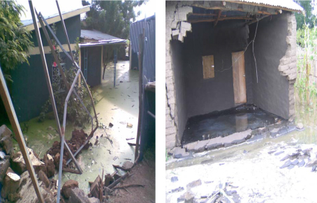
Figure 10.1 Homes damaged by the 2006 flood in Gambela town, Ethiopia.

Table 10.1 Some impacts of the 2005 and 2006 floods in Ethiopia. (EM-DAT, n.d.)
Year | Region/towns affected | Human deaths | Total affected people | Costs due to flood damage ($US)
2005 | Somali region, Dire Dawa and Wolayta zone, Humbo woreda | 211 | 242,418 | 6,200,000
2006 | Eastern Afar, Eastern Somali, Tigray, Gambela, Omo, Amhara and SNNPR regions; Dire Dawa city, Addis Ababa | 951 | 434,146 | 3,200,000
There are two main types of floods – flash floods and river floods – both of which affect water supply and sanitation.

10.2.1 Flash floods and their causes
Flash floods are floods that happen as a result of intense rainfall in a localised area and they usually drain away quite quickly (Few, 2006). If a large amount of rain falls onto the land in a short time and it cannot soak into (infiltrate) the soil, the water runs downhill across the land surface. This heavy flow of surface run-off can cause a flash flood.
There are many factors that increase the risk of flash floods in Ethiopia, including changes in land use and poor soil permeability (Abaya et al., 2009). As you read in Study Session 6, when forests and grasslands are removed for the construction of roads and buildings, permeable soil is replaced by hard surfaces such as concrete. This reduces the infiltration of water into the ground and increases run-off, making flooding more likely. The proportion of Ethiopia’s land area that is covered by forests has decreased significantly in recent decades, as Study Session 1 demonstrated (see Figure 1.3).
- How do forests help rain to soak into the soil?
- Forests play an important role in the water cycle because the roots of plants reach deep into the soil and create space between soil particles; this increases soil permeability, so when it rains the water can infiltrate the soil.
Failures of dams and reservoirs can also lead to flash floods. Many micro-dams have been constructed in Ethiopia for irrigation, water supply and generating hydroelectric power. Dam failure can occur if they are not properly constructed, or heavy rainfall may cause ‘overtopping’ (water flowing over the top of the dam when it is full).
Flash flooding has happened many times, in many parts of Ethiopia. This causes significant harm to human life and property because it happens so unexpectedly and local people are unprepared (Greenough et al., 2001). For example, the flash flood on 5 August 2006 in Dire Dawa caused 256 deaths and displaced 9956 people (Early Warning Department, Federal Disaster Prevention and Preparedness Agency, 2007).

10.2.2 River floods and their causes
River floods occur when the water level rises and water spills over the top of the river banks. The overflow runs into nearby low-lying areas, where it collects as flood water (Douben, 2006). River floods in Ethiopia generally occur because of intense heavy rain at high altitudes, which results in water flowing down into lowland rivers, which then burst their banks. Unlike flash floods, river floods tend to build up slowly, but they remain for much longer periods. Figure 10.2 shows river floods in Dire Dawa and Gambela.
(a) | (b)
Figure 10.2 Floods in (a) DireDawa and (b) Gambela in 2006, resulting from the overflow of the Dechatu and Gambela rivers respectively.
- Look at the map in Figure 10.3. Which parts of Ethiopia are prone to flooding?
- The main flood prone areas in Ethiopia are in the centre of the country in parts of SNNPR and Oromia, in the north in Amhara region and in the south-east in Somali region.
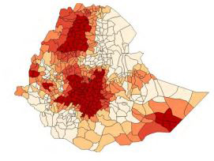
Figure 10.3 Flood-prone areas in Ethiopia. Areas shaded in the darkest colour are at the greatest risk of flooding. (EDRI/GGGI, 2015)
The impacts of river floods depend on many factors, such as the presence of early warning systems (Bonacci and Ljubenkov, 2008). There is no effective early warning system in place in most flood-prone areas of Ethiopia, but rural communities can reduce the impact, for example by moving livestock to higher ground at the start of the flood season. But this precaution is only effective for the normal intensity and frequency of floods – it cannot deal with unusually extreme flooding – and people in urban communities are usually unable to take any action to avoid flood damage.
The severity of flooding is increased by the absence of vegetation, intensive farming methods and deforestation, all of which increase soil erosion. Bare soil is more easily washed away by heavy rain than soil that is held together by the roots of trees and other plants. Soil erosion is the main cause of increased amounts of sediment in many Ethiopian reservoirs. As soil is washed off the land into the reservoir, sediment builds up behind the dam and it can significantly reduce the reservoir capacity, leaving the dam less able to withstand a major flood.

10.2.3 The impact of floods on WASH in Ethiopia
Floods often cause major damage to basic facilities such as water supplies, sanitation, waste disposal systems and other essential services. This poses a serious challenge to public health. Excessive rain and flooding can create conditions that increase the spread of faecal-oral diseases because flood waters flush pathogens and pollutants into water supplies from flooded latrines and places used for open defecation.
As well as polluting water sources, floods also can damage shallow wells, boreholes fitted with windmills, and protected springs, and they can wash away water pipes (Ethiopia Red Cross/Red Crescent, 2005). The result is that people are unable to access safe drinking water unless temporary water supplies can be provided (Figure 10.4).
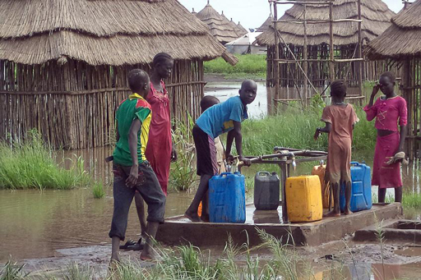
Figure 10.4 Children fetch water from a water point constructed after flooding by the Lutheran World Federations.

10.3 Drought
Drought is not a new word to many Ethiopians. Drought is the absence of rain for an extended period, often for a season or more. Climate change is associated with the significant reduction in rainfall and increase in droughts that is already apparent in some parts of Ethiopia. Droughts have caused loss of human life, livestock and property, as well as migration of people (MoWR/NMA, 2007).
More than 85% of the population of Ethiopia are farmers. Most of the agriculture in the country is small scale and therefore highly dependent on rainfall and traditional technologies. Drought affects agriculture by damaging crops and decreasing crop yield (Figure 10.5), which causes food shortages not only in rural areas but also in towns and cities. In the worst periods of drought there may be widespread famine, when the extreme shortage of food results in many deaths. The drought that occurred in 1984, leading to a famine that killed more than one million people, is still fresh in the memories of many Ethiopians.
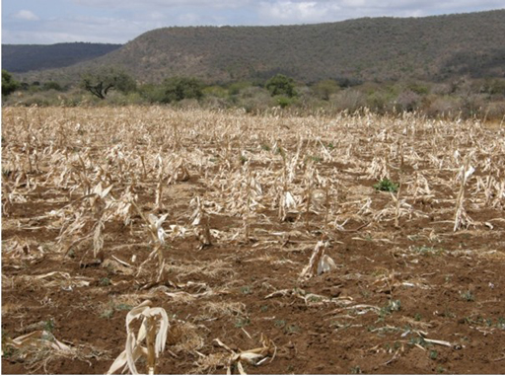
Figure 10.5 Crop failure due to drought in Ethiopia.

10.3.1 How many Ethiopians are affected by drought?
More than 57 million people across Ethiopia have been affected by droughts since 1980 (MoWR/NMA, 2007). Table 10.2 shows the frequency and impacts of droughts between 1964 and 2003.
Table 10.2 Major droughts linked to famines in Ethiopia since 1964 and their impacts on human life and property. (MoWR/NMA, 2007)
Years | Regions affected | Impacts on human life and property
1964–66 | Tigray and Wollo | About 1.5 million people affected
1973–74 | Tigray and Wollo | About 200,000 people and 30% of livestock dead
1978–79 | Southern Ethiopia | 1.4 million people affected
1982 | Northern Ethiopia | 2 million people affected
1983–84 | Ethiopia | 8 million affected, one million dead and many livestock lost
1987–88 | Ethiopia | 7 million people affected
1990–92 | Northern, eastern, south-eastern Ethiopia | 0.5 million people affected
1993–94 | Tigray and Wollo | 7.6 million people affected
2000 | Ethiopia | 10.5 million people affected
2002–03 | Ethiopia | About 13 million people needed food assistance.
- Look at Table 10.2. What trend over time do you notice in the impacts of drought and famine in the period shown?
- The number of people affected by drought and famine has increased during this period, from 1.5 million in 1964–66 to more than 13 million in 2002–03.
Even though the population of Ethiopia has increased over the period from 1964 to 2003 (which could partly explain the increase in numbers affected), the later droughts covered larger areas of the country and were more severe. Currently more than 10 million people live in the drought-prone areas of Ethiopia shown in Figure 10.6.
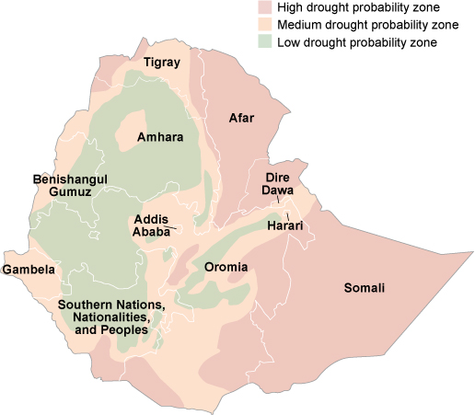
Figure 10.6 Drought probability map of Ethiopia. (Adapted from MoWR/NMA, 2007)
- Based on Figure 10.6, which parts of Ethiopia are most vulnerable to drought?
- The most drought-vulnerable areas in Ethiopia include Somali, Afar, parts of Tigray, eastern and southern Oromia, and southern SNNPR.

10.3.2 The causes of drought in Ethiopia
Global warming and alterations in rainfall patterns are believed to be the underlying cause of the trend towards more frequent and more severe droughts in Ethiopia (MoWR/NMA, 2007).
- Can you suggest why a climate which is gradually becoming warmer will result in an increase in the risk of droughts? (Hint: think back to Study Session 9.)
- Increased air temperature will heat the surface of water bodies and make the soil warmer, resulting in increased evaporation of water into the atmosphere. Also, as plants die through lack of water (remember Figure 10.5), large areas of bare soil are exposed to the heating effects of higher air temperatures, so even more water is lost through evaporation.
There are many other interlinked factors that cause droughts in Ethiopia. Between 1950 and 2014, the population grew from 18.1 million to 96.5 million people, so there has been a rapidly increasing demand for water to meet their needs (Figure 10.7). The rising standard of living, economic growth and industrial development all increase water demand because they require more water for additional uses. Particularly in urban areas, the demand for piped water and flush toilets has increased because households aspire to achieve higher standards of hygiene and sanitation.
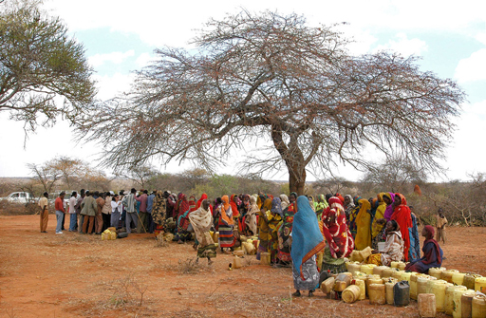
Figure 10.7 Queuing for water near Moyale in Oromia Region, one of the worst-affected areas in the 2011 drought.
Population pressure also leads to high deforestation for agricultural expansion and to meet the growing demand for wood (Figure 10.8) to burn as fuel and also for building fences and houses.
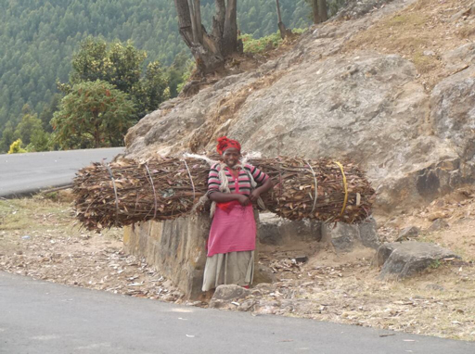
Figure 10.8 Collecting wood for use in construction and for fuel contributes to deforestation.
- Summarise the ways in which forests sustain the water cycle and locally available water resources.
- Forests play a crucial role in stabilising soils, reducing water run-off during rainy periods and increasing the amount of water stored underground. Shade from trees also reduces surface water evaporation and trees add moisture to the atmosphere through the process of transpiration. Thus, forests can be considered an important part of the water cycle and they contribute to sustaining the availability of water in the local area.
In summary, climate change leading to global warming and reduced rainfall, coupled with population pressure, deforestation and change in land use are all major factors in the increasing risk of drought in Ethiopia.

10.3.3 Impacts of drought on WASH in Ethiopia
As well as causing shortages of food and surface water, droughts have a significant effect on the availability of safe water resources. Drought causes water scarcity, so people are more likely to use unsafe water sources such as polluted rivers, streams and lakes. During times of water scarcity, people may save whatever water they can find for drinking and cooking, and stop using it for hygiene activities such as handwashing after defecation (Kovats et al., 2003). Drought can also increase the concentration of pathogenic organisms in rivers and lakes because the lower volume of water cannot dilute the contaminants to below the infectious dose (Kovats et al., 2003). We will discuss the impacts on human health in Study Session 11.

10.4 Heatwaves
Heatwaves are prolonged periods of unusually hot weather, which may or may not be accompanied by high humidity. The World Meteorological Organization definition of a heatwave is ‘when the daily maximum temperature on more than five consecutive days exceeds the average maximum temperature by 5 °C. The perception of a heatwave varies geographically because it is measured relative to the average temperature in that area. For example, weather that is experienced as normal heat in summertime in Gambela town would be considered a heatwave in Addis Ababa city, where the average summer temperature is much cooler.
Heatwaves are a big challenge in low-income countries like Ethiopia, because energy resources for cooling and air conditioning are often lacking. Heatwaves can cause adverse health effects and even death when severe dehydration of the body results from excessive sweating. It is very important to drink plenty of water during a heatwave to replace lost fluids. When heatwaves occur in areas of Ethiopia with water shortages, people cannot get enough water to drink or to cool themselves, so provision of an adequate and safe water supply is important to reduce the impacts on human health.

10.5 Wildfires
Nowadays wildfires are becoming increasingly common in the world because of frequent heatwaves and hot, dry conditions resulting from climate change. A forest fire is called a wildfire when it spreads very rapidly over a large area and is extremely difficult to bring under control (Figure 10.9). In many countries, including Ethiopia, the United States, Russia and Australia, wildfires are common during the dry season and especially in severe droughts. More than 200,000 hectares of forest are lost every year in Ethiopia because of fires (Kovats et al., 2003). Climate change is expected to increase the intensity and frequency of droughts in many parts of Ethiopia, increasing the risk of more severe and frequent forest fires.
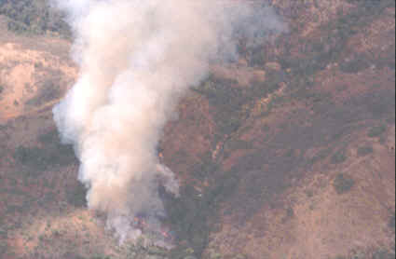
Figure 10.9 Aerial view of burning vegetation in Bale region, Ethiopia.
Wildfires are dangerous because they spread so quickly, destroying large areas of forest, damaging buildings and infrastructure, and killing any people, livestock and wildlife that cannot escape. Wildfires also have effects on human health through the emission of pollutants such as ash, toxic gases, dusts and debris into the atmosphere. Respiratory problems like asthma and bronchitis are made much worse if the air quality is contaminated with these products of burning vegetation.
Wildfires can also severely affect water quality. When the debris and ash are washed away by rain, they enter water sources such as rivers, streams and wells. The water can become cloudy with ash, taste or smell smoky or earthy, and contain toxic chemicals from burnt wood, which in turn can have adverse health effects if used for drinking (Waskom et al., 2013).

10.6 El Niño and La Niña
We conclude this study session by mentioning two natural climate cycles that can affect the location and frequency of extreme weather events around the world, including in Ethiopia. The rise in sea temperature that we described in Study Session 9 has widespread effects on ocean currents, particularly in the Pacific Ocean (National Weather Service, 2006). When the Pacific Ocean is unusually warm, it generates a climate cycle known as El Niño (‘little boy’ in Spanish); when the ocean temperature is unusually cool, the climate cycle is called La Niña (‘little girl’). El Niño and La Niña have opposite effects on the climate. Even though both of these ocean currents occur far away from Ethiopia, they influence the route and speed of major airstreams and alter the pattern of rainfall around the world, so that some regions are wetter than average and others are drier (Waskom et al., 2013).
The effects of El Niño and La Niña in Ethiopia depend on which of our two rainy seasons they occur in. The belg season is from February to March and the kirmit season is from June to September. If El Niño occurs during belg, it can cause above-normal rainfall, whereas if La Niña occurs during belg, it causes below-normal rainfall (FAO, 2014). In contrast, if El Niño occurs during kirmit, it decreases the seasonal rainfall, whereas La Niña during kirmit increases rainfall above the normal level (National Weather Service, 2006).
- Would El Niño or La Niña occurring in the belg season increase the risk of floods or droughts in Ethiopia?
- El Niño occurring in belg can cause above-normal rainfall, so the risk of floods increases. If La Niña occurs during the belg season, it causes below-normal rainfall, so the risk of droughts increases.
- What effects would El Niño have on WASH if it occurred during kirmit?
- It would decrease rainfall and increase the risk of droughts; this would result in water shortages, which may force people to drink water from unsafe sources and they may also stop using water for hygiene purposes.
- What effects would La Niña have on WASH if it occurred during kirmit?
- It would increase rainfall, which could cause more flooding. Floods can contaminate our water resources and destroy the water supply and sanitation facilities.
In the next study session, you will look in more detail at the impacts of climate change and extreme weather events on health, environments, agriculture, water resources and the Ethiopian economy.

Summary of Study Session 10
In Study Session 10, you have learned that:
- Extreme weather is weather that departs from the normal range of climate conditions.
- Floods, droughts, heatwaves and wildfires are the most common extreme weather events in Ethiopia.
- Flash floods develop rapidly and are due to the run-off of intense rainfall collecting in a localised area, usually for a short time. River floods occur when the water level rises and spills over the river banks; the build-up is generally slower than in a flash flood, but the extent is greater and the duration is longer.
- Floods cause major damage to basic facilities such as water supplies, sanitation and waste disposal systems; they contaminate water sources by flushing pathogens, soil and toxins into rivers, lakes, ponds and wells.
- Drought is the absence of rain for extended periods, often for a season or more. The frequency of droughts has increased over time in Ethiopia.
- There are many contributing factors to floods and droughts in Ethiopia, including population pressure, deforestation, climate change and the occurrence of natural climate cycles due to El Niño and La Niña currents in the Pacific Ocean.
- Drought has a significant effect on water resources and WASH; it causes water scarcity which in turn may lead people to use unsafe water sources.
- A heatwave occurs when the daily maximum temperature on more than five consecutive days exceeds the average maximum temperature by 5 °C.
- Climate change is expected to increase the intensity and frequency of drought in many parts of Ethiopia, in turn causing more severe and frequent heatwaves and wildfires.
- When debris and ash from the wildfires enter the atmosphere, they can cause respiratory problems; when they are washed into water sources by rain they can significantly reduce water quality.

Self-Assessment Questions (SAQs) for Study Session 10
Now that you have completed this study session, you can assess how well you have achieved its Learning Outcomes by answering these questions. You can check your answers with the Notes on the Self-Assessment Questions at the end of this Module.

SAQ 10.1 (tests Learning Outcome 10.1)
Write the following words next to their correct definitions in the table below:
El Niño; extreme weather; flash floods; La Niña; river floods.
unusually warm temperatures in Pacific Ocean currents
water spills over the top of the river banks into surrounding areas
unusually cool temperatures in Pacific Ocean currents
weather outside the normal range of weather conditions
intense rainfall causes water run-off to collect locally

SAQ 10.2 (tests Learning Outcomes 10.2 and 10.3)
Explain how each of the human activities described in (a) and (b) can increase the risk of flooding:
- constructing roads and urban areas on land previously used for agriculture
- deforestation.
Explain how each of the human activities described in (c) and (d) can increase the risk of droughts:
- population pressure
- deforestation.

SAQ 10.3 (tests Learning Outcomes 10.2, 10.3 and 10.4)
Which of statements (a) to (h) about the effects of the natural climate cycles known as El Niño and La Niña are true and which are false? For each statement that you think is false, explain why it is incorrect.
- Drought is more likely during kirmit in Ethiopia if it coincides with the El Niño climate cycle.
- Flooding is more likely during kirmit in Ethiopia if it coincides with the El Niño climate cycle.
- Drought is more likely during belg in Ethiopia if it coincides with the El Niño climate cycle.
- Flooding is more likely during belg in Ethiopia if it coincides with the El Niño climate cycle.
- Drought is more likely during kirmit in Ethiopia if it coincides with the La Niña climate cycle.
- Flooding is more likely during kirmit in Ethiopia if it coincides with the La Niña climate cycle.
- Drought is more likely during belg in Ethiopia if it coincides with the La Niña climate cycle.
- Flooding is more likely during belg in Ethiopia if it coincides with the La Niña climate cycle.

SAQ 10.4 (tests Learning Outcomes 10.2 and 10.4)
Explain how each of the extreme weather events listed in (a) to (c) can affect water quality in Ethiopia:
- floods
- droughts
- wildfires.

Study Session 11 Impacts of Climate Change in Ethiopia

Introduction
Climate change is expected to increase the surface temperature of the Earth and the oceans, raise sea levels, alter the global distribution of rainfall, affect the direction of ocean currents and major airstreams, and increase the intensity and frequency of extreme weather events. Climate change is already causing loss of life, damaging property and affecting livelihoods in many parts of the world, and it is expected to continue to do so in the future. Climate change will affect all nations, but the impact will be higher on low-income countries, such as Ethiopia, which have limited capacity to cope with the effects of a changing climate. In this study session you will learn about the impacts of climate change on human health, the environment, agriculture, water supply, sanitation and socio-economic activities, focusing attention on the effects in Ethiopia.

Learning Outcomes for Study Session 11
When you have studied this session, you should be able to:
11.1 Define and use correctly all of the key words printed in bold. (SAQ 11.1)
11.2 Describe the major impacts of climate change on health in Ethiopia. (SAQs 11.1 and 11.3)
11.3 Describe the interactions between climate change, the environment, agriculture, livestock and the Ethiopian economy. (SAQs 11.2 and 11.3)
11.4 Explain how climate change is affecting water resources in Ethiopia. (SAQ 11.3)
11.5 Identify the impacts of climate change on sanitation and hygiene in Ethiopia. (SAQ 11.3)

11.1 Climate change impacts on human health
Climate change can impact human health in many different ways, both positively and negatively. The positive health impacts of climate change are the benefits to health that may arise from a warmer climate. For example, warmer winters may result in fewer deaths resulting from exposure to cold weather; also the geographical range of some disease ‘vectors’, like mosquitoes, may contract if extreme hot weather conditions dry out the shallow water collections they require for their breeding cycle. Vectors are insects such as mosquitoes, flies and other animals (for example snails, rats and dogs) that transmit disease-causing agents such as bacteria and viruses from one host to another. Overall, however, many scientists think that the negative health impacts of climate change are expected to exceed the positive health impacts (Confalonieri et al., 2007).
The health impacts of climate change can be direct or indirect. The direct health impacts occur when climate changes in the temperature, precipitation and weather extremes affect our health and survival directly. For example, very hot weather can cause heat-related illness such as heat exhaustion and heat stroke; and floods can cause injury and drowning. These direct effects are predicted to increase as the rate of climate change increases in the future. You should be able to recall the effects of extreme weather events from Study Session 10.
The indirect health impacts of climate change are health problems caused by changes in natural and social systems as a result of shifts in the climate, which in turn have adverse effects on human health. Changes to social and ecological systems can allow disease to spread more easily, or cause disease to emerge in areas where previously it was unknown or only present at low levels (Senay and Verdin, 2005; Gage et al., 2008). For instance, 40 years ago you would not find a single case of malaria in the highlands of Ethiopia, but today outbreaks of malaria in the Ethiopian highlands are common. This is because climate change has increased the night-time temperatures in the highlands, allowing malaria-infected mosquitos to live at altitudes where previously they could not survive the cold nights. Longer periods of warm weather have created favourable conditions for mosquitoes to breed and these changes in the highland climate have led indirectly to outbreaks of malaria occurring for the first time (Abeku et al., 2004; Pascual et al., 2006).
- Study Session 10 stated that an increase in flooding leads to higher frequency of diarrhoeal diseases. Can you explain how flooding resulting from climate change can indirectly have this effect on human health?
- Flood water washes animal and human waste from latrines and open defecation into rivers, lakes, ponds and wells where people obtain their drinking water. It may also destroy water treatment facilities and breaks water pipes, allowing waterborne diarrhoea-causing organisms to spread through the water resources in rural and urban areas.
Climate change is expected to increase the frequency of waterborne and food-borne infectious diseases in countries like Ethiopia because of the inadequate supply of safe drinking water, low sanitation coverage and poor hygiene practices (Kovats et al., 2003; Confalonieri et al., 2007). For example, following the 2006 flood in many parts of the country there were outbreaks of acute watery diarrhoea among people in Gambela Region, West Arsi Zone, Oromia Region, Addis Ababa and very remote places like Guji Zone (International Federation of Red Cross and Red Crescent Societies, 2005). Acute watery diarrhoea is a symptom of many faecal–oral diseases including cholera.
- What are faecal–oral diseases? Can you name any other examples that occur in Ethiopia?
- Faecal-oral diseases occur when pathogenic organisms from faeces are transmitted from person to person via the oral route (mouth), for example when contaminated hands or utensils (cups, spoons) touch the mouth, or infected food or water is swallowed. Faecal–oral diseases include cholera, giardiasis, typhoid and dysentery, among others.
As you learned in Study Session 1, Ethiopia is already classified by the United Nations as water stressed, meaning that the availability of water is less than 1700 m³ per person per year. If climate change reduces the amount of accessible water to less than 1000 m³ per person per year, Ethiopia will be in the ‘water scarce’ category. Water stress and water scarcity increase the risk of water-washed diseases, which occur as a result of poor personal hygiene and inadequate washing. Examples of water-washed diseases include the infectious eye diseases trachoma and conjunctivitis, and scabies caused by tiny mites that burrow into the skin.
Malnutrition among children aged under 5 is another widespread problem in Ethiopia, and one which could become more prevalent if climate change leads indirectly to food shortages. As Study Session 10 described, more frequent or more severe droughts reduce food production because crops fail and livestock die (Abaya et al., 2011). Malnutrition, malaria and diarrhoeal diseases are particularly related to the increased frequency and intensity of floods and droughts in Ethiopia, as you can see in Table11.1.
Table 11.1 Climate change impacts on human health. (Few, 2007)
Health problem | Flood | Drought
Faecal-oral, waterborne and water-washed diseases | Contamination of the home and living environment  Disruption of water and sanitation facilities | Shortage of water for hygiene and food preparation; use of untreated water sources; inadequate sanitation
Vector-borne diseases | Altered breeding conditions for mosquitoes; rodents taking refuge in houses | Altered breeding conditions for mosquitoes; human population movements
Malnutrition | Crop damage and loss of subsistence food; disruption of food supplies; disruption of livelihood/income | Loss of subsistence food or income; regional food shortages; use of nutrient-deficient alternative foods

11.2 Climate change impacts on the environment
Climate change has several impacts on the environment in addition to the disruption to water resources we have just described. Increased heavy rainfall as a result of climate change can cause soil erosion, crop damage and waterlogging, which makes the land difficult or impossible to cultivate for agriculture. It is estimated that Ethiopia loses more than 1.5 billion tons of fertile soil each year through heavy rain and flooding; this lost soil could have increased the country's crop production by an estimated 1.5 million tons (Tamene and Vlek, 2008). Soil erosion like that shown in Figure 11.1 aggravates the problem of food security in the country.
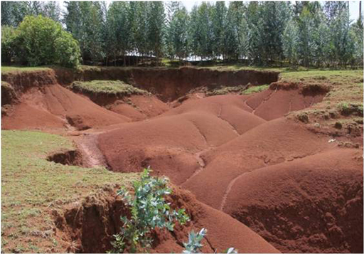
Figure 11.1 Active land degradation as a result of soil erosion in Northern Ethiopia.
Climate change is also expected to affect biodiversity significantly, because it will change the environment and climatic conditions where plants and animals live (IPCC, 2007b). The average global surface temperature is about 15 ºC and it is estimated that if the global average temperature increases by 1.5 ºC to 2.5 ºC, many species will not be able to survive in the warmer environment (IPCC, 2007b). According to the IPCC report, at present rates of climate change, about 20–30% of the world’s plant and animal species will become extinct by the 2080s, and between 25% and 40% of mammal species in sub-Saharan Africa will become endangered. In Ethiopia, the unique environments that support our already endangered species (Figure 11.2) are becoming less hospitable because climate change is causing longer dry periods and shrinking the available water resources.
Figure 11.2 The Ethiopian wolf is an endangered species.

11.3 Climate change effects on agriculture, livestock and the Ethiopian economy
Climate change poses huge challenges to the global economy and to social development. Its impacts will disproportionately affect sub-Saharan African countries such as Ethiopia because their economies are highly dependent on climate-sensitive activities such as rain-fed agriculture. In Ethiopia, agriculture contributes about 47% of the country’s Gross Domestic Product (GDP) and more than 70 million people (85% of the Ethiopian population) depend on agriculture directly or indirectly for their livelihoods (Index Mundi, 2014). Therefore, any effect on agriculture will significantly affect the Ethiopian economy.
It is predicted that changes in climate will lead to recurrent droughts and heavy rainfall in different parts of Ethiopia, reducing the amount of land that can be used for agriculture and decreasing crop productivity. For example, the 2006 flood in Gambela region (Figure 11.3) damaged about 1650 hectares of maize and reduced crop productivity by 20% as a result of waterlogging of farmland (Gambela Region Disaster Prevention and Preparedness Agency, 2007). This meant a loss of income for the country and also exacerbated food shortages and malnutrition problems in the region.
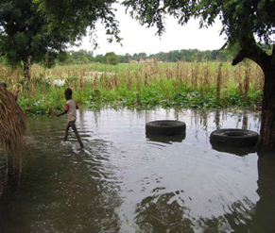
Figure 11.3 Flood-damaged crops in the Gambela Region.
The impacts of climate change on the environment could also reduce the national income from the export of agricultural products such as coffee, pulses and flowers. Of particular concern is the possible impact on Ethiopia’s famous Arabica coffee, which is exported all over the world. Coffee plants are very sensitive to climate change and there are concerns that Arabica coffee production could become impossible in Ethiopia by the end of this century if the change continues at the current rate.
Ethiopia is home to Africa’s largest livestock population, and is the world’s tenth-largest producer of livestock and livestock products (MacDonald and Simon, 2011), which make up about 10% of the country’s foreign currency earnings (Pantuliano and Wekesa, 2008). Frequent and extensive droughts in the country have a considerable effect on Ethiopia’s livestock because decreased rainfall shrinks available water resources and reduces the productivity of grassland and rangeland (Figure 11.4).
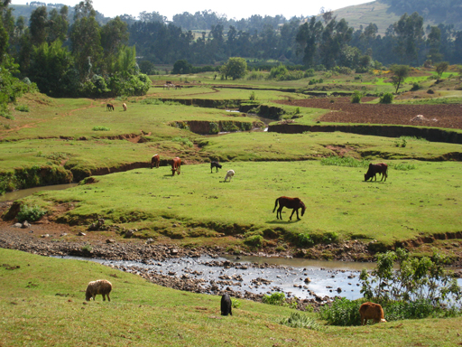
Figure 11.4 Water resources and grazing for animals may be impacted by climate change.
The main causes of livestock deaths in Ethiopia are shortages of water and food during drought (IFAD, 2009; MacDonald and Simon, 2011). Increased temperatures can affect the behaviour and metabolism (internal body processes) of livestock, such as a reduced intake of food and a decline in productivity (IFAD, 2009; Thornton et al., 2009). Changes in rainfall and warmer temperatures may also increase the geographical distribution and survival of vectors like flies and mosquitoes that transmit infectious diseases to livestock (IFAD, 2009; Thornton et al., 2009). These impacts on livestock are already being felt in Ethiopia; in the past two decades in Borana zone, southern Ethiopia, there have been losses of livestock associated with drought (Figure 11.5). The number of animals per household declined on average ‘to three oxen from ten; to seven cows from 35; and to six goats, down from 33’ (MacDonald and Simon, 2011).
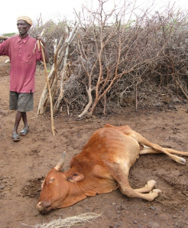
Figure 11.5 Livestock may die as a result of drought.
Like drought, flood has a significant impact on livestock. Animals can be drowned or washed away by flood. For instance, more than 15,600 livestock were lost due to flooding in 2006 in SNNPR (EWD DPPA, 2007). Flood also covers large areas of grazing land with water, making it impossible for the animals to find food.
In addition to affecting agriculture and livestock, floods can cause huge damage to property, livelihoods and infrastructure. This occurred in the 2006 floods in Dire Dawa city, as described in the extract from a government report shown in Box 11.1.

Box 11.1 Impact of the 2006 flood on the Dire Dawa city economy
The flood significantly damaged the livelihoods of 9956 displaced [persons] in Dire Dawa city, washing away their homes and significantly damaging individual assets such as shops, private enterprises and market stalls. Approximately 2685 households were reported to have lost their homes. An additional 1000 homes were also damaged by the flood waters. The damage to livelihood assets had been assessed by the Dire Dawa Investment Bureau, the Dire Dawa Small and Micro Enterprise Agency and the Trade and Industry Office of Dire Dawa. The Investment Bureau found that ten investors lost an estimated 13,162,981 ETB from property damage by the flood. The Dire Dawa Small and Micro Enterprise Agency assessment reported that 882 people incurred losses of 6,697,992 ETB and the Trade and Industry Office also reported the loss of 10,193,302 Birr incurred by 116 traders.
Infrastructure was also severely damaged including roads, the Dechatu River main bridge which cost 2.4 million ETB, Taiwan and Halfkat Irish Crossing and the retaining wall of the Dechatu. In addition, several electric and telephone utility lines and poles were destroyed resulting in a black out in parts of kebeles 05, 06, 07 and 09 for several days. The damage was reported to have incurred the electric and telephone sectors estimated loss of Birr 500,000 and Birr 6,098.36 respectively. On top of these infrastructure damages, all roads found within a 40 [m] radius from the river were completely covered with silt. Its removal and clearance cost about ETB 517,100.
In the surrounding rural areas of Dire Dawa, approximately 257.6 hectares of crops (cereals, vegetables, fruits and cash crops) in 17 kebeles were damaged and six houses were washed away. Soil and water conservation infrastructure in all these kebeles, water schemes in seven kebeles and irrigation schemes in five kebeles, were significantly damaged.
(EWD DPPA, 2007)

11.4 Climate change impacts on water resources
Climate change leading to increased surface temperatures, melting of snow and glaciers, rise in sea level and an increase in extreme weather events such as droughts and floods, can significantly affect water resources. As you learned in Study Session 10, global warming increases the evaporation of water into the atmosphere and changes the patterns of major airstreams and ocean currents such as El Niño and La Niña. This in turn alters the distribution of precipitation, so some regions experience greater rainfall and flooding while others become more prone to droughts.
More frequent and longer periods of drought reduce the amount of run-off into rivers, streams and lakes; also the water table drops, so there is less groundwater to supply springs and shallow wells. During droughts, rural people – particularly women and children – may have to walk for up to six hours to collect water from unprotected water sources such as ponds (Figure 11.6). In drought-stricken rural areas, a higher priority is given to collection of water than to other activities, which can cause children to drop out of school because their labour is needed for water collection. In urban areas, poor people may be forced to use unclean water or to buy water from vendors at high prices. The extra money they spend on buying water could have been used for other purposes such as food, fuel and health care.
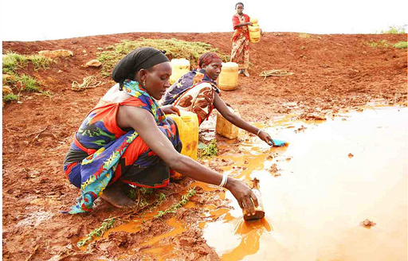
Figure 11.6 Borena women in Southern Ethiopia collecting water from a pond during a drought.

11.5 Climate change impacts on sanitation and hygiene
Flooding due to climate change is expected to affect sanitation because it damages drainage infrastructure and wastewater treatment facilities. During flooding, the flood water can burst sewer lines, where they exist, and overwhelm waste treatment plants. In other areas, pit latrines and septic tanks are liable to overflow. Sanitation facilities in urban and slum areas are highly vulnerable to flooding because they are often poorly designed and constructed.
In rural areas where the latrine coverage is low and open defecation is still a widespread practice, the impact of flooding on sanitation is huge. Even where latrines exist, they often have slabs made of wood and mud, which are much more vulnerable than concrete slabs if there is a flood. Most latrines do not have a proper roof, substantial walls or a diversion ditch to divert flood water and stop it entering the latrine. If the latrine overflows, this leads to contamination of water sources and outbreaks of diarrhoeal diseases, as we described in Section 11.1. The health problems caused by flooding are aggravated when people are displaced by the flood into overcrowded refugee camps with poor sanitation facilities and water supplies. When they return to their homes after the flood ends, their traditional sources of water have been contaminated by pollutants and disease-causing organisms (International Federation of Red Cross and Red Crescent Societies, 2005).
Drought and water shortages also have considerable impact on sanitation and hygiene. Nowadays, an increasing number of households in better-off urban areas use water-flush toilets, which require several litres of water to flush human excreta into a septic tank or sewer. Water shortages mean that the excreta cannot be flushed away, so bad odour builds up which attracts flies. This increases the risk of transmitting faecal organisms on the hands. Water shortages also mean that people cannot maintain their personal hygiene by washing their hands and face or bathing their body.
To conclude this study session, consider the following question before moving on to the next which describes the importance of developing resilience to climate change and coping strategies for the future.
- How is climate change affecting Ethiopia? Can you add your own observations?
- Ethiopia is experiencing increases in temperature, and changes in the levels and patterns of rainfall. We hope you were able to add your own observations such as the start, duration and quality of the rainy season, or sustained drought in certain areas.

Summary of Study Session 11
In Study Session 11, you have learned that:
- Climate change can affect human health both positively and negatively, but the negative health impacts are expected to exceed the positive effects.
- Changes in temperature, precipitation and weather extremes (such as heatwaves) can affect people directly, whereas indirect health impacts result from changes to natural and social systems caused by climate change.
- Climate change is expected to have a greater impact in low-income countries such as Ethiopia because of low numbers of trained people, poor infrastructures and limited economic capability to respond to the challenges.
- Many diseases of humans and livestock are increasing because of the indirect effects of climate change.
- Droughts and floods cause losses of human life and livestock, damage to homes, businesses and infrastructures, erosion of soils, grassland and farmland, and loss of productivity.
- Climate change is expected to reduce biodiversity because it has impacts on the environment and climatic conditions that threaten the survival of endangered plants and animals.
- Climate change is expected to have significant impacts on the economy of Ethiopia which is highly dependent on climate-sensitive activities such as rain-fed agriculture and livestock production. National income from exports, such as coffee, pulses, flowers and animal products, is likely to be reduced if climate change continues.
- Drought has many impacts on WASH in Ethiopia. Water scarcity reduces access to clean drinking water, deters people from bathing and handwashing, and restricts the use of water-flushed toilets. People are forced to use unsafe water sources, or walk long distances to collect water, otherwise they must buy it, which adds to poverty and so increases the risk of disease and also causes children to miss schooling.
- Floods have many impacts on WASH in Ethiopia. Flood water spreads pollutants and disease-causing organisms from latrines, areas of open defecation and damaged sanitation lines and waste treatment facilities.

Self-Assessment Questions (SAQs) for Study Session 11
Now that you have completed this study session, you can assess how well you have achieved its Learning Outcomes by answering these questions. You can check your answers with the Notes on the Self-Assessment Questions at the end of this Module.

SAQ 11.1 (tests Learning Outcome 11.1)
Give two examples of potential positive health impacts and two examples of potential negative health impacts of climate change in Ethiopia.

SAQ 11.2 (tests Learning Outcome 11.3)
Rewrite the paragraph below using terms from the list provided to fill the gaps:
agriculture, climate, crops, export, livestock, waterlogging.
Ethiopia's economy is highly dependent on ……………… which is very sensitive to ……………… change. For example, an increase in flooding will wash away ………………, reduce the amount of grazing land for ………………, and reduce productivity due to ……………… of farmland. The impact on Ethiopia's GDP is likely to be significant because national income relies heavily on the ……………… of agricultural products.

SAQ 11.3 (tests Learning Outcomes 11.2, 11.3, 11.4 and 11.5)
The water supply in Ethiopia is expected to decrease if climate change results in more frequent and more severe droughts. Give one reason why a shortage of water is likely to have a negative impact on each of the following:
- the Ethiopian economy
- the health of people on low incomes in rural and urban populations
- the education of school children
- the efficiency of sanitation.

Study Session 12 Resilience and Coping Strategies

Introduction
People, communities and society are vulnerable to harm arising from a range of sources. Extreme weather events and climate change add to the challenges of rapid urbanisation, population growth and environmental degradation. In order to cope with these problems, people, communities and society need to be resilient; that is, to be able to recover from such shocks and stresses, and have coping strategies to deal with them.
In this study session, you will be looking at Ethiopia’s approaches to climate change resilience. You will learn about some particular features of resilience in the water sector, as well as Ethiopia’s strategic response to climate change. You will also find out about resilience in urban areas and early warning systems that provide information to help us respond to hazards.

Learning Outcomes for Study Session 12
When you have studied this session, you should be able to:
12.1 Define and use correctly all of the key words printed in bold. (SAQs 12.1, 12.3 and 12.5)
12.2 Describe how resilience in the water sector can be improved. (SAQ 12.2)
12.3 Explain how Ethiopia’s Climate Resilient Green Economy can contribute to the adaption to and mitigation of climate change. (SAQ 12.3)
12.4 Describe the key principles for urban resilience to climate change (SAQ 12.4)
12.5 Explain the importance of preparedness and early warning systems. (SAQ 12.5)

12.1 What is resilience?
Resilience is the ability of an individual, household, community, society or system to withstand, cope with and quickly recover from shocks and stresses. Shocks and stresses might include drought, floods and other natural hazards, as well as long-term changes in the climate and environmental degradation. They can result in shortage of resources and failed infrastructure and other situations that have the capacity to cause harm.
Understanding the concept of resilience is useful in addressing climate risk and unexpected events. Responses to climate change largely fall into two categories: mitigation and adaptation. Mitigation involves trying to reduce the causes of climate change, such as reducing carbon emissions and protecting forests and wetlands which act as carbon sinks. Thus, mitigation strategies aim to reduce the sources or enhance the sinks of greenhouse gases (IPCC, 2001). In contrast, climate change adaptation involves addressing the effects of climate change by making communities more resilient. It involves adjustments in natural or human systems in response to actual or expected climatic effects in order to moderate the harm they may cause (IPCC, 2007b). Plans for improving climate change resilience should include adaptation measures, mitigation actions and disaster risk reduction.
- Choose a place you know or have read about that is threatened by climate change. This could be a small village, a town or a particular region of Ethiopia.
- What is the name of your place and where is it located?
- In what ways is it threatened?
- In what ways can it be made resilient?
- You will have your own answer to these questions but in answering them you need to identify the threats to your place, and then consider what can be done to protect it. You might consider what local people could do, as well as what the government or others could do. Possibilities may have been extreme, like relocating people to safer areas; or more manageable such as improving people’s education about the risk and improving preparation for emergencies.
Individuals and communities with low resilience are vulnerable to shocks and stresses and have little ability to recover. Vulnerability means the degree to which individuals, communities or systems are susceptible and less able to cope with harm (IPCC, 2007b). On a wider level, you could think of resilience as the capability of the system or country to manage risks and reduce the occurrence of hazards and to adapt to change over the long term. The ability of a system to adapt to climate change and cope with its consequences is called the adaptive capacity of the system.

12.2 Resilience in the water sector
In Study Sessions 1 and 4 you read about the limited availability of water in terms of both quantity and quality. By 2025, half of the world’s population will live in water-stressed river basins (World Wildlife Fund, 2015). You have also read about population growth, urbanisation, changing land use and the increasing demand for water for domestic, industrial and agricultural purposes. Climate change will aggravate these growing human pressures on water systems.

12.2.1 Adaptation measures
Improving resilience in the water sector means developing the adaptive capacity of the system. Countries need to adopt appropriate adaptation measures in their water supply sector that will reduce wastage, promote wise use of fresh water and improve water management practices. These adaptation measures include:
- Efficient use of water resources: ensure effective use and fair sharing of existing resources; develop new water sources and reservoirs; promote efficient use of water by consumers through education and tariff structures; develop water reuse and recycling; develop rainwater harvesting schemes.
- Leakage reduction: ensure that equipment and fittings of the water supply system are properly maintained to reduce the frequency of leakage, and that they are repaired promptly.
- Testing existing technologies for resilience: water and sanitation services should be robust enough to ensure that water quality, water quantity and sanitation systems can be maintained.
- Protecting ecosystem resilience: the impacts of natural disasters and climate change should be monitored to maintain the resilience of water and wetland ecosystems. Ecosystem resilience means that the effects of events like fires or drought do not make fundamental long-lasting changes to biodiversity within the ecosystem.
- Flexible management approaches: decision makers need to be able to adapt to the full range of climate scenarios and the demands they generate.
Following these principles for adaptation will help to ensure that increasing problems of water stress can be managed appropriately and that the water sector improves its resilience to future change. Many of these measures are about the sustainable use of water and require changes to the way water resources are managed. We will now look at three examples of water management practices that will help improve resilience: water conservation, water reuse and catchment management.

12.2.2 Water conservation
Water conservation covers a broad range of activities from using less water at home to national policies to protect freshwater ecosystems. Its purpose is to manage water sustainably by using less or using it more efficiently so that present and future needs of people and the environment can be met.
Freshwater conservation efforts are designed to protect and restore biodiversity in water and wetland ecosystems and the ecosystem services they provide. Ecosystem services are the benefits that people obtain from these systems, such as the provision of drinking water and food. Freshwater ecosystems support 12% of known species, while they account for only 1% of the Earth’s surface (Gleick, 2012). They include rivers, ponds, lakes, marshes, bogs and swamps, but they are becoming increasingly rare. Wetlands are also important carbon sinks but they are often drained to support agriculture or for human settlement.
An example of water conservation in agriculture is the use of drip-feed irrigation, which provides water directly to the soil near the roots of the growing crops (Figure 12.1). It requires a great deal less water than conventional methods of flood or spray irrigation in which much of the water is lost by evaporation. By using less water, the volume taken from rivers is reduced which helps to maintain the river ecosystem.
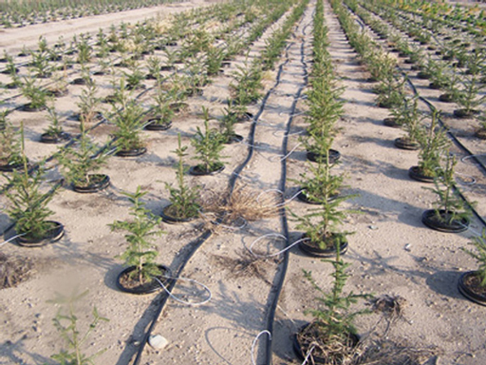
Figure 12.1 Drip-feed irrigation system reduces water loss by evaporation.
Other examples of water conservation from agriculture include changing the variety of crop that is grown to those that require less water and are more drought-resistant. Changing techniques for planting can also reduce water use, for example, creating a small hollow around the stem of a plant can ensure that water seeps into the ground close to the roots rather than running off over the surface.

12.2.3 Recycling water
Wastewater recycling will become an increasingly important source of new water resources. It means finding ways to use water more than once. Recycled water can be used to recharge groundwater aquifers, supply industrial processes, irrigate certain crops and supplement domestic supplies. Recycling helps provide usable water and reduces pollution of existing supplies. Many industrial and domestic processes do not require water of drinking standard. For example, water for flushing toilets does not need to be of the same quality as drinking water. There has been a significant increase in the availability and use of treated wastewater for a wide range of applications in different parts of the world and this is an area that is likely to grow.

12.2.4 Catchment management
In the past, responsibility for management of water resources has often been divided among several different agencies or administrative departments. For example, responsibility for providing water supply for domestic users would be entirely separate from water for irrigation, even though they would both be using the same resource. This lack of coordination creates problems because it does not recognise the processes and connections of the water cycle or the links between the various parts of the water resource system.
To overcome this problem, the natural boundaries of the water catchment should be recognised. The catchment area, also known as the watershed, of a river is the total area of surrounding land that slopes towards the river. Rainwater that falls in a catchment flows into the river and is therefore affected by the type of land over which it flows. Water can be contaminated by pollution sources in the catchment even though they may be some distance away. Adopting an integrated catchment management approach means that these connections are take into account. Integrated catchment management involves both water use and land use within the catchment area. It recognises the connections between water quality and water quantity and those between surface water and groundwater. Importantly, the needs of the environment are also taken into account. This integrated approach can improve resilience because understanding the connections within a system helps managers to predict impacts and identify strategies for coping with change.

12.3 Response to climate change in Ethiopia
- Have you experienced periods of drought or cuts in water supply? How did you cope?
- Most of us in Ethiopia have experienced drought and cuts to supply. While access to drinking water is the main concern, we quickly realise how dependent we are on water for many other things that make life comfortable. Bottled water and tankers that transport water should ensure we have water to drink, but we quickly adjust to washing less frequently, cooking less and eating more raw food. In other words, we adapt and cope.
For reasons you have read about in previous study sessions, climate change is a growing concern for the Ethiopian government. At the heart of Ethiopia’s climate change initiatives is the Climate Resilient Green Economy strategy.

12.3.1 Ethiopia’s Climate Resilient Green Economy
Awareness of climate change impacts has intensified in recent years. The Ethiopian government has decided to respond in a way that not only seeks to mitigate and adapt to climate change, but also to use this as an opportunity to switch to a new development model that will be sustainable. To this end, the government has initiated the Climate Resilient Green Economy (CRGE) strategy (FDRE, 2011). This aims to protect the country from the adverse effects of climate change and to build a green economy that will help realise Ethiopia’s ambition to reach middle-income status before 2025. The term green economy is defined as a sustainable economy and society with zero carbon emissions where all energy is derived from renewable resources which are naturally replenished. In contrast, a black energy economy is based on carbon-intensive fossil fuels such as coal and oil.
Ethiopia’s CRGE strategy identifies more than 60 initiatives to limit greenhouse gas emissions while still bringing economic development. The aim is for emissions in the year 2030 to be roughly the same as they were in 2011 when the strategy was published. This is less than half the level estimated under a conventional development path.
The CRGE plan is based on four pillars (FDRE, 2011):
- Agriculture: improving crop and livestock production practices for higher food security and farmer income while reducing emissions.
- Forestry: protecting and re-establishing forests for their economic and ecosystem services, including as carbon stocks.
- Power: expanding electricity generation from renewable sources of energy for domestic and regional markets.
- Transport, industrial sector and buildings: leapfrogging to modern and energy-efficient technologies in transport, industrial sectors and buildings. (Leapfrogging means jumping ahead without going through a slow development process.)
The required budget for the CRGE is US$150 billion for 20 years, most of which is expected to come from external sources (Gebremedhin and Mengistu, 2014). Four key initiatives have been identified for fast-track implementation:
- Exploiting Ethiopia’s vast hydropower potential.
- Large-scale promotion of advanced rural cooking stoves.
- Efficiency improvements in livestock rearing.
- Reducing emissions from deforestation and forest degradation.
Taking each of these in turn, the country’s vast hydroelectric power potential through its 12 river basins is being exploited by building large dams such as the three Gilgel Gibe dams and the Grand Ethiopian Renaissance Dam (Figure 12.2), which is expected to be Africa’s largest dam. These provide renewable energy but, internationally, these projects are contested because of the potential impact they could have downstream in terms of reducing supply, particularly in Egypt (BBC, 2014).
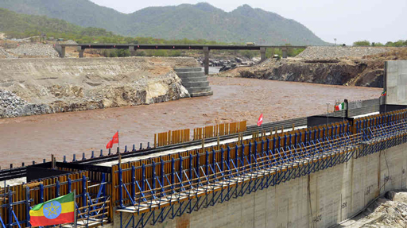
Figure 12.2 The construction site for the Grand Ethiopian Renaissance Dam in northern Ethiopia. When completed, the reservoir will cover an area of 1800 km².
Secondly, the government favours the large-scale promotion of advanced rural cooking stoves because they are fuel efficient (Figure 12.3). Traditionally, most rural households burn wood and charcoal on open fires to cook, causing indoor and outdoor air pollution. The new stoves use less fuel, are safer and produce less smoke which brings health benefits.
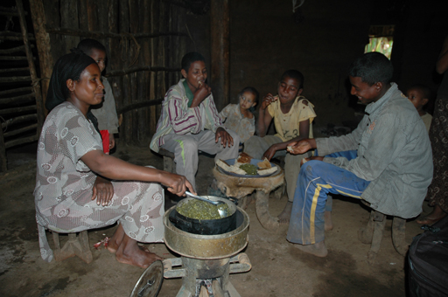
Figure 12.3 An Ethiopian family enjoys a meal cooked on an advanced cooking stove.
Thirdly, efficiency improvements in the rearing of livestock can bring economic benefits. Ethiopia has more cattle than any other African country and is the eighth-largest producer of livestock in the world (CNFA, 2015). Yet in 2011 Ethiopia accounted for less than 1% of total global meat exports, so this is clearly an area of potential growth.
Fourthly, the government is prioritising the reduction of emissions from deforestation and forest degradation. This initiative aims to lower the emission of greenhouse gases as a result of changing land use. The country’s diverse landscapes provide food, water, firewood, construction materials and medicines, and if well managed can help reduce the risk of flooding, drought and famine. While climate change has increased the frequency of these risks, effective land use management can contribute to resilience against such risks, as well as improve biodiversity and carbon stocks in the soil and vegetation (World Bank, 2014). The pressures on land use are due to the expansion of subsistence agriculture and livestock grazing in fragile areas, leading to land and water degradation. But this is now changing, with large-scale landscape restoration underway in Tigray, for example (World Bank, 2014).
The CRGE strategy demonstrates Ethiopia’s commitment to responding to climate change. The government is developing national frameworks for adaptation and establishing the institutional structures to manage climate change such as the country’s Environmental Protection Authority (EPA) which coordinates and makes climate change policy an integral part of development initiatives.

12.4 Resilience in urban areas
Although Ethiopia is currently one of the least urbanised countries in the world, this is likely to change over the next couple of decades.
- Do you recall, from Study Session 5, what the percentage urban growth rate is in Ethiopia? How does this compare with other countries in Africa?
- Ethiopia’s urban growth rate is more than 4% per year, which is one of the highest in Africa.
The increasing urban population puts added pressure on housing, transport, water supply and other systems and services. Urban resilience is when the systems and services of the town or city survive shocks and stresses, the people and organisations are able to accommodate these stresses into their day-to-day decisions, and the city’s institutional structures continue to function (Asian Development Bank, 2014). There is no single action that will make a city resilient to climate change. Resilience is developed through many actions, which build upon each other and where the focus is on preparation for disaster rather than response to it. This means that plans for resilience should be included as part of any urban development plan. The Asian Development Bank (2014) identifies the following guiding principles for urban resilience:
- Combine ‘hard’ and ‘soft’ measures in the plan: this highlights that the actions and behaviours (soft measures) of individuals, communities and institutions are as critical to city resilience as protecting physical structures such as buildings and transport networks (hard measures). Resilience needs regulations, information systems and social networks.
- Engage multiple stakeholders: cities are diverse and complex, so engaging businesses, civil society and government is necessary to build resilience and to form city-wide plans of preparedness.
- Enlist different geographic and governance scales: cities have links with rural areas, internationally, and with each other. These links can be vital for building resilience, providing relief and sharing information about best practice.
- Look to the future: planning processes have to address current issues but should also consider possible future situations, even though they may be uncertain.
- Use local expertise: people with local knowledge can exchange information with external experts to build long-term adaptive capacity.
- Build leadership: effective resilience needs strong leadership and accountability.
- Focus on vulnerable communities: meaningful urban resilience must meet the needs of poor and vulnerable households who lack the resources available to others.
Building communication networks and sharing best practice is an important aspect of these principles. An example in Ethiopia is the Ethiopian Cities Association (ECA), which was launched in 2009 and has a membership of 28 cities. The ECA provides a platform for cities to learn from each other (Cities Alliance, 2014). The ECA also works with residents and other stakeholders, including businesses, to plan urban development more effectively. The idea is that the network enables cities to implement reforms faster and more efficiently because of the shared learning.

12.5 Early warning systems
An important element of resilience is having contingency plans that can be put into action if disaster strikes. These are plans that provide answers to such questions as ‘what if the town floods?’ or ‘what if there’s an earthquake?’ To be effective these plans need an early warning system to alert people of impending danger to trigger avoidance actions and reduce risk. Early warning systems refer to a set of capacities needed to generate and disseminate timely and meaningful warning information to enable individuals, communities and organisations threatened by a hazard to prepare and to act appropriately and in sufficient time to reduce the possibility of harm or loss (UNISDR, 2009). Or, to put it more simply, early warning systems are designed to let people know when something bad is going to happen so they can prepare themselves and try to avoid harm. An early warning system can bring safety, security and peace of mind.
Early warning systems make contingency planning and evacuation procedures more precise and help put people and their property and livelihoods out of harm’s way. In Ethiopia there is a high degree of vulnerability to natural and climate hazards, particularly among the poorest households and those located in remote areas. Communication to these and other people through an early warning system can help reduce disaster risk by improving preparedness and giving greater protection to people and their livelihoods. Figure 12.4 demonstrates the essential elements of an early warning system.
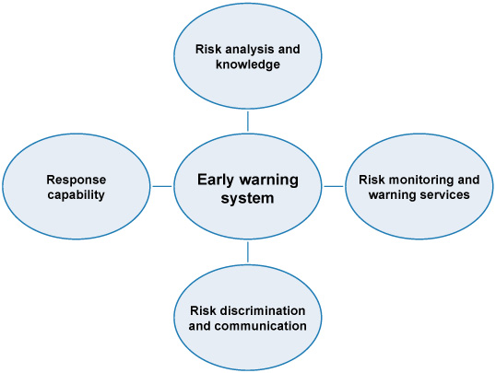
Figure 12.4 The elements of an early warning system.
An early warning system works best as part of an integrated and unified risk management framework. The government launched its National Policy and Strategy on Disaster Risk Management in July 2013. The main objective of the Policy is ‘to reduce disaster risks and potential damage caused by a disaster through establishing a comprehensive and coordinated disaster risk management system in the context of sustainable development’ (FDRE, 2013). Previous policies had focused on drought and are believed to have prevented severe drought disasters in 2002 and 2010. However, the government now acknowledges the risk of disasters other than drought, such as flood, human disease epidemics, livestock disease outbreaks, crop pests, and forest and bush fires. The most notable features of this new strategy have been the movement away from concentrating on drought and relief assistance to a more proactive strategy that seeks to monitor, prepare and warn people of risks both in the urban and rural areas, to decentralise the disaster risk management system and incorporate the strategy into development policies (FDRE, 2013).
With this and other policies Ethiopia is moving forward with plans to build adaptive capacity and improve resilience to climate change. We conclude this study session with a comment on the ultimate goal for resilience strategies. Whereas early notions of resilience spoke of systems returning to a stable and pre-existing state, there is now an acceptance that this is rarely possible, and perhaps not even desirable. Instead, more recent ideas have emphasised the system’s capacity to reorganise, change and adapt to threats. This is because episodes of stress can be recurrent events, and returning to the situation that existed before the disturbance may simply be a return to vulnerability. Change, however, can build greater resilience in order to be less reactive and more proactive.

Summary of Study Session 12
In Study Session 12, you have learned that:
- Resilience is the ability of an individual, a household, community, or society to withstand, cope with and quickly recover from shocks and stresses such as drought, floods or natural disasters.
- Climate change resilience should comprise climate change adaptation, mitigation actions and disaster risk reduction.
- Adaptation for resilience in the water sector involves efficient use of water, reducing leakage, robust systems, ecosystem resilience and flexible management.
- Water conservation, recycling of water and integrated catchment management are examples of possible improvements in water resource management.
- The Ethiopian government has initiated the Climate Resilient Green Economy strategy to protect the country from the adverse effects of climate change and to build a green economy that will help realise its ambition of reaching middle-income status by 2025.
- Increasing urban populations make urban resilience a high priority. Developing urban resilience includes recognising the importance of soft and hard systems, engaging all stakeholders, making links with others, looking to the future, using local knowledge, building leadership and focusing on vulnerable people.
- Early warning systems are designed to warn people of possible harm. They require risks to be monitored and analysed so they can be communicated to people and responses can be prepared.

Self-Assessment Questions (SAQs) for Study Session 12
Now that you have completed this study session, you can assess how well you have achieved its Learning Outcomes by answering these questions. You can check your answers with the Notes on the Self-Assessment Questions at the end of this Module.

SAQ 12.1 (tests Learning Outcome 12.1)
Write the following words next to their correct definitions in the table below:
adaptive capacity; black energy economy; early warning system; ecosystem services; green economy; integrated catchment management; resilience; vulnerability.
ability to withstand, cope with and quickly recover from shocks and stresses
land and water management approach that takes account of the links between land use and water resources
susceptibility to the effects of harm
economy with zero carbon emissions and all energy derived from renewable resources
ability of a system to adapt to climate change and cope with its consequences
benefits and essentials for living that people get from natural environmental processes
economic system based on carbon-intensive fossil fuels such as coal and petroleum
mechanisms to produce timely and meaningful information about a forthcoming emergency

SAQ 12.2 (tests Learning Outcome 12.2)
Resilience to the uncertainties of climate change in the water sector depends on the sustainable use of water. Give four examples of methods for improving efficiency in water use, choosing one example from each of the following: agriculture, domestic supply, industrial use and water management.

SAQ 12.3 (tests Learning Outcomes 12.1 and 12.3)
Consider the four pillars of Ethiopia’s Climate Resilient Green Economy strategy and identify whether they are examples of climate change mitigation or adaptation or both.

SAQ 12.4 (tests Learning Outcome 12.4)
Which of the following statements is false? Explain why it is incorrect.
- Urban resilience plans should prioritise poor and vulnerable people who are less able to protect themselves.
- Cities should share information about their experiences of climate change so they can learn from each other.
- The best people to prepare urban resilience plans are international experts in climate change because they can accurately predict future changes in weather patterns.

SAQ 12.5 (tests Learning Outcomes 12.1 and 12.5)
What are the essential elements of an effective early warning system?

Study Session 13 Human Values and Behaviour

Introduction
In Study Session 8 you learned about ways in which pollution of the air, water and food can affect the environment and human health. In this study session we focus on the human values and behaviour that either protect our health and the environment from contamination by human and animal waste, or result in exposure to sources of pollution. We describe how behaviour is influenced by knowledge, beliefs, attitudes and traditions concerning the causes of disease and responsibility towards the environment, and also by household economic factors and gender issues. These aspects of the social environment must be considered in your own community if you are to be successful in preventing and controlling infectious diseases and environmental pollution by encouraging everyone to use good WASH practices consistently and to value them as normal practices.

Learning Outcomes for Study Session 13
When you have studied this session, you should be able to:
13.1 Define and use correctly all of the key words printed in bold. (SAQs 13.1, 13.2 and 13.3)
13.2 Describe ways in which the social environment of knowledge, beliefs, attitudes and traditions can affect human values and behaviour towards WASH practices. (SAQs 13.1 and 13.3)
13.3 Give examples of how positive or negative human values and behaviour concerning WASH practices can affect infectious disease transmission and the physical environment. (SAQs 13.1, 13.2 and 13.3)
13.4 Explain why it is important to address economic factors and gender issues when devising a communication strategy to promote good WASH practices. (SAQs 13.1 and 13.3)

13.1 The physical and the social environment
Everywhere you look, you see people, animals and plants living in fields and forests, streams and hillsides, or in villages, towns and cities. These are all part of the physical environment of the ‘real world’ that we can see with our eyes and touch with our hands. In your town, there are physical structures that humans have built or made, including houses, churches, mosques, schools, shops and market stalls, a health centre, kebele office or a police station.
- Can you identify some other features of the physical environment in your town? (Figure 13.1 gives some clues.)
- You may have mentioned roads and traffic, pavements, advertising signs, electricity cables and lamp-posts, or perhaps ditches to catch water and prevent flooding in the rainy season, which are not visible in Figure 13.1.
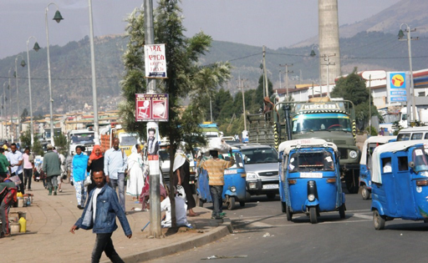
Figure 13.1 The physical environment in an urban community in Ethiopia.
The physical structures we have mentioned also provide the local population with various kinds of social services. For example, a church or mosque provides religious services; a school provides education; shops and markets provide access to food and other products; roads provide transport links; and houses provide shelter. These services contribute to the social environment of the community. The social environment also includes the attitudes, beliefs, practices and traditions that are expressed by the members of a community. Unlike the physical structures, they cannot be seen.
Case Study 13.1 will help you to see the difference between the physical and the social environment. Read the case study and then answer the questions that follow it.

Case Study 13.1 Ato Belay interviews community members on their latrine use
Ato Belay was recently employed on an urban Health Extension project. He was given a task to prepare the annual plan of action on excreta management in his urban neighbourhood. He went house to house to collect data to identify who has, or has not, got a latrine, in order to design his plan of action. He recorded that less than 40% of households had latrines. The others were using open defecation and open urination in public places such as close to fences, around riverbanks, near waste containers or in the bush.
Ato Belay asked questions to find out why households do not have latrines, or do not use their latrine. Some said that constructing a latrine is too expensive. Others reported that collecting faeces in a latrine creates bad odour; they believed defecating in the open air is healthier because bad odour causes illness; others also said that open spaces have ‘good air’ when defecating. When Ato Belay asked about soiling the physical environment, some community members said: ‘Our ancestors never used latrines and the bush is not harmed by defecating there.’ Some people said that children should defecate in the open because latrines are only meant for adults. Others believed that children may be exposed to ‘evil’ influences emerging from the latrine pit if they use it at night. Ato Belay concluded that open defecation was the main sanitation problem in his community.

- Now answer these questions:
- Which parts of the physical environment did Ato Belay ask about?
- What was the social environment he investigated?
- What was the public health problem he identified?
- What information does Ato Belay need to find out from community members in order to design his sanitation action plan?
- The answers are as follows:
- The physical environments he asked about were latrines and the places where people urinated or defecated in the open.
- The social environment he investigated was the attitudes and beliefs of community members about using latrines and open defecation.
- The public health problem he identified was the widespread practice of open defecation by adults and children.
- Ato Belay needs to find out why residents are not using latrines even when the household has the facility, and why households without a latrine do not want to build one.
The part that the social environment plays in the above example demonstrates the importance of understanding why someone is defecating in the open or not using their latrine. So now we will look more closely at how the social environment influences WASH practices.

13.2 How does the social environment influence WASH practices?
The building blocks of our behaviour lie in our knowledge, practices, attitudes, beliefs and traditions, all of which contribute to the social environment. Figure 13.2 summarises the interactions between these invisible aspects of the inner personal world of every individual and their community, and shows that they all influence whether good water, sanitation and hygiene practices are adopted.
Figure 13.2 Diagram summarising the interaction between knowledge, beliefs, attitudes, practices and traditions in a community and their influence on valued WASH practices.
We have called the behaviours at the centre of Figure 13.2 ‘valued WASH practices’ to indicate that they are actions that a community values and approves. Individuals who are observed doing these actions (for example, washing their hands before eating) gain credit from others in the community because they are behaving in these valued ways. An example of a behaviour that is valued in rural Ethiopia is debo, the practice of neighbours working together to harvest the crops from each farm in turn.
Notice that each part of Figure 13.2 is interacting with all the other parts to influence valued WASH behaviours. The main message of the diagram is that you must consider all these aspects in the social environment of your community if you want to be successful in replacing unhealthy or environmentally damaging behaviours by valued WASH practices. We begin by considering the limitations of knowledge to bring about behaviour change from unhealthy to good WASH practices.

13.2.1 Knowledge of WASH practices is not enough to change behaviour
Knowledge can be defined as all the information we have learned and synthesised during our growth and development.
- We assume you know that people who drink dirty water may get sick as a result because harmful bacteria live in the water. Think for a moment about how you acquired this knowledge?
- You may have been told not to drink dirty water by your parents; or perhaps you learned about bacteria at school; or maybe the Health Extension Worker made a poster about only drinking clean water to avoid getting diarrhoea; you could have heard about it on the radio, or learned from your own experience if you drank dirty water as a child and developed diarrhoea afterwards.
Figure 13.3 summarises the ‘upside-down pyramid’ of sources of knowledge acquired during a lifetime.
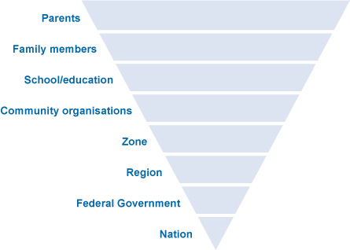
Figure 13.3 Diagram representing the different levels of influence on a person’s knowledge.
Education is a key factor in improving the knowledge of WASH issues in a community. Learning about hygiene and sanitation in school is a particularly important driver of behaviour change. The Ethiopian government has a strong commitment that all children should attend school. If children learn the right way from a young age, they will keep good WASH practices throughout their lives. For example, they can be taught the correct way to wash their hands at critical times, that is, before and after preparing food or eating, and after urinating, defecating or cleaning a child’s bottom (Figure 13.4).
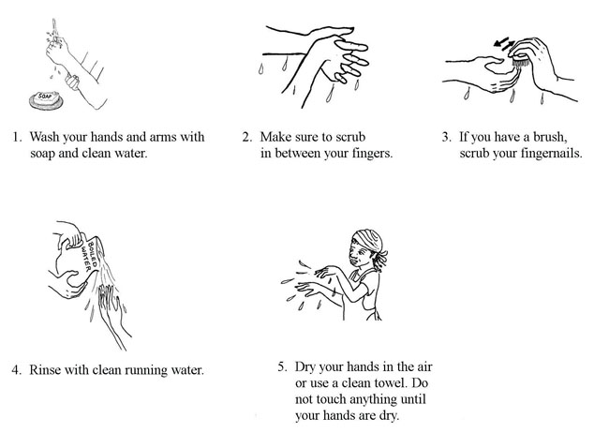
Figure 13.4 Correct handwashing takes about one minute.
However, health education programmes are often unable to achieve behaviour change simply by giving adults knowledge of the health risks of poor hygiene or why they should not pollute the physical environment with waste. Even if people are given accurate information about what causes diarrhoea, this knowledge is generally not enough to persuade them to change poor hygiene and sanitation practices, their routine actions, doing something in the same way every time. For example, people whose routine practice is to defecate in the open every day are unlikely to change their behaviour simply because they have been given new knowledge about the risks to their health and the environment.

13.2.2 Attitudes, beliefs and traditions influence WASH practices
There are several reasons why unhealthy WASH practices persist, even if people have been given good information to help them change for the better. If you look again at Figure 13.2, you can see we have put ‘attitudes’ and ‘beliefs’ on either side of ‘valued WASH practices’. Attitudes are individual preferences or opinions about what a person likes or dislikes. Beliefs are firmly held states of mind about what is true or false. One reason for the persistence of bad WASH practices, even when correct knowledge is available, is that people have attitudes and beliefs that make them ignore the facts.
- Can you suggest an attitude and a belief that people might express about not using a latrine even when there is one nearby?
- Here are our suggestions, but you may have given other good answers:
- Attitudes against using latrines: ‘I dislike using latrines because they smell bad’; or ‘I prefer to empty my bowels in the open because the bad smell is blown away by the fresh air’.
- Beliefs against using latrines: ‘The bad odour collects in the latrine and causes disease if you breathe it into your body’; or ‘It is safer to defecate in the open because there are evil influences in latrines’.
Good WASH practices at community level also include handwashing, accessing clean drinking water, and keeping the physical environment clean and free from waste. Sustaining these practices builds our health, improves our lifestyle and helps us all to live longer. But first, negative attitudes and beliefs must be overcome and replaced with valued behaviours. For example, handwashing with soap before eating is not practised by everyone in Ethiopia, even though it prevents transmission of infection from dirty hands to the mouth. (Figure 13.5).
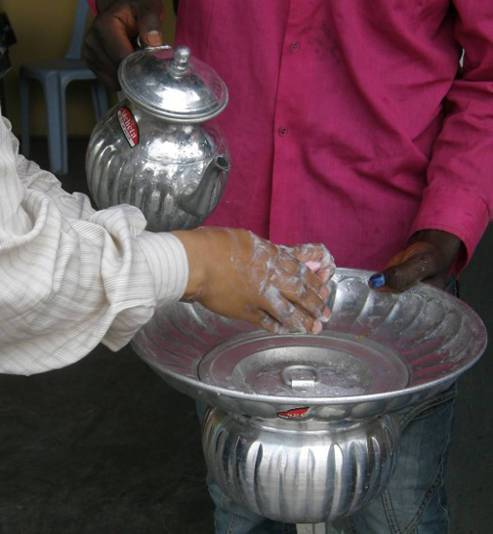
Figure 13.5 Handwashing with soap before eating is a valued WASH practice.
The example we gave earlier of debo – the valued practice in rural communities of neighbours helping to harvest crops from each other’s fields – can also be termed a tradition, a behaviour that is learned from previous generations and passed on to the next generation. Some traditions, like debo, bring positive benefits to the community and also to the environment. But some traditions expose people and the environment to possible harm.
- Open defecation is a tradition in communities like the one we described in Case Study 13.1. Can you recall the tradition mentioned by some of the people he spoke to?
- They told him that they continued to defecate in the open because their ‘ancestors never used latrines’. Behaviour that was accepted by the ancestors has become a tradition that people in this community pass on to their children.
Tradition is one reason why, according to the report of the Joint Monitoring Programme for Water Supply and Sanitation in Ethiopia (JMP, 2014), about 37% of Ethiopians were still practising open defecation in 2012.
Traditions are very difficult to change because everyone in a community believes it is the right way to behave. Individuals who challenge the tradition are likely to meet opposition from the majority who want to go on doing things in the old way. If open defecation or not washing the hands at critical times is considered normal and traditional in a community, it will take time and effort to persuade people that using a latrine (Figure 13.6) or handwashing with soap are valued practices that benefit the whole community and also protect the environment.
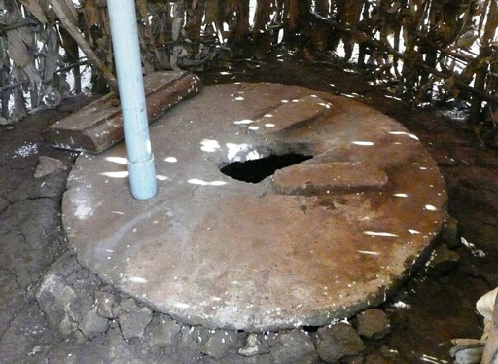
Figure 13.6 It takes time and effort to convince people that building a covered pit latrine like this one will benefit their family’s health and improve the local environment.

13.3 Other influences on WASH practices
In this section, we discuss three factors that influence whether WASH practices are adopted in a community: economic factors; gender and privacy issues; and caring for the environment.

13.3.1 Economic factors influence WASH practices
The cost of constructing a protected water source, a latrine or handwashing facilities may be too much for some households to pay, especially when purchasing WASH facilities and services is seen as a lower priority than spending limited financial resources on other needs. Primary priorities for most households, whether urban or rural, include secure housing, food, clothing and education for their children, and possibly also transport costs to take children to school or adults to work. Installing even the most basic latrine or handwashing basin may be unaffordable, but people can still wash their hands with a bowl and a bar of soap (Figure 13.7).
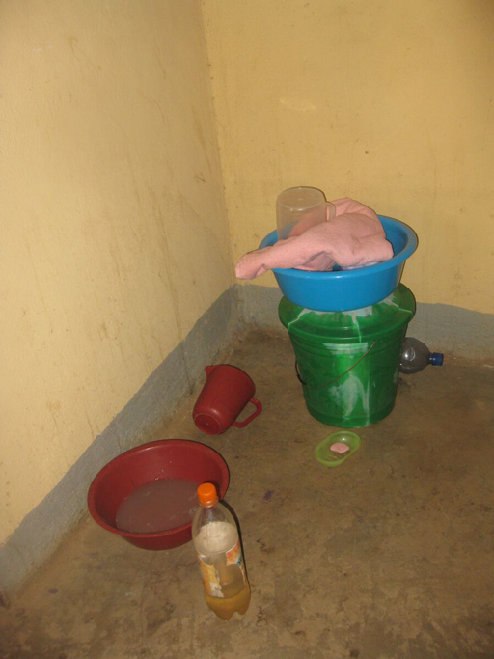
Figure 13.7 Households that cannot afford piped water and a washbasin can use soap, a bucket and a jug for pouring water over the hands.
However, constructing a latrine is much more expensive than buying a plastic bucket and some soap. The typical cost of a circular concrete slab for a pit latrine was about 260 ETB in 2015, plus there is also the cost of digging the pit and constructing a shelter, and paying a carpenter or bricklayer.
Local government may be able to assist households to obtain loans at low interest rates so that they can install WASH facilities. Community WASH projects may also be funded by local contributions and provide shared labour to build a communal latrine or protect a water source from contamination by human and animal waste.
Although there are costs involved, installing a WASH facility can also save some expenses for a household that uses them consistently. Diarrhoea, worm infestations and other communicable diseases resulting from poor WASH practices cause a significant economic burden on individuals, families, communities and Ethiopia nationally.
- Can you think of expenses that the family of a child with severe diarrhoea will have to pay?
- You may have mentioned the cost of treatment, including transport costs if the child goes to the health centre; and family members may lose income from their employment while caring for the sick child.
These expenses could have been reduced by using a latrine, handwashing at critical times and accessing improved water sources. The prevalence of diarrhoea among children in Ethiopia is still high: it tops the list of causes of morbidity (illness) in children under 5 and accounts for 16.5% of cases (MoH, 2014). If you multiply the costs to a single family with a sick child by the huge number of illness episodes that could be prevented by good WASH practices, you can see that WASH could bring huge economic benefits to the nation.

13.3.2 Gender, privacy and access issues influence WASH practices
It is against Ethiopian culture for women and girls to urinate in public, but it is quite common to see men and boys urinating in the street. Access to a safe and private place for this purpose is therefore a high priority for women, who may suffer great discomfort to avoid urinating or defecating until night time when they can go without being seen. However, this also exposes them to the risk of rape or robbery. Therefore, the provision of household latrines is a gender issue: it affects males and females differently.
Another difference between the genders in most Ethiopian families is that a woman prepares all the food. If her hands are clean when she touches food items and she washes fruits, vegetables and cooking utensils in clean water, the risk of transmitting infectious organisms to family members is much reduced. Research has shown that washing the hands with soap at critical times can reduce the incidence of diarrhoeal diseases in families by as much as 44%, and even without soap the reduction is about 30% (Curtis et al., 2011). This is very important in Ethiopia, where traditional food is eaten with the hands (Figure 13.8).
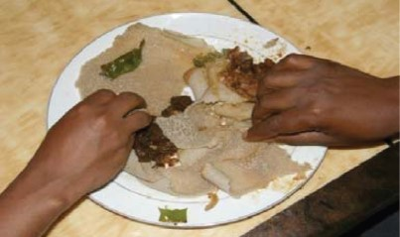
Figure 13.8 Handwashing is particularly important because Ethiopian food is traditionally eaten with the hands.
Installing handwashing facilities or building a latrine for the household therefore brings benefits to women in particular, but also improves the health of all family members.

13.3.3 Caring for the physical environment improves health outcomes
In Study Session 8, you learned about pollution of the urban environment when human excreta, household waste, animal droppings and other filth collects in the streets. All waste products are sources of disease because they attract rats, mice, dogs, flies and mosquitoes that can transmit infectious organisms to people. Bacteria, viruses and worms in rotting food and faeces are washed by rain into the soil and local sources of drinking water; they contaminate crops and get onto the hands of people working on the land or children playing. Unless hands are washed at critical times, the transmission of infection from soil to hands and into mouths is impossible to prevent. Therefore, keeping the community environment clean and free from waste (Figure 13.9), and persuading people of the health benefits of handwashing and latrine use are key goals for health workers and WASH workers.
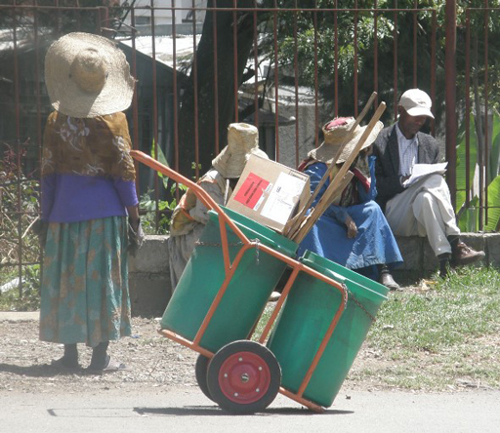
Figure 13.9 A road sweeper collects rubbish in an Ethiopian street.
In addition to protecting the environment as a way of protecting human health, we should also see the beautiful land, lakes and rivers, animals and plants of Ethiopia as our heritage.

13.4 Making WASH practices socially accepted and valued
It should be the aim of every WASH worker to make WASH practices socially acceptable and the norm in your community. If the majority of community members value and promote WASH practices, social pressure to conform will be felt by any individuals or households who do not behave in accordance with these shared norms. In model WASH communities, every household will use a latrine, hands are always washed at critical times, homes are kept clean and the neighbourhood is free from dirt and waste.
You will have to use excellent communication methods to give people accurate knowledge of the benefits of good WASH practices and the risks to health and the environment of persisting in harmful behaviours. Consultation and joint learning can be achieved through behaviour change communication (BCC) methods. These are a range of methods for communicating messages to communities and individuals about desirable changes to their behaviour, for example to improve hygiene practices. BCC methods include community meetings, local health conferences and community conversations (Figure 13.10), which enable everyone to share their views on WASH-related issues. BCC may include education of household members by urban Health Extension Workers and involvement of the Health Development Army.
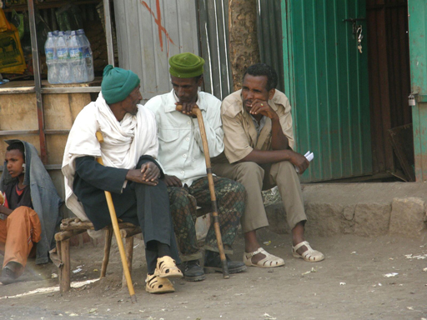
Figure 13.10 Community conversations can bring neighbours together to agree a plan to improve WASH practices.
To achieve the national goals for improvement in WASH provision, the ultimate aim is that community members, working with the local administration, have a clear plan of action for changing behaviour locally, so that good hygiene and sanitation practices become the norm for every household. Caring for the physical environment around us, whether it is the urban world of houses and streets or the natural world of fields and streams, is a responsibility that everyone should value. Evaluation of WASH practices as they are implemented enables you and the community to keep track of the improvements to health and the environment that have been achieved.

Summary of Study Session 13
In Study Session 13, you have learned that:
- The physical environment is the world we can see around us; the social environment is the invisible world of social interactions between people, their knowledge, attitudes, beliefs, practices and traditions.
- As a WASH worker you should understand the attitudes and beliefs about WASH practices in your community and whether they are valued or rejected.
- You should share your knowledge of how WASH practices benefit human health and protect the environment, but knowledge alone may not convince people to change traditional behaviours.
- Misconceptions, unhelpful attitudes and factually incorrect beliefs must be respectfully challenged and changed if you are going to achieve the goals for WASH improvement.
- Economic factors make it difficult for families to afford WASH facilities or make them a priority; however, repeated episodes of avoidable infections are a financial burden that WASH practices could reduce.
- Gender differences in sanitation behaviour mean that women in particular will be more comfortable, private and safe if they can access a latrine.
- Handwashing at critical times protects everyone from infection.
- Protecting the environment from pollution by faeces and other waste is a responsibility that everyone should share and value.
- Behaviour change communication strategies engage the whole community in developing an action plan, to make WASH facilities more available and good WASH practices the norm.

Self-Assessment Questions (SAQs) for Study Session 13
Now that you have completed this study session, you can assess how well you have achieved its Learning Outcomes by answering these questions. You can check your answers with the Notes on the Self-Assessment Questions at the end of this Module.

SAQ 13.1 (tests Learning Outcomes 13.1 to 13.4)
First read Case Study 13.2 and then answer the questions that follow it.

Case Study 13.2 Ato Belay observes handwashing practices at a wedding
Ato Belay was invited to a wedding where food and drinks were served. He observed that most people washed their hands in plain water before eating, but used soap after eating. Some people did not wash their hands at all, so he politely asked them why not. Some said: ‘The handwashing facility is too crowded’, or ‘There is not enough soap’. Others believed there was no health benefit from handwashing. Some said that soap and water was for washing clothes and should not be wasted on washing hands.
- What handwashing practice was used by most people at this wedding?
- Identify a negative belief concerning handwashing at this wedding.
- Identify a negative attitude concerning handwashing at this wedding.
- How may economic factors have influenced handwashing behaviour at this wedding?

SAQ 13.2 (tests Learning Outcomes 13.1 and 13.3)
- What are the critical times for handwashing that can have the greatest impact on infectious disease transmission?
- What percentage reduction in diarrhoeal disease episodes is achieved by routine handwashing at critical times with plain water or using water and soap?

SAQ 13.3 (tests Learning Outcomes 13.1 to 13.4)
How could building a latrine and ensuring all family members use good WASH practices benefit:
- the economic sustainability of the household?
- the women and girls in the family?
- the physical environment around the household?

Study Session 14 Global Environmental Policies and International Agreements

Introduction
The air, water, weather and climate of the continents of the Earth are interconnected. Human activities across the globe that use natural resources or produce wastes have also become interconnected, particularly with improvements in communication and transport. Many of Ethiopia’s activities both affect and are affected by those of other countries.
International activities and our shared global environment mean that countries worldwide have common interests that need to be addressed through international or global agreements on our environment, trade and business. Such agreements can take place between different countries or more widely through the United Nations. Global environmental policies are internationally agreed goals, principles or procedures used to guide decisions and actions to address specific environmental issues.
In this study session you will learn about global environmental policies and international agreements on environment and health with a focus on water quality, water pollution and use of water resources.

Learning Outcomes for Study Session 14
When you have studied this session, you should be able to:
14.1 Define and use correctly all of the key words printed in bold. (SAQs 14.1 and 14.5)
14.2 Explain the need for global environmental agreements and give examples of issues that need to be addressed at international level. (SAQs 14.2 and 14.3)
14.3 Explain the differences between some types of international agreement. (SAQ 14.1)
14.4 Describe some of the international agreements that relate to climate change and environmental protection. (SAQs 14.4 and 14.5)
14.5 Explain who has responsibility for monitoring implementation of conventions and protocols at international and national levels. (SAQ 14.6)

14.1 Why are global environmental policies needed?
Our world is facing multiple environmental crises, especially from different types of pollution. Pollution from one country can affect a neighbouring country, or even have a global impact. For example, untreated industrial waste discharged into rivers causes pollution at its source but can also affect people who live downstream of the discharge point. In large river systems this can create problems if the river crosses a border with another country and carries the pollution with it (Figure 14.1).
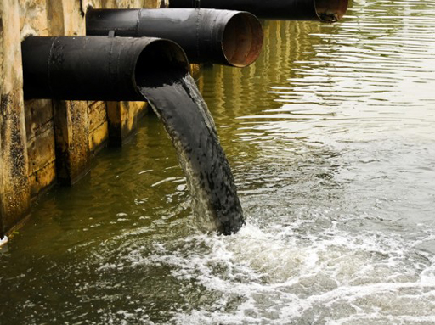
Figure 14.1 Pollutants discharged into a river will be carried with the flow and may create problems downstream.
Air pollution from factories, vehicles and wood fires contributes to localised health problems in towns and cities but is also moved around by wind and air currents. These emissions may also contribute to global-level climate change (Salih, 2001; UN-Habitat, 2014). Exporting polluting materials such as hazardous waste from one country to another also raises a concern. There are other ecological crises, such as extinction of animals and plants from the Earth because of destruction of habitats and hunting. Humans’ inability to respond to these various crises leads to a need for global policies to strengthen weak institutions and improve governance.
If you could view the Earth from space (Figure 14.2) you would see that we are all living on one planet and share one global environment. There is a great threat to our survival if humankind continues to damage the environment and if countries do not act together. We have shared responsibilities in caring for current and future generations.
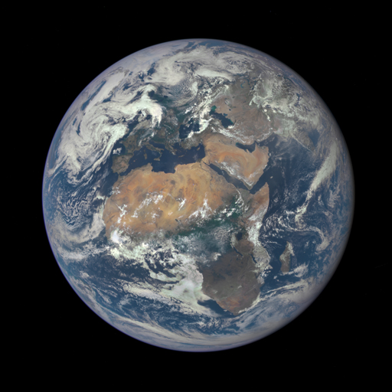
Figure 14.2 An image of Earth from space.
- If you had your own business, say a factory producing textiles, and you wanted to operate according to the principles of sustainable development, what would you need to take into account?
- In Study Session 3 you learned that sustainable development involves ‘meeting the needs of the present without compromising the ability of future generations to meet their own needs’. So, you would need to think about how your business would affect current and future generations. You would need to take into account the three pillars of sustainability – economy, environment and society. For economy you would need to consider both efficient and effective use of resources. For environment you should aim to use best practices that minimise the environmental impacts of your business. For society you would need to act responsibly and consider livelihoods, human health and well-being, equity, rights and quality of life, not just for current workers and their communities but for the future.
Protecting and managing our global shared resources requires institutions that support collective action (Ostrom, 1990). Such institutions include internationally agreed rules, laws and policies, as well as organisations. International agreements that become policies allow countries to work together in trade and investment and in addressing global concerns such as air pollution, water pollution, managing hazardous wastes, and climate change. All these issues are transboundary in nature, which means that the potential impacts from these events and developments cross national boundaries and affect more than one country.

14.2 Types of international agreement
International agreements take various forms depending on their stage of negotiation and implementation and whether they are intended to detail aims and aspirations or legal rights and duties. In this section we will consider some international agreements developed by the United Nations that have formed global environmental policies.
The United Nations (UN) is an intergovernmental global organisation with 193 member states (including Ethiopia) that promotes and facilitates international cooperation in order to address global concerns such as maintaining international peace and security, solving international problems and encouraging respect for human rights (United Nations, 1945). UN summits and conferences bring together representatives of the member states to discuss transboundary issues (Figure 14.3).
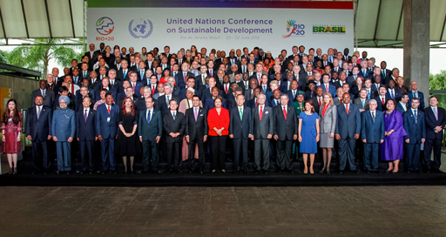
Figure 14.3 Heads of state and delegates from UN member states at the UN Conference on Sustainable Development, in Brazil in 2012.
Every member nation has the right to raise its concerns with the UN and can propose items for the agenda of the General Assembly, the UN’s main deliberative body. The self-interest of individual countries and the common interests of the international community can be in conflict. This means international agreement can be difficult to obtain and the process of developing agreements through the UN is highly political, involving many negotiations. Following drafting, discussion and negotiation on their details, many multilateral treaties are adopted by the UN General Assembly and subsequently implemented by the member states.
The terminology for international agreements is complicated. Several words have meanings that overlap and they are not always used consistently. Table 14.1 explains the most usual meanings of various terms used to describe the different types of agreement. Beyerlin and Marauhn (2011) listed 194 of these various agreements that apply internationally.
Table 14.1 Some different types of United Nations international collaboration initiatives and their characteristics. (United Nations, 2015)
Type of initiative | Characteristics
Agreement | Can be used generically to mean international agreement in its broadest sense including the widest range of international collaborations. It can also be used more specifically to describe initiatives that are less formal than conventions or treaties and often deal with a narrower range of subject matter.
Convention | Generally used for formal multilateral treaties with many parties; normally open for participation by the international community as a whole, or by a large number of states. A convention becomes legally binding on the states that sign up and ratify it.
Treaty | Embraces all agreements that are binding in international law; treaties are intended to create legal rights and duties.
Declaration | Usually used to declare aspirations rather than to create binding obligations.
Protocol | A supplementary document used to add detail or additional rights and obligations to a convention or treaty.
In order to come into force, an international convention or treaty needs to be ratified, which means individual states agree to be legally bound by it. Once an international agreement is ratified, then that agreement is enforced and monitored internationally. However, this applies only to the states that have ratified the convention and agreed to be bound by its conditions. For example, Ethiopia has ratified two conventions on the control of hazardous wastes, the Basel Convention and the Bamako Convention (described in Section 14.5).
A protocol, containing details of technical and administrative provisions, can be used to create legally binding obligations in international, and subsequently national, law. An example of such a protocol is the Kyoto Protocol on climate change, which was created under the United Nations Framework Convention on Climate Change (see Section 14.4).
Examples of declarations include the Declaration of Human Rights of 1948, the 1992 Rio Declaration on Environment and Development, the 2000 United Nations Millennium Declaration and the 2002 Johannesburg Declaration on Sustainable Development.
Note that UN initiatives are often referred to by the name of the place where they were created: for example, the Bamako Convention was agreed at a meeting in Bamako, Mali; the Kyoto Protocol from Kyoto, Japan, etc.
In the following sections, we will look at some of the main international agreements relevant to environment and WASH, organised by the topics they cover.

14.3 Conventions and agreements on climate change
In 1998 the UN Assembly determined climate change to be a common concern of humankind. The Intergovernmental Panel on Climate Change (IPCC), which is sponsored by the United Nations Environmental Programme (UNEP) and the World Meteorological Organization (WMO), produced evidence in its First Report in 1990 that climate change is a real threat to our environment (IPCC, 1990). More recently, the IPCC formed three working groups that considered three aspects of the problem: the detail of the physical sciences basis for climate change; its impacts on socio-economic systems, their vulnerability and their options for adaptation; and options for mitigation of climate change (IPCC, 2014).
- Why is climate change a concern for the global community rather than just a concern for individual countries?
- As you know from Study Sessions 9 and 10, climate change is a long-term shift in global weather patterns and average temperatures. At present there is a trend in global warming that is leading to the heating up of the atmosphere and oceans with melting ice at the poles and rising sea level. Temperatures and rainfall have become unpredictable in many parts of the world. Climate change is affecting the environment, water resources and human health and well-being across the world. It is of global concern because it affects the entire planet and because measures to combat climate change need to be implemented globally.
There have been lots of arguments and negotiations between less-developed countries, which are assumed to be most affected because of their currently limited resilience, and industrialised countries, which are blamed for contributing most to global pollution and warming. However, by 1992, there was sufficient scientific and political understanding to persuade 154 heads of state to sign an agreement for the United Nations Framework Convention on Climate Change (UNFCC). This convention has mandated countries that have signed up to it to substantially reduce greenhouse gases (GHGs). For industrialised countries this is on an obligation basis and for developing countries on a voluntary basis. There was universal agreement that each country must develop technology and adaptation strategies to reduce greenhouse gases.
Further discussion after the signing of the UNFCC led to the Kyoto Protocol, which was brought in as a legally binding protocol to monitor the progress of GHG emissions. It was adopted in 1997 and came into force, as of August 2005, among 155 countries. For political and economic reasons, not all states ratify conventions and protocols. In this case the United States and some other countries did not ratify the protocol so it was not legally binding in those countries. This was later followed by the Copenhagen Accord of 2009, a non-binding agreement, under which countries pledged targets to reduce GHG emissions. In 2012 the Doha Amendment to the Kyoto Protocol was adopted so that the protocol could continue.
As you can see, there are many arguments, negotiations and non-binding agreements during the development of international policy and legislation. It can be very difficult to obtain international agreement, especially when it is to be legally binding.

14.4 Conventions on hazardous wastes
- What is hazardous waste?
- Hazardous waste is waste that is potentially harmful to people or the environment by, for instance, being toxic, explosive, flammable or corrosive. (You learned about the definition of hazardous waste in Study Session 1.)
Hazardous wastes cause a range of damage to humans, such as infections, toxicity to the body, burns to skin and eyes, and cancerous changes in the body and in genetic material. Industrial processes, mining industries and healthcare facilities are the main sources of these wastes.
Waste materials such as toxic chemicals are exported by some countries for treatment or disposal in other countries (Figure 14.4). This is dangerous and is likely to cause environmental pollution and health problems in the receiving countries. The export of hazardous wastes from industrialised to developing countries was highlighted by a case in 1987 where Italian companies exported 18,000 barrels to a local farmer in Nigeria for storage. It was later found that the barrels contained hazardous waste, including polychlorinated biphenyls. The waste was eventually sent back to Italy, but that led to protests in Italy as Italian ports did not want to handle the hazardous material.
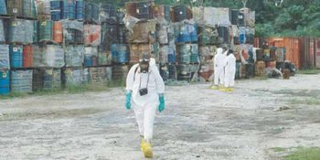
Figure 14.4 Hazardous waste. These drums had stored toxic chemicals that could leak into the environment any time if not properly handled.
Experiences like this Italian case led to increased awareness and recognition of the need for international agreement about the proper handling of hazardous waste. The Basel Convention (Convention on the Control of Transboundary Movements of Hazardous Wastes and their Disposal) was the output of a series of negotiations on the management of hazardous waste. It was adopted in 1989, came into force in 1992, and currently involves 166 countries. The convention provides guidelines for the sound management of hazardous waste using waste optimisation and the assurance of this principle when exporting such wastes to a country.
The Basel Convention encouraged regional agreements on hazardous wastes. Concern over the export of hazardous wastes to African countries led to the Bamako Convention, which has the full title of Convention on the Ban of the Import into Africa and the Control of Transboundary Movement and Management of Hazardous Wastes within Africa. The main aims of the Bamako Convention (UNEP, n.d. 1) are to:
- prohibit the import of all hazardous and radioactive wastes into the African continent for any reason
- minimise and control transboundary movements of hazardous wastes within the African continent
- prohibit all ocean and inland water dumping or incineration of hazardous wastes
The Convention was adopted in 1991 and came into force in 1998. It was originally negotiated by 12 countries of the African Union and has since been ratified by 25 African countries (African Union, 2013).

14.5 Convention on Environmental Impact Assessment in a Transboundary Context
Environmental impact assessment (EIA) is a procedure and set of activities that aim to prevent damage from developments such as the construction of major infrastructure projects. The process of EIA identifies potential impacts and issues at the planning stage of the development initiative and links these to mitigation at the implementation phase. Most EIAs involve at least three stages:
- Collecting data and preparing a written environmental statement that describes the possible impacts of the proposed development.
- Consultation based on the statement.
- Taking account of the assessment findings in the development process with the aim of mitigating the environmental impacts.
The Convention on Environmental Impact Assessment in a Transboundary Context, also known as the Espoo Convention, was adopted in 1991 and came into force in 1997. (Espoo is a city in Finland.) It has the aim of preventing environmental damage and threats from transboundary developments. Examples include irrigation and diversion of watercourses, oil refineries, power stations, radioactive waste processing and storage, large-scale projects for construction, pipelines, bridges and dams. As well as the environmental impacts, developments of this type can also bring changes in community lifestyles and social values.
Generally, an EIA is a means of supporting sustainable development, depending on how the assessment is carried out. The great majority of countries in the world, including Ethiopia, have adopted mandatory regulations. The Espoo Convention was signed and ratified by the Ethiopian parliament and has led to several regulations and proclamations in order for it to be applicable under Ethiopian law.

14.6 Conventions on chemical pollutants
In this section, we will look at two conventions on specific chemical pollutants that are of international concern because of their particular characteristics.

14.6.1 Stockholm Convention on Persistent Organic Pollutants
Persistent organic pollutants (POPs) are chemicals produced by industrial processes, mostly for use as pesticides (Figure 14.5). You may recall from Study Session 8 that POPs are characterised by high toxicity and persistence (lasting for years or even decades before degrading into less dangerous forms). They are also highly mobile in the environment because they may evaporate or dissolve and travel long distances through air or water. They also bioaccumulate in fatty tissues and biomagnify in the food chain. The Stockholm Convention was adopted in 2001 to restrict the production of POPs, eliminating the most dangerous, and to clean up stockpiles and equipment containing POPs. Many POPs contain chlorine in their composition. Examples are aldrin, chlordane, DDT, heptachlor, and hexachlorobenzene. Many of these pesticides are now banned.
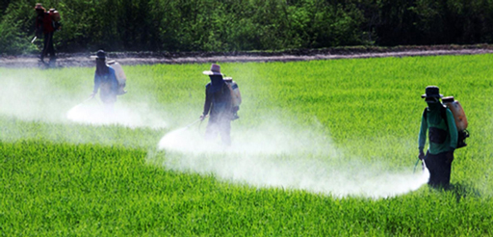
Figure 14.5 Pesticide application in East Africa.
- What is the difference between bioaccumulation and biomagnification?
- Bioaccumulation is the increase of a pollutant in an individual plant or animal because of continued exposure. Biomagnification is the increase of the pollutant in organisms through a food chain. (You learned about bioaccumulation and biomagnification in Study Session 8.)

14.6.2 Minamata Convention on Mercury
This convention’s name comes from the Japanese town that you read about in Study Session 8 where mercury poisoned many of the local population. The convention deals with mercury use and handling with the purpose of reducing and preventing its release and bioaccumulation in the environment including water bodies that might be used for drinking. The ultimate goal is to phase out the release of mercury into the environment. This is a new convention that was adopted in October 2013 and is still open for signing by countries. Ethiopia is a signatory to this convention.

14.7 International declarations
- Are declarations legally binding agreements?
- Declarations are usually not legally binding agreements. Countries that sign up to declarations are expressing their aspirations in a formal way that requires them to take action.
In addition to formal conventions there are also several international declarations that are relevant to the environment and to WASH.
The Universal Declaration of Human Rights was adopted by the UN General Assembly in 1948 and specifies: ‘All people have the right to a standard of living adequate for health and wellbeing of themselves and their family, including food, clothing, housing, health care, and the necessary social services’ (Article 25) (Figure 14.6).
Much more recently, in 2010 the UN recognised the human right to safe drinking water (United Nations, 2010). The UN General Assembly in its Resolution 64/92 recognised ‘the right to safe and clean drinking water and sanitation as a human right that is essential for the full enjoyment of life and all human rights’.
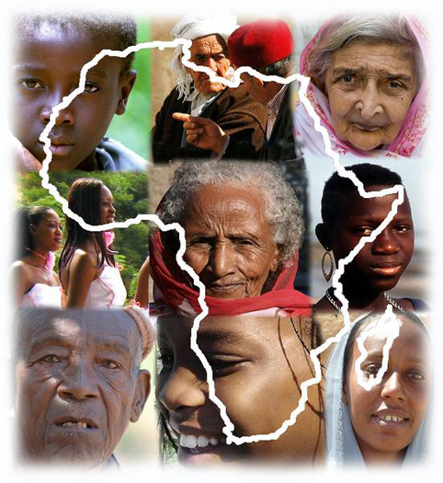
Figure 14.6 All people in Africa and the world share the same human rights.
The Declaration of Almaty on primary health care was adopted at an international conference that took place in Almaty (formerly Alma Ata), Kazakhstan in 1978. Primary health care is essential health care that must be accessed by every citizen of the country using locally appropriate technologies and community participation. Access to safe drinking water and sanitation is one of the components of primary health care. Ethiopia has accepted this declaration and has been applying it since 1978.
The United Nations Millennium Declaration (UNMD) was adopted in 2000 by resolution of the UN General Assembly. This was the declaration that announced the Millennium Development Goals (MDGs) for countries to achieve by 2015, which you read about in Study Session 3. The aim was to make progress across the globe on issues of poverty, education, health, hunger and the environment.
Following on from the MDGs, Sustainable Development Goals (SDGs) have been developed by the UN to guide development issues until 2030. There are 17 SDGs to replace the eight MDGs and each is sub-divided into a number of targets. Several SDGs are relevant to the environment and WASH (UNDP, 2015), including:
- Goal 6 Clean water and sanitation: Ensure access to water and sanitation for all.
- Goal 13 Climate action: Take urgent action to combat climate change and its impacts.
- Goal 15 Life on land: Sustainably manage forests, combat desertification, halt and reverse land degradation, halt biodiversity loss.

14.8 Monitoring implementation of international agreements
Each UN Convention has a Secretariat at the UN which monitors the implementation of agreed actions and disseminates the performance of each convention to signing countries. It also provides technical guidance and advice.
A signing country is expected to ratify a convention by designing an act or regulation in the national laws to meet the requirements of the agreed convention. The act or regulation is expected to provide the mechanisms or framework of implementation including monitoring. It provides standards, requirements, institutional implementation arrangements and sets out duties and responsibilities of the competent authority and the stakeholders.
As with all international agreements and legislation, implementation in the various countries is dependent on the capacity of those countries to do that meaningfully. To have real impact in practice, legislation requires political will at a national and local level and sufficient resources for implementation to be achieved. The next and final study session goes on to look at the national regulations and policies relating to water, sanitation and hygiene in Ethiopia.

Summary of Study Session 14
In Study Session 14, you have learned that:
- Countries of the world need international agreements in order to work together. Activities in one country may affect others in terms of damaging the environment.
- There are different categories of international agreements. A convention is a formal overall agreement, while a protocol provides specific details to be implemented. Declarations are non-binding agreements in which aspirations are expressed.
- The UN Convention on Climate Change, and subsequent agreements such as the Kyoto Protocol and Copenhagen Accord, deal with how to protect the environment by reducing greenhouse gas emissions.
- The Basel and Bamako Conventions deal with the movement of hazardous wastes between countries; the Bamako Convention especially aims to stop the import of hazardous wastes into African countries.
- The Convention on Environmental Impact Assessment (EIA) in a Transboundary Context recognises that harm from development does not just occur within a country but across borders. The Convention aims to control such harm using EIAs.
- Some international agreements focus on specific chemical pollutants such as persistent organic pollutants and toxic heavy metals such as mercury.
- UN declarations of relevance to WASH include those on human rights, the right to water and sanitation, and on primary health care.
- Millennium Development Goals were internationally agreed targets for countries on a range of development issues to be met by 2015. These have been followed by the Sustainable Development Goals which set targets for 2030.
- Secretariats at the UN take the lead in monitoring the implementation of UN conventions and protocols. Each signatory country to the convention and protocol is expected to ratify the provisions in a form of national laws (regulations or acts) to be implemented in its territory, so declaring its international commitment.

Self-Assessment Questions (SAQs) for Study Session 14
Now that you have completed this study session, you can assess how well you have achieved its Learning Outcomes by answering these questions. You can check your answers with the Notes on the Self-Assessment Questions at the end of this Module.

SAQ 14.1 (tests Learning Outcomes 14.1 and 14.3)
What distinguishes the different types of international agreements developed by the United Nations?

SAQ 14.2 (tests Learning Outcome 14.2)
Why are global environmental policies and international agreements needed? In what ways can the activities of one country affect others?

SAQ 14.3 (tests Learning Outcomes 14.2 and 14.4)
It is often said that environmental threats don’t respect borders. Explain what this means, giving an example and mentioning an international agreement that aims to tackle such a threat.

SAQ 14.4 (tests Learning Outcome 14.4)
What is hazardous waste and which conventions address its transboundary movement and disposal?

SAQ 14.5 (tests Learning Outcomes 14.1 and 14.4)
What is the purpose of Environmental Impact Assessment?

SAQ 14.6 (tests Learning Outcome 14.5)
Who has responsibility for monitoring implementation of conventions and protocols?

Study Session 15 National Policy Context in Ethiopia

Introduction
Safeguarding the environment requires coordinated effort by individuals, communities, institutions and governments. In this final study session you will learn about the Ethiopian government’s policy response to the challenges of water, sanitation and hygiene (WASH) with a focus on the relevant health, water and environmental policies. We start this study session with an overview of the different types of national law and policy before briefly describing the most important policies and programmes that relate to WASH.

Learning Outcomes for Study Session 15
When you have studied this session, you should be able to:
15.1 Define and use correctly all of the key words printed in bold. (SAQ 15.1)
15.2 Describe the hierarchy of laws in Ethiopia. (SAQ 15.1)
15.3 Briefly describe the process of policy development in Ethiopia. (SAQ 15.2)
15.4 Outline the main policies in health, water, and the environment that are related to WASH.
(SAQs 15.3 and 15.4)

15.1 Laws and policies in Ethiopia
There are many different words used to describe the various types of law and policy, so we start with an overview of the terminology.

15.1.1 The hierarchy of laws
The highest law in Ethiopia is the Constitution (Proclamation No.1/1995) which was adopted by the highest legislative body (parliament) and signed by the head of state in 1995. It states (FDRE, 1995):
The Constitution is the supreme law of the land. Any law, customary practice or a decision of an organ of state or a public official that contravenes this Constitution shall be of no effect.
The Constitution declares that Ethiopia is a federal and democratic state, and that religion and the state are separate. It describes the parliamentary structure of government and the human rights that are protected in the country. The Constitution states that the power to make national laws lies with the House of People’s Representatives (HPR) although some of their law-making powers are delegated to the Council of Ministers, which is the highest executive body in the government structure (Degol and Kedir, 2013).
The Constitution is at the top of a hierarchy of laws with different levels of importance, as shown in Figure 15.1.
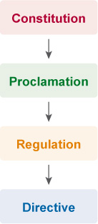
Figure 15.1 The hierarchy of laws in Ethiopia.
Proclamations come below the Constitution in the hierarchy. They are acts of parliament, discussed and voted on in the HPR and signed by the president of Ethiopia. International treaties that have been ratified by Ethiopia (such as those you read about in Study Session 14) have similar status to proclamations because they are also enacted by the HPR.
Regulations are the next level. They are issued by the Council of Ministers to supplement a proclamation. Regulations have detailed descriptions of the provisions of the respective proclamation.
Directives are the lowest level in the Ethiopian legislation hierarchy. They describe how regulations should be implemented and are usually developed by a ministry or a department within a ministry.
At regional level, there is a similar hierarchy of state laws that includes proclamations, regulations and directives.

15.1.2 Policies, strategies and programmes
Policies are important statements of government plans. They lie outside the hierarchy of laws because they do not have the same legal status as proclamations, regulations and directives; however, they are related. Policies are statements of overall purpose that set out goals and provide principles that should be followed to achieve those goals. Policy goals and principles are made into laws by proclamations and regulations.
A strategy provides details for implementing a given policy. It sets out how policy goals will be achieved, for example by identifying who should be involved, and allocating roles and responsibilities. Examples of national strategies include the Food and Nutrition Strategy, Poverty Reduction Strategy, Climate Resilient Green Economy Strategy, and National Hygiene and Sanitation Strategy.
Policies and strategies are put into effect in a range of programmes and projects, which could be described as action plans for implementation. Programme is a broad term used to describe any set of related events, activities or projects. Government programmes are specific to a particular sector and often cover a specified period such as five years. (Note that the word ‘policy’ is sometimes used in a more general sense to include any statement of overall aims, including strategies and programmes as well as named policies. We have used it in this broader sense in this study session.)
Ethiopian Government policies are based on the provisions of the Constitution. Several policies seek to deliver public benefits, including the Health Policy, Population Policy, Women’s Policy and the Ethiopian Water Resources Management Policy.
Public policy is created at all levels of government – federal, regional, zonal and woreda – but it is not only governments that have policies. Organisations, and even families and individuals, develop policies to guide their actions.
- Can you think of any policies you are subject to at your place of work? (Or someone that you know if you are not currently in employment.)
- The organisation you work for is likely to have a number of policies that apply to you, such as policies on holidays, sickness leave entitlement and disciplinary matters, to name a few.

15.2 Policy development
Policies are designed to serve the public at large, so policy development should be participatory, democratic and transparent. The process involves both top-down (initiating draft policies) and bottom-up (getting responses and feedback) approaches. Policy development has three main processes:
- identifying the need for a policy
- formulating the policy
- monitoring the policy and evaluating its effectiveness.

15.2.1 Initiating a policy idea
Policy can be reactive or proactive. Reactive policy is formulated in response to issues or concerns and to solve existing problems; proactive policy is designed to prevent a problem arising. Proactive policies are more difficult to formulate because it is challenging to persuade decision makers to allocate funds and other resources to a problem that is not yet perceived as a problem.
- When you think about environmental policy, do you think it is mostly reactive or proactive? Which type of policy do you think is best suited to environmental issues, and why?
- It is likely that you thought that environmental policy is largely reactive, for example, a policy on pollution is a response to a problem caused by pollution. But proactive policy would be better for environmental issues because it prevents problems from happening in the first place.
Ideas for new policies may come from the House of People’s Representatives (the parliament), from a specific ministry, or from the Council of Ministers through its Expert Group. The Expert Group may identify policy gaps based on research or public opinion, which are then developed and considered by the Council of Ministers.

15.2.2 Formulating the policy
Formulating a policy and developing a draft document is done by the process owner (policy-making institution). They will organise their own Expert Group or committee of government stakeholders to be responsible for the task. Sometimes a consultancy firm is used to fully develop the draft.
The draft policy document is disseminated to different audiences including policy beneficiaries and other stakeholders who may include federal and regional ministries, community and professional representatives, academic institutions, the donor community, etc. The feedback from these interested parties enables the Expert Group to enrich and revise the draft policy, which can then be submitted for approval. Once it has been approved internally it can be submitted to the Council of Ministers. Further discussion follows and modifications and additions are considered.
The Council of Ministers submits the revised policy to the relevant parliamentary committee who discuss it and may ask for clarifications from the process owner. The committee may call on public opinion in specially arranged meetings to get additional inputs to shape the final draft.
The revised draft policy will then be debated in parliament. Final amendments can be made and then the policy document is published. Proclamations and regulations linked to the policy are published in Negarit Gazeta and become law. The Negarit Gazeta is the official government gazette for the publication of all federal laws.

15.2.3 Implementing and monitoring
After the policy or proclamation is put into practice, its implementation should be monitored so that its effectiveness and continuing relevance can be evaluated. Monitoring may involve routine discussion of progress at meetings of the relevant ministry, annual meetings with wider stakeholder groups, reports on performance delivered to parliament, or field evaluations. This may lead to identification of policy gaps and then possible requests to the Council of Ministers and parliament to repeal or modify the provisions. In this way, policy implementation can be improved and kept up to date.

15.3 The Constitution of the Federal Democratic Republic of Ethiopia
The Constitution includes several articles that are relevant to WASH, public health and the environment (FDRE, 1995).
Article 41/4: The State has the obligation to allocate ever-increasing resources to provide to the public health, education and other social services (economic, social and cultural duty and objectives).
Article 42/1: Workers have the right to reasonable limitation of working hours, to rest, to leisure, to periodic leaves with pay, to remuneration for public holidays as well as a healthy and safe work environment (labour rights).
Article 44/1 states that all persons have the right to a clean and healthy environment (environmental rights).
Article 89/8 states that government shall endeavor to protect and promote the health, welfare and living standards of the working population of the country (economic duty and objective).
Article 90/1 To the extent the country’s resources permit, policies shall aim to provide all Ethiopians access to public health and education, clean water, housing, food and social security (social duty and objective).
Article 92/1: Government shall endeavor to ensure that all Ethiopians live in a clean and healthy environment (environmental duty and objective).
These articles give rights to citizens and assign duties and objectives to the government. The Constitution states that all persons have the right to a clean and healthy environment, and the government has a duty to ensure that all Ethiopians live in a clean and healthy environment as far as it is able, which includes access to and use of clean water, sanitation and hygiene facilities.
Safeguarding the environment from any human-made damage is covered by Articles 92/2 and 92/4 which state that projects, investments or developments should not destroy and pollute the environment (water, air and soil).

15.4 Health policies
The rights and principles set out in the articles of the Constitution form the basis of government policy. In the health sector there are a number of different policy, strategy and programme documents that are relevant to WASH.

15.4.1 Health Policy (1993)
The Health Policy of 1993 outlines the need for strategies linked to the democratisation and decentralisation of the health system, and inter-sectoral collaboration. It specifies the need for ‘accelerating the provision of safe and adequate water for urban and rural populations’, ‘developing safe disposal of human, household, agricultural and industrial wastes and encouragement of recycling’, and ‘developing measures to improve the quality of housing and work premises for health’ (Transitional Government of Ethiopia, 1993). The Health Policy has led to several health-related programmes and strategies.

15.4.2 Health Sector Development Programme
The Health Sector Development Programme (HSDP) guides the development of national long-term plans in the health sector including those concerning water, sanitation and hygiene. The current programme, HSDP IV, covers the years 2010 to 2015 and is the fourth in a series of five-year programmes. It set targets at the national level for latrine access, household use of water treatment and safe water storage practices, and achievement of open-defecation-free (ODF) status in villages (MoH, 2010).
The Health Extension Programme (HEP) is an innovative community-based primary care system developed under the HSDP. Health Extension Workers deliver community-based antenatal and postnatal care as well as basic health information about WASH (Figure 15.2).
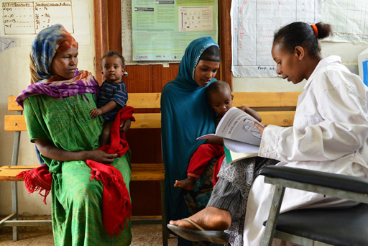
Figure 15.2 A health extension worker advising new mothers.
- Health Extension Workers (HEWs) are often drawn from the communities they serve. What do you think are the advantages of this?
- The HEW will understand the community and its cultural practices and will be better equipped to adapt the health messages to the community’s situation. The HEW is also likely to be trusted by the community as one of their own.

15.4.3 National Hygiene and Sanitation Strategy
The National Hygiene and Sanitation Strategy (NHSS) of 2005 was developed by the Ministry of Health to complement the Health Policy. Figure 15.3 shows the image on the front cover of the document. This clearly illustrates the links between health and the three components of WASH.
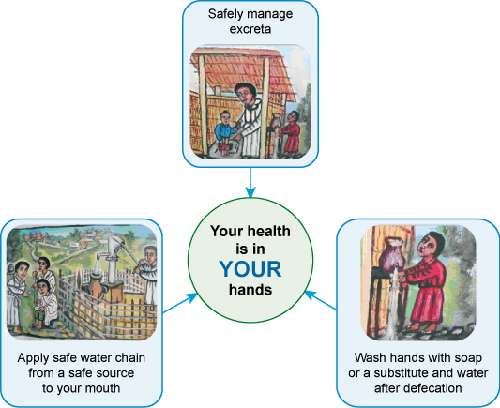
Figure 15.3 Cover page of the National Hygiene and Sanitation Strategy publication. (MoH, 2005)
The strategy starts with a ‘Sanitation Vision for Ethiopia’, which is: ‘100% adoption of improved (household and institutional) sanitation and hygiene by each community which will contribute to better health, a safer, cleaner environment, and the socio-economic development of the country’ (MoH, 2005). The strategy first describes the current situation, as it was in 2005, and then sets out objectives and plans for achieving the goal of the Vision Statement, which are being carried forward in various programmes and projects.

15.5 Water policies
In the water sector, there are also several relevant government policy documents. Two of the most important are briefly described here.

15.5.1 Ethiopian Water Resources Management Policy
This policy aims to enhance and promote the efficient and fair use of water resources for socio-economic development in a sustainable manner (MoWR, 1999). It has specific provisions related to water supply and sanitation, irrigation, and hydropower, and also specifies policy on cross-cutting issues such as allocation of resources, watershed management, technology and gender.

15.5.2 Ethiopian Water Resources Management Proclamation (No. 197/2000)
This proclamation was issued in 2000 with the purpose of protecting natural water sources from degradation, excessive use and pollution. It gave authority to the Ministry of Water Resources to issue licences for the development of water resources (dams, drinking water supply and irrigation schemes) and permits to discharge wastes.

15.6 Climate policies
As you know from previous study sessions, climate change is causing higher temperatures and changing rainfall patterns leading to increased drought and flooding. Flooding can destroy poorly constructed latrines and pumps and contaminate drinking water sources unless they are built with the risks from flooding in mind.
- Look at the pump in Figure 15.4. What aspects of its construction will help resist damage from flooding?
- The base is raised higher than the ground surface and it has a solid concrete cover which should be watertight to prevent floodwater entering the well or borehole.
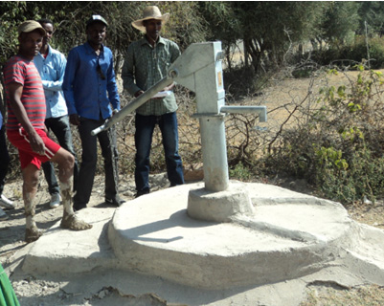
Figure 15.4 A newly constructed hand pump.

15.6.1 Ethiopian Programme of Adaptation to Climate Change (EPACC)
On the basis of its vulnerability to climate change, Ethiopia adopted the National Adaptation Programme of Action in 2007. This was updated with the Ethiopian Programme of Adaptation to Climate Change in 2011, which looks at the challenges of climate change and seeks to design adaptation responses (The Red Desk, 2015).
EPACC envisages that each sector, region and local community in Ethiopia will have its own programme of adaptation. Adaptation practices are indicated for each sector including crop production, livestock, water, health, education, energy, infrastructure, institutional capacity and cultural heritage.

15.6.2 Climate Resilient Green Economy Strategy
While the EPACC focuses on climate change adaptation, the government’s Climate Resilient Green Economy (CRGE) strategy, also launched in 2011, focuses on climate change mitigation. It seeks to cut the country’s carbon emissions, as you read in Study Session 12.
- What is the overall aim of the CRGE strategy?
- It aims to limit greenhouse gas emissions to 2011 levels while supporting economic development and growth.

15.7 Environment policies
There are several national policy documents that relate to environmental protection.

15.7.1 Environmental Policy of Ethiopia (EPE)
This policy, issued in 1997, aims to maintain the health and quality of life of all Ethiopians and to promote sustainable social and economic development. It seeks to do this through the sound management and use of resources and the environment as a whole, in accordance with the principles of sustainable development. It considers the rights and obligations of citizens, organisations, and government to safeguard the environment as indicated in the Constitution of Ethiopia. The EPE is a comprehensive document that defines policies for ten separate environmental sectors, covering soil and agriculture, forest and woodland, biodiversity, water, energy, minerals, human settlement, industrial waste, climate change and cultural heritage (FDRE, 1997). It also includes policies for ten cross-sectoral issues that need to be considered for effective implementation: population, community participation, land tenure, land use, social and gender issues, environmental economics, information systems, research, impact assessment, and education.

15.7.2 Environmental Impact Assessment Proclamation (No. 299/2002)
This proclamation follows the principles of the international agreement on Environmental Impact Assessment (EIA) that you read about in Study Session 14. Major development projects that are likely to damage the environment (physical and social) are expected to have an EIA that identifies hazards and possible damage so that they can be mitigated during the project development. The proclamation outlines the duties of the proponent (developer) and specifies the details that must be included in the assessment and the impact study report (FDRE, 2002a). Approximately 30 EIAs are produced at the federal level each year, which is relatively low compared to other countries, but most EIAs happen at the regional level (SIDA, 2013).

15.7.3 Environmental Pollution Control Proclamation (No. 300/2002)
Pollution is defined in this proclamation as: ‘any condition which is hazardous or potentially hazardous to human health, safety, or welfare or to living things created by altering any physical, radioactive, thermal, chemical, biological or other property of any part of the environment in contravention of any condition, limitation or restriction made under this Proclamation or under any other relevant law’ (FDRE, 2002b).
The proclamation states that ‘no person shall pollute … the environment’ but also includes provisions for prevention and penalties if pollution does occur. It follows the ‘polluter pays principle’ and requires the person who causes pollution to pay for any clean up. Specific articles detail the need for proper management of hazardous and municipal waste and the adoption of environmental standards with reference to wastewater effluents, air, soil, noise and waste.

15.7.4 Solid Waste Management Proclamation (No. 513/2007)
This proclamation aims to prevent environmental damage from solid waste while harnessing its potential economic benefits. It defines solid waste management as the collection, transportation, storage, recycling or disposal of solid waste. The proclamation indicates the need for involvement of the private sector for effective management and describes the safe transport of solid waste including hazardous waste (FDRE, 2007).

15.7.5 Prevention of Industrial Pollution Regulation (No. 159/2008)
The purpose of this regulation is clear from its name. Factories must make sure their liquid waste meets environmental standards, and obtain a permit before discharging any liquid waste (FDRE, 2008). The factory must monitor the composition of its waste, keep records and report periodically to the Environmental Protection Authority (EPA).

15.7.6 Environmental and Social Management Framework
This framework document was prepared in collaboration with the World Bank. It sets out procedures to ensure that investments in WASH are implemented in an environmentally and socially sustainable manner (FDRE, 2013). It recognises the importance of protecting people and the environment from the negative impacts of development and safeguarding the lives and livelihoods of the population.

15.8 One WASH National Programme
To conclude this overview of national policies, and to conclude this module, we must consider the One WASH National Programme (OWNP). The OWNP, as the name suggests, is a single programme that combines water with sanitation and hygiene (Figure 15.5). Announced in 2013, it aims to address the WASH challenges in Ethiopia by adopting a unified and collaborative approach. The overall objective of the OWNP (FDRE, 2014) is:
to improve the health and well-being of communities in rural and urban areas in an equitable and sustainable manner by increasing access to water supply and sanitation and adoption of good hygiene practices.
The innovative characteristic of the OWNP is that it involves four ministries: Ministry of Water, Irrigation and Energy; Ministry of Health; Ministry of Education; and Ministry of Finance and Development. The four ministries have signed a Memorandum of Understanding (MoU) that sets out their roles and responsibilities. It therefore cuts across the traditional separation of responsibilities between ministries and has structures and processes designed to ensure closer cooperation and collaboration between all the stakeholders.
Figure 15.5 Logo for the One WASH National Programme.
The guiding principles of the OWNP are integration, alignment, harmonisation and partnership and its motto, ‘One Plan, One Budget, One Report’, neatly summarises its approach. Funds from external donors are pooled in a Consolidated WASH Account which will help to reduce problems of fragmentation of resources and lack of coordination between development programmes. The organisational structure of the programme describes the roles and responsibilities at all levels from the WASH National Steering Committee at federal level through Regional Steering Committees, Woreda WASH Teams and Town/City WASH Technical Teams, to Kebele WASH Teams and communities. Successful implementation of the One WASH National Programme should result in huge and sustainable changes to WASH provision in Ethiopia.

Summary of Study Session 15
In Study Session 15, you have learned that:
- There is a hierarchy of laws in Ethiopia. The Constitution is the supreme law of the land with proclamations, regulations and directives at lower levels of the hierarchy.
- Policies set out government and regional plans and provide goals and principles to be followed. Strategies and programmes provide details for how policies should be implemented.
- Development of national policies has several steps from initial idea through consultation to final approval by parliament and publication.
- The Constitution has several articles that safeguard the environment and public health.
- The Health Policy of 1993 established the overall direction for health services in Ethiopia. This has been developed in several strategies and programmes, including HSDP IV and the National Health and Hygiene Strategy.
- The Water Resources Management Policy and Proclamation set out the principles and practice for fair and efficient use of water.
- Ethiopia’s Programme of Adaptation to Climate Change and the Climate Resilient Green Economy Strategy seek to adapt to and mitigate the adverse effects of climate change respectively.
- Several proclamations provide the legal framework to support the goals and principles set out in the Environmental Policy of Ethiopia.
- Unlike previous programmes for WASH improvement, the One WASH National Programme takes a unified and collaborative approach to addressing the challenges of water and sanitation in Ethiopia.

Self-Assessment Questions (SAQs) for Study Session 15
Now that you have completed this study session, you can assess how well you have achieved its Learning Outcomes by answering these questions. You can check your answers with the Notes on the Self-Assessment Questions at the end of this Module.

SAQ 15.1 (tests Learning Outcomes 15.1 and 15.2)
Which of the following statements are false? In each case explain why it is incorrect.
- Proclamation is the highest law in Ethiopia.
- Policy sets overall goals.
- Policies provide details for implementation of programmes.
- Regulations provide detailed descriptions of the provisions of strategies.
- Directive is lowest in the hierarchy of law.

SAQ 15.2 (tests Learning Outcome 15.3)
Why is public consultation important when developing environmental and WASH-related policies?

SAQ 15.3 (tests Learning Outcome 15.3)
- What does the Constitution of Ethiopia say about people’s environmental rights?
- List three WASH-related national policies.

SAQ 15.4 (tests Learning Outcome 15.4)
What environmental proclamation or regulation would you use to demonstrate wrongdoing in the following examples?
- A factory owner is discharging toxic effluent into a nearby river.
- A builder has dumped old building materials such as bricks and plaster at the edge of a slum area.
- A transport company is transporting radioactive waste in open-topped lorries.

Notes on the Self-Assessment Questions (SAQs) for WASH: Context and Environment

Study Session 1

SAQ 1.1
This game is intended to familiarise you with the terms you will meet again in subsequent study sessions. To find the right answer, you can check the definition written in your own words with that in the study session.

SAQ 1.2
B is false. Agricultural activity can have significant negative impacts on our environment, including loss of biodiversity, water contamination, climate change, soil erosion and pollution.
E is also false. Some human activity can prevent damage or repair past damage, for example recovery of hazardous materials from waste and reforestation programmes where many trees are planted. It is important to work towards creating a better environment in order to protect our health, and because environmental improvements such as tree-planting can have many beneficial effects, such as creating more spring water, a higher water table, and less soil erosion and flooding.

SAQ 1.3
Biomass resources are derived from living organisms. They are renewable because they are replaced by the continuing processes of growth and reproduction. However, they are vulnerable to over-exploitation if they are used more quickly than they can naturally reproduce and regenerate. Overfishing and deforestation are examples of the over-use of biomass resources. The consequences include loss of biodiversity and loss of income for the people who depend on these resources for their livelihood.

SAQ 1.4
You could start by saying that technology plays an important role in improving the quality of our lives and our environment. For example, we use renewable energy such as wind and solar power to reduce the release of greenhouse gases, and we use high-tech waste treatment plants to protect water sources from pollution. But you would agree that technology can also damage the environment. For example, e-wastes contain many toxic substances that can pollute groundwater, soil and air. So your conclusion is that technology can have both positive and negative environmental impacts.

Study Session 2

SAQ 2.1
Populations change over time as birth and death rates vary in a process called demographic transition. At any one time, the characteristics of the population of a country are described by its population composition. One of the factors typically included is the sex ratio, which compares the numbers of men and women. The other important ratio is the age dependency ratio. These two main population characteristics can be presented as a population pyramid.

SAQ 2.2
B is false. Falling birth and death rates are characteristic of stages 2 and 3, not stage 1.
D is also false. Processes for food production and distribution are not the same throughout the world; food production systems are generally more advanced in developed than in developing countries.

SAQ 2.3
A is false. Developing countries have young populations while developed countries have old populations.
D is false. If the shape of the population pyramid is broader at the bottom this indicates a large number of young children; however, the age dependency ratio also depends on the number of people aged over 65.

SAQ 2.4
Population growth means that more people will require sufficient food to meet their dietary needs. Food security can be improved by increasing the quantity of food produced by changing agricultural practices such as use of fertilisers or growing different crops. However, any improvements to agricultural productivity have to match the rate of population growth if they are to make a difference to food security. Long-term malnutrition makes people more vulnerable to disease and causes stunting, which impairs child development.

SAQ 2.5
In your presentation you should have covered five of the following points:
- Poor people are more directly dependent on the environment for their food, water, fuel and medicines.
- The environment is the source of income for many poor people through sectors such as agriculture, forestry, fishery and tourism.
- Environmental problems such as flood and drought tend to have a bigger impact on poor people.
- As environment influences poverty, poverty also affects the environment. For example, cutting down trees for fuel leads to deforestation and soil erosion.
- Poor farmers tend to lack the education, resources and security in land ownership to invest in environmentally friendly technologies.
- Poverty leads to environmental degradation which reduces agricultural productivity and makes poor people poorer in a downward spiral.

Study Session 3

SAQ 3.1
economic growth | measured by Gross Domestic Product (GDP)
Gross Domestic Product (GDP) | the total volume of goods and services produced by a country
sustainability | an approach that considers environmental, economic and social aspects to produce long-lasting development or prosperity
sustainable development | meeting the needs of the present without compromising the ability of future generations to meet their own needs
economic development | more than just measuring GDP; it also includes some aspects of technological and social progress
human development | continuous improvement in human well-being and quality of life

SAQ 3.2
You could start by saying that economic development is primarily concerned with income although it is more than just economic growth. Economic development means improving the living standards of people, for example by improvements in infrastructure, education and health systems as well as income. The central concept of sustainable development is that people’s lives can be improved without exhausting natural resources and without damaging the environment. In other words, it is about friendly coexistence between economic growth and the environment so that the needs of future generations can continue to be met.

SAQ 3.3
Your notes might have resembled the following:
Pillar 1: Economic sustainability
- Efficient and responsible use of land, labour, capital and technology.
- Good value for money
Pillar 2: Environmental sustainability
- Minimise damage and impact on the environment.
- Use renewable energy to limit environmental damage and climate change.
- Minimise waste
Pillar 3: Social sustainability
- Improve quality of life for the population.
- Reduce poverty.

SAQ 3.4
- It is important to involve users in decision making but future financial sustainability is also important. The service is likely to fall into disrepair if maintenance cannot be paid for.
- Project design should take account of future needs as well as the current needs. Keeping costs down should not be the only criterion.
- Consulting with the users about their preferred location is important but other factors must also be considered including the potential environmental impacts and also the costs, which may differ between different possible locations.

Study Session 4

SAQ 4.1
Water on the Earth’s surface moves in an unceasing cycle through rivers, oceans, clouds and rain called the water or hydrological cycle. The heat from the sun causes evaporation of water from oceans and from lakes and wetlands on land. Plants lose water through their leaves by transpiration. Water vapour in the atmosphere condenses to form clouds which are moved around by wind. Rain and snow, collectively known as precipitation, fall from the clouds. Some water that falls on the ground forms run-off which collects into streams and rivers and some percolates through the soil to become groundwater, which is held in layers of rock called aquifers.

SAQ 4.2
The main sources of water are surface water, groundwater and rainwater. Rainwater collection is obviously not possible during times of drought. The water available from surface water sources such as rivers and lakes will be reduced by drought because there will be no run-off so the volume of water in rivers and lakes will fall and they may even dry up. Groundwater reserves will also be reduced by drought although not as immediately as surface water. If there is no rainfall to recharge the aquifer and water continues to be extracted then the water table will gradually drop.

SAQ 4.3
You might have considered the following four points:
- Water quantity and reliability; there must be sufficient quantity of water to meet current and future needs.
- Water quality; the water must be free from contamination; fluoride levels may be relevant in some locations.
- Socio-cultural considerations; there may be local beliefs and practices among users that should be considered.
- Technical requirements; the practical feasibility of developing the source is important; operation and maintenance in the future should also be planned.

SAQ 4.4
A is false. From Figure 4.2 approximately 30% of fresh water is groundwater and only 0.4% is surface and atmospheric water. The volume of water held in lakes is approximately two-thirds (67.4%) of this 0.4%, and therefore there is much more water in aquifers than in lakes.
C is false. Rainwater will wash all types of contaminants including pathogenic micro-organisms into rivers and lakes, so they are more likely to be polluted than groundwater. It is possible for groundwater to be contaminated but if pathogens are present, most are removed as the water trickles down through soil and rock.

Study Session 5

SAQ 5.1
Urbanisation is an increase in the number of people living in towns and cities. The two causes of urbanisation are natural population increase and rural to urban migration. Urbanisation affects all sizes of settlements from small villages to towns to cities, leading up to the growth of mega-cities which have more than ten million people. Rapid urbanisation often means that peri-urban areas immediately around a city grow more rapidly than urban centres and this can lead to development of slums.

SAQ 5.2
Pull factors in migration are factors that attract people to urban areas, e.g. good employment opportunities in cities.
Push factors in migration are factors that drive people from the countryside, e.g. lack of sufficiently productive land to make a good living.
Other pull factors that encourage migration to urban areas include better education opportunities, better health care, improved access to social services and opportunities for social and cultural activities. Other push factors that drive people away from rural areas are poor living conditions, lack of paid employment, poor health care, limited educational and economic opportunities and environmental changes.

SAQ 5.3
Urbanisation is occurring faster in developing countries, with Africa and Asia showing the highest rates of urbanisation. Ethiopia has an urban growth rate of 4% per year, which is among the highest in Africa and in the world, but it is starting from a low proportion of people living in cities (18%).

SAQ 5.4
You could answer either way – you could view urbanisation either as a good thing or as a bad thing.
You might justify answering that urbanisation is a good thing because, first, it brings together economic and human resources that stimulate the economy through the development of business, science, technology and industry and, second, it is more cost-effective and efficient to supply facilities such as fresh water and electricity to a concentrated population in a city. Other justifications you might have thought of include the fact that the concentration of people and resources leads to more readily available education, health, social services and cultural activities in cities; urban living is linked with higher levels of literacy and education, better health, lower fertility and a longer life expectancy; there are better communication and transport networks; and social and cultural barriers can be overcome.
You might justify your answer that urbanisation is a bad thing because, first, rapid and unplanned growth in urban areas is associated with inadequate housing, water and sanitation which leads to health problems and, second, it is associated with adverse environmental effects such as reduced water quality, a build-up of waste materials and poor air quality. Other possible reasons you might have thought of include the link between urbanisation and increasing urban poverty and inequality; rises in slum and squatter populations; adverse social effects such as higher levels of crime and violence; and a lack of social support.
As urbanisation has both positive and negative impacts, you might feel that you can’t say that it is totally good or bad, but that is has mixed impacts and is both good and bad.

Study Session 6

SAQ 6.1
Term | Definition | Part of physical environment
Urban heat island | Effect caused by heat energy radiated from hard surfaces in large cities that raises temperature relative to surrounding rural areas, especially at night | Land, atmosphere
Land use | Arrangements, activities and inputs by people to produce, change or maintain a certain land cover type | Land
Deforestation | Clearance of forest areas | Land, water
Impermeable surfaces | Hard surfaces such as roofs, roads and pavements that water cannot infiltrate | Land, water
Land cover | Visible cover of the land such as forest, grassland, farmland, desert | Land

SAQ 6.2
The aim of urban planning is to design towns and cities to function effectively and meet the needs of people living in them.
Three problems of uncontrolled urban development that can be solved by urban planning are:
- poor housing quality, including poor construction
- lack of infrastructure and services, especially for water, sanitation and solid waste management, but also electricity, roads and transport facilities, shops, schools and health care.
- lack of drainage systems that leads to flooding.
(You might also have chosen the following problems: increase in peri-urban areas, building insecure homes in unsafe places, lack of green spaces such as parks, disease outbreaks caused by poor sanitation.)

SAQ 6.3
Zoning is the creation of defined areas within a town that are designated for different activities, for example zones for housing, commerce and industry, with the aim of improving urban living conditions by separating people from land uses that are harmful, such as industry. Zoning is no longer considered a good idea as it had the unintended effect of creating a social divide by separating well-off people and poorer people into different areas. This social separation was associated with inequality in services and facilities available in different zones – with poorer people having worse services and facilities.

SAQ 6.4
We have selected the following, you may have chosen other examples:
- Economics – urban planning should consider economic benefits, for example affordable housing and employment.
- Society – urban planning needs to consider social equity, for example planning for mixed land use developments that integrate different functions of residential, commercial and business together, so that there is equitable access to services and facilities.
- Environment – urban planning should protect the environment. For example, it should provide sufficient green spaces; these areas of natural ground absorb run-off and assist in the problems of surface water drainage.

SAQ 6.5
The Integrated Housing Development Programme (IHDP) is an Ethiopian government-led programme begun in 2005 to provide new, affordable housing for low- and middle-income people. It was set up under the Urban Development Package which set out the answer to the question ‘what’ was the government going to do to deliver urban-based public services of jobs, houses, roads, schools, clinics and water supply.
The achievements of the IHDP are as follows: implementation in 56 towns to date; building of many condominiums in Addis Ababa; creation of 176,000 jobs in construction and mineral extraction; increased home ownership; and improved living conditions for many people.
There have also been, however, a number of challenges in its implementation. The IHDP has been suspended outside Addis Ababa because the high-rise condominiums were unpopular in smaller, low-rise towns. Where condominiums have been built, there have been delays in infrastructure and essential services such as electricity and sewerage because companies are unable to keep up with demand and there are concerns about the construction quality of some blocks. There has also been a reduction in planned green spaces and communal buildings for social activities in order to increase housing density and reduce costs. Although the condominiums are popular, they are expensive, which has led to some people sub-letting their units, or buying units that are smaller than required, leading to overcrowding. As condominiums have mainly been built on the edges of Addis Ababa where there is little employment, this has meant increasing pressure on transport because people have to travel into the city for work.

Study Session 7

SAQ 7.1
Point sources of pollution are easier to identify because they come from points or places that you can easily locate, such as a pipe discharging waste into a river. A non-point source is more difficult to identify because it does not come from just one place, but can come from a wide area, for example fertiliser washing off a number of fields or floodwater that washes waste from latrines.

SAQ 7.2
Sewage consists of human excreta and wastewater. It has a high concentration of organic matter.
Some pollutants, called persistent pollutants, do not break down naturally in the environment. Examples are mercury, cadmium and other heavy metals.

SAQ 7.3
Liquid waste is liquid material that is thrown away, or discharged into the environment. From the household you might include human excreta (both faeces and urine) and other wastewaters. In your area you might also see urban run-off when rain washes waste from the land surface. You might also see liquid waste discharged from factories through a pipe into a river.
Solid waste is any solid material that is assumed not to be useful and is therefore thrown away; examples that you might use include food waste, cloth, paper and plastic that are thrown out from your own household or that you see in the area where you live.

SAQ 7.4
 | Pollutant | Source | Pathway | Recipient
(a) | pesticide | agriculture | through the river | lake, humans
(b) | leachate | domestic / household | through soil and groundwater | soil, groundwater, humans
(c) | liquid effluent (organic matter and tannery chemicals) | industry | through the river | river, humans, wildlife
(d) | black smoke | transport | through the air | humans

SAQ 7.5
Natural or unpolluted water is colourless, odourless and transparent. Water pollution changes the characteristics of water by the presence of excess physical, chemical or biological substances that change the qualities of the water and are capable of causing harm to living organisms.
Polluted water can taste or smell bad or be cloudy. Polluted water can contain suspended solids that make the water look brown in colour; most of the solids are fine particles of soil that have been washed into the river by rain from surrounding land. Large quantities of solids in the water can reduce light penetration into the water which can affect the growth of plants.
Water pollution changes more than just the appearance of the water. Polluted water can also contain chemicals, such as pesticides, fertilisers and heavy metals that are toxic. Polluted water also can contain biological substances such as organic matter and micro-organisms that cause waterborne diseases.

Study Session 8

SAQ 8.1
Degradation means ‘breaking down’, and biodegradation means the breaking down of complex substances into simpler substances by biological processes, mostly the action of bacteria. Accumulation means ‘build-up’, and bioaccumulation is the gradual build-up or increase of persistent pollutants in the body of individual animals as they eat contaminated food. Magnify means ‘to enlarge’ and biomagnification is the gradual increase of pollutants in the bodies of different organisms linked by a food chain.
So, all these processes involve living organisms (biological processes), but the first involves the breaking down of complex substances, the second involves build-up of persistent pollutants in an organism and the third involves the increase of pollutants up the food chain.

SAQ 8.2
Your answer will not be exactly the same; this is one possible answer.
When nitrogen and phosphorus are washed into a river or lake, the water becomes eutrophic, meaning that it has high levels of plant nutrients. This will cause excess plant growth and may produce a sudden increase in microscopic algae called an algal bloom. When the plants die, the dead plant material adds to the organic matter in the water. Decomposition of the organic matter can result in deoxygenation of the water, which will kill fish.

SAQ 8.3
You may have chosen any of the following:
Examples of air pollutants: dust, soot, particulates, nitrogen oxides, sulphur dioxide, carbon monoxide.
Sources: domestic fires, vehicle emissions, industrial chimneys.
Effects on human health: reduced lung function (difficulty with breathing), asthma, bronchitis.

SAQ 8.4
- The answers are as follows:
Water pollutant | Exposure route | Human health effect
Vibrio cholerae bacteria | ingestion | cholera
Schistosoma worm | skin contact | schistosomiasis/bilharzia
organic mercury | ingestion | Minamata disease
Ascaris worm | ingestion | ascariasis
- Cholera and ascariasis are both transmitted by the faecal-oral route. People become infected with these diseases when they drink water or eat food that is contaminated with faecal matter from infected individuals.

SAQ 8.5
Our company has a duty to reduce pollution from the wastes produced in our factory. We should adopt policies of pollution prevention, which avoid pollution in the first place. I recommend that we follow the precautionary principle and do not assume that our wastes will not cause any environmental damage. We should adopt cleaner production processes to ensure we reduce our impact on the environment.
For management of the solid wastes produced in our factory we should follow the waste hierarchy. This means we should first reduce the amount of waste produced and identify opportunities for reuse and recycling. If we successfully adopt these waste minimisation procedures we will reduce potential pollution from our company. Although some costs may be incurred, this could save money in the long run because under the polluter pays principle we may be liable for costs of any environmental damage that we cause.

Study Session 9

SAQ 9.1
weather | a condition of the atmosphere over a short period of time
greenhouse effect | natural process in which heat energy from the sun is trapped by the Earth’s atmosphere so the surface stays warm
climate variability | short-term fluctuations from the expected average weather conditions
climate | the average weather over a relatively long period
climate change | a change in the average climate over a long period of time
carbon sink | process or system that removes carbon dioxide from the atmosphere

SAQ 9.2
The rise in the mean global surface temperature referred to as global warming is partly due to an increase in the concentration of greenhouse gases in the atmosphere. This change in the global climate is expected to melt Arctic sea ice, leading to rising sea levels and to alter the pattern of rainfall, so that there are more severe floods in wetter regions, and more severe droughts in drier regions.

SAQ 9.3
B is false. Dust, ash and gases released during volcanic eruptions create a shield around the Earth that reflects sunlight energy back into space, so that the Earth’s atmosphere is cooled – not warmed. The statement would have been correct if it said that volcanic eruptions contribute to climate change.
C is also false. Greenhouse gases occur naturally in the atmosphere and keep the global mean surface temperature of the Earth at around 15 ºC. Without these natural greenhouse gases, the global mean surface temperature would be around –18 ºC.

SAQ 9.4
The correct sequence of statements explaining how the rising emission of greenhouse gases in the Earth’s atmosphere is leading to global warming is as follows:
- Visible sunlight has a short wavelength and high energy, which enables it to pass through greenhouse gases in the Earth’s atmosphere.
- Sunlight energy reaches the Earth and heats the Earth’s surface.
- Heat is radiated from the surface of the Earth back towards the atmosphere.
- Heat energy is infra-red radiation, which has a long wavelength and low energy, and is absorbed by greenhouse gases in the atmosphere.
- Heat energy trapped in the atmosphere by the greenhouse gases causes the atmosphere to become warmer.
- Human activity since the start of the 20th century has increased the emission of greenhouse gases and accelerated the rate of global warming.

SAQ 9.5
The completed statements of evidence for climate change in Ethiopia are:
- Since 1950 the average minimum temperature in Ethiopia has been rising by about 0.37 ºC per decade.
- Before 1990 there were 10 floods in Ethiopia, but between 1990 and 2014 there were 46 reported flood events.
- Before 1990 there were 6 droughts in Ethiopia, but between 1990 and 2014 9 drought events were reported.
- In 1965, about 1.5 million people were affected by droughts, but in 2003 about 13 million people in Ethiopia were drought-affected.

Study Session 10

SAQ 10.1
El Niño | unusually warm temperatures in Pacific Ocean currents
river floods | water spills over the top of the river banks into surrounding areas
La Niña | unusually cool temperatures in Pacific Ocean currents
extreme weather | weather outside the normal range of weather conditions
flash floods | intense rainfall causes water run-off to collect locally

SAQ 10.2
- Urbanisation increases the risk of flooding because the paved surfaces and concrete constructions are impermeable and prevent rainfall from soaking into the soil as it used to do when the land was used for agriculture.
- Deforestation increases soil erosion because bare soil is more easily washed away by heavy rain when not held together by tree roots. Soil washed off the land builds up in reservoirs and rivers, significantly reducing their water-holding capacity, so they overflow during intense rainfall and flood surrounding areas.
- Population pressure increases the risk of droughts because there is increasing demand for water as the population increases, especially when concentrated in urban areas, where water is required for additional uses in industry and to meet rising expectations of piped water and sanitation.
- Deforestation increases the risk of droughts because forests reduce the loss of rainwater through evaporation from the surface of bare soil, they increase groundwater storage by reducing run-off, and they add moisture to the atmosphere through transpiration.

SAQ 10.3
- Drought is more likely during kirmit in Ethiopia if it coincides with the El Niño climate cycle. (True)
- Flooding is more likely during kirmit in Ethiopia if it coincides with the El Niño climate cycle. (False: El Niño during kirmit decreases rainfall, so drought is more likely.)
- Drought is more likely during belg in Ethiopia if it coincides with the El Niño climate cycle. (False: El Niño during belg increases rainfall, so flooding is more likely.)
- Flooding is more likely during belg in Ethiopia if it coincides with the El Niño climate cycle. (True)
- Drought is more likely during kirmit in Ethiopia if it coincides with the La Niña climate cycle. (False: La Niña during kirmit increases rainfall, so flooding is more likely.)
- Flooding is more likely during kirmit in Ethiopia if it coincides with the La Niña climate cycle. (True)
- Drought is more likely during belg in Ethiopia if it coincides with the La Niña climate cycle. (True)
- Flooding is more likely during belg in Ethiopia if it coincides with the La Niña climate cycle. (False: La Niña during belg decreases rainfall, so drought is more likely.)

SAQ 10.4
- Floods affect water quality by washing animal, human, agricultural and industrial waste into streams, rivers, lakes and reservoirs, contaminating the water with infectious organisms, chemicals and other toxins so it is unsafe for domestic use.
- Droughts affect water quality by concentrating contaminants such as infectious organisms, chemicals and other toxins in environmental water sources as they shrink due to evaporation.
- Wildfires affect water quality because burning vegetation generates smoke, debris, ash and toxic chemicals, which are washed by rain into water sources.

Study Session 11

SAQ 11.1
Examples of potential positive health impacts of climate change in Ethiopia include:
- a reduction in deaths due to exposure to extreme cold in winter
- a reduction in the geographical distribution of some vectors of infectious disease (e.g. mosquitoes that transmit malaria) because they are less able to survive in the changed climate conditions.
Examples of potential negative health impacts of climate change in Ethiopia include (you only need two of these):
- an increase in extreme weather events (floods, droughts, heatwaves, wildfires) that directly cause injury or loss of life
- a reduction in the productivity of agriculture and livestock farming, leading to food shortages and malnutrition, which in turn increases susceptibility to disease
- an increase in the contamination of environmental water sources by animal, human, agricultural and industrial waste, leading to an increase in waterborne and water-washed diseases
- an increase in the geographical distribution of some vectors of infectious disease, because they are more able to survive in the changed climate conditions.

SAQ 11.2
Ethiopia's economy is highly dependent on agriculture which is very sensitive to climate change. For example, an increase in flooding will wash away crops, reduce the amount of grazing land for livestock, and reduce productivity due to waterlogging of farmland. The impact on Ethiopia's GDP is likely to be significant because national income relies heavily on the export of agricultural products.

SAQ 11.3
- The Ethiopian economy is likely to be affected by water shortages because agriculture and many industries are dependent on water for their productivity.
- The health of people on low incomes in rural and urban populations is likely to be affected by water shortages because they may be forced to use unsafe water sources for drinking, which increases their exposure to waterborne disease. They might also wash less frequently, which could increase the risk of water-washed diseases.
- The education of school children is likely to be affected by water shortages because they are often required to walk long distances to collect water and so are unable to attend school.
- The efficiency of sanitation is likely to be affected by water shortages because there would not be enough water available to flush human excreta from toilets and latrines into septic tanks.

Study Session 12

SAQ 12.1
resilience | ability to withstand, cope with and quickly recover from shocks and stresses
integrated catchment management | land and water management approach that takes account of the links between land use and water resources
vulnerability | susceptibility to the effects of harm
green economy | economy with zero carbon emissions and all energy derived from renewable resources.
adaptive capacity | ability of a system to adapt to climate change and cope with its consequences
ecosystem services | benefits and essentials for living that people get from natural environmental processes
black energy economy | economic system based on carbon-intensive fossil fuels such as coal and petroleum
early warning system | mechanisms to produce timely and meaningful information about a forthcoming emergency

SAQ 12.2
Examples of methods for improving efficiency of water use you may have chosen include:
- From agriculture: drip-feed irrigation; growing drought-resistant crops.
- From domestic supply: prompt repair of water pipes to reduce leakage; using less water at home; using rainwater where appropriate.
- From industry: reusing water in manufacturing processes where appropriate.
- From water management: adopting more flexible approaches; integrated catchment management.

SAQ 12.3
- Agriculture: Both. Changing farming practices is an adaptation to climate change but in the process, emissions will be cut which is climate change mitigation.
- Forestry: Mitigation. Protecting forests and planting new ones is a way of enhancing carbon sinks which is part of mitigation.
- Power: Mitigation. Using renewable energy reduces emissions of greenhouse gases.
- Transport, industrial sector and buildings: Mitigation. Adopting new technologies in transport, industry and buildings will improve energy efficiency and reduce carbon emissions.

SAQ 12.4
C is false. International experts in climate change may have a part to play in developing resilience plans but local people need to be involved in the process. They have essential knowledge and experience of the particular situation in the location where they live. It is also not necessarily true that the international experts can accurately predict the future. There is always some degree of uncertainty in climate change predictions.

SAQ 12.5
The essential elements of an effective early warning system are:
- Risk analysis and knowledge: possible hazards and risks need to be understood.
- Risk monitoring and warning services: there need to be systems in place to monitor changing situations and raise the alarm if needed.
- Risk dissemination and communication: news of impending danger needs to be spread quickly and efficiently to everyone who may be affected.
- Response capability: contingency plans should be prepared and resources available so that, when needed, the appropriate response can be made.

Study Session 13

SAQ 13.1
- The handwashing practice used by most people at this wedding was washing their hands in plain water before eating, but using soap after eating.
- A negative belief expressed by some wedding guests is that there is no health benefit from handwashing before eating.
- A negative attitude concerning handwashing at this wedding is that it is a waste of soap and water which should be saved for washing clothes.
- Better handwashing facilities and more soap would cost more to provide and may not have been affordable at this wedding.

SAQ 13.2
- The critical times for handwashing are before and after preparing food or eating, and after urinating, defecating or cleaning a child’s bottom.
- Handwashing with plain water at critical times can reduce episodes of diarrhoea by about 30%; using soap and water reduces diarrhoeal diseases by about 44%.

SAQ 13.3
Building a latrine and ensuring all family members use good WASH practices would have the following benefits:
- The economic sustainability of the household will be improved because there will be fewer episodes of diarrhoea and other infections, so the cost of health care, including transport to a health facility will be saved and adults will not lose so much in earnings when they are looking after a sick child.
- The women and girls in a family with a latrine will benefit from the privacy and security of having a safe place to urinate and defecate during the day, instead of the discomfort and risks associated with waiting to ease themselves in the open after dark.
- The physical environment around the household will not be contaminated by human waste, which attracts vermin and flies that spread infection; also, the waste will not be washed into the soil and local water sources where pollution not only affects the health of people but it also damages other animals and plants.

Study Session 14

SAQ 14.1
Conventions and treaties are formal agreements. They are intended to create legal rights and duties but this only happens once member states sign up to and ratify these agreements. Conventions are broad in scope and open for participation by a large number of states.
Declarations usually describe aspirations rather than binding obligations. Protocols are supplementary to conventions or treaties and add details or additional rights and obligations.

SAQ 14.2
Our global environment is shared. Interconnections through air, water and human activities mean that one group of people affects and is affected by another group, with effects on the environment that cross national boundaries. We therefore need policies and agreements that enable us to share resources fairly and limit potentially harmful effects of human activities.
Rivers may flow through adjoining countries and the activities in the upstream country can affect the downstream country. This could be pollution in the water or change in volume resulting from water abstraction. You may also have mentioned groundwater; aquifers can extend underneath several countries and be altered by groundwater pollution and over-extraction. Air pollution can spread long distances by the action of wind. Emissions of greenhouse gases into the atmosphere will contribute to global climate change affecting all countries.

SAQ 14.3
Environmental threats are of international importance because environmental pollution can cross national borders, so cannot be addressed just from one country. An example of a global threat is climate change – greenhouse gases need to be controlled in all countries to tackle the issue of climate change. Both the UN Convention on Climate Change and the Kyoto Protocol aim to tackle climate change by reducing greenhouse gas emissions.

SAQ 14.4
Hazardous waste is harmful to people and the environment. It may contain infectious agents; be explosive or cancer-producing; affect genetics; cause fire hazards; be toxic and/or corrosive. The Basel Convention encouraged regional agreements on hazardous wastes. The Bamako Convention bans the import of hazardous wastes into Africa, aims to control transboundary movement of these wastes within the continent, and prohibits incineration and dumping in oceans and inland waters.

SAQ 14.5
The purpose of Environmental Impact Assessment, or EIA, is to systematically evaluate potential environmental impacts and issues associated with a given development project. Proposals for actions that will prevent or mitigate the potential impacts can then be prepared.

SAQ 14.6
Each UN Convention has a Secretariat at the UN which monitors the implementation of agreed actions and disseminates the performance of each convention to signing countries. A signing country is expected to provide the mechanisms or framework of implementation, including monitoring when designing an act or regulation in the national laws to meet the requirements of the agreed convention.

Study Session 15

SAQ 15.1
A is false. The Constitution is the highest law in Ethiopia.
C is false. The statement would be true if it were reversed: programmes provide details for implementation of policies.
D is false. Regulations provide further details of proclamations, not strategies.

SAQ 15.2
Article 92/3 of the Constitution states that people have the right to be consulted about environmental policies that affect them. It is important to involve all stakeholders in the development of policy so they have the opportunity to give their opinions to the policymakers and influence the outcomes. Policies should serve the public at large, so the policymakers need to be aware of all possible impacts of the policy they are formulating.

SAQ 15.3
- In Article 44/1, the Constitution states that ‘All persons have the right to a clean and healthy environment’. You may also have mentioned the right to a healthy and safe work environment (Article 42/2).
- The three main policies are the Health Policy, the Water Resources Management Policy and the Environmental Policy.

SAQ 15.4
To some extent there is overlap between the various proclamations and regulations and in some cases more than one could be applied but possible answers are:
- Factory owner – Environmental Pollution Control Proclamation and Prevention of Industrial Pollution Regulation.
- Builder – Solid Waste Management Proclamation.
- Transport company – Environmental Pollution Control Proclamation.

Key terms

Key term | Study session
adaptation (to climate change) | 12
adaptive capacity | 12
age-dependency ratio | 2
agreement | 14
air pollution | 7
algal bloom | 8
aquifer | 4
attitudes | 13
Bamako Convention | 14
Basel Convention | 14
behaviour change communication | 13
beliefs | 13
bioaccumulation | 8
biodegradation | 8
biodiversity | 1
biomagnification | 8
biomass | 1
black energy economy | 12
carbon sink | 9
catchment area | 12
cleaner production | 8
climate | 9
climate change | 9
climate variability | 9
concentration | 7
condenses | 4
Constitution (of Ethiopia) | 15
convention | 14
critical times (for handwashing) | 13
declaration | 14
deforestation | 1
demographic transition | 2
deoxygenation | 8
directive | 15
drought | 10
early warning system | 12
ecology | 8
economic development | 3
economic growth | 3
ecosystem | 1
ecosystem services | 12
El Niño | 10
Environmental Impact Assessment (EIA) | 14
eutrophication | 8
evaporate | 4
e-waste | 1
exposure | 8
extreme weather events | 10
faecal-oral transmission | 8
flash floods | 10
food security | 2
fossil fuels | 1
freshwater | 4
GDP per capita | 3
gender issue | 13
global warming | 9
green economy | 12
greenhouse effect | 9
greenhouse gases | 1
Gross Domestic Product (GDP) | 3
groundwater | 4
hazardous waste | 1
heat wave | 10
heavy metals | 7
human development | 3
Human Development Index (HDI) | 3
hydrology | 4
impermeable | 6
integrated catchment management | 12
knowledge | 13
La Niña | 10
land cover | 6
land use | 6
leachate | 7
leaching | 1
life expectancy | 3
liquid waste | 7
mega-city | 5
migration | 5
Millennium Development Goals (MDGs) | 3
mitigation (of climate change) | 12
noise pollution | 7
non-point source (of pollution) | 7
non-renewable resources | 1
organic matter | 7
overfishing | 1
pathogen | 1
pathway (of pollution) | 7
percolate | 4
peri-urban | 5
permeability | 1
permeable | 4
persistent organic pollutants (POPs) | 7
persistent pollutant | 7
pH | 8
point source (of pollution) | 7
policy | 15
polluter pays principle | 8
pollution | 1
pollution control | 8
pollution prevention | 8
population composition | 2
population pyramid | 2
ppm | 7
practices | 13
precautionary principle | 8
precipitation | 4
proclamation | 15
programme | 15
protocol | 14
pull factors | 5
push factors | 5
ratified | 14
recipient (of pollution) | 7
recovery | 8
recycling | 8
reduction (waste) | 8
regulation | 15
renewable resources | 1
replacement level | 2
reproductive age group | 2
reservoirs | 4
resilience | 12
reuse | 8
river floods | 10
run-off | 4
saturated zone | 4
septic tank | 6
sewage | 7
sex ratio | 2
slums | 5
social environment | 13
solid waste | 7
source (of pollution) | 7
standard of living | 3
strategy | 15
suspended particulates | 4
suspended solids | 4
sustainability | 3
sustainable development | 3
Sustainable Development Goals (SDGs) | 14
sustainable drainage systems (SuDS) | 6
sustainable water supply | 1
toxic | 1
traditions | 13
transboundary | 14
transpiration | 4
treaty | 14
turbidity | 4
urban heat island | 6
urban planning | 6
urbanisation | 5
vectors | 11
vulnerability | 12
waste hierarchy | 8
waste optimisation | 8
water cycle | 4
water pollution | 7
water table | 4
water scarce | 1
water stressed | 1
water-washed diseases | 11
weather | 9
zoning | 6

References

Abaire, B., Zewge, F. and Endalew, M. (2009) ‘Operational experiences on small-scale community defluoridation systems’, 34th WEDC International Conference, Addis Ababa, 2009 [Online]. Available at http://wedc.lboro.ac.uk/resources/conference/34/Abaire_B_LOCAL.pdf (Accessed 3 September 2015).
Abaya, S., Mander, N. and Ewald, G. (2009) ‘Floods and health in Gambela region, Ethiopia: a qualitative assessment of the strengths and weaknesses of coping mechanisms’, Global Health Action, 28 October [Online]. Available at http://www.globalhealthaction.net/index.php/gha/article/view/2019 (Accessed 17 June 2015).
Abaya, S.A., Mandere, N.M. and Winqvist, N. (2011) ‘Health officials’ perceptions of and preparedness for the impacts of climate variability on human health in the Somali region of Ethiopia’, Mitigation and Adaptation Strategies for Global Change, vol. 16, no. 5, pp. 585–96.
Abeku, T., Devlas, S., Borsboom, G., Tadege, A., Gebreyohannes, H., Alamirew, D., Seifu, A., Nagelkerke, N.J. and Habbema, J.D. (2004) ‘Effects of meteorological factors on epidemic malaria in Ethiopia: a statistical modelling approach based on theoretical reasoning’, Parasitology, vol. 128, pp. 585–93 [Online]. Available at http://researchonline.lshtm.ac.uk/14632/1/Effects.pdf (Accessed 21 October 2015).
ACF International Network (2007) How to Make WASH Projects Sustainable and Successfully Disengage in Vulnerable Contexts, Paris, ACF [Online]. Available at http://www.actionagainsthunger.org/publication/2007/11/how-make-wash-projects-sustainable-and-successfully-disengage-vulnerable (Accessed 9 October 2015).
Ademe, A. and Alemayehu, M. (2014) ‘Source and determinants of water pollution in Ethiopia: distributed lag modeling approach’, Intellectual Properties Rights, vol. 2, no. 2. [Online]. Available at http://esciencecentral.org/journals/source-and-determinants-of-water-pollution-in-ethiopia-distributed-lag-modeling-approach.1000110.pdf (Accessed 17 June 2015).
African Union (2013) List of Countries which have Signed, Ratified/Acceded to the Bamako Convention, Addis Ababa, African Union [Online]. Available at http://www.au.int/en/sites/default/files/Bamako%20Convention.pdf (Accessed 21 October 2015)
Agence France-Presse (AFP) (2010) ‘Ethiopia’s forest cover triples: ministry’, The Independent on Sunday, 18 July [Online]. Available at http://www.independent.co.uk/environment/ethiopias-forest-cover-triples-ministry-2029508.html (Accessed 16 June 2015). See also: http://www.un.org/sg/spokesperson/highlights/?HighD=11/28/2007&d_month=11&d_year=2007 (Accessed 13 July 2015).
Asian Development Bank (ADB) (2014) Urban Climate Change Resilience: A synopsis, Manila, ADB [Online]. Available at http://www.adb.org/sites/default/files/publication/149164/urban-climate-change-resilience-synopsis.pdf (Accessed 21 October 2015)
Ayenew, M. (2008) ‘A review of the FDRE’s Urban Development Policy’, in Assefa, T. (2008) Digest of Ethiopia’s National Policies, Strategies and Programs, Forum for Social Studies, Addis Ababa.
Banteyerga, H., Kidanu, A., Conteh, L. and McKee, M., (2011) ‘Chapter 4, Ethiopia: Placing health at the centre of development’, in Balabanova, D., McKee, M. and Mills. A. (eds) Good Health at Low Cost, London School of Hygiene &Tropical Medicine [Online]. Available at http://ghlc.lshtm.ac.uk/files/2011/10/GHLC-book_Chapter-4.pdf (Accessed 19 October 2015).
Bates, B. Kundzewicz, Z.W., Wu, S. and Palutikof, J. (eds) (2008) ‘Observed and projected changes in climate as they relate to water’ in Climate Change and Water (pp. 13–31), Technical Paper of the Intergovernmental Panel on Climate Change, Geneva, IPCC [Online]. Available at https://www.ipcc.ch/pdf/technical-papers/ccw/chapter2.pdf (Accessed 17 June 2015).
BBC (2014) ‘Will Ethiopia’s Grand Renaissance Dam dry the Nile in Egypt?’, World News, 22 March [Online]. Available at http://www.bbc.co.uk/news/world-africa-26679225. (Accessed 21 October 2015).
Beyerlin, U. and Marauhn, T. (2011) International Environmental Law, Oxford, Hart.
Bihon, A.K. (n.d.) Housing for the Poor in Addis Ababa, Alumni Papers, Housing Development and Management, Lund University [Online]. Available at http://www.lth.se/fileadmin/hdm/alumni/papers/sdd2006/sdd2006-12.pdf (Accessed 15 October 2015)
Bonacci, O. and Ljubenkov, I. (2008) ‘Changes in flow conveyance and implication for flood protection, Sava River, Zagreb’, Hydrological Processes, vol. 22, no. 8, pp. 1189–96.
Brockerhoff, M.P. (2000) ‘An urbanizing world’, Population Bulletin, vol. 55, no. 3 [Online]. Available at http://www.prb.org/Source/ACFAC3F.pdf (Accessed 20 July 2015).
Brundtland, G.H. (1987) Our Common Future: The World Commission on Environment and Development, New York: Oxford University Press.
Cities Alliance (2012) ‘Ambitious housing delivery programme transforms Ethiopia’s cities’ [Online]. Available at http://www.citiesalliance.org/node/3006 (Accessed 15 October 2015).
Cities Alliance (2014) The Cities Alliance in Ethiopia: A Decade of Strategic City Planning [Online]. Available at http://www.citiesalliance.org/node/3657 (Accessed 21 October 2015).
Corburn, J. (2005) ‘Urban planning and health disparities: Implications for Research and Practice’, Planning, Practice and Research, vol. 20, no.2, pp. 111–26 [Online]. Available at http://www.precaution.org/lib/planning_and_disparities.050501.pdf (Accessed 26 July 2015).
Confalonieri, U., Menne, B., Akhtar, R., Ebi, K.L., Hauengue, M., Kovats, R.S., Revich, B. and Woodward, A. (2007) ‘Human health’ in Parry, M.L., Canziani, O.F., Palutikof, J.P., van der Linden, P.J. and Hanson, C.E. (eds) Climate Change 2007: Impacts, Adaptation and Vulnerability. Contribution of Working Group II to the Fourth Assessment Report of the Intergovernmental Panel on Climate Change, Cambridge/New York, Cambridge University Press, pp. 391–431 [Online]. Available at https://www.ipcc.ch/publications_and_data/ar4/wg2/en/ch8.html (Accessed 17 June 2015).
Cultivating New Frontiers in Agriculture (CNFA) (2015) Agricultural Growth Program – Livestock Market Development [Online]. Available at http://www.cnfa.org/program/agricultural-growth-program-livestock-market-development-2/ (Accessed 21 October 2015).
Cunningham, W.P. and Cunningham, M. (2011) Principles of Environmental Science: Inquiry & Applications, 6th edn, Dubuque, McGraw Hill.
Curtis, V., Schmidt, W., Luby, S., Florez, R., Touré, O. and Biran, A. (2011) ‘Hygiene: new hopes, new horizons’, The Lancet Infectious Diseases, vol. 11, no. 4, pp. 312–2 [Online]. Available at http://www.sciencedirect.com/science/article/pii/S1473309910702243 (Accessed 14 May 2015).
Degol, A. and Kedir, A (2013) ‘Administrative rulemaking in Ethiopia: normative and institutional framework’, Mizan Law Review, vol. 7, issue 1, [Online]. Available at http://www.ajol.info/index.php/mlr/article/view/100520 (Accessed 28 September 2015).
Douben, K.-J. (2006) ‘Characteristics of river floods and flooding: a global overview’, Irrigation and Drainage, vol. 55, supplement 1, pp. S9–21.
Early Warning Department, Federal Disaster Prevention and Preparedness Agency (EWD DPPA) (2007) Regional Summary of Multi-agency Flood Impact Assessment of 2006, Addis Ababa [Online]. Available at http://tinyurl.com/zafbxjc (Accessed 20 October 2015).
EM-DAT (n.d.) The International Disaster Database [Online]. Available at http://www.emdat.be/ (Accessed 20 October 2015).
Environmental Protection Authority (2003) State of Environment Report of Ethiopia, Addis Ababa, EPA [Online]. Available at http://tinyurl.com/hg67lyh (Accessed 23 October 2015).
Esayas, S., Mattle, M.J. and Feyisa, L. (2009) ‘Household water treatment: defluoridation of drinking water by using bone char technology in Ethiopia’, 34th WEDC International Conference, Addis Ababa, 2009 [Online]. Available at http://wedc.lboro.ac.uk/resources/conference/34/Esayas_S_LOCAL.pdf (Accessed 3 September 2015).
Ethiopia Red Cross/Red Crescent (2005) Ethiopia: Floods (Emergency Appeal), Addis Ababa [Online]. Available at http://www.ifrc.org/docs/appeals/05/05EA013.pdf (Accessed 20 October 2015).
Ethiopian Development Research Institute/Global Green Growth Institute (EDRI/GGGI) (2015) Unlocking the power of Ethiopia’s cities: a report by Ethiopia’s New Climate Economy Partnership, EDRI/GGGI [Online]. Available at http://2014.newclimateeconomy.report/wp-content/uploads/2015/03/Unlocking-the-Power-of-Cities-in-Ethiopia.pdf (Accessed 1 December 2015).
Ethiopian Roads Authority (2013) Road Sector Development Program 16 Years Performance Assessment [Online]. Available at http://www.era.gov.et/Portals/0/Final%2016%20Years%20Assessment%20Report.pdf (Accessed 28 August 2015)
Federal Democratic Republic of Ethiopia (FDRE) (1995) Constitution of Ethiopia. Ethiopia Proclamation No. 1/1995 [Online]. Available at http://www.ethiopia.gov.et/web/Pages/Constitution (Accessed 23 October 2015).
Federal Democratic Republic of Ethiopia (FDRE) (1997) Environmental Policy of Ethiopia, Addis Ababa, FDRE [Online]. Available at http://www.mfa.gov.et/docs/ENVIRONMENT%20POLICY%20OF%20ETHIOPIA.pdf. (Accessed 22 October 2015).
Federal Democratic Republic of Ethiopia (FDRE) (2002a) Environmental Impact Assessment Proclamation No. 299/2002, Addis Ababa, FDRE [Online]. Available at http://www.ilo.org/dyn/natlex/docs/ELECTRONIC/85156/95183/F804075597/ETH85156.pdf (Accessed 23 October 2015).
Federal Democratic Republic of Ethiopia (FDRE) (2002b) Environmental Pollution Control Proclamation No.300/2002, Addis Ababa, FDRE [Online]. Available at http://faolex.fao.org/docs/pdf/eth44282.pdf (Accessed 28 September 2015).
Federal Democratic Republic of Ethiopia (FDRE) (2007) Solid Waste Management Proclamation No.513/2007, Addis Ababa, FDRE [Online]. Available at http://www.epa.gov.et/Download/Proclamations/Proc%20No.%20513-2007%20Solid%20Wast%20Management.pdf (Accessed 22 October 2015).
Federal Democratic Republic of Ethiopia (FDRE) (2008) Prevention of Industrial Pollution Regulation 159/2008, Addis Ababa, FDRE.
Federal Democratic Republic of Ethiopia (FDRE) (2011) Ethiopia’s Climate-Resilient Green Economy: Green Economy Strategy. Addis Ababa, FDRE [Online]. Available at http://www.undp.org/content/dam/ethiopia/docs/Ethiopia%20CRGE.pdf (Accessed 21 October 2015).
Federal Democratic Republic of Ethiopia (FDRE) (2013) Environmental and Social Management Framework (ESMF), Water Supply and Sanitation Program – WaSH-II, Addis Ababa [Online]. Available at http://tinyurl.com/nayrw26 (Accessed 5 November 2015).
Federal Democratic Republic of Ethiopia (FDRE) (2014) One WASH National Program, Program Operation Manual for the Consolidated WASH Account. Available at http://www.cmpethiopia.org/page/884 (Accessed 19 June 2015).
Federal Environmental Protection Authority (FEPA) (2004) Environmental Impact Assessment Guideline on Pesticides, Addis Ababa, FEPA. [Online]. Available at http://www.epa.gov.et/Download/Guidelines/Pesticides.pdf (Accessed 14 October 2015).
Few, R. (2006) ‘Flood hazards, vulnerability and risk reduction’ in Few, R. and Matthies, F. (eds) Flood Hazards and Health: Responding to Present and Future Risks, London, Earthscan.
Few, R. (2007) ‘Health and climatic hazards: framing social research on vulnerability, response and adaptation’, Global Environmental Change, vol. 17, no. 2, pp. 281–95.
Feyisa, G.L., Dons, K. and Meilby, H. (2014) ‘Efficiency of parks in mitigating urban heat island effect: an example from Addis Ababa’, Landscape and Urban Planning, vol. 123, pp. 87–95 [Online]. Available at http://tinyurl.com/hxxkk4o (Accessed 20 July 2015).
Food and Agriculture Organization of the United Nations (FAO) (2012) ‘Water use’ [Online]. Available at http://www.fao.org/nr/water/aquastat/water_use/index.stm (Accessed 13 July 2015).
Food and Agriculture Organization of the United Nations (FAO) (2014) ‘Ethiopia: El Niño–Southern Oscillation (ENSO) and the main Kiremt rainy season: an assessment using FAO’s Agricultural Stress Index System (ASIS)’, GIEWS update, 30 June [Online]. Available at http://www.fao.org/giews/english/shortnews/enso27062014.pdf (Accessed 20 October 2015).
Food and Agriculture Organization (FAO)/United Nations Environment Programme (UNEP) (1999) The Future of Our Land [Online]. Available at http://www.fao.org/docrep/004/x3810e/x3810e04.htm#g (Accessed 25 July 2015).
Gage, K.L., Burkot, T.R., Eisen, R.J. and Hayes, E.B. (2008) ‘Climate and vectorborne diseases’, American Journal of Preventive Medicine, vol. 35, no. 5, pp. 436–50.
Gambela Region Disaster Prevention and Preparedness Agency (2007) Report on Emergency Disaster Study, Gambela.
Gebremedhin, A. and Mengistu T. (2014) Climate Resilient Green Economy Strategy (CRGE)/Low-Carbon Development Strategies (LCDS) in Ethiopia, Country presentation at FIRM Country Interaction Workshop, Copenhagen, 9 April 2014 [Online]. Available at http://www.lowcarbondev-support.org/FIRM-Country-Interaction-Workshop-Copenhagen-April-2014 (Accessed 21 October 2015).
Gleick, P.H. (2012) The World’s Water, Volume 7: The Biennial Report on Freshwater Resources, Washington DC, Island Press.
Graff, M. and Bremner, J. (2014) A Practical Guide to Population and Development, Washington DC, Population Reference Bureau [Online]. Available at http://www.prb.org/pdf14/guide-population-development.pdf (Accessed 22 October 2015).
Greenough, G., McGeehin, M., Bernard, S., Trtanj, J., Riad, J. and Engelberg, D. (2001) ‘The potential impacts of climate variability and change on health impacts of extreme weather events in the United States’, Environmental Health Perspective, vol. 109, no. 2, pp. 191–8.
Hachiya, N. (2006) ‘The history and the present of Minamata disease’, Japan Medical Asociation Journal, vol. 49, no. 3, pp. 112–18, [Online]. Available at http://www.med.or.jp/english/pdf/2006_03/112_118.pdf (Accessed 22 July 2015).
Hopping, K. and Wann, G. (2009) ‘Ethiopia base maps’, GIS Education through Real World Applications, Colorado State University [Online]. Available at http://gisedu.colostate.edu/webcontent/nr505/ethiopia2009/nr505_fall09_final_Hopping_Wann/BaseMap.html (Accessed 18 January 2016).
Index Mundi (2014) Ethiopia Economy Profile 2014 [Online]. Available at http://www.indexmundi.com/ethiopia/economy_profile.html (Accessed 21 October 2015).
Intergovernmental Panel on Climate Change (IPCC) (1990). First Assessment Report, Geneva, IPCC [Online]. Available at https://www.ipcc.ch/publications_and_data/publications_and_data_reports.shtml#1 (Accessed 23 September 2015)
Intergovernmental Panel on Climate Change (IPCC) (2001) Third Assessment Report: Climate Change 2001, Working Group III: Mitigation [Online]. Available a thttp://www.ipcc.ch/ipccreports/tar/wg3/index.php?idp=0 (Accessed 21 October 2015)
Intergovernmental Panel on Climate Change (IPCC) (2007a) ‘FAQ 2.1 How do human activities contribute to climate change and how do they compare with natural influences?’ in Climate Change 2007: The Physical Science Basis. Contribution of Working Group I to the Fourth Assessment Report of the Intergovernmental Panel on Climate Change Solomon, S., Qin, D., Manning, M., Chen, Z., Marquis, M., Averyt, K.B., Tignor, M. and Miller, H.L. (eds.) Cambridge University Press, Cambridge, United Kingdom and New York, NY, USA. [Online] Available at http://www.ipcc.ch/publications_and_data/ar4/wg1/en/faqs.html (Accessed 19 October 2015)
Intergovernmental Panel on Climate Change (IPCC) (2007b) ‘Summary for policymakers’ in Climate Change 2007: Impacts, Adaptation and Vulnerability. Contribution of Working Group II to the Fourth Assessment Report of the Intergovernmental Panel on Climate Change, Parry, M.L., Canziani, O.F., Palutikof, J.P., van der Linden, P.J. and Hanson, C.E. (eds) Cambridge, UK/New York, NY, Cambridge University Press [Online]. Available at http://www.ipcc.ch/publications_and_data/ar4/wg2/en/spm.html (Accessed 17 June 2015).
Intergovernmental Panel on Climate Change (IPCC) (2013) ‘Summary for policymakers’ in Climate Change 2013: The Physical Science Basis. Contribution of Working Group I to the Fifth Assessment Report of the Intergovernmental Panel on Climate Change, Stocker, T.F., Qin, D., Plattner, G.-K., Tignor, M., Allen, S.K., Boschung, J., Nauels, A., Xia, Y., Bex, V. and Midgley, P.M. (eds) Cambridge/New York, Cambridge University Press [Online]. Available at http://www.climatechange2013.org/images/report/WG1AR5_SPM_FINAL.pdf (Accessed 17 June 2015).
Intergovernmental Panel on Climate Change (IPCC) (2014) Climate Change 2014 Synthesis Report Summary for Policymakers, Geneva, IPCC [Online]. Available at http://www.ipcc.ch/pdf/assessment-report/ar5/syr/AR5_SYR_FINAL_SPM.pdf (Accessed 21 October 2015).
International Fund for Agricultural Development (IFAD) (2009) Livestock and rangeland [Online]. Available at www.ifad.org/lrkm/index.htm (Accessed 21 October 2015).
International Federation of Red Cross and Red Crescent Societies (2005) Ethiopia: Floods (Operations Update) [Online]. Available at http://reliefweb.int/report/ethiopia/ethiopia-floods-emergency-appeal-no-05ea013-operations-update-no-1 (Accessed 21 October 2015).
International Monetary Fund (IMF) (2015) World Economic Outlook Database [Online]. Available at http://www.imf.org/external/pubs/ft/weo/2015/01/weodata/index.aspx (Accessed 19 October 2015).
Joint Monitoring Programme (JMP) (2014) Ethiopia: Estimates on the Use of Water Sources and Sanitation Facilities (1980–2015), Joint Monitoring Programme for Water Supply and Sanitation, WHO/UNICEF [Online]. The 2015 update of the resource used for this Module is available at http://www.wssinfo.org/documents/?tx_displaycontroller[type]=country_files (Accessed 25 May 2015).
Kovats, S., Ebi, K.L. and Menne, B. (2003) Methods of Assessing Human Health Vulnerability and Public Health Adaptation to Climate Change, Health and Global Environmental Change Series No. 1, Copenhagen, World Health Organization [Online]. Available at http://www.preventionweb.net/files/1987_VL206508.pdf (Accessed 21 October 2015).
MacDonald, A.M., Calow, R.C., Nicol, A., Hope, B.and Robins, N.S. (2001) ‘Ethiopia: water security and drought’, BGS Technical Report WC/01/02 [Online]. Available at http://nora.nerc.ac.uk/501045/1/Ethiopia_map.pdf (Accessed 15 January 2016).
MacDonald, M. and Simon, J. (2011) ‘Climate, Food Security, & Growth: Ethiopia’s Complex Relationship with Livestock’, New York, Brighter Green [Online]. Available at http://www.brightergreen.org/files/ethiopia_bg_pp_2011.pdf (Accessed 21 October 2015).
Manhart, A., Amera, T., Belay, M. (2013) Solving the E-Waste Problem (StEP) Green Paper: E-waste Country Study Ethiopia, Bonn, United Nations University/StEP [Online]. Available at http://ewasteguide.info/files/Manhart_2013_StEP.pdf (Accessed 16 June 2015).
Mankiewicz-Boczek, J., Gągała, I., Jurczak, T., Urbaniak, M., Negussie, Y.Z. and Zalewski, M. (2015) ‘Incidence of microcystin-producing cyanobacteria in Lake Tana, the largest waterbody in Ethiopia’, African Journal of Ecology, vol. 53, pp. 54–63 [Online]. Available at http://onlinelibrary.wiley.com/doi/10.1111/aje.12170/abstract (Accessed 16 September 2015).
Marshall, F., Waldman, L., MacGregor, H., Mehta, L. and Randhawa, P. (2009) On the Edge of Sustainability: Perspectives on Peri-urban Dynamics, STEPS Working Paper 35, Brighton, STEPS Centre. [Online]. Available at http://opendocs.ids.ac.uk/opendocs/bitstream/handle/123456789/2461/On%20the%20Edge%20of%20Sustainability.pdf?sequence=1 (Accessed 20 July 2015).
Mekiso, M. (n.d.) ‘Water and the environment in Ethiopia’, MoWR/EARO/IWMI/ILRI Workshop [Online]. Available at http://publications.iwmi.org/pdf/H032455.pdf (Accessed 4 July 2015).
Mekuyie, M. (2014) ‘Heavy metals concentration in effluents of textile industry, Tikur Wuha River and milk of cows watering on this water source, Hawassa, Southern Ethiopia’, Journal of Natural Sciences Research, vol. 4, no. 20, pp. 47–56 [Online]. Available at http://www.iiste.org/Journals/index.php/JNSR/article/viewFile/16363/16874 (Accessed 17 June 2015).
Mideksa, A. (2015) ‘Ethiopia performing well in reducing stunting’, Ethiopian News Agency, 24 February [Online]. Available at, http://www.ena.gov.et/en/index.php/social/item/440-ethiopia-performing-well-in-reducing-stunting (Accessed 14 July 2015).
Ministry of Environment, Government of Japan (2002) Minamata Disease: The History and Measures, Tokyo, Ministry of Environment, Government of Japan [Online]. Available at http://www.env.go.jp/en/chemi/hs/minamata2002/index.html (Accessed 19 October 2015).
Ministry of Finance and Economic Development (MoFED) (2006) Ethiopia: Building on Progress, A Plan for Accelerated and Sustained Development to End Poverty (PASDEP) (2005/06–2009/10), Volume I: Main Text [Online]. Available at, http://www.afdb.org/fileadmin/uploads/afdb/Documents/Policy-Documents/Plan_for_Accelerated_and_Sustained_(PASDEP)_final_July_2007_Volume_I_3.pdf (Accessed, 6 July 2015).
Ministry of Finance and Economic Development (MoFED) (2012a) Assessing Progress Towards the Millennium Development Goals: Ethiopia MDGs Report 2012, Addis Ababa, MoFED/UN [Online]. Available at http://www.et.undp.org/content/dam/ethiopia/docs/Ethiopia%20MDG%20Report%202012_Final.pdf (Accessed 17 June 2015). See also the UN Millennium Development Goals Indicators: http://mdgs.un.org/unsd/mdg/Data.aspx (Accessed 17 June 2015).
Ministry of Finance and Economic Development (MoFED) (2012b) Ethiopia’s Progress Towards Eradicating Poverty: An Interim Report on Poverty Analysis Study (2010/11), Addis Ababa, MoFED.
Ministry of Health (MoH) (2005) National Hygiene and Sanitation Strategy, Federal Democratic Republic of Ethiopia, Addis Ababa, [Online]. Available at http://www.wsp.org/sites/wsp.org/files/publications/622200751450_EthiopiaNationalHygieneAndSanitationStrategyAF.pdf (Accessed 21 October 2015).
Ministry of Health (MoH) (2010). Health Sector Development Programme IV 2010/11 – 2014/15, Federal Democratic Republic of Ethiopia, Addis Ababa [Online]. Available at http://phe-ethiopia.org/admin/uploads/attachment-721-HSDP%20IV%20Final%20Draft%2011Octoberr%202010.pdf (Accessed 22 October 2015).
Ministry of Health (MoH) (2014) Health and Health Related Indicators 2005 EC (2012/2013), Addis Ababa, Federal Ministry of Health [Online]. Available at http://www.moh.gov.et/documents/26765/0/Health+and+Health+Related+Indicators+2005+E.C/1b5b2a9f-a960-4024-8d92-519195364023?version=1.0 (Accessed 21 October 2015).
Ministry of Water Resources (MoWR) (1999) Ethiopian Water Resources Management Policy, Federal Democratic Republic of Ethiopia, [Online]. Available at http://www.mfa.gov.et/docs/Ethiopian%20Water%20Policy.pdf (Accessed 28 September 2015).
Ministry of Water Resources/National Meteorological Agency (MoWR/NMA) (2007) Climate Change National Adaptation Programme of Action (NAPA) of Ethiopia, Addis Ababa, NMA [Online]. Available at http://unfccc.int/resource/docs/napa/eth01.pdf (Accessed 20 October 2015).
Ministry of Works and Urban Development (MWUD) (2007) Plan for Urban Development and Urban Good Governance, Federal Democratic Republic of Ethiopia [Online]. Available at http://tinyurl.com/h6qamnd (Accessed 20 July 2015).
Ministry of Works and Urban Development (MWUD) (2008) ‘Integrated housing development programme of the Federal Democratic Republic of Ethiopia’, African Ministerial Conference on Housing and Urban Development, Abuja, Nigeria, 28–30 July, p. 8.
Mulholland, E.K., Smith, L., Carneiro, I., Becher, H. and Lehmann, D. (2008) ‘Equity and child-survival strategies’, Bulletin of the World Health Organization, vol. 86, no. 5, pp. 321–416 [Online]. Available at http://www.who.int/bulletin/volumes/86/5/07-044545/en/ (Accessed 22 November 2015).
National Aeronautics and Space Administration (NASA) (n.d.) ‘A blanket around the Earth’ [Online]. Available at http://climate.nasa.gov/causes/ (Accessed 17 June 2015).
National Planning Commission and the United Nations in Ethiopia (NPC) (2015) MDG Report 2014 Ethiopia, Assessment of Ethiopia’s Progress towards the MDGs, Addis Ababa, [Online] Available at http://www.undp.org/content/dam/ethiopia/docs/EthiopiaMDG%202014%20Final%20final.pdf (Accessed 1 December 2015)
National Weather Service (2006) ‘What are El Niño, La Niña, and ENSO?’, El Niño, La Niña, and ENSO Public Fact Sheet, August 2006 [Online]. Available at http://www.nws.noaa.gov/om/brochures/climate/El_NinoPublic.pdf (Accessed 20 October 2015).
Ncube, M., Lufumpa, C.L. and Ndikumana, L. (2010) ‘Ethiopia’s economic growth performance: current situation and challenges‘, Economic Brief, vol. 1, no. 5 [Online]. Available at http://www.afdb.org/fileadmin/uploads/afdb/Documents/Publications/ECON%20Brief_Ethiopias%20Economic%20growth.pdf (Accessed 17 June 2015).
Osterwalder, L., Bretzler, A., Huber, C.H., Johnston, R.B., Mosler, H.-J., Yang, H. and Johnson, C.A. (2015) ‘Implementation of defluoridation filters in Ethiopia’, in Johnson, C.A. and Bretzler, A. (eds) Geogenic Contamination Handbook – Addressing Arsenic and Fluoride in Drinking Water, Dubendorf, Swiss Federal Institute of Aquatic Science and Technology (Eawag) [Online]. Available at http://www.eawag.ch/repository/wrq/geogenic-contamination-handbook-chapter9.pdf (Accessed 3 September 2015).
Ostrom, E. (1990) Governing the Commons: The Evolution of Institutions for Collective Action, Cambridge, Cambridge University Press.
Pantuliano, S. and Wekesa, M. (2008) Improving Drought Response in Pastoral Regions of Ethiopia: Somali and Afar Regions and Borena Zone in Oromiya Region, London, Humanitarian Policy Group, Overseas Development Institute [Online]. Available at http://www.fao.org/fileadmin/user_upload/drought/docs/HPG%20Drought%20Response.pdf (Accessed 21 October 2015).
Pascual, M., Ahumada, J., Chaves, L., Rodó, X. and Bouma, M. (2006) ‘Malaria resurgence in the East African highlands: temperature trends revisited’, Proceedings of the National Academy of Sciences of the United States of America, vol. 103, no. 15, pp. 5829–34.
Pollution Probe (2004) Primer on Climate Change and Human Health, Toronto, Pollution Probe [Online]. Available at http://tinyurl.com/h94l5wd (Accessed 17 June 2015).
Population Reference Bureau (2011) PRB’s Population Handbook, 6th edn [Online]. Available at http://www.prb.org/pdf11/prb-population-handbook-2011.pdf (Accessed 2 August 2015).
Rashid, S., Tefera, N., Minot, N. and Ayele, G. (2013) Fertilizer in Europe: An Assessment of Policies, Value Chain, and Profitability, Discussion Paper 01304, Washington, DC, International Food Policy Research Institute [Online]. Available at http://ebrary.ifpri.org/cdm/ref/collection/p15738coll2/id/127922 (Accessed 26 October 2015).
The Red Desk (2015) Ethiopia’s Programme of Adaptation on Climate Change [Online]. Available at http://theredddesk.org/countries/plans/national-adaptation-programme-action-climate-change-ethiopia (Accessed 22 October 2015).
Rinaudo, T. (2010) Trip Report and Recommendations: Regreening Tigray, 15–22 July, Melbourne, World Vision Australia [Online]. Available at http://fmnrhub.com.au/wp-content/uploads/2014/02/Tigray-Regreening-Report.pdf (Accessed 22 October 2015).
Salih, M. (ed.) (2001) Local Environmental Change and Society in Africa, 2nd edition, Dordrecht, Springer.
Scripps (2007) ‘Mauna Loa record’, Scripps CO₂ Program, Scripps Institution of Oceanography, La Jolla, CA [Online]. The 2015 update of the resource used for this Module is available at http://scrippsco2.ucsd.edu/graphics_gallery/mauna_loa_record/mauna_loa_record.html (Accessed October 2007).
Senay, G.B. and Verdin, J.P. (2005) ‘Developing a malaria early warning system for Ethiopia’, Paper No. UC2409, Twenty-Fifth Annual ESRI International User Conference, San Diego, CA, 25–29 July [Online]. Abstract available at http://gis.library.esri.com/cgi-bin/koha/opac-detail.pl?biblionumber=66490&query_desc=kw%2Cwrdl%3A%20Ethiopia (Accessed 21 October 2015).
SERI, GLOBAL 2000 and Friends of the Earth Europe (2009) Overconsumption? Our Use of the World’s Natural Resources, September, SERI/ GLOBAL 2000/Friends of the Earth Europe [Online]. Available at http://www.foe.co.uk/sites/default/files/downloads/overconsumption.pdf (Accessed 22 October 2015).
Swedish International Development Cooperation Agency (SIDA) (2013) ‘Ethiopia Environmental and Climate Change policy brief’, Sida's Helpdesk for Environment and Climate Change [Online]. Available at http://sidaenvironmenthelpdesk.se/wordpress3/wp-content/uploads/2013/05/Ethiopia-Environmental-and-Climate-Change-policy-20130527.pdf. (Accessed 2 July 2015).
Tamene, L. and Vlek, P.L.G. (2008) ‘Soil erosion studies in Northern Ethiopia’ in Brairnoh, A.K. and Vlek, P.L.G. (eds) Land Use and Soil Resources, Springer Science + Business Media, pp. 73–100 [Online]. Abstract available at http://link.springer.com/search?query=Tamene+and+Vlek (Accessed 21 October 2015).
Tegegn, F.E. (2012) ‘Physico-chemical pollution pattern in Akaki River basin, Addis Ababa, Ethiopia’, masters thesis, Stockholm, Stockholm University Department of Physical Geography and Quaternary Geology [Online]. Available at http://www.diva-portal.org/smash/get/diva2:555414/FULLTEXT02 (Accessed 17 June 2015).
Thornton, P.K., van de Steeg, J., Notenvaert, A. and Herrero, M. (2009) ‘The impacts of climate change on livestock and livestock systems in developing countries: a review of what we know and what we need to know’, Agricultural Systems, vol. 101, no. 3, pp. 113–127.
Tiwari, A. (2012) ‘Urban air pollution caused by automobiles in Addis Ababa, Ethiopia, and its health consequences’, The IUP Journal of Environmental Sciences, vol. V, no.3 August 2011, pp. 49–58 [Online]. Available at http://papers.ssrn.com/sol3/papers.cfm?abstract_id=2077794 (Accessed 21 July 2015).
Tolon, U.W. (2008) Comparison of Urban Upgrading Projects on Development Cooperation in Ethiopia, Barcelona, Universitat Politéchnica de Catalunya [Online]. Available at http://upcommons.upc.edu/handle/2099.1/6374 (Accessed 22 October 2015).
Transitional Government of Ethiopia (1993) Health Policy of the Transitional Government of Ethiopia [Online]. Available at http://phe-ethiopia.org/resadmin/uploads/attachment-157-Health_Policy_Sept_1993.pdf (Accessed 22 October 2015).
UN-Habitat (2011) Condominium Housing in Ethiopia: The Integrated Housing Development Programme, Nairobi, UN-Habitat [Online]. Available at http://www.iut.nu/Facts%20and%20figures/Africa/Ethiopia_CondominiumHousingUN-Habitat2011.pdf (Accessed 12 July 2015).
UN-Habitat (2012) State of the World’s Cities 2012/13: Prosperity of Cities, Nairobi, United Nations Human Settlements Programme (UN-Habitat), Nairobi. [Online]. Available at https://sustainabledevelopment.un.org/content/documents/745habitat.pdf (Accessed 20 October 2015).
UN-Habitat (2014) The State of African Cities 2014: Re-imagining sustainable urban transitions, Nairobi, UN-Habitat [Online]. Available at http://unhabitat.org/books/state-of-african-cities-2014-re-imagining-sustainable-urban-transitions/ (Accessed 21 October 2015).
UN-Habitat (n.d. 1) A New Strategy of Sustainable Neighbourhood Planning: Five principles, Discussion Note 3, Urban Planning [Online]. Available at http://unhabitat.org/wp-content/uploads/2014/05/5-Principles_web.pdf (Accessed 15 October 2015).
UN-Habitat (n.d. 2) ‘UN-habitat at a glance’, About us [Online]. Available at http://unhabitat.org/about-us/un-habitat-at-a-glance/ (Accessed 15 October 2015).
United Nations (1945) United Nations Charter, New York, UN Department of Public Information
United Nations (2010) A/RES/64/292: The Human Right to Water and Sanitation [Online]. Available at http://www.un.org/ga/search/view_doc.asp?symbol=A/RES/64/292 (Accessed 23 September 2015)
United Nations (2014) Water Scarcity [Online]. Available at http://www.un.org/waterforlifedecade/scarcity.shtml (Accessed 14 July 2015).
United Nations (2015) United Nations Treaty Collection [Online]. Available at https://treaties.un.org/Pages/Overview.aspx?path=overview/definition/page1_en.xml (Accessed 23 September 2015).
United Nations Department of Economic and Social Affairs (UNDESA) (2008) World Urbanization Prospects: 2007 Revision, Highlights, New York, UNDESA [Online]. Available at http://www.un.org/esa/population/publications/wup2007/2007WUP_Highlights_web.pdf (Accessed 20 October 2015).
United Nations Department of Economic and Social Affairs (UNDESA) (2013) World Population Prospects: The 2012 Revision, Highlights and Advance Tables, Working Paper No. ESA/P/WP.228 [Online]. Available at http://esa.un.org/wpp/Documentation/pdf/WPP2012_HIGHLIGHTS.pdf (Accessed 22 October 2015).
United Nations Department of Economic and Social Affairs (UNDESA) (2014) World Urbanization Prospects: 2014 Revision, Highlights, New York, UNDESA [Online]. Available at http://esa.un.org/unpd/wup/ (Accessed 20 October 2015).
United Nations Development Programme (UNDP) (2012) Annual Report 2012, United Nations Development Programme in Ethiopia [Online]. Available at http://www.et.undp.org/content/dam/ethiopia/docs/UNDP%20Ethiopia%20Annual%20Report_for%20Web%20FINAL.pdf (Accessed 17 June 2015).
United Nations Development Programme (UNDP) (2013) ‘The rise of the south: human progress in a diverse world’, Human Development Report 2013, explanatory note on 2013 HDR composite indices [Online]. Available at http://hdr.undp.org/sites/default/files/Country-Profiles/ETH.pdf (Accessed 17 June 2015).
United Nations Development Programme (UNDP) (2015) Sustainable Development Goals [Online]. Available at http://www.undp.org/content/undp/en/home/mdgoverview/ (Accessed 9 November 2015).
United Nations Environment Programme (UNEP) (2002) United Nations Environment Programme [Online]. Available at http://www.unep.org/geo/geo3.asp (Accessed 22 October 2015).
United Nations Environment Programme (UNEP) (2012) ‘Africa without ice and snow’, UNEP Global Environmental Alert Service [Online]. Available at http://www.unep.org/pdf/UNEP-GEAS_AUG_2012.pdf (Accessed 19 October 2015).
United Nations Environment Programme (UNEP) (n.d. 1) First Conference of Parties to the Bamako Convention [Online]. Available at http://www.unep.org/delc/BamakoConvention (Accessed 21 October 2015).
United Nations Environment Programme (UNEP) (n.d. 2) ‘Lake Alemaya’, UNEP [Online]. Available at, http://na.unep.net/atlas/webatlas.php?id=2173 (Accessed 22 October 2015).
United Nations Office for Disaster Risk Reduction (UNISDR) (2009) Terminology [Online]. Available at http://www.unisdr.org/we/inform/terminology (Accessed 21 October 2015).
United States Environmental Protection Agency (USEPA) (n.d.) ‘Causes of climate change’ [Online]. Available at http://www.epa.gov/climatechange/science/causes.html (Accessed 17 June 2015).
Waskom, R., Kallenberger, J., Grotz, B. and Bauder, T. (2013) ‘Addressing the impacts of wildfire on water’, Natural Resources Series/Water, Fact sheet 6.706, Fort Collins, Colorado State University [Online]. Available at http://www.ext.colostate.edu/pubs/natres/06706.pdf (Accessed 20 October 2015).
WaterAid (2011) Sustainability Framework [Online]. Available at http://www.wateraid.org/publications (accessed 4 July 2015)
Waterwiki (n.d.) [Online]. Available at http://waterwiki.net/images/8/8e/Ethiopia.pdf (Accessed 17 July 2015).
Willén, E., Ahlgren, G., Tilahun, G., Spoof, L., Neffling,M-R., and Meriluoto, J. (2011) ‘Cyanotoxin production in seven Ethiopian Rift Valley Lakes’, Inland Waters, vol. 1, no. 2, pp. 81–91 [Online]. Available at https://www.fba.org.uk/journals/index.php/IW/article/view/391 (Accessed 16 September 2015).
World Bank (2014) Project Information Document, Appraisal Stage: REDD+ Readiness Preparation Support, Report no. 88693 [Online]. Available at http://tinyurl.com/zvdnoqu (Accessed 21 October 2015).
World Food Programme (2013) 10 Things Everyone Should Know about Hunger in Ethiopia [Online]. Available at https://www.wfp.org/stories/10-things-everyone-should-know-about-hunger-ethiopia (Accessed 14 July 2015).
World Health Organization (WHO) (2014) World Health Statistics 2014: A Wealth of Information on Global Public Health, Geneva, WHO [Online]. Available at http://tinyurl.com/jbn7pxg (Accessed 17 June 2015).
World Health Organization (WHO) (n.d.) Food Security [Online]. Available at http://www.who.int/trade/glossary/story028/en/ (Accessed 14 July 2015).
World Water Assessment Programme (WWAP) (2012) The United Nations World Water Development Report 4: Managing Water under Uncertainty and Risk, Paris, UNESCO [Online]. Available at http://tinyurl.com/7uf4hkl (Accessed 5 July 2015).
World Wildlife Fund (2015) ‘Water scarcity’, Threats [Online]. Available at https://www.worldwildlife.org/threats/water-scarcity (Accessed 21 October 2015).
Wosnie, A. and Wondie, A. (2014) ‘Assessment of downstream impact of Bahir Dar tannery on the head of Blue Nile River using macroinvertebrates as bioindicators’, African Journal of Environmental Science and Technology, vol. 8, no. 6, pp. 312–18 [Online]. Available at http://www.academicjournals.org/article/article1395937615_Wosnie%20%20and%20Wondie.pdf (Accessed 17 June 2015).
Yang, H., Osterwalder, L., Johnston, R.B. and Johnson, C.A. (2015) ‘Multi-criteria decision analysis to evaluate fluoride-removal options in Ethiopia’, in Johnson, C.A. and Bretzler, A. (eds) Geogenic Contamination Handbook – Addressing Arsenic and Fluoride in Drinking Water, Dubendorf, Swiss Federal Institute of Aquatic Science and Technology (Eawag) [Online]. Available at http://www.eawag.ch/repository/wrq/geogenic-contamination-handbook-chapter9.pdf (Accessed 3 September 2015).
Zinabu, G.M. and Pearce, N.J.G. (2003) ‘Concentrations of heavy metals and related trace elements in some Ethiopian rift-valley lakes and their in-flows’, Hydrobiologia, vol. 492, Issues 1–3, pp. 171–8.

Acknowledgements

Except for third party materials and otherwise stated below, this content is made available under a Creative Commons Attribution-ShareAlike licence (http://creativecommons.org/licenses/by-nc-sa/4.0/). The material acknowledged below is Proprietary and used under licence for this project, and not subject to the Creative Commons Licence. This means that this material may only be used unadapted within the OpenWASH project and not in any subsequent OER versions.
We have used some images of products for illustrative purposes only. The Open University is not endorsing or recommending such branded products but illustrating what may be available and what they achieve. There are other brands available other than those illustrated.
Grateful acknowledgement is made to the following sources for permission to reproduce the material in this unit:
Cover image: Trees for the Future in Flickr, https://creativecommons.org/licenses/by/2.0/.
Figure 1.1: Basiro Davey; Figure 1.2: from ‘Overconsumption? Our use of the world’s natural resources’, Friends of the Earth, http://www.foe.co.uk; Figures 1.3 and 1.8: © The Open University; Figure 1.4: Ethiopia Forward in Flickr, all rights reserved; Figure 1.5: © The Open University; Figure 1.6: The United Nations World Water Report, 2007, vol. 1, http://www.unesco.org; Figure 1.7: http://na.unep.net/; Figure 1.9: © http://ewasteguide.info/; Figure 1.10: United Nations University/StEP Initiative, 2013, http://creativecommons.org/licenses/by-nc-nd/3.0/; Figure 1.11: http://www.permaculturenews.org; Figure 1.12: Trees for the Future, http://www.treesforthefuture.org.
Figure 2.1: adapted from http://www.knowledge.allianz.com/; Figure 2.2: http://esa.un.org; Figure 2.3: adapted, © http://www.bbc.co.uk/; Figure 2.4: Pam Furniss; Figure 2.5: © The Open University; Figure 2.6: https://www.cia.gov/library; Figure 2.7: adapted from http://www.prb.org/; Figure 2.8: © Magnus Franklin in Flickr, https://creativecommons.org/licenses/by-nc/2.0/; Figure 2.9: https://www.cbd.int/.
Figure 3.1: © Lalka ac in Flickr, https://creativecommons.org/licenses/by-sa/2.0/; Figure 3.2: GlobalPartnership for Education in Flickr, https://creativecommons.org/licenses/by-nc-nd/2.0/; Figure 3.3: UNICEF Ethiopia in Flickr, https://creativecommons.org/licenses/by-nc-nd/2.0/, http://www.unicef.org/ethiopia; Figure 3.4: adapted from http://www.afdb.org; Figure 3.5: http://www.thwink.org/.
Figures 4.1 and 4.7: © The Open University; Figure 4.2: © The Open University; Figure 4.3: © http://www.mowr.gov.et/AWMISET/Pages/Map.html; Figure 4.4: http://nora.nerc.ac.uk/; Figure 4.5: UNICEF Ethiopia, http://www.unicef.org/ethiopia; Figures 4.6 and 4.8: Pam Furniss.
Figures 5.1, 5.2 and 5.4: adapted from United Nations Department of Economic and Social Affairs (UNDESA) (2014) World Urbanization Prospects: 2014 Revision, Highlights, New York, UNDESA, http://esa.un.org/unpd/wup/; Figure 5.5: Tolon, U.W. (2008) Comparison of Urban Upgrading Projects on Development Cooperation in Ethiopia, Barcelona, Universitat Politéchnica de Catalunya, http://upcommons.upc.edu/; Figure 5.6: Basiro Davey; Figure 5.7: © Eddy Mbuyi/Oxfam in Commons Wikimedia, https://creativecommons.org/licenses/by/2.0/deed.en; Figure 5.8: Pam Furniss; Figure 5.9: Nicholas Watson; Table 5.1: adapted from Ministry of Works and Urban Development (MWUD) (2007) Plan for Urban Development and Urban Good Governance, Federal Democratic Republic of Ethiopia, http://www.germany-wuf4.de/.
Figures 6.1, 6.2 and 6.7: Basiro Davey; Figure 6.3: Pam Furniss; Figure 6.4: Magnus Franklin in Flickr, https://creativecommons.org/licenses/by-nc/2.0/; Figure 6.5: Nicholas Watson; Figure 6.6: Janet Haresnape.
Figure 7.1: http://news.hopethiopia.com/; Figures 7.2, 7.4, 7.5, 7.7 and 7.10: Abera Kumie; Figure 7.3: Pam Furniss; Figure 7.6: Nicholas Watson; Figure 7.8: David Stanley in Flickr, https://creativecommons.org/licenses/by/2.0/; Figure 7.9: Magnus Franklin in Flickr, https://creativecommons.org/licenses/by-nc/2.0/.
Figure 8.1: eutrophication&hypoxia in Flickr, https://creativecommons.org/licenses/by/2.0/; Figure 8.2: http://www.ethiomedia.com/; Figure 8.3: Mulu Sulute; Figure 8.4: http://learn.anaee.com/ecobasics/processes/transformation-of-energy/biomagnification/; Figure 8.5: adapted from http://www.clipartpal.com/ (public domain image); Figure 8.6: Artist Paint Pots Trail in Flickr, https://creativecommons.org/licenses/by-nc/2.0/; Figure 8.7: W. Eugene Smith; Figure 8.8: Abera Kumie; Figure 8.9: © The Open University.
Figure 9.1: NASA; Figures 9.2 and 9.3: Intergovernmental Panel on Climate Change (IPCC) (2013) ‘Summary for policymakers’ in Climate Change 2013: The Physical Science Basis. Contribution of Working Group I to the Fifth Assessment Report of the Intergovernmental Panel on Climate Change, Stocker, T.F., Qin, D., Plattner, G.-K., Tignor, M., Allen, S.K., Boschung, J., Nauels, A., Xia, Y., Bex, V. and Midgley, P.M. (eds) Cambridge/New York, Cambridge University Press, http://www.climatechange2013.org/; Figure 9.4: http://www.usgs.gov/; Figure 9.5: http://www.ipcc.ch/publications_and_data/ar4/wg1/en/faq-2-1.html; Figure 9.6: (a) Janet Haresnape, (b) © The Open University; Figure 9.7: Scripps (2007) ‘Mauna Loa record’, Scripps CO₂ Program, Scripps Institution of Oceanography, La Jolla, CA, http://scrippsco2.ucsd.edu/; Figure 9.8: Basiro Davey; Figure 9.9: data from http://www.worldclim.org/download.
Figures 10.1 and 10.2(b): Samson Wakuma; Figures 10.2(a) and 10.6: Ministry of Water Resources/National Meteorological Agency (MoWR/NMA) (2007) Climate Change National Adaptation Programme of Action (NAPA) of Ethiopia, Addis Ababa, NMA, http://unfccc.int/; Figure 10.3: http://2014.newclimateeconomy.report/wp-content/uploads/2015/03/Unlocking-the-Power-of-Cities-in-Ethiopia.pdf; Figure 10.4: LWF/DWS, Ethiopia, https://www.lutheranworld.org/; Figure 10.5: Mikael Bjerrum, https://www.danchurchaid.org/; Figure 10.7: © Andrew Havens in Flickr, https://creativecommons.org/licenses/by-nc/2.0/; Figure 10.8: Janet Haresnape; Figure 10.9: Global Fire Monitoring Center, http://www.fire.uni-freiburg.de/; Table 10.2: Ministry of Water Resources/National Meteorological Agency (MoWR/NMA) (2007) Climate Change National Adaptation Programme of Action (NAPA) of Ethiopia, Addis Ababa, NMA, http://unfccc.int/;.
Figure 11.1: http://soilandwater.bee.cornell.edu/Research/erosion.htm; Figure 11.2: Gert Vankrunkelsven in Wikimedia Commons, http://creativecommons.org/licenses/by-sa/3.0/; Figure 11.3: Samson Wakuma; Figure 11.4: Pam Furniss; Figure 11.5: Sarah Packwood/Help Age International, http://www.helpage.org/; Figure 11.6: Argaw Ashine, Oxfam, http://www.oxfam.org.uk. Table 11.1: adapted from Few, R. (2007) ‘Health and climatic hazards: framing social research on vulnerability, response and adaptation’, Global Environmental Change, vol. 17, no. 2, pp. 281–95.
Figure 12.1: © unknown; Figure 12.2: Inter Press Service, 2014; Figure 12.3: © World Vision, 2013; Figure 12.4: © The Open University.
Figures 13.1, 13.5 and 13.7–13.10: Basiro Davey; Figure 13.2: © The Open University; Figure 13.3: Abera Kumie; Figure 13.4: from Federal Democratic Republic Ethiopia Ministry of Health, Figure 3.4 in HEAT, http://www.open.ac.uk/africa/heat/heat-resources, http://creativecommons.org/licenses/by-nc-sa/2.0/uk/; Figure 13.6: Pam Furniss.
Figure 14.1: http://www.ethiopianopinion.com/factories-in-addis-that-dont-treat-their-waste-are-to-be-punished/; Figure 14.2: NASA in Flickr, https://creativecommons.org/licenses/by/2.0/; Figure 14.3: http://en.wikipedia.org/wiki/United_Nations_Conference_on_Sustainable_Development, http://creativecommons.org/licenses/by-sa/2.0/; Figure 14.4: C. Secrett/Still Pictures; Figure 14.5: http://www.minagri.gov.rw/; Figure 14.6: http://www.claiminghumanrights.org/; Table 14.1: United Nations Treaty Collection, 2015, https://treaties.un.org/.
Figure 15.1: Sarah Davis; Figure 15.2: © UNICEF Ethiopia/2014/Nesbitt in Flickr, https://creativecommons.org/licenses/by-nc-nd/2.0/; Figure 15.3: adapted from Ministry of Health (MoH) (2005) National Hygiene and Sanitation Strategy, Federal Democratic Republic of Ethiopia, Addis Ababa, http://www.wsp.org/; Figure 15.4: Abera Kumie; Figure 15.5: One WASH National Programme.
Every effort has been made to contact copyright owners. If any have been inadvertently overlooked the publishers will be pleased to make the necessary arrangements at the first opportunity.

