Community Assets Based Learning STUDENT Guide

Preparing Students for Learning (PSfL) Written by Gary McKenna and Kate Miller

Erasmus Plus EU Project: August 2018

Assets Based Collaborative Open Educational Resources (COERS)

Contents

Preparing Students for Learning (PSfL) 2

SECTION 1: PSfL Student Notes 2

1.1 What is Included in the Student Guide: An Overview 2

1.2 Overarching Goal(s): Understand the Purposes and Outputs of the COERS 2

1.3 Key Understandings: What You Will Learn About 4

1.4 Assumed Entry Skills and Knowledge 4

SECTION 2: PSfL Getting Started 4

2.1 Welcome to Assets Communication Website 4

2.2 What is A-B-As? 4

2.3 The Aim of Assets Communication 5

2.4 Collaborative Open Educational Resources (COERS) 6

2.5 Learning Objectives 6

2.6 What is Reflective Thinking? 6

2.7 Becoming a Reflective Practitioner 8

2.8 What You Will be Asked to Do 9

2.9 Group Participation 10

2.10 The Main Theories and Concepts Covered 10

SECTION 3: PSfL The Learning Management System 11

3.1 Overview of COERS Development Site Structure 11

3.2 The COER Educational Content Layout 12

3.3 An Introduction to Navigating the Assets Communication Website 13

3.4 The Four Rs of Open Educational Resources (OERS) 18

SECTION 4: PSfL Understanding how to Interpret Progress 19

4.1 Progress Monitoring and Self-review 19

4.1.1 Facilitator Student review 19

4.1.2 Student Self-review 20

4.3 The Learner Experience 21

4.3.1 Feedback and Quality Assurance Processes 21

References 22

Appendix 24

4.1 A List of The Main Theories and Concepts Covered in the COERS 24

4.1.1 PARTNERSHIP AND NETWORKING 24

4.1.2 THEORY AND PRAXIS 24

4.1.3 UNDERSTANDING CONTEXT 25

4.1.4 IDENTITY AND INTER-PROFESSIONAL WORKING 25

4.1.5 LEADERSHIP AND MANAGEMENT 27

4.2 The Overarching Purposes and Outputs of each of the COERS 28

4.3 The Key Strength Based Concepts and Theories 30

4.4 Student Learner Experience and Satisfaction Survey 31

4.5 Learner Self-review Questions 36

4.5 Learner Self-review Questions 37

4.6 Tables and Figures Listing 38

# Preparing Students for Learning (PSfL)

Use this student guide to actively support your learning.

# SECTION 1: PSfL Student Notes

This student guide will provide support for learners who will use ‘Collaborative Open Educational Resources’ (COERS) online to learn about Asset Based Approaches (A-B-As) and interprofessional working with communities. Whether you are a practitioner working with community members or a student learning about community development or are interested in this area you will have the opportunity to develop the skills and techniques used in A-B-As through participating in reflective activities and tasks which underpin the COERS.

## 1.1 What is Included in the Student Guide: An Overview

This guide is intended for practitioners and students to use when engaging with COERS and A-B-As to participate in interprofessional ways of working with communities using Case Based Learning (CBL). In section 1 PSfL Student Notes: the learner is introduced to the concept of a COER and how it has been used in training and education to keep the curriculum relevant and up-to-date. Details about the Erasmus plus project which the COERS were developed from are presented to provide context to COERS and A-B-As developed for the Assets Communication website. Section 1 provides a description of each of the COERS and a synopsis of the topic areas that each COER covers in the website and what the learner should know to be able to participate in the activities and tasks in the Assets Communication website.

Section 2 PSfL Getting Started: welcomes the learner to the Assets Communication Website and provides a brief introduction to what A-B-As are. Details about the aim of Assets Communication, the focus of each of the COERS and the learning objectives are presented. The importance of reflective thinking for understand and making sense of an event, a situation or an incident is discussed in relation to becoming a reflective practitioner. Section 2 also covers what the learner will be asked to do both as an individual learner and as a participant in peer group learning. The main theories and concepts used in the COERS are also listed.

Section 3 PSfL The Learning Management System: the learner is given an overview of COERS Development Site structure in the form of a diagram and the COER educational content layout is outlined in a table for the learners’ reference. An introduction to navigating the Assets Communication website is provided which includes details about how to logon and access the features in the development site and the importance of the Four Rs of Open Educational Resources (OERS) are outlined with regards to the reuse and modification of the content held on the website.

Section 4 PSfL Understanding how to Interpret Progress: includes information about the Progress Monitoring and Self-review of learners along with guidelines on how to view and interpret student progress and details about the Learner Student Experience.

## 1.2 Overarching Goal(s): Understand the Purposes and Outputs of the COERS

It is important that you understand what a COER is and how it is used in this education and training course. The acronym COER stand for Collaborative Open Educational Resource and represents any type of educational content that are in the public domain or are made available for use with an open license. Open Educational Resources (OERs) can be used by anyone legally and can be freely copied, used, adapted and re-shared for further use. OERs range from textbooks to curricula, syllabi, lecture notes, assignments, tests, projects and can include audio, video and animation. The benefit to using Open Educational Resources is that they can be remixed and added to collaboratively by professionals to enhance a domain of knowledge and to further training and can be used by scientists, students, educators, practitioners and anyone who has an interest in a particular area online anywhere in the world (unesco, 2018).

The COERS in the Assets Communication website were designed and constructed collaboratively as part of the Erasmus Plus project ‘Designing Collaborative Educational Resources (COERS) for Assets-Based Community Participation (ABCP) across Europe’. A key action of the project is to promote cooperation for innovation and the exchange of good practices amongst community workers and practitioners from diverse backgrounds, in order to foster interprofessionalism amongst colleagues.

The C in COER stands for ‘Collaborative’ and is central to promoting interprofessionalism. The Collaborative aspect of the COER is an important feature because it presents the opportunity to develop the materials further by using a continuous collaborative method among practitioners and students for updating and remixing content. The educational content developed for the Asset Communication website used the collaborative method to produce the resources in collaboration with our international HEI partners and community stakeholders to foster interprofessionalism and knowledge exchange.

Five Higher Education Institutions (HEIs) participated in the design and construction of the COERS. Each partner HEI involved in the project nominated a COER lead who was responsible for overseeing the completion of their COER.

Each COER was designed and built by a different country. The country and the institution and the focus of each COER are shown in Table 1 as follows:

|  |  |  |  |
| --- | --- | --- | --- |
| **Country** | **Institution** | **Stakeholder** | **COER** |
| Denmark | University of Syddansk (USD) | The Danish Prison and Probation Service | Partnership and Networking |
| Finland | University of Laurea | Youth services Vantaa and MarjaVerkko NGO | Theory and Praxis |
| Italy | University of Unibo | The Local Health Service of Forlì and LHC of Parma | Mapping the Context |
| Scotland | University of the West of Scotland (UWS) | Centrestage, Wheatley Group, and Social Services | Identity and Inter-professional Working |
| Slovenia | University of Maribor | Sistemski pristop k medvrstniškemu nasilju v VIZ (NasVIZ) and Center otrok, najstnikov in aktivistov (CONA) | Leadership and Management |
| Table 1 Erasmus Plus Project | | | |

## 1.3 Key Understandings: What You Will Learn About

It is important that you understand what you will be learning about in relation to A-B-As. Assets Based Approaches or A-B-As are becoming an essential part of community development because they help to facilitate people and communities in coming together to attain positive change in their lives using their own strengths, and knowledge, skills, talents, abilities and lived experience of the problems they encounter (SCDC, 2018). For a full listing of the concepts and theories that are discussed in this website that students will become familiar with in relation to Assets Based Approaches to Professional Development and Strength Based Community Work, please see: Appendix section 4.1 The Overarching Purposes and Outputs of each of the COERS.

## 1.4 Assumed Entry Skills and Knowledge

It is assumed that you will have the previous experience, skills and knowledge obtained from working as a professional with communities and or successful completion of a qualification associated with community work as a professional working with communities before you begin engaging with the COERS in the Assets Communication website. Check the Appendix running order. Add in-text references to the appendices.

# SECTION 2: PSfL Getting Started

## 2.1 Welcome to Assets Communication Website

This is an Open Educational Resource (OER) Asset Based Approaches (A-B-As) subject covering ways of working in community development and is produced in partnership with community organisations across Europe in collaboration with five Higher Education Institutions working together on an Erasmus plus project, to promote interprofessionalism and to produce Collaborative Open Educational Resources (COERS). The COERS on this website offer you the opportunity to learn about A-B-As in community work practice outside of the conventional client ‘deficit’ based model using a case-based learning approach which draws from a variety of not-for-profit organisations, public interest groups and government agencies and asset strength-based theory.

The focus of each case differs from agency to agency and from each location but will include some, if not all, of the following: learning about the context, policy, project work undertaken, practice, law, campaign work, client advice, and client representation conducted by each organisation working with a community. Your previous work, or course, experience and knowledge will be complemented by your work on this website as you progress through each OER. Each COER will give you the opportunity to reflect on what you have learned from your practical work on this website, in connecting the theory to practice and in questioning assumptions held about the professional practice being implemented in community work in different organisations across Europe who participated in the Erasmus Plus project.

## 2.2 What is A-B-As?

Asset Based Approaches (A-B-As) includes any strength-based approach used when working with an individual or group of people in a community with draws upon the skills, interests and natural abilities of those individuals and groups of people to make their community a better place to live and to improve the quality of their lives, as opposed to the deficit solution based model which constantly views people as something that needs to be fixed or as a problem that requires solving. The Assets Communication COERS aims to enhance practitioners’ and students’ learning of A-B-As by exposing them to the realities and lessons learned in the practice and strategies conducted in each of the Case Based Learning (CBL) examples provided in the COERS.

You will be encouraged to use your experience and knowledge to analyse the principles and ideas you will learn about in the COERS and to reflect on the values and dynamics that an Asset Based System embedded within community groups and organisations will have on a community. You will be given the opportunity to assess the effectiveness of A-B-As as an alternative remedy to deficit-based solutions available to clients and practitioners in the community environments in which they operate. With respect to a community environment you will also have the opportunity to consider the meaning of professional responsibility and ethical practice within different contexts and within your own practice.

Access to help and services for people who do not have the resources and means to get the type of support they need has been a longstanding characteristic of community work. A response in the UK has been the intertwining of service using a ‘Whole Systems Approach’ involving a wraparound service strategy by community services and groups to share resources and expertise among practitioners, voluntary workers and different originations to provide the necessary support. Similar approaches have been used by other services in Europe to provide a wraparound service strategy. Using a ‘wraparound the client service strategy’ based on and underpinned by A-B-As is a continuing feature of the programme and domain of knowledge supported by interprofessional strength-based ways of working in communities currently being developed as part of the Assets Communication project.

As confirmed in our preliminary investigative interviews with those practitioners who work with communities. Professionals and voluntary workers have found that working with communities can be exciting, frustrating, depressing and immensely satisfying and rewarding. Practitioners and students who join the Assets Communication website will have the support of their peers working with the materials, activities and tasks and the support of the facilitators of this site in confronting and evaluating their experiences and practices of working with members of the community. For those who decide not to work in the area of community work, the experience of learning from CBL can provide insights into other areas of work and open up alternative career opportunities.

## 2.3 The Aim of Assets Communication

The aim of the Assets Communication website is to give practitioners and students interested in working with communities the opportunity to learn about A-B-As in practice through CBL and to reflect critically on the work and obligations of practitioners and volunteers, the ways in which assets-based organisations operate and how A-B-As are practised in the community for the public interest.

A critical aspect in learning about A-B-As through CBL is reflective practice. Throughout the COERS, you will develop and build on the skill of reflective learning in relation to thinking about the cases you are presented with and your own experiences of providing support for people living in the community.

We hope you enjoy working with the materials and doing the activities and tasks designed to further develop your academic, communication and reflection skills and to enhance your understanding of the value of interprofessional ways of working using A-B-As to working in communities.

This student guide contains important information about the Assets Communication website and what you will be required to do when using the COERS. We suggest that you read this guide carefully and refer to it if you require help or seek clarification about any aspect of the course.

## 2.4 Collaborative Open Educational Resources (COERS)

During this course you will reflect critically on the work and responsibilities of practitioners and on how Asset-based organisations operate within a community. You will select from a choice of five OERS subjects one subject which interests you and work your way through the educational content. You can work at your own pace and can spend as much time working with the materials, activities and tasks as you desire to explore, learn and expand your knowledge.

During the tutorials you will interpret information and reflect on, compare and contrast your experiences with those of your peers, other practitioners in the field of community work and against the theory upon which practice has been develop from.

## 2.5 Learning Objectives

On completion of each COER subject, you should be able to:

* Practise a reflective approach to learning;
* Distinguish between Asset-based Approaches and Deficit Based Approaches;
* Explain and evaluate the concept, techniques and practice of Asset-based Approaches and its place within community work as an option;
* Explain and analyse the professional and ethical responsibilities of a community practitioner seeking to adopt interprofessional ways of working with a community;
* Apply the appropriate level of communication skills in written activities and tasks;
* Apply the knowledge and skills you have developed from working in a community environment or studying about A-B-AS to community work in a supportive responsible way.

## 2.6 What is Reflective Thinking?

Reflective thinking and keeping a written record of experiences in a journal has a long history in literature and is more recently been used in education for students to keep a written record of their learning and to develop Personal Development Plans (PDP). Writers, explorers, philosophers and scientists have often kept a journal in which to record their ideas and experiences for later use in their work.

In this course, the reflective Individual Wiki is used as a learning and teaching tool. Specifically, it is a regular written communication from you to your future self and to your facilitator or tutor about what has been learned during your time spent on a COER. The reflective Wiki is authored and kept by you, the student, at the request of the facilitator and to which the facilitator may respond in writing with feedback.

You can also use the Group Wiki provided in the Assets Communication website for group discussions to reflect on your experience and others and to draw principles and ideas for practice from it. A written record kept and developed over time provides another less confronting avenue for student discussion to develop from which can be both insightful and beneficial if kept up to date on a regular basis.

It is important for you to realise the main goals of reflective thinking and writing if you are to keep a written reflective record of your own. We have listed the main reflective goals as:

* To provide regular student feedback to the course facilitator on the student’s progress when working with the COERS (or the self-review process can be used if there is no facilitator);
* To promote reflective thinking and behaviour;
* To facilitate the connection between previous experience and online student participatory synchronous and asynchronous discussions;
* To exploit the connection between writing and learning;
* To foster self-awareness through various forms of reflective thinking (in-action, on-action and for-action);
* To help to relieve stress by keeping a reflective record of work related incidents and situations to forward plan and prepare for occurrences of a similar nature.

A reflective journal, diary, log and more recently a digital blog or wiki are used as a means of keeping communication open between one’s self and others and to create a record of tacit knowledge. Increasingly, professionals recognise that they will develop their skills more by continual reflection on how they apply their skills in practice and how they might go about doing things differently to bring about a positive outcome. During your time spent using the COERS you will develop this habit. The reflective activities will allow you to ask yourself questions about the way practitioners working with communities and use their skills; identify what those skills are and how you can adapt what you have learned for use in your own practice.

It has been established that writing on a topic focuses the writer and allows them to articulate their thoughts. Keeping a regular record of your reflections is a way of setting down clearly how you think about an idea, a rule, a situation or an experience. This is part of the reflective process. The reflective record allows you to ask yourself why you feel or respond in a certain way and to develop your understanding of your own attitudes to anything you face in your work life as a reflective practitioner.

A reflective record can be an effective way of letting off steam or expressing and dealing with anxiety about an experience, an incident or a situation and its regularity can be an advantage for clarifying your thoughts and feelings. You are encouraged to develop your reflective thinking skills drawing from the examples of the case studies provided in the COERS and your own experience to make comparisons with the theories and approaches you have been introduced to.

The reflective model you are introduced to that will help you to do this and encouraged to use, as part of your reflective practice, is the ‘Reflective Cycle’ introduced by Gibbs (1998) and adapted by Ghaye and Lillyman (2006) for ‘Personal Development Planning’ (PDP) shown in Fig. 1. The six stages in the cycle can be used to examine the extent to which you have reflected in-action and on-action and to indicate what you have learned from introspecting on your own experience and practice and contrasting this against the case studies and theory in the COERS. The Reflective Cycle can also be used as a framework to determine the level of learning that has taken place in the class/group activity when working with the other students in groups to co‐construct knowledge and to sense check your understanding of a particular phenomenon or your own interpretation of a complex situation or problem.

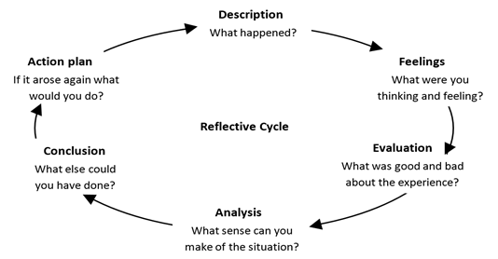

Fig. 1 Adapted from (Gibbs, 1988) ‘Reflective Cycle’ in Ghaye and Lillyman (2006, p. 23)

You can use the Reflective Cycle to ask yourself prompt questions about what actions you have taken in a high intensity situation where you had little time to prepare for the event that took place and to identify the insights you have gained from reflect on what you learned.

## 2.7 Becoming a Reflective Practitioner

A key aspect to understand in this section is the importance of self-reflection with respect to becoming a ‘reflective practitioner’ and developing reflective skills. It is important for you to routinely reflect on what you do in order for you to step outside the ‘*single loop*’ to: experience, reflect, conceptualise, and apply what you have learned within a ‘*second loop,*’ to re-frame your ideas and to learn from your experience so that you may change what you do to create different outcomes (see Chris Argyris double-loop learning).

Reflection is well aligned with the concept of learning from experience in that individuals think about what they did and what happened and make decisions from thinking about those previous situations what they would do differently or similarly next time if that situation were to occur.

It is important that you engage in the activities and tasks which are designed for you to realise the benefits of reflecting on your practice and situations where you can develop: the critical, constructive and creative thinking that is necessary for improving your practice. Six steps have been suggested that can help you to engage as a reflective practitioner with the reflective process these are:

* **Read** - around the topics you are learning about or want to learn about and develop;
* **Ask** - others about the way they do things and why;
* **Watch** - what is going on around you;
* **Feel** - pay attention to your emotions, what prompts them, and how you deal with negative ones;
* **Talk** - share your views experiences and impressions with others in your organisation;
* **Think** - learn to value time spent thinking about your work (Thompson, 2018).

It is essential for your development as a reflective practitioner to develop an understanding of the theory that other practitioners practice too and to explore those ideas with others to interpret knowledge from multiple perspectives, in order to gain a holistic understanding of a given context.

You will make use of online Wikis to act as your reflective space which is similar to keeping a learning journal or a learning diary. A starting point for you to work through is shown in Fig. 2 ‘*The Reflective Learning Process*’. This simple process involves five steps that consist of: (1) Identifying a learning incident; (2) Describing the experience; (3) Reflecting upon the experience; (4) Thinking about how the experience links to theory; and (5) Experimenting by trying out new approaches to create or initiate different outcomes. This process is useful as it provides prompt questions that can help to get you started when making entries into your reflective Wikis.

The reflective learning process is a useful staring point for practitioners and students seeking to embed reflective thinking as part of their daily or weekly work practice (Thompson, 2018).

|  |
| --- |
| **The Reflective Learning Process** |
| **The Learning Incident** |
| **Identify a situation you encountered in your work or personal life that you believe could have been dealt with more effectively.** |
| **Describe the Experience** |
| **What happened?  When and where did the situation occur?  Any other thoughts you have about the situation?** |
| **Reflection** |
| **How did you behave?  What thoughts did you have?  How did it make you feel?  Were there other factors that influenced the situation?  What have you learned from the experience?** |
| **Theorising** |
| **How did the experience match with your preconceived ideas, i.e. was the outcome expected or unexpected?  How does it relate to any formal theories that you know?  What behaviours do you think might have changed the outcome?** |
| **Experimentation** |
| **Is there anything you could do or say now to change the outcome?  What action(s) can you take to change similar reactions in the future?  What behaviours might you try out?** |

Fig. 2 Adopted from Thompson (2018) The Reflective Learning Process

## 2.8 What You Will be Asked to Do

* The reflective Wiki is only semi-private. That means, the entries are written to be read by you the student and by your peers and the course facilitator (if you have one). In this way it is different from a personal diary because it can be read by others;
* You will be offered the opportunity to write entries into your Individual Wiki and Group Wiki of approximately 300 words per reflective activity;
* The entries are not assessed on the content, findings, style and grammar although what is written must be comprehensible and will be subject to feedback from your facilitator, your peers or feedback from self-review if you so wish.

Please note that, the reflective Wikis are not to consist of simple descriptions but is to consist of detailed observations, analysis and comments on the practice and processes you are learning about and are involved in. When writing your reflections take the time you need to make sure you write in a style which is clear, fluent and concise, and always write in plain English and regularly proofread what you have written to sense check the meaning of your reflections. This is especially important when others will be reading your work and when you review your work at a later time and have trouble remembering what you meant, and what you found out, at the time of writing your reflection.

## 2.9 Group Participation

Group participation will consist of contributing to the Group Wiki extracts of your reflective analysis, findings and experiences to collaborate in building a Knowledge Map with your peers to foster interprofessionalism in Asset-Based Community Development.

## 2.10 The Main Theories and Concepts Covered

The following is a useful list of all the main theories and concepts that will be covered or touched upon in the COERS. A full list of references to sources materials will be provided in Appendix 4.1 A List of The Main Theories and Concepts Covered in the COERS for you to follow up on if any of the theories and concepts are unfamiliar to you.

1. Assets-Based-Approaches (A-B-As);
2. Open Educational Resources (OERs);
3. Case Based Learning (CBL);
4. Appreciative Inquiry (AI);
5. Motivational Interviewing (MI);
6. Self-Identity;
7. Theories of Empowerment;
8. Self-regulating Efficacy;
9. The Reflective Practitioner: Professional knowledge Reflection-in-Action and on-Action (double looped learning);
10. Critical Reflection and Dialogue;
11. Reflective Cycle Models;
12. Activity Theory;
13. American Inside Out Approach;
14. Social Networks;
15. Social Capital;
16. Human Capital;
17. Cultural Capital;
18. Performativity Theory;
19. Appreciative Inquiry;
20. Community Work Theory;
21. Shared Experience;
22. Effective Decision Making; and
23. Group Dynamics.

# SECTION 3: PSfL The Learning Management System

Section 3 of the student guide will cover the basics on how to login and navigate through the Assets Communication website and will include the information you need for making contributions to your reflective Wikis which will be used as a record of personal progress, for knowledge construction and for review by a facilitator or by you the student for the purposes of self-review.

## 3.1 Overview of COERS Development Site Structure

The diagram in Fig. 3 provides an overview of the structural layout of the COERS developed for the Assets Communication website of which there are five COERS. Each COER includes educational content about theory and practice based upon case-based learning and theories from the academic literature base linked to working in and with communities. The COERS also include reflective thinking activities which students can record in their Individual reflective Wiki and their Group reflective Wiki to keep a record of their learning and demonstrate their progress. The COERS developed for this site are: (1) Identity and Interprofessional Working; (2) Theory and praxis; (3) Understanding Context; (4) Partnership and Networking; and (5) Leadership and Management. As shown in the diagram each COER is built within Moodle Book and contains activities and tasks for you to complete, in addition to the Individual and Group Wikis for you to record your reflections in.

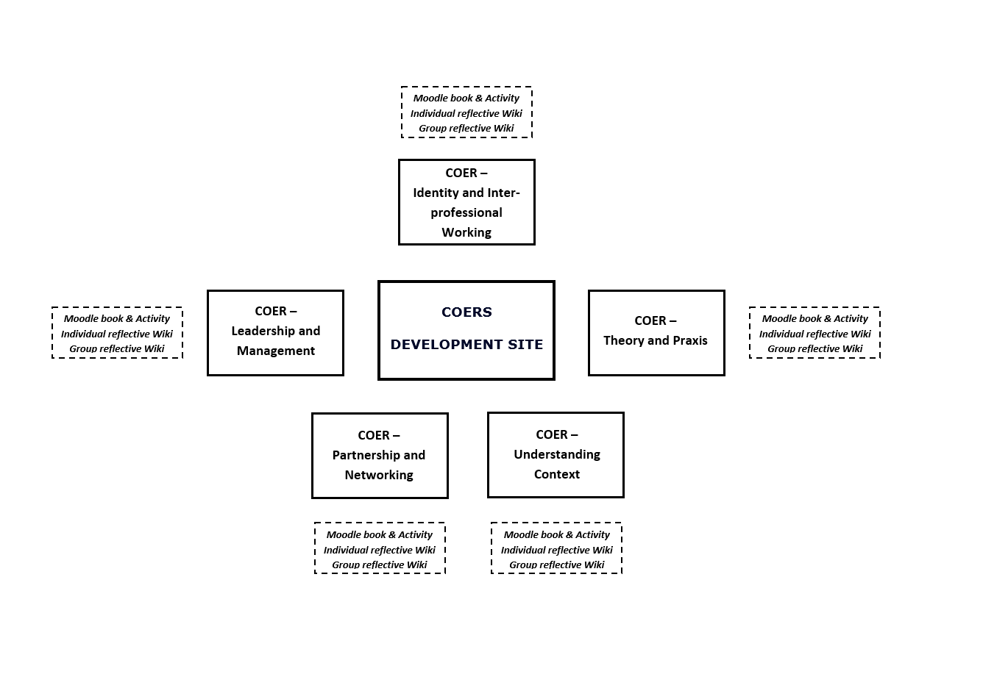

Fig. 3 An Overview of the COERS and Activities in the Assets Communication Website

## 3.2 The COER Educational Content Layout

Each COER on the Assets Communication website presents the educational content in conformance to the following structure which will be similar in format no matter which COER you decide to participate in and is described in Table 2 The COER Educational Content Layout.

|  |  |  |
| --- | --- | --- |
| **Web page Number** | **COER Webpage Template Structure** | **Description of the Page** |
| Page. 1 | Welcome/Overview | The Purpose of the resource and what you will get from working your way through this resource. |
| Page. 2 | Introducing the case | Presents a mini-case study consisting of some or all of the following: textual extracts from audio interviews; video clips; and photographs which you will analyse to address a set of critical questions about the content of the mini-case study. |
| Page. 3 | The Artefact | The selected artefact(s) are presented in this page and will include for example: an extract from a video exemplifying A-B-As accompanied with a transcription of the dialogue from the video. |
| Page. 4 | The Context of the Artefact | This page provides further information about the artefact for example: the story behind the artefact and/or a literature review of the concepts and theories need to understand the context of the artefact. |
| Page. 5 | Critical Questions | This page facilitates critical questions that encourage you to think about what you read or observed about A-B-As and how you might apply what they have learned about A-B-As in other contexts. |
| Page. 6 | Professional Practice | This page encourages you to think about sharing theory and practice to promote interprofessionalism. |
| Page. 7 | Current Practitioners | This page facilitates the comparing of international practice and academic perspectives. |
| Page. 8 | Bringing it all together | This page provides the opportunity for you to compare and contrast the answers you gave to the questions from the previous sections to gain a deeper understanding of the multiple perspectives associated with A-B-As. |
| Page. 9 | Summary | The summary outlines what you will have learned and/or will now be able to do after completing the COER. |
| Page. 10 | References | The reference section provides the full source references to the citations referenced in the educational content in the COER. |
| Table 2 The COER Educational Content Layout | | |

## 3.3 An Introduction to Navigating the Assets Communication Website

The following provides a basic introduction to the features of the Assets Communication Website. Students should become familiar with the website navigation and how to log on and off of the website.

To access the Website, you can copy and paste the following web link into your web browser search bar where you will be taken to the UWS Moodle Virtual Learning Environment web page as shown in in Fig. 4. If you are experiencing problems do a search in your web browser for UWS Moodle.

Web link: http://moodle.uws.ac.uk/

Once the welcome web page has loaded click on the Log in icon located at the top right-hand side of the screen – as shown.

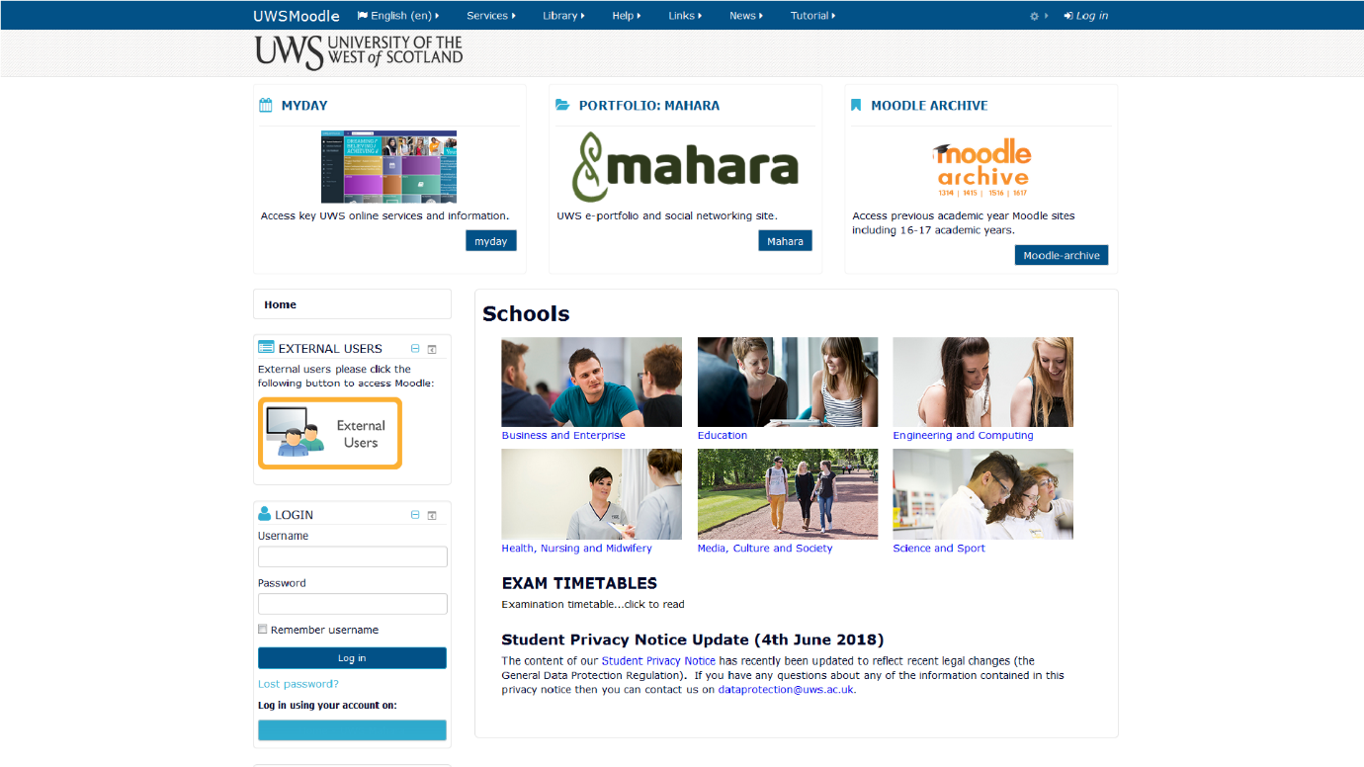

Fig. 4 UWS VLE Moodle Website Welcome Page

Once you have entered your login name and password you can select the Remember Username checkbox to store your login details for the next time you visit the website or proceed to click the log in button without selecting the Remember Username as shown in Fig. 5. To do so will result in you having to re-enter your login details each time you visit the web site.

The UWS VLE Login web page will load and you will enter your login and password to gain entry to the UWS Moodle VLE website – as shown.

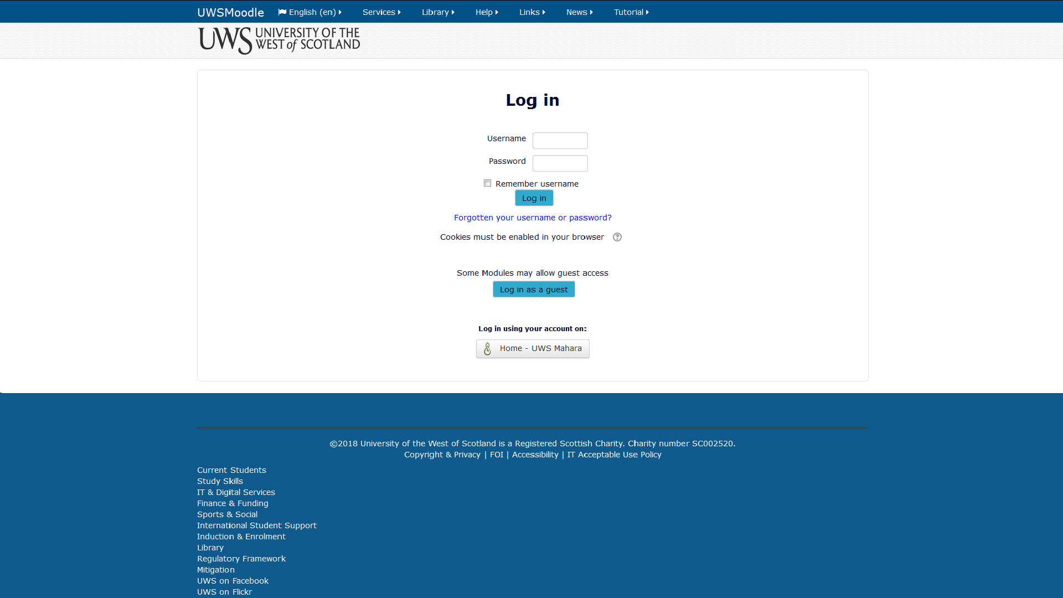

Fig. 5 UWS Moodle VLE Login Screen

You are now logged in as indicated by your user name now showing at the top right-hand side of the screen as shown in Fig. 6. Next you will click on the more tab – as shown.

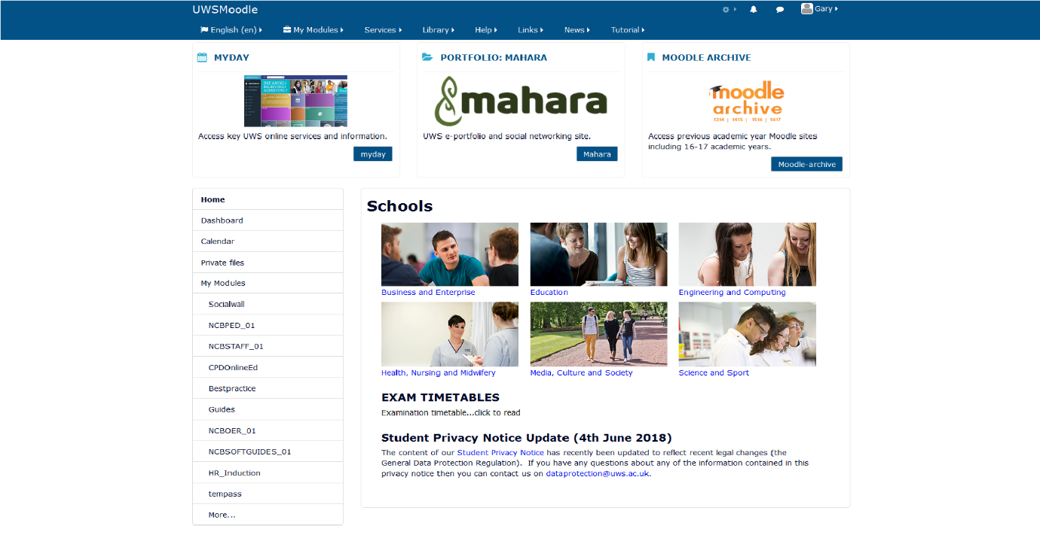

Fig. 6 UWS VLE Main Services Page

Once the Module Search facility web page has loaded enter the following name to find the COERS content as shown in Fig. 7. The name of the COERS site is: *COERS - Development Site* and click go – as shown.

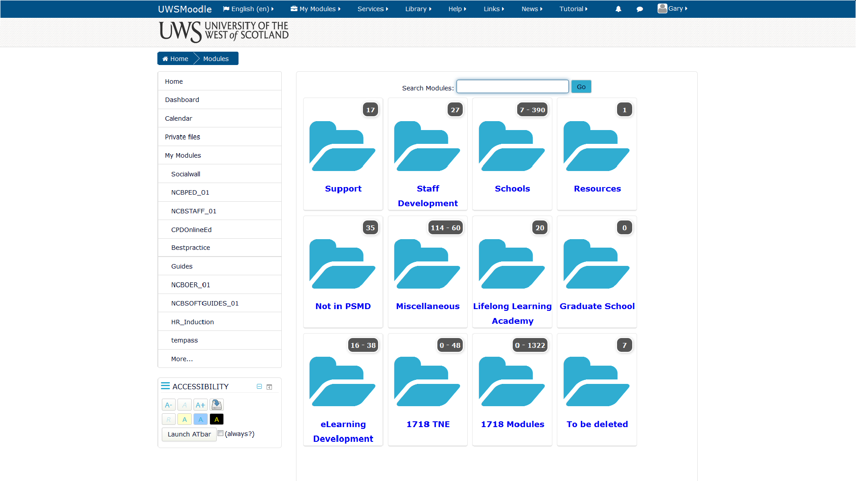

Fig. 7 UWS VLE Module Search Services Page

Once the Module Search facility has found and returned the link to the *COERS - Development Site* asshown in Fig 8*.* Click on the link to enter the COER web site – as shown.

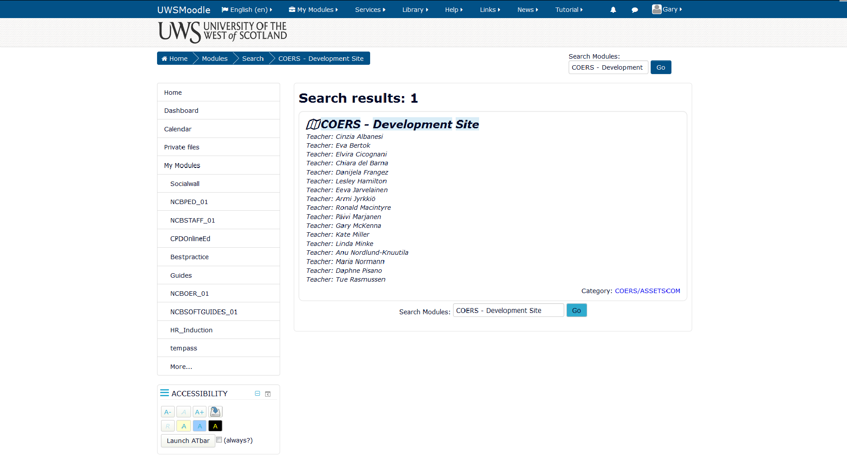

Fig. 8 UWS VLE Results of Module Search Services Page

You will now be taken to the COERS – Development Site where you can access all five of the COERS. To access a COER click on the tab with the name of the COER you would like to access, and a drop-down menu will appear below the COER name tab as shown in Fig. 9. A COER tab can contain links to the COER learning content, activities, surveys, Wikis and other learning mediums. The COERS can be taken in any order of learning.

To access the COER content in Moodle Book click on the link next to the green book icon – as shown.

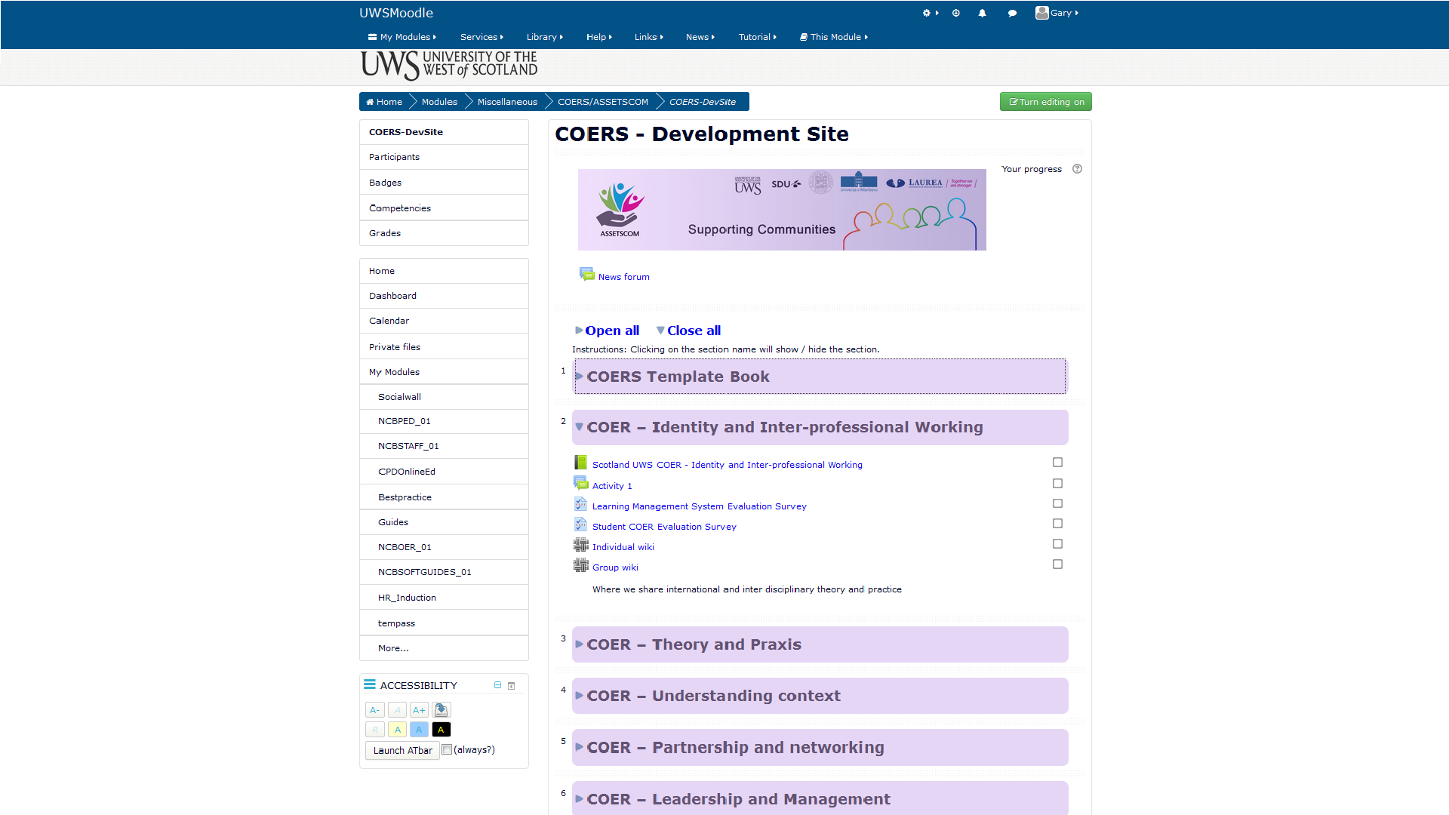

Fig. 9 UWS VLE COERS Development Site Page

You can now access all of the course content as shown in Fig. 10 by clicking on the links in the table of contents on the panel on the left-hand side – as shown.

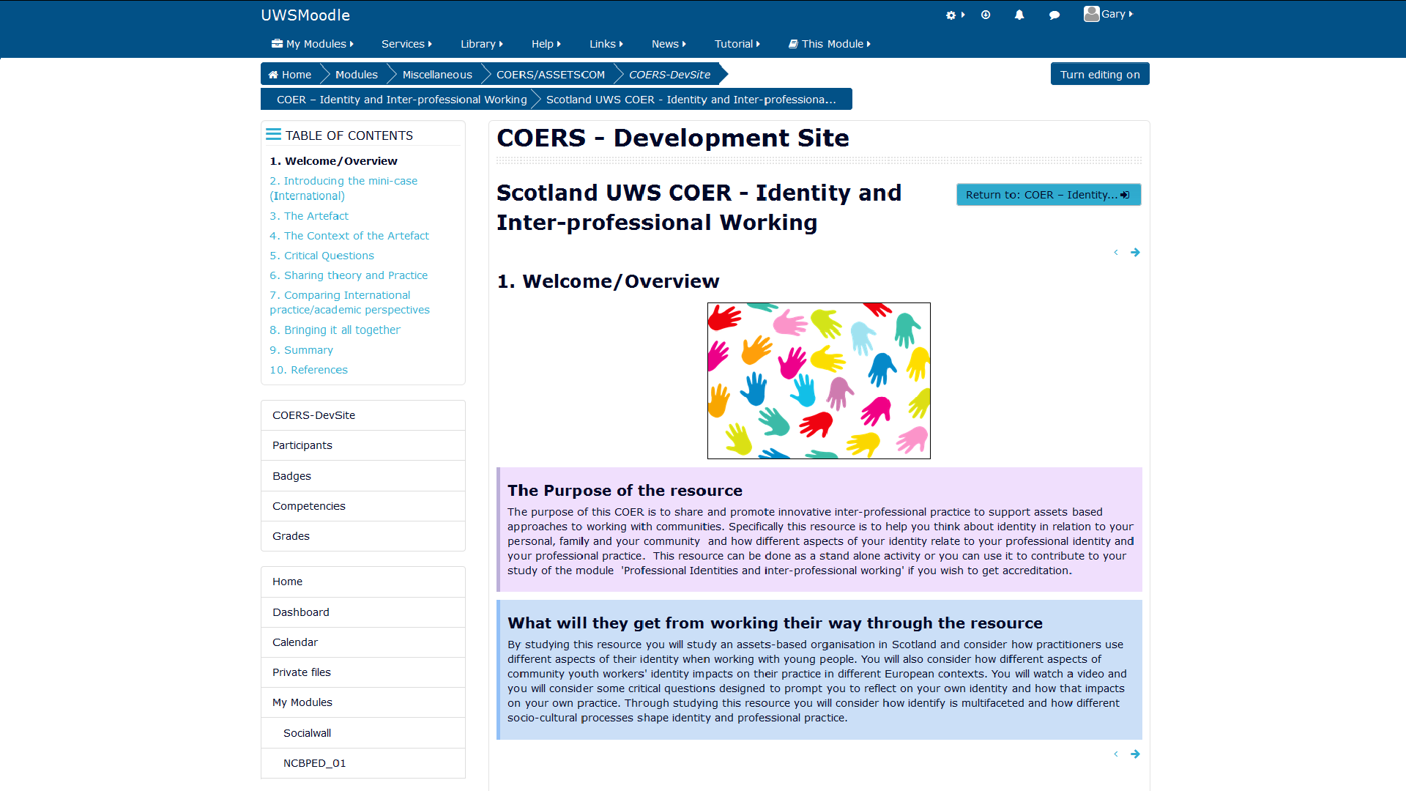

Fig. 10 UWS VLE COER Table of Contents Page

From the Main Webpage and from within the Moodle page you can access the Individual and Group Wiki as shown in Fig. 11 by clicking on the pencil icon link with the text ‘Individual Wiki Link’ – as shown.

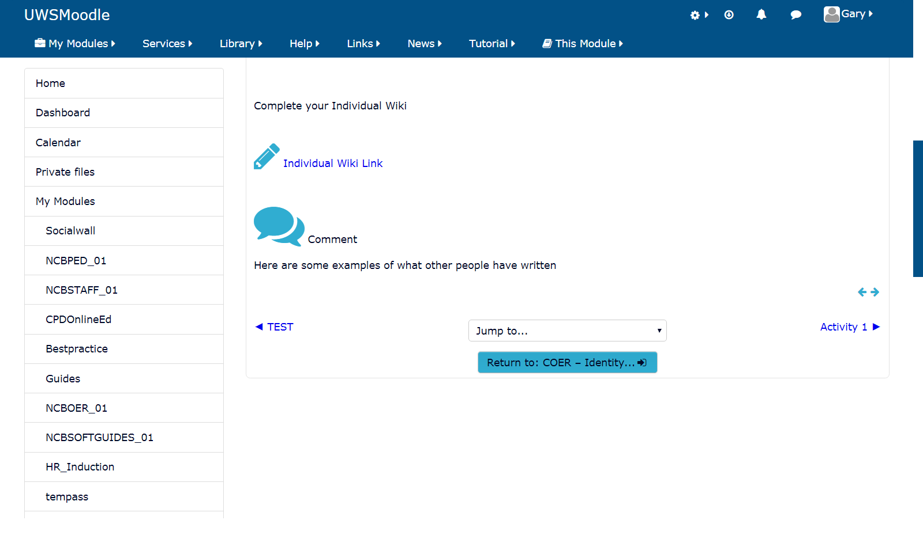

Fig. 11 UWS VLE COER Wiki Access

The Individual Wiki can be accessed by clicking on the edit tab shown in Fig. 12 and text entries can be entered into the space provided and can be saved by clicking on the save tab as shown.

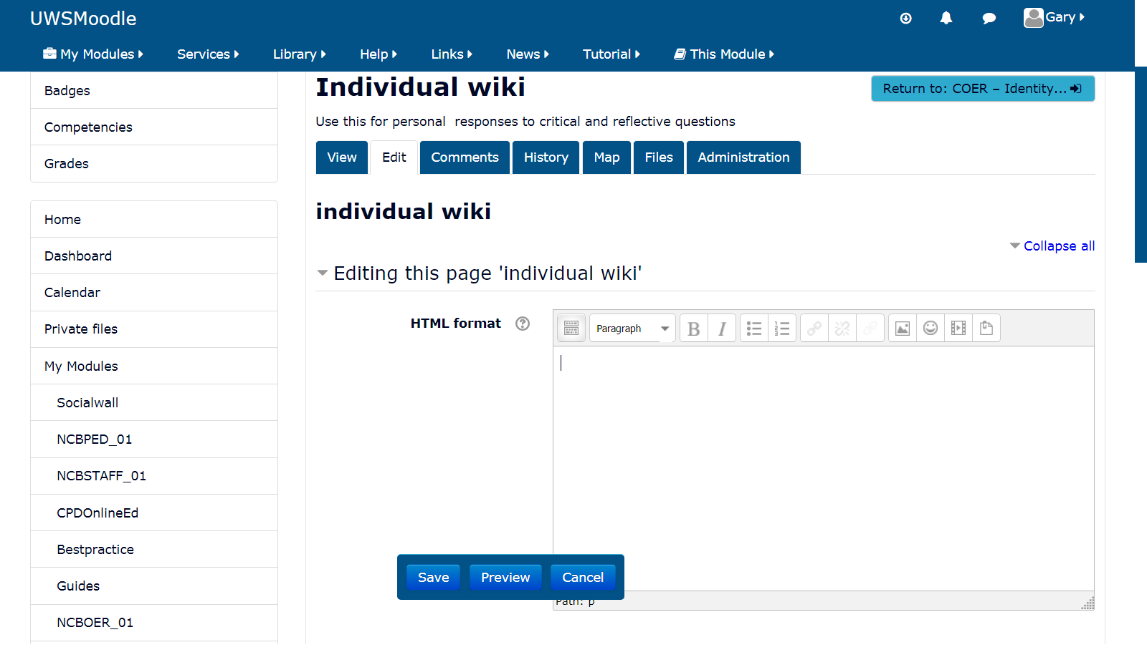

Fig. 12 UWS VLE COER Wiki Entry Page

## 3.4 The Four Rs of Open Educational Resources (OERS)

This website supports Open Educational Resources (OERS) which you as both a learner and user of this website will contribute to based on ‘The Four Rs of Open Educational Resources (OERS)’. The word Open in ‘Open Educational Resources’ (OERS) refers that the resources can be used at no cost by any individual(s) for adaptation and for reuse in various contexts. There are four separate aspects of reuse and different levels of openness. It is important to note that the licensing and technical aspects of open educational resources affect the relative openness of an OER.

The definitions found in the academic literature that are most aligned with our philosophy of learning at Assets communication are as follows. OERS are educational resources accessed through information and communication technologies, for consultation, use and adoption by a community of users for non-commercial purposes; freely accessible and open for educators, students, and self-learners to use and reuse for teaching, learning and research (Bissell, 2009, UNESCO, 2002). OERS are resources that reside in the public domain or have been released under an intellectual property license that permits their free use or re-purposing by others (D’Antoni, 2009). An OER may be an entire course, a complete book, or a more concise piece, such as a single learning object (Downes, 2007).

The openness of learning content in relation to the rights a user of the content is granted can be measured using *The Four R’s* (Wiley, 2009). The 4Rs Framework describes the four most important rights:

1. **Reuse** – the right to reuse the content in its unaltered / verbatim form;
2. **Revise** – the right to adapt, adjust, modify, or alter the content itself;
3. **Remix** – the right to combine the original or revised content with other content to create something new;
4. **Redistribute** – the right to make and share copies of the original content, your revisions, or your remixes with others (opencontent.org, 2009).

Facilitators of this website are permitted to ‘Reuse’, ‘Revise’, ‘Remix’ and ‘Redistribute’ the learning content situated within the Assets Communication website. We encourage facilitators and students to contribute material and their experience as practitioners to the Assets Communication website to help build a knowledge base of A-B-A content using OERS collaboratively to create COERS. This can be done by expanding upon the theories that underpin practice that can be considered strength-based approaches or A-B-As and by altering and/or extending the reflective activities and tasks to generate new practice based educational content and to promote interprofessionalism.

# SECTION 4: PSfL Understanding how to Interpret Progress

Section 4 of the student guide will help you become familiar with the Assets Communication COERS Learning Management System. Section 4 will explain the method for monitoring and reviewing the reflective activities and tasks you will undertake and will describe the process of self-reviewing your own progress.

## 4.1 Progress Monitoring and Self-review

There are two progress monitoring tools which are offered to you which are drawn from: the ‘*Student Individual Progress*’ recoded in the student individual Wiki and the ‘*Student Class Progress*’ recorded in the student Group Wiki.

If you have a facilitator you should ask him or her if they will be providing you with a review of your progress and development of working on the COER activities and tasks. Alternatively, you can use the process of self-review to determine your progress and development by assessing your portfolio of work recorded in both of the Wikis you have contributed to on this website. Self-review as a process is a useful way to determine your own progress and focus on areas that need to be developed to make further progress as outlined in Fig 13. Student progress can be generated on the following:

|  |  |
| --- | --- |
| **THE TWO FORMS OF STUDENT PROGRESS MONITORING** | |
| **Facilitator Student review** | **Student Self-review** |
| The Individual Student (Individual Wiki) | The Individual Student (Individual Wiki) |
| The Class Group project (Group Wiki) | The Class Group project (Group Wiki) |
| Learning Path Status (completed by facilitator) | Student Self-Progress Report (Completed by the student) |

Fig. 13. Student Progress Monitoring

### 4.1.1 Facilitator Student review

We recommend that facilitators, and students undertaking self-review, assess for evidence of practitioners and students having demonstrated the following three forms of reflection in their Individual Wiki and Group Wiki: (1) Reflection in action; (2) Reflection on action; and (3) Reflection for action. These three types of reflection are important for practitioners and students to become familiar with and to master to develop personally and as a reflective professional.

A description of the three kinds of reflective thinking important for facilitators to promote for practitioner and student development and to assess are as follows:

(1) **Reflection-in-action** can be described as ‘action present’ and involves reflecting on an incident when it is occurring to benefit that situation rather than reflecting on how you would do things differently in the future should that situation occur (Schön, 1983). This form of reflection is useful in disciplines where a professional must react to a situation at the time it occurs without being able to think about what just occurred and make the necessary changes later.

(2) **Reflection-on-action** means reflecting on ways in which practice can be developed (changed) after a situation has occurred. Therefore, as practitioners and students: “*We reflect on action, thinking back on what we have done in order to discover how our knowing-in-action may have contributed to an unexpected outcome*” (Schön, 1983, p. 26).

(3) **Reflection-for-action** involves thinking about future actions for improving or changing a practice (Grushka, Hinde-McLeod and Reynolds, 2005; Killion and Todnem 1991). This form of reflection requires practitioners to anticipate what will occur when a particular situation occurs, and to reflect on their past experiences, before that situation occurs to make proper preparations (Farrell, 2013). Facilitators, and students performing self-review, should take note that the main problem learners have in doing reflection-for-action is knowing what they should reflect on to be able to make improvements or changes in their own practice – which can be addressed by keeping a reflective log.

**For self-review please ponder these questions:**

* Based on duration is there evidence of a real effort to develop higher order thinking skills or just the bare minimum effort for going through the motions to complete the Wikis?
* Is there evidence of different forms of reflection, for example: evidence of reflecting on previous experiences to learn and develop; instances where reflection has been used in a live situation to divert an incident from occurring; and cases were forward planning has been used to prepare for a situation should it arise based on reflective thinking?

### 4.1.2 Student Self-review

For students and practitioners to become more effective learners and to improve upon their skills they need to learn the importance of self-review. Many occupations call for workers to become lifelong learners which involves managing their own personal and professional development within and outside of the workplace. When students and practitioners evaluate themselves, they are assessing what they know, do not know, and what they would like to know. In using the process of self-review, they begin to recognise their own strengths and weaknesses by asking the question: “*What have I learned?*”.

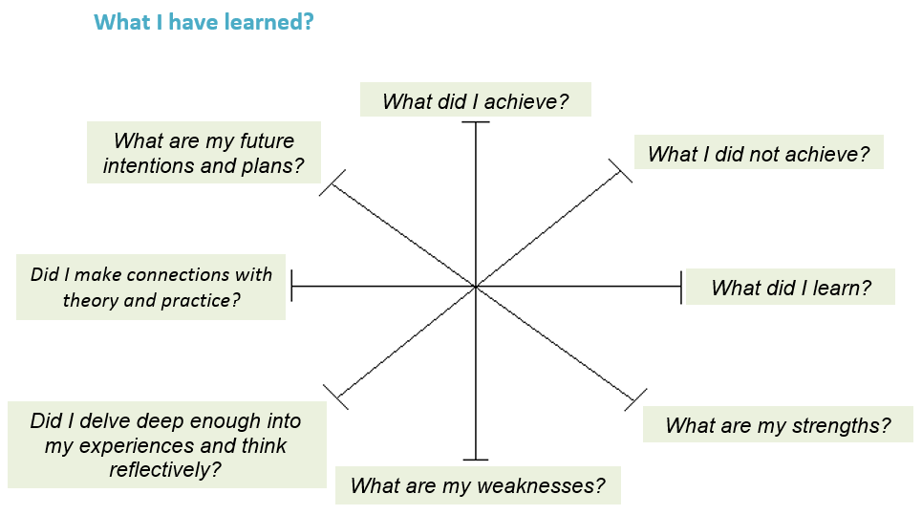

Fig. 14. Student Learning Clock (adapted from Castley, 2015)

The student learning clock shown in Fig. 14 can be used by practitioners and students as a form of self-review to ascertain what they have learned during and after completing a course or a project. In the absence of a facilitator students can use the Learning Clock to identify and respond to their own learning needs.

The Learning Clock involves answering eight self-review questions which begins with answering the question: “*What did I achieve?*” and continues clockwise until the practitioner or student reach the final question “*What are my future intentions or plans?*” – which is used to encourage the learner to set a goal or goals and to create an action plan to carry out their learning intentions and goals (Castley, 2015). For more self-review questions see Appendix 4.5 Learner Self-review Questions. The concept activity think and write questions can also be used for the purposes of self-review for monitoring learner progress, identify possible learning gaps and to shape future action to address these gaps in learning.

**Concept Activity Think and Write:**

* Think about the material we just covered what did you like the most about it?
* Summarise how each reflective report you generate can support your development needs as a practitioner and learner?
* What is your action plan for progress monitoring, please summarise it?
* Write down one question you still have and share it with us at Assets Communication.

## 4.3 The Learner Experience

The student experience feedback survey has been designed to capture views and opinions of the quality of your learning experience when using the Assets Communication website and the COERS.

### 4.3.1 Feedback and Quality Assurance Processes

Feedback, both formal and informal, is sought from students who have used the COERS in the Assets Communication website. Changes to the subject structure and student review are made to address the student feedback.

Students can complete a student experience feedback survey and can comment about such things as the workload being too high for the subject or too low for the students to engage with in relation to their learning experiences. The student experience feedback survey is part of the quality assurance process that occurs for the Erasmus Plus project which supports the Assets Communication website. In this survey you are invited to tell us about your learning experiences of the COER Subject you studied and learned about. We would like you to tell us how you experienced the COERS units. Your views will be used to assist us to enhance the COERS units for the next group of students. Please make use of the student feedback survey and make time to tell us your views.

**Student Survey to be created but will include**

* Student on-line experience of lessons
* Student on-line experience of the activities and tasks (working on their Individual Wiki or the Class Group Wiki).
* Student views of learning through reflection.
* Student views of using a case-study based approach to learning.
* Student views of the quality of the offline sources and additional resources.

# References

Bissell, A. (2009). Permission granted: Open licensing for educational resources. *Open Learning, The Journal of Open and Distance Learning*, 24, 97-106.

Castley, A. J. (2015). *Strengthening your reflective commentary*. Learning and Development Centre. Warwick. Retrieved July 26, 2018, from http://aem.cast.org/about/publications/2003/ncac-differentiated-instruction-udl.html#.W1mb69JKiM8

D’Antoni, S. (2009). Open Educational Resources: Reviewing initiatives and issues. *Open Learning, The Journal of Open and Distance Learning*, 24, 3-10.

Downes, S. (2007). Models for sustainable open educational resources. *Interdisciplinary Journal of Knowledge and Learning Objects*, 3, 29-44.

Farrell, T. S. (2013). Reflecting on ESL teacher expertise: a case study. *System*, 41(4), 1070–1082.

Grushka, K., Hinde-McLeod, J., and Reynolds, R. (2005). Reflecting upon reflection: theory and practice in one Australian university teacher education program. *Reflective Practice*, 6(1), 239–246.

Hall, T., Vue, G., Strangman, N., and Meyer, A. (2004) *Differentiated Instruction and Implications for UDL Implementation: Effective Classroom Practices Report*. National Center on Accessible Educational Materials. Retrieved July 26, 2018, from http://aem.cast.org/about/publications/2003/ncac-differentiated-instruction-udl.html#.W1mb69JKiM8

Killion, J., and Todnem, G. (1991). *A process of personal theory building*. Educational Leadership, 48(6), 14–17.

Learning and Development Centre. (2018) Questions to ask yourself. CENTRE FOR ACADEMIC PRACTICE THE UNIVERSITY OF WARWICK. [Accessed: July 20, 2018] https://warwick.ac.uk/services/ldc/resource/evaluation/tools/self/

SCDC. (2018). Encouraging confident, healthy communities: Assets Based Approaches [Accessed online: July 18, 2018] <http://www.scdc.org.uk/what/assets-scotland/>.

Schön, D. (1983). *The Reflective Practitioner: How professionals think in action*. London: Temple Smith.

Thompson, N. (2018). *The Skills You Need Guide to Personal Development*. Skills You Need Ltd.

Tomlinson, C. A. (August, 2000). Differentiation of Instruction in the Elementary Grades. ERIC Digest. ERIC Clearinghouse on Elementary and Early Childhood Education.

UNESCO. (2018). Communication and Information: What are Open Educational Resources (OERs)? [Accessed online: July 18, 2018] http://www.unesco.org/new/en/communication-and-information/access-to-knowledge/open-educational-resources/what-are-open-educational-resources-oers/

UNESCO. (2002). Forum on the impact of open courseware for higher education in developing countries: Final report. Retrieved July 20, 2018, from http://unesdoc.unesco.org/images/0012/001285/128515e.pdf

Wiley, D. (2018). *Iterating toward openness*, opencontent. [Accessed: July 20, 2018] https://opencontent.org/blog/archives/1123

# Appendix

## 4.1 A List of The Main Theories and Concepts Covered in the COERS

### 4.1.1 PARTNERSHIP AND NETWORKING

Bourdieu, P. (1986) The forms of capital. In J. Richardson (Ed.) *Handbook of Theory and Research for the Sociology of Education* (New York, Greenwood). Page 241-258.

Coleman, J. (1988). Social Capital in the Creation of Human Capital. Source: *The American Journal of Sociology*, Vol. 94, Page 95-120

Lazega. E. (1997). Network analysis and qualitative research: A method of contextualization. In Gale Miller and Robert Dingwall (eds.) *Context and Method in Qualitative Research*. Sage. London

Putnam, R. (2000). *Bowling alone: Simon and Schuster Paperbacks*. Page. 15-26

Turner, J. H. (2013). *Contemporary Sociological Theory*. Sage, London. Page 627-638.

### 4.1.2 THEORY AND PRAXIS

Beresford, P. (2003) It`s Our Lives: A short Theory of Knowledge, Distance and Experience. London: OSP for Citizen Press in association with Shaping Our Lives. <https://shapingourlives.org.uk/wp-content/uploads/2015/03/ItsOurLives.pdf>

Cooperrider, D. & Whitney, D. (2005). *A Positive Revolution in Change: Appreciative Inquiry*. The change handbook: The definitive resource on today's best methods for engaging whole systems. 87.

Healy. K. (2012) *Social work methods and skills*. Palgrave Macmillan: Basingstoke.

Kretzmann, J. & McKnight, J. (1993). Building Communities from the Inside Out: A Path Toward Finding and Mobilizing a Community’s Asset. Evanston, IL: The Asset Based Community Development Institute, Northwestern University. In Healy. K. (2012) *Social work methods and skills*. Basingstoke: Palgrave Macmillan.

Lerner, R. M., Alberts, A. E., Jelicic, H., & Smith, L. M. (2006). Young people are resources to be developed: Promoting positive youth development through adult-youth relations and community assets. In *Mobilizing adults for positive youth development* (pp. 19-39). Springer US.

Mathie, A. & Cunningham, G. (2003). *From clients to citizens: asset-based community development as a strategy for community driven development*, Development in Practice. 13(5), 474–86.

Mannes, M., Roehlkepartain, E. C., & Benson, P. L. (2005). *Unleashing the power of community to strengthen the well-being of children, youth, and families: An asset-building approach*. Child Welfare, 84(2), 233.

Rose, H. A. (2006). *Asset-based development for child and youth care*. Reclaiming Children and Youth, 14(4), 236.

Russell, C. (2010). Making the Case for an Asset-Based Community Development (ABCD) Approach to Probation: From Reformation to Transformation, *Irish Probation Journal*, Vol, 7, Sept. 2010, pp. 119-131, https://www.drugsandalcohol.ie/16533/1/Irish_Probation_Journal_2010.pdf

Scales P. C & Leffert N. (2004). *Developmental Assets: A Synthesis of the Scientific Research on Adolescent Development*, 2nd Edition. Search Institute. 2004.

Stanford Encyclopedia of Philosophy: Feminist Epistemology and Philosophy of Science. First published Wed Aug 9, 2000; substantive revision Wed Aug 5, 2015

https://plato.stanford.edu/entries/feminism-epistemology/

Theory of 20/20 Internal/ External assets: https://www.search-institute.org/our-research/development-assets/developmental-assets-framework/

The Importance of Sharing Experiences, published 16.10.2016. www.theatlantic.com/health/archive/2014/10/the-importance-of-sharing-experiences/381493/

Twelvetrees, A. (2008). Community work. 4th edn. Basingstoke: Palgrave Macmillan. In Healy. K. (2012) *Social work methods and skills*. Basingstoke: Palgrave Macmillan.

Rissanen, P. (2015) Toivoton tapaus?: Autoetnografia sairastumisesta ja kuntoutumisesta.  (in English: *Hopeless Case? An Autoethnography of Getting Mentally Ill and Re-habilitation of It*) Kuntoutussäätiön tutkimuksia 88/2015. URN:ISSN:0358-089X. <https://kuntoutussaatio.fi/files/2116/Paivi_Rissanen.pdf>

Rissanen, P. & Puumalainen, J. (2015) Kokemuksen kautta osaamiseen: Vapaaehtoisuus, vertaisuus ja kokemusasiantuntijuus. Kuntoutus 1/2015.

### 4.1.3 UNDERSTANDING CONTEXT

Bedny, G. Z. and Karwowski, W. (2006) A Systemic-Structural Theory of Activity: Applications to Human Performance and Work Design. Boca Raton, CRC Press/Taylor & Francis.

Bedny, G. Z. and Meister, D. (1997). *The Russian Theory of Activity: Current Applications To Design and Learning*. Series in Applied Psychology. Psychology Press. ISBN 978-0-8058-1771-3.

Engeström, Y., Miettinen, R., Punamäki, R. (1999). *Perspectives on Activity Theory*. Cambridge University Press. ISBN 0-521-43730-X.

Fjeld, M., Lauche, K., Bichsel, M., Voorhorst, F., Krueger, H., Rauterberg, M. (2002): Physical and Virtual Tools: Activity Theory Applied to the Design of Groupware. In B. A. Nardi & D. F. Redmiles (eds.) *A Special Issue of Computer Supported Cooperative Work (CSCW): Activity Theory and the Practice of Design*, Volume 11 (1–2), pp. 153–180.

Foot, K. (2001). Cultural-Historical Activity Theory as Practical Theory: Illuminating the Development of a Conflict Monitoring Network. *Communication Theory*, 11(1), 56–83.

Vygotsky, L. S. (1978). *Mind in society: The development of higher psychological processes. Cambridge*, MA: Harvard University Press. p. 56. ISBN 0-674-57628-4.

Wilson, T. D. (2008). Activity theory and information seeking. *Annual Review of Information Science and Technology*, 42, 119–161.

### 4.1.4 IDENTITY AND INTER-PROFESSIONAL WORKING

***Reflective Thinking*:**

https://learn.solent.ac.uk/mod/book/view.php?id=2732&chapterid=1101

http://www.open.edu/openlearn/ocw/mod/oucontent/view.php?id=51386&section=2

http://www.hawaii.edu/intlrel/pols382/Reflective%20Thinking%20-%20UH/reflection.html

***Empowerment*:**

Adams, R. (2008). *Empowerment, participation and social work*. New York: Palgrave Macmillan.

Humphries, B. (1996). *Critical Perspectives on Empowerment*. Birmingham: Venture.

Rappaport, J., Carolyn F.S., and Hess, H. (1984). *Studies in Empowerment: Steps toward Understanding and Action*. New York: Haworth.

http://www.who.int/healthpromotion/conferences/7gchp/track1/en/

http://www.socialworker.com/extras/social-work-month-project-2016/empowering-clients-means-empowering-ourselves-first/

***Self-regulating Efficacy*:**

Bandura, A. (1982). “*Self-efficacy mechanism in human agency”*. American Psychologist. 37 (2): 122–147. doi:10.1037/0003-066X.37.2.122.

Bandura, A. (1977). “*Self-efficacy: Toward a Unifying Theory of Behavioral Change*”. Psychological Review. 84 (2): 191–215. doi:10.1037/0033-295x.84.2.191. PMID 847061.

https://www.uky.edu/~eushe2/Bandura/BanEncy.html

https://www.verywellmind.com/what-is-self-efficacy-2795954

http://professoralbertbandura.com/albert-bandura-self-regulation.html

***Motivational Interviewing*:**

Miller, W. R., & Rollnick, S. (1991). Motivational Interviewing: Preparing People to Change Addictive Behavior. New York: Guilford Press. ISBN 978-0-89862-566-0

Miller, W. R. and Rollnick, S. (2002). Motivational Interviewing: Preparing People to Change, 2nd ed. New York: Guilford Press. ISBN 978-1572305632.

Miller, W. R., & Rollnick, S. (2012). Motivational Interviewing, Helping People Change, 3rd ed. New York: Guilford Press. ISBN 978-1-60918-227-4.

https://www.psychologytoday.com/us/therapy-types/motivational-interviewing

https://www.umass.edu/studentlife/sites/default/files/documents/pdf/Motivational_Interviewing_Definition_Principles_Approach.pdf

***The Reflective Practitioner*:** Professional knowledge Reflection-in-Action and on-Action (double looped learning)

Bolton, G. (2010). Reflective practice: writing and professional development (3rd ed.). Los Angeles: Sage Publications. p. xix. ISBN 9781848602113. OCLC 458734364.

Boud, D., Keogh, R., Walker, D. (1985). *Reflection, turning experience into learning*. London; New York: Kogan Page; Nichols. p. 19. ISBN 0893972029. OCLC 11030218.

Schön, D. A. (1983). The reflective practitioner: how professionals think in action. New York: Basic Books. ISBN 046506874X. OCLC 8709452.

http://infed.org/mobi/donald-schon-learning-reflection-change/

https://graysreadinggroup.wordpress.com/2012/12/18/the-reflective-practitioner-by-donald-schon/

***Critical Reflection and Dialogue*:**

http://www.wilderdom.com/experiential/elc/ExperientialLearningCycle.htm

<https://uwaterloo.ca/centre-for-teaching-excellence/teaching-resources/teaching-tips/planning-courses-and-assignments/course-design/critical-reflection>

https://www.education.vic.gov.au/Documents/childhood/professionals/support/reffram.pdf

http://faculty.coloradomtn.edu/orl/critical_reflection.htm

### 4.1.5 LEADERSHIP AND MANAGEMENT

Altier, W. J. (1999). *The Thinking Manager's Toolbox: Effective Processes for Problem Solving and Decision Making* (1stedition). New York: Oxford University Press.

Berne, E. (1964). *Games people play : the psychology of human relationship*. London: Penguin Group

Forsyth, D. R. (2006). *Group Dynamics* (4th edition). Belmont: Wadsworth Publishing

Kretzmann, J. P. and McKnight, J. L. (1993). *Building communities from the inside out: a path toward finding and mobilizing a community assets*. Evanston: Center for Urban Affairs and Policy Research, Northwestern University

## 4.2 The Overarching Purposes and Outputs of each of the COERS

|  |
| --- |
| **Partnership and Networking COER** |
| The overarching purposes and outputs for the Partnership and Networking COER are:   * To share and promote innovative assets-based practice between professionals and practitioners. * To provide students with the ability to reflect upon important aspects of partnership and networking in an organisation. * To help students identify existing strengths in an organisation and discern new beneficial partnerships. * To provide students with an understanding of how social capital supports sustainable partnerships and community development. |
| The outputs from working through the COER are:   * Students will study how partnership and networking are structured in asset-based organisations. * Students will learn how different aspects of these structures provides strengths and limitations and will understand how this can influence organisations. * Students will develop an understanding of resource-based partnership models and the influence of social capital on both an intra- and extra- organisational level. |

|  |
| --- |
| **Theory and Praxis COER** |
| The overarching purposes and outputs for the Theory and Praxis COER are:   * Students will become familiar with the concepts of shared expertise in the context of an assets-based approach. * Students will learn from examples of the Finnish youth work context to identify ways to help youths in communities to recognise their assets in equal dialogue with professionals. |
| The outputs from working through the COER are:   * Students will be able to understand the theoretical principles of community participation. * Students will be able to understand the theoretical principles of social inclusion. * Students will be able to recognise the structures where participation of youth can be promoted. * Student will be able to recognise the tools and methods that can be used in work with youth. * Student will be able to apply theory and praxis in their own work. * Student will be able to understand the meaning of interprofessional work. |

|  |
| --- |
| **Mapping the Context COER** |
| The overarching purposes and outputs for the Mapping the Context COER are:   * The student will learn about the ‘context concept’, its observation levels and analysis methodologies, with particular reference to those addressing an assets-based approach. * Students will learn from examples of the Dreamcatcher Project case study through the excerpts of interviews made with the operators. * Students will learn about a best practice method that Dreamcatcher operators use in collaboration with the Network Adolescence of Forlì: the "network map" tool used to analyse the context in which operators work. * Students will be able to put into practice what they have learned about the network map tool to create a map of the links present in their context that will bring out the resources and potential of the community. |
| The outputs from working through the COER are:   * Students will learn the basics of the context analysis through the experimentation of a mapping path to be carried out first individually with the aid of an exemplary case study and then, by involving their working group, they will be able to apply the tool to a specific context (project, intervention, etc.). * Students will be able to use the tool to highlight the resources and potential present in the context the students are analysing, activate a process of reflection in their working group with respect to the links they have created with the community and to have a graphic scheme that represents their reference network. * Students will use stimulus material to reflect on the context analysis methodologies based on the exploitation of resources and on the participation of community actors to think and apply them in an original way in other contexts. |

|  |
| --- |
| **Identity and Inter-professional Working COER** |
| The overarching purposes and outputs for the Identity and Inter-professional Working COER are:     * The students will learn about the benefits of sharing inter-professional practice to support assets-based approaches to working with communities. * The students will think about identity in relation to their personal, family and community and how different aspects of identity relate to professional identity and professional practice. |
| The outputs from working through the COER are:   * Students will study an assets-based organisation in Scotland and consider how practitioners use different aspects of their identity when working with young people. * Students will consider how different aspects of community youth workers' identity impacts on their practice in different European contexts. * Students will be able to answer critical questions and reflect on their own identity and how that impacts on their own practice. * Students will gain an understanding of how identify is multifaceted and how different socio-cultural processes shape identity and professional practice. |

|  |
| --- |
| **Leadership and Management COER** |
| The overarching purposes and outputs for the Leadership and Management (Slovenia) COER are:   * Students will become familiar with the group dynamic that can occur when managing and leading teams that are established within A-B-As. * Students will learn about multiversity and different ways to manage teams that are comprised of a diverse set of members and the skills, practice, and energy that are needed to properly and effectively run such a team. |
| The outputs from working through the COER are:   * Students will gain an understanding of how to conduct and lead management tasks in a team and manage team group dynamics. * Students will gain an understanding about how A-B-A projects are funded by funds gained from public tenders and how to manage A-B-A administrative project funding related tasks. |

## 4.3 The Key Strength Based Concepts and Theories

|  |  |
| --- | --- |
| **COER** | **Concepts and Theories** |
| **Partnership and Networking (Denmark)** | American Inside Out Approach; Social Networks; Social Capital; Human Capital; and Cultural Capital. |
| **Theory and Praxis (Finland)** | Performativity Theory; Appreciative Inquiry; Community work; Asset Based Approaches Theory; and Shared Experience. |
| **Mapping the Context (Italy)** | Activity Theory. |
| **Identity and Inter-professional Working (Scotland)** | Reflective Thinking; Empowerment; Self-regulating Efficacy; Motivational Interviewing; The Reflective Practitioner: Professional knowledge Reflection-in-Action and on-Action (double looped learning); Critical Reflection and Dialogue; and Reflective Cycle Models. |
| **Leadership and Management (Slovenia)** | Effective Decision Making; and Group Dynamics. |

## 4.4 Student Learner Experience and Satisfaction Survey

Assets communication aims to make a large set of teaching and learning materials in Inter-professional approaches to assets-based community participation freely and openly available to educator, professionals/practitioners, and students anywhere in the world as Open Educational Resources (OERs). The project is funded by Erasmus plus in collaboration with a number of academic institutions and stakeholders across Europe. Your organisation is one of the key partners in the Assets communication project. We would appreciate your time in completing the survey to give us feedback on the OERs produced by the Assets communication team. The results of this questionnaire will inform future policies on Open Educational Resources.

Any information you provide as part of this questionnaire will be used for research purposes only and will be kept confidential in accordance with university ethical policies. We value your time and input.

**\* Data Protection**

All data collected in this survey will be held anonymously and securely. Individual results are strictly confidential, and individuals will not be identified in any way.

Demographic data collected will only be used for the purposes of this survey and cannot be used to identify and individuals.

Please place a cross in the box if you agree with the following statements:

 1. I understand that my participation is voluntary and that I am free to withdraw at any time without giving any reason.   
 2. I agree to take part in the above study.

Please enter your information and details in the boxes provided below.

1. Please print your full name in capital letters clearly in the text box provided if you are willing to fill out this survey.



2. Please enter the date you completed this survey in the boxes provided.



3. Please enter the name of the organisation you are affiliated with.



4. Please select which gender you identify yourself with.

 1. Male  2. Female  3. Other

5. Please select the age range you fall between.

Under 20 20-29  30-39  40-59  50-59  Over 60

6. Please enter the name of the country are you currently a resident of.



**\*Student Learning Experience and Satisfaction Survey**

**TEACHING ON MY COURSE**

To what extent do you agree or disagree with the following statements regarding teaching on your course?

Please consider the following statements and rate each one based on the following scale:

1 = Strongly agree | 2 = Agree | 3 = Unsure | 4 = Disagree | 5 = Strongly disagree

|  |  |  |  |  |  |  |
| --- | --- | --- | --- | --- | --- | --- |
|  | |  |  |  |  |  |
|  |  | 1 | 2 | 3 | 4 | 5 |
| 1. Staff are good at explaining things.  2. Staff have made the subject interesting.  3. The course is intellectually stimulating.  4. My course has challenged me to achieve my best work. |  |  |  |  |  |  |
|  |  |  |  |  |  |
|  |  |  |  |  |  |
|  |  |  |  |  |  |
|  |  | | | | | |

**LEARNING OPPORTUNITIES**

To what extent do you agree or disagree with the following statements regarding learning on your course?

Please consider the following statements and rate each one based on the following scale:

1 = Strongly agree | 2 = Agree | 3 = Unsure | 4 = Disagree | 5 = Strongly disagree

|  |  |  |  |  |  |  |
| --- | --- | --- | --- | --- | --- | --- |
|  | | | | | | |
|  |  | 1 | 2 | 3 | 4 | 5 |
| 1. My course has provided me with opportunities to explore ideas or concepts in depth.  2. My course has provided me with opportunities to bring information and ideas together from different topics.    3. My course has provided me with opportunities to apply what I have learned. |  |  |  |  |  |  |
|  |  |  |  |  |  |
|  |  |  |  |  |  |
|  |  |  |  |  |  |  |
|  |  |  |  |  |  |  |

**REVIEW AND FEEDBACK**

To what extent do you agree or disagree with the following statements regarding review and feedback about your progress on your course? (Feedback includes written feedback from your facilitator, your peers and/or self-review.)

Please consider the following statements and rate each one based on the following scale:

1 = Strongly agree | 2 = Agree | 3 = Unsure | 4 = Disagree | 5 = Strongly disagree

|  |  |  |  |  |  |  |
| --- | --- | --- | --- | --- | --- | --- |
|  |  |  |  |  |  |  |
|  |  | 1 | 2 | 3 | 4 | 5 |
| 1. The criteria used in marking have been clear in advance. |  |  |  |  |  |  |
| 2. Marking and assessment has been fair. |  |  |  |  |  |  |
| 3. Feedback on my work has been timely. |  |  |  |  |  |  |
| 4. I have received helpful comments on my work. |  |  |  |  |  |  |

**SUPPORT AND GUIDANCE**

To what extent do you agree or disagree with the following statements regarding support on your course?

Please consider the following statements and rate each one based on the following scale:

1 = Strongly agree | 2 = Agree | 3 = Unsure | 4 = Disagree | 5 = Strongly disagree

|  |  |  |  |  |  |  |
| --- | --- | --- | --- | --- | --- | --- |
|  |  |  |  |  |  |  |
|  |  | 1 | 2 | 3 | 4 | 5 |
| 1. I have been able to contact the Assets Communication website administrator for support when I needed to. |  |  |  |  |  |  |
| 2. I have received sufficient advice and guidance in relation to my COER course. |  |  |  |  |  |  |
| 3. Good advice was available when I needed to make study choices on my COER course. |  |  |  |  |  |  |

**ORGANISATION AND MANAGEMENT**

To what extent do you agree or disagree with the following statements regarding the organisation and management of your course?

Please consider the following statements and rate each one based on the following scale:

1 = Strongly agree | 2 = Agree | 3 = Unsure | 4 = Disagree | 5 = Strongly disagree

|  |  |  |  |  |  |  |
| --- | --- | --- | --- | --- | --- | --- |
|  |  |  |  |  |  |  |
|  |  | 1 | 2 | 3 | 4 | 5 |
| A  1. The COERS course is well organised and runs smoothly.  A |  |  |  |  |  |  |
| 2. Instructions are stated simply and are easy to understand.  A |  |  |  |  |  |  |
| 3. I can complete all of the COER activities and tasks.  A |  |  |  |  |  |  |

**LEARNING COMMUNITY**

To what extent do you agree or disagree with the following statements regarding the learning community on your COER course?

Please consider the following statements and rate each one based on the following scale:

1 = Strongly agree | 2 = Agree | 3 = Unsure | 4 = Disagree | 5 = Strongly disagree

|  |  |  |  |  |  |  |
| --- | --- | --- | --- | --- | --- | --- |
|  |  |  |  |  |  |  |
|  |  | 1 | 2 | 3 | 4 | 5 |
| 1. I feel part of a community of practitioners and students.  A |  |  |  |  |  |  |
| 2. I have had the right opportunities to work with other practitioners and students as part of my COER course.  A |  |  |  |  |  |  |
| 3. I have had the opportunity to learner interprofessional skills that are useful for my future practice.  A |  |  |  |  |  |  |

**OVERALL SATISFACTION**

To what extent do you agree or disagree with the following statement regarding your overall satisfaction of your COER course?

Please consider the following statements and rate each one based on the following scale:

1 = Strongly agree | 2 = Agree | 3 = Unsure | 4 = Disagree | 5 = Strongly disagree

|  |  |  |  |  |  |  |
| --- | --- | --- | --- | --- | --- | --- |
|  |  |  |  |  |  |  |
|  |  | 1 | 2 | 3 | 4 | 5 |
| 1. My overall satisfaction of the Assets Communication website and COERS course was positive.  A |  |  |  |  |  |  |

**STUDENT VOICE**

Please provide any comments you have regarding using Collaborative Open Educational Resources in the comments boxes.

|  |  |  |  |  |  |  |  |  |  |  |  |  |  |  |  |  |
| --- | --- | --- | --- | --- | --- | --- | --- | --- | --- | --- | --- | --- | --- | --- | --- | --- |
| |  | | --- | | 1. What did you like or dislike by learning through reflection? | |  |  |  | | --- | | 2. In what specific ways has learning with COERS benefited you in your learning? (For example, expand your knowledge, learn a new skills or to revise etc.) | |  |      |  | | --- | | 3. What did you learn from using a case-study based approach to learning? | |  |      |  | | --- | | 4. In your opinion, how can the learning acquired from studying the COERS benefit you and your organisation? | |  |  |  | | --- | | 5. What most engaged you as a learner when studying the  COER(S)? | |  |  |  | | --- | | 6. What most disengaged you as a learner when studying the  COER(S)? | |  |  |  | | --- | | 7. How can the COERS be further improved to share with other learners? | |  |      |  | | --- | | 8. What motivated you to engage with using the COERS from  Assets communication website? | |  |   On completion of the survey please return to: [gary.mckenna@uws.ac.uk](mailto:gary.mckenna@uws.ac.uk) |

## 4.5 Learner Self-review Questions

**Questions for problem solving**:

* What would make the situation better?
* What do you want? What else?
* How do you feel about the situation?
* What is most important to you in this situation?
* How do you want to feel about this situation?
* What assumptions are you making about the situation?
* What assumptions are you making about someone else in this situation?
* What could be the cost to you of not solving this problem?
* What does you response to this situation tell you about yourself?
* How do you know this?
* What could you, do differently?
* Where could get help to improve this situation?
* What is positive about the situation?
* What is the most radical thing you could do?
* What is the simplest thing you could do?
* What don't you know about the situation?
* What is the relationship between how things are now and how you want them to be?
* What about this situation would you most like to change?
* What would you like someone else to do differently?
* How does this situation affect you personally?
* Can you explain that further?
* If you get what you want what will this achieve for you?
* What do you need to do first?
* What is stopping you?
* What do you want instead?
* What will happen if you are not successful in getting what you want?
* Why do you believe what you want is reasonable?
* Why do you believe what you want has value?
* Why are you the best person to be doing what you are thinking of doing?
* What about this situation causes you most anxiety or distress?
* If you are successful how will you feel?

## 4.5 Learner Self-review Questions

**(Continued from previous page)**

**Questions to prompt learning from experience:**

* What would have made this better?
* What did you want? What else?
* How did you feel about the situation?
* What from this experience do you most appreciate about yourself?
* How do you feel al out this situation now?
* What result did you want?
* What could you learn about yourself from this experience?
* How do you know this?
* What could you do differently next time?
* What do you remember thinking but not saying?
* What did you feel but not reveal?
* What is the most radical thing you could have done?
* What is the easiest thing you could have done?
* What don't you know about the situation?
* What can this experience tell you about how you 'see' the world?
* What could you definitely not have done?
* What might you have invented or imagined about the situation?
* What surprised you about the situation?
* What surprises you about it now?
* What else?

## 4.6 Tables and Figures Listing

|  |  |  |
| --- | --- | --- |
| **Listing** | **Heading** |  |
| Table 1 | Erasmus Plus Project Partners.………………………………………………………………………. | 3 |
| Table 2 | The COER Educational Content Layout…………………………………………………………… | 12 |
| Figure 1 | Reflective Cycle ……………………………………………………………………………………………. | 8 |
| Figure 2 | The Reflective Learning Process……………………………………………………………………. | 9 |
| Figure 3 | An Overview of the COERS and Activities in the Assets Communication Website…………………………………………………………………………………………………………. | 11 |
| Figure 4 | UWS VLE Moodle Website Welcome Page……………………………………………………. | 13 |
| Figure 5 | UWS Moodle VLE Login Screen………………………………………………………………………. | 14 |
| Figure 6 | UWS VLE Main Services Page…………………………………………………………………………. | 14 |
| Figure 7 | UWS VLE Module Search Services Page…………………………………………………………. | 15 |
| Figure 8 | UWS VLE Results of Module Search Services Page…………………………………………. | 15 |
| Figure 9 | UWS VLE COERS Development Site Page………………………………………………………. | 16 |
| Figure 10 | UWS VLE COER Table of Contents Page…………………………………………………………. | 16 |
| Figure 11 | UWS VLE COER Wiki Access……………………………………………………………………………. | 17 |
| Figure 12 | UWS VLE COER Wiki Entry Page……………………………………………………………………… | 17 |
| Figure 13 | Student Progress Monitoring…………………………………………………………………………. | 19 |
| Figure 14 | Student Learning Clock…………………………………………………………………………………. | 20 |