Inclusive Teaching Practice
Participant’s Book
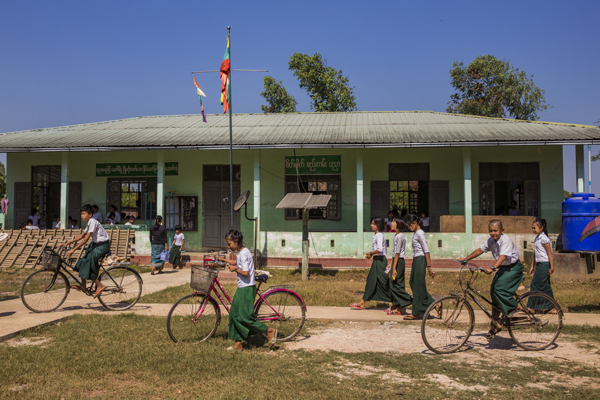

Source: VSO Image library

Module 14:
Positive Behaviour Management
Module 14: Positive behaviour management.

Overview
This is the fourteenth of fifteen modules that look at how we create a positive Inclusive Learning Environment for all. You will see how inclusive teaching practices encourage, develop and use the 21st century skills of critical thinking, communication, collaboration and creativity. These modules are for any educators or those studying in education in Myanmar. The terms student and learner are used interchangeably throughout the module.

Module number | Module title
1 | What is an Inclusive School, Classroom and Teacher?
2 | Knowing your learners
3 | Planning learning outcomes for all
4 | Participating through learner centred approaches
5 | Creating a positive learning environment
6 | Effective questioning and feedback
7 | Active participation
8 | Peer, cooperative and collaborative learning
9 | Supporting students’ emotional and social wellbeing
10 | Legal framework and policies around Inclusion in Myanmar
11 | Supporting all students through differentiation
12 | Identifying specific learning difficulties
13 | Supporting all learners with differences or disabilities
14 | Positive behaviour management
15 | Assessment for student achievement

This module looks at different types of behaviour and explores potential causes. It focuses on identifying ways to prevent undesirable behaviour and how to encourage positive behaviour amongst the students that you teach.
You will be asked to record your reflections in a learning journal, so it is important to make detailed notes and think carefully and deeply about your current and future practice. This CPD module also encourages you to develop communities of practice between yourself and your colleagues. This will support and extend your own use of inclusive practices in your teaching and will help your student teachers build on inclusion in their learning and future professional practice.

Learning Journal
It will be useful to record your reflections in a learning journal throughout the module.
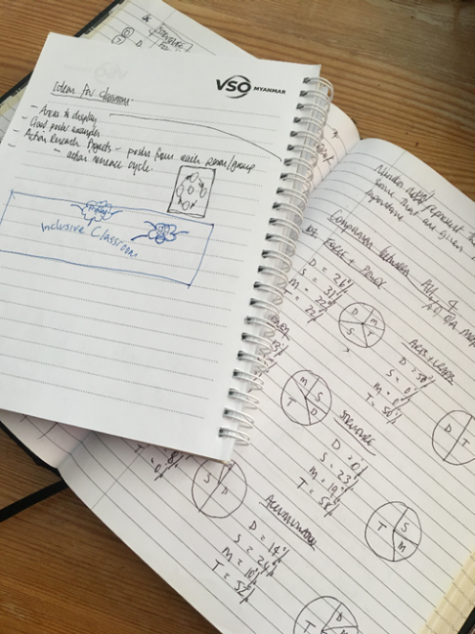
A learning journal can be digital (e.g. using Word or Google Docs) or on paper. You can also take photos of your learning journal pages if you want to share your thoughts with others. It is important that you record your thoughts and ideas so that you can remember and use them later in activities and in your own teaching.

Here are some useful tips for a good learning journal:
- Use headings and dates for all your journal entries.
- Use the activity number for reflections linked to that activity, e.g. Activity 1.1
- Add references to any other resources you find that help you.
- Record answers to activities.
- Write reflections about your learning.
- Make notes of new vocabulary.
- Identify topics you want to learn more about.

Source: Rose, N. (2018) Personal Learning Journals

The important thing is that it is easy for you to use. You can take notes which answer simple questions like these:

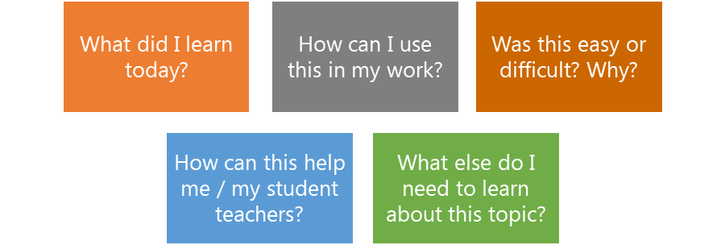

These questions follow the LEARN- APPLY- REFLECT model which is used in education globally. You can return to this journal as you progress through your CPD journey and reflect on your progress.

Study tips
Take your time to work through the activities, rather than trying to complete the whole unit at once. Set yourself a timetable and choose a time to work through the tasks, then check and compare ideas with colleagues. Finally, remember to make notes in your learning journal as you go. This will help you remember more about the skills and knowledge you develop as you complete these units.

Working alone or with colleagues
This unit is designed for self-study. The answers can be found after each activity. However, if possible, we recommend working in a pair or group so you can share ideas, ask questions, check your work, and give feedback.

If you work in a pair or group, we recommend using Think / Pair / Share for each activity.
Discuss your ideas in a group, and then check the answers on the next page(s) together.
Check your answers with your partner.
Work alone and make brief notes of your own ideas.

Learning outcomes for module 14
By working through this module, you will be able to:
- Consolidate understanding of children’s rights to education and the importance of treating children equally.
- Explore the causes of undesirable behaviour in the classroom.
- Create an environment for good behaviour to support learning for all children.
- Identify strategies to build positive relationships and effective systems for behaviour in the classroom.
- Understand the importance of routines
- Explain the responsibility educators have in teaching positive behaviour

- Introduction
The previous module 13 looked at how to support students with learning difficulties and disabilities in the classroom, building on previous modules about differentiation, multi-sensory learning and collaboration.
This module looks at the importance of teaching and learning to develop and encourage positive behaviour. It looks at potential causes of undesirable behaviour and suggest strategies to establish positive systems to manage behaviour in educational settings.
You will be asked to:
- Read various texts about the topic.
- Watch videos and provide some analysis.
- Complete activities either alone, in pairs or in small groups.
- Think about key questions.
- Reflect on your experience and knowledge.

The module will take approximately 6 hours to complete. We hope you have an enjoyable learning experience.

Key to symbols
Activity – this is work you need to complete.

Question/s – please answer the questions.
Reflection – think carefully about how you feel about this.
Learning Journal – please write your answers in your learning journal.
Read – please read the text provided. Make any notes you like.

Activity 14.1 Self-assessment
REFLECTION: How well do you think you are equipped to manage students’ behaviour effectively? Look at the scale below and choose the number that best describes you now. Answer in your learning journal.
VERY well
NOT well
You will be asked to do this again at the end of the module.

    - Link to previous learning – Module 13 (Supporting all learners with differences or disabilities)
Think back to module 13. Fill in the missing words to the following statements about the Universal Design for Learning. One example has been given.
Missing words
  - UDL helps all students.
  - UDL makes learning more ___________ in general classrooms, which is where most students with learning and thinking differences spend most or all of the school day.
  - UDL presents ______________ in ways that ________ to the learner, instead of asking the learner to adapt to the information.
  - UDL gives students more than one way to _________ with material.
  - UDL builds in flexibility that can make it easier for students to use their ___________ to work on their weaknesses.
  - UDL can reduces stigma ( _________ feelings or beliefs about a person or group of people).
  - By giving a __________ of options to all students, UDL doesn’t single out the few who need extra support.

all | adapt | negative | strengths
interact | information | variety | accessible

- all | - accessible | - (a) information | 3 (b) adapt
- interact | - strengths | - negative | - variety
1.1.2 Answers

- Introduction to behaviour management
Behaviour management is a core competency for inclusive teachers. Behaviour management is not about discipline or punishing poor or undesirable behaviour. It is about equipping teachers with the knowledge and skills to be able to create a safe and supportive learning environment for all learners (including addressing issues of inclusion, health and well-being) and to develop positive relationships, effective systems and routines. Module 1 stressed that behaviour management is a key part of an inclusive classroom, where teachers help students learn to manage their behaviour with respect and care for their well-being. This module will provide a range of practical strategies to support teachers to create learning environments which promote positive behaviour for learning and respect the rights of children.

- A rights-based approach to behaviour management
In Module 10 you studied some of the important conventions, laws, policies and plans which aim to support inclusive education in Myanmar. These include:
- Sustainable Development Goals (SDGs), particularly Goal 4
- United Nations Convention on the Rights of Persons with Disabilities
- National Education Law
- National Disability Law
Many of these laws and policies protect the rights of children.

Activity 14.2 – Rights reflection (20 minutes)
Working with a partner or on your own, consider the following questions. Use your learning journal to write down your responses.
- What do we mean by a ‘right’?

- What are the rights of children? List as many child rights as you can think of.

- What are the rights of parents?

Activity 14.2 answers
- A (human) right is something that we are entitled to and can expect. Human rights are the basic rights and freedoms that belong to every person in the world, from their birth until their death.
- Some rights of children include: the right to education, to be respected, treated fairly, treated with consistency, to be listened to, to be safe.
- Parents have the right to know that their children are safe, are being treated fairly, are being well educated.

Another important United Nations Convention is the Convention on the Rights of the Child (CRC, 1989). The CRC is the most widely ratified human rights treaty in history and has been adopted by 194 countries, including Myanmar. The CRC is very important because it sets out the rights of children and ensures that there are safeguards in place to protect children from violence and exploitation. The CRC forbids corporal punishment of children.
Article. 28(2) says: “States Parties shall take all appropriate measures to ensure that school discipline is administered in a manner consistent with the child's human dignity and in conformity with the present Convention.” The full text of the Convention on the Rights of the Child (English) can be accessed here. https://www.ohchr.org/en/professionalinterest/pages/crc.aspx
Meanwhile the Child Rights Law was enacted by the Government of Myanmar in 2019. The law is aligned to the Convention on the Rights of the Child and identifies a child as anyone under the age of 18 years. Some important areas of the Child Rights Law are shown below:
- All children born in Myanmar have the right to birth registration
- 18 years is the minimum age for marriage, regardless of gender
- The minimum age of employment is 14 years and the law forbids children from doing dangerous forms of labour
- The elimination of torture, cruelty and corporal punishment of children

3.1 Physical punishment linked to behaviour
The Child Rights Law calls for the elimination of corporal punishment. Corporal punishment is the most common form of violence against children worldwide and is still used in schools in some countries. It includes any punishment in which physical force is used and intended to cause some degree of pain or discomfort, however light, as well as non-physical forms of punishment that are cruel and degrading.
Any corporal punishment violates children’s right to respect for their human dignity and physical integrity, and their rights to health, development, education and freedom from torture and other cruel, inhuman or degrading treatment or punishment.

Activity 14.3 – Examples of corporal punishment (20 minutes)

  - Having read the summary of corporal punishment, reflect on your personal experiences. Have you witnessed or experienced it first-hand? How did you feel?

  - Working with a partner or on your own, consider the following statements provided in the table below.

  - Copy the table into your learning journal. Put a tick for Yes or No if you think the actions are examples of teachers using corporal punishment with children. Discuss your responses with a colleague if you can.

Actions | Yes | No
Pinching a child who is being rude
Swearing at a child who refuses to stop shouting out in class
Moving a child to work on their own because their behaviour is disruptive
Hitting a child with a stick as punishment
A teacher shouting at a child who has not completed his homework
Punching a child as punishment for bad behaviour
Walking around with a stick (but not using it)
Making a child eat soap as a punishment for bullying
Lightly smacking a child on their head if they make a mistake

Activity 14.3 answers
Look at the answers below and read the comments to explain the answers given.
Try and discuss these with a colleague or explore them further with additional reading around corporal punishment.

Actions | Yes | No | Comments
Pinching a child who is being rude |  |  | Pinching is the use of physical force and is a form of corporal punishment. It is never acceptable to pinch a child.
Swearing at a child who refuses to stop shouting out in class |  |  | Although this is not corporal punishment, it is never appropriate to swear at children.
Moving a child to work on their own because their behaviour is disruptive |  |  | This is not an example of corporal punishment, but if children are isolated from their peers for a long period it can cause anxiety and impact on their learning.
Hitting a child with a stick as punishment |  |  | Hitting a child with an object is the use of physical force and is a form of corporal punishment. It is never acceptable to hit a child with a stick or any object.
A teacher shouting at a child who has not completed his homework |  |  | Shouting is not an example of corporal punishment. However some children will not respond well to shouting and will become anxious.
Punching a child as punishment for bad behaviour |  |  | Punching a child with an object is the use of physical force and is a form of corporal punishment. It is never acceptable to punch a child.
Walking around with a stick (but not using it to hit students) |  |  | Although physical force is not used, the threat of using a stick is intimidating behaviour. Corporal punishment should never be used or threatened.
Making a child eat soap as a punishment for bullying |  |  | Making a child eat soap or another unpleasant substance is corporal punishment and is never acceptable.
Lightly smacking a child on their head if they make a mistake |  |  | Smack is a physical punishment whether it is a light or hard smack.

Discussion – Summary (10 minutes)
- Corporal punishment is a violation of children’s rights.
- This module will focus on behaviour management approaches which respect the rights of children enshrined in the Convention on the Rights of the Child and the Myanmar Child Rights Law.
- Both the CRC and the Child Rights Law require the elimination of corporal punishment. In the next section, you will learn about some of the reasons why children misbehave.

- Undesirable behaviour in the classroom
When children are struggling socially and emotionally it can affect their behaviour and their ability to learn. In module 2 you identified some of the important factors that can help teachers to know and understand their learners.

Activity 14.4 – Reflection (20 minutes)
Working with a partner or on your own, consider the following questions. Use your learning journal to write down your responses. Discuss this with a colleague. Think about occasions when you have faced challenging or difficult behaviour in your class.
- What was the behaviour?

- What do you think the causes of this behaviour were?

- What did you do to manage the behaviour?

Activity 14.5 – Types of behaviour (20 minutes)
Undesirable behaviour refers to actions which prevent the child or other children from learning, or in some cases present a risk to the safety of students and teachers.
Some examples are shown in the table below – try to add more common behaviours to this list and tick if they cause low, moderate or severe disruption to learning.
Type of behaviour | Low level disruption | Moderate disruption | Severe disruption
Calling out in class
Answering back to the teacher
Physical violence towards others

Activity 14.5 answers
Now compare your list to the table below.

Type of behaviour | Low level disruption | Moderate disruption | Severe disruption
Calling out in class
Answering back to the teacher
Physical violence towards others
Fidgeting
Inappropriate language
Throwing items at the teacher or other students
Walking around the classroom
Daydreaming
Threatening behaviour to others
Destroying property
Distracting other learners whilst they are working
Being noisy
Talking to others instead of completing tasks or whilst the teacher is talking
Bullying another student

Reflect:
- Do you mostly experience low level behaviour problems in your class?
- When do you think, a low-level disruption would change to moderate or severe?
- Do you tend to see more undesirable behaviour from girls or boys?

4.1 Causes of undesirable behaviour
There are many causes of undesirable behaviour. The diagram below shows a variety of factors which can cause children to misbehave in the classroom. A number of these factors are related to the teaching and learning approaches used by teachers. If children are not fully engaged, if their learning abilities are not considered or if teachers do not plan for different learning styles, some children may respond negatively, resulting in poor behaviour.
Reflecting on your own experiences and topics covered in previous modules (particularly Module 2: Knowing your learners), think about some of the causes of undesirable behaviour. These could be
related to social, emotional, physical and learning factors. Discuss your ideas with a colleague and compare your ideas to the diagram below. The causes in the diagram are inter-connected, with a range of factors often causing poor behaviour in the classroom.

Consider your responsibility in the behaviour of the students you teach. Study the checklist below of the possible reasons why students may display poor or undesirable behaviour.
- Student does not have any prior knowledge about a particular concept or topic | - Student does not have enough time to finish the task and gets frustrated
- Student finds the work too difficult | - Student does not understand the task
- Student finds the work too easy | - Student is not able see the blackboard
- Student is not engaged in the way the learning is presented | - Student is hungry and does not have enough energy to work
- Student does not have the right equipment | - Student is not able to hear your instructions
- Student has no interest in the subject or can’t see the relevance/bigger picture | - Student finds it difficult to work as part of a small group

Activity 14.6 – Causes checklist (10 minutes)
Review the checklist above and discuss it with a colleague.
- Are there any causes missing from this checklist?
- Where do you go to get information about your students (e.g. about their prior learning)?

4.2 Where do students learn how to behave?
Influence from Friends
Behaviour is learned in the same way as any other attitude or skill and children need to be taught.
Learning to behave appropriately and to gain social skills is a very important part of children’s social, personal and emotional development. It is an area that supports all other forms of learning, and builds sociability, confidence, and independence.
Influence from family members
You
Children will watch their parents, siblings, and those around them. As they get older the sphere of influence changes – from parents and school, more towards peers. We can’t just expect children to behave. As educators, we must recognize the role we play and take responsibility too. There is a section on educators as role models later in this module.
Sphere of influence

Activity 14.7 – Whose responsibility is it? (20 minutes)
Consider how behaviour is viewed in your context and who is responsible for manging students’ behaviour. Is it down to the parents, older family members to ensure their children behave or is it down to teachers to ensure students behave well in their care? Perhaps, it is down to the child themselves?
Draw a line from each box, according to who you think should be responsible. The first one is done for you. Note that some may be attached to more than one box.

Encourage positive behaviour at home
Be responsible for their own behaviour
Encourage positive behaviour at school
Leaders ensure positive
behaviour systems are in place
Provide consistency
Support students to follow rules
Policy on behaviour in place
Work together
Follow rules in school

School staff

Parents/carers

Students

Activity 14.7 answers
School staff | Parents/carers | Students
Provide consistency | Provide consistency | Follow rules in school
Support students to follow rules | Support students to follow rules | Be responsible for their own behaviour
Work together | Work together
Encourage positive behaviour at home | Encourage positive behaviour at home
Encourage positive behaviour at school | Encourage positive behaviour at school
Policy on behaviour in place
Leaders ensure positive behaviour systems are in place

Discussion – Summary (10 minutes)
Children must recognize their responsibility in self-discipline and meeting the expectations set by school. Involving parents and students in setting rules and standards of behaviour can be very effective.
Parents should be informed of any action taken for negative behaviour. Equally as a prevention, phone calls and contact to discuss positive behaviour can be motivational, especially where specific praise is given on effort the student is putting into their learning.
Involving students in setting rules is not just practical but it can be linked with the rights-based approach. In this way, children have the right to express their views in matters affecting them. Self-discipline is about both rights and responsibilities.

- Strategies to prevent or manage behaviour
Knowing our responsibilities means we all have a choice. Do we fulfil our responsibilities, or not?
To motivate students to make the right choice we need to utilise positive and negative consequences.
Well done

Positive consequences may be praise, such as “well done”.
What are you supposed to be doing?
Negative choices may have a negative consequence such as a reminder of the rules or a warning (the behaviour is challenged).
Tactical ignoring can be helpful in preventing the negative choice or praising other students around the child showing poor behaviour to encourage them to make better choices. By reacting to a behaviour we are giving it recognition and attention which maybe the intention of the negative behaviour.
Children make mistakes. As we progress through life, we get better at making good decisions. We also build our confidence that we can make a choice and stick to it.
Feedback should always refer to the choice, not the person. e.g., DON’T SAY “You’re lazy!” Instead, you could say “You’re not working. You need to work now.” Where possible when we are giving feedback on behavior, we should try and do it one to one. It is important not to label children, calling them naughty, lazy, etc. The other children will base their opinion of that child around on what the teacher says. If a child is noticeably the one who always gets in trouble, then it is the teacher’s job to create positive opportunities for that child to be seen as a successful learner. Acknowledging that we all find things difficult.
Good morning Myat Myat. How are you today? How was your walk to school this morning?
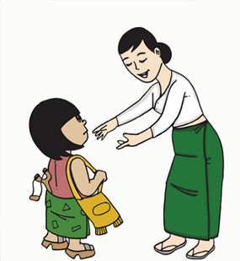
Paying more attention when the child arrives, checking in with them, and having honest conversations, shows the students you teach that you care about them.
- Have we tried to understand the behaviour?
- When does it happen?
- Are we reacting or responding in a calm way?

Activity 14.8 – How we react (15 minutes)

The teacher has noticed that a child has gone off task and is starting to distract their peers. Look at the different responses offered by the teacher and think about which one might be the most appropriate. Write some notes in your learning journal to justify your reasons.
I can see you haven’t been able to really focus on this activity yet, is there something you need some clarity on?

Is there somewhere else in the room you would find it easier to concentrate?
b)
You need to stay behind at lunch time and finish your work.
a)
c)
How often do you give students the opportunity to take responsibility for their behaviour by asking what would help them to resolve an issue?

Activity 14.8 suggested answers
- This is a negative consequence for the poor behaviour. If a teacher has given a student the opportunity to change their behaviour or given warnings, this could be an appropriate response. In the first instance, if the teacher has noticed the student is off task, responses a and b would be more appropriate.
- This response encourages the student to reflect on their performance so far. The teacher is taking responsibility by asking if they need to explain something further but also asking the student to take responsibility by asking what they need to be able to focus on the task. This response might be the most appropriate in the given scenario.
- This response encourages the student to think about where they will learn best. Note the teacher does not ask or tell the student to move but allows them to make the decision. This response may be appropriate, following b, if the student is still not focussing on the task.

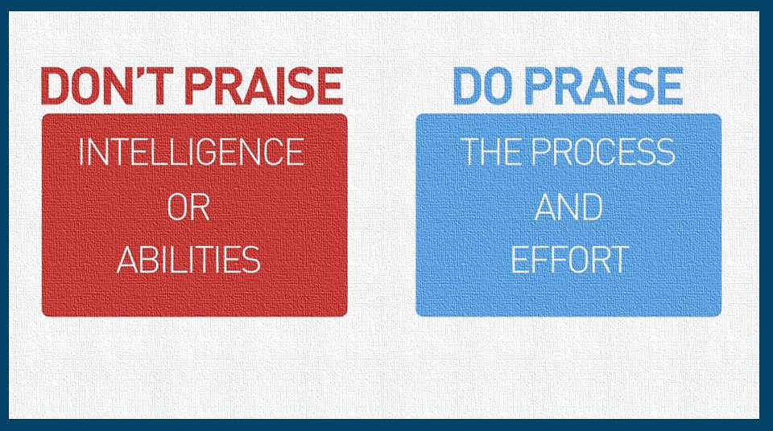
5.1 Positive consequences
Educators should aim for 3-5 times as many positive responses as negative feedback. Think about how often you praise students for their effort or contributions in class and the impact this has on their performance. Young children are often eager to please their teacher so acknowledging that you are proud of them, or their efforts can be a real motivator. Image source: https://www.flickr.com/photos/kenwhytock/23666431572 (free)

PRAISE
Based on effort rather than ability
Doesn’t need to be big
Needs to be valued (be clear what the reason is)
Needs to be regular
Needs to be consistent – how will you ensure all children will receive praise?

Is it genuine? Do children believe you are pleased/proud of them?

Giving students a get out (explanation for their behaviour) can also be effective: “I can see this 'fraction problem' is difficult to solve, would you like some help with it?”
Offering distractions can often help too as a way of prevention. For example, if a teacher can see a student is struggling to focus, they might ask them to hand something out, such as books to give them a brain break and an opportunity to move around.
Educators should be careful not to overly praise the same students or put them on a pedestal. If the student thinks you are not sincere, they will not accept the reward/praise or think it is genuine. Be clear what is for and why, so they can repeat that positive behaviour again.
You have to show fairness, but reward learning behaviours, not outcomes. So, student A and student B might achieve different outcomes (e.g. student A got 30% and student B got 70%), but if both made a great effort, then both deserve praise.

5.2 Negative consequences
Negative consequences are sometimes referred to as punishments or sanctions, and they are something a person can do if undesired behaviour persists. It could include ignoring, distraction or time-out. They work as a deterrent (best given slowly) with a reminder of the desired behaviour and what will happen if that behaviour continues, for example, “If we do not finish this piece of work, we won’t be able to play the game at the end of the lesson” (which could be to apply skills learnt).
Educators must ensure they focus the choice the student has made, rather than the student themself (we can change our choices, we can’t change the person). This example ensures all students are clear on what the teacher is expecting and have a reminder of the rules to enable them to take responsibility for their own behaviour.
I am waiting for everyone to put their pens down and look this way.

Remind the student they have the option - they may need reminding of their options.
Keep the language and instruction simple.
It must be clear what changes in behaviour could avoid a consequence
It must be clear why there is a consequence
Group consequences should be avoided as they breed resentment.

It is the behaviour not the student that is met with disapproval. “I am disappointed with your behaviour” rather than “You are naughty”.

All strategies should not exercise power or authority. Consequences should support the student’s developing self-esteem and self-image.

Activity 14.9 – Strategy check (15 minutes)
Look at the strategies below that address undesirable behaviour and tick the ones that you have tried.
Strategy | Tried X Not
Use non-verbal signals, such as a disapproving look.
Praise other students that are doing what they have been asked to do.
Reinforce the expectation – I am looking for students looking this way.
Ignore the behaviour
Have a quiet word with the student away from others
Give a warning (tell the student what the consequence will be)
Check in with the student and ask them if everything is okay/is the work too hard/easy? etc
Walking around room, standing near the disruption.

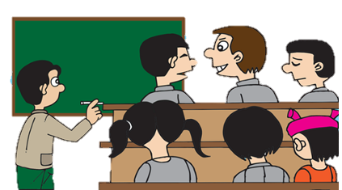
The teacher is writing on the board and notices that 2 students are not listening.
Observe behaviour

Strategy choice ignore, reminder praise, etc
The teacher reminds the whole class that they need to listen when someone else is talking (at the moment it is the teacher). The teacher explains that the students will be given time to discuss in pairs in a few minutes. He praises other students for their attention and ignores the 2 students who are talking for now.
The teacher speaks to the 2 students quietly and asks them if there is an issue – do they not understand the rule?
Give a warning
If I have to stop and speak to you both again, you will need to sit away from each other so you can concentrate.
Offer a choice
The teacher allows time for partnered discussion and is careful to not speak for long periods of time. The 2 students continue to talk when they are asked not to. The choice given in the example may depend on the age of the students.
Consequence
You need to sit somewhere else. You can decide or I will choose somewhere for you.
The student moves to another space for the duration of the lesson.
Note: In the example the teacher was conscious of whether the students needed time to talk before they gave a warning. The teacher spoke to the students to try and understand if there is another reason for their behaviour, asking if they understood. The teacher shows respect towards the children by talking to them about their behaviour in private, rather than in front of others. He reminds them of reasons for rules and discusses what they can do differently.

Negative consequences will depend on the behaviour and the relationship the student has with the educator. There can be benefits and barriers to all the strategies discussed so far. For example, a student may benefit from time out in another class – usually around five minutes but this can also be seen as by the student as the educator having enough of them or unable to manage their behaviour.
If the student returns to class to continue with normal activities after having talked to their teacher about how they intend to change their behaviour, it could be an effective strategy. A visit to the headteacher for a discussion about the behaviour may also be appropriate but the headteacher is likely to want to discuss this with you after and what strategies you will use to support the student if they present the behaviour again.
The age of the student will also determine how appropriate and effective a strategy might be. Losing a few minutes of their break time might be effective for older students but younger students may not link the behaviour to the consequence and may need the break time to enable them to refocus again.

5.3 The behaviour not the person
Being specific to only criticise actions and choices, is important when talking about behaviour. The student can change their choice next time (e.g. choose to work hard). They can’t change who they are. If you tell a student they are lazy, it won’t achieve anything, they will probably lose motivation and will not work harder. This reinforces the negative choice. Read the examples below where responses about the student have been changed to shift the focus to the behaviour.
“I need you to sit down now.”
“You can’t keep still!”

“You need to make more effort on this task. I expect more work from you.”
“You’re lazy”

“You’re the best student in the class.”
“You’re making a really great effort at the moment and that is why you are doing so well. Keep it up.”

Activity 14.10 – Managing behaviour (20 minutes)
- Choose three causes of undesirable behaviour from your own experiences and think about how this impacted on children’s learning.
- Then think about strategies you used to manage this behaviour.

An example has been provided for you. It might be helpful to discuss this example first.
Behaviour observed | Impact on teaching and learning | Possible cause(s) | Strategies used to manage behaviour
A grade 5 student is making noises and walking around the classroom. | The student is not focusing on the task. Other children in the class become distracted and their work is not completed. | The student is bored and not engaged in the task. | I used more interactive teaching strategies, including more open-ended questioning to engage the student.

- Responding to extreme behaviour
Although rare, extreme behaviour can be very challenging and, in some cases, present risks to the safety of children and teachers. If children in your class are displaying signs of extreme behaviour, it is important to:
- Ensure that all students are safe. If they are not, you should take the students away from the dangerous situation.
- Report concerns to the school leaders and ask for support
- Talk to the student’s parents to understand if there are any problems outside the classroom
- Talk to the student and try to understand why they display these behaviours. For example, is a child with sensory difficulties affected by the noise from a school bell ringing?
- If the behaviour becomes frequent, try to identify patterns, what happens before, etc.
Sometimes the ABC model can be helpful to track challenging behaviour you may have concerns about.
Antecedent (or action) – What happened before the behaviour? It could be tiredness, a difficult piece of work, a comment that was made or a noise that had an impact on how the student felt. It is helpful to track the antecedents to look for patterns and triggers.
Behaviour – What did the student do that you considered to be inappropriate? What happened? What was said? For how long did the behaviour last and how intense was it?
Consequence – What happened as a result of that behaviour? Did the student fail to complete a task? Did other students react to the behaviour?

Discussion – Summary (20 minutes)
- Consequences register the disapproval of unacceptable behaviour and protect the security and stability of the school community.
- Consistency in rules and the way behaviour is dealt with allows students to have confidence in the fairness of systems, ensuring they feel safe and protected in school or the setting.
- Students learn to trust adults who do what they say – even when they don’t always like it.
- When teaching diverse classes, inclusive teachers in Myanmar will often need to respond to low level disruption.
- If low level disruption becomes persistent, it can be very challenging and can impact on children’s learning.
- When extreme behaviour occurs, it is important to track concerns using the ABC approach.
- Creating an inclusive and safe learning environment and building positive relationships with children are effective ways of managing most low-level behaviour problems.
- If a student’s behaviour is regarded by the class teacher as serious, educators should speak to the parents to discuss how they can work together to support the student.

Leadership may decide to keep a log folder about behaviour;
• To record any concerns or complaints about a specific student’s behaviour
• To record any damage to property
• To discuss the details of an incident at a later date or track if there are patterns in behaviour
• To ensure that a student’s behaviour is improving and that the strategies put in place are working
• To ensure that any incidents of bullying are being dealt with and tracked

- Restorative enquiry
It is important for staff to think about how they act and what they say after any displays of undesirable behaviour. If the teacher moves on and doesn’t have a conversation with a student, it can be seen as unimportant, and the behaviour may be repeated. We want students to feel comfortable to discuss what happened and how it can be resolved.
At the same time, if behaviour has been dealt with, it is important that the teacher moves on and does not keep talking about it.

If educators are asking students about their behaviour or what has happened, they should;
- Be non-judgemental
- Not assume the truth or jump to conclusions
- Be curious – What happened?
- Summarise what is being said.
- Be empathetic – how did that make you feel?
- Not to take sides
- Not give advice
- Not give reprimands
- Establish a timeline - what happened before?
- Be concerned - Who has been affected?
- Be empowering – What do you think needs to happen to put things right?

Try and understand the underlying behaviour and have a discussion with the child and their parents. If a child becomes physically aggressive towards another child or a member of staff, all attempts must be made verbally for them to stop.
- Creating an environment for good behaviour to support learning for all children
An inclusive teacher will use space and classroom materials to ensure that all children can participate, plan lessons to ensure time is used effectively and use a range of seating and grouping arrangements to encourage collaborative group work, paired activities and independent learning.

Creating a safe and supportive learning environment for children is a core competency for inclusive teachers. In module 12 we looked at Universal Design for Learning (UDL). UDL can help schools and teachers to create learning environments that are flexible, and where there are no barriers to inclusion. UDL enables equitable access and participation in education.
UDL is about providing flexibility in the physical learning environment to support the diverse learning needs of all children. Some ways in which teachers provide flexible workspaces in their classroom include providing spaces for quiet individual work, paired and group work, and whole class instruction.

Activity 14.11 – Flexible workspaces (20 minutes)
  - For each of the workspace arrangements shown in the table below, think about the benefits for learners. Copy the table into your learning journal and add your ideas.
Work space | Benefits to learners
Quiet spaces for individual work
Paired work
Group work (5-6 students working together)
Whole class instruction

  - Do you use any other flexible working arrangements to support children’s learning needs?

Activity 14.11 answers
Work space | Benefits to learners
Quiet spaces for individual work | A quiet space is important for students who may become overwhelmed or anxious in a crowded and noisy classroom. A quiet space can allow them to relax and take time out before returning to the main class. For example, students with autism can be very sensitive to noise and their surroundings and will benefit from a quiet space.
Paired work | Paired work allows students to discuss ideas in a comfortable way. It is useful for students who find it difficult to talk in larger groups and gives them an opportunity to develop communication skills with a peer.
Group work (5-6 students working together) | When working in a group with others, students develop important skills such as listening, problem solving, respect for others, patience and tolerance of others. This is important in promoting inclusion and can be used in multigrade classrooms.
Whole class instruction | Whole class teaching provides an opportunity for shared learning experiences and developing a sense of community to classrooms. It is often used to introduce new topics to students.

Classroom routines
Age-appropriate classroom routines are important for helping teachers to manage time, space and classroom activities efficiently. We have discussed routines in previous modules and here we link the consistency, and habitual systems that embed good behaviour.
Teachers must be consistent with a routine so that their students understand the boundaries. When we have consistency, we feel safe, and relaxed and we know what to expect and how others will react. In education, routines can enable trust that what the teacher says will happen, will always happen.
Routines reinforce positive behaviour and define acceptable standards. They also;
- help establish smooth transitions between activities
- reduce opportunities for poor behaviour and disruption to occur.
- are very useful for students with disabilities and difficulties.
- ensure that everyone understands their role and what is expected.
- create a sense of belonging, security, safety, social/community event, establishing and reinforcing unity.

Activity 14.12 – Classroom routines (20 minutes)
Decide whether these examples of common classroom routines are appropriate for Kindergarten, Primary or Middle/High school students. Put a tick in the box (or boxes) which you think apply.

Example of classroom routine | Kindergarten | Primary | Secondary
Lining up at the door to enter the classroom
Handing out books and resources
Use of a student seating plan
Silent reading
Putting hands up
Bringing the correct equipment to class
A starter activity is on the board for students on arrival
Clap and ask the children to repeat when they hear it to get their attention.
Teacher does not talk until every child is listening.
Give the children a subject to discuss when they enter the classroom in relation to lesson.
The teacher uses a rhyme or song so that the class know what to do during a transition.
Students know that if the teacher writes a mark on the board that they will receive/lose a minute of break time.
Teacher dismisses one row of students at a time at the end of a lesson.

Activity 14.13 – Which routine would be best? (20 minutes)
  - Read the scenarios below of typical behaviour in classrooms.
  - Use the routines listed in the previous task to help you to think about routines that might be appropriate and effective. You might have other strategies that you feel would be more effective. Discuss them with a colleague if you can.
Scenario | Routines
At the beginning of a lesson students talk over the teacher. It takes 5 minutes for the teacher to be heard.
Every day, boys in class 9 fight with boys in class 10 over who will use the volleyball net at lunch time.
At the end of group discussions the students take a long time to become quiet.
Last week a girl was hurt when other students accidentally knocked her to the floor as they ran out of the room at the end of the day.
You notice that the students sitting at the back of the room often appear to be unengaged or distract others.

Activity 14.13 suggested answers
Scenario | Routines that could help
At the beginning of a lesson students talk over the teacher. It takes 5 minutes for the teacher to be heard. | -Clap a pattern and the students repeat it back. They know it is time to stop & listen.  -Teacher doesn’t talk until the students stop.  -Students have a topic to discuss as soon as they enter the class so conversations are about the learning - transition into the lesson.  -Students engage in silent reading before class starts.
Every day, students in class 9 fight with students in class 10 over who will use the volleyball net at lunch time. | -A rota for the volleyball net is in place so each class know whose turn it is.
At the end of group discussions, the students take a long time to become quiet. | -Clap a pattern and the students repeat it back. They know it is time to stop & listen.  -Teacher doesn’t talk until the students stop.  -Teacher asks the students how long they need. They are given a 5-minute reminder to bring the discussion to an end.
Last week a girl was hurt when other students accidentally knocked her to the floor as they ran into the room to find a seat next to their friends. | -Students line up before the lesson starts.  -Students are allocated a seat so they know where they sit.
You notice that the students sitting at the back of the room often appear to be unengaged or distract others. | -Students have an allocated seat that the teacher has placed them with students they will work well with.

- Building positive relationships and effective systems for behaviour in the classroom
In Module 2, you learnt about the importance of knowing your learners when creating an inclusive classroom. We have included this revision section to now make that link, specifically with behaviour. Knowing your learners, will help you to:

- Create a safe environment for every learner in your class and help them feel more confident.
- Understand each learner’s “readiness to learn” (how ready and motivated they are to learn?)
- Respond and interact with your learners in a caring and understanding way.
- Appreciate and learn from the diversity (the differences) in your classroom.
- Plan your teaching so it is most effective for your learners’ learning.
Earlier in this module we looked at some of the causes of poor or undesirable behaviour. By knowing their learners, teachers can plan and prepare to manage behaviour effectively in their classrooms so that all children can participate and achieve. In this section, you will explore strategies for building positive relationships in the classroom.

10.1 Knowing your learners
Knowing your learners is key to being an inclusive teacher and plays a key part in behaviour management. By knowing how ready and motivated children are for learning, teachers can plan for poor behaviour and be ready to respond to learners in a caring and understanding way.

Activity 14.14 – Student scenarios (20 minutes)
In Module 5 (Creating a Positive Learning Environment) you studied a case study of a lesson with a class of nine-year old students. Read the information about three students in the class below:

  - Nay Lin entered the classroom looking sad and did not respond to the teacher’s greeting. He has not joined in the singing and is sitting with his head down.
  - Htay Myint is fidgeting and distracting other students, she frequently calls out the answers not giving others a chance.
  - Nilar Soe takes the lead in the group but does not listen to the others, she begins answering all the questions while they start to wander around the classroom.

- Think about Nay Lin, Htay Myint and Nilar Soe and their social and emotional wellbeing. What could be some of the reasons for their behaviour?
- If you were the teacher, what could you do to support them?
- What positive behaviour strategies could you use in these situations?

Discuss your responses with a colleague. Do you agree with how you would manage these situations?

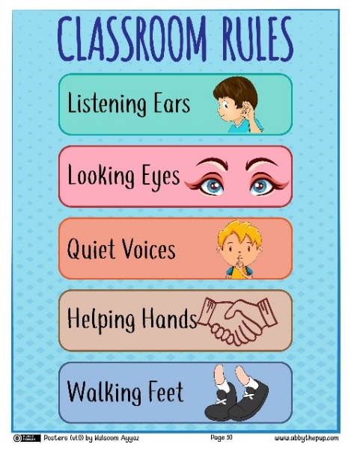
  - Positive classroom behaviours
A list of positive classroom behaviours (or classroom rules) is a good way of supporting positive behaviour management. Students should be involved in making the list which should be short and simple, positive and child-friendly. The list of positive classroom behaviours should be displayed in the classroom. Look at the rules to the right, they are short and simple to understand and have picture cues.
Use words that focus on what to do rather than what not to do. For example;
• "Walk in class" instead of "No running"
• "Use quiet voices inside" instead of "No shouting"
Image source: https://commons.wikimedia.org/wiki/File:Classroom_Rules_2_(Abby_the_Pup).jpg (free)

Activity 14.15 - Positive classroom behaviours (20 minutes)
Review the example of positive classroom behaviours below.
- Complete assigned work.
- Keep spaces tidy.
- Follow directions.
- Always do your best.
- Use time wisely.
- Be interested.
- Ask questions.

- Walk around learning spaces.
- Keep hands/feet to yourself.
- Be kind to others.
- Show good manners.
- Be a good listener.
- Allow others to learn.
- Respect others’/property.
- Are there any other behaviours you would add to the list?
- Are there any behaviours you would remove from the list?
- What rules do you expect your students to follow?

Class rules should be easy to remember. Some schools might focus on 2 or 3 overriding rules such as ‘Be kind, safe and responsible’ but this could depend on the age of the students. Kindergarten rules maybe ‘Kind hands, kind words’. The best rules are clear
and memorable (i.e. short, and not many).
If students cannot remember all the rules, then there is no point.
Rules should be reinforced by praise, attention and rewards for positive actions, effort, co-operation and caring attitudes.

Activity 14.16 - Positive classroom behaviours in action (20 minutes)
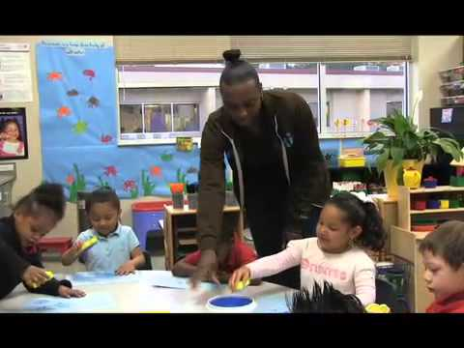
Watch the video (with subtitles) to see primary teachers reinforcing classroom rules with their students in the U.S.
- Do Myanmar children behave similarly?
- What about their teachers?
- Note any thoughts in your journal.

Video: Creating classroom rules in primary school
https://www.youtube.com/watch?v=69ehhIwC8eY

- Listen to how the teachers use praise and positive interactions with students.
- What routines did you see?

Discussion/reflection – Summary (10 minutes)
- How will students in your class can be part of the decision making around class rules?
- What do you think is working well, what things are not working so well?
- Would you like to see/change in your class?
- When people walk into your classroom what do you want them to see?
- How are you displaying the rules, can the students read them?

- Learner friendly spaces and the impact on behaviour
In module 4 we discussed learner centred approaches and the impact that has on learning and how involved students are in the learning process. If we link this to the physical environment and think about learner friendly spaces,
It means …
- Students should feel safe
- Students must not be abused (sexually, emotionally, physically, verbally)
- Students understand their role
- Children take responsibility for their behaviour

It doesn’t mean…
- Students should be happy all the time
- There are no consequences for behaviour
- Rules are not enforced
- Teachers are powerless
- Children will be out of control

Child/learner friendly is often mistaken for ‘being nice to children’ or not strict enough but it is about respecting the rights of children (to feel safe, listened to, respected and not experience abuse- either physical or emotional). It shouldn’t mean children do not experience consequences for their behaviour (good or bad). In fact, not challenging inappropriate behaviour is NOT child friendly. If a student does not receive some sort of consequence for physical violence, then it is likely the action will be repeated, and the other students will not feel safe and protected in that environment. This undermines a child’s right to safety. Likewise, a child who does not learn good behaviour in school is more likely to misbehave outside of school and that might increase the risk of harm, or decrease their opportunities beyond school.

Organizing a multigrade classroom
Multigrade classes are common in Myanmar, particularly in smaller schools in rural areas where fewer teachers are available. In a multigrade class, a single teacher is responsible for teaching children from two or three different grades at the same time. When faced with a wide range of age, ability, maturity and interests among the class, it is very important that teachers are flexible in the way their classroom is organised and structured as there is likely to be less whole class instruction. Here are some tips for organizing physical space in a multigrade class to minimize disruption and reduce opportunities for poor behaviour:

- Desks organized into small groups instead of facing the front of the class
- Workstations can be established where individual students or small groups can go to complete activities.
- Store resources in labelled boxes around the room. Establish routines to ensure that resources are returned to correct box at the end of the lesson
- Provide individual students with boxes or folders for storing their work
- Create a space in the room where younger students can sit on the floor and work
- Lots of example of individual or group work on display around the classroom

Activity 14.17 – Multigrade classes (20 minutes)

Reflect on the questions below. Use your learning journal to write down your ideas or discuss them with a colleague.
- Have you ever taught a multigrade class?
- What behaviour challenges did you face?
- How did you organise the classroom to manage behaviour?

- Teachers as role models for behaviour

We learn our behaviour from watching others. Think about who has been a good role model for you. It is quite possible that as educators, we teach in a similar way to the experiences we have of being taught. Think about who your role models were in education and your experiences of teachers. Copying how to speak to children and how we respond to their behaviour can be dangerous as since we were at school, it is likely that lots more research has been carried out around effective teaching and learning and particularly around how children learn best. In the past the teacher’s role was often to inject fear or control and children’s voices were not heard in classrooms. We now know that when children feel safe, relaxed and comfortable they will learn more effectively.
- Children watch adults to find out what they do and how they speak to others.
- Children will copy adult behaviour. Consider what behaviour you model to students.
- Are you on time and organized?
- Are you respectful to all students and treat them fairly?
- Are you kind and warm towards others?
- Do you speak to students in a calm way, even if you are feeling stressed or upset by their behaviour?
- Are you well presented and make an effort with your appearance?
- Do you work hard? If a teacher comes to class ready with an interesting lesson and spends time with students to make sure they understand, then the students will be more likely to.
- Do you talk with students, rather than talk at them? Looking them in the eyes and talk with them at their level. Resisting the urge to lecture by giving students time to respond.
- Do you set a good example? Do you model how to cope with anger or frustration, and how you deal with sadness and joy?
- Do you encourage students to set good examples for each other?

Discussion/reflection – Summary (10 minutes)

- Think of a teacher you admired when you were a student. How did they behave towards children? How did you behave towards them?
- Think of a teacher you didn’t admire when you were a student. How did they behave towards children? How did you behave towards them?
- What about you as a student? How did you behave?
- How about you as a teacher. How would you like to be remembered by students?

- Possible ideas for action research projects
In module 6, you were introduced to the idea of carrying out small-scale action research projects.
The diagram below shows the action research cycle.

1) decide on the question,
2) plan how to answer it,
3) carry out the research – observe, question, etc.
4) review the data
5) plan if/how to improve.

The cycle then continues until you are confident with the changes you have made.
Action Research
Cycle
- Question
5. New plan

4. Review
2. Plan

3. Do

Suggestions:
- Exploring whether you have unconscious bias
- Consider how you treat boys and girls and if there are any differences in the way you respond to their behaviour.
- The use of different approaches in responses to behaviour and how effective they are.

- Wrap up
In this module you have:
  - Consolidated your understanding of children’s rights to education and the importance of treating children equally.
  - Explored the potential causes of undesirable behaviour in the classroom.
  - Discussed ways to create an environment for good behaviour to support learning for all children.
  - Identified strategies to build positive relationships and effective systems for behaviour in the classroom.
  - Understood the importance of routines.
  - Explained the responsibility educators have in teaching positive behaviour

Key points from this module:
- All children have the right to learn in a safe and supportive learning environment
- Corporal or physical punishment is a violation of children’s rights and is illegal under the Child Rights Law in Myanmar
- Undesirable or behaviour is the result of a number of interrelated causes and together they can have a negative impact on teaching and learning
- Low level behaviour problems can lead to more severe behaviour problems if they are not effectively managed by teachers
- Inclusive teachers create physical learning environments based on UDL principles. Multigrade teachers need to be flexible in the way they organize their classrooms
- Some children with disability will experience behaviour problems related to low self-esteem and anxiety and other factors
- Classroom routines and rules can help to reduce poor behaviour and disruption
- Inclusive teachers know their learners, and this supports positive behaviour management

Reflection
To help you remember and think about the topics introduced in this module, try to answer the following questions. Use your learning journal to make a note of your reflections.
- What types of behaviour problems have you faced in your classrooms?
- Why do some children with disability of learning difficulties experience behaviour problems?
- What strategies will you use to manage behaviour?
- Have you asked the child if they need any help with their learning? Is it too hard/easy? Do they understand the task?
- Have you told the child clearly what behaviour you expect to see?
- End of module 14 quiz
Please answer the following questions in your learning journal. You can attempt as many times as you like to reach 100% pass. Some questions require more than one answer.

Q1 – Which law established in 2019 eliminates corporal punishment (Choose 1 answer)
- National Education Law
- National Disability Law
- Child Rights Law

Q2 - UDL is an approach to creating flexible learning environments which support positive behaviour. What do the letters UDL mean? (Choose one answer)
- Universal Design for Learning
- Universal Discipline for Learning
- Universal Development for Learning

Q3 – The ABC model can be helpful to track any challenging behaviour you may have concerns about. What do the letters ABC mean? (Choose 1 answer)
- Alternative, Behaviour, Control
- Antecedent, Behaviour, Consequence
- Applying, Behaviour, Consequences

Q4 – Why are classroom routines an important part of behaviour management? (Choose 1 answer)
- Teachers have full control over their students
- Teachers can discipline children if they do not follow classroom routines
- Teachers can manage time, classroom space and ensure a smooth transition between activities

Q5 – What are the benefits of establishing a quiet space in the classroom? (Choose 1 answer)
- Providing a space for the teacher to send children who behave poorly
- Providing a space for the teacher to work without being distracted by students
- Providing a calm and quiet space for children who become anxious or worried in a noisy classroom

Answers – end of module 14 quiz
Answers in bold

Q1 – Which law established in 2019 eliminates corporal punishment (Choose 1 answer)
  - National Education Law
  - National Disability Law
  - Child Rights Law

Q2 - UDL is an approach to creating flexible learning environments which support positive behaviour. What do the letters UDL mean? (Choose one answer)
  - Universal Design for Learning
  - Universal Discipline for Learning
  - Universal Development for Learning

Q3 – The ABC model can be helpful to track any challenging behaviour you may have concerns about. What do the letters ABC mean? (Choose 1 answer)
  - Alternative, Behaviour, Control
  - Antecedent, Behaviour, Consequence
  - Applying, Behaviour, Consequences

Q4 – Why are classroom routines an important part of behaviour management? (Choose 1 answer)
    - Teachers have full control over their students
    - Teachers can discipline children if they do not follow classroom routines
    - Teachers can manage time, classroom space and ensure a smooth transition between activities

Q5 – What are the benefits of establishing a quiet space in the classroom? (Choose 1 answer)
- Providing a space for the teacher to send children who behave poorly
- Providing a space for the teacher to work without being distracted by students
- Providing a calm and quiet space for children who become anxious or worried in a noisy classroom

- Improving teaching and learning

Activity 14.18 Improving your own teaching practice. (30 minutes)
It is important to reflect on the answers to the activities you have completed earlier.

Scenario – Your Head of Department asks to meet you to ask about the behaviour of students in your class. They ask you to complete the following statement.
Make notes in your learning journal:
- The systems I have in place to encourage good behaviour are:
LJ
  - …
  - …
  - …

Activity 14.19 Self-assessment
REFLECTION: How well do you think you are equipped to manage students’ behaviour effectively? Look at the scale below and choose the number that best describes you now. Answer in your learning journal.
VERY well
NOT well
Compare your first self-assessment score at the beginning of this module to this one. In your learning journal provide a short analysis of your thoughts about any differences.

Your 14th PROMISE to your STUDENTS

1
3
2

Review

Do

Plan

Please add your 14th promise to the section in your learning journal entitled ‘Promises.’
Each module contains one promise you will make to your learners: you will make 15 promises in total.

References

End Violence against Children (2018)
https://endcorporalpunishment.org/

Government of the Union of Myanmar (2019) Child Rights Law
https://www.ilo.org/dyn/natlex/natlex4.detail?p_lang=en&p_isn=72890 (unofficial English translation)

