**Inclusive Teaching Practice**

**Participant’s Book**

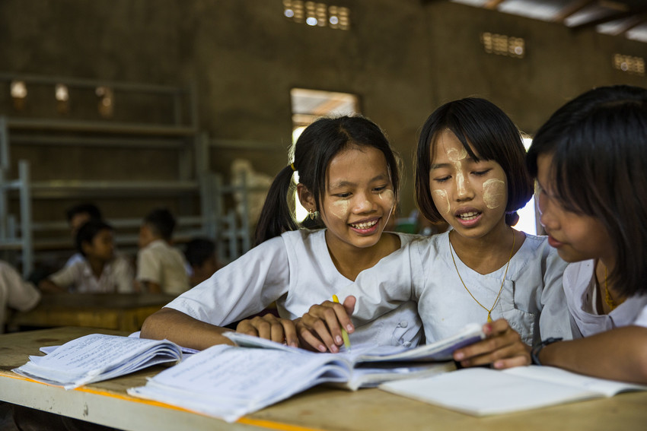

Source: VSO Image library

**Module 11:**

**Supporting all students through differentiation**

Module 11: Supporting all students through differentiation

# **Overview**

This is theeleventh **of fifteen modules** that look at how we create a positive Inclusive Learning Environment for all. You will see how inclusive teaching practices encourage, develop and use the 21st century skills of critical thinking, communication, collaboration and creativity. These modules are for any educators or those studying in education in Myanmar. The terms student and learner are used interchangeably throughout the module.

|  |  |
| --- | --- |
| Module number | Module title |
| 1 | What is an Inclusive School, Classroom and Teacher? |
| 2 | Knowing your learners |
| 3 | Planning learning outcomes for all |
| 4 | Participating through learner centred approaches |
| 5 | Creating a positive learning environment |
| 6 | Effective questioning and feedback |
| 7 | Active participation |
| 8 | Peer, cooperative and collaborative learning |
| 9 | Supporting students’ emotional and social wellbeing |
| 10 | Legal framework and policies around Inclusion in Myanmar |
| **11** | **Supporting all students through differentiation** |
| 12 | Identifying specific learning difficulties |
| 13 | Supporting all learners with differences or disabilities |
| 14 | Positive behaviour management |
| 15 | Assessment for student achievement |

This module helps you to think about what and how you facilitate learning for students, with the ultimate goal of improving student learning. It focuses on the delivery of instruction, which often follows a "one size fits all" approach. In contrast, this module explores differentiation and revisits learner centred approaches.

You will also be asked to record your reflections in a learning journal, so it is important to make detailed notes and think carefully and deeply about your current and future practice. This CPD module also encourages you to develop communities of practice between yourself and your colleagues. This will support and extend your own use of inclusive practices in your teaching and will help your student teachers build on inclusion in their learning and future professional practice.

**Learning Journal**

It will be useful to record your reflections in a learning journal throughout the module.

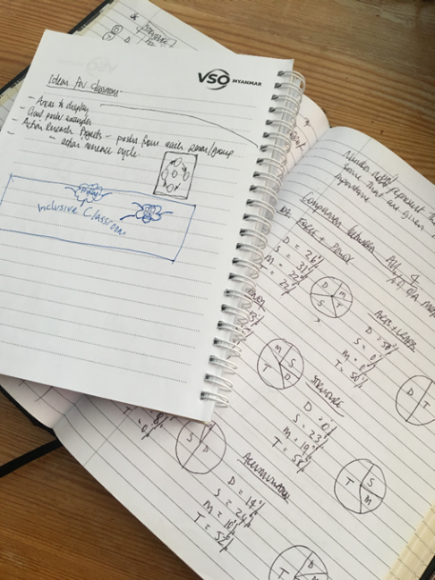A learning journal can be digital (e.g. using Word or Google Docs) or on paper. You can also take photos of your learning journal pages if you want to share your thoughts with others. It is important that you record your thoughts and ideas so that you can remember and use them later in activities and in your own teaching.

Here are some useful tips for a good learning journal:

* Use headings and dates for all your journal entries.
* Use the activity number for reflections linked to that activity, e.g. Activity 1.1
* Add references to any other resources you find that help you.
* Record answers to activities.
* Write reflections about your learning.
* Make notes of new vocabulary.
* Identify topics you want to learn more about.

Source: Rose, N. (2018) Personal Learning Journals

The important thing is that it is easy for you to use. You can take notes which answer simple questions like these:

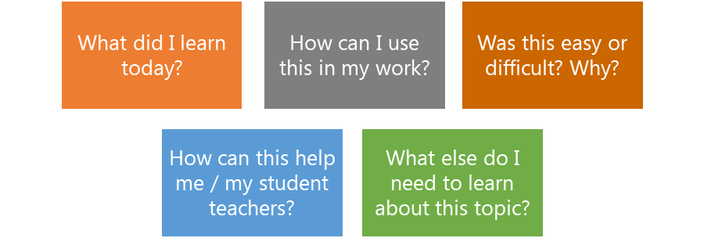

These questions follow the LEARN- APPLY- REFLECT model which is used in education globally. You can return to this journal as you progress through your CPD journey and reflect on your progress.

**Study tips**

Take your time to work through the activities, rather than trying to complete the whole unit at once. Set yourself a timetable and choose a time to work through the tasks, then check and compare ideas with colleagues. Finally, remember to make notes in your learning journal as you go. This will help you remember more about the skills and knowledge you develop as you complete these units.

**Working alone or with colleagues**

This unit is designed for self-study. The answers can be found after each activity. However, if possible, **we recommend working in a pair or group** so you can share ideas, ask questions, check your work, and give feedback.

If you work in a pair or group, we recommend using **Think / Pair / Share** for each activity.

Discuss your ideas in a group, and then check the answers on the next page(s) together.

Check your answers with your partner.

Work alone and make brief notes of your own ideas.

# **Learning outcomes for module 11**

|  |
| --- |
| **By working through this module, you will be able to:**   1. **Understand how to use differentiation to support Inclusion.** 2. **Understand how to use differentiation strategies, such as graphic organisers, writing frames and other multisensory activities can be used to support learning.** 3. **Adapt lesson plans for your students using differentiation.** 4. **Plan and deliver a multisensory activity to a small group of peers.** 5. **Write lesson plans with differentiated Learning Outcomes** |

# **Introduction**

This module looks at general supportive and inclusive practices that teachers can use in the classroom to adapt the learning to meet the needs of students. We explore the term differentiation and what that looks like using strategies such as graphic organisers to support thinking and discussion, writing frames to support writing (different levels of scaffolding for different pupils) and various other differentiation techniques.

You will be asked to:

* Read about differentiated instruction and consider ways to adapt the content, process, task and learning environment to ensure **all** students can participate and achieve.
* Watch videos and provide some analysis.
* Complete activities either alone, in pairs or in small groups.
* Think about key questions.
* Reflect on your experience and knowledge.
* Make a promise to your learners.

The module will take **approximately 8 hours to complete.** We hope you have an enjoyable learning experience.

# **Key to symbols**

|  |  |
| --- | --- |
|  | **Activity** – this is **work you need to complete.** |
|  | **Question/s** – please answer the questions. |
|  | **Reflection** – think carefully about how you feel about this. |
|  | **Learning Journal –** please write your answers in your learning journal. |
|  | **Read –** please read the text provided. Make any notes you like. |

# **Activity 11.1 Self-assessment**

REFLECTION: How well do you think you **adapt learning to meet all the needs of the learners you teach?** Look at the scale below and choose the number that best describes you now. Answer in your learning journal.

VERY well

NOT well

You will be asked to do this again at the end of the module.

* + 1. **Shape, arrow

       Description automatically generatedLink to previous learning – module 10 (Legal framework and policies around Inclusion in Myanmar)**

Think back to module 10. Fill in the missing words to the following statements about the Sustainable Development Goals. One example has been given.

Missing words:

* Equal
* Gender
* ~~Inclusive~~
* Household chores
* Child labour
* Lifelong learning
* Persons with disabilities

1. Sustainable Development Goal 4. Target 4.5 aims to “ensure inclusive and equitable quality education and promote lifelong learning opportunities for all.”
2. By 2030, the aim is to eliminate _________ disparities in education and ensure equal access to all levels of education and vocational training for the vulnerable, including persons with disabilities, indigenous peoples and children in vulnerable situations.
3. All people, irrespective of sex, age, race, colour, ethnicity, language, religion, political or other opinion, national or social origin, property or birth, as well as persons with disabilities, migrants, indigenous peoples, and children and youth, especially those in vulnerable situations or other status, should have access to inclusive, equitable quality education and ______________ opportunities.
4. Vulnerable groups that require particular attention and targeted strategies include, ____________, indigenous peoples, ethnic minorities and the poor.
5. All girls and boys, women and men, should have _________ opportunity to enjoy education of high quality, achieve at equal levels and enjoy equal benefits from education.
6. Adolescent girls and young women, who may be subject to gender-based violence, child marriage, early pregnancy and a heavy load of __________, as well as those living in poor and remote rural areas, require special attention.
7. In contexts in which boys are disadvantaged, targeted action should be taken for them. Policies aimed at overcoming gender inequality are more effective when they are part of an overall package that also promotes health, justice, good governance and freedom from _____.
   * 1. **- Answers**

|  |  |  |  |
| --- | --- | --- | --- |
| 1. inclusive | 1. gender | 1. lifelong learning | 1. persons with disabilities |
| 1. equal | 1. household chores | 1. child labour |  |

1. **Differentiation and how it links with inclusion**

Inclusion in learning is about **finding** and **removing barriers** that make it difficult to learn. Barriers may come from:

* the way learning or a task is organised,
* the way it is delivered/taught,
* the content of the task
* the way we look at how well students learn and our expectations
* the wellbeing of students (see Module 9 – social and emotional wellbeing and the impact on learning)

It is important that educators look for these barriers and understand how they make it difficult for students to learn. In previous modules, you have learnt about the importance of **presence, participation and achievement of *ALL* students**.

**Differentiated instruction**, also known as **differentiated learning** or, in education, simply, **differentiation**, is a strategy for effective teaching that involves providing all students with a variety of different ways to learn and understand new information. It could be the way an educator phrases a question. This was outlined in module 6 using Bloom’s taxonomy, where a teacher might ask one student for facts on a subject, and another a question that requires more thinking based on the teacher’s knowledge of their students and what they know.

In this module we will use the term **differentiation.**

|  |  |  |  |
| --- | --- | --- | --- |
| **Activity 11.2 – Differentiation Definition (15 minutes)**  Read the definition of the word **differentiation** and synonyms.   |  |  | | --- | --- | | **Differentiation** | **Definition** – adapting instruction to meet individual needs. A teacher might differentiate the content, process, the task, or the learning environment, to enable all students to access learning. | | **Similar words;** - adapt, modify, alter, change, adjust, reshape, tailor, tweak |   Using the definition and synonyms above, write your own definition of what the phrase ‘differentiation’ means to you. Write your thoughts in your learning journal. Discuss with a colleague if you can.  **Differentiation** is… |

|  |
| --- |
| **A blue circle with a white circle  Description automatically generated with low confidence11.2 Discussion**  Think back to Module 2 - **Knowing your learners** and Module 3 - **Planning learning outcomes for all.**    The key learning in these modules was about knowing your learners well to enable you to adapt to meet their individual needs.  **A picture containing text  Description automatically generated**Think about or discuss with others if you can about how you assess learners to find out what they know and the opportunities you provide to allow students to show their learning in different ways. For example, if we want to understand how well students understand a text and we ask them to write an assignment about it, will all students be able to show their understanding in this way? Could we allow students to discuss the text or show their understanding in a way that allows the teacher to assess how well their students have understood?  Adapting to meet the needs of all students is a huge challenge, particularly when educators teach large classes. This may also be a challenge for teachers teaching small but multi-grade classes in many schools in village or small towns in Myanmar. Are your students able to choose a way of showing their understanding? What would you as an educator need to do to enable them to that? What can you do to ensure that you give boundaries for student choice and remain responsible for their progress? |

1. **Four ways to differentiate instruction**

You can differentiate instruction across the following four main areas:

To differentiate **content**, teachers consider the objective of a lesson, then provide students with **flexible options** about the content they study to meet the objective.

With **process** differentiation, teachers differentiate **how** students learn.

**Product** differentiation applies to the type of activity students carry out. A teacher might ask students to explain, draw, perform or write about a concept.

The classroom **environment** affects learning and the way it is organised can be a form of differentiation.

We will explore these in more detail in the next section.

|  |
| --- |
| Look at Appendix 1 and **read** the article on **differentiation**. Use your learning journal to write down key words or ideas.  If you can, discuss the article with a colleague. |

**3.1 Whole class teaching and differentiation**

Whole class instruction is the most traditional method of teaching. It can be an effective model, particularly when introducing a new concept or modelling a task that the teacher then requires students to carry out in groups or independently.

Before a teacher asks students to carry out tasks, they need to assess what they already know and what they still need to learn. The challenge is then to provide a way for students to learn. This could be different for different groups of students, for example;

* One group may need time to revisit prior learning
* One group may be ready to look at the learning
* One group may already be comfortable with the learning and need something new

Imagine the following scenario. Aye Myat Thu is teaching her students English language. She spends the lesson asking questions and students provide choral answers (altogether – explored in module 6).

Aye Myat Thu also asks her students in turn to repeat back the same response when she asks them individually a question to check their understanding.

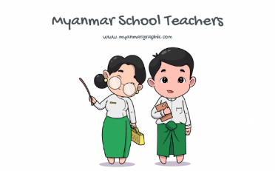

How are you?

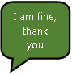

I am fine, thank you

I am fine, thank you

I am fine, thank you

I am fine, thank you

I am fine, thank you

I am fine, thank you

I am fine, thank you

I am fine, thank you

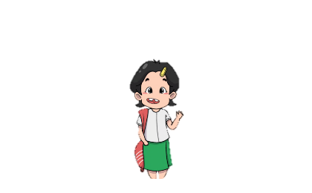

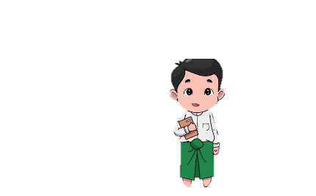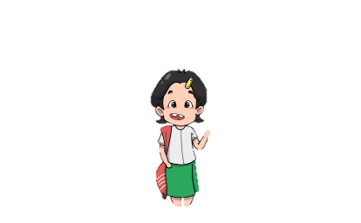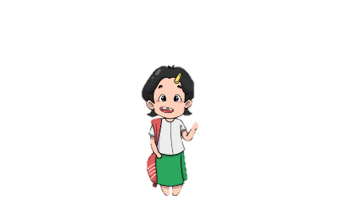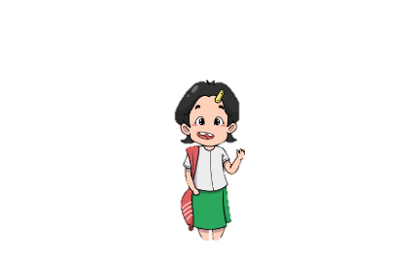

When Aye Myat Thu is communicating with each student, the others sit and listen. Whilst this may provide a model and support some children to hear a repeated phrase, this could also be an example of the teacher meeting the needs of one child – whilst the rest look on.

Consider how long this might take with a class of many students and if it is meeting the needs of students who have a higher language proficiency.

**3.2 Differentiation through content**

To differentiate content, teachers consider the objective of a lesson, then provide students with different adaptations of the content to meet the objective.

The content of lessons may be differentiated based on what students already know, age, specific difficulties, language proficiency, etc

In the example below, Aye Myat Thu has differentiated the lesson based on what students already know. Some students in the class are;

* completely unfamiliar with the concepts in a lesson (Group 1)
* familiar with the concepts and have some understanding (Group 2)
* have an in-depth understanding of the concepts already (Group 3)



Aye Myat Thu teaches the new phrase and response to all students to ensure that they all have access to the learning. She models it and encourages all students to repeat it and say it aloud. She expects all students to be able to greet each other in English by the end of class.

How are you?

Good morning, how are you? today?

I am feeling really excited today because..

Hello/Hi/ Good morning/afternoon/evening

How are you?

Good afternoon

Hello



And you?

Good morning



**Note –** All groups practice speaking and listening but the content for each group is different. Group one focuses on content from the previous lesson, group 2 use the new phrase and group 3 have new vocabulary to use. By the end of the class, students have met the learning objective to greet each other in English. Some students are able to do this on a higher level than others, but they have all achieved using **differentiated content** within the lesson.

Group 2 **work in groups** and use role play to practice **asking and answering** the question. The teacher reminds them of other phrases to say hello from the previous lesson.

Group 3 work **independently** exploring more options to respond to the question **adding a different feeling and a reason** for that response e.g. I feel excited because I am seeing my Grandmother today.

Group 1 **work with the teacher** – repeating the phrase and re visiting greetings from the previous lesson. They look at when to say Good morning, afternoon and evening using role play. The **teacher asks** the question and **students answer**.

|  |  |  |  |  |  |  |  |  |  |  |  |  |
| --- | --- | --- | --- | --- | --- | --- | --- | --- | --- | --- | --- | --- |
| **Shape, arrow  Description automatically generatedActivity 11.4 – Content – who is it for? (45 minutes)**  To make your lessons more inclusive and to think of a different technique to facilitate learning rather than using a traditional lecture method, read the following descriptions which focus on your learners:  **Read** the subheadings and **match** them with the corresponding description.  **Learning styles**  **1.**Can students work together? Do they need support in organising and managing themselves in a group? Do you need to problem solve before the task about what they might do if they face a challenge?  **Social skills**  **2.**Understanding the student’s current level of understanding. Think about if they are similar or if you can group students who have similar understanding. You might decide mixed groups are more effective so that students can support each other.  **Inclusion**  **3.**Can ALL students participate and achieve? Do any students need further support. How will they contribute to the team performance or can other students offer support?  **Number of students**  **4.**Younger learners may need more support or need concepts breaking down into small steps.  **Academic readiness**  **5.**Do all students learn in the same way? Would using different multi-sensory styles make activities more engaging and varied?  **Age/Grade**  **6.**The number of students in your class will affect the success of group work. Think about the size of groups and individual learners within them. If students do not have lots of experience of working in a group, you might start with smaller sizes and build up.  Copy the table below into your learning journal and write the numbers of the answers. One example is given.   |  |  |  |  |  |  | | --- | --- | --- | --- | --- | --- | | A picture containing logo  Description automatically generatedLearning styles | Social skills | Inclusion | Number of students | Academic readiness | Age/Grade | |  |  | **3** |  |  |  | |

|  |  |  |  |  |  |  |  |  |  |  |  |  |
| --- | --- | --- | --- | --- | --- | --- | --- | --- | --- | --- | --- | --- |
| **Activity 11.4 answers**   |  |  |  |  |  |  | | --- | --- | --- | --- | --- | --- | | Learning styles | Social skills | Inclusion | Number of students | Academic readiness | Age/Grade | | 5 | **1** | **3** | **6** | **2** | **4** | |

In previous modules we have discussed using the Bloom’s Taxonomy to adapt the learning for students. Think about how you can use it to differentiate the content of lessons.

Image source: <https://www.flickr.com/photos/vandycft/29428436431> (Creative Commons)

In the example earlier where students were unfamiliar with the new concept in a lesson, they may find it useful to carry out tasks on the lower levels of Bloom's Taxonomy, recalling facts and basic concepts. Students who have a higher level of understanding may need **content** in lessons to apply the knowledge.

When teachers differentiate **content**, they adapt what they want students to learn or how students access the knowledge, and skills.

They use different texts, novels, or short stories at a reading level appropriate for each individual student. Another example would be including visuals, maps, or graphic organizers to introduce or reinforce concepts as opposed to only providing written or oral text. This provides students with different methods of viewing, considering and absorbing content. Teachers can also use flexible groups and have students assigned to like groups listening to audiobooks or accessing specific internet sources. Students could have a choice to work in pairs, groups, or individually, but all students are working towards the same standards and objectives. For face-to face delivery printed books can be used using graded reading books for differentiation rather than all students reading at the same level.

|  |  |  |  |  |  |  |  |  |  |  |  |  |  |  |
| --- | --- | --- | --- | --- | --- | --- | --- | --- | --- | --- | --- | --- | --- | --- |
| **Shape, arrow  Description automatically generatedActivity 11.5 – Video – differentiating content (30 minutes)**  1. **Watch the video** below and think about directed activities related to texts. In this video they are referred to as DARTs but the acronym isn’t important to remember. Instead focus on how tasks are broken down or adapted to create different content for learners.     <https://www.bell-foundation.org.uk/eal-programme/guidance/effective-teaching-of-eal-learners/great-ideas/darts/>   1. **A picture containing logo     Description automatically generatedList some of the strategies** from the video in your learning journal with a brief description.  * Draw a table or diagram * Underlining key words or specific language * Gap filling * Sequencing  1. Imagine you are asking students to read a text. Think about what activity you will create to ask them to complete in class. **Select** the most appropriate directed activity relating to the text.  |  | | --- | | **you may develop a …** | | a flow chart. | | a table or Venn diagram | | a flow chart. | | a spider diagram or mind map | | a branch diagram. | | a labelled diagram. |  |  | | --- | | **If the text …** | | … compared and contrasted two or more things | | … described a process | | … described a fictional or non-fictional sequence of events | | … described how something can be classified | | … described an object | | … presented an argument |  * + 4. For more information on DARTS, **read** the further reading document in **Appendix 2.** You might choose to discuss this with a colleague and watch the video together. |

|  |  |  |  |  |  |  |  |  |  |  |  |  |  |  |
| --- | --- | --- | --- | --- | --- | --- | --- | --- | --- | --- | --- | --- | --- | --- |
| **Activity 11.5 answers**   |  |  | | --- | --- | | **If the text …** | **you may develop a …** | | … compared and contrasted two or more things | a table or Venn diagram | | … described a process | a flow chart. | | … described a fictional or non-fictional sequence of events | a flow chart. | | … described how something can be classified | a branch diagram. | | … described an object | a labeled diagram. | | … presented an argument | a spider diagram or mind map | |

**3.3 Differentiation through process**

When we think about differentiating the **process** of learning, we are thinking about **how** students learn. Grouping students based on their understanding or mixing them up to complement or support each other is one way we have already discussed previously is an example of **process** differentiation.

Another is changing the way concepts are taught: through visual, auditory, or kinesthetic, for example (or multi-sensory as we explored in module 2).

The example shared in the previous section with Aye Myat Thu’s class, also showed us a differentiated process even though the focus was on changing the content. Look at the lesson again and write in your learning journal how the **process** for the learners is differentiated.



Aye Myat Thu teaches the new phrase and response to all students to ensure that they all have access to the learning. She models it and encourages all students to repeat it and say it aloud. She expects all students to use the phrase by the end of class.

How are you?

Good morning, how are you today?

Hello/Hi/Good morning/afternoon/evening

I am fine, thank you

How are you?

Hello, how are you?

I am , thank you and you?

And you?

Hello, how are you?





Group 3 work **independently** exploring more options to respond to the question **adding a different feeling and a reason** for that response e.g. I feel excited because I am seeing my Grandmother today.

Group 2 **work in groups** and use role play to practice **asking and answering** the question. The teacher reminds them of other phrases to say hello from the previous lesson.

Group 1 **work with the teacher** – repeating the phrase and re visiting greetings from the previous lesson. They look at when to say Good morning, afternoon and evening using role play. The **teacher asks** the question and **students answer**.

**Discuss –**

In the lesson Aye Myat Thu chooses a different process for each group to adapt the learning.

* Group 1 have an **adult supporting** them. They are asked to consolidate learning content from the previous lesson using role play. The stakes are lower here for these students. It gives them the opportunity to practice skills and embed them before they move on to new learning.
* Group 2 are **working in groups** so there is still an element of support amongst each other. They are asked to use role play to practice but the expectations are higher for this group to build on their learning from the previous lesson.
* Group 3 are asked to work **independently** making this the more challenging process. They are exposed to more language and put it into sentences, selecting an appropriate response to questions when they are asked rather than the one model that the teacher provided to the rest of the class.

**Discuss/reflect –** How do you think Aye Myat Thu grouped students? What **assessment** method could she use to determine the groups that she puts students in?

There will be a whole unit on assessment so we will not go into it in depth in this module but it is a helpful discussion to have at this stage.

* + 1. **Process …continued**

In module 4 we explored traditional teaching methods verses a more modern approach, looking at learner centred approaches, including group work. You might find it helpful to revisit this module to recap the advantages.

We have looked at examples of a teacher breaking students into small "ability" groups based on their readiness. The teacher gave each group a task, based on each group's appropriate level of understanding, related to the objectives of the lesson. Teachers could also think about how the learning is best carried out, either independently, with a peer, as part of a group or with the whole class.

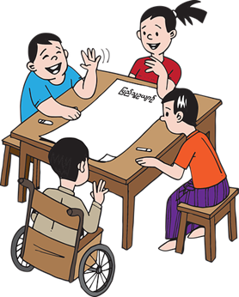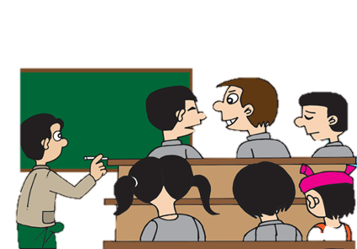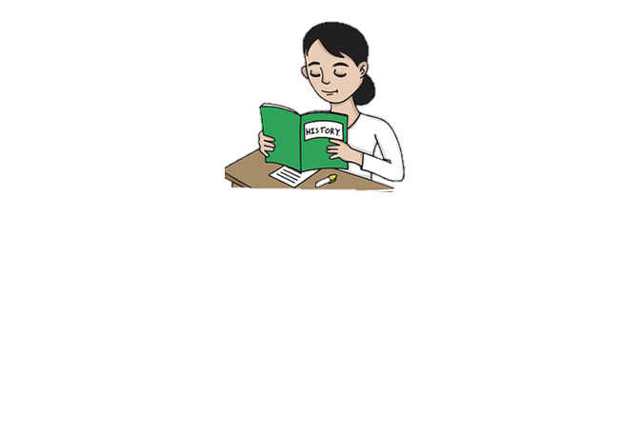

Image sources: <https://pixabay.com/images/search/burma/?pagi=2&> (free)

Another way to group the students could be based on **learning styles.** To do this a teacher understands that students are at different levels and learn in different ways, making it hard to teach them all the same way.

Think about how you like to learn.

* Do you like to have time to read about something before it is taught?
* Do you enjoy time to discuss before you are asked to feedback?
* Do you enjoy practical learning experiences?

Look at the image below from Activity 2.12 in module 2 on multi-sensory learning. Think about the opportunities we provide students to learn in different styles – through listening, watching and time to explore and experiment.



|  |
| --- |
| **Shape, arrow  Description automatically generatedActivity 11.6 – Video – differentiating process (30 minutes)**  1. **A picture containing logo     Description automatically generatedWatch the 2 videos** below and think about the process of learning.  * Have you used these techniques before? * If yes, how effective were they? * If no, how confident do you feel to give it a try?   Use your learning journal to answer the questions and make notes about the ideas in the videos.  [Freeze Framing](https://www.youtube.com/embed/7N_cT-bjSqI?feature=oembed)  **Video Freeze Framing**  <https://youtu.be/7N_cT-bjSqI>  In a freeze frame, students work together in groups to visually represent one part of a story through creating a scene. Members of a group use their bodies to make an image or picture capturing an idea, theme, or moment in time from the text.  [Hot Seating](https://www.youtube.com/embed/54zLEORXImY?feature=oembed)  **Video Hot Seating**  <https://youtu.be/54zLEORXImY>  Hot Seating is a strategy in which a character or characters, played by the teacher or a student, are interviewed by the rest of the group.   1. **Choose 1 of the activities** that could support a lesson in your subject. Plan a small group activity and be prepared to deliver it.To plan to use these activities you will need to know the confidence levels of your students and how well they will work together in a team.   You might find it useful to group your students into teams that you think will work well together.  **Top tip –** planning groups before a lesson and writing them down will save time in the lesson. You can organise students more effectively and timely so they can get started. You have also had time to consider personalities and which students you think will compliment or support each other. |

The **process** of how the material in a lesson is learned may be differentiated for students based on their age or grade. This stage of differentiation allows students to learn based on the method that is easiest for them to gain knowledge.

For example, when teaching younger students who find it difficult to focus for long periods of time, the process of learning may be more interactive, including songs or opportunities to move.

In later modules, we will discuss multi-grade teaching and strategies to support teachers who are teaching students who are different ages, etc.

**Discuss –**

It is important that if a teacher is grouping students that these groups are flexible and change according to the lesson or activity. There is a risk that if students are grouped according to ability that the technique no longer feels inclusive, potentially deepening any educational attainment divide among students of different socio-economic backgrounds. There is a risk that it introduces labels that limit educational achievement and affects educational opportunities for students placed in “lower level” groups.

It might be helpful to consider the **advantages** and **disadvantages** of grouping students and discussing this with your colleagues.

When used effectively, students would be mixed up in different ways during different lessons. It is also important for a differentiated classroom to allow students to work alone and show what they can do independently. Often educators think they are using a learner-centred approach when they give group work, without being clear about the purpose or able to facilitate.

Other examples of differentiating **process** or activities include:

* Using tiered activities where all learners work with the same understanding and skills, but proceed with different levels of support, challenge, or complexity.
* Offering manipulatives or other hands-on supports for students who need them.
* Varying the length of time, a student may take to complete a task in order to provide additional support for a struggling learner or to encourage an advanced learner to pursue a topic in greater depth.

**3.4 Differentiation through product or outcome**

To differentiate through the **product,** we are now thinking about what students will produce to show their learning within a lesson. This could be a written report, a story, a song, a speech, or a drawing. Varying the types of assessments you give students is also an example of product differentiation.

When an educator differentiates by **product** or performance, they are providing students a variety of ways to demonstrate what they have learned from the lesson. This differentiation may be based on students learning preferences, ability, need, interests and strengths.

Look at the visual representation of differentiation through **product** below using the 3 jigsaw puzzles. It is obvious which product will be the easiest and hardest to complete.





Image sources: <https://freesvg.org/solved-puzzle> <https://pxhere.com/en/photo/1600619> (free)

Providing students with verbal and visual representations at the same time is more engaging and supports students who may have difficulties in one of those areas. It allows them to process the knowledge in either or both ways.

In module 8 we looked at the Learning Pyramid which looks at how students are taught and the impact that has on how much learning they retain.

In Edgar Dale’s (1946) model, the average retention rate for listening alone is 5%. When it is combined with a visual opportunity, it increases to 20%.

Image: <https://www.flickr.com/photos/dkuropatwa/with/2097911609/> (free)

Remind yourself of the other teaching models and the advantages of combining different approaches to support students in retaining knowledge and skills over a period of time.

|  |
| --- |
| **Shape, arrow  Description automatically generatedActivity 11.7 – Differentiating products (30 minutes)**  Students have discussed the advantages and disadvantages of the internet.    **Read the 2 examples** below and think about how they are presented to students.  Which example would be most appropriate to present and why?  **Example 1 – The teacher** asks each group to report back orally through their reporter;  **Example 2 – The teacher** asks each group to produce a poster and put it on the wall. She then asks groups to walk around and look at/ read each other's posters. |

* + 1. **Challenge**

When educators are thinking about adding an extra challenge for their students or adapting work to stretch their learning further, it is important to consider how the learning is an extension.

* Are you providing more work at the same level? If so, do students need the practice to consolidate?
* Are you providing opportunities for depth rather than breadth? Activities that promote a deeper understanding ensure that students fully understand before moving on to more information (breadth). For example, in maths are you providing students with harder sums, higher numbers or do they need an opportunity to explain their thinking, or a task to apply the learning from the lesson?

|  |
| --- |
| **Shape, arrow  Description automatically generatedActivity 11.8 – Planning to differentiate (product) (30 minutes)**  1. A picture containing text     Description automatically generated**Read** the scenario below.   Mi Mi is in Grade 1. Her teacher is planning to teach the next lesson in her textbook to her class with a learning objective to name and describe 2D shapes. At the end of the previous lesson the teacher gave students an exit pass which was a small piece of paper (like a ticket). The teacher asked students to label a square, circle, triangle and rectangle adding any information the students knew about those shapes.  By using this **pre-assessment** technique, the teacher knows that most of the class are not able to name the shapes and describe them using mathematical vocabulary. The teacher noticed that Mi Mi has a good understanding of 2D shapes and that she can recognize and name a square, triangle, circle and rectangle. She also used some words such as corners and sides.   1. **A picture containing logo     Description automatically generatedDiscuss or reflect**  * Have you used this form **of pre-assessment** before? * How did you use the information to plan for the next lesson?  1. **Plan** and **suggest** suitable activity ideas for Mi Mi’s teacher to plan for her.  * What activity could Mi Mi do if she already knows what the teacher intends to deliver? * Think about if she would need any support with these activities and if this is feasible if the teacher needs to teach the other students. For example, the use of mini blackboards could be useful here. |

|  |
| --- |
| **Activity 11.8 ideas and suggestions**  What did the **pre-assessment** tell the teacher?  Mi Mi can;   * - recognise and name the 2D shapes square, circle, triangle and rectangle * - use the words ‘sides’ and ‘corners’ to describe 2D shapes   Rather than introduce more shapes for Mi Mi to learn try to think about how the teacher can add depth to her understanding. This will ensure that the gap between what she knows and others does not widen.  When the teacher describes the 2D shapes to all the children, Mi Mi needs this new information. It is important that she learns the correct vocabulary and the details needed to describe the shapes, such as vertices, equal sides, symmetrical, parallel, edges.  The teacher might draw these shapes or display them, labelling the parts for students to use as a success criteria.  **Suggested activities for Mi Mi**  P1P/P1S – Shape Hunt | Primary 1 – Bishopton Primary SchoolCreate a poster for younger students, drawing the 2D shapes accurately and labelling the parts. By asking Mi Mi to draw shapes accurately, the teacher is able to see if she understands the differences between the shapes rectangle and square. Mi Mi could use the model (success criteria) created by the teacher to support her in labelling the shapes accurately. This would also allow her to carry out this task independently.  Bag Paper Brown - Free vector graphic on Pixabay  Using a bag and some 2d shapes, Mi Mi can describe the shape to another student or a group who are learning their names. This activity would allow Mi Mi to practice describing the shapes using the correct terminology. She models this to her peers, whilst supporting them to name the shapes (which she already knows).  Provide Mi Mi with some examples of shapes that are and are not accurate.  Look at the example shared – ask Mi Mi to explain or write why the shapes on  the sheet are or are not triangles. This would ensure that Mi Mi has a deep  understanding and help her to recognise common misconceptions. For example,  the shape on bottom right looks like a triangle but the edges are not straight.  Similarly, the shape on the bottom left looks like a triangle but there are only  two vertices.    Image sources: <https://blogs.glowscotland.org.uk/re/primary1bps/2020/10/02/p1p-p1s-shape-hunt/>  <https://pixabay.com/vectors/bag-paper-brown-food-sack-24550/> (Creative commons) |

**3.4.2 Supporting students’ learning**

When we are simplifying products (the output of the lesson), we are adapting the learning by breaking it into smaller parts or steps so that students can build on what they already know and are not overwhelmed by too much new information. It helps to break the learning down into manageable parts before moving on.

To support students through differentiation, you may;

* begin the lesson with a review of previous learning. This supports students to link prior learning so there is a smaller gap in the new material.
* introduce new learning in small steps.
* ask a lot of questions to confirm understanding
* provide clear models, use success criteria or worked examples so students are clear the outcome for the lesson.
* Provide opportunities for students to practice using the new material.
  + 1. **Providing a template or using a graphic organiser**

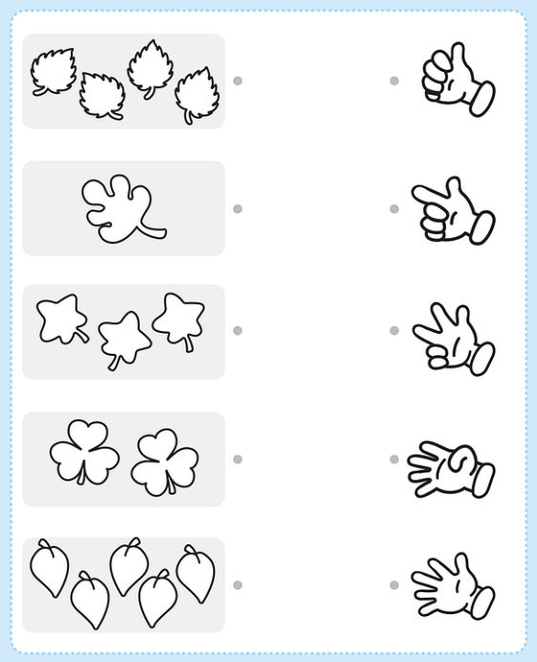Providing students with a template or some sort of writing frame, can help a task seem clearer. It could be a worksheet that sets out a structure or a particular text type, such as a set of instructions.

Students may be less likely to have a feeling of ‘I don’t know how to start’. It can also give students a sense of what they are writing and allows the teacher some control over what the students will produce.

The use of graphic organisers can be as simple as asking students to using a mind map to write down key ideas about a topic or providing a table with the headings

What I Know about … What I Want to find…What I Learned about ….. to talk about their learning. In previous modules we have used tables and Venn diagrams to present advantages and disadvantages or similarities and differences.

Image source: <https://pixabay.com/vectors/activity-child-children-coloring-4998528/> (free)

In module 9, we discussed the fishbone - cause-and-effect model to aid the discussion around a complex issue.

|  |
| --- |
|   1. **Read** the information about **Graphic Organisers** in Appendix 3. 2. **Choose** one example and think about how you could use it in a lesson with your students.   Write it in your learning journal and discuss it with a colleague if you can.     1. **Think** about the use of **writing frames** or providing students with a structure of a particular text type. For example, a template for a recipe may include a box for the title, a section to list ingredients, a numbered list for the instructions and a space for a picture or a diagram.   You may have heard this sort of activity as ‘**scaffolding’** where we provide support (or a scaffold) to support students. It is helpful when students are learning about text types for the first time. |

|  |
| --- |
| **Shape, arrow  Description automatically generatedActivity 11.10 – Reading – Graphic organisers (product) (30 minutes)** **Watch** the Video on **Talk for Writing**  <https://youtu.be/lTbS3Vx2Ruk>  **[Year 1 - Talk 4 Writing - The Gingerbread Man](https://www.youtube.com/embed/lTbS3Vx2Ruk?feature=oembed)Talk for Writing** is an approach to teaching writing. It has three stages to scaffold students learning and is mainly used with younger students.  ***Imitation -***students learn and internalise texts,  This helps them to identify transferrable ideas and structures.  ***Innovation -*** *students* use these ideas and structures to co-construct new versions. This is done with the teacher.  ***Invention -***teachers help pupils to create original texts independently.    These tasks aim to improve writing ability by giving pupils an understanding of the structure and elements of written language.  **Reflect;**  - How much time do I give students to **talk and discuss** before I ask them to write?  - Talk about the strategy of **internalising texts** and how it can support student’s **fluency** in reading.  - If I ask students to write a story, how much time have they spent **imitating and innovating** to be confident enough to **invent**? |

|  |  |  |  |  |  |  |
| --- | --- | --- | --- | --- | --- | --- |
| Think back to the example lesson shared in the previous 2 sections with Aye Myat Thu’s class and think about appropriate tasks that you could suggest to her that might be suitable for the groups that she has set.  Myanmar School Teachers  How are you?    Good morning, how are you today?  Hello/Hi/Good morning/afternoon/evening  I am fine, thank you  Graphical user interface, application, chat or text message  Description automatically generated  How are you?  Hello, how are you?  I am , thank you and you?  And you?  Hello, how are you?  Myanmar School Teachers  Myanmar (Burma) Students VectorMyanmar (Burma) Students VectorMyanmar (Burma) Students VectorMyanmar School TeachersMyanmar (Burma) Students VectorMyanmar (Burma) Students VectorMyanmar (Burma) Students VectorMyanmar (Burma) Students Vector    Group 3 work **independently** exploring more options to respond to the question **adding a different feeling and a reason** for that response e.g. I feel excited because I am seeing my aunt today.  Group 2 **work in groups** and use role play to practice **asking and answering** the question. The teacher reminds them of other phrases to say hello from the previous lesson.  Group 1 **work with the teacher** – repeating the phrase and re visiting greetings from the previous lesson. They look at when to say Good morning, afternoon and evening using role play. The **teacher asks** the question and **students answer**.  Think about how you would like students to show their learning. Would you like them to produce something on paper or present their understanding in another way? Consider the level of understanding for each group and how the outcome of their learning may differ.  If you can, discuss your ideas with a colleague.   |  |  |  | | --- | --- | --- | | **Group 1** | **Group 2** | **Group 3** | |  |  |  | |

|  |  |  |  |  |  |  |
| --- | --- | --- | --- | --- | --- | --- |
| **Activity 11.11 Suggested ideas**   |  |  |  | | --- | --- | --- | | **Group 1** | **Group 2** | **Group 3** | | Group 1 could be asked to present their phrases back using the role play they have practiced in the lesson. | If group 2 are starting to become familiar with the phrases from the previous and current lesson they could begin looking at it in a text. Students could be provided with a comic strip of characters greeting each other and reading it aloud. | Group 3 could now start to read and write the English phrases around greeting people (reading and writing are higher level skills than speaking and listening). |   **Note:** It would be easy for the teacher to introduce more language for students to learn. If we consider the discussion in the earlier section about ensuring that opportunities for learning a fair and equal, we must consider the widening of the learning we are adding to by providing more information to learners that might understand concepts more quickly. |

**3.5 Differentiation through environment**

Changing physical things in the classroom, like **how desks are set up or arranged**, or where students can sit serves as classroom **environment differentiation**.

The learning environment includes the physical layout of the classroom, the way that the teacher uses the space and elements such as lighting. In previous modules we have discussed the teacher's role in creating a **positive learning environment** that supports each student. There are often challenges with how flexible the physical environment can be, where desks may often be fixed. If possible, think about how the furniture in your setting is arranged and if there is a possibility of providing areas for quiet individual work as well as areas for group work and collaboration. This supports a variety of ways to engage in flexible and dynamic learning.

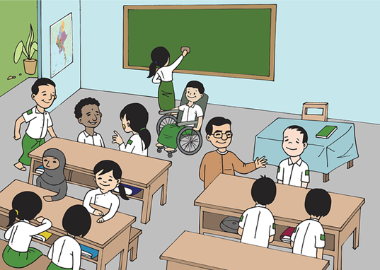

In the next module, we discuss this further, outlining the principles around universal design for learning (UDL) approach. It recognizes that each student learns in a different way and requires flexible ways to learn, including high expectations for all learners and creating an engaging learning environment and allowing multiple ways of meeting expectations.

Educators can differentiate seating by having **flexible arrangements.** For example, in some lessons a teacher might decide to have students working in mixed ability to support each other but for another lesson the teacher may want all learners working at a similar level together.

Teachers should observe the way the classroom environment supports students' ability to interact with others. Like in the above picture, you can see an easy way to make arrangements even when the furniture is not easy to move around, like in many classrooms in Myanmar.

**Discuss –**

Examples of differentiating learning environment could include:

* Providing places in the room to work quietly. If this isn’t possible, teachers should provide times within the lesson for students to be able to work quietly.
* Places or opportunities that encourage student collaboration. If desks are fixed, can systems be set up so that students know which way to turn to make up a group?
* Providing materials and resources that reflect a variety of cultures and home settings. Consider if all your students are represented in the examples you share in class and textbooks.
* Developing routines that allow students to seek help when teachers are busy with other students and cannot help them immediately. This could be ‘3 before me’ prompting students to seek support from 3 of their peers before they ask the teacher.
* Helping students understand that we all like to learn in different ways. Whilst some learners need to move around to learn, others like to sit quietly.
* Having students work displayed on the walls in the classroom and around the school.

1. **Differentiating learning outcomes**

In module 3, we focused on planning inclusive learning outcomes for all using the SMART acronym.

Can you remember what the letters stand for?

**S M A R T**

Look at the 2 examples of a Learning Outcome for a social science/geography lesson.

|  |  |
| --- | --- |
| **Learning Outcome 1:**  To know about the continents and oceans. | **Learning Outcome 2:** Name and locate the world’s seven continents and 5 oceans |
| It would be difficult for a learner or teacher to know whether any type of meaningful learning has taken place. | **Specific** – ‘name and locate seven’ tells students exactly what to expect.  **Measurable** – both students and the teacher can tell whether the learning objective has been attained.  **Achievable** – the learning objective is open-ended enough to allow for effective differentiation.  **Realistic** – this learning objective can be used  **Time-related** – students need to have achieved this learning objective by the end of the lesson. |

You might consider using the terms ALL, MOST and SOME with learning objectives, which allows for more differentiation. Notice in the example the learning objective for **ALL** is the easiest to achieve.

* **ALL** students should: Name and locate the world’s seven continents and 5 oceans (students should be able to point to the continents and oceans on a map and name them).
* **MOST** students should: Discuss where continents and oceans are in relation to each other.
* **SOME** students should: Describe and contrast the continents and oceans– which hemisphere they are, describe the climate, size, etc.

In the previous sections, students are working towards 1 learning of objective and the content, process and product has been differentiated. Here the learning objective has been differentiated to provide 3 learning outcomes that can be achieved by different groups of learners.

You might decide that planning 3 learning objectives is too much or too confusing for students.

|  |
| --- |
| **Activity 11.12 – Differentiating learning outcomes (30 minutes)** A picture containing logo  Description automatically generatedWhat differentiate learning outcomes might be suitable for Aye Myat Thu’s English language lesson?  Myanmar School Teachers  How are you?    Good morning, how are you today?  Hello/Hi/Good morning/afternoon/evening  I am fine, thank you  Graphical user interface, application, chat or text message  Description automatically generated  How are you?  Hello, how are you?  I am , thank you and you?  And you?  Hello, how are you?  Myanmar School Teachers  Myanmar (Burma) Students VectorMyanmar (Burma) Students VectorMyanmar (Burma) Students VectorMyanmar School TeachersMyanmar (Burma) Students VectorMyanmar (Burma) Students VectorMyanmar (Burma) Students VectorMyanmar (Burma) Students Vector    Group 3 work **independently** exploring more options to respond to the question **adding a different feeling and a reason** for that response e.g. I feel excited because I am seeing my Grandmother today.  Group 2 **work in groups** and use role play to practice **asking and answering** the question. The teacher reminds them of other phrases to say hello from the previous lesson.  Group 1 **work with the teacher** – repeating the phrase and re visiting greetings from the previous lesson. They look at when to say Good morning, afternoon and evening using role play. The **teacher asks** the question and **students answer**.   1. Write 3 differentiated Learning Outcomes for the lesson in your learning journal using the words ALL, MOST and SOME.   Discuss them with a colleague and see if they agree with you.  **ALL –**  **MOST –**  **SOME –**   1. Write 3 differentiated Learning outcomes for a lesson in your subject. Give your Learning outcomes to a friend or colleague and see if they can order them. |

|  |  |  |  |  |  |  |  |  |  |
| --- | --- | --- | --- | --- | --- | --- | --- | --- | --- |
| **Activity 11.12 Suggested differentiated learning outcomes**   |  |  |  | | --- | --- | --- | | **ALL** | **MOST** | **SOME** | | **ALL students should:** say 3 ways to greet others in English. | **MOST students should:** select the most appropriate way to greet others in English (based on the time of day) and ask how someone is. | **SOME students should:** experiment using learnt English phrases to hold a greeting conversation (questioning and responding). | | Bloom’s taxonomy **Remembering –** recalling memorised phrases. | Bloom’s taxonomy  **Understand & apply –** selecting and applying new information. | Bloom’s taxonomy  **Analyse and create –** experimenting and formulating sentences. |   **Note:**  It is only after the learning objectives have been formulated that lesson activities and resources should be prepared.  If the activities and resources need to be focused on the learning.  Image source: <https://www.flickr.com/photos/vandycft/29428436431> (Creative Commons) |

1. **Differentiation, not lowering expectations**

Knowing your learners and the use of ongoing assessment and flexible grouping enables educators to make the best choices on when to adapt learning for their students.

Making work accessible doesn’t mean reducing the challenge. Work that you expect ALL students to complete should have an element of challenge.

Educators should be able to distinguish between general under-achievement and difficulties arising from specific educational needs (more details in module 12). Not all under-achievement is because of a student’s specific difficulty and low expectations because of a student’s difficulty can often be the biggest barrier to their learning and achievement. The support educators put in place should encourage skill development and independent learning.

# **Wrap up**

In this module you have:

* 1. Explained how to use differentiation to support Inclusion.
  2. Read about different ways to differentiate learning for students.
  3. Explored how to use differentiation strategies, such as graphic organisers, writing frames and other multisensory activities can be used to support learning.
  4. Adapted lesson plans for your students using differentiation.
  5. Written lesson plans with differentiated Learning Outcomes

**Key points from this module:**

* Differentiation can be achieved through effective questioning – selecting closed, open or differentiated questions based on the teachers’ knowledge of their students.
* To differentiate content, teachers consider the objective of a lesson, then provide students with flexible options about the content they study to meet the objective.
* With process differentiation, teachers differentiate how students learn.
* Product differentiation applies to the result of an activity but there can also be differentiation of the product depending on what is being asked of the student. E.g. draw, perform, write.
* The classroom environment affects learning and the way it is organised can be a form of differentiation.
* If planned appropriately, writing frames are an excellent way of differentiating tasks to meet the needs of all students.
* Delivery of instruction is often a "one size fits all" approach. In contrast, differentiation is a focus on appropriate instructional and assessment tools that are fair, flexible, challenging, and engage students in the curriculum in meaningful ways.
* The use of Directed Activities Related to Texts (DARTs) such as providing true/false statements to check understanding, story boarding, etc, ensures that all students can access the learning.
* Opportunities to develop language/vocabulary skills through collaborative working including drama conventions such as use of freeze frame, hot seating, role on the wall, etc.
* Logo

  Description automatically generatedDifferentiated planning can be used with 3 level Learning Outcomes (module 3), all, most and some, or must know, should know, could know.

**Reflection**

Think about your students.

* How would they respond to a more flexible approach to seating arrangements?
* How can you encourage students to make sensible choices about their learning? For example if a few sheets are offered by a teacher providing scaffolding can they select the one that they think will support their learning best for that lesson?
* Are there students who you often feel can’t access the learning? What do they do in lessons and how can you enable them to achieve?

# **End of module 11 quiz**

Please answer the following questions in your learning journal. You can attempt as many times as you like to reach 100% pass. Some questions require more than one answer.

Q1 – The 3 key elements of inclusion for all students are; (Choose 1 answer)

1. Collaboration, participation and differentiation
2. Presence, participation and achievement
3. Effective questioning, step by step learning and cooperation

Q2 - You can differentiate instruction by: (Choose 2 answers)

1. Adapting the process in which the lesson is delivered.
2. Asking all students to repeat and answer in chorus
3. assessing students prior learning and planning an activity to meet their needs
4. asking all students to complete the same task every lesson

Q3 - The number of students in your class will affect the success of group work. (Choose 2 answers)

1. Don’t use group work as it is too confusing for students
2. Think about the size of groups and individual learners within them.
3. If students are finding group work difficult, let them choose their own groups.
4. If students do not have lots of experience of working in a group, you might start with smaller sizes and build up.

Q4 – The following are examples of Directed Activities Related to Texts (DARTs) (Choose 2)

1. providing true/false statements to check understanding,
2. story boarding,
3. hot seating
4. freeze frame

Q5 – Differentiation can be achieved in the physical environment by;

1. rearranging desks to allow students to work together
2. rearranging desks so students are sitting in groups and not allowing any interaction or discussion in the lesson
3. sitting all students in rows and not allowing any interaction
4. sitting all students in rows, allocating students specific spaces

**Answers – end of module 11 quiz**

Answers in **bold**

Q1 – The 3 key elements of inclusion for all students are; (Choose 1 answer)

a) Collaboration, participation and differentiation

**b) Presence, participation and achievement**

c) Effective questioning, step by step learning and cooperation

Q2 - You can differentiate instruction by: (Choose 2 answers)

**a) Adapting the process in which the lesson is delivered.**

b) Asking all students to repeat and answer in chorus

**c) Assessing students prior learning and planning an activity to meet their needs**

d) Asking all students to complete the same task every lesson

Q3 - The amount of students in your class will affect the success of group work. (Choose 2 answers)

a) Don’t use group work as it is too confusing for students

**b) Think about the size of groups and individual learners within them.**

c) If students are finding group work difficult, let them choose their own groups.

**d) If students do not have lots of experience of working in a group, you might start with smaller sizes and build up.**

Q4 – The following are examples of Directed Activities Related to Texts (DARTs) (Choose 2)

**a) providing true/false statements to check understanding,**

**b) story boarding,**

c) hot seating

d) freeze frame

Q5 – Differentiation can be achieved in the physical environment by; (Choose 2)

* + 1. **rearranging desks to allow students to work together**
    2. rearranging desks so students are sitting in groups and not allowing any interaction or discussion in the lesson
    3. sitting all students in rows and not allowing any interaction
    4. **sitting all students in rows, allocating students specific spaces**

Explanation: If we rearrange the desks but do not allow students to talk to each other within a lesson, the rearrangement of desks is not inclusive as it doesn’t allow students to work together and support each other. By allocating spaces to students, the teacher can sit certain students next to each other. This will allow students to support each other through paired discussion.

1. Shape, arrow

   Description automatically generated**Improving teaching and learning**

|  |
| --- |
| **Activity 11.13 Improving your own teaching practice. (30 minutes)** It is important to reflect on the answers to the activities you have completed earlier.  Scenario – Your Head of Department asks to meet you to ask about how you adapt learning to meet the needs of the students you teach. They ask you to **complete the following statement**.  Make notes in your learning journal:     1. I plan to develop/improve **differentiation** in my class by doing the following 3 things…   **LJ**   * 1. …   2. …   3. … |

**Activity 11.14 Self-assessment**

REFLECTION: How well do you think you **adapt learning to meet all the needs of the learners you teach?** Look at the scale above and choose the number that best describes you now. Answer in your learning journal.

VERY well

NOT well

Compare** your first self-assessment score at the beginning of this module to this one. In your learning journal provide a short analysis of your thoughts about any differences.

# **Shape, arrow Description automatically generatedYour 11th PROMISE to your STUDENTS**

**Review**

**Do**

**Plan**

**Please add your 11th promise to the section in your learning journal entitled ‘Promises.’**

**Each module contains one promise you will make to your learners: you will make 15 promises in total.**

**Appendix1 - Differentiation - Michele Hill**

What does differentiation actually mean?

What it’s not!

I used to think that differentiated instruction was meeting the individual needs of a student through individual instruction and ‘remedial’ practices. Differentiated teaching is not:

1… about individual instruction

Although there will be times that individual instruction happens in the classroom, it is not the goal of a differentiated classroom. Differentiated teaching and learning incorporates individual, small group and whole group teaching. Many people believe that if you are teaching to the whole group or a small group that the needs of individual students are not being met. On the contrary, whole group and small group instruction can be very successful if followed up with differentiated activities that promote mastery.

2… freedom of choice completely

Students should have an input on instruction, but they do not choose the topics and curriculum. Differentiated learning includes student choices but the teacher is responsible for ensuring that students meet the standards, therefore they need to give boundaries for student choice.

3… about more or less

Many teachers believe that differentiating means they should adjust the workload of students [based upon ability](https://www.teachertoolkit.co.uk/2017/03/05/differentiation-education-for-all-abilities/). More doesn’t mean better. Altering projects and assignments that causes students to reach their potential for growth is the best approach.

What it is!

I have since learned that differentiated instruction allows for multiple pathways to ensure that students have equal and appropriate access to curriculum; with a variety of classroom instruction techniques and assessments.

[Differentiated](https://www.teachertoolkit.co.uk/2017/03/28/differentiate/) teaching:

1… should be proactive

Teachers should anticipate the [learning needs](https://www.teachertoolkit.co.uk/2018/01/21/research-myth-3/) of students and tailor lessons to fit. The learning opportunities should be robust enough to challenge every student in the class, but not so challenging that students are feeling overwhelmed and frustrated and shut down.

2… often involves group work, but not always

An effective differentiation strategy is to group students heterogeneously, not homogeneously. Students can bring both strengths and weaknesses to the activity and work together for the benefit of all students. There are times when whole-group teaching is effective and can be followed up with small group and individual activities designed to meet students’ needs.

3… is more about [formative assessment](https://www.teachertoolkit.co.uk/2017/03/01/fragile-do-not-drop-afl-inside/) than summative assessment

In a differentiated classroom, you don’t wait until the end of a unit to see who mastered the information. Assessments should happen all throughout the learning process. This style of teaching allows the teacher to design and adapt lessons that make the most of every student’s potential and attend to weaknesses as they arise

4… should have multiple activities and assessments

One size does not fit all and there should be a range of activities and assessments that allow students of all levels to [demonstrate mastery of information](https://www.teachertoolkit.co.uk/2017/11/08/one-minute-cpd-8/). Clear objectives help to create meaningful assessments that are tailored to individual students’ needs.

5… should be student centred

It’s no secret that effective learning experiences are based upon student interests and filled with engaging and relevant activities. Teachers who differentiate, build upon the diversity of student’s learning foundation. They modify and adapt activities/assessments to push students for maximum growth while including opportunities for student voice.

**Appendix 2 – Further reading on DARTS – British Council**

**What are directed activities related to texts (DARTs)?**DARTs are activities which get students to interact with texts. Their aim is to improve students' reading comprehension and to make them critical readers. They can be done by individual students or in groups.  
  
**What type of activities can you use in DARTs?**DARTs can be divided into two groups: **reconstruction activities** and **analysis activities.**

**Reconstruction activities -** activities that require students to reconstruct a text or diagram by filling in missing words, phrases or sentences, or by sequencing text that has been jumbled.

**Texts used:** modified texts - the teacher modifies the original text, taking out words, phrases or sentences, or cutting the text into segments.

**Types of activities:**

* Text completion (Fill in missing words, phrases or sentences.)
* Sequencing (Arrange jumbled segments of text in a logical or time sequence.)
* Grouping (Group segments of text according to categories.)
* Table completion (Fill in the cells of a table that has row and column headings, or provide row and column headings where cells have already been filled in.)
* Diagram completion (Complete an unfinished diagram or label a finished diagram.)
* Prediction activities (Write the next step or stage of a text, or end the text.)

**Analysis activities**

**Definition:** activities that require students to find and categorize information by marking or labelling a text or diagram.

**Texts used:**unmodified texts

**Types of activities:**

* Text marking (Find and underline parts of the text that have a particular meaning or contain particular information.)
* Text segmenting and labelling (Break the text into meaningful chunks and label each chunk.)
* Table construction (Draw a table. Use the information in the text to decide on row and column headings and to fill in the cells.)
* Diagram construction (Construct a diagram that explains the meaning of the text. For example, draw a flow chart for a text that explains a process, or a branch diagram for a text that describes how something is classified.)
* Questioning (Answer the teacher's questions or develop questions about the text.)
* Summarizing

**What type of texts can you use in DARTs?**You can base a DART on traditional language texts like poems and extracts from short stories, novels and plays. You can also base them on extracts from magazines, newspapers, pamphlets, passages from history, geography and science textbooks.  
  
**What are the advantages of using DARTs?**

* When students interact with texts, their reading comprehension improves.
* They also become more aware of how texts are constructed.
* This makes them more critical of texts. They begin to ask questions about the information that has been included in, and excluded from, the text.
* And about the words and sentence constructions that the writer chose.
* As students' understanding of how text is constructed improves, so too does their own writing.
* Research has shown that interacting with texts also improves students' cognitive development.
* You don't need fancy equipment and resources to use DARTs. You can use textbooks from various subjects. Therefore, DARTs can be used in under-resourced schools.
* DARTs can make your students' textbooks more interesting.
* If you teach English in a context where English is the medium of instruction but it is not the students' first language, using DARTs based on passages from the students' textbooks will help prepare them for the texts they will encounter in other subjects.
* It will also help prepare them for the types of tasks they will encounter in other subjects. For example, filling in tables, labelling diagrams, completing Venn diagrams etc.
* DARTs also help students learn how to use texts without plagiarizing them.

And they help students learn how to produce their own graphic information like tables, flow charts, branch diagrams etc.

**How can you develop your own DART?**  
Here is one method you could use:

* Once you have chosen the text, read it carefully. As you read, interact with the text. For example, underline or circle important information, write questions which you think the text raises or doesn't answer, list the main ideas and the supporting detail, draw a table or a diagram etc.
* Take note of how you interacted with the text. Did the text lend itself to a particular type of interaction. For example, it is often quite natural to develop a graphic organizer when we are reading and interacting with some types of texts. So...

|  |  |
| --- | --- |
| If the text … | you may have developed … |
| … compared and contrasted two or more things | a table or Venn diagram |
| … described a process | a flow chart. |
| … described a fictional or non-fictional sequence of events | a flow chart. |
| … described how something can be classified | a branch diagram. |
| … described an object | a labelled diagram. |
| … presented an argument | a spider diagram or mind map |

 Decide whether you want your students to do a reconstruction activity or an analysis activity.

* Use how you interacted with the text as a basis for your DART.
  + For example, if you developed a flow chart while reading the text and you want your students to do a reconstruction activity, develop a relevant flow chart and then delete some of the information from the chart. Your students must fill in the missing information as they read. Write the instructions for the task.
  + Or, if you developed a flow chart while reading the text and you want your students to do an analysis activity, write the instructions that will help them construct their own flow chart. There might be several steps in this activity. Firstly, you might ask your students to underline the steps in the process that is being described. Then you might ask them to draw a flow chart and fill this information in to it.

**Appendix 3 – Graphic organisers – Janelle Cox TeachHUB.com**

As educators, we’re always looking for new ways to help students organize and communicate their ideas more effectively. A graphic organizer can help students plan and structure their ideas in an organized manner. Here we will take a brief look at what a graphic organizer is, the different types of graphic organizers that you can use, as well as how you can use them effectively in the classroom.

**What is a Graphic Organizer?**

A graphic organizer is a powerful, visual learning tool that teachers like to use to help students organize their ideas. They can also be used to clarify or simplify complex concepts, help with [problem solving or decision making](https://www.mindtools.com/pages/article/newTMC_00.htm), or be used to plan research or brainstorm ideas.

**Venn Diagram**

A Venn diagram is a graphic organizer that has two interlocking circles. This type of organizer is used to identify differences and similarities. Students write details about how the topics are different in the outer parts of the circles and how they are the same in the shared inner space of circles.

Venn diagrams can be used to compare and contrast two characters. For example, students would write how each character is different in the outer spaces and how they are the same in the overlapping space in the middle. Then, students can use this graphic organizer to help them write an essay about each character.

**Concept Map**

A concept map is a graphic organizer that looks like a web with arrows connecting each circle. This type of map helps students identify a main concept as well as sub-concepts. It can be used to help visually organize thoughts as well as illustrate hierarchical information.

There are a variety of ways this type of organizer can be used in the classroom. Students can show relationships between specific concepts, characters in a story, or even vocabulary words. Many teachers like to use it to assess students’ prior knowledge on a topic.

**T-Chart**

A T-chart is a graphic organizer that is used to compare and contrast two different things. Students can use a T-chart to make comparisons related to a variety of topics or subjects; they can also be used in any content area or genre. For example, in social studies students can compare two different political candidates, then use the chart to help them in a class debate.

**Idea Web**

An idea web is a graphic organizer that is used for brainstorming and helps students organize ideas or concepts. Much like a concept map, an idea web is made of circles that are connected. This type of organizer is mainly used to help students brainstorm story ideas. For example, a topic is written in the center circle and students write in the details in the surrounding smaller circles.

**KWL Chart**

A KWL chart is another popular graphic organizer, especially in the elementary classroom. This visual learning tool consists of three questions, each in their own column (‘what I Know’, ‘what I Want to know’, and ‘what I Learned’). This is a great graphic organizer for activating prior knowledge.

This organizer is used both before and after learning a concept. Before learning, students write down “what they want to know” and “what they already know” about the topic. Then, after the concept is learned, students write down “what they learned” in the third column of the chart. This three-step process is great for developing a sense of purpose and helps students become more engaged in the topic they are learning.

**How to Use Graphic Organizers Effectively**

Graphic organizers can be a helpful learning tool, especially when they can guide students to a deeper understanding of what they are learning. To effectively support student learning, it’s important to always model how to use the organizer, as well as instruct students on why you choose the graphic organizer that you did for that specific topic.

For example, explain to students that you choose a Venn diagram as a starting point for an essay they will be writing because it will help them compare two characters before they begin writing their essay. When students understand what they are doing and why they are doing it, it will give them a sense of purpose.

Graphic organizers are great tools to meet the needs of [all learners](https://www.teachhub.com/teaching-strategies/2020/01/what-are-the-different-types-of-learners/). By presenting information in a graphic format, you can easily make a lesson accessible to all students. To increase the effectiveness of a graphic organizer, always make sure to model beforehand and explain why you are using it and what you are using it for. Also, make sure that each graphic organizer that you choose is aligned with your learning goal; this will ensure that students will apply the information learned and develop a deeper understanding of the concept.

**References**

British Council article - Interacting with texts - Directed activities related to texts (DARTs)

<https://www.teachingenglish.org.uk/article/interacting-texts-directed-activities-related-texts-darts>

Dale, E (1964) Audio-Visual Methods in Teaching: Cone of Experience (Learning Pyramid)

Hill, M (2018) What is Differentiation all about?

<https://www.teachertoolkit.co.uk/2018/03/05/what-is-differentiation/>

Tomlinson, C (2000) Differentiation of Instruction in the Elementary Grades. ERIC Digest. ERIC Clearinghouse on Elementary and Early Childhood Education.

<https://www.readingrockets.org/article/what-differentiated-instruction>

Olicav - Dual coding with teachers

<https://www.olicav.com/>