**Exercise**

Read the paper ‘Integrating economic costs into conservation’. It will help with this exercise.

You have been tasked with setting up a protected area and have to conduct a cost-benefit analysis of the three proposed reserves. This is a simplified version of the landscape, with 25 cells of equal area and four different land uses.

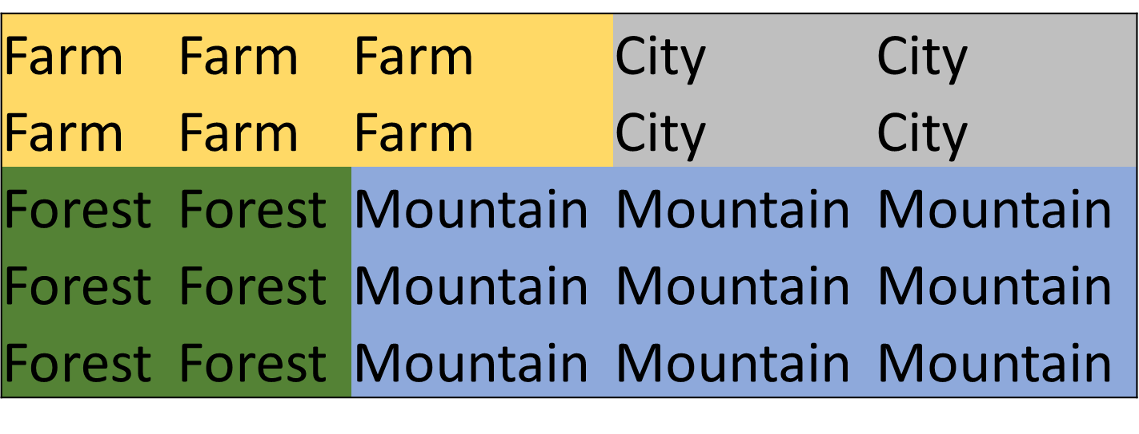

There are five different costs associated with converting an area to a protected area:

1. Acquisition
2. Management
3. Transaction
4. Damage
5. Opportunity

Each land use has different biodiversity value, and different costs associated with its conversion to a protected area. Acquisition of places already used by humans, city and farm, is expensive, as are the transaction costs of buying city area. The damage costs occur to the cells next to the protected area, and more damage can occur to places where humans live, cities and farms. Opportunity costs are low for mountainous areas, because they cannot be used for farming or other economic activities. Biodiversity value is lower for mountainous areas than the lowland areas of the other three land uses.



In order to conduct a cost-benefit analysis, you need to calculate the costs and biodiversity value of converting particular cells to protected area. An example is presented below. The green area is converted to protected area, and the red areas experience damage costs.



**EXAMPLE**

Costs:

1. Acquisition – 1 x 6 = 6
2. Management – 1 x 2 = 2
3. Transaction – 1 x 2 = 2
4. Damage – 3 x 2 = 6
5. Opportunity – 1 x 10 = 10

Total cost = 26

Biodiversity value = 20

Biodiversity value per unit cost - 26 / 20 = 0.77

**EXCERCISE**

Calculate the costs, biodiversity value and biodiversity value per unit cost for each of the three potential scenarios.

**Scenario 1**



Costs:

1. Acquisition
2. Management
3. Transaction
4. Damage
5. Opportunity

Total cost

Biodiversity value

Biodiversity value per unit cost

**Scenario 2**



Costs:

1. Acquisition
2. Management
3. Transaction
4. Damage
5. Opportunity

Total cost

Biodiversity value

Biodiversity value per unit cost

**Scenario 3**

Costs:

1. Acquisition
2. Management
3. Transaction
4. Damage
5. Opportunity

Total cost

Biodiversity value

Biodiversity value per unit cost

**DISCUSSION QUESTIONS**

**Question 1**

Which of these three scenarios would you choose and why?

**Question 2**

These costs just refer to the setting up of the protected area. However, damage and opportunity costs are ongoing so will increase over time. Does this affect which scenario you choose?

**Question 3**

If you could pay initial costs of 10 per red cell to prevent damage occurring at all over time, would this be a good investment? (Think about how long the protected area would have to exist before this large initial cost is less than the annual damage costs)

Lecture references

Balmford, A., Carey, P., Kapos, V., Manica, A., Rodrigues, A.S., Scharlemann, J.P. and Green, R.E., 2009. Capturing the many dimensions of threat: comment on Salafsky et al. *Conservation Biology*, *23*(2), pp.482-487.

Moodley, Y., Russo, I.R.M., Dalton, D.L., Kotzé, A., Muya, S., Haubensak, P., Bálint, B., Munimanda, G.K., Deimel, C., Setzer, A. and Dicks, K., 2017. Extinctions, genetic erosion and conservation options for the black rhinoceros (Diceros bicornis). *Scientific reports*, *7*, p.41417.

Thuiller, W. (2007) Biodiversity: climate change and the ecologist. *Nature*

Foley, J.A., DeFries, R., Asner, G.P., Barford, C., Bonan, G., Carpenter, S.R., Chapin, F.S., Coe, M.T., Daily, G.C., Gibbs, H.K. and Helkowski, J.H., 2005. Global consequences of land use. *science*, *309*(5734), pp.570-574.

Naidoo, R., Balmford, A., Ferraro, P.J., Polasky, S., Ricketts, T.H. and Rouget, M., 2006. Integrating economic costs into conservation planning. *Trends in ecology & evolution*, *21*(12), pp.681-687.

Ellis et al (2010)Anthropogenic transformation 1700-2000. *Global Ecology and Biogeography*

Vose, R. S., D. Arndt, V. F. Banzon, D. R. Easterling, B. Gleason, B. Huang, E. Kearns, J. H. Lawrimore, M. J. Menne, T. C. Peterson, R. W. Reynolds, T. M. Smith, C. N. Williams, and D. L. Wuertz, 2012: NOAA’s Merged Land-Ocean Surface Temperature Analysis. *Bulletin of the American Meteorological Society*, **93**, 1677–1685, doi:[10.1175/BAMS-D-11-00241.1](http://dx.doi.org/10.1175/BAMS-D-11-00241.1).

Razgour, O., Taggart, J.B., Manel, S., Juste, J., Ibanez, C., Rebelo, H., Alberdi, A., Jones, G. and Park, K., 2018. An integrated framework to identify wildlife populations under threat from climate change. *Molecular ecology resources*, *18*(1), pp.18-31.

Trivedi, M.R., Morecroft, M.D., Berry, P.M. and Dawson, T.P., 2008. Potential effects of climate change on plant communities in three montane nature reserves in Scotland, UK. *Biological Conservation*, *141*(6), pp.1665-1675.

Porter, R.D. and Wiemeyer, S.N., 1969. Dieldrin and DDT: effects on sparrow hawk eggshells and reproduction. *Science*, *165*(3889), pp.199-200.

Smith, K.F., Acevedo‐Whitehouse, K. and Pedersen, A.B., 2009. The role of infectious diseases in biological conservation. *Animal conservation*, *12*(1), pp.1-12.

Johnson, C.K., Hitchens, P.L., Pandit, P.S., Rushmore, J., Evans, T.S., Young, C.C. and Doyle, M.M., 2020. Global shifts in mammalian population trends reveal key predictors of virus spillover risk. *Proceedings of the Royal Society B*, *287*(1924), p.20192736.

Carvalho, T., Becker, C.G. and Toledo, L.F., 2017. Historical amphibian declines and extinctions in Brazil linked to chytridiomycosis. *Proceedings of the Royal Society B: Biological Sciences*, *284*(1848), p.20162254.

Ripple, W.J., Beschta, R.L., Fortin, J.K. and Robbins, C.T., 2014. Trophic cascades from wolves to grizzly bears in Y ellowstone. *Journal of Animal Ecology*, *83*(1), pp.223-233.

Goosse, H., Kay, J.E., Armour, K.C., Bodas-Salcedo, A., Chepfer, H., Docquier, D., Jonko, A., Kushner, P.J., Lecomte, O., Massonnet, F. and Park, H.S., 2018. Quantifying climate feedbacks in polar regions. *Nature communications*, *9*(1), pp.1-13.