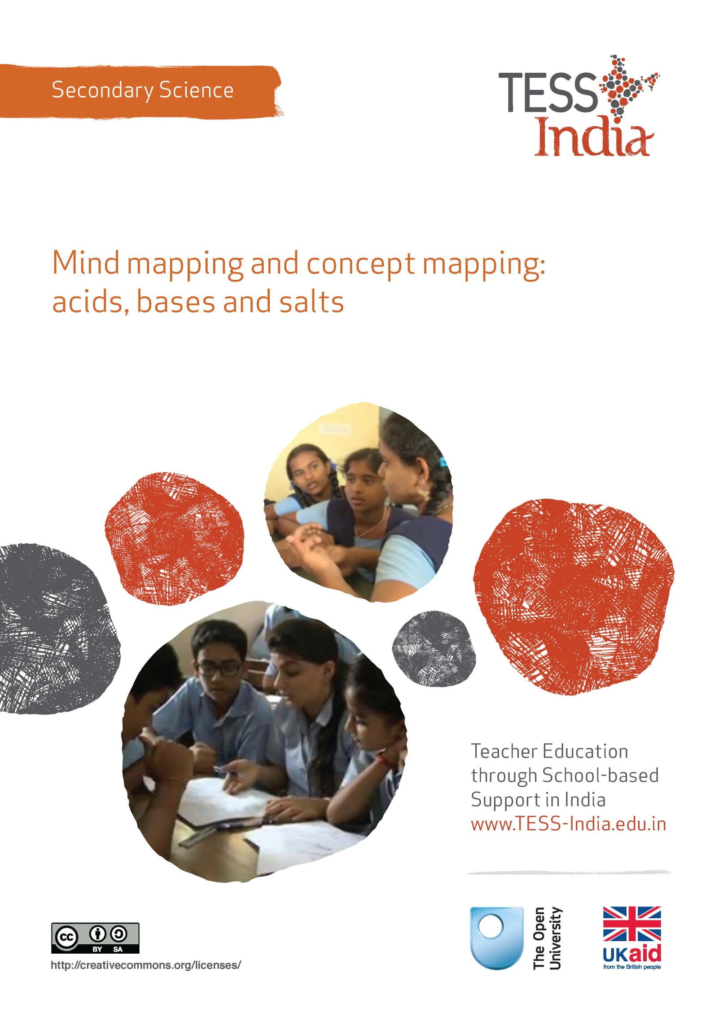
TESS-India (Teacher Education through School-based Support) aims to improve the classroom practices of elementary and secondary teachers in India through the provision of Open Educational Resources (OERs) to support teachers in developing student-centred, participatory approaches. The TESS-India OERs provide teachers with a companion to the school textbook. They offer activities for teachers to try out in their classrooms with their students, together with case studies showing how other teachers have taught the topic and linked resources to support teachers in developing their lesson plans and subject knowledge.
TESS-India OERs have been collaboratively written by Indian and international authors to address Indian curriculum and contexts and are available for online and print use (http://www.tess-india.edu.in/). The OERs are available in several versions, appropriate for each participating Indian state and users are invited to adapt and localise the OERs further to meet local needs and contexts.
TESS-India is led by The Open University UK and funded by UK aid from the UK government.
Video resources
Some of the activities in this unit are accompanied by the following icon: . This indicates that you will find it helpful to view the TESS-India video resources for the specified pedagogic theme.
The TESS-India video resources illustrate key pedagogic techniques in a range of classroom contexts in India. We hope they will inspire you to experiment with similar practices. They are intended to complement and enhance your experience of working through the text-based units, but are not integral to them should you be unable to access them.
TESS-India video resources may be viewed online or downloaded from the TESS-India website, http://www.tess-india.edu.in/). Alternatively, you may have access to these videos on a CD or memory card.

Version 2.0 SS03v1
All India - English
Except for third party materials and otherwise stated, this content is made available under a Creative Commons Attribution-ShareAlike licence: http://creativecommons.org/licenses/by-sa/3.0/

What this unit is about
This unit is about how you can develop skills to help students to process information effectively and present it in the form of mind maps and concepts maps.
A mind map organises information and presents it in a visual way so it is easier to remember. A mind map is created around a central word or phrase and associated ideas, words and concepts are added in hierarchical branches. The creation of mind maps supports the development of memory, visual thinking and problem solving skills. Creating a mind map involves structuring knowledge about a topic, in a way that can help to consolidate understanding.
Mind maps are personal and there are no right answers. It is helpful for students to look at each other’s mind maps, so this unit will also help you to organise ‘peer review’ in your classroom.
A concept map is similar, but places more emphasis on making connections between key words and concepts. A concept map still uses a visual diagrammatic representation of knowledge and aims to show the conceptual relationships between the entries. It does this with lines, arrows and linking text. The key words and the linking words should make a meaningful sentence. Concept maps are particularly helpful for eliciting students’ understanding.
This unit will introduce mind maps and concept maps in the context of acids, bases and salts. This topic requires students to remember quite a lot of factual information and to use technical terms correctly. Mind mapping and concept mapping will help your students to make sense of the information that they need to learn and can be used in many topics in science.

What you can learn in this unit
- How to create your own mind maps.
- How to help your students to use mind mapping in order to support their understanding of scientific concepts.
- Some strategies for organising peer review in your classroom.
- How to construct a concept map to show how concepts are linked.

Why this approach is important
Being successful at science at secondary school requires your students to understand and remember large amounts of information. They must also be able to master the specialised vocabulary of science. Everyone learns in different ways and as a teacher it is your responsibility to support the learning of all students. Mind mapping appeals to visual learners and can help them to remember information more easily. However, making a mind map or a concept map involves engaging with and processing information that will help all students to improve their understanding.
There are other important advantages that mind mapping and concept mapping can bring to your teaching:
- They help students to think creatively and independently.
- They can help to structure the topic in students’ minds by providing them with an overview of the topic. This helps students to store, package and retain the concepts and link one lesson to another.
- They provide an opportunity for peer review. Peer review helps students to develop evaluative skills that in turn will help them to take responsibility for their own learning.
- They link well with brainstorming. Students can work in groups to brainstorm everything they can remember about a topic. Converting the brainstorm in to a mind map or a concept map involves careful thought and will help students to organise the information for themselves.
- Mind maps and concepts maps will tell you a great deal about how your students are thinking and the depth of their understanding. You can use this to inform your planning.
Pause for thought
- How do you prefer to learn?
- Have you used mind maps and concepts maps in the past?
- If so – what challenges did you find?
There is a tendency for teachers to teach in the way in which they prefer to learn. By being aware of your own preferences, you will be able to be explicit about introducing variety into your teaching. Even if you are not a visual learner, it is worth remembering that the process of constructing a mind map or a concept map is as important as the finished product.
There is no right answer when drawing a mind map, but some are more useful than others. This can be disconcerting for some students who might lack confidence in their own ability. Looking at many examples will help them, and you, develop skills in this area.

1 Introducing mind maps

Activity 1: Looking at mind maps
You should try this activity on your own, or with a colleague. You will need to refer to Resource 1.
Look at the examples of mind maps on a variety of topics.
- What do they all have in common?
- Which do you think would be the most helpful and why?
- Imagine you were trying to explain to someone how to draw a mind map. Make a list of instructions that they could use.
It is important to remember that the process of constructing a mind map is just as important as the end product. The features that all mind maps have in common are:
- the main idea, subject (heading) or focus is identified in a central image, word or phrase
- the main themes (sub-headings) radiate from the central image as ‘branches’, which may be drawn in different colours
- topics that are further removed from the central idea are represented as ‘twigs’ of the relevant branch.
A good mind map will be well-organised and will contain lots of detail.
Before you ask your students to draw a mind map, it is helpful for them so see some examples. In Case Study 1, Mr Ditta used a game to introduce mind maps to his Class X.

Case Study 1: Games and mind maps
Mr Ditta introduces mind maps to his class.
Exams were approaching and I wanted to find ways of helping my students to revise. I like using mind maps to organise information, so I organised a game to help my students understand some of the benefits of mind maps.
First of all I drew a detailed mind map of acids, bases and salts [see Resource 2]. I put it on a table at the front of the room. I divided my students into groups of four. There were 40 students in the class, so that made ten groups. Each group had a large piece of paper and one student was chosen to be the scribe. Only that person was allowed to write anything. The idea was that each group would make a copy of the mind map.
One person from each group came to the front table and had 20 seconds to look at the mind map. They went back to their place and had to tell the scribe what to write. After about a minute, another person in the group then came to the front and looked for 20 seconds. Each person in the group had two ‘looks’, except for the scribe, who just had to write what they were told.
At the end I stuck my mind map on the blackboard so that they could all see it and compare it with theirs. We had a vote about which was the best one and then I asked that group to describe how they had tackled the problem.
Petra had taken the lead and organised a systematic approach. She went first and had had memorised the six branches. She then instructed her classmates to concentrate on one of the branches so that they could get as much detail as possible. It really highlighted the structure of a good mind map and I am sure it helped when they did one for themselves. Also – it was good fun. They did not realise that they had actually done some good revision of acids, bases and salts!

2 Drawing a mind map
The best use of mind maps is as a revision tool for making sense of a body of information. So the best time to get your students to draw a mind map (Figure 1) is when you have completed a topic. They will have forgotten some of the things that you covered at the beginning, so in the next activity, you will start with a brainstorm in order to help them remember some of the information.
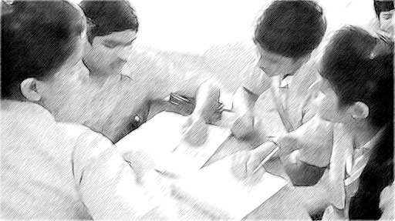
Figure 1 A group of students working on a mind map in class.

Activity 2: Helping your students draw a mind map
Before the lesson you will need to decide on the topic that you will be covering. Write out the criteria that you will use to judge the mind maps on a large piece of paper, which you will be able to stick on the wall (Resource 3).
- Gather your students round the front of the class, so they can all see the blackboard. Get them to volunteer anything that they remember about the topic you have just completed. As they offer ideas, write them on the blackboard. Write the ideas as your students suggest them and don’t attempt to group the ideas at this stage.
- When they run out of suggestions and the blackboard is full, explain that you want them to do a mind map to summarise the topic. Check that they understand what you mean and remind them of the main features of a mind map. Students should work in pairs to produce a mind map. Draw their attention to the criteria for a good mind map on the wall.
- When they have finished, either collect them in for you to mark, or conduct a peer review exercise.
Peer review is helpful for students as it helps them to understand the assessment process. Once they understand the criteria against which they are being judged, they will be able to take more responsibility for their own learning. However, they will need help in the form of clear criteria for the task and clear instructions about how to give feedback to each other. See Resource 4 for more information on monitoring and giving feedback.

Video: Monitoring and giving feedback
http://tinyurl.com/video-monitoringandfeedback

Case Study 2: Peer reviews
Mrs Rakhi teaches her students about peer review, using mind maps that they have made.
In the last lesson, my class had worked in pairs to produce a mind map. I explained that today they were going to assess each other’s work. Before we started, we had a discussion about how to give feedback. I explained that it was important to highlight the good points. If something could be improved, I encouraged them to think of ways of making the criticism constructive to help each student move forward with their learning. Here are some of the examples I used:
- ‘It looks very muddled’: I can see the main structure, but perhaps you could have used different colours to make the detail clearer.
- ‘There is nothing on preparing salts’: You have covered a lot of detail. It would be even better if you had included something on the methods of preparing salts.
- ‘Some of the science is wrong’: It is very well presented, but you should check some of the details.
- ‘It is not detailed enough’: The structure is very helpful. It would be good to have a bit more detail at the end of the branches.
For the peer review, I asked each pair to join up with another pair and swap mind maps. I wrote the criteria for assessing the mind maps on the blackboard so that everyone could see it clearly.
Each pair assessed the mind map they had against the criteria. I said, ‘Write down two things that you really like about the mind map and suggest one thing that could be improved.’ Then they swapped back again and I gave them a few minutes to make some changes to their mind maps.
Finally, I asked each pair to put their mind map on the desk and I let them walk around the room and look at each other’s. I did this because I think that the best way to get better at drawing mind maps is to see lots of examples and to think about what makes some better than others. We had a vote on which was the best one, and I asked three different people to explain why they had voted for that one.

Pause for thought
- Have you ever used peer review as a way of assessing students’ work?
- If so, how did it go?
- If not, what do you think the challenges will be?
Research (Hattie, 2012) shows that one of the things which has the most impact on students’ learning is getting feedback on their work. Obviously they get feedback from you, but by making use of peer review and self-assessment, your students will get more feedback and will get a better understanding of the assessment process. However, if they have not assessed work before, they will need help. They need clear assessment criteria and guidance about how to give feedback. Starting with work that has been produced in a group is less threatening that looking at the work of individuals. Also, you need to think carefully about who is giving feedback and make sure that students have the opportunity to work with different people. It is important that they trust and respect the person giving the feedback.

3 Making a concept map
A concept map places more emphasis on making connections between key words and concepts than a mind map. It uses a visual diagrammatic representation of knowledge with lines and arrows to make links between key words. The idea is that the key words and the linking words make a meaningful sentence.
Concept maps are particularly helpful for assessing students’ understanding of a topic. There is an example of a concept map in Resource 5.

Activity 3: Making a concept map
You should do this activity on your own and then with your class. Your class should do the activity in groups of three of four.
- Make a list of about 20 key words associated with the topic of acids, bases and salts.
- Write each word on a separate piece of paper.
- Place the words on a large piece of poster paper. Put words that are related near to each other. When you are happy with the arrangement, stick the words down with glue or sticky tape.
- Draw lines to connect the terms that are related. Write a few words on the connecting arrow to explain the connection. The words that are at one end of the arrow, on the arrow and at the other end of the arrow should make a sentence.
- When your students do this activity, look carefully at their concept maps. What do they tell you about their understanding? Are there topics that they are finding difficult? Is there a topic you need to discussion again in the next lesson?

Case Study 3: Thinking about how to make groups
Mr Singh thinks about how to divide students into groups.
I decided to get my class to make a concept map. At first I thought I would use mixed ability groups on the basis that the high attainers would be able to help my students who find science difficult. This has worked well in the past, but there is a danger that the people who are confident will take over. This time, I put my students into groups based on their achievement in the last test.
While they were writing the key words onto small pieces of paper, I talked to the groups who I knew would be confident and checked that they understood the task. I was then able to devote myself to the two groups who I knew would find it difficult. In fact, I decided to link the two groups and we did a few examples together. Once they got the idea, I left them to do a few by themselves. But I kept going back to see how they were getting on.
Overall, this approach worked very well. The high attainers produced detailed concept maps with a lot of detail. They really stretched themselves. The concept maps produced by some of the other groups were not as good. But that did not matter, because in the process of doing the activity they had learnt a lot. They had helped each other and looked up definitions of words that they did not know. They were not dominated by people who were very confident. It also gave me the opportunity to see exactly who understood what and who needed more help. It helped me to identify areas to discuss again with my students.

Pause for thought
How do you usually organise the groups in your classroom?
It is a good idea to vary the way in which you split your students into groups. Sometimes, it is helpful for them to work with friends as this will give them confidence. Sometimes it will be helpful for the high attainers to be able to support people who find science more difficult. If the task you have set is open-ended (such as a mind map or a concept map) with no single ‘right answer’, it is a good opportunity to let your students find their own level. High attainers will really challenge each other and you will be free to provide support for those that need more help. Read Resource 6 to find out more about using groupwork in your classroom.
Video: Using groupwork
http://tinyurl.com/video-usinggroupwork

4 Summary
You can use mind maps or concepts maps in any topic as they are essentially a revision tool. They will help them to organise information into a form that is easier to remember. They are also a very good way of providing your students with the opportunity to talk about their ideas and to learn from each other. A mind map or a concept map done by an individual student will tell you a great deal about the level of their understanding, so you will be in a better position to support their learning effectively.

Resources
Resource 1: Examples of mind maps
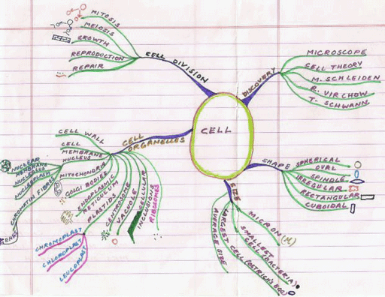
Figure R1.1 An example of a mind map.
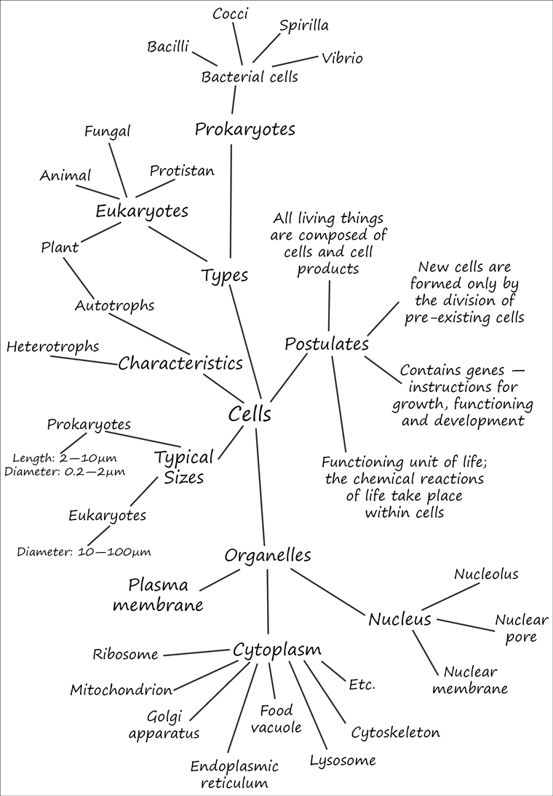
Figure R1.2 An example of a mind map.

Resource 2: An acids, bases and salts mind map
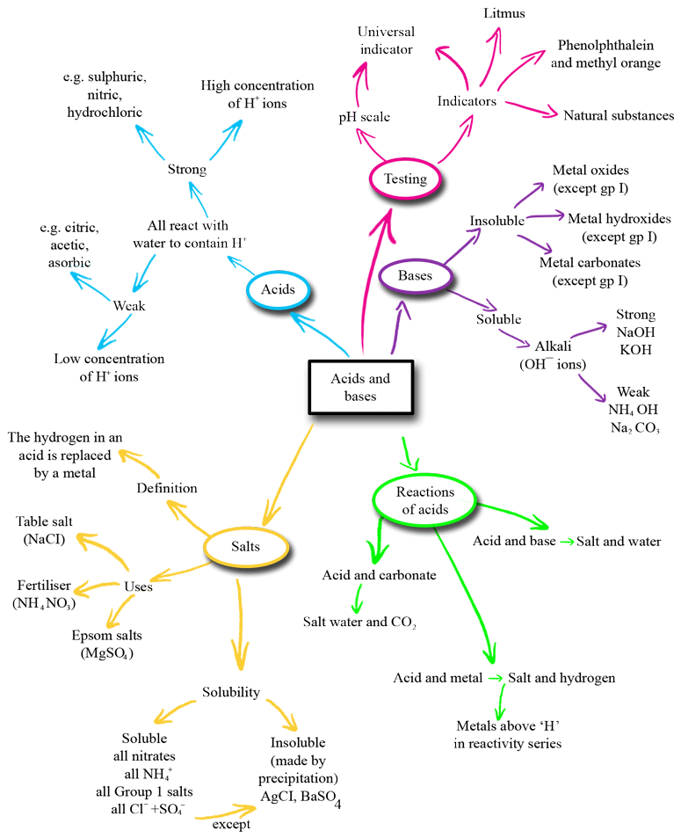
Figure R2.1 An acids, bases and salts mind map.

Resource 3: Assessment criteria for a mind map

Organisation
- Does the mind map cover the key ideas?
- Is the information arranged logically?

Scientific content
- Is the science on the mind map correct?
- Does the mind map help explain the topic?
- Have all the important points been included?

Presentation
- Does the mind map look attractive?
- Would the mind map help me to learn the information?
Resource 4: Monitoring and giving feedback
Improving students’ performance involves constantly monitoring and responding to them, so that they know what is expected of them and they get feedback after completing tasks. They can improve their performance through your constructive feedback.

Monitoring
Effective teachers monitor their students most of the time. Generally, most teachers monitor their students’ work by listening and observing what they do in class. Monitoring students’ progress is critical because it helps them to:
- achieve higher grades
- be more aware of their performance and more responsible for their learning
- improve their learning
- predict achievement on state and local standardised tests.
It will also help you as a teacher to decide:
- when to ask a question or give a prompt
- when to praise
- whether to challenge
- how to include different groups of students in a task
- what to do about mistakes.
Students improve most when they are given clear and prompt feedback on their progress. Using monitoring will enable you to give regular feedback, letting your students know how they are doing and what else they need to do to advance their learning.
One of the challenges you will face is helping students to set their own learning targets, also known as self-monitoring. Students, especially struggling ones, are not used to having ownership of their own learning. But you can help any student to set their own targets or goals for a project, plan out their work and set deadlines, and self- monitor their progress. Practising the process and mastering the skill of self-monitoring will serve them well in school and throughout their lives.

Listening to and observing students
Most of the time, listening to and observing students is done naturally by teachers; it is a simple monitoring tool. For example, you may:
- listen to your students reading aloud
- listen to discussions in pair or groupwork
- observe students using resources outdoors or in the classroom
- observe the body language of groups as they work.
Make sure that the observations you collect are true evidence of student learning or progress. Only document what you can see, hear, justify or count.
As students work, move around the classroom in order to make brief observation notes. You can use a class list to record which students need more help, and also to note any emerging misunderstandings. You can use these observations and notes to give feedback to the whole class or prompt and encourage groups or individuals.

Giving feedback
Feedback is information that you give to a student about how they have performed in relation to a stated goal or expected outcome. Effective feedback provides the student with:
- information about what happened
- an evaluation of how well the action or task was performed
- guidance as to how their performance can be improved.
When you give feedback to each student, it should help them to know:
- what they can actually do
- what they cannot do yet
- how their work compares with that of others
- how they can improve.
It is important to remember that effective feedback helps students. You do not want to inhibit learning because your feedback is unclear or unfair. Effective feedback is:
- focused on the task being undertaken and the learning that the student needs to do
- clear and honest, telling the student what is good about their learning as well as what requires improvement
- actionable, telling the student to do something that they are able to do
- given in appropriate language that the student can understand
- given at the right time – if it’s given too soon, the student will think ‘I was just going to do that!’; too late, and the student’s focus will have moved elsewhere and they will not want to go back and do what is asked.
Whether feedback is spoken or written in the students’ workbooks, it becomes more effective if it follows the guidelines given below.
Using praise and positive language
When we are praised and encouraged, we generally feel a great deal better than when we are criticised or corrected. Reinforcement and positive language is motivating for the whole class and for individuals of all ages. Remember that praise must be specific and targeted on the work done rather than about the student themselves, otherwise it will not help the student progress. ‘Well done’ is non-specific, so it is better to say one of the following:

That’s a good question!
I really liked the way you …
What would make this even better is …
I was impressed by how you helped your group by reminding them to read aloud.

Using prompting as well as correction
The dialogue that you have with your students helps their learning. If you tell them that an answer is incorrect and finish the dialogue there, you miss the opportunity to help them to keep thinking and trying for themselves. If you give students a hint or ask them a further question, you prompt them to think more deeply and encourage them to find answers and take responsibility for their own learning. For example, you can encourage a better answer or prompt a different angle on a problem by saying such things as:
That’s a good start, now do some more thinking about …
Explain how you came up with that.
Think again …

It may be appropriate to encourage other students to help each other. You can do this by opening your questions to the rest of the class with such comments as:
So we have two factors. What other factors might we consider?
I want to see groups helping each other.
Can anyone add to that answer?

Correcting students with a ‘yes’ or ‘no’ might be appropriate to tasks such as spelling or number practice, but even here you can prompt students to look for emerging patterns in their answers, make connections with similar answers or open a discussion about why a certain answer is incorrect.
Self-correction and peer correction is effective and you can encourage this by asking students to check their own and each other’s work while doing tasks or assignments in pairs. It is best to focus on one aspect to correct at a time so that there is not too much confusing information.

Resource 5: Example of a concept map
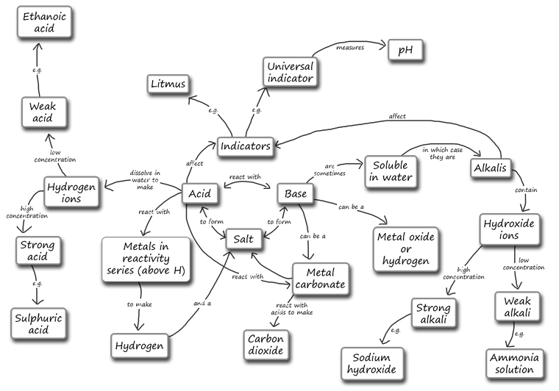

Resource 6: Using groupwork
Groupwork is a systematic, active, pedagogical strategy that encourages small groups of students to work together for the achievement of a common goal. These small groups promote more active and more effective learning through structured activities.
The benefits of groupwork
Groupwork can be a very effective way of motivating your students to learn by encouraging them to think, communicate, exchange ideas and thoughts, and make decisions. Your students can both teach and learn from others: a powerful and active form of learning.
Groupwork is more than students sitting in groups; it involves working on and contributing to a shared learning task with a clear objective. You need to be clear about why you are using groupwork for learning and know why this is preferable to lecturing, pair work or to students working on their own. Thus groupwork has to be well-planned and purposeful.

Planning groupwork
When and how you use groupwork will depend on what learning you want to achieve by the end of the lesson. You can include groupwork at the start, the end or midway through the lesson, but you will need to allow enough time. You will need to think about the task that you want your students to complete and the best way to organise the groups.
As a teacher, you can ensure that groupwork is successful if you plan in advance:
- the goals and expected outcomes of the group activity
- the time allocated to the activity, including any feedback or summary task
- how to split the groups (how many groups, how many students in each group, criteria for groups)
- how to organise the groups (role of different group members, time required, materials, recording and reporting)
- how any assessment will be undertaken and recorded (take care to distinguish individual assessments from group assessments)
- how you will monitor the groups’ activities.

Groupwork tasks
The task that you ask your students to complete depends on what you what them to learn. By taking part in groupwork, they will learn skills such as listening to each other, explaining their ideas and working cooperatively. However, the main aim is for them to learn something about the subject that you are teaching. Some examples of tasks could include the following:
- Presentations: Students work in groups to prepare a presentation for the rest of the class. This works best if each group has a different aspect of the topic, so they are motivated to listen to each other rather than listening to the same topic several times. Be very strict about the time that each group has to present and decide on a set of criteria for a good presentation. Write these on the board before the lesson. Students can the use the criteria to plan their presentation and assess each other’s work. The criteria could include:
  - Was the presentation clear?
  - Was the presentation well-structured?
  - Did I learn something from the presentation?
  - Did the presentation make me think?
- Problem solving: Students work in groups to solve a problem or a series of problems. This could include conducting an experiment in science, solving problems in mathematics, analysing a story or poem in English, or analysing evidence in history.
- Creating an artefact or product: Students work in groups to develop a story, a piece of drama, a piece of music, a model to explain a concept, a news report on an issue or a poster to summarise information or explain a concept. Giving groups five minutes at the start of a new topic to create a brainstorm or mind map will tell you a great deal about what they already know, and will help you pitch the lesson at an appropriate level.
- Differentiated tasks: Groupwork is an opportunity to allow students of different ages or attainment levels to work together on an appropriate task. Higher attainers can benefit from the opportunity to explain the work, whereas lower attainers may find it easier to ask questions in a group than in a class, and will learn from their classmates.
- Discussion: Students consider an issue and come to a conclusion. This may require quite a bit of preparation on your part in order to make sure that the students have enough knowledge to consider different options, but organising a discussion or debate can be very rewarding for both you and them.

Organising groups
Groups of four to eight are ideal but this will depend on the size of your class, the physical environment and furniture, and the attainment and age range of your class. Ideally everyone in a group needs to see each other, talk without shouting and contribute to the group’s outcome.
- Decide how and why you will divide students into groups; for example, you may divide groups by friendship, interest or by similar or mixed attainment. Experiment with different ways and review what works best with each class.
- Plan any roles you will give to group members (for example, note taker, spokesperson, time keeper or collector of equipment), and how you will make this clear.

Managing groupwork
You can set up routines and rules to manage good groupwork. When you use groupwork regularly, students will know what you expect and find it enjoyable. Initially it is a good idea to work with your class to identify the benefits of working together in teams and groups. You should discuss what makes good groupwork behaviour and possibly generate a list of ‘rules’ that might be displayed; for example, ‘Respect for each other’, ‘Listening’, ‘Helping each other’, ‘Trying more than one idea’, etc.
It is important to give clear verbal instructions about the groupwork that can also be written on the blackboard for reference. You need to:
- direct your students to the groups they will work in according to your plan, perhaps designating areas in the classroom where they will work or giving instructions about moving any furniture or school bags
- be very clear about the task and write it on the board in short instructions or pictures. Allow your students to ask questions before you start.
During the lesson, move around to observe and check how the groups are doing. Offer advice where needed if they are deviating from the task or getting stuck.
You might want to change the groups during the task. Here are two techniques to try when you are feeling confident about groupwork – they are particularly helpful when managing a large class:
- ‘Expert groups’: Give each group a different task, such as researching one way of generating electricity or developing a character for a drama. After a suitable time, re-organise the groups so that each new group is made up of one ‘expert’ from all the original groups. Then give them a task that involves collating knowledge from all the experts, such as deciding on what sort of power station to build or preparing a piece of drama.
- ‘Envoys’: If the task involves creating something or solving a problem, after a while, ask each group to send an envoy to another group. They could compare ideas or solutions to the problem and then report back to their own group. In this way, groups can learn from each other.
At the end of the task, summarise what has been learnt and correct any misunderstandings that you have seen. You may want to hear feedback from each group, or ask just one or two groups who you think have some good ideas. Keep students’ reporting brief and encourage them to offer feedback on work from other groups by identifying what has been done well, what was interesting and what might be developed further.
Even if you want to adopt groupwork in your classroom, you may at times find it difficult to organise because some students:
- are resistant to active learning and do not engage
- are dominant
- do not participate due to poor interpersonal skills or lack of confidence.
To become effective at managing groupwork it is important to reflect on all the above points, in addition to considering how far the learning outcomes were met and how well your students responded (did they all benefit?). Consider and carefully plan any adjustments you might make to the group task, resources, timings or composition of the groups.
Research suggests that learning in groups need not be used all the time to have positive effects on student achievement, so you should not feel obliged to use it in every lesson. You might want to consider using groupwork as a supplemental technique, for example as a break between a topic change or a jump-start for class discussion. It can also be used as an ice-breaker or to introduce experiential learning activities and problem solving exercises into the classroom, or to review topics.

Additional resources
- An introductory lecture on YouTube: https://www.youtube.com/watch?v=HW6OzOeOZOI (accessed 20 May 2014)
- Revision notes and exam questions: http://www.excellup.com/classten/scienceten/acidbasesalt.aspx (accessed 20 May 2014)
- An activity sheet on making indicators: http://www.raftbayarea.org/ideas/Acid%20or%20Base.pdf (accessed 20 May 2014)
- A quiz on acids, bases and salts: http://www.docbrown.info/page03/AcidsBasesSalts/AcidBaseQmcF.htm (accessed 20 May 2014)

References/bibliography
Hattie, J. (2012) Visible Learning for Teachers: Maximising Impact on Learning. Abingdon, UK: Routledge.
Mortimer, E.F. and Scott, P.H. (2003) Meaning Making in Secondary Science Classrooms. Maidenhead, UK: Open University Press.
Petty, G. (2009) Evidence-based Teaching: A Practical Approach. Cheltenham, UK: NelsonThornes.

Acknowledgements
Except for third party materials and otherwise stated below, this content is made available under a Creative Commons Attribution-ShareAlike licence (http://creativecommons.org/licenses/by-sa/3.0/). The material acknowledged below is Proprietary and used under licence for this project, and not subject to the Creative Commons Licence. This means that this material may only be used unadapted within the TESS-India project and not in any subsequent OER versions. This includes the use of the TESS-India, OU and UKAID logos.
Grateful acknowledgement is made to the following sources for permission to reproduce the material in this unit:
Resource 1 (top): cell mind map – Mrs Shreen Abbas, Mrs Alka Chopra, Mrs Nilanjana Lal and Mrs Alka Masih (http://www.freewebs.com/indiaenglishforum/lamartiniere.htm).
Resource 1 (bottom): cells summary mind map (http://311-sandratan.wikispaces.com/1_Cells), made available under Creative Commons (http://creativecommons.org/licenses/by-sa/3.0/).
Every effort has been made to contact copyright owners. If any have been inadvertently overlooked the publishers will be pleased to make the necessary arrangements at the first opportunity.
Video (including video stills): thanks are extended to the teacher educators, headteachers, teachers and students across India who worked with The Open University in the productions.

