Contents

Topic 4: Introduction to hospitality
4.1 History of hospitality 3
4.2 Serviced accommodation 8
4.3 Non-serviced accommodation 10
4.4 Dawei case study 13
4.5 What is a hotel? 16
4.6 Trends in hotel development 19
Answers to activities 22
References 24

Topic 4:
Introduction to hospitality
This topic looks at types of accommodation that tourists use and the business of hospitality. It begins by tracing the history of hospitality, before looking at serviced and non-serviced accommodation. It considers how a tourist destination is born by telling the story of Dawei, in the south of Myanmar, before looking at the major form of tourist accommodation, hotels, and the latest trends in their development.

4.1 History of hospitality
Hospitality is the friendly and generous reception and entertainment of guests, visitors or strangers. Hospitality also refers to how guests are received in hotels, restaurants, entertainment venues, sporting events and other tourism-related services. In this session, we look at the history of hospitality. It complements and builds on the discussion in Session 1.1, which looked at the history of travel and tourism.

The Empire Era (900 BCE–300 CE)
In ancient Greece and Rome, spas and bathhouses not only provided recuperation for weary travellers, but some provided sleeping facilities as well. The Romans also built large houses to accommodate travellers on government business.

The Middle Ages (5th–14th centuries CE)
On Middle Eastern routes, caravanserais, which were roadside inns that existed in the Middle Ages, provided travellers with rest from the day’s journey, as well as caring for their camels and horses. Caravanserais were important for supporting the flow of commerce, information and people along Asian, Middle Eastern and African trade routes, most notably the Silk Road. Refuges or inns also served pilgrims and crusaders on their way to the Holy Land, while in China and Mongolia staging posts provided shelter for couriers and allowed horses to be changed more easily. In Japan, a type of inn called a ryokan began to be built in the early 700s. It typically features tatami-matted rooms and communal baths (Figure 4.1.1). They continue to exist today.
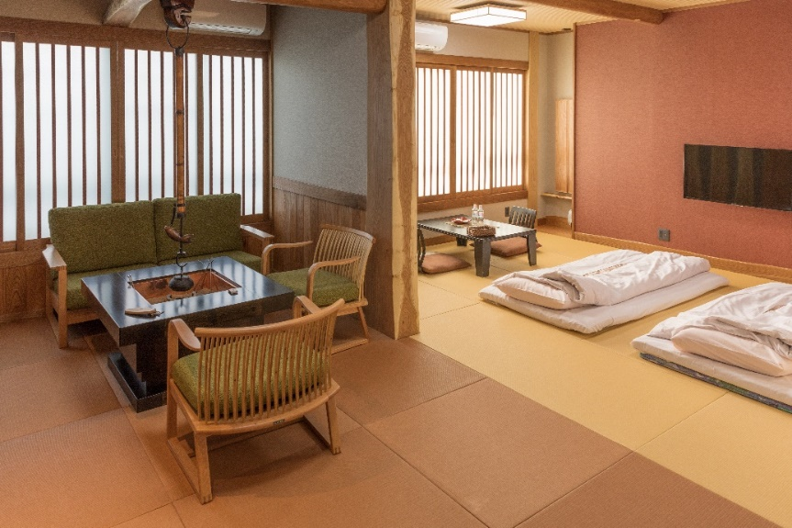
Figure 4.1.1 A contemporary Japanese ryokan following the traditional style

In Europe, cloisters and abbeys provided free accommodation to travellers. Gradually, inns and guest houses began to open on popular trade routes to provide lodging for travelling merchants and their horses.

16th–17th centuries
During this time, the law in France required that inns keep a register. English law introduced rules for inns at a similar time and more than 600 inns were registered in England (Figure 4.1.2). Guide books for travellers began to be published in France and signs were displayed outside establishments advertising their hospitality.
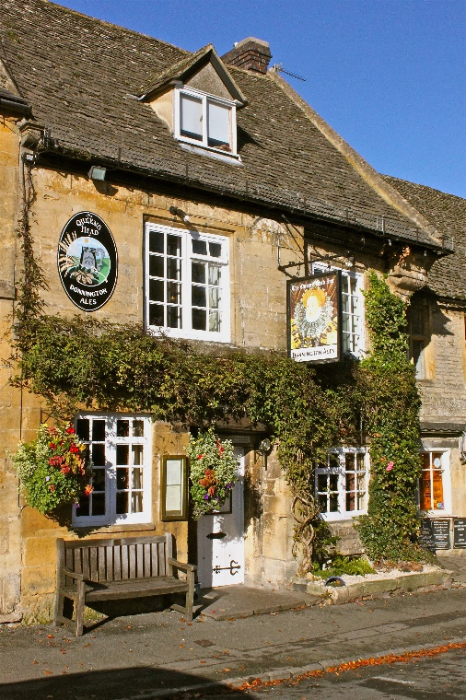
Figure 4.1.2 A seventeenth-century inn in England

18th–19th centuries
In the 1750s the Industrial Revolution began and hotels began to be built. They were bigger than guest houses and inns, and provided more services as the newly wealthy began to travel to explore. Travel became more of a leisure activity than it had ever been before. Hotels became grand and offered their guests something extra that they couldn’t get at home. Hotel construction increased across England, mainland Europe and America.
In the early 1800s, the first modern hotel built in England was the Royal Hotel in Plymouth. Holiday resorts began to flourish along the Mediterranean Riviera. In Boston, in the US, the first deluxe hotel, the Tremont House, was opened in a city centre (Figure 4.1.3). The hotel was the first to provide its guests with indoor toilets and baths, and bell boys to help guests with their luggage. It also offered free soap (which tourists continue to enjoy even today) and had a proper reception desk area servicing guests beyond simply checking in and taking payment. Charles Dickens, the English author, was a guest. In 1890, a training school for hoteliers was founded in Lausanne, Switzerland, as the importance of good service was recognised.
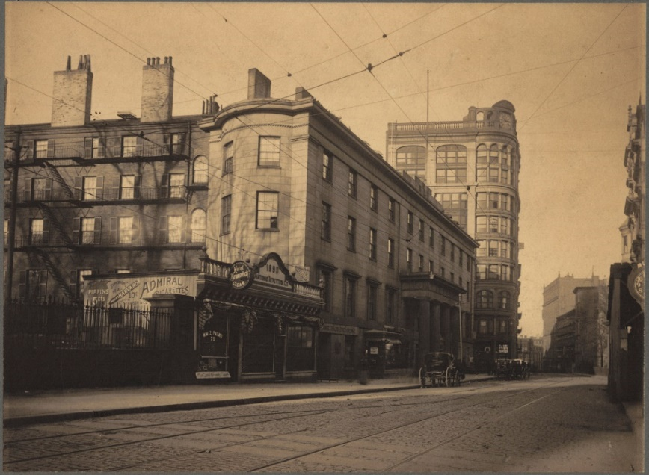
Figure 4.1.3 The Tremont House hotel, Boston, USA

The 20th century
As travelling got physically easier, enabling more people to travel and to travel further, the hotel industry boomed. The first business hotel, the Hotel Statler (later called the Hotel Buffalo), was established in 1907 in the US. The economic boom after World War II meant people had more disposable income and leisure time, which many decided they wanted to spend abroad, particularly in Europe. In the 1960s, new tourist resorts grew up around the Mediterranean and countries such as Spain, Greece and Yugoslavia thrived with the development of beach hotels (Figure 4.1.4). Today the hospitality industry is a major contributor to many countries’ foreign exchange earnings and a large source of employment.
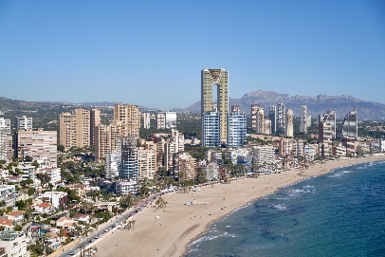
Figure 4.1.4 Hotels line the beach in Benidorm, Spain

The differences between hospitality and tourism
The hospitality industry and the travel industry are closely connected, but there are also some subtle differences. At a basic level, the travel and tourism industry is concerned with services for people who have travelled away from their usual place of residence, for a relatively short period of time. By contrast, the hospitality industry is concerned with services related to leisure and customer satisfaction. This may well mean offering services to tourists, but it can also include the provision of services to people who are not tourists, such as locals enjoying their free time or people coming to an area for reasons other than tourism. The hospitality sector forms part of the wider service industry.

Activity 4.1
Look at the timeline for the development of hospitality. Match each picture to each point on the timeline.
1. 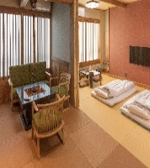 2. 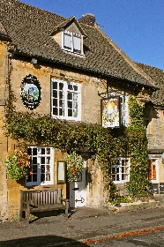
3. 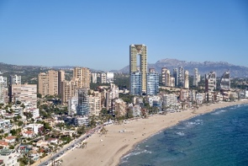 4. 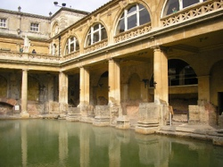
5. 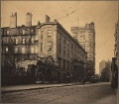
Answers to Activity 4.1

4.2 Serviced accommodation
Accommodation plays a prominent part within hospitality and the tourism industry. Accommodation refers to a temporary lodging, where travellers may rest and sleep. In the previous study session, you saw how hospitality developed across the centuries and around the world. The choice of accommodation is a big consideration for travellers today and is influenced by the amount they want to pay, the level of service they require and the degree of privacy they expect.
Hotels are the most traditional and most common types of accommodation and offer a full range of services. You will learn more about hotels in Session 4.5, but here other forms of serviced accommodation are considered.
Motels are a form of hotel that are mostly situated along highways and roads, and designed primarily for motorists. They typically have the rooms arranged in low blocks with parking directly outside. Some motels have restaurants, dining rooms and swimming pools (Figure 4.2.1).
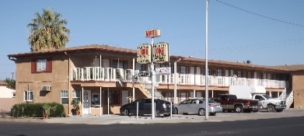
Figure 4.2.1 A motel along a US highway

A guest house is a private house converted into a lodging facility for tourists. Breakfast may or may not be offered at the guest house. The owner and family often live in another building nearby.
Bed and breakfast (B&B) is accommodation provided in a private house by the owner for up to six paying guests. The owners typically live in the accommodation and separate their personal living space away from the guest space. The breakfast served is traditionally a cooked breakfast.
An inn is an establishment that offers travellers food, drink and lodging. They are typically located in the country or along a highway and are usually used for a short stay as travellers pass through.

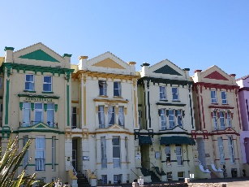
Figure 4.2.2 A British B&B in a seaside resort

A home stay is intended to facilitate a deep cultural tourism experience. The guest stays with a family and immerses themselves in the family’s life.

Activity 4.2
Match the type of serviced accommodation with its explanation.
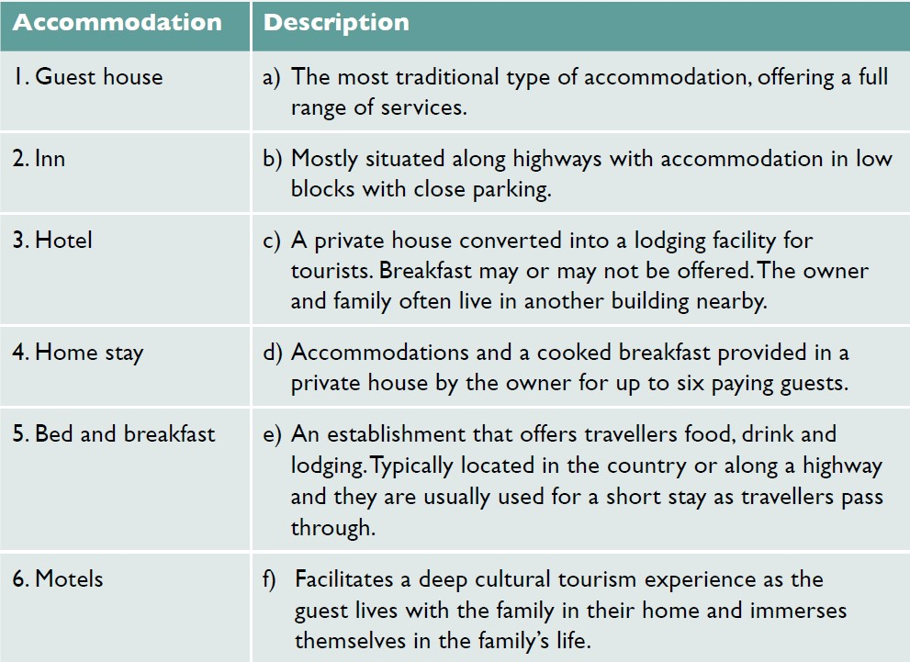
Answers to Activity 4.2

4.3 Non-serviced accommodation
Non-serviced accommodation is accommodation that does not offer food or cleaning. Non-serviced accommodations include apartments, villas, cottages, campus accommodation, youth hostels and campsites. The guest has to do most things for themselves, like cooking, cleaning and changing the bed linen.
Apartments and villas are privately owned by individuals or companies. They can be large or small and can be offered on a short-term or long-term let. Guests must provide their own food and do their own cooking during their stay.
Cottages are typically a small, cosy house that is classed as being old or traditional. They are found in semi-rural locations. Because of their unique character, culture and heritage, cottages make popular holiday homes. Cottages provide tourists with the opportunity for a ‘home from home’ experience.
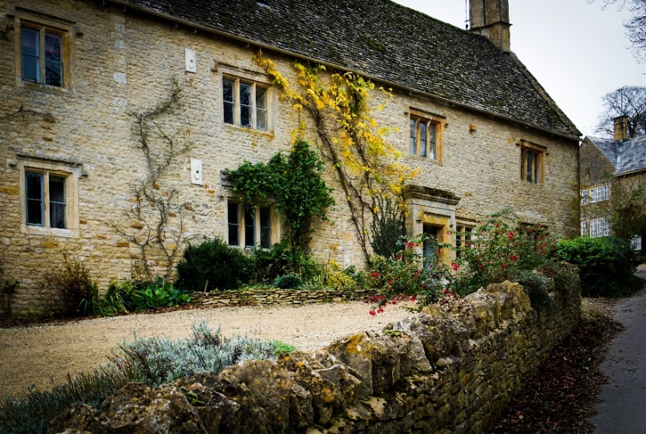
Figure 4.3.1 An English holiday cottage in the Cotswolds

Youth hostels are a form of cheap accommodation for travellers. Guests can rent a bed, often in a dormitory or a smaller shared room. They share a bathroom, lounge and possibly a kitchen with other guests. Hostels are popular with young people and others travelling on a small budget. They are less formal than hotels and offer a lot of opportunity to socialise, but also less privacy.
Campsites are a place used for an overnight stay outdoors. They offer ground pitches for the erection of tents, with facilities for washing and sanitation, campfires and sometimes electricity. Campsites charge a nightly user fee for the services they provide. Caravans can also be driven on to campsites and stay there overnight.
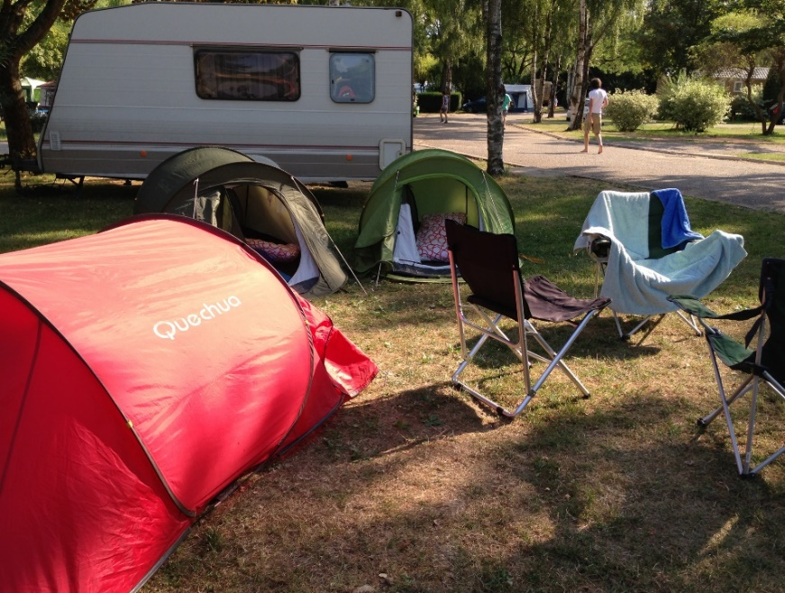
Figure 4.3.2 A campsite in France

Activity 4.3
What type of accommodation would best suit each of these four different travellers?
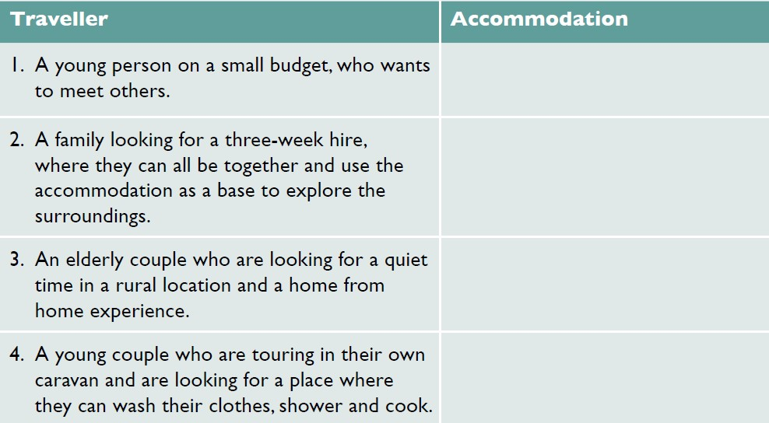
Answers to Activity 4.3

4.4 Dawei case study
We now consider how a tourist destination is built, by looking at one area: Dawei, in Tanintharyi Region, in the south of Myanmar (Figure 4.4.1). This region was closed to international tourists until 2013 and encouraging tourism is a recent initiative. Because of the lack of tourist development, the city and area retains an authentic charm, with many surviving colonial buildings.
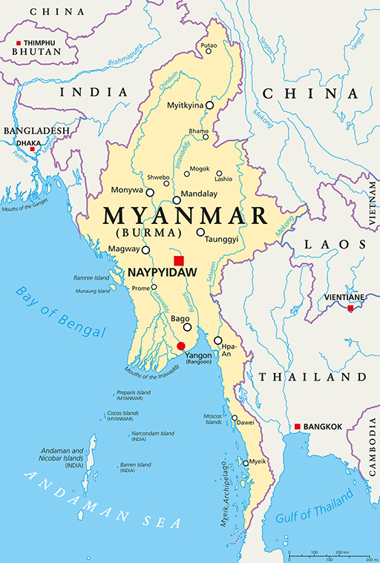
Figure 4.4.1 Map of Myanmar showing Dawei in the south

Tourists first started to go to Dawei for pilgrimage. The pilgrims stayed at numerous monastery compounds and rest houses (Zayat). Today, Dawei is being supported to build its tourism presence by investment from the Dutch government, through the International Trade Centre (ITC). They are supporting the development of tourism products and services, which include cultural community-based tours and creative tourism activities. They are also providing training to tourism service providers, such as local communities, local guides, ground handlers, hotels and restaurants (ITC, 2019).
Certain villages have been identified as offering the best potential for inclusive tourism activities, as well as showcasing the local style of housing (Figure 4.4.2). Dawei city centre is also seen as ideal for cultural and heritage walks. Working with the Ministry of Hotels and Tourism, the ITC are supporting the local communities to develop tourism products and increasing their quality through training. To build Dawei’s presence as a tourism destination, Yangon tour operators were consulted and invited to visit. The purpose of the visit, called a familiarisation trip, was to market the new community-based tourism experiences to Yangon tour operators. This is seen as a first step to reach international tourism markets.
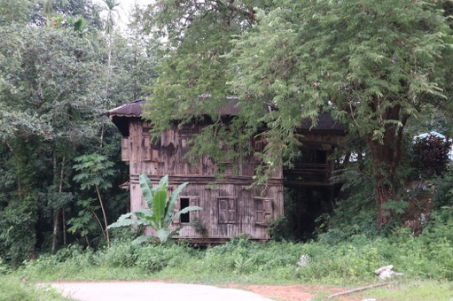
Figure 4.4.2 Traditional village home in Dawei

The familiarisation visit has built trust and understanding between the communities, local tourism businesses and domestic tour operators. Dawei ground handlers, hoteliers, restaurants and tour guides presented their products and services, which were well received.

Activity 4.4
Read the following account of the day experienced by 30 Yangon tour operators on their familiarisation visit to Dawei and answer the following question.
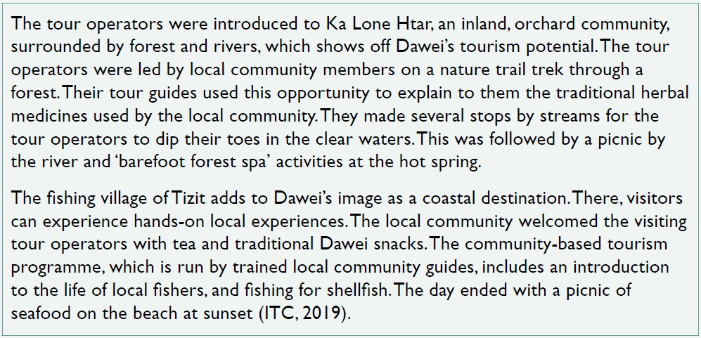
What types of tourism experiences are on offer here:
- religious tourism
- community-based tourism
- wellness tourism
- nature tourism
- disaster tourism
- eco tourism
- dark tourism
- rural tourism
- sport tourism?
Answers to Activity 4.4

4.5 What is a hotel?
This session looks at what a hotel is, the types of hotel and the types of meal plans that are available to hotel guests.
A hotel is an establishment that provides accommodation, meals and other services, such as a pool, gym, conference facilities and banqueting rooms to its guests. There are a number of ways of classifying hotels. They can be classified according to their size. A small hotel has up to 150 bedrooms, a medium hotel has 150 to 250 bedrooms and a large hotel has over 250 bedrooms (Figure 4.5.1).
Figure 4.5.1 Classification of hotels based on number of rooms

They can also be classified by the location of the hotel, such as a resort hotel, airport hotel and ski hotel, or by the clientele of the hotel, such as a business hotel, spa hotel and casino hotel. Hotels are also characterised according to the ambience and vibe they create, such as a boutique hotel (a small hotel with individualised unique selling points) or a heritage hotel (a hotel that has historical or cultural significance).
The most common classification is to rank hotels according to a star system, which tells the guest the level of service to expect. Hotels are awarded a grade between one and five stars, with one being the lowest and five the highest (Figure 4.5.2).
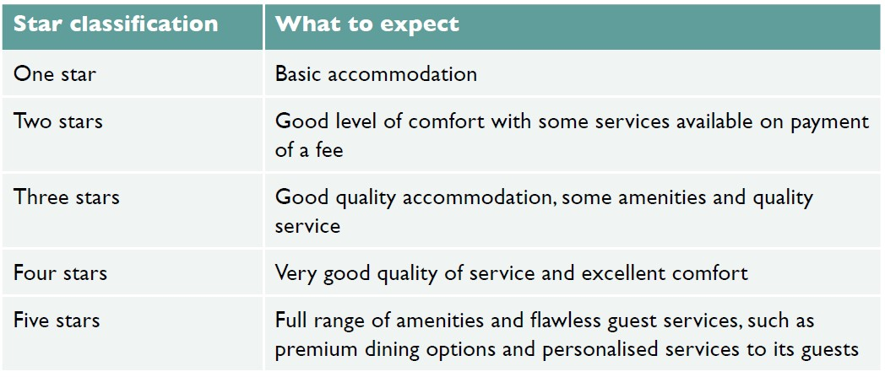
Figure 4.5.2 Hotel star classification

Hotel tariff
A hotel tariff is the charge for services offered by the hotel. Most commonly it refers to the room charge. The main types of room in a hotel are:
- single room – a single bed for single occupancy
- double room – a double bed for two-person occupancy
- double and double room – two double beds for up to four people
- triple room – one double bed and one single bed, or three single beds for three people
- twin room – two single beds, each for single occupancy
- interconnecting rooms – a door connects two adjacent rooms, allowing the guests to access either room without passing through the public area
- suite – more than one room, normally a bedroom and lounge
- deluxe room – a larger room and larger bed for two people, often with view
- king room – a king-sized bed for two people
- queen room – a queen-sized bed for two people.
Guests can also choose different meal combinations or a meal plan. There are many different types of plan that guests can choose from, even at the same hotel, although not all would be available at every hotel. Some types of meal plans include:
- full board (FB) or American plan – accommodation, breakfast, lunch and dinner
- modified American plan – accommodation, lunch or dinner
- half board (HB) – accommodation, breakfast and dinner
- bed and breakfast (B&B) or continental plan – accommodation and breakfast
- Bermuda plan – accommodation with morning tea and coffee
- room only (RO) – accommodation only.
Hotels operate 24 hours a day with staff working eight hours each day. Their duty time is called a shift. Thus, staff might work the morning shift, afternoon shift or night shift. Sometimes this is called A shift, B shift and C shift. Most hotels have some handover time of 30 minutes or one hour, so that the staff starting the new shift can be briefed about the guests by the staff just finishing. In this way, hotels operate a smooth 24-hour service.

Activity 4.5
Look at the photos and match them to the type of room shown.
1) 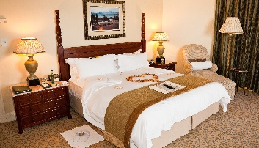 2) 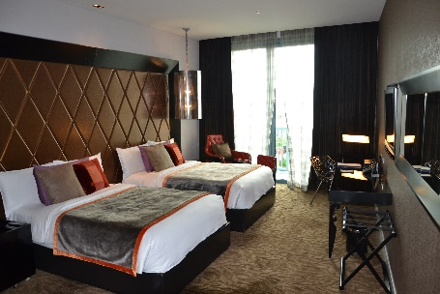
3) 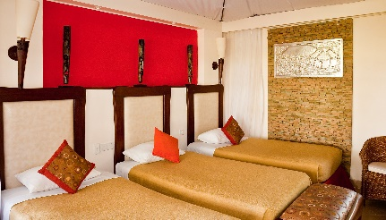 4) 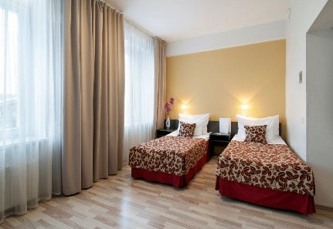
5) 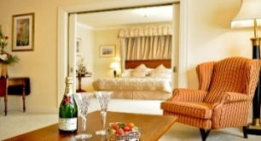
- Triple room – one double bed and one single bed, or three single beds for three people.
- Double room – a double bed for two-person occupancy.
- Suite – more than one room, normally a bedroom and lounge.
- Double and double room – two double beds for up to four people.
- Twin room – two single beds, each for single-person occupancy.
Answers to Activity 4.5

4.6 Trends in hotel development
This session looks at three current trends in the development of hotels: environmental impact, digitalisation and different hotel ownership models.

Environmental impact
Hundreds of millions of people travel around the world every year staying in hotels, which makes hotels a multimillion-dollar industry. But hotels’ environmental impact is becoming an increasing concern for hoteliers, governments, local communities and guests. The three key areas of concern are energy, water and waste (Figure 4.6.1).
Figure 4.6.1 Three areas of environmental concern for hotels

Addressing these issues is called ‘greening’ and hotels are increasingly greening their management approach, becoming more environmentally responsible and sustainable by adopting good environmental practices. Technology has supported and driven these environmentally aware changes. Customers are also becoming increasingly aware of the environmental credentials of hotels, which influences their hotel choice.

Energy
Hotel guests use more energy than local residents, because there are more energy-intensive services available to guests, such as air conditioning, restaurants and gyms. Hotels are installing energy-efficient technologies and fittings, for example energy-efficient lighting. These small adjustments can lead to major cost savings, as well as cutting greenhouse gas emissions. Today, most hotels are changing their practices from energy consumption to energy conservation.

Water
Water is central to many of the extra services provided to guests, such as gardens, spas, golf courses and pools. Water-efficient devices can cut water usage and leakage. Guests are also encouraged to reuse towels and bed linen, rather than having them changed daily. This reduction in laundry cuts water and energy usage.

Waste
Hotels produce a lot of waste, because they are major consumers. They are increasingly looking at reducing, reusing and recycling their waste. For example, rather than providing water in plastic bottles in every guest room, hotels are providing water fountains on each floor and glass jugs for filling (Figure 4.6.2). They are providing shampoo and conditioner in refillable bottles rather than single-use plastic bottles, as well as purchasing organic products and using fewer chemicals as cleaning agents.
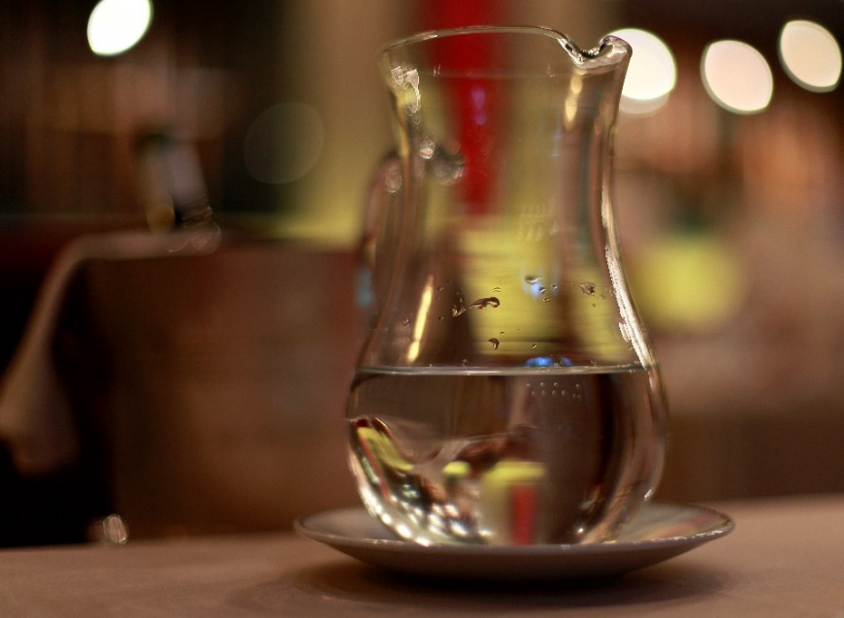
Figure 4.6.2 Hotels increasingly provide glass jugs of water in hotel rooms, rather than single-use plastic bottles of water

A hotel impacts its environment not only at the operational stage of its life cycle, but also at the planning and construction stages. Consequently, developers are seeking the support of local communities when making choices about where to locate a new hotel. Consideration is given to the construction materials used and their source, and the building techniques used. All of these elements add to the environmental footprint of the hotel, as does its closure and decommissioning.

Digitalisation of hotels
Many hotels are becoming paperless and moving to greater digitalisation. The central reservation system is increasingly computerised, cutting out the need to print documents. Digital copies are held and emailed to guests, saving time and resources. In many hotels, guests no longer have physical keys, but plastic key cards that offer greater security and convenience. Staff increasingly check in for their shifts using face scans or a fingerprint for secure recognition.
Guests are increasingly likely to make their reservation online, having searched the internet to view the hotel’s website and reading online reviews. They can also book dinner at a hotel restaurant or view their bill any time through their room TV screens. Some hotels even use robots for front office operations, housekeeping and service in restaurants and bars.

Hotel ownership models
Vacation ownership is the fastest growing segment in the travel and tourism industry. These properties are where multiple parties hold rights to use the property, and each owner of the same accommodation is allotted their period of time when they can use it. Many leading hoteliers are entering this market, building resort properties, urban condos, townhouses or single-family homes.
Another developing trend is franchise hotels. Most hotels are independent hotels or chain hotels. An independent hotel is a small-scale hotel, for example a family-run hotel. Chain hotels are normally local hotels in a country, or international chains, owned by a parent or partner company. Chain hotels each occupy an identical position in the market, with the same concept, design, service and name. In contrast, a franchise hotel is a way of growing the business in multiple locations, with the same or similar products or services, through a contractual agreement. The franchisor grants the franchisee the rights to use the company name.

Activity 4.6
Covid-19 has had a devastating impact on tourism. Hotels are likely to start exploring strategies that target local customers to grow their income until overseas guests return. Imagine you are a hotel general manager. Which of the following reopening strategies might you use:
- encourage domestic guests to stay with special local rates
- market conference facilities
- market banqueting facilities
- promote the hotel as a wedding venue
- promote hotel restaurants with special dining offers, such as children under 12 eat free
- promote the bars with special entertainment evenings, such as a jazz evening?
Answers to Activity 4.6

Answers to activities

Activity 4.1
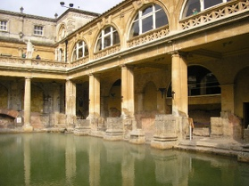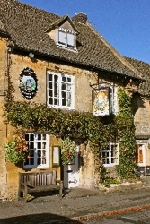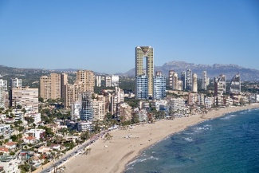

Activity 4.2
1. c), 2. e), 3. a), 4. f), 5. d), 6. b)

Activity 4.3
1. Youth hostel
2. Apartment or villa
3. Cottage
4. Campsite

Activity 4.4
- b) community-based tourism, c) wellness tourism, d) nature tourism, f) eco tourism, h) rural tourism.

Activity 4.5
- b) Double room
- d) Double and double room
- a) Triple room
- e) Twin room
- c) Suite

Activity 4.6
All answers a) to f) are likely to grow hotel earnings.

References
International Trade Centre. (2019) Experiencing local life and culture in Dawei, Myanmar. Available at: https://www.intracen.org/news/Experiencing-local-life-and-culture-in-Dawei-Myanmar/ (Accessed: 1 March 2021).

