Using a teaching diary

Introduction
As you know from other communications you are part of the first cohort of academic professionals to take part in the professional development strand of the TIDE project.
In this professional development strand:
- You will participate in four residential schools.
- You will participate in a variety of learning events between these residential schools.
- You will also be involved in the evaluation and re-development of existing and development of new ‘open educational resources (OERs).
- You will share your new knowledge and skills with others.
While you will gain much from the experience of participating in these activities, we believe you will gain even more by keeping a teaching diary as well about your professional learning about your teaching practices.

Why keep a teaching diary?
All professionals start their careers as novices with a lot to learn. For university teachers, their learning must be related to two areas - their subject and how to teach it effectively. It is likely that a new lecturer will already have significant knowledge of their subject, having built upon their undergraduate studies by taking a postgraduate degree or through professional experience. But of course it will be important to deepen further their understanding and keep their subject knowledge updated over the three or four decades of their career.
Many new teachers have a lot more to learn about how to teach. They may be starting at a very basic level. They have been students, they have observed their own teachers in action, but they may never have studied teaching, nor done any themselves.
Teaching is a practical skill, and the best way to learn and improve a practical skill is through practice. Learning to drive, playing a musical instrument, playing a sport are all familiar examples of activities which cannot be learnt from a book, but must be learnt through practice. We practice our new skill, we evaluate what went well and what could be improved, we identify key learning points and then apply these in our next attempt. Sometimes we rely on feedback from others to help us with this process. We each of us do this automatically as we go through life getting better at the things that we do.
So this cycle of practice >> evaluation of practice >> professional learning >> application of professional learning (Figure 1) to improve future practice is one important way that novice teachers can learn how to teach, and experienced teachers can get even better at teaching across their whole career. Many university teachers have found that using a teaching diary can help with this process, by making us pay more attention to, and therefore think more deeply about, the middle stages of this cycle - evaluation of practice and professional learning.
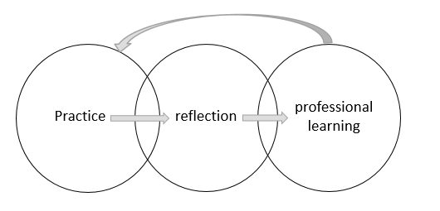
Figure 1: The professional learning from practice cycle

Furthermore, evaluating practice and learning from it is something that TIDE project will be doing as well for all the activities it undertakes. So we will be asking you to give us feedback from time to time on what you have learned and this will be made easier if you have kept a teaching diary. We will not ask to see your teaching diary – that is personal to you – but we do want to know where and when we could do things better for you and for the future cohorts.

What is a teaching diary?
Teaching diarys come in many different forms. Some are hand-written in notebooks. Some are arranged in folders or ring-binders to file the material, perhaps with background documents. They can be typed up using a word processor and stored on a hard drive or USB stick. Or they can be kept online in the Cloud, either as a document file, or in a commercial software package designed for keeping a diary. Not all teaching diarys are written. Audio or video diaries can be very effective as a way of quickly capturing thoughts and reflections, using a phone or other mobile device.
No matter what the format, the focus of a teaching diary is on the author, their practice, and how to improve it over time. So it is always a very personal document. Most teaching diarys are kept private, but it is possible for them to be shared with one or more colleagues as part of staff development activities, provided this is agreed and understood at the outset of the process (but as noted above will the TIDE team will not ask to see them).

How can I start my teaching diary?
First, you need to get comfortable with the idea of writing about your own practice. It might be helpful to think about the task as “writing a letter to myself”. The writing style is likely to be very different to other academic writing you have done. It will be in the first person (“I”) and rather informal. Spelling and grammar do not have to be perfect. If you are writing by hand, you need to be neat enough so that you will be able to read it later, but crossings out, and comments in the margins, are fine. You can choose to write either in your first language, or in English - whichever is the most comfortable for you.
Moon (2006: 102-3) suggests these points are important if a teaching diary is to be a useful document:
- Make the teaching diary your own: make the writing personal so that it reflects you as an individual
- Be honest: because confronting difficulties honestly is the best way to make progress
- Let words flow: do not worry about presentation, just write! This is why you may wish to keep the teaching diary in your first language.
- Use your own words: explaining things in your own words is a powerful way to come to a deeper understanding of them
- Dig deeper: As you think deeply about the strengths and challenges of your practice as a teacher, you will come to a clearer understanding, not only of what needs to continue and what needs to change, but also of the reasons why.
- Be flexible: effective teaching diary writing has many styles - try out alternative ways of writing and structuring your teaching diary
- Write things up as soon as you can - you will remember a lot more. Making even brief notes soon after a class or field trip can provide a framework that you can return to later to explore in greater depth
- Seek help if necessary: from fellow participants on the TIDE programme, at a TIDE residential school, or from other colleagues.
- Be selective: teaching experiences that went really well and ones where problems arose are probably the best source material for teaching diary, especially when you are getting started. This is because these will be the richest source of professional learning for you.

How can I structure my teaching diary?
Moon also suggests that one way to get started is by asking yourself some questions about your practice. These might be very specific (for example “how can I help my students come to a better understanding of topic X?” or “how can I check that students understand the theory behind today’s practical class?”). If you have similar questions about your practice that could be a good way to theme your early teaching diary writing.
However, there is also a set of generic questions which might be useful to you in coming to a clearer understanding of your practice and how to make it even more effective. This is the “What?/how?/why?/so what?/now what?” framework.
To use the framework, ask yourself these questions in turn about a particular teaching experience:
- What was I trying to teach? What was the teaching environment and did this affect the teaching or learning?
- How did I go about it? What did I actually do?
- Why did I choose to do it this way? Because I always have? Because I have seen other teachers do something similar? Because of something I read? Because of feedback from last year’s class?
- So what? What happened? How well do you think it went? What were the students’ reactions? What was their feedback? If other colleagues were present what did they think? Is there any evidence of how well the students learnt during the session?
- Now what? What have I learnt about my teaching and how will I apply this in my future practice?
You can see that these questions take you through the cycle of practice >> evaluation of practice >> professional learning >> application of professional learning, by starting with your practice, asking evaluative questions about your practice, asking you to identify key learning points, and finally tying down the implications for your future practice (Figure 2).

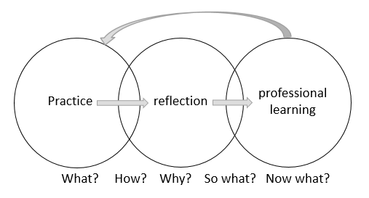
Figure 2: The professional learning from practice cycle and the “what?/how?/why?/so what?/now what?” framework

Good luck with your teaching diary writing. A good time to start would be now!

Reference
Moon, Jennifer A. (2006) Learning Journals: A Handbook for Reflective Practice and Professional Development, London: Taylor & Francis Group.

