Leadership for Effective Learning
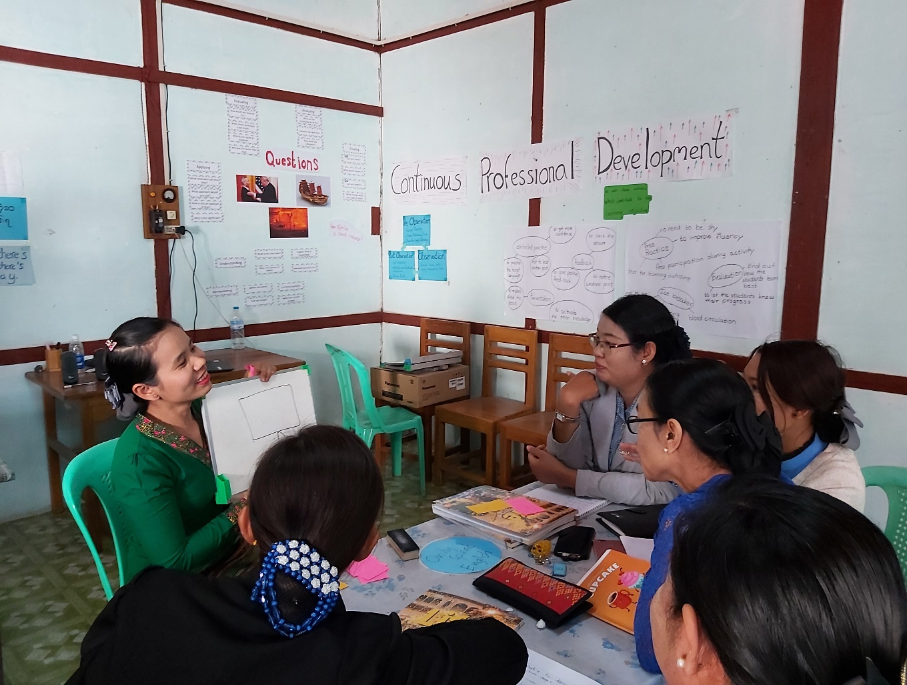
Unit 2: The learner and the classroom environment
Participants’ Book

Overview

This module considers what effective learning looks like in the context of educational institutions and organisations in Myanmar and how leadership teams of these institutions and organisations can influence attitudes and approaches to effective learning.
The course will consider questions such as:
- Who are our learners?
- What is effective learning?
- Who is responsible for effective learning?
- What leadership approaches and strategies can leaders employ to enable and ensure effective learning in their contexts?
- What skills do leaders require in order to enable and ensure effective learning and how can these be developed?

This is the second of five units:
- What is Effective Learning?
- The Learner and Classroom Environment
- Leadership for Effective Learning
- Strategies for Leading for Effective Learning
- Skills for Leading for Effective Learning

Contents

Overview 2
Contents 3
Outcomes 3
2.1 Your learning journey 4
2.2 Ghosts behind the blackboard 6
2.3 What really makes effective teaching? 7
2.4 What really makes an effective learner? 9
2.5 Which classroom activities support learning most effectively? 11
2.6 Which classroom strategies impact on student outcomes? 12
Appendix 1 What really makes effective teaching? 14
Appendix 2 What really makes an effective learner? 15
Appendix 3 Hattie’s analysis (2012) 17
Further reading and references 18

Outcomes
By the end of this unit, participants will be able to:
- reflect on their own learning journeys and those of their learners
- identify and discuss features of effective teaching
- identify and discuss features of effective learning
- reflect on the differences between fixed mind sets and growth mind sets and how we can encourage learners to develop growth mind sets
- identify and discuss which classroom activities and strategies best support effective learning.

2.1 Your learning journey

2.1 Discuss: Read the text below. What does a learning journey mean to you?
Learning is a journey – a journey from one place to another. When people go on a journey they almost always bring some baggage with them. On a journey of learning this includes their previous experiences either as learners or as teachers; their expectations of the training and often questions, worries and concerns about the training. Therefore, it is very useful at the start to find out what this baggage is.
(Adrian Tennant and Nigussie Negash)
2.1 Task: your learning journey
Step 1
We can reflect on our learning journey and show it as a timeline.
Look at the example below. It shows the career over years of a teaching professional.
There are times when the journey of our career progresses positively. There are times when the journey feels negative and we are faced with problems and challenges.
The line in the diagram shows how this professional feels about their career.
Throughout our career, effective learning takes place. Maybe we take a qualification, participate in a training course, learn from colleagues or have other experiences which help us learn.
The crosses in the diagram show times when the professional reflecting on their career feels the most effective learning took place.
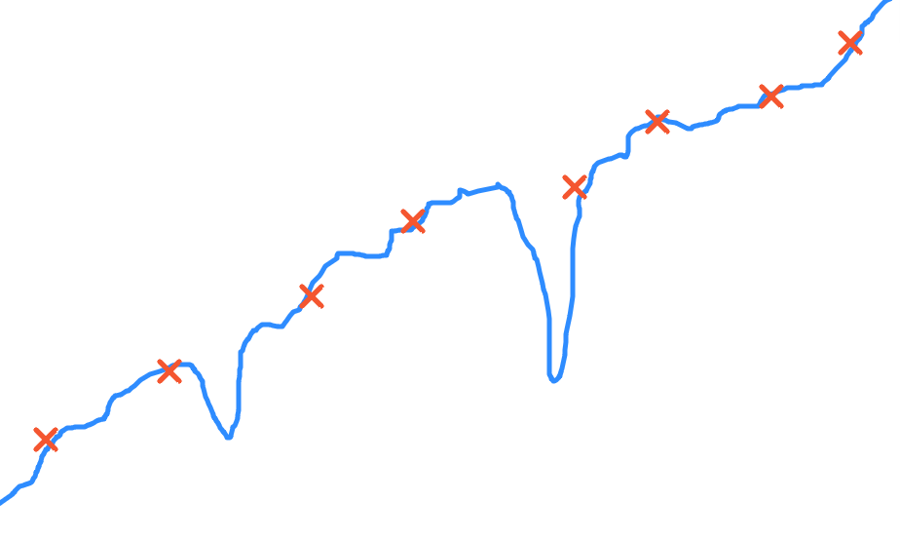
1990 1996 2000 2002 2007 2012 2014 2019 2021 NOW
Step 2
In the box below, reflect on your own career and draw a timeline which shows your career.
Which years have been most important in your career? Show them on the diagram.
Think about times when your career progressed positively and times when you faced challenges and problems. Show these in your diagram.
When did the most effective learning take place? Add crosses to your diagram to show when this occurred.

Step 3
Now think about a typical student who is studying to become a teacher and their learning journey, from when they leave secondary school to the end of their third year of teaching after they graduate.
At which points is the student likely to progress positively?
When might they face challenges and problems?
When does the most effective learning take place?

2.2 Ghosts behind the blackboard

A ghost behind the blackboard is someone who taught you in the past and who influenced the way you teach or train (positively or negatively).
Task: In a major study on what makes an inspirational study, a team of researchers led by Professor Pam Sammons asked teachers to identify their ‘ghosts behind the blackboard’.
Read what these two teachers said.
What qualities did these ‘ghosts’ have? What does this tell us about teaching and learning?
Teacher 1
I had a PE teacher who was really good fun. She just had a real passion for her subject and she really enjoyed teaching and you could tell she really enjoyed being with the students, and it was just enjoyable to be in her classroom. So I don’t know whether her actual teaching was inspiring, but just the atmosphere of the classroom made you want to be there.

Teacher 2
She was my Year 6 teacher and she told my parents that I would not go very far, and my parents told me this when I was in secondary school. She said to my parents: ‘Don’t expect a lot from her, she won’t go very far’, and that gave me the incentive to prove her wrong. There have been not inspirational teachers for the right reasons in my educational career and I think that’s probably another reason why I am as I am, because I want children to be inspired for the right reasons.

Now it’s your turn:
- Think of someone who taught you in the past (not necessarily a teacher in a formal capacity) who really motivated you and helped you to learn effectively.

- Think of someone who taught you in the past (not necessarily a teacher in a formal capacity) who did not motivate you and who did not help you to learn effectively.

What does this tell us about teaching and learning?

2.3 What really makes effective teaching?

2.3 Discuss: what really makes effective teaching?
What do you think are the features of effective teaching?
Think about:
- the skills an effective teacher demonstrates
- the attitudes an effective teacher demonstrates
- the knowledge an effective teacher demonstrates.

Make a list in the box below.

Try to focus on features of effective teaching which you can directly observe when you watch a class.
2.3 Task: what would students say?
Step 1
Think about the learners in the context you work in. They watch teachers or trainers in every lesson they participate in and probably have strong opinions about what makes effective teaching.
How many of the features you have identified would learners agree makes effective teaching?
Step 2
Researchers from Creative Education have made a video about student opinions.
You will hear eight students talking about what they think makes a good teacher.
Watch the video. You can find the video at: www.youtube.com/watch?v=iHapv0Tv7vM
Record your answers in the table below:

Olivia:
Ryan
Emma:
Claire:
Danielle
Emma:
Beth
Emille:
Rick:
Ryan
Harriet

Which features of effective teaching you identified above are described by the eight students?
Are there any features mentioned by the students which you did not identify?
Step 3
Read the features of effective teaching identified by a research study led by the United Kingdom National College for School Leadership in Appendix 1 to this unit.
Which features are similar or different to your ideas?

2.4 What really makes an effective learner?

2.4 Discuss: what really makes an effective learner?
Over the last thirty years, there has been a great deal of research into what makes an effective learner.
What do you think are the characteristics of an effective learner?
Make a list. Then compare your ideas with the characteristics of an effective learner presented in Appendix 2 to this unit.

2.4 Task: the concept of mindsets
Read the definitions of a growth mindset and a fixed mindset:
Personal mastery in learners arises from collaborative and independent learning and a growth mindset.
Helplessness in learners arises from passive learning behaviours and a fixed mindset.
Carol Dweck (2012)

You will hear Carol Dweck talking about growth mindsets and fixed mindsets.
Watch the video. You can find the video at: www.youtube.com/watch?v=TTXrV0_3UjY
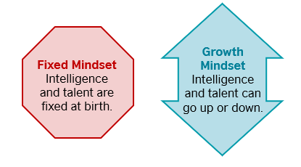

Work with a partner or partners and discuss these two questions. Record your ideas in the box below.

- What role does praise play in developing a growth mindset?

- Why is having a growth mindset such an important feature of an effective learner?

2.5 Which classroom activities support learning most effectively?

2.5 Discuss: activities which support effective learning?
Work with a partner or partners and discuss this question:
What makes an effective classroom activity?
2.5 Task: what the research shows
Look at the two diagrams 1 and 2 below. What do they tell us about which activities support learning most effectively?

1. Concentration rate during a lecture
From Why Lectures Don’t Work’ Gillian Belbin

2. Student retention rates for different activities

NTL Institute, Bethel, Maine

2.6 Which classroom strategies impact on student outcomes?

2.6 Discuss: how strategies have impact on student outcomes
Work with a partner or partners and discuss this question:
Which classroom strategies have significant impact on student outcomes?

2.6 Task: factors impacting learners
Here are ten factors which impact on learning. The list is based on John Hattie’s work in which he undertook a meta-analysis of the research and evaluation evidence into the classroom and lesson factors that impact on student outcomes. His analysis is based on a synthesis of more than 50,000 studies covering more than 80 million learners.
In groups, arrange Hattie’s ten factors into three categories:
Share your reasons for the choices you have made:
- small group learning
- homework
- classroom discussion
- teaching test-taking strategies
- feedback from teachers (written and verbal)
- whole school effective teaching practice
- open vs traditional classrooms
- scaffolding
- one-on-one laptops
- study skills (to know how to work independently).

Significant impact | Moderate impact | Little or no impact

Discuss this question:
- Is there anything not included in the list that you think has an important impact on effective learning?

Now compare your answers with Hattie’s list (2012) (see Appendix 3 to this unit).
- Is your list similar or different?

- As a leader in your context, how much influence do you have over the ten factors listed above?

Appendix 1 What really makes effective teaching?

- Teachers are enthusiastic and knowledgeable.
- Teachers are focused clearly on developing pupils’ understanding of important skills.
- Teachers use effective subject-specific teaching methods.
- Teachers plan and develop lessons effectively.
- Teachers have high expectations of learners and set tasks that are sufficiently demanding and extend knowledge and understanding.
- Tasks designed by teachers meet the needs of pupils of different abilities and address what pupils need to do to improve.
- Teachers build constructive relationships with learners.
- Teachers encourage learners to become independent in their learning.
- Teachers use formative assessment to monitor pupils’ progress and match activities to learner needs and abilities.
- Teachers enable learners to understand how well they are doing
- Teachers to plan challenging activities which engage learners.
- Teachers work ‘beyond the coursebook’ – they are not simply reliant on published materials which are not well matched to pupils’ needs.

From ‘How do school leaders successfully lead learning?’
Peter Matthews, Institute of Education, London

Appendix 2 What really makes an effective learner?

Some research findings

Knowing where to go | An effective learner knows how to set his or her own goals and objectives.  They can plan and prioritise.  They can answer the question ‘What will I do?’ and know when they have reached a milestone in their learning.
Knowing how to get there | An effective learner can plan his or her path to reach the destination they are aiming for. They can decide how they will go about developing a new skill and manage the process – they can be self-managing.
Being responsible | An effective learner knows that it is the learner not the teacher who is responsible for the process of learning. They can take charge of their own learning and have control over the learning process. They are able to work and study on their own or with a partner – not just under the control of the teacher.
Being able to choose | An effective learner can make intelligent decisions about what to do and what not to do. They can choose their own way of learning, their aims, the pace of learning, any materials they might choose – they can exercise freedom of choice.
Being active and attentive | An effective learner is actively involved in the learning process. They know where to turn their attention and how to be selective in being attentive.
Being organised | An effective learner is organised – can manage time, documents and planning. They can organise their own learning too and can make links and connections between different ideas.
Applying skills and strategies | An effective learner can actively use a wide range of different learning skills and strategies to make progress.  They are aware of not just what to learn but how to learn.
Being proactive and not reactive | An effective learner is proactive and not reactive. An effective learner is not someone to whom things happen but someone who makes things happen.
Self-monitoring | An effective learner can monitor their own progress – they can self-monitor. They can think and reflect about their own learning and evaluate themselves effectively so they can determine what has been learnt successfully and what remains to be learnt.
Being communicative | An effective learner can communicate and share with other people. They can talk about their own process of learning – they are articulate. They know when to ask if there are problems and who to ask – they are not afraid of asking for help or advice and they are prepared to ask questions. They can cooperate and empathise with other people.
Memory | In many types of learning, being able to transfer what has been learnt from short term memory to long term memory is also a characteristic of an effective learner.
Personalising | An effective learner can personalise their learning so that they use what they have learnt for their own personal purposes and aims.
Taking risks | An effective learner is prepared to take risks and to learn from mistakes. They are not afraid of making mistakes but can use what they have learnt from making them to make progress.
Being open to possibilities | An effective learner has an open mind. They can look for alternatives and they are open to new possibilities.
Being confident | An effective learner has an appropriate level of self-esteem. They are self-motivated and have a generally high level of confidence. They are prepared to put in effort to achieve but also to be satisfied with the result. They have comparatively lower levels of anxiety and give themselves the opportunity to encourage and congratulate themselves.

(Source: British Council Ethiopia/Afghanistan/Mongolia: Towards More Independent Learning)

Appendix 3 Hattie’s analysis (2012)

significant difference | - whole school effective teaching practice 1.57
 | - scaffolding 0.82
 | - classroom discussion 0.82
 | - feedback from teacher (written or verbal) 0.75
 | - study skills 0.63
moderate difference | - small group learning 0.47
 | - teaching test-taking strategies 0.3
 | - homework 0.29
little or no difference | - one-on-one laptops 0.16
 | - open vs traditional classrooms 0.01

Numbers refer to the effect size of the strategy. Hattie identified 252 strategies with an effect size of 0.4. Strategies with an effect size above 0.5 are particularly significant.
influences and effect sizes (Cohen’s d)
Effect size | r
significant | 0.50
moderate | 0.30
small | 0.10

You can find a summary of Hattie’s work at:
https://visible-learning.org/hattie-ranking-influences-effect-sizes-learning-achievement/

Further reading and references

Dweck, C. (2012) Mindset - Updated Edition: Changing The Way You Think To Fulfil Your Potential. London: Constable

Hattie, J. 252 Influences and effect sizes related to student achievement
Available online at: https://visible-learning.org/hattie-ranking-influences-effect-sizes-learning-achievement/

Matthews, P. (2010) How Do School Leaders Successfully Lead Learning? National College for School Leadership
Available online at: https://dera.ioe.ac.uk/254/1/download%3Fid=23637&filename=how-do-school-leaders-successfully-lead-learning.pdf

Sammons, P., Kington, A., Lindorff-Vijayendran, A. and Ortega, L. (2014) Inspiring Teachers: Perspectives and Practices,. Reading: CfBT Education Trust.
Available online at:
https://www.researchgate.net/publication/273316486_Inspiring_teachers_perspectives_and_practices_Full_report/link/54fdb58c0cf270426d12ca50/download

