Leadership for Effective Learning
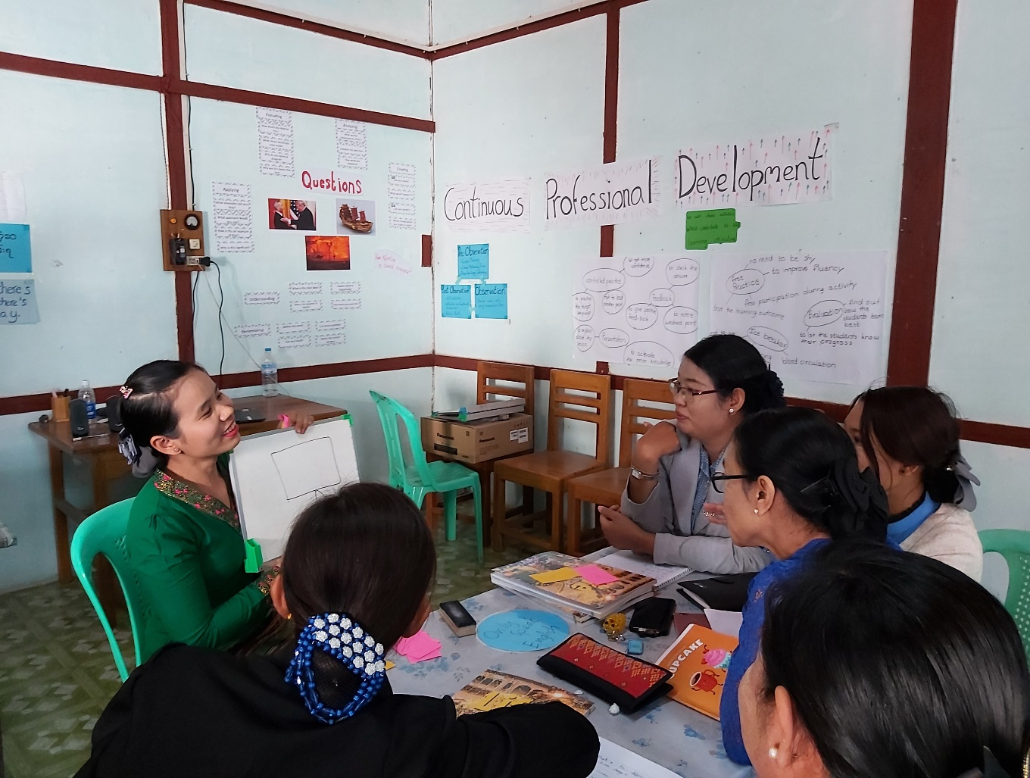
Unit 2: The learner and the classroom environment
Trainer’s Guide

Overview
This module considers what effective learning looks like in the context of educational institutions and organisations in Myanmar and how leadership teams of these institutions and organisations can influence attitudes and approaches to effective learning.
The course will consider questions such as:
- Who are our learners?
- What is effective learning?
- Who is responsible for effective learning?
- What leadership approaches and strategies can leaders employ to enable and ensure effective learning in their contexts?
- What skills do leaders require in order to enable and ensure effective learning and how can these be developed?

This is the second of five units:
- What is Effective Learning?
- The Learner and Classroom Environment
- Leadership for Effective Learning
- Strategies for Leading for Effective Learning
- Skills for Leading for Effective Learning

Contents
Section | Materials | Timing
Outcomes | Participant Book | 5 mins
2.1 Your learning journey | Participant Book | 20 mins
2.2 Ghosts behind the blackboard | Participant Book | 20 mins
2.3 What really makes effective teaching? | Participant Book  YouTube video | 20 mins
2.4 What really makes an effective learner? | Participant Book  YouTube video | 20 mins
2.5 Which classroom activities support learning most effectively? | Participant Book | 15 mins
2.6 Which classroom strategies help to achieve student outcomes most effectively? | Participant Book | 20 mins

Outcomes

By the end of this unit, participants will be able to:
- reflect on their own learning journeys and those of their learners
- identify and discuss features of effective teaching
- identify and discuss features of effective learning
- reflect on the differences between fixed mind sets and growth mind sets and how we can encourage learners to develop growth mind sets
- identify and discuss which classroom activities and strategies best support effective learning.

Learning Outcomes
- Briefly introduce the course overview and answer any questions.
- Explain the outcomes for this unit and check participants understand them.
- Highlight that this unit aims to encourage reflection about learning and leadership, rather than teach facts.

2 The learner and the classroom environment

2.1 Your learning journey

2.1 Discuss
- Ask the participants to read the quote by Tennant and Negash.

- Show the discussion question below. Ask participants to quietly reflect on their ideas and make notes for a minute. Remind them that there is no right or wrong answer.
What does a learning journey mean to you?
- Ask participants to share and compare their ideas with a partner and take feedback from a few pairs.

- Acknowledge any interesting ideas but don’t provide any correction or specific feedback. This question is only to elicit participants’ pre-existing ideas.
2.1 Task: your learning journey
- Step 1: Ask participants’ to look at the diagram in Step 1 and help participants to see how it describes how a career can progress over time (both positively and negatively) and shows key learning points.

- Step 2: Ask participants to draw a diagram of their own to show their personal career.

- Ask participants to work in pairs, compare diagrams and briefly describe their diagrams to other participants.

- Step 3: Ask participants to draw a diagram showing the possible learning journey of a typical Student Teacher, identifying key points at which key learning takes place and possible problems and challenges.

- Ask participants to work in pairs and compare diagrams. Participants identify any similarities and differences between their own personal learning journeys and those of Student Teachers.

- For feedback, if time allows, elicit any key ideas which have emerged during participant discussion. Highlight the fact that everyone involved in teaching or learning undertakes a learning journey, with high and low points and points at which effective learning takes place.

2.2 Ghosts behind the blackboard

Ghosts behind the blackboard is a training activity originally designed by Tessa Woodward (Ways of Training). It aims to enable participants to identify features of effective teaching through reflecting on the behaviours and attitudes of teachers participants have experienced themselves as learners.

Task:
- Ask the participants to read the two quotes from the Sammonds research.

- Ask participants to work in pairs or small groups and discuss these questions:
What qualities did these ‘ghosts’ have?
What does this tell us about teaching and learning?

- Elicit participant responses. Possible responses might include:
- the personality of the teacher might be an important factor in motivation
- learners appreciate activities which they see as enjoyable (but also useful)
- negative comments are unlikely to motivate.

- Ask participants to think individually about:
a) someone who taught them in the past (not necessarily a teacher in a formal capacity) who really motivated them and helped them to learn effectively.
b) someone who taught them in the past (not necessarily a teacher in a formal capacity) who did not motivate them and who did not help them to learn effectively.
Participants may make notes if they wish to.

- Organise participants in pairs. Ask participants to share experiences of a) and b) above.

- Ask participants to list two or three key qualities of effective teaching which were important in the experiences they described for teachers a) and b). Accept any relevant answers – the aim is to produce as many features as possible.

- Based on features identified in the previous step, ask participants to select features which it is possible to observe directly through classroom observation. This concept will be investigated further in the next activity.

2.3 What really makes effective teaching?

2.3 Discuss: what really makes effective teaching?
- Show the discussion question below. Ask participants to quietly reflect on their ideas, working individually, and make notes for a minute. Remind them that there is no right or wrong answer.
What do you think are the features of effective teaching?
Draw participants’ attention to the use of skills/knowledge/attitudes as a way of categorising their ideas.
- Ask participants to work in groups and share and compare their ideas. Participants compile a list of features which they can share with other groups after the session.

- Acknowledge any interesting ideas: the aim of the activity at this stage is to elicit as many features as possible.
2.3 Task: what would students say?
- Step 1: Ask participants to reflect on how students would describe features of effective teaching.

- Elicit ideas. Elicit any similarities and differences with the features participants identified in the ‘2.3 Discuss’ activity above.

- Step 2: Ask participants to watch the video and make notes of the features each learner identifies.
Creative Education: www.youtube.com/watch?v=iHapv0Tv7vM
Suggested Answers:
Olivia: | being a good listener and knowing when to respond
Ryan | getting people involved
Emma: | relating the subject to children’s lives
Claire: | working actively to help you remember
Danielle | being firm but fair
Emma: | ‘knowing where to draw the line’
Beth | being approachable and helping you sort out problems
Emille: | being consistent
Rick: | being able to communicate with the class
Ryan | showing enthusiasm
Harriet | dealing with people as individuals not just dealing with the whole class

- Ask participants to identify any features which may not have been mentioned so far.

- Ask participants to decide which features are similar or different to the features they identified in the ‘2.3 Discuss’ activity above.
Step 3
Appendix 1 presents a summary of features of effective teaching identified in the United Kingdom National College for School Leadership report produced by Peter Matthews.
The full report provides a very useful (if lengthy) discussion of topics relevant to Learning for Life and can be found at
https://dera.ioe.ac.uk/254/1/download%3Fid%3D23637%26filename%3Dhow-do-school-leaders-successfully-lead-learning.pdf
A link to the document is included in Further Reading and References.
Step 3 is most effectively delivered as a post-session task, in which participants read the summary and identify any additional characteristics of effective teaching before they begin Unit 3.

2.4 What really makes an effective learner?

2.4 Discuss: what really makes an effective learner?
- Show the discussion question below. Ask participants to quietly reflect on their ideas, working individually, and make notes for a minute. Remind them that there is no right or wrong answer.
What do you think are the characteristics of an effective learner?
- Ask participants to work in groups and share and compare their ideas. Participants compile a list of features which they can share with other groups after the session.

- Acknowledge any interesting ideas: the aim of the activity at this stage is to elicit as many features as possible.
2.4 Task: the concept of mindsets
Participants have already been introduced briefly to the idea of fixed and growth mindsets in Unit 1. The video examines these issues in more detail.
- Ask participants to read and discuss the two definitions.

- Ask participants to watch the video in which Carol Dwek describes the two mind sets.

- Organise participants in pairs or small groups and ask them to discuss the two questions:
What role does praise play in developing a growth mindset?
Why is having a growth mindset such an important feature of an effective learner?

Suggested Answers:

What role does praise play in developing a growth mindset?
In the video, praise is given to learners who have successfully solved a set of puzzles. Some learners are given praise for their intelligence and some for the effort they have made. Learners who are given praise for the effort they have made are more confident and more motivated and prepared to tackle more difficult problems. This is evidence of a growth mindset. Learners who are praised for their intelligence are less likely to want to continue with more difficult problems.

Why is having a growth mindset such an important feature of an effective learner?
Children and adults are very sensitive to judgements. A growth mindset implies that no matter how well a learner performs, they feel they can perform better and are prepared to try and do so. They feel ‘smart’ when they are working hard on something difficult. They are happy to tackle more difficult problems. Learners with growth mindsets look for opportunities and learn from mistakes.

2.5 Which classroom activities support learning most effectively?

2.5 Discuss: activities which support effective learning?
Organise participants in pairs or small groups and ask them to discuss the following question:
What makes an effective classroom activity?
Accept any relevant responses. The aim of this activity is to establish as many features of an effective activity as possible.
Possible answers could include:

- the activity has a clear aim – it is clear what learners have learnt through doing the activity
- the activity helps learners to think for themselves and does not tell them what they already know
- the activity is at learner level – it is not so difficult that it is hard for learners to understand it and not so easy that it wastes time
- the activity is involving and gives trainees chance to express their own ideas – it includes an element of interaction
- the activity addresses different learning styles and levels and will appeal to different types of learner
- the activity is motivating and interesting – and if possible, fun
- the activity is adaptable: you can use it with different groups of learners and sometimes to achieve different aims.

2.5 Task: what the research shows
Ask participants to look at the two diagrams 1 and 2 and draw conclusions.
Suggested answers:
1 Concentration rate during a lecture
The diagram shows clear evidence for the ineffectiveness of lectures (with concentration quickly tapering off after an initial presentation) and consequently the need for learner involvement and practice.
2 Student retention rates for different activities
Similarly this diagram shows how little learners retain from a lecture (and from reading during class time) and how only activities which involve learners can achieve a retention rate of 50 per cent and above. Activities in which Student Teachers discuss, practice and especially peer teach are essential for their learning.

2.6 Which classroom strategies help to achieve student outcomes most effectively?

2.6 Discuss: how strategies have impact on student outcomes
Introduce this stage by explaining to participants that to help understand what they can do as leaders to ensure effective learning at their institution, they should consider factors that might impact on effective learning.
Organise participants in pairs or small groups and ask them to discuss the following question:
- Which classroom strategies have significant impact on student outcomes?
Accept any relevant responses. The aim of this activity is to establish as many features of an effective activity as possible.
2.6 Task: factors impacting learners
- Introduce Hattie’s research (see Participants’ Book)

- Display the list of factors from Hattie’s research which might impact learning. Give participants a minute to read them.

- Explain to participants they need to work in small groups to organize the factors into three categories: significant impact on learning (five factors); moderate impact (three factors) on learning; little or no impact on learning (two factors).

- Assign a member of each group to note down key points from their discussion to report back to the group.

- Give participants ten minutes to discuss and decide together where each factor should go. Monitor and make sure participants are giving reasons for their decisions.

- Feedback
  - either display each group’s tables and encourage them to compare their ideas, eliciting and summarising and pointing out any major agreements or disagreements.
  - or ask each group to summarise which two or three factors have the biggest impact and give reasons why.

- Wrap up
- Ask participants if there is anything not included in the list that they think has an important impact on effective learning? Elicit answers.
  - Ask participants to compare their answers with Hattie’s list (2012). Are their lists similar or different?
  - Ask participants as leaders, how much influence they have over the ten factors listed above?
Further reading and references

Dweck, C. (2012) Mindset - Updated Edition: Changing The Way You Think To Fulfil Your Potential, London: Constable

Hattie, J. 252 Influences and effect sizes related to student achievement
Available online at: https://visible-learning.org/hattie-ranking-influences-effect-sizes-learning-achievement/

Matthews, P. (2010) How Do School Leaders Successfully Lead Learning? National College for School Leadership
Available online at: https://dera.ioe.ac.uk/254/1/download%3Fid=23637&filename=how-do-school-leaders-successfully-lead-learning.pdf

Sammons, P., Kington, A., Lindorff-Vijayendran, A. and Ortega, L. (2014) Inspiring Teachers: Perspectives and Practices. Reading: CfBT Education Trust.
Available online at:
https://www.researchgate.net/publication/273316486_Inspiring_teachers_perspectives_and_practices_Full_report/link/54fdb58c0cf270426d12ca50/download

