OnSSET/Global Electrification Platform
Hands-on 5: Data extraction to CSV
In order to facilitate the extraction of GIS data to CSV format, the team at KTH-dES has developed a QGIS plug-in. This document is divided into two parts. The first explains how to install the plug-in and make it available for use in QGIS, and the second part explains how to extract the data using the plug-in.
NOTE1: This Plug-in works only with QGIS 3.10. If you use any other version there will be issues for the plug-in to work properly.
- Follow the instruction “QGIS 3.10 Installation Instructions” to install QGIS 3.10 to your computer if do not have this version of QGIS.
- Download the remaining datasets for Benin here.
- Note: In order to run this version of the plug-in you have to make sure that your population data are available in polygon form.

Learning outcomes
By the end of this exercise, you will be able to:
1) Use the plug-in to extract the data to a csv file.
2) List the datasets that are used in the plug-in.
3) Create the CSV file required for Hands-on 6.

1. Installing the plug-in
- Go to the OnSSET github page to download the extraction plugin
- Click in the gep_onsset.zip file
- Click on the Download button on the right side of the screen
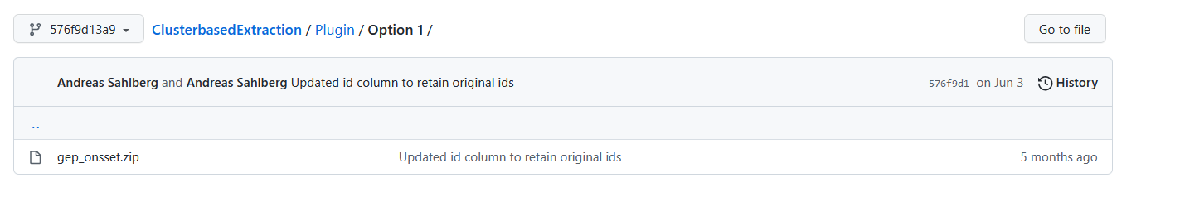
Figure 1. GitHub page (Picture source: Screenshot from https://github.com/OnSSET/ClusterbasedExtraction/tree/576f9d13a9207c8c4ad1bb321c162c80c16fbc24/Plugin/Option%201 licensed under MIT license)

- Open QGIS Desktop (make sure that you use version 3.10).
- On top of the window you have a number of menus; click on the one that reads Plugins.

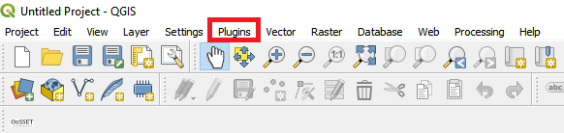
Figure 2. Plug-in menu

- Next, go to Manage and Install Plugins…

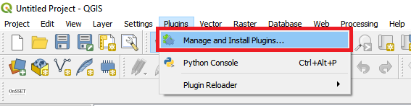
Figure 3. Management menu for plug-ins

- This opens a new window with a number of different options on the left-hand side. Choose Install from ZIP
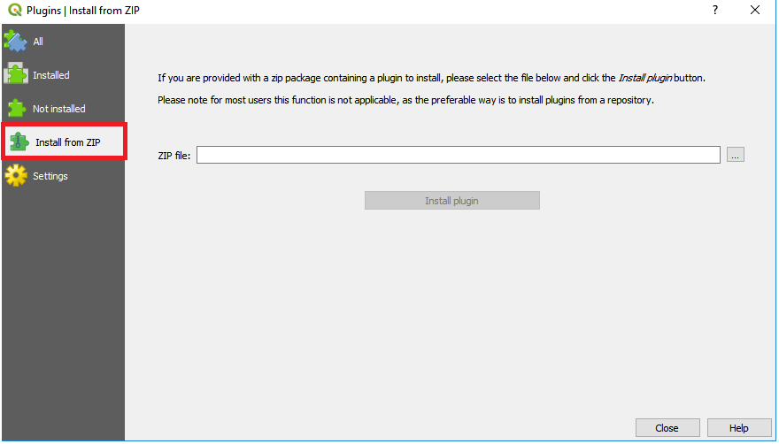
Figure 4. Installing plug-ins using ZIP-files

- In the window that opens, click on the three dots next to the empty field; then navigate to wherever you saved the gep_onsset.zip file and select it.

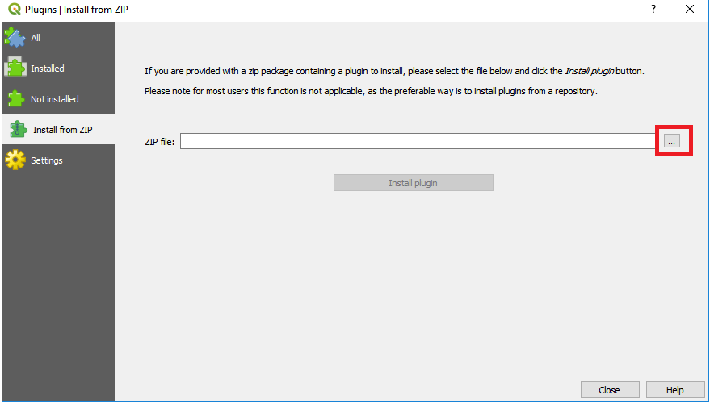
Figure 5. Click on this button to browse to the zipped file

- When you have found it, click on Install plugin.
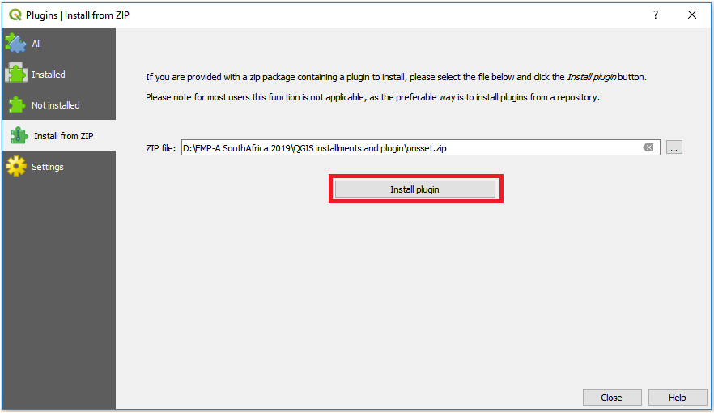
Figure 6. When you have found the zipped folder click on this button to install it

- After the plug-in has been installed it will appear under the Database menu on top of the screen. You are now ready to run the plug-in.

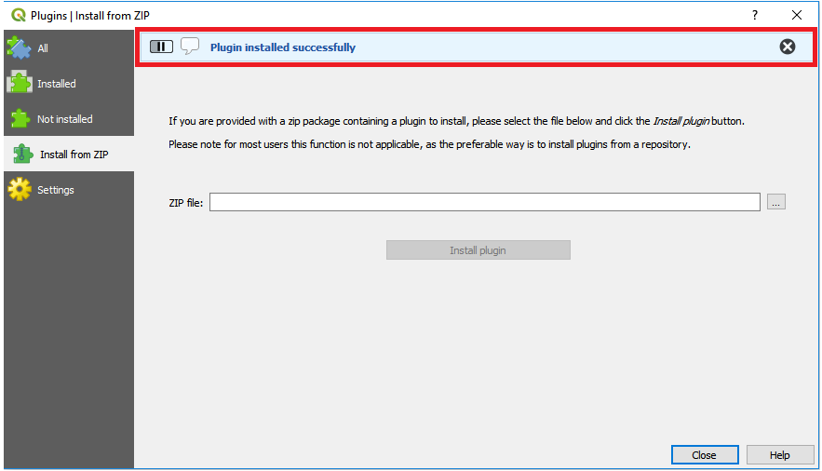
Figure 7. This field will appear when the install is completed

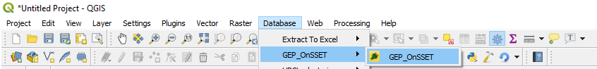
Figure 8. When the plug-in is installed, it will appear under the database menu with the name "GEP_OnSSET"

2. Running the plug-in
Before opening the plug-in, make sure that all the datasets that are required to run it are loaded into your QGIS window. Make sure that all the datasets have the correct type as specified in the table below.
Note2: All datasets in this import have to be in the coordinate system WGS 84 - WGS84 - EPSG:4326.

Table 1. The datasets required for the analysis (source: table licensed under CC-BY 4.0)
Dataset | Type
Administrative boundaries | Polygon
Population (clusters) | Polygon
GHI | Raster
Wind speed | Raster
Travel hours | Raster
Custom demand layer  (Customized layer with estimation of average per capita demand for each cluster in 2030) | Raster
Elevation | Raster
Land cover | Raster
Existing HV lines | Lines
Planned HV lines | Lines
Existing MV lines | Lines
Planned MV lines | Lines
Substations | Points
Transformers | Points
Roads | Lines
Hydropower | Points

NOTE3: The name of the datasets do not have to match with the table, but they must be of the correct type.
NOTE4: When you have made sure that you have all the required datasets loaded into QGIS, create an empty folder and name it after your study area. This folder will serve as your workspace. The folder needs to be emptied before every new run otherwise the code will crash.
NOTE5: The HV and MV lines have the same file name for Benin. To identify the different types, rename the layers in QGIS after import.

- Open the plug-in from the Database menu. The name of the plug-in when installed will be GEP OnSSET.
- The following window will open up:
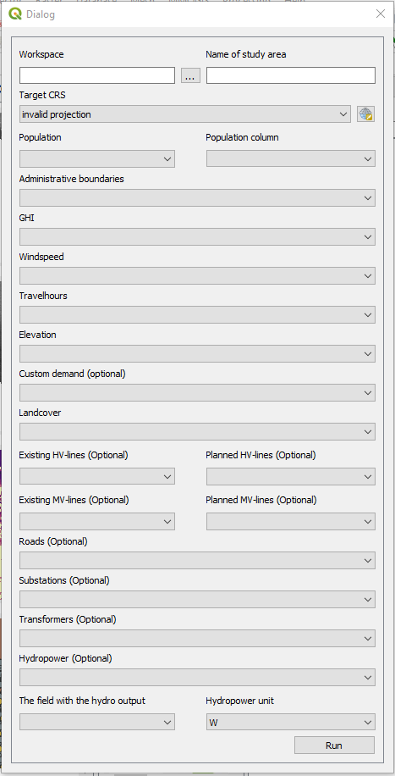
Figure 9. The plug-in in use (source: image licensed under CC-BY 4.0)
Below information will be provided regarding the use of each box.
Box 1. This box lets you choose the workspace. Click on the three dots and navigate to the empty folder that you have created previously. When you have found it click ok and continue.
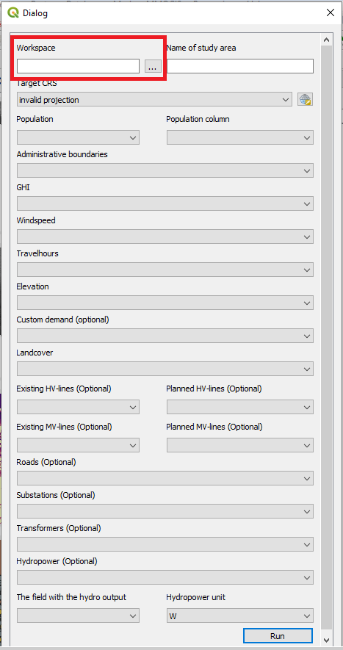
Figure 10. Box 1: enter the workspace by clicking on the button with three dots and navigate to the empty folder you are using as workspace (source: image licensed under CC-BY 4.0)

Box 2. Enter the name of your study area. This is the name given to your csv output file.
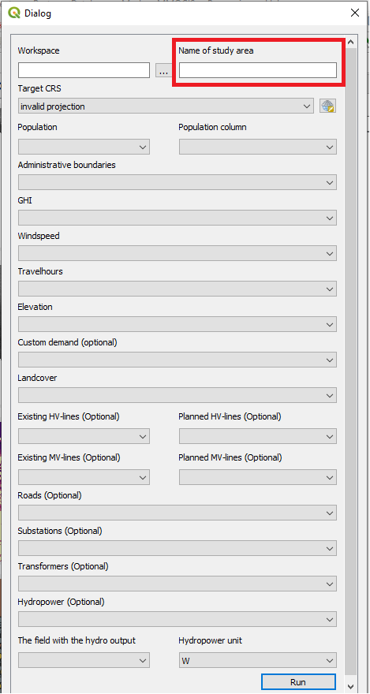
Figure 11. Box:2 Enter the name of the study area (source: image licensed under CC-BY 4.0)

Box 3. This box lets you choose an appropriate coordinate system.
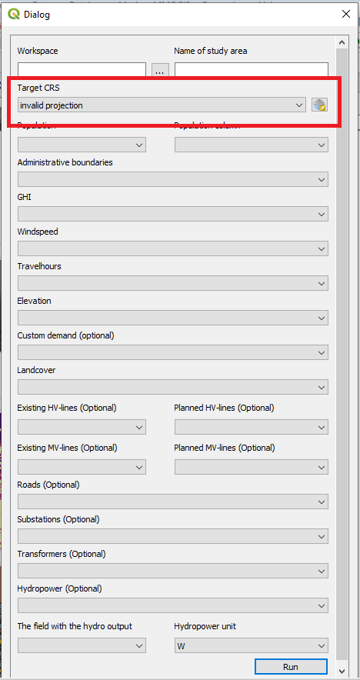
Figure 12. Box 3. Enter the coordinate system that you wish to reproject your data to (source: image licensed under CC-BY 4.0)
To find the coordinate system that is appropriate for your country please visit http://epsg.io/ and search for your country.
For Benin we use: WGS 84 / UTM zone 31N, EPSG:32631
Next, come back to QGIS. Click on the icon next to the field and check the EPSG code, for Benin 32631.
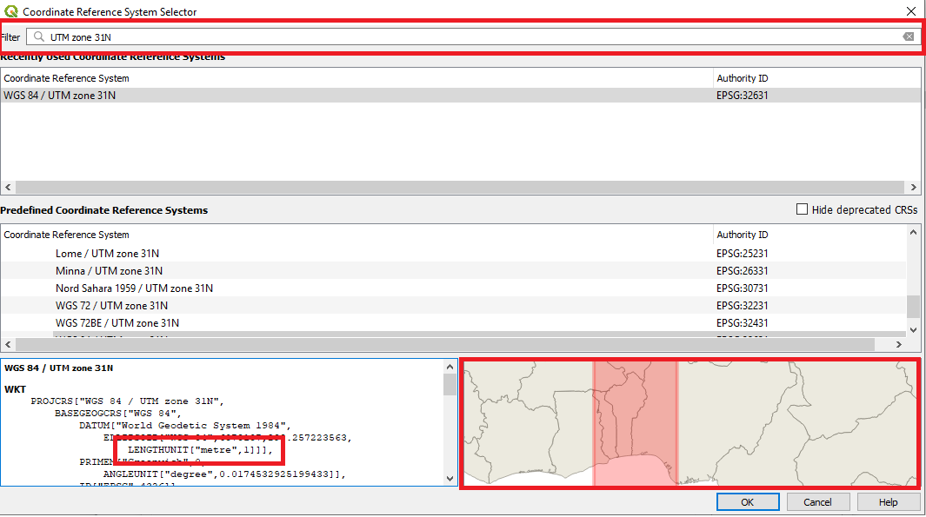
NOTE: The unit is in metres and the red box on the map in the lower right corner covers Benin.

Figure 13. Enter the coordinate system you have chosen in the field. Make sure that the unit is metres (lower left box) and that the red area covers your study area (lower right box)

Box 4 and 5. In box 4 select the population dataset. You will have to choose the column that represents the population in the attribute table in box 5.
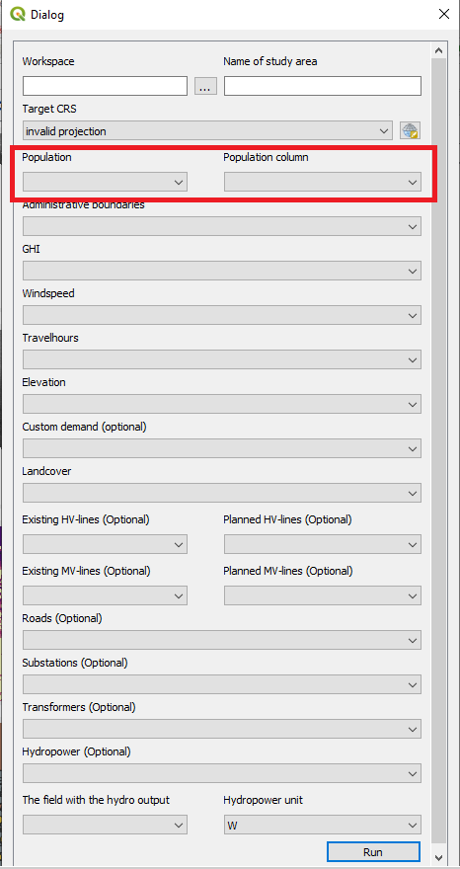
Figure 14. Box 4: enter the population clusters and in Box 5 select the column representing the population (source: image licensed under CC-BY 4.0)

Box 6 – Box 19. Select the matching datasets for the boxes
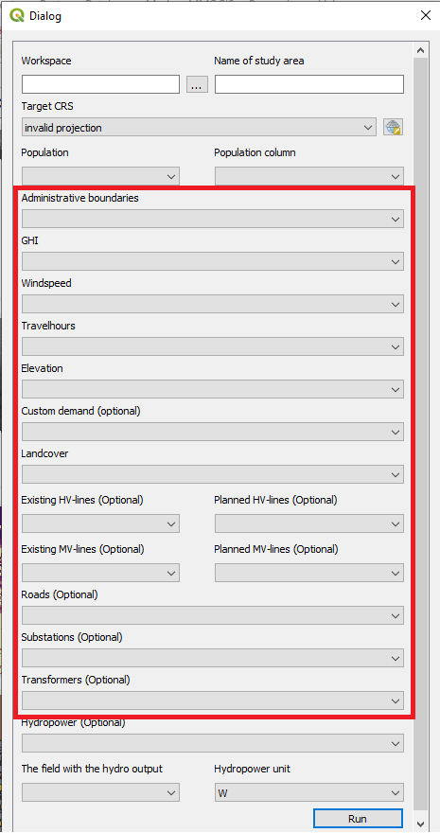
Figure 15. Fill in the correct datasets for each one of these boxes. (source: image licensed under CC-BY 4.0)
Box 20. Click on the box and select the hydropower layer; make sure that it is a point vector.
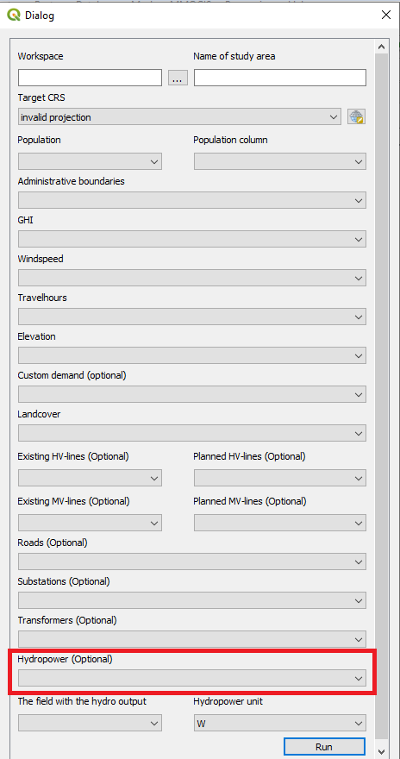
Figure 16. Hydropower points to be entered in this box (source: image licensed under CC-BY 4.0)
Box 21. Select the box that includes the hydropower output (in this box you will select a column in the attribute table). The hydropower output is the potential electricity that can be outputted from each plant. In this case it is PowerMW.
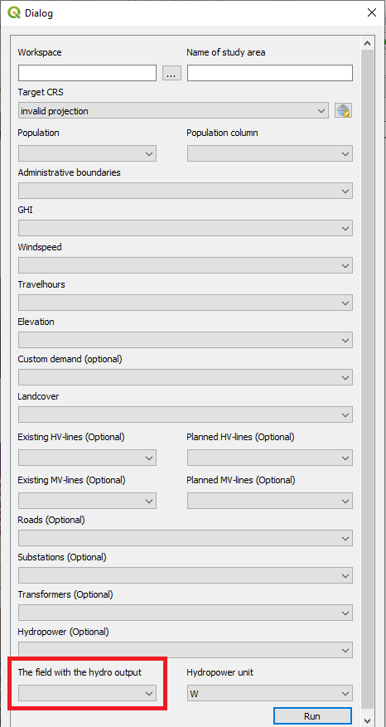
Figure 17. The field in the attribute table that includes the hydropower potential (source: image licensed under CC-BY 4.0)

Box 22. Select the unit of that the hydropower output is given in. You can choose between W, kW, and MW. If you chose PowerMW in the previous step the unit should be MW.
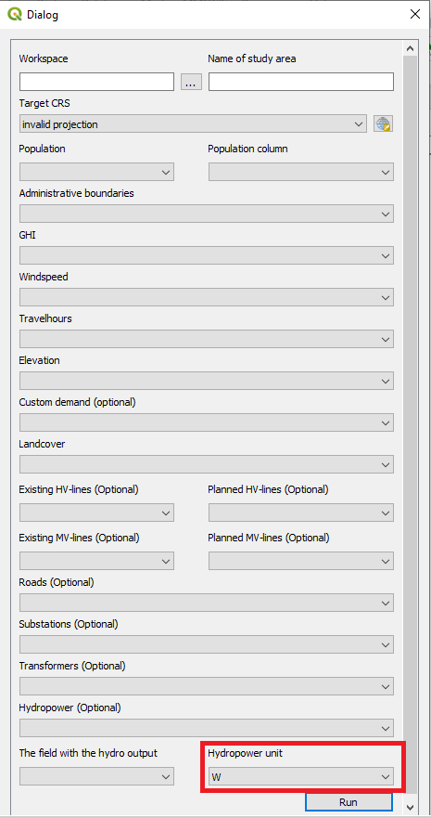
Figure 18. The unit of the values in Box 18 (source: image licensed under CC-BY 4.0)
- When all boxes have the correct data, click “Run”. This will run the plug-in. Depending on the size of the country this can take between 15 minutes and a few of hours.
NOTE6: While the plug-in is running you will not be able to use QGIS. If you try to use QGIS you will get a loading icon. As the plug-in is working different messages will be printed in the QGIS python console that opens automatically when you start the plug-in. When the plug-in is finished a message will be displayed stating so.
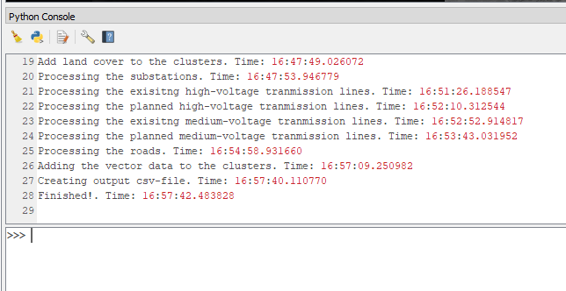
Figure 19. Printed text during the run with timestamps
- When the plug-in has finished a CSV file with the same name as you specified in box 2 will appear in your workspace-folder

Finally, create a copy of the CSV file, we will use it in the next hands-on exercise.

This exercise is an exercise developed by Khavari, B., 2019. Exercise 5: Data extraction to CSV [WWW Document]. OnSSET Teaching Kit. URL https://onsset.github.io/teaching_kit/courses/module_2/Excercise%205/ (accessed 2.18.21). All images are screenshots from QGIS 3.10, which is licensed under Attribution-ShareAlike 3.0 Unported (CC BY-SA 3.0) unless stated otherwise.

