Contents

Study Session 1 Water Supply in Myanmar 3
Learning Outcomes for Study Session 1 3
1.1 The basic need for water 3
1.2 The different uses of water 4
1.2.1 Water for domestic use 5
1.2.2 Water for agricultural use 5
1.2.3 Water for industrial use 6
1.3 Water sources in Myanmar 8
1.4 The challenges for water supply in Myanmar 10
1.4.1 Seasonal variation 11
1.4.2 Regional variation 12
Summary of Study Session 1 15
Answers to in-text questions 16
References 17

Study Session 1
Water Supply in Myanmar
One of the most important elements that we need to look at to ensure good health and well-being is where our water is coming from. All living things need water for their survival. Water is one of the essential requirements for life. It is used for a variety of purposes by people, including drinking, food preparation, irrigation and manufacturing. Although water covers more than 70% of the Earth’s surface, less than 1% of it is available as fresh water – and this is not evenly distributed throughout the world. More than one billion people (one thousand million) worldwide, mostly in less developed countries, lack safe drinking water. Apart from the scarcity of water, there are many other challenges in providing a safe, adequate and reliable water supply in many parts of the world.
In this study session, you will learn about the different uses of water, how water gets to the inhabitants of cities, towns and villages in Myanmar and the challenges faced in delivering water to people.
Learning Outcomes for Study Session 1
When you have studied this session, you should be able to:
- list the various ways in which water is used
- describe how water gets to consumers in cities, towns and villages in Myanmar
- understand the seasonal and regional variability of water supply in Myanmar
- identify the challenges involved in providing safe and adequate water for people in Myanmar.

1.1 The basic need for water
Water is essential for the proper functioning of the body. Human beings can live for many days without food, but only three or four days without water. Each person needs to consume about 2–4.5 litres of water per day (depending on the climate and level of activity) for their body to function properly. According to national and international guidelines, the quantity of water available to all people should be 50–100 litres per person per day, or an absolute minimum of 20 litres per person per day (UNDP, 2006).
The water must be safe for drinking and other household uses. Drinking water must be free from pathogenic (disease-causing) micro-organisms (tiny living organisms that you can see only with a microscope), and free from chemical and physical contaminants that constitute a danger to a person’s health. It must also be free from colour and odour. Water must be within safe physical reach, in or near the house, school or health facility. According to the World Health Organization (WHO), the water source has to be within one kilometre of the home and collection time should not exceed 30 minutes (UNDESA, 2014).
As well as being physically accessible, water should be reasonably priced and affordable for everyone. This means that the cost of water must be kept low and essential amounts of water must sometimes be provided free. The requirements for drinking water are summarised in Figure 1.1.
Figure 1.1 Requirements for drinking water

Water in rural areas in Myanmar is largely provided free through village ponds, communal rainwater collection tanks, wells and springs which are managed by water management committees. The treatment of this water happens in the home by filtering through cloth and boiling. In the cities and towns there is some piped water into people’s homes, but most rely on deep tube wells and/or bottled water, all of which are paid for.

1.2 The different uses of water
Water is used in many ways in Myanmar: for domestic purposes; in industry; and in farming (for agriculture and animal-rearing) as shown in Figure 1.2. But the quality and quantity of water for each use is different. Water for domestic purposes needs to be of high quality but is used in relatively small amounts, whereas usage in industry or agriculture can be of a lower quality but the demand is much higher in terms of quantity.
Figure 1.2 Main water uses in Myanmar
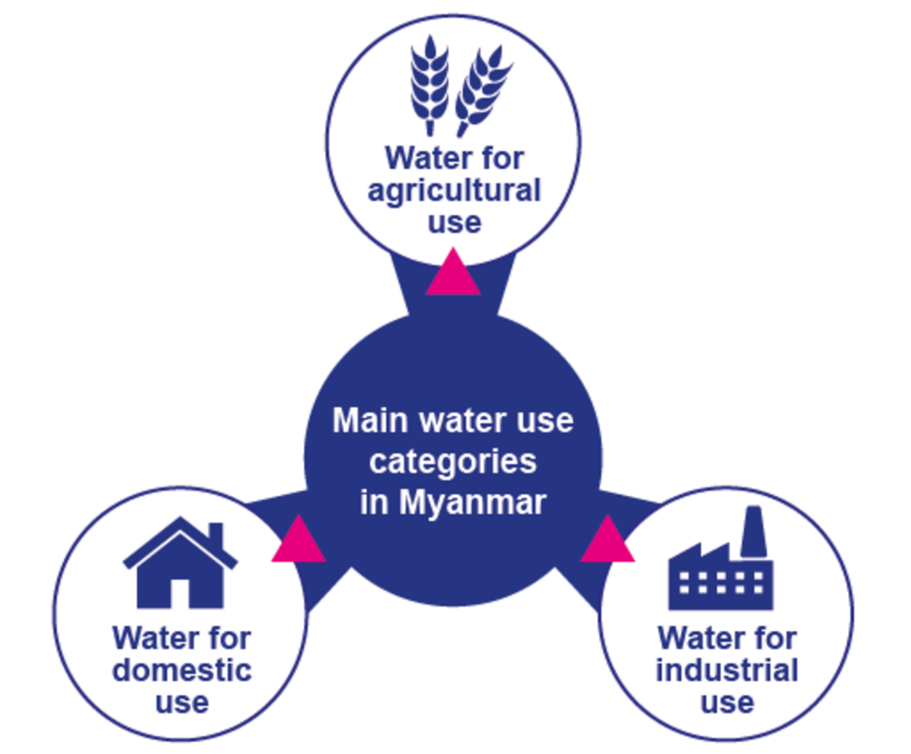

1.2.1 Water for domestic use
In-text question 1.1
Can you think of five uses for water in your daily life?

The quality of water required for domestic use needs to be high to safeguard health. Piped water supplies in towns and cities that come from drinking water treatment plants should be safe to drink but poor maintenance means this is not always the case.
The 2014 census reveals that about 70% of households in Myanmar have access to sources of drinking water that are protected from contamination, particularly by faecal matter, compared to 90% across Southeast Asia (Government of Myanmar, 2017). This is nine in 10 households in urban areas, and six in 10 households in rural areas.
Domestic use is growing because more people are moving to the towns and cities, a process called urbanisation. Currently, fewer than 30% of the population – or nearly 15 million people – live in urban areas. People living in towns and cities are more likely to have a piped water supply into their homes. This makes them wash and bathe more frequently. Some may even have water-using appliances like washing machines.

1.2.2 Water for agricultural use
Myanmar is largely an agricultural economy with both society and agriculture relying heavily on rainwater. Too much rainfall causes floods and too little causes droughts, both of which have a negative impact on agricultural production.
The Government of Myanmar has focused on rural development to grow the country’s economy. This is because over two-thirds of the population live in rural areas and most are engaged in subsistence farming.
Rice, which is a water-intensive crop, is the main crop and staple food. More than half of the Ayeyarwady Delta region, where agriculture is concentrated, is cultivated with rain-fed rice. In the dry season, rice is mostly cultivated in Lower Myanmar using irrigation.
Irrigation is supplied through water diversion with canals, weirs, dams and tanks, and in recent years with substantial development of an infrastructure of water pumps and tube wells (Figure 1.3).

Figure 1.3 Irrigation of agriculture through diversion of water from canals

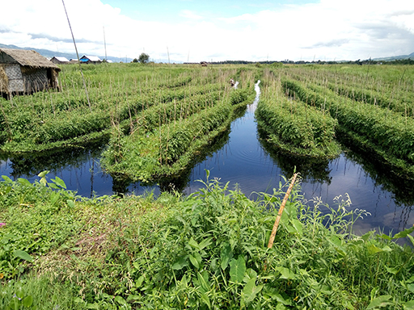

Water is also used for supporting livestock such as cows, goats and pigs and for aquaculture. Aquaculture is basically farming (aquatic organisms) in water, rather than on land. Water is used to hatch fish eggs under controlled conditions, and the fish are grown to maturity in tanks or ponds, before being sold for food. Aquaculture is widespread in the coastal regions and the Ayeyarwady Delta, particularly shrimp farming, and is growing. In 2017, aquaculture supplied a fifth of all fish eaten in Myanmar (Van Beijinen, 2018).

1.2.3 Water for industrial use
In many industries water is essential. Some industries use piped water supplied from water treatment plants while others draw the water from underground sources and treat it on site for use.
The water may be used either as part of the production process, for cooling, washing, diluting, boiling or cooking, transportation of raw materials (for example, moving potatoes in a food factory), and as a cleaning agent. It can also be used directly as an ingredient for the product, for example in a soft-drink plant. Hydropower and mining are the two most important industries using water in Myanmar with other industry use still quite small.

Hydropower is energy that can be harnessed from a continuous flow of water, such as a river. It is a renewable source of energy because the water cycle is constantly renewed by the sun. Modern hydropower plants produce electricity using turbines which spin with the moving water. The turbines are connected to a generator where the mechanical energy is converted into electricity.
However, it is important to realise that in hydropower the water is not ‘used’ in the sense of being consumed, because after passing through the hydropower plant the water continues on its path in a river channel. Myanmar has been accelerating its hydropower development as it offers a renewable source to meet the country’s growing domestic electricity needs.
The other major user of water in industry is for mining. Mining activities use huge amounts of water in processing ore to extract minerals.
Myanmar is richly endowed with mineral resources including copper, gold, lead, zinc, silver, tin and nickel. It also has extensive gemstone deposits, and oil and natural gas fields (see Figure 1. 4).
Figure 1.4 Sluice Mining for rubies and sapphires in Mogok, Mandalay Region, which needs large volumes of water
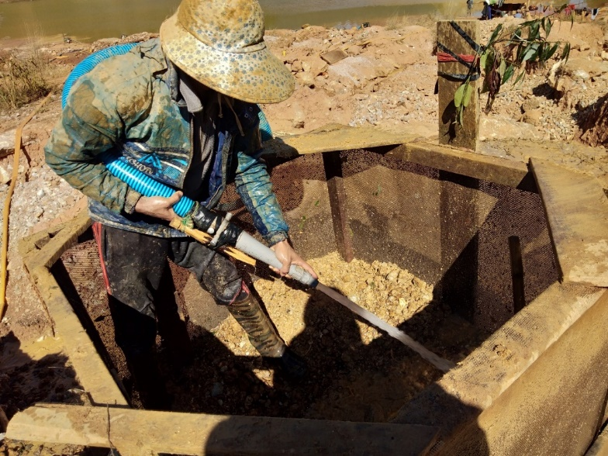

1.3 Water sources in Myanmar
All water comes from three basic sources: groundwater; surface water; and rainwater.
Groundwater includes all water that is found underground within the rocks. Surface water means water in rivers, lakes, pools and ponds. Rainwater replenishes both groundwater and surface water and can also be collected directly.
The water supply originates from one of the following basic sources:
- A spring (a point where groundwater emerges at the surface of the ground), from where the water can be carried or piped to consumers. A spring may flow throughout the year or only at certain times.
- A well or borehole. These may supply individual residences or a large number of houses where the water is delivered through a network of pipes. In addition to this, institutions such as schools, health facilities, religious establishments, small commercial enterprises and industries may have their own water supply system from hand-dug or deep wells.
- Surface water from rivers and lakes, which may be abstracted directly or stored in a reservoir created by building a dam across a river. Abstraction means taking water from the source so that it can be used.
Springs and wells are considered improved sources of water if they are constructed and used in such a way that they adequately protect the water from contamination, especially by faecal matter.
Spring or well water is generally used with minimal or no treatment. Surface water is an unimproved source and will require some form of treatment before it is safe to use for drinking. In larger towns and cities, surface water is treated in a water treatment plant before being distributed to consumers.
The term raw water is used to describe the water before it is treated.

In-text question 1.2
Demand for water fluctuates throughout the day. Why do you think this is?

Continuity of supply is important so that people can be confident that water will be available when they need it. Where the supply of water is not continuous, many households have storage tanks to accumulate water for use when the supply is off.
It is important to check the cleanliness of the storage tank regularly, and to clean and disinfect it as necessary.

In-text question 1.3
In many towns and cities in Myanmar, if you turn on a water tap at any random time it is quite likely that you will not get any water. Why do you think this happens?

1.4 The challenges for water supply in Myanmar
Myanmar is a country in a favourable situation with respect to water resources. It has eight major river basins (the area of land that is drained by a river and its tributaries) which cover large areas of the country and provide natural resources for many livelihood sectors (Figure 1.5).
But despite these abundant water resources, there are marked seasonal and regional variations in water supply.
Figure 1.5 The major river basins in Myanmar
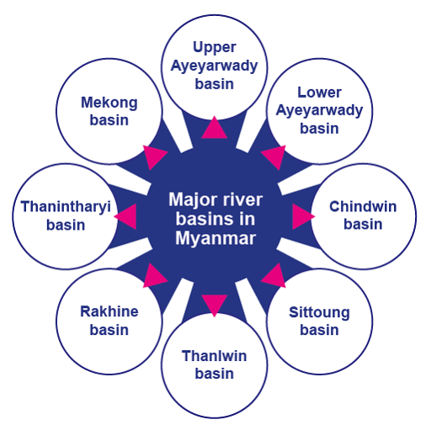

1.4.1 Seasonal variation
Water supply varies according to the season (Figure 1.6). At times of poor supply, users may be forced to obtain water from alternative sources. These are often of inferior quality and far away. As a consequence, the health of people will be put at risk by poor quality and low quantity of water. In addition, considerable time and effort are spent on collecting water.
Myanmar has three seasons. The cool winter season is followed by a hot summer season, which is followed by the rainy season dominated by the southwest monsoon. Temperatures are increasing while the length of the monsoon is decreasing. A shorter monsoon means more intense rainfall, leading to flooding, contamination of water resources and more limited replenishment of waterways.
Figure 1.6 Myanmar’s climate is subtropical and tropical.
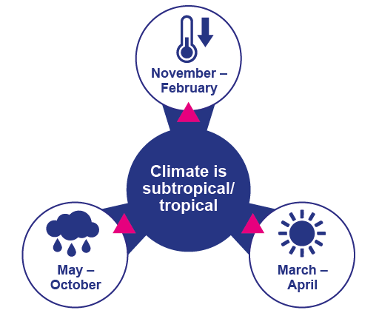

1.4.2 Regional variation
Just as there is seasonal variation in the availability of water, so it is also not distributed evenly across the country. The Central Dry Zone, whose agricultural productivity is crucial for the country, experiences water scarcity (Figure 1.7). Climate change is having severe impacts on agricultural production with changes in rainfall patterns and rising temperatures increasing the likelihood of crop failures in the short run and production declines in the long run.
Watch this eight-minute video called ‘The Last drop’ on the water challenges faced by villagers in central Myanmar where climate change means longer and more intense dry seasons and worsening local livelihoods. Then answer the question. You will need to scroll down to near the bottom of the page to find the video.
https://www.sei.org/featured/rural-myanmar-frequent-intense-droughts-affecting-local-livelihoods/

In-text question 1.4
What changes in water availability have the villagers noticed?
What are the economic impacts of weather uncertainty and water scarcity?

In the hilly zone in the north of the country unsustainable agriculture practices of slash-and-burn and deforestation are eroding slopes, increasing flooding, building up sediment and contaminating water supply (Government of Myanmar, 2014).

Figure 1.7 The three agricultural zones of Myanmar (Government of Myanmar, 2012)

The challenge in any situation is to maintain a year-round supply of water that is adequate to meet people’s needs. Planning for present and future demand should consider population growth and location. The demand for water is increasing in cities and towns as a result of a growing population and the migration of people from rural areas to towns in search of jobs and a better life. The quantity of water required for domestic use depends not only on the number of people but also on their habits and culture, and on how accessible the water is. There are also increasing demands from industrial development.
As water supply systems improve and access increases, the consumption of water will increase also. It is therefore important for water supply planners to consider the expected changes in society and in living standards. Planning of water supply projects should also consider the water requirements of schools, hospitals and other health facilities, religious institutions, hotels and other community facilities.
The Myanmar government has begun this process through the launch of a National Strategy for Rural Water Supply, Water and Sanitation, WASH in Schools and WASH in Health Facilities, 2016-2030 (2016). The strategy sets out to meet the needs of the rural population for improved domestic water supply, improved sanitation and improved hygiene practice. However, it does not cover urban water supply and sanitation.
There are many challenges that need to be overcome for the strategy to be successful. Shortage of funding means that maintenance of existing water supply and sanitation facilities is poor, which means they regularly break down. Coordination of services is fragmented between different levels of government: Union; State/Region; District; and Township.
The roles and responsibilities within government departments for parts of the water sector is unclear with duplication and gaps. Data-gathering on all aspects of WASH is poor. For example, the gender aspects of WASH have received little consideration up to now even though women and girls have the main responsibility for domestic water and for household sanitation as was shown in the video.
At the beginning of this study session, you read that water supply must be accessible and affordable. It is important that affordability extends to all sectors of society, including vulnerable people. Vulnerable groups include low-income households, older people and disabled people. Equitable access to water supply for all these groups should be taken into consideration.
The following changes will all contribute to future success:
- an increase in funds for the expansion of water supply services to satisfy the demand of growing populations, particularly in towns and cities
- an increase in human resource capacity and expertise at different levels to ensure better maintenance of existing water infrastructure
- better coordination between the different levels of government, and within government departments
- the collection of data to improve and monitor services and accessibility
- better information management systems, giving early warning of requirements.

Summary of Study Session 1
In Study Session 1, you have learned that:
- Water is essential for life. Drinking water must be safe, of adequate quantity, accessible and affordable.
- Water has several uses of which the most important are domestic, agricultural and industrial. The quality of water acceptable for the various uses can be different.
- Water supply may originate from springs, wells or surface water. Water from springs and wells is generally used without any treatment, while surface water needs treatment before it is safe to drink.
- Water supply planning must take account of present and future water demand by people, and by industrial and agricultural development. Domestic use is likely to increase as living standards improve. Planning also needs to consider the needs of schools, health facilities and other institutions.
- There are many challenges facing water supply in Myanmar and several factors that can contribute to overcoming them, including more funding, increasing capacity, better coordination between the different levels of government and across government departments and better data collection and information management.

Answers to in-text questions
1.1 We use water in our homes, both indoors and outdoors. Uses include for drinking, food preparation, washing hands, bathing/showering, brushing teeth, toilet-flushing (if there is a flush toilet), cleaning, washing clothes and dishes, and watering plants.
1.2 People generally use more water in the mornings and evenings when they are washing and cooking. Usage during the night while people are asleep will be much lower.
1.3 It may be because demand for water exceeds the supply available at that time. It can also happen due to a power failure or poor maintenance.
1.4 A nearby pond where water was collected has dried up, which means the villagers need to travel much further to another pond to get water. Before the government’s involvement, they had been unsuccessful in sinking wells that produced water. They also need to buy water.
Farmers’ crop yields are low because of the variable rainfall and resulting droughts which means they earn less from their labour.

References
Government of Myanmar (2012) Myanmar’s National Adaptation Programme of Action (NAPA) to Climate Change [Online]. Available at:
https://unfccc.int/ resource/ docs/ napa/ mmr01.pdf (Accessed 16 April 2020).

Government of Myanmar (2014) Myanmar IWRM Strategic Study [Online]. Available at:
https://english.rvo.nl/ sites/ default/ files/ 2015/ 02/ Myanmar%20Integrated%20Water%20Resources%20Management%20from%20vision%20to%20action_1.pdf
(Accessed 15 April 2020).

Government of Myanmar (2016) National Strategy for Rural Water Supply, Water and Sanitation (WASH), WASH in Schools and WASH in Health Facilities [Online]. Available at: https://www.myanmarwaterportal.com/repository/623-national-strategy.html.
(Accessed 2 November 2020).

Government of Myanmar (2017) The 2014 Myanmar Population and Housing Census. The Republic of Myanmar. Department Population, Ministry of Labour, Immigration and Population with Technical assistance from UNFPA, pp 2–12.

United Nations Department of Economic and Social Affairs (UNDESA) (2014), International decade for action Water for life’ 2005–2015’ [Online]. Available at:
http://www.un.org/ waterforlifedecade/ human_right_to_water.shtml
(Accessed 20 February 2015).

United Nations Development Programme (UNDP) (2006) Human Development Report 2006: Beyond Scarcity: Power, Poverty and the Global Water Crisis, Basingstoke and New York, Palgrave Macmillan [Online]. Available at:
http://hdr.undp.org/ en/ content/ human-development-report-2006
(Accessed 3 June 2015).

Van Beijinen, J. (2018) The future of fish farming in Myanmar [Online]. Available at:
https://thefishsite.com/ articles/ the-future-of-fish-farming-in-myanmar
(Accessed 12 April 2020).

