Contents

Topic 2: Travel and tour operations 1
2.1 Travel agents and tour operators 3
2.2 Functions and operations of a travel agency and tour operator 6
2.3 Tour packaging 10
2.4 Ticketing 13
2.5 Transportation services 16
2.6 Digital tourism 19
Answers to activities 22
References 24

Topic 2:
Travel and tour operations 1
This topic looks at what travel agents and tour operators do, their scope and range. It looks at the elements that make up an all-inclusive tour package and how they are costed, before looking at ticketing for air, rail and sea transportation. These transportation services are explored and finally, the concept of digital tourism is examined.

2.1 Travel agents and tour operators
A travel agent facilitates people travelling to distant places. Planning a trip can be time-consuming and complicated. Travel agents simplify this process for their customers. They can book flights, accommodation and rental cars, as well as entry to attractions and events.
Travel agents serve both individuals and corporations. Some concentrate on a special segment of the industry, for example, a cruise specialist or ski specialist. Others are location-specific, such as for Europe, Africa or Latin America. Travel agents are travel intermediaries between the customer, the tour operator and tourist service providers.
The development of organised travel has its roots in the mid-nineteenth century, with a man called Thomas Cook (Figure 2.1.1) who you were first introduced to in Session 1.1. Thomas Cook helped his community members travel safely to a temperance (teetotal) meeting by railway between the cities of Leicester, Nottingham, Derby and Birmingham in 1841. Cook is considered the first organised travel agent in the world and is credited with being the inventor of the value-for-money travel and tour package. Cook quickly expanded his tour packages, taking 150,000 people from across Britain to visit the Great Exhibition in London in 1851 and offering the first continental tour in 1855.
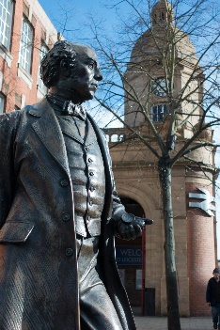
Figure 2.1.1 Statue of Thomas Cook in Leicester, UK

Cook introduced hotel coupons, circular notes (an early form of travellers’ cheques) and advance reservation as part of his travel innovations. This led to the all-inclusive package tour for leisure tourists, showing the way for other travel agents. Gradually, the business has grown in scale with many multinational travel agency chains operating today.
The main responsibility of a travel agent is to make the process of travel planning easier for their clients and ensure they have the best trip possible. Travel agents need to understand what the customer is looking for in their trip, as well as their budget, preferences and expectations. This is normally done through a conversation in person, on the telephone or online. The information provided enables the agent to determine the best possible travel destinations, transportation arrangements and accommodations for the client. Travel agents can also make suggestions to the client based on their own experience or offer complete travel packages from various tour operators. Agents work with computers or call airlines, cruise lines, tour operators, resorts and rental companies to secure travel reservations for their customers.
Travel agents also relay important information such as travel advisories, health requirements (vaccinations needed) and required documents (such as visas) for their destination. Travel agents keep up to date with the latest news, ensuring that each planned destination is safe for their customers to visit. They provide cultural guidance on what is acceptable and unacceptable behaviour at the destinations. Travel agents work all year round, but there are particularly busy periods when customers plan their vacations for the summer.

What is a tour operator?
A tour operator is an organisation or company that buys individual travel components separately from their suppliers and combines them into a package tour. Tour operators sell only the product they created. The package tour is sold with its own price tag directly to the public or through intermediaries like travel agents.
Tour operators are primarily responsible for delivering and performing the services specified in a given package tour. They can provide these services themselves or can buy them from other suppliers. Tour operators are sometimes seen as acting like wholesalers because they buy tourism goods and services in bulk, which they package and then sell through travel agencies or directly to clients.
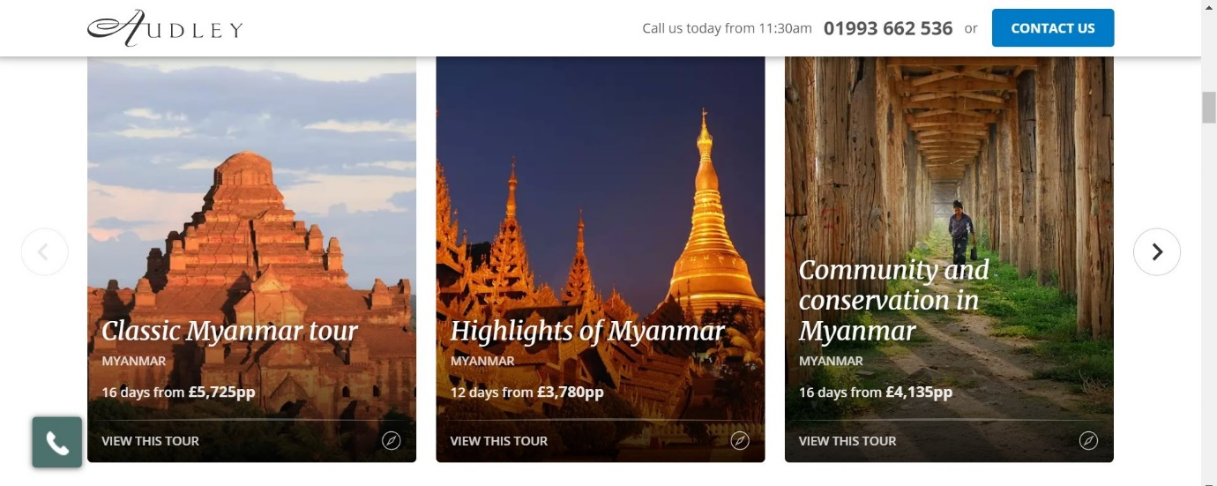
Figure 2.1.2 A range of tour packages to Myanmar by the British tour operator Audley

Activity 2.1
1. Identify the services offered by a travel agent from the following list:
- book flights, rail transport and ferries
- reserve accommodation
- hire rental cars
- purchase attraction entry tickets
- holiday planning
- provide travel advice
- issue passports and visas
- book tour packages.

2. Identify whether the following statements are true or false.
- The package tour is sold with its own price tag to the public directly or through intermediaries like travel agents.
- Tour operators are not responsible for delivering and performing the services specified in a given package tour.
- Tour operators can provide travel services themselves or can buy them from other suppliers.
Answers to Activity 2.1

2.2 Functions and operations of a travel agency and tour operator
The scope and range of travel agency operations depends on the size of an agency, with large agencies offering a more comprehensive choice and range of services. A large agency will have specialised departments, each performing different functions, such as provision of travel information, preparation of itineraries, provision of foreign currencies, airline ticketing, accounts and more.
A travel agency sells package tours from tour operators and other separate services, such as transport, accommodation, attraction tickets, activities, etc. They act as a representative of airlines, hotels, tour companies and cruise lines, and give advice to tourists to follow at the destinations.
The range of activities a travel agency provides depends upon the extent of the economic development in the country, the travel patterns of its citizens and the availability of disposable incomes for holidays (Figure 2.2.1).
Figure 2.2.1 Factors affecting travel agency services

Types of travel agency

Retail travel agency
The retail travel agency (Figure 2.2.2) sells directly to customers and gets commission from the gross sale of hotel rooms; airline, train and bus tickets; insurance; foreign exchange, etc. Commission is the primary source of its revenues.

Wholesale travel agency
The wholesale travel agency initiates the process of forming organised tours or sells the individual components directly or indirectly through franchise or retail agents. The wholesale travel agency doesn’t get its revenue from commissions directly, but earns revenue through discounts on bulk reservations from principal suppliers.

Full service agency or commercial agency
The full service or commercial agency is a complete travel agency, as it deals with all kinds of services and owns the transport fleets, charter flights and cruises. A sub-category deals with business travel booking, convention centres and stalls in exhibition centres, and arranges venues for conducting small and large meetings or conferences.

Online travel agency (OTA)
The OTA operates on the internet through a website connected to a global distribution system. They sell package tours where they customise tours and take enquiries. Transaction of payment is also done online using online payment methods. Some of the major OTAs are Expedia, Priceline, Lastminute.com, Orbitz, Booking.com and Travelocity.
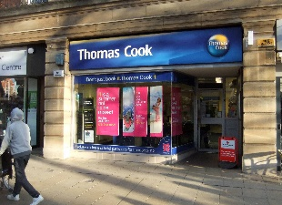
Figure 2.2.2 A high street retail travel agency

Types of tour operator

Inbound tour operator
Inbound tour operators handle inbound foreign tourists in the host country and provide them with various services on their arrival and departure. They make tour packages individually or in collaboration with foreign tour operators. They are paid in foreign currency, which increases the foreign exchange reserves of the host country.

Outbound tour operators
Outbound tour operators sell package tours highlighting the destinations in foreign countries and specialise in designing and promoting multinational tours. Generally, they appoint inbound tour operators/ground operators to make arrangements for services in the foreign countries visited.

Domestic tour operator
Domestic tour operators provide tours within the boundary of the home country and cater to the diverse needs of individuals and group travellers. They promote tour packages through their own outlets or other retail travel agents.

Ground handlers/operators
Ground handlers provide ground arrangements in country, such as transfers on arrival and departure and between destinations, and deliver the services required by large tour companies.

Special interest tour operator
Special interest tour operators mostly rely on direct marketing to sell their special interest packages to customers or sell them through retail travel agents. These special interest packages are niche products, such as wildlife tourism or dark tourism, which you learned about in Session 1.3. They do not plan for the mass market, as buyers are limited in number.

Differences between travel agencies and tour operators
The major difference between travel agencies and tour operators is in the system of providing service to customers. A tour operator is a company that buys certain services from different companies and forms them into a single tourist product using its own pricing system. A travel agency acts like an independent reseller. Its profit is the commission for the sale of the operator’s tours to customers.
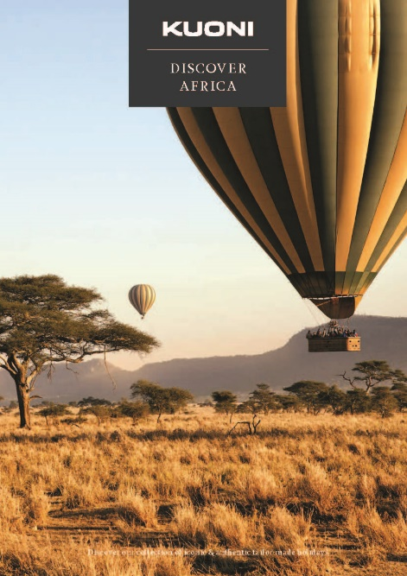
Figure 2.2.3 Tour operator brochure for Africa

Activity 2.2
1. Imagine you are a tour operator offering package tours to Myanmar for guests from Thailand. Identify the components of the tour that need to be included for an eight-day tour from the following list:
- transfers within Thailand to and from the airport
- return flight from Bangkok to Yangon
- ground travel services in Myanmar (transfer to hotels, to attractions, and from and to airport)
- accommodation for seven nights
- bar bills at the accommodation
- meals for eight days
- entrance fees for attractions
- services of tour guides
- guest’s personal travel insurance.
Answers to Activity 2.2

2.3 Tour packaging
A tour package includes several components of travel that are sold as one product, such as transportation, accommodation, entrance fees or tickets for events or attractions, meals and may also include a tour guide. Types of tour packages vary according to the desires and needs of consumers. Tourists buy package tours for different reasons, such as convenience, competitive pricing, recommendation from peers, and a desire for a smooth flow of specialised activities and experiences offered in the tour.

Examples of package tours
In Session 1.2 you were introduced to five different types of tour:
- independent
- escorted
- hosted
- incentive
- freedom.
Here you are introduced to some more types of tour.
- All-inclusive group tour – fixed itinerary and schedule, includes all elements that might be required in a trip.
- Event package tour – simple transportation and entry fee or registration fee for an event and on-site lodging and meals.
- Fly-drive package tour – includes the airfare, car rental and sometimes land accommodation.
- Fly-cruise package tour – includes the air and ground transportation to and from the cruise ship’s home and destination ports.
- Convention/meeting package tour – includes meeting and convention centre hire, with coffee break(s), lunch, screen, IT equipment and accommodation.

Elements of a tour package
A tour operator generally purchases the following elements to create an all-inclusive tour:
- transport – flights, rail, ferry
- accommodation
- services – sightseeing, meals, ground handling, car rental, etc.
A well-planned itinerary holds the key to success of a package tour. Planning an itinerary normally involves choosing points of interest (POIs), deciding in which order to visit them, and accounting for the time it takes to visit each POI and transit between them. Resources like information brochures pertaining to places of interest, hotel and ground transport tariff, rail and airfare, guide charges, toll taxes, entry fees and so on are collected before the preparation of a tour itinerary. Planning for preparing an itinerary is done one to two years before a tour package is launched and advertised. Pricing of a package is settled after estimating the operational costs and profit margin.

Factors influencing package pricing
The pricing of a package is dependent on the costs of all the services offered in a package, of which there are two types:
- fixed costs – costs that stay the same regardless of the number of tours sold by the operator
- variable costs – costs that change as the number of customers that book the package tour changes.
Fixed costs include interest on business loans taken to fund the business, building rents, salaries, insurance, advertising. The variable costs include meals, accommodation, entrance fees and other costs charged at a rate per person. It includes the actual expenses of rooms, tickets and other package components incurred with the sale of each package.
After taking all these costs into consideration, tour operators usually add a 10–15% mark-up for an individual tour package to make their profit. However, the pricing tourists pay can vary depending on other factors (Figure 2.3.1).
Figure 2.3.1 Factors affecting tour pricing

Activity 2.3
1. From the following list, identify which are advantages and which are disadvantages of all-inclusive tours for the customer.
- often cheaper than buying each element separately
- no package has every destination that meets the personal choice of a customer
- multiple destinations increase the attractiveness to customers
- saves time
- saves lots of individual enquiries to suppliers
- some places in the tour may not be of interest to the customer
- confidence that all will go to plan
- customer cannot change the itinerary.

2. Identify the two correct statements.
- when there is low demand for all-inclusive tours, prices are low
- when there is high demand for all-inclusive tours, prices are low
- when there is low demand for all-inclusive tours, prices are high
- when there is high demand for all-inclusive tours, prices are high.

3. Which season do you think would be the most attractive to foreign tourists to visit Myanmar:
- wet season
- summer
- winter?
Answers to Activity 2.3

2.4 Ticketing
An important function of a travel agency is selling tickets to clients using different modes of transport. Ticketing is not an easy job as the range and diversity of international airfares, train journeys and sea crossings is very complex and varied. A constant challenge for a travel agent is changing air schedules, train and sea timetables, and the addition/reduction of flights, train and boat services from time to time. Access to current data about various timetables of airlines, railways and steamship companies is essential. The computerised reservation system has revolutionised the reservation system for air, rail and sea travel, and also booking rooms in hotels with confirmation of reservations available in seconds (Figure 2.4.1).
Figure 2.4.1 Computerised reservation systems have transformed bookings, enabling services such as air, rail and sea – and more – to be booked online

An expensive element of many package tours is the cost of flying to the country and to different destinations within it. Airline ticketing is especially complex and varied with thousands of different types of fare combinations available across the world. The routing, pricing and ticketing for flights is largely done electronically through the computerised network of a global distribution system (GDS). There are a number of these, such as Amadeus, Galileo and Sabre. This means that there is no issuing of physical tickets, just e-ticket numbers and an airline reference, which is called a passenger name record (PNR).
The PNR is a digital file that contains information about the passenger which is shared by different airlines that are carrying the passenger. It allows passengers to check in either through the airline websites or at the airport and print airline boarding passes. If a passenger books an itinerary containing flights with multiple airlines, the PNR in the GDS system would hold information on their entire itinerary, while each airline they fly with would only have the portion of the itinerary that is relevant to them. The staff of airlines and travel agents have to double-check ticketing to ensure there are no incorrect entries in a passenger ticket, as this could result in serious problems for the client and substantial financial loss for the agent.
Price-comparison websites are increasingly used by individuals to book flights. They offer a huge range of flight combinations, with several airlines, departure times, routing with direct and indirect flights, and layover lengths (time spent waiting between parts of a journey on an itinerary). They allow maximum flexibility on price and convenience.

Airline e-ticketing
E-tickets contain all the information relating to a passenger’s itinerary, such as fare, class, taxes, endorsements, baggage, etc. They are stored as an electronic record in the database of the airline issuing the ticket. The passengers can access their booking details at any time on an airline’s website or at an airport check-in desk, using their booking reference/PNR and their last name.

Activity 2.4
Look at the example e-ticket and identify the following information from the ticket.
1. What is the passenger’s name?
2. What is the passenger’s booking reference/PNR?
3. How many flights are in the itinerary?
4. How much did the passenger pay for the ticket?
5. The ticket pricing is broken down into different elements. How much was the base fare, and how much was added to the base fare in duties, taxes and other fees?
6. How did the passenger pay for the ticket?
7. Can the passenger get a refund if they cancel?
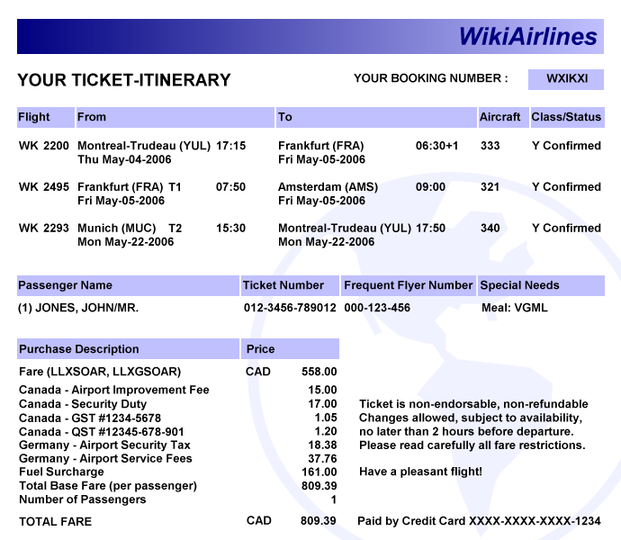
Answers to Activity 2.4

2.5 Transportation services
Transportation lies at the heart of the tourism industry and is the link between home, destination, accommodation, attraction and all other sites on the tourist trip. Its efficiency, comfort and safety make a considerable contribution to the quality of the tourism experience. In many cases, its cost comprises the largest portion of a tourist’s total expenses. This session discusses the important aspects of air, ground/land and water transportation.

Air travel
The earliest passenger service in airborne vehicles began in 1910 with airships in Germany. Aircraft engines which were originally powered by propellers are now powered by jet engines, thanks to substantial technological advances. Boeing, the plane manufacturer, introduced its first commercial passenger flight with the Boeing 707 plane in the late 1950s, as you learned in Session 1.1. In 1970, the wide-bodied or jumbo jet – the Boeing 747 – was introduced, followed by the Airbus A300 in 1972. The Boeing 747 carried many more passengers on long-haul journeys.
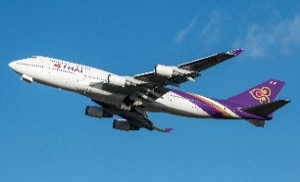
Figure 2.5.1 A jumbo jet, the Boeing 747

Passenger air transportation is differentiated into two categories: scheduled and charter flights.
A scheduled flight is one in which the airline sells single seats to individuals until the aircraft is full. Flights are offered on a regular, timetabled basis, with the departure times and routing fixed. Thus, scheduled flights offer reliability.
A charter flight is when a person or company rents an entire aircraft for a flight, with the departure time and final destination set out in the agreement between the hirer and the aircraft company. Therefore, charter flights do not follow an airline schedule. Tour operators often charter whole planes for their customers when building packages.
Although charter services can be an important component of tourism, most air travel statistics refer primarily to scheduled air services. The regulatory environment of international air travel is shaped by agreements between countries. The UN, through the International Civil Aviation Organization (ICAO), provides general rules and mediates international concerns regarding aviation law.

Land travel
The term ground transportation generally refers to travel by bus, limousine, caravan, train and other modes for sightseeing and for travel between hotels, attractions and airports. The railroads, which utilised steam engine technology to power trains, transformed land travel, making it much more accessible and affordable. Improvements in roads and coach design also made land travel more comfortable for passengers.
Buses, also referred to as coaches, are a major mode of passenger travel within countries for tourists, providing service between air and rail terminals, accommodations and attractions. Modern buses have many amenities such as larger, more comfortable seats that can recline, air conditioning, Wi-Fi and toilets. One of the most popular types of bus service is the bus tour.

Water travel
Improvements in steamship technology in the early 1900s led to the age of the great ocean liners. These included the Queen Mary and the Queen Elizabeth, which could make the transatlantic voyage in less than four days. They operated a twice weekly service across the Atlantic Ocean from the 1930s to 1960s, when the jet engine meant they became less profitable. However, they still sail today.
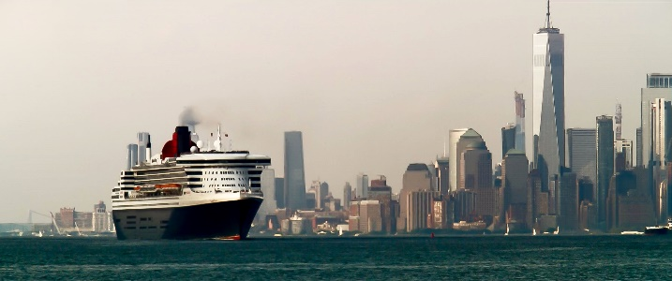
Figure 2.5.2 The Queen Mary 2 outbound from New York Harbour for Southampton, England

Today the primary form of water travel for tourists is the cruise ship. A ship might include various amenities, such as a gym, swimming pool, health spa, movie theatre, restaurant and bar, casino, discotheque and retail shops. The larger cruise ships are like floating hotels (Figure 2.5.3).
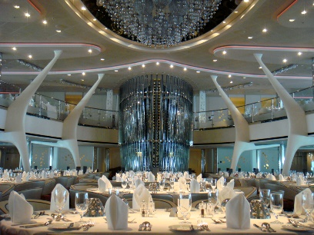
Figure 2.5.3 The dining area of a cruise ship can be very luxurious

Ferry boats offer tourists a leisurely and often scenic route between inland points. Ferry boats may also feature snack bars, restaurants and lounges.
Chartering a yacht has traditionally been associated with the very rich. Today, it is available for other income groups and offers a trip from place to place as well.

Activity 2.5
Create two escorted package tours for two different tourist markets. The first package should be targeted at tourists who want to see as much of Myanmar as possible, but have a limited budget and limited time available.
The second escorted package should be targeted at tourists who want a leisurely, luxury and educational experience, seeing the highlights of Myanmar.
Select one component from each category.
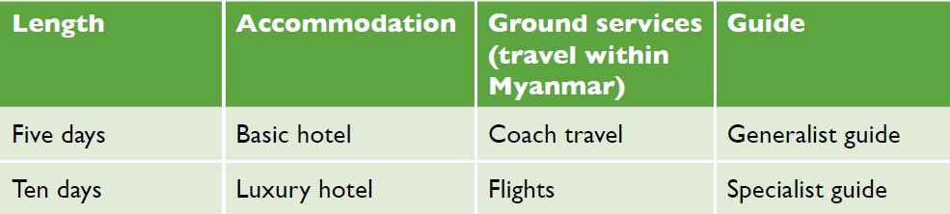
Answers to Activity 2.5

2.6 Digital tourism
Digital tourism refers to how digital tools are used to select, book, manage and deliver tourism products and experiences. In Session 1.6 you saw how the tourist journey has been transformed by digital tools from the perspective of the customer. Here the impact of digital technologies for travel agents, tour operators and tourism service providers is explored, in particular how they market and supply their services using the new opportunities provided by the internet and social media.

Dreaming
The customer journey begins when they are considering a vacation and looking for ideas and recommendations. Sites such as Instagram have become an online brochure of trips to choose from. Research from the travel site Expedia found that one-in-four millennials (those aged 18 to 34) were influenced by Instagram posts when booking trips abroad. This led the airline easyJet to add a new feature in its app that lets customers upload screenshots of celebrities, friends and family on holiday to find out where they went and how to get there (Microsoft, 2019). The Look&Book feature uses artificial intelligence and image recognition technology to identify where the photo was taken. Then easyJet identifies the nearest airport to that location and searches for available flights to market its services (Microsoft, 2019).

Planning
Once the customer has decided on which country to visit they will be looking for specific information. Customers increasingly plan their holidays with a view to the photo opportunities a destination may give. Trolltunga is a rock formation in Norway that was not well known ten years ago. However, photos posted on Instagram awakened interest in the place and, in the month of January 2019, there were over 100,000 photos on Instagram with the Trolltunga hashtag (Righini, 2020).
Figure 2.6.1 Trolltunga, Norway

Booking
Increasingly, travellers are booking their own itineraries directly with individual tourism service providers. Alternatively, sites such as Google Flights, Priceline, Booking.com and Hotels.com allow travellers to compare prices before booking flights and hotels. Different business models mean tourists also have access to a much broader range of accommodations. Airbnb, for example, enables tourists to book stays in other people’s homes, and Couchsurfing, a hospitality exchange service, allows people to provide their sofa or rooms in their home for short periods to tourists.
TripIt and KAYAK can be used to organise and archive different bookings. They are travel management sites that automatically process and import original vendor confirmations into a master itinerary, which is available to the customer on the web and their mobile device.
Digital technologies have not only changed the way many tourism providers market and sell their products and services, and brought new companies into the market, but have also enabled small hotels and guest houses to reach millions of customers through online booking portals such as Lastminute.com, Expedia and eDreams.

Experiencing
The tourist’s research and engagement in the earlier stages of their journey mean they have a well curated expectation of the experience and one that they are personally invested in. There is emerging evidence that this in itself can improve the experience, regardless of the quality of the physical offering, as was discussed in Session 1.6. Thus, tourism product suppliers need to be mindful of the expectations of tourists as curated by social media, providing sufficient opportunities for tourists to visit iconic places and capture them in photos.

Remembering
On their return home, the customer will recall their journey and will reflect on whether it was good or bad. Some travellers are adept at using Flickr, Instagram and Facebook to manage and curate the photo record of their journey. Moreover, they can also write and publish reviews on sites such as TripAdvisor. Tour operators ask guests to evaluate their experience at the end of their trip to capture their insights for tour improvements and encourage guests to place reviews on such sites.

2.6 Activity
Visit one of the websites mentioned in this session and explore the offering. Then answer the following questions.
1. Did you find the website attractive and engaging?
2. Were you able to navigate around the site to follow your interests?
3. Can you see an opportunity to use this website in your next tourism journey?
Answers to Activity 2.6

Answers to activities

Activity 2.1
- a) book flights, rail transport and ferries, b) reserve accommodation, c) hire rental cars, d) purchase attraction entry tickets, e) holiday planning, f) provide travel advice, h) book tour packages.
- a) true, b) false, c) true.

Activity 2.2
- b) return flight from Bangkok to Yangon, c) ground travel services in Myanmar (transfer to hotels, to attractions, and from and to airport), d) accommodation for seven nights, f) meals for eight days, g) entrance fees for attractions, h) services of tour guides.

Activity 2.3
- Advantages: a) Often cheaper than buying each element separately, c) Multiple destinations increases the attractiveness to customers, d) Saves time, e) Saves lots of individual enquiries to suppliers, g) Confidence that all will go to plan.
Disadvantages: b) No package has every destination that meets the personal choice of a customer, f) Some places in the tour may not be of interest to the customer, h) Customer cannot change the itinerary.
- a) When there is low demand for all-inclusive tours, prices are low, b) When there is high demand for all-inclusive tours, prices are high.
- c) Winter, because the weather is dry and cool.

Activity 2.4
- John Jones
- WXIKXI
- Three
- CAD 809.39
- Base fare: CAD 558. Duties, taxes and other fees: CAD 251.39
- Card
- No, the ticket is non-refundable.

Activity 2.5
First package: five days, basic hotel, coach and generalist guide.
Second package: ten days, luxury hotel, flights and specialist guide.

Activity 2.6
Students’ own answers.

References
Microsoft. (2019) You can now book your dream holiday by uploading a picture of someone else’s break.
Available at: https://news.microsoft.com/en-gb/2019/01/14/you-can-now-book-your-dream-holiday-by-uploading-a-picture-of-someone-elses-break/ (Accessed: 8 March 2021).

Righini, E. (2020) What is digital tourism? Much more than a definition.
Available at: https://www.doxee.com/blog/customer-experience/what-is-digital-tourism/ (Accessed: 8 March 2021).

