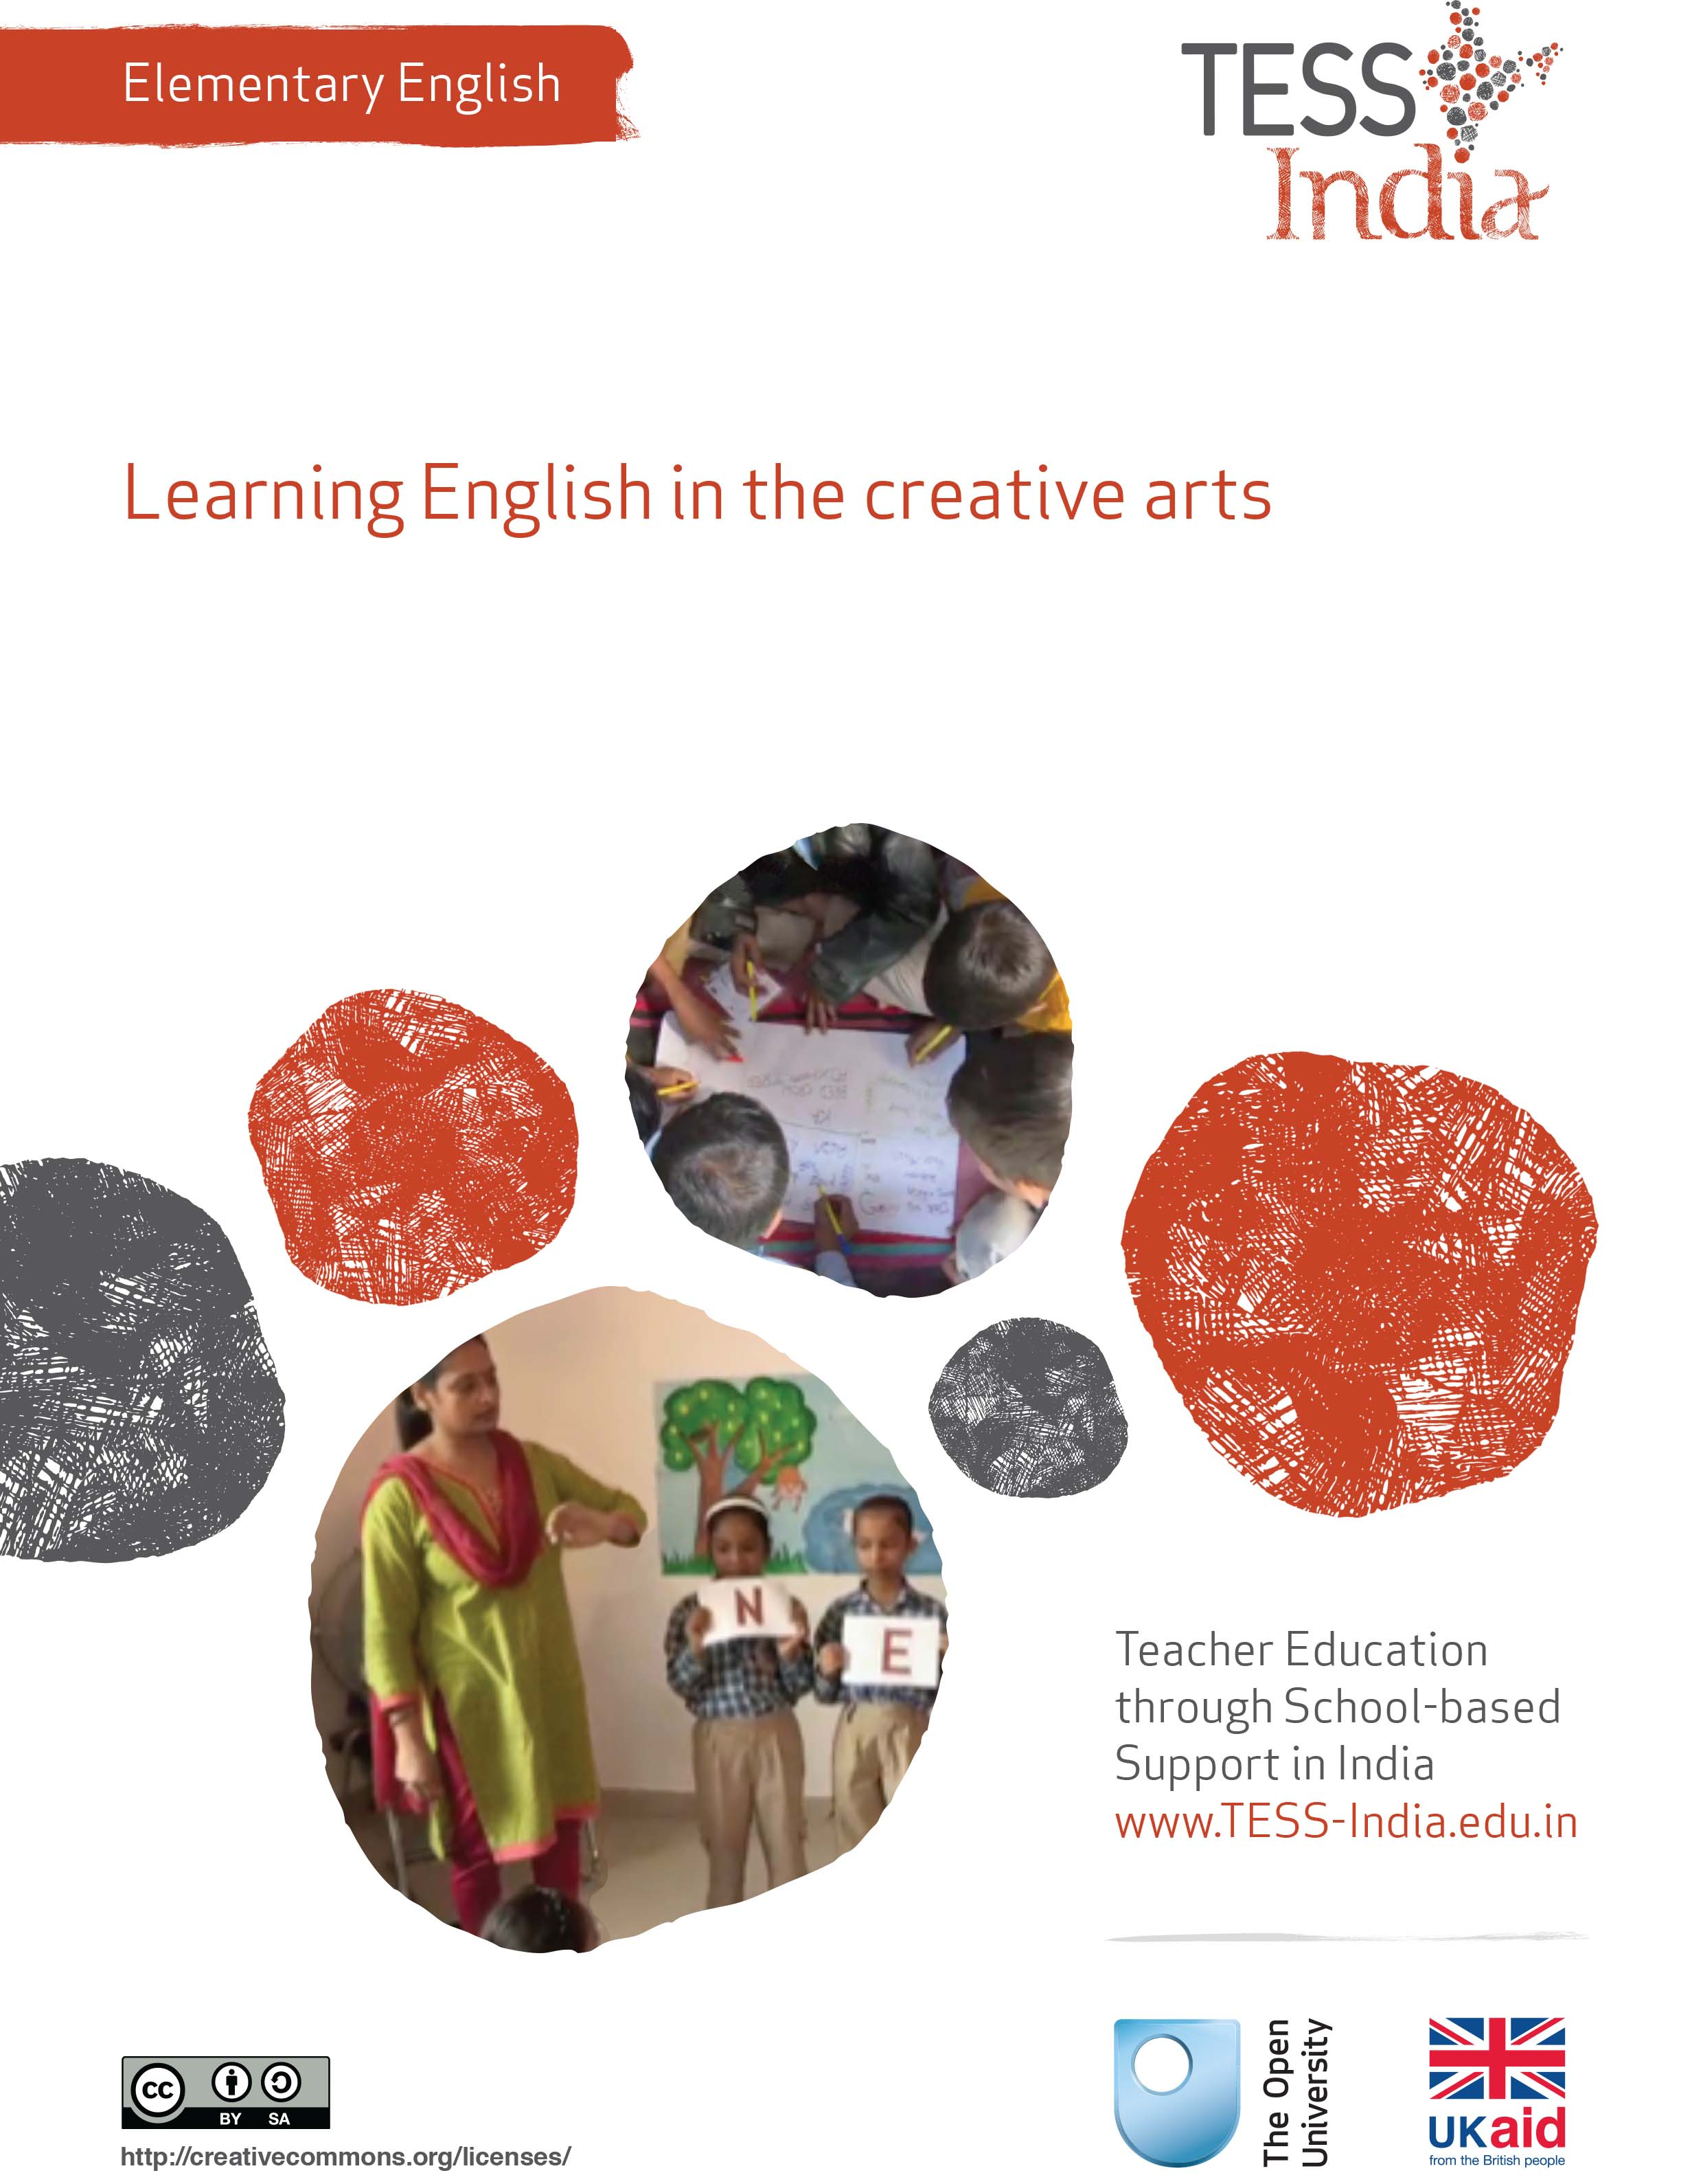
TESS-India (Teacher Education through School-based Support) aims to improve the classroom practices of elementary and secondary teachers in India through the provision of Open Educational Resources (OERs) to support teachers in developing student-centred, participatory approaches. The TESS-India OERs provide teachers with a companion to the school textbook. They offer activities for teachers to try out in their classrooms with their students, together with case studies showing how other teachers have taught the topic and linked resources to support teachers in developing their lesson plans and subject knowledge.
TESS-India OERs have been collaboratively written by Indian and international authors to address Indian curriculum and contexts and are available for online and print use (http://www.tess-india.edu.in/). The OERs are available in several versions, appropriate for each participating Indian state and users are invited to adapt and localise the OERs further to meet local needs and contexts.
TESS-India is led by The Open University UK and funded by UK aid from the UK government.
Video resources
Some of the activities in this unit are accompanied by the following icon: . This indicates that you will find it helpful to view the TESS-India video resources for the specified pedagogic theme.
The TESS-India video resources illustrate key pedagogic techniques in a range of classroom contexts in India. We hope they will inspire you to experiment with similar practices. They are intended to complement and enhance your experience of working through the text-based units, but are not integral to them should you be unable to access them.
TESS-India video resources may be viewed online or downloaded from the TESS-India website, http://www.tess-india.edu.in/). Alternatively, you may have access to these videos on a CD or memory card.

Version 2.0 EE11v1
All India - English
Except for third party materials and otherwise stated, this content is made available under a Creative Commons Attribution-ShareAlike licence: http://creativecommons.org/licenses/by-sa/3.0/

What this unit is about
This unit explores some ways to teach English through art, craft and drama.
The creative arts can make learning English fun and interesting. Students of all ages enjoy making things and being active. Incorporating English into art, craft and drama activities can motivate students to express themselves in English. In these kinds of activity you can practise and develop your own language skills along with students.
The unit suggests how your English textbook can be a resource for creative activities that can reinforce and extend language learning.

What you can learn in this unit
- To use art and craft to stimulate English language learning.
- To use drama and role play to stimulate English language learning.
- To develop art, craft and drama activities from textbook lessons.

1 Using art and craft to stimulate English language learning
Creative arts lessons are hands-on and active for students. Language learned and used in these sessions can be memorable. In the first case study, the teacher takes notice of how students use language generally in art and craft lessons, and decides to incorporate English into these activities.
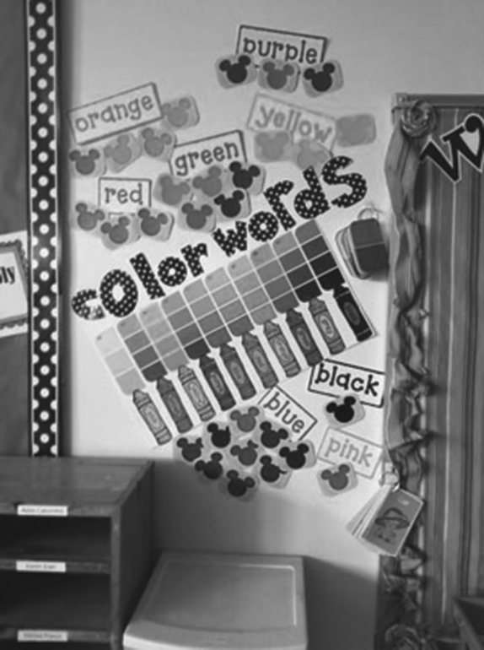
Language in art and craft lessons.
Case Study 1: Mrs Pooja uses art to develop spoken English
Mrs Pooja, a new teacher in Class V, was not very confident about teaching English. During her pre-service teacher training she had done Hindi pedagogy, but had not opted for ‘pedagogy of English’.
My assessments showed that very few students had learnt any English since Class 1. I thought back to my pre-service training, when I observed students learning Hindi during art and craft activities. I decided to try out the same strategy for English lessons.
From my English textbook, I chose a story that had many different animal characters. I had students make masks and costumes for the animals in the story.
Before the students started to create their masks and costumes, I wrote some vocabulary in English on the blackboard:
- Art words: ‘colour’, ‘cut’, ‘paste’, ‘material’, ‘paint’, ‘draw’, ‘shape’.
- Animals: ‘monkey’, ‘tiger’, ‘deer’, ‘pig’, ‘frog’, ‘fish’.
- Adjectives: ‘old’, ‘young’, ‘small’, ‘big’, ‘bright’, ‘dark’, ‘brown’, ‘orange’, ‘black’, ‘green’, ‘striped’, ‘slippery’, ‘shiny’.
I had the students repeat the words after me, in English. I used the textbook pictures and my own gestures to make sure they understood.
As the students worked on their masks and costumes, I encouraged them to use the English words as much as possible with me and with each other. As they worked, I also used English for making suggestions, agreement or disagreement, and descriptions. For instance:
- ‘Try this …’
- ‘That’s a good idea!’
- ‘Is it hard or soft?’
- ‘What colour is this?’
- ‘Please give him/her the paint.’
- ‘It’s very beautiful!’
- ‘I like it very much!’
- ‘Do you like it?’
- ‘Show me … Show [other student’s name].’
If my students didn’t understand a word or sentence in English, I would repeat what I said in Hindi. I encouraged the students to practise the English sentences with me and with each other as they made masks and costumes. It was good practise for my own English.
At the end of the art lesson I asked students to write words and sentences in their notebooks, in English, to describe their masks and costumes. For example:
- ‘My mask is red and orange. It is a lion.’
- ‘My costume is shiny and green. I am a crocodile.’
While correcting their notebooks, I noticed that all the students had attempted to write, including one who had been diagnosed as dyslexic.

Pause for thought
Mrs Pooja was observant about what worked for students, and developed her practice based on her observations. Do you think Mrs Pooja had good opportunities for assessing the students’ English in the art and craft lesson?
What else do you think Mrs Pooja’s students could do with their masks and costumes, in terms of writing or performance?
In the art and craft lesson, how do your students talk to you and to each other? Do they ask questions, follow instructions and describe their plans and the outcomes of their work? Do they use special vocabulary? How could you use this for English language teaching?
Art and craft lessons have the potential to include all students, including those with learning disabilities. The rest of the unit gives you activities to use with art and craft for teaching and learning English language.
See Resource 1, ‘Using questioning to promote thinking’ to learn more about the value of discussion and interaction in lessons.
Activity 1: Your textbook, art and craft − a planning activity
Choose a lesson from your English textbook – this might be a story, a poem or a description. With other teachers, write down your ideas for art or craft activities that could be included in this lesson. You can ask the art, craft or drama teacher for advice. Some ideas might include:
- making puppets, masks or costumes for characters
- drawing or painting scenes or characters
- creating clay models or constructions of buildings or environments
- making props from recycled materials to act out the story
- painting a large picture for scenery or a mural
- creating a collage
- weaving.
Now choose one of these art or craft forms to extend the English lesson.
Think of English words and phrases to use with students for the activity. These might include:
- art and task-specific language, for example ‘cut’, ‘paste’, ‘paper’, ‘paint’, ‘draw’, ‘clay’ …
- descriptive language, for example ‘bright’, ‘dark’, ‘red’, ‘blue’, ‘beautiful’ …
- instructional language and directions, for example ‘watch’, ‘look’, ‘first’, ‘next’, ‘now you need to’, ‘slowly’, ‘carefully’ …
- evaluative comments, for example ‘Do you like it?’, ‘What do you think?’, ‘Is it nice?’ …
Write down the English words that you will use in the lesson. Practise these words and sentences.
Write down the English words you want your students to use in the lesson.
Discuss your ideas with fellow teachers or your head teacher.
In Activity 2, you will implement the lesson you have planned.
Activity 2: Using English in the art or craft lesson
Let students know you expect them to use English in the art or craft activity. Label materials and tools in English. Teach students simple sentences to use while working in groups, such as:
- ‘Please give me ______?’
- ‘Will you please pass the ______?’
- ‘May I take ______?’
Give and repeat instructions in English. Like the teacher in Case Study 1, model the English you want students to use. Use English to describe, praise and ask questions. As students work, move around the classroom to monitor and support the English they are using.
You can assess students’ attempts to use English. Use a simple checklist as suggested in Table 1.
Table 1 Checklist for students’ English use.
Student’s name | Uses English frequently | Uses English occasionally | Yet to attempt using English
Encourage students to use the English they learn in the art or craft lesson. This will boost their confidence to use English for different purposes.

2 Art, talk and writing
Now try these activities for yourself.
Activity 3: Art, talk and writing
Art can stimulate language learning and language practice. Look at these two paintings made by Class VI students. The teacher asked students to describe their paintings. The teacher transcribed these descriptions into Hindi and English, and created bilingual reading passages to go with the pictures. Students practised reading the passages in the language lesson.
The teacher then created the following reading and writing activity, using the transcribed descriptions. Try it out yourself.
Look at the painting [Figure 1].
Figure 1 A painting by a Class VI student.
Fill in the blanks in the passage given below with the words in the box.
On the right side ____________ a man is standing near a big bin. On the ____________ there is a woman. She ____________ doing some work. There are children playing ____________ their parents. The house ____________ it belongs to this family. By the river ____________ many trees. The sky ____________ and the trees ____________.
seems to be | left side | looks like | there is
is blue | are green | near | there are
Now look at a second painting [Figure 2].
Figure 2 Another painting by a Class VI student.
Write a short passage about the picture in English and read the passage aloud.
Now choose some words and phrases in the passage to leave out and mark these on your writing.
How would you adapt this activity for younger or older classes?

Activity 4: Art, talk and writing − a planning activity
Using the previous activity as a guide, develop an exercise using paintings made by students that will help their English language skills. If you don’t have paintings from your students you can use pictures from magazines, newspapers or catalogues.
List the steps you would need to take to implement this activity.
Would you do it over one lesson or two lessons?
Now carry out the activity with your students. Did they enjoy it? Did all the students participate? Did you notice any students who did not participate?
This type of art activity encourages students to talk and write in English. Such activities can also help students to talk and write about bullying among students and societal biases, in a non-threatening manner. For example, a teacher can use students’ drawings largely depicting women in the kitchen and men reading newspapers to get them to think about gender stereotypes.

3 Using drama and role play to stimulate English language learning
Drama activities also encourage students to speak and practise English. Dramatisation of the language textbook lesson is a very good method for teaching English. You may be hesitant, because you may not have any training in drama or theatre. But you do not need to be an expert in order to use drama in the classroom, as the next case study will show you.
Case Study 2: Ms Shalini makes drama from the textbook
Ms Shalini is a Class IV teacher.
I chose a short and simple lesson about a boy who boasts to his friends, one after another, about how far he can shoot his arrow. I chose it because it had characters and ready-made dialogue, and the students knew it well.
First I told the story in English, focusing on words that the students already knew such as ‘friend’, ‘laughing’, ‘mine’, ‘lucky’ and ‘quietly’. I encouraged students to join in with me as I told the story.
Then I told the students that they would do a play based on the story. The students were very excited because they had not done a play before.
I explained that there would be a part for each student. I had created some new characters: more friends for the boy, a king and a queen. I asked students for their ideas, and they suggested new characters such as a doctor, a teacher, a princess, a movie star and a monster.
I had pairs of students improvise dialogues for their parts, using as much English as they could. The students tried out different words and phrases. I was surprised to hear them using English that had not been taught to them in the classroom. For instance, one pair of students developed this dialogue from the characters in the story:
- ‘That is very bad! Such a small way!’
- ‘No! Look! Watch me, I will do better!’
Some students were less confident in developing dialogues in English. I discussed with them, in Hindi and in English, different ways to express their ideas in English.
When the students had practised their dialogues and were happy with them, I had everyone practise their lines, speaking with more expression and gestures. I did not insist on perfect pronunciation. As the students practised, I was able to observe their English usage and confidence. I had time to make notes on their progress.
Because the class was large, I decided to have two groups so that one group could be the audience for the other and vice versa. This was good for their listening skills.

Video: Using pair work
http://tinyurl.com/video-usingpairwork

Activity 5: Convert a chapter to dialogue – a planning activity
From your textbook, select a chapter that has characters and that you could change into dialogue. Maybe you can find a chapter that already contains dialogue and characters.
Plan your lesson and use these questions to help you:
- How many characters are there in the chapter?
- Do you need to create more characters so that all students can have a part?
- How could you involve students in creating more characters?
- Do you need to rewrite any of the chapter to change it into a dialogue form?
- How could you involve students in developing the dialogues?
- What words or phrases do you think are difficult to comprehend and pronounce? How will you and your students practise these?
- How will you organise the class to enable all students to take part?
Talk with colleagues about how you could implement your plan.
‘Drama’ does not mean a perfect theatrical performance. In the language lesson, drama allows students and teachers to develop conversations, make dialogues and practise them by becoming familiar with the roles and using vocabulary that is appropriate.
Students can develop English through role play, encouraged and modelled by you. In role play, you encourage students to use English in imaginary but still familiar situations. The next case study demonstrates this.
Case Study 3: Ms Sapna introduces role play
Ms Sapna is a Class IV teacher. Students start to learn English in Class I, but when they get to Sapna’s class they generally cannot speak any English.
I wanted to develop a fun activity for students to practise English with each other. In each of the four corners of my classroom I put a small desk. On each desk I put a sign, in English:
- Doctor’s Office
- Garage
- Ticket Office
- School
I asked the students: What happens in these places? Who works here? What do they say? Do they say anything in English? Do they write anything in English? They had lots of ideas from their life experiences, since many people in our community use English for work.
I demonstrated how I wanted students to use these areas. I became ‘Doctor Sapna’. I sat at the desk and told students to wait for their appointment. I called one student to the desk. I asked him: ‘Are you sick? What is your problem? I will give you some medicine. You must take it three times a day.’ The student had to try to answer me as much as possible in English.
I put students into four groups, one for each role play area. I put one student in charge of each area, with the responsibility to make sure that everyone got a turn to speak and take the lead role.
To start, I asked for volunteers to lead the role play in each area. I encouraged the others to imitate them.
I helped each group, and monitored the activity. The ‘school’ area was very amusing to observe, since the students were pretending to be me! I recorded students on my mobile phone and played their words back to them, so they could hear themselves using English.

Activity 6: Role play – a planning activity
Set up a role play area in your classroom. You could use the examples in Case Study 3, or it could be a fruit shop, health clinic or bus station. Decide on the English words or sentences you want students to learn to use in these situations.
Talk to your students about these places. What do people say to each other in them? Model the language you want the students to use. It is a good idea to write these key words and phrases on the board or on a poster. For younger students you could draw a picture next to the word to help them learn the words.
Then ask your students to act in the situation. As you observe students in these areas, notice if there are students who are better English speakers. Are they helping the students who are less confident?
You can also evaluate students who show they understand but do not yet speak by nodding their head, following an instruction, or by giving one-word answers of ‘yes’ or ‘no’. If you have a mobile phone, record the students and play back the video to them.

4 Summary
We hope you have enjoyed this unit, and that it has given you some ideas and confidence to integrate art, craft and drama from the English textbook.
Why not plan some imaginative and interesting activities where you can practise English together with your students? When students learn English through art, craft and drama you can have them present or perform their work to the school or to parents.
Other Elementary English teacher development units on this topic are:
- Using the textbook creatively
- Songs, rhymes and word play
- Planning around a text
- English and subject content integration
- Community resources for English.

Resources
Resource 1: Using questioning to promote thinking
Teachers question their students all the time; questions mean that teachers can help their students to learn, and learn more. On average, a teacher spends one-third of their time questioning students in one study (Hastings, 2003). Of the questions posed, 60 per cent recalled facts and 20 per cent were procedural (Hattie, 2012), with most answers being either right or wrong. But does simply asking questions that are either right or wrong promote learning?
There are many different types of questions that students can be asked. The responses and outcomes that the teacher wants dictates the type of question that the teacher should utilise. Teachers generally ask students questions in order to:
- guide students toward understanding when a new topic or material is introduced
- push students to do a greater share of their thinking
- remediate an error
- stretch students
- check for understanding.
Questioning is generally used to find out what students know, so it is important in assessing their progress. Questions can also be used to inspire, extend students’ thinking skills and develop enquiring minds. They can be divided into two broad categories:
- Lower-order questions, which involve the recall of facts and knowledge previously taught, often involving closed questions (a yes or no answer).
- Higher-order questions, which require more thinking. They may ask the students to put together information previously learnt to form an answer or to support an argument in a logical manner. Higher-order questions are often more open-ended.
Open-ended questions encourage students to think beyond textbook-based, literal answers, thus eliciting a range of responses. They also help the teacher to assess the students’ understanding of content.
Encouraging students to respond
Many teachers allow less than one second before requiring a response to a question and therefore often answer the question themselves or rephrase the question (Hastings, 2003). The students only have time to react – they do not have time to think! If you wait for a few seconds before expecting answers, the students will have time to think. This has a positive effect on students’ achievement. By waiting after posing a question, there is an increase in:
- the length of students’ responses
- the number of students offering responses
- the frequency of students’ questions
- the number of responses from less capable students
- positive interactions between students.
Your response matters
The more positively you receive all answers that are given, the more students will continue to think and try. There are many ways to ensure that wrong answers and misconceptions are corrected, and if one student has the wrong idea, you can be sure that many more have as well. You could try the following:
- Pick out the parts of the answers that are correct and ask the student in a supportive way to think a bit more about their answer. This encourages more active participation and helps your students to learn from their mistakes. The following comment shows how you might respond to an incorrect answer in a supportive way: ‘You were right about evaporation forming clouds, but I think we need to explore a bit more about what you said about rain. Can anyone else offer some ideas?’
- Write on the blackboard all the answers that the students give, and then ask the students to think about them all. What answers do they think are right? What might have led to another answer being given? This gives you an opportunity to understand the way that your students are thinking and also gives your students an unthreatening way to correct any misconceptions that they may have.
Value all responses by listening carefully and asking the student to explain further. If you ask for further explanation for all answers, right or wrong, students will often correct any mistakes for themselves, you will develop a thinking classroom and you will really know what learning your students have done and how to proceed. If wrong answers result in humiliation or punishment, then your students will stop trying for fear of further embarrassment or ridicule.
Improving the quality of responses
It is important that you try to adopt a sequence of questioning that doesn’t end with the right answer. Right answers should be rewarded with follow-up questions that extend the knowledge and provide students with an opportunity to engage with the teacher. You can do this by asking for:
- a how or a why
- another way to answer
- a better word
- evidence to substantiate an answer
- integration of a related skill
- application of the same skill or logic in a new setting.
Helping students to think more deeply about (and therefore improve the quality of) their answer is a crucial part of your role. The following skills will help students achieve more:
- Prompting requires appropriate hints to be given – ones that help students develop and improve their answers. You might first choose to say what is right in the answer and then offer information, further questions and other clues. (‘So what would happen if you added a weight to the end of your paper aeroplane?’)
- Probing is about trying to find out more, helping students to clarify what they are trying to say to improve a disorganised answer or one that is partly right. (‘So what more can you tell me about how this fits together?’)
- Refocusing is about building on correct answers to link students’ knowledge to the knowledge that they have previously learnt. This broadens their understanding. (‘What you have said is correct, but how does it link with what we were looking at last week in our local environment topic?’)
- Sequencing questions means asking questions in an order designed to extend thinking. Questions should lead students to summarise, compare, explain or analyse. Prepare questions that stretch students, but do not challenge them so far that they lose the meaning of the questions. (‘Explain how you overcame your earlier problem. What difference did that make? What do you think you need to tackle next?’)
- Listening enables you to not just look for the answer you are expecting, but to alert you to unusual or innovative answers that you may not have expected. It also shows that you value the students’ thinking and therefore they are more likely to give thoughtful responses. Such answers could highlight misconceptions that need correcting, or they may show a new approach that you had not considered. (‘I hadn’t thought of that. Tell me more about why you think that way.’)
As a teacher, you need to ask questions that inspire and challenge if you are to generate interesting and inventive answers from your students. You need to give them time to think and you will be amazed how much your students know and how well you can help them progress their learning.
Remember, questioning is not about what the teacher knows, but about what the students know. It is important to remember that you should never answer your own questions! After all, if the students know you will give them the answers after a few seconds of silence, what is their incentive to answer?

Additional resources
- Teachers of India classroom resources: http://www.teachersofindia.org/en

References/bibliography
Amritavalli, R. (2007) English in Deprived Circumstances: Maximising Learner Autonomy. Department of Linguistics, The English and Foreign Languages University, University Publishing Online: Foundation Books.
Cummins, J. (undated) ‘BICS and CALP’ (online), Jim Cummins’ Second Language Learning and Literacy Development Web. Available from: http://iteachilearn.org/cummins/bicscalp.html (accessed 2 July 2014).
Cummins, J. (2000) Language, Power, and Pedagogy: Bilingual Children in the Crossfire. Bristol: Multilingual Matters.
Gibbons, P. (2002) Scaffolding Language, Scaffolding Learning: Teaching Second Language Learners in the Mainstream Classroom. Portsmouth: Heinemann.
Hastings, S. (2003) ‘Questioning’, TES Newspaper, 4 July. Available from: http://www.tes.co.uk/article.aspx?storycode=381755 (accessed 22 September 2014).
Hattie, J. (2012) Visible Learning for Teachers: Maximising the Impact on Learning. Abingdon: Routledge.
Krashen, S. (1981) Second Language Acquisition and Second Language Learning. Oxford: Pergamon Press.
Krashen, S. (1982) Principles and Practice in Second Language Acquisition. Oxford: Pergamon Press.
Mohan, B. (1986) Language and Content. Reading, MA: Addison-Wesley.
Mohan, B., Leung, C. and Davison, C. (eds) (2001) English as a Second Language in the Mainstream: Teaching, Learning and Identity. New York, NY: Longman.
Wells, G. (2003) ‘Children talk their way into literacy’, published as ‘Los niños se alfabetizan hablando’ in García, J.R. (ed.) Enseñar a escribir sin prisas … pero con sentido. Sevilla, Spain: Publicaciones MCEP. Available from: http://people.ucsc.edu/~gwells/Files/Papers_Folder/Talk-Literacy.pdf (accessed 8 July 2014).
Wells, G. (2009) The Meaning Makers: Learning to Talk and Talking to Learn, 2nd edn. Bristol: Multilingual Matters.

Acknowledgements
Except for third party materials and otherwise stated below, this content is made available under a Creative Commons Attribution-ShareAlike licence (http://creativecommons.org/licenses/by-sa/3.0/). The material acknowledged below is Proprietary and used under licence for this project, and not subject to the Creative Commons Licence. This means that this material may only be used unadapted within the TESS-India project and not in any subsequent OER versions. This includes the use of the TESS-India, OU and UKAID logos.
Grateful acknowledgement is made to the following sources for permission to reproduce the material in this unit:
Figures 1 and 2: http://www.childrensbooktrust.com.
Every effort has been made to contact copyright owners. If any have been inadvertently overlooked the publishers will be pleased to make the necessary arrangements at the first opportunity.
Video (including video stills): thanks are extended to the teacher educators, headteachers, teachers and students across India who worked with The Open University in the productions.

