Inclusive Teaching Practice
Participant’s Book
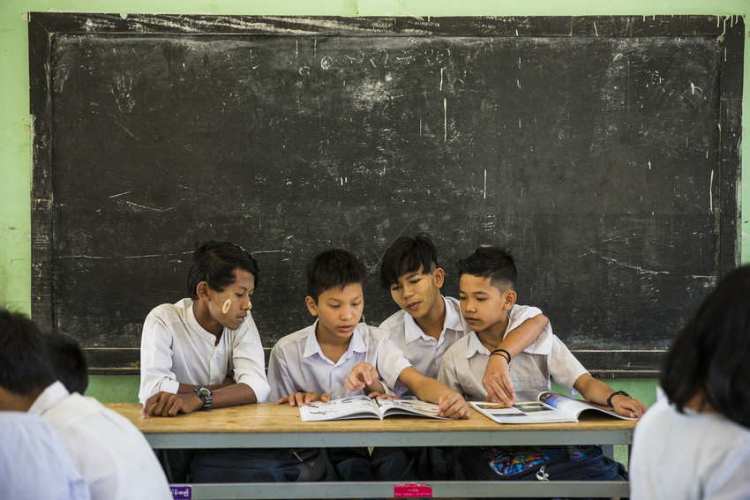

Source: VSO Image library

Module 4: Participating through Learner Centred Approaches

Module 4: Participating through learner centred approaches

Overview
This is the fourth of fifteen modules that look at how we create a positive Inclusive Learning Environment for all. You will see how inclusive teaching practices encourage, develop and use the 21st century skills of critical thinking, communication, collaboration and creativity. These modules are for any educators or those studying in education in Myanmar. The terms student and learner are used interchangeably throughout the module.

Module number | Module title
1 | What is an Inclusive School, Classroom and Teacher?
2 | Knowing your learners
3 | Planning learning outcomes for all
4 | Participating through learner centred approaches
5 | Creating a positive learning environment
6 | Effective questioning and feedback
7 | Active participation
8 | Peer, co-operative and collaborative learning
9 | Supporting students’ emotional and social wellbeing
10 | Legal framework and policies around Inclusion in Myanmar
11 | Supporting all students through differentiation
12 | Identifying specific learning difficulties
13 | Supporting all learners with differences or disabilities
14 | Positive behaviour management
15 | Assessment for student achievement

This module helps you to think about inclusion and how learners participate more effectively through learner centred approaches and well organised group work.

We will also be asking you to record your reflections in a learning journal, so it is important to make good notes and think carefully and deeply about your current and future practice. This CPD module also encourages you to develop communities of practice between yourself and your colleagues. This will support and extend your own use of inclusive practices in your teaching and will help your student teachers build on inclusion in their learning and future professional practice.

Learning Journal
It will be useful to record your reflections in a learning journal throughout the module.
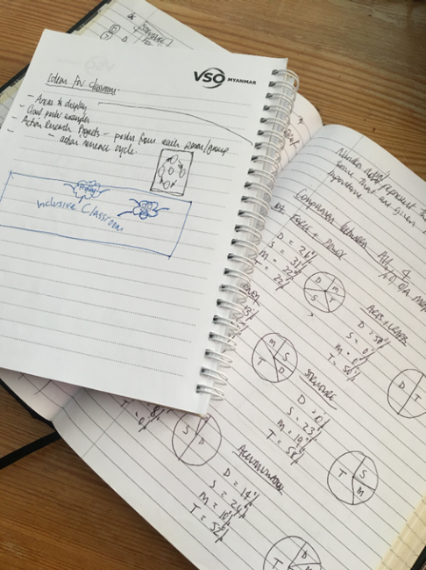
A learning journal can be digital (e.g. using Word or Google Docs) or on paper. You can also take photos of your learning journal pages if you want to share your thoughts with others. It is important that you record your thoughts and ideas so that you can remember and use them later in activities and in your own teaching.

Here are some useful tips for a good learning journal:
- Use headings and dates for all your journal entries.
- Use the activity number for reflections linked to that activity, e.g. Activity 1.1
- Add references to any other resources you find that help you.
- Record answers to activities.
- Write reflections about your learning.
- Make notes of new vocabulary.
- Identify topics you want to learn more about.

Source: Rose, N. (2018) Personal Learning Journals

The important thing is that it is easy for you to use. You can take notes which answer simple questions like these:

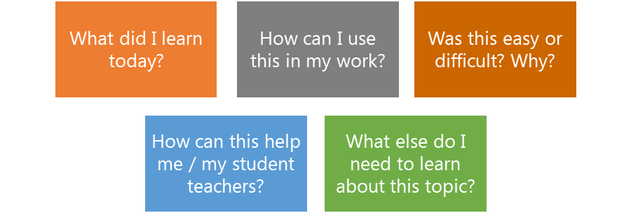

These questions follow the LEARN- APPLY- REFLECT model which is used in education globally. You can return to this journal as you progress through your CPD journey and reflect on your progress.

Study tips
Take your time to work through the activities, rather than trying to complete the whole unit at once. Set yourself a timetable and choose a time to work through the tasks, then check and compare ideas with colleagues. Finally, remember to make notes in your learning journal as you go. This will help you remember more about the skills and knowledge you develop as you complete these units.

Working alone or with colleagues
This unit is designed for self-study. The answers can be found after each activity. However, if possible, we recommend working in a pair or group so you can share ideas, ask questions, check your work, and give feedback.

If you work in a pair or group, we recommend using Think / Pair / Share for each activity.
Discuss your ideas in a group, and then check the answers on the next page(s) together.
Check your answers with your partner.
Work alone and make brief notes of your own ideas.

Learning outcomes for module 4
By working through this module, you will be able to:
- recognise key elements of learner-centred approaches (LCA) to learning and teaching.
- compare key elements of LCA to the features of Inclusive practice and 21st century skills.
- demonstrate understanding of 2 or 3 key elements of LCA, their implementation in an inclusive classroom and how they help develop 21st century skills.
- describe how to organise group work activities that are effective and inclusive.

Introduction
The previous module (module 3) you explored how effective learning outcomes can be used to support inclusive practice. It focused on how ‘step by step’ learning can be used to include all learners in their own learning – where they can stop anywhere in the learning process and start again when they are confident to move on.
This fourth module introduces the key elements of a learner centred approach (LCA) in the classroom. It encourages all learners to participate in activities and take responsibility for their own learning. Links are also made between LCAs and the development of 21st century skills. The last section considers group work and how this can be used to support all learners no matter what their style of learning, interests or learning difficulties or disabilities.
You will be asked to:
- Read about ‘learner centred approaches’ and effective group work.
- Watch videos and provide some analysis.
- Complete activities either alone, in pairs or in small groups.
- Think about key questions.
- Answer an end of module quiz.
- Reflect on your experience and knowledge.
- Make a promise to your learners.

The module will take approximately 8 hours to complete. Take your time to ensure it is an enjoyable learning experience.

Key to symbols
Activity – this is work you need to complete.

Question/s – please answer the questions.
Reflection – think carefully about how you feel about this.
Learning Journal – please write your answers in your learning journal.
Read – please read the text provided. Make any notes you like.

1.1 Link to previous learning - Planning inclusive learning outcomes for all
Think back to module 3 and the discussions around learning outcomes (the foundation of every lesson). Go back to module 3 if you find this activity difficult.
R
Reflect on ‘what a learning outcome needs to do.” Most teachers know that learning outcomes should be SMART: specific, measurable, achievable, relevant and timed. How does being SMART help us? Match the correct definitions to the SMART acronym. One example is given.
11
Always say what the learners will be able to do by the end of the lesson. This helps give purpose, expectations and direction.

Specific

21
The outcomes should be about the learning that will take place in the lesson. This helps you then plan appropriate learning activities for the lesson. It makes it clear for your learners what you expect them to be able to learn in the lesson.
Measurable

31
Write your learning outcome so that it is short and precise. This helps them understand the purpose of learning activities and the direction of the lesson. It also needs to be relevant to the topic of the lesson and to your learners.
Achievable

41
Using a thinking action verb to write your learning outcome means that the learning can be seen and easily assessed or measured.

Relevant

51
By knowing your learners you can write learning outcomes so that all your learners can achieve. Think about the skill or knowledge that all, most and some of the learners in the class will achieve at the end of the lesson.
Timely

Copy the table below into your learning journal and write the numbers of the answers. One example is given.
LJ
Specific | Measurable | Achievable | Relevant | Timely
 |  |  |  | 11

Answers to the recap of Module 3 - SMART
Specific | Measurable | Achievable | Relevant | Timely
21 | 41 | 51 | 31 | 11

Learner centred approaches for 21st century skills
With this approach learners are at the very centre of learning and focus has been taken away from the teacher doing most of the work. In the 21st century, learning is not a “one size fits all” approach. It has become more about developing skills instead of just absorbing information. The most important skill is self-development. This includes knowing one’s strengths and weaknesses and finding ways to fill gaps in personal development. This can be achieved by implementing student-centred learning practices, i.e. letting students take charge of their learning. This method prepares individuals to take responsibility and makes them independent. It helps develop the characteristics of lifelong learning – motivation, self-evaluation, time management and skills to access information. For more information visit the article by Beas Dev Ralhan.
https://yourstory.com/2019/11/student-centered-learning-approach-21st-century

Self-assessment 1 – learner centred approaches
REFLECTION: Think about all the recent learning or professional development you have done - what do you know about learner centred methodology? How well do you think you understand learner centred approaches? Look at the scale below and identify the number that best describes YOU. Answer in your learning journal.
LJ
VERY well
NOT well
We will ask you to do this again at the end of the module.

Self-assessment 2 – effective group work for inclusion
REFLECTION: How well do you think you understand effective group work when linked to inclusion? Look at the scale below and identify the number that best describes YOU. Answer in your learning journal.
LJ
VERY well
NOT well
We will ask you to do this again at the end of the module.

2.1 Terminology for this module

Activity 4.1 – vocabulary (20 minutes)

Think: What do you think each of the words mean below linked to learner centred learning?

- Match the vocabulary words below to the definitions (using the numbers). Try to give the definitions before you read the answers. Write in your learning journal.
LJ

Words
Engagement

Paradigm shift

Analysing

Active

Competency

Critical thinking

Collaborative

Responsible

Motivation

Inquiry-based

Facilitate

Rote learning

Participant

Co-operative

interactive

Creativity

Active

Example answer = 6 (busy with an activity)

Note: there are two more definitions than words.

Definitions
1 | participants asking questions | 10 | Person of same age
2 | Supports and guides the leaners | 11 | involving the learner in sharing information
3 | giving and receiving information | 12 | having control over
4 | Working well with others | 13 | Separating into smaller parts to make clearer
5 | level of motivation in an activity | 14 | enthusiasm for doing something
6 | busy with an activity | 15 | the ability to have new ideas
7 | learning by repeating not understanding | 16 | a person who takes part in something
8 | important change - replaced by new ways | 17 | Analysing facts to understand something
9 | the ability to do something well | 18 | working together
Extension activity

- One important word, linked to the 21st Century Skills, is missing. What is it?

Clue – one of the extra definitions above is the answer.

Activity 4.1 answers

The Learner Centred Approach (LCA)

Key elements of the LCA – the words are taken directly from EACH KEY ELEMENT.

Active

131
81
Engagement

Paradigm shift

Analysing

61
51

Responsible

181
Competency

Critical thinking

Collaborative

121
171
91

11
Rote learning

141
71
21
Motivation

Inquiry-based

Facilitate

Creativity

111
Participant

Co-operative

interactive

161
151
41

There are many skills required for education practitioners in the 21st century. We focus the 4Cs of 21st century skills for the purpose of this module. See Beas Dev Ralhan – student centred learning approach for the 21st-century.
https://yourstory.com/2019/11/student-centered-learning-approach-21st-century

- Creativity

- Communication
- Collaboration
- Critical thinking.
31
The missing word is COMMUNICATION

2.2 What is a learner centred approach in the classroom?

Activity 4.2 – 2 videos about the Learner-Centred Approach (LCA) (20 minutes)

- Watch both videos and list, in your learning journal, some of the things you can do to make learning more learner centred.
LJ

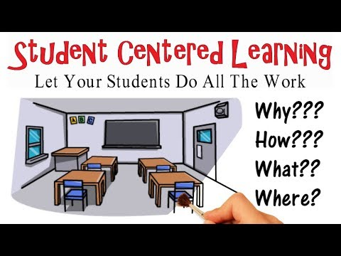
Video 1 - This video describes key benefits and aspects of student-centred learning (cartoon style).

https://www.youtube.com/watch?v=WvzVAQkuSqU (4 minutes).

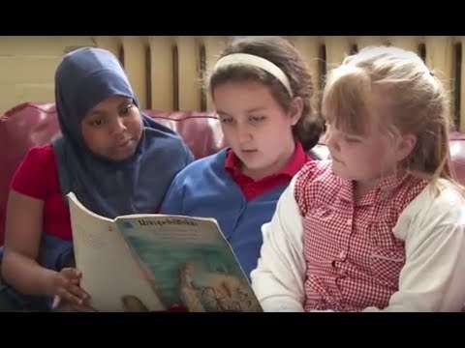
Video 2 - Watch (the first 5 minutes minimum): Teaching and learning in Inclusive Education. This describes key aspects of learner-centred approaches.

www.youtube.com/watch?v=KyheWrstoHU (13 minutes in total).
- Think: what percentage of your time in class is explaining, demonstrating, talking, lecturing etc?
- Think: what percentage of the time do your learners spend actually doing activities where THEY have to think and work together?
% teacher | % student
Answer here please.

Further reflection – think about the following linked to your classes:
R
- Planning for multisensory activities that involve looking, listening, talking, touching & moving.
- Providing opportunities to work together and alone.
- Do you make the most of the space available? Can opportunities to work outside help focus and engagement?
- Providing positive feedback even when answers are incorrect to encourage inclusion and motivation.

Activity 4.2 discussion

Reflect: Thinking about how time is used in class is an important identifier of whether you have a teacher centered or learner centered classroom.

If you spend a large percentage of your time explaining, demonstrating, talking, lecturing etc. it’s probably too teacher centered. One common thought is that it should be 80% learner focused and 20% teacher (facilitator) focused. Notice the shift towards the learner.

The more time learners spend creating, critically thinking, collaborating, and communicating about ideas and problems, the more they will develop the 21st century skills required in today’s societies.

Start to think how you might improve / increase the amount of time learners are engaged on their own or group activities.

Reflection points – There are many opportunities to improve your teaching linked to being learner centred. Think about how, where, when and with whom they learn and explore your own class environment. Think about how to experiment. This is where you can think about the promises you are making to your learners.

Teacher Centred versus learner centred approaches.
The following section considers how the classroom environment has changed from using traditional (rote / transmission) approaches of teaching to the 21st Century, learner centred (constructivist) approaches. This supports and enhances creativity, critical thinking, communication and collaboration - 4 Cs. (Ralhan, B. D. 2021.)

3.1 Traditional teaching versus learner centred approaches.
Traditionally teaching was teacher centred, meaning the teacher was seen to have all of the knowledge and experience. The students were sometimes seen as empty vessels ready to be filled with knowledge by the teacher (Freire, 19xx). Assessment meant purely reciting known facts about a subject.
Today, teaching has shifted to being learner centred (a paradigm shift). Students are classed as learners, which immediately emphasises the importance of THEM being involved in their OWN learning. Teachers can be referred to as facilitators. Facilitators support and guide the learners whilst everyone learns together to solve problems and find solutions - it is a collaboration of experience, knowledge and beliefs. Learners, because they engage in their own learning whilst working with others, develop strong, multiple connections which allows them to create, interpret, analyse, present, communicate information more easily (module 2 – multisensory). These skills can be used in any situation to find solutions to social and workplace issues, anywhere in the world.

3.2 Traditional verses modern classrooms
Traditional  Knowledge  Experience  Students  Teacher  Teacher-centered learning | 21st Century  Experience  Individual and collaborating learners  Learner-centered learning  Facilitator  Beliefs  Knowledge
Least desired approach
Desired approach
Paradigm shift

3.3 student centered classroom
Learning happens in many ways, using many sources, guided by the facilitator (teacher). Notice the many opportunities to develop creativity, critical thinking, communication and collaboration (4 Cs).
21st Century Skills
Facilitator
Beliefs
Knowledge
External collaborators
?

Individual and collaborating students
Experience
Source for images: Pixabay (free)
Learner-centered learning

The Myanmar classroom – a learner centred approach (main features)
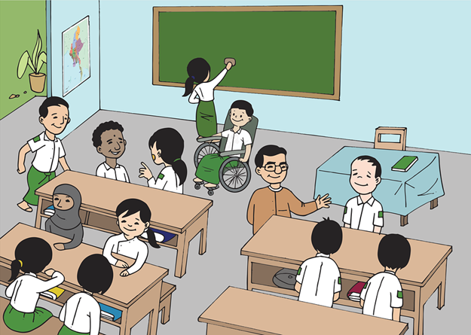
Learners make decisions about how and what they will learn
Emphasis on fulfilling the needs of the learner.
Students feel more comfortable to contribute.
Putting the learner’s interests first.
Source: https://pixabay.com//illustrations/burma-myanmar. (free)

All learners are included in the process of discussion.
Teacher’s role as facilitator.
Encouraging learners to reflect
Learners challenging what they are learning.
Building learner–teacher interactive relationship.
Using various instructional strategies rather than rote learning
Students ask more questions.
Acknowledging the learner’s voice.
The learners are active.
Promoting peer communication.
Encouraging inquiry-based, cooperative, and collaborative. Learning.
Learners develop independence.
Learners construct new knowledge and skills based on prior knowledge and experiences.

Student centred classroom of the 21st Century

A closer look at the implications for teachers

students as creators
product
content
process
teacher as facilitator/guide
Planning – flexible schedule, collaborate
Curriculum – interdisciplinary, collaborative
Resources – student choice, range of options
Collaboration – peers, teachers, others
Research – student-led inquiry, draw conclusions, share findings
Formative assessment – ongoing, check progress to goals
Technology use – communicate, research, explore
Self-management – solve problems, make decisions, creative thinking
Application – learning relevant to real life
Student work – portfolios, collaborative
Summative assessment – conducted by student and teacher, checklist to evaluate

Activity 4.3 – 21st Century Skills comparison (30 minutes)

- Reflect on the information above about teacher centred versus learner centred teaching. Compare what it was like in your classroom before to what it needs to be now – it may be the same. One example is given. Write in your learning journal.
LJ
R
Teaching and Learning
Before
Now

Traditional  Teacher centred |  | 21st Century - learner centred approach
The teacher is seen to fill the learner with knowledge. | Who?  Who is seen to have the knowledge/experience? | The teacher is facilitator. Sharing knowledge between learners and facilitators.
Where?
Where does learning take place?
What?
What do learners do in and out of class?
Resources?
What resources are used?
Choice?
What choices can learners make?
Assessment?
How are learners assessed?
Barriers?
What difficulties do teachers / learners have?
Effects?
What are the effects of this approach?

Activity 4.3 – Answers 21st Century Skills comparison

Teaching and Learning
Then
Now

Traditional  Teacher centred |  | 21st Century - learner centred approach
The teacher is seen to fill the learner with knowledge. | Who?  Who is seen to have the knowledge/experience? | The teacher is facilitator. Sharing knowledge between learners and facilitators.
In the classroom. Sometimes at home doing homework. | Where?  Where does learning take place? | Anywhere. Links to external collaborators. Library. At home. At work.
Answer set questions, listen to lectures from the teacher for most of the time | What?  What do learners do in class? | Collaborate, create, research, solve problems in groups. Use technology. Share ideas, experience, knowledge and beliefs.
Very limited. Some text books in class/library. | Technology?  What technology is used? | Links to the WWW. Presentation packages, laptops, mobile phones. Online resources
Assignments issued with very little choice. | Choice?  What choices can learners make? | Learners are given choice about what, how, when, with whom.
Summative written exams. Limited in class tests to check recall. | Assessment?  How are learners assessed? | Variety of methods to suit individuals (visual, auditory, kinaesthetic). Formative assessment with support.
Boring, no stimulation, repeating answers in a choral way. Rote learning | Barriers?  What difficulties do learners have? | Lack of access to technology and resources for self study. Teacher not having the right attitude.
Poor motivation for teachers and learners. Only remember facts | Effects?  What are the effects of this approach? | High motivation because learning is Interesting. 21st Century skills developed

Linking three core elements for a learner centred approach
There are three sets of guiding principles / elements / features that can be used to contribute to effective inclusive teaching and learning in the classroom. You will notice you have already studied the 8 features of an inclusive classroom in module 1. The guiding principles are:
1) 15 key elements of learner centred classrooms. (TETM, pp. 24 and 25).
2) 8 features of an inclusive classroom. (UNESCO, 2016: 13-14).
3) 4 Cs of 21st Century Skills. (Ralhan, 2021).

11
15 key elements of a learner centered classroom

21
8 features of an inclusive classroom
31
4 Cs of 21st Century Skills

It is important to recognise each set of principles individually but also to recognise the strong links between them. Each will be reviewed in the following pages.

4.1 - Fifteen key elements of a learner centred classroom
The key elements of the learner centred approach put the learner at the heart of their own learning. Think back to earlier modules and how inclusion identifies learners’ individual learner needs. The LCA explores the numerous ways this can be achieved for learners.

Activity 4.4 – The Learner-Centred Approach (LCA) (20 minutes)

- Read each of the 15 key elements (a-o) below and think about the classes you teach. Assess your practice against each statement. Use this checklist to think about yourself as an inclusive teacher who uses the LCA. You can use the results to inform and develop your CPD plan. Record your answers in your learning journal.
LJ
Key elements of the learner centred approach
R
- Emphasis on fulfilling the needs of the learner.
Never
Always

- Putting the learner’s interests first.
Never
Always

- Acknowledging the learner’s voice as central to the learning experience.
Never
Always

- The learner is an active and responsible participant in their own learning.
Never
Always

- Strengthening the learner’s motivation.
Never
Always

- Promoting peer communication.
Never
Always

- Building learner–teacher interactive relationship.
Never
Always

- Encouraging inquiry-based learning, cooperative and collaborative learning, activity-based learning.
Never
Always

- The teacher’s role as a facilitator.
Never
Always

- Learners make decisions about what they will learn and how.
Never
Always

- Encouraging learners to reflect on what they are learning and how they are learning it.
Never
Always

- Using various instructional strategies rather than rote learning.
Never
Always

- Promoting learner’s engagement in learning.
Never
Always

- Learners construct new knowledge and skills based on prior knowledge and experiences.
Never
Always

- Paradigm shift from teacher-centred/content-based instruction to learner-centred/competency-based instruction.
Never
Always

NOTE: there are no right or wrong answers. If there are any words or phrases you do not understand, go back to activity 4.1 and review the definitions.

Note: Most of the words within the statements above are from activity 4.1.

Activity 4.5 – The Learner-Centred Approach (LCA) (10 minutes)

True or False

Using the elements of a LCA in activity 4.3, read the following statements and identify whether they are true or false. Use a to show your answer. Alternatively, write the answers in your learning journal. One example has been given.
LJ

 | Statement | True | False
1 | There is more focus on the teacher’s knowledge.
2 | Learners are encouraged to actively participate in class.
3 | Learners are encouraged to work alone when doing activities.
4 | Learner voice should NOT be listened to.
5 | Teachers need to be facilitators.
6 | LCA supports an inclusive approach to learning.
7 | A variety teaching and learning strategies used to help all learners.
8 | LCA allows for learner choice with their learning

Activity 4.5 answers – The Learner-Centred Approach (LCA)

True or False

 | Statement / comment | True | False
1 | There is more focus on the teacher’s knowledge.  The focus is more about the learner - what and how they are learning.
2 | Learners are encouraged to actively participate in class.  Learners are encouraged to learn through doing activities in class.
3 | Learners are encouraged to work alone when doing activities.  Learners are encouraged to work with peers, facilitators etc. This allows the sharing of ideas and building knowledge together.
4 | Learner voice should NOT be listened to.  Facilitators need to LISTEN to learners’ systematically and adapt where appropriate
5 | Teachers need to be facilitators.  Teachers need to support and facilitate learners rather than simply imparting wisdom. Learners need to develop criticality in their work.
6 | LCA supports an inclusive approach to learning.  As the phrase suggests, it is learner centred and supports an inclusive approach.
7 | A variety teaching and learning strategies are used to help all learners.  Learning can be adapted to suit the individual needs of the learners. See Module 2 – learner profiles and Moule 3 – learning outcomes/step by step.
8 | LCA allows for learner choice with their learning.  LCA needs to allow the opportunity for learners to make choices about their learning. This could be the type of activity, which topic, how they present etc.

In a learner centred approach, the focus is on the learner developing skills, not just absorbing information.

4.2 Eight features of an inclusive classroom
In module 1 you learnt about the eight features of an inclusive classroom. Notice how the eight features link closely with the fifteen key features of the learner centred approach. Also notice how the list has been displayed as a mind map in this module to help learners who prefer visual styles of learning.
221
- Lessons encourage the participation of all students.

- Students are actively involved in their own learning.

- Teaching is planned with all students in mind.

321
121

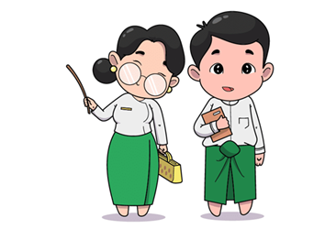
I can see how these link to the 15 key features of a LCA.

821
421
- Students are encouraged to support one another’s learning.

- Assessment contributes to the achievement of all students.

And to the 21st Century Skills.

521
- Support is provided when students experience difficulties.

721
- Students feel that they have somebody to speak to when they are worried or upset.

621
- Classroom discipline is based on mutual respect and healthy living.

Image source: https://pixabay.com//illustrations/burma-myanmar-classroom-boy-girl-5204371/ (free)

4.3 Four Cs of 21st century skills
Educators today need a range of cross-cutting skills so that they can help prepare students for life and work in the 21st century. There are many key strengths [that] have been identified as being required for success in 21st century society and workplaces. The following specifically explores the 4Cs – Creativity, Communication, Collaboration and Critical thinking: there are many more examples.
- Creativity
- Communication
- Collaboration
- Critical thinking
In-depth descriptions of the 4Cs can be viewed below. Why are these skills important for the success of learners in the future?
- Creativity - Creativity is not just about creating something original but also about making something new and innovative from things they already have. Creativity lets students think outside-the-box and offer solutions to problems in a different way.
- Communication – So many situations need students to communicate. They need to know how to communicate to get the right results. They need to interpret and analyse the information they receive. At the same time, they need to share information effectively with other people
- Collaboration – Students should be able to work well together so that they can deal with situations that need team work.
- Critical Thinking - With rapid changes happening everywhere, students must learn how to adapt, analyse and solve problems in all situations. We need to help them to develop problem-solving skills which will support them to make the right decisions when they face challenging situations.
Image source: https://pixabay.com//illustrations/burma-myanmar-classroom-boy-girl-5204371/ (free)

Ok, let me reflect on my teaching.
Now think about some examples using your own teaching practice linked to 21st Century Skills.

Activity 4.6 – 21st Century Skills Analysis (10 minutes)

- What do you think are the most important 21st Century Skills (e.g. 4 Cs) that all educators need to develop in their classrooms (minimum of 2 examples for each ‘C’)?
One example is given. Write in your learning journal and then review your answers below.

- Think about the skills you identified above and how much you currently develop them with your learners in class. Give a percentage for each ‘C’. One example is given.
R
Think / pair / share if you can.

Creativity  1.  2. | Critical thinking  5%  1. Solving ‘real life’ problems  2.
Collaboration  1.  2. | Communication  1.  2.

LJ

Activity 4.6 discussion

The number of skills that can be developed for the 21st Century is almost limitless. Notice also that they tend to be higher order (Bloom’s Taxonomy).

Examples of skills for each of the 4Cs. How many did you think of?
Creativity  - Courage to explore the unknown  - Innovation  - Generation of ideas  - Work creatively with others  - Creative production with others | Critical thinking  - Solving ‘real life’ problems  - Constructing arguments  - Reasoning  - Interpretation and analysis  - Evaluation of ideas
Collaboration  - Co-operation  - Flexibility  - Responsibility and production  - Constructive feedback  - Sharing on digital media | Communication  - Engaging in conversations  - Actively listening  - Oral presentations  - Use digital media to communicate  - Communicating in diverse environments

Reflect on the examples you have provided and review the percentages you gave to each. Where these are low percentages, you could think about how you can improve these scores by being creative and changing focus in your class.

Example discussion
This involves the learner and links their own life to maths. They are engaged and more interested in problem solving, probably in pairs or small groups (peer, collaboration or co-operative).
5% is a low number - think about how you can use more ‘real life’ examples in your classes.
5%
Critical thinking –
Using a ‘real life’ example to solve a maths problem.

In this section you have explored 1) 15 key elements of a learner centred classroom. 2) 8 features of an inclusive classroom and 3) 4 Cs of 21st Century Skills. When the three are viewed together, there is a clear link and learners are at the heart of the learning process. Links made were;
- Planning of lessons to meet individual’s needs – 8 features of inclusive classrooms.
- Learner participation in activities, having choice – 15 learner centred approaches.
- Developing future transferable workplace skills – 4Cs of 21st Century Skills.

Revisit your answers for activity 4.3– the key features of the learner centred approach (self- assessment). You will have identified the features you are particularly good at and also those features that you find more difficult, or you have not thought about before.

Activity 4.7 – Developing a learner centred approach in your classroom (60 minutes)

This activity asks you to apply the knowledge learnt in the previous activities. Carefully reflect about the answers you gave for activity 4.3 where you completed a self-assessment against the 15 key features of LCA.

- Choose 2 or 3 key elements you want to learn more about.
- Describe how you would use them in your classroom.
- Explain why you have chosen those key elements.
- Prepare one side of A4 maximum / 1 PPT slide / 1 poster / 1 list / 1 mind map / 1 flow chart (choose one only)

Points to note:
- You can work in pairs, small groups or alone.
- You can choose what 2 or 3 key elements you want to learn more about.
- You can use whatever technology or resources you like.
- You can choose how you present your work.
- You can choose when and where you work.
LJ

Make notes in your learning journal.

5.Creating groups that are inclusive and promote effective collaborative learning.
It is important to remember that inclusive, learner centred learning, includes lots of collaboration between different people. Therefore, great care is required by the teacher in the classroom when deciding how groups are organised. They must be inclusive and effective for collaborative learning, in order to help develop the 4Cs of 21st century skills. Group work is a central approach to learning and getting it right is crucial for powerful inclusive practice.
Grouping of learners should be done deliberately. This could be:
- By performance levels- either the same level of learners (homogenous) or different levels learners (heterogenous).
- For harmony – learners stay in safe groups – avoiding any chance of bullying.
- By using a random approach (luck of the draw).
- By assigning specific roles.

Activity 4.8 – Importance of Cooperative learning (45 minutes)
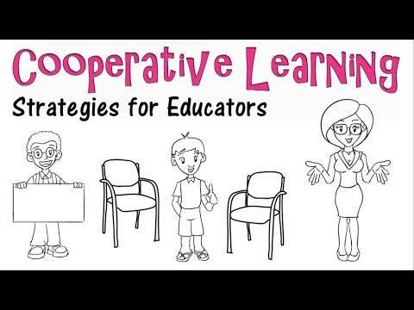
Watch the video about cooperative Learning (pair and groupwork) and make notes in your learning journal.
https://www.youtube.com/watch?v=cnkKHL_dyGE

LJ

- Give three reasons why cooperative learning is important.

See the example below of how a teacher might group students in a ‘Think / pair / share’ activity.
Example | Explanation
Think / pair / share | Partner students with others who are the same level learner or a different level. Needs to be safe. Students will be given time to think or work alone first, then work with a partner or a group before being asked to share or feedback to the whole class.

- How might you group students in the following examples? Complete the following table about how to ‘group’ students for cooperative learning.

Example | Explanation
Jigsaw
Project based learning
Add another example here

- Complete the following table (give solutions) about the dangers and difficulties of group work.

Dangers and difficulties | Solution
Learners tend to talk in groups (being sociable)
Group size can be large – limited learning
Limited direction, goals or targets in group
Some learners will not do the work

You will revisit this in module 6

Activity 4.8 – answers - Importance of Co-operative learning

- Three reasons why cooperative learning is important
- Allows learners to hear other learners’ views and opinions.
- It is all about the learners’ contributions.
- Learner is central not the teacher

- Complete the following table about how groups cooperate during learning.

Example | Explanation
Think / pair / share | Partner students with others who are the same level learner or a different level. Needs to be safe. Students will be given time to think or work alone first, then work with a partner or a group before being asked to share.
Jigsaw | Students start in a home group where a topic is assigned to an individual, that individual then joins others of same topic (expert group). They then return to their home group to share ideas and explain.
Project based learning | Students are given a project/real-life problem to solve. It is based around standards and competencies and begins with an inquiry.
Add another example here

- Complete the following table (give solutions) about the dangers and difficulties of group work

Dangers and difficulties | Solution
Learners tend to talk in groups (being sociable) | Facilitators need to keep a close eye on learners & prompt with questions to keep on task.
Group size can be large – limited learning | Ensure groups have a maximum of 3 to 4 learners. Either homogenous, heterogeneous, random or assigned roles.
Limited direction, goals or targets in group | Make sure lessons have learning goals and objectives. These need to be checked throughout the activity.
Some learners will not do the work | Ensure individual learners are responsible for something (roles and responsibilities during activities).

Appendix 1 gives examples of individual responsibilities during group work. You can print these out or just copy them onto paper. These can be issued to individual learners working in groups. They will each have a responsibility during the group activity. Younger children would need to practice these roles before they could be used effectively in an assigned groupwork task.

6. Wrap up
In this module you have:
- recognised the key elements of learner-centred approaches (LCA) to learning and teaching.
- compared the key elements of LCA to the features of Inclusive practice and the 21st century skills.
- demonstrated understanding of 2 or 3 key elements of LCA, their implementation in an inclusive classroom and how they help develop 21st century skills.
- described how to organise group work activities that are effective and inclusive.

Key points from this module:
- Learner-centred approaches (LCA) in the classroom encourage all learners to participate in activities and take responsibility for their own learning.
- There are strong links between LCAs, inclusive classrooms and the development of 21st century skills.
- The most important skill is self-development. This includes knowing one’s strengths and weaknesses, and finding ways to fill gaps in personal development.
- LCAs support individuals to take responsibility and makes them independent. It helps develop the characteristics of lifelong learning – motivation, self-evaluation, time management and skills, including the 4Cs (communication, creativity, collaboration and critical thinking.
- Classrooms have seen a paradigm shift from teacher centred to learner centred. Rote and transmission learning are outdated now.
- Managing group work is key to effective collaboration for learning. This can be used to support all learners no matter what their style of learning, interests or learning difficulties or disabilities.

7. End of module 4 quiz
Please answer the following questions in your learning journal. You can attempt as many times as you like to reach 100% pass. Some questions require more than one answer.
LJ
Q1 - 21st century learning is about
- Absorbing information
- Developing skills

Q2 - Which of the 4Cs of 21st century skills involve problem solving, reasoning, developing arguments, analysing information, adapting to new situations?
- Critical thinking
- Communication
- Collaboration
- Creativity

Q3 - Which of the 4Cs of 21st century skills involve working together through cooperation, being flexible, showing leadership, being responsible and respectful to others, giving and accepting constructive feedback?
- Critical thinking
- Communication
- Collaboration
- Creativity

Q4 - Which of the 4Cs of 21st century skills involve listening, talking, presenting, reading, writing, drawing, discussing, acting?
- Critical thinking
- Communication
- Collaboration
- Creativity

Q5 - Which of the 4Cs of 21st century skills involve new ideas, developing ideas, being open to exploring and new discoveries, making new solutions, doing things in new ways?
- Critical thinking
- Communication
- Collaboration
- Creativity

Q6 - In a learner centred approach the teacher’s role’s are (choose 2)
- A facilitator
- An instructor
- A trainer
- A guide

Q7 - Which of these are key elements of a learner centred approach? (Choose 4)
- Peer communication.
- Learners listening to the teacher and writing down information to remember.
- Inquiry-based learning, cooperative and collaborative learning, activity-based learning.
- Learners reflecting on what they are learning and how they are learning it.
- Learners speaking together to answer the teacher or repeat what the teacher said.
- Learners making decisions about what they will learn and how.

Q8 - Which method of putting students into study groups involves the teacher knowing how well the students are learning, their abilities, their preferred way of learning or showing what they have learnt, or their interests?
- Homogenous – similar performance, abilities, interests
- Heterogenous – different performance, abilities, interests
- Harmony
- Random

Q9 - Which method of putting students into study groups involves the teacher knowing which students work well together or letting the students choose who they want to work with in a group?
- Homogenous – similar performance, abilities, interests
- Heterogenous – different performance, abilities, interests
- Harmony
- Random

Q10 - Which method of putting students into study groups involves the teacher mixing up the students into groups by using methods such as numbers or coloured cards?
- Homogenous – similar performance, abilities, interests
- Heterogenous – different performance, abilities, interests
- Harmony
- Random

Q11 - Which method of putting students into study groups involves the teacher knowing how well the students are learning and making groups of differences?
- Homogenous – similar performance, abilities, interests
- Heterogenous – different performance, abilities, interests
- Harmony
- Random

Answers - end of module 4 quiz
Answers in bold
Q1 - 21st century learning is about;
- Absorbing information
- Developing skills

Q2 - Which of the 4Cs of 21st century skills involve problem solving, reasoning, developing arguments, analysing information, adapting to new situations?
- Critical thinking
- Communication
- Collaboration
- Creativity

Q3 - Which of the 4Cs of 21st century skills involve working together through cooperation, being flexible, showing leadership, being responsible and respectful to others, giving and accepting constructive feedback?
- Critical thinking
- Communication
- Collaboration
- Creativity

Q4 - Which of the 4Cs of 21st century skills involve listening, talking, presenting, reading, writing, drawing, discussing, acting?
- Critical thinking
- Communication
- Collaboration
- Creativity

Q5 - Which of the 4Cs of 21st century skills involve new ideas, developing ideas, being open to exploring and new discoveries, making new solutions, doing things in new ways?
- Critical thinking
- Communication
- Collaboration
- Creativity

Q6 - In a learner centred approach the teacher’s role’s are (choose 2)
- A facilitator
- An instructor
- A trainer
- A guide

Q7 - Which of these are key elements of a learner centred approach? (Choose 4)
- Peer communication.
- Learners listening to the teacher and writing down information to remember.
- Inquiry-based learning, cooperative and collaborative learning, activity-based learning.
- Learners reflecting on what they are learning and how they are learning it.
- Learners speaking together to answer the teacher or repeat what the teacher said.
- Learners making decisions about what they will learn and how.

Q8 - Which method of putting students into study groups involves the teacher knowing how well the students are learning, their abilities, their preferred way of learning or showing what they have learnt, or their interests?
- Homogenous – similar performance, abilities, interests
- Heterogenous – different performance, abilities, interests
- Harmony
- Random

Q9 - Which method of putting students into study groups involves the teacher knowing which students work well together or letting the students choose who they want to work with in a group?
- Homogenous – similar performance, abilities, interests
- Heterogenous – different performance, abilities, interests
- Harmony
- Random

Q10 - Which method of putting students into study groups involves the teacher mixing up the students into groups by using methods such as numbers or coloured cards?
- Homogenous – similar performance, abilities, interests
- Heterogenous – different performance, abilities, interests
- Harmony
- Random

Q11 - Which method of putting students into study groups involves the teacher knowing how well the students are learning and making groups of differences?
- Homogenous – similar performance, abilities, interests
- Heterogenous – different performance, abilities, interests
- Harmony
- Random

8. Improving teaching and learning

Activity 4.9 Improving your own teaching practice. (30 minutes)

It is important to reflect on the answers to the activities you have completed earlier.

Scenario – Your Head of Department asks to meet you to ask about how well you use a learning centred approach in your class. They ask you to complete the following statement. Make notes in your learning journal:

- I plan to develop/improve learner centred learning in my class by doing the following 3 things…
LJ
  - …
  - …
  - …

Activity 4.10 - Self-assessment (10 minutes)
REFLECT: How well do you understand ‘Learner Centred Approaches’ in your class right NOW? Look at the scale below and choose the number that best describes YOU.
VERY well
NOT well

Compare your first self-assessment score at the beginning of this module to this one. In your learning journal provide a short analysis of your thoughts about any differences.
LJ

Your 4th PROMISE to your STUDENTS

1
LJ
3
2

Review

Do

Plan

Please add your 4th promise to the section in your learning journal entitled ‘Promises.’
Each module contains one promise you will make to your learners: you will make 15 promises in total.

References

Cooperative Learning – Strategies for Educators. Available at: https://www.youtube.com/watch?v=cnkKHL_dyGE [accessed 16th July 2021].
Friere, P. (1970) Pedagogy of the Oppressed. Continuum. The Seabury Press: New York.
Ralhan, B. D. Yourstory Student Centred Learning Approach. Available at:
https://yourstory.com/2019/11/student-centered-learning-approach-21st-century [accessed 8th July 2021].
Student Centred Learning. Available at: https://www.youtube.com/watch?v=WvzVAQkuSqU [accessed 16th July 2012]
Teaching and Learning in Inclusive Education. Available at: www.youtube.com/watch?v=KyheWrstoHU [accessed 16th July 2021]
TETM (ND) Teacher Education Training Manual - Myanmar.
UNESCO (2016) – Reaching out to all learners. Available at: www.ibe.unesco.org/sites/default/files/resources/ibe-crp-inclusiveeducation-2016_eng.pdf [accessed 16th July 2021].

Appendix 1 – ideas for roles and responsibilities during group work (issued to learners)
Reader
You are responsible for:
• Reading the instructions for the exercise to others in your group.
• Explaining the instructions to other people in the group.
Leader
You are responsible for:
• Making sure everyone does their job and helps.
• Making sure the group completes the task on time.

Reporter
You are responsible for
• Making notes about what the group does
• Reporting what the group has done at the end of the task
Challenger
You are responsible for
• Trying to think of what might go wrong
• Explaining your ideas to the leader
Maker
You are responsible for:
• Making things that the group needs to complete the task
• Checking with the leader that you are making what is needed.
Ideas person
You are responsible for:
• Thinking up ideas to help the group solve problems.
• Explaining your ideas to the leader.
Coach
You are responsible for
• Finding ways to encourage others.
• Making sure everyone works well together.
Technician
You are responsible for
• Looking after the tools and materials.
• Making sure everyone has the tools and materials to do their job.
Scribe
You are responsible for:
• Writing about what your group decides and does.
• Helping the reporter to explain about your group at the end of the exercise.
Helper
You are responsible for :
• Looking out for who has too much to do and offering help
• Telling the leader who you have decided to help.

