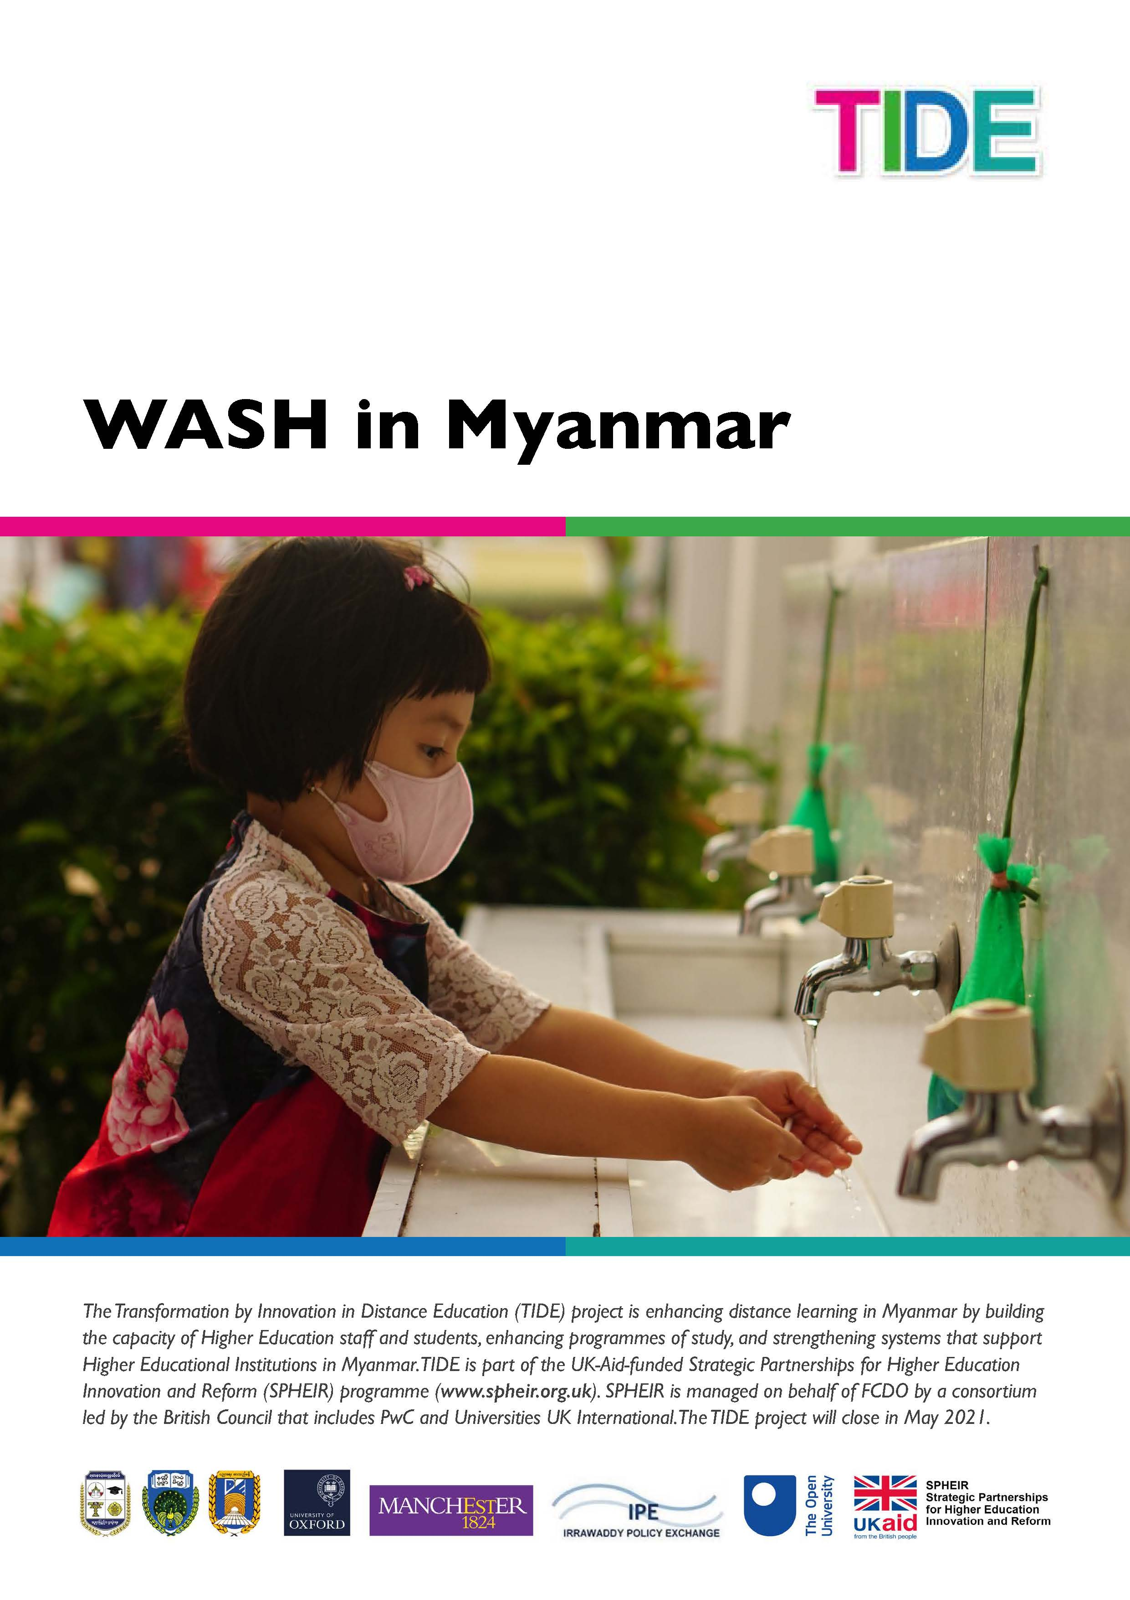
Contents

Study Session 1 Water Supply in Myanmar 6
Learning Outcomes for Study Session 1 6
1.1 The basic need for water 7
1.2 The different uses of water 8
1.2.1 Water for domestic use 9
1.2.2 Water for agricultural use 9
1.2.3 Water for industrial use 10
1.3 Water sources in Myanmar 12
1.4 The challenges for water supply in Myanmar 14
1.4.1 Seasonal variation 15
1.4.2 Regional variation 16
Summary of Study Session 1 19
Answers to in-text questions 20
References 21
Study Session 2 Water and Public Health 22
Learning outcomes for Study Session 2 22
2.1 Water for human consumption 23
2.1.1 Importance of water for human health 23
2.2 Diseases associated with water 25
2.2.1 Waterborne diseases 25
2.2.2 Water-washed diseases 27
2.2.3 Water-based diseases 28
2.2.4 Water-related diseases 29
2.3 Major diseases associated with water in Myanmar 30
2.3.1 Diarrhoeal diseases 30
2.3.2 Malaria 31
2.4 Water quality assessment 32
2.4.1 Physical tests 32
2.4.2 Chemical tests 33
2.4.3 Microbiological tests 34
2.5 Water provision in Myanmar 34
Summary of Study Session 2 35
Answers to in-text questions 36
References 36
Study Session 3 Introduction to Sanitation and Waste Management 37
Learning outcomes Study Session 3 37
3.1 What are sanitation and waste management 38
3.2 Types of liquid and solid waste 40
3.2.1 Types of liquid waste 40
3.2.2 Types of solid waste 41
3.3 The sanitation ladder and waste hierarchy 42
3.3.1 The sanitation ladder 42
3.3.2 The waste hierarchy 44
3.4 Sanitation and waste management in urban areas 45
3.4.1 The trend of urbanisation 45
3.4.2 Environmental challenges 47
3.5 The present state of sanitation and waste management in Myanmar 49
3.5.1 Liquid waste 50
3.5.1 Solid waste 50
Summary of Study Session 3 53
Answers to in-text questions 54
References 56

Study Session 4 Human Values and Behaviour 57
Learning outcomes Study Session 4 57
4.1 The physical and the social environment 58
4.2 How does the social environment influence WASH practices? 60
4.2.1 Knowledge of WASH practices is not enough to change behaviour 60
4.2.2 Attitude, beliefs and traditions influence WASH practices 62
4.3 Other influences on WASH practices 64
4.3.1 Economic factors influence WASH practices 64
4.3.2 Gender, privacy and access issues influence WASH practices 65
4.3.3 Caring for the physical environment improves health outcomes 67
4.4 Making WASH practices socially accepted and valued 68
Summary of Study Session 4 70
Answers to in-text questions 71
References 73
Study Session 5 Personal Hygiene 74
Learning outcomes of Study Session 5 74
5.1 What is personal hygiene? 75
5.2 Public health importance of personal hygiene 75
5.2.1 Preventing faecal-orally transmitted diseases 75
5.2.2 Aesthetic values of personal hygiene 75
5.2.3 Social impact 76
5.3 Components of personal hygiene 77
5.3.1 Body hygiene (skin care) 77
5.3.2 Oral hygiene (oral care) 78
5.3.3 Handwashing (hand care) 79
5.3.4 Face hygiene 80
5.3.5 Fingernail and toenail hygiene (nail care) 81
5.3.6 Ear hygiene 81
5.3.7 Hair hygiene (hair care) 81
5.3.8 Foot hygiene (foot care) 83
5.3.9 Armpit and bottom hygiene 83
5.3.10 Clothes hygiene 83
5.3.11 Menstrual hygiene (Personal hygiene for women) 84
5.4 Planning for the improvement of your personal hygiene 85
Summary of Study Session 5 86
Answers to in-text questions 87
Study Session 6 Institutional Hygiene and Sanitation 89
Learning outcomes for Study Session 6 89
6.1 Scope of institutional hygiene 90
6.2 Public health importance of institutional hygiene 90
6.3 School hygiene and sanitation 91
6.3.1 Public health importance of school hygiene and sanitation 91
6.3.2 Components of school hygiene and sanitation 91
6.4 Health facilities 97
6.5 Public offices 97
6.6 Religious institutions 98
6.7 Identifying the problems related to hygiene and sanitation in an institution of your choosing 98
6.7.1 Carrying out WASH inspection 99
6.7.2 Making recommendations 101
Getting your messaging right 102
Summary of Study Session 6 103
Answers to in-text questions 104
References 104

Study Session 1
Water Supply in Myanmar
One of the most important elements that we need to look at to ensure good health and well-being is where our water is coming from. All living things need water for their survival. Water is one of the essential requirements for life. It is used for a variety of purposes by people, including drinking, food preparation, irrigation and manufacturing. Although water covers more than 70% of the Earth’s surface, less than 1% of it is available as fresh water – and this is not evenly distributed throughout the world. More than one billion people (one thousand million) worldwide, mostly in less developed countries, lack safe drinking water. Apart from the scarcity of water, there are many other challenges in providing a safe, adequate and reliable water supply in many parts of the world.
In this study session, you will learn about the different uses of water, how water gets to the inhabitants of cities, towns and villages in Myanmar and the challenges faced in delivering water to people.
Learning Outcomes for Study Session 1
When you have studied this session, you should be able to:
- list the various ways in which water is used
- describe how water gets to consumers in cities, towns and villages in Myanmar
- understand the seasonal and regional variability of water supply in Myanmar
- identify the challenges involved in providing safe and adequate water for people in Myanmar.

1.1 The basic need for water
Water is essential for the proper functioning of the body. Human beings can live for many days without food, but only three or four days without water. Each person needs to consume about 2–4.5 litres of water per day (depending on the climate and level of activity) for their body to function properly. According to national and international guidelines, the quantity of water available to all people should be 50–100 litres per person per day, or an absolute minimum of 20 litres per person per day (UNDP, 2006).
The water must be safe for drinking and other household uses. Drinking water must be free from pathogenic (disease-causing) micro-organisms (tiny living organisms that you can see only with a microscope), and free from chemical and physical contaminants that constitute a danger to a person’s health. It must also be free from colour and odour. Water must be within safe physical reach, in or near the house, school or health facility. According to the World Health Organization (WHO), the water source has to be within one kilometre of the home and collection time should not exceed 30 minutes (UNDESA, 2014).
As well as being physically accessible, water should be reasonably priced and affordable for everyone. This means that the cost of water must be kept low and essential amounts of water must sometimes be provided free. The requirements for drinking water are summarised in Figure 1.1.
Figure 1.1 Requirements for drinking water

Water in rural areas in Myanmar is largely provided free through village ponds, communal rainwater collection tanks, wells and springs which are managed by water management committees. The treatment of this water happens in the home by filtering through cloth and boiling. In the cities and towns there is some piped water into people’s homes, but most rely on deep tube wells and/or bottled water, all of which are paid for.

1.2 The different uses of water
Water is used in many ways in Myanmar: for domestic purposes; in industry; and in farming (for agriculture and animal-rearing) as shown in Figure 1.2. But the quality and quantity of water for each use is different. Water for domestic purposes needs to be of high quality but is used in relatively small amounts, whereas usage in industry or agriculture can be of a lower quality but the demand is much higher in terms of quantity.

Figure 1.2 Main water uses in Myanmar

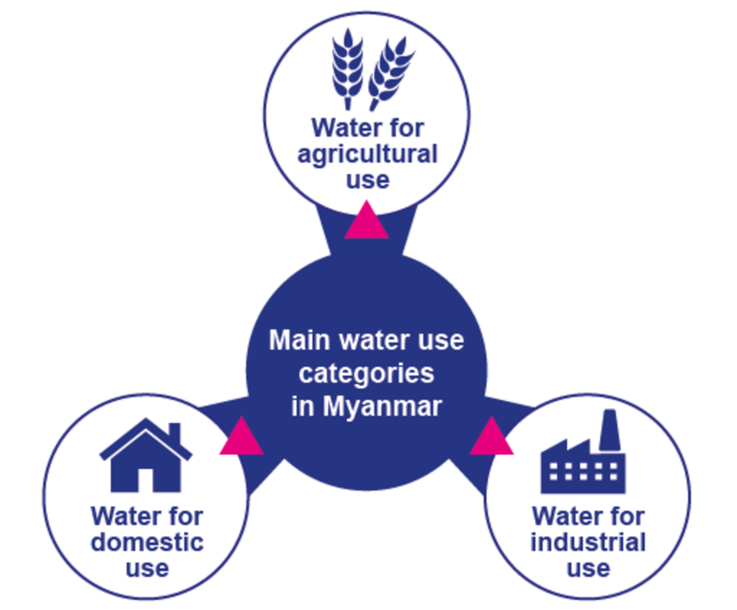

1.2.1 Water for domestic use
In-text question 1.1
Can you think of five uses for water in your daily life?

The quality of water required for domestic use needs to be high to safeguard health. Piped water supplies in towns and cities that come from drinking water treatment plants should be safe to drink but poor maintenance means this is not always the case.
The 2014 census reveals that about 70% of households in Myanmar have access to sources of drinking water that are protected from contamination, particularly by faecal matter, compared to 90% across Southeast Asia (Government of Myanmar, 2017). This is nine in 10 households in urban areas, and six in 10 households in rural areas.
Domestic use is growing because more people are moving to the towns and cities, a process called urbanisation. Currently, fewer than 30% of the population – or nearly 15 million people – live in urban areas. People living in towns and cities are more likely to have a piped water supply into their homes. This makes them wash and bathe more frequently. Some may even have water-using appliances like washing machines.

1.2.2 Water for agricultural use
Myanmar is largely an agricultural economy with both society and agriculture relying heavily on rainwater. Too much rainfall causes floods and too little causes droughts, both of which have a negative impact on agricultural production.
The Government of Myanmar has focused on rural development to grow the country’s economy. This is because over two-thirds of the population live in rural areas and most are engaged in subsistence farming.
Rice, which is a water-intensive crop, is the main crop and staple food. More than half of the Ayeyarwady Delta region, where agriculture is concentrated, is cultivated with rain-fed rice. In the dry season, rice is mostly cultivated in Lower Myanmar using irrigation.
Irrigation is supplied through water diversion with canals, weirs, dams and tanks, and in recent years with substantial development of an infrastructure of water pumps and tube wells (Figure 1.3).

Figure 1.3 Irrigation of agriculture through diversion of water from canals

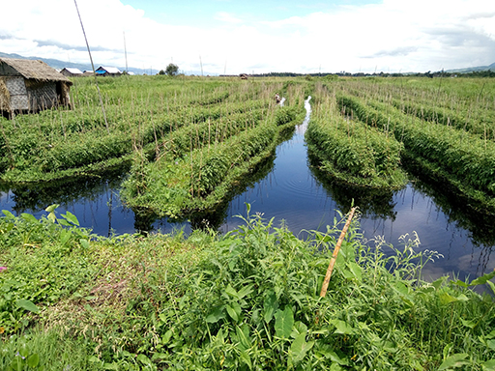

Water is also used for supporting livestock such as cows, goats and pigs and for aquaculture. Aquaculture is basically farming (aquatic organisms) in water, rather than on land. Water is used to hatch fish eggs under controlled conditions, and the fish are grown to maturity in tanks or ponds, before being sold for food. Aquaculture is widespread in the coastal regions and the Ayeyarwady Delta, particularly shrimp farming, and is growing. In 2017, aquaculture supplied a fifth of all fish eaten in Myanmar (Van Beijinen, 2018).

1.2.3 Water for industrial use
In many industries water is essential. Some industries use piped water supplied from water treatment plants while others draw the water from underground sources and treat it on site for use.
The water may be used either as part of the production process, for cooling, washing, diluting, boiling or cooking, transportation of raw materials (for example, moving potatoes in a food factory), and as a cleaning agent. It can also be used directly as an ingredient for the product, for example in a soft-drink plant. Hydropower and mining are the two most important industries using water in Myanmar with other industry use still quite small.

Hydropower is energy that can be harnessed from a continuous flow of water, such as a river. It is a renewable source of energy because the water cycle is constantly renewed by the sun. Modern hydropower plants produce electricity using turbines which spin with the moving water. The turbines are connected to a generator where the mechanical energy is converted into electricity.
However, it is important to realise that in hydropower the water is not ‘used’ in the sense of being consumed, because after passing through the hydropower plant the water continues on its path in a river channel. Myanmar has been accelerating its hydropower development as it offers a renewable source to meet the country’s growing domestic electricity needs.
The other major user of water in industry is for mining. Mining activities use huge amounts of water in processing ore to extract minerals.
Myanmar is richly endowed with mineral resources including copper, gold, lead, zinc, silver, tin and nickel. It also has extensive gemstone deposits, and oil and natural gas fields (see Figure 1. 4).
Figure 1.4 Sluice Mining for rubies and sapphires in Mogok, Mandalay Region, which needs large volumes of water
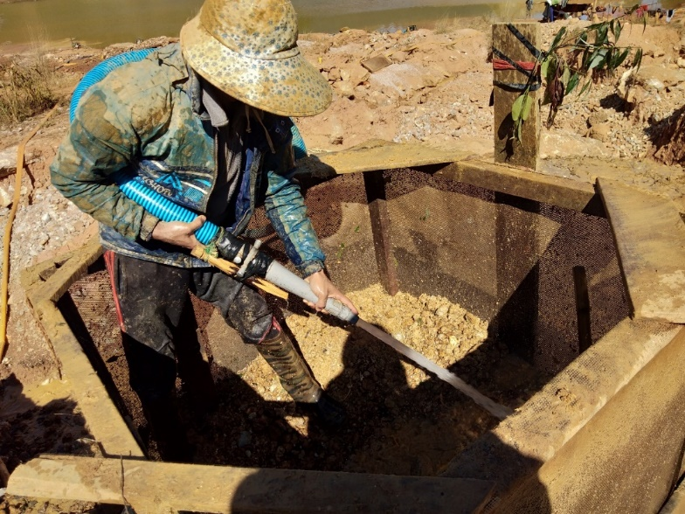

1.3 Water sources in Myanmar
All water comes from three basic sources: groundwater; surface water; and rainwater.
Groundwater includes all water that is found underground within the rocks. Surface water means water in rivers, lakes, pools and ponds. Rainwater replenishes both groundwater and surface water and can also be collected directly.
The water supply originates from one of the following basic sources:
- A spring (a point where groundwater emerges at the surface of the ground), from where the water can be carried or piped to consumers. A spring may flow throughout the year or only at certain times.
- A well or borehole. These may supply individual residences or a large number of houses where the water is delivered through a network of pipes. In addition to this, institutions such as schools, health facilities, religious establishments, small commercial enterprises and industries may have their own water supply system from hand-dug or deep wells.
- Surface water from rivers and lakes, which may be abstracted directly or stored in a reservoir created by building a dam across a river. Abstraction means taking water from the source so that it can be used.
Springs and wells are considered improved sources of water if they are constructed and used in such a way that they adequately protect the water from contamination, especially by faecal matter.
Spring or well water is generally used with minimal or no treatment. Surface water is an unimproved source and will require some form of treatment before it is safe to use for drinking. In larger towns and cities, surface water is treated in a water treatment plant before being distributed to consumers.
The term raw water is used to describe the water before it is treated.

In-text question 1.2
Demand for water fluctuates throughout the day. Why do you think this is?

Continuity of supply is important so that people can be confident that water will be available when they need it. Where the supply of water is not continuous, many households have storage tanks to accumulate water for use when the supply is off.
It is important to check the cleanliness of the storage tank regularly, and to clean and disinfect it as necessary.

In-text question 1.3
In many towns and cities in Myanmar, if you turn on a water tap at any random time it is quite likely that you will not get any water. Why do you think this happens?

1.4 The challenges for water supply in Myanmar
Myanmar is a country in a favourable situation with respect to water resources. It has eight major river basins (the area of land that is drained by a river and its tributaries) which cover large areas of the country and provide natural resources for many livelihood sectors (Figure 1.5).
But despite these abundant water resources, there are marked seasonal and regional variations in water supply.

Figure 1.5 The major river basins in Myanmar

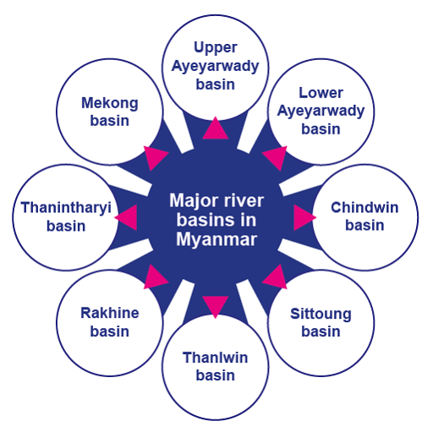

1.4.1 Seasonal variation
Water supply varies according to the season (Figure 1.6). At times of poor supply, users may be forced to obtain water from alternative sources. These are often of inferior quality and far away. As a consequence, the health of people will be put at risk by poor quality and low quantity of water. In addition, considerable time and effort are spent on collecting water.
Myanmar has three seasons. The cool winter season is followed by a hot summer season, which is followed by the rainy season dominated by the southwest monsoon. Temperatures are increasing while the length of the monsoon is decreasing. A shorter monsoon means more intense rainfall, leading to flooding, contamination of water resources and more limited replenishment of waterways.

Figure 1.6 Myanmar’s climate is subtropical and tropical.

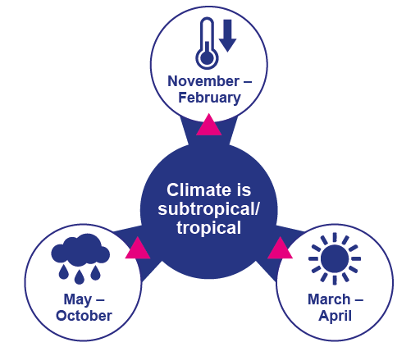

1.4.2 Regional variation
Just as there is seasonal variation in the availability of water, so it is also not distributed evenly across the country. The Central Dry Zone, whose agricultural productivity is crucial for the country, experiences water scarcity (Figure 1.7). Climate change is having severe impacts on agricultural production with changes in rainfall patterns and rising temperatures increasing the likelihood of crop failures in the short run and production declines in the long run.
Watch this eight-minute video called ‘The Last drop’ on the water challenges faced by villagers in central Myanmar where climate change means longer and more intense dry seasons and worsening local livelihoods. Then answer the question. You will need to scroll down to near the bottom of the page to find the video.
https://www.sei.org/featured/rural-myanmar-frequent-intense-droughts-affecting-local-livelihoods/

In-text question 1.4
What changes in water availability have the villagers noticed?
What are the economic impacts of weather uncertainty and water scarcity?

In the hilly zone in the north of the country unsustainable agriculture practices of slash-and-burn and deforestation are eroding slopes, increasing flooding, building up sediment and contaminating water supply (Government of Myanmar, 2014).

Figure 1.7 The three agricultural zones of Myanmar (Government of Myanmar, 2012)

The challenge in any situation is to maintain a year-round supply of water that is adequate to meet people’s needs. Planning for present and future demand should consider population growth and location. The demand for water is increasing in cities and towns as a result of a growing population and the migration of people from rural areas to towns in search of jobs and a better life. The quantity of water required for domestic use depends not only on the number of people but also on their habits and culture, and on how accessible the water is. There are also increasing demands from industrial development.
As water supply systems improve and access increases, the consumption of water will increase also. It is therefore important for water supply planners to consider the expected changes in society and in living standards. Planning of water supply projects should also consider the water requirements of schools, hospitals and other health facilities, religious institutions, hotels and other community facilities.
The Myanmar government has begun this process through the launch of a National Strategy for Rural Water Supply, Water and Sanitation, WASH in Schools and WASH in Health Facilities, 2016-2030 (2016). The strategy sets out to meet the needs of the rural population for improved domestic water supply, improved sanitation and improved hygiene practice. However, it does not cover urban water supply and sanitation.
There are many challenges that need to be overcome for the strategy to be successful. Shortage of funding means that maintenance of existing water supply and sanitation facilities is poor, which means they regularly break down. Coordination of services is fragmented between different levels of government: Union; State/Region; District; and Township.
The roles and responsibilities within government departments for parts of the water sector is unclear with duplication and gaps. Data-gathering on all aspects of WASH is poor. For example, the gender aspects of WASH have received little consideration up to now even though women and girls have the main responsibility for domestic water and for household sanitation as was shown in the video.
At the beginning of this study session, you read that water supply must be accessible and affordable. It is important that affordability extends to all sectors of society, including vulnerable people. Vulnerable groups include low-income households, older people and disabled people. Equitable access to water supply for all these groups should be taken into consideration.
The following changes will all contribute to future success:
- an increase in funds for the expansion of water supply services to satisfy the demand of growing populations, particularly in towns and cities
- an increase in human resource capacity and expertise at different levels to ensure better maintenance of existing water infrastructure
- better coordination between the different levels of government, and within government departments
- the collection of data to improve and monitor services and accessibility
- better information management systems, giving early warning of requirements.

Summary of Study Session 1
In Study Session 1, you have learned that:
- Water is essential for life. Drinking water must be safe, of adequate quantity, accessible and affordable.
- Water has several uses of which the most important are domestic, agricultural and industrial. The quality of water acceptable for the various uses can be different.
- Water supply may originate from springs, wells or surface water. Water from springs and wells is generally used without any treatment, while surface water needs treatment before it is safe to drink.
- Water supply planning must take account of present and future water demand by people, and by industrial and agricultural development. Domestic use is likely to increase as living standards improve. Planning also needs to consider the needs of schools, health facilities and other institutions.
- There are many challenges facing water supply in Myanmar and several factors that can contribute to overcoming them, including more funding, increasing capacity, better coordination between the different levels of government and across government departments and better data collection and information management.

Answers to in-text questions
1.1 We use water in our homes, both indoors and outdoors. Uses include for drinking, food preparation, washing hands, bathing/showering, brushing teeth, toilet-flushing (if there is a flush toilet), cleaning, washing clothes and dishes, and watering plants.
1.2 People generally use more water in the mornings and evenings when they are washing and cooking. Usage during the night while people are asleep will be much lower.
1.3 It may be because demand for water exceeds the supply available at that time. It can also happen due to a power failure or poor maintenance.
1.4 A nearby pond where water was collected has dried up, which means the villagers need to travel much further to another pond to get water. Before the government’s involvement, they had been unsuccessful in sinking wells that produced water. They also need to buy water.
Farmers’ crop yields are low because of the variable rainfall and resulting droughts which means they earn less from their labour.

References
Government of Myanmar (2012) Myanmar’s National Adaptation Programme of Action (NAPA) to Climate Change [Online]. Available at:
https://unfccc.int/ resource/ docs/ napa/ mmr01.pdf (Accessed 16 April 2020).

Government of Myanmar (2014) Myanmar IWRM Strategic Study [Online]. Available at:
https://english.rvo.nl/ sites/ default/ files/ 2015/ 02/ Myanmar%20Integrated%20Water%20Resources%20Management%20from%20vision%20to%20action_1.pdf
(Accessed 15 April 2020).

Government of Myanmar (2016) National Strategy for Rural Water Supply, Water and Sanitation (WASH), WASH in Schools and WASH in Health Facilities [Online]. Available at: https://www.myanmarwaterportal.com/repository/623-national-strategy.html.
(Accessed 2 November 2020).

Government of Myanmar (2017) The 2014 Myanmar Population and Housing Census. The Republic of Myanmar. Department Population, Ministry of Labour, Immigration and Population with Technical assistance from UNFPA, pp 2–12.

United Nations Department of Economic and Social Affairs (UNDESA) (2014), International decade for action Water for life’ 2005–2015’ [Online]. Available at:
http://www.un.org/ waterforlifedecade/ human_right_to_water.shtml
(Accessed 20 February 2015).

United Nations Development Programme (UNDP) (2006) Human Development Report 2006: Beyond Scarcity: Power, Poverty and the Global Water Crisis, Basingstoke and New York, Palgrave Macmillan [Online]. Available at:
http://hdr.undp.org/ en/ content/ human-development-report-2006
(Accessed 3 June 2015).

Van Beijinen, J. (2018) The future of fish farming in Myanmar [Online]. Available at:
https://thefishsite.com/ articles/ the-future-of-fish-farming-in-myanmar
(Accessed 12 April 2020).

Study Session 2
Water and Public Health
In Study Session 1 you read about the need for an adequate, safe and accessible water supply. If there is an insufficient quantity of water, or if the water is contaminated, this can have serious effects on people’s health and can be the cause of many different illnesses – even death.
In this study session you will look at what is meant by safe and unsafe water and learn why water is important for human health. You will also consider the various classifications of diseases that are associated with unsafe water and be introduced to the types of test used to assess water quality.
Learning outcomes for Study Session 2
When you have studied this session, you should be able to:
- understand the importance of water for the human body
- understand the different ways in which water is involved in the transmission of human diseases
- describe the situation in Myanmar in relation to diseases from unsafe water.

2.1 Water for human consumption
Water for human consumption must be palatable and safe. Palatable water is pleasant to drink, meaning it is completely clear and free from tastes, odours (smells) and colours.
Safe drinking water, also known as ‘potable water’, is defined as water that does not contain harmful or potentially harmful substances and does not present any risk to human health. Harmful substances can be in the form of micro-organisms or chemicals.
Unsafe water is a cause of bad health for people of all age groups. There are, however, some groups of people who are at greater risk. These include infants and young children, older people and people who are debilitated by diseases (such as HIV/AIDS).

2.1.1 Importance of water for human health
Water makes up about 70% of an adult human being’s weight. In the human body, blood contains about 82% water and our brain is made up of about 95% water. Losing just 2% of our water content can result in signs of dehydration, fuzzy short-term memory and difficulty in focusing on smaller print or words displayed on a computer screen.
Water plays several roles in supporting human health. It helps us keep our environment clean. It is essential for good personal hygiene, particularly washing our hands, and it is used to wash places in our homes, such as toilets, that could possibly harbour harmful micro-organisms (Figure 2.1).
Figure 2.1 Water supporting human health
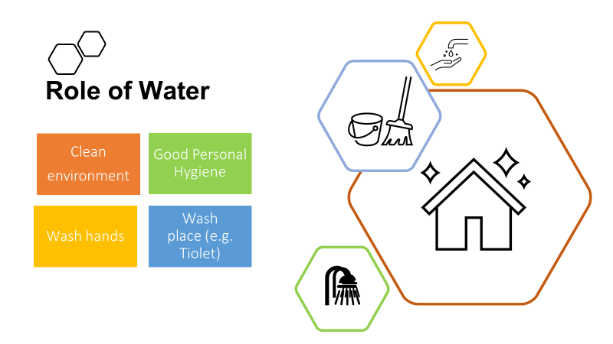

Water is also vital for many bodily functions (see Figure 2.2).
Many of our foods are prepared with water and others naturally contain large amounts of water (e.g. milk is made up of approximately 88% water; eggs 66%; fish 80%; potatoes 75%; and beef 77%).
Inside the body water serves as a lubricant during digestion of our food. Water in saliva makes chewing and swallowing easier, and the food goes down into the stomach with the help of water. The functions of all the body’s cells and organs depend on water.
Water is involved in transporting valuable nutrients around the body in the bloodstream. Nutrients are broken down in the digestive system and transported to where they are needed in the body.
Water is used by the body to remove harmful toxins and wastes through urination and perspiration. Water also helps to reduce constipation. Drinking enough water helps body organs such as the kidneys and the liver to get rid of waste products.
Water helps to regulate body temperature. The body controls over-heating through perspiration. When sweat evaporates from the surface of the skin, it takes heat from the body and produces a cooling effect.

Figure 2.2 Water functions in the body

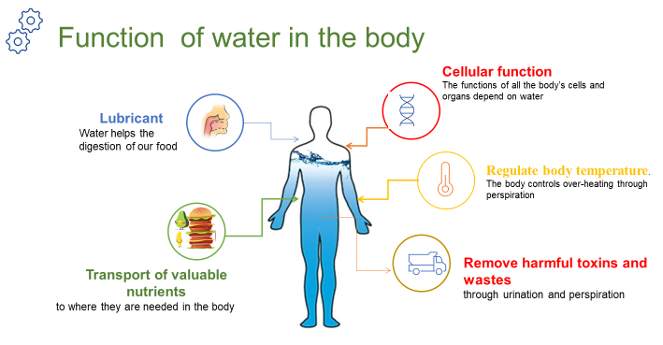

2.2 Diseases associated with water
Most water-related health problems are caused by infectious agents that can invade the body and cause disease. They include pathogenic (disease-causing) bacteria, viruses, protozoa and parasites. Infectious agents can cause disease when they are ingested (eaten or swallowed) or otherwise come into contact with the human body.
The different ways in which water is involved in this contact can be used to classify the diseases into four main groups:
- waterborne
- water-washed
- water-based
- water-related

2.2.1 Waterborne diseases
Waterborne diseases are caused by people ingesting water contaminated by human or animal faeces containing pathogens. Such diseases can also be caused by food that has been prepared using water contaminated with pathogens. The diseases are caused only when the infectious agent enters the body. Waterborne diseases include diarrhoeal diseases which are caused by bacteria and viruses. Bacteria are unicellular organisms (made of one cell) and are very small. Viruses are microscopic infectious particles, much smaller than bacteria, that can only reproduce when inside the living cells of organisms. Waterborne diseases also include some caused by protozoa (single-celled micro-organisms that are much larger than bacteria) and helminths. Helminths is a general term for worms, usually applied to those that are parasites on humans and other animals. These causative agents of disease in unsafe water are shown in Figure 2.3.
Figure 2.3 Causative agents of disease in unsafe water

Although drinking contaminated water is a very significant route of transmission for many of the diseases, they may also be transmitted by other means such as by eating contaminated food. Food can become contaminated by poor hygiene during preparation. We use our fingers for eating and frequently put our hands to our mouths; touching contaminated surfaces can also be a route for disease transmission (Figure 2.4).
Figure 2.4 Using our fingers for eating can lead to the transmission of disease if good hygiene is not practised.
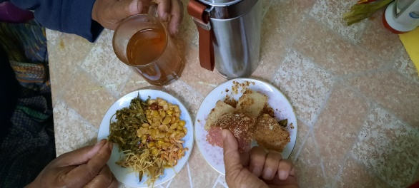

Field (or soil) infection can happen through eating unwashed vegetables and fruit grown in soil contaminated by faeces. Flies are also major transmitters of contamination from faeces to food. Infections can also be transmitted through dirty floors if food is dropped on the floor and then picked up and eaten (Figure 2.5).
Figure 2.5 Methods of disease transmission
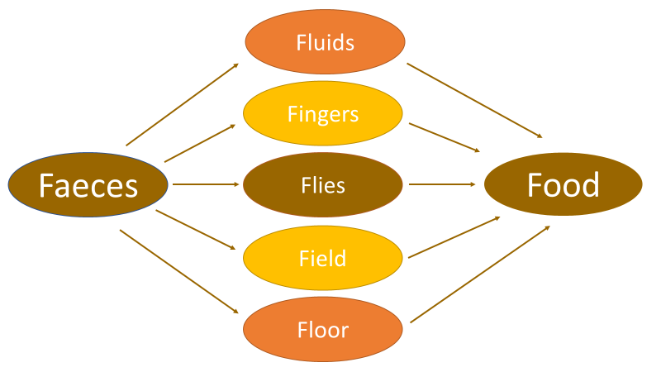
In-text question 1.1
How could poor personal hygiene by people preparing food cause disease?

In all these cases, the origin of the contamination is faeces of people who are already infected by the disease. Some diseases may be transmitted via the faeces of infected animals. In places without adequate sanitation and where people defecate in the open, waterborne disease is far more likely to occur. By sanitation, we mean the prevention of human contact with wastes. If faeces are effectively separated from people, then the transmission routes of waterborne diseases are broken. Examples of common waterborne diseases are cholera and typhoid.
Watch this short video and answer the question.
https://www.youtube.com/watch?v=SDiH_6nndwU

In-text question 1.2
What does this video show?

2.2.2 Water-washed diseases
Water-washed diseases are those that occur as a result of inadequate quantities of water being available for good personal hygiene. Good personal hygiene habits include:
- washing hands with soap, or using an alternative such as ash, after using the latrine (Figure 2.6)
- washing hands before preparing and/or eating food
- washing the body frequently
- cleaning the teeth at least once a day
- washing the hair with soap or shampoo at least once a week.

Figure 2.6 The steps in a thorough technique for handwashing

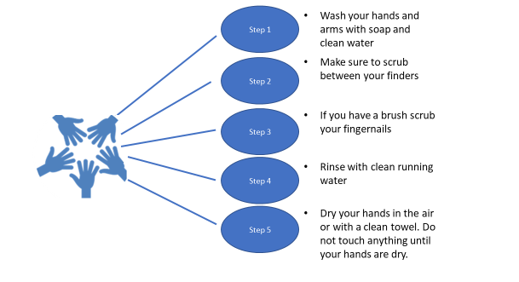
Water-washed diseases include fungal skin diseases such as ringworm, diseases of the eye such as trachoma and conjunctivitis, and infections caused or carried by lice, mites, fleas or ticks. Scabies – a skin disease – is caused by mites for example. Adequate quantities of clean water can prevent such diseases affecting a population.

In-text question 1.3
Why do you think this is so?

2.2.3 Water-based diseases
Water-based diseases are caused by parasites that spend part of their life cycle in water. Water-based diseases such as bilharzia are caused by helminths, but they do not get into the body as a result of ingesting contaminated water or food. This is a water-based, not a waterborne disease. The worm enters the body by penetrating through the skin. It has a complicated life cycle and spends part of its life in a human body and part in a particular species of water snail. This is why bilharzia is called ‘snail fever’ in Myanmar.

2.2.4 Water-related diseases
Water-related diseases are transmitted by insects that breed or feed in or near bodies of water. The best-known example is malaria, which is spread by the Anopheles mosquito (this disease will be described in Section 2.3.2).
Water-related diseases are not associated with lack of access to clean drinking water or to hygiene and sanitation services. They are caused by the presence of standing water, which provides a habitat for the insects to breed as shown in Figure 2.7. Other water-related diseases include dengue fever and yellow fever (also spread by mosquitoes).

Figure 2.7 A dam leads to standing water, a perfect breeding ground for mosquitoes

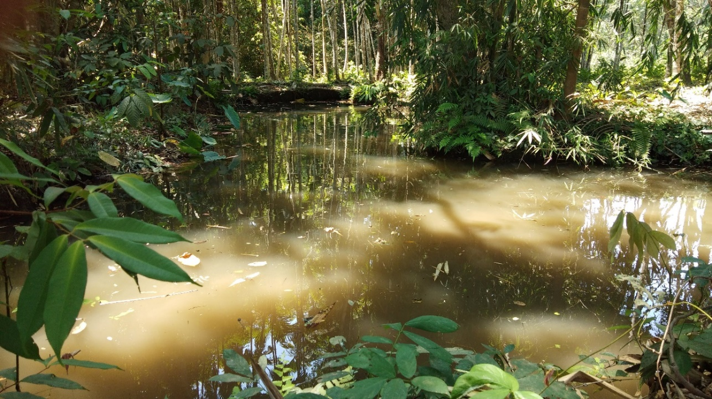

2.3 Major diseases associated with water in Myanmar
The major water-associated diseases in Myanmar (CIA, 2000) are:
- diarrhoea
- hepatitis A
- typhoid fever
- malaria
- dengue
- Japanese encephalitis
Below we look at two of the most common diseases associated with water in Myanmar, diarrhoea, and malaria.

2.3.1 Diarrhoeal diseases
Diarrhoea is a symptom of many waterborne diseases. Globally, there are nearly 1.7 billion cases of childhood diarrhoeal disease every year and it is the cause of over half a million child deaths each year (WHO, 2017).
A significant proportion of diarrhoeal disease can be prevented through safe drinking water and adequate sanitation and hygiene (Figure 2.8). Children, especially those under five years of age, are vulnerable to infection because they frequently put their unwashed fingers in their mouths.
Figure 2.8 The bacteria responsible for many cases of diarrhoea (Gram stain X1000, and on EMB agar)
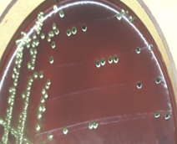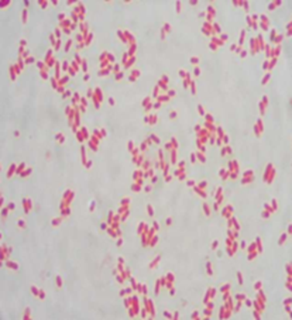

2.3.2 Malaria
Malaria is a parasitic disease transmitted by the female Anopheles mosquito and caused by the pathogenic protozoa Plasmodium. When a mosquito bites an infected individual, it sucks up blood containing the parasite. If it then bites a healthy person, the protozoa are transferred into their blood and they can become ill.
The mosquitoes breed in standing water such as swamps, lakes, pools and open channels dug for crop irrigation; even a puddle can provide enough water for mosquitoes to breed. Only the female mosquitoes take human blood, which is needed to develop their eggs. The most likely time for Anopheles mosquitoes to bite is in the early evening or at night.

In-text question 1.4
Can you think of ways to avoid being bitten by mosquitoes?

2.4 Water quality assessment
Many analytical methods are used to test for the presence and concentration of possible contaminants in water. Concentration is the measure of the quantity of a substance dissolved in a known volume of water. For water quality assessment, the units used are usually milligrams per litre, which is written as mg/l.

2.4.1 Physical tests
Physical tests are the easiest water assessment test as they do not need to be analysed in the laboratory. Anyone can assess the turbidity (cloudiness caused by a large number of very tiny particles), colour, taste and odour of water (Figure 2.9).
As you know water should be free of tastes and odours that would be unpleasant to most people. In extreme cases, people may avoid water that does not look or taste good – even if it is otherwise safe – in favour of something more pleasant-looking and tasting water that may actually be contaminated.
Figure 2.9 Physical testing of water quality (Photo: Laura Richards)
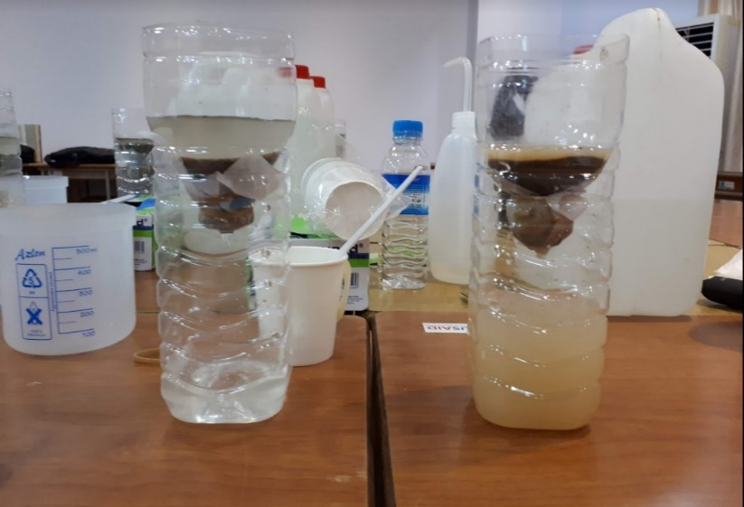

Colour in drinking water occurs due to the presence of dissolved organic matter (once living) and metals such as iron and manganese. Colour can come from industrial pollution such as from dyes used in textile manufacture. Odour in water is due mainly to the presence of organic substances. Taste is the combined perception of substances detected by the senses of taste and smell.
Changes in the normal taste of a piped water supply can be important as they may signal changes in the quality of the raw water source or deficiencies in the treatment process.

2.4.2 Chemical tests
Although the great majority of health-related water quality problems are the result of biological contamination, chemical contamination of water sources can also cause serious health problems and is analysed in the laboratory (Figure 2.10). For example, arsenic levels exceed WHO guidelines for drinking water in large parts of the Ayeyarwady Delta. Long exposure to arsenic in drinking water is highly toxic and can lead to cancers and skin lesions.

Figure 2.10 Conducting a pH test of river water
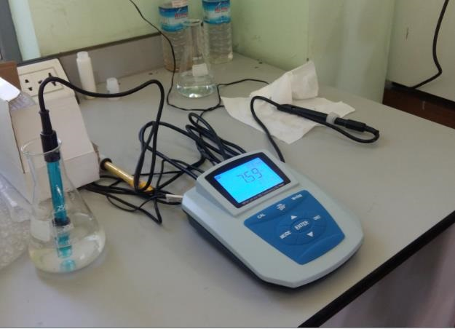

2.4.3 Microbiological tests
There are many different types of pathogenic micro-organisms that may be present in water, but it would be very difficult and time-consuming to test for all of them.
The source of the pathogens is usually human faeces; therefore, laboratory tests have been devised that detect the presence of faecal contamination. If faecal contamination is found, this indicates that pathogenic organisms may be present (Figure 2.11).

Figure 2.11 Faecal contamination test of river water

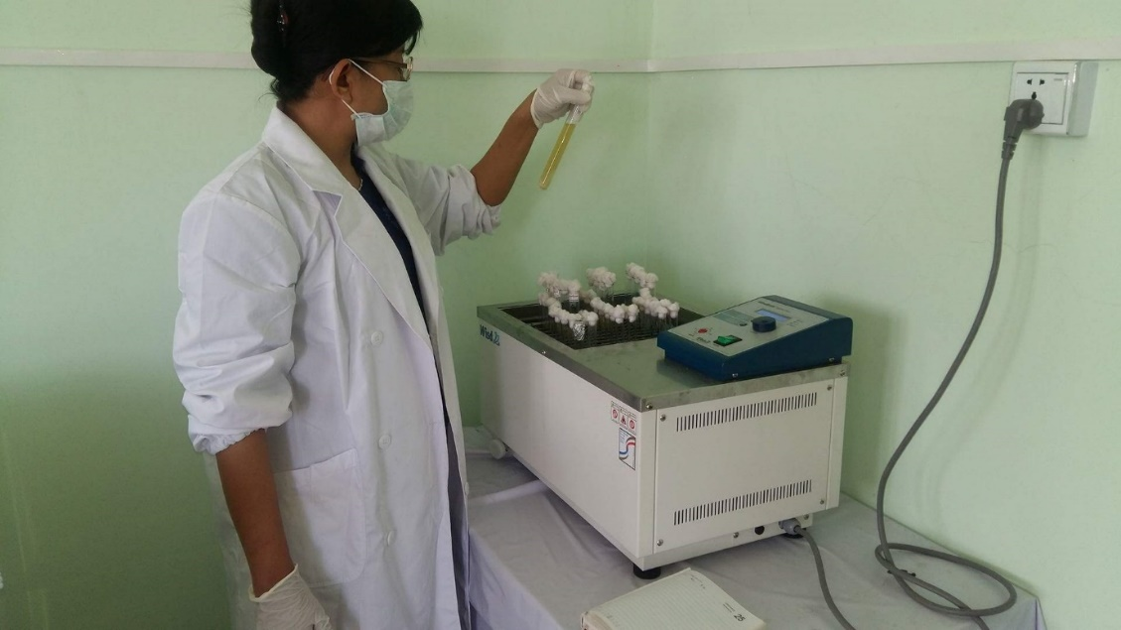

2.5 Water provision in Myanmar
An important step in developing the water supply issues in Myanmar has been the development of the Myanmar National WASH strategy for 2016–2030. The strategy outlines key WASH actions in rural areas, schools, healthcare facilities and in emergencies. It sets targets for a major rise in the quality and quantity of facilities country-wide for all the organisations working in or supporting the WASH Sector: Government; development partners; international NGOs; national and local NGOs; and private sector (Government of Myanmar, 2016).

Summary of Study Session 2
In Study Session 2, you have learned that:
- Water is essential to life. People can live for many days without food but for very few days without water.
- Water for public consumption must be palatable and safe.
- Unsafe water can seriously harm human health. Infants, young children, older people and people debilitated by disease are the most vulnerable.
- Water in the human body is essential for several bodily functions.
- The diseases associated with water can be classified as waterborne, water-washed, water-based and water-related.
- The causative agents of disease in unsafe water include bacteria, viruses, protozoa and helminths.
- The main water associated illnesses in Myanmar include diarrhoeal diseases and malaria.
- Detection of faecal contamination in drinking water indicate the likelihood of pathogenic organisms being present.
- Chemical contamination of water can cause health problems.

Turbidity, colour, taste and odour are important factors in water being acceptable to people.

Answers to in-text questions
1.1 If cooks do not thoroughly wash their hands before touching food, they could easily transfer contamination by infectious agents. When the contaminated food is eaten, this could pass on disease to the consumers.
1.2 The video shows that it is necessary to maintain a village well and to keep the area around it clean in order to avoid contamination of the water.
1.3 If plenty of water is available, people can wash frequently, and the disease-causing organisms will be washed away.
1.4 Wearing long-sleeved clothing and using insect repellents helps to keep people from being bitten. At night, mosquito nets (preferably impregnated with permethrin, which is toxic to mosquitoes) or various sprays or vapours can be used to keep them away.

References
Government of Myanmar (2016) National Strategy for Rural Water Supply, Water and Sanitation (WASH), WASH in Schools and WASH in Health Facilities. [Online]. Available at:
www.myanmarwaterportal.com/repository/623-national-strategy.html
(Accessed 2 November 2020).

Study Session 3
Introduction to Sanitation and Waste Management
All humans produce wastes of various types; for example, urine and faeces, wastes from washing and cooking, and solid wastes produced at home and in workplaces, schools, hospitals and other public buildings. All these wastes need to be controlled and managed for the benefit of people and the environment that they live in. Sanitation aims to protect people from contact with waste (particularly faeces) and waste management protects the environment so people can live healthy lives. In urban areas where people live close together and space can be limited, managing these wastes is a particularly difficult problem.
Learning outcomes Study Session 3
When you have studied this session, you should be able to:
- describe the similarities and differences between sanitation and waste management
- describe the sanitation ladder and the waste hierarchy
- describe the particular features of urban areas that influence sanitation and waste management
- understand the current level of sanitation and waste management in Myanmar.

3.1 What are sanitation and waste management
We can think of sanitation as the prevention of human contact with wastes, or as the provision of facilities and services for the safe disposal of human faeces and urine as shown in Figure 3.1. Inadequate sanitation is a major cause of disease world-wide.
Figure 3.1 Sanitation as facilities and services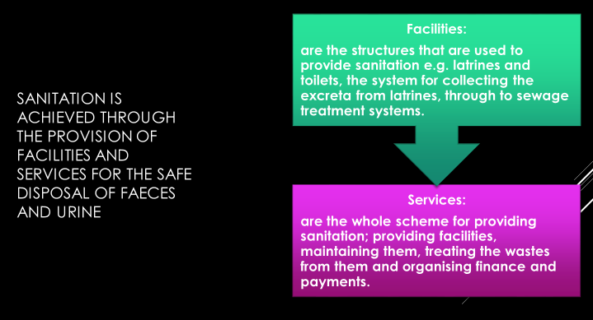
Waste management is the collection, transport, recovery and disposal of waste. The two terms – sanitation and waste management – both refer to waste, but sanitation is primarily concerned with liquid waste and waste management is primarily concerned with solid waste.
Liquid wastes are any wastes in a liquid form such as wastewater and sewage. Faeces and the contents of pit latrines and septic tanks are also classed as liquid wastes. Solid wastes are anything in solid form that is discarded as unwanted.
Throughout this course we will be using the following definitions:
- Sanitation means preventing people from coming into contact with wastes by providing facilities and services for the treatment and disposal of human excreta and other liquid wastes produced in homes, workplaces and public buildings.
- Waste management is the collection, treatment and disposal of solid wastes produced in the home, workplace, and public buildings.
Some of the consequences of a lack of waste management and sanitation can be seen in Figures 3.2.

Figure 3.2 Wastes including paper, plastics and other solid waste, litter the environment and are discharged into a river that may be used as a water source. (Photo: Susan Fawssett)

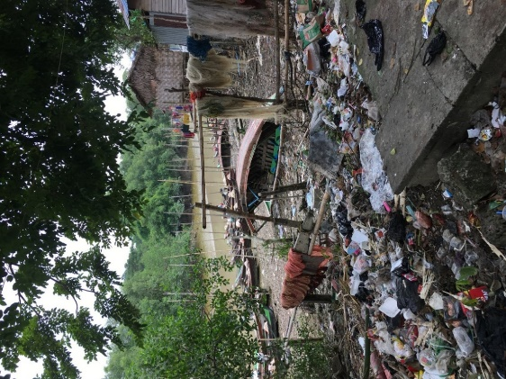

Although sanitation and waste management address different issues using different techniques, they have a number of features in common. For example, they both:
- deal with wastes
- are concerned with safeguarding human health and preventing disease
- cause major problems if not done correctly
- help to reduce environmental pollution (introduction into the environment of substances liable to cause harm)
- need to be paid for by the users, the city authorities, or the government.

3.2 Types of liquid and solid waste
Solid and liquid wastes are usually transported and treated in different ways, so we will consider the two wastes separately. Note that all human excreta (urine and faeces) are considered to be liquid wastes.

3.2.1 Types of liquid waste
A useful general classification of domestic liquid waste is shown in Figure 3.3.
Figure 3.3 Types of domestic liquid waste

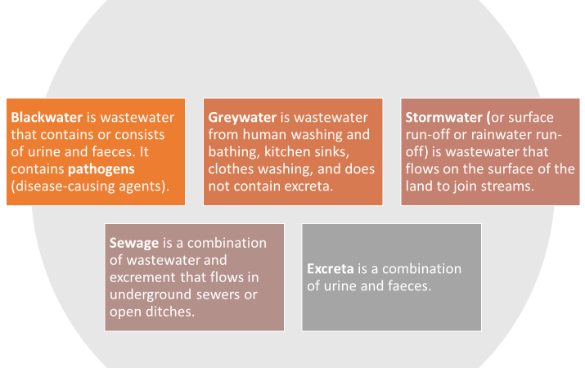

3.2.2 Types of solid waste
There are different ways of classifying solid wastes according to the source of generation or the nature of the waste. Solid waste can be categorised as follows:
- residential waste: from households and residential areas, sometimes called household waste
- commercial waste: from businesses such as food and drink establishments, shops, et cetera
- industrial waste: from various types of industrial processes, e.g. food processing, paper manufacture, manufacture of chemicals and metal processing
- institutional waste: from public and government institutions, e.g. offices, religious institutions, schools, universities, etc. This is similar to residential and commercial waste in composition
- municipal waste (or municipal solid waste) covers all the above wastes produced in an urban area. It is similar in composition to residential waste but excludes some industrial wastes
- healthcare waste: any solid waste produced in hospitals, clinics, health posts and other health facilities
- agricultural waste: waste that comes from farming
- waste from open areas: street sweepings, contents of roadside dustbins, ditches and other public places
- construction and demolition waste: from various types of building and demolition activities in urban areas
- electronic and electrical waste (e-waste): wastes generated from used electronic devices such as computers and TVs and household appliances such as fridges and washing machines.

3.3 The sanitation ladder and waste hierarchy
Generally speaking, all countries are aiming to improve their standards of sanitation and waste management and have many policies and regulations to try and achieve these improvements. The sanitation ladder and the waste hierarchy provide an excellent summary of these aims.

3.3.1 The sanitation ladder
The sanitation ladder provides a measure of progress towards the provision of adequate sanitation facilities for every household as shown in Figure 3.4
Figure 3.4 The WHO/UNICEF Joint Monitoring Programme (JMP) sanitation ladder

SERVICE LEVEL
DEFINITION
OPEN DEFECATION
Disposal of human faeces in fields, forests, bushes, open bodies of water, beaches or other open spaces, or with solid waste.
SAFELY MANAGED
Use of improved facilities which are not shared with other households and where excreta are safely disposed of in situ or transported and treated off-site
LIMITED
Use of improved facilities shared between two or more households
BASIC
Use of improved facilities which are not shared with other households
UNIMPROVED
Use of pit latrines without a slab or platform, hanging latrines of bucket latrines
SANITATION LADDER

The lowest rung of the ladder is open defecation (no service), where people without access to latrines or toilets deposit their faeces in open spaces such as fields, bushes, bodies of water and beaches.
Unimproved facilities are one step up and include latrines that do not ensure the separation of faeces from humans. Examples are pit latrines without a platform, hanging latrines or bucket latrines.
Then comes limited facilities where people use improved facilities, but they are shared with other households, for example a pit latrine with a slab or a composting toilet.
Then there is basic sanitation which is using improved sanitation facilities which are not shared with other households.
Finally, at the top of the sanitation ladder is safely managed facilities where human contact with faeces is avoided and disposed of in one of the following ways:
- treated and disposed in situ
- stored temporarily and then emptied and transported to treatment off-site, or
- transported through a sewer with wastewater and then treated off-site.
Improved sanitation facilities are the three categories at the top of the sanitation ladder, and unimproved sanitation facilities are the bottom two categories. Improved sanitation facilities are those designed to hygienically separate excreta from human contact and include flush/pour to piped sewer system, septic tanks and pit latrines, ventilated improved pit latrines, composting toilets or pit latrines with slabs.

3.3.2 The waste hierarchy
The waste hierarchy is shown in Figure 3.5. The hierarchy ranks the different ways of dealing with waste in order of priority. At the top is waste reduction, which means not generating waste in the first place or minimising the amount of waste produced. Below that is waste reuse (for example, refilling a drinks bottle), followed by recycling (processing of wastes into new raw materials). Then comes the recovery of energy by burning or biological treatment.
Waste disposal, ideally in a landfill site, is the final option for any wastes that cannot be dealt with in any other way. A landfill site is an area of land set aside for the final disposal of solid waste.
Figure 3.5 The waste hierarchy
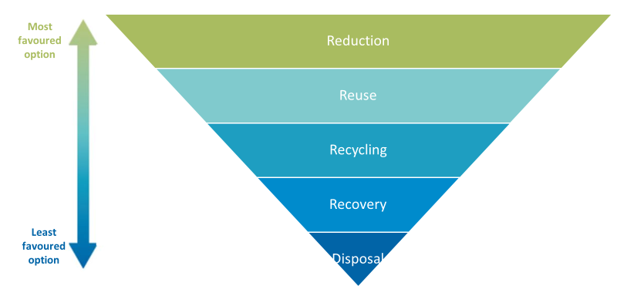

The top three stages of the hierarchy (reduction, reuse and recycling) are often referred to as the ‘3 Rs’.

In-text question 1.1
What are some of the ways that you could reuse wastes at home?

3.4 Sanitation and waste management in urban areas
Sanitation and waste management can cause problems in any community, regardless of its size. In urban areas, where people live close together these problems can have a much greater effect on people’s health and on their surroundings. The following sections explore some of these issues.

3.4.1 The trend of urbanisation
Over half of the world’s population live in urban areas. The United Nations Department of Economic and Social Affairs (2014) predicts that between 2014 and 2050 the global urban population will rise from 3.9 billion to 6.4 billion people, and that about 90% of this increase will be in Asia and Africa. Figure 3.7 looks at the percentage urban population in each of the ASEAN countries in 2019.
Figure 3.6 Urbanisation in the ASEAN countries 2019 (Plecher, 2020)

In-text question 1.2
Explain what Figure 3.6 shows about Myanmar’s urban population relative to other ASEAN nations?

Figure 3.7 Urban population growth rate of Myanmar from 2009 to 2019 (World Bank, 2020)

Figure 3.8 Flooding in an informal settlement of Yangon

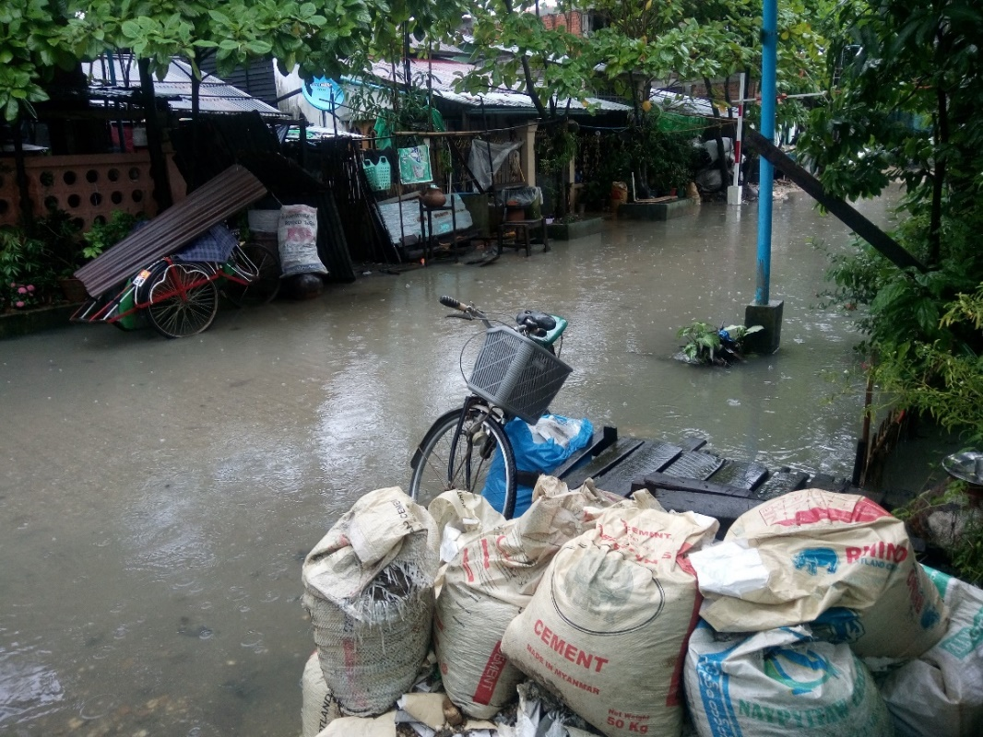
Rapid urbanisation creates a number of additional health risks to the population (Bai et al., 2012) to add to those caused by inadequate sanitation and waste management. These include:
- infectious diseases among crowded communities with substandard living conditions
- acute and chronic respiratory and other illnesses caused by air pollution
- chronic and non-communicable diseases that are on the rise with unhealthy urban lifestyles (physical inactivity, unhealthy diets, tobacco smoking, and the harmful use of alcohol)
- injuries resulting from motor vehicle collisions, violence and crime
- health risks related to climate change, such as heat stress and changed patterns of infectious disease, which are considered to be one of the biggest health risks in the twenty-first century.
In the next section we will look at some of these challenges in more detail.

3.4.2 Environmental challenges
Even without the influxes from rural areas, urban centres are congested and crowded. They have often grown without any planning, so the problems arising from the lack of sanitation, waste management and other infrastructure are present. Urban growth also means that there is an increase in the area of land covered with concrete and other hard surfaces.

In-text question 1.3
Why would an increase in the area of land covered with concrete or other hard surface be a problem?

Challenges from industrial discharges
Most industries in developing countries discharge untreated or partially treated liquid wastes to sewers, where these are available, or to rivers, streams or ditches. Industries also release waste gases that may contain harmful substances and produce solid wastes that may contain hazardous materials (such as poisons, strong acids, infectious material, et cetera that can cause harm to humans because of their properties). As a result, unregulated industries can harm human health and the environment in many ways.

Challenges from transport
We have already mentioned problems from traffic congestion, but the use of a large number of often badly maintained petrol- and diesel-fuelled cars, lorries and buses cause additional health problems. The exhaust gases from these vehicles contain fine particles, partly burned fuel and acidic substances that make breathing difficult and cause irritation of the lungs. While this is a problem for all people, it is much worse for the old, the very young and the ill, especially those with heart problems or who suffer from asthma.

3.5 The present state of sanitation and waste management in Myanmar
The WHO/UNICEF Joint Monitoring Programme (JMP) data for sanitation coverage in Myanmar in 2019 is shown in Figure 3.9.
Figure 3.9 Sanitation services accessed by people living in urban areas, rural areas and by the total population of Myanmar (JMP, 2020)

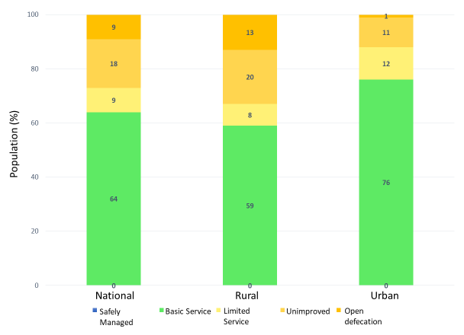

In-text question 1.4
What is the percentage of open defecation nationally in Myanmar?

3.5.1 Liquid waste
Though there have been improvements in recent years, Myanmar struggles to provide basic sanitation services as shown in Figure 3.9 which shows that 0% is safely managed. This is especially the case in areas affected by extreme poverty, conflict and natural disasters.
Only three cities (Yangon, Mandalay and Nay Pyi Taw) have piped sewerage systems or centralised wastewater treatment systems. Most households outside of these three cities in formal residential areas, have septic tanks but these are not routinely emptied and there is no systematic collection and treatment of domestic wastewater.
Households in informal settlements rely on improvised latrines and stormwater drains that carry untreated sewage in open channels. Furthermore, small-scale enterprises and industries often allow chemical waste (such as dyes for silk and weaving cloth) to run into the roadside drains causing pollution of water courses and groundwater (ADB, 2017).
Watch this video that looks at how a poor community in Yangon built their own latrines and improved hygiene in their neighbourhood thanks to a small-scale sanitation project supported by the Asian Development Bank.
Then answer the question. Whilst the video is narrated in English, we hear from the community members in Myanmar language.
https://www.adb.org/news/videos/four-cleans-myanmars-sanitation-challenge

In-text question 1.5
What was the situation before the sanitation project?
What is the situation after the sanitation project?

3.5.1 Solid waste
At present, solid waste collected by the respective townships and city development committees is transported to the final disposal sites, mostly open dumping sites located within city boundaries (Figure 3.10).
Waste separation at source and 3 R activities (reduce, reuse and recycle) are not widely prevalent in Myanmar, although some cities conduct public awareness-raising campaigns and environmental education programmes in order to promote 3 R activities.

Figure 3.10 Waste disposal site in Mandalay

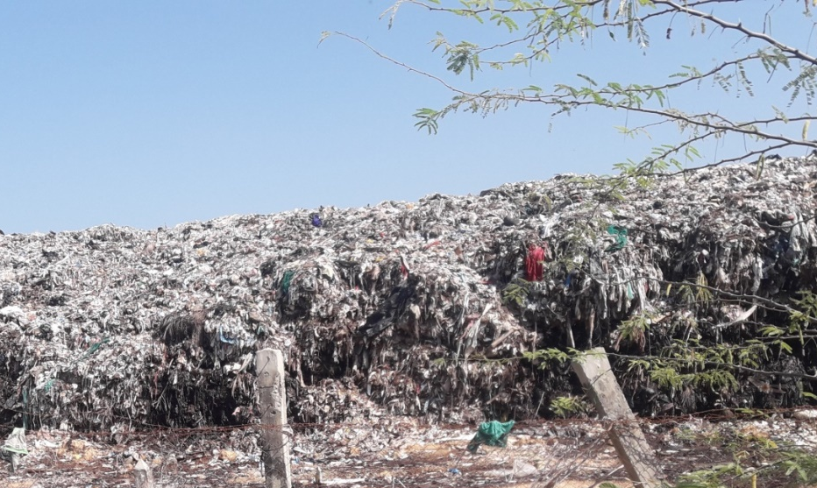

The recycling of solid waste that does happen is carried out mostly by the informal sector, which includes waste pickers, waste collectors, and waste dealers.
These waste pickers and waste collectors gather recyclable materials such as newspapers, metal, plastic bottles, tin and glass from households, communal depots, streets, commercial areas, and final disposal sites.
In turn they sell these items to waste dealers who subsequently clean, sort, store and sell them in bulk to the recycling industry both locally and for export (Premakumara et al., 2017)
The problems associated with waste management in Myanmar can be categorised as shown in Figure 3.11.
The sanitation landscape is extremely fragmented in Myanmar, with responsibility for rural sanitation and hygiene falling under the Ministry of Health and Sports, and responsibility for urban sanitation resting with individual municipalities with no central government oversight.
But the profile of sanitation needs in Myanmar is growing, and the Minister of Health has assumed a leadership role for the overall sector which should strengthen co-ordination.

Figure 3.11 Problems associated with solid waste management in Myanmar (Source: Adapted from Premakumara et.al. (2017))
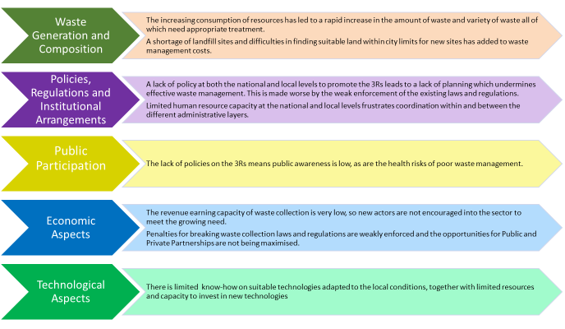

An important step was the development of the Myanmar National WASH strategy for 2016–
2030 to which you were introduced in Study Sessions 1 and 2 and which outlines key WASH actions in rural areas, schools, healthcare facilities and in emergencies, and sets targets for a major rise in the quality and quantity of sanitation facilities country-wide. However, it says nothing about solid waste management.

Summary of Study Session 3
In Study Session 3 you have learned that:
- Sanitation and waste management both refer to the appropriate management of waste to protect people and the environment. Sanitation generally focuses on liquid waste and waste management on solid waste.
- Liquid waste includes all types of wastewater and includes human excreta. Solid waste is any solid material discarded by people and is often classified according to its source.
- The sanitation ladder illustrates the different types of sanitation provision in order of desirability.
- The waste hierarchy is a guide to the different ways of treating wastes from waste reduction (the best option) through to disposal (the worst option).
- The challenges and unplanned population growth and urbanisation in Myanmar make it difficult to achieve acceptable levels of sanitation and waste management quickly.
- Sanitation in Myanmar has experienced increased attention in recent years.

Answers to in-text questions
1.1 Some suggestions are to:
- use empty food containers to store food that was bought loose
- refill plastic drinks bottles with water
- use clothes from your oldest child to dress younger children
- use worn-out clothes as cleaning cloths
- give books to friends when you have finished with them.

1.2 With approximately 31% of Myanmar population living in cities in 2019, Myanmar is still considered to be at an early stage of urbanisation with a level below that of Laos PDR (35.65%) and Vietnam (36.63%), but higher than Cambodia (23.81%).
The annual urban population growth rate of Myanmar has risen from 1.3% in 2009, to 1.51% in 2019 (Figure 3.7).
This is also lower than that of other countries in the region. However, Myanmar is expected to continue to urbanise, with a projected increase to 35% of the total population urbanised by 2050 (World Bank, 2020).
Despite the positive benefits to economic growth that urbanisation brings, the increase in urban population has begun to put a strain on cities and the need for affordable housing, infrastructure and services.
In Yangon, only a third of the city’s population have access to piped water, traffic congestion is on the rise, as is solid waste, flooding and pollution as shown in Figure 3.8. There is also a rise in the number of informal settlements as new residents cannot afford the existing supply of housing (World Bank, 2019).

1.3 Urban development reduces the ability of the ground to absorb rainwater. In urban areas a high proportion of the ground is paved, which prevents the absorption of rainwater. Also, unplanned developments usually lack the drainage ditches or channels necessary to carry away surface waters.
These two factors combine to create an increased risk of flooding and the outbreak of waterborne disease that can follow floods.
1.4 A total of 9% of the national population use open defecation.
1.5 Before the project people used to defecate out in the open and rubbish was scattered everywhere because people could not afford to do otherwise.
After the project, the neighbourhood is clean, and people have more knowledge about health and understand the importance of environmental sanitation. New latrines keep human excreta inside the pit and there is no contamination of the tidal water and so no more human excreta getting into the houses when there is flooding.

References
ADB Asian Development Bank (2017) Urban Development and Water Sector Assessment, Strategy and Road Map: Myanmar [Online]. Available at:
https://www.adb.org/publications/myanmar-urban-development-water-strategy-roadmap (Accessed 13 November 2020).

Bai, X., Nath, I., Capon, A., Hasan, N. and Jaron, D. (2012) ‘Health and wellbeing in the changing urban environment: complex challenges, scientific responses, and way forward’, Current Opinion in Environmental Sustainability, vol. 4, no. 4, pp. 465–72.

Plecher, H. (2020) Urbanization in the ASEAN countries 2019 [Online]. Available at:
www.statista.com/statistics/804503/urbanization-in-the-asean-countries/
(Accessed 24 March 2021).

Premakumara, D.G.J., Hengesbaugh, M., Onogawa, K. and Ohnmar May Tin Hlaing (2017) Waste Management in Myanmar: Current Status, Key Challenges and Recommendations for National and City Waste Management Strategies. POLICY REPORT UN Environment International Environmental Technology Centre and IGES. 45pp [Online]. Available at:
https://www.researchgate.net/publication/331332872_Waste_Management_in_Myanmar_Current_Status_Key_Challenges_and_Recommendations_for_National_and_City_Waste_Management_Strategies (Accessed 24 March 2021)

WASH data (2020) JMP Household data. [Online]. Available at: https://washdata.org/data/household#!/dashboard/new (Accessed 24 March 2021)

WHO (2020) Sanitation. WHO/UNICEF Joint Monitoring Programme (JMP). [Online]. Available at: https://washdata.org/monitoring/sanitation (Accessed 10 November 2020)

World Bank (2019). Myanmar’s urbanization creating opportunities for all, full report. World Bank, Washington, DC. [Online]. Available at:
https://openknowledge.worldbank.org/handle/10986/31824
(Accessed 12 November 2020)

World Bank (2020) World Development Indicators. World Bank, Washington, DC. [Online]. Available at:
https://databank.worldbank.org/source/world-development-indicators
(Accessed 24 March 2021).

Study Session 4
Human Values and Behaviour
In this study session we focus on how human values and behaviour can influence WASH. Human values and behaviour can protect our health and the environment from contamination by human and animal waste, or they can result in exposure to sources of pollution. So, it is important to encourage those human values and behaviour that support WASH.
Our WASH behaviour is influenced by knowledge, beliefs, attitudes and traditions about the causes of disease, our responsibility towards the environment, and also by household economic factors and gender issues.
These aspects of the social environment must be considered to encourage all to use good WASH practices. Only when WASH practices are adopted can infectious diseases and environmental pollution be prevented and successfully controlled.
Learning outcomes Study Session 4
When you have studied this session, you should be able to:
- describe ways in which the social environment of knowledge, beliefs, attitudes and traditions can affect human values and behaviour towards WASH practices.
- give examples of how positive or negative human values and behaviour concerning WASH practices can affect infectious disease transmission and the physical environment.
- explain why it is important to address economic factors and gender issues when devising a communication strategy to promote good WASH practices.

4.1 The physical and the social environment
Everywhere you look, you see people, animals and plants living in fields and forests, streams and hillsides, or in villages, towns and cities. These are all part of the physical environment of the ‘real world’ that we can see with our eyes and touch with our hands.
In your town or village, there are physical structures that humans have built or made, including houses, monasteries, schools, shops, a health centre, administrative unit office or a police station.

In-text question 1.1
Can you identify some other features of the physical environment in town?
(Figure 4.1 gives some clues)

Figure 4.1 The physical environment in an urban community in Myanmar

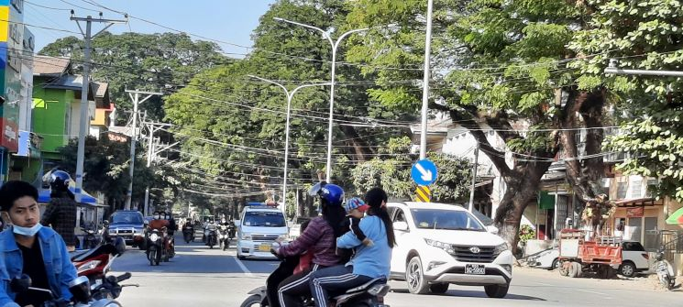

The physical structures we have mentioned also provide the local population with various kinds of social services. For example, a monastery or mosque provides religious services; a school provides education; shops and markets provide access to food and other products; roads provide transport links; and houses provide shelter.

These services contribute to the social environment of the community which are derived from human and social structures and institutions e.g. services provided by schools, religious institutions and shops. The social environment also includes the attitudes, beliefs, practices and traditions that are expressed by the members of a community.
- Attitudes are individual preferences or opinions about what a person likes or dislikes.
- Beliefs are firmly held states of mind about what is true or false.
- Practices are routine actions, doing something in the same way every time.
- Traditions are behaviour that is learned from previous generations and passed on to the next generation.
- Unlike the physical structures, they cannot be seen.
Getting people to adopt good WASH practices is not just about providing latrines, toilets or handwashing facilities – the physical elements for WASH. These can be available, but people still may not be using them. Knowledge and understanding also need to change. People need to want to use these facilities and that can mean changing attitudes, beliefs and values. So, you can see that encouraging WASH practices is quite complex.

4.2 How does the social environment influence WASH practices?
The building blocks of our behaviour lie in our knowledge, practices, attitudes, beliefs and traditions, all of which contribute to our social environment.
Figure 4.2 summarises the interactions between these invisible aspects of the inner personal world of every individual and their community, and shows that they all influence whether good water, sanitation and hygiene practices are adopted.
Figure 4.2 Diagram summarising the interaction between knowledge, beliefs, attitudes, practices and traditions in a community and their influence on valued WASH practices.

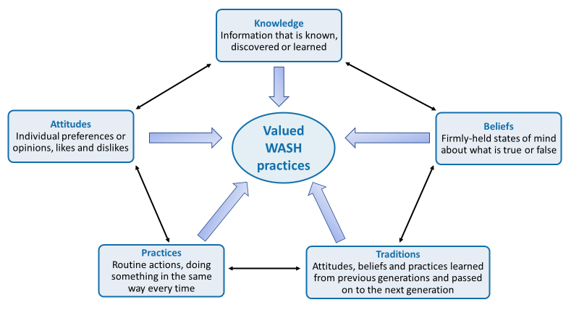

4.2.1 Knowledge of WASH practices is not enough to change behaviour
Knowledge can be defined as all the information we have learned and processed during our growth and development.

In-text question 1.2
We assume you know that people who drink dirty water may get sick because harmful bacteria live in the water. Think for a moment about how you acquired this knowledge?

Figure 4.3 Diagram representing the different levels of influence on a person’s knowledge

Education is a key factor in improving the knowledge of WASH issues in a community. Learning about hygiene and sanitation in school is a particularly important way to change behaviour. If children learn WASH practices from a young age, they will keep them throughout their lives.
For example, they can be taught the correct way to wash their hands at critical times, that is, before and after preparing food or eating, and after urinating, defecating or cleaning a child’s bottom.

In-text question 1.3
Think about where you get your knowledge from today? Do you think the inverted pyramid needs another layer?

In-text question 1.4
Why do you think it is easier to change children’s WASH practices than adults?

4.2.2 Attitude, beliefs and traditions influence WASH practices
There are several reasons why unhealthy WASH practices persist, even if people have been given good information to help them change for the better. One reason for the persistence of bad WASH practices, even when correct knowledge is available, is that people have attitudes and beliefs that make them ignore the facts.

In-text question 1.5
Can you suggest an attitude and a belief that people might express about not using a latrine even when there is one nearby?
Good WASH practices at community level also include handwashing, using clean drinking water, and keeping the physical environment clean and free from waste. Repeating these practices builds our health, improves our lifestyle and helps us all to live longer.

Figure 4.5 Handwashing with soap before eating is a valued WASH practice.

But first, negative attitudes and beliefs must be overcome and replaced with valued behaviour. For example, handwashing with soap before eating is not practised by everyone in Myanmar, even though it prevents transmission of infection from dirty hands to the mouth (Figure 4.5). Also, nearly 10% of people in Myanmar still practice open defecation as you learned in Study Session 3 (Trading Economics, 2020)
The example we gave earlier of the valued practice in rural communities of neighbours helping at times of bereavement can also be termed a tradition, a behaviour that is learned from previous generations and passed on to the next. Some traditions bring positive benefits to the community and also to the environment. But some traditions expose people and the environment to possible harm.
Traditions are very difficult to change because everyone in a community believes it is the right way to behave. Individuals who challenge the tradition are likely to meet opposition from the majority who want to go on doing things in the old way.
If open defecation or not washing the hands at critical times is considered normal and traditional in a community, it will take time and effort to persuade people that using a latrine (Figure 4.6) or handwashing with soap are valued practices that benefit the whole community and also protect the environment.
Figure 4.6 It takes time and effort to convince people that building a covered pit latrine like this one will benefit their family’s health and improve the local environment.

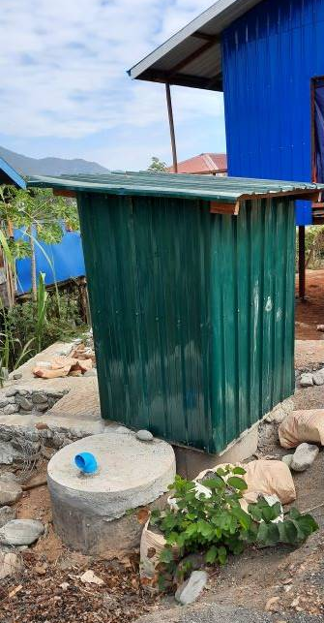

4.3 Other influences on WASH practices
In this section, we discuss three factors that influence whether WASH practices are adopted in a community: economic factors; gender and privacy issues; and caring for the environment.

4.3.1 Economic factors influence WASH practices
The cost of constructing a protected water source, a latrine or handwashing facilities may be too much for some households to pay, especially when purchasing WASH facilities and services is seen as a lower priority than spending limited financial resources on other needs.
Primary priorities for most households, whether urban or rural, include secure housing, food, clothing and education for their children, and possibly also transport costs to take children to school or adults to work. Installing even the most basic latrine or handwashing basin may be unaffordable, but people can still wash their hands with a bowl and a bar of soap (Figure 4.7).

Figure 4.7 Households that cannot afford piped water and a washbasin can use soap, a bucket and a cup for pouring water over the hands.

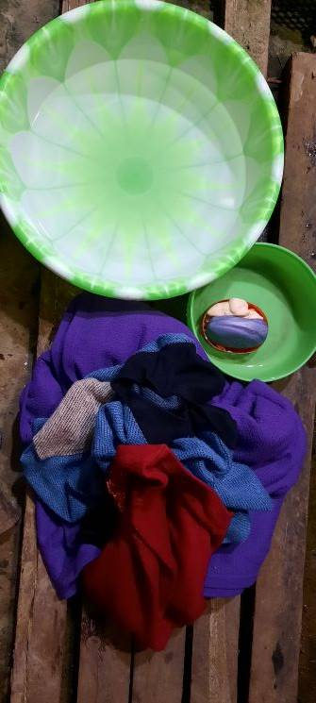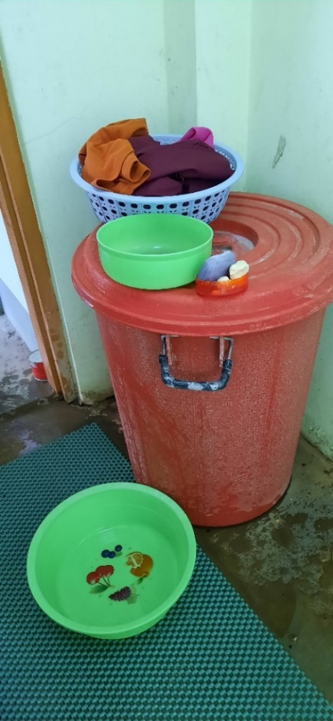
However, constructing a latrine is much more expensive than buying a plastic bucket and some soap. To build a latrine a circular concrete slab is needed, a pit needs to be dug and a shelter built, which means paying a carpenter and bricklayer.
Local government may be able to assist households to obtain loans at low interest rates so that they can install WASH facilities. Community WASH projects may also be funded by local contributions and provide shared labour to build a communal latrine or protect a water source from contamination by human and animal waste.
Although there are costs involved, installing a WASH facility can also save some expenses for a household over time. Diarrhoea, worm infestations and other diseases that can be passed between people resulting from poor WASH practices cost a lot of money for individuals, families, communities, and Myanmar nationally.

In-text question 1.6
Can you think of expenses that the family of a child with severe diarrhoea will have to pay?

4.3.2 Gender, privacy and access issues influence WASH practices
It is against Myanmar culture for women and girls to urinate in public, but it is quite common to see men and boys urinating in the open. Access to a safe and private place for this purpose is therefore a high priority for women, who may suffer great discomfort to avoid urinating or defecating until night-time when they can go without being seen. However, this also exposes them to the risk of rape or robbery. Therefore, the provision of household latrines is a gender issue – it affects males and females differently.
Another difference between the genders in Myanmar is that in most families it is a woman that prepares the food and is primarily responsible for the day-to-day collection and subsequent use of water. If her hands are clean when she touches food items and she washes fruits, vegetables and cooking utensils in clean water, the risk of transmitting infectious organisms to family members is much reduced.

Research has shown that washing the hands with soap at critical times can reduce the incidence of diarrhoeal diseases in families by as much as 44%, and even without soap the reduction is about 30% (Curtis et al., 2011). This is very important in Myanmar, where traditional food is eaten with the hands (Figure 4.8).

Figure 4.8 Handwashing is particularly important because Myanmar food is traditionally eaten with the hands.

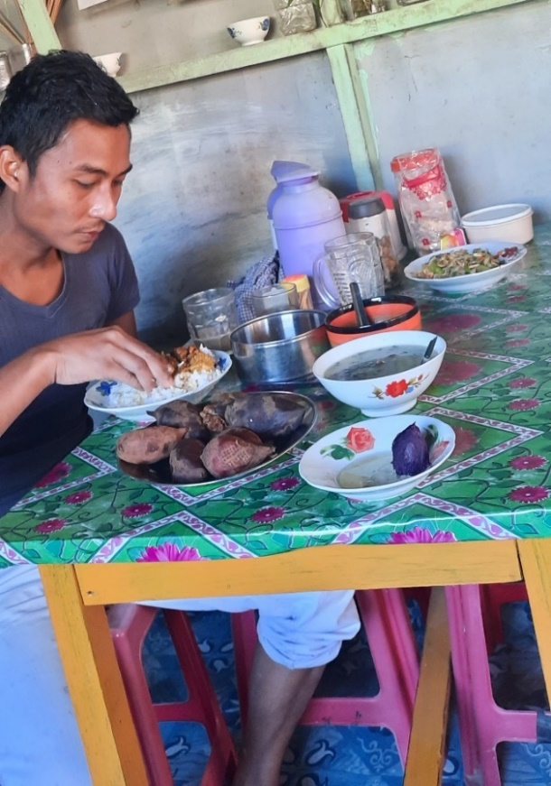

Installing handwashing facilities or building a latrine for the household therefore brings benefits to women in particular, but also improves the health of all family members.

4.3.3 Caring for the physical environment improves health outcomes
Pollution of the environment with human excreta, animal droppings and household rubbish are sources of disease because they attract rats, mice, dogs, flies and mosquitoes that can transmit infectious organisms to people. Bacteria, viruses and worms in rotting food and faeces are washed by rain into the soil and local sources of drinking water; they contaminate crops and get onto the hands of people working on the land or children playing.
Unless hands are washed at critical times, the transmission of infection from soil to hands and into mouths is impossible to prevent. Therefore, keeping the community environment clean and free from waste (Figure 4.9), and persuading people of the health benefits of handwashing and latrine use are key goals for WASH programmes.
In addition to protecting the environment as a way of protecting human health, we should also see the beautiful land, lakes and rivers, animals and plants of Myanmar as our heritage.

Figure 4.9 Street cleaners collect rubbish in a Myanmar street. 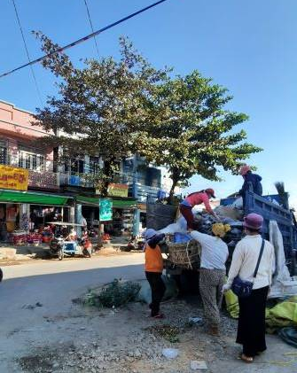

4.4 Making WASH practices socially accepted and valued
WASH practices becoming socially acceptable and the norm in all communities is the goal or WASH programmes. If the majority of community members value and promote WASH practices, social pressure to conform will be felt by any individuals or households who do not behave in accordance with these shared norms.
In model WASH communities, every household will use a latrine, hands are always washed at critical times, homes are kept clean, and the neighbourhood is free from dirt and waste.
Behaviour change communication (BCC) methods have had success in improving WASH behaviour. BCC methods involve consultation and joint learning with individuals and communities about desirable changes to their behaviour. Misconceptions, unhelpful attitudes and factually incorrect beliefs are respectfully challenged and changed in a safe and supportive setting. Through community meetings, local health conferences and community conversations (Figure 4.10), everyone is able to share their views on WASH-related issues and to explore healthy practices.

Figure 4.10 Community conversations can bring neighbours together to agree a plan to improve WASH practices.
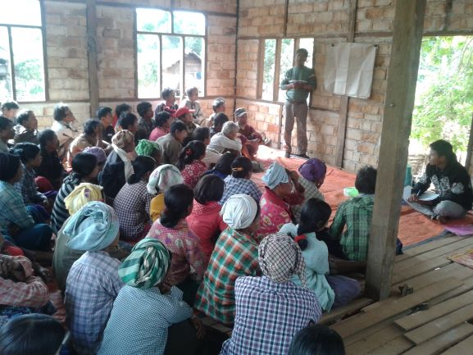

To achieve the national goals for improvement in WASH provision, good hygiene and sanitation, practices need to become the norm for every household.
Caring for the physical environment around us, whether it is the urban world of houses and streets or the natural world of fields and streams, is a responsibility that everyone should value.
Watch this short video about healthy eating which shows the benefits of the BCC approach. It is being used to encourage a change in diet and cooking practices in DaLa and Hlegu townships around Yangon.
https://www.youtube.com/watch?v=3a2k1vO7HmI

In-text question 1.7
Why do you think the conversation with the friend changed the woman’s view on diet and food preparation? Did anyone else try to change the practices of others?

Summary of Study Session 4
In Study Session 4, you have learned that:
- The physical environment is the world we can see around us; the social environment is the invisible world of social interactions between people, their knowledge, attitudes, beliefs, practices, and traditions.
- Provision of WASH facilities alone may not convince people to change traditional practices.
- Misconceptions, unhelpful attitudes and factually incorrect beliefs must be respectfully challenged and changed for WASH improvement.
- Economic factors make it difficult for families to afford WASH facilities or make them a priority; however, repeated episodes of avoidable infections are a financial burden that WASH practices could reduce.
- Gender differences in sanitation behaviour mean that women in particular will be more comfortable, private and safe if they can use a latrine.
- Handwashing at critical times protects everyone from infection.
- Protecting the environment from pollution by faeces and other waste is a responsibility that everyone should share and value.
- Behaviour change communication strategies engage the whole community in developing an action plan, to make WASH facilities more available and good WASH practices the norm.

Answers to in-text questions
1.1 You may have mentioned roads and traffic, pavements, electricity cables and lampposts, or perhaps ditches to catch water and prevent flooding in the rainy season, which are not visible in Figure 4.1.
1.2 You may have been told not to drink dirty water by your parents; or perhaps you learned about bacteria at school; or maybe a health worker made a poster about only drinking clean water to avoid getting diarrhoea; you could have heard about it on the radio or learned from your own experience if you drank dirty water as a child and developed diarrhoea afterwards.
Figure 4.3 summarises the ‘upside-down pyramid’ of sources of knowledge acquired during a lifetime.
1.3 It is likely you answered ‘yes’ to reflect the role of the internet and sites like Facebook.
However, health education programmes are often unable to achieve behaviour change simply by giving adults knowledge of the health risks of poor hygiene or why they should not pollute the physical environment with waste.
Even if people are given accurate information about what causes diarrhoea, this knowledge is generally not enough to persuade them to change poor hygiene and sanitation practices. For example, people whose routine practice is to defecate in the open every day are unlikely to change their behaviour simply because they have been given new knowledge about the risks to their health and the environment.
1.4 Children are learning about the world around them and are responsive to new knowledge and new practices. They also understand that school teaches them knowledge and skills to live good lives when they are adults.
Adults can be more resistant to change because they have been doing what they currently do for a long time, as have others around them. To make change may mean not only breaking a habit but breaking a community tradition.

1.5 Here are our suggestions, but you may have given other good answers:
- Attitudes against using latrines: ‘I dislike using latrines because they smell bad’; or ‘I prefer to empty my bowels in the open because the bad smell is blown away by the fresh air’.
- Beliefs against using latrines: ‘The bad odour collects in the latrine and causes disease if you breathe it into your body’; or ‘It is safer to defecate in the open because there are evil influences in latrines’.
1.6 You may have mentioned the cost of treatment, including transport costs if the child goes to the health centre; and family members may lose income from their employment while caring for the sick child.
These costs could have been reduced by using a latrine, handwashing at critical times and accessing improved water sources. The prevalence of diarrhoea among children in Myanmar is still high with 18% of deaths among children under five due to diarrhoeal diseases even though these can be prevented (Kemp, 2017). If you multiply the costs to a single family with a sick child by the number of illness episodes that could be prevented by good WASH practices, you can see that WASH could bring huge financial benefits to the nation.
1.7 It changed her views because she trusted her friend who didn’t criticise what she did but showed good practice by example. At the end of the video, the woman’s son says that he wants to share what he now knows with his school friends.

References
Curtis, V., Schmidt, W., Luby, S., Florez, R., Touré, O. and Biran, A. (2011) ‘Hygiene: new hopes, new horizons’, The Lancet Infectious Diseases, vol. 11, no. 4, pp. 312–2 [Online]. Available at:
http://www.sciencedirect.com/science/article/pii/S1473309910702243
(Accessed 14 May 2015).

Kemp, K. (2017) ‘Diarrhea among children under five in Myanmar: a systematic review’. Journal of Health Research, Vol. 31 No. 1: January–February 2017. [Online]. Available at: https://he01.tci-thaijo.org/index.php/jhealthres/article/view/78346
(Accessed 24 March 2021)

Trading Economics (2020) ‘Myanmar – People Practicing Open Defecation’. [Online]. Available at: https://tradingeconomics.com/myanmar/people-practicing-open-defecation-percent-of-population-wb-data.html#:~:text=People%20practicing%20open%20defecation%20(%25%20of%20population)%20in%20Myanmar%20was,compiled%20from%20officially%20recognized%20sources (Accessed 24 March 2021)

Study Session 5
Personal Hygiene
The exercise of proper personal hygiene is one of the essential parts of our daily life. The prevention of communicable diseases like diarrhoea is highly possible if proper personal hygiene is followed. Hygiene is a series of practices to preserve health.
Understanding the proper practice of personal hygiene can help the prevention and control of important public health diseases in your community. This study session also explores the links between personal hygiene and dignity, confidence, and comfort.
Learning outcomes of Study Session 5
When you have studied this session, you should be able to:
- describe the public health importance of personal hygiene
- list and describe the components of personal hygiene
- describe what are acceptable and poor personal hygiene practices

5.1 What is personal hygiene?
Personal hygiene is a concept that is commonly used in medical and public health practices. It is also widely practised at the individual level and at home. It involves maintaining the cleanliness of our body and clothes.
Personal hygiene is defined as a condition promoting sanitary practices to the self. Everybody has their own habits and standards taught or learned from others. Generally, the practice of personal hygiene is employed to prevent or minimise the incidence and spread of communicable diseases.

5.2 Public health importance of personal hygiene
The knowledge, purpose and practice of personal hygiene are vital in all our everyday activities.

5.2.1 Preventing faecal-orally transmitted diseases
The fingers may get contaminated with one’s own faeces, either directly or indirectly, which can make it easier for disease to spread. Defecation and child bottom-washing are opportunities for the contamination of the fingers that allow infections to pass between one person and another.
In-text question 1.1
Think back to the diagram in Study Session 2, Figure 2.5 showing the different methods of disease transmission from faeces to food. While fingers are one way that faeces can contaminate food, can you name two other ways?

5.2.2 Aesthetic values of personal hygiene
A person with clean hands can feel proud while eating because they are confident about preventing diseases. A teacher in a school is happy to see their students with clean faces and eyes and dressed in clean clothes. A mother is mentally satisfied to feed her infant with clean hands because she ensures her child’s health. Generally, cleaning oneself produces pride, comfort and dignity at home and in public places. Caring about the way you look is important to your self-esteem.

5.2.3 Social impact
A person with poor personal hygiene might be isolated from friendships because being honest with them about the situation might be sensitive and culturally difficult. The success of a job application or the chance of promotion could be affected by poor personal hygiene; no company wants to be represented by someone who does not appear to be able to look after themselves (Figure 5.1).

Figure 5.1 Summary of personal hygiene

5.3 Components of personal hygiene
There are different elements that contribute to good personal hygiene.

5.3.1 Body hygiene (skin care)
The body has nearly two million sweat glands. Moistened and dried sweat and dead skin cells all together make dirt that sticks on to the skin and the surface of underclothes.
The action of bacteria decomposes the sweat, thereby generating bad odour and irritating the skin. This is especially observed in the groin, underarms and feet, and in clothing that has absorbed sweat. Skin infections such as scabies, pimples and ringworm are results of poor body hygiene. Figure 5.2 shows ringworm of the scalp.

Figure 5.2 Scalp ringworm
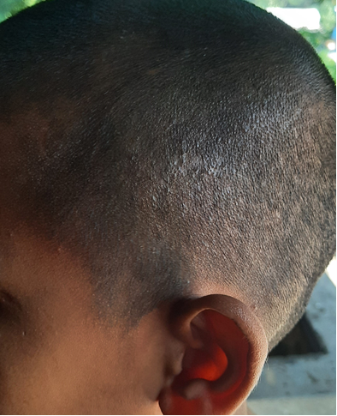

The first task in body hygiene is to find water, soap and other cleansing materials. Taking a bath or a shower using body soap at least weekly is very important to ensuring our body stays clean (Figure 5.3).
Bathing can be every day or after periods of sweating or getting dirty. The genitals and the anal region need to be cleaned well because of the natural secretions of these areas. Dry the body with a clean towel after thorough rinsing. Change into clean underwear after a bath. Changing sweat-soaked clothes after each bath is advised. Cleaning the ears after every bath is also necessary. Avoid sharing soaps and towels because of the danger of cross-infection.

Figure 5.3 Body washing
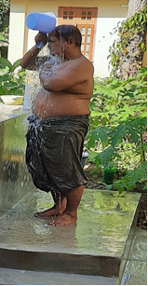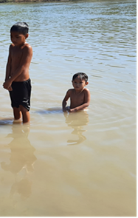

5.3.2 Oral hygiene (oral care)
The mouth is the area of the body most prone to collecting harmful bacteria and generating infections. Our mouth mechanically breaks food into pieces. This process leaves food particles (food debris) that stick to the surface of our gums and teeth. Our mouth cavity is full of bacteria and is a good environment for bacterial growth.

In-text question 1.2
Why is the mouth a good environment for bacterial growth?

5.3.3 Handwashing (hand care)
The cleanliness of our hands is very important in all our daily activities. In our normal activities our hands frequently get dirty and micro-organisms attach to our hands along with the dirt. There are many communicable diseases that follow the route of faecal–oral transmission. Hand hygiene plays a critically important role in preventing cross-infection.
Hygienic handwashing involves the mechanical removal of micro-organisms from contaminated hand surfaces using soap or detergent. Handwashing should involve more than a quick rinse under a tap or in running water.
Figure 5.5 Handwashing
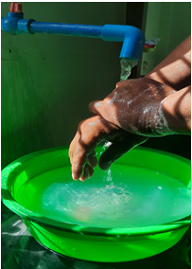
You were introduced to proper handwashing techniques in Study Session 2, but here is a short video demonstrating the steps of good handwashing from the WHO.
https://www.youtube.com/watch?v=IisgnbMfKvI&t=19s
If you want to download the WHO poster on these handwashing steps, follow this link:
https://www.who.int/gpsc/5may/How_To_HandRub_Poster.pdf?ua=1
To get clean hands, you must POUR the water over your hands (no dipping in a bowl!). The soap ‘lifts’ the dirt, and the water then washes off the visible dirt and the invisible germs (Figure 5.5).
As well as routine personal hygiene that applies to everyone, your daily work will include many situations when you may ask yourself when you need to wash your hands. To know when to wash your hands at home and at work, you must first identify critical moments; that is, circumstances, activities or incidents that indicate the possibility that pathogenic micro-organisms are present on hands, fingers and nail surfaces.
Critical situations in everyday activity include:
- after using the toilet (or disposing of human or animal faeces)
- after changing a baby’s diaper (nappy) and disposing of the faeces
- immediately after touching raw food when preparing meals (e.g. chicken or other meat)
- before preparing and handling cooked/ready-to-eat food
- before eating food or feeding children
- after contact with contaminated surfaces (e.g. rubbish bins, cleaning cloths, food-contaminated surfaces)
- before and after coming in contact with an infected wound
- after handling pets and domestic animals
- after wiping or blowing the nose or sneezing into the hands (respiratory hygiene)
- after handling soiled tissues (your own or others’, e.g. children).

5.3.4 Face hygiene
Our face reveals our daily practice of personal hygiene. Face hygiene includes all parts of the face. The most important area to keep clean is the eyes.
The eye discharges protective fluids that could dry and accumulate around the eye. They are visible when a person gets up in the morning. The substance of the eye discharge can attract flies, and this is dangerous because the fly is a carrier (‘vector’) of conjunctivitis.
A person should wash their face every morning and evening in order to remove all dirt. Children are advised to wash their face frequently. Never share your face towel with others.

In-text question 1.3
Why is it advisable not to share a face towel?

5.3.5 Fingernail and toenail hygiene (nail care)
A nail is hard tissue that constantly grows. Long fingernails tend to accumulate or trap dirt on the underside. The dirt could result from defecation or touching infected and contaminated surfaces.
Keeping nails trimmed and in good shape weekly is important in maintaining good health. Clip nails short along their shape but do not cut them so close that it damages the skin. Razor blades and fingernail cutters or scissors are used to cut nails. Nail cutters should not be shared with others.

In-text question 1.4
Why is it advisable not to share nail cutters?

5.3.6 Ear hygiene
Ear wax accumulates in the ear canal that leads from the outer ear to the ear drum. As the secretion comes out of the ear it collects dust particles from the air. Daily washing with soap and water is enough to keep the outer ear clean.
Do not reach farther than you can with your little finger into your ear. Putting in hairpins, safety pins or blunt-edged things for cleaning purposes might harm the ear. If you feel wax has accumulated and is plugging your ears and interfering with hearing, consult your doctor.

5.3.7 Hair hygiene (hair care)
The hair follicles from which the hair grows produce oil from the sebaceous glands that keeps the hair smooth. The scalp (the skin covering the head) also has numerous sweat glands and is a surface for the accumulation of dead skin cells. The oil sweat and dead cells all add together and can make the hair greasy and look dirty unless you wash it regularly.
Poor hair hygiene could cause dandruff and skin infections (see Figure 5.6). Dandruff is dead skin on the scalp that comes off in tiny flakes when too much oil is produced and accumulates on the scalp.
Head hair is a good home for head lice and nits (eggs of head lice). The head louse is a tiny insect that lives by sucking blood. Children are especially prone to lice infestation.
Lice spread from one head to another when there is close contact, as in school environments. They make the scalp itchy and are a cause of annoyance, irritation and embarrassment. Shaving of the head hair is possible in bad cases of lice infestation. Sharing of blades with others, however, should be discouraged.
Hair-cleaning is important to ensure it stays clean, healthy and strong. The recommended procedures for cleaning the hair are:
- Use clean water to wash your hair regularly (at least twice weekly, preferably once every other day) with body soap or shampoo, whichever is available.
- Massage your scalp well to remove dead skin cells, excess oil and dirt.
- Rinse well with clear water.
- Conditioner is helpful if you have longer hair as it makes the hair smoother and easier to comb, but hair doesn’t need to have conditioner.
- Use a wide toothed comb for wet hair as it is easier to pull through.
- Dry the hair and the head with a clean towel but never share a towel with someone else.
- Comb the hair to look beautiful for the day.

Figure 5.6 Combing through hair during washing
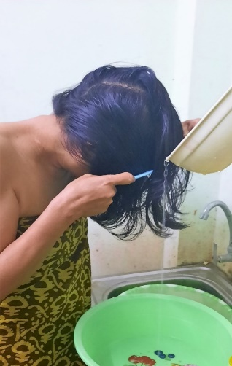

5.3.8 Foot hygiene (foot care)
We spend a lot of time on our feet. Our feet sweat throughout the day and the sweat accumulates on all foot surfaces and between the toes. The sweat may stain the shoes and can produce an awful odour.
In-text question 1.5
What causes sweat on the skin to produce an unpleasant odour?

5.3.9 Armpit and bottom hygiene
These are body parts that easily get sweaty and where ventilation is very poor. After puberty, our sweat gains a specific and unpleasant odour which may be offensive to others. The armpits and the bottom should be washed daily.
Anal cleansing is the hygienic practice of cleaning the anus after defecation. The anus and buttocks may be cleansed with clean toilet paper or similar paper products. Water may be used. Hands must be washed with soap afterwards.

5.3.10 Clothes hygiene
We usually have two layers of clothing. The internal layer is underwear. These are right next to our skin and collect sweat and dead skin cells, which can stain the cloth.
Bacteria love to grow on this dirt and produce a bad smell in addition to the specific odour of the sweat. Underwear must be washed more frequently than the outer layer of clothing.
Clothes hygiene is an important aspect of one’s dignity. Changing used clothes for clean ones every day is recommended.

Washing dirty clothes requires adequate clean water, detergents and washing facilities (Figure 5.7a and b).
If possible, the washed clothes should be ironed to help kill body lice and nits. Boiling water or insecticides can be used to destroy infestations on clothes
Figure 5.7 Washing clothes in rural areas (a) by a river (above) and (b) in a stream (below)

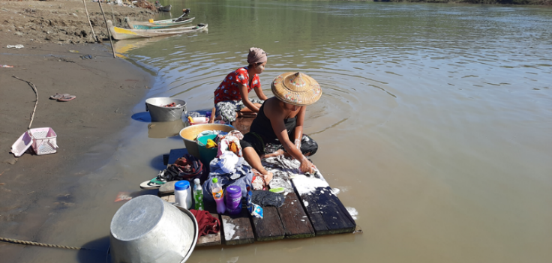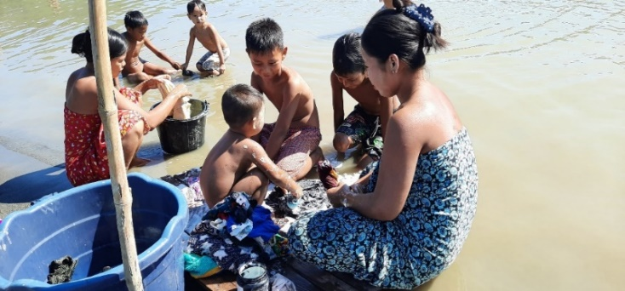
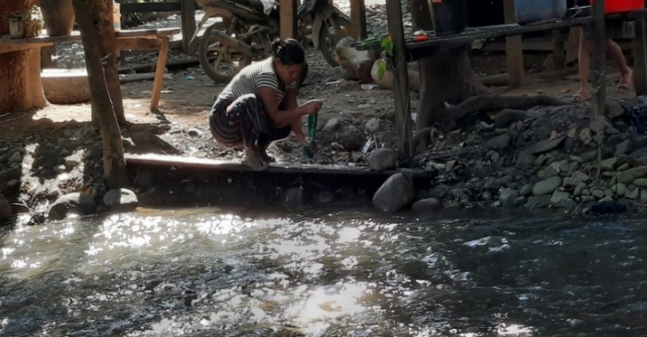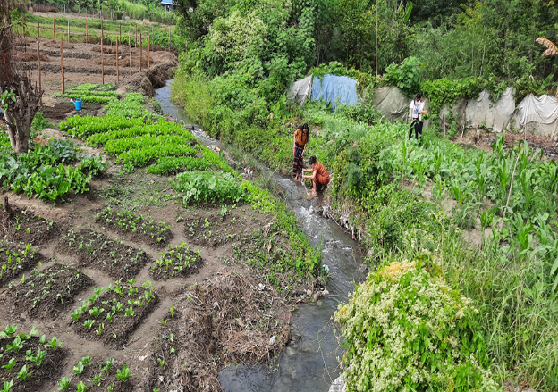

5.3.11 Menstrual hygiene (Personal hygiene for women)
The vagina is able to clean itself; no special care is needed other than washing the external genitals. Washing the outer genital area with clean water must be a daily practice. Change tampons and sanitary napkins or pads regularly.
Always wash your hands before and after handling a tampon or pad. Clean and soft cloths can be used in place of sanitary pads. The use of dirty cloths must be discouraged. Menstrual blood-absorbing items must be properly disposed of in an appropriate way.

5.4 Planning for the improvement of your personal hygiene
Planning for personal hygiene became a particularly important issue during the Covid-19 pandemic of 2020-21, when handwashing and preventing the spread of airborne droplets when coughing and sneezing was a global health message, as shown in Figure 5.8.
Reflect on what you have learned in this session and ask yourself whether there are some practices that you should change to safeguard your health and the health of others more effectively. Having identified these, consider how you will make the necessary changes.
Finally, commit to a time in the future (a day, a week or month) when you will review how successful or otherwise you have been in making these behaviour changes.

Figure 5.8 Children discuss the message in a health poster.
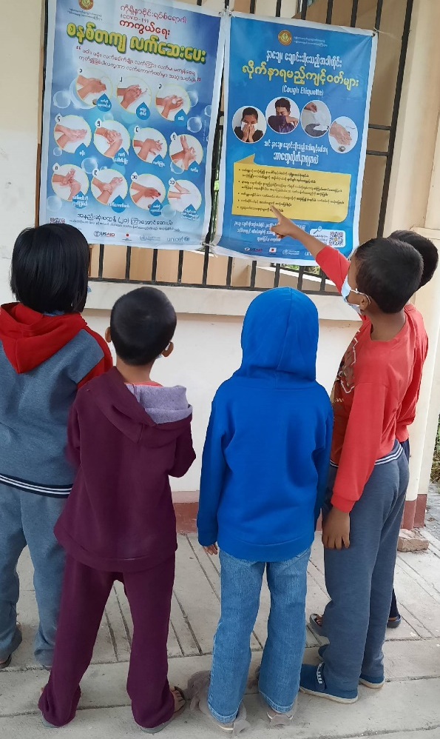

Summary of Study Session 5
In Study Session 5, you have learned that:
- Personal hygiene is a necessity for our daily activities. It is very important for the protection of our health and helps to prevent the spread of diseases.
- Personal hygiene has social and aesthetic values. An individual who follows the practice of proper personal hygiene gains confidence, pride and dignity.
- Personal hygiene applies to all parts of the body, but hand hygiene is probably the most important for public health.
- The procedures that apply in personal hygiene (such as handwashing and oral hygiene) need to be followed strictly to gain the best results.
- The promotion of personal hygiene should aim to change human behaviour. The provision of hygiene information first improves knowledge and then practice.
- The promotion of personal hygiene must be well planned in order to bring positive changes.

Answers to in-text questions
1.1 There were five ways: fluids; fingers; flies; field; floor. It is at the optimum temperature (37°C) and is often rich in food particles that support bacterial growth.
1.2 The decaying process that takes place on the surface of the teeth eventually produces a build-up called plaque (a sticky deposit on which bacteria grow) that is then converted into tartar (a hard, yellowish, calcified deposit on the teeth, consisting of secretions and food particles). The result is tooth decay. In addition, unpleasant smelling breath, teeth and gum infections could be a result of poor oral hygiene.
Figure 5.4 Mouth cleaning
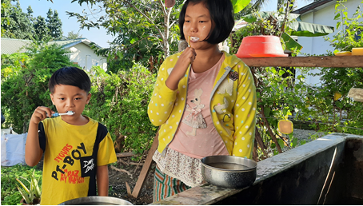

Advice for keeping the mouth clean (Figure 5.4) is:
- rinse the mouth after each meal
- brush your teeth with a fluoride-containing toothpaste twice a day – before breakfast and before you go to bed
- during the day, fill your mouth with water and swish it around to get rid of anything sticking to your teeth
- in addition to regular brushing, it is advisable to floss your teeth at least once a day, usually before you go to bed.

1.3 Some diseases, such as conjunctivitis, can be transmitted easily from person to person in this way.

1.4 Some diseases, such as fungal infections, can be transmitted easily from person to person in this way.
1.5 The action of bacteria as they break down the sweat.
As well as bacteria, sweat also encourages fungal growth between the toes. This is called ‘athlete’s foot’. The signs of athlete’s foot are scaly skin and sores or blisters, which start between the toes but can often spread to the soles of the feet. This is a minor irritation and often disappears by itself but sometimes these cracks and sores become the site for other infections. The feet should be washed daily, or at least twice weekly.

Study Session 6
Institutional Hygiene and Sanitation
In this session you will be introduced to the public health importance of various local institutions, such as schools, offices, health clinics and hospitals, and religious institutions.
The essential hygiene requirements of these institutions will be considered, and suggestions made as to how these could be better planned for and managed.
You will also have an opportunity to apply what you have learned in the course to benefit your local community by taking action as a WASH champion.
Learning outcomes for Study Session 6
When you have studied this session, you should be able to:
- identify the local institutions that require attention for hygiene
- describe the public health importance of public institutions
- explain the basic hygiene requirements of different institutions
- develop an action plan for the promotion of hygiene and sanitation in an institution of your choice.

6.1 Scope of institutional hygiene
Public institutions are those that provide social, educational and religious public services to the general population. They include schools, nurseries, health clinics, hospitals and religious institutions. These are the focus of institutional hygiene which is the promotion of basic hygiene in local institutions. Children attending school, patients attending health clinics and people seeking services are vulnerable to various diseases, accidents and stresses. Protecting the health of all these people is essential from a public health point of view.

6.2 Public health importance of institutional hygiene
Protection against infections in these institutions depends on how hygiene is promoted. It is possible for places like schools to be the focal points for epidemic diseases such as diarrhoea and measles that are due to poor hygiene. Measures must be in place to address this risk.

6.3 School hygiene and sanitation
When we say schools, we include kindergartens, primary schools, and high schools, all of which could be present in your locality (Figure 6.1).
Figure 6.1 A rural high school in Myanmar
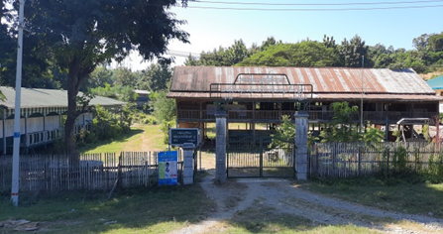

6.3.1 Public health importance of school hygiene and sanitation
Schoolchildren spend about one third of their time in school, so schools provide an ideal opportunity to detect poor hygiene practice by children. Safe water, basic toilets and good hygiene are essential to child survival and development.
The provision of school hygiene and sanitation ensures the rights of students to acceptable hygiene practices, safe water supply, latrines and a healthy school environment in general. The impact could also have further beneficial effects, for example:
- healthy environments promote more effective learning
- opportunities for students to gain life-long positive hygiene routines
- opportunities for increased school enrolment, retention and attendance for girls who may miss school because of inadequate facilities for menstrual hygiene.

6.3.2 Components of school hygiene and sanitation
The components of good school health services are shown in Figure 6.2. We discuss these and other aspects of the school environment in turn.
All schools should be aware of the importance of school hygiene and sanitation for their students. There is a national standard for WASH in Myanmar Schools. For example, the government standard is 50 pupils to one latrine, but only half of schools meet this standard.
Two thirds of schools have access to sanitation facilities, and four-fifths of schools have access to an improved water source on site throughout the year. A quarter of schools provide soap for handwashing on a daily basis (UNICEF, 2020). Therefore, the provision of WASH services in Myanmar schools is mixed.
Promotion of hygiene, organising hygiene/health clubs, having a clean school compound and supervising classrooms for their cleanliness are some of the items for the attention of school authorities.
Figure 6.2 Health-related policies in schools

Promoting hygiene
Teaching students about health focuses mainly on delivering hygiene information. Health information is usually incorporated within various school subjects such as science, biology and physical education.
However, teaching aimed at changing the behaviour of students is not part of the traditional education system. There are ways to fill this gap. Setting up and supporting health or hygiene clubs in schools is one way.
The effective involvement of the local health clinic can also help in the promotion of school hygiene and sanitation.
Provision of drinking water
The provision of safe water for drinking and personal hygiene is important and there needs to be adequate facilities in proportion to the number of students.
Low-cost water fountains and water taps arranged in a water trough design are acceptable for schools. They should be mounted at the appropriate height from the ground surface to match the height of the students (Figure 6.3).
Figure 6.3 Drinking taps and handwashing basin arrangements in a school

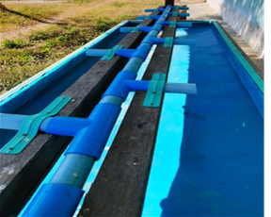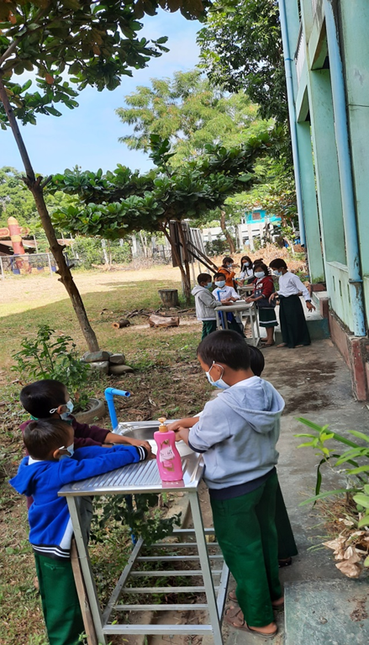

Water must be available throughout the school day. A water storage tank may be necessary to provide water reserves and satisfy the demand at peak hours. The wastewater (greywater) that results because of handwashing must be drained to a seepage or soak pit, or a ditch.

Provision of latrines
The provision of latrines (toilets) is also extremely important. In addition, separate latrines for girls and boys should be provided to encourage girls to continue their education when menstruating.
The usual type of latrine at schools is a communal dry pit latrine equipped with a vent.
School latrines should meet the following requirements:
- The latrines must be located away from the classroom in order to avoid interfering with the students’ learning process. They must be accessible for students with disabilities.
- The latrines must be well-maintained and agreeable to use. They should provide privacy and security.
- The dimensions of the latrine must be adequate to accommodate the storage needs for three to five years.
- There must be handwashing facilities near the latrine (Figure 6.3). Handwashing with soap after using the latrine and before lunch must be encouraged.
- There should be separate latrines for male and female students. Latrines for teachers must be separated as well.
- There must be a bucket with water and a jug inside female latrines. This is essential for cleaning for female students during menstruation.
- Latrines should be hygienic to use and easy to clean. Students themselves should participate in daily cleaning of the latrine.

Figure 6.4 School latrines and handwashing facilities

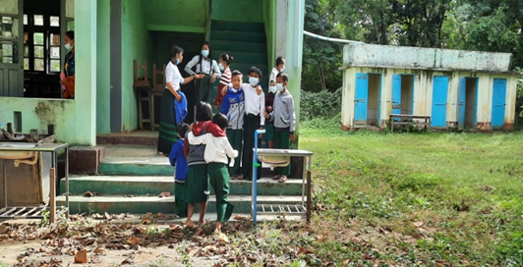

Provision of solid waste management facilities
Discarded paper and cartons are the usual type of waste at schools. Teaching around reducing, reusing and recycling solid waste (3 Rs) could be usefully taught in the classroom. There could also be chemical wastes from school laboratories. Schools should have the following facilities:
- waste bins/buckets in each classroom and teacher’s office; waste bins may be placed in the school compound when deemed necessary (around corridors, playgrounds)
- waste disposal pit at an appropriate location; a local incinerator can be used if the amount of school solid waste is significant.

Classroom sanitation
The cleanliness of the classroom like the one shown in Figure 6.5 is vital to create a good place to learn. Students should be involved on a daily basis in the maintenance of classroom cleanliness. Dust and cracks in the floor must be avoided because these are good hiding sites for biting animals such as the chigger (also known as the chigger red bug or harvest mite).
Figure 6.5 Classroom sanitation: smooth floor, physical suitability of seats and desks, and adequate light and ventilation
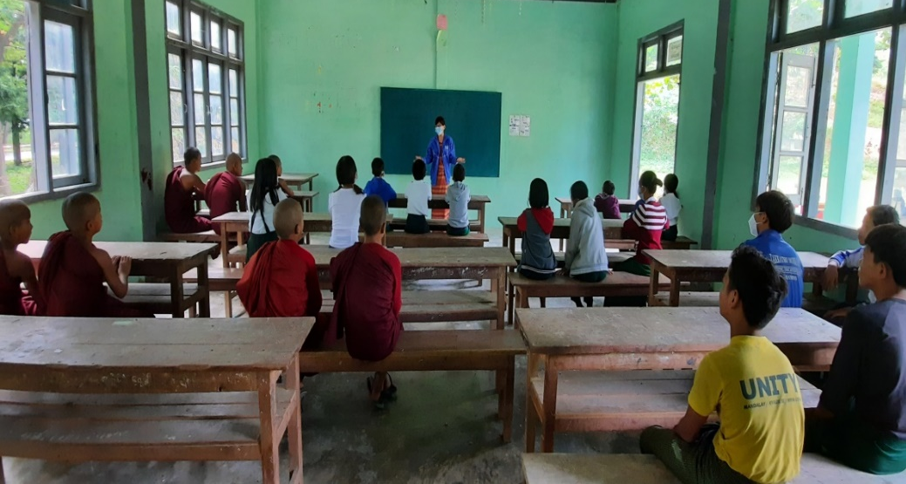

Watch this short film looking at a project to provide clean water and sanitation to several rural schools in Myanmar and answer the question.
https://www.pactworld.org/video/world-toilet-day-promoting-wash-and-waste-management-myanmar

In-text question 1.1
What WASH improvements did this project make?

6.4 Health facilities
Over half of health facilities in Myanmar significantly lack WASH services and the systems to monitor them effectively (UNICEF, 2020). But there are added health risks associated with health facilities that are not always well understood by patients and the general population.
Health facilities generate infectious wastes, needles and other sharps that are potentially harmful and need careful disposal as shown in Figure 6.5.
Figure 6.5 Health facility waste disposal

6.5 Public offices
For the benefit of the health of the civil servants working in offices to serve the population, it is important to maintain a healthy office environment such as well-lit and ventilated rooms, latrines, and proper solid waste management. The supply of safe water and handwashing facilities are also important for the provision of personal hygiene.

6.6 Religious institutions
In monasteries, temples and mosques, the provision of a safe water supply and the development of latrines should have priority. Proper liquid and solid waste management are also important areas for action.

6.7 Identifying the problems related to hygiene and sanitation in an institution of your choosing
How can you help to promote institutional hygiene and sanitation in your community? You can do so by becoming a WASH champion. A champion is someone who works to improve the lives of others by changing community attitudes and practices.
As a WASH champion you can seek to bring about good WASH practices in the community or in a school or religious institution or working with others in a WASH club to make a difference (Figure 6.6).
Figure 6.6 WASH champions bring change.

So far, this session has focused on helping you gain an understanding of hygiene and sanitation requirements in different institutions.
Using this knowledge, we hope you will now consider how you can contribute to the improvement of institutional hygiene and sanitation in your community by focusing on an institution that is important to you. This could be your school, the office you work in, or the religious institution where you worship.
Whichever institution you chose, it should be one that you have a personal connection with. This will make it easier to build a relationship with the management or leadership. If you cannot carry out an inspection of an institution, you could inspect your own home.
Some simple steps to plan for the improvement of hygiene and sanitation in your chosen institution are briefly described here.

6.7.1 Carrying out WASH inspection
Once you have identified your institution, approach the management or leadership of your chosen institution. Tell them of your association with their institution, that you have studied this new WASH course and would like to use the new knowledge you have to improve hygiene and sanitation for all at the institution.
Be open, honest and sincere when you approach them to show that you want to help the institution to attain proper sanitation and hygiene practices and not to criticise them. Remember what you learned about BCC in Study Session 5:
- Tell them that you would like to carry out an inspection of their existing WASH services and how effectively they are used.
- Make it clear that any recommendations you make will not need financial outlay. You are looking at ways that the existing services can be better delivered, used and enhanced.
- Try to build a good relationship with the management or leadership so that they see your interest as helpful rather than critical, as this will make them more likely to listen to the recommendations you make.
- If you have opportunities to interview people (staff, pupils, worshippers, visitors, community members) on your visit they can help you gain a more detailed understanding of the hygiene and sanitation provision at the institution and any problems.
Below is a checklist to help you carry out a sanitary inspection of your chosen institution which you can download HERE. Please add comments on things you notice.

Table 6.1 Sanitary inspection checklist
Service | Availability | Comments
Water supply
Is water available in the school compound? | Yes/No
Supply of drinking water and handwashing facilities | Yes/No
Number of water taps | ?
Are the wash basins accessible for all ages and for those with disabilities? | Yes/No
Cleanliness around wash basins | Yes/No
Is soap provided? | Yes/No
Latrine/toilet provision
Is a latrine/toilet available in the compound? | Yes/No
Type of latrine/toilet? | Pit latrine,  ventilated improved pit latrine,  Flush
Floor of latrine | Concrete slab/earth
Latrine available for: | Staff/students  Staff/visitors
Separate latrines for male and female students (if yes, is there a bucket for sanitary products) | Yes/No
Excreta seen around the latrine | Yes/No
Excreta inside the latrine | Yes/No
Can the latrine be used in its current condition? | Yes/No
Number of latrine holes/toilets | ??
Is there a toilet that is accessible by wheelchair? | Yes/No
Solid waste management
Is there a refuse container in the compound? | Yes/No
Is there waste lying around the compound? | Yes/No
Is there a burial pit for refuse? | Yes/No
Is there an incinerator? | Yes/No
Summary of findings

6.7.2 Making recommendations
Now you have an idea of weaknesses in the WASH services of your chosen institution, you need to identify some actions to strengthen WASH. You want to be positive and helpful when you share the findings from your inspection with the management or leadership of the institution. This will make them more likely to listen to you, and they could share more about the difficulties they face.
Any actions you recommend are likely to be quite modest and focus mostly on changing attitudes and practices of people or minor changes to the physical environment. You cannot pay for the construction of new latrines or an incinerator or even provide soap for handwashing. But if your inspection revealed that there was excreta around the latrines, you could develop a cleaning schedule and encourage individual users to leave the latrine clean.
If there were no separate latrines for males and females, you might think about how to designate latrines for different genders. If the latrines were not accessible by wheelchair, you might designate one latrine for disabled use and make it accessible.
If the handwashing basins were too high for the smallest children to reach, you might think of ways of adjusting the height difference. And if there was waste lying around the compound, you might suggest ways that the compound could be tidied.
Here are some suggestions for action:
- Establish a hygiene/health club to take the leading role in the maintenance of latrine cleanliness.
- Paint latrine doors to indicate whether they are for male of female use, providing buckets for sanitary products in the female latrines.
- Build an access ramp to a dedicated latrine for wheelchair access.
- Provide a low bench for the smaller children to reach the handwashing basins.
- Recycle old boxes as waste containers, painted the same colour for ease of recognition, and with the wording ‘I am a bin, please use me!’ and position these around the complex to keep the compound tidy.
- Longer-term initiatives that require collaborative working within the institution could be to encourage the setting up of a WASH Action group inviting staff /students/visitors /parents/worshippers to participate and discuss how to improve WASH practices.
- An education campaign via a school-produced drama with clear messaging about clean water, sanitation and hygiene which the students could perform for parents.

Getting your messaging right
What type of messages will prompt others to take action for change? You will need to develop strong stories that inspire others to do what they might otherwise not do e.g. washing hands after using the toilet or not discarding litter around the school compound. Figure 6.7 shows three types of messaging to persuade someone to do something or not to do something:
- Appeal to their emotions and values – with stories based on feelings such as love, fear, anger, shame or disgust. Here you are appealing to their heart.
- Appeal to their reason – with facts, figures and examples based on evidence. Here you are appealing to their head and intelligence.
- Appeal to their desire for change – show what difference they can make. Here you are appealing to their wanting to be involved in change, so we say you are appealing to their hands.

Figure 6.7 Messaging for action

Really powerful messaging would include elements of all three approaches to reach different types of people. A simple structure to help with your messaging is to lay it out as a story as follows:
- (PURPOSE) The problem we want to change is… (need)
- (MOTIVATIONS) It matters that we fix it because… (shared values, beliefs, concerns)
- (SOLUTION and BENEFITS) If we can achieve… the difference it will make to people’s lives is…
- (POWER and ACTION) You have the power to make or influence this change, by doing …

Summary of Study Session 6
In Study Session 6, you have learned that:
- Institutional hygiene is important for a range of institutions including schools, health facilities and local religious institutions.
- It is important for public and environmental health that public institutions meet basic sanitation requirements, including water supply, provision of latrines and proper waste management.
- School hygiene and sanitation are especially important because children spend a great deal of time at school and they need a healthy environment to learn and grow, physically, mentally, and socially.
- You can become a WASH champion by inspecting a local institution for WASH services and taking action to address weaknesses.

Answers to in-text questions
  - A water tank and water purification system to provide safe drinking water, separate latrines for girls and boys and handwashing facilities were provided.

References
UNICEF (2020) ‘Water, sanitation and hygiene (WASH)’. [Online]. Available at: https://www.unicef.org/myanmar/water-sanitation-and-hygiene-wash
(Accessed 24 March 2021)

