Leadership for Effective Learning
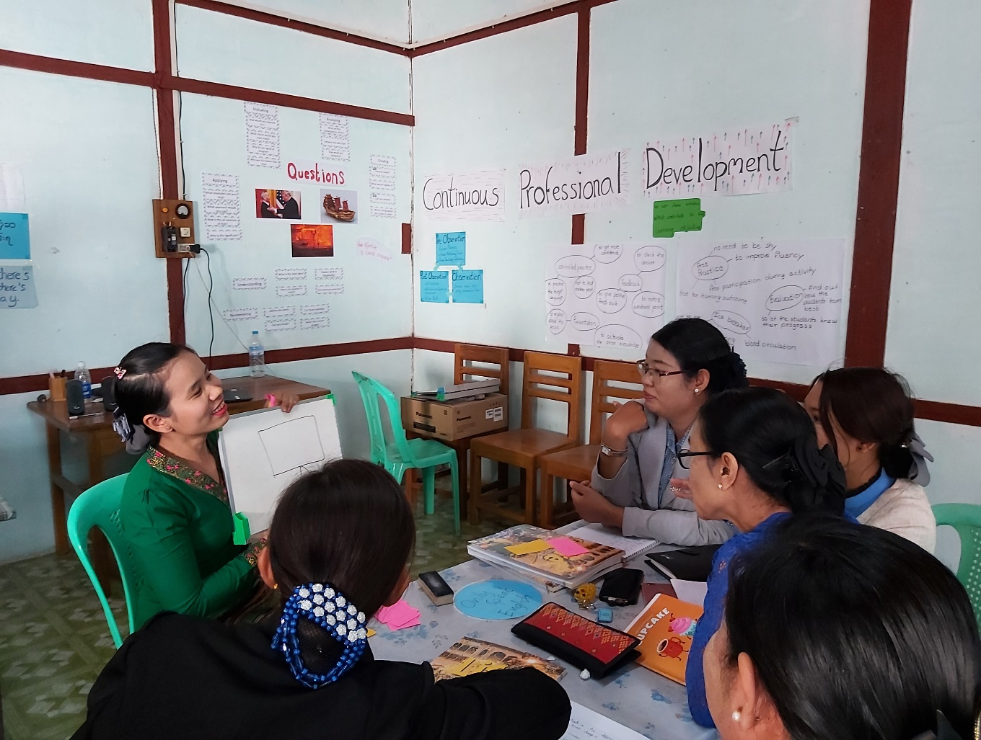
Unit 1: What is effective learning?
Trainer’s Guide

Overview

This module considers what effective learning looks like in the context of educational institutions and organisations in Myanmar and how leadership teams of these institutions and organisations can influence attitudes and approaches to effective learning.
The course will consider questions such as:
- Who are our learners?
- What is effective learning?
- Who is responsible for effective learning?
- What leadership approaches and strategies can leaders employ to enable and ensure effective learning in their contexts?
- What skills do leaders require in order to enable and ensure effective learning and how can these be developed?

This is the first of five units:
- What is Effective Learning?
- The Learner and Classroom Environment
- Leadership for Effective Learning
- Strategies for Leading for Effective Learning
- Skills for Leading for Effective Learning

Contents

Section | Materials | Timing
Outcomes | Participant Book | 5 mins
1.1 What does effective learning look like? | Participant Book | 15 mins
1.2 The role of leadership in effective learning | Participant Book | 20 mins
1.3 What other factors influence effective learning? | One enlarged pyramid template from Appendix A for each group | 20 mins
1.4 Principles of effective learning | Participant Book | 20 mins
1.5 Our principles | Poster paper for each group | 30 mins
1.6 Reflect and apply | Participant Book | 20 mins

Outcomes

By the end of this unit, participants will be able to:
- reflect on and share ideas about what effective learning looks like
- describe the role of leadership in facilitating effective learning in educational institutions
- describe what factors have the greatest impact on effective learning in educational institutions
- agree on principles of effective learning in educational institutions.

Learning outcomes
- Briefly introduce the course overview and answer any questions.
- Explain the outcomes for this unit and check participants understand them.
- Highlight that this unit aims to encourage reflection about learning and leadership, rather than teach facts.

1 What is effective learning?

1.1 What does effective learning look like?

- Show the discussion question below. Ask participants to quietly reflect on their ideas and make notes for a minute. Remind them that there is no right or wrong answer.
What does effective learning mean to you?
- Ask participants to share and compare their ideas with a partner and take feedback from a few pairs.

- Acknowledge any interesting ideas but do not provide any correction or specific feedback. This question is only to elicit participants’ pre-existing ideas.

- Ask participants’ to look at the six pictures. Give them a minute to read the questions and think of answers to the three questions:

- Who are the learners?
- Where are they?
- Is this effective learning in your opinion? Why/why not?

- Organise participants into groups to share their ideas about the pictures.

- Monitor and encourage participants to give reasons for their opinions and ensure everyone has a chance to share.

- Give participants 8-10 minutes to share ideas.

- For feedback, if time allows, elicit ideas from groups for each picture and each question.

- If short on time, elicit feedback for only a few pictures e.g. a, b, f. Encourage differences of opinions. The purpose of this task is to draw out pre-existing ideas of learning as a springboard for discussion.

Note: Stress to participants that everyone can be a learner. Use the participants taking this course as an example of adult learning and elicit other examples.

1.2 The role of leadership in effective learning

This task relates to a key theme of this course which will be visited in more detail in later units. The purpose of this task is to present some quotes from western classroom-based research about the role of leadership, and gauge participants’ exposure to, and agreement or disagreement with these ideas. Assure participants there are no right or wrong answers, and that disagreement can promote good discussion.

- Write the following question on the board or in the chat box:
What is your role in supporting effective learning in your context?

- Allow participants some thinking time and then elicit ideas.

- Tell participants that they are going to read three quotes about the role of leadership in supporting effective learning.

If participants are using the English version of the training materials, check understanding of new words or provide participants with the Myanmar translation of the three quotes so they can compare the English version with the Myanmar version.

Give participants time to work alone to read the quotes.

- Put participants in pairs or groups to check their understanding of the quotes and to decide whether they agree or disagree.

- Monitor and encourage participants to give reasons for their opinions.

- Nominate some pairs or groups to share ideas during the feedback stage. Acknowledge and note down any reasons for disagreement.
Variation:
- Organise participants into three groups.

- Assign one quote to each group and ask them to explain it to the other groups using either the board or a PPT. Allow approx. seven minutes preparation time plus ten minutes for presentations.

- Hold a small group or plenary discussion asking participants which quotes they agree with.

Suggested answers:
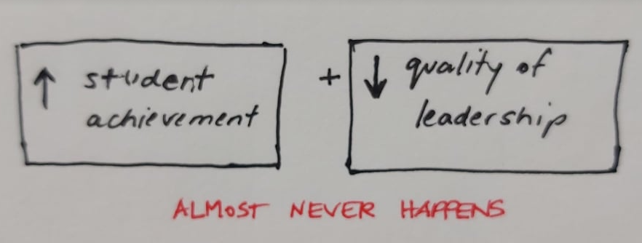
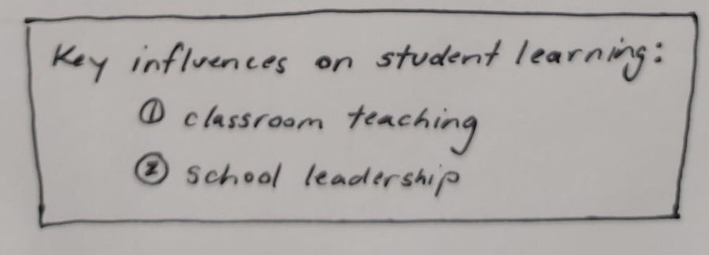
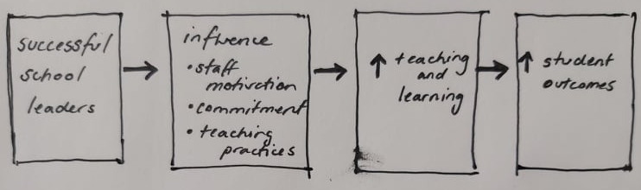

1.3 What other factors influence effective learning?

- Introduce this stage by explaining to participants that to help them understand what they can do as leaders to ensure effective learning in their context, they should consider other factors that might impact on effective learning.

- Briefly ask participants what they think has the biggest impact on effective learning. Elicit a couple of ideas and ask respondents to justify their answers.

- Display the list of factors from which might impact learning. Give participants a minute to read them.

- Explain to participants they need to work in small groups to rank the factors in order of their impact on learning. Display the pyramid and demonstrate the task by choosing two example factors and eliciting where in the pyramid it should go.

- Make sure participants understand that multiple factors can be put at the same level i.e. may have equal impact.

- Assign a member of each group to note down key points from their discussion to report back to the group.

- Give participants ten minutes to discuss and decide together where each factor should go. Monitor and make sure participants are giving reasons for their decisions.

- Feedback
  - either display each group’s pyramids and encourage them to compare their ideas, eliciting and summarizing and pointing out any major agreements or disagreements.
  - or ask each group to summarize what two or three factors have the biggest impact and give reasons why.

- Wrap up
- Ask participants if there is anything not included in the list that they think has an important impact on effective learning? Elicit answers.

Possible responses: CPD, timetables, teacher/trainer motivation, learner motivation, attitudes to learning

  - Ask participants as leaders how much influence do they have over the ten factors listed above?

1.4 Principles of effective learning

The purpose of this stage is to establish a shared understanding of what principles are in general, and that they can help us to achieve goals. Participants then consider the shared goals of institutions in their context and what the role of leadership is in achieving them. This leads into the following stage which asks participants to agree on their own principles of effective learning for their individual institutions.
- Display the following questions to the group and give participants a minute to think:
What is a principle? Can you give any examples? Why are principles important?
- Draw participants’ attention to the statements about principles in the box and ask them to discuss these questions in pairs or groups:
Are the ideas the same as your answers? Are there any ideas which are new for you? Do you agree with these ideas?
- The next activity aims to introduce some principles of effective learning drawn from western classroom-based research and encourage participants to reflect on their appropriacy for their own contexts.

- Ask participants to read the principles individually first. If participants are studying in a second language, check the meaning of any new/difficult words or concepts e.g. the relationship between teaching and learning, mindset, scaffolded, concrete v’s abstract.

Note the concept of mindset is explained below:
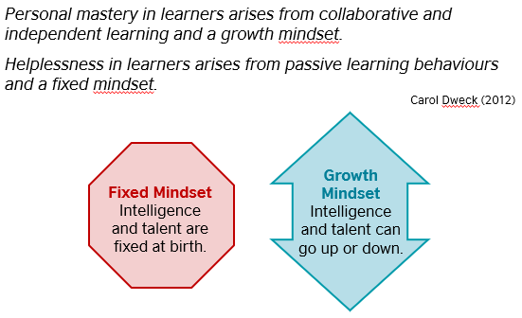
- Put participants in small groups to discuss the questions for approximately five minutes.

- For feedback, make sure there is enough time to hear from each group and note down any common themes, particularly for question 2: Which of these principles are the most challenging to follow for TEs and Leadership Teams in your context? Why? Encourage open and honest reflection on the challenges in the current context.

1.5 Our principles

This task invites participants to come up with their own principles for effective learning in their contexts. Encourage reflection on what they have discussed so far in the session, but make sure they understand that these principles should be based on their own specific contexts and what they hope to achieve in the longer term. Discourage uncritical ‘borrowing’ of the principles introduced in the previous stage.
- Introduce the task by sharing this notice and instructions.
A group of parents of learners in the context you work in have selected a representative to talk to your institution and to you as leaders.
Here is their request:
We would like to request leaders of your institution to write some principles of effective learning.

These can be shared with parents through letters and by displaying them on classroom walls.
How would you respond to this request?
- Group participants who work in a similar context where possible.

- Instruct groups to discuss their ideas and make a draft first for ten minutes. Remind participants to consider the following: the people, the culture, the strengths, the needs, and your vision for the future of your institution. What are the essential principles for effective learning needed to achieve this?

- When drafts are checked, give out poster paper (or instruct to open a PPT if online) and allocate a further 5-10 minutes for participants to complete the task.

- For feedback, conduct a gallery walk (or group presentation if online), giving groups a few minutes to read the other groups’ principles and note down any questions or comments they have. Then allow time for Q&A for each group’s principles. Give your own feedback and ask follow-up questions where appropriate.

- Ask participants, ‘Where should we display these principles? Who needs to understand them? How will you share them?’ Encourage them to share the principles they made with staff and learners in contexts where they work.

- Before finishing this stage, ask participants to look back at the pyramids they made in 1.3, and ask them if the principles they made reflect their ideas about what impacts learning.
- Either take photos of the posters they made or save the PPTs if online. If possible, display their principles in the room and refer to them throughout the course as different ideas about leadership are explored. Participants are free to change or update them as the course goes on.

1.6 Reflect and apply

This stage aims to wind down and wrap up the unit by encourage reflection on topics covered and learning in the unit and set up an interview task with a teacher or trainer from their own context around some of the ideas from the session.
- Direct attention to the stages of this session and ask participants to reflect on what has been discussed and any questions they have about the topics covered.

- Instruct participants to work alone for five to seven minutes and note down their ideas in the stars.

- Ask participants to share their ideas with a colleague and let them know they are free to ask any questions to the trainer or other participants.

Follow up
- Tell participants that it is a good idea to find out if teachers and trainers in their own contexts share their ideas and views about effective learning and leadership.

- Give a few minutes for participants to read through the instructions and check their understanding of the task.

- Remind participants of the extra reading task in Appendix 1 of the Participants’ Book if they would like to know more about principles of effective learning from this session.

Appendices

Appendix 1 – Pyramid
What impacts effective learning in your context?

Appendix 2 Extra Reading

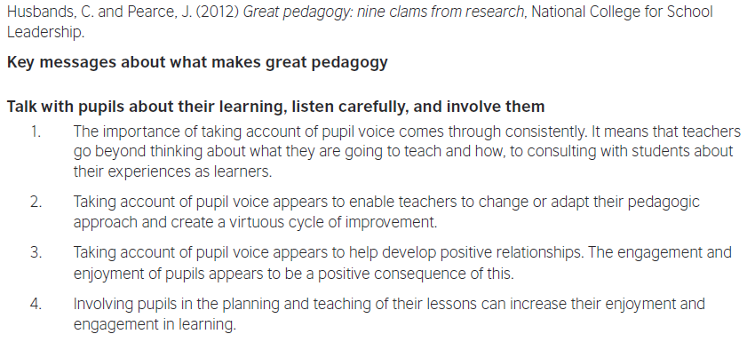
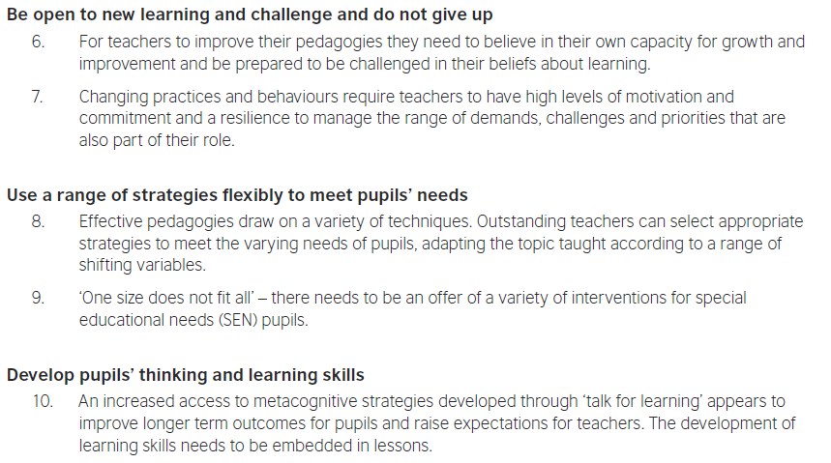
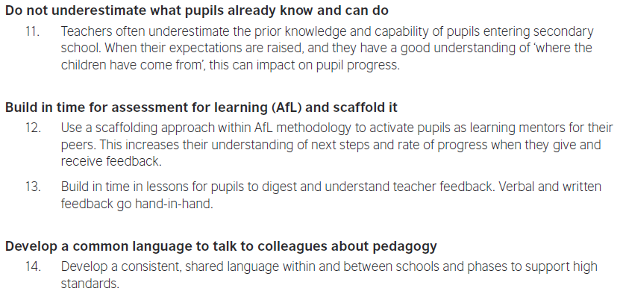

Further reading and references

Barber, M. et al. (2010) Capturing the Leadership Premium. National College for School Leadership
British Council, Connecting Classrooms Leading Effective Teaching and Learning
Day, C. et al. (2010) Ten Strong Claims about Successful School Leadership. National College for School Leadership
Dweck, C. (2006) Mindset: the New Psychology of Success. New York: Random House
Hattie, J. (2010) Visible Learning for Teachers, London: Routledge
Husband, C. and Pearce, J. (2012) Great Pedagogy; Nine Claims from Research, National College for School Leadership
Leithwood, K et. al. (2008) Investigating the Links to Student Learning. University of Minnesota.

