Urban WASH: Working with People

About OpenWASH

OpenWASH learning resources provide an innovative curriculum of study designed to be used in education and training programmes in the water, sanitation and hygiene (WASH) sector in Ethiopia. They have been written by Ethiopian WASH experts with the support of teaching specialists from The Open University UK (OU). The name ‘OpenWASH’ is derived from this link with the OU and also indicates that the resources are free to use as open educational resources.
The OpenWASH resources are the output from a partnership agreement between the OU, World Vision Ethiopia (WVE) and UNICEF. They are part of the capacity-building component of WVE’s Urban WASH programme. This is part of UNICEF’s One WASH plus programme, which is funded by UK aid from the UK Government as a contribution to the Ethiopian Government’s One WASH National Programme (OWNP).
The modules are designed for people engaged across a range of positions and levels in the WASH sector. The main audience is intended to be students who are training to work in the sector, but the modules may also be used for in-service training of new employees and by more experienced practitioners seeking to improve knowledge and skills in specific areas. The material could also contribute to training of community groups, in schools, etc.
There are five OpenWASH modules covering a range of WASH subjects, with an emphasis on WASH in urban settings. The module titles are:
- Ethiopia’s One WASH National Programme
- WASH: Context and Environment
- Urban Water Supply
- Urban Sanitation and Solid Waste Management
- Urban WASH: Working with People.
They have been written in such a way that they can be used separately or together. As a set of five, the modules provide a comprehensive set of resources that introduce students to a wide range of essential skills and knowledge about urban WASH. They can also be used individually or as a group of two or more modules to support particular training needs. Each module consists of 15 separate ‘study sessions’ that follow a consistent structure and length thus facilitating effective learning.
The modules are accompanied by the OpenWASH Trainers’ Handbook, which provides guidance on how the modules can be used in a variety of teaching contexts.

This Module, Urban WASH: Working with People, was prepared by a team of Ethiopian authors with support from experts in blended learning pedagogy at The Open University UK. It was first published in February 2016. The contributors of original material are:
Tesfay Alemseged, Ethiopian Institute of Water Resources
Araya Mengistu, SNV Netherlands Development Organisation
Wossen Assefa, SNV Netherlands Development Organisation
The Academic Editors of Urban WASH: Working with People are Dr Janet Haresnape, Staff Tutor in the Faculty of Science, and Pam Furniss, Senior Lecturer in Environmental Systems in the Faculty of Mathematics, Computing and Technology, The Open University UK.
Additional thanks to:
Michele Paba, Urban WASH Specialist, UNICEF Ethiopia
Rahel Kaba, Urban WASH Specialist, UNICEF Ethiopia
Tamene Gossa, Urban WASH Specialist, UNICEF Ethiopia
Dr Sam Godfrey, Chief of WASH, UNICEF Ethiopia
Dereje Alemu, WASH Operations Director, World Vision Ethiopia
Felipe Chaparro, Team Leader Urban WASH Project, World Vision Ethiopia
Nicholas Owuor, Team Leader Urban WASH Project, World Vision Ethiopia
Ellen Scott, OpenWASH Project Manager
Gail Vardy, OpenWASH Project Coordinator
Hannah Juma, OpenWASH Curriculum Manager
This Module should be cited as follows:
OpenWASH (2016) Urban WASH: Working with People, The Open University UK/World Vision Ethiopia/UNICEF.

Contents

Study session | Title | Page
 | Introduction to Urban WASH: Working with People | 7
1 | Characteristics of Urban Communities | 9
2 | Environmental Pollution and Health | 19
3 | Existing WASH Service Provision | 31
4 | Stakeholders in Urban WASH | 41
5 | Social Accountability and Social Responsibility | 51
6 | Community Engagement | 61
7 | Role of Frontline WASH workers | 71
8 | Assessing Behaviour | 81
9 | Influencing Behaviour | 93
10 | Promoting Improved Hygiene and Sanitation | 103
11 | Mobilisation of Urban Communities | 115
12 | Advocacy and Networks | 125
13 | Sustainability of WASH Services | 135
14 | Emergency WASH Behaviour Communication | 145
15 | Monitoring and Evaluation | 157
 | Notes on the Self-Assessment Questions (SAQs) for  Urban WASH: Working with People | 167
 | Key terms | 187
 | References | 189
 | Acknowledgements | 193

Introduction to Urban WASH: Working with People

It is widely accepted that the provision of new WASH services will only bring benefits if the people using the services are willing to recognise their own role and responsibilities, for example by adopting good hygiene practices and new methods of waste disposal. The users should also be able to participate in, or at least be aware of, the planning, design and management of WASH services.
WASH technicians and other employees of service providers and local bureaus need to have a good understanding of social, cultural, financial and institutional issues at the local level. They also have responsibility to ensure that the service users are aware of their rights and responsibilities, such as how users may influence decision makers, and ensure the service providers are accountable to their customers.

Learning Outcomes for this Module
After you have studied this Module you should be able to:
- Describe the characteristics of urban communities and how they can affect behaviour and environmental responsibility.
- Explain the importance of social accountability and community involvement for effective and sustainable WASH services.
- Discuss the different approaches that are available to influence people’s behaviour in the home, in schools and other institutions, and in the wider community.
- Plan and undertake community engagement activities to achieve sustainable change in WASH behaviour.
- Explain how monitoring and evaluation should be used to assess impact of WASH interventions.

How to use this Module
This Module is designed for independent study, although you may in fact be studying in a group with others. Either way, we recommend that you use a Study Notebook that you keep with you as you work through the Module to note down answers to questions and keep a note of any important points.
The Module is divided into 15 separate study sessions, each expected to take about two hours to study if you are learning on your own. You will see that the study sessions all have a similar structure. Following a brief introduction, each study session has a set of learning outcomes that are linked to self-assessment questions (SAQs) at the end of the session. Within the text, there are in-text questions (ITQs) with answers immediately following. When you come across one of these questions, try to answer it in your head or by noting down your answer in your notebook before you read the response that is given. This will help you to learn.
Each session ends with a summary, which lists the key points that have been made, and the SAQs. Each SAQ tests one or more of the learning outcomes that were stated at the beginning of the session. When you have finished reading, you should work through the SAQs, writing answers in your notebook. Writing your answers, rather than just thinking about them, will reinforce your learning and enable you and anyone else to check how well you have achieved the learning outcome. You can check your answer with the notes on the SAQs from all sessions, which you will find collected together at the back of this book.
Important terms are highlighted in bold and defined in the text. You will find that the first learning outcome for all study sessions is to be able to understand and use these key terms. All the key terms from this Module are listed alphabetically at the back of this book with a reference to the study session where they are defined.
You will see that the sources of information used in the text are indicated by the name of the author or organisation followed by the date of publication in brackets, for example ‘(Haddis and Genet, 2012)’. Full details of these sources are listed alphabetically by author in the list of references at the back of the book. If an article has more than two authors, we have used the notation ‘Faris et al., 2012’, where ‘et al.’ is a shortened form of the Latin words for ‘and others’.
Please note that we have used UK English spellings rather than US spellings. Please also note that all years are according to the Gregorian rather than Ethiopian calendar, unless otherwise stated.

Study Session 1 Characteristics of
Urban Communities

Introduction
Urban communities have characteristics that expose them to particular health risks related to their living conditions. Some segments of the community are particularly severely affected by these conditions. This study session introduces you to aspects of life in urban areas that are important for understanding and addressing WASH issues. (WASH stands for water, sanitation and hygiene.)

Learning Outcomes for Study Session 1
When you have studied this session, you should be able to:
1.1 Define and use correctly each of the key words printed in bold. (SAQ 1.1)
1.2 List the key features of rapid urbanisation and briefly discuss their causes. (SAQ 1.1)
1.3 Describe the particular challenges of providing WASH services in urban settings. (SAQ 1.2)
1.4 Identify vulnerable segments of urban communities and explain the challenges they face in accessing WASH services. (SAQ 1.3)
1.5 List some factors that complicate emergency incidents and identify interventions to tackle them in urban areas. (SAQ 1.4)

1.1 Urbanisation and development trends
Ethiopia is among the poorest countries in the world and, with a population approaching 100 million, has grown and developed significantly in recent decades. One of the many ways you can see this growth reflected is by looking at how fast existing urban areas are expanding, and how villages and small towns are rapidly growing into larger towns and cities. Between 1984 and 2007, the urban population – defined as the percentage of the population living in towns of at least 150,000 people or within one hour’s travelling distance of a town of at least 50,000 people – increased from 3.7% to 14.2% (Schmidt and Kedir, 2009). Between 2010 and 2015, the rate of urbanisation is estimated to have further increased at a rate of 4.9% every year (CIA, 2015). (Urbanisation is the increase in the number of people living in towns and cities relative to rural areas.)
The trend in urbanisation is strongly associated with economic growth and development. As economic activities increase in urban areas, opportunities open up for employment, which attract people living in rural areas to move into the towns and cities.
As the total population increases, the land available per person for farming in rural areas decreases. Furthermore, degradation of the natural environment leads to low productivity of the land. The shortage of land, coupled with reduced productivity, results in a low income for rural households. This encourages people, particularly young adults, to migrate from rural to urban areas in search of better employment opportunities.
The overall effect of these trends is that the number of people living in urban areas keeps increasing.
Political and administrative bodies in urban areas have to provide basic services such as electricity, telephone, water supply, waste disposal, healthcare and education. However, the infrastructure required to deliver these basic services to an acceptable standard is growing at a much slower pace compared to the increase in population.
Slums are becoming a common feature in most towns (Figure 1.1). Slums are urban areas that are heavily populated and have sub-standard housing and very poor living conditions. They provide minimum shelter requirements for communities with low or no income. Slums are the usual entry point for those from rural areas to the complex urban environment. However, due to intense competition, securing a job with reasonable pay often proves very difficult. As a result, the majority of people who live in slum areas remain there permanently because they cannot earn enough to move into better housing.
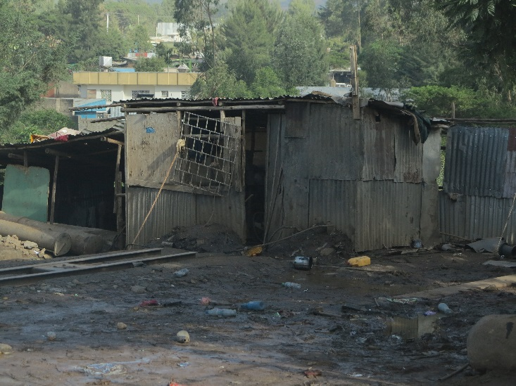
Figure 1.1 Slum area of an Ethiopian town.
Despite the very high population density – the number of people living in a unit area of land – and the dire need for access to water, electricity and roads, slums are not the main focus of attention for administrative bodies. Slums arise in areas with little or no government scrutiny and are mainly illegal settlements. Therefore these communities do not have legal rights to the land they live on, which is a fundamental requirement for claiming services in urban areas. Although the government recognises the need, it is difficult to provide basic services to slum areas as part of its regular work.
Peri-urban areas are another common feature of towns. These areas are interface zones, located on the outskirts of towns, which show characteristics of both rural and urban areas. They are similar to urban centres in that they have high population density and services such as electricity, water and transport are probably available nearby (but may not be affordable). However, people in peri-urban areas may be farmers and grow food to supplement their income so also share similarities with rural communities. As towns spread, peri-urban areas may become part of the main urban area (Figure 1.2).
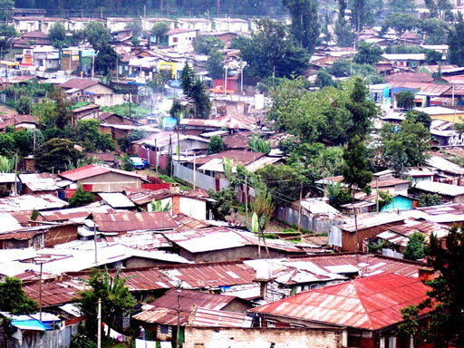
Figure 1.2 Peri-urban areas have similar characteristics to slums.
The increasing urban population in Ethiopia may support economic growth in the country, but it is a continuing challenge for urban administrations to provide adequate access to basic services to enable these communities to remain healthy and productive.
- Identify three key features of urbanisation.
- The three main features are listed below. You may be able to think of others.
- Significant population numbers caused by increasing influx of people from rural areas.
- Slums populated by low income communities with little or no access to services.
- Peri-urban areas located on the outskirts of the town that exhibit characteristics of both urban and rural areas.

1.2 WASH in urban areas
This section outlines the challenges of WASH service delivery in an urban context.
- List the services which you consider essential in urban areas.
- You may have thought of water supply, healthcare, electricity, telecommunication, and waste collection and disposal services.
The term WASH services includes supply and distribution of clean water, promotion and implementation of environmental sanitation, and promotion of safe hygiene practices to communities. Sanitation includes provision of latrines and other methods to protect health by preventing human contact with wastes. All three components – water, sanitation and hygiene – are important to ensure healthy community life. These services are also interdependent. For instance, handwashing with soap after visiting latrines is a safe hygiene practice. However, communities can only do this if clean water is available. Even when communities have an adequate supply of water, the lack of latrines can lead to open defecation and pose threats to health (see Figure 1.3). Contamination of water and the wider environment is the source of many diseases caused by micro-organisms found in faeces.
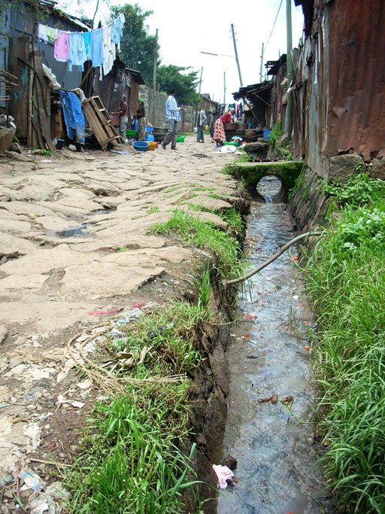
Figure 1.3 A slum area of an Ethiopian town showing faeces in the drainage channel.
WASH services should ideally be provided for the whole urban area at all times. Lack of services in one small area can lead to significant risk of contamination of water or food. A disease outbreak in a poorly serviced area of town can quickly spread to better serviced areas. Lack of WASH services therefore directly affects the health and well-being of whole communities. If not tackled, this will diminish Ethiopia’s capacity to progress towards its goals for economic development. WASH services are issues of basic human rights and dignity, and reflect politically on local and national government.
The Joint Monitoring Programme (JMP), led by UNICEF and the World Health Organization (WHO), monitors the progress in water supply and sanitation services worldwide. The 2012 Ethiopia data shows that in urban areas access to improved water supply and improved latrines is 97% and 69% respectively. In a town of 150,000 people, this indicates that 31% (or 46,500 people) lack access to improved sanitation facilities, and 3% (or 4,500 people) lack water from improved sources (JMP, 2014).
- In a small town of 35,000 people, approximately how many people would have access to improved latrines, and how many would not, according to the 2012 JMP data?
- Approximately 24,000 people would have access to improved latrines and approximately 11,000 people would not. (The estimated population with access to improved latrines is 69% of the 35,000 obtained by multiplying 35,000 by 69/100, which gives 24,150 or approximately 24,000. The remaining people, i.e. 35,000 − 24,000 = 11,000 do not.)
Much more needs to be done to provide urban communities with WASH services of sufficient quality and quantity. The government of Ethiopia, with support from international and local organisations, plans and implements interventions in urban areas to expand existing systems or invest in new infrastructure. (An intervention is any action intended to improve a situation.) For example, Ethiopia set out to achieve 98% access to water in urban areas by the year 2015 as part of its Growth and Transformation Plan I (2010–15) and significant progress has been made. However, improving WASH services to the desired level of coverage continues to be extremely challenging.

1.2.1 Challenges related to population size and characteristics
WASH service upgrade and expansion is slower than the rate of population growth, which puts pressure on the existing systems. As the services are shared by many more people, they quickly become inadequate and may break down.
Urban communities come from different backgrounds and have varying economic status. They are likely to be very mixed and include people from different ethnic groups and religions. Moreover, most people living in urban areas move frequently in and out of town. They may not feel they are part of a community or care very much about the place where they live. These characteristics make it difficult to raise awareness and understanding of basic service issues and pose significant challenges for mobilising people to change their behaviour and actions. You will learn more about the challenges involved in engaging and mobilising such communities and implementing behaviour change to promote good sanitation practices in Study Sessions 6, 9 and 11.

1.2.2 Challenges related to infrastructure
The key challenge to meeting the increasing WASH service needs in Ethiopia’s urban areas is the availability of adequate resources, including finance and human resources that can provide and maintain the necessary infrastructures. The infrastructures required are:
- water supply system
- stormwater drainage system
- solid waste collection, transportation equipment and disposal sites
- liquid waste (including faecal sludge from latrines) transportation and disposal sites
- waste recycling or reuse equipment and facilities.
Water supply systems include developed water sources, treatment plants, storage reservoirs, and a network of distribution pipes delivering water to users. Growing population numbers and economic activity in urban areas mean that:
- Large amounts of investment are required to expand the capacity of these systems to meet the water needs of the population adequately. Mobilising sufficient funding is often difficult.
- Water sources, especially groundwater, may become depleted over time because of high extraction rates.
- Waste from industrial activities increases the threat of contamination of water sources.
Sanitation services include infrastructure for collection and safe disposal of liquid and solid waste. The amount of waste increases with the population size. Industrial activities also add to the type and composition of wastes generated. You may have noticed the excessive waste accumulated in different parts of urban areas. Figure 1.4 shows an example where rubbish and flooding have caused problems in a suburb of Accra in Ghana – similar scenes can also be found in Ethiopia.
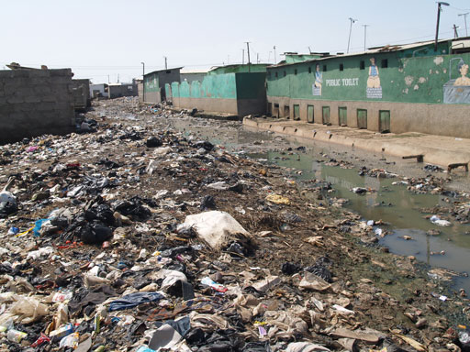
Figure 1.4 Accumulated solid waste and effluent from a latrine block have filled a drainage canal in Accra, Ghana.
Wastes from residential areas and from industries often require treatment before being safely discharged into the environment. Faecal sludge from latrines or toilets needs to be transported, treated and disposed of safely. Most towns do not have a proper treatment facility or a suitable disposal site. In emerging towns, where agricultural processing is a growing trend, industrial wastes, for example from coffee processing plants and hide processing factories, are causing an additional burden. Wastes from such industries are often released into the environment without treatment.
Again, mobilising sufficient finance to expand services in a timely manner is critical to managing these situations, but is difficult.

1.2.3 Challenges related to governance
The term governance is used to represent many interrelated areas in government systems and refers to such things as the ways decisions are made and strategies are developed. Here, the focus is on responsibility and accountability of local governments in decision making to improve and effectively manage WASH services. Accountability means an obligation or a willingness by an organisation or individual to account for their actions and accept responsibility for them.
You have read that finance is a key resource needed to improve WASH services. Appropriate allocation of public funds between WASH and other sectors, such as roads, is a governance issue. Within the WASH sector, most of the budget goes to water-related works and the sanitation component is usually left with very little. Even the small proportions of resources available are spent on financing major infrastructure in urban centres where most of the rich families reside. This may mean that tax collected from the larger community is only benefiting a selected few, which is not considered fair.
Effective operation and management of urban WASH facilities is another challenge related to governance. In principle, WASH facilities are managed by service providers, such as water utilities and micro- and small enterprises (MSEs). These groups are expected to recover costs for operating and maintaining the facilities but their performance is often below expectations. Service providers may not listen to the needs and complaints of user communities. Where services are not provided to the expected standard, the community’s motivation and willingness to pay the tariffs is reduced. This affects the capacity of the service providers to manage the WASH facilities and is a major challenge for governance.

1.3 Equity and inclusion in urban WASH
This section examines the challenges of ensuring equitable access to WASH services for all groups within urban communities.
The terms equality and equity may appear to mean the same thing. However, equality of service means that everyone gets equal amounts of services regardless of need, whereas equity of service refers to services allocated according to need, which is more fair and just, as illustrated in Figure 1.5.
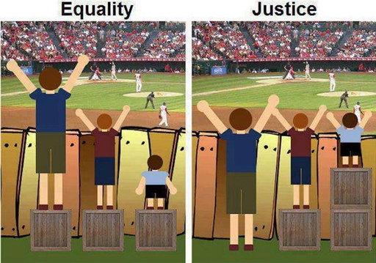
Figure 1.5 Equality and justice, which is similar to equity.
Urban communities consist of diverse groups of people and all need access to WASH services. However, depending on their age, lifestyle, nature of their daily work, and/or physical condition, these groups require different levels of service. Some in the community, referred to as vulnerable groups, have particularly special needs and are most affected by the lack of WASH services, for example:
- children and the elderly
- people living with HIV/AIDS
- people with disabilities (of any age)
- poor families with little or no income.
Children, especially those under five years of age, are more likely to die of diarrhoea caused by lack of clean water. Disabled people may not easily access and use conventionally built latrines because of steps or rough and uneven ground. This not only limits their ability to practise safe sanitation but also makes them socially marginalised.
To ensure equity, stakeholders should consider these vulnerable individuals, and devise means to ensure that their needs are identified and addressed. Inclusion refers to the process of incorporating the needs of vulnerable groups. Inclusive programmes or projects ensure that WASH service environments are accessible to everyone, as shown in Figure 1.6.
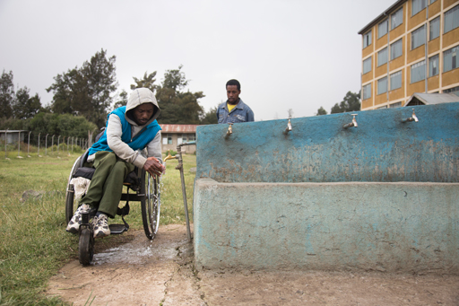
Figure 1.6 An inclusive facility at an urban school enables a disabled student to wash his hands in clean water.
Disabled students who use wheelchairs require special access to latrines in schools. If ramps are not in place, these students either avoid using the facility or struggle to use it despite uneven and often unsanitary floors. The health risk to disabled students can be significantly increased by lack of ramps. The situation is the same in public latrines that serve market centres.
It is also important to think about disabled people without mobility aids (Figure 1.7). Many disabled people are poor and do not have access to mobility aids such as wheelchairs. Where possible, local solutions developed in consultation with the users can assist them to access the WASH facilities more easily and safely.
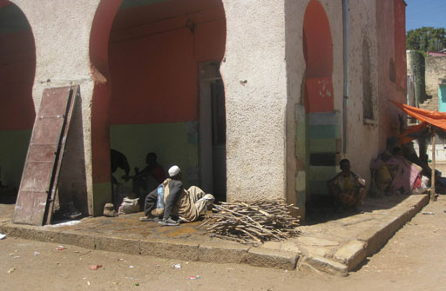
Figure 1.7 Many disabled people do not have wheelchairs, making access to WASH facilities extremely difficult.

1.4 Youth and unemployment
Nearly 50% of the population of Ethiopia is aged under 15 years (CSA, 2012). As these young people grow up they will help to provide the necessary workforce for continued development. However, in the current market the majority of urban youth remains unemployed. If the population continues to grow at a faster rate than employment opportunities, then unemployment will increase over time, unless innovative solutions are introduced to reduce or reverse this trend.
The WASH service sector, as discussed earlier, needs to grow substantially to meet expected standards of service. If appropriately developed, the sector can offer much sought after employment opportunities within the urban environment. Some initiatives are already taking shape in urban areas to engage unemployed youth in income-generating activities such as new enterprises in solid waste collection, transport and/or disposal services.
These initiatives, which are very small compared with the potential market and high unemployment rate, need to be developed into wide-scale application to have a meaningful impact on unemployment. Such initiatives are commonly referred to as public–private partnerships because privately owned enterprises are working together with the public sector to improve services. In Ethiopia, there is an increasing number of private groups employed by municipalities (the public service provider) to collect waste from households and transport it to disposal sites.
Additional areas of service that can contribute to employment generation include:
- voluntary sanitation and hygiene promotion campaigns to promote and create demand for improved WASH products
- supply and sales of hygiene/sanitation products (e.g. soaps, menstrual pads, household water treatment equipment or chemicals, latrine slabs, smoke-free stoves)
- supply of services (sludge emptying, waste collection and/or disposal, waste recycling).
Addressing unemployment is a joint responsibility for the community, government, non-governmental and civil society organisations (NGOs and CSOs), private organisations and schools. For example, the municipality can work with micro- and small enterprises to create jobs in the WASH sector and their finance office can facilitate long-term loans with microfinance institutions for business start-up needs. To bring about improvement, joint commitment is needed by all.

1.5 WASH-related emergencies in urban areas
Emergency situations can arise as a result of disease outbreaks, natural disasters or man-made incidents. Contamination of water sources or distribution systems by disease-causing micro-organisms is a common cause of widespread disease outbreaks, leading to emergency in urban areas. Contamination at the source, or along the pipe network where there are leakages, can reach a large number of people very quickly. Piped-water systems are more likely to become contaminated when pipes are allowed to become empty, either as a result of the common practice of rationing water distribution or because the supply has dried up. This is because the pressure goes down in empty pipes, which can lead to contaminated water seeping in through defects in the pipe.
Floods are another common cause of emergency situations in urban areas. When extreme rainfall occurs, the run-off generated can exceed the capacity of the town’s drainage systems. Accumulated solid wastes may have already piled up in the canals, reducing their water carrying capacity. As a result, flood water can overflow into streets and houses and, as this happens, harmful bacteria living and reproducing in the waste are also transported to households.
In communities that practise open defecation, excreta may be carried with the flood water to contaminate the surrounding neighbourhood. The floods can also cause pit latrines and septic tanks to overflow causing further contamination. In addition, peri-urban and rural communities living downstream of the urban area are threatened because the flood eventually transports contaminants to these areas. The risk may be even higher here, especially if these communities depend on river water for their daily needs.
We cannot control natural incidents, such as rains and floods. However, we can control how we choose to live our lives in order to reduce health risks. Individuals and communities are responsible for stopping bad practices, such as open defecation, and adopting safe practices such as using latrines and handwashing. Communities are sometimes reluctant to use safe practices and, in urban areas, due to their mixed and diverse characteristics and a poor sense of belonging, this reluctance can be particularly pronounced.
The WASH service providers (e.g. water utilities), in collaboration with communities, must be alert to continuously ensure water safety from source to use. Routine activities to ensure this can include water source protection, distribution system inspection and maintenance, and monitoring the efficiency of water treatment facilities.
However, it is not always possible to ensure complete safety at source for technical or operational reasons. Therefore household water treatment (HWT) options, using chemicals or other alternatives, are widely recommended as a means to ensure water safety at point-of-use. Even if water arriving at users’ homes is contaminated, using household treatment options (also known as point-of-use treatment) should guarantee 100% safety if instructions are followed correctly. During emergencies these chemical treatments serve a very important and lifesaving role, and are usually distributed in tablet or powder forms to affected communities (Figure 1.8).
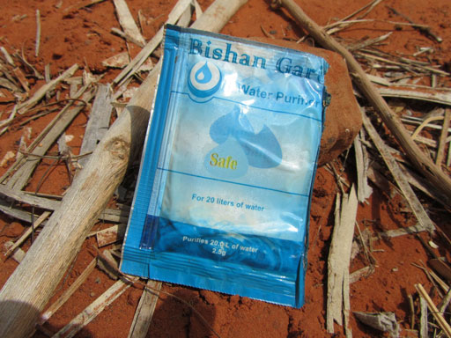
Figure 1.8 Water treatment sachets may be distributed in emergency situations.
In such emergency situations, slum areas are particularly prone to being affected, owing to their lack of infrastructure. Vulnerable groups may be more seriously affected by the lack of WASH services than other users, so emergency interventions should provide inclusive solutions to assist vulnerable people such as children, the elderly and the disabled, alongside the plan for the wider community.
You will learn more about assessing and responding to emergencies in Study Session 14.

Summary of Study Session 1
In Study Session 1, you have learned that:
- Rapid increase in population and unplanned expansion of slums and peri-urban areas are typical features of rapid urbanisation.
- Providing WASH services in an urban context presents numerous challenges, particularly as a result of increasing population and increased pressure on infrastructure. Limited financial resources makes it difficult to meet the rapidly growing need for improved WASH services.
- Vulnerable individuals, such as children, the elderly and the disabled, are likely to be more seriously affected than the rest of the urban community, if their access to WASH services is limited. WASH services should be equitable and inclusive.
- Urban youth unemployment is a significant problem in Ethiopia that could be improved with the development of new WASH enterprises.
- Emergencies such as disease outbreaks and floods are closely related to WASH provision. Promoting safe sanitation and hygiene practices and providing household water treatment products can reduce or prevent the damage that WASH-related emergencies can cause to urban communities.

Self-Assessment Questions (SAQs) for Study Session 1
Now that you have completed this study session, you can assess how well you have achieved its Learning Outcomes by answering these questions. You can check your answers with the Notes on the Self-Assessment Questions at the end of this Module.

SAQ 1.1 (tests Learning Outcomes 1.1 and 1.2)
Rewrite the paragraph below using terms from the list provided to fill the gaps.
employment, peri-urban areas, population density, productive, rural areas, sanitation, slum areas, urban areas, urbanisation, WASH services, water supply.
Increasing scarcity of ……………… land for farming and the prospect of better ……………… opportunities are encouraging more and more people in Ethiopia to move from ……………… to towns and cities. This ……………… has led to many people living in ……………… of poor housing that lack essential services. Towns and cities are also spreading over larger areas of land with expanding ……………… that have mixed urban and rural characteristics. The ……………… in ……………… is much higher than in rural areas. This creates challenges for providers of ……………… because of the high demand for ……………… and effective ……………… systems.

SAQ 1.2 (tests Learning Outcome 1.3)
Describe the particular challenges of providing WASH services in urban settings arising from each of the following factors.
        - Increasing population size
        - The diverse nature of the urban community
        - Infrastructure required for WASH services
        - Governance, in particular the process through which resources for improving WASH services are allocated and utilised.

SAQ 1.3 (tests Learning Outcome 1.4)
Imagine that you are conducting a community meeting on WASH issues and you have highlighted to the participants that the needs of vulnerable groups of people require adequate attention in WASH interventions. One participant asks you to clarify which specific issues are important to physically disabled people and how these issues can be addressed or provided for. What will be your explanation?

SAQ 1.4 (tests Learning Outcome 1.5)
One of the factors that can cause problems in an emergency situation is contamination of water supply systems. Explain how this can cause problems, identify what those problems might be and outline two interventions that could help to tackle them.

Study Session 2 Environmental Pollution and Health

Introduction
In Study Session 1 you read about urbanisation and how its trends are challenging WASH service provision. You also saw how urbanisation can have a negative impact on the environment. In this study session you will consider environmental pollution issues related to WASH and the implications for the health of communities.
Later in the module, you will learn how these issues might be tackled through community engagement (Study Session 6), influencing behaviour (Study Session 9) and promoting improved hygiene and sanitation (Study Session 10).

Learning Outcomes for Study Session 2
When you have studied this session, you should be able to:
2.1 Define and correctly use each of the key words printed in bold. (SAQ 2.1)
2.2 Give examples of different types of waste that can be causes of air, water or soil pollution. (SAQs 2.2 and 2.3)
2.3 Identify the major health risks associated with poor access to, or improper use of, WASH facilities. (SAQ 2.4)
2.4 Explain the relationship between current practices that result in environmental pollution and health issues. (SAQ 2.4)

2.1 What is environmental pollution?
The environment should be clean and safe and provide healthy surroundings for people and other living things. However, continued expansion of urban areas, industrialisation and population growth are causing environmental damage. Large quantities of industrial and community waste, as well as human bodily waste, are released into the environment every day. The effect of continued disposal of untreated waste and release of harmful substances is called environmental pollution.
Global warming is one well-known effect of environmental pollution, caused primarily by increased concentration of carbon dioxide in the atmosphere, but there are many others. Many people are exposed to smoke from motor vehicles, burning wood or charcoal on a daily basis, which can cause respiratory infections. Industrial waste containing toxic chemicals causes contamination of water resources. Fertilisers and pesticides used by farmers are easily washed by rain into run-off water, eventually reaching surface water sources, such as rivers, and groundwater sources, such as wells and springs. Moreover, many wastes can also lead to pollution and degradation of soil, making it impossible to grow crops and other plants successfully. Examples of potential soil pollutants include waste from dumping sites, industry, vehicle workshops and chemical fertilisers.
There are many different causes of environmental pollution related to different types of waste; these are described in the following sections.

2.2 Solid waste
Solid waste means all types of waste in solid form. It includes organic waste such as paper and leftover food, and inorganic waste such as plastic bags, cans and condoms. (Organic waste includes anything that is derived from living organisms; it decomposes by natural processes. Inorganic waste does not decompose so easily.)
Urban households and businesses generate a significant amount of solid waste. Plastic materials are long-term threats to the environment as they do not decompose easily. Coloured plastics are of particular concern because the sources of their colour are heavy metals such as lead, copper and chromium that are toxic to the environment. Use of plastics, particularly coloured ones, is actively discouraged in some countries, as is the case in India (Pradhan, 2000). However, their intensive use continues in developing countries such as Ethiopia, which adds to environmental pollution.
In schools, waste paper is a major component of the solid waste and where adolescent girls are students, menstrual pads can be an additional waste.
Restaurants, cafeterias and hotels generate a substantial volume of waste on a daily basis, including vegetables and other surplus food. These organic wastes quickly start to decompose, creating a strong and unpleasant odour and encouraging the growth of microbial pathogens (disease-causing agents). In addition, organic waste attracts mosquitoes, flies and rats, which can be responsible for spreading diseases. Such animals and insects are referred to as vectors of disease.
Health centres and clinics create different kinds of solid waste including used needles, gloves and bandages contaminated with body fluids from patients. These are all hazardous wastes that can cause harm to people. Waste in healthcare facilities is considered critical because new infections can occur in people dealing with the waste if it is not handled safely. Healthcare facilities are usually provided with incinerators that burn the waste at high temperatures to kill pathogens and remove any risk of new infections. Some facilities may have special storage containers for ‘sharps’ (i.e. items such as needles and razor blades), covered placenta pits for anatomical waste (blood, body parts), and open pits for other medical waste.
Market centres and public gathering areas produce significant volumes of organic and inorganic solid waste, such as plastic bags and packaging materials (Figure 2.1). Not only does accumulated solid waste create favourable conditions for pathogens and vectors to breed, it is also unsightly and a source of unpleasant odours.
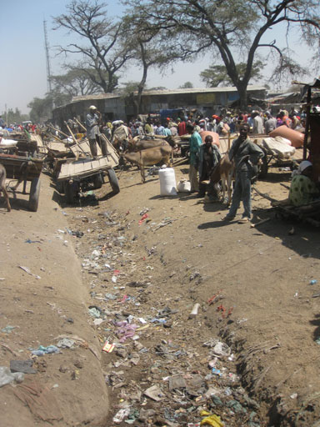
Figure 2.1 Plastic bags frequently pollute the environment around markets.
To protect urban communities from these health threats it is critically important to establish a waste management system. A waste management system includes the complete chain of service from waste collection, through transportation, to final disposal in appropriate locations. This may include informal waste collectors and waste pickers, who make a living from waste (Figure 2.2).
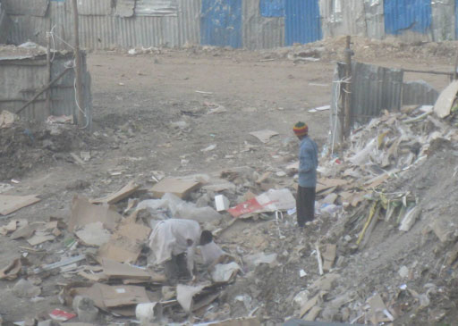
Figure 2.2 Waste pickers on a rubbish dump.
In ideal conditions, solid wastes are safely collected and transported to a designated dumpsite. In practice, a significant proportion of waste fails to reach the dumpsite quickly. The resulting waste accumulation from households, institutions and industries can be significant. Often, this accumulated waste is meant to be temporarily stored before being transported to the final dumpsite. However you may have noticed the condition of containers, skips or barrels near where you live and seen the threats posed by such transient waste. Figure 2.3 shows an overflowing skip and illustrates the unsightly result of an inefficient system that doesn’t move waste in a timely manner.
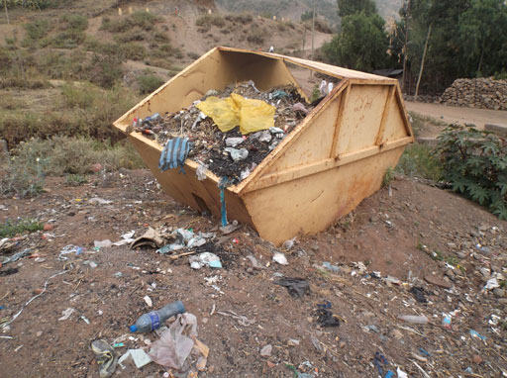
Figure 2.3 Solid waste spilling from an overflowing skip.
Final disposal sites should have adequate facilities and be well managed to avoid threats to the people working in them. However, in most towns designated disposal sites with necessary equipment and/or infrastructure are not yet established. Efficient systems are needed along the complete chain of service – from collection to disposal – in order to protect urban communities from health threats.
Where population density is very high and adequate latrine facilities are unavailable, communities may use buckets or plastic bags for handling excreta. Sometimes such excreta is thrown to solid waste collection spots in the hope that they will be removed along with other waste material, a practice sometimes known as flying toilets. Human excreta contains harmful pathogens that can cause disease and is a health risk if not buried or treated. Flying toilets are particularly dangerous if thrown into rivers or recreational areas. In slums, or where adequate latrines have not been built, it is always prudent to assume that solid waste may contain human excreta.
Sometimes anal cleansing materials are collected into waste bins and eventually removed from the facility along with other solid wastes. Such wastes are obviously contaminated by human excreta and may pose additional health risks.
So far you have been learning about the direct impact of solid wastes. Solid wastes can also block drainage canals and flood channels, causing them to fill up and overflow, leading to problems like the situation illustrated in Figure 2.4.
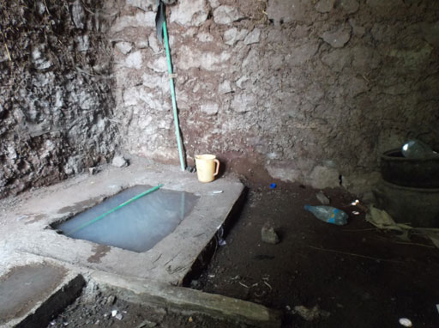
Figure 2.4 A flooded soakaway in a household latrine area.
- List the major solid waste contaminants of the environment.
- The major contaminants in this category are:
- organic waste from households, cafeterias and restaurants
- medical wastes
- plastics – especially coloured ones
- paper, cardboard and packaging waste.
If left in the open, as in the case of ‘flying toilets’, then faeces are also in the solid waste category.
- What kinds of solid waste are commonly produced by:
- a household
- a school
- a health centre?
- The answers are:
- A household might produce food waste such as vegetable peelings, leftover food, plastic bottles, bags, condoms and used menstrual pads.
- A school might produce food waste, waste paper and also used menstrual pads.
- A health centre might produce food and plastic waste as well as medical waste such as used bandages, syringes, needles, etc.
Instead of just discarding solid waste, a better approach to waste management is to adopt the 3 Rs approach. The 3 Rs stand for reduce, reuse and recycle. These three options can all contribute to improvements in the problems of waste disposal in urban areas. In order of preference, they are:
- Reduce the amount of waste produced. For example, throw away less food and avoid heavily packaged items.
- Reuse items many times before throwing them away. Bottles, plastic containers and bags can all be reused (Figure 2.5).
- Recycle wastes by using them to make new items. For example, paper waste can be recycled to make fire briquettes.
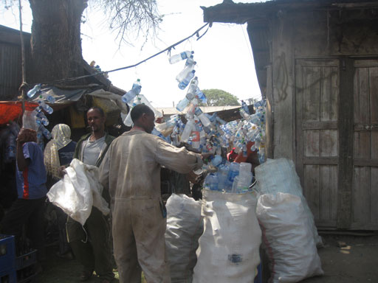
Figure 2.5 Plastic bottles being collected for sale and reuse.

2.3 Liquid waste
Liquid waste includes human excreta (both faeces and urine), industrial wastewaters, and other forms of waste from water-using activities in homes and institutions.
Households produce liquid waste from baths, showers and handwashing, as well as from washing dishes and clothes. This liquid waste is called greywater.
Faeces and urine are called blackwater. Blackwater is produced from water-flushed toilets and contains excreta, the flushing water and the anal cleansing materials (e.g. toilet paper) that people dispose of when using toilets. This waste may be transported in sewers to a treatment plant but is more likely to be held in a septic tank, which provides partial treatment of human waste. Liquid waste also includes human waste in pit latrines, even though there is no added water.
As you can imagine, public and private institutions, such as restaurants, cafeterias, hotels, bus terminals and market places which service large numbers of individuals, produce significant volumes of both blackwater and greywater.
Industries also release a significant volume of liquid waste. In addition to waste produced by the workers during routine hygiene and sanitation activities, the processes in factories may produce liquid waste. For example, hide processing factories, coffee washing facilities, and building projects use large volumes of water. Sometimes the wastes include chemicals that have been added as part of the industrial process and may be toxic. If waste produced from these facilities is released directly to a nearby stream or river without prior treatment (see Figure 2.6), the environmental pollution risk and the effect on a community’s health is of significant concern.
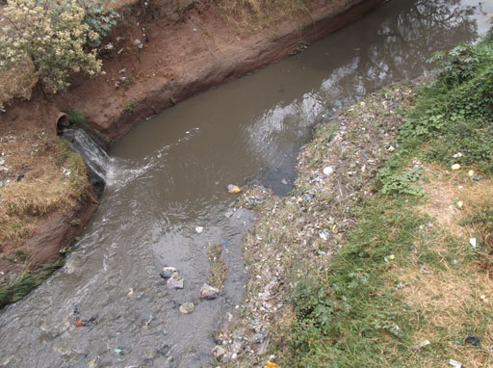
Figure 2.6 Industrial wastewater should be treated before being discharged to a river.
Medical facilities such as hospitals and health centres produce large volumes of liquid waste because hygiene is critically important for healthcare. Such waste may contain dangerous pathogens and can present a significant health risk to visitors, patients, healthcare workers and people handling the waste. It is therefore crucial for liquid waste to be treated appropriately.
Liquid waste is mostly water but it may also include:
- human waste (faeces, toilet paper, urine, vomit and blood)
- pathogens such as bacteria, viruses and parasites
- organic matter (e.g. animal faeces, vegetable and plant pieces)
- chemicals (e.g. pharmaceuticals), industrial wastes and toxins such as pesticides from agriculture.
The detrimental effects of these constituents on the environment can be minimised or eliminated by applying appropriate transportation and treatment technologies. Liquid waste is ideally transported using a well-engineered network of pipes and canals. Treatment technologies for liquid wastes should be applied at the point where the wastes are produced or before they are released into the environment at a disposal site. However, in most urban areas of Ethiopia, both the transportation infrastructure and the appropriate treatment facilities are lacking, so liquid waste is often released into the environment without treatment (Figure 2.6). Eventually the contaminated water is likely to be reused by people living downstream, putting community health at serious risk.

2.4 Surface and groundwater
Pollutants from liquid waste can seep into groundwater or flow into rivers or lakes. Where wells and boreholes are used to access groundwater for drinking and domestic purposes, or surface water from rivers is used for such purposes, this can introduce a high level of risk. The major danger in urban Ethiopia is contamination from faeces, although pesticides and industrial waste may also cause contamination of water. Figure 2.7 summarises potential sources of water contamination.
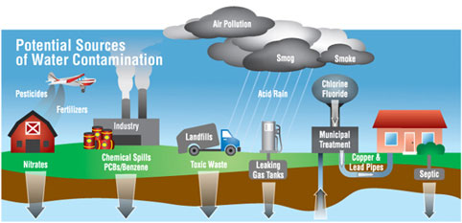
Figure 2.7 Potential sources of water contamination, showing how liquid waste and industrial waste can cause pollution of groundwater and surface water sources (Andrews, 2015).
- List two major environmental contaminants in the liquid waste category and explain why they pose a health risk.
- You may have thought of:
- human excreta from pit latrines and septic tanks, which may contain dangerous pathogens
- liquid medical wastes from health centres, which may also contain pathogens
- industrial wastewater, which may contain toxic chemicals.

2.5 Excreta and faecal sludge
Human excreta is of immediate health concern to communities because:
- Faeces contain pathogens that cause disease. Children under five years of age are particularly vulnerable.
- In many urban areas, faeces are currently not contained, collected and disposed of safely.
The combined effect of the presence of pathogens and inefficiencies in waste management systems leads to an increasing risk of new infection. If these problems can be brought under control the health risks associated with infection as a result of contact with faecal matter can be avoided.
- Of the two reasons (a) and (b) given above, which do you think might be easier for us to control?
- It is easier to control (b). Human faeces always contain pathogens and there is nothing we can do about it. However, we can manage how faeces are disposed of and prevent contamination of the environment.
Pit latrines and septic tanks are appropriate sanitation options but they must be properly built and maintained to reduce the risk of groundwater contamination. In particular, latrines should be lined with an impermeable (watertight) material. If they are just lined with stone walls, the contents of the pit will seep out near the surface and pathogens in faeces may eventually be washed out into the surrounding soil. From there they can contaminate groundwater, nearby rivers, springs or water pipes. People will eventually drink the contaminated water. Contamination from animal faeces may also be an issue. For example chicken excrement can contain high levels of pathogenic bacteria, which can cause health issues for humans.
Flying toilets are particularly dangerous because human faeces are discarded close to where people are conducting their daily chores. Flies thrive and breed on faeces and organic wastes. They can easily transfer faeces to the food or water we use, ultimately leading to pathogens being ingested by people living in the nearby communities, resulting in disease.
Open defecation is the practice of excreting faeces in the open rather than in a latrine, and is common practice in highly populated corners of urban areas, as well as in peri-urban settings where adequate latrines are not available. People practise open defecation because there is no suitable alternative. The possibility of pathogens from faeces reinfecting people is very high in this situation.
Where latrines are available, they may become overfull if not emptied regularly. As a result, faecal matter may overflow the pit and become a contamination risk in the same way as open defecation or flying toilets.
Faecal waste that accumulates in the bottom of pits and septic tanks is called faecal sludge, septic sludge or simply sludge. Inefficiencies in sludge management systems can increase the chances of contaminating the environment during collection, transport or disposal of sludge.
Management and appropriate disposal of human excreta is a key environmental issue. It is important to remember the inevitable link between human excreta and disease. That is why building latrines, encouraging their proper use and promoting handwashing stand out as key strategic interventions to reduce the incidence of disease.

2.6 Air pollution
Due to industrialisation trends worldwide, particularly in developed countries, the pollution level in the atmosphere has increased significantly. Air pollution can lead to disease. In particular, polluted air can irritate a person’s trachea (windpipe) and lungs, which may affect breathing.
Air pollution is caused by the release of small particles and gases into the surrounding air. For example, motor vehicles release significant amounts of carbon monoxide and particulate material. Smoke from domestic fires, coal-based power generation and heavy industries (see Figure 2.8), and methane from waste disposal sites, all contribute to air pollution.
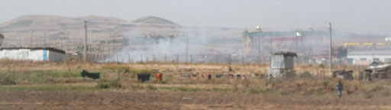
Figure 2.8 Smoke is a common air pollutant from many sources.
In urban areas, the air contains more pollutants than in rural areas because the day-to-day activities in urban areas are continually releasing pollutants into the atmosphere. For example the increase in motor vehicles and construction activities has led to Addis Ababa becoming noticeably more smoggy than it was five or ten years ago. Older vehicles that are poorly maintained are particularly likely to produce clouds of black smoke – as you have probably seen!
At the household level, using wood and charcoal for cooking purposes can contribute to indoor air pollution, which may result in some individuals being exposed to highly polluted air.

2.7 Major health risks associated with environmental pollution
So far you have learned how different categories of waste (solid waste, liquid waste including human excreta, and air pollutants) pollute the environment and can have a serious effect on human health. Table 2.1 summarises the major health problems associated with wastes and pollution.
Table 2.1 Summary of major pollutants and associated health risks.
Contamination | Waste category | Related health problems
Bacteria, protozoa, viruses and parasites such as intestinal worms | Human excreta | Acute watery diarrhoea (AWD), dysentery, cholera, typhoid fever, ascariasis, schistosomiasis, polio, and intestinal infections caused by roundworm, whipworm and hookworm
Heavy/toxic metals | Industrial wastes  Plastics | Continued and long-term ingestion of heavy metals can cause cancer and have direct toxic effects
Smoke (very small airborne solid particles) | Vehicle emissions  Domestic fires  Industrial emissions | Respiratory infections, pneumonia, in severe cases lung cancer can occur
Carbon monoxide | Vehicle emissions | Can cause acute respiratory problems and death
Viruses | Medical wastes containing body fluids from patients | HIV/AIDS infections  Hepatitis
Of all the health risks identified in Table 2.1, the problem of contamination with human excreta has the greatest impact. Globally, diarrhoea is the second most common cause of death in children under five years of age (Walker et al., 2013, cited in Brown et al., 2013). Worldwide, 807 million people are infected with the Ascaris worm that causes ascariasis (Hotez et al., 2008, cited in Brown et al., 2013).
It is clear that there is a significant disease burden on urban communities because waste is not efficiently managed. Access to proper latrines is one crucial area of WASH service that can help to reduce or eliminate the major health risks related to faeces given in Table 2.1. Solid waste collection, transport and disposal are essential areas of service. Pit emptying, which ensures faecal sludge is collected and disposed of safely, is particularly important to minimise the health risks to local communities. The government of Ethiopia is therefore putting considerable emphasis on working to improve these particular WASH services in urban areas.
- List the major health risks associated with poor access to, or improper use of, latrine facilities.
- The major health risks are waterborne diseases related to faeces such as acute watery diarrhoea, dysentery, ascariasis, cholera, typhoid fever and intestinal worm infection.
These health risks do not affect everyone in the same way. Certain segments of urban communities are more vulnerable to the effects of environmental pollution than others.
- Which groups of people were identified in Study Session 1 as being particularly vulnerable in urban communities?
- Young children, the elderly, people with disabilities, people living with HIV/AIDS or infected by other diseases, and poor families are the main vulnerable groups.
Exposing these vulnerable people to an additional disease burden can significantly affect their health status. For example, if people already living with HIV/AIDS are infected by diarrhoea, their lives can be threatened, which can have serious implications for those providing care and support, as well as having a substantial economic impact on the families involved.
Poor people are a particularly vulnerable group. They are likely to live near waste dumpsites because they cannot afford to live in areas where there is a proper infrastructure. They may be the first people to be exposed to the effects of accumulated waste. They are also the most likely people to be hired to work in the collection and transportation of waste, but because proper protective clothing and equipment are often lacking, they are exposed to infection as they go about their daily work. Some in extreme poverty, commonly called rag pickers (or korales), try to survive by collecting reusable waste. Their health is at continuous risk due to their constant exposure to wastes.
When disease affects those in vulnerable groups, it may spread to the entire urban community. For WASH services to be effective they need to be designed and implemented to reach everywhere and everyone.
- List some of the poor environmental practices seen in urban communities. Explain the relationship between these practices and the health problems they may cause.
- Poor environmental practices include:
- throwing faeces away in plastic bags
- open defecation
- inappropriate construction of pit latrines
- dumping solid waste without care
- using wood or charcoal for cooking indoors.
The first three in this list can all cause the spread of infectious diseases that are transmitted from person to person through pathogens in faeces. Dumping solid waste carelessly can create conditions that encourage breeding of disease vectors. Respiratory infection due to polluted air is another risk area, which can result from the last point.

Summary of Study Session 2
In Study Session 2, you have learned that:
- Environmental pollution is the release of harmful substances into water, air or soil.
- Solid waste is produced by households, industry, institutions and healthcare facilities and includes organic and inorganic materials. It should be properly collected, treated and disposed of to protect the environment and human health.
- Reducing, reusing and recycling waste are better options than simply throwing it away.
- Liquid waste includes human excreta and other waste waters. It is essential to ensure excreta is separated from people and to protect water sources from contamination by liquid waste.
- Examples of surface and groundwater pollution include contamination by human excreta, pesticides used in agriculture and toxic chemicals from industries.
- Examples of air pollutants include smoke, carbon monoxide, carbon dioxide and methane. The main sources are domestic fires, industrial activity and motor vehicles. Air pollution can cause respiratory infections.
- There are major health risks associated with water pollution, caused when people use water or food contaminated by faeces. Open defecation, improper use of latrines, disposing of faeces with solid waste or in fields are among the unhealthy practices that promote infection by disease. Unattended solid waste accumulation encourages flies and rodents to breed; they are responsible for transmitting disease.
- Some sectors of the community are particularly vulnerable to the health risks created by environmental pollution.

Self-Assessment Questions (SAQs) for Study Session 2
Now that you have completed this study session, you can assess how well you have achieved its Learning Outcomes by answering these questions. You can check your answers with the Notes on the Self-Assessment Questions at the end of this Module.

SAQ 2.1 (tests Learning Outcome 2.1)
Write the following words next to their correct definitions in the table below:
blackwater, faecal sludge, greywater, pathogen, vector.
organism that transmits disease
sludge that builds up in pit latrines and septic tanks
used water from domestic washing, food preparation, etc.
disease-causing agent
wastewater containing human excreta

SAQ 2.2 (tests Learning Outcome 2.2)
Which of the following statements are false? In each case explain why it is incorrect.
- Exhaust gases from industries and motor vehicles are major causes of air pollution.
- Medical wastes should be collected and disposed of with normal household waste.
- Organic solid waste from households, cafeterias and restaurants provide breeding places for pathogens and vectors.
- Faeces are an environmental pollutant when left in the open, as in the case of flying toilets.
- Industrial wastewater can cause water pollution if discharged directly into a river but is safe to spread over bare ground. .

SAQ 2.3 (tests Learning Outcome 2.2)
By what route do pollutants get into rivers and other surface waters?

SAQ 2.4 (tests Learning Outcomes 2.3 and 2.4)
What are the major health risks from:
        - open defecation
        - allowing food waste and litter to accumulate in a ditch
        - not washing hands before eating.
Briefly explain how these risks could be reduced.

Study Session 3 Existing WASH Service Provision

Introduction
Protecting our environment is vital for the healthy and productive livelihood of urban communities. Healthy communities are crucial for sustained economic development. One of the important mechanisms through which the health and well-being of communities can be assured is the provision of safe, adequate and affordable WASH services.
In this study session, you will learn about key WASH service areas that are necessary to reduce or eliminate the risks of environmental pollution and ensure the health and safety of urban communities.

Learning Outcomes for Study Session 3
When you have studied this session, you should be able to:
3.1 Define and use correctly each of the key words printed in bold. (SAQ 3.1)
3.2 Briefly describe key WASH services in urban settings and give examples of service providers. (SAQ 3.1)
3.3 Describe the specific challenges posed by peri-urban and slum areas as attempts are made to improve access and use of WASH services. (SAQ 3.2)
3.4 List the key government offices at local level that are responsible for regulating WASH services, and describe their roles. (SAQ 3.3)

3.1 What are WASH services?
You were briefly introduced to services in Study Session 1. Services are systems that supply a public need, for example transport, communications, waste management or utilities such as electricity and water.
- How were WASH services defined in Study Session 1?
- WASH services are systems that provide for the water, environmental, sanitation and hygiene needs of communities.
Water supply utilities, solid waste management systems, and liquid waste collection and disposal systems are all examples of WASH services in urban areas. These systems are intended to protect the urban environment, as well as ensure that the water, sanitation and personal hygiene needs of urban communities are met.
There are different costs associated with the provision of WASH services. These include the initial investment cost, which is usually large, the operation and maintenance costs, and also future replacement and/or upgrading costs. The initial investment cost is usually paid for by communities, for example through taxes or other means. Such services financed by public money are known as public services.
In some towns, privately operated systems may exist. For example, as you read in Study Session 1, solid waste collection and disposal is increasingly becoming a service provided by organised youth groups through micro- and small enterprises (MSEs). In industrialised countries, private companies often take a significant role in the provision of WASH services including septic sludge emptying, operation and/or maintenance of water distribution systems, and installation and management of public latrines. Such companies that are privately owned and involved in service provision are called private service providers.
Increasing demand for improved WASH services in urban areas, coupled with the ever-increasing population, means that public or private providers alone may not be able to provide adequate services. Joint partnership between public and private service providers is an increasingly preferred and effective approach that improves service levels of WASH facilities. The solid waste collection scheme in most Ethiopian towns is a good example of such a public–private partnership (Figure 3.1).
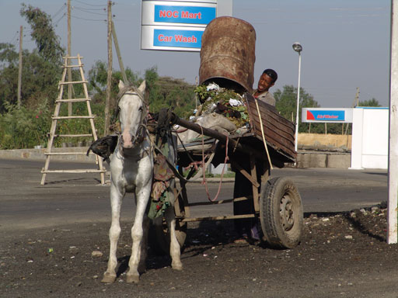
Figure 3.1 MSEs collect solid waste from households and transport it to a collection site within a public–private partnership.

3.2 Key service areas in urban WASH
As discussed in Study Sessions 1 and 2, urban communities contribute to environmental pollution in many ways. To effectively reduce the impact of such pollution on the environment and its negative effect on the health of the public, it is critically important that service providers are mindful of pollution issues and work efficiently.
There are three key service areas in the WASH sector: water supply, liquid waste and solid waste management services.

3.2.1 Water supply services
Water supply includes the source of water, treatment plant, reservoir and tanks, main trunk lines, distribution lines and individual connection lines for the delivery of potable water (Ministry of Works and Urban Development, 2006). (Potable water is water that is safe to drink.) Treatment systems are not needed where sources are known to be clean and safe, for example water from protected springs and boreholes (Figure 3.2).
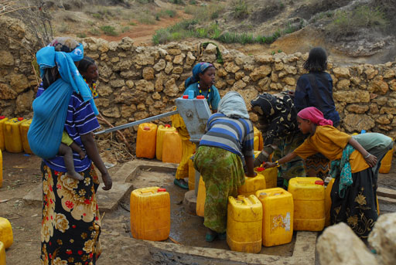
Figure 3.2 A protected borehole provides a clean source of water.
Due to the large number of different components required for an efficient system, water supply services require substantial investment. Governments may take loans from international development banks and other foreign agencies to finance large urban infrastructure projects, but in general most of this investment is obtained from the public in the form of tax.
Water supply systems also require adequate finance to operate and function properly. This cost is usually recovered from revenue generated as users pay for the services they get, and depends on the volume of water consumed over a period of time.
An adequate level of service for urban water supply was defined in 2011 as a minimum of 20 litres of clean water for one person per day, accessible at a distance not exceeding 500 m (MoWE, 2011). (Note that this figure has since changed and the minimum urban water supply service standard is now 40 litres/person/day within a distance of 250 m (MoWIE, 2015).) Based on this service level, water supply coverage in urban areas reached 81.3% in 2012/13 (MoFED, 2014). This indicates that a high proportion of the urban population can access an adequate supply of water. However, those living in slum areas often have to buy water from water vendors. They could be paying up to ten times more than those with access to piped water, for water of dubious quality.
Providing an uninterrupted supply of water is a huge challenge for most towns due to limited finance, equipment or manpower. Some sectors of the urban population get more water, while others get only a limited amount. For example, town centre families with higher than average income and water taps on their premises may get a lot more than 20 litres per person per day. Alternatively, poor families who live in peri-urban areas or slums may use less than five litres per person per day.

3.2.2 Sanitation and sewerage services
Figure 3.3 shows 2012 data on access to different types of sanitation facilities in Ethiopia. It shows that the situation in urban areas is much better than in rural parts of the country. However, 8% of the urban population still practised open defecation at that time. This is an estimated 1.2 million people, equivalent to almost 40% of the population of Addis Ababa or more than four times the population of Gondar or Dire Dawa.
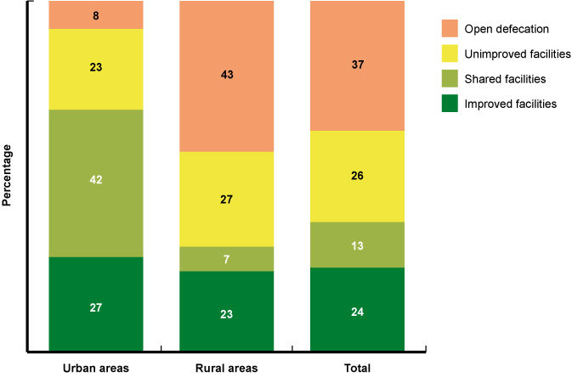
Figure 3.3 Access to sanitation facilities in Ethiopia. ‘Improved facilities’ includes water-flushed toilets and improved pit latrines. (Data from JMP, 2014)
In addition to urban and rural differences, economic status has a significant impact on sanitation access. Figure 3.4 shows the percentage of high and low-income communities in Ethiopia with access to latrines. Of those in the richest communities, only about 8% used open defecation in 2012 and 92% of the community used latrine facilities of some kind. However, in the poorest communities, 78% of the people used open defecation and only 22% used latrine facilities. Although the government of Ethiopia is making an effort to provide services equitably, more work is needed to achieve desired levels of service provision, especially to poorer communities.
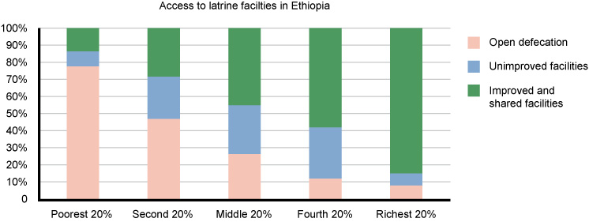
Figure 3.4 Access to latrine facilities in Ethiopia for different wealth groups. Data is for 2012 and for the entire population, not just those in urban areas. (Adapted from UNICEF, 2014)
Water-flushed toilets need to be connected to a septic tank or to a sewer network. A sewer network includes a system of underground lines (pipes) for collecting and removing liquid wastes from residential, commercial and industrial sources (MoWUD, 2006). The sewerage system is used for two major liquid waste categories: blackwater and greywater.
- What is meant by the terms greywater and blackwater?
- Greywater is liquid waste from showers, wash basins, dish washing in kitchens and clothes washing. Blackwater is the water flushed from toilets and contains faeces and urine. (You read about this in Study Session 2.)
Most towns and cities in Ethiopia do not currently have a sewer network or sewage treatment system. (Sewage means combined greywater, blackwater and other wastewater. It is not the same as sewerage, which means the network of pipes that carry sewage.) In Addis Ababa some central areas have sewerage services that collect and transfer sewage to the treatment works. Elsewhere people rely on septic tanks and pit latrines. These both need regular emptying to safely remove and dispose of faecal sludge.
The local municipality may provide emptying services using vacuum trucks. These trucks provide collection and transport of faecal sludge from households and institutions on a needs basis. Although published statistics are not available, it is often the case that the available trucks cannot meet the demand and users may have to wait to get the service. The waiting time can vary between weeks and months, depending on the available equipment and manpower. Such vacuum truck services may not only be unavailable but also unaffordable.

3.2.3 Solid waste management services
Solid waste management services are another key service area in the WASH sector. Efficient solid waste management is critical for the well-being of urban communities. Without this service, solid waste can accumulate and quickly become a health risk. Figure 1.4 of Study Session 1 shows such a situation.
Solid waste management systems include collection, transport and final disposal systems. With the 3 R approach in mind, waste management may also include separating waste into its different components (glass, metal, plastic, paper, etc.) so that some of the waste can be reused or recycled. Infrastructure and equipment for solid waste management is usually paid for by the government and is therefore a public service. However, there are initiatives in most towns to engage private operators in one or more components of the waste management system.
The solid waste service is usually a low priority service, particularly in small and emerging towns. The general trend is that solid waste management does not become a critical concern until the point where accumulated waste has already become unsightly and caused inconvenience to communities, as illustrated in Figure 3.5.
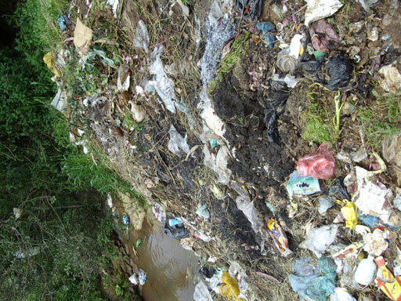
Figure 3.5 Rubbish tips are unsightly and a potential source of pollution.
Information about access to waste management services in urban areas is not as easily available as information on other services, so less detailed data can be presented here than for water supply and sanitation services. Moreover, since service levels are not clearly defined, it is impossible to accurately and objectively determine the service coverage. However, larger towns that produce significant quantities of waste tend to have better established systems. Some towns in Ethiopia such as Addis Ababa and Bishoftu have invested in building solid waste disposal sites, but many are still not able to cope with the increasing demand (Figure 3.6).
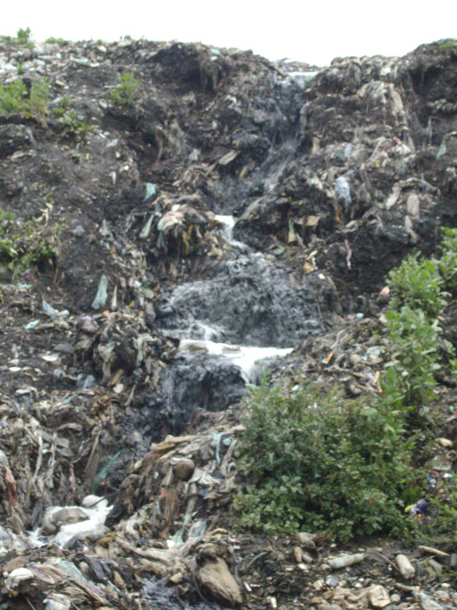
Figure 3.6 A stream of dirty water cascades down from the Addis Ababa landfill site.
- Which of the three key WASH service areas for urban areas, would be involved in:
        - disposing of household plastic waste
        - providing clean piped water
        - disposing of septic sludge?
- The answers are as follows:
- Solid waste management services
- Water supply services
- Sanitation and sewerage services.

3.3 Service provision arrangements
The key WASH services that you learned about in Section 3.2 are largely public services, paid for by the communities and administered by local government. In this section, you will learn how the provision of these services is organised and managed.

Water supply utilities
Water supply services are managed by organisations called utilities. Water utilities take overall responsibility for operating, maintaining and managing the water supply system. Utilities collect money from users based on the amount of water used. They use this to cover the costs of supplying the water including staff costs, office running costs and reserve capital for maintenance works.
The Town Water Board oversees the performance of the utilities. The board also helps to address challenges or issues as they occur in the course of operating and managing the water supply system. It comprises influential people from the Mayor’s office, sector offices and other relevant organisations.

Water supply and sewerage utilities
Water supply and sewerage services are often managed by a single utility. This is common in large towns, for example, Addis Ababa Water and Sewerage Authority (AAWSA), Bahir Dar City Water Supply and Sewerage Service, Hawassa Town Water Supply and Sewerage Service Enterprise.
Utilities for sewerage services are organised in a very similar way to water supply utilities. Slightly different modalities are used to recover regular costs, for example for sewerage services the payment is included in the fee for water supply. This addition can include fixed fees that all users pay and fees as a percentage of the consumed water. This is fair because the volume of sewage produced by a household or other user will be proportional to the volume of water used. For septic tank emptying services, utilities usually charge their customers a fixed amount per service.

Solid waste management services
Municipal authorities of towns and cities often provide solid waste management services, from collection to transport and final disposal. In recent years, departments with responsibility for ‘town greening and beautification’ have been created in municipalities of some towns and cities. Their main role is to ensure that unsightly spots in the town are well maintained and that the urban environment is attractive for the community. As part of their routine tasks, they may provide waste collection, transport and disposal services for households and institutions.
As you have read, micro- and small enterprises (MSEs) also play a significant role in solid waste management. It is common in many towns to see MSEs contracted by municipalities to provide solid waste management services.
- Look back to Figure 3.1. It shows an example of a public–private partnership. Identify the public providers and the private providers in this example, and their common goal.
- The municipality represents the public provider, and the MSE represents the private provider. Both are in partnership for the common goal of increased efficiency in solid waste management.
Private providers can usually offer a service that is better suited to communities, although this comes with a slightly higher cost than that of public providers. In view of the higher quality (reliability and continuity) of service, the slight addition in cost is generally considered acceptable. If correctly implemented, increasing public–private partnerships can help public service providers to focus on regulating services as well as ensuring the quality of service.
However, the role of the private sector has yet to grow large enough for the WASH sector to benefit. More companies that are both entrepreneurial and visionary are needed to strengthen the partnership with public providers. The lack of appropriate private providers contributes to the limited number of partnership arrangements in practice. In addition, WASH as a business is not generally very attractive to private entrepreneurs. Unlike luxury services and products, WASH services are basic and therefore only nominal charges can be applied. This directly affects the available profit margin and so makes it less attractive to business.
- Name the providers for key WASH services in urban areas. For each service provider, describe the main focus of their services.
- The main service providers are:
- water supply utilities, which serve urban communities by providing adequate clean water at affordable prices
- sewerage utilities, which serve to maintain the infrastructure for collection, transport and disposal of liquid waste from households and institutions
- MSEs – business organisations that work on waste collection and transport.
You might also have mentioned the town greening and beautification department, which is supposed to ensure that the urban environment is pleasant for the community, and town municipalities, which may provide waste collection, transport and disposal services to households and institutions.

3.4 WASH service provision for low-income communities
People on little or no income tend to live in peri-urban areas and slums.
- What are the main characteristics of peri-urban and slum areas?
- These areas are characterised by dense populations, poor quality housing, lack of proper access to infrastructure such as roads, and lack of basic services such as water supply, sanitation and waste disposal.
In Study Session 1 you were introduced to the key challenges of WASH service provision in urban areas. You learned that communities living in slums and peri-urban areas of towns and cities are among the least served segments of the urban population.
- Look at the percentages of the population with access to improved or shared latrine facilities shown in Figure 3.5 and compare the percentage for the richest 20% of the population with that for the poorest 20%.
- According to Figure 3.5, 85% of those in the richest 20% of the population have access to improved or shared latrine facilities. In comparison, only 15% of those in the poorest 20% of the population have access to such facilities.
You also learned in Study Session 1 that the poor and other vulnerable communities are forced to live in peri-urban and slum areas. They have no choice. Poor people cannot afford to live in areas where basic services are easily accessible so they are forced to live in areas within or on the fringes of the urban area where infrastructure has not reached. Settlement in these areas is illegal because the inhabitants do not have the proper permits to occupy the land and therefore the government may not be able to invest in new infrastructure in these areas.
Providing short-term solutions in such areas is also challenging because the settlements in them are informal and unplanned without proper access roads and pathways. Even when such solutions are introduced, it is difficult to provide continuous support and follow-up for the proper use and management of the facilities by the community. There are therefore huge difficulties for government and other stakeholders involved in improving WASH situations in these areas.
As a result, the most vulnerable communities live in conditions where they are constantly exposed to critical health risks (see Study Session 1, Figure 1.3). Urban communities and local government are faced with the challenge of working together to change this situation, and improve WASH facilities for the most vulnerable.

3.5 Regulation of WASH services
In addition to the service providers, there are also important stakeholders who regulate and control the services they deliver. Their major role is to ensure that the quality and quantity of the service provided by WASH facilities complies with existing standards for urban communities in Ethiopia. They also work towards equity of access, trying to ensure fair distribution of facilities and services to all parts of the urban population.
Table 3.1 Roles of key stakeholders in WASH regulation.
 | Regional Water Bureau and Woreda Water Desk | Regional Health Bureau and Woreda Health Office | Municipality
Regional | Proclamations and legislation to improve service provision by utilities  Legalisation of water utility enterprises or companies  Inspection of water supply facilities, services and standards | Registration and licensing of health professionals  Inspection of healthcare services and standards  Setting regulations, directives and guidelines | Not applicable
Woreda (works with regional counterparts) | Water quantity, water quality assurance  Construction quality assurance during expansion or upgrade of facilities | Water quality inspection  Healthcare service inspection  Sanitary service inspection | Quality and coverage of waste management and disposal services  Land development planning to accommodate WASH facility needs  Construction quality assurance
Table 3.1 summarises some of the important roles in regulating WASH services in urban areas. Notice that all the stakeholders in this table are government institutions. It is the duty and responsibility of the government structure to ensure that adequate, safe and environmentally friendly services are provided to communities.
The responsibility for regulating WASH services is decentralised down to the woreda level, empowering local government administrators to assure the quality and quantity of service provided to communities.
- Name the key government offices at woreda level that are responsible for regulating WASH services. Refer to Table 3.1 and explain the roles of each.
- The answers are as follows:
- Woreda Water Desk – confirms the quality and quantity of water supply, in collaboration with regional counterparts.
- Health Office – inspects water quality and healthcare services.
- Municipalities – include or certify WASH facilities location in town-wide land development plans, as well as the quality and coverage of waste management and disposal services.

Summary of Study Session 3
In Study Session 3, you have learned that:
- WASH services provide the water, sanitation and hygiene needs of urban communities. These include water supply systems, sanitation services and waste management services.
- Water supply services consist of the provision, operation and management of infrastructure for withdrawal (from the water source), treatment and distribution of clean water to communities.
- Sanitation or sewerage services consist of household, institutional and public latrines and the system for collecting and safely disposing of sludge from septic tanks and pit latrines.
- Waste management services include the complete chain of service from waste collection and transport to final disposal, and the management and administration of equipment and infrastructure related to the service.
- WASH services in urban areas are delivered through utilities and municipalities. Utilities are semi-private organisations that provide water supply and sewerage services, septic sludge collection and disposal services to urban communities at affordable prices. Water supply and sewerage utilities recover their expenses through tariffs collected from users.
- Municipalities provide solid waste collection, transport and disposal services. Micro- and small enterprises may partner with municipalities in public–private partnerships.
- Slums and peri-urban areas, characterised by informal and unplanned settlement, with little or no basic services and poor access, pose particularly difficult challenges for provision of WASH services.
- WASH service provision is regulated by government sector offices at both regional and woreda level.

Self-Assessment Questions (SAQs) for Study Session 3
Now that you have completed this study session, you can assess how well you have achieved its Learning Outcomes by answering these questions. You can check your answers with the Notes on the Self-Assessment Questions at the end of this Module.

SAQ 3.1 (tests Learning Outcomes 3.1 and 3.2)
For each of the key WASH services listed below, identify the important service providers at a town level.
- Water supply services
- Solid waste disposal services
- Liquid waste disposal services.

SAQ 3.2 (tests Learning Outcome 3.3)
Describe three specific challenges posed by peri-urban areas and slums for improving access and utilisation of WASH services.

SAQ 3.3 (tests Learning Outcome 3.4)
For each of the following government offices, select the description below that accurately depicts its role in the regulation of WASH services.
Regional Water Bureau; Woreda Water Desk/Office; Regional Health Bureau; Woreda Health Office; municipality.
- Controls the quality and coverage of waste management and disposal services and provides land development planning to accommodate WASH facility needs in towns.
- Inspects healthcare and sanitary services. Also provides inspection of water quality.
- Establishes the legal grounds (e.g. regulations, directives and guidelines) to provide healthcare services to communities. Conducts inspections and monitors the service level that healthcare facilities provide. Registers and licenses healthcare professionals.
- Provides the legal framework (proclamations and legislations) to improve service provision by utilities. Conducts inspections of water supply facilities, services and standards.
- Provides quality assurance at town level including quantity and quality of water delivered. Supervises quality of construction during system expansion or upgrade.

Study Session 4 Stakeholders in Urban WASH

Introduction
This study session explains how to identify and characterise people and groups who are stakeholders in urban WASH. You will learn about the advantages of working across discipline and sector boundaries, and of teamwork. This will help you, as a WASH worker, to understand the importance of involving stakeholders in planning and implementing WASH projects in your local context.

Learning Outcomes for Study Session 4
When you have studied this session, you should be able to:
4.1 Define and use correctly each of the key words printed in bold. (SAQs 4.1 and 4.2)
4.2 Identify the range of stakeholders in urban WASH. (SAQs 4.1 and 4.3)
4.3 Explain how stakeholder mapping can be used to analyse the roles and influence of stakeholders. (SAQ 4.2)
4.4 Explain the purpose and advantages of stakeholder engagement. (SAQ 4.3)
4.5 Describe some of the challenges of stakeholder engagement. (SAQ 4.4)

4.1 What are stakeholders?
Part of the job of an urban WASH worker involves mobilising local resources to improve the water supply and sanitation situation in your community. This means helping to develop partnerships and collaborations among the stakeholders, for example, by gathering them together at a meeting, as shown in Figure 4.1. But who are the stakeholders and how do you identify them?
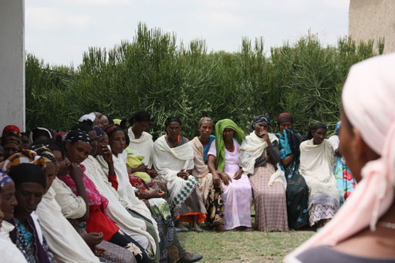
Figure 4.1 A community meeting to discuss improved WASH services.
A stakeholder is any person, organisation or group with an interest (stake) in something, such as a particular situation, intervention, project or programme. The stakeholders depend on the type and scale of the project, the local context, the local institutional set-up and the cultural conditions.
If you are considering a specific project and wish to identify the stakeholders involved (Mathur et al., 2007), you should consider those who:
- are responsible for the project and its different components (including funders, WASH officials from different sector offices, managers, employees, etc.)
- are intended users or beneficiaries
- are negatively affected by the project but may not be in a position to say so
- might threaten the success of the project through their opposition or lack of cooperation
- could represent the interests of people unable to participate
- have unique knowledge related to an aspect of the project.
- Think of an urban WASH project you know about. Try to identify those who might have been involved throughout the planning and implementation process. Can you identify their stake in the project?
- The stakeholders will vary from one project to another and you will have your own answer but you may have identified examples from several of the categories above, including representatives of project donors, utilities, contractors, schools, health facilities, local government offices, businesses and householders.
You may also have identified stakeholders who are not visible in direct implementation, but should be taken into consideration. For example, people from neighbouring villages and visitors to the area may wish to use facilities when they become available. Each of these groups have an interest in facilities being developed and hence a stake in the project.
Some of those among the wide group of possible stakeholders can be identified as key stakeholders. A key stakeholder is a person or a group of people with significant influence over a programme or who will be significantly impacted by it. For the programme to be successful, their interests and influences must be recognised. Key stakeholders may include individuals, organisations and businesses in the public, private and non-profit sectors. These could be local community representatives, municipal sector offices (for example, water resources, health and education) and development partners including donors, non-governmental organisations (NGOs), community-based organisations (CBOs) and private sector groups.
Sometimes, new stakeholders may emerge during the lifetime of a project. For instance, community water supply points may be used by people from adjacent villages who had not been considered during initial planning. This can lead to conflicts between intended and unintended users. If such a stakeholder was not involved during the planning stage, then conflicts are likely to be more serious and require resolution. It is much better to try to identify any unintended users at an early stage as this will enable them to feel some sense of ownership and reduce the likelihood of future conflict.

4.2 Why do we engage stakeholders?
Stakeholder engagement is the process by which the organisers of a project involve the stakeholders so they can influence its decisions and implementation. Some stakeholders may support the decisions, while others may oppose them. Some may be influential in the organisation or community in which they operate and hold official positions. Others may be affected in the short or long term by the outcomes of the project. The underlying principle of stakeholder engagement is that stakeholders have the opportunity to influence the decision-making process. This differentiates stakeholder engagement from communications processes, which just share and explain decisions that have already been made (SMARTe.org, 2010).
- What is the difference between communication with stakeholders and engagement with them?
- In stakeholder communication, stakeholders are invited to hear about and accept a decision that has already been made. In stakeholder engagement, the stakeholders have the opportunity to influence the decision making.
The aim of stakeholder engagement is to:
- hear what stakeholders have to say to establish what issues matter most to them
- develop understanding and agree how best to deal with issues of concern to the stakeholders
- ensure project sustainability by involving stakeholders in planning, implementation and monitoring
- improve decision making and accountability.
Through working together, key stakeholders can identify common concerns, develop common goals and reap the benefits of the impact of a WASH project. Some stakeholders may also become involved in technical aspects, contributing to implementation, designing solutions and providing technical advice. Involving stakeholders in this way ensures more effective outcomes.
As a WASH practitioner you may be involved in arranging and facilitating discussions with stakeholders. This means encouraging people to participate. For this you will need to develop your communication skills so you can:
- ensure involvement of all stakeholders, including vulnerable and marginalised individuals and households
- understand their demand for service options and their willingness to contribute
- create a sense of ownership among users and beneficiaries
- help to achieve common understanding between the implementing organisation, user community and relevant stakeholders.
It’s important to involve stakeholders throughout the planning and implementation process. This brings benefits through:
- opening the planning process to the public, making it more transparent and equitable
- allowing stakeholders to participate in budget setting
- ensuring the needs of the whole community are considered, so making projects more effective
- helping to overcome resistance and mistrust by building support.
It may also increase efficiency if stakeholders contribute their labour and resources. Community involvement is shown in the construction of a school latrine facility in Figure 4.2 and a water point in Figure 4.3.
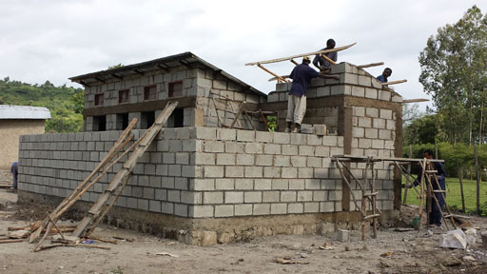
Figure 4.2 Construction of latrine and sanitation facilities at a school in Hawassa.
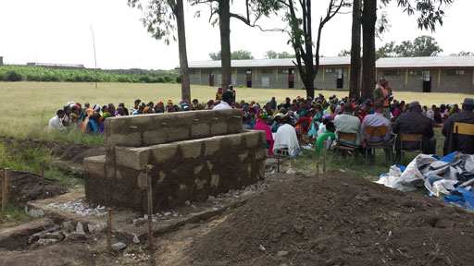
Figure 4.3 Community meeting at the site of a newly constructed water point in Hawassa.
Now read Case Study 4.1 and then answer the questions below.

Case Study 4.1 Ms Genet and the holy water
Ms Genet is an urban WASH practitioner who has started some collaborative work with an NGO to improve the town’s water supply. The NGO coordinator promised to cover all the project expenses and advised Ms Genet to design a development structure on a nearby spring called Tsebel.
Ms Genet shared this information with her immediate supervisor and, realising the benefits the improved water supply would bring, they decided to use the promised money to implement the scheme. She designed the spring development structure and in consultation with the donor agency hired a contractor to start construction.
However, Ms Genet then faced unexpected resistance from the community, especially from the church because the spring was regarded as holy. She tried to explain that the scheme would increase the available water supply by more than forty per cent. However they still expressed their concerns because they felt the scheme was abusing holy spring water.
- What important steps did Ms Genet ignore while planning the scheme?
- She failed to identify the key stakeholders associated with the use of the water from Tsebel spring. She did not consider cultural and religious issues relating to using holy water from the spring.
- What is problematic with the way Ms Genet surprised the community members with the scheme?
- Community and stakeholder consultations are crucial for the success of any new scheme. If community members are taken by surprise with a scheme they have not been consulted about, and have no understanding of the reasons for it, they will not develop any sense of ownership of it.
Stakeholder engagement improves communication and leads to better understanding. The benefits will depend on the context, but include increased community confidence, which comes from cooperating over project development. It can also encourage a culture of innovation and learning, which enables participants to make better-informed decisions. It builds trust, through open discussion of issues that are difficult to resolve, bridges cultural gaps and helps to reduce conflict. It can also enhance partnerships, for example, between the community and industry, increasing efficiency and so reducing future costs.
Read Case Study 4.2 and answer the questions that follow.

Case Study 4.2 Mr Mohammed’s dilemma – should he tell the user community?
Mr Mohammed is a WASH practitioner who manages a new water treatment and water supply scheme in Kori town. The groundwater source has high fluoride content but was the only water source available to be developed. Direct use of the groundwater for drinking will cause serious health problems for the community because of its high fluoride content. The proposed scheme uses chicken bone char to reduce the amount of fluoride in water supplied from two boreholes. Mohammed understands that the use of bone char is the only option available for treating the water but is concerned that the community may not accept the treated water for religious and cultural reasons.
Mohammed is considering whether he should either:
- inform the community and stakeholders during the planning stage about the use of bone char
or:
- keep the technical details of the use of bone char a secret because of its religious and cultural sensitivity.
- Which option do you think Mohammed should adopt and why?
- Mohammed should be loyal to the society he serves and build long-term trust by openly discussing the problem and the technology options. It is essential to inform the community and help them to understand the situation and decide together upon the best course of action.
- What additional efforts could Mohammed make to help the community understand the benefits of using bone char?
- He could identify key stakeholders and influential members of the community (opinion leaders and religious leaders) and ask them to help him. This could create a better situation for informed decision making and, by using scientific facts about the use of chicken bone char, he may be able to help community members to amend their religious and cultural views.
(Note there is work underway in Ethiopia to find alternative ways to remove fluoride from water, including activated alumina and artificial bone chars (Tesfay and Feleke, 2011). As yet, an alternative technology is not widely available.)

4.3 Identifying and mapping local stakeholders
Key stakeholders can be identified based on their relative influence in decision making, their responsibility, their involvement in day-to-day operations, their direct or indirect dependency on the project and their representation in the community.

4.3.1 Identifying key stakeholders
Representation from all the stakeholders is a priority in a multi-stakeholder WASH engagement project. Some less obvious stakeholders may be excluded from the usual decision-making processes; this should be avoided.
- You have already come across a situation where some stakeholders were excluded from the decision-making process because they were not obvious. Look back to Section 4.1 and see if you can find it.
- In Section 4.1 you read about community water supply points that may be accessed by people from adjacent villages who had not been considered during initial planning.
Local institutions such as schools, health centres, mosques and churches are considered important stakeholders. These are important strategic institutions for promoting community-based WASH interventions. While at school, children gain knowledge that influences them and informs their attitude and practice. In addition school children, via their teachers and WASH clubs, can educate their families and relatives when they return home. By this route, they can serve as agents of change to their communities. For example, Figure 4.4 shows a school WASH club performing a drama about handwashing for their relatives. (You will learn more about the role of schools in mobilising urban communities in Study Session 11.)
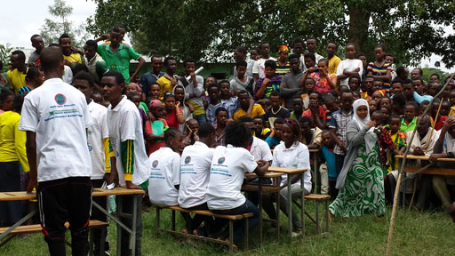
Figure 4.4 School WASH club performing a handwashing drama.
- How might establishing WASH clubs in schools help in promoting improved hygiene in the wider community?
- School children may learn at WASH clubs about washing their hands thoroughly after using the latrine. This could potentially lead to improved hygiene practices in the wider community if they tell their families what they have learned at school.
It is important to identify all stakeholders from the community including women, children and marginalised people. Marginalised people are those on the edges (margins) of society who are treated as insignificant or not important. There may be people in your community who find it difficult to come to meetings, for example because of their work pattern or because they have a disability. It is particularly important to ensure that such groups have a voice and are listened to. Excluding less obvious stakeholders from the usual decision-making processes is an easy mistake to make and may have serious social or economic costs. It can lead to unsustainable projects and no overall improvement in conditions.
A systematic approach to defining and identifying all relevant stakeholders during early planning stages is therefore essential for ensuring the effectiveness and sustainability of urban WASH initiatives.

4.3.2 Stakeholder mapping
Stakeholder mapping is the process of systematically identifying and analysing the relevant stakeholders, their relationship to each other, their level of interest, and their roles and responsibilities in relation to the power they hold.
Mapping the levels of interest of different stakeholders in relation to their interest or power can be done using the diagram shown in Figure 4.5. Their relative power and interest is categorised into four groups: those with high interest but little power (A), high interest and high power (B), low interest but high power (C) and low interest and little power (D).
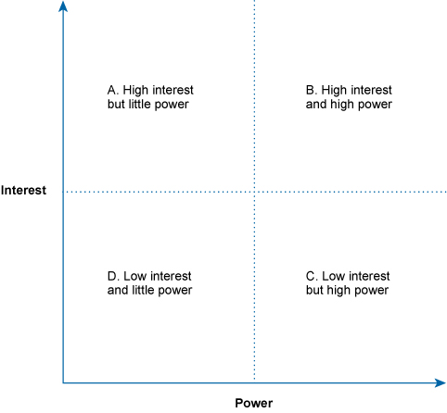
Figure 4.5 Mapping stakeholders on a power/interest grid. (Adapted from DfID, 2003)
- Consider a family with a disabled child living in an area with poor WASH facilities. They stand to benefit from a planned urban WASH initiative in their area. In which group would you place such a stakeholder on the diagram shown in Figure 4.5? In which group would you place a local politician, who lives outside the area served by the planned facility? Explain your answers.
- The family would be in group A: they have a high interest in the success of the initiative but have little power. The politician would be in group C: they have a large amount of power but little personal interest in the initiative.
- Which group is likely to include the most marginalised individuals and why?
- Group A is likely to include the most marginalised individuals because it will comprise those who are sick or have disabilities. They have little power and are unable to participate fully in the community.
Stakeholder mapping can help you fully understand a situation and see the relationships between the stakeholders and their role in the project or programme. This can be useful when developing a plan for stakeholder engagement. Such a plan should outline:
- objectives (what are you trying to achieve?)
- scope (who and what is included?)
- methods (how will you put the plan into action?).
The methods used will vary for different stakeholders and will depend on several factors including how actively they are involved. For example, for users and beneficiaries, mediated discussions with service providers could be appropriate. For other, less engaged stakeholders, printed leaflets or other methods for providing information could be considered. (The methods for stakeholder engagement are considered in more detail in Study Sessions 5 and 6.)

4.4 Challenges for stakeholder engagement
Involving stakeholders in planning and implementing projects is essential for their success and sustainability. However it can present challenges that need to be understood and overcome.

4.4.1 Lack of coordination
In the past there has tended to be a lack of coordination among the organisations and agencies responsible for WASH projects, for example between governmental and non-governmental organisations, and this has resulted in duplication of effort, contradiction or inconsistency (WUP, 2003). There has also tended to be separation between projects to improve water supply and those related to sanitation and hygiene. As a result of this fragmented approach, there have been gaps in communications with stakeholders and some have been left out of the planning and knowledge sharing in a project.
New approaches to WASH are more integrated and aim to bring different stakeholders together. There is a new emphasis on the importance of communication and collaboration. For example, the One WASH National Programme, launched in 2013 is a shared programme across four federal ministries. The National WASH Coordination Office has mandates to support stakeholder communications, knowledge sharing and dissemination, and to facilitate concerted urban WASH efforts at both national and sub-national levels.

4.4.2 Reaching low-income households
The delivery of water supply and sanitation to low-income urban and peri-urban communities is complex. Poor consumers may not be adequately represented in community organisations and are often perceived as being ignorant and apathetic. However, in many instances this is clearly not the case because they have proved themselves able and willing to help bring about change that will improve their living conditions (WUP, 2003). Effective communication strategies that reach out to low-income communities will be needed to ensure they are also included within the stakeholder group of users and beneficiaries.

4.4.3 Working across boundaries
One of the particular challenges of WASH is that it means working across sector and disciplinary boundaries. Although commonly referred to as the ‘WASH sector’, WASH is a combination, as you know, of water, sanitation and hygiene sectors and is therefore cross-sectoral, meaning it involves people from different sectors working together. In particular it involves representatives from offices and bureaus of water, health, urban development and finance. It is also cross-sectoral in the sense that it involves both public and private sectors including government departments and agencies, and contractors, consultants and other private companies.
Cross-disciplinary communication is also essential because many complex WASH problems require more than one source of information to solve them. Cross-disciplinary refers to the academic disciplines and training of the people involved. These could include engineers, sociologists, hydrologists, doctors, nurses, accountants and managers to name but a few. People trained in different disciplines often have different ways of thinking and approaching an issue that can make communication between them difficult. Care is needed to ensure that everyone understands each other and that the information provided by and to stakeholders is accurate, relevant and can be easily understood.
Although it can be a challenge, it is important to realise that cross-boundary working has many advantages as well. The combination of different perspectives and experiences brings a diversity of thinking and approach that can ultimately make a project more successful. The key issue is to recognise the differences and work with them to ensure all voices are heard.
- Imagine you are working on a programme that involves liaising with officials from different government departments, including water resources, health and education. What issues would this raise?
- The officials from the water resources department (engineers or water supply technicians), those from the health department (community health workers, nurses or midwives) and those from the education department (teachers) would all have different academic backgrounds and varying knowledge which they could contribute to the discussion.
Cross-disciplinary engagement is about teamwork, where individuals bring different skills to the table and see issues from different perspectives. However, in order for a new cross-disciplinary team to become effective that team must develop shared values and culture. As a WASH practitioner you may be involved in the development and maintenance of effective forms of cross-sectoral and cross-disciplinary communication to manage complex WASH problems in your locality.

Summary of Study Session 4
In Study Session 4, you have learned that:
- It is important to identify and characterise the stakeholders involved when planning urban WASH projects so that all interests can be considered.
- The planning and implementation stages of community WASH projects needs effective communication with stakeholders so that their knowledge and resources can be included.
- Engaging stakeholders helps to improve decision making and accountability and ensure sustainability of WASH projects.
- Stakeholder mapping is a useful tool for defining the level of interest and power of each stakeholder.
- In the past, the approach has been fragmented with a lack of coordination between organisations responsible for WASH projects.
- It is important to understand the advantages of working across disciplinary and sector boundaries. Teamwork involving a variety of people with different skills and knowledge will bring more effective and sustainable results.

Self-Assessment Questions (SAQs) for Study Session 4
Now that you have completed this study session, you can assess how well you have achieved its Learning Outcomes by answering these questions. You can check your answers with the Notes on the Self-Assessment Questions at the end of this Module.

SAQ 4.1 (tests Learning Outcomes 4.1 and 4.2)
Explain what is meant by a stakeholder and give three examples of key stakeholders in urban WASH schemes.

SAQ 4.2 (tests Learning Outcomes 4.1 and 4.3)
Outline the purpose of stakeholder mapping.

SAQ 4.3 (tests Learning Outcome 4.4)
Imagine you are working on a project to build a new public latrine block at a market place. You are preparing a plan to engage stakeholders in the project. A new colleague has recently joined your work team and you are asked to explain to them what you are doing and why. What are the main points you would include in your explanation?

SAQ 4.4 (tests Learning Outcome 4.5)
List three challenges associated with engaging stakeholders in planning and implementing urban WASH projects.

Study Session 5 Social Accountability and Social Responsibility

Introduction
This study session introduces you to the concepts of social accountability and social responsibility. You will learn about the enabling environment for social accountability and how such an environment helps to improve service delivery and facilitates community empowerment. This will help you as an urban WASH practitioner to understand the principles and benefits of social accountability and the importance of social responsibility. You should consider these basic principles as part of urban WASH interventions in your local context.

Learning Outcomes for Study Session 5
When you have studied this session, you should be able to:
5.1 Define and use correctly each of the key words printed in bold. (SAQ 5.1)
5.2 Describe what is meant by personal and social accountability. (SAQ 5.1)
5.3 Explain how social accountability principles can be implemented in the WASH context. (SAQs 5.2, 5.3 and 5.4)
5.4 Explain the importance of social responsibility to communities and wider society. (SAQ 5.5)

5.1 What is social accountability?
Accountability was defined in Study Session 1 as the duty of an organisation or individual to account for their actions and accept responsibility for them. Different aspects of accountability apply to organisations and individuals. Personal accountability is the duty of the individual to take responsibility for his or her actions. Every individual is socially, morally and legally accountable to the community or organisation that they belong to. Defining what this means for each member of a team is often a critical part of a community or organisation leader’s job. Encouraging team members to be personal accountable can have the following results:
- It can ensure that community members and organisational employees are held accountable to local agreements and bylaws.
- The leader’s willingness to promote personal accountability in others and in themselves helps to create a positive focus in which great things can be achieved.
Organisations, including all levels of government, should also be accountable. Social accountability means that public officials, politicians and service providers are held accountable to the public and service users for their conduct and performance. A fundamental principle of democracy is that citizens have a right to demand a governance system that ensures accountability of power holders and public actors. In a democratic society, public actors such as elected officials and civil servants are obliged to be accountable for their conduct and performance (ANSA-EAP, 2010). Citizens get a better service when officials respect the public and follow the principles of social accountability. The relationship between democracy and social accountability is therefore important in ensuring that government officials and community representatives respect the wider community.
Social accountability is about involving citizens and communities in the processes of governance so that decisions and actions of the people and organisations with power are made public and can be questioned. This not only improves governance but also leads to better service delivery and to community empowerment.
Social accountability mechanisms for involving the community can be applied in (ANSA-EAP, 2010; World Bank n.d.):
- planning and development
- setting budgets
- tracking expenditure
- monitoring the performance of projects.
An essential part of social accountability is open and effective communication with communities so that they are informed and can participate in these areas of project development and service delivery. Figure 5.1 shows an example where a community is participating in discussion about plans for new WASH facilities at the local school.
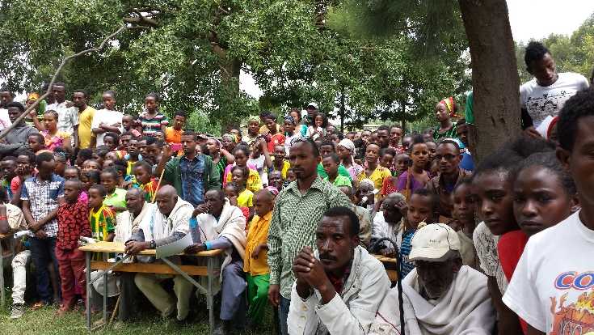
Figure 5.1 Communicating with the community is part of social accountability.

5.1.1 Enabling environment for social accountability
It is important to ensure that the mechanisms used to achieve social accountability will be effective. For this to happen there needs to be a suitable enabling environment in which these approaches will work. An enabling environment means the set of conditions that need to exist for some event, phenomenon or action to take place. According to ANSA-EAP (2010), an enabling environment for social accountability of government organisations has four pillars. These are listed below.

1. Organised and capable community groups
Well-organised community groups should be able to gather information about government programmes and services, and use this to directly engage public officials, politicians and service providers. They can ask questions and demand that they serve the community interest, justly, efficiently and effectively.

2. Responsive government
The government organisation should be willing to respond positively to the community and provide opportunities and processes for constructive community engagement. The government officers should believe in the value of social accountability and community participation in governance, and support these processes.

3. Access to and effective use of adequate and essential information
High quality and reliable information is an important prerequisite for any social accountability programme. Monitoring and evaluation of government’s performance should be based on reliable evidence to make credible claims about whether the government is performing well or not.

4. Sensitivity to culture and context
All the people involved should have a good understanding of contextual factors that could help or hinder the adoption of social accountability mechanisms. Hindering factors may include values and beliefs that sustain a culture of favouritism, corruption and mismanagement in the government.

5.1.2 Social accountability in WASH services
For social accountability in the WASH sector, the first step is to consider who the service providers might be, because these are the people or organisations that need to be socially accountable.
- Who do you think are the service providers for an urban WASH project?
- Public officials, professionals, government employees, non-governmental organisations and community-based organisations are all considered to be service providers. All these groups of people should therefore be accountable for their conduct and performance in delivering the services.
Community-based urban WASH projects may encounter serious challenges as a result of poor service delivery. Such challenges may arise if WASH facilities have been installed without the participation of the local community (KIND, 2014). Involving the community at an early stage helps individuals to realise their responsibilities as citizens (personal accountability) and helps to ensure that public officials, politicians and service providers are accountable for their actions (social accountability).

5.2 Putting social accountability principles into practice
Applying social accountability principles helps government officials and community representatives to respect the wider community. It encourages government officials to take the community into consideration when making decisions and this should improve the delivery of urban WASH services in the long term.
As a WASH practitioner and development worker you should understand the general approaches to achieving social accountability so that you can encourage and support these practices to be applied in your particular locality. Common approaches to putting social accountability into practice include the following methods:
- Producing clear, relevant information in a simple and understandable way. If such information is made public and is easily accessible, this can raise public awareness and help promote mobilisation of resources at a local level.
- Creating opportunities for communities to meet, discuss and present their views to the decision makers and power holders. Listening to community needs, opinions and concerns is an important part of social accountability. If there are good communications between a community and the government, this can help the government to understand the local context, including community priorities and concerns, and therefore enhance the performance of the public service. It is also empowering for the community because their voices are heard and they gain experience of participating in decision making.
- Negotiating about possible changes and new services. This can be achieved by direct and regular interactions between government officials and members of the community. Such interactions could include community level meetings, mediated consultations and conversations between community and government officials (Figure 5.2).
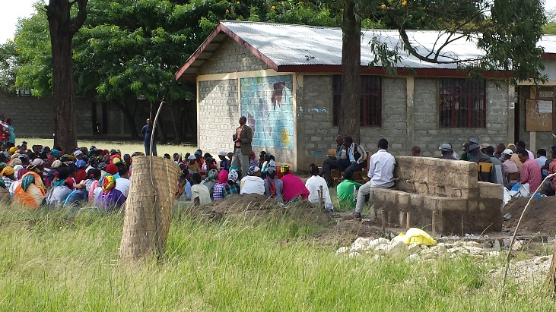
Figure 5.2 A community meeting to discuss provision of WASH services in Hawassa.
It’s important for information and communication to reach all members of the community. Effective social accountability needs to have active engagement of everyone, including less powerful stakeholders, poor people and disadvantaged community groups such as women, youth and minority groups. This can improve equity and strengthen social accountability.
Four key areas for implementing social accountability mechanisms were listed in Section 5.1. Putting the principles into practice in these areas means the following:
- Participation in planning and development: This can be achieved by sharing information and communicating effectively by such methods as local radio, public hearings, public announcements (Figure 5.3) and community meetings and discussions.
- Participatory budget setting: By involving community members in formulating and prioritising budgets for urban WASH projects.
- Participation in expenditure tracking: This involves citizen groups or community members monitoring the manner in which the government spends public funds.
- Participatory performance monitoring: This involves keeping track of and evaluating the impacts of government projects on intended beneficiaries. It includes assessing the efficiency, quality and responsiveness of public service delivery using participatory performance monitoring tools such as community score cards and citizen report cards (see Box 5.1).
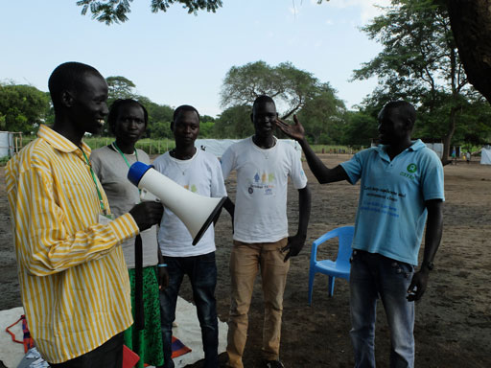
Figure 5.3 Using a loud hailer to make announcements can help to spread the message.
- You will see that all four of the methods for implementing social accountability mechanisms include the word ‘participatory’ or ‘participation’. What does this mean in practical terms?
- This means that community participation is essential in order for any of the methods to be successful.

Box 5.1 Citizen report cards and community score cards
Citizen report cards are a type of survey tool used to get feedback from users about the performance of public services (World Bank, 2004). They consist of questionnaires that are used to collect data from large numbers of households or individuals. The collected data is analysed and written up in a report that is published and can be discussed at public meetings.
Community score cards (CSCs) are another participatory tool for evaluating public services. CSCs are used at a smaller, more local scale than citizen report cards and focus on a specific community. Information is not gathered by questionnaire but through a focus group, A focus group is a selected group of people who are brought together to discuss an issue (Figure 5.4). The method includes a face-to-face meeting between the community and the service provider, which allows for immediate feedback on the quality of service provided (World Bank, 2005).
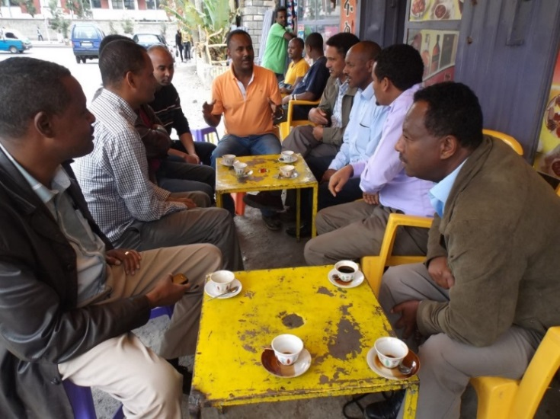
Figure 5.4 A focus group discussing a WASH project.
The effectiveness of implementing social accountability measures depends on the local context. Its success rate depends on:
- communication between the community and the service provider
- attitudes and capacities of citizens
- attitudes and capacities of government officials
- an enabling environment.
Implementing social accountability is challenging for government officers at all levels. The attitudes of both citizens and officials are important because they need to value the principles of accountability and be committed to putting them into practice. However, social accountability has many benefits. Promoting the principles of social accountability can contribute towards improved governance, enhanced public services and enabling local officials to make well-informed decisions. Social accountability can also facilitate multi-stakeholder communications and empower local communities, especially marginalised social groups.

5.3 What is social responsibility?
Social responsibility is related to social accountability but is a broader concept that includes us all. Social responsibility means individuals and organisations behaving and acting for the benefit of, or at least not causing harm to, society at large.
Consider a person who you see urinating on the side of a building in your local town, even though there is a notice that reads ‘Urination is not allowed here, you will be charged 10 birr!’ He has ignored the notice. The notice has not protected this public place in the town from such undesirable use and the offending smell that results.
- Why do you think this person was urinating on the street?
- He had a personal need to urinate. He may have been unaware that the practice of urinating in an urban street is an undesirable practice.
The composition of most urban communities in Ethiopia is quite diverse. Many inhabitants of Ethiopian towns have migrated there from rural areas. As a result there is inadequate awareness of the importance of maintaining sanitation and hygienic conditions. There may also be inadequate latrine facilities and poor regulatory mechanisms to ensure that the notice is obeyed.
- How could you influence undesirable individual behaviours such as urinating on street corners?
- You could perhaps organise a community group to raise awareness of the need to avoid the practice of urinating on street corners.
Such a community group could be used to provide information and raise awareness of social responsibility and the need to avoid undesirable practices. The group could discuss the cultural context and possibilities of citizen monitoring, as well as legal enforcement to ensure the well-being of the wider community.
Now read Case Study 5.1 and answer the questions that follow.

Case Study 5.1 Gemechu and the community who won’t obey the bylaws
Many households in the town of Shashemene are quite reluctant to obey the municipal and local bylaws and they pollute their neighbourhood by simply dumping solid waste (see Figure 5.5) and improperly releasing their wastewater. A project has been initiated to enable residents to dispose of their liquid and solid waste in collaboration with youth entrepreneurs.
Gemechu is a WASH practitioner working in Shashemene who wishes to influence the behaviour of those who irresponsibly pollute their neighbourhood. He sees the need to (a) educate the community and (b) ensure that local bylaws are obeyed, so he works with the local administration to take corrective measures. These include campaigns to educate the community and the introduction of municipal directives to ensure local bylaws are enforced.
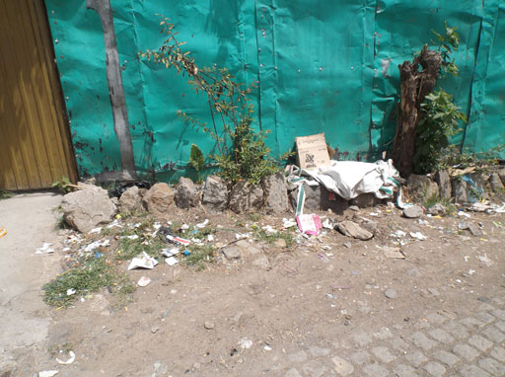
Figure 5.5 Dumped solid waste is a common sight in urban streets.
- In what ways are the members of the Shashemene community failing to be socially responsible?
- Dumping solid waste creates an unhealthy environment, as well as being unsightly. The individuals in the Shashemene community should think about their neighbour’s safety and well-being.
This example illustrates the gaps between the personal and collective responsibilities of the inhabitants of the town. Personal liberty should be respected. However, it is part of the responsibility of each individual citizen in a community to manage their solid and liquid waste in accordance with the environmental and social safety procedures. When we live in a community, we should behave in a way that agrees with the norms of the community and avoid actions that negatively impact on the well-being of our neighbours.
Read Case Study 5.2 and then answer the questions that follow.

Case Study 5.2 Alula and Aster meet their targets but encounter difficulties
Alula and Aster are WASH practitioners responsible for the promotion of water supply and sanitation services in a small rural town called Wechale. They have served in this town for more than five years. A couple of years earlier, during an annual planning and orientation workshop, they were instructed to work hard and ensure 100% household latrine coverage.
Despite the refusal of some households to dig a pit and construct the necessary superstructure, the WASH practitioners finally managed to achieve the desired target. Alula and Aster managed to influence most of the households because they considered the fulfilment of this task to be a precondition for getting various other services from the woreda administration.
The whole kebele declared 100% coverage of latrine facilities and they were selected as a model. Alula and Aster were both rewarded for their extraordinary achievements. They became determined to focus on fulfilling the requirements of their next annual plan and the locally designated quotas they had been given for the year ahead. To fulfil these requirements, they fixed handwashing facilities near all the latrines.
However, they were dismayed to discover that both the latrine and handwashing facilities were abandoned just after the inauguration day and that the residents of Wechale returned to their unhygienic practices. Since that time, there has been an increase in the incidence of diarrhoeal diseases (typhoid, amoebiasis, shigellosis, cholera and others) and a case of trachoma was reported to the nearby health centre.
- Why might these diseases have occurred?
- The latrines and handwashing facilities were not being used and as a result the households’ health conditions deteriorated. The inhabitants of Wechale had returned to practices such as open defecation and other unhygienic behaviour.
- Can you identify the source of the community’s discontent and suggest why Alula and Aster’s initiatives ended in such disaster?
- Alula and Aster were so focused on fulfilling their annual plans and locally designated quotas that they disregarded the opinions of the community they served. The installation of these important WASH facilities was therefore not driven by local demand, but was imposed on the community. The community was not involved throughout the planning and implementation processes.
- Can you suggest a solution for the problems?
- Alula and Aster now need to involve the community in tackling the problem and convince the households of their collective responsibility to prioritise the use of WASH facilities, to prevent further incidence of disease.
You may know of other situations in which similar problems have arisen. You may be able to identify how the community could have been more involved in planning and implementing WASH facilities and made aware of their social responsibilities. The recognition by the community as a whole of their social responsibility is crucial for the success of any new WASH initiative.
You may have realised that social responsibility is closely related to personal accountability that we described at the start of this study session. To conclude this study session, Case Study 5.3 brings together personal and social accountability. Now read the case study and answer the questions that follow.

Case Study 5.3 Dejene and the urban and rural community friction
Dejene is a water supply engineer. He works at the Amhara Regional Water Bureau. He is asked to assess the problem of lack of access to safe water supply for people living in major towns of the region. While conducting the assessment at one of the big towns, he found out that the existing water supply system was no longer adequate to meet demand and there was a significant shortage of water for domestic purposes. The present water supply system only covered the water supply needs of 40% of the population of the town and the majority of the people living in this town were suffering from lack of clean water.
As a WASH practitioner, he was keen to find a solution to the problem. When he looked for a source that could be used to enhance the town supply, he found a spring with a strong discharge that could cover the additional need. Then he proceeded with the design of the new water supply system.
He presented his design to the regional water bureau and succeeded in getting funding for the construction of the system. The construction was completed and the people living in the town started to get enough safe water.
However, after the water supply system had been providing water for the town for several months, there were repeated breakages in the pipes where they crossed a more rural area between the source and the town. An investigation of the situation revealed that the people living in this rural area had broken the pipe network intentionally. This was because they themselves had a shortage of water and they were disappointed to see the water supply system crossing their villages without providing any additional water to meet their needs.
- Give examples from Case Study 5.3 of people who have not demonstrated personal and social accountability? Explain your answer.
- The people living in the rural area close to the town have not demonstrated personal accountability or social responsibility. They have acted irresponsibly in intentionally breaking the pipe network. They have not shouldered responsibility for their actions.
In addition, the regional water bureau has not demonstrated social accountability in the eyes of the people in the surrounding villages. When they agreed on the plan to construct the new water supply system, the rural people were not taken into consideration. Dejene and the water bureau did not consider the wider community in attempting to improve the water supply service, improve people’s welfare and protect people’s rights.
In any WASH programme, there may be cultural, administrative or environmental issues to be considered. Inclusive engagement and negotiations with all stakeholders are required to understand and adapt WASH management approaches in line with these complex issues. A negotiated approach can help in bringing both town and rural administrations together to understand and manage the underlying complexities associated with each project.

Summary of Study Session 5
In Study Session 5, you have learned that:
- Social accountability means holding public officials and service providers to account for their actions and performance. It can improve service delivery and community empowerment in WASH projects.
- Factors that provide an enabling environment for social accountability include organised community groups, responsive government officials, access to information and sensitivity to culture and context.
- Mechanisms for social accountability include participation by citizens and community groups in project planning, budgeting and monitoring.
- The relationship between participation and social accountability is important in influencing government officials and community representatives to respect the wider community and bring about improvement of urban WASH services.
- Social responsibility is linked to personal accountability and refers to the attitudes of responsible citizens and organisations that consider the impacts of their actions on the wider community.

Self-Assessment Questions (SAQs) for Study Session 5
Now that you have completed this study session, you can assess how well you have achieved its Learning Outcomes by answering these questions. You can check your answers with the Notes on the Self-Assessment Questions at the end of this Module.

SAQ 5.1 (tests Learning Outcomes 5.1 and 5.2)
Explain the difference between social accountability and personal accountability.

SAQ 5.2 (tests Learning Outcome 5.3)
Imagine you were part of a team that is planning the development of a new water supply source for a small town. Your team leader is a supporter of social accountability. Identify three ways in which the team could implement principles of social accountability during project planning.

SAQ 5.3 (tests Learning Outcome 5.3)
When the project from SAQ 5.2 is complete, you now want to involve the community in evaluating its impact. Which social accountability mechanism would you apply in this case? What methods could you use and how might you go about it?

SAQ 5.4 (tests Learning Outcome 5.3)
What factors are likely to determine the success of a specific social accountability method? Imagine that before planning a new WASH project, there is a public hearing to discuss the issues involved. Which of the factors you have identified is this an example of?

SAQ 5.5 (tests Learning Outcome 5.4)
Explain why open defecation could be described as socially irresponsible behaviour.

Study Session 6 Community Engagement

Introduction
In Study Session 4 you learned about stakeholders and stakeholder engagement in general. This study session focuses more specifically on community engagement and why it is important. It describes the guiding principles, levels and key methods for engaging communities in WASH projects in urban settings and the many challenges involved.

Learning Outcomes for Study Session 6
When you have studied this session, you should be able to:
6.1 Define and use correctly each of the key words printed in bold. (SAQ 6.1)
6.2 Describe the advantages of engaging communities in addressing urban WASH problems. (SAQ 6.5)
6.3 Identify and describe the guiding principles, levels and methods of community engagement that should be considered in an urban WASH setting. (SAQs 6.2, 6.4 and 6.6)
6.4 Identify the challenges involved in community engagement initiatives. (SAQ 6.3)

6.1 Communities and their characteristics
We have already used the word ‘community’ many times in this Module. A community is a group of people who are connected to each other by geographic location or special interest. They may share a common concern or set of problems.
You read in Study Session 4 that stakeholder engagement means involving stakeholders in decisions. When the stakeholders concerned are community members, the term ‘community engagement’ is used. Community engagement can be defined as a process of working with people in a community to address issues affecting their well-being, in order to achieve common goals (MFSH, 2008).
Community engagement is based on effective communication between people. It also requires respect and trust between the participants, and a common understanding and purpose. Engaging communities in planning and decision making can strengthen their capacity to take action that produces positive changes. It helps to give communities a sense of ownership of projects and interventions, making them more sustainable into the future.
As an urban WASH practitioner you will work with target communities in your locality to improve their health and living conditions. You should be able to identify and address local ideas, concerns and opportunities in your target community and improve their WASH services through appropriate community engagement methods. Communities are at the centre of every WASH project. Since they are the primary targets and the major stakeholders, their engagement in WASH service delivery is vital for ensuring project sustainability and accountability, from the design stage through implementation and also in monitoring afterwards.
Any development work that strengthens the ability of community organisations and groups to build their structures, systems and skills is called community capacity building. Capacity often refers to skills, knowledge and ability (MFSH, 2008). It can also include leadership, infrastructure, time, commitment and resources. Community capacity building is the process of helping people in the community to participate in partnerships and community enterprises and allowing them, through consultation and planning, to be better equipped to define and achieve their objectives.
Community engagement is a complex, ongoing process and involves developing partnerships between practitioners, government officers, service providers and the community. Understanding the diversity and characteristics of the community that you are working with is fundamental to the long-term sustainability of any WASH project.
You learned in Study Session 1 that urban communities are both socially and religiously diverse (Figure 6.1), and that they are likely to include vulnerable groups of people. Different groups may have conflicting interests. Men and women differ in their views on some issues, but not all men share the same view, and neither do all women. Similarly you may find some differences of opinion between older and younger members of the community, but not all young people will share the same views and neither will all older people. Some may have particular needs as a result of a mental or a physical disability, and their interests should also be considered.
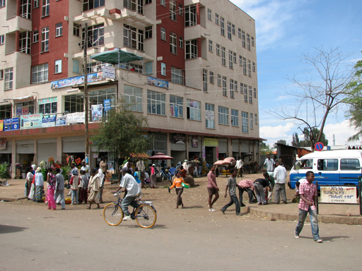
Figure 6.1 People in urban communities in Ethiopia have diverse social and religious backgrounds.
Community engagement has been hugely successful in improving rural water supply and sanitation in Ethiopia. There is less experience of community engagement and participation in urban areas, so for similar methods to be successful in the urban context it is crucial to have a good understanding of the diversity and perspectives of the community involved.

6.2 The purpose of community engagement in WASH
The purpose of community engagement in WASH is to improve the health and economic condition of the community by improving the success and sustainability of WASH projects. This can happen through joint identification of problems, addressing ideas and concerns and identifying opportunities (Figure 6.2). Engaging the community may also enable emerging issues to be identified and be dealt with in a proactive way before they have become problems.
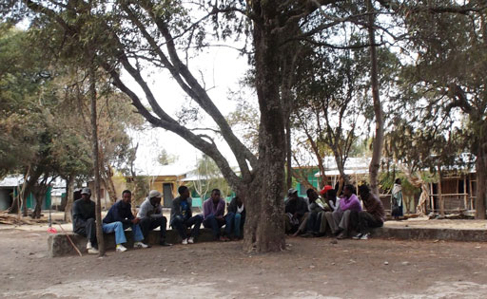
Figure 6.2 Engaging the community to identify opportunities and emerging issues.
If a community is able to join service providers and officials and deal with issues as and when they arise, this:
- may lead to better use of limited resources and more efficient service delivery
- helps officials to appreciate possible untapped community resources that can be mobilised and build on community strengths
- informs policy making at the local level
- improves the targeting and effectiveness of WASH services
- helps to measure how agencies and partnerships are performing
- helps to build community ownership.
Community support for developing services that solve real problems and meet real needs can benefit both the community and the implementing organisation.
- If you were working for an organisation developing new WASH services in your locality, what would be the advantages to you and your organisation of engaging the community?
- Community input can help you to focus on the community's concerns and help you to identify emerging issues earlier. You may then be able to deal with those issues in a proactive way, leading to better use of limited resources and more efficient delivery of services. You may have thought of other advantages.
A well-planned community engagement will enable the diverse concerns of the community to be identified on issues that matter most to them. Moreover, it will ensure that their expectations are met.
From the point of view of the community itself, engagement increases access to information about government operations. This means that people are better informed and therefore more able to put forward ideas and take part in processes that affect them. This helps to reduce the level of misconception or misinformation and conflict with the community. It demonstrates openness and accountability, consequently building trust and credibility. Outcomes that reflect the aspirations of the affected community then become more achievable.
Having a greater input into government planning and decision-making processes gives the community a voice and helps vulnerable individuals to become more aware of their constitutional rights. Moreover, if communities are involved at all stages of a WASH initiative, from planning through implementation to monitoring, it is much more likely to be sustainable and successful in the long term.
The sustainability of a community initiative in the urban setting demands high-quality leadership, a strong sense of ownership, social cohesion, gender equality, effective management and adoption of effective and environmentally sustainable technologies. You will learn more about sustainability in Study Session 11.

6.3 Guiding principles of community engagement
The following principles are intended to underpin the community engagement process and should be taken into consideration as you plan engagement activities (adapted from MFSH, 2008):
- Transparency: Provide relevant information to the community in an understandable way.
- Recognise diversity: A community usually comprises a broad and diverse group of people encompassing different ethnicities, gender, age, socio-economic backgrounds, values and physical and mental ability. They may speak different languages and have a wide range of literacy and numeracy skills. All their backgrounds, interests, needs, values and aspirations should be considered.
- Inclusive participation: Provide all sections of the community with opportunities to contribute to and influence outcomes that will directly affect their lives.
- Equality: Encourage open discussion so that no sections of the community are left out and all ideas are treated with respect. Decisions should not be controlled by one particular section of a community.
- Cooperation: Schedule meetings at times and in places that are convenient for as many people as possible.
- Responsiveness: Respond to concerns and complaints from members of the community and provide feedback on the project process.
- Deliberation: Decisions should be made with careful deliberation to reach consensus among those involved, following a process of thoughtful consideration of different options, through reason and dialogue rather than power struggles.
- Influence: The outcome of the community engagement process should influence policy making and the eventual decisions.
These guiding principles are an important foundation for effective community engagement so that initiatives can be implemented, understood and reported appropriately.

6.4 Levels of community engagement
Community engagement activities can be categorised as different levels, as shown in Figure 6.3. The levels indicate increasing involvement and active participation by the community in the process.
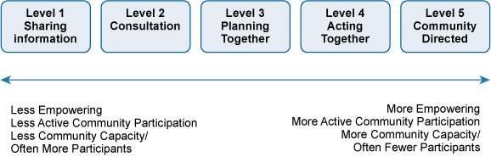
Figure 6.3 Community engagement model (MFSH, 2008).
The first level is information sharing. This is a two-way process in contrast to just providing information, which is a one-way flow of information from government (or other authority) to the community. Under information sharing, government considers information from the community as well as providing the community with information.
The second level of community engagement is consultation. This is a another two-way process in which government or service provider seeks and considers the views of citizens, clients or communities on policies, programmes or services that affect them directly or in which they may have a significant interest (Figure 6.4).
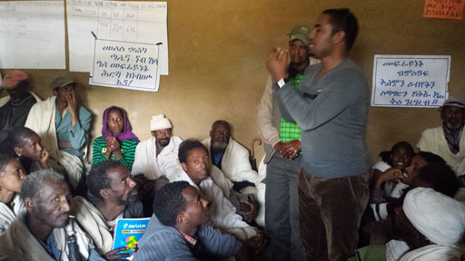
Figure 6.4 Involving the community in a handwashing campaign.
- Which methods of providing information to communities have you read about in previous study sessions?
- In Study Session 5, community meetings, local radio, public hearings and public announcements were mentioned. You may have also thought of posters and leaflets.
The different levels of engagement illustrated in Figure 6.3 may not all apply in all community engagement initiatives. However, as the levels of engagement extend from consultation (Level 2) through the higher levels, the amount of community participation increases and so does the level of community empowerment. Empowerment is the process whereby individuals or communities gain confidence, self-esteem and power to articulate their concerns and ensure that action is taken to address them. Each successive level enables communities to be more active and empowered participants, having a greater voice and greater influence in decision making on policies, programmes, practices or in addressing urban WASH issues. At the highest level, Level 5, the community takes over management and control of the project.
The objectives of each level of engagement are summarised in Table 6.1. Essentially each level focuses on a different type of engagement and can achieve different objectives.
Table 6.1 Levels of community engagement and their objectives. (Adapted from MFSH, 2008)
Level and type of engagement |  | Explanation
1 | Sharing  information | Objective: To share accurate, timely, relevant and easily understood information about decisions regarding policies, WASH programmes, services or issues that have arisen.  Information can be passive (poster or brochure) or active (face-to-face meetings).  This level is the primary form of community engagement, on its own it offers no further involvement – but it underpins all other levels and is necessary for successive levels of engagement.  Information assists the community in understanding the issues and increases their capacity to effectively contribute in successive levels of engagement.
2 | Consultation | Objective: To actively seek community opinions, before a decision is made.  Communities’ views helps inform the final decision.
3 | Planning  together | Objective: To collaborate with the community in identifying and analysing issues, developing alternatives and identifying preferred solutions, communities provide input into the planning and evaluation.  May involve short-term collaboration or more permanent partnerships, and a reporting mechanism so that contributions are monitored.
4 | Acting  together | Objective: Similar to planning together, except that the community will be involved in implementing as well as identifying preferred solutions, i.e. the WASH practitioner and communities share in the planning and evaluation and also share responsibility for making decisions and implementing them.  May involve sharing additional resources.
5 | Community directed | Objective: To support or enable the community to identify issues and solutions, make decisions and implement them and hence forward to manage a service. Community may be referred to as a partner.  Provides a framework with financial resources to enable communities to plan, commission, manage, deliver and evaluate their own services.  Builds community capacity for planning and delivering services and addressing community issues.

6.5 Methods of community engagement
There are many different methods of community engagement. Table 6.2 gives some examples. Some are only suitable for one level of engagement and others can be used more widely.
Table 6.2 Community engagement methods. (Adapted from MFSH, 2008)
Level and type of engagement |  | Methods of engagement
1 | Sharing  information | Face-to-face meetings  Newsletters, posters in public places, letters and flyers  Press releases for local radio and television  Advertisements, notifications or articles in local newspaper  Website
2 | Consultation | Stakeholder meetings, interviews  Public meetings and forums  Surveys, questionnaires  Focus group discussions  Distribution of documents
3 and 4 | Planning together  and acting together | Stakeholder meetings  Workshops, discussions, action planning meetings  In-depth interviews and discussions  Participatory stakeholder mapping  Participatory planning and implementation  Advisory committees, area councils or steering committees  Taskforces, planning groups, strategic alliances and formal agreements
5 | Community directed | Community development  Participatory planning, implementation, expenditure tracking and performance monitoring, with public authority support
A high level of community engagement, such as collaborating to develop partnerships and provide recommendations at the project design stage, will help to sustain a project, empowering the community to make decisions and to implement and manage change.
It may be impossible to fully engage the community at every stage and you should consider the most appropriate level of engagement and participation for each particular situation. Most WASH programmes claim to have high community engagement, but may actually provide very little opportunity for the community to participate in the project implementation, so a key message is to avoid promising a level of participation that cannot actually be achieved. But the more you engage the community in decision making, the higher the level of ownership of the decisions made and consequently, the greater the likelihood of success.

6.5.1 Engaging schools and WASH clubs
As we discussed in Study Session 4, school children are considered effective WASH promotion agents who can catalyse behavioural changes in their community. Many children experience the use of improved WASH facilities on a daily basis in school. They learn why sanitation and good hygiene are important and this can influence their attitude and practice.
Involving schools and strengthening school WASH clubs helps to introduce behavioural change, firstly in the children; secondly, through influence on their families at home; and thirdly, through influence in the wider community (Figure 6.5).
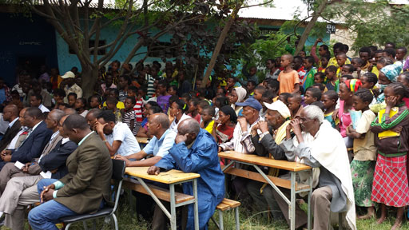
Figure 6.5 Parents and other members of the community watching a school WASH club drama event in Bushulo.
- Imagine you are working with the school principal and WASH club to promote improved WASH technologies and healthy hygiene practices among school children. What sort of events could you organise and what might be the outcome?
- Possible events might include regular WASH promotion days that bring families, students and teachers together. During such special days or on parents’ days or during semester breaks and holidays, children could present poetry, dramas, exhibitions or demonstrations. You may have additional ideas. Such events can inform and inspire not only parents, but also the wider local community.

6.6 Challenges of community engagement
In your work in the urban WASH sector you are likely to be exposed to many challenges during your attempts at community engagement. These are some possible examples.
- Attitudes and expectations: There may be a feeling in the community that they cannot provide constructive input, won’t be taken seriously or cannot influence the decision-making process. It may be difficult for them to contribute skills, resources and time because of geographic or cultural barriers. They may also have unrealistic expectation of WASH initiatives. Moreover, the WASH practitioner may find it difficult to apply his/her technical knowledge or may lack self-confidence in influencing decision making, impacting livelihoods and meeting public expectations.
- Characteristics of urban communities: Close communities are common in rural areas. In urban areas, the members of the community may not know each other, so communities may be more fragmented – this can present particular challenges for urban WASH initiatives. Urban communities are very mixed, with diverse backgrounds and needs that can make it difficult to accommodate different people’s interests. Communicating technical information in an understandable manner is also made more difficult if local residents speak different languages or have conflicting priorities. A related challenge is identifying suitable representatives for meetings and planning sessions who can genuinely represent the diverse nature of the community. It may be that people who believe or claim to know and understand the community may not be aware of the full diversity of opinions.
- Including women: The traditional role of women in Ethiopian society means that they take responsibility for most of the cooking and childcare, even if they live in urban areas and are in paid employment. It is particularly important to engage women in WASH projects because they are likely to have a major influence on hygiene and sanitation practices in the family. However, because of their responsibilities in the home, they may find it difficult to attend community meetings and participate in discussions. Consider their commitments when you arrange the time and place of meetings. For women with babies and infants, suitable childcare arrangements should be considered.
- Commitment to the future: Higher levels of community engagement continue beyond the initial planning stage to project management and maintenance. This requires a continuing commitment from all stakeholders. Preparing plans for the future and identifying possible challenges that may arise can help with preparations to avoid them and should improve sustainability of the project.
Only a well-informed community can be an effective part of the decision-making process, but when well-informed and given an opportunity to be involved, they can be crucial in helping a project to be successful. Incorporating their concerns from the outset can help to reduce potential conflicts. Community members will be more likely to support a project they had input into; enabling them to contribute to the planning, implementation and monitoring will be much more likely to lead to a successful and sustainable urban WASH project.

Summary of Study Session 6
In Study Session 6, you have learned that:
- Community engagement is a process of working with a community to address issues affecting their well-being, involving them in problem-solving or decision-making activities. Urban communities are diverse, which creates challenges for community engagement in the urban WASH sector.
- The purpose of community engagement in WASH is to improve the success and sustainability of WASH projects, and thereby promote the health and well-being of the community.
- There are several guiding principles for community engagement that emphasise the need for an open process that includes all members of the community.
- There are different levels of community engagement from simply sharing information through to community-directed projects.
- The appropriate method of community engagement varies for different situations. All methods depend on providing clear and relevant information at the start.
- Schools and WASH clubs are important agents for change in WASH.
- Community engagement presents many challenges, both to the community and to the practitioner trying to promote it.

Self-Assessment Questions (SAQs) for Study Session 6
Now that you have completed this study session, you can assess how well you have achieved its Learning Outcomes by answering these questions. You can check your answers with the Notes on the Self-Assessment Questions at the end of this Module.

SAQ 6.1 (tests Learning Outcome 6.1)
Briefly explain how community engagement leads to empowerment of communities and how this relates to community capacity building.
The other SAQs for this study session are based on Case Study 6.1, which is in two parts. Read the first part and then answer the SAQs that follow. As you read the case study, think about which of the levels, methods and guiding principles were followed by Jallele in the construction of the communal latrine.

Case Study 6.1, Part 1 Jallele and the communal latrine
Jallele is a WASH practitioner based at Kembebit Woreda Health Office, Oromia region. Sheno is the woreda centre, with four kebeles. Kebele 01 is one of the four. The woreda’s biggest market place is found in Kebele 01 and the people who live in both rural and urban parts of the woreda gather there on Wednesdays and Saturdays to buy and sell goods.
One of the problems Jallele observed at Sheno is the common practice of open defecation by members of the community living in Kebele 01. Jallele called a meeting to discuss the issue with the community. She provided them with information about the health hazards from open defecation and explained that using latrines would benefit their community. The community members told her they had no land to spare for building individual household latrines.
During the discussion, the community suggested construction of a communal latrine as a solution. Jallele discussed the situation with an NGO engaged in WASH programmes and was able to convince them to allocate money for the construction of a communal latrine. She told the kebele administration about the funding she obtained from the NGO and held discussions with them. The kebele administration identified an open access area next to the market place in the centre of the community. The communal latrine was built by contractors working for the NGO at the site the kebele administration had identified.
When the community started to use the latrine, Jallele was delighted. However, after some time, it started to smell bad as a result of poor management. The community stopped using it and went back to using open defecation. After some time, it was totally abandoned. The people coming to market to buy and sell goods complained about the smell and the construction of the latrine next to the market.

SAQ 6.2 (tests Learning Outcome 6.3)
Which of the levels of community engagement shown in Figure 6.3 and Table 6.1 did Jallele follow appropriately?

SAQ 6.3 (tests Learning Outcome 6.4)
What do you think is the possible cause of the failure of the project that Jallele implemented? What steps are missing in Jallele's community engagement strategy?

SAQ 6.4 (tests Learning Outcome 6.3)
Which of the guiding principles outlined in this study session did Jallele adhere to well and which were not considered adequately?

Case Study 6.1, Part 2 Jallele and the communal latrine
Jallele then engaged the community in addressing the problems encountered. After discussion with the wider community, including those who had not been involved initially, she introduced a follow-up scheme. She encouraged the community to make a contribution to renovate the abandoned latrine facility and involved them in the decision-making process. She facilitated the setting up of an appropriate management system, whereby users made a small contribution for using the facility and this money was used to pay two people who kept the latrine clean and to provide soap. She also introduced a bylaw for dealing with any misconduct or misuse. Following this, the facility was kept clean, so didn’t smell and the community began to use it again. There are a number of examples where such initiatives have been successful in Ethiopia.

SAQ 6.5 (tests Learning Outcome 6.2)
Give two advantages that resulted from Jallele engaging the community at this stage.

SAQ 6.6 (tests Learning Outcome 6.3)
Which of the guiding principles were better adhered to through Jallele’s follow-up scheme?

Study Session 7 Role of Frontline WASH Workers

Introduction
The various infrastructures and systems involved in provision of WASH services include water supply and distribution systems, and latrine and waste management facilities (Study Sessions 2 and 3). These are planned, developed, installed and maintained through the active involvement of a number of frontline WASH workers. This study session describes the roles of different types of key frontline WASH worker in these practical aspects of WASH provision. It also explains why facilitation is an important skill for WASH workers and provides guidance on how it should be done.

Learning Outcomes for Study Session 7
When you have studied this session, you should be able to:
7.1 Define and use correctly each of the key words printed in bold. (SAQs 7.1, 7.2 and 7.3)
7.2 Identify the key frontline workers responsible for promoting adequate access to and utilisation of WASH services. (SAQs 7.1 and 7.2)
7.3 Describe their roles in promoting and facilitating improved WASH services. (SAQs 7.1 and 7.2)
7.4 Outline ways in which you as a frontline worker could help to improve WASH situations through facilitating community meetings. (SAQ 7.3)

7.1 Who are frontline WASH workers?
There are many people involved in the provision of WASH services, from planning and construction to operation and maintenance. For example, engineers, health workers, social development and economic professionals, community leaders, community mobilisation experts, builders, contractors, and many others are involved. They contribute from town level, to zonal or regional level, and, depending on the scale of the project, to federal level. Even small projects such as construction of public latrines involve many different stakeholders including user communities, private contractors, town municipalities and utilities.
Frontline WASH workers are those who work closely with the beneficiaries of a scheme. Their role focuses on WASH service provision and maintenance. They mobilise urban communities to work towards improved personal hygiene and environmental sanitation, and promote proper care and utilisation of WASH infrastructure. They include health workers and those who operate WASH infrastructure and provide the necessary care and maintenance to WASH services, such as trained technicians, operators and facility administrators. All are important, irreplaceable contributors who improve and sustain basic services in urban areas.
- Which of the following would be frontline WASH workers? Urban Health Extension Workers, members of the Health Development Army, woreda water experts, WASH facility operators, plumbers, mechanics, technicians and sludge collection operators.
Which do you think would be the most crucial for improving and sustaining WASH services in your locality?
- All these are frontline WASH workers. The most crucial groups will vary from project to project, but are likely to be the Urban Health Extension Workers, members of the Health Development Army, woreda water experts, and both public and private WASH facility operators.
If these crucial groups of workers are absent, inadequately trained or not undertaking their daily tasks effectively, access to urban WASH service facilities will be restricted or reduced. In extreme cases, WASH facilities may break down altogether leading to total lack of WASH services.
The following sections outline the roles of the key groups of frontline workers.

7.2 Role of Health Extension Workers
Health Extension Workers (HEWs), are usually graduates of Technical and Vocational Education and Training Colleges (TVETCs) or Health Science Colleges. They are trained to promote preventative healthcare practices among communities, undertaking community outreach activities and conducting house-to-house visits to provide important information, knowledge and skills on important health-related topics.
HEWs undertake 16 essential health packages that can be grouped into three key areas:
- disease prevention and control
- family health
- hygiene and environmental sanitation.
Promotion of safe and healthy practices in relation to infant care, nutrition, immunisation, growth monitoring for babies and family planning advice are among the many services in the first two areas above that HEWs undertake. They provide these services during house-to-house visits or at health posts or health centres. Here we focus on their hygiene and environmental sanitation work.
The health packages that relate to major WASH issues are:
- Excreta disposal: Human faeces is a major health risk (Study Session 2). HEWs provide information and guidance on how human excreta can be safely managed and disposed of through the construction and use of appropriate latrines.
- Solid waste and domestic liquid waste disposal: HEWs discuss health and environmental issues caused by solid and liquid waste produced at household level, their risk to community health, and how they can be safely managed.
- Water supply and safety measures: Contaminated water is a major cause of transmission of waterborne diseases that cause diarrhoea. HEWs explain how water can be handled safely to avoid contamination during transport and storage and how contaminated water should be boiled or treated using chemicals.
- Food hygiene and safety measures: Food can transmit disease if proper hygiene and safety measures are not practised. HEWs demonstrate safe practices for preparing and storing food.
- Healthy home and environment: HEWs demonstrate how family members can take care of their home and its surroundings to ensure a clean and safe environment.
- Control of insects and rodents: These are not only a nuisance, but may also transmit diseases. HEWs teach possible methods to control and prevent the breeding of these animals in and around the household.
- Personal hygiene: Finally, HEWs promote the importance of keeping and maintaining good personal hygiene, particularly emphasising handwashing before coming in contact with food and after using the latrine, and the importance of washing faces to protect from eye infections.
HEWs promote all these recommended practices in urban communities (Figure 7.1). They work to ensure that all health extension packages are implemented at a household level, including the seven listed, through training of model families. They may use youth associations and traditional cooperative associations such as idir, ekub and mahiber to promote community involvement. They also work with students in schools to promote proper sanitation and hygiene practices.
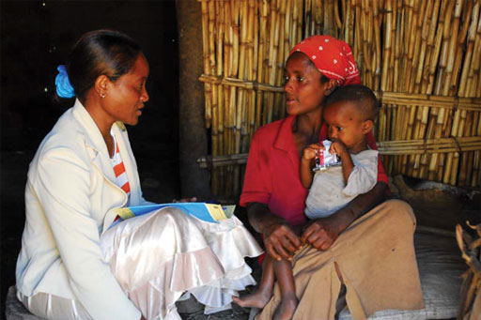
Figure 7.1 A HEW giving advice to a mother.

7.3 Role of the Health Development Army
The Health Development Army (HDA) is another key group with a significant role in WASH. You may already be familiar with them as enormous numbers of people are involved. They are organised groups of families who promote healthy activities and behaviour among other families. More than 2.25 million HDA families have been mobilised in Tigray, Amhara, Oromia and SNNP regions (Figure 7.2). Since 2010/11, the Ethiopian government has invested a lot in establishing the HDA who have made a huge contribution to the major achievements made in the health sector, including reduction of the number of deaths in children under five. HDAs are regarded as the key players in the attempts to achieve government targets in the Health Sector Development Programme (HSDP).
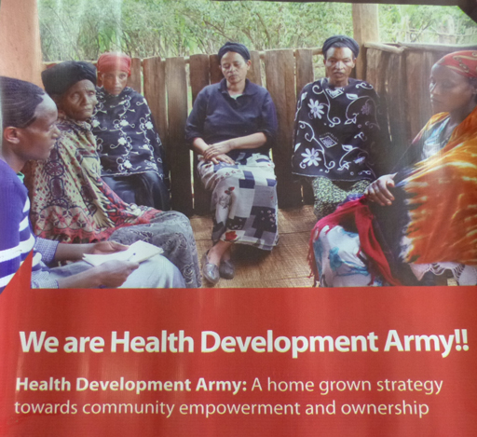
Figure 7.2 HDA promotional banner.
The smallest unit of the HDA consists of six households organised together and is referred to as a one-to-five (1–5) network. One of the households is a model family who have mastered and implemented some or all of the WASH packages such as access to an improved latrine, handwashing and solid waste management. Usually it is mostly the women who are involved. The family head of the model household leads the 1–5 network. Five of these networks are organised into a larger team comprising 30 households in the same neighbourhood. The leaders of these teams undergo intensive training over seven to ten days to ensure that they fully understand their tasks. The HEWs, described in Section 7.2, facilitate the establishment of these teams and in collaboration with the health centres, provide training for the team leaders.
The main task of the HDAs is implementing the components of a Health Extension Package in each household. These are first adopted in the model household and then cascaded to the other families in the 1–5 network. To achieve this, the 1–5 networks meet every week to:
- identify the major bottlenecks and gaps in implementing the WASH improvement components of the Health Extension Package
- prioritise gaps and agree on strategies to address them
- review progress.
This process has accelerated achievements in achieving HSDP targets, notably the use of health facilities by mothers with newborn babies. It has also successfully increased knowledge and practice of safe hygiene and sanitation practices among households, including construction of basic or improved latrines at household level, improved personal hygiene, waste management, and safe handling and storage of water.
In summary, HDAs work to change practice in communities through a participatory process of learning and action-oriented meetings, working below HEWs at neighbourhood and family levels. They are the key players in the improved WASH situations that many households enjoy today and will continue to be an important part in future progress towards improved and sustainable WASH services in communities.

7.4 Role of woreda water experts
Woreda water experts in urban settings focus mainly on providing support to ensure continuous water supply to communities. They regularly:
- provide technical support to facility managers and operators, such as utilities in medium and large towns, WASH Committees (WASHCOs) in small towns
- provide training to facility managers and operators on operation, maintenance and tariff setting
- provide supportive supervision to ensure utilities and WASHCOs are operating and managing facilities properly
- conduct minor or major maintenance to water supply facilities, depending on their skills and expertise
- conduct water quality checks at different points in the water supply and distribution system and on any alternative sources that the community is regularly using.
Woreda water experts are sometimes asked to address WASH facility management issues. This usually calls for community meetings to identify issues and decide on appropriate actions. On these occasions, the woreda water experts work closely with communities to develop and implement participatory plans (Figure 7.3).
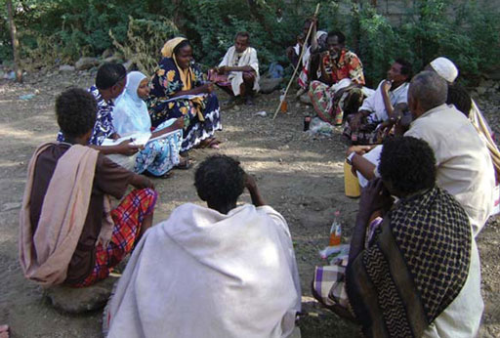
Figure 7.3 Groupwork in the community.

7.5 Role of private operators
Private operators and service providers are also frontline workers who play a key role in making WASH services accessible to communities.
Private suppliers may supply WASH-related products such as soaps, sanitary pads and household water treatment chemicals or sachets such as Bishan Gari and Wuha Agar.
Privately hired technicians may provide maintenance services for water distribution systems, mainly in household connections and related plumbing tasks. In smaller towns, they also provide minor operation and maintenance of the water supply system, for example they may be called in to repair electromechanical components.
Micro- and small enterprises (MSEs) are increasingly participating in the WASH sector (see Study Session 3). Many towns in Ethiopia use the services of MSEs to collect solid waste from households and transport it to a centralised collection site or sometimes to final disposal sites.
In some towns, the service by MSEs has grown to include septic sludge emptying using vacuum trucks (Figure 7.4).
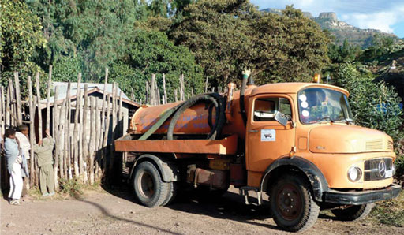
Figure 7.4 A tanker pumping out sludge from a septic tank.
Others are selling items for household use (Figure 7.5), or producing and selling pre-cast concrete slabs for use in household latrines (Figure 7.6).
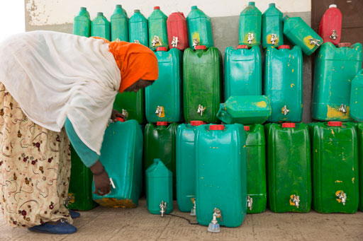 | 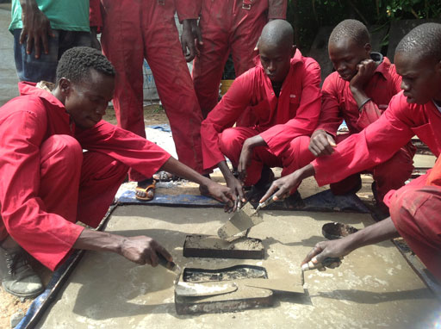
Figure 7.5 Selling jerrycans as a small business enterprise. | Figure 7.6 Young men producing concrete slabs for use in household latrines, as part of a youth employment scheme in Gambela Region.
The number of private operators is growing, although they currently provide only a small proportion of WASH services. Organised groups are managing public WASH facilities, such as public showers and latrines, which have been constructed by NGOs or other development partners. Other private operators include water vendors (Figure 7.7) and informal waste collectors like the cart that you saw in Figure 3.1 in Study Session 3.
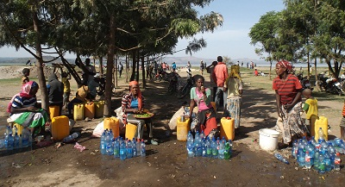
Figure 7.7 Informal water sellers in Hawassa.
Private sector participation is still developing in Ethiopia. Urban settings and their communities provide a number of opportunities for entrepreneurs. The government of Ethiopia encourages private sector initiatives and provides start-up support to promote improved service delivery. Government partners are also investigating innovative approaches and best practices from other countries, to accelerate private sector participation in the WASH sector.
With time, urban communities will benefit more from services provided by the private sector, as the public sector shifts its focus to regulation of the services.
- Which frontline workers play the following roles?
- Work below HEWs at neighbourhood and family levels through a participatory process including action-orientated meetings.
- Management of public WASH facilities.
- The answers are as follows:
- HDA members work below HEWs at neighbourhood and family levels.
- Private operators usually manage public WASH facilities.

7.6 Role of frontline workers in facilitation
The communities are the ultimate users of WASH services and they are the ones who probably know more about their situation and understand their problems better than anyone else. The role of frontline workers is to provide adequate information to the community and facilitate the process for them to make informed decisions about their actions. You may find that, as an additional frontline worker, part of your role is to facilitate the process that leads to a solution that is acceptable by all.
Facilitation means helping groups of people to understand and agree on their objectives. It involves engaging communities in a process, as you learned in Study Session 6.
Initiating sustainable change to improve WASH services requires full understanding of the existing situation, the barriers to improvement and the available resources. The commitment for change must come from within the communities themselves. Change should not be imposed externally. Frontline workers, while working with communities, should avoid imposing a new regime, otherwise the desired changes will not happen or will not be sustained. Mobilising communities for positive action and sustainable change without imposing solutions on them requires specific skills in the processes of facilitation.

7.6.1 What are facilitation skills?
Facilitation skills are skills used to direct and guide important processes with groups of people. These processes can involve meetings, discussions and planning sessions or training events. Somebody needs to guide these processes to make sure the objectives are met. This person is called the facilitator.
The facilitator plays a key role in the success of a community meeting. He or she ensures that ideas raised by participants are coherent with the main agenda of the meeting and works towards finding an agreeable consensus solution to the problem at hand. A good facilitator also ensures that all present are participating adequately in the process and their voices are heard (Figure 7.8).
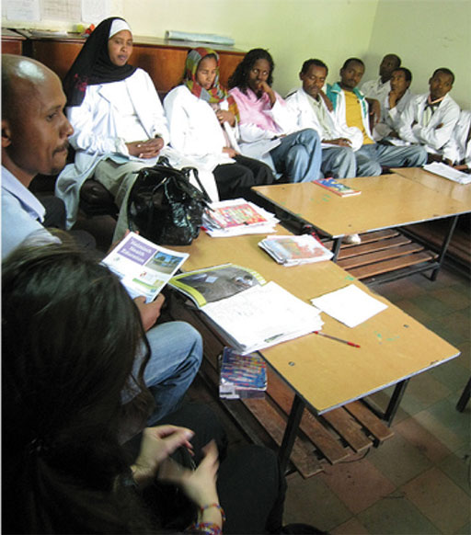
Figure 7.8 Facilitating a meeting means listening and encouraging participation.
Facilitating is different from chairing a meeting. Neither is it teaching, giving orders or prescribing solutions. It means encouraging of the flow of ideas and systematically drawing the discussion to a conclusion that addresses the agenda.
A facilitator has three main roles:
- To guide a group of people to move through a process together. A facilitator does not give opinions, but encourages others in the group to voice theirs.
- To focus on achieving solutions, but also on how people participate in the process.
- To remain open and neutral throughout the process and not to take sides.

7.6.2 Key steps to facilitating a meeting
There is no specific formula for conducting effective facilitation. However, there are a series of steps that should generally be included, though their order may vary depending on the context.

Introduction
Always introduce yourself and anyone who has accompanied you by giving your name(s) and explaining your role. This helps put participants at ease so that they are not meeting with strangers. Explain the purpose of the meeting and what it seeks to achieve.

Set the agenda
Clearly state the problem that needs to be addressed and explain how it affects those present. Everyone must understand what is at stake. List the discussion points and ask participants if they would like to change or add any.

Ground rules
Sometimes it helps to set ground rules for the group process. This is especially important when conflicting interests are expected. Setting and agreeing on ground rules is not mandatory but can help you to have more control over the process. Try to start meetings on time as much as possible. Waiting for latecomers is not fair on those who arrived promptly and encourages people to be even later next time. If some key participants are late, explain firmly that you had to start the meeting without them because of the need to finish on time.

Encourage participation
Remember that you are a facilitator, not a participant. Refrain from giving opinions, taking sides or prescribing solutions. Instead, provide resources, information and strategies to guide participants to give their views and reach a solution.
Some participants may be more vocal than others and some may try to dominate the discussion. Be firm and encourage everyone to share ideas and observations to ensure that voices of all those present are heard. Remember that those members of the community who are poor or disadvantaged in some way may not willingly speak out. It is important to hear their views, because the objective is to facilitate a community-wide commitment.
Rarely, some participants may ridicule or try to undermine opinions from vulnerable groups. Your ground rules may be useful in such circumstances.

Stick to the agenda
Do not deviate from the agenda. Some participants may be focused on points that are not on the agenda and may repeatedly raise them. Keep reminding them of the need to stick to the agenda. If this does not work, ask the group to help you decide on the appropriate process and encourage them to support you.

Always build towards actions
Look out for any ideas from the participants that could lead to appropriate actions. Actions should be practical and achievable with available resources. Remember that this is the aim of the meeting and the reason why you got the groups together in the first place.
The actions must be accomplished by responsible bodies and a definite time should be set in which to complete them. Your objective is to build a plan with clear actions, which specifies the person or group that is going to perform each action and the time by which it should be completed. Make sure individuals or groups are willing to take responsibilities for the identified actions and guide them to agree on the necessary time to complete them.

Reiterate solutions/agreements reached
Ensure that participants understand and agree to the identified actions. State a complete action statement on each issue after agreement is reached and ensure all participants agree to it, before proceeding to the next agenda item.

Propose follow-up meetings
Before concluding the process, summarise agreed actions and ask participants to agree on a follow-up mechanism. This could be another meeting or a series of follow-up meetings at regular intervals for the group to update each other on progress.

Conclude the meeting
Thank everyone for their participation and for the achievements of the process. Take a moment to thank the people who assisted in setting up the meeting and those whose input required preparation beforehand. Close the meeting on time. Members of urban communities normally have a busy life and appreciate a meeting that keeps to schedule.
These are only guidelines and you may need to be flexible to accommodate variations. Case Study 7.1 illustrates a slightly different facilitation approach.

Case Study 7.1 Addressing school sanitation issues
As part of an urban sanitation project to address school sanitation issues, a planning session was initiated in a small town in Welaita zone of SNNPR by the implementing NGO.
The participants for the session came from different government offices, including municipality, water desk and health office, and also the parent teacher association (PTA), kebele administration and the schools themselves. The facilitator introduced himself and the NGO he worked for. He allowed enough time for participants to introduce themselves and the offices they represented. Then he briefly introduced the urban sanitation project and explained why the planning session was important.
Participants had been sent in groups to visit selected schools prior to the meeting and to record their own assessment of the situation. They used observations and interviews with both students and teachers.
First, the facilitator asked participants to share their findings and list the major issues they had identified during their visit. The most pressing issues identified were lack of access to water, open defecation and solid waste accumulation in the school premises.
The facilitator asked participants to identify the key stakeholders among the participants themselves, who could act on these issues. After some discussion, the group identified the school principals and members of the PTA, school WASH clubs, the woreda education office, health office and the water desk.
Next, the facilitator asked all participants to link each of the identified issues to no more than one responsible stakeholder as a primary contact to address each issue. For example maintaining latrines was assigned to the PTA; providing access to water was assigned to the water desk in the municipality. Ending open defecation and managing solid waste was assigned to WASH clubs, with the support of the health and education offices.
The facilitator summarised the process so far, and reiterated which issues were assigned to which stakeholders. He then asked the identified stakeholder for each issue to outline clear actions to solve it, their resource requirement, and a reasonable time for completion for each action. He encouraged them to prioritise actions where necessary and present their plans to the larger group.
The planning session was completed with clear action plans to improve the WASH situation in the visited schools and a follow-up mechanism to track progress.
- What is different about the approach used in this case study, compared with the approach outlined in Section 7.6.2? In particular, how were the issues or problems identified? Do you think that this different approach worked well?
- The facilitator used the inputs from the participants to identify the key issues or problems, instead of drawing up an agenda beforehand. However it worked well in this instance, probably because the participants had been given responsibility for identifying the problems from their own observations.
As a frontline WASH worker, much of your work may involve organising communities and conducting group meetings, planning sessions and discussions. If you manage to develop and apply good facilitation skills, communities will:
- become increasingly comfortable about participating in your meetings
- take responsibility and ownership of the outcomes
- develop sustainable solutions.
In the process, you will build a good reputation among the communities and get their trust, which is crucial for your success in addressing more issues in the future.
Remember that facilitation skills – just like any other skills – are mastered with practice.

Summary of Study Session 7
In Study Session 7, you have learned that:
- Frontline WASH workers are people working closely with the users of WASH facilities. Their role focuses mainly on mobilising communities towards improved practices of WASH. They also work with the community to provide adequate care and maintenance of the WASH facilities for sustainable service.
- The key frontline workers in WASH for urban areas include Urban Health Extension Workers (HEWs), members of the Health Development Army, woreda water experts and both public and private WASH facility operators.
- The roles of HEWs are to promote the health extension programme among families and communities and to ensure communities have adequate and proper understanding about WASH issues.
- HDAs are groups of families that plan, implement and review actions to improve WASH situations in their neighbourhood. They are led by model families under the guidance of the HEWs, to construct and use improved latrines with handwashing facilities and adopt safe sanitation and hygiene practices.
- Woreda water experts provide technical support in maintaining water supply facilities for utilities and WASHCOs, provide training on operation and maintenance, conduct water quality checks.
- Private operators or service providers play key roles in making WASH services accessible to communities, supplying commodities, providing spare parts and equipment for construction and maintenance. MSEs are one type of private operator and provide solid waste collection service in most towns.
- All frontline workers need to have good facilitation skills, so that they can effectively encourage and promote change.

Self-Assessment Questions (SAQs) for Study Session 7
Now that you have completed this study session, you can assess how well you have achieved its Learning Outcomes by answering these questions. You can check your answers with the Notes on the Self-Assessment Questions at the end of this Module.

SAQ 7.1 (tests Learning Outcomes 7.1, 7.2 and 7.3)
In Sections 7.2 to 7.5, you learned about the roles of the different groups of WASH workers in urban settings. Which of the groups of frontline workers play the following roles?
- Provide operation and maintenance to water supply and sanitation facilities and their systems.
- Supply WASH products such as sanitary pads to communities.
- Share their knowledge of the benefits of handwashing with their neighbours.

SAQ 7.2 (tests Learning Outcomes 7.1, 7.2 and 7.3)
How does the work of HEWs link with the role of private service providers?

SAQ 7.3 (tests Learning Outcomes 7.1 and 7.4)
Suppose you have arranged a meeting with a community of a small town to discuss sanitation issues. Your role in the meeting is to facilitate discussion and encourage the participants to reach a consensus on feasible action points. List at least three important things you should do in the process of facilitating the community meeting.

Study Session 8 Assessing Behaviour

Introduction
In this study session you will learn about the purpose of assessing behaviour and how to use a framework approach to identify and understand the causes of a particular behaviour for different participant groups. You will also learn how to identify the context of a particular behaviour and the role of gender in influencing behaviour.

Learning Outcomes for Study Session 8
When you have studied this session, you should be able to:
8.1 Define and use all of the key words marked in bold. (SAQ 8.1)
8.2 Identify target groups for a behaviour change intervention using participant analysis. (SAQ 8.2)
8.3 Analyse and explain behaviours in the context of hygiene and sanitation using a FOAM framework. (SAQs 8.3 and 8.4)
8.4 Understand the difference between sex and gender characteristics, and summarise the role of gender in hygiene and sanitation behaviour. (SAQs 8.4 and 8.5)

8.1 Assessing behaviour in the context of hygiene and sanitation
Health behaviour is defined as any action that is related to disease prevention, health maintenance, health improvement or the restoration of health. Health behaviour can be affected by many different personal attributes such as beliefs, expectations, status, income, motives, values, perceptions and personality characteristics including emotional states and traits.
As a frontline WASH practitioner you may be tasked with promoting improved hygiene and sanitation related health behaviours in your community. Improving behaviours means getting people to change their existing behaviour – not always an easy activity!
Think of a time when you have tried to get one or more people to change their behaviour, either at home or in your job. You should be able to say:
- who needed to make what change (and who needed to support them)
- what the key factors were in motivating and/or holding back these individuals/groups
- what you did to influence those factors and bring about the change.
Identifying these key components to your situation is essentially applying a framework that helps you to understand and consider all the factors involved in the process. In this case, these three points could be grouped as follows:
In order to help … | I focused on … | through …
… the target population to achieve desired behaviour | … the key factors | … influencing activities.
When you want to plan a behaviour change, using a framework approach like this is a good way to make sure you are capturing all the important issues.

8.2 Analysing and explaining behaviours using a FOAM framework
A number of frameworks have been developed specifically for use in the WASH sector. We are going to concentrate on a framework called FOAM, which stands for Focus, Opportunity, Ability and Motivation (Devine, 2009). The FOAM framework is shown in Figure 8.1. (Note that this version of FOAM is sometimes called SaniFOAM, when it has a particular focus on sanitation.) This is a comprehensive approach that expands on our simple framework above by asking us to think in more detail about the determinants affecting the behaviour that we want to change. Behavioural determinants are the reasons why people do or do not practise a given behaviour. Behavioural determinants can be internal (such as a belief about menstruation habits) or external (such as regulations against open defecation). The FOAM framework groups behavioural determinants under four headings.
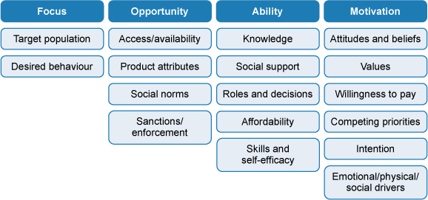
Figure 8.1 FOAM framework. (Devine, 2009)
In this framework:
- focus identifies the target group and the behaviour that needs to change
- opportunity includes questions around whether someone has the chance to change their behaviour
- ability looks at whether someone is capable of changing their behaviour
- motivation explores whether someone wants to change their behaviour.
Through these indicators, FOAM can be used to:
- define and prioritise interventions that aim to change behaviour
- analyse results of studies
- inform the design of new research and data gathering.
So how do we put it into action? In the rest of this session we will look at understanding Focus, Opportunity, Ability and Motivation in more detail and explore some tools that will help you gather the information you need to understand the current situation for a behaviour that you want to change.

8.2.1 Focus
You can see from Figure 8.1 that the first step is to identify your target population and the behaviour that you want to see changed.
The behaviour change could be driven by lots of different factors. In some cases it will be urgent, perhaps because of a disease outbreak linked to certain hygiene habits. In others it may be driven by the routine requirements of your role or perhaps a government programme to reach particular targets. You should always seek support and guidance from senior colleagues to ensure that your planned change is appropriate and review this decision once you have completed the FOAM framework and have a better understanding of all the determinants. You will spend more time thinking about desirable behaviours in Study Session 9.
The target population is simply the group that needs to make the change and this is up to you to define. For example a target population could be:
- male heads of households
- girls aged 10–16
- mothers
- rural households
- households of more than six people
- urban slum dwellers
- parents with a child under the age of three
- people living with HIV/AIDS.
Target populations can usually be divided into different levels according to their positions and influence on the desired outcome. We will use an example to illustrate these different levels. Imagine that you have been tasked with promoting handwashing with soap among young children in schools in your woreda. The children (Figure 8.2) will be your primary target population or group.
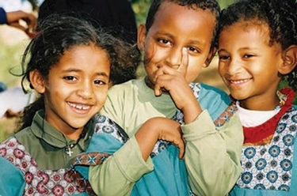
Figure 8.2 Children’s handwashing behaviour is critical for their health.
Associated with the primary target group are the people and community organisations that directly influence them through their own behaviour and actions (see Figures 8.3 and 8.4). This is your secondary target group and could include parents, teachers, or members of parent teacher association (PTAs).
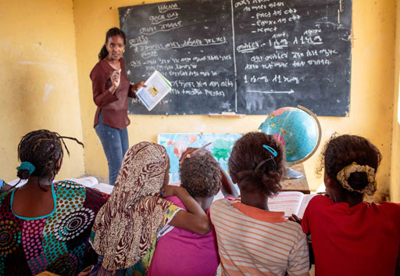 | 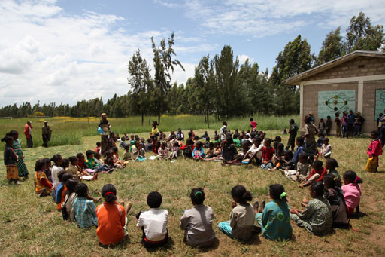
Figure 8.3 Teachers are able to influence school children in lessons. | Figure 8.4 A supervised outdoor activity may have a big influence on school children.
Beyond this is the tertiary group. Figure 8.5 shows the relationship between the primary, secondary and tertiary groups. The tertiary target group, in the outermost ring, is composed of people who indirectly help or hinder the primary and secondary groups. The actions of tertiary participants reflect the broader social, cultural and policy factors that create an enabling environment for behaviour change. In our example these may include kebele or woreda administrators, religious leaders, and representatives of women’s groups and youth associations.
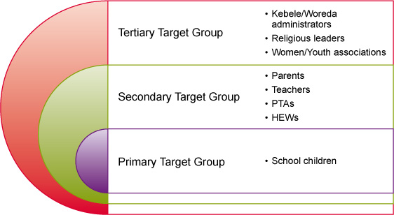
Figure 8.5 Primary, secondary and tertiary target groups.
This process of analysing the different target groups is called a participant analysis. When you have completed it, you will have identified the primary, secondary and tertiary target populations for your planned handwashing promotion in schools. You will also have filled the first column of your FOAM framework. Note that depending on the scale of the intervention there may sometimes be only primary, or only primary and secondary, groups.
- Imagine you are planning to promote handwashing with soap among mothers of children under the age of five in your woreda. Draw a diagram like the one in Figure 8.5 and identify who might be the main primary, secondary and tertiary target populations.
- Your answer should look similar to Figure 8.6.
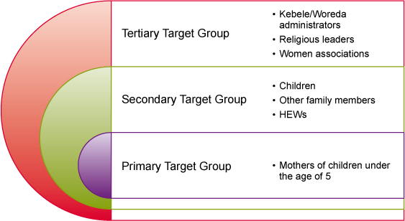
Figure 8.6 Suggested answer showing the main primary, secondary and tertiary target populations.

8.2.2 Opportunity determinants
The FOAM framework (Figure 8.1) provides four subheadings for the behavioural determinants relating to whether someone has the chance to engage in the desired behaviour.

Access and availability
These are external factors that will influence the opportunity for change. For example, if you want your target population to use latrines for defecation, then some of the access and availability determinants might be as follows:
- If a man is working in an area where there are no latrines then he may defecate in the open, even if he used a latrine at home.
- If there are no materials available to build latrines or no skilled builders in the area, then people will not have access to a latrine.

Product attributes
It’s not sufficient for there just to be access and availability if the products or services are not appropriate. Following on from the examples above:
- If there is a latrine available near the man’s workplace but it is poorly maintained and unpleasant, he may not use it.
- If there are materials available but they are poor quality, or there is a skilled builder who has a reputation for dishonesty, latrines may still not be built.
These examples of behavioural determinants are deterrents to the desired behaviour, but it’s important to note that factors under these headings can also be facilitators – things that encourage and support the desired change. (In Study Session 7, facilitators were defined as people who guide and support meetings. The word can also be applied more broadly to anything that helps or supports an outcome.)

Social norms
Our behaviour is strongly influenced by the behaviour of similar people around us, in other words by social norms. People may follow examples of both good and bad behaviour and you need to consider both in your framework. For example you may note that a worker at a building site opts to use a public latrine rather than defecate in the open because he has seen his colleague using it. You might also note that people don’t clean this latrine after use because each person observes that the user before them hasn’t done so.

Sanctions and enforcement
Sanctions are penalties that may be imposed on people who behave badly. For example, people who leave their rubbish by the roadside may have to pay a fine. You should note whether any sanctions like this influence behaviour and how firmly they are enforced.

8.2.3 Ability determinants
The FOAM framework provides five subheadings for the behavioural determinants relating to whether someone is capable of engaging in the desired behaviour.

Knowledge
Knowledge can mean understanding or the lack of it. For example:
- A woman knows she should store water in a vessel with a secure lid.
- A man is not aware that he should wash his hands after using the latrine.
- An urban dweller knows which company will empty their septic tank.
Knowledge about the desired behaviour is essential for your target population, but knowledge alone is rarely sufficient to bring about a change in action.

Skills
The special knowledge of how to do something in an effective way is a skill. For example:
- A caretaker knows how to properly clean a toilet.
- A technician knows how to repair a hand pump.
- A young woman knows how to manage menstruation hygienically and with dignity.
Again, remember that each behaviour determinant can be a facilitator or a deterrent. Each of the examples above are facilitators, but if you were to swap ‘knows’ for ‘doesn’t know’, they become examples of deterrents.
- Consider the two situations below. Which relates to knowledge and which to skills?
        - A mother is unaware that she can use sterilising tablets to make river water safe for drinking.
        - A mother doesn’t know how to sterilise water to make it safe for drinking.
- The first situation relates to knowledge because she is unaware or ‘doesn’t know’ something. The second relates to skills because she ‘doesn’t know how to do’ something.

Social support
Social support is the care that individuals and groups give to each other. This sort of care may be physical, emotional or in the form of information. Examples could include helping a disabled family member to wash themselves, providing emotional support for a young girl as she begins menstruating or telling a new neighbour where they can access clean water.

Roles and decisions
Within any behaviour change plan there will be a number of people who have influential decisions to make. For example, if you are asking households to adopt a certain practice (such as sweeping floors daily), then the roles may include anyone in the household who might take a turn in the activity, and decisions could include the purchase of a new broom.

Affordability
People may want to do something, or feel they should, but are not able to afford to pay for it. Saving money can be a powerful influencer. There are long-term economic benefits from many WASH practices, generally from improved health, but these are difficult to relate to individual behaviour.
It is also worth noting that affordability may be different from willingness to pay – for example, if a woman can afford to buy sanitary goods but knows that her friend gets them for free from a health centre, she might not be willing to pay. Affordability is an ability determinant, but willingness is a motivation. We’ll look more at this in the next section.

8.2.4 Motivation determinants
The FOAM framework provides six subheadings for the behavioural determinants relating to whether someone wants to engage in the desired behaviour.

Attitudes and beliefs
Beliefs are ideas that people hold to be true. Attitudes are shown in the way people treat others, express themselves or approach a situation. People are often unaware of their attitudes and beliefs. Regardless of whether a person’s beliefs are factually correct or not, they can be a powerful determinant in their understanding and perception of WASH behaviours. For example, some people believe that children’s faeces are not harmful but, in fact, they may pose a greater health risk than adult faeces because diarrhoea and parasitic worm infections are more common in young children (Brown et al, 2013). Assessing attitudes and beliefs can be difficult, but should not be underestimated in your FOAM framework.

Values
Values are closely related to beliefs and represent the code of conduct that a group or community choose to act by. For example, if modernity and progress are values that a community aspires to, then it will be more likely to adopt behaviour that is seen as consistent with these standards.

Emotional, social and physical drivers
Drivers are strong feelings that drive us or lead us to behave a certain way. For example, safety, comfort, privacy, disgust, status, pride, shame, shyness, modesty and vanity could all be drivers of either positive or negative behaviour.

Competing priorities
We have already noted affordability as a determinant, but just because someone can afford something doesn’t necessarily mean they will prioritise it in their spending, particularly when a household has very little money. Understanding the way financial decisions are made within a family and/or community can help you decide how and when to present the case for any expenditure that you are proposing.

Intention
In the context of the FOAM framework, intention describes the stage that your target population is at in its decision-making process and helps you to plan your intervention accordingly. For example, if there has been a public-awareness campaign about handwashing and you know that people understand the value of it, then your intervention might be focused on the provision of facilities. Or if people had slipped back into lazy habits and stopped bothering to wash their hands, then you might plan a new campaign to remind them. If there has been no such campaign, then there is no existing intention and your intervention will need to take a different approach.

Willingness to pay
As previously noted, willingness to pay tells us how much an individual or group will consider paying for what feature or benefit. It is closely related to both affordability and competing priorities.

8.3 Gathering information using a situation analysis
Situation analysis is, simply, finding out about a situation so you understand it. In the context of health behaviour assessment, it is a tool that helps to identify the various behavioural determinants that are facilitating or preventing progress in improving health, including improved hygiene and sanitation. The information that you gather will help to fill the spaces in your FOAM framework and to identify what you will need to overcome in order to bring about the desired change.
Using a situation analysis, you can also identify what has already been done to address hygiene and sanitation problems, what results were obtained and lessons learned. For example, you might find that people are using a local latrine that is well maintained and pleasant to use, and this could provide a model for building or upgrading other latrines in your area (Figure 8.7). You may also be able to find out who the main influential people are and who it might be important to get involved. In addition to ensuring that a particular intervention is appropriate to the local context, a situation analysis will also help avoid duplication of efforts.
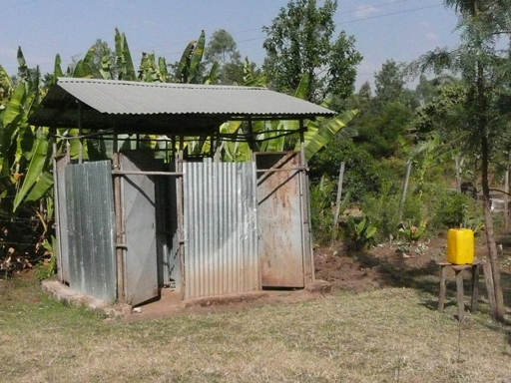
Figure 8.7 This latrine with handwashing facility at a rural health post is kept clean and tidy, and could be used as an example for others to follow.
You need to take four steps to conduct behavioural situation analysis and organise the information you require. These are explained in Box 8.1.

Box 8.1 Steps of behavioural situation analysis for FOAM

Step 1: Identify what information is already available
When capturing a situation to populate the FOAM framework, you should use headings and subheadings (see Figure 8.1) to guide your thinking. It is important to start by listing all your available information and information sources. This could be knowledge that you have gained by observation, information gathered from colleagues, research and published data from journals or government documents, etc. Often, a lot more information is available than you might first expect.

Step 2: Identify what information is still required
When the available information is identified, it will become apparent where the gaps exist. List your unanswered questions and start to think about what you will need in order to gather the responses. Do note that this should be realistic – if you wait until the situation analysis is ‘perfect’, it will never be finalised.

Step 3: Collect the required information
You might want to carry out some in-depth interviews with members of your target population and/or the influencers around them or you might need to find out information such as prices, availability of a product or other external determinants. One very thorough method of understanding your target population or group better is to conduct a barrier analysis. Barrier analysis is a process for identifying the behavioural determinants that prevent or discourage change, i.e. the barriers to change. The process involves dividing a group into doers (who already practise the desired behaviour) and non-doers (who do not). You then interview all participants asking about their behaviour and the reasons for it, and then compare the results from the two groups to identify the key differences between them (Kittle, 2013).

Step 4: Complete the FOAM framework
When the situation analysis is complete you should have all the information that you need in your FOAM framework and should have captured a good understanding of the behaviour that you want to change.
Note that you may also come across the term ‘KAP analysis’, which stands for knowledge, attitudes and practice. This is another approach to finding out about a situation. It relies on collecting data from community members using surveys and questionnaires.

8.4 Role of gender in determining hygiene and sanitation behaviours
Gender plays a particularly significant role in hygiene and sanitation interventions. It is therefore important that we pay it particular attention in any behaviour analysis.
Some people may have difficulty in understanding exactly the difference between sex and gender. ‘Sex’ refers to a person’s biological status and is typically categorised as male or female. There are a number of indicators of biological sex, including sex chromosomes, internal reproductive organs and external genitalia. ‘Gender’ refers to the roles, behaviours and activities that a given society considers appropriate for males and females. In other words, ‘sex’ refers to biological differences between men and women and ‘gender’ refers to social and cultural differences.
While planning hygiene and sanitation promotion, you should consider that women, girls, men and boys all have different needs which must be identified and addressed. In hygiene and sanitation, gender makes a difference to:
- the way people are affected by a situation, especially access to latrines and hygiene facilities
- their attitudes, opinions and the way they see a situation
- whether they are more or less likely to support change
- their role, influence and ability to act.
Now read Case Study 8.1 and answer the question that follows.

Case Study 8.1 A teenage girl’s dilemma
Tirunesh is a teenage girl who started her periods about two years ago. She finds it embarrassing to go to school when she is having her period because her school does not have a separate latrine for girls. Moreover, her mother does not consider it particularly important to spend money on sanitary pads, preferring to keep her at home during her period to help look after her younger siblings. For these reasons, Tirunesh misses about five days of school every month, and now she is falling behind in her studies (Figure 8.8).
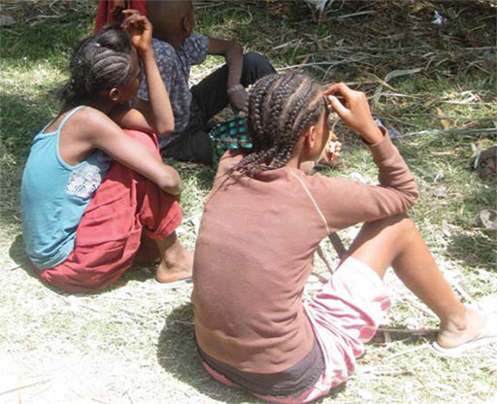
Figure 8.8 Teenage girls often miss school when they are having periods.
- Explain why Tirunesh’s dilemma is a gender issue.
- Girls all over the world have periods, but in the society in which Tirunesh lives, it is not considered important by her mother to provide her with sanitary pads in order that she should go to school every day, even during her period. This is a gender issue because it is her gender that makes it less likely that she will successfully complete her education.

Summary of Study Session 8
In Study Session 8, you have learned that:
- A framework approach helps to identify behavioural determinants that can facilitate or prevent progress in improving health including hygiene and sanitation.
- One such framework is FOAM, which identifies the target groups and people who can influence them as well as the opportunity, ability and motivation determinants of a behaviour.
- Tools that can be used to help build the content of a FOAM framework include participation, situation and barrier analysis.
- Gender has a strong influence on hygiene and sanitation-related behaviour.

Self-Assessment Questions (SAQs) for Study Session 8
Now that you have completed this study session, you can assess how well you have achieved its Learning Outcomes by answering these questions. You can check your answers with the Notes on the Self-Assessment Questions at the end of this Module.

SAQ 8.1 (tests Learning Outcomes 8.1 and 8.3)
Write the following words next to their correct definitions in the table below:
barrier analysis, gender, health behaviour, participant analysis, sex, situation analysis.
any action that is related to disease prevention, health improvement or restoration of health
the roles, behaviours and activities that a given society considers appropriate for men and women
analysis that help you understand a situation
a person’s biological status as male or female
a means to determine the primary, secondary and tertiary target populations for a particular intervention
method for identifying the reasons why people do or do not practise a given behaviour

SAQ 8.2 (tests Learning Outcome 8.2)
An intervention is planned to provide free sanitary products to girls at local schools. A participant analysis has been conducted and has identified primary, secondary and tertiary target populations for the intervention. Classify the following according to where you think they were placed:
- teachers
- women/youth associations
- head teachers
- mothers
- other women in the household
- other women in the extended family and community
- girls of menstruating age
- health extension workers
- kebele/woreda administrators
- religious leaders.

SAQ 8.3 (tests Learning Outcome 8.3)
        - According to the FOAM framework, the determinants of opportunity can be grouped under four subheadings:
- access and availability
- product attributes
- social norms
- sanctions and enforcement.
Match each of the following sentences to one of these determinant groups.
Determinants of opportunity | Determinant subgroup
A toddler sees an older child washing their hands after using the latrine and copies this behaviour
A family decides what sort of sanitary facility to build based on the single type of platform that is for sale in their local marketplace
The mother in a household wants a different latrine because her friends have told her it is easy to clean
The village community establishes a system for punishing anyone who contaminates their water supply
        - The determinants of ability are grouped under subheadings of:
- knowledge
- skills
- social support
- roles and decisions
- affordability.
Match each of the following sentences to one of these determinant groups.
Determinants of ability | Determinant subgroup
A grandmother tells her daughter where she can dispose of her baby’s faeces
A man starts encouraging his family to use soap for handwashing, because a local initiative is giving the soap away for free
A girl hides her used sanitary pads because she doesn’t know where she should dispose of them
A boy knows how to wash his hands effectively using soap and water
A head teacher decides to implement changes at her school, meaning that all children have access to safe drinking water during the school day.
        - The determinants of motivation are grouped under subheadings of:
- attitudes and belief
- values
- emotional, social and physical drivers
- competing priorities
- intention
- willingness to pay.
Match each of the following sentences to one of these determinant groups.
Determinants of motivation | Determinant subgroup
During Ramadan, a family would rather save for celebration than spend money on sanitation
A community would welcome the provision of an alternative to open defecation because they have a big problem with snakes
A mother believes that her baby’s faeces are harmless and therefore do not need special measures for disposal
The head of a household will pay for the materials needed to build a latrine but refuses to pay for the labour required
A community believes in environmental sustainability
A landlord agrees that he will upgrade the sanitation facilities in his properties

SAQ 8.4 (tests Learning Outcomes 8.3 and 8.4)
Assume that your primary target group in a handwashing promotion is mothers of children under the age of five years in your woreda.
- Identify one person who can directly influence these mothers.
- Identify one social norm that can negatively influence mothers’ handwashing behaviours.
- Identify one gender issue that affects mothers.

SAQ 8.5 (tests Learning Outcome 8.4)
Which of the following are sex characteristics and which are gender characteristics?
- Women have breasts while men do not.
- Women do more household work than men.
- Women menstruate while men do not.
- Men are mostly responsible for earning money for the family.
- Many more men hold managerial positions than women.
- Men generally have larger bones than women.
- Women take most of the responsibility for caring the children at home.
- Men have facial hair while women do not.

Study Session 9 Influencing Behaviour

Introduction
Once you have identified the determinants of a behaviour that you want to change (Study Session 8), it is time to think about how you might influence the desired behaviour by developing a behaviour change strategy. You may encounter both barriers and motivators relating to cost, availability, service delivery, interaction with communities, channels of communication, or the content or clarity of the messages about change.
There are several reinforcing approaches to communication that aims to influence behaviour – the main ones are behaviour change communication, social change communication, social mobilisation, and advocacy. A WASH communication programme may include all these approaches to increase and sustain demand, acceptance and utilisation of various services.
This study session introduces these major communication approaches to influencing behaviour, which are described in more detail in following study sessions. It also describes the main steps for organising and implementing a successful WASH campaign.

Learning Outcomes for Study Session 9
When you have studied this session, you should be able to:
9.1 Define and use correctly all of the key words printed in bold. (SAQs 9.1 and 9.2)
9.2 Develop a simple behaviour change strategy. (SAQ 9.1)
9.3 Explain key communication approaches related to hygiene and sanitation promotion. (SAQs 9.2 and 9.3)
9.4 Describe the processes involved in conducting WASH campaigns. (SAQs 9.3 and 9.4)

9.1 Developing a behaviour change strategy
Once you have completed your analysis of a behaviour, using the tools we explored in Study Session 8, you are ready to design the strategy that can be used to bring about the desired behaviour change. Having a thorough understanding of the current situation is critically important here. Consider the following case study.

Case Study 9.1 The importance of linking information and strategy
Tedlar is a health promotion worker who has been tasked with getting mothers in his community to wash their hands before cooking food. Tedlar thinks that the women don’t understand the health risks of not washing their hands and spends nearly all his budget on a big promotion campaign with leaflets and radio messaging. Three months into the campaign he conducts a survey and finds that there has been minimal progress in achieving the desired behaviour.
Tedlar realises he has relied on his own beliefs and needs a more objective understanding of the situation. He conducts a situation analysis and barrier analysis to inform a FOAM framework describing the existing situation. At this point he discovers that the women are aware of the health risks but not driven by this knowledge. The reasons for handwashing that are important to them are disgust at dirty hands, nurture of their children, and the critical opinions of other women. These are much stronger determinants in this context. He also finds that some of the women have no access to handwashing facilities, so no amount of desire to wash is going to help them with the practical activity. Those that do have access and good intentions still need frequent reminding to change their habits.
Tedlar now needs to develop a behaviour change strategy that focuses on providing the missing facilities and the facilitating determinants through appropriate communication and support. (Remember from Study Session 8 that determinants can be facilitating (helpful and encouraging) or deterrents (barriers) to desirable behaviour.)
What Tedlar was missing was a clear and well-designed behaviour change strategy that set out how resources are allocated and how he should plan his time in order to be most effective. Behaviour change strategies should focus on maximising the facilitating determinants of a behaviour and minimising the deterrents.
A behaviour change strategy should therefore be driven by the information you gathered in your framework analysis. It should include:
- the goal that you want to achieve
- the activities that you will need to complete in order to achieve that goal
- the resources you will need to support those activities (e.g. money, people, products, facilities, licenses, approvals, etc.)
- the schedule for the activities
- the means by which you will evaluate the effectiveness of the programme.
Arguably the most important thread in your behaviour change strategy is communication, the process by which information is exchanged between individuals or groups. Effective communication takes place when all parties in the exchange understand the information in the same way.

9.2 Channels for communication
Communication can take place through a wide variety of means or channels including interpersonal, group, community, and mass and social media communication channels. If you are planning behaviour change communication or social change communication you should assess all possible ways and means to get your message across. For example, consider what might be the most appropriate channels to promote handwashing with soap in primary schools in your woreda. You will need to consider:
- Are there WASH clubs in the schools?
- Would posters be effective?
- Do the schools have radios?
- Do the schools have television sets?
- Do the schools have computers? With or without internet access?
- Which of these communication channels do students prefer?
- Which channel do they trust?
Some methods of transmitting information to children are illustrated in Figures 9.1 and 9.2.
 | 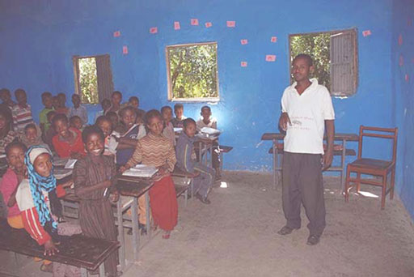
Figure 9.1 Primary school child listening to the radio. | Figure 9.2 Practical demonstration to primary school children.
It is critical to select the channels that will be most appropriate for reaching the school children frequently and effectively. You should take the following points into consideration.
- Different channels play different roles. Using several channels at the same time increases the impact of communication messages. For example, you can use school clubs to promote handwashing with soap but, with the cooperation of teachers, you can also use peer education sessions where children learn with and from each other, as shown in Figure 9.3, or recorded audio messages to reinforce the message.
- Select channels that are accessible and appropriate. For example, printed written materials should be distributed only to literate participants but materials based on pictures can be used to communicate with almost anyone.
- The effectiveness of a channel can be measured by its ability to get people to understand and remember information, to be motivated to tell other people about this information, and to change their behaviour based on the information. A channel could also be considered effective if it provides timely information, creates an appropriate climate for change, efficiently reaches targeted groups of people, and is cost-effective.
Figure 9.3 Peer learning as children are working in pairs in a class.
Your behaviour change strategy will depend on effective communication with your target group. The following sections of this study session look at the main approaches to communicating about changing WASH behaviour. These approaches are (UNICEF, 2005):
- behaviour change communication, which is about influencing individuals
- social change communication and social mobilisation, which are about influencing communities and other groups
- advocacy, which is about influencing decision makers at all levels.

9.3 Behaviour change communication
In the context of WASH initiatives, behaviour change communication is communication that is intended to help individuals change their behaviour so that they develop more healthy practices. It attempts to bridge the gap between factual information, a person's knowledge and attitudes, and their subsequent behaviour.
This approach addresses the knowledge, attitudes, practices and skills of individuals as they relate to specific WASH programme goals. Targeted individuals gain more accurate knowledge, and hence change or develop attitudes and skills that will motivate them to develop more positive, healthy and protective practices. Now read Case Study 9.2 and answer the questions that follow.

Case Study 9.2 Child marriage and its reduction
In a rural woreda, there had been frequent occurrences of child marriage. This continued for many reasons, but the central issues were that the local authorities did not consider child marriage a problem and there were no punitive measures towards the perpetrators.
In an effort to reverse these trends, a behaviour change strategy was developed to convince local level decision makers to take action. They were encouraged to establish ‘action committees’ and force parents to get permission from the kebele administration before they could arrange a wedding for their daughters. The kebele administration issues permission for the marriage only after making sure, through testimonies of witnesses,that the bride is at least 18 years of age. The establishment of the ‘action committees’ have resulted in girls having somewhere to go for support and advice when their rights are violated. In addition, community conversations (Figure 9.4) were conducted in the communities to empower them to draw up bylaws to stop the child marriage practice. Religious leaders, women’s associations and youth groups were brought on board to create awareness of the issues involved.
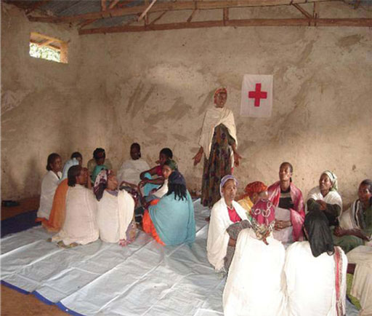
Figure 9.4 A community conversation can be an effective form of communication.
Because of all these interventions, there has been a noticeable reduction in incidences of child marriage. Young girls in the woreda are now less likely to drop out of school to marry, as no man can marry a woman without written approval of the kebele administration. In addition, counselling sessions have been introduced in the primary school, and students are encouraged to discuss child marriage and girls' education as part of Girls' Forum and Girls' Club activities. Such a session is shown in Figure 9.5.
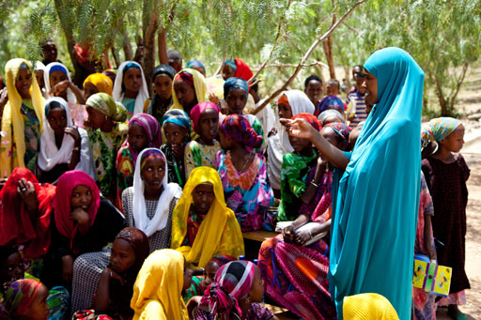
Figure 9.5 A counselling session in which girls discuss child marriage and girls’ education.
- The two main reasons why child marriage continued to be practised were that the local authorities did not consider it to be a problem and it was not punished. Which of the subgroups of behavioural determinants in the FOAM framework are demonstrated by these reasons?
- The first indicates that the local authorities were not motivated to change because of their attitudes to child marriage and their values. Child marriage was also a social norm in this community. The lack of punishment shows how sanctions and enforcement can influence behaviour.
- Identify two individual behaviour changes that helped to reduce child marriage in this case study.
- The answer is as follows:
- Parents were helped to understand the negative effects of child marriage.
- Parents were encouraged to seek permission of the kebele administration before arranging marriages.
Behaviour change communication is concerned with influencing the behaviour of individuals. Individuals are highly influenced by factors in the environment around them, such as gender, power and culture, as well as by the organisation of their local community and the political and economic environment. This is explained in Section 9.4.

9.4 Social change communication and social mobilisation
Some theories of behaviour change move away from the individual and focus more on the relationships between behaviour and the social and physical environments in which it occurs. Individuals are dependent on their environment and the structure of the systems in which they live. This means that they are influenced by the organisational, political and economic environment and also by gender, power, culture and community issues.
If you were undertaking an assessment of behaviour, you will identify any relevant values and social norms as behaviour determinants when completing the FOAM framework. If they were significant factors, as in the case study above, then a social change communication approach could be a useful tool in your behaviour change strategy. Social change communication focuses on the community as the unit of change rather than the individual. It is a process whereby ‘community dialogue’ and ‘collective action’ work together to produce social change in a community. This can mean changes in people’s understanding of an issue, in their behaviour and practices, in policies, and in gender norms and relations.
The aim of social change in the WASH context is to improve the health and welfare of all members of the community. A response to social change communication might come in the form of social mobilisation, where people in the community come together to act for change. (Community mobilisation is the topic of Study Session 11.)
Community-led total sanitation (CLTS) is one of the social change approaches that helps rural communities to understand the negative effects of poor sanitation and encourages them to take action to eliminate the practice of open defecation. It is an approach that focuses on the community as a whole rather than on individuals. (You will learn more about CLTS in Study Session 10.)
- Look back at Case Study 9.2 and identify the social change communication intervention which was used to draw up bylaws to reduce child marriage.
- Community conversation were used here to involve the community in drawing up the new bylaws. You might also have mentioned the counselling sessions that took place at the primary school.

9.5 Advocacy
Advocacy means making a case in support of a particular cause or activity and trying to convince other people that it is a good idea. It is a process of gathering and organising information to be communicated to decision makers in an attempt to influence decisions.
Advocacy aims to influence decision makers at various levels – at federal, regional, woreda and local levels. Advocacy for WASH may, for example, try to raise funds and other resources or get support for a particular project from political and social leaders.
You will learn more about advocacy for urban WASH in Study Session 12.
- Consider the following approaches that a WASH worker might use to promote improved hygiene and sanitation in their communities. Which of the four communication approaches explained in Sections 9.2 to 9.5 is involved in each case?
- Moving from house to house and counselling household members to give advice on hygiene and sanitation issues.
- Discussing the importance of hygiene and sanitation with community and religious leaders and encouraging them to provide support in helping communities to improve their practice.
- Facilitating dialogue by setting up community discussion groups to talk about sanitation issues.
- Coordinating support from local groups such as women’s groups or youth associations, to encourage improvements to hygiene and sanitation practises.
- The answers are as follows:
- This is an example of behaviour change communication, because it is an attempt to help individual people change their behaviour so that they develop more healthy practices.
- This is an example of conducting advocacy, because it is done in an attempt to influence the views and decisions of decision makers themselves.
- This is an example of social change communication, because it focuses on community dialogue and action.
- This is an example of social mobilisation because it brings together community members to strengthen wider participation and a feeling of ownership of the initiatives to improve hygiene and sanitation.

9.6 Organising WASH campaigns
A campaign is an organised effort that seeks to influence a decision-making process and is generally appropriate when there is a need to raise awareness of an issue within a particular group. Health communication campaigns apply strategies intended to deliver messages designed to influence health behaviours of target audiences. Messages are communicated, either directly or indirectly, through various channels such as:
- mass media (e.g. television, radio, billboards)
- small media (e.g. brochures, leaflets, posters)
- social media (e.g. Facebook, Twitter, blogs, chat rooms, as shown in Figure 9.6)
- interpersonal communication (e.g. one-to-one or group face-to-face education).
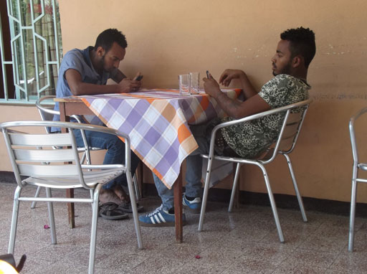
Figure 9.6 Accessing messages via social media.
The ten important steps needed to conduct an effective hygiene and sanitation campaign are as follows.

Step 1: Analysing the situation
This is covered by the material you studied in Study Session 8.

Step 2: Defining the target audience
This may be any one or more groups from the primary, secondary or tertiary target populations that you identified in the FOAM framework.

Step 3: Identifying objectives
Identifying objectives is a key starting point when planning a hygiene and sanitation campaign. You should consider your objectives in terms of what needs to change. It may be knowledge, attitudes or practices and it is important to identify and describe specific objectives which can be measured, to help you to identify how the effectiveness of the campaign will be ascertained.

Step 4: Designing the campaign
After the objectives have been identified, the campaign strategy should be defined. This includes deciding upon the type of campaign (for example media-based only or an integrated campaign using several communication channels) and its scale (national, regional or local). When you plan the activities of the campaign, you will need to match the behaviour change campaign activities to the determinants that have been identified in the FOAM framework.

Step 5: Selecting media
Once you have defined the design for an appropriate hygiene and sanitation campaign, careful selection of the right communication media is a critical next step. There are four important factors to consider in selecting the most appropriate campaign media:
- How closely your target audience fits the audience profile of the different media.
- The comparative costs of reaching the target audience through different media.
- The time taken for messages to reach the target audience using the different media and whether this matches the timing of your campaign.
- The appropriateness of the different media for the communication of your message.

Step 6: Planning campaign timing
Timing is crucial. You must create a realistic schedule. Estimate the time required for the campaign and decide how long it will take and use this estimate to decide when your campaign should start.

Step 7: Deciding on frequency required for messages
Campaign messages raise levels of awareness each time they are communicated. They also move individuals further along the decision-making process and can serve to maintain contact during an extended process. Campaigns should use repetition to reinforce the impact of their message, and also provide an opportunity to communicate multiple or complex messages about hygiene and sanitation.
Advertising frequency is often decided by the type of media. For example, meetings can be held weekly, print messages can be released daily, public loud hailer announcements can work twice daily, and radio or television commercials can be broadcast many times during the same day.

Step 8: Setting a budget
There are various costs associated with a campaign and you must plan a careful budget to accommodate them. A campaign budget will include both direct and indirect costs. Direct costs include the costs of designing, writing and producing materials and media costs. Indirect costs can include of the cost of activities such as planning, managing and evaluating the campaign.

Step 9: Delivering the messages
Once the decisions have been made about the appropriate communication channel and the design of the campaign, the campaign messages should be delivered. Messages should be clear and – most importantly – few in number. Try to identify one key message for a campaign with two or three supporting messages that reinforce the central point. Ensure that messages are appropriate for the audience and do not be tempted to ‘say everything’. The message should also be presented to audiences at an appropriate time for the audience to receive, consider and act on the messages.
Messages can be delivered using many communication channels including public announcements, written materials (Figure 9.7), radio and TV broadcasts, and community meetings and discussions, which can take place in many locations including meeting places, market places, churches and mosques (Figures 9.8 and 9.9).
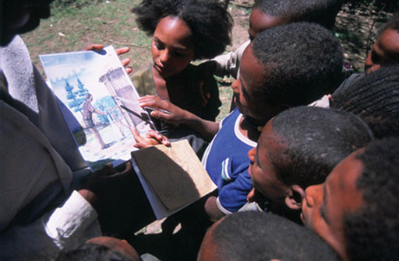 | 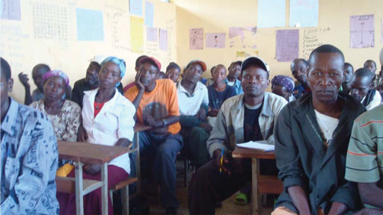
Figure 9.7 Delivering a message using written materials. | Figure 9.8 Delivering a message at a meeting.
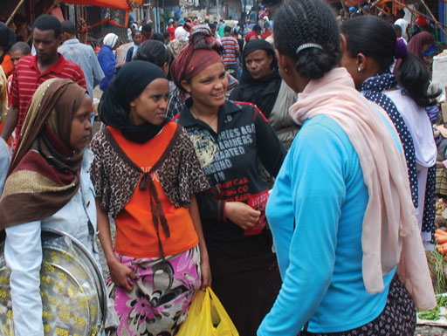
Figure 9.9 Delivering a message through discussion.

Step 10: Evaluating the campaign
Finally the campaign should be evaluated. The evaluation report ends the campaign process. It is what justifies the work and money spent on the campaign by those who provided the finance, the policymakers, authorities, partners, stakeholders and the campaign team. The final report should provide an overview of each step carried out in preparing and conducting the campaign and its supportive activities. It needs to include an explanation of the rationale for the campaign, the campaign’s basic design, including campaign strategy, how the messages were developed, the communication channel used, and the frequency and intensity at which they were presented.
The evaluation report should end with a discussion and a final conclusion about the strengths and/or weaknesses of the campaign, and its effectiveness.

Summary of Study Session 9
In Study Session 9, you have learned that:
- A behaviour change strategy helps set out a plan for achieving a desired change in health behaviours.
- Behaviour change communication is an approach that addresses the knowledge, attitudes, practices and skills of individuals as they relate to specific WASH programme goals.
- Social change communication is an approach that focuses on changes in community behaviour.
- Social mobilisation is the process of communities acting together towards a shared goal.
- Advocacy is a communication approach used to influence decision makers at all levels, for example to influence their decisions about raising resources or to gain political commitment for a hygiene and sanitation initiative.
- A campaign is an organised effort that seeks to influence a decision-making process and is generally appropriate when there is a need to raise awareness of an issue within a particular group. Health communication campaigns apply strategies intended to deliver messages which are designed to influence health behaviours of target audiences.

Self-Assessment Questions (SAQs) for Study Session 9
Now that you have completed this study session, you can assess how well you have achieved its Learning Outcomes by answering these questions. You can check your answers with the Notes on the Self-Assessment Questions at the end of this Module.

SAQ 9.1 (tests Learning Outcomes 9.1 and 9.2)
Imagine that an outbreak of acute watery diarrhoea (AWD) has occurred in a community where you are working. You have identified that most people who are ill, and/or their families, have attended the same community centre building. A FOAM analysis has found that:
- there is only one latrine at the centre and people say that it is always smelly and dirty
- women particularly do not like using the latrine
- there are no functioning handwashing facilities near the latrine
- people do not understand the link between poor hygiene at the centre and their AWD
- the manager of the community centre wanted to build a new latrine block and has identified materials and skilled labour to do so, but has run out of budget for improvements/repairs in the current financial year.
Complete the table below to outline a possible behaviour change strategy that would stop the outbreak. Describe the steps in bullet points rather than detail.
Goal
Activities
Resources
Schedule | In one week:  In one month:  In three months:
Evaluation

SAQ 9.2 (tests Learning Outcomes 9.1 and 9.3)
What would be the most appropriate communication approach to use for each of the following scenarios?
- The woreda administration is not allotting sufficient budget for hygiene and sanitation promotion.
- Mothers do not have a sound knowledge of the transmission methods of childhood diarrhoea.
- Open defecation is common practice in your locality.
- NGOs, youth and women associations, and religious institutions are not currently involved in hygiene and sanitation campaigns.

SAQ 9.3 (tests Learning Outcomes 9.3 and 9.4)
What would be the most appropriate communication channel or channels to use for the campaign to prevent the AWD outbreak mentioned in SAQ 9.1 from spreading?

SAQ 9.4 (tests Learning Outcome 9.4)
Rearrange these steps in a WASH campaign so they are in the right order:
- Evaluate the campaign.
- Deliver the messages.
- Plan the timing and schedule for your campaign messages.
- Identify the target audience and your objectives.
- Design the campaign and select the media you want to use.
- Set the budget.
- Analyse the situation.

Study Session 10 Promoting Improved Hygiene and Sanitation

Introduction
You have learned in Study Session 2 that human faeces are the main source of diarrhoeal pathogens. They are the cause of many infections such as dysentery, ascariasis, schistosomiasis, cholera, typhoid and acute watery diarrhoea (AWD) (see Table 2.1 in Study Session 2). There is also growing evidence that diarrhoea is a significant contributory cause of stunted growth in children (Checkley et al, 2008).
The disease-causing pathogens that originate from faeces can be passed from an infected host to a new one via various routes. Promotion of practices that can prevent transmission of the pathogens that cause diarrheal diseases is therefore hugely important. These practices include handwashing with soap, proper handling of food and water purification. Where adequate sanitation is available coupled with improved hygiene behaviours, there can be dramatic reductions in the incidence of diarrhoea. Improvements can also be expected in other areas such as a cleaner environment, safer water and food, better nutrition and hence improved learning among school children and improved dignity and privacy for everybody, especially women.
This study session will focus on ways in which improved hygiene and sanitation can be promoted.

Learning Outcomes for Study Session 10
When you have studied this session, you should be able to:
10.1 Define and use correctly all of the key words printed in bold. (SAQ10.1)
10.2 List desired priority behaviours in the WASH context. (SAQ 10.2)
10.3 Describe the possible barriers that might prevent improvements to WASH practices. (SAQ 10.3)
10.4 Give examples of methods for promoting improved WASH practices in urban settings. (SAQ 10.4)

10.1 Selecting priority behaviour in the WASH context
You learned in Study Session 8 how to assess and analyse behaviour within a FOAM framework. Based on the findings from such an analysis, priority behaviours can be identified. These are behaviour changes that could contribute to an improvement in the health of the target population. The purpose of identifying priority behaviours in WASH is to assist in developing a focused behaviour change communication intervention that can contribute to sustainable change in the health condition of the population. Specific behaviours related to WASH will need to be addressed at individual, household and community levels.
The behaviour change strategy would also need to identify potential target audiences for the campaign. If there are inadequate resources to address every target audience at the same time, then some will need to be prioritised. For example, you might give priority to audience groups that comprise the largest proportion of the target population, or are identified as having high public health importance, or likely to be most receptive to communication messages.
Some key WASH related priority behaviours, and suggested target audiences, are presented in Table 10.1. These are just a few examples. In practice there are many other possible priority behaviours depending on the situation. You should select appropriate priority behaviours and target audiences based on a situation analysis for the community in which you are working.
Table 10.1 Priority behaviours and target audiences for key WASH components.
Key WASH component | Priority behaviour | Target audience
Safe drinking water | Keep water safe at source of supply | Private water vendors  Public stand pipe attendants  People who collect water from protected springs and wells  People who sell from their own wells
 | Always transport water in closed containers | Women, men, children in homes without pipe connection
 | Cover drinking water container at all times | All residents
 | Fetch drinking water in a manner that does not put hands/fingers into drinking water, i.e. tap, long-handled ladle | All residents
 | Place drinking water container on a raised surface out of reach of small children | All residents
 | Use proven, effective methods to purify drinking water, i.e. boiling, purification tablets/sachets, filtration, solar heating | All residents
 | Clean containers used for transportation and storage of drinking water at least once a week | All residents
Latrine use | Use a latrine at all times (including for disposal of child faeces) and do not use open defecation | All residents including those living in compound houses, in peri-urban areas, parents, guardians and carers of children under five years, carers of elderly or disabled residents
 | Dispose of solid waste generated at home safely | All residents
Other home practices | Wash hands with soap and air dry at the five critical times, i.e. before eating, after handling child‘s faeces, before preparing food, before feeding a child, and after defecating | All residents, but especially parents, guardians and carers of children under five years, school children and anyone handling food
 | Sweep the house and surroundings daily and dispose of the sweepings in a designated place | All residents
 | Cook food well  Wash vegetables well in brine (salt water)  Wash all utensils, containers, surfaces before preparing meat  Do not use the same surface for cutting meat and vegetables | Food vendors, restaurant owners, women, men, children
 | Clean yourself with adequate water and soap regularly | All residents
Some of these priority behaviours are illustrated in Figures 10.1 to 10.4.
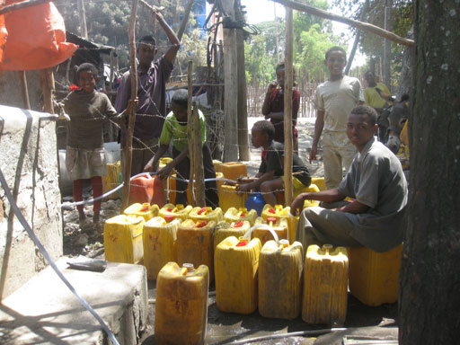 | 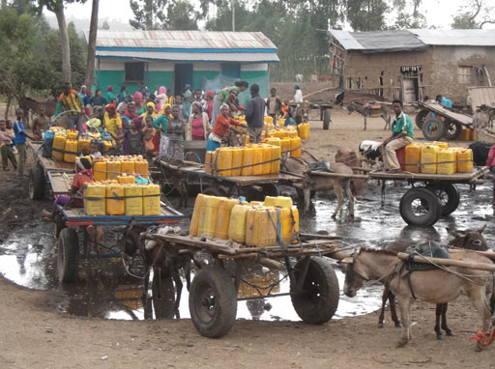
Figure 10.1 Supplying water in closed containers with secure lids. | Figure 10.2 Using closed containers is particularly important when there is stagnant water nearby.
 | 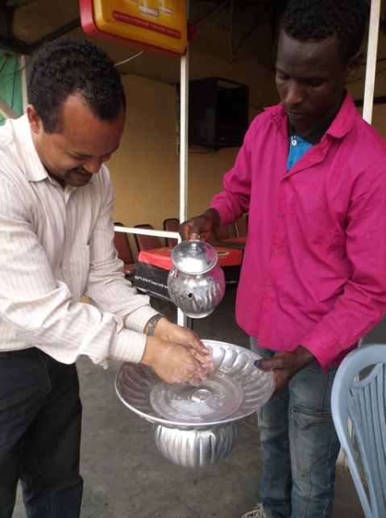
Figure 10.3 Water purification tablets for household water treatment. | Figure 10.4 Washing hands with soap before eating at a restaurant.

10.2 Behavioural barriers to improving hygiene and sanitation
There are many difficulties with improving hygiene and sanitation; in particular there are many reasons why the behaviours listed in Table 10.1 may not be adhered to. These behavioural barriers differ from context to context. Results of a situation analysis used to complete the FOAM framework will help you to identify the most crucial WASH related behavioural barriers in your context.
The behavioural barriers may be the result of personal or socio-cultural factors, or may be due to service and infrastructure issues, or to economic or environmental factors. Here we present some of the most important WASH related behavioural barriers that you may encounter when conducting a situation analysis. Please note that the list is by no means exhaustive.

10.2.1 Personal barriers
Personal barriers include those resulting from lack of knowledge or awareness. For example, people may not be aware of the health dangers of contamination, and in particular that hands can contaminate water, and they may not know about all the critical times to wash hands. There may also be a lack of knowledge about appropriate disinfection procedures or of household water treatment and filtration devices and other products available, and limited awareness of the health dangers posed by decomposing waste.
People may not have the habit of regular bathing, or good handwashing behaviour because of a lack of time in busy households. It may also be that there is no scoop available in the household for moving faeces, or no jerrycan in the home to use for storing water.
Another personal barrier could be a perception that boiled or purified water has an unpleasant taste.
- List the personal barriers to improved hygiene and sanitation that result from lack of knowledge or of awareness. Which three of these are the most important in your area? Which other personal barriers are particularly important in your area?
- You might have included a lack of knowledge or limited awareness of:
- health dangers of contamination
- unwashed hands can contaminate water
- all the critical times to wash hands
- health dangers from decomposing waste
- methods for household water treatment
- products available for disinfection.
The three that are most important will vary from one area to another but it is likely that lack of awareness of the health dangers, of the fact that hands can contaminate water, and of all the critical times to wash hands will be among them. Other important personal barriers might be that there is no habit of bathing or of good handwashing behaviour.

10.2.2 Socio-cultural barriers
There are a number of social and cultural or religious barriers which might prevent people from adopting good WASH behaviours. For example, many mothers believe that child faeces are harmless and hence they do not discard them properly. It is very common to see people washing their hands with only water even though soap is available. Figure 10.5 shows a woman cleaning a latrine – it is rare to find a man engaged in such activity, which may lead to lack of interest in the issues of cleanliness.
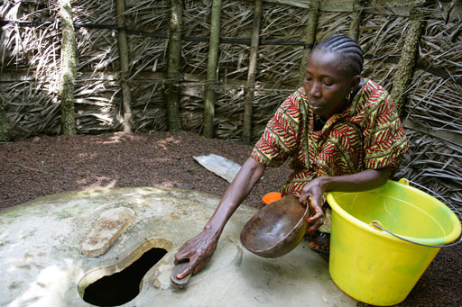
Figure 10.5 A woman cleaning a latrine.
There may also be a preference for water from natural sources for drinking due to perceived taste differences when water has been treated (Figure 10.6).
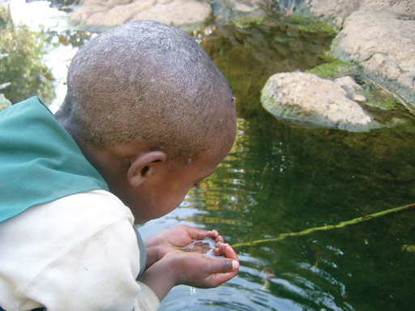
Figure 10.6 This boy, like many children in Ethiopia, drinks untreated water every day.
- Figure 10.7 shows water that has been left in a church to be blessed. Can you identify the health risk here and the barrier that is involved?
- The water has been left in a open containers, so could become contaminated. The barrier here is a religious one, arising from a belief that the water cannot be blessed unless it is in an open container. In the FOAM framework this is an ‘attitudes and beliefs’ determinant.
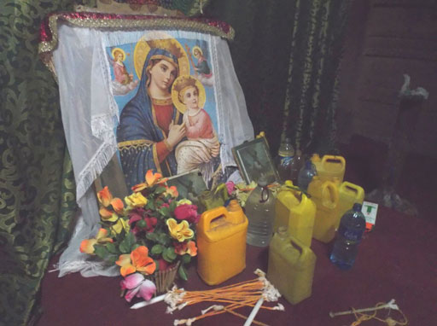
Figure 10.7 Water placed in a church to be blessed.
All these factors can lead to poor adoption of good hygiene and sanitation practice.

10.2.3 Service and infrastructure-related barriers
Some serious barriers in urban and peri-urban communities relate to issues of service and infrastructure (UNICEF, 2008). There may be inadequate sanitation and latrine facilities, in particular in schools. Public latrines are often not well kept and may be poorly ventilated and unclean, so people avoid using them because of an unpleasant stench. Moreover there are only a few child-friendly and disability-friendly latrines available. In households, there may be limited space for constructing latrines. Those who own houses which are rented may refuse to provide latrines. Poor ground conditions such as a high water table and loose soil may restrict design choices and technology options.
As for water supply, there may be an irregular flow of water in piped areas, and seasonal changes in water availability and quality. There may be high salinity or high fluoride content. Moreover there are often only a limited number of water sources, leading to long pipelines, and this can result in a long distance between water points and homes. Water points may be poorly maintained. There may also be limited availability of water purifying tablets or sachets.
With regard to waste disposal, municipal waste collection and sludge removal services may be absent or inadequate. Even if such services are present, they may be expensive. There may be only weak enforcement of municipal sanitation laws. In some urban areas, such as in Addis Ababa, litter bins are provided (Figure 10.8) but in others there may be no litter bins, or they may be expensive to provide, or rarely emptied. There may not be the appropriate vehicles available for removing sludge regularly from public latrine facilities.
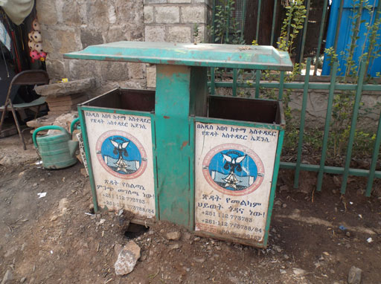
Figure 10.8 Litter bin in Addis Ababa.

10.2.4 Economic barriers
A number of economic barriers exist for urban communities and these include the high costs of obtaining a household pipe connection (Figure 10.9) and acquiring a latrine facility, the cost of water, and the cost of soap. In places where handwashing facilities and soap should be available (near latrines and kitchens, and in restaurants), it may be too expensive to provide them. Moreover the cost of removing sludge and of refuse collection may be prohibitively high.
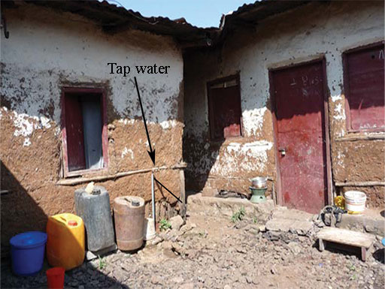
Figure 10.9 A pipe connection providing safe water for a group of households.

10.2.5 Environmental barriers
There are often environmental constraints to provision of adequate latrine facilities. For example, hard rocks increase the cost of constructing latrines because it makes it difficult to dig a pit. Sandy soils or marshy environments are not suitable for construction of latrines. High rainfall and/or recurrent flooding can pose significant barriers to construction and use of latrines (UNICEF, 2008).
The existence of bushes and open spaces around communities can be a barrier to use of improved latrines, as open defecation can be an easy alternative in such areas. Bushes and other weedy growth in open spaces also tend to promote indiscriminate dumping of waste, and so constitute a barrier to safe solid waste disposal.
- Identify the most significant barriers which are likely to prevent WASH behaviour improvement in your community.
- The most significant barriers may be different from one community to another but are most likely to be economic ones, as outlined in Section 10.2.4. You may have identified some of the following:
- financial constraints in building a latrine
- high cost of obtaining a household piped water connection
- high cost of removing sludge
- high cost of refuse collection
- lack of or high cost of handwashing facilities at community latrines
- high cost of water
- high cost of soap, or unavailability of soap at community latrines.

10.3 Interventions to promote improved hygiene and sanitation
Based on the identification of barriers as outlined in Section 10.2, you can then plan appropriate interventions that aim to change people’s behaviour and practices. You learned about the four main approaches which are used to address such barriers in Study Session 9. A health promotion intervention or initiative is one that actively encourages positive behaviour, and is usually concerned with change that will occur over a relatively long period of time.
- What are the four approaches to influencing behaviour that you learned about in Study Session 9?
- The four approaches are individual behaviour change communication, social change communication, social mobilisation and advocacy.
A health promotion intervention would use these approaches for different purposes. Here are some examples of the aims they might be used to achieve:
- Behaviour change communication aims to promote child-friendly pit latrines in households, water treatment at the point of use, handwashing with soap, proper household water treatment, safe storage and disposal of waste water and food hygiene.
- Social change communication aims to increase community involvement in selecting appropriate design options for water and sanitation facilities, to change cultural beliefs and to promote community-led total sanitation (CLTS). You will learn more about CLTS in Section 10.4.
- Social mobilisation aims to bring stakeholders together to promote social marketing strategies in water and sanitation, handwashing, utilisation of locally available materials for construction of sanitation and hygiene facilities, technologies suitable for environments that have unstable and/or rocky soil and to introduce low-cost handwashing technologies near latrines.
- Advocacy aims to persuade decision makers to reduce the cost of clean water provision, to promote child, girl and disability friendly WASH services in schools, to improve maintenance of water points and to improve municipal waste collection services.
Now read Case Study 10.1 on open defecation and answer the question that follows.

Case Study 10.1 Open defecation
There are some communities in Ethiopia where people do not use a latrine even when one is available. This is because their tradition prohibits male and female members in the same household from using the same place to expel their faeces. It is culturally unacceptable for them to defecate on top of each other’s excrement. In particular the community considers the act of defecating on faeces of the household head or that of respectful community members as quite despicable. For example, children are not allowed to defecate on top of their parents faeces, and a wife would never defecate on top of her husband's faeces. This belief and practice has adversely affected the community's use of latrines and aggravated the widespread practice of open defecation.
- Identify the type of barrier which best explains the issue raised in Case Study 10.1. Explain which of the following types of barrier it represents and why.
- Personal
- Socio-cultural barrier
- Infrastructure
- Economic
- Environmental.
- The barrier is related to culture and tradition so it is a socio-cultural barrier (b).
- Which type of communication intervention do you think would be the most appropriate for overcoming such a barrier and why?
- Behaviour change communication
- Social change communication
- Social mobilisation
- Advocacy.
- To address socio-cultural barriers, social change communication (b) would be most appropriate because the behaviour change which is needed relates to social customs.

10.3.1 Community-led total sanitation (CLTS)
Community-led total sanitation (CLTS) was mentioned in Study Session 9. It is a method for mobilising communities to completely eliminate open defecation by triggering collective behaviour change (UNICEF, 2008). In Ethiopia the name has been modified and you are more likely to come across ‘CLTSH’, which stands for community-led total sanitation and hygiene.
CLTS/CLTSH depends on raising awareness that everyone in the community is at risk of exposure to disease even if only a few people continue to defecate in the open. It has been successful in ensuring that all households gain access to safe sanitation facilities in many parts of Ethiopia. It helps communities to understand the negative effects of poor sanitation and empowers them to collectively find solutions to their sanitation situation. CLTSH is about bringing sustainable behavioural change. In general, it works best in villages that have enthusiastic leadership but it is also dependent on convincing everyone to change their behaviour. Besides leadership, many other local social, physical and institutional conditions affect the prospects for CLTSH.
CLTSH involves trained facilitators working with communities as they go through three phases of the process: pre-triggering, triggering and post-triggering phases (Kar and Chambers, 2008).

CLTSH pre-triggering phase
The facilitators must visit the selected kebele or kebeles prior to the community triggering. This visit is mainly to estimate the size of the community and its population but also to identify the dirtiest areas in the vicinity that are most frequently used for open defecation. This must be done with the community, possibly using a participatory mapping process, as shown in Figure 10.10. They also decide on the most appropriate season and place to conduct the community triggering.

CLTSH triggering phase
Community triggering happens at a gathering of the local inhabitants who come together to have a dialogue about concerns related to open defecation. The purpose of this dialogue is to bring collective action against the open defecation behaviour. Triggering refers to the moment when the whole community shares a sense of disgust and shame about open defecation. The facilitator helps them to come to the realisation that they quite literally will be eating one another’s shit if open defecation continues.
In particular, the aim of the triggering phase is to reach agreement about actions to be taken. The actions will be governed by bylaws developed by the community. The final output of triggering is a community-based action plan, which includes an agreed schedule and set of activities that everyone in the community commits to participating in. This involves construction of latrines with handwashing facilities and commitment from everyone that they will use the new facilities at all times.

CLTSH post-triggering phase
After the community-based action plan is prepared, the community members must put the plan into action. They develop bylaws to ensure the elimination of the practice of open defecation in their community. The plan also states who will implement and enforce the bylaw.
In this phase, participatory review meetings should be organised by community members and facilitated by Health Extension Workers or other CLTSH-trained facilitators. The main purpose of these sessions is to review the progress made towards achieving the objectives of the plan. A sanitation map prepared during triggering can be used again to follow the progress made (Figure 10.10). Households that have constructed and started using a latrine are marked on the sanitation map. Comparing this with the original map can show the progress made in the reduction of open defecation sites.
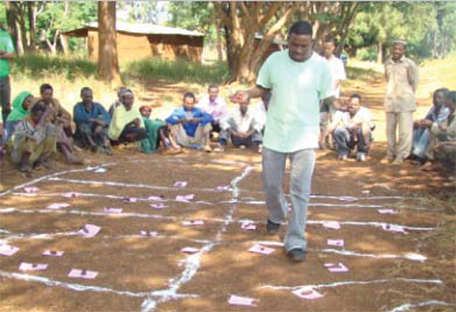
Figure 10.10 Producing a sanitation map using a community participatory approach.

10.4 Sustainability of behaviour change
Sustainability means ‘able to last or continue for a long time’ (Merriam-Webster online dictionary). So the sustainability of a certain behaviour means that the ability of an individual to maintain that behaviour (in this case a hygiene and sanitation behaviour) for a long time. Ideally the behaviour change becomes a habit, something that is so familiar it is routinely practiced correctly, without variation and without thinking.
Behaviours are complex. Physical, social, cultural and institutional contexts shape and constrain people’s choices and options and hence their behaviour. The desire to target attitudes and behaviours using education and awareness-raising still remains strong. However, these measures tend to have little or no influence on behavioural shift if they run counter to other powerful incentives, such as prices or social norms.
Adopting a sustainable behaviour is the ultimate goal of hygiene and sanitation promotion interventions. You will learn more about sustainability in Study Session 13.

Summary of Study Session 10
In Study Session 10, you have learned that:
- Priority behaviours should be identified in order to develop a focused behaviour change intervention that can contribute to sustainable change in the health condition of the urban population. Specific priority behaviours for WASH interventions should be selected based on a situation analysis.
- Behavioural barriers differ from context to context. Results of a situation analysis help identify the specific WASH-related behavioural barriers.
- Behavioural barriers may include personal, socio-cultural, service and infrastructure, economic and environmental barriers.
- Based on behaviour analysis, a combination of four main intervention approaches may be pursued to increase, encourage and sustain a change in sanitation hygiene and health practices – individual behaviour change communication, social change communication, social mobilisation and advocacy.
- CLTSH is a method for mobilising communities to completely eliminate open defecation by triggering collective behaviour change. It is divided into pre-triggering, triggering and post-triggering phases.
- The ultimate goal of WASH promotion interventions is for them to be sustainable.

Self-Assessment Questions (SAQs) for Study Session 10
Now that you have completed this study session, you can assess how well you have achieved its Learning Outcomes by answering these questions. You can check your answers with the Notes on the Self-Assessment Questions at the end of this Module.

SAQ 10.1 (tests Learning Outcome 10.1)
Rewrite the paragraph below using terms from the list provided to fill the gaps.
behavioural barriers, community-based action plan, CLTSH, health promotion intervention, open defecation, priority behaviours, sustainable.
When planning a ……………… in a community it is important to identify the ……………… that can make a difference to the health of the target population. You also need to be aware of possible ……………… that may present challenges for your plan.
……………… aims to improve hygiene and sanitation behaviour by helping communities to realise the health risks from ……………… so that they all make a commitment to change their behaviour. During the process they prepare a ……………… that describes the activities and schedule for building new latrines. It is important to check for ……………… change by having regular reviews of progress to ensure that the improved practices of latrine use and handwashing continue into the future.
The remaining SAQs are based on the following case study. Read Case Study 10.2 about menstrual hygiene and then answer the SAQs which follow.

Case Study 10.2 Menstrual hygiene
Like many parents in Ethiopia, Selam does not discuss menstrual hygiene with her daughter, Mana. She is not willing to provide Mana with sanitary towels even though the family has no shortage of money. Selam believes that menstruation is not something that should be discussed openly with her daughter. Because Mana lacks the knowledge and the material to manage her menstruation properly, she misses up to five school days every month. Her school does not have separate latrines for girls and boys because of shortage of budget. During her period, Mana generally tells her teachers that she is sick and stays at home. At home, she tells her mother that there are no classes. This is adversely affecting her performance at school.

SAQ 10.2 (tests Learning Outcome 10.2)
Identify two priority behaviours which are important to try to change to improve the chances for girls like Mana to successfully complete her education.

SAQ 10.3 (tests Learning Outcome 10.3)
What are the personal, cultural and infrastructure barriers which might prevent the change of such behaviours?

SAQ 10.4 (tests Learning Outcome 10.4)
Which type of communication intervention would you recommend in order to improve Mana’s situation and why?

Study Session 11 Mobilisation of Urban Communities

Introduction
This study session is about community mobilisation in the context of urban WASH. You may be involved in an urban WASH activity in your locality and this session emphasises the skills needed to mobilise an urban community and promote community participation.

Learning Outcomes for Study Session 11
When you have studied this session, you should be able to:
11.1 Define and use correctly each of the key words printed in bold. (SAQ 11.1)
11.2 Explain the benefits of mobilising communities. (SAQ 11.2)
11.3 Describe the strategies and methods required for community mobilisation to be effective. (SAQs 11.3 and 11.4)
11.4 Identify the community groups that need to be involved in addressing urban WASH initiatives. (SAQ 11.4)
11.5 Give examples of the challenges for community mobilisation. (SAQ 11.5)

11.1 What is community mobilisation?
In Study Session 6 you learned that a community is a group of people connected to each other by geographic location or common concern or interest. An urban community refers to the inhabitants of a town or sub-town with families who share facilities and are connected to each other by their location. You also learned about community engagement, the process of working with people in a community to address issues affecting their well-being.
Community mobilisation has much in common with community engagement in that it is about participation of community members. However, ‘mobilisation’ places the emphasis on actions. ‘Mobilising’ means getting things moving. Community mobilisation also has much in common with social mobilisation but has a more specific focus on communities. Social mobilisation was defined in Study Session 9 as a process enabling people to organise themselves to act collectively to achieve desired goals (WHO, 2006).
Community mobilisation can be defined as the process in which members of a community act together to achieve desired community goals. The process involves the community identifying their own needs and priorities, devising solutions and taking action to make changes happen.
Mobilisation empowers the community and enhances their ability to act together. The process involves facilitators whose role is to ensure that the community take the lead in the process. If essential WASH services are to be made available to every household in Ethiopia, communities should be mobilised and technically supported to identify their own WASH issues. Sustained mobilisation takes place when communities remain active and empowered after a particular community mobilisation programme ends (Mercy Corps, 2013).
Community mobilisation is a capacity building process, through which individuals, families, groups and organisations plan, implement and evaluate activities on a participatory and sustained basis to achieve an agreed goal. This might be a goal they have set themselves or a goal set by others. Figures 11.1 shows community members in discussion during such a process.
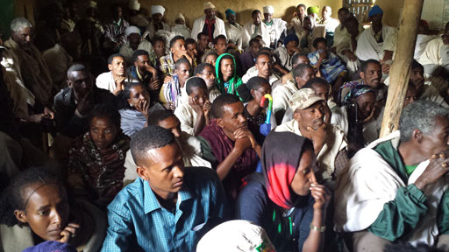
Figure 11.1 Community mobilisation meeting.
Effective community mobilisation requires consensus among key stakeholders, including community organisations and leaders. It should aim to involve all the community including religious groups, opinion leaders, schools, and marginalised groups.
The objectives of community mobilisation (adapted from WHO, 2006) are to:
- alert the community to their needs and rights
- encourage the community to be proactive, rather than passive
- develop awareness of the importance of sustainability of WASH facilities
- build the capacity of the community to take on decision making and self-management roles
- identify all the needs of the community and explore the resources available in the locality
- strengthen community participation.
In Study Session 9, you learned about ways of influencing behaviour. The urban setting has its own challenges and opportunities for community mobilisation and behaviour change. For example, understanding the roles and relationships among business, government and civil society stakeholders in a community is important for any mobilisation effort but could be even more complex in big urban communities because there are so many more stakeholder groups than in a rural setting.

11.2 Benefits of community mobilisation
Communities have an extensive wealth of local knowledge and wisdom. WASH practitioners should make use of this wider community experience and insight when implementing specific WASH initiatives, together with their own knowledge and understanding of procedures. Working together can help to identify what works for the community and what does not, and why.
Analysis of urban WASH problems and addressing critical gaps can only be achieved by building on the community’s knowledge and beliefs through a continuous dialogue and not by dictating to them what they should do. Participatory engagement is crucial.
Through community involvement, ordinary urban residents and professionals study WASH problems, pool their knowledge and experience and develop ways of solving their WASH problems. Community mobilisation helps leverage the resources available for specific WASH interventions, promotes self-help and self-reliance and improves trust and partnership between WASH practitioners and the community. As an urban WASH practitioner your role is to help the community organise themselves and contribute to the success of urban WASH interventions.
Community mobilisation can bring the following benefits (adapted from Mercy Corps, n.d., Florida DoH, n.d.). For example, it:
- allows people to make their own decisions about things that affect them
- expands inclusion of often marginalised groups, such as women, youth, people with disabilities, the elderly, and religious or ethnic minorities
- makes use of local resources, both human and material
- ensures local ownership of the issues and enables communities to create local solutions to local problems, which improves sustainability.
There can also be other longer-term benefits. For example, communities can reduce their dependence on outside aid because they develop the ability to identify and solve their own problems. They can also be better prepared for responding to disasters and emergencies because they have experience in quickly identifying their needs and priorities, and have established relationships with decision makers.
Now read Case Study 11.1 and answer the questions that follow.

Case Study 11.1 Gelila and the disastrous communal latrine-building project
Gelila has been working for nearly five years as a WASH practitioner in a small town called Rama. The town has a poorly managed latrine, which is badly maintained and hardly used because of its unpleasant smell. Gelila has built an excellent communication with a donor agency working in the region and managed to secure resources to build five new public latrines in the town. Gelila identified five sites and facilitated the processes of hiring a contractor through her office and the construction work started. She announced this good news to the residents of the town during the bi-annual community meeting. Proudly, she announced the availability of enough money for the intended task. However, some weeks later, during the construction of the latrines, disaster struck. Some of the construction materials, including steel bars and corrugated iron sheets, were stolen. Then, as construction continued, more materials were damaged.
- Who in the local community could possibly have opposed the decisions about the identified latrine sites?
- Some of the households that are closer to the latrine sites could have opposed the decision, especially if they are concerned that poor management of the latrine might lead to an offensive smell.
- What could be the source of their mistrust?
- The major mistrust among the Rama town residents and particularly the closer households could be the result of two things. Firstly, the community were not involved in the planning and operation phases (Gelila did not follow a participatory planning approach). Secondly, Gelila did not take into account the negative experience of the community over the management of the existing public latrines, when deciding on sites for the new latrine.
- What do you think Gelila should do in order to win community interest and support?
- Gelila should better understand the local context, particularly the previous experience, beliefs and values of the community and should engage the community in every step of the project cycle. She needs to build public trust and engage community members in selecting appropriate sites and designing sustainable management approaches.
Note that well managed communal latrines are quite rare. Where they have been successful, such as in the Piazza area of Addis Ababa, their relative success can be attributed largely to the management system adopted through engaging youth groups or women’s groups based on an income generation approach. An understanding of the local context and ability of the user community to pay for the services have contributed to the sustainability of its operation.

11.3 Strategies for community mobilisation
Much research has been done on good practice in community mobilisation and the evidence for effective strategies tends to come from these studies and experiences. They show that community mobilisation can change attitudes, norms, practices and individual behaviours (Pact Tanzania, 2006). Figure 11.2 shows a community mobilisation process in which a demonstration of effective handwashing practice is taking place.
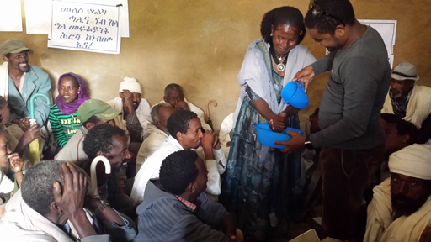
Figure 11.2 Community demonstration of critical moments of handwashing.
Community mobilisation is not a task for one person working on their own. It needs a team of people each with different roles who work collaboratively with the community. The team needs to include technical support staff and people with skills in project management as well as the key facilitators who have the main role of liaising with the community.
Developing a strategy for community mobilisation to address a particular problem requires:
- knowing your community and understanding the local situation
- identifying the purpose for mobilising the community – this requires understanding of the community’s goals
- assessing the issues and identifying possible projects – this needs skills to assess the problems and align them to the purpose of the community mobilisation
- obtaining wide community support – it is essential to build good relationships with individuals and groups within the community; it is very important that the facilitator has excellent communication skills
- prioritising projects and developing implementation plans
- pooling of available resources, including labour
- gathering and reflecting on feedback from the community
- refining and improving activities, based on the findings and feedback from the community.
The key steps of knowing your community and prioritising projects are described in more detail in the following sections.

11.3.1 Knowing your community
To mobilise your local community effectively, you need know about its social organisation, economy, problems and politics. This information can be obtained from many sources, both formal and informal, and might include (Pact Tanzania, 2006):
- political and administrative structure
- demographic features and population characteristics (e.g. number of people in different age groups, gender balance)
- economic activities (e.g. employment, market days)
- social stratification and economic status of households
- organisations, their functions and activities
- leadership pattern and its influence
- languages and cultural traditions
- health, sanitation and nutrition levels
- education levels.
Through stakeholder mapping (as described Study Session 4) you will begin to understand the nature of your community as a social system. Think about how the different elements of the community such as the children, women, youth and local organisations are connected to each other. You will soon realise that a community is not merely a collection of individuals but a system that involves a lot of intricate links and relationships between those individuals. People enter and leave the community, by birth, death and migration, so it is constantly changing and yet it continues to exist.
Getting to know your community is not something that can be achieved quickly. You will need time to develop relationships with the community members. For successful community mobilisation you need to know what will motivate people to become involved and this requires understanding of their interests and concerns.
Stakeholder mapping will also help to identify the key stakeholders in WASH and especially those who are the existing leaders within the community. Working with existing leaders is much more likely to be successful because other community members will be influenced by them and follow their lead (Mercy Corps, 2013).

11.3.2 Prioritisation of projects
Part of the process when trying to mobilise a community is to work with them to identify and prioritise possible projects, as shown in Figure 11.3. There are several approaches for project prioritisation.
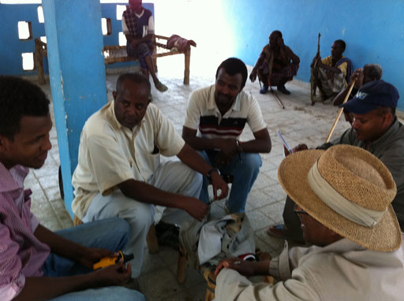
Figure 11.3 Prioritisation meeting at Kori, Afar.
Some Ethiopian towns already have Water and Sanitation Master Plans that have been prepared through a consultative process with the local population. If such a plan exists, this is a good place to start because this will have identified the most important water and sanitation problems for the town. If not, your WASH project prioritisation procedure might follow these steps:
- Organise a meeting with community representatives and try to build consensus on priorities. This is most likely to be feasible in smaller urban communities.
- Facilitate the formation of community action groups (CAGs). These are small groups tasked with managing individual projects and should involve those best placed to help with project implementation.
- Ensure discussions include the pros and cons of various options, based on criteria that have been agreed by the community.
- If community members realise that more information is needed to make a decision, the CAG can agree on how to collect the required information and arrange another meeting for further reviewing priorities before project selection.
- Keep the larger community informed about the schedule, process and actions taken by the CAG, using appropriate communication channels such as community notice boards or local radio announcements.
- Organise a community vote or some alternative way to obtain acknowledged agreement, so that you ensure the project is acceptable to the community.

11.4 Involving local groups
As noted above, community mobilisation means involving all members of a community if possible but there are some groups that can have particularly significant roles.

11.4.1 Role of schools
You learned in Study Session 6 about the importance of engaging school children in WASH initiatives. In school, children gain knowledge that can influence and stimulate their attitude and practice, help them to develop their life skills and play an important role in influencing their families and the wider community. However, the existing water supply and sanitation conditions of many of the schools in urban and peri-urban parts of Ethiopia are alarmingly inadequate and unsafe. Most of the school latrines are filthy, and their poor condition is contributing to a high level of disease, creating a poor learning environment. The lack of adequate facilities is a particular problem for girls’ education, as you read in Case Study 10.2 on menstrual hygiene. It is important for the community to be involved in planning WASH facilities, especially in schools (Figure 11.4).
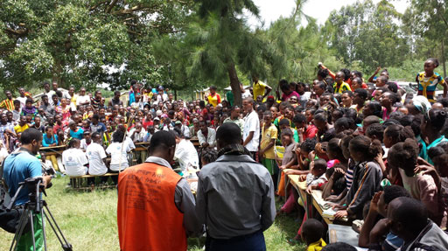
Figure 11.4 Community involvement in planning school WASH facilities.
School children who are loved and trusted by their families and communities may be effective agents of change in their localities, particularly in the use and management of water supply and sanitation facilities, if they are guided appropriately in school. School teachers and school WASH clubs can therefore play a crucial role in promoting better hygiene practices among school children and better management of WASH facilities. This has a great impact not only in influencing the delivery of quality education, but also as a strategy for spreading the WASH technologies and the changes required by the community, and hence contributing towards a positive social change in their localities.
As a WASH practitioner you are expected to understand the advantages of working closely with school WASH clubs and bringing about a change in hygiene behaviour focused on school children, who are the future of the country.
Effective sanitation and hygiene education in a school should include:
- A healthy physical environment:
- Keep the school compound and classrooms clean and free of waste of all types.
- Latrines that are appropriately designed for children (boys and girls).
- Convenient handwashing facilities.
- Safe drinking water.
- Active and organised children:
- Careful use of facilities by all children and also by teachers.
- Consistent and organised cleaning and maintenance of latrines and also of handwashing and drinking water facilities with active participation of the students.
- Roles for older children to help supervise and monitor younger children when using facilities and maintaining school cleanliness.
- Trained and committed school personnel:
- Appropriately trained head teacher and other key teachers.
- Relevant child-centred learning environment.
- Organised plans for children to help with use, monitoring and maintenance of facilities and learn good personal hygiene, e.g. through school WASH clubs.
- Links to home and community:
- Ensure that key health and hygiene information and behaviours flow back to the home.
- Organise WASH outreach activities in the community and carry out extension activities such as dramas, poetry recitals and demonstrations (see Figure 11.5).
- Encourage families and the community to provide finance and other support for maintenance and repair of school facilities.
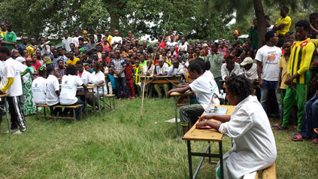
Figure 11.5 A school WASH club drama, being performed to family and friends.

11.4.2 Role of other key groups
Religious leaders, youth and women’s groups can play an important role in mobilising local communities and promoting urban WASH initiatives. These groups may use community mobilisation channels such as public meetings, social gatherings, festivals, cultural shows, exhibitions, visits, posters, pamphlets and notice boards. As a result they can make a huge contribution towards the improvement of community awareness and participation. They can therefore help to improve awareness of the WASH sector and of local sanitation and environmental health issues and appropriate WASH technologies.
The training and capacity building of target groups and community workers can enhance the community engagement opportunities, which will have an impact on service delivery and development of local partnerships. Therefore, as strategic social targets, women’s and youth groups should be encouraged to get mobilised and organised, to play their role in supporting and facilitating the implementation of urban WASH facilities. As you learned in Study Session 6, raising awareness of social groups and community workers is essential for engaging all of the community and initiating change in society.

11.5 Challenges of community mobilisation
There are many potential benefits from community mobilisation but it also presents several challenges. It is a complex, long-term process that requires considerable resources. For the long-term benefits to be realised, the process needs trained and effective leaders, organisers and facilitators with the necessary skills and it needs continuing support over a period of time. For these reasons it can be expensive. There are also challenges linked to the nature of urban communities. In particular there will be challenges associated with extreme poverty, informal settlements and slum areas, migration, governance issues and also disaster and emergency conditions. There may be huge variation in culture and habits, as well as in attitudes and awareness and language issues. You need to be able to adopt systematic community mobilisation strategies that are appropriate to the reality on the ground.
Urban WASH interventions always need to consider community interest. You should be especially alert to any factors likely to subvert collaborative efforts. Specific goals and objectives should be established that attempt to tackle the prioritised problem. They should be based on a general strategy of community mobilisation, consensus and cooperation, for the service delivery and long-term benefit of the community as a whole.
Now look again at Case Study 11.1 and answer the following questions:
- Identify which key steps Gelila omitted in planning the latrine project?
- Before embarking on the construction of the latrines, Gelila did not engage the community through regular communication and information sharing. She did not help the community to prepare for the new facility, they were not involved in the organisation of the project.
- What other opportunities did she lose by not engaging the community at earlier stages?
- She lost the opportunity of winning the interest of the community, which affected the sustainability of the project. She didn’t try to generate resources and ideas from the community that could help them to feel more empowered and might have enabled her to achieve better results and maximise the impact of the project.
The sustainability of water, sanitation and hygiene improvements has continued to challenge the Ethiopian government and those involved in development projects. Due to their social, cultural, economic and educational diversities, urban communities are more complex than rural communities. The sustainability of urban WASH can be more challenging in urban communities and this is partly because of the difficulties involved in mobilising urban communities.
Where the internal sustainability of urban WASH projects had been successful and challenges in mobilising local communities overcome, these successes have generally been attributed to:
- high quality leadership in the community
- good social cohesion and gender equality
- good management capability, skills and education
- sense of community ownership and legal ownership, which brings commitment from the community and willingness to pay for capital costs
- existence of an effective management system for financing operation and maintenance, including collecting and managing funds for recurrent costs – this encourages the community to raise money for major rehabilitation or replacement
- appropriate service level and technology of water supply systems, latrines and related WASH facilities
- introducing appropriate WASH facility management systems, appropriate to the local income levels, knowledge and culture.

Summary of Study Session 11
In Study Session 11, you have learned that:
- Community mobilisation is a process to encourage members of a community to act together to achieve desired community goals.
- The greatest benefits of community mobilisation are to build community capacity and to help the community identify and address its own needs. Other benefits are that all community groups are included and it encourages use of local resources. All these factors lead to improved sustainability.
- Developing a strategy for community mobilisation requires several steps. Knowing your community and understanding their needs and situation is essential.
- Working with community action groups can be helpful for prioritising and implementing specific projects.
- School children and WASH clubs and other community groups such as religious groups, youth associations and women’s groups all play an important role.
- Community mobilisation can be a challenging process because it requires time and can be costly. It requires good leadership and organisation as well as people with skills in facilitation and project management.

Self-Assessment Questions (SAQs) for Study Session 11
Now that you have completed this study session, you can assess how well you have achieved its Learning Outcomes by answering these questions. You can check your answers with the Notes on the Self-Assessment Questions at the end of this Module.

SAQ 11.1 (tests Learning Outcome 11.1)
What do you understand by community mobilisation? Describe briefly how it can be achieved.

SAQ 11.2 (tests Learning Outcome 11.2)
Name four reasons why community mobilisation can be beneficial when implementing specific WASH initiatives.

SAQ 11.3 (tests Learning Outcome 11.3)
Explain why knowing your community is essential for effective community mobilisation.

SAQ 11.4 (tests Learning Outcomes 11.3 and 11.4)
Briefly describe how the following can contribute to a community mobilisation process.
- schools and WASH clubs
- community action groups.

SAQ 11.5 (tests Learning Outcome 11.5)
Imagine you are trying to improve the condition of a communal latrine in an urban locality. What challenges might you expect?

Study Session 12 Advocacy and Networks

Introduction
Advocacy is an important part of your work as an urban WASH worker. This session will provide you with an overview of advocacy – its goals, objectives and practices, as well as its advantages and challenges, all of which should help you use advocacy to improve the status of WASH provision for the people in your community.

Learning Outcomes for Study Session 12
When you have studied this session, you should be able to:
12.1 Define and use correctly all of the key words printed in bold. (SAQs 12.1 and 12.2)
12.2 Identify the goals and objectives of advocacy. (SAQ 12.2)
12.3 Explain the role of networks in urban WASH advocacy. (SAQ 12.3)
12.4 Describe the advantages and challenges of working with networks for advocacy in an urban WASH context. (SAQs 12.3 and 12.4)

12.1 What is WASH advocacy?
Advocacy was introduced in Study Session 9 as one of the main approaches to influencing behaviour. It means making a case in support of a particular cause or activity and trying to convince other people, usually decision makers, that it is a good idea. Advocacy is a process to influence decisions within political, economic and social systems and institutions. In an urban WASH context, advocacy may include many activities that you and your organisation undertake including engaging opinion leaders, addressing community meetings, media campaigns and public speaking.
In general, advocacy approaches are either directed towards policies or towards programmes. Policy advocacy involves attempts to explain to senior politicians and administrators the impact of an issue at the national level and the need for changes to laws and policies (WHO, 2008). In a WASH context, an example is a media campaign to advocate a decrease in the tax imposed on soap to help improve use of soap. Programme advocacy takes place at a more local level. It involves attempts to explain to local leaders the need for action at local community level. In an urban WASH context this might include the mobilising of community leaders to promote the practice of handwashing or mobilising religious leaders to interpret and explain faith-based texts which refer to the importance of personal hygiene.
Advocacy for improving urban WASH services involves organising public opinion and participation to make changes in policy and practice as well as influencing policy makers and implementers to consider community interests. It can involve a range of strategies and activities that are intended to draw attention to an issue. Various materials and media can be used to communicate WASH information, not only posters and pamphlets but other options such as spoken messages or T-shirts, as shown in Figure 12.1.
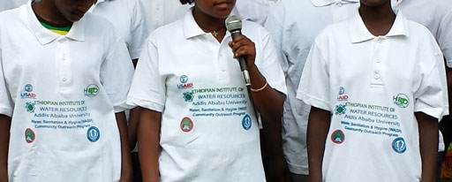
Figure 12.1 These T-shirts have been printed with information about a community outreach programme.
Advocacy should be strategic and use well-designed and organised activities to influence policy or decision makers about the important issues that you think will affect the water supply, sanitation and hygiene of your community. For instance urban WASH policy, legislation and regulations may be in place but might not be applied. As a WASH practitioner you could identify these gaps and advocate the use of existing structures and mechanisms to try to close them.

12.2 Goals and objectives of WASH advocacy
The goals and objectives of WASH advocacy are to facilitate change and the development of policies to tackle unmet water supply, sanitation and hygiene needs or deal with emerging WASH service requirements in your community.
An advocacy goal is the desired result of any advocacy activity. It generally relates to a long-term result, which may take several years of advocacy work to achieve.
An advocacy goal:
- is a broad statement of what you are trying to do
- refers to the benefit that will be felt by those affected by an issue
- is long term and gives direction – it helps you know where you are going. It needs an accompanying route map or strategy to show you how to get there
- links to the mission and vision of your organisation or employer.
Without a goal, you may lose sight of what you are trying to do. Moreover it is vital to develop a goal that applies to the specific situation that needs to change.
Examples of urban WASH advocacy goals could include:
- significant improvement in coverage of clean water supply
- significant improvements in access to and use of household and community latrines
- reduction of child sickness in the community.
An advocacy objective is more specific than a goal. Objectives are the intended desired impacts of an advocacy activity such as the specific change that you want to see in improving urban WASH services. It often refers to the desired changes in policy and practice that will be necessary to help you and your community meet your goal.
When formulating a plan for an advocacy project, you should ensure your objectives meet the SMART criteria (Box 12.1). You also need to link these objectives to the resources available in order to be able to achieve them.

Box 12.1 SMART objectives
‘SMART’ is a way of reminding you that your objectives should be:
S: Specific – a specific objective that is clearly defined.
M: Measurable – your objective should be measurable.
A: Achievable – the objective should be attainable.
R: Realistic – which also means credible.
T: Time-bound – should be achieved within a certain time.

As a WASH practitioner you may need to influence community and political leaders in your locality. You may have multiple WASH issues in mind for improving the WASH situation, including policies, laws, regulations and programmes or funding from the public and private WASH sectors.
For example, despite their general understanding about their environmental and health impacts, some households still practise open defecation and irresponsible disposal of solid and liquid waste, which negatively influences their neighbourhoods. If the municipal and local governments are convinced of the negative influences, they may be prepared to introduce new bylaws, as well as implementing effective enforcement strategies that prohibit such practices. These could be your advocacy objectives. Such an advocacy initiative will contribute to the goal of improving environmental safety and health.
In order to develop an effective advocacy strategy that has a clear goal and objectives, you should understand the WASH situation and what needs to change. To prepare an advocacy strategy you will need knowledge of the local context because it is important to have and be able to provide evidence that supports your case. You will also need a good understanding of the key stakeholders and their roles, influence and importance (see Study Session 4).

12.3 Tools and methods for advocacy
How do you get support in the form of political will, funds and other resources from your leaders to facilitate WASH initiatives in your locality? There are a number of different methods that might be appropriate in different circumstances (Coulby, n.d.).
There will almost certainly be meetings involved in any advocacy campaign both with community members and with the people you are trying to influence. Organising meetings with decision makers so that you can brief them about a situation may be an effective way of raising awareness and presenting your case. Gathering all stakeholders together to discuss and coordinate activities will also be necessary.
Lobbying is a form of advocacy where a direct approach is made to legislators or other public officials about an issue. The term originates from the practice of waiting in the lobbies and corridors of government buildings in order to speak to politicians and lawmakers (Coulby, 2008). Nowadays, lobbying has a broader meaning and includes any direct attempt to influence policy, usually at national level.
Advocacy campaigns can make use of many of the communication tools we have discussed in previous study sessions including leaflets and posters that highlight the issue of concern. Messages through newspapers, radio and television programmes (also known as media advocacy) can be valuable if these facilities are available. Using entertainment such as drama and music is also a useful tool.
Being good at public speaking is an important skill for people involved in advocacy campaigns, especially those in leadership roles. It is important to be able to speak confidently and clearly if you are addressing large gatherings of people. Effective communication is also essential in smaller meetings with decision makers. They are likely to be busy people so you will need to get your message across to them quickly and clearly.
Now read Case Study 12.1 and answer the questions that follow.

Case Study 12.1, Part 1 Abebe and the dirty latrine
Abebe is an urban WASH worker in a small town in Amhara Region. Although there is a latrine in the market in his town, it is smelly and unpleasant and very few people use it. Moreover, although there is a bucket of water there, the bucket is dirty and the water is old and stagnant, so nobody uses it for handwashing. Many people avoid using these facilities altogether and a wooded area behind the market is often used for open defecation instead. Abebe has identified this as a major issue and realises that in the short term what is required is to clean up the existing facilities. In the medium term, it needs someone to clean the facilities, fill the bucket with fresh water and provide soap on a regular basis.
- Identify two advocacy activities that Abebe could undertake to improve WASH service delivery.
- There are many possible answers. You may have thought of two of the following:
- Raise awareness of the issue by arranging to meet local leaders.
- Arrange a meeting with the community to explore possible solutions.
- Engage opinion leaders.
- Initiate media campaigns.
- Speak at public meetings.
- What would Abebe’s role be as an urban WASH practitioner in these advocacy activities?
- Abebe could lead the advocacy effort or work with others as part of a team. His role would be to raise awareness of the issue to local leaders and to be a facilitator at the community meeting (Figure 12.2). He could try to identify individuals willing to clean the facility and refresh supplies of water and soap on a regular basis. He could also find out if money was available to pay them to do so and explore how much people might be prepared to pay to use the clean facility.
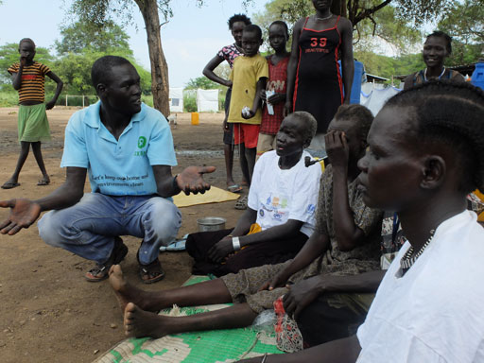
Figure 12.2 A WASH practitioner speaking to members of the community about sanitation issues.

12.4 Networks for WASH advocacy
In common with many of the activities involved in trying to change people’s behaviour, advocacy is something that is very difficult to do on your own. Working in partnerships, alliances and coalitions with others will bring much better results. These collaborative organisations are all forms of network. A network is a collaborative body involving many participants from many organisations that (Coulby and Barcelo, n.d.):
- form around an issue or a general set of values
- have an explicit purpose
- communicate and interact towards achieving this purpose
- have a distinct, non-managerial, non-hierarchical form
- are facilitated by a designated person or body (chairperson, coordinator, secretariat, steering group, etc.).
Networks can connect people from a wide range of backgrounds with different expertise and experience. In the urban WASH sector, this may include practitioners as well as researchers serving in government offices, academic and research institutions, NGOs and community-based organisations (CBOs) and other civil groups working on urban WASH related issues. Multi-stakeholder groups that bring together people from different disciplines and sectors will be stronger and more effective because they can share experiences and learn from each other.
Networks can exist at many levels from international and national levels down to localised groups who collaborate over a particular issue of importance to them. Effective urban WASH practitioners should engage in networks to improve sustainable service provision in their locality.
For any advocacy activity, working within a network of collaborators can share the tasks and bring added benefits such as (Coulby and Barcelo, n.d.):
- convening meetings and encouraging dialogue between network members and with other stakeholders
- developing and strengthening common messages and shared values
- building solidarity among network members
- conducting research and gathering data
- facilitating learning, building knowledge and sharing of information
- raising or distributing funding for the network and its members or supervising the spending of funding.

Case Study 12.1, Part 2 Improvements to the dirty latrine
Two years later, Abebe had implemented some successful advocacy work around the town. He persuaded the community to pay a small tariff every time they used the latrine and he secured some finance from a local NGO. He identified some members of the local youth community to provide regular fresh water (Figure 12.3) and soap. With the support of the local town administration officials, he facilitated the implementation of special service payment systems and opened a new employment opportunity to these youths. In collaboration with the NGO staff, he also outlined management and sustainability plans to ensure the improvements would continue into the future.
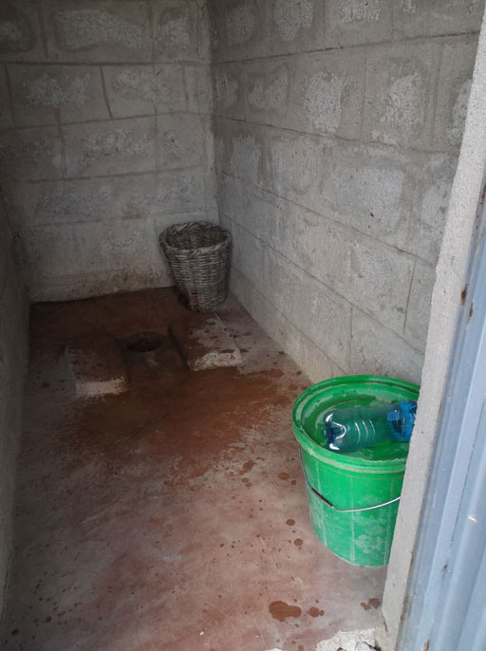
Figure 12.3 Public latrine with bucket of clean water.
- Explain how involvement of a local network had helped Abebe’s attempts to improve the latrine facilities.
- Abebe convened meetings with youth groups, NGOs and the user community. This was built on his knowledge of the local area and of the health risks. He organised community meetings to share information, like the one shown in Figure 12.4, to ensure the community were informed about the health risks of open defecation and the importance of having a clean latrine facility which people would actually use. In this way, he facilitated the developing of shared values by emphasising the importance of reducing the amount of open defecation in the town. Working with the local administration, he raised money from users to pay for soap and arranged for someone to clean the latrine on a regular basis and ensure that there is fresh water in the bucket every day. Working with the NGO he developed plans to ensure the latrine was managed sustainably.
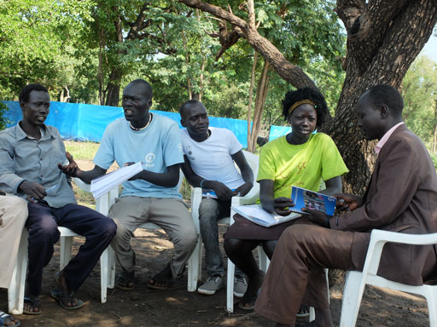
Figure 12.4 A meeting, organised to share information.
Joining or creating manageable and meaningful networks is important to facilitate advocacy initiatives and take up local governance agendas relating to WASH. However, having too many networks can cause problems rather than solving them. As a WASH practitioner you could consider forming a new network if there is not one already or if you find it difficult to address pressing issues using an existing one. Try to include people and groups that capture the gender, age, disciplinary and sectoral diversity of the urban population in your locality. Before forming a new WASH network you should see if any successful networks already exist and learn from their experience.

12.5 Advantages and challenges
Being part of a network brings benefits to you as in individual. As a practitioner and member of a network you can represent your organisation and feel shared ownership of the network, its ideas and its advocacy. You can keep your own organisation up-to-date with new ideas and activities. Active involvement in successful urban WASH networks can bring you closer to colleagues and facilitate sharing of challenging, exciting and successful activities.

12.5.1 Advantages of networks for advocacy
There are also wider advantages that are the reasons why networks are important for effective advocacy. Coulby and Barcelo (n.d.) identify the main advantages as follows.
If groups with different experiences and perspectives work together, this enables participants to learn from each other. Building skills and knowledge together can lead to strong mutual support and solidarity.
A network helps avoid duplication of effort. Responsibilities and tasks can be shared according to the expertise and capacity of members and such sharing helps key stakeholders (e.g. donors, policy-makers and media representatives) to get to know each other better. Exposure to others in the network can lead to new opportunities for visits and training and lead to increased capacity building. Gaining valuable experience in cooperation and compromise and negotiation with members of a network can be very useful when negotiating with government agencies and service providers.
A network can enable more rounded policy proposals, based on experiences from many localities, different perspectives and critical discussions between members, to be produced. A strong, united voice reduces the risk of contradictory and mixed messages being sent to decision-makers. It also reduces the risk of any one individual being punished for speaking out.
If institutions such as NGOs and/or community-based organisations (CBOs) participate in sector discussions, there is likely to be more success in changing government policies and practices. It is also likely to result in respect and credibility from the WASH sector and potential donors. Ultimately, the benefit will be a bigger success in changing government policies and practices and increasing access to WASH services for poor communities.
- List four benefits that come from collaborating in a network.
- You may have picked any four of the benefits mentioned above but the most important ones are probably:
- working with groups that have different experiences and perspectives enables participants to learn from each other
- increased skills and knowledge builds mutual support and solidarity
- avoids duplication of effort
- responsibilities and tasks can be shared according to the expertise and capacity of its members
- helps key stakeholders (e.g. donors, policy-makers and media representatives) get to know each other better
- increases capacity building as participants gain valuable experience of working cooperatively.

12.5.2 Challenges of networks for advocacy
Supporting local and national networks to influence those who create policies, laws, regulations and budgets may present significant challenges. Belonging to a network can take up a lot of time and many of the activities involved are complex and difficult to achieve. These challenging activities could include:
- training communities (Figure 12.5), community leaders, other network members and local water boards and associations on their rights and responsibilities regarding urban WASH laws, budgets and policies
- educating national and local political leaders on urban WASH
- strengthening policy dialogues between communities, civil society groups and decision makers
- urging increased funding for government-funded urban WASH programmes
- supporting high-quality urban WASH messaging in local news media etc. may require more time and resources.
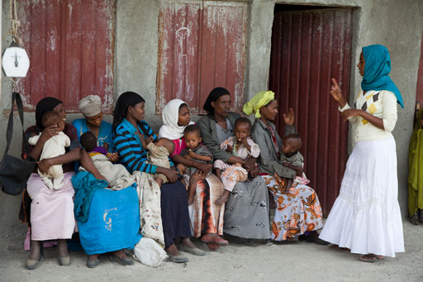
Figure 12.5 Training and counselling mothers on keeping their children healthy near Shashemene, Oromia Region.
All of these advocacy initiatives are likely to require considerable time and resources, but influencing decision makers and strengthening their political will is essential for making any large-scale change.
- Try to identify an important advocacy initiative in your local context. In relation to this advocacy initiative:
What activities would you put in your advocacy plan to ensure urban WASH services are better promoted and resourced in your locality or organisation? For each activity, consider who should undertake it, how it should be undertaken, what resources will be required and what your role will be.
- You will have your own answer but you may have mentioned activities such as convening meetings, public speaking, messages through local media, and consultations with the user community. You might also have mentioned developing a local network. This might involve the municipal government, youth groups (Figure 12.6), and women’s groups, non-governmental agencies and local traders.
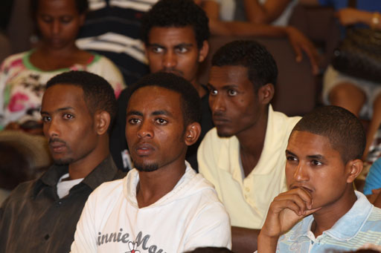
Figure 12.6 Students involved in debating an issue.
Whatever the advocacy initiative you are considering, networking would facilitate inter-sectoral communications between all those involved. This is important for the participation processes and will always be likely to lead to more effective planning and implementation.

Summary of Study Session 12
In Study Session 12, you have learned that:
- Advocacy is speaking up and drawing policy makers and the community’s attention to an important urban WASH issue.
- Advocacy involves working with other people and stakeholders to improve the status of urban WASH services of the community.
- Planning an effective advocacy initiative demands an enhanced understanding of the local context, specifically on who the critical stakeholders are and their influence and importance.
- Without a clear, articulated issue and well-defined goals and objectives, the remaining steps of an advocacy campaign will lose focus.
- A network is a collaborative body formed around an issue or a general set of values that involve participants from many organisations.
- A network is important to facilitate advocacy initiatives and take up the local governance agendas relevant to WASH issues.

Self-Assessment Questions for Study Session 12
Now that you have completed this study session, you can assess how well you have achieved its Learning Outcomes by answering these questions. You can check your answers with the Notes on the Self-Assessment Questions at the end of this Module.

SAQ 12.1 (tests Learning Outcomes 12.1)
How would you explain what advocacy means to a colleague who is not a WASH worker? Explain the difference between policy advocacy and programme advocacy.

SAQ 12.2 (tests Learning Outcomes 12.1 and 12.2)
‘The intended impact of the work you are doing or the specific change that you want to see in improving urban WASH services.’
Is this a description of an advocacy goal or an advocacy objective?

SAQ 12.3 (tests Learning Outcomes 12.3 and 12.4)
Give three reasons why networks can be more effective for advocacy than an individual working on their own.

SAQ 12.4 (tests Learning Outcome 12.4)
Outline two particular challenges involved in urban WASH advocacy.

Study Session 13 Sustainability of WASH Services

Introduction
You have already learned that WASH situations in urban communities change over time for reasons such as continued urbanisation, population growth and changing lifestyles. You have also seen that stakeholders seek to improve the WASH situation through planning and implementing interventions and hence contribute to improvements in health and wellbeing.
There is one single key concept that all WASH stakeholders should aim to embed in their activities. That is, to ensure that their activities will always result in long term benefits to the environment and communities living in it. This study session will introduce to you what this sustainability means in practical terms.

Learning Outcomes for Study Session 13
When you have studied this session, you should be able to:
13.1 Define and use correctly each of the key words printed in bold. (SAQ 13.1)
13.2 Explain what is meant by sustainability. (SAQ 13.1)
13.3 Explain the key factors contributing to sustainable WASH service delivery in different stages of a project. (SAQ 13.2)
13.4 Describe how access to facilities can positively or negatively influence community’s behaviour in safe hygiene and sanitation practices. (SAQ 13.3)
13.5 Demonstrate how governance can positively and negatively affect sustainability. (SAQ 13.4)

13.1 The concept of sustainability
You were introduced to the idea of sustainability in Study Session 10 where it was defined as the ability ‘to last or continue for a long time.’
As simple as it seems, the concept of sustainability is actually quite complex. Sustainability in a WASH context involves many different inputs and links between causes and effects. An intervention or activity in one area affects not only that community, but also the people living far away. For example, a town that uses a river as its water source may suffer if the water is contaminated by a community located upstream who have poor control of waste collection and disposal. What happens in one place can have an effect on another, even if it is a distance away.
Similarly, what happens at one point in time has an effect on the period that follows. How our forefathers fulfilled their energy needs has affected the environment we live in today. How we look after our water resources affects sources of water available for coming generations. When a community decides to end open defecation, they are improving their own health and also the future health of the whole community, including the children.
Sustainability of WASH in urban areas is further complicated by competing demands for resource. Water is a critical resource for communities, as it is for hospitals and schools, industries, businesses and agriculture. As competition and the demand for water increases, sustainability of sources becomes more difficult to guarantee. Ensuring sustainability requires substantial work towards improved care of resources and responsible use by all stakeholders.
Sustainability is a concept used to ensure that activities – regardless of the place or the time they happen – result in a long-term positive impact on the environment and its inhabitants, or at least do not have negative impacts. Urban communities are part of a larger national community, and are also part of the community of the world as whole. The concept of sustainability helps us to think locally, nationally and globally, when planning interventions.
- What do you understand by the word sustainability in the context of planning urban WASH activities?
- Sustainability means that the WASH activities would be planned with consideration for the long term benefits to the environment and communities living in it both now and in the future. By environment we mean the larger environment including nearby towns and villages. By communities, we mean everyone in them.

13.2 Sustainability of WASH facilities
In making WASH facilities sustainable, we mean that the concepts described above are taken into consideration to ensure that facilities function properly for long periods. WaterAid (2011) uses this definition:
Sustainability is about whether or not WASH services and good hygiene practices continue to work and deliver benefits over time. No time limit is set on those continued services, behaviour changes and outcomes. In other words, sustainability is about lasting benefits achieved through the continued enjoyment of water supply and sanitation services and hygiene practices.
For numerous reasons, urban areas do not always get adequate access to WASH facilities. Where facilities are not functioning properly, even for a short period, the lives of communities are immediately and severely affected. The hygiene and sanitation conditions of individuals or families can rapidly worsen if WASH facilities are poor, exposing them to significant health risks. Lack of nearby clean water means communities have to use water from further away, which may become contaminated during transport and handling. This increases the risk of exposure to waterborne diseases. Figure 13.1 shows the familiar sight of water being carried because no water supply is available in the home.
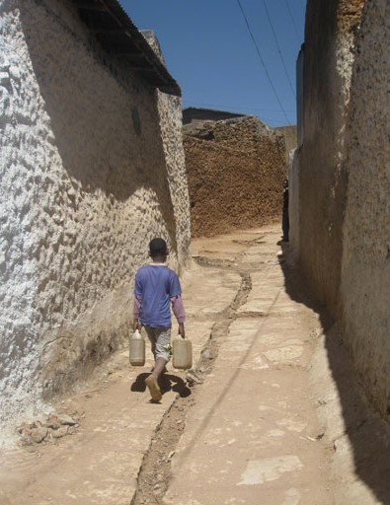
Figure 13.1 Carrying water home.
Sustainable facilities, i.e. facilities that operate continuously and fully for a long time, are required to safeguard the safety and health of urban communities. Thus building WASH facilities alone is not enough. It is equally important to embed strong measures to ensure their sustainable operation during the full project cycle.
The project cycle is the term used to describe the life of a project. It consists of three stages, the planning stage, the construction stage and the post-construction stage. It is common to think that sustainability of facilities is only a concern during the last stage of the project, when communities will actually be using the facilities – but this is not correct. It is impractical and illogical to expect facilities to last for a long time if measures are not taken during the planning and construction stages to ensure that they can. Table 13.1 summarises the key factors to be considered at each stage of a project cycle to ensure sustainability.
Table 13.1 Key factors affecting sustainability of WASH facilities during the project cycle.
Planning stage | Construction stage | Post-construction stage
Participatory planning: Users must participate in planning so their opinions, interests and needs are addressed. | Site selection: Location is crucial because it affects accessibility. Consultation is essential to find and agree on a suitable location. | Management: Ensuring proper management of WASH facilities is essential. This needs an effective management body, with adequate capacity building and sound financial management.
Socially inclusive planning: WASH facilities should be planned with all sectors of the community in mind, including the poor, elderly, disabled and children. | Construction management: Close supervision of quality of materials, timely progress of construction and completion in the proposed time and within budget. | Operation and Maintenance: Establishing a system for timely, efficient and cost-effective maintenance is essential so that breakdowns are prevented.
Technology choice: Technologies used in providing WASH facilities should be easy for the community to understand, use and maintain. | Functionality (review of designs): The design and engineering of the project must be appropriate and function correctly. | Good governance and social accountability: Continued support to the community and management body is required to ensure financial sustainability, build strong local capacity to replicate or expand the facilities and ensure that existing facility can be replaced when the service period ends.
- The sustainability of WASH facilities and services will be affected by how well the factors summarised in Table 13.1 are considered and acted upon. Summarise the key factors contributing to sustainable WASH service delivery in each of the three stages of the project cycle.
- The answers are as follows:
- During the planning stage: Participatory planning, socially inclusive designs and technology choice.
- During construction stage: Location (site selection), quality assurance (effective management during construction) and focus on functionality.
- During post-construction stage: Management, operation and maintenance and governance.
In the next sections we will examine three important dimensions of sustainability in urban WASH services to be considered at all three stages of project implementation – namely sustainable behaviour, financial sustainability, and good governance and social accountability.

13.3 Encouraging sustainable behaviour change
In Study Sessions 9 and 10, you learned about influencing behaviour in relation to improved sanitation and hygiene practices. Here we will consider how such behaviour change can be sustained.
The objective of any WASH promotion activity or intervention should be to ensure that achieved changes in behaviour are deeply rooted in the social and economic values of the community, rather than being temporary. In this way, behaviour change in communities resulting from promotion activities can potentially be sustainable.
To encourage sustainable behaviour change, interventions should be planned and implemented with sustainability in mind. Monitoring and follow-up mechanisms should be put in place to ensure that communities do not revert back to old practices. In Section 13.2, we mentioned factors that affect sustainability of WASH facilities in terms of planning, construction and post-construction stages. You can see in Table 13.2 that a similar concept applies to sustainability of WASH promotion and behaviour change interventions.
Table 13.2 Factors affecting sustainability of WASH promotion and behaviour change activities.
Planning stage | Implementation stage | Post-implementation stage
In-depth assessment of existing situation: Before planning a promotion activity, investigate the existing level of knowledge, attitudes and hygiene practices. | Participatory implementation: All key sectors of the communities should be involved, allowing for possible adjustments in approach and methodology to ensure even stronger sustainability. | Monitoring for impact: Once promotion activities are completed, monitor changes in behaviour and consider messages for subsequent interventions. Monitoring also provides the basis for reinforcement in communities and advocacy with local government.
Communication strategy (channels, materials, agents): Based on assessment, identify preferred communication channels. Develop communication materials to disseminate messages through preferred and high impact channels. | Focus on families, particularly mothers: Working with mothers and school children for behaviour change helps improve and sustain impact in community-wide behaviour change. | Repeating the cycle: There is usually more than one behaviour to try to change in communities. Repeat the process from planning stage, to work on additional behaviour that was not addressed in previous phase.
Participatory planning: As in facility construction, ensuring participation, involvement and commitment of all stakeholders is crucial. | Focus on one message at a time: Hygiene and sanitation promotion work should focus on one behaviour at a time, rather than on multiple messages, to maximise the chance that behaviour change is sustained. | Reinforcement: Organise events at suitable intervals to reinforce messages, e.g. sanitation campaigns, street role-plays by students.
One key consideration during the planning stage is the availability of adequate, well-functioning WASH facilities in the community. Promoting behaviour change in situations where there is no access to facilities is always challenging and rarely successful. Communities may agree to change their practice as a result of the communication work. However, if they do not have the means to actually practise the behaviour change, the work will be in vain.
You will remember from Study Session 8 that there is a wide range of determinants that will affect the behaviour of communities. The importance of WASH promotion is to bring about behaviour change in communities by creating adequate knowledge of safe hygiene behaviours and encouraging the necessary conditions for their full practice by all members of the community.
- Describe how access and condition of facilities can influence school children’s behaviour in safe hygiene practices (a) where facilities are good, as shown in Figure 13.2 and (b) where facilities are poor and dirty, as shown in Figure 13.3.
- The answers are as follows:
        - Where facilities are clean, accessible and functional school children can practise what they learned and make changes in their day-to-day behaviour. Access to well-maintained facilities positively influences their behaviour.
        - Where there is lack of access or facilities are not kept clean, school children will not be able to practise the learned behaviour – however good the promotion work. The result will be an increase in awareness, but not a practical change of behaviour. If there is no access to well-maintained facilities behaviour change in school children will be negative rather than positive.
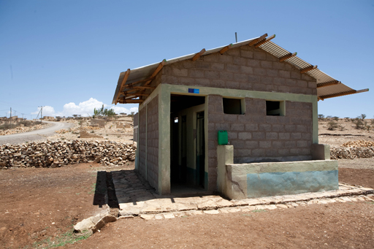 | 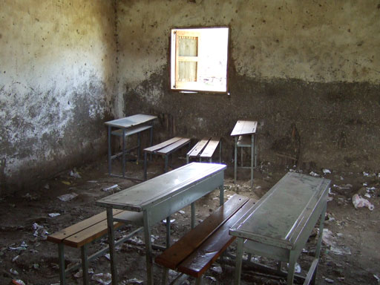
Figure 13.2 A new school latrine block with handwashing facilities. | Figure 13.3 A dirty school room.
You may find that even where hygiene promotion activities are undertaken and WASH facilities are adequate and functioning, communities are still not applying safe practices. This is a critical challenge encountered during behaviour change activities, underlining the need to remind communities continuously about safe practices until the desired behaviour becomes habit. Both the presence or absence of facilities and also the will to use them, can be critical factors to identify as opportunities for, or threats to, sustainable behaviour change.
- Look at Tables 13.1 and 13.2 and compare them. What similarities and differences can you identify?
- The tables are similar in that they both refer to factors affecting sustainability of WASH facilities at three distinct stages of a project cycle. They are different in that Table 13.1 summarises the facilities, whereas Table 13.2 summarises information relating to the user communities.
Improving facilities and influencing people’s behaviour are interventions that mutually reinforce the improvement of WASH situations in communities. They can be most effective when undertaken simultaneously.

13.4 Financial sustainability of WASH services
As you can see in Table 13.1, finance is a key determinant in the sustainable operation and utilisation of WASH facilities. All WASH facilities, once in operation, require proper care and management. If they are to provide long-term service and hence be sustainable, adequate finance is required.
Financial sustainability refers to the ability to generate adequate revenue from provision of services, in order to cover expenses and generate additional money for future needs. In simple terms, there must be more money coming in than there is going out.
The managing body of a facility should ensure people are nominated to looking after it over its service life. Some should look after the day-to-day operation and others provide maintenance when the need arises. These people need to be paid. Some maintenance activities require money for the purchase of spare parts. Some facilities require electricity and water, which need to be paid for each month. For some facilities it may also be necessary to recover all or part of the initial cost of construction. For example, urban water utilities are expected, by law, to fully recover their initial investment cost over the service life of the facility.
All these expenses must be covered if a facility is to provide continuous service to users. If maintenance technicians are not paid for their work, the facility will be poorly maintained. As a result the facility will provide only a reduced service or may fall into disrepair. If electricity and water bills are not paid, a public latrine will soon be without light and flushing water. In short, without the ability to cover costs and expenses WASH facilities cannot be sustained. Conversely, if adequate money is generated to cover expenses, the facility will be able to provide long-term and full capacity service because an appropriate level of care and maintenance can be provided.
WASH facilities are usually designed and operated in such a way that that they can generate income (revenue). The income is collected from users, who may be individuals in the community, companies and organisations. These users may pay for the services they get on a regular basis or per use. A group or company is established to manage the facility, its revenues and expenses. For example, a private company may take on a contractual agreement with a municipality to manage a public latrine. Urban water utilities oversee the management and operation of water supply and liquid waste disposal in towns and they have the right to collect money from users for the services their facilities provide.
- What do you think happens if financial sustainability is not achieved and maintained?
- Where revenues collected are not adequate to cover the running costs including salaries of employees and other miscellaneous expenses, the facility will reduce its service level and eventually stop functioning.
Financial sustainability should be considered at the planning stage and carefully implemented throughout the rest of the project cycle. An important part of financial sustainability is setting an appropriate tariff. The tariff is an amount of money that a user pays for a single unit of service. For instance, a utility may set a tariff of Birr 2.50 per cubic metre of water provided. A public shower operator may set a tariff of Birr 5.00 for a single use. Similarly, organised youth groups may set their own tariff to households that use waste collection and disposal services they have set up.
During the planning stage, different tariff rates for services should be compared with the estimated expenses to decide if the facility can be financially sustained. Tariffs should also be set to ensure than the poorest users will be able to afford the cost. Regrettably, the poorest people have not always benefitted to the same extent as the better off from WASH developments in either urban or rural settings in many countries.
During the construction and post-construction stages, costs should be kept to a minimum. If expenses rise, the tariff will have to be increased so that financial sustainability is maintained.
Urban communities, as users of these facilities, should be aware of this concept and willing to pay for services they are getting. Paying is the only way to guarantee that services will continue to be available. As you learned in Study Session 6 and in Study Session 11, community engagement and community mobilisation are used to ensure urban communities understand their role and contribution in sustaining WASH services.
Now read Case Study 13.1 and answer the question that follows.

Case Study 13.1 Emanuel public facility
Emanuel public facility is located in Akaki, a sub-city of Addis Ababa (Figure 13.4). The facility provides services of latrine, shower and cafeteria to the surrounding community. The facility has a biogas digester which uses the excreta collected in the latrines and most of the organic waste from the kitchen to produce biogas. The gas is used in the kitchen for cooking food using a stove similar to the one shown in Figure 13.5. The facility also uses electricity to supplement its energy needs. The main users are visitors to the nearby market.
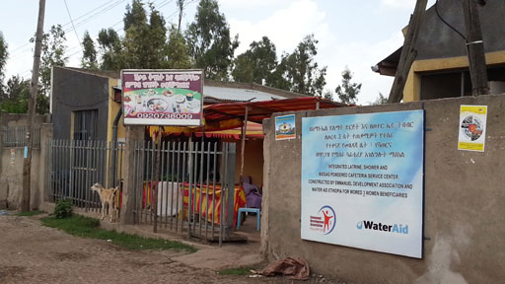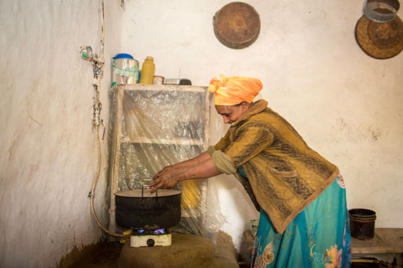
Figure 13.4 A public shower and latrine with Figure 13.5 This cooking stove is fuelled by
cafeteria – a financially sustainable WASH facility. biogas.
The facility is managed by a group of women who have received training and support on the sustainable use and management of the facility.
The chairwoman of the group reports that they have made an effort to ensure profitability by setting tariffs for users. They have ensured continuous investment in maintenance (e.g. timely desludging of slurry from the digester), reduced incidental costs by avoiding use of external labour and doing most of the work themselves, and minimised recurrent costs including their own salaries.
Today, two years after the start of their small business, the facility generates more revenue than expenses and has proved to be financially sustainable. As a result, the group has ventured further and have started up an additional small restaurant business in a different location.
- What additional factors would need to be taken into consideration to ensure continuous functionality of this facility in the long term?
- It would be sensible to set aside money to pay repair costs in the event of a major breakdown, for example if the digester develops a leak or other unforeseen problem..

13.5 Good governance and social accountability
WASH facilities and services are provided as a result of decisions made by those with leadership roles. These decisions include approval of plans, allocation of necessary resources for construction and enforcement of standards during construction and service periods. Such leaders also create and support management bodies for WASH facilities, establish tariff rates and manage revenues from WASH services. Decisions made by those who assume responsibility at different levels affect the sustainability of WASH services enormously.
As you learned in Study Session 1, governance refers to the interrelated parts of government systems through which decisions about services, in our case WASH services, are made and implemented. Governance can help improve WASH situations by providing resources and facilitating an appropriate environment for sustainable management. However governance can also negatively influence sustainability if poor decisions are made, or if there is a lack of transparency. If good decisions are made but poorly implemented or not explained clearly, this can also have a negative effect on the sustainability of WASH services.
You learned in Study Session 5 that social accountability refers to the requirement that leaders, decision makers and service providers have a responsibility to address the needs and priorities of service receivers, i.e. communities and users. The intensity of social accountability awareness in a town will be a major factor in determining the sustainability of WASH facilities and services. Strong social accountability ensures that resources are allocated to address the most pressing needs of a community and are utilised effectively for the intended purpose.
Good governance and social accountability go hand-in-hand. Good governance ensures the right decisions are made and are implemented as planned. Strong social accountability ensures that the decision making and implementation process is executed in a responsible manner.
Lack of good governance and/or absence of social accountability in local structures soon impacts on sustainability of WASH facilities and services. For instance, assume a decision is reached to raise the tariff for water consumption in a given service area of a water supply network. The community will naturally resist an increase in price. However, they may still be willing to pay the extra if they are confident that the management body came to a fair decision (good governance) and that all the revenue will be used to ensure a continuous supply of water in their taps (social accountability). However, if there is a history of resource abuse by the management body, the community will strongly resist an increase in charge and may refuse to pay at all. They will question the decision to raise the tariff, and they will object once the decision is implemented. The negative impact on sustainable service in such circumstances is clear.
The lack of equity in WASH service provision is one of the key challenges in urban areas. In this study session, you have learned about a number of reasons contributing to this, including both social and economic factors. The decision-making process also contributes to how information on equity is collected, analysed and used to reach appropriate decisions that serve the rights and meet the needs of under-served sectors of the population, particularly vulnerable groups, such as disabled people who are likely to find it particularly difficult to access WASH services, as shown in Figure 13.6.
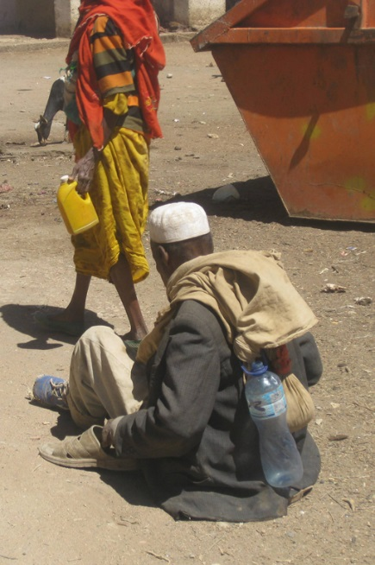
Figure 13.6 A disabled person with no mobility aids will find it extremely difficult to access WASH services even if they are available.
The level of accountability among the leaders, experts and stakeholders in implementing decisions ultimately determines the level of service that can be attained from the WASH facility and whether it will be sustained over long periods of time.

Summary of Study Session 13
In Study Session 13, you have learned that:
- Sustainability is a concept used to ensure that activities result in long term positive impact on the environment and those who live in it.
- Sustainable WASH facilities and systems can provide adequate services to communities for long periods, without negative impact on the environment.
- Factors which critically affect sustainability of WASH services from the planning stage, through construction to post-construction or operation stages, include participatory planning, social inclusion, technology choice, site selection, quality assurance, operation/maintenance, governance and social accountability.
- Proper utilisation of WASH facilities may require behaviour change communication to ensure that desirable hygiene and sanitation practices are effectively adopted by the community.
- Financial sustainability is a key aspect of sustainability and requires full community ownership from the beginning.
- Lack of good governance and social accountability has a negative impact on technical and financial sustainability of WASH facilities and makes it impossible to achieve equity of service.

Self-Assessment Questions (SAQs) for Study Session 13
Now that you have completed this study session, you can assess how well you have achieved its Learning Outcomes by answering these questions. You can check your answers with the Notes on the Self-Assessment Questions at the end of this Module.

SAQ 13.1 (tests Learning Outcomes 13.1 and 13.2)
Which of the following statements are false? In each case explain why it is incorrect.
- Sustainability ensures that activities result in lasting benefit to communities and their environment.
- Financial sustainability is achieved when expenditure on a project is greater than revenue.
- Sustainability is about benefits in one place at one particular time.
- Tariffs for water supply should be set at a level that will maximise the profits of the service provider.
- Consideration of sustainability should be included in all stages of a project cycle.

SAQ 13.2 (tests Learning Outcome 13.3)
The key stages of a project cycle are the planning stage, construction stage and post-construction stage. To which stage do the following factors contribute?
- Site selection.
- Construction management.
- Technology choice.
- Good governance and social accountability.
- Participatory planning.
- Operation and maintenance capacity.

SAQ 13.3 (tests Learning Outcome 13.4)
Consider the following two situations faced by two mothers, Qwara and Wagaye. In each case, explain how lack of access to facilities will influence her behaviour in safe hygiene and sanitation practices.
- Qwara is aware that contaminated water can be treated to make it safe to drink but she can’t find the treatment chemicals in her nearby shop.
- Wagaye knows that she should encourage her family to wash their hands with soap after using the latrine but her compound does not have a latrine and the nearby communal latrine does not have handwashing facilities.

SAQ 13.4 (tests Learning Outcome 13.5)
How could good governance and strong social accountability improve Wagaye’s situation, as outlined in SAQ 13.3?

Study Session 14 Emergency WASH Behaviour Communication

Introduction
Emergencies and disasters can occur anywhere and when they do, lack of clean water, poor sanitation and inadequate hygiene practices put people at risk of contracting communicable diseases. Availability of WASH infrastructures and promotion of proper hygiene practices are of paramount importance when disaster strikes. The aim of emergency WASH communication is to enable people in emergencies to take actions to prevent or mitigate water, sanitation and hygiene related diseases and to facilitate community participation to improve their situation.
This study session will focus on promoting improved WASH practices in the context of an emergency and in particular on hygiene behaviour.

Learning Outcomes for Study Session 14
When you have studied this session, you should be able to:
14.1 Define and use correctly all of the key words printed in bold. (SAQ 14.1)
14.2 Explain why WASH behaviour is important in an emergency situation. (SAQ 14.1)
14.3 Outline the key steps in WASH behaviour communication at different phases of an emergency. (SAQ 14.2)
14.4 Describe the process of rapid assessment of an emergency situation to identify needs for WASH behaviour communication. (SAQ 14.3)

14.1 What is emergency WASH?
An emergency is defined as an unexpected and usually dangerous situation that calls for immediate action (Merriam Webster, 2015). Floods, droughts and earthquakes are all possible causes of emergency situations. In such an emergency, many systems you rely on may not function as well as they usually do. Utilities such as electricity, water and phone services may be disrupted. War and other conflicts can also be the cause of emergencies and may result in many people leaving their homes and moving to safer areas. Refugee camps for people fleeing from natural or man-made disasters may be established in locations that do not have the resources to meet basic human needs for water, food and shelter.
People in emergency situations are generally much more susceptible to illness and death from disease, often caused by a lack of sanitation, inadequate water supplies and poor hygiene. Diarrhoea and infectious diseases transmitted from faeces to mouth are the most significant health problems. Increased risk of disease also arises from overcrowding, exposure to new pathogens and the disruption of routine and safe habits.
Inevitably it is the poorest and weakest in society – children, the elderly and disabled – who are most vulnerable in such circumstances and need particular consideration. It is also important to note that whatever physical distress people suffer in an emergency event they will also be mentally traumatised so psychosocial care and counselling are vital components of any response plan. ‘Psychosocial’ refers to both psychological and social effects, which continually interact and influence each other. ‘Psychological effects’ are those that affect perceptions, memory, thoughts, learning, emotions and behaviour. ‘Social effects’ are concerned with altered relationships with family and community (UNICEF, 2006).
Along with food and shelter, safe water, hygiene and sanitation are the highest priority in emergency situations. Unless adequate emergency WASH services are provided quickly to emergency-affected people, disease and possibly death are likely to follow. And unless good hygiene is consistently practised by affected people, the danger of diarrhoea, cholera and other disease outbreaks will persist. This is true in all types of emergencies, from rapid onset natural disasters to long-term crises caused by a range of complex factors.
The main objective of WASH intervention in emergencies is to reduce the transmission of diseases through the promotion of good hygiene practices, the provision of safe drinking water, as illustrated in Figures 14.1 and 14.2, and the reduction of health risks related to poor sanitation.
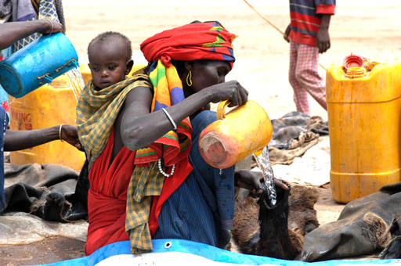 | 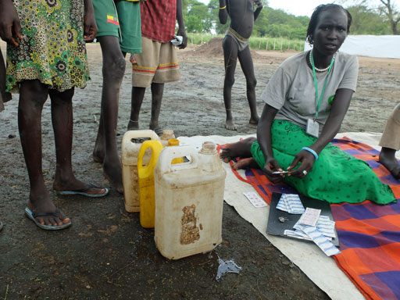
Figure 14.1 A mother fills goatskin water containers at the collection point for the emergency water supply delivered by water tanker in Somali Region. | Figure 14.2 A community worker adds water purification tablets to water in jerrycans in an emergency situation in Gambela Region.

14.1.1 Standards for emergency response
The organisations usually involved in responding to emergencies include national and local government and many different international, national and local organisations as well as other local groups. They aim to provide humanitarian assistance to the people affected by the emergency. The Sphere Project is an international initiative that aims to improve the quality of actions taken in response to disaster situations. It provides standards against which all humanitarian response activity can be held to account (Sphere Project, 2011). The Sphere Handbook has core sets of standards for:
- water supply, sanitation and hygiene promotion
- food security and nutrition
- shelter, settlement and non-food items
- health actions.
These standards describe the humanitarian actions that should be taken in the event of an emergency in order for ‘disaster-affected populations to survive and recover in stable conditions and with dignity’ (Sphere Project, 2011). Within the water supply, sanitation and hygiene promotion section, standards are set in several different categories, as you can see in Figure 14.3.
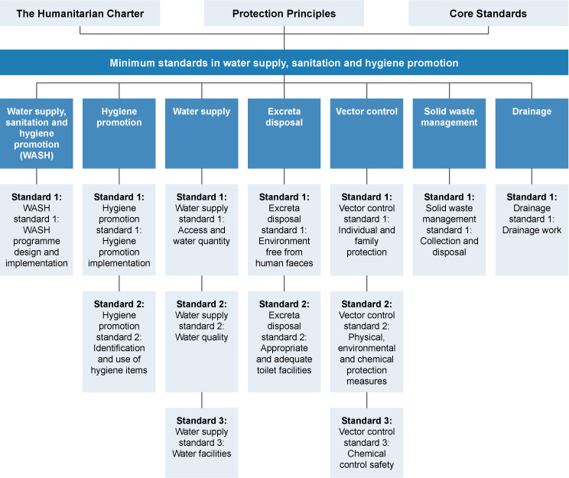
Figure 14.3 The Sphere Handbook: Contents of the chapter ‘Minimum standards in water supply, sanitation and hygiene promotion’. (Sphere Project, 2011)
The Sphere Handbook includes standards for responses to meet needs for clean water, basic shelter and sufficient food. It also includes standards for responses concerned with promotional activities and behaviour change, which are the focus of this study session.
Communication interventions for an emergency can be summarised as consisting of three distinct phases: preparedness, response and recovery. We will look at each of these phases in turn in the following sections.
- Why is hygiene behaviour critical during emergency?
- Hygiene behaviour is critical because disease risks are higher in emergency situations. This is because of overcrowding, lack of safe water and poor sanitation facilities, so has a critical influence on the transmission of disease. In emergency situations it is particularly important to prevent spread of disease.

14.2 Preparedness phase
Preparing for an emergency means planning ahead so that when disaster strikes, there are systems in place to respond quickly and effectively. Being prepared will save lives and help response and rescue operations. Plans for behaviour communication will be part of a broader preparedness plan that covers all aspects of emergency preparation.
For behaviour communication, preparation follows similar principles to those for behaviour and social change communication that you have read about in previous study sessions. Preparedness for behaviour communication in an emergency situation includes a number of steps, outlined below.

1. Develop a communication plan
The first step is to develop an emergency communication plan. Designing a communication plan should begin with bringing the various stakeholders together to determine the objectives of the plan, the methods to be used and the resources required, including financial and human resources (UNICEF, 2012). The stakeholders could include government, NGOs and community representatives. It is important for community representatives to participate in the planning and decision making so that they can provide information about the local situation as well as develop a sense of ownership of the plan.
Remember that effective behaviour change communication is a two-way process and should be a dialogue between the people giving out the information and those receiving it. Working with communities through a process of dialogue can help identify potential barriers to change and specific cultural and social beliefs and practices which might prevent desired behaviour. Sustained dialogue can help bring about community involvement and participation in addressing the emergency.
The communication plan should also consider the roles and responsibilities of different partners, the results in terms of changed behaviour that it is aiming to achieve, and how those results will be monitored at different phases of the emergency (UNICEF, 2006).

2. Identify communication channels
The communication plan will also need to consider the possible methods to be used for providing information. In an emergency, communications need to reach as many people as fast as possible. It is advisable to use both interpersonal methods and mass media methods during an emergency.
Communications to individuals or small groups are unlikely to have the necessary impact but interpersonal methods that reach large numbers of people such as public meetings will be more effective (Figure 14.4). Other options include public address systems with speakers mounted on vehicles.
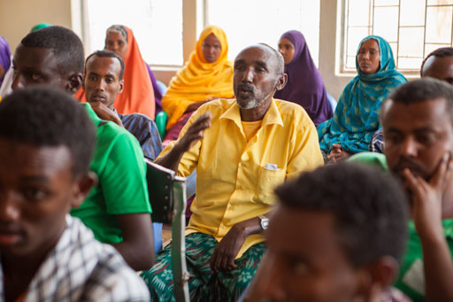
Figure 14.4 Meeting of a community association.
Mass media, such as radio, television, text messaging via mobile phones, and newspapers can be useful to raise awareness and can also help promote critical behaviours and disseminate programme information (Figure 14.5). These methods help inform large numbers of people quickly but they often do not provide the opportunity for feedback.
Choosing more than one channel for emergency communication means that messages can be repeated and reinforced and can help ensure that as many people as possible are reached. Mass media methods are most effective when combined with interpersonal methods that allow affected people to discuss the information with someone they trust such as community opinion leaders (UNICEF, 2006).
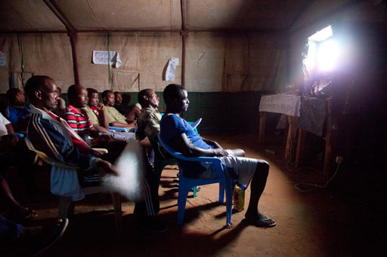 | 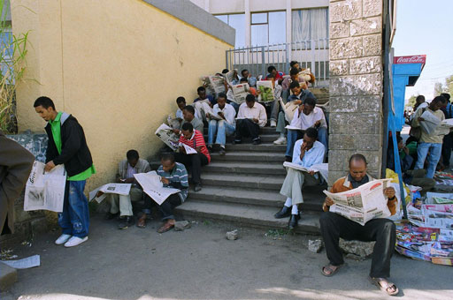
Figure 14.5 Raising awareness through mass media.

3. Prepare communication materials and keep them ready to use
Some communication materials can be prepared in advance and stored ready for distribution, as shown in Figure 14.6. These would have to be stocked at the district level, so that during an emergency they can be immediately distributed in the field, saving precious time and resources. It may be possible to prepare electronic copies (soft copies) of materials in draft versions that can be finalised and printed (hard copies) when needed.
In the eventuality that new materials need to be produced, it would also be helpful to create a directory of graphic designers, media producers, radio /TV channel contacts and others who you would need to call on for support if an emergency arose.
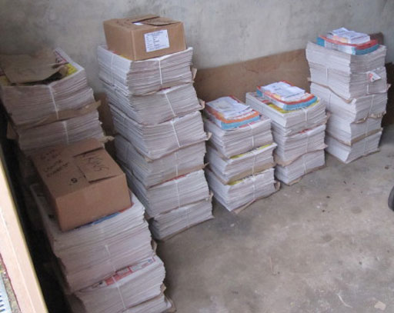
Figure 14.6 Communication materials ready for distribution.

4. Train service providers in emergency communication skills
In times of stress and trauma caused by an emergency, community level communicators such as Health Extension Workers (HEWs) and members of the Health Development Army (HDAs) need good interpersonal communication skills to inform, motivate, counsel and encourage affected people and communities. Providing the necessary training on interpersonal communication for these frontline workers is an important preparatory activity.

5. Engage communities in preparing and planning for emergencies
The human rights-based approach, supported by the Sphere standards, stresses participatory approaches that engage communities in planning, implementation and monitoring processes. This means that programmes should build on what people already know, and recognise their social and cultural strengths. An important part of preparation, therefore is gathering information from all members of local communities (Figure 14.7).
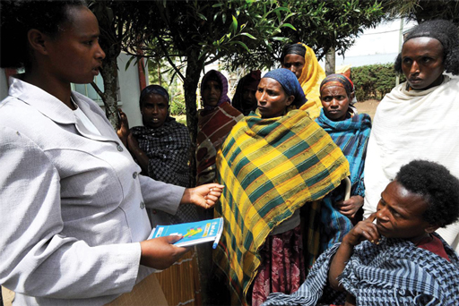
Figure 14.7 Gathering information from the community is part of emergency preparation and planning.
Communities are, however, made up of many different types of people. Some people may be less able to take part in decision-making processes due to vulnerabilities related to age, gender inequalities, ethnicity, socio-economic status and disability. In areas that are particularly vulnerable to emergency, supporting communities to develop community action plans themselves is a key preparedness activity. The HEWs and HDAs could be instrumental in developing and supervising the implementation of such a plan.
- Explain why the following actions are important parts of preparing for an emergency.
- Create a directory of useful contacts for disseminating emergency communications.
- Train frontline health workers in counselling skills.
- The answers are as follows:
- Having a directory of useful contacts for disseminating emergency communications would be helpful if there was an emergency because it would save time and enable messages to be sent out more quickly.
- Training health workers in counselling would ensure they had the necessary skills to support their community in the event of an emergency, especially in terms of psychosocial impact. They would also be able to explain messages sent out by other methods such as radio or TV.

14.3 Response phase
The next phase is the response phase which begins when an emergency strikes. An emergency response encompasses the decisions and actions taken to deal with the immediate effects of an emergency. For behaviour communication, UNICEF have described this phase in a number of steps, listed below (UNICEF, 2006; UNICEF, 2012). It should be noted that in some emergency situations, some of these steps may not apply.

1. Participate in rapid assessments
The first step is to assess the situation so that the scale of the emergency is understood. This involves assessments for different sectors including health, water and sanitation, child protection, food etc. When WASH rapid assessments are conducted in the initial phase of an emergency, it is critical that the assessments also identify any high risk practices that have implications for public health of affected communities. Rapid assessment for WASH behaviour is described in more detail in Section 14.3.1.

2. Conduct a rapid appraisal of communication channels and resources
Soon after an emergency is announced, efforts should be made to find ways to reach the vast majority of affected people quickly with information and key messages. This rapid appraisal will revisit the channels identified in the preparedness plan and assess if they are affected by the emergency and which will be the most effective.

3. Revisit and activate the detailed communication plan
Based on the preparedness plan, the details of the implementation of the communication initiative(s) should be activated. All partners should be mobilised to fulfil the roles that had been determined at the planning stage.

4. Focus on re-establishing existing behaviours and norms
In the initial phase, the focus would be on re-establishing the positive behaviours and social and cultural values that existed prior to the emergency. For example, providing handwashing facilities enables people to continue to practice good hygiene behaviour, as shown in Figure 14.8. However, depending on the situation, emergencies might also provide opportunities to promote new behaviours.
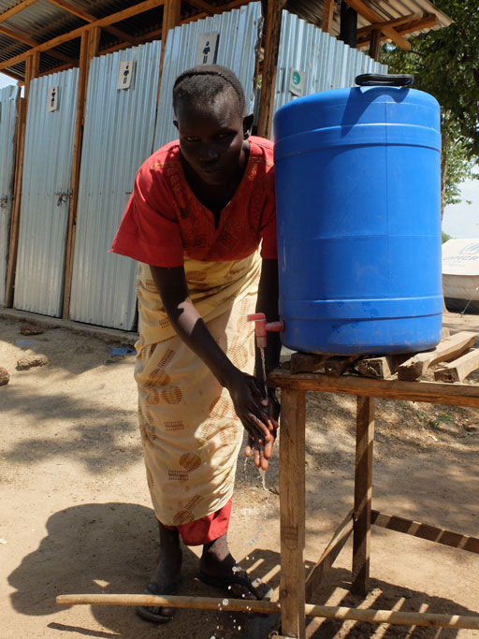
Figure 14.8 Latrines with handwashing facilities in a refugee camp help refugees to re-establish handwashing behaviours that existed prior to their displacement.

5. Forge additional alliances for communication
The emergency might provide opportunities to build additional alliances to include relief workers, service providers, journalists and others so that they are able to directly support desired behaviours among affected people.

6. Facilitate community and children's participation
Through established community level committees, pro-active efforts should be made to create opportunities for affected families and communities, including children and young people, to participate in the response.

7. Working with the media
As a priority, decision makers should come together and decide on what to communicate to the media. The communication should be frequent and effective and through a dedicated spokesperson.

8. Reach the poorest, most vulnerable and hard to reach
You should give particular attention to people who are more vulnerable or marginalised or those who are harder to reach, through special outreach activities.

9. Dealing with psychosocial impact
Emergency can have a variety of psychosocial impacts. People may have strong feelings of fear, insecurity and helplessness. People might not be allowed to undertake usual funeral and mourning practices. Community workers would have to be trained to deal with this situation and community leaders encouraged to help in supporting the community.
- Put these actions in the appropriate order when responding to an emergency.
- Create opportunities for children and young people to help out.
- Identify particularly high risk practices.
- Re-establish normal healthy practices and cultural values.
- The most appropriate order for these actions would be:
- Identify particularly high risk practices.
- Re-establish normal healthy practices and cultural values.
- Create opportunities for children and young people to help out (see Figure 14.9).
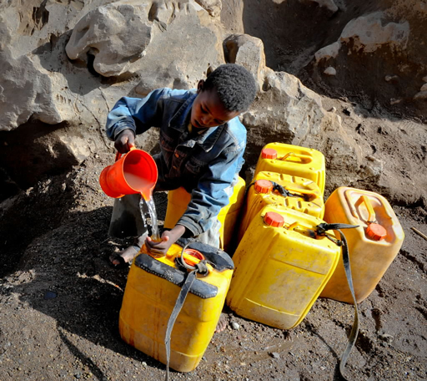
Figure 14.9 Children can be mobilised to help in an emergency situation.

14.3.1 Rapid assessment of hygiene behaviour
As noted above, when responding to an emergency, the first step is to make an assessment so that the situation is understood. Rapid initial assessments will provide information about the nature and scale of the emergency and the likely need for external assistance (WHO, 2002). There will need to be detailed assessments to plan, implement and coordinate responses to meet basic needs for water, food, shelter and medical care. Part of this assessment will be a behavioural situation analysis, such as you encountered in Study Session 8. This will provide understanding of current hygiene behaviours and identify where change is needed and how behaviour change could be achieved. In particular, the assessment should try to identify any key practices that may be putting people at risk, and any alternative or safer practices which would help to mitigate such risks. It should identify any barriers that might prevent people from adopting safer practices and any key motivating factors that will enable change. It should also ascertain preferred communication channels for different participant groups and identify any particularly vulnerable or high-risk groups.
The World Health Organization (2004) recommends the following checklist of questions for a rapid assessment of the public health situation in a community affected by an emergency:
- What health-related behaviours are contributing to public health risks faced by the affected population?
- What are the common health-related practices among the affected population and how have these been affected by the emergency?
- What are the current practices on key hygiene behaviours such as:
- washing hands after defecation?
- disposal of children‘s faeces?
- storage and handling of water?
- storage and handling of food?
- How is the community disposing of their solid waste?
- Is there an understanding in the community of the relationship between water/sanitation/shelter/vectors and disease?
- Does the community have access to water containers with lids/cooking utensils/mosquito nets/soap/sanitary protection/blankets/bathing facilities?
- Are the users involved in the management and maintenance of water sources and latrines?
- What health promotion media are available/accessible to the affected population (radio, posters/leaflets, local folk media and others)?
The answers to these questions will help you identify the key hygiene behaviours in the community affected by the emergency and therefore to target the high-risk behaviours for public health promotion activities. While designing the hygiene promotion campaign in an emergency situation it is important to consider the community’s traditional practices and the facilities available, as well as the damage caused by the emergency. You should also pay special attention to the needs of vulnerable groups such as the sick and wounded, children, the elderly and pregnant women.
- What are the main areas of concern for an emergency hygiene promotion programme?
- There are many areas of concern, but the main ones are probably:
- safe disposal of faeces
- handwashing after defecation and prior to food preparation
- clean water use and storage
- control of flies and other insect vectors
- personal hygiene (particularly for women and girls)
- food hygiene.

14.4 Recovery phase
The post-emergency or recovery phase is defined as the process of rebuilding, restoring and rehabilitating the community following an emergency. It is a time to revisit the communication plan that was drawn up during the preparedness phase and reassess behaviour to monitor the effectiveness of the plan.
The recovery phase offers an opportunity to expand service delivery and to increase quality and availability of water, hygiene and sanitation related services. In this phase it is important to continue communication activities and to establish and sustain normality as far as is possible in the emergency affected communities. ‘Building back better’ is a principle that takes a positive approach to the opportunities presented post-emergency, underpinning recovery and reconstruction activities that promote more resilient and capable communities. For example, Practical Action (2014) do this through seven principles:
- Do no harm: learn from the past, and avoid unnecessary damage to future recovery.
- Agencies must be accountable to the people they seek to assist.
- People affected by disaster should be the decision makers.
- Recovery of local economy and livelihoods must be a priority.
- Reconstruction and recovery efforts must recognise diversity.
- Communities should be allowed to use their own resources wherever possible.
- Reconstruction must take account of future hazards and risks.
Following these principles can encourage positive developments such as the construction of improved water supply and better sanitation provision for the future. However, the physical reconstruction of buildings and infrastructure following an emergency can sometimes be achieved more quickly than social or psychological rehabilitation (WHO, 2002). The recovery phase in terms of people’s sense of wellbeing may therefore take a long time. Planning for long-term recovery is an important part of emergency planning that needs to be considered as part of the pre-emergency planning phase.
- During which phase of emergency should community workers be trained in interpersonal communication skills and why?
- Such training should be given during the response phase. This is because people may get strong feelings of fear, insecurity and helplessness during emergencies, and this can have significant psychosocial impact. For example people might not be allowed to undertake usual funeral arrangements and mourning practices and this needs careful handling by people with appropriate training.
- During which phase should communication materials be prepared and made ready for dissemination?
- Communication materials should be developed, produced and stored ready for distribution during the preparedness phase. This will save precious time and resources. It may also be necessary to produce materials during the response phase.

Summary of Study Session 14
In Study Session 14, you have learned that:
- The main objective of WASH communication intervention in emergencies is to reduce the transmission of diseases from faeces to mouth through the promotion of good hygiene practices, the provision of safe drinking water and the reduction of health risks related to poor sanitation.
- Hygiene behaviour is particularly important in emergency situations where disease risks are acute due to overcrowding, poor water and sanitation, exposure to new pathogens and disturbance of familiar and safe habits.
- Preparing for emergencies involves developing a communication plan with participation from the community. The plan should set objectives, identify communication channels and human and financial resources required in an emergency.
- During the response phase actions are taken to deal with the immediate effects of the emergency. After an initial rapid assessment, activities for behaviour communication will be based on the prepared communication plan using the most effective communication channels to reach people affected with the priority messages.
- Rapid assessment of the public health situation is an important first step in emergency response to identify high risk behaviours that should be targeted for behaviour change communication.
- The recovery phase involves rebuilding, restoring and rehabilitating the community following the emergency. This phase can provide opportunities for improvements in WASH services but recovery from psychosocial impact may take longer.

Self-Assessment Questions (SAQs) for Study Session 14
Now that you have completed this study session, you can assess how well you have achieved its Learning Outcomes by answering these questions. You can check your answers with the Notes on the Self-Assessment Questions at the end of this Module.

SAQ 14.1 (tests Learning Outcomes 14.1 and 14.2)
Give three reasons why emergencies can put people at greater risk of waterborne disease.

SAQ 14.2 (tests Learning Outcome 14.3)
Interventions for WASH emergencies can be divided into three distinct phases. What are these three phases? Consider each of the following actions and identify in which of the three phases it would be actioned:
- Production and storage of communication materials.
- Restoring interrupted essential services.
- Contact partners in the media who can help deliver important messages to the community.
- Re-establishing of transportation routes.
- Get information and key messages to affected people quickly.
- Providing food and shelter for those displaced by the incident.
- Designing a communication plan.
- Create opportunities for those affected by the emergency to participate in the response.

SAQ 14.3 (tests Learning Outcome 14.4)
Look at the suggestions given in Section 14.3.1 of questions you might ask as you undertake a rapid assessment of hygiene behaviour. Select four questions which you think would be most helpful in identifying the key practices that are putting people at risk. How might the answers to these questions help in identifying the key high risk behaviours? What actions could help mitigate the risks? Present your answer as a table, with one column for the key question, a second column for how the answers could help identify the key practices, and a third column for the actions.

Study Session 15 Monitoring and Evaluation

Introduction
How do you know that your sanitation and hygiene promotion is making a difference? Is your behaviour change communication having the intended results? What can be done differently to better meet objectives? These are the sorts of question that monitoring and evaluation allow you to answer.
Good intentions, effective planning, large programmes and projects, and even an abundance of financial resources are not enough to ensure that development projects will be successfully implemented. Monitoring and evaluation are essential to track whether a project is delivering against its desired outcomes. It is a process that helps us learn from past successes and make the right decisions, so that current and future initiatives are better able to improve people’s lives.
This study session will focus on monitoring and evaluation of behaviour change interventions.

Learning Outcomes for Study Session 15
When you have studied this session, you should be able to:
15.1 Define and use correctly all of the key words printed in bold. (SAQ 15.1)
15.2 Distinguish between monitoring and evaluation and explain why both are important. (SAQs 15.1 and 15.2)
15.3 Describe the results chain and give examples of behavioural indicators. (SAQs 15.3 and 15.4)
15.4 Outline the key components of a monitoring and evaluation plan. (SAQs 15.3 and 15.4)

15.1 The importance of monitoring and evaluation
Assume that you are managing a ‘handwashing with soap after visiting latrine’ campaign in your community. How do you make sure that the activities of the campaign are on track? How do you know that the necessary products (e.g. soap) and services (e.g. water) are available during the campaign? How would you know at the end of the campaign that community members are definitely washing their hands with soap after visiting a latrine (Figure 15.1)?
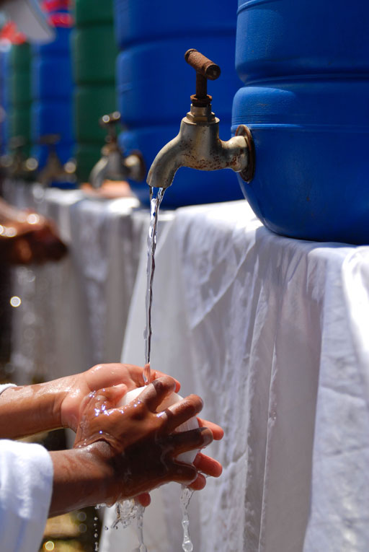
Figure 15.1 Washing hands with soap.
Monitoring and evaluation are ways of systematically measuring and assessing programme activities and results. Their purpose is to check on the progress of implementation and outputs systematically. They help to determine when a programme is going to plan and when changes may be needed. They form the basis for modification of interventions, and of assessing the quality of any activities that are being conducted. Moreover, with a positive outcome, they can be used to demonstrate that programmes have been implemented effectively and have had a measureable impact.
Together, monitoring and evaluation (frequently abbreviated to M&E) provide the necessary data to guide planning, to allocate resources, to design and implement programmes and projects and, if necessary, to re-allocate resources in better ways. They are essential in providing planners, implementers, policy makers and donors with the information and understanding they need to make informed decisions about the operation of their programmes.
Although often referred to together as M&E, monitoring and evaluation are two different but linked processes that apply to many projects, programmes and other interventions. (Note that in following sections, we have used ‘projects’ to include all types of activity that would need M&E.)

15.1.1 What is monitoring?
Monitoring is systematic, timely and purposeful observation and data collection to check if project activities are being implemented as planned. More precisely, monitoring assesses project activities to establish what activities are being done, and where, with whom, when and how many have been completed. Box 15.1 explains some of the key terms that are used when discussing monitoring and evaluation.

Box 15.1 Key terms in monitoring and evaluation
Outputs are the things produced by a project or programme. In WASH, examples include tangible products like new or rehabilitated wells and pumps, new latrines and training manuals; they could be events and activities like running a training workshop for frontline workers, or producing hygiene promotion posters.
Outcomes are the effects of the outputs, usually in the short- to medium-term. Examples, following those above, could be the number of people who now have access to safe water as a result of the new water schemes or attendance at the training workshop.
Impacts are long-term effects and consequences. Examples could be a fall in the incidence of diarrhoeal disease, improved school attendance, or pumps that last longer because they are well-maintained.
An indicator is something that can be seen or measured or counted, which provides evidence of progress towards a target. Indicators are used to monitor or evaluate project performance. They are project-specific and defined by the objectives of the project. They can be based on either quantitative or qualitative measurements.
Monitoring is used to track changes in project performance over time against measurable indicators defined well in advance. It involves collecting data and tracking actions being taken in order to measure progress towards the goals and to identify any problems. For any particular activity, the output, the outcome and the process should all be monitored.
The purpose of monitoring is to permit managers to make informed decisions regarding the implementation and performance of projects and the efficient use of resources. Monitoring is often done internally by project managers or by dedicated project monitoring staff. It involves a continuous process of checking, analysing and giving feedback into project activity and resource allocation plans.
One well-known example of an international monitoring programme is the WHO/UNICEF Joint Monitoring Programme (JMP) for Water Supply and Sanitation. This is a global monitoring programme for the WASH sector that annually collects and publishes data on a range of indicators for countries all over the world (JMP, 2014). At national level in Ethiopia, the National WASH Inventory is a monitoring system that collects data on water supply in urban and rural areas, sanitation and hygiene practices of households, and the status of water supply and sanitation facilities at health institutions and schools (Pratt, 2015).

15.1.2 What is evaluation?
Evaluation is an objective assessment of the design, implementation and results of an ongoing or completed project. Evaluations can be conducted during or at the end of the project period, depending on the purpose of the evaluation. Unlike monitoring, which should be done frequently, evaluation involves collecting data or undertaking surveys at particular points during a project (Figure 15.2). This will include baseline data collected at the start and follow-up data collected during or at the end of the project. Baseline data provides information about the situation before the project began which can then be compared with the follow-up data collected later. This comparison means that the effects of the project activities can be measured.
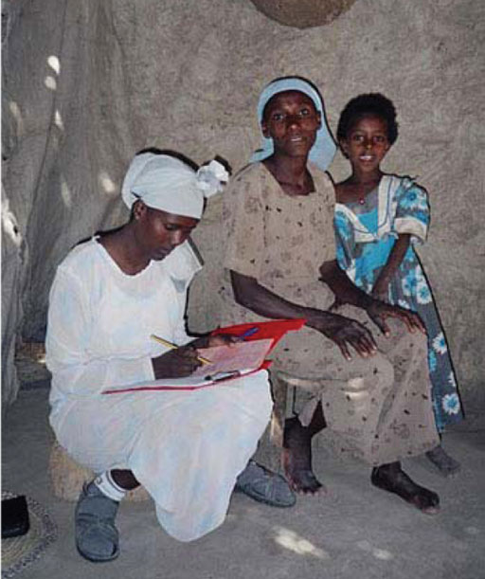
Figure 15.2 Collecting data during an interview so that project outcomes can be evaluated.
Evaluation also provides information that can help decision makers when planning new initiatives. Reflections on lessons learned from past successes and failures can be very helpful when planning future interventions. Unlike monitoring, evaluation of a project is usually done by an independent individual or firm in order to provide managers and staff with an objective assessment of the project. The aim of evaluation is to determine the efficiency, effectiveness, impact and sustainability of a project, and whether it has met its objectives.
In summary, monitoring and evaluation are important management tools for providing information that can help to inform decisions, improve performance and achieve planned results.

15.2 Behavioural indicators
Following on from the definition of an indicator in Box 15.1, behavioural indicators are measures used to assess progress towards achieving targets of a behaviour change intervention. There are several different types of behavioural indicator that can be used in M&E programmes to measure process, outputs, outcomes and impacts.
- Process indicators measure the ways in which planned activities have been implemented, with respect to both time schedule and the quality of the implementation. Examples could be the number of effective training sessions to help people (e.g. health extension workers (HEWs) and health development army members (HDAs)) to improve their counselling skills, the number of effective posters produced or the number of community conversation groups formed.
- Output indicators measure the extent to which the planned activities have actually been implemented. Examples could be the number of street shows organised, the number of posters actually displayed, the number of group meetings organised or the number of counselling sessions completed. It is important to note that output indicators do not measure actual outcomes such as behaviour change or increase in knowledge of the target audience.
- Outcome indicators measure the outcomes that a particular project hopes to achieve, as identified in the communication plan objectives. Outcome indicators give an indication of whether the project is having an impact. Examples could be the percentage of mothers washing their hands with soap, the percentage of households that made use of handwashing facilities, the percentage of people who correctly identify the critical times for handwashing, etc.
- Impact indicators measure the long-term effects, or end results, of a project. It takes longer to obtain these so they may not necessarily be captured in the evaluation of a short duration campaign. Examples of impact indicators could be a change in child death rate, a change in diarrhoea incidence rate or a change in neonatal and infant mortality.
- Imagine you want to reduce the incidence of diarrhoeal diseases in your locality. You are encouraging people to use a clean water source for drinking (Figure 15.3) instead of using water from a pond (Figure 15.4).
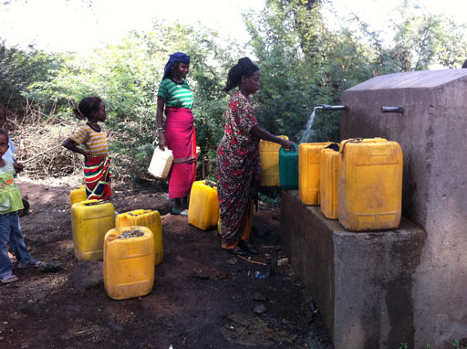 | 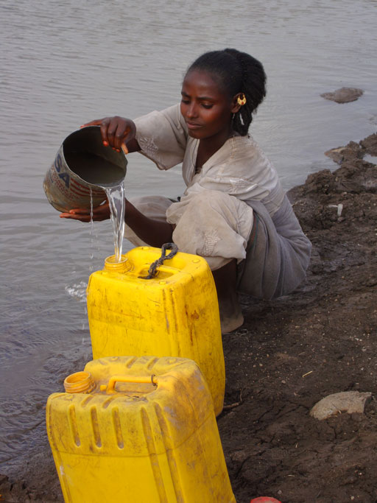
Figure 15.3 Safe water source. | Figure 15.4 Unsafe water source.
Listed below are measurements you might obtain. What type of indicator is each one?
- Change in number of people who take water from the new clean water source each day.
- Number of leaflets produced to discourage people from drinking water from the pond, and to raise awareness of the new water supply.
- Number of these leaflets actually distributed.
- Change in number of people collecting water from the pond.
- The incidence of diarrhoeal diseases.
- The answers are as follows:
- Outcome indicator: this indicator will tell you if you have succeeded in encouraging more people to use the clean water source.
- Process indicator: this is a measure of the actions you took.
- Output indicator: this measurement will indicate how many people received your leaflet (but it does not tell you if they read it).
- Outcome indicator: this indicator will tell you if you have succeeded in discouraging people from collecting water from the pond.
- Impact indicator: this will measure the long-term result of your campaign. If people are using clean water the incidence of diarrhoeal diseases will go down.

15.3 Developing a monitoring and evaluation plan
Planning for M&E should be part of the design phase of a project and included at the beginning when the objectives of the project are decided. The M&E plan needs to describe how the results will be measured to determine if the project objectives have been achieved.
- Assume you want to conduct a hygiene promotion campaign to increase awareness in your woreda of the importance of handwashing after using the latrine. What do you think could be the results of your campaign? (Your answer should summarise the changes that happen as a result of the activities you organise. The results do not refer to the completion of the activities themselves.)
- You might have thought of:
- increased knowledge (about the critical times for handwashing, for example)
- improved hygiene practice (e.g. handwashing)
- reduction of disease.
A result is not the completion of activities. A ‘result’ is defined as a describable or measurable development change that happens as a consequence of a cause-and-effect relationship (UNDP, 2009). Results include the outputs, outcomes and impacts of project activities. These are linked together into what is commonly referred to as a results chain. The results chain essentially tells us that completion of the stated activities will lead to the outputs; the outputs will lead to the outcomes; and the outcomes will lead to the impacts (Figure 15.5).
Figure 15.5 The results chain.
There are various models, or frameworks, used when planning for M&E. You may come across results frameworks or logical frameworks. These are similar and both methods can be used to ensure a systematic and comprehensive approach to M&E planning.
A logical framework, or simply logframe, links the planned activities, which have been introduced to address the objectives, with the expected results in terms of outputs, outcomes and impacts. It indicates how they will be monitored and evaluated. The logframe allows information to be analysed and organised in a structured way. It encourages clear and specific thinking about what the project aims to do and how, and highlights the aspects upon which the success of the project depends.
A logframe consists of a matrix or table with rows and columns that have a vertical logic and a horizontal logic. An example is shown in Table 15.1.
The rows of the logframe are linked by a vertical logic that corresponds to the results chain (Figure 15.5). In a logframe the impacts are placed at the top and activities at the bottom.
- Impacts are the long-lasting changes in the situation.
- Outcomes are changes that can be seen in a shorter timescale.
- Outputs are completed projects or their products.
- Activities are the main elements of project implementation.
The columns of the logframe have a horizontal logic that links each of the interventions to their measurement indicators. It has three main parts – results, indicators and means of verification (Table 15.1).
- Results: the expected results at activity, output, outcome and impact levels (Table 15.1, column 1).
- Indicators: the measurements used to assess progress (Table 15.1, column 2).
- Means of verification: this is the source of information required to confirm progress against the indicators. (Table 15.1, column 3).
- Assumptions and risks (not shown in Table 15.1): external factors that need to be in place or may affect whether the result is achieved (Jensen, 2013).
Table 15.1 Example of a completed logframe for a project to reduce diarrhoeal disease.
Results | Measurable indicators | Means of verification
Impact level
Reduced diarrhoea incidence | Number of diarrhoea episodes in children | Demographic and health survey report
Outcome level
Increased number of households who have a latrine | Percentage of households having a latrine facility | Baseline and follow-up survey reports
Increased levels of knowledge and awareness regarding the importance of using a latrine | Percentage of men, women and children who understand the need for using a latrine | Baseline and follow-up survey reports
Output level
Increased involvement of HEWs and HDAs in hygiene and sanitation promotion | Number of household counselling visits by HEWs and HDAs | Mid-term project reports  Implementation reports  Field visit reports
Hygiene promotion leaflets disseminated | Number of copies disseminated and used effectively | Mid-term project reports  Implementation reports  Field visit reports
Activity level
HEWs and HDAs are equipped with the knowledge and skills to conduct interpersonal communication to promote latrine use | Number of HEWs and HDAs trained in the use of interpersonal communication techniques | Implementation reports  Field visit reports
Hygiene promotion leaflets and other materials developed | Number of materials developed | Implementation reports

15.4 Methods and tools for monitoring
There is no one-size-fits-all monitoring tool. We will focus on two of the most common tools used for systematic monitoring, data gathering and reporting applicable at woreda level. These are annual work plans and field visits.

15.4.1 Annual work plans
Annual work plans (AWPs) detail the activities to be carried out by the woreda in the year ahead. The plans are specific to a project and are based on its intended outputs in relation to each intended outcome. AWPs include details of who is responsible for what, time frames and budget. They also serve as useful references for monitoring progress later in the year. A sample annual plan is given in Table 15.2. It provides a template that may be adapted for practical use, as appropriate.
Table 15.2 Annual work plan format – one plan for each project outcome. (Adapted from UNDP, 2009)
Outcome:
Expected outputs | Planned activities | Time frame |  |  |  | Person responsible | Budget | Monitoring framework
 |  | Q1 | Q2 | Q3 | Q4 |  |  | Expenditures | Progress towards outputs
Output 1 targets:
Output 2 targets:
Output 3 targets:
- Expected outputs (Table 15.2, column 1) should be completed with baselines, associated indicators and annual targets, as applicable.
- All planned activities, including monitoring and evaluation activities, to be undertaken during the year towards each stated output should be included in column 2. The planned time frame (divided into quarter years), name of the person responsible and the estimated budget required for each activity go in columns 3 to 5.
- The monitoring framework includes the expenditures and a record of the progress made towards each output (columns 6 and 7). These columns should be completed later in the year based on measurement of the defined indicators. Where relevant, comments should be included on factors that facilitated or constrained achievement of results, including factors such as timing of inputs and activities, quality of products and services, coordination and other management issues.

15.4.2 Field visits
Field visits are essential for any community-based interventions (Figure 15.6). Field visits should be planned thoroughly in order to be of maximum use. As summarised by UNDP (2009), the following considerations may help in planning an effective field visit.
- Purpose: Field visits can provide necessary evidence to confirm results reported by kebeles, HEWs, etc. They involve an assessment of progress and problems.
- Timing: A field visit may take place at any time of the year but seasonal factors should be considered when planning a visit. The focus of the visit may vary, relative to the schedule of the annual work plan.
- Who should participate: This will vary but joint visits involving teams from project partners are often an efficient way to monitor progress and share information.
- Dialogue and consultations: The emphasis should be on collecting information on progress being made towards the goals (outputs and outcomes) as well as their quality and sustainability.
- Findings: Field visit reports should be brief, with an emphasis on actions completed. Reports should be forwarded to appropriate departments and stakeholders for consideration and effective action.
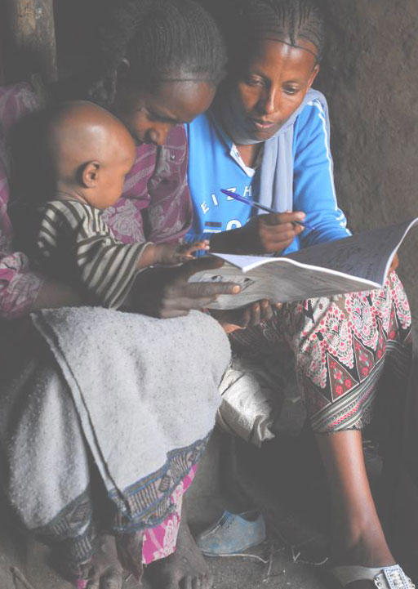
Figure 15.6 A practitioner undertaking a field visit to interview mothers to monitor performance of a WASH initiative.
The content of a field visit report varies depending on the purpose of the visit. At a minimum, it should contain an analysis of the progress towards results, the identification of outputs, partnerships, key challenges and proposed actions. A form illustrating the type of information that could be gathered during a field visit is given in Table 15.3. This form may be changed to suit your particular needs.
Table 15.3 Example field visit form.
Date of visit:
Subject and place of visit:
Purpose of the field visit:
Main challenges in implementation:
Progress towards results:
Prepared by:

15.5 Methods and tools for evaluation
The focus of evaluation is on outcomes and impacts. For behaviour change communication projects, these two result categories will require different approaches to evaluation.
An outcome evaluation would tell you the short-term results of a WASH promotion intervention. It shows what kind of change has occurred in environment, behaviour, health knowledge, social participation, lifestyle or risk factors. Examples of questions you may ask in an outcome evaluation include:
- Since the project started, has there been an increase in the number of people who know about the subject of your promotion? Has there been a change in the environment, e.g. are there now more handwashing facilities available in homes?
- Has there been a change in behaviour, e.g. are more people now washing their hands with soap?
An impact evaluation looks at the long-term changes that have resulted from a health intervention, such as how a communication project has affected people’s lives. Examples of questions you may ask in an impact evaluation include:
- Has there been a decrease in the incidence of diarrhoea since the project started?
- How much reduction has been seen in the child death rate from diarrhoea?
Methods used for outcome and impact evaluations of health promotion projects may be qualitative or quantitative. Qualitative evaluation methods explore why particular effects have resulted following a behaviour change communication. These methods include interviews and focus group discussions. For example, interviews might help establish why more mothers wash their hands with soap now, compared with before the project began. Quantitative evaluation methods explore by how much change has occurred. For example a survey might be done to estimate the proportion of the population who now regularly wash their hands with soap, compared with before the project started. The results can be analysed using statistical analysis.
The most comprehensive behaviour change communication evaluations use a combination of qualitative and quantitative methods. For both methods, recording information is crucial (Figure 15.7).
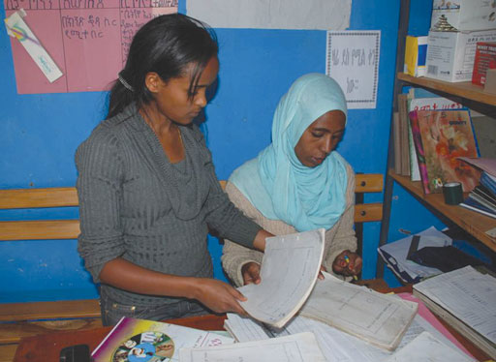
Figure 15.7 Recording information during evaluation.

Summary of Study Session 15
In Study Session 15, you have learned that:
- The purpose of monitoring and evaluation is to track implementation and outputs systematically, and measure the effectiveness of projects and programmes.
- Monitoring is systematic observation and data collection to check if and how planned activities are being implemented.
- Evaluation measures how well the project activities have met expected objectives and whether outcomes can be attributed to them.
- Indicators are measurements used in monitoring and evaluating project performance, which should be measurable and help assess the extent to which an intervention has changed the situation.
- The results of monitoring and evaluation can be shown by a results chain, which shows how completion of the activities will lead to outputs, outputs will lead to outcomes, and the outcomes will lead to impacts.
- The logframe is a monitoring and evaluation tool that links the planned activities with expected results. It indicates how monitoring and evaluation will take place, and allows information to be analysed and organised in a structured way.
- Annual work plans can be used to monitor activities. Field visits are used for both monitoring and evaluation.
- Both qualitative and quantitative methods should be used to evaluate both outcomes and impacts of behaviour change communication programmes.

Self-Assessment Questions (SAQs) for Study Session 15
Now that you have completed this study session, you can assess how well you have achieved its Learning Outcomes by answering these questions. You can check your answers with the Notes on the Self-Assessment Questions at the end of this module.

SAQ 15.1 (tests Learning Outcomes 15.1 and 15.2)
The descriptions below explain five of the following terms: monitoring, evaluation, indicator, result, outputs, outcomes, impacts.
Which description relates to which term? Provide an explanation for the terms for which no description has been given here.
- This process aims to understand the progress that has been made towards the achievement of an outcome or an impact at a specific point in time, and is linked to outcomes and impact rather than to outputs.
- These are the immediate results of the activities conducted. They are usually expressed in quantities, either in absolute numbers or as a proportion of a population. They are generally expressed separately for each activity.
- This is a measure of performance that provides evidence of progress towards a target.
- This describes the long-term results expected of a project, and generally refers to its overall goal(s).
- These are the medium term results of one or several activities. They are what the immediate outputs of the activities are expected to lead to, and they often require separate surveys to be undertaken.

SAQ 15.2 (tests Learning Outcome 15.2)
Explain what is wrong with this statement: ‘M&E activities should be left until the end of a project when the final results are known.’
SAQs 15.3 and 15.4 are based on Case Study 15.1.

Case Study 15.1 The mothers who believe that eating berbere will protect them.
In one rural woreda in Ethiopia there is a high incidence of child diarrhoea. Research has shown that the majority of mothers do not wash their hands with soap after visiting latrines and after discarding child faeces. Furthermore, mothers wash their hands only with water before preparing food or before feeding their babies. Mothers believe that child faeces is harmless and that, as they eat berbere (chili) most days, germs will have no chance to grow in their bodies.
A social and behaviour change intervention is planned in the woreda to increase awareness, change belief and increase the practice of handwashing with soap. The intervention includes the production of posters, leaflets and training tools, training of health development army members in the use of interpersonal communication, conducting household-level counselling, community conversations and transmission of radio messages.

SAQ 15.3 (tests Learning Outcomes 15.3 and 15.4)
Based on Case Study 15.1, list the intended results of the intervention at activity, output, outcome and impact levels.

SAQ 15.4 (tests Learning Outcomes 15.3 and 15.4)
Based on Case Study 15.1, give one behavioural indicator that could be used for each of the four levels in SAQ 15.3.

Notes on the Self-Assessment Questions (SAQs) for Urban WASH: Working with People

Study Session 1

SAQ 1.1
Increasing scarcity of productive land for farming and the prospect of better employment opportunities are encouraging more and more people in Ethiopia to move from rural areas to towns and cities. This urbanisation has led to many people living in slum areas of poor housing that lack essential services. Towns and cities are also spreading over larger areas of land with expanding peri-urban areas that have mixed urban and rural characteristics. The population density in urban areas is much higher than in rural areas. This creates challenges for providers of WASH services because of the high demand for water supply and effective sanitation systems.

SAQ 1.2
The particular challenges for providing WASH services in urban areas arising from these factors include:
        - Increasing population size – places pressure on existing WASH facilities due to the increased number of users and often leads to generally reduced access levels and frequent breakdown. The rate of increase in population is often many times higher than the rate at which WASH service improvements are actually planned and implemented.
        - The diverse nature of the urban community – promoting safe hygiene and sanitation practices is difficult if the community is very mixed and the people do not share a sense of responsibility for their neighbours or environment.
        - Infrastructure required for WASH services – mobilising sufficient funds to plan and implement infrastructure projects is difficult. In water supply, meeting the growing demand of the continuously increasing population size is a challenge. Lack of waste collection, transport and disposal infrastructure adds to increasing environmental pollution in urban and peri-urban areas.
        - Governance – the process through which resources for improving WASH services are allocated and utilised is complicated. Moreover the distribution of resources and infrastructure may not be town-wide, socially inclusive or equitable.

SAQ 1.3
The key challenge for physically disabled people in using WASH facilities is the lack of proper access. If latrines are far away and/or located in corners and over paths that are rugged or marshy, disabled individuals, particularly those without mobility aids, such as wheelchairs, will face enormous difficulty in accessing and using such facilities on a daily basis. To address the problem, the latrines should be located nearby and designed with the needs of disabled people in mind. For example, they should have extra space inside, supporting rails, wider doors and ramps for access by wheelchair users.
Your explanation should also mention the cleanliness and sanitary conditions of the latrines, which are equally important. Where there are no special provisions (rooms and supports), disabled people will have no option but to use the facilities that are suited for non-disabled people. If these are not kept clean, disabled people will have to use the facilities with much discomfort and struggle, and with increased health risks.
You can also explain these challenges in the context of water supply facilities, where the location, design and access to the water supply point should consider the needs of disabled people.

SAQ 1.4
Water supply systems are a very common route for transmission of disease-causing micro-organisms to communities and these risks are increased in emergency situations. The organisms can enter the system at the source or through weak joints in the distribution system. This is particularly likely to happen if pipes have been allowed to become empty.
Appropriate interventions which would help to tackle this problem include:
- proper maintenance and operation of water supply systems
- promoting the use of point-of-use water treatment chemicals.

Study Session 2

SAQ 2.1
vector | organism that transmits disease
faecal sludge | sludge that builds up in pit latrines and septic tanks
greywater | used water from domestic washing, food preparation, etc.
pathogen | disease-causing agent
blackwater | wastewater containing human excreta

SAQ 2.2
B is false. Medical waste should not be handled with normal household waste. It needs special disposal because it may contain hazardous substances including body fluids from patients, pharmaceutical chemicals and sharp objects such as needles.
E is false. Industrial wastewater can cause water pollution if discharged into a river but can also pollute soil and groundwater if spread over the ground.

SAQ 2.3
Contaminants can flow directly into surface water sources, such as rivers, from pipes and drainage channels, e.g. industrial wastewater from a factory. They may also enter rivers in rainwater run-off that has washed over surrounding land and collected pollutants from any wastes discarded there, including faeces. Another possible route is from groundwater. If groundwater in the area has become contaminated, this may seep out into the river. You may also have thought of direct contamination from activities in the river water such as cleaning dirty vehicles.

SAQ 2.4
        - If faeces are deposited in open areas then pathogens can be washed into rivers and groundwater (see answer to SAQ 2.3). Also flies are likely to transfer pathogens from faeces onto food. Many diseases are caused by ingesting contaminated food or water, including diarrhoea, dysentery, cholera, typhoid, and infection by intestinal worms and other parasites.
These problems could be reduced by providing sufficient numbers of well-designed and maintained latrines so that people did not have to defecate in the open.
- If food and other organic waste is allowed to accumulate it will encourage flies and rats to breed, which are vectors of disease. It is possible that piles of waste will also contain excreta so the risks will be the same as those listed in (a).
These problems could be reduced by providing a waste management service that ensured wastes were collected and disposed of appropriately.
- Handwashing before eating is an important aspect of good hygiene practice. Without this there is a risk of transmitting pathogens into your mouth, which may result in the faecally transmitted diseases listed in (a).
These risks could be reduced by ensuring everyone has access to sufficient water to make it easy to wash hands routinely and by introducing community programmes to inform people about the benefits of handwashing and good hygiene.

Study Session 3

SAQ 3.1
The important WASH service providers at town level are as follows:
- For towns of moderate to large size, utilities provide water supply services. (You may also have mentioned WASHCOs, which may be involved in providing water supply services in small towns; you will learn more about this in Study Session 7.)
- Solid waste disposal services are provided by municipalities in partnership with MSEs.
- Utilities provide sewerage or liquid waste disposal services, if these are present.

SAQ 3.2
Urban communities living in slums and peri-urban areas have particular characteristics that make it challenging to provide sustainable WASH services. These are:
- Poverty: Communities are usually very poor and cannot pay for improved services.
- Lack of infrastructure: These areas have little or no infrastructure and often there are no access roads. In the absence of access roads, bringing WASH services to residents of slum areas is impossible or very challenging.
- Unplanned settlement patterns: These are a key feature in peri-urban and slum areas. This makes it difficult to provide basic infrastructure, including WASH services. Roads, water supply networks and public latrines with proper access for sludge removal are lacking. The settlement pattern also hinders attempts to plan interventions that can improve the situation.
- Illegal settlement: People living in slum areas and at times in peri-urban areas have no legal status, which automatically makes it impossible to improve the WASH situation. For example, utilities provide connections to legally owned premises but most slum dwellers do not have these rights. The case of latrine construction is similar.

SAQ 3.3
- Municipality: Controls the quality and coverage of waste management and disposal services and provides land development planning to accommodate WASH facility needs in towns.
- Woreda Health Office: Inspects healthcare and sanitary services. Also provides inspection of water quality.
- Regional Health Bureau: Establishes the legal grounds (e.g. regulations, directives and guidelines) to provide healthcare services to communities. Conducts inspections and monitors the service level that healthcare facilities provide. Registers and licenses healthcare professionals.
- Regional Water Bureau: Provides the legal framework (proclamations and legislations) to improve service provision by utilities. Conducts inspections of water supply facilities, services and standards.
- Woreda Water Desk/Office: Provides quality assurance at town level including quantity and quality of water delivered. Supervises quality of construction during system expansion or upgrade.

Study Session 4

SAQ 4.1
A stakeholder is any person, group of people or organisation with a possible interest or stake in something. Key stakeholders are those who have significant influence or will experience significant impact. In urban WASH schemes typical key stakeholders include the users and beneficiaries, the people responsible for the scheme (for example, local sector officials, service providers), and people who may be negatively affected.

SAQ 4.2
The purpose of stakeholder mapping is to analyse the relative power and influence of different stakeholders and relate this to their level of interest in the scheme, project, programme, etc. Successful stakeholder mapping helps you to design effective engagement processes based on your knowledge and understanding of the relationships between the different stakeholders.

SAQ 4.3
You might start with an explanation of the overall purpose of stakeholder engagement, which is to involve stakeholders in project planning and development so they can influence the decisions and outcomes. You may also have mentioned any of the following points:
- You are developing a plan to meet with stakeholders to hear their opinions about the proposed scheme because it is important their views are taken into consideration.
- By involving the stakeholders, they will feel a sense of ownership and responsibility so the project is more likely to be successful and sustainable.
- You need to prepare information about the scheme that you can share with stakeholders.
- It is important to reach all members of the community so you need to consider how you can ensure that there is representation from all the groups, including the vulnerable and marginalised.
- The process will help to develop two-way communication skills and will lead to better understanding on both sides.

SAQ 4.4
There are many challenges associated with community involvement that you might come across when planning and implementing urban WASH projects. They include:
- Lack of coordination between different sectors and organisations makes it difficult to make effective plans. Poor communications between different organisations adds to the problem.
- It is difficult to reach all members of a community especially those on low income, people with disabilities and other vulnerable groups. Women may not be able to participate in meetings but it is important that they are involved in WASH developments.
- Working across disciplinary and sector boundaries presents challenges because different ways of working must be brought together cooperatively, but this is not always easy to achieve.

Study Session 5

SAQ 5.1
Social accountability is about citizens and communities holding public officials and service providers to account. Personal accountability applies to all individuals and is about each of us taking responsibility for our own actions and behaviour.

SAQ 5.2
- The team should ensure that the community is informed about the plans by providing clear and relevant information that is easy to understand.
- There should be opportunities for the community to participate in discussions about the plans. This could be by arranging public meetings or inviting representatives to discuss specific issues. It’s important to include all groups from the community in these discussions.
- The community should be able to negotiate with the team about the plans so they know they have been listened to and that their opinions matter.

SAQ 5.3
The social accountability mechanism involved here is that of monitoring the performance of projects. The method used is that of participatory performance monitoring. You could ask members of the community to complete citizen report cards or you could organise focus groups to help you evaluate the impact of the project.

SAQ 5.4
The selection and success rate of a specific social accountability method is determined by:
- having effective mechanisms to communicate between the community and the service provider
- the attitudes and capacities of citizens
- the attitudes and capacities of the government officials involved
- the existence of an enabling environment.
A public hearing to discuss issues would be a mechanism to communicate between the community and the service provider.

SAQ 5.5
If someone is defecating in the open, their faeces could contaminate the environment. Rainwater could wash faecal material into rivers or other sources of water. This contamination could cause the spread of disease in the community. It is socially irresponsible because the person is not considering the potential harm to other people.

Study Session 6

SAQ 6.1
Community engagement means involving people in planning, developing and implementing projects. Communities feel empowered when they are allowed to participate in and share responsibility for decisions and actions that affect them. This gives them confidence in their own abilities, which helps them to successfully undertake responsible roles in future projects. In other words, their capacity to make valued and worthwhile inputs to projects is increased.

SAQ 6.2
Jallele engaged the community at an early stage in project identification. She shared information with them (Level 1) by providing information about the problems of open defecation and possible solutions, and by listening to their difficulties with lack of available land. She consulted with the community (Level 2) about a possible solution and they suggested a communal latrine. However, the information about funding from the NGO, planning the location for the latrine (Level 3) and constructing the latrine (Level 4) were only shared with the kebele administration and the NGO.

SAQ 6.3
Jallele didn’t consult widely enough with the whole extended community about the proposed site of the latrine. Although the solution was proposed by the community, they didn’t use it for long. Jallele didn't recognise the need to engage all community members in every key step of the project implementation. She involved the community in some of the major steps of the project implementation, such as problem identification and prioritisation, and she even engaged them in proposing a possible solution. However, she missed the key step of engaging them in identifying an appropriate place for the construction of the communal latrine. She might have realised that the allocation of the land for communal development activities is done by the kebele administration. She could have consulted the community on the appropriateness of the land identified by the kebele administration before proceeding to the actual construction activity. Also, she did not consider what would happen in the future or identify that a plan was needed to manage and maintain the latrine after it had been constructed.

SAQ 6.4
Jallele’s community engagement showed:
- transparency – she kept the community informed about the plans
- cooperation – she held a meeting and consulted widely with the community
- deliberation – it gave the opportunity for different options to be discussed
- influence – it influenced the decision which was made
- responsiveness – action was taken in response to the community’s discussion.
However, it was not inclusive and didn’t demonstrate an awareness of the diversity of the community, or of equality (some parts of the community were not consulted).

SAQ 6.5
Some of the advantages resulting from the engagement of the community at this stage were that:
- members of the community had ownership of the management scheme that had been arranged
- members were consulted, so were able to contribute to defining and achieving the objective of eliminating the bad smell and attracting buyers back to the market
- it strengthened partnerships involving all those whom Jallele had consulted with
- the organisation skills gained in managing the follow-up scheme contributed to the capacity of the community
- it provided a small income for those who agreed to manage the community latrine facility
- the problem of the bad smell was overcome
- buyers and sellers could use the market without complaining about the smell
- the inhabitants of the kebele stopped using open defecation.
You may have thought of others.

SAQ 6.6
Jallele’s follow-up scheme addressed the shortcomings of the initial scheme. It was inclusive, and addressed the issues of diversity and equality, because she engaged the wider community, including those who had not been consulted over the initial scheme.

Study Session 7

SAQ 7.1
- Woreda water experts provide operation and maintenance to water supply and sanitation facilities and their systems.
- Private operators supply WASH products such as sanitary pads to communities.
- The Health Development Army share their knowledge of the benefits of handwashing with their neighbours.

SAQ 7.2
HEWs’ main responsibility is to promote safe hygiene and sanitation practices in communities. When successful, their effort changes the norms and behaviour of the community. The most important changes occur in the construction of improved latrines, in the practice (how and when) of handwashing, household water treatment, safe water handling at home, personal hygiene and solid waste collection.
Private service providers deliver important services and products to their customers or communities. These include improved slabs and vent pipes for latrines, soaps for handwashing and personal hygiene, sachets and chemicals for water treatment, menstrual pads for adolescent girls and women, and others.
The HEWs’ work creates the demand for the products by private providers and strengthens a favourable market condition. However, if private providers are not able to provide the products, the community will not be able to implement the safe hygiene and sanitation practices encouraged by HEWs. You can see that HEWs or private providers alone cannot achieve improved WASH conditions in urban communities, but it is the joint effort that makes a difference.

SAQ 7.3
You may have answered with any three of the following:
- Introduce yourself and put participants at ease.
- Clearly explain the purpose of the meeting and check that everyone agrees with the agenda.
- Set ground rules such as listening, respect for ideas, and not interrupting while others are speaking. This is very important when conflicting ideas or interests are expected.
- Encourage participation from everyone present.
- Keep to the agreed agenda and objectives of the meeting.
- Build towards actions. In the discussion, ensure that ideas and suggestions do not only focus on problems and the past, but on practical solutions that can be put into action.
- Develop a plan that involves a clear list of action items and identifies one responsible body or person to implement the action. If necessary, identify additional stakeholders who can give support. Agree on a reasonable time to complete the action. The facilitator must ensure that this is done with the participation of all, and is agreed by all.
- Arrange a follow-up meeting. Before the end of the meeting, it is very important to agree on a follow-up mechanism and its timing. Usually a meeting can be arranged to review the progress on the actions. This can be arranged at the middle of the period where all actions are expected to be finished. A final meeting is also important to learn from challenges and multiply successes to address other WASH-related problems in the community.

Study Session 8

SAQ 8.1
health behaviour | any action that is related to disease prevention, health improvement or restoration of health
gender | the roles, behaviours and activities that a given society considers appropriate for men and women
situation analysis | analysis that help you understand a situation
sex | a person’s biological status as male or female
participant analysis | a means to determine the primary, secondary and tertiary target populations for a particular intervention
barrier analysis | method for identifying the reasons why people do or do not practise a given behaviour

SAQ 8.2
Primary target population:
- Girls of menstruating age.
Secondary target population:
- Teachers.
- Head teachers.
- Mothers.
- Other women in the household.
Tertiary target population:
- Other women in the extended family and community.
- Health extension workers.
- Kebele/woreda administrators.
- Religious leaders.

SAQ 8.3
(a)
Determinants of opportunity | Determinant subgroup
A toddler sees an older child washing their hands after using the latrine and copies this behaviour | social norm
A family decides what sort of sanitary facility to build based on the single type of platform that is for sale in their local marketplace | access and availability
A woman selects a new latrine for her household because her friends have told her it is easy to clean | product attributes
A village community establishes a system for punishing anyone who contaminates their water supply | sanctions and enforcement
(b)
Determinants of ability | Determinant subgroup
A grandmother tells her daughter where she can dispose of her baby’s faeces | social support
A man starts encouraging his family to use soap for handwashing, because a local initiative is giving the soap away for free | affordability
A girl hides her used sanitary pads because she doesn’t know where she should dispose of them | knowledge
A boy knows how to wash his hands effectively using soap and water | skills
A head teacher decides to implement changes at her school, meaning that all children have access to safe drinking water during the school day | roles and decisions
(c)
Determinants of motivation | Determinant subgroup
During Ramadan, a family would rather save for celebration than spend money on sanitation | competing priorities
A community would welcome the provision of an alternative to open defecation because they have a big problem with snakes | emotional, social and physical drivers
A mother believes that her baby’s faeces are harmless and therefore do not need special measures for disposal | attitudes and beliefs
The head of a household will pay for the materials needed to build a latrine but refuses to pay for the labour required | willingness to pay
A community believes in environmental sustainability | values
A landlord agrees that he will upgrade the sanitation facilities in his properties | intention
If you got any of these determinant questions wrong you should revisit the text to understand the differences. It is important to note that in every case there will be a number of complex issues and so you will be able to argue for other likely determinants coming into play if you start to think in more depth about each scenario. This is why it is important to spend time gathering all the available information in every case!

SAQ 8.4
These are some examples you may have thought of:
- People who can directly influence mothers of children under the age of five years include HEWs, members of the Health Development Army, grandmothers and other relatives.
- Personal beliefs that may negatively influence mothers’ handwashing behaviour include believing that hands are clean unless they are visibly dirty. They may also believe that children’s faeces are not dangerous.
- Gender issues that may affect mothers are mostly related to their role in the home. Mothers are likely to be very busy with household chores. Husbands may not help mothers at home. Traditionally men do not get involved in household activities, such as food preparation, childcare and cleaning, so mothers often have to do these on their own.

SAQ 8.5
Points 1, 3, 6 and 8 are sex characteristics:
- Women have breasts while men do not.
- Women menstruate while men do not.
- Men generally have larger bones than women.
- Men have facial hair while women do not.
Points 2, 4, 5, and 7 are gender characteristics:
- Women do more household work than men.
- Men are mostly responsible for earning money for the family.
- Many more men hold managerial positions than women.
- Women take most of the responsibility for caring the children at home.

Study Session 9

SAQ 9.1
You probably did not include all these points, but your behaviour change strategy should look something like this:
Goal | To stop the current outbreak of AWD that originates from [insert name] Community Centre
Activities | Repair/clean existing latrine facilities to make it pleasant to use.  Repair handwashing facilities close to the latrine.  Work with centre manager to conduct behaviour change communication to make sure people understand the importance of washing hands after using the latrine.  Identify/allocate/raise funds to build additional latrine facilities, complete with sufficient handwashing stations, so that there are separate latrines for men and women with appropriate facilities – this might need to include a communication strategy for raising funds.  Build additional latrine facilities and conduct awareness campaign.  Review and evaluate effectiveness of programme.
Resources | Two people for one day to clean and paint latrine and repair handwashing station (semi-skilled).  Cleaning materials, paint etc. and any parts needed to repair handwashing station.  Funds to build additional latrine facilities, if available from existing budget, or one person for six days over four weeks to raise funds from identified sources.  Printing, paper and other sundries for communications.  One person (you?) for 16 days over three months to oversee and manage behaviour change.  Materials and labour for additional latrine facilities.
Schedule | In one week: repair, clean and paint latrine, repair handwashing facilities, begin behaviour change communication, begin fundraising activity.  In one month: continue behaviour change communication, raise funds, continue behaviour change communication.  In three months: additional latrine facilities built and in use.
Evaluation | Activities completed according to schedule.  People understand importance of handwashing and link to health (conduct survey with community centre users).  Number of new cases of AWD declines and becomes zero by week four.

SAQ 9.2
- Advocacy is an appropriate approach to use to convince decision makers.
- Through behaviour change communication (BCC) it may be possible to increase awareness of how diarrhoea is transmitted, and to change individual behaviour in order to prevent this transmission.
- Social change communication is an appropriate approach to use to promote collective actions at community level to eliminate open defecation.
- Social mobilisation helps you bring together all stakeholders and partners (including NGOs, youth and women associations, and religious institutions) to take action on problems which affect the whole community.

SAQ 9.3
Many different communication channels might be appropriate, and it would be better to use more than one of these. Interpersonal communication (e.g. meetings and conversations) would be most appropriate and it would be a good idea to reinforce this using small media (e.g. posters, leaflets), social media (e.g. Facebook, Twitter) and mass media (e.g. radio and television) if possible.

SAQ 9.4
The correct order is:
- Analyse the situation.
- Identify the target audience and your objectives.
- Design the campaign and select the media you want to use.
- Plan the timing and schedule for your campaign messages.
- Set the budget.
- Deliver the messages.
- Evaluate the campaign.

Study Session 10

SAQ 10.1
When planning a health promotion intervention in a community it is important to identify the priority behaviours that can make a difference to the health of the target population. You also need to be aware of possible behavioural barriers that may present challenges for your plan.
CLTSH aims to improve hygiene and sanitation behaviour by helping communities to realise the health risks from open defecation so that they all make a commitment to change their behaviour. During the process they prepare a community-based action plan that describes the activities and schedule for building new latrines. It is important to check for sustainable change by having regular reviews of progress to ensure that the improved practices of latrine use and handwashing continue into the future.

SAQ 10.2
You may have identified two of the following three priority behaviours:
- Mothers should openly discuss menstruation with their daughters, since it is a normal feature of female physiology and nothing to be ashamed of.
- School girls should be provided with sanitary towels and be taught about menstrual hygiene management.
- Schools should prioritise the building of separate latrines for girls and boys.

SAQ 10.3
These are among the examples of behavioural barriers you might have thought of:
- Personal: Lack of proper knowledge about menstruation, negative attitude towards open discussion, lack of appreciation of the advantages of providing daughters with sanitary towels.
- Socio-cultural: A culture of silence about menstruation.
- Infrastructure: Unavailability of separate latrines for girls in schools, shortage of budget for providing separate latrines or for providing sanitary towels at affordable prices.

SAQ 10.4
- Behaviour change communication could help to increase awareness about menstruation, encourage mothers to talk to their daughters about menstruation and encourage them to provide their daughters with sanitary towels.
- Social change communication, such as community conversation, would help to change attitudes and social norms about menstruation.
- Social mobilisation to all stakeholders in support of constructing separate latrines for girls in schools.
- Advocacy to convince decision makers to allocate budget for constructing separate latrines for girls in schools and to subsidise the price of sanitary towels.

Study Session 11

SAQ 11.1
Community mobilisation is the process of mobilising people within communities. This means encouraging and supporting them to act together to achieve desired community goals. Communities can be mobilised through helping them to identify their priorities, resources, needs and solutions.

SAQ 11.2
There are many reasons why community mobilisation is beneficial, including:
- sharing local knowledge and wisdom makes good use of wider community experience and insight
- involvement helps the community to have ownership of projects, and of their outcomes
- it promotes self-reliance among community members
- it improves trust and partnership between wash practitioners and the community
- it helps members of the community to develop skills and knowledge to solve problems on their own
- all of the above help to make projects more sustainable, which means they will last longer and bring long-term benefits to the community.

SAQ 11.3
Knowing the community is essential for effective community mobilisation because you need to understand the people in the community and the issues that are important to them. Facilitators should be familiar with the social structure of the community and the different groups and their leaders. Knowing about language, culture, religion and economic status are also important. It’s important to identify the key stakeholders who have influence of others and who are likely to lead any decision-making process. For WASH projects, the current water supply situation, sanitation habits and health status of the community are also essential information.

SAQ 11.4
- Schools and WASH clubs can contribute because children are useful agents of change. They take messages learned in school back to their homes and spread the information to their family members. WASH clubs in schools are a good focus for community action, especially about sanitation, handwashing and good hygiene practices.
- Community action groups involve a small group of people with particular skills who are committed to working on a specific project. They can be helpful to move projects forward because a small group focused on a task is often more effective that a larger group. The CAG can be helpful for communicating with the wider community.

SAQ 11.5
There could be many challenges, including:
- lack of leadership or of management capabilities
- lack of social cohesion and/or gender equality
- users unwilling to pay to use the facility, and may need persuasion
- poor sense of community ownership
- inadequate expertise to provide appropriate service level
- there may be arguments which require resolution
- complaints about the smell if the facility is poorly maintained.

Study Session 12

SAQ 12.1
Advocacy means making a case in support of a particular cause. It is a process that aims to influence decisions within political, economic and social systems and institutions.
Policy advocacy involves trying to influence senior politicians who are responsible for policy setting and aims to get changes in policies and legislation. Programme advocacy is more localised and directed to make changes in the opinions and attitudes of local leaders.

SAQ 12.2
This is an advocacy objective.
‘Objective’ refers to the desired changes in policy and practice that will be necessary to help you and your community meet a ‘goal’.

SAQ 12.3
A network brings together people with different knowledge, skills and experience, so there is more chance of someone having the specific skills for each of the tasks within an advocacy campaign such as leadership skills, public speaking skills, etc. Several people working together can share the tasks, which can be time-consuming and complex. They can also learn from each other and improve their knowledge and abilities.

SAQ 12.4
You may have mentioned any two of the following challenges:
- training communities, community leaders, networks and local water boards and associations on their rights and responsibilities regarding urban WASH laws, budgets and policies
- educating national and local political leaders on urban WASH
- strengthening policy dialogues between communities, civil society groups and decision makers
- urging increased funding for government-funded urban WASH programmes
- supporting high-quality urban WASH messaging in local news media, etc.

Study Session 13

SAQ 13.1
B is false. Expenditure must be less than revenue to be financially sustainable.
C is false. Sustainability should ensure that benefits are widespread and long lasting.
D is false. Tariffs should be set to cover costs rather than maximise profits and they should not be so high that people cannot afford to pay for water.

SAQ 13.2
Options (a), (c) and (e) all contribute to the initial planning stage.
Option (b) contributes to the construction stage.
Options (d) and (f) contribute to the post-construction stage.

SAQ 13.3
        - Qwara knows the benefits of treating water at point of use and could treat water at home if she could find any treatment chemicals to buy. But although she knows she could adopt this practice to ensure that the water her family are drinking is safe, she is unable to do so because she does not have access to the necessary treatment. This lack of access is negatively influencing Qwara’s practice, despite her good intentions.
        - Wagaye would like to encourage her family to wash their hands with soap after using the latrine because she know this will help prevent her children from getting diarrhoeal diseases. But although she is aware of the dangers, there are no handwashing facilities near the latrine that her children use. This lack of an adequate facility is preventing Wagaye’s children from adopting safe and hygienic practices, despite her encouragement to do so. It is having a negative influence.

SAQ 13.4
- Good governance: Leaders and decision makers might be able to use their influence to improve the latrine facility that Wagaye uses and to ensure that handwashing facilities are built nearby. This will only be feasible with good governance, i.e. governance systems that allow appropriate decisions to be made and implemented.
- Strong social accountability: The decisions made will depend on the level of accountability among leaders and decision makers. Wagaye’s family have no latrine in their own compound, so have to use the communal latrine. Without handwashing facilities, they are vulnerable to disease. With strong social accountability, sound decisions that serve the rights and needs of the population are more likely to be made. This would result in equitable services to all sectors of the community, including those who are vulnerable. So with strong social accountability, handwashing facilities are more likely to be installed at the latrine used by Wagaye and her family.

Study Session 14

SAQ 14.1
You may have mentioned any three of the following reasons why emergencies can lead to increased risk of waterborne disease:
- Water supply systems may be broken or contaminated so people only have unsafe water to drink.
- Lack of latrines or other safe method for disposing of human waste forces people to defecate in the open.
- Disruption of normal routine and regular habits means that people may not wash their hands at critical times.
- Flies and other disease vectors may increase in the disturbed conditions following an emergency.
- Some emergencies will force people out of their homes to refugee camps which may be in locations with insufficient resources to meet people’s needs. Overcrowding can add to the increased health risk in these camps.
- Displacement of people may possibly expose them to new pathogens.

SAQ 14.2
The three phases of emergency WASH communication are preparedness, response and recovery or post-emergency phases. For each of the actions given, the appropriate phase is as follows:
- Production and storage of communication materials – preparedness phase.
- Restoring interrupted essential services – responses and recovery phases.
- Contact partners in the media who can help deliver important messages to the community – preparedness and response phases.
- Re-establishing of transportation routes – response and recovery phases.
- Get information and key messages to affected people quickly – response phase.
- Providing food and shelter for those displaced by the incident – response phase.
- Designing a communication plan – preparedness phase.
- Create opportunities for those affected by the emergency to participate in the response – response phase.

SAQ 14.3
Most of the questions listed would help to identify the key practices which are putting people at risk, but you have probably selected four of the six most crucial questions listed in the table below.
Key question | How answers to this question could help | Actions to mitigate the risks
What are the common health-related practices among the affected population and how have these been affected by the emergency? | Identify what has become more of a risk now that the emergency situation has arisen | Target the behaviour communication interventions at these specific practices
What are the current practices on the key hygiene behaviours such as washing hands after defecation? | Identify if handwashing has been compromised as a result of the emergency and whether there has been an increase in the practice of open defecation | Provide handwashing facilities and latrines
What method is being used for disposal of children‘s faeces? | Identify if children’s faeces are a source of infection | Using appropriate communication channels, explain that children’s faeces are no different from adult faeces as a health risk
What practices are being used for storage and handling of water and of food? | Identify whether water and food could be getting contaminated and could therefore be an additional source of infection. | Provide storage containers and explain why correct storage is important to prevent contamination
How is the community disposing of their solid waste? | Identify whether solid waste might be an additional source of infection or encouraging disease vectors such as flies | Establish a waste collection site and organise proper disposal e.g. burning
Does the community have access to water containers with lids/cooking utensils/mosquito nets/soap/sanitary protection/blankets/bathing facilities? | Identify particular items which need to be provided urgently | Provide and distribute required items

Study Session 15

SAQ 15.1
- Evaluation.
- Outputs.
- Indicator.
- Impact.
- Outcomes.
Descriptions for the other two terms are as follows:
- Monitoring is the routine, frequent and regular assessment of ongoing activities and/or processes.
- Result is defined as a describable or measurable change resulting from a cause-and-effect relationship.

SAQ 15.2
This statement is wrong for two main reasons. First, M&E activities should be planned from the start of any project. Baseline data need to be collected for comparison with the final results, otherwise it will not be possible to know what difference the project has made. Second, M&E activities should take place throughout a project so that progress towards goals is measured regularly and any necessary adjustments made to project implementation.

SAQ 15.3
The intended results at activity, output, outcome and impact levels are:
Activity:
- HDAs equipped with the knowledge and skills to conduct interpersonal communication to promote practice of handwashing with soap.
- Radio broadcasts arranged.
- Posters and leaflets prepared.
- Community conversations organised.
Output:
- Skills of HDAs on interpersonal communication developed.
- Increased involvement of HDAs in handwashing promotion.
- Increased media involvement in handwashing promotion; links made to radio broadcasters.
- Posters and leaflets distributed.
- Community conversations held and attended by mothers of young children.
Outcome:
- Increased numbers of mothers wash their hands with soap after visiting latrines and discarding child faeces, before preparing food and before feeding their children.
- Increased understanding that child faeces is as harmful as that of an adult.
- Increased understanding that eating berbere does not kill germs.
Impact:
- Reduction in incidence of child diarrhoea.

SAQ 15.4
Behavioural indicators for each of the above could include:
Impact level:
- Number of diarrhoea episodes in children.
Outcome level:
- Number or percentage of households having handwashing facilities with soap.
- Number or percentage of mothers reporting regular handwashing with soap after visiting latrine or cleaning a baby’s bottom.
- Number or percentage of men, women and children who understand the need for handwashing with soap at critical times and can explain why it is important.
Output level:
- Number of household counselling visits by HDAs.
- Number of people reached through the radio messages.
- Number of posters displayed or leaflets distributed.
- Number of mothers participating in community conversations.
Activity level:
- Number of HDAs trained in use of interpersonal communication.
- Number of training sessions organised.
- Number of posters and leaflets prepared.
- Number of community conversations organised.

Key terms

Key term | Study session
3 Rs approach | 2
accountability | 1
advocacy | 9
advocacy goal | 12
advocacy objective | 12
barrier analysis | 8
behaviour change communication (BCC) | 9
behaviour change strategy | 9
behavioural barriers | 10
behavioural determinants | 8
blackwater | 2
communication | 9
community | 6
community action groups (CAGs) | 11
community capacity building | 6
community engagement | 6
community mobilisation | 11
community-based action plan | 10
community-led total sanitation (CLTS) | 10
community-led total sanitation and hygiene (CLTSH) | 10
emergency | 14
empowerment | 6
environmental pollution | 2
equality of service | 1
equity of service | 1
evaluation | 15
facilitation | 7
facilitator | 7
faecal sludge (septic sludge) | 2
financial sustainability | 13
flying toilets | 2
gender | 8
governance | 1
greywater | 2
health behaviour | 8
Health Development Army (HDA) | 7
Health Extension Workers | 7
health promotion intervention or initiative | 10
household water treatment (HWT) | 1
impact indicator | 15
impacts | 15
inclusion | 1
indicator | 15
key stakeholder | 4
liquid wastes | 2
lobbying | 12
logframe | 15
marginalised people | 4
monitoring | 15
network | 12
one-to-five (1–5) network | 7
open defecation | 2
outcome indicators | 15
outcomes | 15
output indicator | 15
outputs | 15
participant analysis | 8
pathogen | 2
peri-urban areas | 1
personal accountability | 5
policy advocacy | 12
population density | 1
potable (water) | 3
priority behaviours | 10
private service providers | 3
process indicator | 15
programme advocacy | 12
project cycle | 13
public services | 3
public–private partnerships | 1
result | 15
sanitation | 1
service | 3
sex | 8
situation analysis | 8
slums | 1
social accountability | 5
social change communication | 9
social mobilisation | 9
social responsibility | 5
solid wastes | 2
stakeholder | 4
stakeholder engagement | 4
stakeholder mapping | 4
sustainability | 10
tariff | 13
urbanisation | 1
vectors (of disease) | 2
vulnerable groups | 1
WASH services | 1
waste management system | 2

References

Affiliated Network for Social Accountability in East Asia and the Pacific (ANSA-EAP) (2010) A Manual for Trainers of Social Accountability, Ateneo de Manila University, Manila, Philippines [Online]. Available at http://www.ansa-eap.net/assets/120/ANSA_EAP_SAc_Training_Manual.pdf (Accessed 1 July 2015).
Andrews, R. (2015) All About Water, Precision Nutrition Inc. [Online]. Available at http://www.precisionnutrition.com/all-about-drinking-water (Accessed 22 June 2015).
Brown, J., Cairncross, S. and Ensink, J.H.J. (2013) ‘Water, sanitation, hygiene and enteric infections in children’, Archives of Disease in Childhood, vol. 98, pp. 629–34 [Online]. Available at http://adc.bmj.com/content/98/8/629.full (Accessed 5 November 2015).
Central Statistical Agency (Ethiopia) and ICF International (CSA) (2012) Ethiopia Demographic and Health Survey 2011, Addis Ababa, Ethiopia/Calverton, MA, USA [Online]. Available at http://www.unicef.org/ethiopia/ET_2011_EDHS.pdf (Accessed 10 October 2015).
Checkley, W., Buckley, G., Gilman, R.H., Assis, A.M.O., Guerrant, R.L., Morris, S.S., Mølbak, K., Valentiner-Branth, P., Lanata, C.F., Black, R.E. and The Childhood Malnutrition and Infection Network (2008) ‘Multi-country analysis of the effects of diarrhoea on childhood stunting’, International Journal of Epidemiology, vol. 37, pp. 816–30 [Online]. Available at http://www.ncbi.nlm.nih.gov/pmc/articles/PMC2734063/pdf/dyn099.pdf (Accessed 5 November 2015).
CIA (2015) The World Factbook [Online]. Available at https://www.cia.gov/library/publications/resources/the-world-factbook/geos/et.html (Accessed 10 October 2015).
Coulby, H. (2008) Advocacy and Campaigning Course Toolkit, INTRAC [Online]. Available at http://www.intrac.org/data/files/resources/629/INTRAC-Advocacy-and-Campaigning-Toolkit.pdf (Accessed 12 November 2015).
Coulby, H. (n.d.) Engagement and Advocacy for Better WASH Governance, WaterAid and Freshwater Action Network [Online]. Available at http://www.wateraid.org/what-we-do/our-approach/research-and-publications/view-publication?id=f1738e29-266b-4c97-bbf7-2fa538d67092 (Accessed 12 November 2015).
Coulby, H. and Barcelo, M. (n.d.) Networks and WASH Governance Advocacy, WaterAid and Freshwater Action Network [Online]. Available at http://www.wateraid.org/what-we-do/our-approach/research-and-publications/view-publication?id=f1738e29-266b-4c97-bbf7-2fa538d67092 (Accessed 15 July 2015).
Department for International Development, UK (DfID) (2003) Tools for Development: A Handbook for Those Engaged in Development Activity [Online]. Available at http://webarchive.nationalarchives.gov.uk/+/http:/www.dfid.gov.uk/Documents/publications/toolsfordevelopment.pdf (Accessed 29 June 2015).
Devine, J. (2009) Introducing SaniFOAM: A Framework to Analyse Sanitation Behaviours [Online]. Available at http://www.wsp.org/sites/wsp.org/files/publications/GSP_sanifoam.pdf (Accessed 19 November 2015).
Florida Department of Health (DoH) (n.d.) Community Mobilization [Online]. Available at https://www.myctb.org/wst/floridacommunityprevention/mobilization/default.aspx (Accessed 10 November).
Hotez, P.J., Brindley, P.J., Bethony, J.M., King, C.H., Pearce, E.J. and Jacobson, J. (2008) ‘Helminth infections: the great neglected tropical diseases’, The Journal of Clinical Investigation, vol. 118, no. 4, pp. 1311–21 [Online]. Available at http://www.jci.org/articles/view/34261/pdf (Accessed 19 November 2015).
Jensen, G. (2013) The Logical Framework Approach How To Guide, Bond [Online]. Available at https://www.bond.org.uk/data/files/resources/49/The-logical-framework-approach-How-To-guide-December-2013.pdf (Accessed 18 November 2015).
Joint Monitoring Programme (JMP) (2014) Ethiopia: Estimates on the Use of Water Sources and Sanitation Facilities (1980–2015), Joint Monitoring Programme for Water Supply and Sanitation, WHO/UNICEF [Online]. The 2015 update of the resource used for this Module is available at http://www.wssinfo.org/documents/?tx_displaycontroller[type]=country_files (Accessed 25 May 2015).
Kar, K. and Chambers, R. (2008) Handbook on Community-Led Total Sanitation, Plan International and Institute of Development Studies at the University of Sussex [Online]. Available at http://www.communityledtotalsanitation.org/sites/communityledtotalsanitation.org/files/cltshandbook.pdf (Accessed 19 November 2015).
KIND (2014) Citizen Report Card (CRC) [Online]. Available at http://kindcambodia.org/wp-content/uploads/2014/09/Citizen-Report-Card-CRC-final-report.pdf (Accessed 1 June 2015).
Kittle, B.L. (2013) A Practical Guide to Conducting a Barrier Analysis, New York, NY, Helen Keller International [Online]. Available at http://www.coregroup.org/storage/barrier/Practical_Guide_to_Conducting_a_Barrier_Analysis_Oct_2013.pdf (Accessed 3 November 2015).
Manitoba Family Services and Housing (MFSH) (2008) Community Engagement Framework May 2008 [Online]. Available at http://www.gov.mb.ca/fs/ce/pubs/community_engagement_framework_May08.pdf (Accessed 2 July 2015).
Mathur, V.N., Price, A.D.F., Austin, S.A. and Moobela, C. (2007) ‘Defining, identifying and mapping stakeholders in assessment of urban sustainability’ at the International Conference on Whole Life Urban Sustainability and its Assessment, Glasgow, 27–29 June 2007 [Online]. Available at http://leeds.academia.edu/VivekMathur/Papers (Accessed 29 June 2015).
Mercy Corps (2013) Guide to Community Mobilization Programming [Online]. Available at http://www.mercycorps.org.uk/sites/default/files/CoMobProgrammingGd.pdf (Accessed 9 November 2015).
Ministry of Finance and Economic Development (MoFED) (2014) Growth and Transformation Plan Annual Report for FY 2012/13, Addis Ababa [Online]. Available at http://aigaforum.com/documents/GTP-APR-2005-Annual-Progress-Report-04-2014.pdf (Accessed 13 October 2015).
Ministry of Water and Energy (MoWE) (2011) Urban Water Supply Universal Access Plan 2011–2015, Addis Ababa [Online]. Available at http://www.cmpethiopia.org/media/urban_water_supply_universal_access_plan_uap_iii/(language)/eng-GB (Accessed 13 October 2015).
Ministry of Water, Irrigation and Electric (MoWIE) (2015) Second Growth and Transformation National Plan for the Water Supply and Sanitation Sub-sector 2015/16–2019/20, Federal Democratic Republic of Ethiopia. Available at http://www.cmpethiopia.org/media/english_gtp_2_for_water_sector_final_draft (Accessed 9 November 2015).
Ministry of Works and Urban Development (MoWUD) (2006) Integrated Urban Infrastructure and Services Planning Manual, Addis Ababa [Online]. Available at http://www.mwud.gov.et/c/document_library/get_file?uuid=6c5f9a49-4ae2-4c17-9b62-310234d691f7&groupId=10136 (Accessed 24 June 2015).
Pact Tanzania (2006) Advocacy Expert Series: Community Mobilisation Manual [Online]. Available at http://www.eldis.org/go/home&id=23741&type=Document#.Vk2qC0snyfx (Accessed 15 July 2015).
Practical Action (2014) Principles of ‘Building Back Better’ [Online]. Available at http://practicalaction.org/principles-building-back-better (Accessed 17 July 2015).
Pradhan, S. (2000) Plastic Bags to be Binned [Online]. Available at http://www.atimes.com/ind-pak/BA20Df02.html (Accessed 22 June 2015).
Pratt, J. (2015) Government of Ethiopia and UNICEF Compile National Water & Sanitation Inventory, [Online]. Available at http://akvo.org/blog/government-of-ethiopia-and-unicef-compile-national-water-sanitation-inventory/ (Accessed 19 November 2015).
Schmidt, E and Kedir, M. (2009) Urbanization and Spatial Connectivity in Ethiopia: Urban Growth Analysis Using GIS [Online]. Available at http://essp.ifpri.info/files/2011/02/ESSP2_DP03_Urbanization-and-Spatial-Connectivity-in-Ethiopia.pdf (Accessed 18 June 2015).
SMARTe.org (2010) Community Involvement [Online]. Available at http://www.smarte.org/smarte/resource/sn-community.xml;jsessionid=580bbhorfbk7 (Accessed 29 June 2015).
Sphere Project (n.d.) ‘Minimum standards in water supply, sanitation and hygiene promotion’, in The SHERE Project Handbook [Online]. Available at http://www.spherehandbook.org/en/ (Accessed 17 July 2015).
Tesfay, A. and Feleke, Z. (2011) Fluoride Mitigation Project Document, Water Treatment Feasibility Study for Kori Wereda Centre, Afar Regional State, Ethiopian Institute of Water Resources/AAU, Addis Ababa, Ethiopia.
UNICEF (2005) Strategic Communication for Behaviour and Social Change in South Asia [Online]. Available at http://www.unicef.org/rosa/Strategic_Communication_for_Behaviour_and_Social_Change.pdf (Accessed 10 November 2015).
UNICEF (2006) Behaviour Change Communication in Emergencies: A Toolkit, UNICEF, ROSA, [Online] Available at http://www.unicef.org/rosa/Behaviour.pdf (Accessed 18 November 2015).
UNICEF (2008) Why Improved Sanitation is Important for Children [Online]. Available at http://www.unwater.org/wwd08/docs/kids-sanitation.pdf (Accessed 13 July).
UNICEF (2012) Communication Strategy on Water, Sanitation and Hygiene for Diarrhoea and Cholera Prevention [Online]. Available at http://www.unicef.org/cbsc/files/WASH-Cholera-Diarrhoea_Comms_Strategy_2012_.pdf (Accessed 17 July 2015).
UNICEF (2014) UNICEF Sanitation Priority Country Factsheet 2014 Ethiopia [Online]. Available at http://www.unicef.org/ethiopia/Ethiopia_Fact_Sheet_Jan_2014._final.pdf (Accessed 24 June 2015).
United Nations Development Programme (UNDP) (2009) Handbook on Planning, Monitoring and Evaluating for Development Results [Online]. Available at http://web.undp.org/evaluation/guidance.shtml#handbook (Accessed 20 July 2015).
Walker, C.L., Rudan, I., Liu, L., Nair, H., Theodoratou, E., Bhutta, Z.A., O’Brien, K.L., Campbell, H. and Black, R.E. (2013) ‘Global burden of childhood pneumonia and diarrhoea’, The Lancet, vol. 381, no. 9875, pp. 1405–16 [Online]. Available at http://www.thelancet.com/pdfs/journals/lancet/PIIS0140-6736(13)60222-6.pdf (requires registration on the site).
Water Utility Partnership for Capacity Building (WUP) (2003) Better Water and Sanitation for the Urban Poor: Good Practice from Sub-Saharan Africa [Online]. Available at http://www.wsp.org/sites/wsp.org/files/publications/330200725049_afBetterWaterandSanitationForTheUrbanPoorGoodPracticeFromSSA.pdf (Accessed 29 June 2015).
WaterAid (2011) Sustainability Framework [Online]. Available at http://www.wateraid.org/publications (Accessed 4 July 2015).
Wisner, B. and Adams, J. (eds) (2002) Environmental Health in Emergencies and Disaster: A Practical Guide, World Health Organization [Online]. Available at http://www.who.int/water_sanitation_health/hygiene/emergencies/emergencies2002/en/ (Accessed 17 July 2015).
World Bank (2004) Citizen Report Card Surveys, Social Development Notes: Participation and Civic Engagement, Note No. 91 [Online]. Available at http://siteresources.worldbank.org/INTPCENG/1143380-1116506267488/20511066/reportcardnote.pdf (Accessed 28 October 2015).
World Bank (2005) The Community Score Card process in Gambia, Social Development Notes: Participation and Civic Engagement, Note No. 100 [Online]. Available at http://siteresources.worldbank.org/INTPCENG/Resources/CSC+Gambia.pdf (Accessed 28 October 2015).
World Bank (n.d.) Social Accountability Sourcebook Chapter 2 [Online]. Available at http://www.worldbank.org/socialaccountability_sourcebook/PrintVersions/Conceptual%2006.22.07.pdf (Accessed 28 October 2015).
World Health Organization (WHO) (2004) Rapid Needs Assessment for Water, Sanitation and Hygiene [Online]. Available at http://www.who.int/hac/crises/en/WSH%20EHA%20Assessment%20report.pdf (Accessed 18 November 2015)
World Health Organization (WHO) (2006) Training Manual for Community-based Initiatives: A Practical Tool for Trainers and Trainees [Online]. Available at http://applications.emro.who.int/dsaf/dsa736.pdf (Accessed 13 July).
World Health Organization (WHO) (2008) Advocacy, Communication and Social Mobilization for Tuberculosis Control: A Guide to Developing Knowledge, Attitude and Practice Surveys [Online]. Available at http://www.who.int/tb/people_and_communities/advocacy_communication/en/ (Accessed 15 July 2015).

Acknowledgements

Except for third party materials and otherwise stated below, this content is made available under a Creative Commons Attribution-ShareAlike licence (http://creativecommons.org/licenses/by-nc-sa/4.0/). The material acknowledged below is Proprietary and used under licence for this project, and not subject to the Creative Commons Licence. This means that this material may only be used unadapted within the OpenWASH project and not in any subsequent OER versions.
We have used some images of products for illustrative purposes only. The Open University is not endorsing or recommending such branded products but illustrating what may be available and what they achieve. There are other brands available other than those illustrated.
Grateful acknowledgement is made to the following sources for permission to reproduce the material in this unit:
Cover image: Tesfay Alemseged.
Figure 1.1: © Kehitys Lehti in Flickr, https://creativecommons.org/licenses/by-nc/2.0/; Figure 1.2: © Furyk in Flickr, https://creativecommons.org/licenses/by-nc-nd/2.0/; Figure 1.3: Canadian Urban Institute, Patrick Dubuc in Flickr, https://creativecommons.org/licenses/by-nc/2.0/; Figure 1.4: IDRC/Joan Baxter, http://www.idrc.ca/EN/Pages/default.aspx; Figure 1.5: http://indianfunnypicture.com; Figure 1.6: WaterAid/Guilhem Alandry, http://www.wateraid.org/uk; Figure 1.7: Janet Haresnape; Figure 1.8: Melissa Price.
Figures 2.1–2.6 and 2.8: Janet Haresnape; Figure 2.7: http://www.precisionnutrition.com/all-about-drinking-water; Table 2.1: Araya Mengistu.
Figure 3.1: © Stefan Garg in Flickr, https://creativecommons.org/licenses/by-nc-nd/2.0/; Figure 3.2: UNICEF Ethiopia in Flickr, http://www.unicef.org/ethiopia/in, https://creativecommons.org/licenses/by-nc-nd/2.0/; Figure 3.3: adapted from Joint Monitoring Programme data, 2014, http://www.wssinfo.org; Figure 3.4: adapted from UNICEF (2014) UNICEF Sanitation Priority Country Factsheet 2014 Ethiopia, http://www.unicef.org/ethiopia/; Figures 3.5 and 3.6: © Magnus Franklin in Flickr, https://creativecommons.org/licenses/by-nc/2.0/; Table 3.1: Araya Mengistu .
Figure 4.1: Nena Terrell, USAID Ethiopia in Flickr, https://creativecommons.org/licenses/by-nc/2.0/; Figures 4.2–4.4: Tesfay Alemseged; Figure 4.5: derived from Department for International Development, UK (DfID) (2003) Tools for Development: A Handbook for Those Engaged in Development Activity, https://www.gov.uk/government/organisations/department-for-international-development.
Figures 5.1 and 5.2: Tesfay Alemseged; Figure 5.3: UNICEF Ethiopia in Flickr, http://www.unicef.org/ethiopia/in, https://creativecommons.org/licenses/by-nc-nd/2.0/; Figures 5.4 and 5.5: Janet Haresnape.
Figure 6.1: Al and Maries in Flickr, https://creativecommons.org/licenses/by-nc-nd/2.0/; Figure 6.2: Janet Haresnape; Figure 6.3: adapted from http://tinyurl.com/jpg6jd3; Figures 6.4 and 6.5: Tesfay Alemseged; Tables 6.1 and 6.2: http://tinyurl.com/jpg6jd3.
Figure 7.1: UNICEF Ethiopia/Indrias Getachew, http://www.unicef.org/ethiopia/, http://www.open.ac.uk/africa/heat/home, https://creativecommons.org/licenses/by-nc-sa/2.0/uk/; Figure 7.2: Pam Furniss; Figure 7.3: AMREF/Sophie Zeegers, http://amref.org/, https://creativecommons.org/licenses/by-nc-sa/2.0/uk/, http://www.open.ac.uk/africa/heat/heat-resources; Figure 7.4: © Nicholas Watson, http://www.open.ac.uk/africa/heat/heat-resources, https://creativecommons.org/licenses/by-nc-sa/2.0/uk/; Figures 7.5 and 7.6: UNICEF Ethiopia in Flickr, http://www.unicef.org/ethiopia/in, https://creativecommons.org/licenses/by-nc-nd/2.0/; Figure 7.7: Janet Haresnape; Figure 7.8: © Carrie Teicher, http://www.open.ac.uk/africa/heat/heat-resources, https://creativecommons.org/licenses/by-nc-sa/2.0/uk/.
Figure 8.1: adapted from Devine, J. (2009) Introducing SaniFOAM: A Framework to Analyse Sanitation Behaviours, http://www.wsp.org/sites/wsp.org/files/publications/GSP_sanifoam.pdf; Figure 8.2: SOS Children’s Villages, http://www.open.ac.uk/africa/heat/heat-resources, https://creativecommons.org/licenses/by-nc-sa/2.0/uk/; Figures 8.3 and 8.4: UNICEF Ethiopia in Flickr, http://www.unicef.org/ethiopia/in, https://creativecommons.org/licenses/by-nc-nd/2.0/; Figure 8.5 and 8.6: Anna Childs; Figure 8.7: Pam Furniss; Figure 8.8: © Janet Haresnape, http://www.open.ac.uk/africa/heat/heat-resources, https://creativecommons.org/licenses/by-nc-sa/2.0/uk/.
Figure 9.1: Sjors 737 in Dreamstime.com; Figures 9.2 and 9.9: © Ali Wyllie, http://www.open.ac.uk/africa/heat/heat-resources, https://creativecommons.org/licenses/by-nc-sa/2.0/uk/; Figures 9.3 and 9.5: UNICEF Ethiopia in Flickr, http://www.unicef.org/ethiopia/in, https://creativecommons.org/licenses/by-nc-nd/2.0/; Figure 9.4: Addis Continental Institute of Public Health Students presentation, 2010, http://www.open.ac.uk/africa/heat/heat-resources, https://creativecommons.org/licenses/by-nc-sa/2.0/uk/; Figure 9.6: Janet Haresnape; Figure 9.7: WaterAid/Caroline Irby, http://www.wateraid.org/uk, http://www.open.ac.uk/africa/heat/heat-resources, https://creativecommons.org/licenses/by-nc-sa/2.0/uk/; Figure 9.8: AMREF, http://amref.org/, http://www.open.ac.uk/africa/heat/heat-resources, https://creativecommons.org/licenses/by-nc-sa/2.0/uk/.
Figures 10.1, 10.2, 10.4, 10.7 and 10.8: Janet Haresnape; Figure 10.3: http://www.aquatabs.com/; Figure 10.5: Giacomo Pirozzi, http://www.panos.co.uk/; Figure 10.6: Yonas Bogale, IFPRI in Flickr, http://www.ifpri.org/, https://creativecommons.org/licenses/by-nc-nd/2.0/; Figure 10.9: Richard Adam; Figure 10.10: WaterAid in Ethiopia, http://www.wateraid.org/uk, http://www.open.ac.uk/africa/heat/heat-resources, https://creativecommons.org/licenses/by-nc-sa/2.0/uk/; Table 10.1: Wossen Assefa .
Figures 11.1–11.5: Tesfay Alemseged.
Figure 12.1: Tesfay Alemseged; Figures 12.2 and 12.4–12.6: UNICEF Ethiopia in Flickr, http://www.unicef.org/ethiopia/in, https://creativecommons.org/licenses/by-nc-nd/2.0/; Figure 12.3: Janet Haresnape.
Figures 13.1 and 13.6: Janet Haresnape; Figures 13.2 and 13.5: UNICEF Ethiopia in Flickr, http://www.unicef.org/ethiopia/in, https://creativecommons.org/licenses/by-nc-nd/2.0/; Figure 13.3: Canadian Urban Institute in Flickr, https://creativecommons.org/licenses/by-nc/2.0/; Figure 13.4: Araya Mengistu; Tables 13.1 and 13.2: Araya Mengistu.
Figures 14.1, 14.2, 14.4 and 14.8: UNICEF Ethiopia in Flickr, http://www.unicef.org/ethiopia/in, https://creativecommons.org/licenses/by-nc-nd/2.0/; Figure 14.3: http://www.spherehandbook.org/; Figure 14.5: (left) Albert González Farran, UNAMID in Flickr, http://unamid.unmissions.org/, https://creativecommons.org/licenses/by-nc-nd/2.0/, (right) Tristram Sparks, Addis Ababa Newsgroup in Flickr, https://creativecommons.org/licenses/by-nc-nd/2.0/; Figure 14.6: Leonora Enkling in Flickr, https://creativecommons.org/licenses/by-sa/2.0/; Figure 14.7: Marie Stopes International/Susan Shulman, http://www.open.ac.uk/africa/heat/heat-resources, https://creativecommons.org/licenses/by-nc-sa/2.0/uk/; Figure 14.9: © 2009 Jon Warren/World Vision, http://www.worldvision.org.uk/.
Figures 15.1 and 15.4: UNICEF Ethiopia in Flickr, http://www.unicef.org/ethiopia/in, https://creativecommons.org/licenses/by-nc-nd/2.0/; Figure 15.2: Yesim Tozan, http://tinyurl.com/j279bc9, http://www.open.ac.uk/africa/heat/heat-resources, https://creativecommons.org/licenses/by-nc-sa/2.0/uk/; Figure 15.3: Tesfay Alemseged; Figure 15.5: Janet Haresnape for The Open University; Figure 15.6: UNICEF/Indrias Getachew, http://www.unicef.org/ethiopia/, http://tinyurl.com/j279bc9, http://www.open.ac.uk/africa/heat/heat-resources, https://creativecommons.org/licenses/by-nc-sa/2.0/uk/; Figure 15.7: © Ali Wyllie, http://tinyurl.com/j279bc9, http://www.open.ac.uk/africa/heat/heat-resources, https://creativecommons.org/licenses/by-nc-sa/2.0/uk/; Table 15.1: Wossen Assefa ; Tables 15.2 and 15.3: © The Open University.
Every effort has been made to contact copyright owners. If any have been inadvertently overlooked the publishers will be pleased to make the necessary arrangements at the first opportunity.

