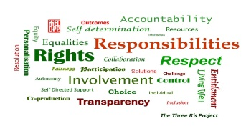
MECOPP 3 R’s Project

Self-directed Support: Making the Law Work for You Training Course

Pre-Course Assessment

Your Details
This allows us to compare your pre-course evaluation with the post-course evaluation that you will complete at the end of the training course. Your answers will remain confidential.
Name

Job Title

Organisation

Your Current Skills and Knowledge
Using a numerical scale from 1-5, where 1 is strongly disagree, and 5 is strongly agree, please tell us about your skills and knowledge now. We will ask you the same questions again at the end of the course.
 | 1 | 2 | 3 | 4 | 5
1. I understand the general principles and entitlements contained in social
care legislation and statutory guidance, how they relate to the rights of my clients at assessment and decision making stages, and the working relationship between the local authority and the supported person.

2. I am able to identify and challenge poor decision making by local authorities in relation to social care.

3. I am able to recognise potential breaches of human rights in scenarios I may come across in my work, and know how to challenge local authority decision making in this area.

4. I understand the rights and protections included in the Equality Act, how they may impact on my work in supporting individuals in receipt of social care, and how the Equality Act impacts on challenging decision-making by local authorities.

5. I understand the links between human rights, equalities and social care legislation.

What is the most important thing you hope to learn during the course?

