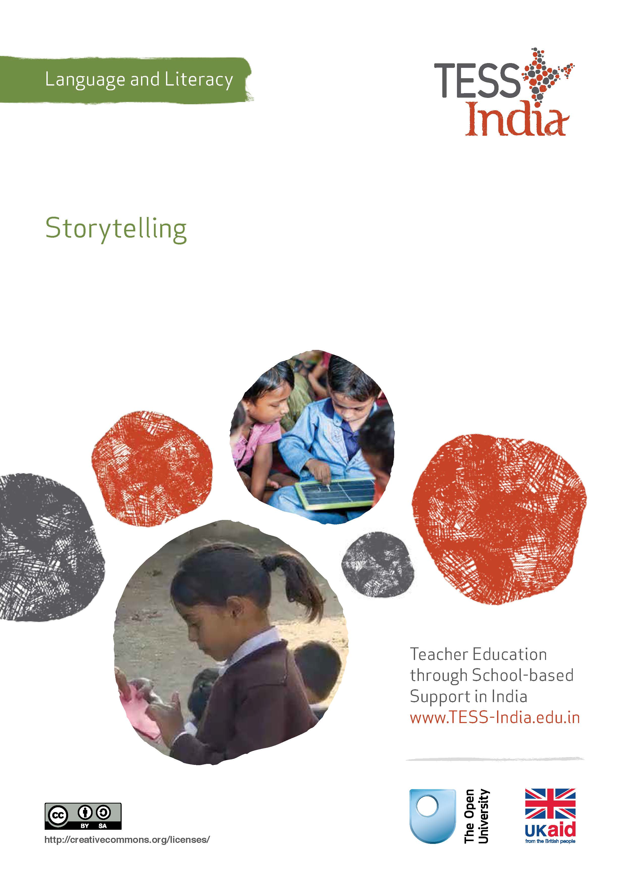
TESS-India (Teacher Education through School-based Support) aims to improve the classroom practices of elementary and secondary teachers in India through the provision of Open Educational Resources (OERs) to support teachers in developing student-centred, participatory approaches. The TESS-India OERs provide teachers with a companion to the school textbook. They offer activities for teachers to try out in their classrooms with their students, together with case studies showing how other teachers have taught the topic and linked resources to support teachers in developing their lesson plans and subject knowledge.
TESS-India OERs have been collaboratively written by Indian and international authors to address Indian curriculum and contexts and are available for online and print use (http://www.tess-india.edu.in/). The OERs are available in several versions, appropriate for each participating Indian state and users are invited to adapt and localise the OERs further to meet local needs and contexts.
TESS-India is led by The Open University UK and funded by UK aid from the UK government.
Video resources
Some of the activities in this unit are accompanied by the following icon: . This indicates that you will find it helpful to view the TESS-India video resources for the specified pedagogic theme.
The TESS-India video resources illustrate key pedagogic techniques in a range of classroom contexts in India. We hope they will inspire you to experiment with similar practices. They are intended to complement and enhance your experience of working through the text-based units, but are not integral to them should you be unable to access them.
TESS-India video resources may be viewed online or downloaded from the TESS-India website, http://www.tess-india.edu.in/). Alternatively, you may have access to these videos on a CD or memory card.

Version 2.0 LL05v1
All India - English
Except for third party materials and otherwise stated, this content is made available under a Creative Commons Attribution-ShareAlike licence: http://creativecommons.org/licenses/by-sa/3.0/

What this unit is about
This unit focuses on the many ways in which storytelling can contribute to learning and language development in the classroom. It shows you how to plan and evaluate a storytelling session for your students. It then suggests ways you can encourage your students collect and tell stories themselves. A story told well is an experience that your students will remember for a long time.

What you can learn in this unit
- Several techniques for telling stories.
- How to plan and evaluate storytelling sessions for your students.
- How to draw on community resources for storytelling.

Why this approach is important
Storytelling differs from reading aloud in that it involves recounting from memory and does not involve a text. It therefore requires a single resource: the storyteller.
Stories help people to make sense of their lives. Many traditional stories that have been passed down from generation to generation help to explain some of the rules and values of the societies and communities that they are associated with. With its multiple languages and cultures, India is particularly rich in vibrant spoken folk tales.
Storytelling has a very important role to play in developing your students’ language skills. It not only passes on wisdom and knowledge in memorable ways, but it also helps to develop children’s imagination as ideas are introduced from other times and places, and through real and invented characters.

1 Why use storytelling?
Stories are a very powerful medium in the classroom. They can be funny, inspiring and challenging. They can take their listeners from their everyday life into fantasy worlds. They can stimulate thinking about new concepts, and help people explore problems and feelings in an imaginary and unthreatening context.
Storytelling can also be used across a range of curriculum areas, including maths and science, to introduce topics and issues in engaging ways.
Pause for thought
Think back to your childhood.
- Do you remember anyone telling you stories? Who told them: your father, your mother, a grandparent or a sibling? Can you remember any of the stories? What made them special?
- When did you last tell a story to someone? Was it about an experience you had, or an imaginary tale?
Stories play an important part in our lives, and can also be a valuable classroom resource, as you will read in Case Study 1.
Case Study 1: Preparing for storytelling
Mr Sinha is an elementary school teacher from Kushinagar in Uttar Pradesh. Here he explains how he engages his young students in his storytelling.
When I was very young, my grandmother told me stories every evening. I was captivated by them. I now tell some of those stories to my own children, drawing on the same techniques as my grandmother did.
At school, I teach young students in Classes I–III. They love listening to the stories I tell them each week. Some teachers find it difficult to tell stories from memory and prefer to read to their students from a book – perhaps they feel safer that way. Storytelling does require practice and confidence, but it can be very worthwhile.
With a new story, I prepare myself in advance by telling it to my daughters or to an imaginary audience. I use a natural ‘narrator’s’ voice for the body of the story, but give the characters distinctive voices for variety. I use my face to show particular expressions like sadness or surprise, and my hands for gestures like waving.
By observing my students as I tell the story, I can tell if they are following and interested.

Pause for thought
What techniques does Mr Sinha use to engage his students in his stories?
Compare your ideas with ours:
- he uses his voice in different ways
- he employs facial expressions and hand gestures
- he observes his students’ reactions.
Now read Resource 1, ‘Storytelling, songs, role play and drama’.
Video: Storytelling, songs, role play and drama
http://tinyurl.com/video-ssrpd

2 Using stories in the classroom
Listening to stories exposes children to new vocabulary, phrases and language structures, thereby expanding their communicative abilities in speech and writing. As your students listen to stories and are given the opportunity to tell stories themselves, their language skills will improve.
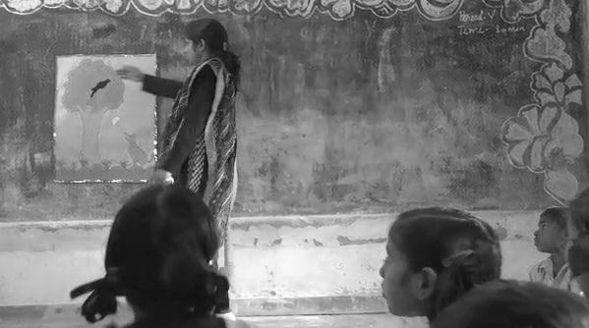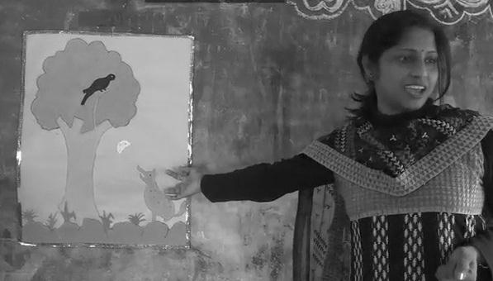
Figure 1 Using stories in the classroom.

Activity 1: Three stories
Read the three stories in Resource 2: ‘The Wide-mouthed Frog’, ‘An Old Tiger and a Greedy Traveller’ and ‘A Tale from Persia’. Each corresponds to a different type of story.
Here are three descriptions. Can you match the correct story with each one?
- One story is repetitive and humorous. It is especially good for language and literacy development. It refers to the gestures that the teller can use, while students join in by repeating the phrases and miming.
- One story is a traditional tale, with a strong moral message.
- One story is also a traditional tale that includes mathematical concepts such as addition and division, together with odd and even numbers.
Select one or more of the stories. Practise reading it aloud to your family or colleagues. Then try telling it in your own words, without the text for support. Feel free to change parts of the story. It does not need to be told exactly as it is written. Where appropriate, make up some gestures to accompany the story.
The next activity shows you how to plan a storytelling session for your class. You can use one of the stories that you have read in Activity 1 or you can choose another story that you enjoy and can tell confidently.

Activity 2: Planning a storytelling lesson
Select a story that is suitable for your class. You might choose a familiar folk tale, adapt a story from the textbook, or recount an interesting incident that you or someone else has experienced.
This example uses the story of ‘The Wide-mouthed Frog’ in Resource 2, but you may use a different story and adapt the plan accordingly.
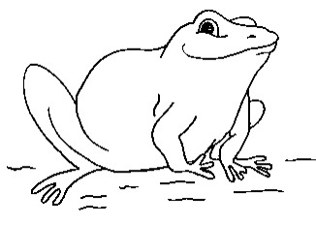
Figure 2 The wide-mouthed frog.
- Learn the story well and practise telling it without the text, using different voices, expressions and gestures for each character.
- Identify the key words and expressions in the story (e.g. frog, goat, bear, wide mouth, mother, milk, seeds, insects). Draw pictures or find objects to illustrate the key words. These illustrations and props will also help you to remember the story as you tell it.
- Gather your students around you. Ask them some introductory questions, such as:
- ‘Do you know what a frog is? What does it look like?’
- ‘What noise does it make?’
- ‘How does it move? Can you show me?’
- ‘Do you know what frogs like to eat?’
- Talk about the other animals in the story and ask questions about them.
- Use the students’ home languages to help them understand your questions and any new words or expressions, as required.
- Explain that the story you are going to tell them is about a frog who has a very wide mouth. Demonstrate a wide mouth.
- Tell the story, using appropriate voices for the different characters, varying the volume for effect (by shouting or whispering, for example), employing gestures, and showing your students any props or pictures to accompany it.
- Pause every so often to ask your students questions. These could include:
- ‘What do you think Mother Bird feeds her babies?’
- ‘Who do you think she is going to meet now?’ (Show them a picture of the answer if you have one.)
- Discuss the ending of the story with the whole class. Ask questions such as:
- ‘Why was the frog afraid?’
- ‘How did the frog answer the bear? Why?’
- ‘What do you think the frog did next?’
- Reflect on how the lesson went, making notes as you do so. What worked well? What would you improve next time? Were all the students engaged? If some did not seem to understand, what might be the reasons for this? Did all of them have the chance to respond and talk about the story? Evaluating the lesson in this way will inform you as to how your students are developing their language and listening skills, while also helping you to improve your storytelling techniques.
- Be sure to make eye contact with all your students – whether they are sitting close to you or further away – as you tell the story.
Storytelling can prompt a number of student activities beyond listening. Students can be asked to note down all the colours or numbers mentioned in the story, illustrate it in groups, change the ending, compare two characters, or discuss the issues it raises.
They can be divided into groups and given pictures or props to retell the story from another perspective, or they could take the parts of the characters and do a role play together.
Older students can be invited to analyse a more complex story, debate scientific explanations for particular phenomena, distinguish fact from fiction, or solve any associated mathematical problems.

3 Collecting community stories
Storytelling is a shared activity that can bind a family or community together, recall histories, and preserve languages and cultures. There are many stories that older members of the community will remember. Collecting these stories is an exciting way of involving your students, their families and the community in the life of the school. You can read about an example of how one class does this in Case Study 2.
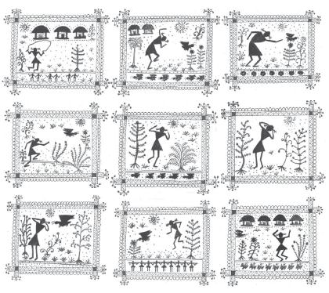
Figure 3 Community stories are a useful resource for your teaching.
Case Study 2: Collecting local stories
Ms Kuheli is an elementary school teacher from Lucknow. Here she describes how she encourages her students to share stories from their community.
I ask my students to learn a story from their family members or neighbours. I give them about a week to collect and learn the story. I then invite one or two students a day to tell their story to the class, using different voices, gestures and actions to accompany it.
The first time I did this, my students told their stories in Hindi. However, the next time, I decided to include stories in the various local languages spoken in Lucknow, such as Awadhi, Braj, Bhojpuri, Koeli and Urdu. I asked the students who speak these languages to collect a story and tell it to the class. When they had finished, they translated the story into Hindi, with the help of their classmates.
I followed this up by inviting the whole class to draw pictures to illustrate the key events or main characters in the story they had heard or to write it out in their copybooks.
By sharing the stories from their communities with their peers, this activity seems to be building connections among my students within the classroom.

Pause for thought
- What is the value of encouraging students to tell stories in their home language?
- How might students who are shy be supported to tell their stories to their classmates?
- What other activities can you think of to follow up the students’ stories?
Collecting stories, songs, poems or other oral traditions from the community creates a positive link between the school, your students’ families and other local people. It enables students to ask thoughtful questions and listen carefully to accounts of the history and culture of their locality. Encouraging students to retell these stories in their home languages emphasises the value of these languages in the local environment. It also allows students to use these languages to develop their Hindi.
If some students seem hesitant to tell their stories, you might ask them to tell you their story after the lesson. This would give them an opportunity to try telling it in a safe and private space, instead of in front of their peers. Make sure to praise and encourage these students so as to build their confidence. You could also try pairing them with students that you know are their friends, or who speak the same home language.
Read the key resource ‘Involving all’ (http://tinyurl.com/kr-involvingall) to learn more about the principles of inclusion and participation in the classroom.
Video: Involving all
http://tinyurl.com/video-involvingall
For further ideas about how to follow up students’ stories, see Activity 3.

Activity 3: Collecting stories from the community
Organising the collection of stories by your students will need time, along with sensitive and careful planning.
- Using Case Study 2 as a guide, prepare your students to ask their family members at home if they are familiar with any stories, songs, or poems. Encourage your students to learn these stories, songs or poems, in Hindi or their home language, using voice, gestures and actions to accompany them if they wish.
- Make a special time each day, or once a week, for a student to tell their story.
- Allow them to practise the story with a partner or small group before telling it to the whole class.
- Model to the rest of the class how to be a good and appreciative listener. Respond positively to your students’ efforts to tell the stories and encourage their classmates to do the same.
- If the story is in a local language, allow time to discuss the translation into Hindi, focusing on the corresponding key words in the story.
- Seek out opportunities for your students to tell their stories to other classes, at the school assembly or at a local event.
- Ask your students write out their stories in their copybooks, accompanying them with illustrations.

4 Summary
This unit has described a number of ways in which storytelling can be exploited in the language and literacy classroom. It has outlined a series of steps that you can follow to plan storytelling sessions that are appropriate to your students’ ages and interests. It has also proposed ways in which your students can be involved in collecting stories and telling them to their classmates, perhaps in their home language, thereby developing stronger links between the school and the local community. This will help make students feel that their home languages and cultures are valued at school, and will also allow them to build on their skills in these languages to develop their Hindi. In most cases, students enjoy listening to and telling stories. Try to find ways to increase the amount of stories you use in your lessons, as they can be valuable for learning in any subject area.

Resources
Resource 1: Storytelling, songs, role play and drama
Students learn best when they are actively engaged in the learning experience. Your students can deepen their understanding of a topic by interacting with others and sharing their ideas. Storytelling, songs, role play and drama are some of the methods that can be used across a range of curriculum areas, including maths and science.

Storytelling
Stories help us make sense of our lives. Many traditional stories have been passed down from generation to generation. They were told to us when we were young and explain some of the rules and values of the society that we were born into.
Stories are a very powerful medium in the classroom: they can:
- be entertaining, exciting and stimulating
- take us from everyday life into fantasy worlds
- be challenging
- stimulate thinking about new ideas
- help explore feelings
- help to think through problems in a context that is detached from reality and therefore less threatening.
When you tell stories, be sure to make eye contact with students. They will enjoy it if you use different voices for different characters and vary the volume and tone of your voice by whispering or shouting at appropriate times, for example. Practise the key events of the story so that you can tell it orally, without a book, in your own words. You can bring in props such as objects or clothes to bring the story to life in the classroom. When you introduce a story, be sure to explain its purpose and alert students to what they might learn. You may need to introduce key vocabulary or alert them to the concepts that underpin the story. You may also consider bringing a traditional storyteller into school, but remember to ensure that what is to be learnt is clear to both the storyteller and the students.
Storytelling can prompt a number of student activities beyond listening. Students can be asked to note down all the colours mentioned in the story, draw pictures, recall key events, generate dialogue or change the ending. They can be divided into groups and given pictures or props to retell the story from another perspective. By analysing a story, students can be asked to identify fact from fiction, debate scientific explanations for phenomena or solve mathematical problems.
Asking the students to devise their own stories is a very powerful tool. If you give them structure, content and language to work within, the students can tell their own stories, even about quite difficult ideas in maths and science. In effect they are playing with ideas, exploring meaning and making the abstract understandable through the metaphor of their stories.

Songs
The use of songs and music in the classroom may allow different students to contribute, succeed and excel. Singing together has a bonding effect and can help to make all students feel included because individual performance is not in focus. The rhyme and rhythm in songs makes them easy to remember and helps language and speech development.
You may not be a confident singer yourself, but you are sure to have good singers in the class that you can call on to help you. You can use movement and gestures to enliven the song and help to convey meaning. You can use songs you know and change the words to fit your purpose. Songs are also a useful way to memorise and retain information – even formulas and lists can be put into a song or poem format. Your students might be quite inventive at generating songs or chants for revision purposes.

Role play
Role play is when students have a role to play and, during a small scenario, they speak and act in that role, adopting the behaviours and motives of the character they are playing. No script is provided but it is important that students are given enough information by the teacher to be able to assume the role. The students enacting the roles should also be encouraged to express their thoughts and feelings spontaneously.
Role play has a number of advantages, because it:
- explores real-life situations to develop understandings of other people’s feelings
- promotes development of decision making skills
- actively engages students in learning and enables all students to make a contribution
- promotes a higher level of thinking.
Role play can help younger students develop confidence to speak in different social situations, for example, pretending to shop in a store, provide tourists with directions to a local monument or purchase a ticket. You can set up simple scenes with a few props and signs, such as ‘Café’, ‘Doctor’s Surgery’ or ‘Garage’. Ask your students, ‘Who works here?’, ‘What do they say?’ and ‘What do we ask them?’, and encourage them to interact in role these areas, observing their language use.
Role play can develop older students’ life skills. For example, in class, you may be exploring how to resolve conflict. Rather than use an actual incident from your school or your community, you can describe a similar but detached scenario that exposes the same issues. Assign students to roles or ask them to choose one for themselves. You may give them planning time or just ask them to role play immediately. The role play can be performed to the class, or students could work in small groups so that no group is being watched. Note that the purpose of this activity is the experience of role playing and what it exposes; you are not looking for polished performances or Bollywood actor awards.
It is also possible to use role play in science and maths. Students can model the behaviours of atoms, taking on characteristics of particles in their interactions with each other or changing their behaviours to show the impact of heat or light. In maths, students can role play angles and shapes to discover their qualities and combinations.

Drama
Using drama in the classroom is a good strategy to motivate most students. Drama develops skills and confidence, and can also be used to assess what your students understand about a topic. A drama about students’ understanding of how the brain works could use pretend telephones to show how messages go from the brain to the ears, eyes, nose, hands and mouth, and back again. Or a short, fun drama on the terrible consequences of forgetting how to subtract numbers could fix the correct methods in young students’ minds.
Drama often builds towards a performance to the rest of the class, the school or to the parents and the local community. This goal will give students something to work towards and motivate them. The whole class should be involved in the creative process of producing a drama. It is important that differences in confidence levels are considered. Not everyone has to be an actor; students can contribute in other ways (organising, costumes, props, stage hands) that may relate more closely to their talents and personality.
It is important to consider why you are using drama to help your students learn. Is it to develop language (e.g. asking and answering questions), subject knowledge (e.g. environmental impact of mining), or to build specific skills (e.g. team work)? Be careful not to let the learning purpose of drama be lost in the goal of the performance.
Resource 2: Three stories

‘The Wide-mouthed Frog’
Once there was a wide-mouthed frog who always talked too much. She decided to go around to all the other animals and ask them what kind of food they feed their babies.
As the wide-mouthed frog hopped along, she met Mother Bird. The wide-mouthed frog asked, ‘Mother Bird, what kind of food do you feed your babies?’ [Use a very wide mouth when telling the frog’s part.]
‘I feed my babies … [Ask your students ‘What do you think mother bird feeds her babies?’] … insects!’
And the wide-mouthed frog said with her mouth wide open, ‘Oh, is that so?’
Then the wide-mouthed frog met … [Show the picture and ask ‘Who do you think she is going to meet this time?’] … Mother Goat and asked her, ‘Mother Goat, what kind of food do you feed your babies?’
The mother goat said, ‘I feed my babies … [Ask your students ‘What do you think mother goat feeds her babies?’] … milk!’
Then the wide-mouthed frog said with her mouth wide open, ‘Oh, is that so?’
[You can add one or two more animals that your students will be familiar with. The last animal should be a rather frightening one to the frog, such as a crocodile or bear – as follows.]
Then the wide-mouthed frog met a mother bear and asked, ‘Mother Bear, what kind of food do you feed your babies?’
When the mother bear saw the wide-mouthed frog, she was very happy and said, ‘Ooooh!’ The wide-mouthed frog became very afraid when she saw her great big mouth.
The mother bear said, ‘I feed my babies wide-mouthed frogs!’
The wide-mouthed frog said, with a very small mouth, ‘Oh, is that so?’ [Remember to use a small mouth!]

‘An Old Tiger and a Greedy Traveller’
Once upon a time, there lived a tiger in a forest. With the passing year, he became too old to hunt. One day, the tiger was walking by the side of a lake and suddenly saw a gold bangle. Quickly he picked up the bangle and thought that he could use it as a lure to catch someone. As he was thinking this, a traveller happened to pass by on the other side of the lake.
The tiger instantly thought to himself, ‘What a delicious meal he would make!’ He planned a scheme to attract the traveller. He held the bangle in his paw, making it visible to the traveller and said, ‘Would you like to take this gold bangle? I don’t require it.’ At once, the traveller wanted to take the bangle, but he hesitated to go near the tiger. He knew that it was risky, yet he sought the beautiful gold bangle. He planned to be cautious, so he asked the tiger, ‘How can I believe you? I know you are a beast and would kill me.’
The tiger innocently said, ‘Listen traveller, in my youth, I was wicked unquestionably, but now I have changed. With the advice of a Sanyasi, I have left all evil. Now I am all alone in this world and have engaged myself in kind deeds. Moreover, I have grown old. I have no teeth and my claws are blunt. So, there is no need to fear me.’ The traveller was taken in by this talk and his love for gold soon overcame his fear of the tiger. He jumped into the lake to wade across to the tiger.
But as the tiger planned, the traveller got trapped in the marsh. On seeing this, the tiger consoled him and said, ‘Oh! You need not worry. I’ll help you.’ Gradually he came towards the traveller and seized him. As the traveller was being dragged out onto the bank, he thought to himself, ‘Oh! This beast’s talk of saintliness took me in totally. A beast is always a beast. If only I had not let my greed overcome my reason, I could be alive.’ However, it was too late; the tiger killed the traveller and ate him up. And so the traveller became a victim of greed and the tiger was successful in his evil plan.
Moral: greed never goes unpunished.

‘A Tale from Persia’
Long ago, a man from Persia hosted a Bedouin from the desert, sitting him at table with his wife, two sons and two daughters. The wife had roasted one chicken, and the host told his guest: ‘Share it out among us,’ meaning to make fun of him. The Bedouin said he did not know how, but if they humoured him he would try. When they agreed, he took the chicken and chopped it up, distributing it with these words: ‘The head for the head of the family,’ as he gave his host the bird’s head; ‘the two wings for the two boys, the two legs for the two girls,’ giving them out, and ‘the tail for the old woman,’ giving the wife the tail of the bird and finally, taking the best portion for himself, ‘The breast for the guest!’ he said.
Now, the next day, the host said to his wife (having enjoyed this joke) that she should roast five chickens, and when lunchtime came he told the Bedouin, ‘Share them out among us.’
‘I have an idea,’ his guest replied, ‘that you are offended.’
‘Not at all. Share them out.’
‘Would you like me to do it by even numbers or odd?’
‘By odd numbers.’
‘Very well,’ said the Bedouin. ‘You, your wife and one fowl make three.’ (Giving them one chicken.) ‘Your two sons and one fowl make three. Your two daughters and one fowl make three. And I and two chickens make three,’ he finished, taking two chickens for himself; and the joke was on the host again.
Seeing them eyeing his share, he smiled and continued, ‘Perhaps you are not content with my method. Shall I share them out by even numbers, then?’ When they said yes, he replied, ‘Well, then, my host, you and your two sons and one fowl make four. Your wife, her two daughters and one fowl make four.’ He passed the three male members of the household one chicken, and the three female members got one. ‘And,’ he concluded, giving himself three chickens, ‘myself plus three fowls makes four.’

Additional resources
- Indian folk tales: http://www.culturalindia.net/indian-folktales/
- The World Storytelling Institute’s website includes resources for teachers (http://www.storytellinginstitute.org/12.html) and a wealth of links to stories, many from India (http://www.storytellinginstitute.org/87.html)
- The Storytelling in the Classroom website has a variety of ideas and stories for teachers to tell in the classroom: http://www.storyarts.org/classroom/index.html
- Katha is a publisher that has produced more than 300 books from various regions in India; it also provides training in storytelling: http://www.katha.org/site/katha-bookstore
- Kathalaya provides training and resources for teachers in storytelling in the classroom: http://kathalaya.org/
- The Tallest Story Competition includes animated stories from different tribal groups in India: http://www.talleststory.com/
- The Society for Storytelling website contains a lot of factsheets for learning about storytelling: http://www.sfs.org.uk/resources

References/bibliography
Morgan, J. and Rinvolucri, M. (1983) Once Upon a Time. Cambridge: Cambridge University Press.
Slattery, M. and Willis, J. (2001) English for Primary Teachers. Oxford: Oxford University Press.
Society for Storytelling (2004) ‘Telling tales: a beginner’s guide to telling stories’ (online), March. Available from: http://www.sfs.org.uk/content/telling-tales-beginners-guide-telling-stories (accessed 18 November 2014).
Wakefield, D. (1992) The Wide-Mouthed Frog, Illustrated by Spaeth, C. SIL International.
Wright, A. (1996) Storytelling with Children. Oxford: Oxford University Press.

Acknowledgements
Except for third party materials and otherwise stated below, this content is made available under a Creative Commons Attribution-ShareAlike licence (http://creativecommons.org/licenses/by-sa/3.0/). The material acknowledged below is Proprietary and used under licence for this project, and not subject to the Creative Commons Licence. This means that this material may only be used unadapted within the TESS-India project and not in any subsequent OER versions. This includes the use of the TESS-India, OU and UKAID logos.
Grateful acknowledgement is made to the following sources for permission to reproduce the material in this unit:
Figure 3: courtesy of Eram Gomango from Gajipati district of Odisha
Resource 2: ‘The Wide-mouthed Frog’, extract adapted from Keith Faulkner’s ‘The Wide-mouthed Frog’; ‘An Old Tiger and a Greedy Traveler’, adapted from the Hitopadesha, a collection of Sanskrit fables in prose and verse from the 12th century.
Every effort has been made to contact copyright owners. If any have been inadvertently overlooked the publishers will be pleased to make the necessary arrangements at the first opportunity.
Video (including video stills): thanks are extended to the teacher educators, headteachers, teachers and students across India who worked with The Open University in the productions.

