Workbook for ‘What managers need to know to introduce new approaches successfully’
In this workbook you will be encouraged to reflect on how each of the approaches introduced in this course could be introduced by managers within your institution. You now have a good knowledge of a new and better way of doing things and begin to discuss how to bring about these changes within your institutions.
The activities below are for your personal reflection, but they would work very well as collaborative activities in a workshop setting too, perhaps facilitated by yourself.

Approach 1 How to design curriculum to empower learners

Study the following table showing tertiary education in ASEAN countries and answer the following questions.
- What is the most studied degree programme in Myanmar?
- What are the second and third most studied degree programmes in Myanmar?
- How does this compare with one developed country, such as Germany, and an ASEAN state, such as Vietnam?
- What does this comparison tell you?
- Do you feel Myanmar has a good balance of graduates to help it become a dynamic economy to compete in a globalised world? If so, why, if not, why not?
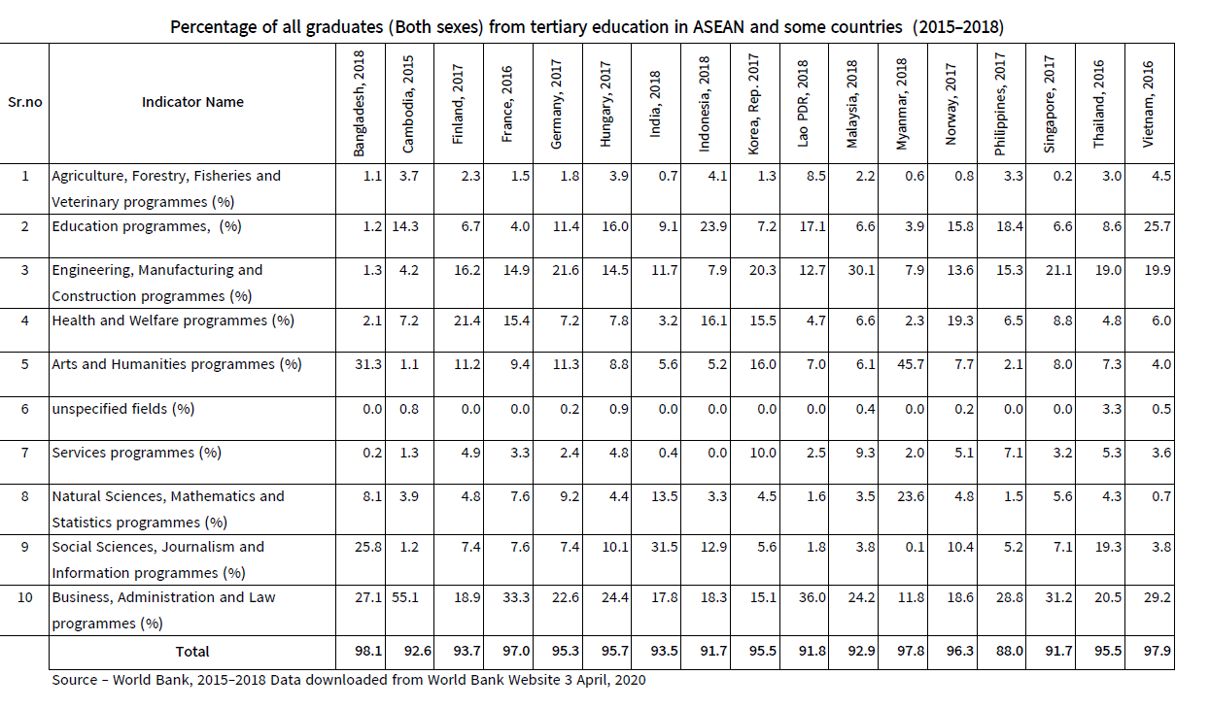
- On the basis of your answers to Q.1 what new programmes of study do you think Myanmar needs?

Answers:
Q.1
a. Arts and Humanities
b. 2nd Natural sciences, Mathematics and Statistics, 3rd Business, Administration and Law.
c.d.e. We don’t know how you answered these questions but we hope the exercise provided a good basis to reflect on the balance of graduates across programmes
Q.2
For interest and to stimulate discussion, Dr. Myo, the Chairman of the National Education Policy Committee, proposed the following new programs or study and subjects in 2019.

•Tourism
•Eco-tourism, Hotel Management
•Business Management
•Accountancy
•English for Specific Purposes (ESP)
•Business Law, Trade law, Industry law
•Creative Arts, Painting, Designs, fashions,
•Sociology
•Social Works
•Nursing, Medical aids,
•Construction Works, Estate Management,
•Banking, Monetary Works,
•ICT Subjects, Media Development,
•Office Management, etc.
Source: Presentation to NEPC.

Approach 2 How to engage students to be more active in their learning
- This activity is to help you understand your students better and why they might be more comfortable with passive rather than active study. If you can understand the challenges they face you will be better able to encourage and support them to become more active in their own learning. Below is a diagram of a typical student with 4 lines coming off the student and 2 boxes for two different text answers. Record in the red boxes reasons why effective study is difficult for students drawing on your experience. Provide one reason in each red box, so a total of 4 reasons.

In the green boxes record ways the barriers to students’ effective learning might be overcome, with one way in each of the 4 green boxes. This is more difficult but try to recall your own student days and the coping strategies you used to overcome similar constraints. As a successful academic, you have a wealth of good experience to draw-on.
2. Myanmar academics are usually most comfortable using assimilative activities in their teaching. Think about a piece of teaching for which you might use a different type of activity and write the activity for it. It doesn’t matter what other activity type you select as long as it isn’t assimilative. Reflect on the extra learning that this activity would deliver over the learning from an assimilative activity. Please try this activity with your students when you next teach this topic and evaluate how successful it is. You could ask students to evaluate it too.

Answers:
- There is no set of correct answers to this question as they are unique to you and your experience of your students. Some points you might have raised are internet challenges experienced by students. A way of addressing this is for the student to download materials when they have internet access so that they can work offline. Another challenge may be weak study skills which can be addressed by encouraging students to reflect on the feedback they receive from their teachers and thinking of an action plan to overcome identified weaknesses. Inculcating an approach of reflection and responding with an action plan will improve student study skills, although it will take honesty and commitment from the student.
- This is likely to have been challenging taking you out of your comfort zone. But trying different activity types will enable you to see different ways to teach the same material. Testing the activities with your students will be a dynamic way of learning for both you and your students. Remember, if the activity isn’t well received by your students, don’t give up as there are lots of other activity types to try.

Approach 3 How to build employability skills
- Study the following graduate competency framework produced for TIDE and answer the following questions.
- Does anything surprise you about the graduate competency framework?
- Are there any technical skills that have been missed?
- Are there any behaviours that have been missed?
- Are there any values that have been missed?
- Is there the right balance between generality and detail?
- Is it simple enough to engage employers and educators?
- How might you use this in your university to inform curriculum design?
Level | Personal conduct and work relationships | Technical knowledge and skills | Communication skills
Competent | A leader (demonstrated by sports leadership, community leadership or taking the initiative in study group work)  Strong interest in major subject  Ability and motivation to undertake own research to build subject based knowledge  Closely follows assignment guidelines and meets deadlines  Manages time well  Actively networks with study group within major | Good understanding of degree subject foundations (knowledge and skills)  Can use email and attachments, and print.  Uses Viber and Facebook for personal communication and to access learning content  Can download online material for offline working  Some knowledge of WORD although unlikely to extend to archiving in folders  Can operate a photocopier, scanner and other office devices | Very good written and spoken Burmese using correct grammar and a range of vocabulary  Good understanding of written English, sound understanding of spoken English and developing skills in speaking English  Able to vary writing and speaking style for different tasks and audiences  Can produce an appropriate CV
Basic Competency | A participator (demonstrated by involvement in sporting activities, community involvement or study group work)  Instrumental interest in subject sufficient to get the degree  Loosely follows assignment guidelines but meets deadlines  Time pressured but manages to prioritise  Passively networks with study group within major | Solid understanding of degree subject foundations (knowledge and skills)  Can use email with basic language but no ability to attach documents  Uses Viber and Facebook largely for personal communication but some use for study  Weak knowledge of WORD and other software packages or office devices | Good written and spoken Burmese with some grammar errors but a solid range of vocabulary  Weak understanding of written and spoken English, and weaker ability to speak English  Tries to vary writing and speaking style for different tasks and audiences  Can produce a basic CV
Barely competent | A non-participator  Little or no genuine interest in degree subject  Struggles to follow assignment guidelines and to submit on time  Struggles to manage study time effectively  Does not network with other students | Weak understanding of degree subject foundations (knowledge and skills)  Does not use email.  Uses Viber and Facebook for personal communication only  No knowledge of software packages or office devices | Adequate written and spoken Burmese with many grammar errors and limited vocabulary  Minimal understanding of written or spoken English, and no confidence to speak English  Unable to vary writing and speaking style for different tasks and audiences  Has never produced a CV

2. Suggest how such competences might be evidenced by graduates. Think about how your institution might show them in degree transcripts and how your students can demonstrate them on an employment application and at an employment interview.
3. What information would employers like to see in course descriptions that would help them understand if and how such competences are being developed in a particular degree programme?
Answers:
- This answer is dependent on your experiences. But it is also likely to be influenced by your subject field, and your knowledge of what employers want. If you meet with family and friends who work outside education it may be interesting to ask for their viewpoints as to the skills, behaviours and values they most prize in their employees.
- This might be achieved by providing opportunities for students to show leadership through extra-curricular activities, developing team working through group projects, and practising communication skills by delivering presentations. There should also be a way to capture student achievements of competences, perhaps by the student writing a personal statement for inclusion on their transcript. This can be verified by the institution, and would also be something the student can draw on for employment applications and interviews.
- Course descriptions are usually written with the student in mind. But including the competences a course develops will provide an employability focus helping employers better evaluate what a graduate will bring to their organisation. Approach 4 will offer support with engaging employers.

Approach 4 How to engage with employers
1. Of the nine different ways universities can engage with employers (listed below), which are your university currently involved with, or have been in the last 2 years?
- Apprenticeships
- Placements and internships
- Mentoring
- Funding study
- Curriculum design
- Networking
- Consultancy services
- Customised training
- Job fairs

- Rank the employers your university would be most interested to work with, where 1 is the highest priority and 6 the lowest priority.
- Government departments
- Multi-national companies
- Non-governmental organisations/Charities
- Small businesses
- Social enterprises
- Foreign aid donors

- Reflecting on the 4 key reasons universities should work with employers, (student success, innovation, government policy and income diversification), what do you think is the most important for your university and why?
Answers:
Qs. 1, 2 and 3
There are likely to many different responses to these three questions as you are being asked to evaluate the practice of your university which is subjective. Not only will there be differences between universities, but also within them. The important learning from these questions is to identify the evidence base for your answers. In this way you can engage in a more critical evaluation.
END

