Inclusive Teaching Practice
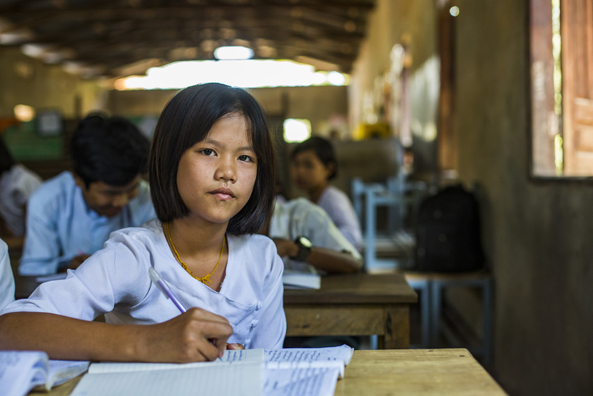
Facilitator’s Guide

Source: VSO Image library

Module 5:
Creating a Positive Learning Environment

Module 5: Creating a positive learning environment.

Overview
This is the fifth of fifteen modules that look at how we create a positive Inclusive Learning Environment for all. You will see how inclusive teaching practices encourage, develop and use the 21st century skills of critical thinking, communication, collaboration and creativity. These modules are for any educators or those studying in education in Myanmar. The terms student and learner are used interchangeably throughout the module.
Module number | Module title
1 | What is an Inclusive School, Classroom and Teacher?
2 | Knowing your learners
3 | Planning learning outcomes for all
4 | Participating through learner centred approaches
5 | Creating a positive learning environment
6 | Effective questioning and feedback
7 | Active participation
8 | Peer, co-operative and collaborative learning
9 | Supporting students’ emotional and social wellbeing
10 | Legal framework and policies around Inclusion in Myanmar
11 | Supporting all students through differentiation
12 | Identifying specific learning difficulties
13 | Supporting all learners with differences or disabilities
14 | Positive behaviour management
15 | Assessment for student achievement

Learning Journal
Please ensure all participants are aware of the learning journal and its purpose for the module. Point them to the advice given in their participants’ copy of the best way to complete. All answers to activities need to be written in their journal. Remember, reflection is an important part of the learning process and a worthy activity alone. Encourage participants to make a note of new and interesting words/phrases/terms as they make their way through the module.

Study tips
It is important to explain how to approach completing the module. Participants need to take their time, develop a suitable timetable and where possible check their answers with colleagues. The use of think / pair / share is a good way for them to collaborate, share ideas, ask questions, check their work, and give feedback.

Background to the Inclusive Practice CPD modules.
There are 3 key themes explored in the modules that reflect the educational reform taking place in all education settings: Inclusion, Gender Equity and 21st century skills. These themes are key in all areas of curriculum, and vital not only for Myanmar’s educational ambitions and sustainable development but equally vital for the global future.
This course has been designed to help participants engage in this discussion by challenging their beliefs and attitudes about their own teaching, their students’ learning and the impact their educational institution has on inclusion. It is expected that as a facilitator, you will challenge their beliefs and attitudes throughout the modules.
It is also important for you as a facilitator to embed many of the teaching and learning techniques associated with inclusion in education into this course. Encourage participants to work at their own pace and consider their own abilities, interests and skills.
The modules look at how we create a positive Inclusive Learning Environment for all. You will see how inclusive teaching practices support gender equity and encourage, develop and use the 21st century skills of critical thinking, communication, collaboration and creativity. Each module is made up of a series of activities participants can work through at their own pace. Once they have completed the module, they will have a multiple-choice quiz to complete.

Learning outcomes for Module 5
By working through this module, you will be able to:
- identify and evaluate elements of a positive learning environment.
- identify and explain strategies so that all students can participate.
- discuss the influence that teachers have in creating a positive learning environment.
- Plan ways to create a positive learning environment for ALL learners.

The previous module introduced the concept of using learner centred approaches in your classroom, where the learner takes responsibility for their own learning - this is very different to traditional teacher centred approaches. Participants explored the differences between the traditional teacher centred approach and teaching in the modern classroom to facilitate development of 21st Century skills in all learners. They also considered how to use group management techniques to encourage the effective participation and collaboration of all learners.

This fifth module introduces the idea of creating a positive learning environment, which builds on previous inclusive practices and modules. It looks at encouraging the participation of all learners by considering how positive the learning environment is in the school and in the classroom where they learn.

Extra instructions for the activities in module 5

Activity | Additional points to consider
Prior knowledge assessment | The first task is a recap assessment of module 4. This reminds the learner of the previous module contents and helps them to recall important information in preparation for this module. After the first attempt, suggest that the learners refer to the first module to check their answers.  Discuss any ways that the learning from Module 4 has been used. Ask participants what impact this has had on teaching and learning.
Introduction | Ask participants what they understand by the term ‘Positive learning Environment.’ Put the participants in groups with a large sheet of paper and some pens. Ask them to add the title ‘Positive learning Environment’ in the middle and draw an eye, ear and a hand around the side. Encourage participants to discuss what they think a positive learning environment looks like, sounds like and feels like. They should write their ideas under the corresponding image and present back to the group.
1.1 Self-assessment | Some participants may need encouragement to be honest in their self-assessment. Encourage participants, by telling them that their understanding and confidence will develop over time. The results from this self-assessment will be compared to another self-assessment at the end of module 5, allowing participants to make comparisons and reflect on their learning.
Activity 5.1 – Positive Learning Environment Definition | Before participants read this section, you could ask them to create a list of words that are similar. Ask participants to work in pairs to come up with their own description/definition of each word. Listening to others when they feedback, participants might choose to refine their definition. Encourage them to read the definitions provided in the Guide and record their own in their learning journal.  See further discussion focus in the Participant guidebook.
Activity 5.2 – Case study - Hnin Nway’s feelings | Participants are asked to read a case study and imagine that they are a student in that scenario. They are asked to think about what they would like the teacher to stop doing and describe how it makes them feel.  Participants might like to share their own personal experiences and describe how they felt and the impact it had on their learning.
Activity 5.3 – The importance of positive interactions | Support participants in reflecting on module 1 about what makes an inclusive teacher and the importance of knowing your learners in module 2 which focussed on the need to develop positive relationships with students. Ask participants why it is important that attending schools and educational institutions is a positive experience for students. You might ask participants to interview family members about their experiences and what they liked and disliked. Notice if the ‘likes’ are linked to people and how they made students feel.  Invite students to watch the video link before class and discuss it. The statements provided in the participant book could be used individually to discuss the impact. The third column in the activity about reflection, might be a more individual task that participants might enjoy following a session when there is time for them to reflect.
2.4.1 A sense of belonging | Provide participants with the statements that make up the triangle and ask them to rank them in order from lowest to highest with the greatest human need at the bottom. Discuss what participants think each part means and encourage them to share examples and link it to the students they teach. Talk about the feeling of ‘belonging’ and why it is important to student’s feeling safe and secure within an educational setting.
Activity 5.4 – The importance of getting the physical space right | Look at images of typical Myanmar classrooms or walk around the setting you are in. Ask participants to comment on the physical space and learning resources available.  Discuss suggestions on how participants can make the physical space more inviting to learners. Encourage participants to revisit module 1 – what makes an inclusive school/classroom and any notes they made in their learning journal. Suggestions are provided in the Participant book, encourage them to discuss these. You might like to ask if participants will face any challenges and encourage them to discuss as a group how they could overcome these.
Activity 5.5 – Routines in place | Write up the word routine. Give the participants a minute to think about routines they have in their settings. They could make notes if that is useful. After a minute, ask participants to work in pairs to discuss their routines and what impact they have on the learning environment. Does their partner use any routines that they think would be useful? Have they seen another colleague using a routine that they would like to use – where should they start?
Activity 5.6 – How a learning environment can be improved | Provided in the participant book is a list of ideas for educational settings that can support a positive learning environment. Participants are asked to group them into categories, such as routines, interactions and physical environment. Ask participants how they would like to represent their task – they could use sheets of paper split into 3 columns, they might like to represent the statements visually using a poster, they might like to create a positive learning environment model to talk through that encompasses all the positive elements from the list. Encourage participants to add their own ideas and present it in a way that will engage them.
Activity 5.7 – Positive learning environment Case Study | Participants are provided with a case study that suggests ideas to help with the development of a positive learning atmosphere. Encourage participants to read it and think about how the teacher worked hard to create a positive learning atmosphere for all students.  When participants have identified key words or phrases in the case study, encourage them to write them in their learning journal. They could link the words back to the previous activity and sort them into the categories; Classroom routines, Physical environment and resources and Interactions.
Activity 5.8 – Develop ideas to create a positive learning environment | This activity asks participants to think about what they need to do to develop a positive learning environment in their own classroom or setting. Allow them time to think back to module 1 (Activity 1.8 – what makes an inclusive classroom) where they drew a classroom in their learning journal. Encourage participants to use their creativity by drawing the classroom again and adding elements that they have discussed through this module to make it more positive and inclusive.  Remind participants to think about inclusive practice and the different needs of all the learners they teach, considering what the learners could see, hear, smell and feel in a PLE, using the previous notes.
Wrap up | A consolidation of the module and key points. There is no activity here.
End of module 5 quiz | This is a multiple-choice questionnaire that tests participants’ understanding of the module. Encourage participants to self-assess and revisit their answers as many times as needed to achieve 100%.
Answers to the end of module 5 quiz | Participants should revisit the questions until they achieve 100%. Remind them that some questions require more than one answer.
5.9 - Improving your own teaching practice | This activity provides a scenario for participants to consider. It asks them to complete two statements provided by their head of department. Invite participants to role play and share their experiences with the group. Ask participants how confident they felt when giving their responses. Encourage them to make notes in their learning journal.
Self-assessment | The self-assessment duplicates the first self-assessment. Ask participants to reflect on their confidence and discuss comparisons between scores.
The 5th promise | Ask participants to think of one thing they will take away from module 5 and make a promise to their learners about what they will improve. Ask them to evaluate that promise and recognise changes (after x weeks). Encourage participants to reflect on any impact that change has had on teaching and learning and how to improve it further. This reflects the beginning of the action research cycle and can be built on in future modules to create an ongoing action plan for development. Participants are encouraged to make a section in their learning journal entitled ‘Promises’. There will be a total of 15 promises.

Answers - end of module 5 quiz
Answers in bold

Q1 - Which of the following help to create a positive learning environment? (choose 3)
- Having daily routines for students to follow
- Providing feedback on student’s work every six weeks.
- Calling your favourite students by their names.
- Providing a warm welcome for every student as they arrive in class
- Making sure the class is quiet and students stay seated in the same place.
- Encouraging students to ask and answer questions
Explanation - Creating a Positive Learning Environment involves not only the school and classroom environment but also the positive relationships built between the teacher and students. The environment can be made interesting, safe and enjoyable for all students by including: water for drinking, natural materials such as plants, displays of student work and by allowing flexibility of where and how they work. Also, positive relationships between the teacher and the student can make a student feel valued and welcome to the learning environment – so they will want to attend school.
Q2 – Which routines might help to create a positive learning environment? (choose 2)
- Asking learners to come into class in a calm way every morning. They might get started with a task on the board whilst others arrive.
- When class ends, students all rush out. Most of the time chairs and desks get knocked over and someone usually gets hurt.
- When the teacher asks for hands up, the same children are selected to keep the pace of the lesson moving. Those children always seem to know the answers.
- Teachers smile at the students and encourage them with their learning. Students know that there will be time to reflect on their learning at the end of each lesson.
Explanation - Routines represent predictability and security, which help students feel safe and confident. Effective routines improve behaviour and make certain practices calm and consistent. If students start the day in a calm way and are encouraged to get started with work, the tone is set for the day. If students know that there will be an opportunity to reflect on their learning, they will see that the lesson/learning is continuous, that they can back to it and have another try.

Q3 – What can teachers do with the physical classroom space to create a positive learning environment?
- Create a clean, bright and organised working environment.
- Ask students to bring in lots of things from home.
- Only allow students to use the older books and materials.
- Put up lots of posters of cute animals.
Explanation – It would be unfair to ask students to bring items in from home as some may not have the ability to do that and the posters of animals might look nice but a teacher would have to consider the impact they have on teaching and learning. If we show students how to use and respect resources, they will take care of them, therefore only allowing them to use older books or materials that does not give the right message – that we trust students and that they can use the best materials the school has to support their learning. Most spaces allow for light, can be cleaned and organised to allow students to study.
Q4 – Which of the following describes a positive learning environment?
- A classroom where everyone performs well on tests set.
- A classroom where everyone is always happy.
- A classroom where everyone feels a sense of belonging.
- A classroom where students are always silent.
Explanation – A positive learning environment does not mean that everyone must be positive and look happy at all times (including the teacher). Not all students will perform well on tests all the times, for a variety of reasons. It is important that all students feel like the belong and feel welcome and valued in class. The classroom may be silent at times but at other times students maybe working in groups (module 4) and discussing their learning.

Q5 – In an inclusive and positive learning environment, the diversity of students is …
- Disregarded
- Punished
- Discouraged
- valued
Explanation – ALL students, regardless should be made to feel valued by their teacher.

