Inclusive Teaching Practice
Facilitator’s Guide

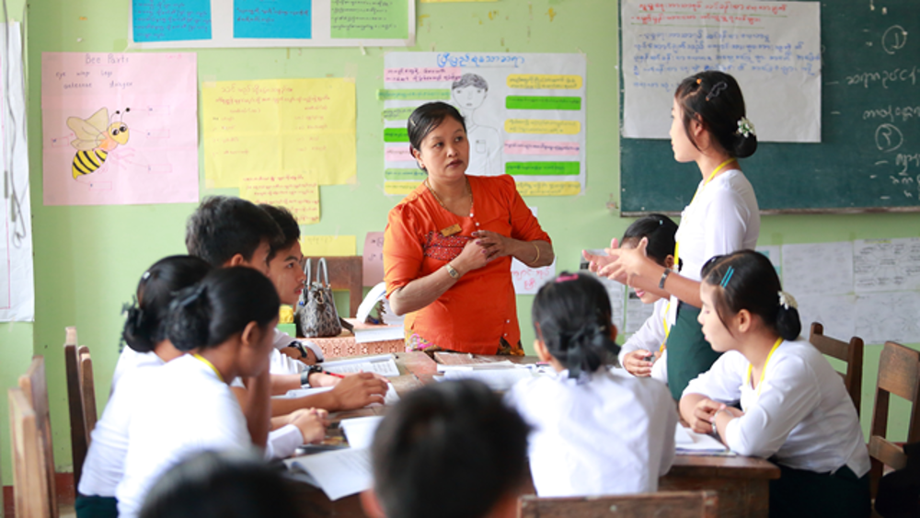
Source: VSO Image library

Module 2:
Knowing your learners

Module 2: Knowing your learners.

Overview
This is the second of fifteen modules that look at how we create a positive Inclusive Learning Environment for all. You will see how inclusive teaching practices encourage, develop and use the 21st century skills of critical thinking, communication, collaboration and creativity. These modules are for the Leadership Teams and Teacher Educators in the educational institutions across Myanmar.

Module number | Module title
1 | What is an Inclusive School, Classroom and Teacher?
2 | Knowing your learners
3 | Planning learning outcomes for all
4 | Participating through learner centred approaches
5 | Creating a positive learning environment
6 | Effective questioning and feedback
7 | Active participation
8 | Peer, co-operative and collaborative learning
9 | Supporting students’ emotional and social wellbeing
10 | Legal framework and policies around Inclusion in Myanmar
11 | Supporting all students through differentiation
12 | Identifying specific learning difficulties
13 | Supporting all learners with differences or disabilities
14 | Positive behaviour management
15 | Assessment for student achievement

Learning Journal
Please ensure all participants are aware of the learning journal and its purpose for the module. Point them to the advice given in their participants’ copy of the best way to complete. All answers to activities need to be written in their journal. Remember, reflection is an important part of the learning process and a worthy activity alone. Encourage participants to make a note of new and interesting words/phrases/terms as they make their way through the module.

Study tips
It is important to explain how to approach completing the module. Participants need to take their time, develop a suitable timetable and where possible check their answers with colleagues. The use of think / pair / share is a good way for them to collaborate, share ideas, ask questions, check their work, and give feedback.

Background to the Inclusive Practice CPD modules.
There are 3 key themes explored in the modules that reflect the educational reform taking place in all education settings: Inclusion, Gender Equity and 21st century skills. These themes are key in all areas of curriculum, and vital not only for Myanmar’s educational ambitions and sustainable development but equally vital for the global future.
This course has been designed to help participants engage in this discussion by challenging their beliefs and attitudes about their own teaching, their students’ learning and the impact their educational institution has on inclusion. It is expected that as a facilitator, you will challenge their beliefs and attitudes throughout the modules.
It is also important for you as a facilitator to embed many of the teaching and learning techniques associated with inclusion in education into this course. Encourage participants to work at their own pace and consider their own abilities, interests and skills.
The modules look at how we create a positive Inclusive Learning Environment for all. You will see how inclusive teaching practices support gender equity and encourage, develop and use the 21st century skills of critical thinking, communication, collaboration and creativity.
Each module is made up of a series of activities participants can work through at their own pace. Once they have completed the module, they will have a multiple-choice quiz to complete.

Learning outcomes for Module 2
By working through this module, your participants will be able to:
- explain why it is important to know your students.
- discuss ways of knowing your students.
- decide if a teaching resource is inclusive.
- explain the importance of multi-sensory learning.
- adapt lesson plans to include multi-sensory learning.

The previous module introduced the concept of inclusion and what it meant. It provided the opportunity to analyse whether an educational institution, the classroom and a teacher were inclusive in their educational practices. This second module introduces why it is vital to ‘know your learners.’ This leads to being able to decide whether the resources used to teach are inclusive. The last section deals with multisensory learning and how this can be used to effectively support the different needs of learners.

Extra instructions for the activities in module 2

Activity | Additional points to consider
Prior knowledge assessment | The first task is a recap assessment of module 1. This reminds the learner of the previous module contents and helps them to recall important information in preparation for this module. After the first attempt, suggest that the learners refer back to the first module to check their answers.
Introduction | Encourage all learners to read the following;  Embracing diversity: toolkit for creating inclusive, learning-friendly environments – booklet 4. https://unesdoc.unesco.org/ark:/48223/pf0000137522_bur  Section 4.1- ‘Learning about Learning as a Learner, pages 3-20  Section 4.2- first section ‘Valuing and Encouraging Diversity’, pages 21-27 and section ‘Bias in the curriculum and learning materials’, pages 34-54  Section 4.3- the first section ’Learning for Life’, pages 57-67
1st Self- assessment | Some participants may need encouragement to be honest in their self-assessment. Ensure that they know it is the beginning of 15 modules around inclusive practice and their understanding and confidence will develop over time. The results from this self-assessment will be compared to another self-assessment at the end of module 2, allowing participants to make comparisons and reflect on their learning.
- – Benefits of ‘knowing your learners’ Part 1 | Participants need to watch 4 videos about ‘knowing your learners.‘ As they watch they need to make notes about the three questions posed. Ensure they know they can turn on subtitles to each video and also open the transcript to read at their own pace. This allows for the different learning needs of individuals. They can watch in pairs or small groups if easier to access using technology. Participants need to make notes in their learning journal of any new terminology. If possible, discuss the new concepts or terminology as a group to ensure understanding.  - Video 1 - Understanding learners’ needs.  www.youtube.com/watch?v=ENvkE_0N3jo  - Video 2 - Getting to know your students.  www.youtube.com/watch?v=Zzvd3VpNCXE  - Video 3 - Making sure each child is known.  www.youtube.com/watch?v=xjZx0VdmgkE  - Video 4 - Building a belonging classroom.  www.youtube.com/watch?v=Q6niuYToam4
- - Benefits of ‘knowing your learners’ Part 2 | Participants have a choice of two texts to read. Explain that text 1 is a shortened version of text 2 and is much easier to read - this can be found in Appendix 1 at the end of the module. Encourage those more comfortable with English to read the full book chapter (text 2). Participants need to make notes in their learning journal of any new terminology, particularly about the benefits of ‘knowing your learners.‘  Text 2 link www.ascd.org/publications/books/111011/chapters/Knowing-Our-Students-as-Learners.aspx (30 minute read)
2.3 – Benefits of ‘knowing your learners’ Part 3 | The videos (2.1) and the reading passage (2.2) must be completed prior to this activity. Participants can work in pairs if possible, to think of as many benefits of ‘knowing your learners’ as possible. Participants need to make a list in their learning journal
2.4 – Benefits of ‘knowing your learners, Part 4 | Using the answers to 2.3 the participants begin to explore what this will look like in the classroom and what they need to begin to consider. The answers to this should be general (broad) in nature – see examples. Participants can make a simple match list in their learning journals.  Participants need to think about the broad answers in 2.3 and provide concrete suggestions of what they need to do in their classroom to prepare for the inclusion of ALL learners. Encourage participants to review either text 1 (Appendix 1) or text 2 again as they do this activity.
2.5 – Categorising information about learners | Participants need to read the two case studies and identify, from the text, areas that could impact on Thu Thu and Min Kyaw’s learning linked to the key factors. Ensure they refer back to the key factors identified on the previous page which will help them make decisions about what could impact Thu Thu and Min Kyaw’s learning. Explain that this information forms the basis of possible questions you can ask leaners. Answers will inform their lesson planning. Participants need to draw and complete the table in their learning journal. There are a few examples given.
2.6 – Types of information that could be used to plan classes (questions) | Encourage participants to think about the activities they have already completed: 1. how much you know about a learner, 2. how much you could know about a learner, 3. the five factors of information and 4. the reading earlier - ‘Know your learners’ and 5. The two case studies. Under the key factor headings participants are asked to think of 6 – 10 questions they could ask their learners that would help them know them better. Participants need to write in their learning journal. Think, pair and share answers if they can. Remind them that the information gained needs to be relevant to improving learning for individuals. One example is given.
2.7 – Writing Learning Profiles | This activity provides an example of how to compile a learning profile. Participants can do this activity from memory or use actual learners in one of their classes. Explain that they need to choose a wide range of learners to show the diversity in the group. Participants need to use the questions they thought of in activity 2.7. There are a wide variety of responses to this activity and participants need to be encouraged to think carefully and deeply about the individual leaners they have chosen.
2.8 - Applying teaching and learning considerations | This activity begins to explore how learner profiles can be used to think about and adapt teaching and learning activities / resources. Participants need to choose 2 learners from activity 2.8 (explain they need to use learners with different profiles). Using the example of Thu Thu they need to identify how they might support both their individual needs in class. Encourage them to think carefully and deeply about what they can do to adapt their teaching and learning to suit individual needs. They can write in their learning journal. Think, pair and share your answers if you can.
2.9 – Identifying a learning resource | Participants are asked to think about their own classroom and review the list of learning resource types. They must, in column 1 identify the resources they use now in class. The second part of the activity asks them to think of the resources they would like to explore in the future, in their class (column 2).
2.10 – Assessing whether resources are inclusive | This activity introduces the notion that all resources need to be inclusive. Furthermore, it asks them to apply the knowledge learnt on the previous pages to assess whether their own resources are inclusive. Participants are asked to identify three resources from their class. They need to choose one and carry out a FULL checklist for the chosen resource. They then provide a short (three sentences maximum) analysis of the resource’s suitability. Remind them that once they are comfortable with how to assess a resource they will not need to use a checklist every time.
2.11 - Effective use of teaching and learning resources | This activity asks participant whether a resource is being used inclusively. Participants need to explore how a resource is used and assess whether it is being used effectively for all students to access the learning. Encourage participants to reflect on how the different resources could support the students they teach. Consider when resources are introduced in a topic or subject and also to reflect on if they are needed. What value are they adding to the learning experience?
2.12 – Multisensory Learning | This activity introduces the importance of multisensory learning. Participants are asked to watch the short video and make notes in their learning journal. The video is about learning through all our senses. The second part of the activity links the principles from the video to the participants’ own thoughts/ideas/memories of how they think they learnt about a tree as a child. They are encouraged to draw a tree in their learning journal and complete a mind map after careful consideration. Remind them, this is about how we use our senses to learn.
2.13 – multisensory learning (football) | This activity tasks participants to make links with their prior learning. They are given a scenario whereby they arrive in class and find they only have a football to teach a group of 5-year-olds. They need to think about a topic from their subject area. This is an opportunity for participants to be creative with their thinking. They need to consider that some resources might be helpful at the start of a learning process. Some students might benefit from time using concrete or visual representations before they move onto more abstract learning, like in maths, calculating answers in their heads.
2.14 - Applying multisensory learning | This activity asks participants to apply the idea of multisensory learning to one of their simple learning activities. Remind them of the brain diagram and the numerous ways we learn through our senses – not just the three: sight, sound and touch. Participants are asked to think of one activity from one of their lesson plans. Encourage them to try and choose something that leaners usually find difficult. This will help to show any clear improvement. They are tasked to redesign the activity using as many of the senses as they can – the more the better. Using a lesson plan from the TCSF is encouraged. They are then asked to share their new plan with a partner or small group and ask for feedback about whether using more senses has improved the activity.
Wrap up | A consolidation of the module and key points. There is no activity here.
End of module 2 quiz | This is a multiple-choice questionnaire that tests participants’ understanding of the module. Encourage participants to self-assess and revisit their answers as many times as needed to achieve 100%.
Answers to the end of module 2 quiz | Participants should revisit the questions until they achieve 100%. Remind them that some questions require more than one answer.
2.15 - Improving  your own  teaching  practice | This activity provides a scenario for participants to consider. It asks them to complete two statements provided by their head of department. They are keen to understand their teachers’ plans to improve how well they know their learners and how multisensory their teaching and learning activities are. Invite participants to role play and share their experiences with the group. Ask participants how confident they felt when giving their responses. Encourage them to make notes in their learning journal.
2nd Self-assessment | The self-assessment duplicates the first self-assessment. Ask participants to reflect on their confidence and discuss comparisons between scores.
The 2nd promise | Ask participants to think of one thing they will take away from module 2 and make a promise to their learners about what they will improve. Ask them to evaluate that promise and recognise changes (after x weeks). Encourage participants to reflect on any impact that change has had on teaching and learning and how to improve it further. This reflects the beginning of the action research cycle and can be built on in future modules to create an ongoing action plan for development. Participants are encouraged to make a section in their learning journal entitled ‘Promises’. There will be a total of 15 promises.

End of module 2 quiz - Answers
Participants can attempt the questions as many times as they like to reach 100% pass. This allows them the opportunity to become confident. (Answers in bold)
Q1 - Why should you know your learners? (Choose 2 answers.) a) to tell your family and friends about them. b) to understand how your learners learn best. c) to find out about their interests and difficulties. d) to tell other learners about them.
Q2 - When you know your learners, you demonstrate that you value their
- presence in your classroom.
- popularity in your classroom.
- status in your classroom.

Q3 - When you use your knowledge about your learners to plan learning activities, you demonstrate you value their (choose 2 answers)
- opinion of you as a 'fun' teacher.
- participation in the lesson.
- achievements in learning.
- opinion of you as a hardworking teacher.

Q4 - What is an inclusive resource? (choose only 2 answers)
- something that shows lots of people with differences.
- something that shows people with differences having equal importance, status and opportunity.
- something that shows your students respect for their differences.
- something that shows you how to include learners with disabilities.

Q5 - What is multisensory learning?
- using all our senses at the same time to learn.
- using our different senses in different activities to learn.

Q6 - What are the benefits of multisensory learning? (Choose 3 answers)
- using different senses to learn shows us how people with disabilities can learn.
- using all our senses to helps us strengthen all our senses so we can learn more from them.
- using different senses to learn reminds us of when we were children learning.
- using different senses to learn makes our brain work more so we remember more.
- using different senses to learn lets us use our stronger senses to learn.

