Everything You Need to Get You Started on OpenLearn

Contents

Hyperlinked Section Titles | Pages
Welcome | 2
What do Open Learning Champions do? | 3-4
Introduction to OpenLearn | 4-9
Accessibility | 10 - 11
Study Levels | 12
Explore OpenLearn 1 | 13
Bite Size Video Overviews | 14-16
Explore OpenLearn 2 | 17
Choosing The Right Course | 17-20
Working With Your Learners | 18-28
Explore OpenLearn 3 | 28
Future Pathways | 29-33
Appendices | 34-57

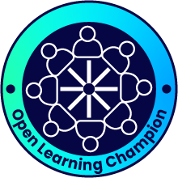

- A warm welcome to the Open Learning Champion network
Welcome from Susan Stewart, Director of Open University in Scotland
I am delighted that you have chosen to become an Open Learning Champion and join a nationwide movement to develop knowledge, skills, and confidence for learners in your community or organisation. I am certain that whatever your needs you will find fantastic free learning resources to suit you and your learners - have fun!
Welcome from Shona Littlejohn, Depute Director for Widening Access & Student Experience
The OU offers free learning to everyone, everywhere through our fabulous Open Learn resources. As Scotland’s national widening access Uni we are committed to open pathways to learning – and while our open learn is a key part of that our research tells us the importance to learners of support to their success.
Which is where you come in -
Open Learn Champions support their clients and learners on their learning journeys – and we support OLCs with resources and facilitate an Open Learn Champions Learning Community. I hope you enjoy this course which has been designed to help you make best use of OpenLearn resources. We thank you for your interest; We value your feedback; and we hope to see you at one of our Open Learn Champions virtual coffee mornings.
Back to contents

2. What do OpenLearning Champions Do?
Bringing free online educational resources to communities across Scotland
The Open Learning Champions project equips a wide network of people with the knowledge and skills to use the Open University's free online resources to help learners in a way that meets individual goals and is adapted to suit learning styles, digital literacy, IT access, time available and other real life factors that we all need to consider when taking on a new course or piece of learning,
How you work with learners in your community or organisation will be your decision, but this online module will lay the foundations for you to be able to:
- Become familiar with OpenLearn - how to navigate the site to find relevant courses, become familiar with formats, course levels, duration, and accessibility in order to then support your learners.
- Support your learners to choose the right first, next, and next again course
- Decide on the right level of facilitation. This will range from very light touch where learners work independently and you may check in from time to time, to where learning takes place in a supported session or series of sessions. This will depend on multiple factors to be explored later in this module
- Recognising achievement and celebrating success
- Understand potential pathways beyond OpenLearn and where to signpost learners for more information
Beyond this module you will be able to connect with other Champions and Open University staff through the modules online forum, monthly newsletters and bimonthly Champion coffee mornings where we can discuss new courses, share practice and celebrate success

Back to contents
OpenLearn & OpenLearn Create
It is worth noting that while much of this module focusses on OpenLearn, where the majority of materials are written by OU academics for the platform, you will also find many useful courses on OpenLearn Create. The functionality is very similar to OpenLearn. The key differences are:
- OpenLearn Create courses have been developed by a range of organisations making use of the functionality that allows you to create your own Open Educational Resources (for more information see the 'Create A Course' should this be of interest to your organisation)
- Some courses start at level '0', very much designed for absolute beginners to online learners.

3. Introduction to OpenLearn
The video linked to the image below is a short introduction of what is available on OpenLearn.

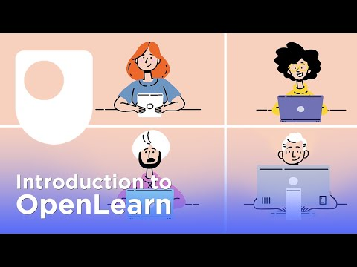

Back to contents
Video Transcript

Narrator: There are so many fascinating things to learn online - but how to choose and what to trust? For more than 50 years The Open University has been offering parts of its curriculum for anyone to study - for free... This is material written and reviewed by Open University academics and now delivered in engaging, bite-sized chunks, via OpenLearn to millions of people around the world. OpenLearn offers learners thousands of free courses, articles, interactive activities and videos - all available 24 hours a day.

And even when you've chosen an area to study - whether for work or for personal reasons - there are also thousands of great resources to help you to develop your study skills, support your employability prospects and help you to make the best choices on your learning journey. OpenLearn enables you to study in a format that suits you, offering text, videos, eBooks and accessible downloads. If you complete a free course, you can earn a Statement of Participation or a digital badge, to demonstrate your achievements. So, whether you're aiming to improve your skills at work, studying for pleasure or making your mind up about your next steps in education, OpenLearn is the place for you

Hopefully this gives you a flavour of the exciting things to come!
Creating Your Openlearn Account
While it is possible to access a wide range of OpenLearn & OpenLearn Create content without creating an account, doing so will allow you to enrol on courses, participate in activities, record progress and create a record of learning including Digital Badges and Statements of Participation.
You can create an account via this link which will work for both OpenLearn and OpenLearn Create courses. If you already have an OU account you can use this. The only details required details are:
Back to contents
- Name
- Date of Birth
- Email Address
- Create a Password
- Contact Preferences
A full set of FAQ's about all aspects of OpenLearn can be found here
You can watch an overview of how to set up your account this video

Video Transcript

How to sign up for a free OL account and the benefits of it?
To sign up for our free OpenLearn account, you’ll find the ‘Create account / Sign in’ button at the top of our website.
Then, click on the ‘Create account’ button under the ‘New visitor?’ section.
A popup will appear, please find your resident country to allow us to provide you the most relevant information, and then click ‘Save location’.
Finally, you just need to fill in the rest of the form and tick any necessary boxes and click 'Submit'.

Benefits of OpenLearn
There were 14 million visits to OpenLearn in 2022 alone from around the world. As we saw in the video on the previous page, OpenLearn has over 1000 free resources from short interactives, articles and courses to longer courses, wit further free learning resources on the OpenLearn Create platform. So, what will learners get out of an OpenLearn course?
Back to contents
KEY BENEFITS
- Try Something New - OpenLearn is a great way to find out if you enjoy certain subjects - and try new ones you have always been interested in - see the 'Free Courses' & 'Subjects' sections for more detail
- Study at your own pace - while there are recommended timings for most courses, these are just recommendations. Courses can be taken at a pace that suits you. You can do one at a time, or multiple. You can take weeks to do a 4 hour course, or a 24 hour course in one week instead of the recommended 8 - it is in your control!
- Improve confidence - in your ability to learn, to learn online and by developing new skills whether these are for study, work, life
- Great addition to your CV - employers will value evidence of your learning especially when it links to roles that you may be applying for. There are some core resources in our 'Skills for Work' section
- Preparation for other study - OpenLearn can be your core learning resource, and it can be a jumping off point for further learning, whether that's with The Open University, or another learning provider. You will develop core study skills that will support your future success, which you can develop further in the 'For Study' section
What are the courses like?
- Longer courses are broken down on a week-by-week basis but you complete them at your own pace
- The courses are made up of a mix of reading, audio/video and activities
- There are quizzes to track your learning and you can take them as many times as you need
- You can track your progress through the course if you have an account
- There are also shorter articles and interactive activities such as "is Social media use impacting your future" or "Your wellbeing MOT"
Back to contents
Snapshot of Course Page
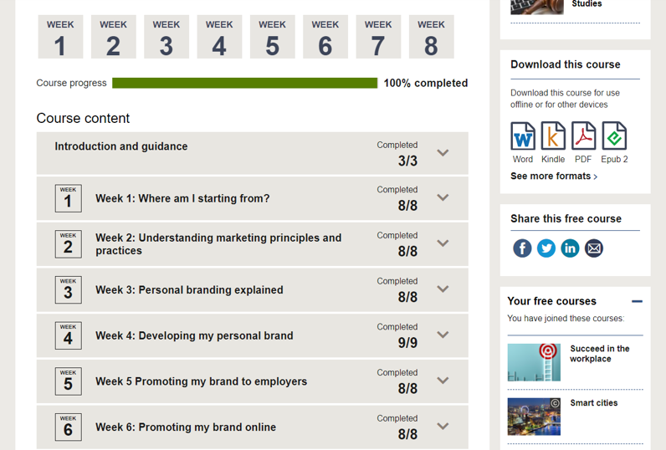

Back to contents

Recognition of Achievements
There are a few videos later in this module showing how to find your certificates and digital badges and how to share. Below are examples of what you will see
My Achievements Section
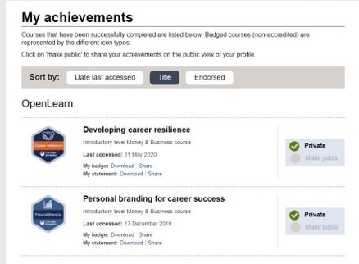
Statement of Participation & Digital Badge
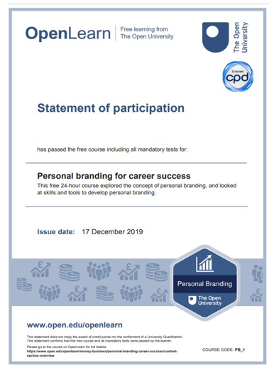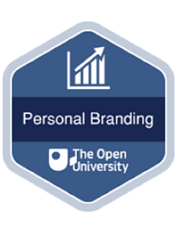
Back to contents

4. Accessibility
Alternative Formats On OpenLearn
While all modules are online, most OpenLearn courses will also be available in a number of formats that can be downloaded. As well as increased accessibility, for example Word Documents for use with screen readers, once downloaded these can be used offline for learners with limited access to IT, broadband or who prefer learning offline. Learners with screen magnifier or who use specific operating system or browser settings should not have any difficulties with the site
It is worth noting that there may be some interactive elements on some courses that will not be included in a printed version of an online course and for completion certificates and/or digital badges there is normally a minimum number of activities that need to be completed online.

Examples of Alternative formats
Below are links to the alternative versions of the short level 1 course IT in Everyday Life
- Word Version - You can download and use the Word version of course materials with most Windows Office software and on many mobile applications. The Word format is particularly useful if you want to annotate your materials or if you use the JAWS screen reader. Word documents also provide flexibility for changing font size, colour and spacing and can be used offline and printed.
- PDF Version - PDF downloads can be used offline across a range of devices. You will need an up-to-date version of Adobe Acrobat Reader in order to view them. PDF downloads might be useful if you want to print out some of your course materials to make notes on directly, you can also make notes on them electronically.
- Epub2 Version - Electronic publications (EPUBs) are the most common form of ebook and will be usable with most e-readers. Downloading course materials in EPUB format to your e-reader may be helpful if you are looking for a portable way to study your materials offline or if you require your e-reader to help support your study due to a disability. In most cases you can adjust EPUB files to change the setting for font size and colour to suit your needs Kindle Version is an ebook format that works on Amazon Kindle
Videos within courses will usually also have captions and transcripts that can be downloaded for offline use, showing as below:
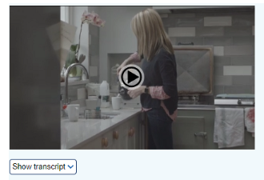
The image is a snapshot from a Health and Social Care online module which shows the transcript and download option below the main video still image

Google Translate
As you may work with learners who do not have English as a first language it is also worth being aware that you can use Google Translate to translate OpenLearn web content into around 50 languages. Most content will be translated with the exception of videos. You may also be able to translate documents embedded within web pages as well.
Instructions on how to use Google Translate from your computer and mobile devices can be found on this google support help page
Back to contents

5. What Do the Different Levels Mean?
It can be useful to know how the different levels map against both Open University study and the SCQF framework. The table below gives a brief overview
OpenLearn / OpenLearn Create | Open University | SCQF Level
0 – beginner level. Accessible inclusive language and focus on functional skills | Access module – equivalent to a Scottish Higher or NC in terms of academic level | 6
1 – Introductory. Can be a good starting point for many with a mix of content created for OpenLearn and extracts of taught OU courses | Roughly equivalent to stage 1 OU study and HNC level | 7
2-Intermediate. Content is similar to degree level | Roughly equivalent to Stage 2 (HND) and 3 (final year) of Open University study | 8-10 depending on course
3-Postgraduate. Usually extracts from postgraduate modules | Postgraduate study such as PG Cert, PG Dip and master’s programmes | 11
Level 0 and Level 1 are usually the best starting points. You can use the search functions on both OpenLearn and OpenLearn Create to search for courses by a number of factors including level.
Back to contents

6. OpenLearn Exploration
Nothing Like Trying Something for Yourself
Now you have had some basic information about how OpenLearn works and what it has to offer, please spend some time on the OpenLearn Exploration Activity. The questions in the activity will support you to explore some of the key features of OpenLearn.
Download form module or see appendix 1
Spend as much time on this as you feel is relevant but probably about 30 minutes should be enough for a first 'deep dive' into the website. Please feel free to save and keep your notes for reference. Enjoy!
Picture of Earth from international space station

Back to contents

7. Video Overviews

What is a digital badge
To find out what we mean when we say Digital Badge, please have a look at this video

Video Transcript

What is a Digital Badge?
A free Open University digital badge is awarded for completing all course sections and passing the assessments. It can demonstrate interest in a subject, evidence of academic and professional development, and are used to augment CV’s and ePortfolios.
It can be shared on social media and LinkedIn

Where to find badged courses
We will show you how to find Badged courses in this video

Video Transcript

Where to find Badged Courses?

Click on the free course tab at the top of our website. Then you should click on the badged courses section. Feel free to filter the courses by subject and the different organisations and institutions that endorse these courses.

Where to find my Statement of Participation and Badge
You can discover how to find your Statement of Participation and Badge via this video

Video Transcript

Where to find my Statement of Participation and Badge

Once you are logged into your OpenLearn account click on ‘My Openlearn profile’ button on the top right-hand corner. Then click on the ‘My achievements’ section. After course completion it will generally take up to 24 hours for both your Statement of Participation and Digital Badge to be uploaded. You will be notified by email once your download link has been made available.

How to share digital badges on LinkedIn
We will show you how to share your digital back on LinkedIn in this video

Video Transcript

How to share digital badges on LinkedIn

Go to your ‘My OpenLearn’ profile. Then click on the ‘My Achievements’ section. On any completed badged courses, click on ‘share’ link and choose the ‘LinkedIn’ option. If you already have a LinkedIn profile, this should automatically present a form like this. The ‘Issuing Organisation’ and ‘Credential URL’ will automatically be filled in for you. You just need to fill in the rest of the form and enter the name of the course. Leave the other sections blank and click ‘Save’. On LinkedIn your badge will appear under the ‘Licences and Certifications’ section and if you click on ‘Show Credential’ it will take you to the badge details page on OpenLearn.

Where to find my In Progress courses
You can find out how to view your 'In progress' courses via this video

Video Transcript

Where to find my ‘In Progress’ courses

Once you are logged into your OpenLearn account, click on ‘My OpenLearn Profile’ button on the top right-hand corner. Then, click on the ‘In Progress’ section. All your enrolled courses that you are working through are all here.

Back to contents
OpenLearn Exploration Activity 2
Skills for Study
Here is another chance to spend a little bit of time exploring one of the OpenLearn sections. Please find a link to the activity below
Download from module or see appendix 1.2

8. Choosing the Right Course
Spoiled for choice
One of the great things about OpenLearn and OpenLearn Create is that there are so many options and different courses - however it can also be overwhelming to know where to start, and what you need to do. To help you and your learners get off to a good start, these next few pages will help you consider things like previous study experience, how much time is available and IT access.
- In appendix 2 you will find a questionnaire which we hope will be helpful in establishing the right starting point. It can be used in 1:1 discussion or as a group activity. A downloadable version of the questionnaire can also be found on the online module – link here
- In appendix 3 you will find an example list of level 0 and 1 course that may be useful in shaping your ideas and to support your learners a little to help with first choices and to reduce the potential impact of considering the volume of courses on offer. A downloadable version of the module list can also be found on the online module – link here. There is also a list of shorter interactive courses in the appendix, with a link to a downloadable version in the online module here

Supporting Course Choice Decisions

- Ensure you understand context and needs of your learner(s)
Through building rapport, active listening and asking curious and purposeful questions, you will develop an understanding of the needs, barriers, support requirements and options you to enable your learners to be more in control of their choices.
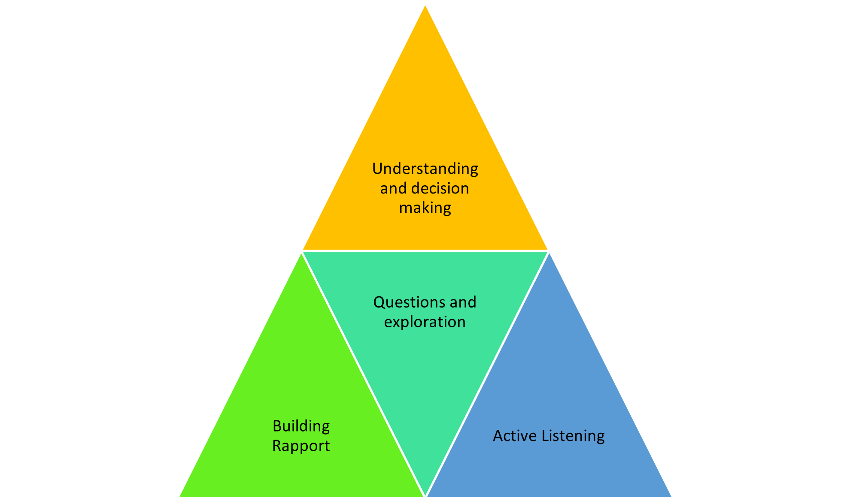
Graham B & Ali L 1996
(Adapted from Counselling Approach to Career Guidance (1996) a pyramid showing key skills for effective choice focussed discussions - (1) Building Rapport (2) Active Listening (3) Questions and Exploration (4) Understanding and decision making)

- Building Rapport - establishes trust which is important for any sort of helping or facilitation role - verbal nods, recognising concerns, mirroring language appropriately and reinforcing positives may all form part of rapport building
- Active Listening - by clarifying, summarising, asking clarifying questions and listening not only to what is said, but how it is said and what is left unsaid will support you to build as full a picture of your learners needs as possible
- Questions & Exploration - with appropriate understanding you can use your knowledge of the learner and the resources to ask questions and explore appropriate options - an example questionnaire can be found in section 7.2
- Understanding & Decision Making - ideally through effective conversation each individual learner will understand what they could do and feel empowered to make a plan - decide the next step along with you
2. Understand the Options
Once you have been able to establish needs and start to ask questions, possibly using the suggested questionnaire in section 8.2, to effectively facilitate an exploration of appropriate options whether with individuals or in a group, it is really helpful to have a good working understanding of the course options -
- Use the search function on OpenLearn / Openlearn Create to look at courses together by subject, length, whether there is a digital badge etc
- It's ok to share your knowledge or experience of courses - as long as this leads to questions for the learner to get them to consider whether course is right for them
- It is also ok to make suggestions - though empowering the individual to undertake their own research and evaluate courses within their own context is the ideal. A balance is needed as confidence may be low initially so you may start with a slightly more directive approach to begin with and over time your learner needs less input from you to make choices.
3. Make information as simple as possible
- Use plain English - you might need to 'translate' complex information into language that works for your learner
- Be impartial where you can- watch out for giving your opinion too much
- Avoid overload - monitor the individuals' reaction as you deliver information as much as possible - be succinct :)

Future Development
At time of writing, we are Open Learning Champions Hub. When this is available. you will be able to access key articles, most popular courses and will a great starting point for both you and your learners.
Picture of a nebula

Back to contents

9. Working with Your Learners
Introduction
Across the next few pages, you will explore the different ways that you might work with your learners and consider the best approach for you. You will also explore some tips on keeping your learners motivated as well as some brief examples of how you and your learners can monitor progress and celebrate success

Deciding On the Right Approach
Getting the right balance of support
How you support your learners and facilitate access to courses will depend on a number of factors:
- Your access to resources (venue, IT, stationary etc)
- Your learners' access to resources (time, IT, internet etc)
- Courses that you are focussing on
- Goals of the learner e.g employability focus may mean a Badged Course is desirable
There is NO defined way that you need to work with your learners but there are 3 main models that you may use -
- Supported online access
- Hybrid delivery (mix of online and offline access of materials and activities)
- Offline delivery
Deciding On the Right Approach
Answer yes or no to the following questions in relation to your learners -
- My learners and I have access to IT equipment that will support online learning
- My learners and I have ongoing internet access
- My learners and I require a digital badge or statement of participation to support longer term goals
- My learners will be able to spend time learning online outside any supported sessions delivered by me
- I can facilitate learning without having to adapt materials and/or deliver additional activities to meet learning outcomes for the learners I am working with
To help with your decision
- If you answered yes to most of these, then supported online delivery is likely suitable for your learners
- If you answered a mix of yes and no then a supported mix of online and offline (hybrid) approach is likely suitable for your learner
- If you answered no to most of these, then supported offline delivery is likely suitable for your learners
This information is also presented as a simple decision tree in appendix 4

Supported Online Delivery
Light Touch Support
If your learners have the IT skills and access required, as well as confidence to work independently online this means that the level of support you need to provide can be very light touch. All OpenLearn courses are written by OU Academics who are experts in online teaching and all the materials and activities are included within the course content. If a course offers a Statement of Participation or Digital Badge then as long as relevant activities are completed these are awarded to your learner direct from OpenLearn.
Examples of support you may decide to offer:
- Introductory group or individual session to give an overview of Openlearn, how it works and what is available. You may also discuss course choice at this stage
- Check ins / catch ups on progress, success, challenges etc - this may be as part of another activity that you are undertaking with your learners. You may find it useful to use the example Open Learning Review Form which you can find in Appendix 5 and as a download via the online module
- Celebrate success whether that is your learner gaining a digital badge, or learning something new within a course that's helped them in some way

Supported Hybrid Delivery
A Mixed Approach
It could be that your learners are able to work online with some support, and may also be reliant on the resources that you provide in order to be able to access online materials. In this case, it could be useful to take something similar to the following approach.
- Introductory group or individual session to give an overview of Openlearn, how it works and what is available.
- Course choice discussion - here as well as agreeing what course the group or individual will work on it could be worth exploring what they will work on individually, and what activities they will need support with
- Access support - you may support your learner to access and complete the online activity
- Offline support - you may download and print and work through an activity offline - please note that if a learner would like a digital badge or statement of participation they will need to complete relevant online activities
- Adapted or additional activities - you may decide with the group or individual learners that to meet their needs you will deliver an adapted activity, or you may use your own activity alongside the OpenLearn or OpenLearn Create material
- Check ins / catch ups on progress, success, challenges etc - this may be as part of another activity that you are undertaking with your learners. You may find it useful to use the Open Learning Review Form .
- Celebrating success and Milestones

Supported Offline Delivery
Offline Approach
As you know there can be many reasons that accessing online materials is difficult for people, at least in the early stages of engagement. This could be due to low confidence, lack of experience, accessibility needs and other factors. Most OpenLearn courses will have downloadable and printable versions, though as previously mentioned some interactive activities will not be available in printed formats.
Supporting learners with offline delivery will follow a similar approach to hybrid delivery, though you may want to give some consideration to the following as your learners progress:
- Working with your learners to do some short activities from the chosen course(s) online together when you feel their confidence with the learning materials is at a point where this would seem more manageable
- Using some of the key introductory IT courses on OpenLearn and OpenLearn Create that will help develop the core skills required to learn online
- Discuss experience, progress and next steps potentially using the Open Learning Review Form or something similar. This could allow you to introduce online learning goals on an iterative and supportive basis, where appropriate
Optional Activity
If you would find it useful you can complete a reflective practice activity which asks you to consider how you would approach adapting an online activity for face-to-face delivery. You can find this in appendix 6 and as a download via the online module.

Do what works for you and be kind to yourself
It's important to note this is just an example approach and idealised and the work you are undertaking with learners may need a more ad hoc and reactive approach or take more time to choose a course. The key is finding the right balance for you and your learners, and you are best placed to do this within the context you are working. You will try things and sometimes they will work, sometimes they won't - both you and your learners will be undergoing a shared experiential learning cycle.
General Tips for Group Delivery
Facilitating In Person Group Activities
If you engage with learners in a setting that supports some face to face facilitated sessions, from light touch support to more guided/directive approaches, hopefully the following general tips will be of use:
Planning
- Make sure you understand the needs of the group, which may include things like goals, experience, how well the group know each other, digital literacy, support needs etc
- Make sure the experience is learner centred - materials being used, pace, opportunity for discussion & reflection, maximise opportunities for peer learning
- Make sure you have clear, achievable objectives for the session
Running the session
- Spend some time at the start of the session / series of sessions agreeing what you will be working on together, and how you will work together. you may want to spend some time on an icebreaker discussion to build rapport, then introduce the structure of the session (s), how you will communicate with each other, the activities planned for that day
- Ensure manner, level and pace of communication is appropriate at all times - you may need to slow down or speed up depending on how the group are engaging with the activities
- Encourage all members of the group to take part, as much as they can
- Where needed manage times and timing of activities so you can maximise the usefulness of the session for al participants - it might be an idea to agree timings ahead of each activity and signpost the end of each activity 5-10 minutes ahead of time
- Be encouraging and celebrate all levels of engagement, progress and in particular encourage questions and discussion (where appropriate to the way you are delivering your session)
See below links to an example and blank session plan for you to use as a reference.
Blank Session Plan download or Appendix 7
Example Session Plan download or Appendix 8

Keeping Your Learners Motivated
Keep on keeping on
Anyone taking on a course of any level and length will be doing so in the context of real life and even if things are going really well, it can at times be difficult to keep motivated. You will likely know what works best for your learners, however when discussing progress and motivation with your learners it may be helpful to support them to consider some of the following:
- What’s going well with the course and what do you enjoy?
- What have you achieved so far – did you think you would get even this far?
- Have you found yourself using your new knowledge maybe in a chat with friends, or at work? Did you even note that you are already using what you have learned?
- What could you change to help you feel better about the course e.g tidying your study space, changing things like working on it for shorter periods but more frequently
- Remember to let people know if you are struggling with it, and talk through the challenges – even just having someone to listen can help
- Remember why you are doing this – what is your goal?
- How are your rewarding yourself for taking on this challenge – set small achievable goals and give yourself a reward for achieving them.
Person sitting on sofa studying on a laptop

Measuring Progress & Celebrating Success
What do we mean by Progress & Success?
It is really important to recognise that depending on the who you and your learners are progress and success will look different -
- For some progress will be about completing courses online relatively independently, completing activities and gaining digital badges and / or statements of participation. Some of your learners may move on to some of the future pathways described in the earlier section.
- For others being able to access one course with support and make it some way through some of the materials is both progress and success because this is happening in the context of challenging circumstances and fluctuating priorities
Therefore, it is key when setting joint goals and reviewing progress that as much as possible learners have some ownership and feel that goals in whatever form they come are achievable with some milestones. Milestones could include:
- Completion of 1 section of a module
- Completing an online activity for the first time
- Completing a course and earning a Digital Badge
- Adding a new skills, experience or achievement to a CV
- Becoming more confident
- Developing new relationships if the learning is taking place in a new setting
This is not an exhaustive list but hopefully reassures you that as Champions it' not all about course completion and moving on to a defined next step - learner journeys are complex and of varying lengths.
And we hope that you have many opportunities to celebrate moments of success with your learners!!
OpenLearn Exploration Activity 3
Skills for Life
This activity will help you explore what is on the Skills for Life section and consider topics that may be of interest to learners you might work with in the future. See the link below for the activity
Download from module or see appendix 1.3

Back to contents
10. Future Pathways
The Future Is Open
For some of your learners, completing OpenLearn courses will empower them to learn new life skills, develop employability attributes and support them to take a variety of next steps. This could include:
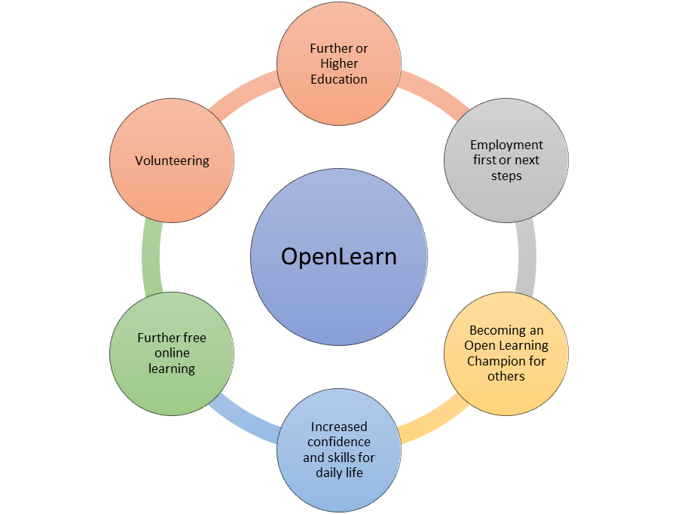
Picture of pathways beyond OpenLearn
(Relationship diagram showing that beyond OpenLearn options include further of higher education, volunteering, employment, increased confidence, becoming an Open Learning champion for others and of course further free open learning)
Studying With the Open University
For some, that next step can include moving onto to study with the Open University. Options to study at the OU can include Open University Access modules, and a course called Making Your Learning Count. These are not the only first steps people can take with the OU but can support effective transition into Higher Education.
This page will take you to a link on OpenLearn that will provide some key information about these options
Resources To Support Further Learning
Other OpenLearn resources that can help with transition to Open University study include the courses linked below:
- Am I Ready To Be A Distance Learner (3 hours)
- Getting Started With Online Learning (6 hours)
- Being An OU Student Induction (12 hours - note some activities will be unavailable unless participant enrolled on an OU module)
For help information and advice your learners can find out more about OU study from Distance Learning and Online Courses | Open University , search for courses via The Open University | Courses and Qualifications and for help call 0300 303 5303 or contact via a webform
Support for Open University Students
Most of our courses at undergraduate level require no previous knowledge and the Access and core Stage 1 courses are developed with new learners in mind with a focus on key study skills development to build a firm foundation for further learning. Taught courses are supported by a Tutor who will provide academic support, feedback on work and be key in supporting learners to develop their knowledge, skills and move to ever more independent learning.
Holistic Support
There is a huge amount of support for Open University students should any of your learners decide this is a step they want to take. Whether they are starting with Access, a single module or embarking on a qualification, The Open University can support them from choosing the right course to graduation and beyond!!
Click the links below to find out more:
- Fees & Funding
- Disability Support
- Mental Health & Wellbeing
- Careers & Employability
- Tutors and Tutorials
- The OU Community
- Support for care Experienced students
- Support for Carers

And who knows, maybe one day it will be you or one of your learners in a picture celebrating like the one below!

Picture of graduates celebrating

Employability in Context
Employability can mean different things to different audiences - what it means to one of your learners may differ greatly from an employer or careers adviser. Words like 'career' and 'employability' may be alienating for some and no doubt you already adapt how you position employability and career planning, if it is even part of the ongoing dialogue you have with your learners.
For many people employability is about much more than getting a job:
- For some, employability will be related to changing job or progressing in their existing area of employment - others might view it as undertaking voluntary activities and community engagement, e.g. being a children’s football coach or a on a parent teacher council
- Some may see it as achieving academic success.
Some useful sources of information
- Skills Development Scotland (SDS) national Career Management Skills framework -
- Skills for the Future - SDS have also produced a report on skills for the future , also referred to as meta skills classified under 3 headings as below. Page 8 onwards in the report has more detail on each of these
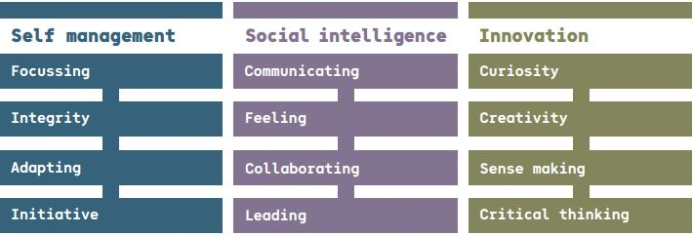
- National careers website - My World of Work | - with resources that can be used to establish goals, understand options and take next steps.

Below you will find a table with short descriptions of core employability skills, competencies, personal attributes, and external awareness along with a link to an OpenLearn course that may be useful for development of the skill. These are just examples, and lots of courses will develop multiple skills.

Core Skill or Competency | Description | Example Module Link
Problem Solving | Analysing facts and circumstances and applying creative thinking to develop appropriate solutions | Understanding Management: I’m Managing Thank you!
Communication | Application of literacy, ability to produce clear, structured written work and oral literacy including listening & questioning. | Talk the talk
Collaboration | Respecting others, co-operating, negotiating/persuading and contributing to discussions | Early Years Team Work & leadership
Numeracy | Manipulation of numbers, general mathematical awareness and its application in practical contexts | You and Your Money
Digital and Information Literacy | Ability to find information, communicate & collaborate online. Have social awareness in digital environment along with understanding of online safety. | Presenting Information
Initiative | Having ideas of your own which can be made into a reality | Innovation in Health & Social Care
Self-Management & Reliance | Readiness to accept responsibility, be flexible, manage own time and seek to improve performance | Developing Career Resilience
Self-Awareness | Insight into personal goals, aptitudes and values and ability to articulate these. | Improving Your Own Learning & Performance
Commercial Awareness | Understanding of the marketplace in which a business operates and / or understanding of a specific sector. | Understanding Your Sector

Back to contents
10. Appendices
Appendix 1.1
OpenLearn Exploration Activity 1

- What broad subject areas are available on the main search page?
  - Pick one and have look at range of courses available
  - Note any that are of interest

- In the Society, Politics & law section
What are the first 5 topics that you can search under?

What types of course can you search for?

What levels are available?

What length of resources are available?

- What are the main benefits of studying a Badged Course?

Appendix 1.2
OpenLearn Exploration Activity 2
Take some time to review the Skills for Study section - Skills for study - OpenLearn - Open University - and find a course that looks of interest to you. Review the learning outcomes, have a look at one of the sections and note –
  - What drew you to this course?
  - If you completed the course, what would the benefits be to you?
  - What would concern you about studying this course
Then
  - If you had to communicate the answers you have noted above to a client / learner you are supporting, what would be the top 5 key pieces of information you would hope to get across?

Appendix 1.3
OpenLearn Exploration Activity 3
Accessing the Skills for Life section of Openlearn consider the following
- What are the 4 broad areas available?
- Pick 1 of the broad areas and spend some time looking at what is available. From the options pick up to 3 subject areas that could be of interest to your learners / clients. For each of these answer
    - Why do you think this would be of interest?
    - Look at the PDF version of the course materials briefly - what do you think would you need to consider in using the PDF either on its own, or alongside online materials?

Appendix 2

Course Choice Questionnaire

Choosing the right OpenLearn Course for You
This questionnaire is just a basic framework to start from. Depending on your role it is very likely you will have had / will have more holistic conversations about lots of things including:
- Life goals and motivations
- Barriers and enablers
- Current priorities and where learning would fit in – and is it the right time
It may be that it will be several conversations before a discussion about learning comes up naturally, and even then you may feel the best approach is a light tough, informal approach and say away from this questionnaire approach. All approaches, as long as they are learner centred, are valid. This is just a tool to use/adapt/refer to if and when appropriate

- How confident are you working on a computer?
1 2 3 4 5
Not  Confident | Very  Confident
- How would you feel about doing an online course with help?
1 2 3 4 5
Not  Confident | Very  confident

- How much time so you think you could spend roughly each week (best guess ok )
In answering this, don’t forget to account for things like sleeping, cooking, putting kids to bed, having time for fun or anything else that’s important to you!!
Time | Please Tick
< 1 hour
1-2 hours
3-4 hours
More than 4 hours

- What topics to you want to learn about?

- What would you want to get out of learning about these topics?

- What kind of support might you need to help you get the best out of your learning?

- What are the next steps and when will you take them?

Next Step | By when

Appendix 3
Example Level 0 & 1 Courses
Section | Link to Content / Notes
Latest courses on OpenLearn | - Live link to ‘latest from openlearn
Short Articles Section – ‘appetisers’ | - What Can I do too support my MH  - 5 tips on self care  - Tips from a Mental health survivor  - Mindfulness  - Support Net – can you help someone in need?  - Finding the truth – forensic evidence  - How women changes the world
Short Courses level 0 (All on OpenLearn Create) | - Climate change – 2 hours  - Energy options for the future – 2 hours  - Computers – bits & bytes – 3 hours  - Navigating and searching the web – 2 hours  - Introduction to autism and inclusive practice - 3 hours  - Introduction to dyslexia and inclusive practice - 3 hours  - How to help your child with talking – 1 hour
Longer courses level 0 (all on OpenLearn create) – lots come with a digital badge | - Digital skills – 5 hours  - Essential Skills for online learning – 5 hours  - Bounce Back – Positive Psychology can give a post pandemic boost to family wellbeing – 5 hours  - Planning a better future (career related) – 15 hours  - Caring for adults – 15 hours  - Supporting children’s development – 15 hours  - Every Computer Skills: A Beginners Guide to computers, tablets, mobile phones and accessibility (with Lead Scotland) – 16 hours  - Caring Counts – self reflection *& planning course for carers – 10 hours
Short Courses Level 1 | - Coping with panic attacks - 3 hours  - Some curated in ‘Explore’ Openlearn pathways  - IT in everyday life – 4 hours  - Presenting information – 3 hours  - Different types of business – 3 hours
Longer level 1 courses | - Learning how to learn – 6 hours  - Money & Business Academy of money with MSE – 12 hours  - Managing money for young adults – 24 hours  - Succeed with Maths 1 – 24 hours  - Succeed with maths 2 – 24 hours  - Supporting children’s MH and Wellbeing – 24 hours  - Digital Skills – 24 hours  - Understanding Autism – 24 hours  - English – Skills for Learning – 24 hours  - Succeed with Learning – 24 hours  - Exploring Sports coaching & Psychology – 24 hours  - Everyday Maths – 48 hours  - Everyday English – 48 hours  - Exploring learning disabilities – 24 hours  - Working with young people – 12 hours  - Talk the talk (delivering great presentations) – 12 hours  - Football world cup – where sport & politics collide – 10 hours  - Physical activity for health & wellbeing for carers – 6 hours  - Introduction to child psychology – 8 hours  - Exploring family health – 8 hours  - Intro to adolescent mental health – 24 hours
Next steps and future pathways | - Links to Career related Badged Open Courses  - Succeed in workplace – 24 hours  - Working in voluntary sector – 24 hours  - So you want to be a nurse – 4 hours  - Importance of interpersonal skills – 3 hours  - Effective communication in the workplace – 24 hours  - Further Learning related courses  - Thinking about next steps in your learning  - Am I ready to be distance learner? – 3 hours  - Get started with online learning – 6 hours  - Being an OU student – 12 hours  - Reading & Notetaking – preparation for study  - For participants who are not wanting to move on to formal further study but want in-depth / stretch resources and are ready for these  - Key Skills – working with others (50 hours)  - Key Skills – Problem Solving – 50 hours  - Key Skills -Information Literacy – 50 hours  - Key Skills – Communication – 50 hours

OpenLearn Interactive Activities
Scan the QR codes with your phone’s camera to access the OpenLearn interactive activities.
Health, Sports and Psychology
Are you a super recogniser?
(5 minutes)
Police super-recognisers have an above average ability to recognise faces and have identified a large number of criminals via CCTV footage. Do you possess the skill?
Do you have a photographic memory?
(5 minutes)
Can you hold an image in your mind by just looking at it for a brief amount of time? Try this photographic memory test and see whether you have eidetic memory.

Living with a learning disability
(5 minutes)
Take this interactive to find out if people with learning disabilities have more independence now institutions are closed and if it has led to a greater inclusion within local communities.

What does it mean, to be a man?
(10 minutes)
Beliefs about what makes a ‘real’ man have changed enormously over time. So what does it mean to be a man in the twenty-first century? Do traditional ideas about masculinity still apply, and if not, what kinds of new ideas have replaced them?
Olympisize Me
(5 minutes)
Have you ever wondered which sport you're most suited to? Play this interactive game to find out if you’ve got what it takes physically, psychologically and socially to make it to the podium at the Olympics and Paralympics.

What do you know about the NHS' history?
(10 minutes)
The National Health Service is over 70 years old, but what do you know about it? Find out some fun facts and see how you compare to others in this quiz.

Your wellbeing MOT
(10 minutes)
Do you consider yourself to be healthy? Check out this interactive quiz where you will get feedback on your lifestyle, diet and physical activity.

Investigating Psychology
(15 minutes)
Investigating Psychology is a tool to enable you to explore the development of psychological thinking not only across time but also within the context of social, conceptual and historical changes; the development and application of different perspectives and methods; and through chains of influence between researchers.
What are the connections between music and memory?
(10 minutes)
Hearing a particular song can take us back to a certain moment in our lives. In this interactive take a trip down memory lane, looking at songs from the past and exploring what music means to you.

How to be a better LGBTQI+ Ally
(20 minutes)
So you think you're supportive? But are you really an LGBTQI+ ally? Test yourself by using this immersive film-based interactive.

Bullying and Manipulation: Join the Resistance
(15 minutes)
When a person is being bullied, who’s at fault - the bully, the enablers, or the bystanders? This interactive explores bullying at work, school and even on Twitter at the hands of Donald Trump.

Beyond belief: talking to the dead
(20 https://www.open.edu/openlearn/spiritual-healingminutes)
Are paranormal experiences real? Can being 'spiritual' help with the way you feel about death, dying and grief? This interactive film delves into spiritual healing and your views on life after death.

Putting the child before the player
(30 minutes)
Football is the most popular team sport for children and young people in the UK and throughout much of the world. In this interactive, you will learn why children’s rights are fundamental to every young person’s experience of football.

History and the Arts
To lie or not to lie?
(5 minutes)
A lie’s a lie, right? But what if it wasn’t that simple? This game makes you think about your moral responses to different lies.

What do you see? How images can change what you think
(10 minutes)
Are images we see every day always what they seem? Look beyond your first glance and discover how images can persuade you to think a certain way.

Languages

Test your language skills: Spanish, French, Italian and German
(10 minutes)
How are your language skills? Heading off on a trip to Spain, France, Italy or Germany and want to know how you'd fare getting by? Find out with virtual, interactive adventures and test your language skills on the way!
Science, Maths and Technology
15 minutes on Mars
(15 minutes)
Have you ever looked up into the night sky at the red planet and wanted to know more? Now here’s your chance to explore Mars.

Explore Moon rocks collected from the first Moon landing
(15 minutes)
Use a Virtual Microscope to examine a selection of Moon rocks collected by Neil Armstrong and Buzz Aldrin, from the Apollo 11 mission in 1969.

Plastics in our ocean
(5 minutes)
Test your knowledge about plastics in our oceans, and learn about how they impact the environment.

Could you be a code breaker?
(15 minutes)
Test your problem-solving skills and try to crack our secret messages using clues.

Society, Politics and Law
LGBTQ History
(10 minutes)
Explore some snapshots of LGBTQ history.

The shops that make us buy
(10 minutes)
What tricks of the trade do shops employ to make us dig deep into our pockets and spend our hard-earned cash?

Crime scene officer
(15 minutes)
Put yourself in a crime scene officer's shoes and try to solve a suspected murder when time and resources are tight. Can you link the suspects to the forensic evidence?
Detecting Deception: Can you spot a liar?
(20 minutes)
Some money has been stolen - everyone denies taking it but some people are lying. Can you work out who is telling the truth and who is being dishonest?

You Decide: Is it a crime?
(15 minutes)
What do you know about England and Wales' criminal justice system? Take a look at four cases then make your decision based on what you think is legal in our interactive.

Education and Development
Good hair: perceptions of racism
(30 minutes)
How does racism manifest itself in schools and workplaces? Explore the policies that discriminate against Black and Minority Ethnic communities in this immersive film interactive.

Nature and Environment

Ocean Explorer
(20 minutes)
Take a journey into the Earth's oceans and discover whether you've got what it takes to become an oceanographer.

Appendix 4
Delivery Approach Decision Tree

Appendix 5
Open Learning Review Form
What have you been working on since we last caught up?

What have you most enjoyed?

What were the key challenges and how did you overcome these?

What are your next steps / goals going forward?

Appendix 6
Optional Activity – Adapting Activities
Pick a course that is of interest to you and identify an activity. For example, the Badged course ‘Working in Diverse Teams’ has an online Activity in section 1 that encourages you to reflect on times where you see teamwork as a core competency in a job advert. Think about the following and consider what would work best for you and potential learners if you were to deliver this activity face to face. These notes are for you, there is no right answer and it is really just to get you to start to consider what could be part of your activity if you are planning to deliver any activities offline.

- What would you need to change about the activity – this could be adding a discussion point, or adapting the language / context for your audience?

- What are the advantages and disadvantages of delivering the activity you have selected in a face-to-face environment?

- How will you link it to the next session of the course?

Back to contents
Appendix 7
Blank Lesson Plan
Timing | Topic | Resources | Who | Notes

Appendix 8
Example Lesson Plan
- All attendees have had discussion with Open Learning Champion about learning goals
- Key objectives
  - Building rapport and trust in group
  - Deciding a plan for sessions
  - Establishing how we will work together
  - Some practice on OpenLearn
  - Peer: Peer discussion and learning.
Timing | Topic | Resources | Who | Notes
14.00 – 14.10 | Icebreaker | Cards | Facilitator and Attendees | - In small groups only  - Ask everyone to pick a picture that appeals to them  - Once picked ask everyone to introduce themselves, and explain what they have chosen and why
14.10 – 14.30 | Group Objectives | Flip Chart | Facilitator and Attendees | Discuss aims of this session and next 2 session  -How we will work  -Resources available  -Respectful communication  -No such thing as a daft question !!
14.30 – 15.00 | OL Activity 1 | Wellbeing MOT interactive on shared centre PC’s | Attendees with help if needed | - 20 mins to work through interactive together in pairs, discuss as they go  - 10 mins Plenary – thoughts, feedback and what was learners (capture to feedback at the end)
15.00 – 15.15 | Break
15:15 – 15:45 | Learning Goals Activity | Flip Chart & pens | Facilitators and attendees | - Groups of 3  - Each person shares a barrier to them reaching their learning goals (on Flip Chart)  - For each, the group work together to consider  - What support would be needed to remove this barrier  - What can they control  - Who can help  - What is the first step  -20 minutes In Groups  -10 Mins Plenary
15:45 – 16:00 | Wrap up and summary | Refer to feedback from learning activities | Facilitator and all | 10 mins summarising, 5 mins confirming next session time, any actions agreed throughout the afternoon and I will follow up by email

Back to contents

