Contents

Topic 5: Hotel operations
5.1 Departments in a hotel 3
5.2 Front office operations 6
5.3 Housekeeping operations 10
5.4 Food and beverage operations 14
5.5 Tourism and hospitality job opportunities 18
5.6 Hotel careers 20
Answers to activities 26
References 28

Topic 5:
Hotel operations
This topic looks at the operations of a hotel. It begins by considering the different departments needed to operate a hotel successfully, focusing on the four main departments: the front office, housekeeping, food and beverage service, and food and beverage production. Travel and tourism’s contribution to employment is then considered, together with career opportunities in the hotel industry and how to extract information from job advertisements.

5.1 Departments in a hotel
This session looks at the organisational structure of a hotel and its many departments to understand how a hotel operates.
Organisational structures can differ from hotel to hotel, but most hotels are usually headed by a general manager. In a small hotel, the hotel owner is usually the general manager, while in a large hotel there may be a president instead of a general manager.
Under the general manager, there are department heads who report to the general manager. Beneath the department heads, there are supervisors who supervise other staff within the department. The number of staff they supervise depends on the size and importance of the department.
Departments in a hotel can be divided into two categories: main departments and support departments. The main departments are shown in Figure 5.1.1.
Figure 5.1.1 The main departments of a hotel

The support departments are shown in Figure 5.1.2.
Figure 5.1.2 The support departments of a hotel

A further distinction is made between those departments that have some direct contact or service to the guests (called front of house) and those departments that have no direct contact with guests (called back of house). Front of house includes the front office department, and food and beverage service (restaurant and bar staff). All of the support departments and two of the main departments – housekeeping, and food and beverage production (kitchen and pastry staff) – are back of house. A consideration of the main departments follows.

Responsibilities of departments

Main departments
The front office is responsible for reservations, guest registration, room arrangements, handling guest complaints and other services. The staff includes the front office manager, receptionists, cashier, night audit, bell attendant, concierge and reservation staff. You will learn more about the front office in Session 5.2.
The housekeeping department is responsible for the daily cleaning and maintenance of the hotel. Bedroom cleaning, public area cleaning, laundry service, linen keeping and flower arrangements are the responsibility of housekeeping. The staff includes the executive housekeeper, floor or public supervisors, room attendants, public attendants, the florist and gardener. You will learn more about housekeeping in Session 5.3.
The food and beverage responsibilities are shared between two departments: food and beverage service, and food and beverage production. Food and beverage service, which is front of house, includes restaurants, bars, banqueting and catering staff. Food and beverage production includes the kitchens, pastry and larder staff, who are back of house. You will learn more about the food and beverage departments in Session 5.4.

Support departments
The supportive departments are not so important for a small hotel, as their roles are often undertaken by the main departments. But for medium and large hotels they operate as separate departments.
- The human resources department is responsible for staff recruitment and training.
- Finance and cost control is responsible for hotel cash flow and cost control for the food and beverage departments. The staff includes an accountant and cashier.
- The maintenance and engineering department is responsible for the upkeep of the building and hotel equipment. The staff includes a carpenter, painter, plumber, electrician and mechanic.
- The security department looks after the security of guests and staff, and the timekeeping of the hotel staff.
- The sales and marketing department is responsible for promoting the hotel and includes sales and marketing staff, event experts and IT technical support.
- The public relations department is responsible for building the brand identity of the hotel and includes guest relations.
- The purchasing department is responsible for buying the goods and services needed to run the hotel. The staff includes a purchaser and storekeeper.

Activity 5.1
1. Which of the following staff work in the front office department:
- florist
- receptionist
- waiter?

2. The bar is an outlet of which department:
- front office
- housekeeping
- food and beverage service?

3. Which of the following staff work in the maintenance department:
- plumber
- room attendant
- purchaser?

4. Which of the following is a support department in a medium or large hotel:
- front office
- food and beverage service
- human resources?

5. Is this statement true or false?
Food and beverage service staff are back of house.

6. Is this statement true or false?
Food and beverage production staff are front of house.
Answers to Activity 5.1

5.2 Front office operations
In this session you will learn about what the front office does, in particular, the basic procedures of check-in and check-out, the duty of a night audit, and how to handle guest complaints.

Check-in
The check-in procedure starts before the guest arrives, when the guest makes the reservation, which is processed by the sales executive. Reservations can be made through the hotel’s website, by telephone call or email.
When a guest arrives at a hotel, the first person they are likely to see is the doorman or bell attendant. The doorman opens the door for them and the bell attendant assists them with their luggage, then leads them to reception for check-in. These people are part of the front office department. The organisational structure of the front office varies according to the size of the hotel, standard of service and the type of hotel.
The guest is greeted by the receptionist and politely asked for their name, in order to search for the reservation. The receptionist prints out the guest registration card and fills in the guest information. The guest is asked to show their ID card or passport and photocopies are made. The guest is asked to sign their guest registration card and the photocopied documents are attached to it and filed.
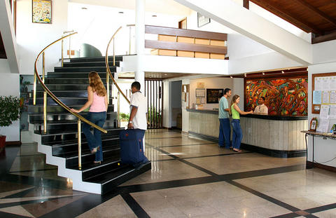
Figure 5.2.1 Reception is part of front office operations

Guests can pay in advance or at the time of check-out. Those who want to pay on check-out are asked during check-in to provide a credit card number against which charges can be applied. Providing a credit card means the guest can also charge extras consumed during their stay directly to their room, rather than having to pay each time. The guest is then given their room key and the bell attendant shows them to their room and brings their luggage. The bell attendant also explains the facilities of the room.

Check-out
When the guest requests to check out, they are asked for their room number and to confirm their name. Reception staff print out the bill for the guest to review. The guest will choose the payment method, complete payment and be offered a paper receipt or to have a digital copy emailed to them. They will be asked if they need assistance with their luggage. The guest is thanked for giving an opportunity to serve and for choosing their hotel for their stay. The guest cycle captures the stages of the guest stay, as shown in Figure 5.2.2.
Figure 5.2.2 The guest cycle

Night audit
Hotels operate 24 hours a day. During the night, the night audit takes control of the front desk. The night audit performs not only as an accountant, but also as a receptionist during the night shift. The responsibilities of night audit are:
- posting room rates and tax charges
- verifying room status reports
- handling guest check-in and check-out during the night
- settling the financial activities of each department
- closing the financial activity for the day
- preparing the list of expected arrivals for the next day
- preparing the night audit report, which balances the regular financial transactions.
Figure 5.2.3 The organisational structure of front office operations

Guest complaints
Another responsibility for the front desk is to handle guest complaints. When a guest makes a complaint, the member of the front desk staff needs to listen with concern and empathy. They should stay calm and not argue with the guest, being mindful of the guest’s self-esteem. They should concentrate on the problem, writing down the key facts. They should apologise to the guest for the inconvenience caused and offer resolution options, but they should not exceed their authority. A report should be made to the supervisor or manager, so they are aware of the problem and how it was resolved. The guest should be contacted later to ensure that they are satisfied with the way their complaint was dealt with.

Activity 5.2
Read the transcript of a guest making a complaint to the front desk and select the most appropriate response from the front desk staff member.
1. Guest: Hello, the air-conditioning unit in my room isn’t working.
Receptionist:
- Oh, that’s a shame. What do you want me to do about it?
- I’m very sorry to hear that. Let me see what I can do. Can I take your room number please?
- I’m sorry but maintenance have finished for today. You will have to wait until tomorrow before I can get someone to have a look at it. Can I take your room number?

2. Guest: Room 208
Receptionist:
- Thank you, Mr Aung San. I’m really sorry for the inconvenience. A maintenance person can be with you in the next 20 minutes. Or if you like, you can have another room right now.
- OK. I’ve got that. I’ll see what I can do.
- Thank you, Mr Aung San. I will make enquiries and get back to you later today.

3. Guest: I really don’t want to change rooms. And if it is only going to be 20 minutes as you said, that will be all right.
Receptionist:
- I’m glad you are satisfied, Mr Aung San. Goodbye!
- I apologise, Mr Aung San, and I’ll call you after the maintenance engineer has been to check that everything is working as you want it to.
- Let’s hope the engineer can fix it.
Guest: Thank you for your help.
Answers to Activity 5.2

5.3 Housekeeping operations
In this session you will learn about the housekeeping department and its operations. Housekeeping are responsible for maintaining a standard of cleanliness throughout a hotel.

Housekeeping staff
Figure 5.3.1 The organisational structure of the housekeeping department in a large hotel

The executive housekeeper is responsible to the hotel general manager for the efficient and effective leadership and operation of all the housekeeping areas. They need a strong level of commitment to maintaining high standards and they are responsible for a substantial amount of record-keeping. They are assisted by a deputy and an assistant housekeeper. Reporting to them are different supervisors, such as the linen room supervisor and the public area supervisor. The supervisors have a number of attendants working under them depending on the size of the hotel (Figure 5.3.1). Housekeeping staff are the largest group of employees in a hotel.

Housekeeping departments
The housekeeping department has two service outlets:
- cleaning
- laundry and linen.
Cleaning consists of preparing and cleaning guest rooms and the public areas. These tasks are undertaken by the room attendants and public area attendants. Laundry and linen involves washing, starching and ironing all the hotel staff uniforms, the food and beverage linen (table covers, dinner napkins, chef aprons), the towels and bed linen for guests, as well as guest laundry when requested. These tasks are undertaken by the uniform room and linen room attendants. To support the smooth running of these services, there are also store attendants and night attendants. Some hotels also have florists (Figure 5.3.2), gardeners, pest control and security in their housekeeping department.
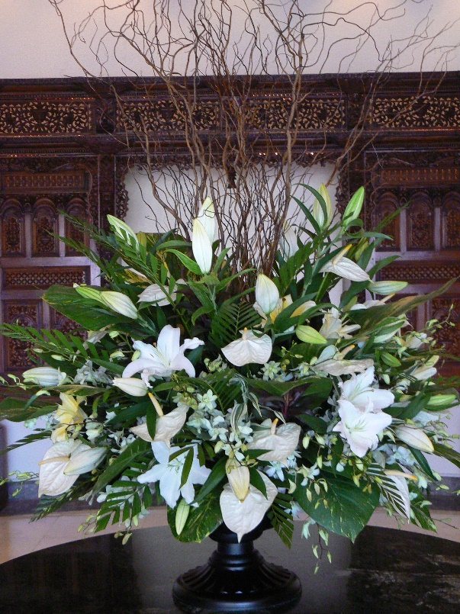
Figure 5.3.2 A floral display to welcome guests to the hotel

Housekeeping coordinates closely with the maintenance and engineering department. For example, they alert maintenance of air-conditioning problems, televisions not working, and toilet and shower problems. As you learned in Session 5.1, housekeeping is considered to be a back of house department, even though housekeeping staff can have some direct contact with the guests. For example, they might interact with guests while cleaning rooms, picking up laundry or providing turndown services.

Housekeeping tasks
Before check-in, a guest’s room is cleaned and checked. It is dusted, swept, scrubbed, mopped and polished starting with the upper parts of the room, including the ceiling and lighting; then the sides of the room, walls and curtains; and finally the bed, furniture and floor by guest room attendants. Housekeeping staff are also responsible for refreshing room amenities, such as shampoo, toothpaste and toothbrushes, for guests. They must check that electrical items, such as an iron and hair dryer, are available.
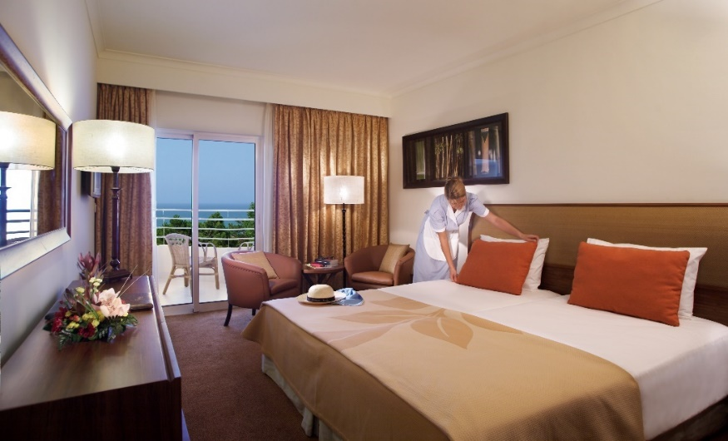
Figure 5.3.3 Room attendant preparing the room for a guest

Before check-out, the guest’s room is checked by a room attendant. They check for linen stains, items consumed from the minibar, broken or damaged furniture and fittings, and missing items. The room attendant also checks that the guest hasn’t left any of their possessions. They make a report to the front office about anything they find. In some instances, the guest may be charged for damages.

Activity 5.3
1. Which members of staff wash and iron the hotel linen:
- room attendants
- laundry attendants
- florists?

2. Who is the head of the housekeeping department:
- executive housekeeper
- store keeper
- gardener?

3. Choose the correct word to fill in the blank in the statement below.
When the guests check out, housekeeping staff check on the room status and report this to the front office ....... the guests check out.
- before
- after

4. Which of the following do housekeeping staff check at guest check-out:
- minibar use
- left guest possessions
- water consumed
- linen stains
- broken items
- damaged furniture
- bed slept in?
Answers to Activity 5.3

5.4 Food and beverage operations
This session looks at the food and beverage operations in a hotel. There are two departments responsible for food and beverage in a hotel: food and beverage production, which prepares the food and beverages; and food and beverage service, which serves food and beverages to the guests. The organisation of the food and beverage department of a small hotel is shown in Figure 5.4.1.
Figure 5.4.1 The organisation of the food and beverage department of a small hotel

The restaurant manager heads up the food and beverage department in a small hotel. It is the food and beverage manager for a medium hotel and the food and beverage director for a large hotel. The organisation of the department is normally divided into two areas:
- restaurant and food outlets
- bar and entertainment outlets.
The range and number of food and beverage outlets depends on the service and type of hotel. Examples of different restaurants and food outlets include:
- fine dining or a signature restaurant (Figure 5.4.2)
- family restaurant
- seafood restaurant
- BBQ or steak restaurant
- quick service/fast-food restaurant
- cake and pastry shop.
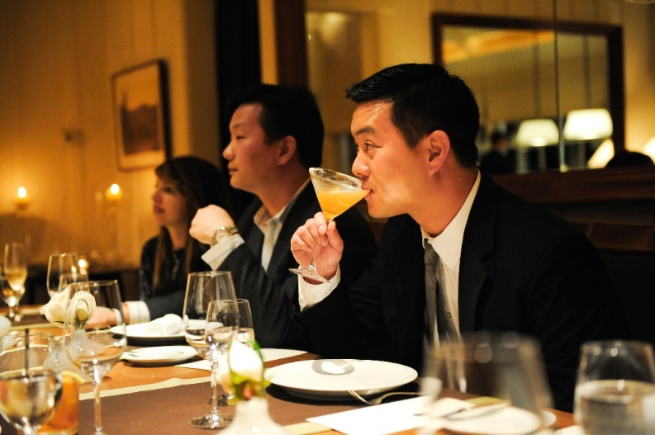
Figure 5.4.2 A fine dining restaurant in a five-star hotel

The bar and entertainment outlets can include a pub, a cocktail bar, a pool bar, a karaoke bar and a nightclub. Room service, banqueting and catering are also included under the food and beverage department in a hotel.

Food service to guests and diners
Depending on the type of establishment and the menus offered, there are a range of service types available to serve guests and other diners, as shown below.
  - Gueridon, trolley or French service – food is cooked and presented to the diner at the table from a movable trolley (Figure 5.4.3).
  - Plated or American service – food is prepared and plated in the kitchen and delivered to the diner at the table.
  - Silver or English service – food service is at the table, with the waiter transferring food from a serving dish to the guest’s plate using service forks and spoons.
  - Buffet or Russian service – courses are brought to the table sequentially. The food is portioned on the plate by the waiter, usually at a sideboard in the dining room, before being given to the diner.
  - Cafeteria or self-service – customers select various dishes from an open-counter display. The food is usually placed on a tray, paid for at a cashier’s station and carried to a dining table by the customer.
  - Family service or Asian service – a casual style of dining, with dishes moderately priced. It usually involves table service rather than counter service.
  - Breakfast service – there are many different types of breakfast service, for example continental, which is pastries, bread, juice and a hot beverage; and English, which is a cooked breakfast.
  - Room service – in-room dining enables guests to choose items of food and drink for delivery to their hotel room. Room service may be provided on a 24-hour basis or limited to late night hours only. Due to the cost of customised orders and delivery of room service, prices charged to the guest are much higher than in the hotel’s restaurant and a gratuity (money paid to service staff for good service) is expected.
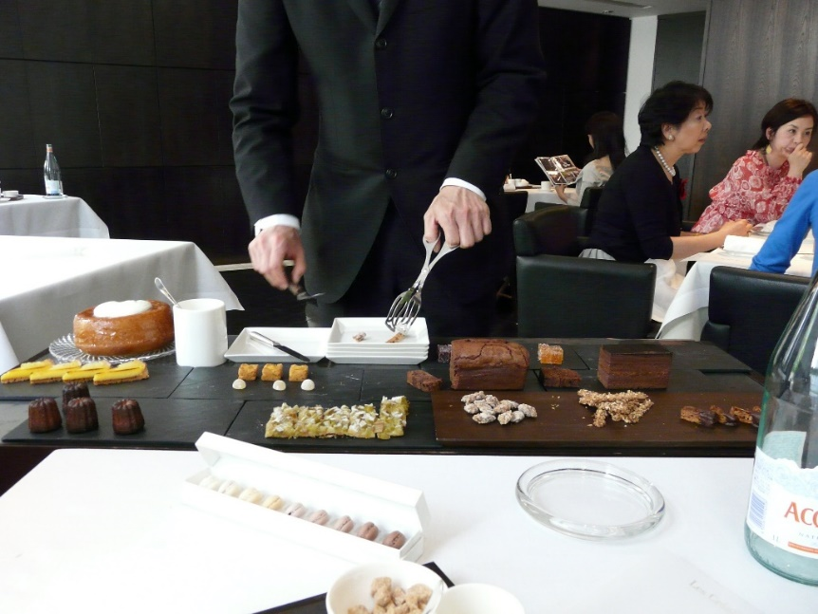
Figure 5.4.3 Gueridon, trolley or French service

Bar service to guests and visitors
A range of beverages are usually available to guests and visitors, including alcoholic and non-alcoholic, mixed beverages, as well as hot and cold drinks.
Alcoholic beverages include:
- aperitifs
- spirits – whiskey, rum, brandy, gin, vodka, tequila
- wines – table, fortified, aromatised, sparkling
- beer – lager, pilsner, ale, stout
- liqueur.
Non-alcoholic beverages include:
- water – natural, manufactured, aerated/carbonated
- juices – fresh, cordials or syrups
- soft drink – colas, lemonade
- hot beverages – tea, coffee, hot chocolate
- milk and milk-based – yoghurt, milkshake.
Mixed beverages include:
- cocktails – one or more alcoholic beverages mixed with other ingredients, such as juice or cream
- mocktails – a non-alcoholic beverage made of a mixture of fruit juices and/or soft drinks.

Activity 5.4
1. A young family want to have lunch at a hotel. They want a casual dining experience and do not want to pay too much. What styles of dining would you recommend for them:
- trolley or French service
- plated or American service
- silver or English service
- buffet or Russian service
- cafeteria or self-service
- family service or Asian service?

2. The young family begin by ordering drinks. They have asked for carbonated water to be provided for the table. The father wants a light alcoholic drink, while the mother would like a mixed beverage with alcohol. The children each want a non-alcoholic, cold drink and both children are intolerant of milk. What drinks would you suggest they order?
Answers to Activity 5.4

5.5 Tourism and hospitality job opportunities
This session looks at the employment opportunities in tourism and hospitality.
Tourism and hospitality are two of the main economic engines for growth in many countries. But the industry can only flourish if it can attract qualified staff and employ a committed workforce. Both are at the heart of excellent service delivery. Employment opportunities in travel and tourism can be created either directly or indirectly (Figure 5.5.1).
Figure 5.5.1 Employment opportunities in travel and tourism

Direct employment opportunities are the total number of job opportunities supported directly by travel and tourism. Direct employment includes jobs in hotels, travel agencies, airlines and other passenger transport services, and the jobs in the restaurant and leisure industries.
Tourism also involves indirect employment, which includes those employed in supporting the tourism sector, such as restaurant and hotel suppliers, construction companies that build hotels, and necessary infrastructure manufacturers and accounting services.
The tourism industry is often characterised by the large number and variety of jobs that must be performed for it to function efficiently. For example, the accommodation sector requires bell staff, front desk staff and room maintenance staff. The food services sector requires chefs, waiting staff, bartenders and kitchen maintenance staff. The attractions sector requires facilitation and equipment operators, as do the entertainment, event and transportation sectors, while the adventure and outdoor recreation sectors need guides and group leaders.
Tourism is one of the most labour-intensive industries among non-agricultural sectors. It offers access to employment in the formal, service economy, and creates significant employment in the informal sector.

Tourism opportunities in Myanmar
Travel and tourism directly generated 804,000 jobs in 2016 in Myanmar, making up 2.7% of the total employment across the country. The total number of jobs indirectly supported by tourism was 1,662,000, which represented 5.7% of the total employment (World Travel and Tourism Council, 2017). Travel and tourism provides a high level of employment and diversified job opportunities in Myanmar, and makes a valuable contribution to gross domestic product (GDP) (Figure 5.5.2).
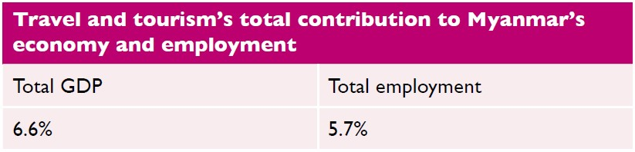
Figure 5.5.2 Travel and tourism’s contribution to Myanmar’s economy

Activity 5.5
The following table shows travel and tourism’s total contribution to GDP and employment in the ten Association of Southeast Asian Nations (ASEAN) countries for 2016. What is Myanmar’s ranking for the total contribution to GDP and employment among its ASEAN neighbours?
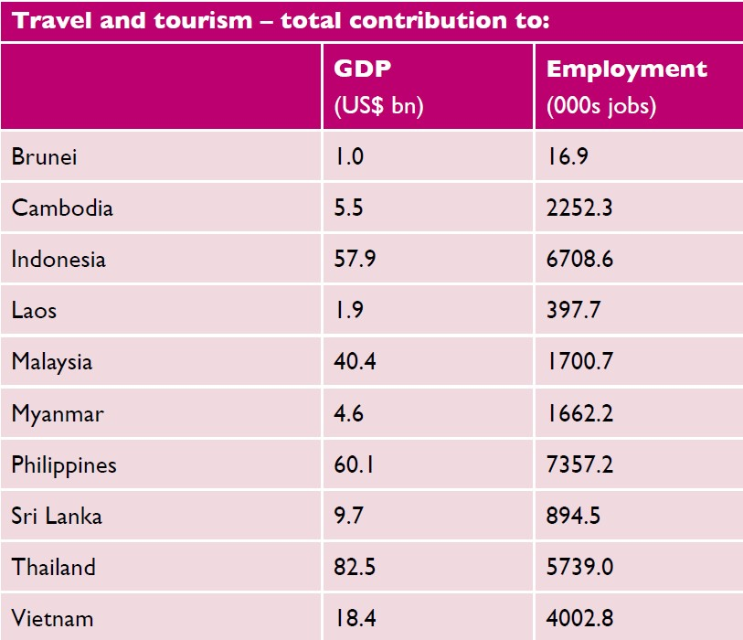
Answers to Activity 5.5

5.6 Hotel careers
Hotel careers can be ideal for people with a wide range of different skills, qualifications and experience. There is often excellent scope to progress to senior positions, for example from working in a busy hotel kitchen as a junior (commis) chef to becoming a hotel general manager (Figure 5.6.1). Here are some brief insights into a selection of hotel careers.
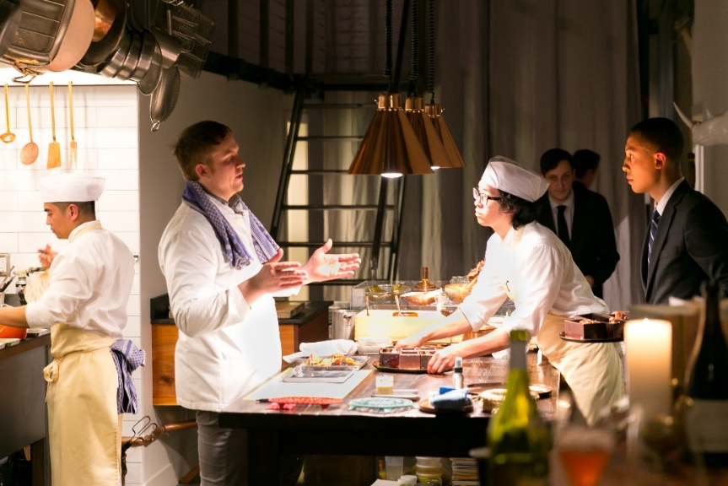
Figure 5.6.1 A junior (commis) chef in a busy hotel restaurant kitchen

Hotel general manager
The general manager is often the most senior executive of a hotel. They set room rates, develop the budget for each department, approve expenses and establish the standards for service to guests.

Experience required
Hotel managers have a degree or certificate in hotel management and a few years of experience. They need to have strong business, management and interpersonal skills.

Duties
Hotel general managers plan and direct the operations of hotels. They have responsibility for front office operations, overseeing restaurant and banquet operations, guest services, housekeeping and decor. They prepare budgets, monitor expenses, and schedule and supervise staff.

Sales manager
A hotel sales manager is responsible for ensuring high occupancy rates and bringing in conference, banqueting and other business.

Experience required
A sales manager must have good communication skills, a confident, optimistic personality and must enjoy working with people. Previous experience of sales, customer service, marketing, business and finance may be requested.

Duties
The sales manager:
- promotes the hotel’s services
- identifies and wins new clients
- prepares sales reports and tracks sales performance
- provides quotes for services
- prepares sales contracts
- processes orders.

Housekeeping room attendant
A housekeeping room attendant ensures guest bedrooms within the hotel are cleaned to a high standard on a daily basis. They should have an eye for detail and notice what isn’t quite right. Being a housekeeping attendant requires some physical stamina, because they have to lift heavy loads.

Experience required
A housekeeping attendant can quickly learn on the job what is required but they need to be willing to learn from and accept criticism in order to maintain high standards.

Duties
The housekeeping room attendant cleans the guest room and bathroom, changes the bed linen, shapes and corrects the curtains and blinds, adjusts the air conditioning and/or heating, and replenishes toiletries for the guest’s comfort. They also provide decoration, such as room flowers, and check the working of electricals. They must report any maintenance issues to the appropriate department.

Front desk agent (receptionist)
Front desk agents provide many guest services. They provide guests with verbal or written information about the hotel facilities, services, room choices and rates, as well as information about area attractions.

Experience required
A front desk agent must have good communication and organisational skills, along with a professional and friendly approach. They also benefit from good computer skills.

Duties
They make room reservations and handle guest arrivals and departures. They also prepare bills and process payments. They deliver hotel information and manage guest complaints.

Executive chef
An executive chef is a managerial role that involves a lot of work in the back office. It can be highly stressful because of the fast-paced working environment (Figure 5.6.2).

Experience required
Many executive chefs have some training at a culinary school, technical school or college programme. They need a track record of meeting deadlines and reaching targets, and experience with stock control. They must have an understanding of health and safety requirements for food hygiene compliance.

Duties
An executive chef oversees the food operations in restaurants, hotels or other venues that serve food. People in this role supervise other chefs and kitchen employees, and manage their performance. They typically order all the food ingredients, plan the menu and supervise the preparation of the food in the kitchen.
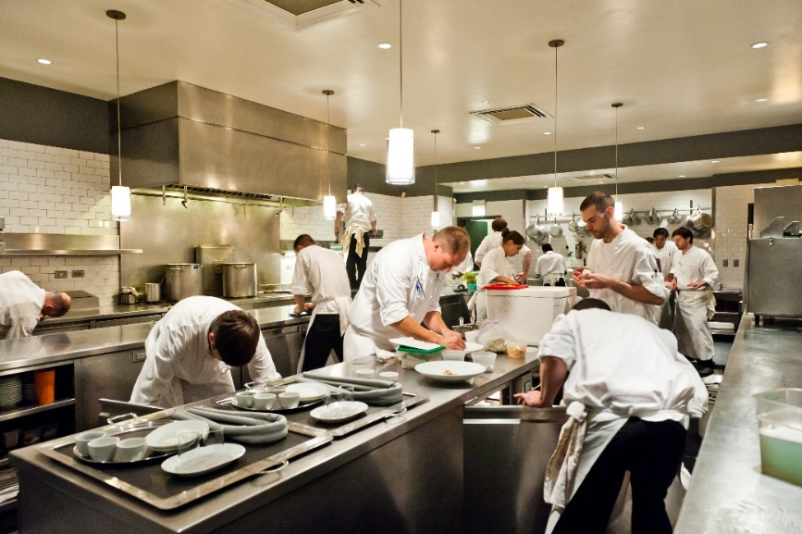
Figure 5.6.2 A busy hotel kitchen

Waiting staff
Waiting staff work in restaurants, bars, hotels, casinos and other food-serving establishments. They have to be detail-oriented, because they need to remember customers’ orders, especially complicated drinks orders.

Experience required
Waiting staff must have strong interpersonal and communication skills. This job is ideal for people in the hospitality industry who want to engage with customers face-to-face.

Duties
They interact directly with customers when taking orders, serving food and beverages, and taking payments from guests.

Finding opportunities
Getting a job in the hospitality industry is likely to start with reviewing job advertisements in newspapers or online recruitment sites. Close reading of job advertisements can tell you a lot about what the job requires and what an employer is looking for.

Activity 5.6
Below is an advertisement for an assistant housekeeping manager in the hospitality industry. The recruiter is looking for a graduate to fill the role. The advert is based on those for similar roles, which appear each week on recruitment websites and in newspapers in Myanmar. It contains the kind of information that is useful for demonstrating an employer’s needs.
Read the job advertisement and extract the relevant information to answer the questions.
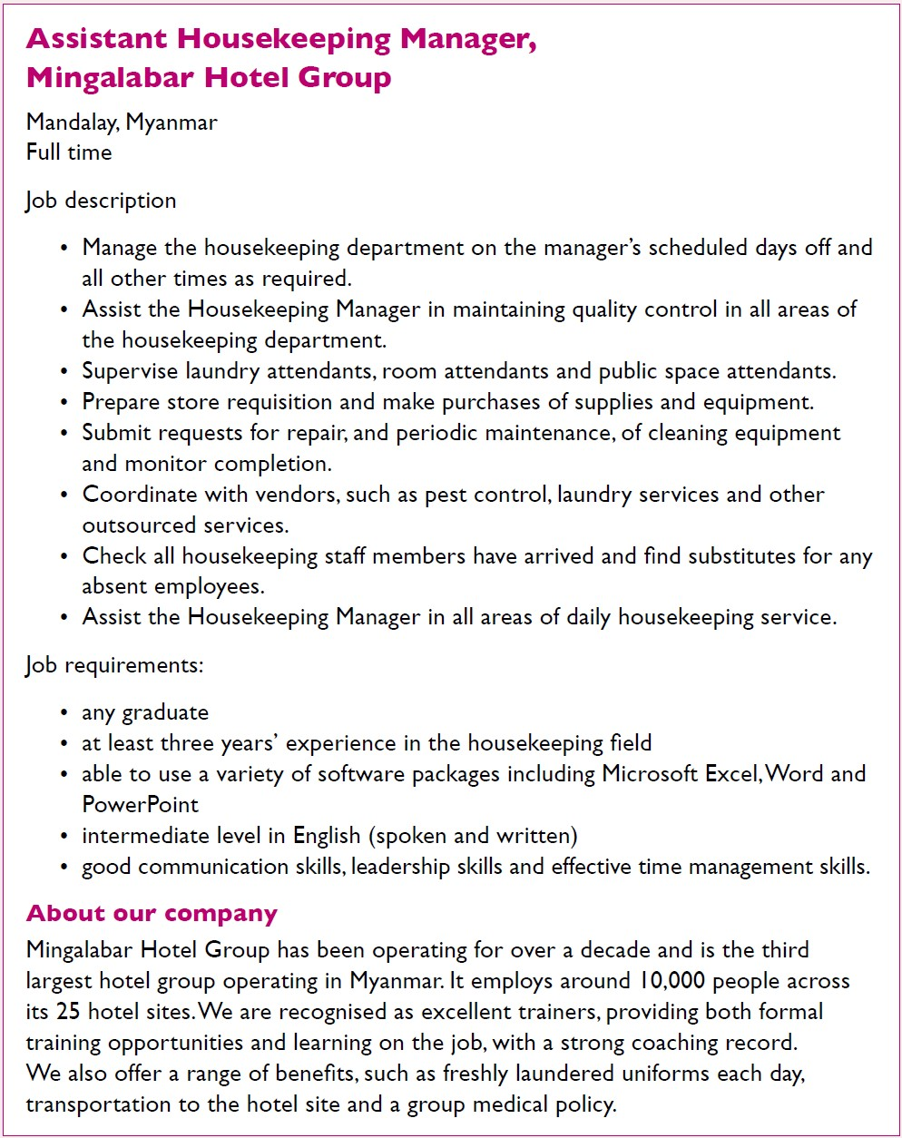
1. What hotel group is the job with?

2. Which of the following will be needed to do the job:
- checking
- dancing
- coordinating
- singing
- cooking
- running
- managing
- ironing
- supervising
- monitoring
- assisting?

3. Identify the requirements for the job:
- degree
- time management skills
- five years’ experience
- basic English
- knowledge of Microsoft packages
- three years’ experience
- leadership skill
- high school certificate
- intermediate English
- no experience needed
- communication skills
- advanced English.

4. What tells you that the company has a good training record?
Answers to Activity 5.6

Answers to activities

Activity 5.1
- b) receptionist
- c) food and beverage service
- a) plumber
- c) human resources
- false
- false

Activity 5.2
- b) I’m very sorry to hear that. Let me see what I can do. Can I take your room number please?
- a) Thank you, Mr Aung San. I’m really sorry for the inconvenience. A maintenance person can be with you in the next 20 minutes. Or if you like, you can have another room right now.
- b) I apologise, Mr Aung San and I’ll call you after the maintenance engineer has been to check that everything is working as you want it to.

Activity 5.3
- b) laundry attendants
- a) executive housekeeper
- a) before
- a) minibar use, b) left guest possessions, d) linen stains, e) broken items, f) damaged furniture

Activity 5.4
- Either e) cafeteria service or f) family service would suit this young family.
- Father – beer or a glass of wine. These are lighter alcoholic drinks.
Mother – a cocktail.
Children – a soft drink or a juice.

Activity 5.5
In 2016, Myanmar was eighth in the ranking for tourism’s total contribution to GDP among ASEAN members. It was seventh for tourism’s total contribution to employment.

Activity 5.6
- Mingalabar Hotel Group
- a) checking, c) coordinating, g) managing, i) supervising, j) monitoring, k) assisting
- a) degree, b) time management skills, e) knowledge of Microsoft packages, f) three years’ experience, g) leadership skills, i) intermediate English, k) communications skills
- The advertisement states, ‘We are recognised as excellent trainers, providing both formal training opportunities and learning on the job, with a strong coaching record.’

References
World Travel and Tourism Council. (2017) Travel and Tourism: Economic impact 2017, Myanmar. Available at: https://bandapost.org/wp-content/uploads/pdf/Economic%20Impact%202017%20Myanmar%20by%20World%20Travel%20&%20Tourism%20Council.pdf (Accessed: 5 March 2021).

