Contents

Study Session 5 Personal Hygiene 2
Learning outcomes of Study Session 5 2
5.1 What is personal hygiene? 3
5.2 Public health importance of personal hygiene 3
5.2.1 Preventing faecal-orally transmitted diseases 3
5.2.2 Aesthetic values of personal hygiene 3
5.2.3 Social impact 4
5.3 Components of personal hygiene 5
5.3.1 Body hygiene (skin care) 5
5.3.2 Oral hygiene (oral care) 6
5.3.3 Handwashing (hand care) 7
5.3.4 Face hygiene 8
5.3.5 Fingernail and toenail hygiene (nail care) 9
5.3.6 Ear hygiene 9
5.3.7 Hair hygiene (hair care) 9
5.3.8 Foot hygiene (foot care) 11
5.3.9 Armpit and bottom hygiene 11
5.3.10 Clothes hygiene 11
5.3.11 Menstrual hygiene (Personal hygiene for women) 12
5.4 Planning for the improvement of your personal hygiene 13
Summary of Study Session 5 14
Answers to in-text questions 15

Study Session 5
Personal Hygiene
The exercise of proper personal hygiene is one of the essential parts of our daily life. The prevention of communicable diseases like diarrhoea is highly possible if proper personal hygiene is followed. Hygiene is a series of practices to preserve health.
Understanding the proper practice of personal hygiene can help the prevention and control of important public health diseases in your community. This study session also explores the links between personal hygiene and dignity, confidence, and comfort.
Learning outcomes of Study Session 5
When you have studied this session, you should be able to:
- describe the public health importance of personal hygiene
- list and describe the components of personal hygiene
- describe what are acceptable and poor personal hygiene practices

5.1 What is personal hygiene?
Personal hygiene is a concept that is commonly used in medical and public health practices. It is also widely practised at the individual level and at home. It involves maintaining the cleanliness of our body and clothes.
Personal hygiene is defined as a condition promoting sanitary practices to the self. Everybody has their own habits and standards taught or learned from others. Generally, the practice of personal hygiene is employed to prevent or minimise the incidence and spread of communicable diseases.

5.2 Public health importance of personal hygiene
The knowledge, purpose and practice of personal hygiene are vital in all our everyday activities.

5.2.1 Preventing faecal-orally transmitted diseases
The fingers may get contaminated with one’s own faeces, either directly or indirectly, which can make it easier for disease to spread. Defecation and child bottom-washing are opportunities for the contamination of the fingers that allow infections to pass between one person and another.
In-text question 1.1
Think back to the diagram in Study Session 2, Figure 2.5 showing the different methods of disease transmission from faeces to food. While fingers are one way that faeces can contaminate food, can you name two other ways?

5.2.2 Aesthetic values of personal hygiene
A person with clean hands can feel proud while eating because they are confident about preventing diseases. A teacher in a school is happy to see their students with clean faces and eyes and dressed in clean clothes. A mother is mentally satisfied to feed her infant with clean hands because she ensures her child’s health. Generally, cleaning oneself produces pride, comfort and dignity at home and in public places. Caring about the way you look is important to your self-esteem.

5.2.3 Social impact
A person with poor personal hygiene might be isolated from friendships because being honest with them about the situation might be sensitive and culturally difficult. The success of a job application or the chance of promotion could be affected by poor personal hygiene; no company wants to be represented by someone who does not appear to be able to look after themselves (Figure 5.1).

Figure 5.1 Summary of personal hygiene

5.3 Components of personal hygiene
There are different elements that contribute to good personal hygiene.

5.3.1 Body hygiene (skin care)
The body has nearly two million sweat glands. Moistened and dried sweat and dead skin cells all together make dirt that sticks on to the skin and the surface of underclothes.
The action of bacteria decomposes the sweat, thereby generating bad odour and irritating the skin. This is especially observed in the groin, underarms and feet, and in clothing that has absorbed sweat. Skin infections such as scabies, pimples and ringworm are results of poor body hygiene. Figure 5.2 shows ringworm of the scalp.

Figure 5.2 Scalp ringworm
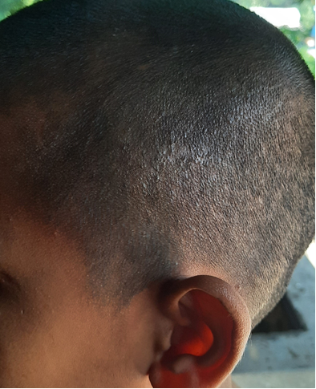

The first task in body hygiene is to find water, soap and other cleansing materials. Taking a bath or a shower using body soap at least weekly is very important to ensuring our body stays clean (Figure 5.3).
Bathing can be every day or after periods of sweating or getting dirty. The genitals and the anal region need to be cleaned well because of the natural secretions of these areas. Dry the body with a clean towel after thorough rinsing. Change into clean underwear after a bath. Changing sweat-soaked clothes after each bath is advised. Cleaning the ears after every bath is also necessary. Avoid sharing soaps and towels because of the danger of cross-infection.

Figure 5.3 Body washing
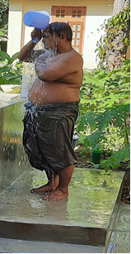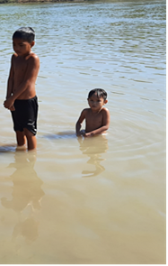

5.3.2 Oral hygiene (oral care)
The mouth is the area of the body most prone to collecting harmful bacteria and generating infections. Our mouth mechanically breaks food into pieces. This process leaves food particles (food debris) that stick to the surface of our gums and teeth. Our mouth cavity is full of bacteria and is a good environment for bacterial growth.

In-text question 1.2
Why is the mouth a good environment for bacterial growth?

5.3.3 Handwashing (hand care)
The cleanliness of our hands is very important in all our daily activities. In our normal activities our hands frequently get dirty and micro-organisms attach to our hands along with the dirt. There are many communicable diseases that follow the route of faecal–oral transmission. Hand hygiene plays a critically important role in preventing cross-infection.
Hygienic handwashing involves the mechanical removal of micro-organisms from contaminated hand surfaces using soap or detergent. Handwashing should involve more than a quick rinse under a tap or in running water.
Figure 5.5 Handwashing
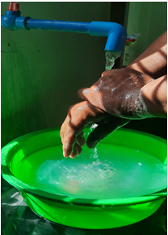
You were introduced to proper handwashing techniques in Study Session 2, but here is a short video demonstrating the steps of good handwashing from the WHO.
https://www.youtube.com/watch?v=IisgnbMfKvI&t=19s
If you want to download the WHO poster on these handwashing steps, follow this link:
https://www.who.int/gpsc/5may/How_To_HandRub_Poster.pdf?ua=1
To get clean hands, you must POUR the water over your hands (no dipping in a bowl!). The soap ‘lifts’ the dirt, and the water then washes off the visible dirt and the invisible germs (Figure 5.5).
As well as routine personal hygiene that applies to everyone, your daily work will include many situations when you may ask yourself when you need to wash your hands. To know when to wash your hands at home and at work, you must first identify critical moments; that is, circumstances, activities or incidents that indicate the possibility that pathogenic micro-organisms are present on hands, fingers and nail surfaces.
Critical situations in everyday activity include:
- after using the toilet (or disposing of human or animal faeces)
- after changing a baby’s diaper (nappy) and disposing of the faeces
- immediately after touching raw food when preparing meals (e.g. chicken or other meat)
- before preparing and handling cooked/ready-to-eat food
- before eating food or feeding children
- after contact with contaminated surfaces (e.g. rubbish bins, cleaning cloths, food-contaminated surfaces)
- before and after coming in contact with an infected wound
- after handling pets and domestic animals
- after wiping or blowing the nose or sneezing into the hands (respiratory hygiene)
- after handling soiled tissues (your own or others’, e.g. children).

5.3.4 Face hygiene
Our face reveals our daily practice of personal hygiene. Face hygiene includes all parts of the face. The most important area to keep clean is the eyes.
The eye discharges protective fluids that could dry and accumulate around the eye. They are visible when a person gets up in the morning. The substance of the eye discharge can attract flies, and this is dangerous because the fly is a carrier (‘vector’) of conjunctivitis.
A person should wash their face every morning and evening in order to remove all dirt. Children are advised to wash their face frequently. Never share your face towel with others.

In-text question 1.3
Why is it advisable not to share a face towel?

5.3.5 Fingernail and toenail hygiene (nail care)
A nail is hard tissue that constantly grows. Long fingernails tend to accumulate or trap dirt on the underside. The dirt could result from defecation or touching infected and contaminated surfaces.
Keeping nails trimmed and in good shape weekly is important in maintaining good health. Clip nails short along their shape but do not cut them so close that it damages the skin. Razor blades and fingernail cutters or scissors are used to cut nails. Nail cutters should not be shared with others.

In-text question 1.4
Why is it advisable not to share nail cutters?

5.3.6 Ear hygiene
Ear wax accumulates in the ear canal that leads from the outer ear to the ear drum. As the secretion comes out of the ear it collects dust particles from the air. Daily washing with soap and water is enough to keep the outer ear clean.
Do not reach farther than you can with your little finger into your ear. Putting in hairpins, safety pins or blunt-edged things for cleaning purposes might harm the ear. If you feel wax has accumulated and is plugging your ears and interfering with hearing, consult your doctor.

5.3.7 Hair hygiene (hair care)
The hair follicles from which the hair grows produce oil from the sebaceous glands that keeps the hair smooth. The scalp (the skin covering the head) also has numerous sweat glands and is a surface for the accumulation of dead skin cells. The oil sweat and dead cells all add together and can make the hair greasy and look dirty unless you wash it regularly.
Poor hair hygiene could cause dandruff and skin infections (see Figure 5.6). Dandruff is dead skin on the scalp that comes off in tiny flakes when too much oil is produced and accumulates on the scalp.
Head hair is a good home for head lice and nits (eggs of head lice). The head louse is a tiny insect that lives by sucking blood. Children are especially prone to lice infestation.
Lice spread from one head to another when there is close contact, as in school environments. They make the scalp itchy and are a cause of annoyance, irritation and embarrassment. Shaving of the head hair is possible in bad cases of lice infestation. Sharing of blades with others, however, should be discouraged.
Hair-cleaning is important to ensure it stays clean, healthy and strong. The recommended procedures for cleaning the hair are:
- Use clean water to wash your hair regularly (at least twice weekly, preferably once every other day) with body soap or shampoo, whichever is available.
- Massage your scalp well to remove dead skin cells, excess oil and dirt.
- Rinse well with clear water.
- Conditioner is helpful if you have longer hair as it makes the hair smoother and easier to comb, but hair doesn’t need to have conditioner.
- Use a wide toothed comb for wet hair as it is easier to pull through.
- Dry the hair and the head with a clean towel but never share a towel with someone else.
- Comb the hair to look beautiful for the day.

Figure 5.6 Combing through hair during washing
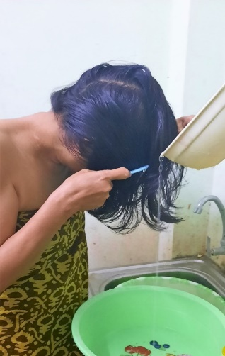

5.3.8 Foot hygiene (foot care)
We spend a lot of time on our feet. Our feet sweat throughout the day and the sweat accumulates on all foot surfaces and between the toes. The sweat may stain the shoes and can produce an awful odour.
In-text question 1.5
What causes sweat on the skin to produce an unpleasant odour?

5.3.9 Armpit and bottom hygiene
These are body parts that easily get sweaty and where ventilation is very poor. After puberty, our sweat gains a specific and unpleasant odour which may be offensive to others. The armpits and the bottom should be washed daily.
Anal cleansing is the hygienic practice of cleaning the anus after defecation. The anus and buttocks may be cleansed with clean toilet paper or similar paper products. Water may be used. Hands must be washed with soap afterwards.

5.3.10 Clothes hygiene
We usually have two layers of clothing. The internal layer is underwear. These are right next to our skin and collect sweat and dead skin cells, which can stain the cloth.
Bacteria love to grow on this dirt and produce a bad smell in addition to the specific odour of the sweat. Underwear must be washed more frequently than the outer layer of clothing.
Clothes hygiene is an important aspect of one’s dignity. Changing used clothes for clean ones every day is recommended.

Washing dirty clothes requires adequate clean water, detergents and washing facilities (Figure 5.7a and b).
If possible, the washed clothes should be ironed to help kill body lice and nits. Boiling water or insecticides can be used to destroy infestations on clothes
Figure 5.7 Washing clothes in rural areas (a) by a river (above) and (b) in a stream (below)

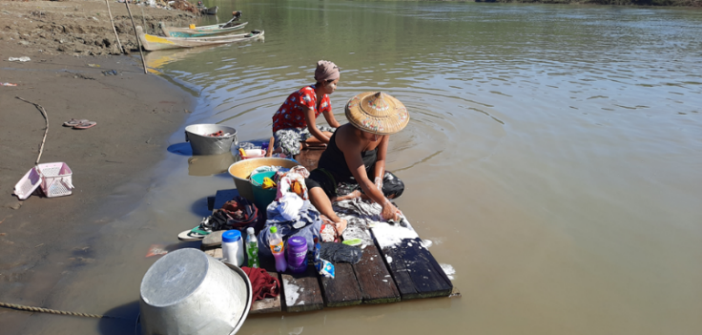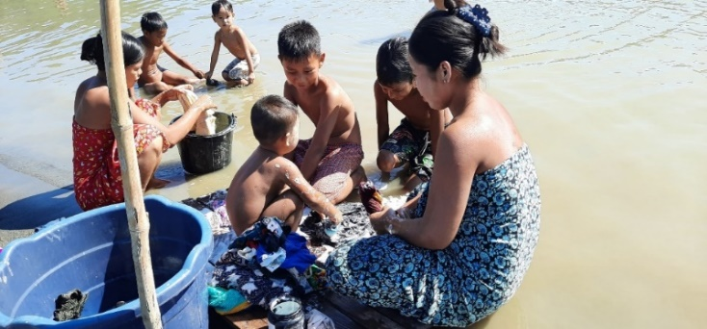
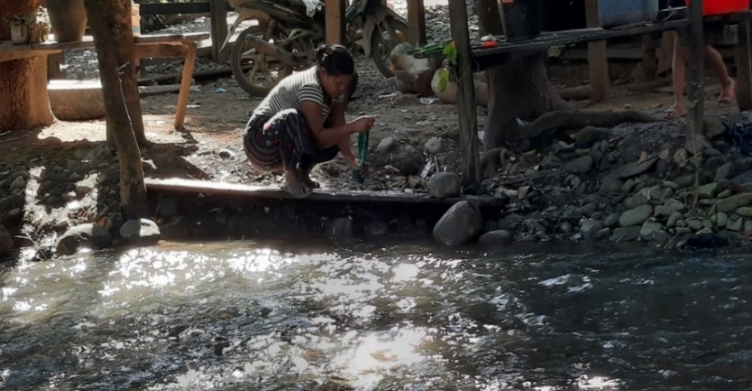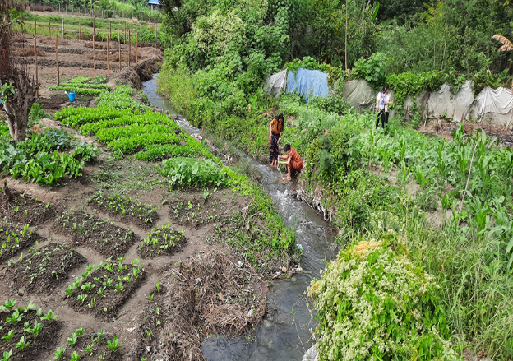

5.3.11 Menstrual hygiene (Personal hygiene for women)
The vagina is able to clean itself; no special care is needed other than washing the external genitals. Washing the outer genital area with clean water must be a daily practice. Change tampons and sanitary napkins or pads regularly.
Always wash your hands before and after handling a tampon or pad. Clean and soft cloths can be used in place of sanitary pads. The use of dirty cloths must be discouraged. Menstrual blood-absorbing items must be properly disposed of in an appropriate way.

5.4 Planning for the improvement of your personal hygiene
Planning for personal hygiene became a particularly important issue during the Covid-19 pandemic of 2020-21, when handwashing and preventing the spread of airborne droplets when coughing and sneezing was a global health message, as shown in Figure 5.8.
Reflect on what you have learned in this session and ask yourself whether there are some practices that you should change to safeguard your health and the health of others more effectively. Having identified these, consider how you will make the necessary changes.
Finally, commit to a time in the future (a day, a week or month) when you will review how successful or otherwise you have been in making these behaviour changes.

Figure 5.8 Children discuss the message in a health poster.
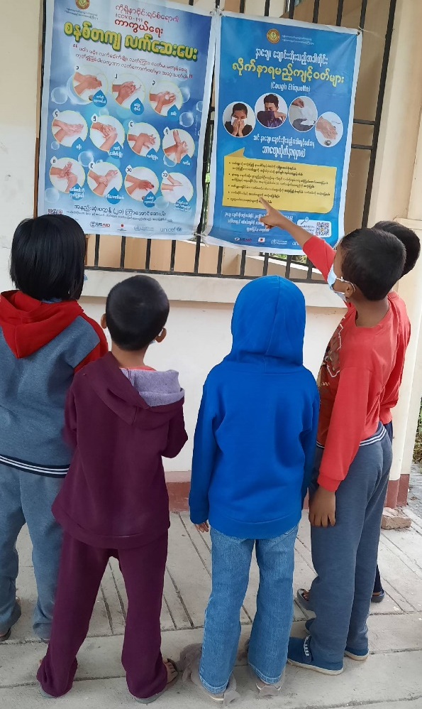

Summary of Study Session 5
In Study Session 5, you have learned that:
- Personal hygiene is a necessity for our daily activities. It is very important for the protection of our health and helps to prevent the spread of diseases.
- Personal hygiene has social and aesthetic values. An individual who follows the practice of proper personal hygiene gains confidence, pride and dignity.
- Personal hygiene applies to all parts of the body, but hand hygiene is probably the most important for public health.
- The procedures that apply in personal hygiene (such as handwashing and oral hygiene) need to be followed strictly to gain the best results.
- The promotion of personal hygiene should aim to change human behaviour. The provision of hygiene information first improves knowledge and then practice.
- The promotion of personal hygiene must be well planned in order to bring positive changes.

Answers to in-text questions
1.1 There were five ways: fluids; fingers; flies; field; floor. It is at the optimum temperature (37°C) and is often rich in food particles that support bacterial growth.
1.2 The decaying process that takes place on the surface of the teeth eventually produces a build-up called plaque (a sticky deposit on which bacteria grow) that is then converted into tartar (a hard, yellowish, calcified deposit on the teeth, consisting of secretions and food particles). The result is tooth decay. In addition, unpleasant smelling breath, teeth and gum infections could be a result of poor oral hygiene.
Figure 5.4 Mouth cleaning
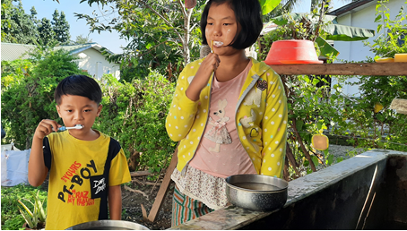

Advice for keeping the mouth clean (Figure 5.4) is:
- rinse the mouth after each meal
- brush your teeth with a fluoride-containing toothpaste twice a day – before breakfast and before you go to bed
- during the day, fill your mouth with water and swish it around to get rid of anything sticking to your teeth
- in addition to regular brushing, it is advisable to floss your teeth at least once a day, usually before you go to bed.

1.3 Some diseases, such as conjunctivitis, can be transmitted easily from person to person in this way.

1.4 Some diseases, such as fungal infections, can be transmitted easily from person to person in this way.
1.5 The action of bacteria as they break down the sweat.
As well as bacteria, sweat also encourages fungal growth between the toes. This is called ‘athlete’s foot’. The signs of athlete’s foot are scaly skin and sores or blisters, which start between the toes but can often spread to the soles of the feet. This is a minor irritation and often disappears by itself but sometimes these cracks and sores become the site for other infections. The feet should be washed daily, or at least twice weekly.

